A critical evaluation on the role of digital innovation in professional practice

In the digital age, digital innovation has become a cornerstone of modern education, reshaping how knowledge is delivered, accessed, and experienced. Digital technologies, ranging from online learning platforms to interactive tools like virtual reality and artificial intelligence, have introduced new opportunities for teaching and learning. Digital tools enable personalised learning experiences, foster collaboration, and provide opportunities for students to develop essential 21st-century skills. The Welsh Curriculum was developed by the Welsh Government and implemented in schools in 2022, with the aim to create students who are equipped with digital knowledge that will be needed as basic life skills after education. Furthermore, these innovations make education and learning more accessible to everyone involved.

This essay will include a literature review on the importance of digital innovation in education by comparing five main sources that discuss both the advantages and disadvantages of digital tools. Furthermore, a section on justification will discuss the TPACK framework and Lev Vygotsky’s theory on cognitive development that have been learnt throughout the module. This section will highlight how digital innovation can link to the fundamental development of children. The application will demonstrate how digital innovation has been applied and used during lectures over the past weeks. Including an example of Mentimeter and its positive learning outcomes. Finally, the last section will evaluate and reflect on how successful the application has been for the students. It will discuss the benefits that Mentimeter has brought to the lesson and how improvements could be made for future lectures.

Literature review

With modern technology growing vastly, technology impacts education positively daily through completing simple tasks. Both Alenezi (2021) and Cojocariu et al., (2024), both agree that the new digital world has opened an array of opportunities for people in education, especially those who are studying at university due to it opening a whole database to search and explore. Cojocariu et al., (2024), state that information “can be gained from various platforms, open-source database and web browsers”. This creates more opportunities for those not only in the university but also for school pupils due to the wide range of available resources. Kopylova (2022) also agrees with Alenezi (2021), Joosten et al., (2020) and Cojocariu et al., (2024) however, reinforces one main advantage of digital innovation which allows the flexibility to create and write about anything and being able to publish it online which personalises everybody’s learning experience individually. Cojocariu et al., (2024) state that research from a 2009 survey shows that “teachers believe creativity is an essential competence that must be developed”. This supports the idea of allowing students the freedom to create and publish work that other writers could use to reference. Digital technology allows easy, improved access to resources worldwide. Additionally, both Kopylova (2022) and Joosten et al., (2020) both discuss the element of translation accessibility, not only for students who are studying in a foreign country but also for resources. With platforms like Google Translate or Google Books, articles, books and websites can be translated and applied to work.

With modern technology improving and expectations for 21st-century students to be up to date with the contemporary world, the implementation of digital technology into education across the world is important. Both Joosten et al., (2020) and Cojocariu et al., (2024) highlight the positives that digital technology brings to education. One point both authors raise is the way that mobile applications, social networks and the internment can spark curiosity, creativity and innovativeness in learners. Joosten et al., (2020) believe it can enhance student learning by providing effective pedagogy, instruction and student support for those who need it. Alenezi (2021) supports shaping 21st-century learners as a priority due to the rapid change in digital technology and the need to adapt to the current technological climate. However, Ilomaki et al., (2018) believe that digital innovation in education has created a problem for teachers/ educators. This problem is that teachers/ educators are expected to prepare learners with basic technological life skills that they might need however, in the past 10 years advances have ranged from cellphones to virtual reality and artificial intelligence to self-driving automobiles, and have advanced at a rapid pace which leaves people questioning what challenges the digital world could face in the next decade.

Digital innovation allows “greater accessibility of education” (Kopylova, 2022). Joosten et al., (2020) support this by discussing the opportunities digital technology brings to education. It is seen as a flexible learning resource that increases students' chances to complete a course. Statistics show that between 2022-2023, 206,175 undergraduate students learnt remotely online instead of attending lectures, Mosley (2024). Both Kopylova (2022) and Ilomaki et al., (2018) agree that the use of digital tools like Zoom and Teams is a flexible way for students to learn. This became especially useful during the Covid-19 pandemic when students globally only had access to online learning. Four years after the Covid-19 pandemic, lectures and schools still use elements of remote learning. Many universities do online learning alongside a mixture of face-to-face lessons, whilst schoolteachers can upload video recordings or voice notes for homework/ to publish students' work that has been completed throughout the week. Work/ recordings can be uploaded onto teams directly or can be uploaded onto platforms like Seesaw which allows teachers, pupils and parents to interact with work, Kopylova (2022). Additionally, both authors discussed the options of adapting lessons for a range of mixed abilities through different digital programs like Microsoft which allows learners access to digital programs to learn/ write and create work.

Digital innovation is a great way to capture student engagement, outcomes and satisfaction through the use of platforms like Mentimeter, Kahoot and Plicker, Alenezi (2021). Ilomaki et al., (2018) agree with Alenezi (2021) and believe that teachers share vision and values through the use of technology, sparking collaborative learning and measuring continuous growth. Digital tools like Mentimeter are great platforms to include and engage everyone in the room through even a response of a one-word answer. Also, it creates data visualisation which creates better results for learning outcomes. While some individuals might find the traditional way of teaching better, Alenezi (2021) states that digital technology in education must be seen as a great advantage to all rather than a threat. Experimenting and testing knowledge through Kahoot or Plicker quizzes is a fun and interactive way for students to learn. Research shows that game-based learning strategies like Kahoot and other gamified platforms enhance classroom dynamics, promote friendly rivalry, and offer real-time feedback. These resources encourage active participation in addition to student engagement, which results in more profound learning opportunities.
Alongside allowing teachers to assess learning through digital tools, Cojocariu et al., (2024) believe it can be a great way for teachers and students to connect and collaborate at the same time. This can be through shared documentation where students and teachers can both edit/ do the task at the same time. Hwb also allows pupils to save digital work straight to the teacher's file which provides instant feedback. Additionally, many universities use the programme Moodle which allows both students and pupils access to modules, assignments and files necessary to complete work. Online assignments are becoming common in many institutions globally because the COVID-19 pandemic accelerates the adoption of digital education technologies. According to surveys, more than 60% of students believe that using digital learning resources can help them do better academically.

In 2022, the Curriculum for Wales was introduced and implemented across Wales. The Welsh government created a vision that included the four purposes. One of the four purposes was to support children to be “ambitious, capable learners” (The Welsh Government, 2020). This means that all students should use digital technologies to communicate, interpret data, be creative and analyse data. Digital technology is now one out of six core subjects all students must do every week. Ilomaki et al., (2018) support the idea of digital technology being implemented into the curriculum highlighting the importance of digital technology and having its area of learning to create learners who are prepared for the future. Alenezi (2021) also agrees with Ilomaki et al., (2018) stating that digital transformation is being integrated into curriculum and education nationally which is “ensuring that the learning of students is supported by digital tools”. Joosten et al., (2020), Cojocariu et al., (2024) and Kopylova (2022), the implementation of digital technology in education has positively influenced education in all areas according to teaching assistants.

Whilst there are many advantages to digital innovation in education, both Kopylova (2022) and Cojocariu et al., (2024) discuss the disadvantages that many educators are facing with the recent development of technology. In 2023 the AI tool began to soar in popularity among students and educators. AI refers to the process by which robots, especially computer systems, mimic human intelligence to carry out tasks that normally call for human intellect. Learning, reasoning, problem-solving, comprehending natural language, and interpreting visual or auditory stimuli are some of these tasks. Kopylova (2022) discussed the increased numbers of plagiarism due to tools like ChatGPT which is a free, online website that students can use to write assignments. Statistics by Kelly (2024) show that 86% of students use AI in their studies. Not only does this affect universities but also schools due to how easy it is for students to access this digital tool. While AI can bring numerous advantages to students' work by providing a quicker way to search for answers to incorporate into their work, many students use the tool to copy the work word for word which is then considered plagiarism. Additionally, Cojocariu et al., (2024) believe that teachers spend more time supporting students while doing digital work due to their lack of knowledge when it comes to technology. 21st-century students know how to play games but don’t know the basics of computers. For example, how to access old work, how to save work and how to access HWB. This results in teachers spending half of the lesson helping children to do the basics before even starting to teach.

Justification

One framework that aids teachers in successfully incorporating technology into teaching and learning is the TPACK Framework (Technological Pedagogical Content Knowledge). It expands on the notion that a combination of three essential knowledge domains is necessary for effective teaching. Included in this is Content Knowledge (CK), which denotes familiarity with the subject area being taught, such as science, math, literature, or history. Technological Knowledge (TK) is the ability to use digital tools, equipment, and software efficiently. Pedagogical Knowledge (PK) is the knowledge of teaching techniques, instructional tactics, and how students learn. The TPACK framework aims to create impactful and meaningful learning experiences for students.

The TPACK framework is broken down into four key components to help understand where and how digital technology can be implemented into learning. The first component explains how digital technology can enhance teaching methods. As previously discussed in the literature review, Mentimeter and Kahoot are some tools that can assess student learning there and then inclusively and adaptively. Capuno (2023) supports this method by believing that learning can be made accessible and efficient for a variety of learners through the use of student-specific quizzes, which can allow teachers to assess learning for each child. Teachers can create inclusive, innovative tests that are in line with certain learning goals by using gamified platforms. Quizzes are also a great way to engage students with learning. Cameron et al., (2019) believe that game-based learning through Kahoot or Mentimeter that are created using gamification principles. Students then foster a sense of challenge which sparks engagement in the lesson. Quizzes give students immediate feedback on their progress through leaderboards, and scores, which increases their motivation to take part in learning activities. This is also a wonderful way for visual learners to enjoy and engage in learning due to having access to leaderboards and scores which can be presented on a digital whiteboard.

The second component is to understand how technology can represent the subject context. Multimedia content like Videos, infographics, and animations can bring topics to life. This can help teachers to demonstrate any topic to any class. Cox (2020) states that applying real-world scenarios to lessons can help students with problem-solving skills. Project-based learning, for instance, helps students bridge the gap between theory and practice by encouraging them to tackle real-world issues or provide thoughtful answers to challenging questions. Students can watch and take part in real-world situations through watching videos and simulations, which enhances the significance and memorability of their education. Using digital technology to apply real-world scenarios can foster teamwork, critical thinking, and problem-solving abilities. The third component is the ability to use technology to teach specific content by using appropriate methods. The first digital graph to analyse data was created in the bed 20th century. With technology now advancing at a fast rate students must have the skills to be able to see data, understand it and plot it through using programmes like Microsoft Excel or J2E Data. Finally, the fourth component is to integrate all three elements to design and deliver instruction that is both content-specific and technologically enriched. TPACK it’s important due to its holistic approach which helps teachers think of ways to align technology in lessons with pedagogy and content. Additionally, it supports teachers in adapting lessons to diverse student needs. Finally, it provides innovation in teaching through opening creative ideas to encourage learning.

Lev Vygotsky’s (1978) sociocultural theory emphasizes the role of social interaction and cultural tools in cognitive development. This makes his framework particularly relevant to digital innovation in education. The Zone of Proximal Development (ZPD) is a core concept in Lev Vygotsky’s sociocultural theory. It refers to the range of tasks that a learner can accomplish with guidance but cannot yet perform independently. Vygotsky described it as the space where learning is most effective, as it pushes the learner's current abilities while providing necessary support. This theory aims to provide scaffolding as an instructional method to help students learn and build on what they can’t do right now but what they will be able to achieve in the future. Vygotsky (1978) states that “What a child can do with assistance today, they will be able to do by themselves tomorrow.". A key component of Lev Vygotsky's sociocultural theory of cognitive development is his idea of cultural tools. The signs, symbols, languages, and artefacts that a civilisation has produced to aid in thought and communication are known as cultural tools. Because they manage interactions between people and their surroundings, these tools have a big impact on how each person learns and thinks. Vygotsky’s theory highlights that social interactions and the application of these tools foster the development of higher mental functions like reasoning and problem-solving. For example, language, a crucial cultural instrument, enables people to internalise external behaviours as mental processes and convey complicated ideas. This relationship between tools and cognition illustrates how social and personal growth are interwoven, Scott (2013).

Vygotsky believed that these tools mediate learning, allowing individuals to construct meaning from their experiences. His work underscores the importance of collaborative and cooperative learning environments, where shared activities enhance understanding and problem-solving skills. These skills can be combined through various learning techniques however digital innovation provides a range of life skills that should be developed whilst in education. Vygotsky’s theory links with the TPACK framework. When applying both digital technology and Vygotsky’s theory to education, can allow both students and teachers to learn new digital skills like coding, data input and how to use digital programmes. This can be applied by complying with both Vygotsky’s theory and the TPACK framework to scaffold digital learning. For practical application, educators can use scaffolding. This provides incremental support to learners until they achieve independence in a task. Strategies like cooperative group work and reciprocal teaching align well with his principles, fostering peer interaction and shared learning experiences. A book by Hughs et al., (2022) highlights the importance digital innovation has in education and its role in fostering teamwork across various subjects and activities. It emphasises the value that tools like Google, digital whiteboards, and apps have on students learning outcomes and how it enhances inclusivity, collaborative working and advanced understanding.
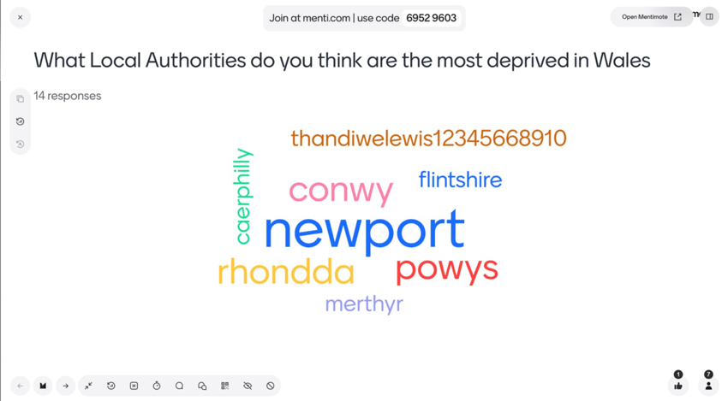
Application

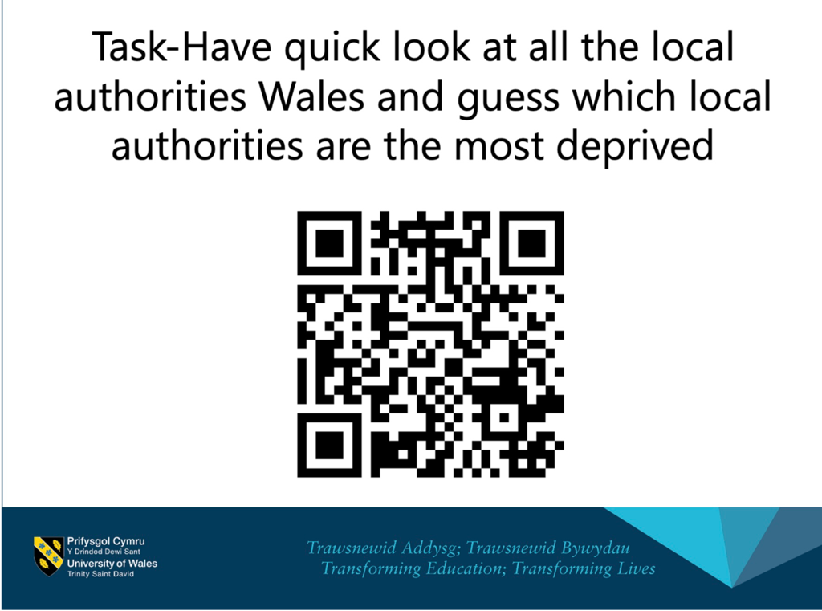
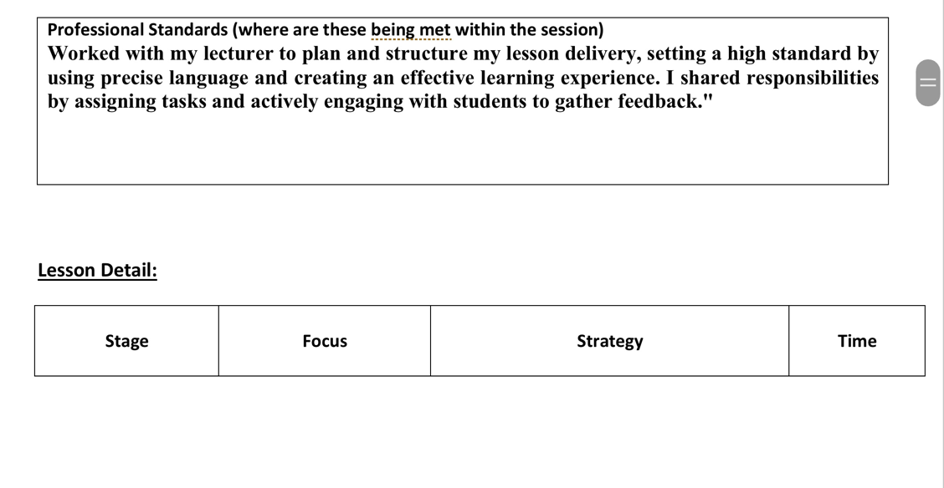
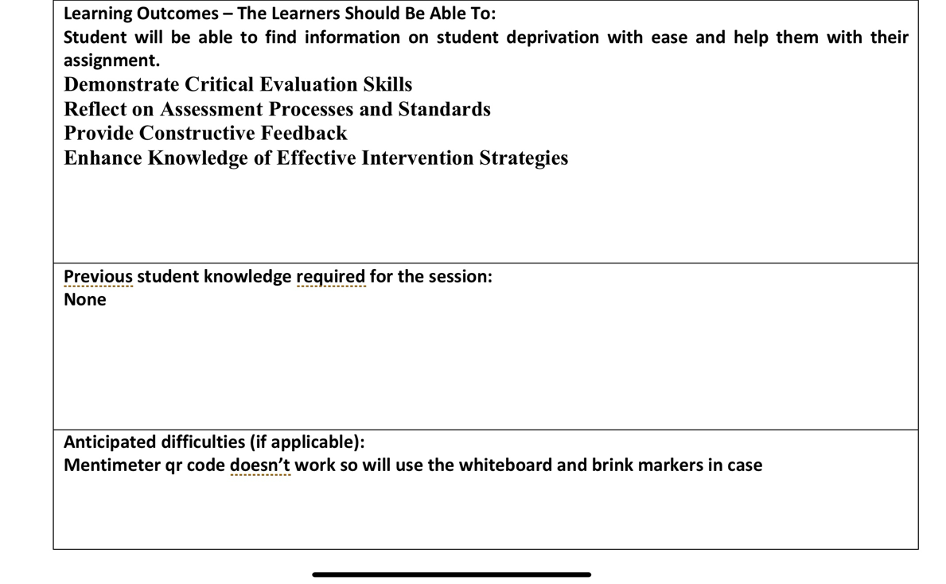
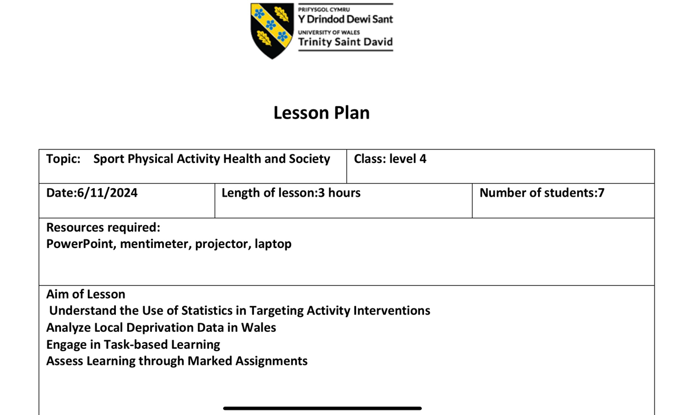
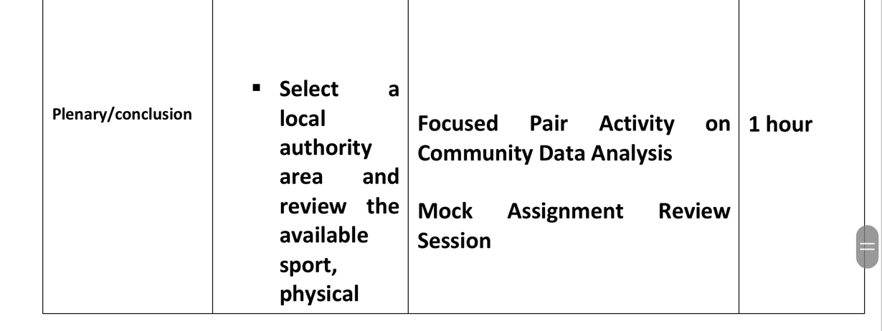
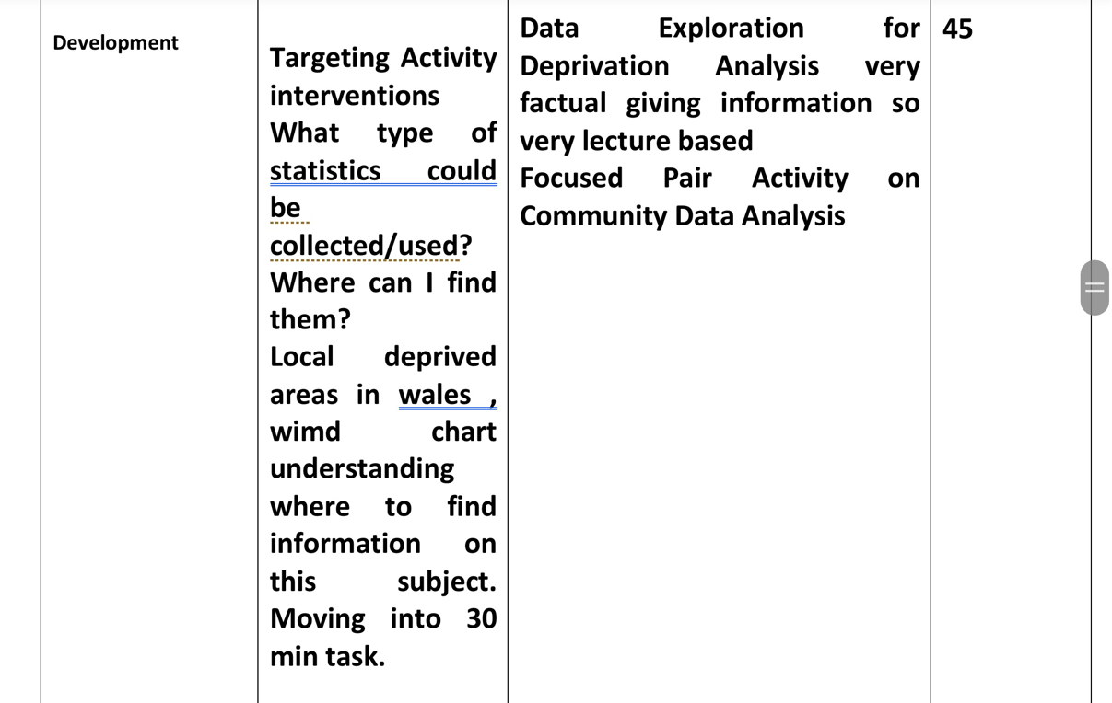
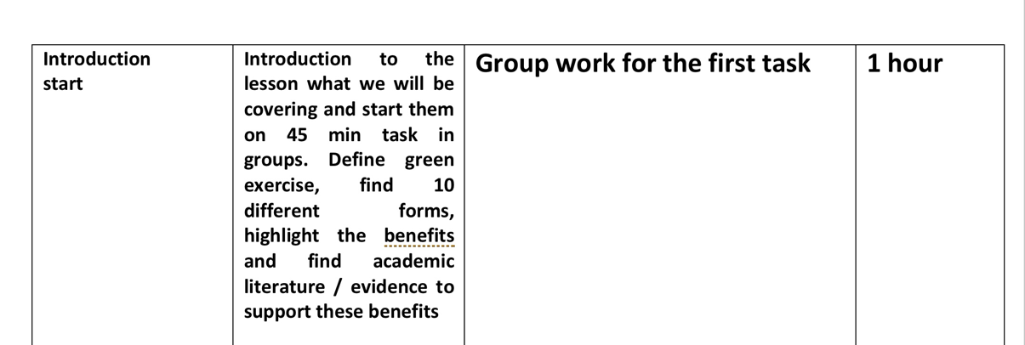

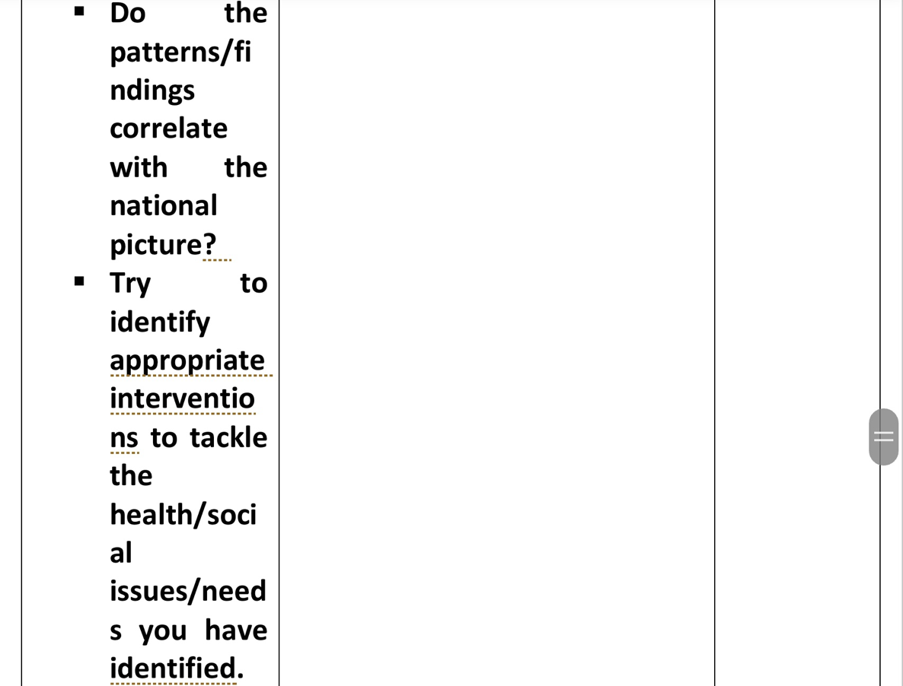
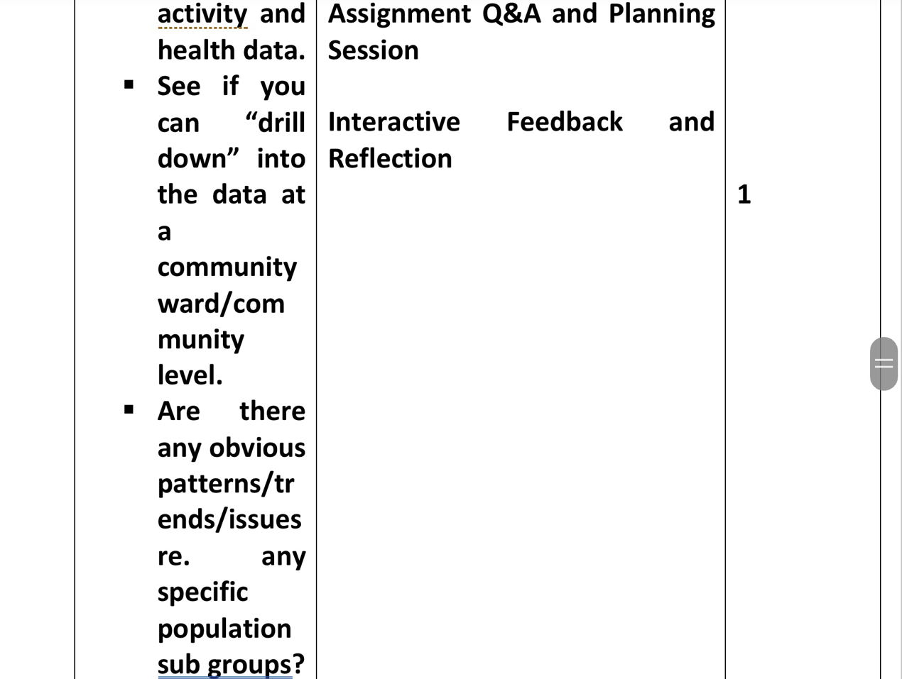

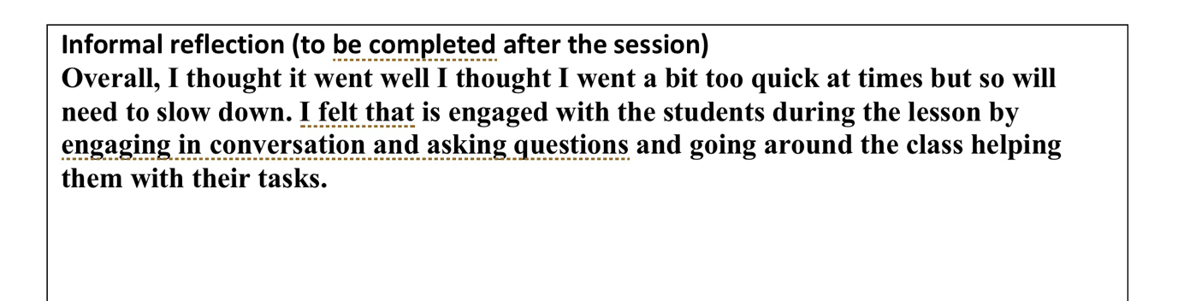
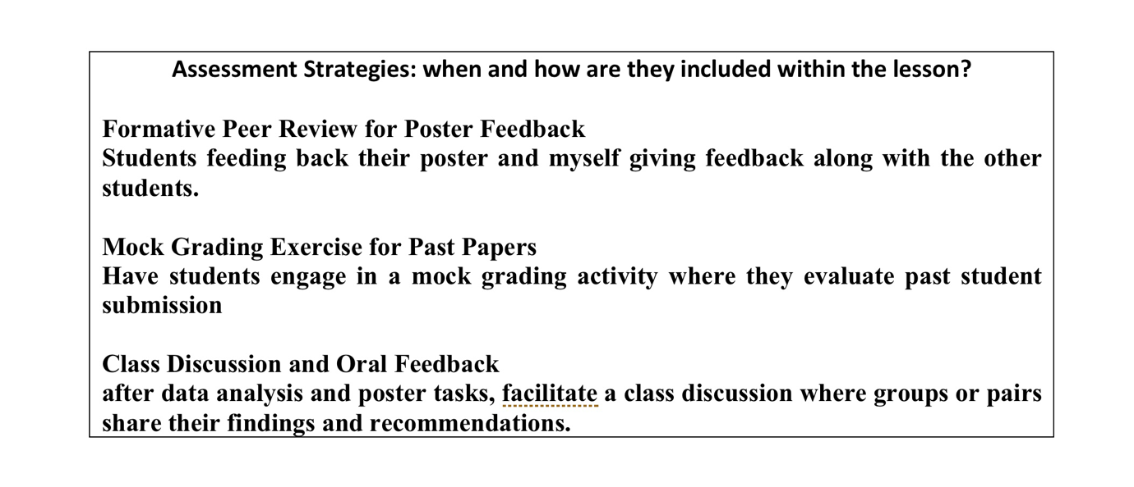
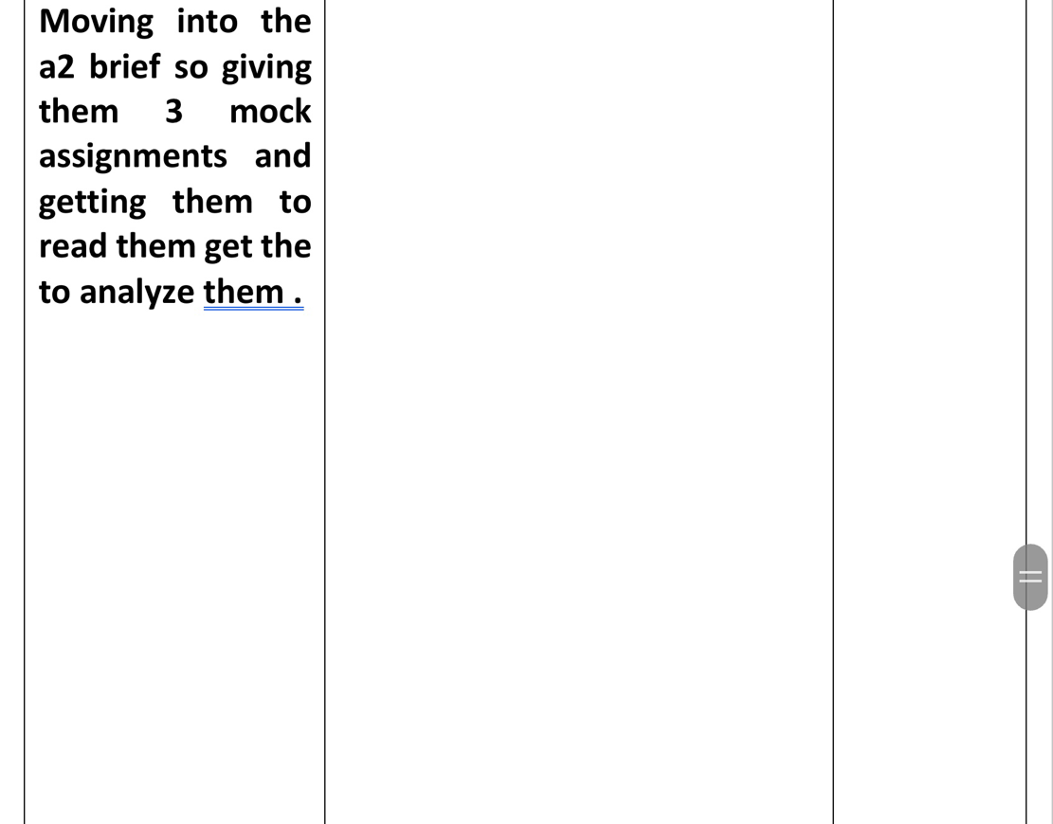

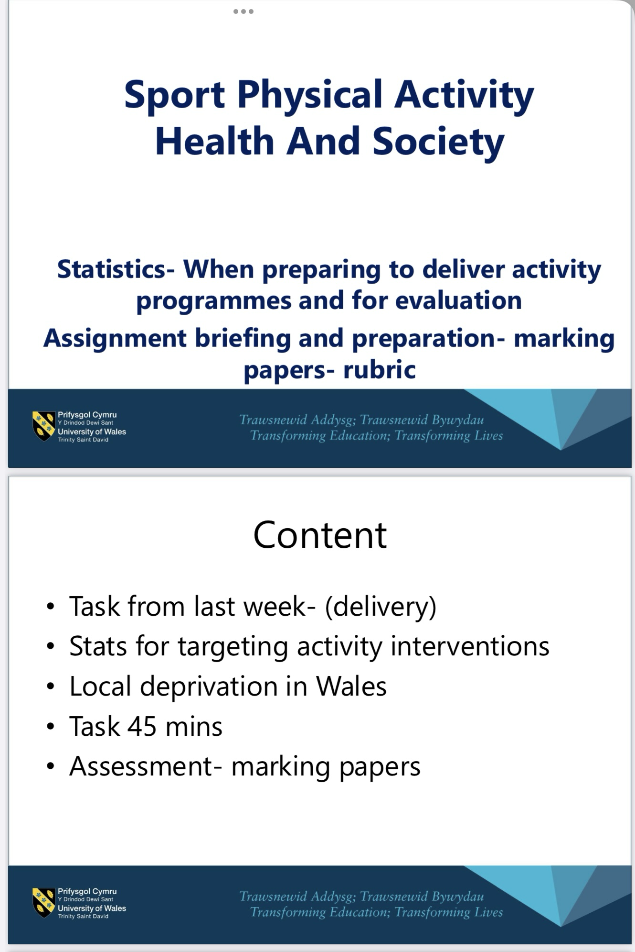
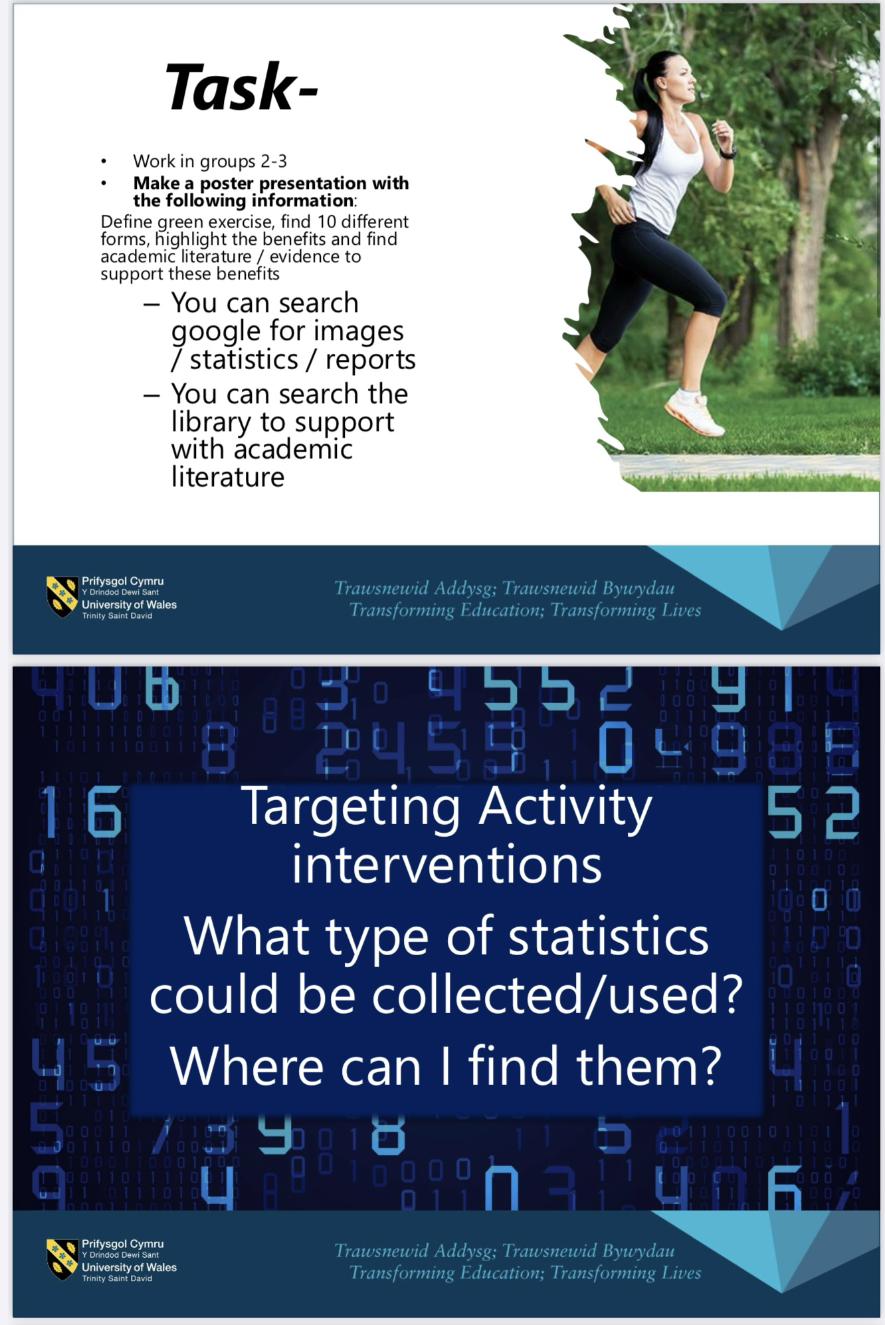
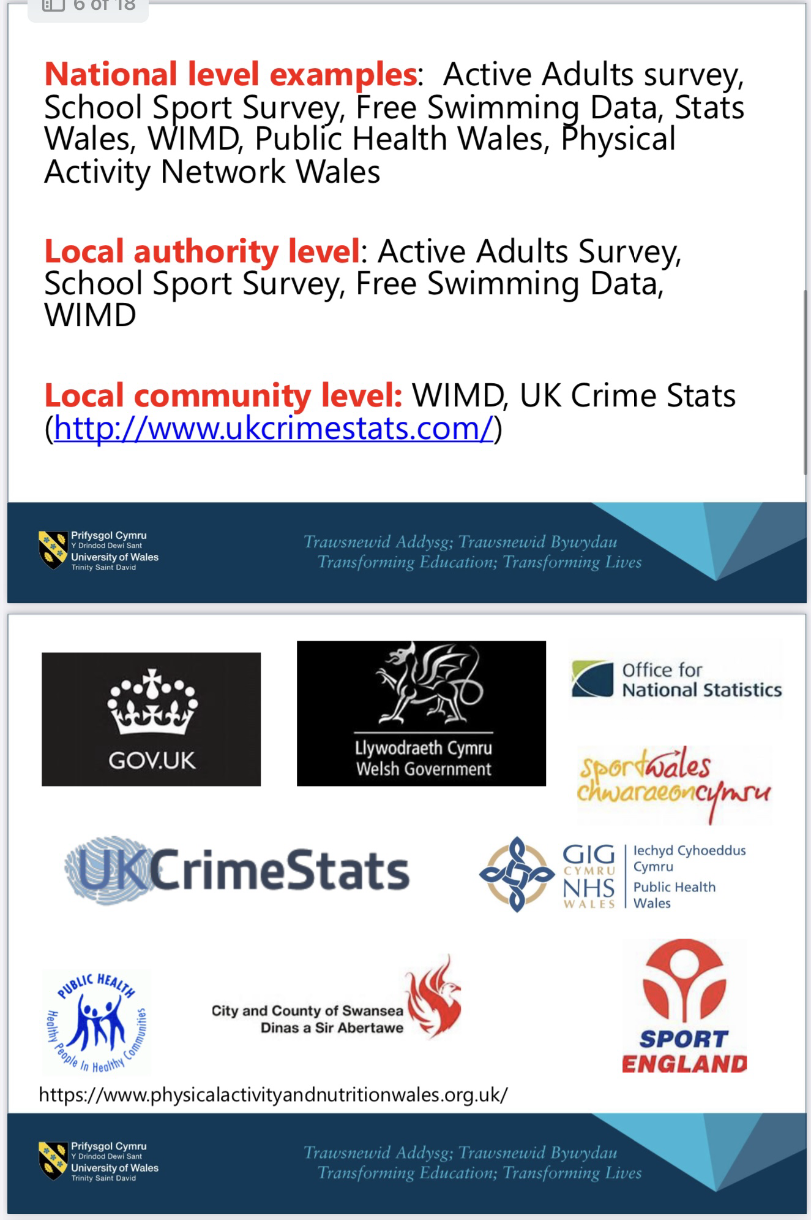
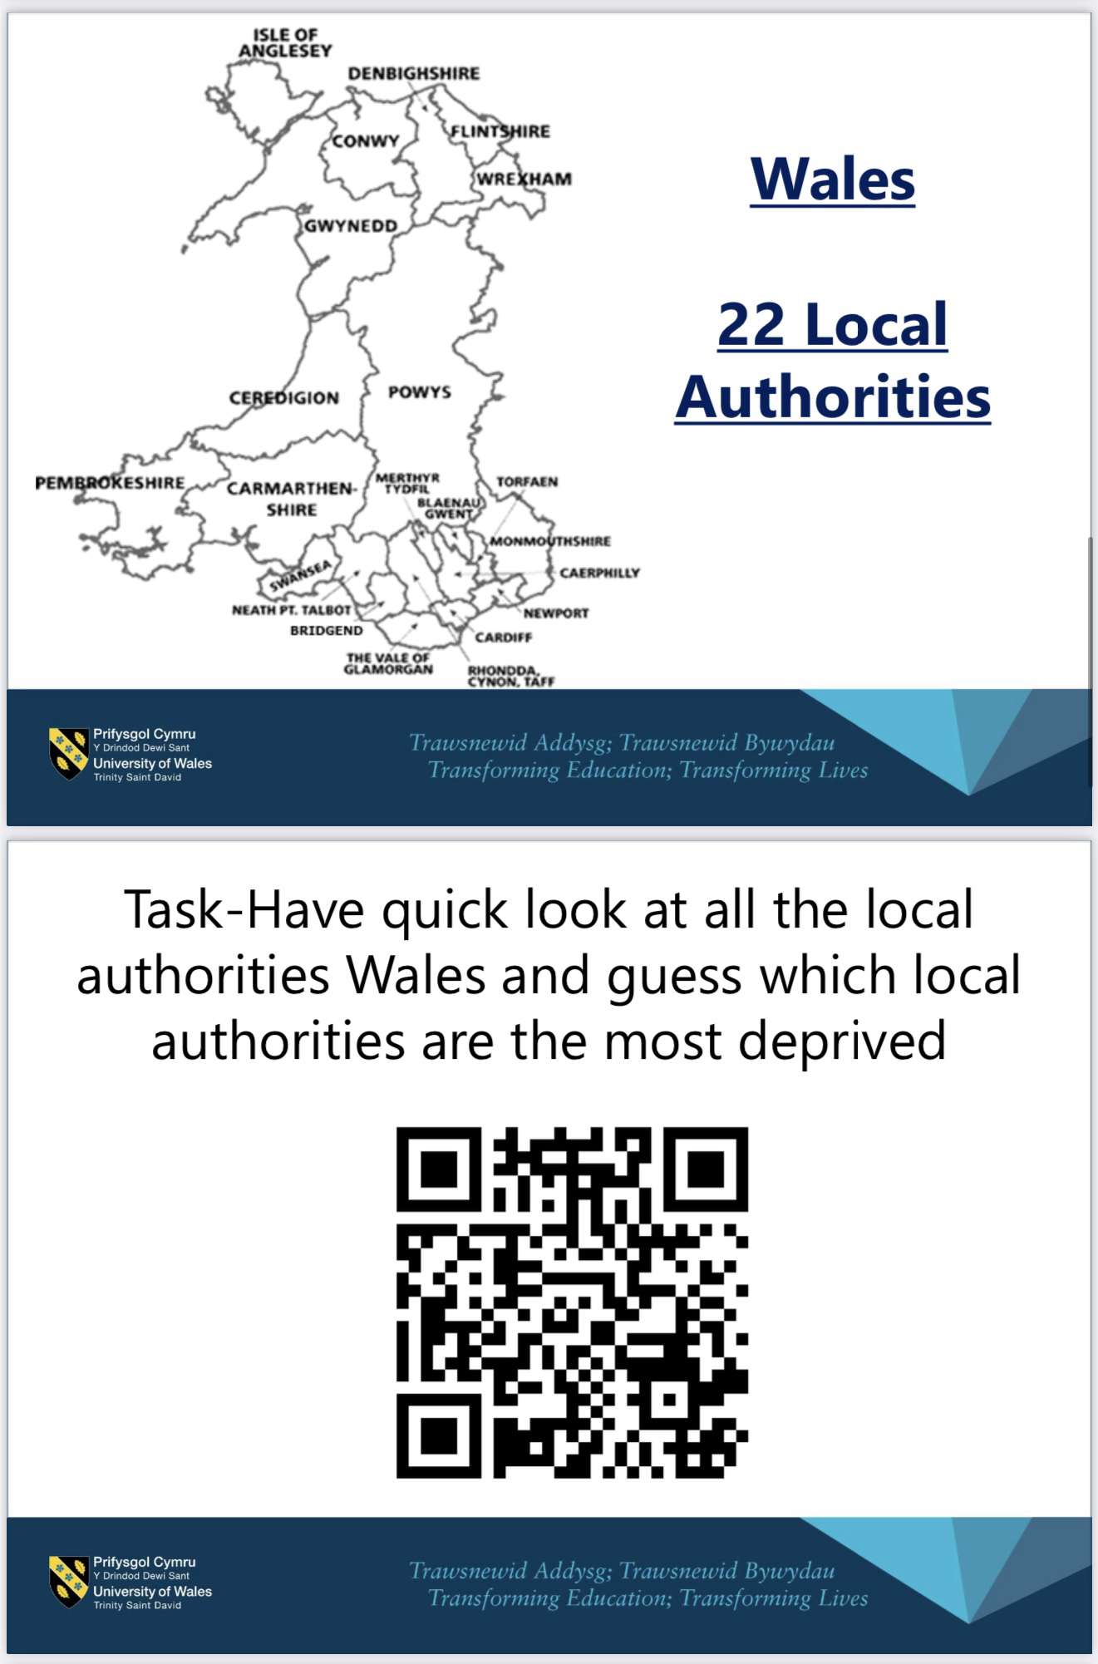
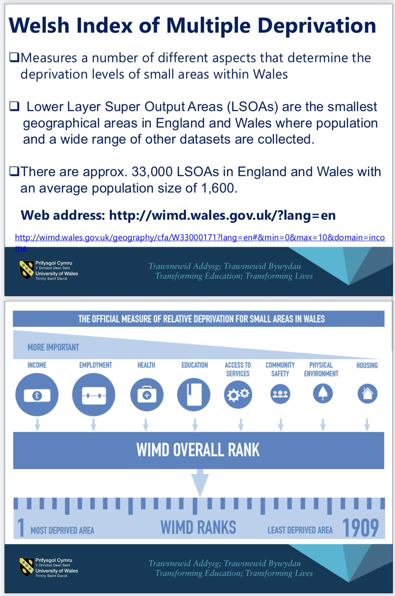
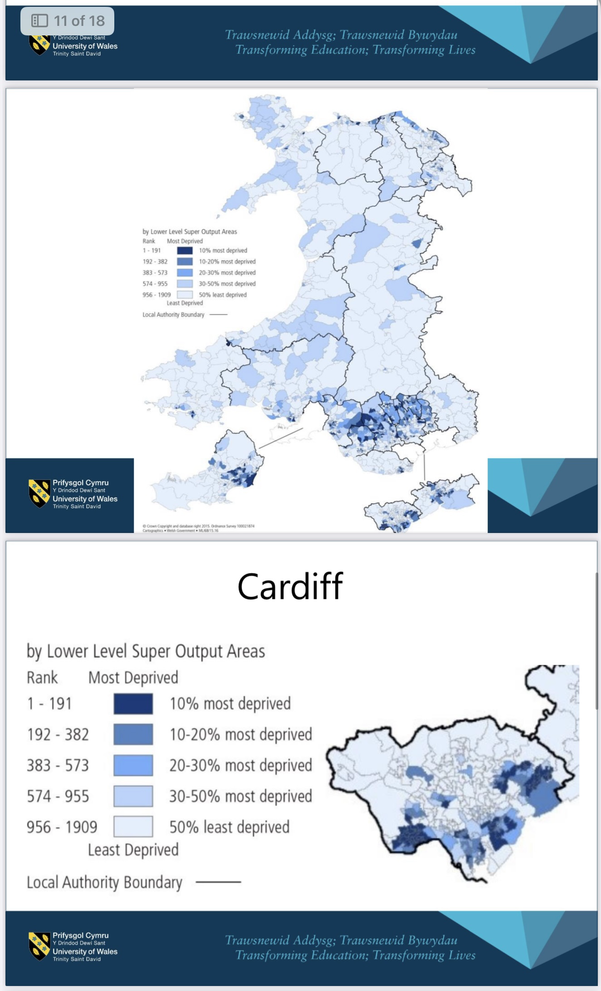
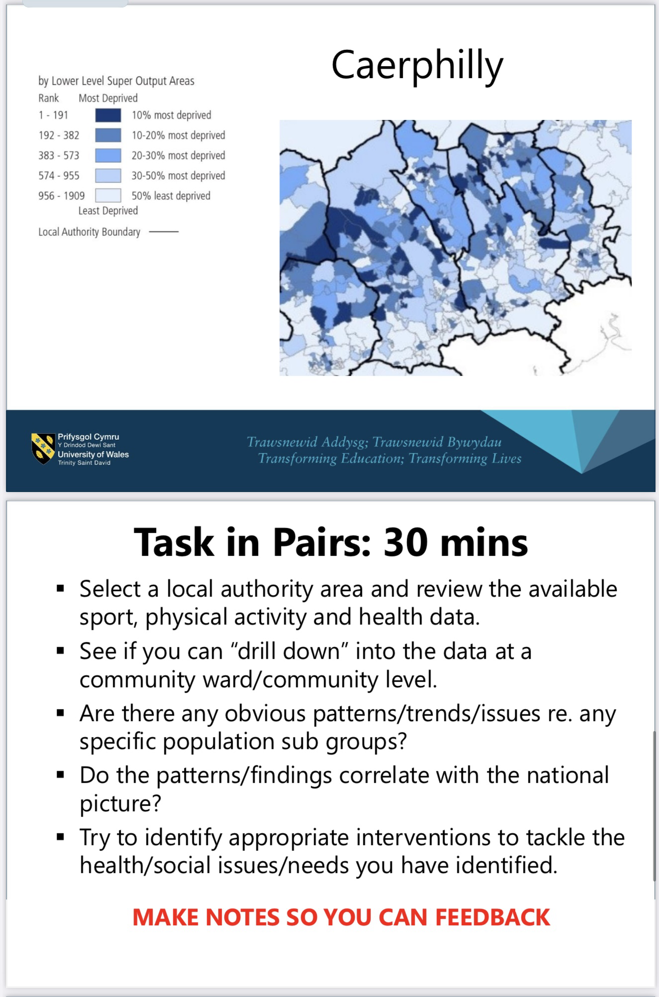
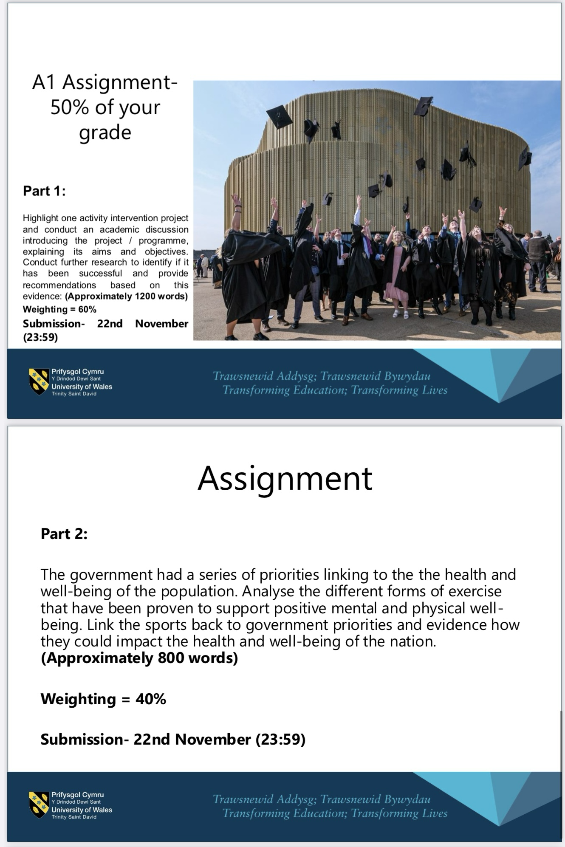

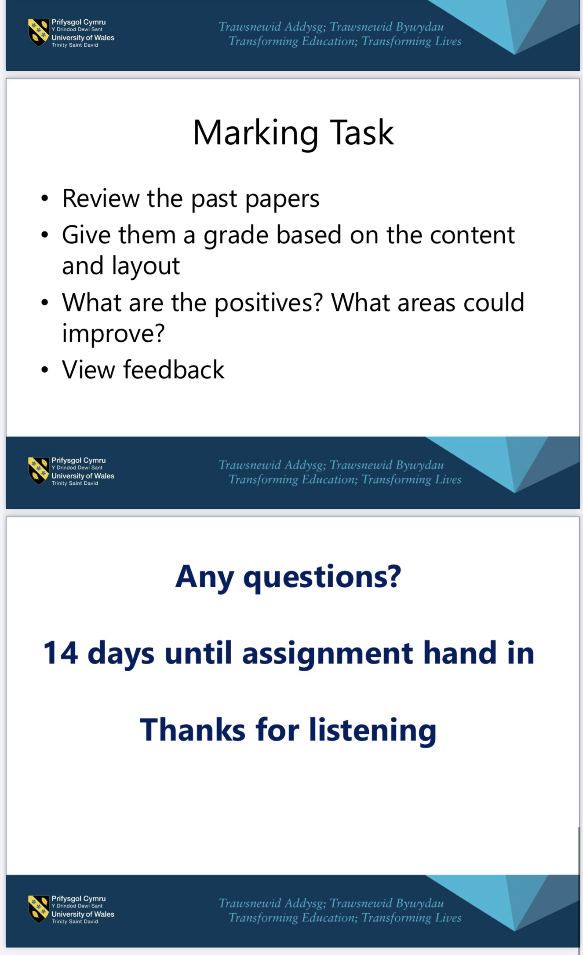
Evaluation and Reflection

While implementing a digital tool into the lesson, the aim was to ensure that students could effectively use digital tools to improve their digital skills. Research shows that teaching and developing digital competence helps students’ academic improvement, helps to prepare students for life after education and helps with self-regulation, Gomez-Poyato et al., (2022). As shown in the application section, a Mentimeter was implemented in a lesson to engage students in the lesson digitally. Instantly, students came into the lecture ready and excited to scan the Menti QR code on their phones. The students had to do research before putting up their answer on Mentimeter which then also made them use digital tools to search for the answer. Instantly this had a positive impact on the teaching due to the students guiding the learning through providing me with their knowledge and answers. The advantages of student-led learning, in which learners actively guide their educational path, are supported by research by Plotinsky (2019). This method encourages drive, critical thinking, and a feeling of pride. It enables students to deeply interact with the content, establish personal learning objectives, and hone their reflection abilities. These tactics demonstrate the value of giving students autonomy, which creates a more vibrant and inclusive learning environment.

Alongside this, the implantation of digital innovation through using Mentimeter provided students with a fun way of learning. Mentimeter is known for making learning more fun and breaking the monotony of lectures into a positive and fun environment. This then improves attention and comprehension which did prove to be effective during the lesson. Mentimeter also supports a variety of learning needs and contexts making it inclusive for all learners, including remote and hybrid sessions, ensuring accessibility for all. Research by Fielden et al., (2017) shows that tools like Mentimeter can increase student focus and participation, especially among less vocal learners, by providing anonymity and varied modes of interaction. Students during the lesson were engaged and enthusiastic to take part in the lesson.

The digital QR code provided statistical information on authorities in Wales. The websites that the students had to use included digital maps with charts which had been made using various digital programmes. These websites provided an opportunity for students to see and visualise digital data that they could input into their work. Reviewing digital data plays a pivotal role across education, by enhancing decision-making, improving learning outcomes, and fostering personalised learning experiences. According to Maitra (2023), by incorporating visualised digital data, people and organisations can find connections, trends, and outliers that might not be visible in raw data. For instance, applying the digital maps and tables to the lesson allows students to analyse the data and answer the question effectively on Mentimeter. These visual aids facilitate the rapid and efficient extraction of actionable insights, which is an essential life skill, especially with modern technology advancing. Additionally, the data visualisation facilitates to create positive collaborative work experiences that could allow groups to communicate exactly what they saw. With data being facts, it means that fostering collaborative decision–making should have been effective throughout the classroom which then provided another life skill for all students. It allowed the students to grasp the information and reduce misunderstanding and miscommunication making the lesson more enjoyable and memorable.

While a Mentimeter was used to assess learning and understanding, Unfortunately, no questionnaires were handed out to students to assess whether the students enjoyed the use of technology in the lesson. Distributing questionnaires after a lecture would be an effective way to understand how the students found the lesson that included lots of digital innovation and if they would like to use Mentimeter as a form of assessment during lectures again. Questionnaires are seen as crucial to student success. This is because they can help educators evaluate if any areas need improvement for future lessons. Ozan et al., (2018) believe that questionnaires are seen as a method of formative assessment, which gives teachers real-time information to adjust their methods. While unfortunately there was no chance to distribute and analyse responses from a questionnaire, students did provide verbal feedback at the end of the lecture which provided clarification that they did enjoy the lesson with digital tools.

In conclusion, it is clear from each section that digital innovation brings numerous positives to both educators and learners through developing key life skills like collaborative working, critical thinking, problem-solving and communication. The TPACK framework supports how digital innovation can support all areas of learning in various subjects. Digital innovation can open new opportunities to create, use and apply data, communication or custom learning to any life problem. Students can then use problem-solving skills to create a solution for anything. Vygotsky discussed how learners' cognitive development can be built through scaffolding. While technology is new to educators and learners, it provides new learning opportunities for both parties to successfully build on new knowledge and eventually learn and understand.

To conclude, the implementation of Mentimeter was successful during the lecture. All students worked as a team to complete the task. All students successfully worked as a team, communicated, problem-solved and analysed digital data which then created a digital mind map that was accessible to all. In future lessons, Mentimeter can be used for any topic or question to help engage students in learning and to create memorable learning experiences that will improve student learning outcomes.

References
Alenezi, M. (2021) Deep dive into digital transformation in higher education institutes , Education sciences . Available at: https://files.eric.ed.gov/fulltext/EJ1323139.pdf (Accessed: 03 December 2024).
Cameron , K. and Bizo, L. (2019) Use of the game-based learning platform KAHOOT! to facilitate learner engagement in Animal Science students, Research gate . Available at: https://rune.une.edu.au/web/bitstream/1959.11/51924/1/openpublished/UseBizo2019JournalArticle.pdf.
Capuno , J. (2023) (PDF) Quizziz: A game-based formative assessment tool for enhancing students self-regulated learning, Research gate . Available at: https://www.researchgate.net/publication/373485801_Quizziz_A_Game-based_Formative_Assessment_Tool_for_Enhancing_Students_Self-Regulated_Learning (Accessed: 04 December 2024).
Cojocariu , V.-M. and Boghian , I. (no date) A Literature Review on Digital Creativity in Higher Education—Toward a Conceptual Model, Education Sciences. Available at: https://mdpi-res.com/d_attachment/education/education-14-01189/article_deploy/education-14-01189-v3.pdf?version=1732093210 (Accessed: 2024).
Cox, J. (2020) Bring the real world into the classroom as a teaching strategy, Future Educators. Available at: https://www.futureeducators.org/bring-the-real-world-into-the-classroom-as-a-teaching-strategy/ (Accessed: 04 December 2024).
Gómez-Poyato, M.J. et al. (2022) Digital Skills, icts and students’ needs: A case study in social work degree, University of Zaragoza (Aragón-spain), MDPI. Available at: https://www.mdpi.com/2227-7102/12/7/443 (Accessed: 03 December 2024).
Hill, D. and Fielden, K. (2017) Using Mentimeter to promote student engagement and inclusion , Insight Cumbria . Available at: https://insight.cumbria.ac.uk/id/eprint/3473/1/Hill_UsingMentimeter.pdf (Accessed: 03 December 2024).
Hughes , J. and Roblyer , M. (2022) Integrating Educational Technology into teaching, Google Books. Available at: https://books.google.co.uk/books/about/Integrating_Educational_Technology_Into.html?id=_OVEzwEACAAJ&redir_esc=y (Accessed: 06 December 2024).
Ilimaki, L. and Lakkala, M. (2018) Digital technology and practices for school improvement: Innovative school model, Springer . Available at: https://link.springer.com/content/pdf/10.1186/s41039-018-0094-8.pdf.
Joosten, T. et al. (2020) Digital Learning Innovation Trends , Online learning consortium. Available at: https://files.eric.ed.gov/fulltext/ED603277.pdf (Accessed: 03 December 2024).
Kelly, R. (2024) Survey: 86% of students already use AI in their studies, Campus Technology. Available at: https://campustechnology.com/articles/2024/08/28/survey-86-of-students-already-use-ai-in-their-studies.aspx (Accessed: 03 December 2024).
Kopylova, N.A. (2022) Educational digital transformation: Advantages and disadvantages , Vitebsk.
Maitra, M. (2023) A picture is worth 1,000 words: The importance of Data Visualization, DATAVERSITY. Available at: https://www.dataversity.net/a-picture-is-worth-1000-words-the-importance-of-data-visualization/ (Accessed: 04 December 2024).
Mosley, N. (2024) Insights from 2022-23 HESA data on UK online education, Neil Mosley Consulting. Available at: https://www.neilmosley.com/blog/what-does-22-23s-hesa-data-tell-us-about-online-education-in-uk-he#:~:text=Online%20distance%20learning%20student%20numbers,110%2C370%20%2D%20Postgraduate%20taught%20students (Accessed: 06 December 2024).
Ozan, C. and Kıncal, R. (2018) The Effects of Formative Assessment on Academic Achievement, Attitudes toward the Lesson, and Self-Regulation Skills, ESPT. Available at: https://files.eric.ed.gov/fulltext/EJ1179831.pdf (Accessed: 03 December 2024).
Plotinsky, M. (2019) The incredible benefits of letting students drive their own learning - edsurge news, EdSurge. Available at: https://www.edsurge.com/news/2019-10-03-the-incredible-benefits-of-letting-students-drive-their-own-learning (Accessed: 04 December 2024).
Scott, S. (2013) Sociocultural theory, The Gale group . Available at: http://dr-hatfield.com/theorists/resources/sociocultural_theory.pdf (Accessed: 02 December 2024).
Vygotsky, L. (1978) Mind in society: Development of higher psychological processes on JSTOR, JSTOR. Available at: https://www.jstor.org/stable/j.ctvjf9vz4 (Accessed: 04 December 2024).
Welsh Government (2020) Developing a vision for curriculum design, Hwb. Available at: https://hwb.gov.wales/curriculum-for-wales/designing-your-curriculum/developing-a-vision-for-curriculum-design (Accessed: 06 December 2024).

