Construction Management
ACBA6004



Lewis Towell
(1702544)
Quantity Surveying

Contents
1.0 Assumptions 3
2.0 Producing a Gannt Chart 3
3.0 Site Specific Reports 4
4.0 Addressing performance issues in terms of productivity and incentivisation 6
5.0 Site Set up 8
5.1 Site Sketch 8
5.2 Site Set Up Key 9
6.0 Accelerating the programme by 2 weeks 10
7.0 Bibliography 13
8.0 Appendix 14

Assumptions

For exercise one, a Christmas break has not been allowed for and the construction programme has been run through the break, this has enabled the construction programme to be drafted up much easier. Pre-construction work has been programmed prior to the agreed start date of 6th of May, ground broken on the 6th.When assigning the resources, lump sum costs has been allowed for different subcontract packages. The costs that have been allowed for on a time basis is the contractors prelims, with sub-contractor’s packages assumed as fixed price lump sum including labour and materials. A labour only contract would be set up for the labourer. Based on a quick calculation the building presumed to be 10x20 3 storey high. Based on previous knowledge an estimate on the construction cost would be £1,800m2 and I have tried to reflect this in the programme. (£1,080,000.00). I have also presumed that time for curing the concrete has been included within the programmed rates.

Producing a Gannt Chart

To produce this project, Microsoft project has been utilised to effectively construct a detailed programme to demonstrate the construction of the library building. ‘MS Project gives construction project managers full access and control over every aspect of the project plans, from determining which projects are behind schedule, adjusting the project durations, assigning new tasks, holding team members accountable and creating progress reports.’ (Construction Scheduling, 2019)

Full Gannt chart can be seen in appendix 1

Site Specific Reports

The Report ‘Cost overview’ as seen in Figure 1 and appendix can be used to monitor the project budget. When the report develops, and percentage completion inputted it will help you monitor the expenditure of the project against percentage completion. Also, in the cost status your actual cost can be monitored against your budget. The cost variance then will provide an overspend. This then can help identify variations. The quantity surveyor can then investigate why there is a variation and can assess whether it is contracharable to another sub-contractor, a variation that needs to be claimed from the client or a cost that should be absorbed. It also breaks down the budget for each area of the project which is key for cashflow and final account projections.
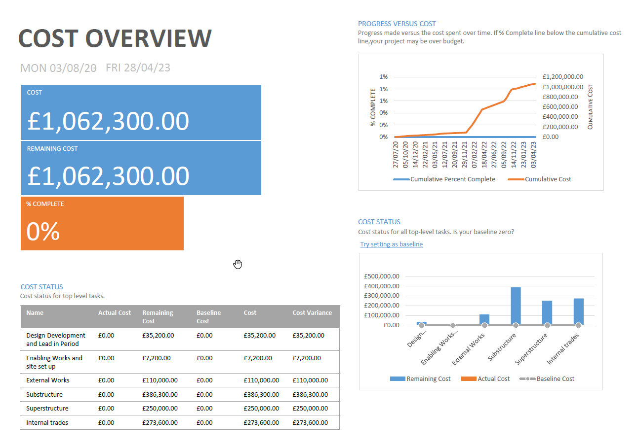

Figure 1

The ‘Work Overview’ is an excellent report for managing the labour only contracts that you will have on site Labour only subcontractors will be paid by the hour so this report is an effective tool to ensure that they are sticking to the time allowances allowed in your budget. It also shows peoples availability during different weeks so can be a good programming tool to ensure that you are using people to their maximum capacity and source work for the if they are not busy. In summary this tab is an excellent time management tool.

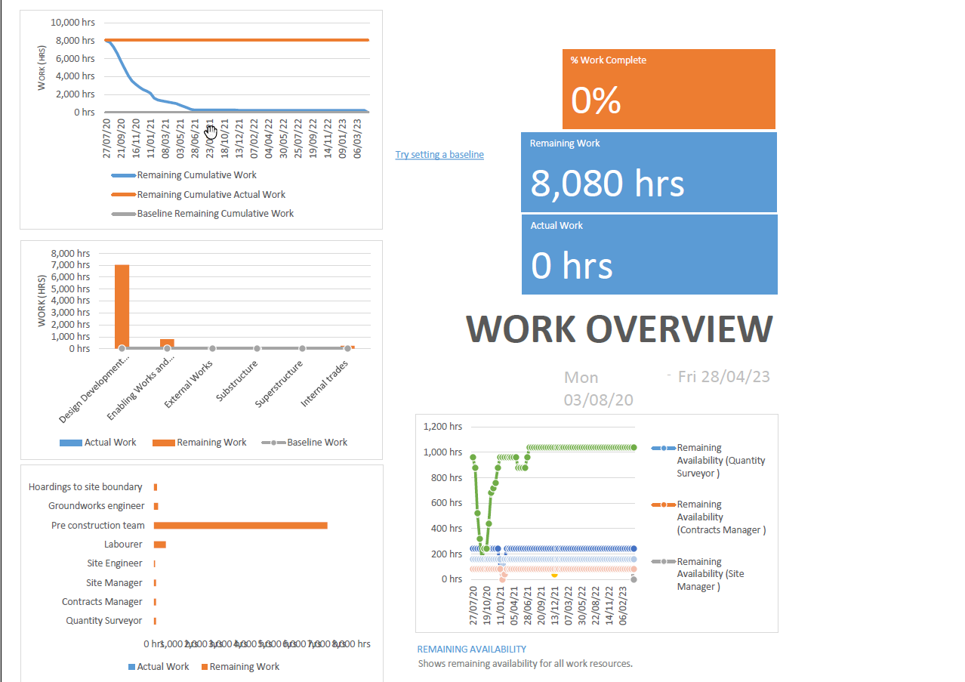

Figure 2

The ‘Resource Overview’ is an excellent report for managing the resources required on site. It can be assessed in comparison to the site progress and whether there is going to be an overspend. The net amount of work remaining is also indicated in the ‘resource status’ this is effective so you can let people know when they will no longer be required on site and when their period for completion is.

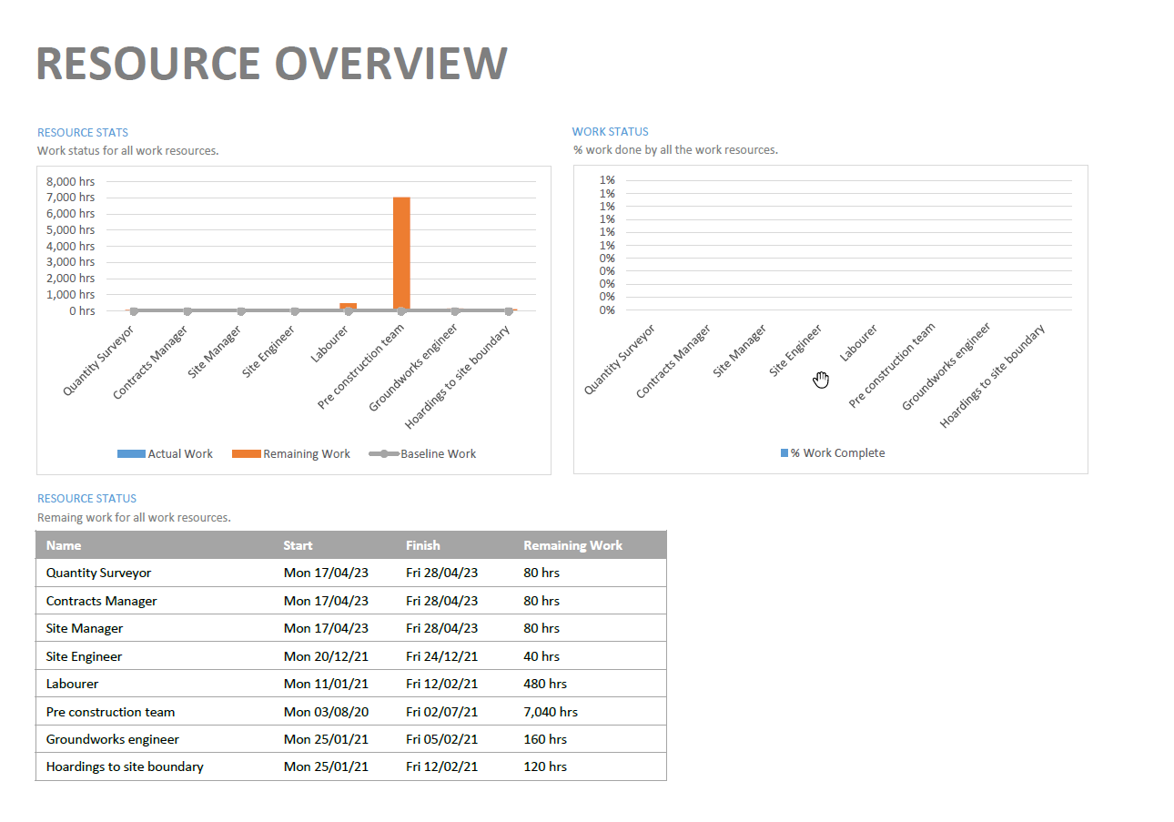

Figure 3

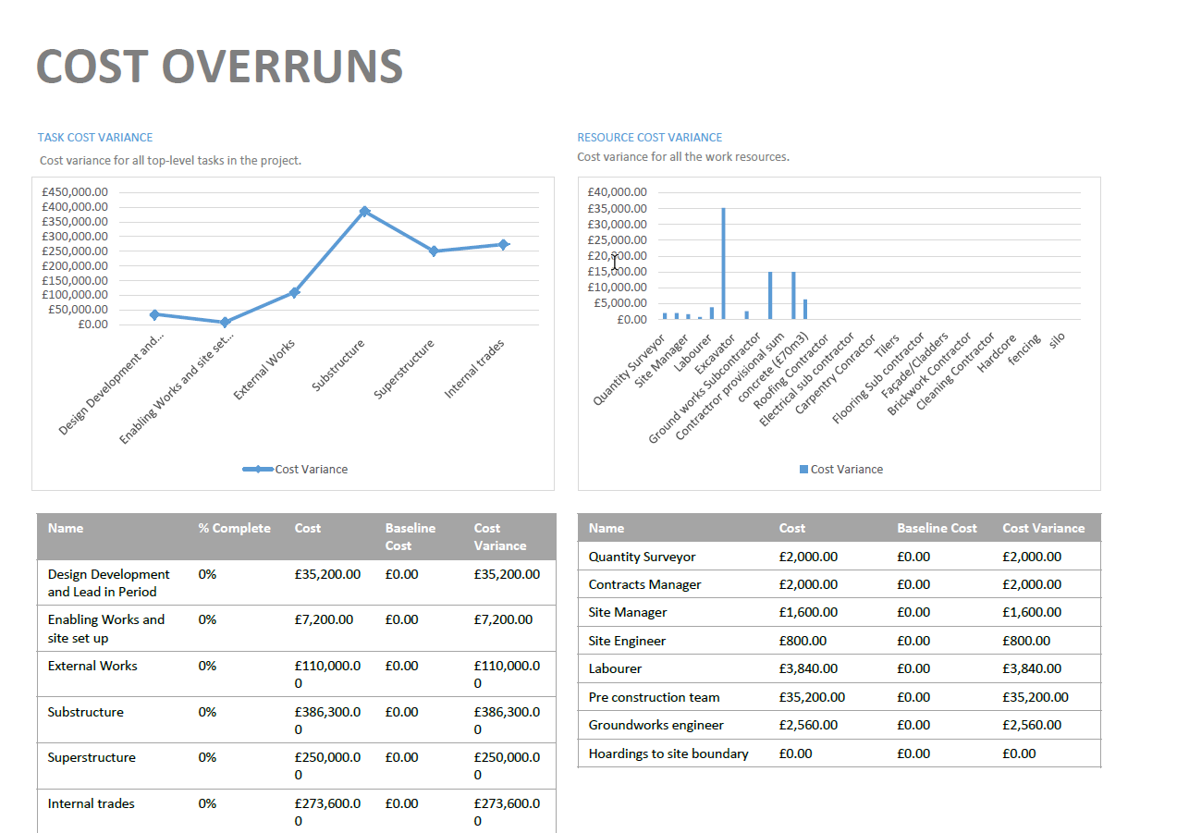
The next two reports are extremely useful for a Quantity surveyor. ‘Cashflow’ and Cost Overruns’
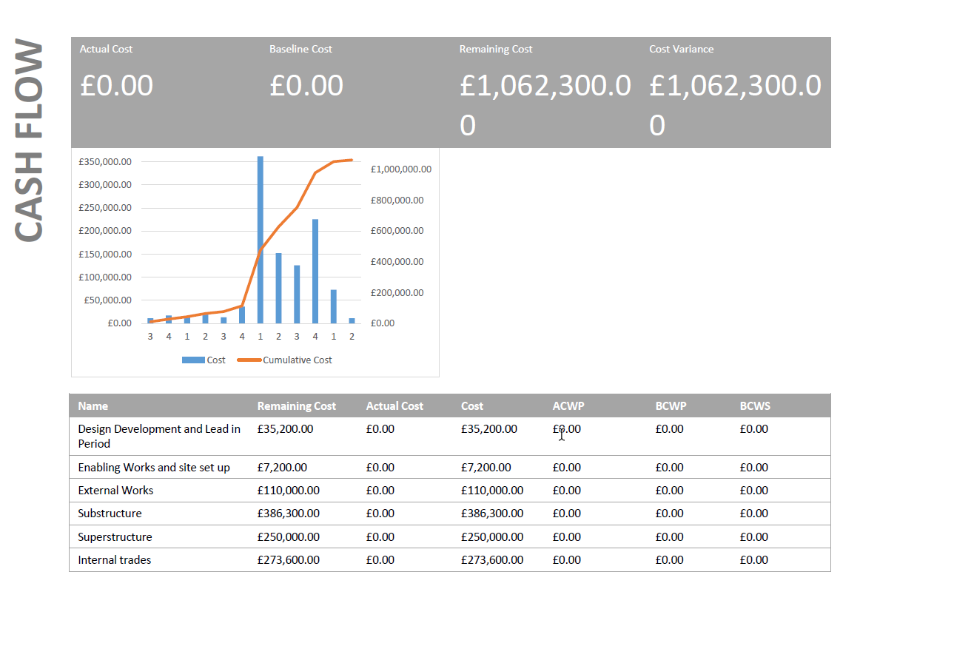

Figure 4 Figure 5

The cashflow report is extremely useful as it can indicate the expect turnover from the job. It can also be used to present the client with a cashflow and also for the main contractor’s accounts who will have an idea how much they will be paying out to subcontractors’ month by month. The cost overrun report will again help with any variance in costs the in job. Having these identified will enable a quantity surveyor to analyse these costs and allocate correctly if required.

Addressing performance issues in terms of productivity and incentivisation
The construction industry has always been notorious for having a hostile and confrontational nature when it comes to completing projects. This is usually down to the number of different subcontractors on site and the usual negative incentives on a contract like LAD’s. In my recent research I have look at a ‘linear construction model’ This is the theory that if a contractor could take on all of the workload i.e. no subcontractors, it would massively reduce construction costs and in my opinion lead to a massive reduction in conflict on site. The problem with this is that the contractor would be liable for all the risk.

‘Incentivisation is incorporating incentives into an arrangement to motivate the parties to it.’ (Parry, 2019) The most common form of contract currently used in construction is the JCT. This is usually based around fixed price lump sum figures and incorporates liquidated and ascertained damages (LAD) as a measure of negative incentivisation. The JCT are produced to minimise transaction cost of entering into a contract and to provide benchmark provisions in standard form contracts. The contracts allocate risk fairly and is a ‘line in the sand’ scenario that clearly outlines responsibility. Usually in construction it is unlikely to see positive incentivisation, this is due to the fact that the threat of the usual negatives such as a LAD are enough of a motivator to get the job done. The contractor would essential be offering up a positive incentive for the same result that would have been achieved through traditional construction methods.
A contractual way of addressing performance issues is to possible introduce the NEC4 Alliance contract. NEC contracts are historically more lenient and are more transparent which helps avoid disputes. A base cost is calculated and then as the project progresses costs are analysed further together with both the contractor and client in an open book approach. I believe these contracts provide comfort to the contractor that any additional costs can get covered. ‘After more than 12 years of use for possibly billions of pounds of work in probably tens of thousands of projects in more than 20 countries there remains only one piece of case law relating to the use of the NEC’ (Patterson, 2009)

Introducing the alliance contract in this scheme would be extremely beneficial in addressing performance in terms of productivity. This is because the contract includes both negative and positive incentivisation. Alliance objectives are measured against a performance table. An alliance manager assesses performance against the objectives in the performance table. If the contractor is exceeding expectation then a sum of money is paid by the client, if the targets are not met a sum of money is due to the client. This contract incorporating both negative and positive incentivisation is a clever way of ensuring that the project stays on time and on budget and will definitely increase productivity across the site as money is the biggest driver on site.

‘Positive incentives work better than negative incentives. There is quite strong evidence, despite the widespread use of damages, that negative incentives have a detrimental effect on contract performance.’ (Broome, 2002) Due to this research in order to address productivity as the client – introducing a bonus scheme as a positive form would be a good idea for the project. The management team would be rewarded through a bonus if they could increase their profit on the job compared to what the contribution was. If contribution (tender margin) was 5% if the project team could increase this to 10% after agreeing final account the project team should be entitled to a bonus. This is a scheme widely used in the construction industry.

While the points discussed in terms of incentivisation so far have been contractual there are other forms that are seen on a day to day basis. These are usually observed by the contractor to the sub-contractors. For example, celebrating success, hitting milestones and even buying colleagues a drink are all forms of incentivisation and can really help get things moving on site. Site usual flows much better if the site manager is getting on well with the subcontractors and they will usually be prone to doing little bits to help out while on other jobs with different management they wouldn’t want too. Some contracts managers have on occasions taken the sub contract team out for dinner to thank them for the hard work they have put in.

Site Set up

5.1 Site Sketch
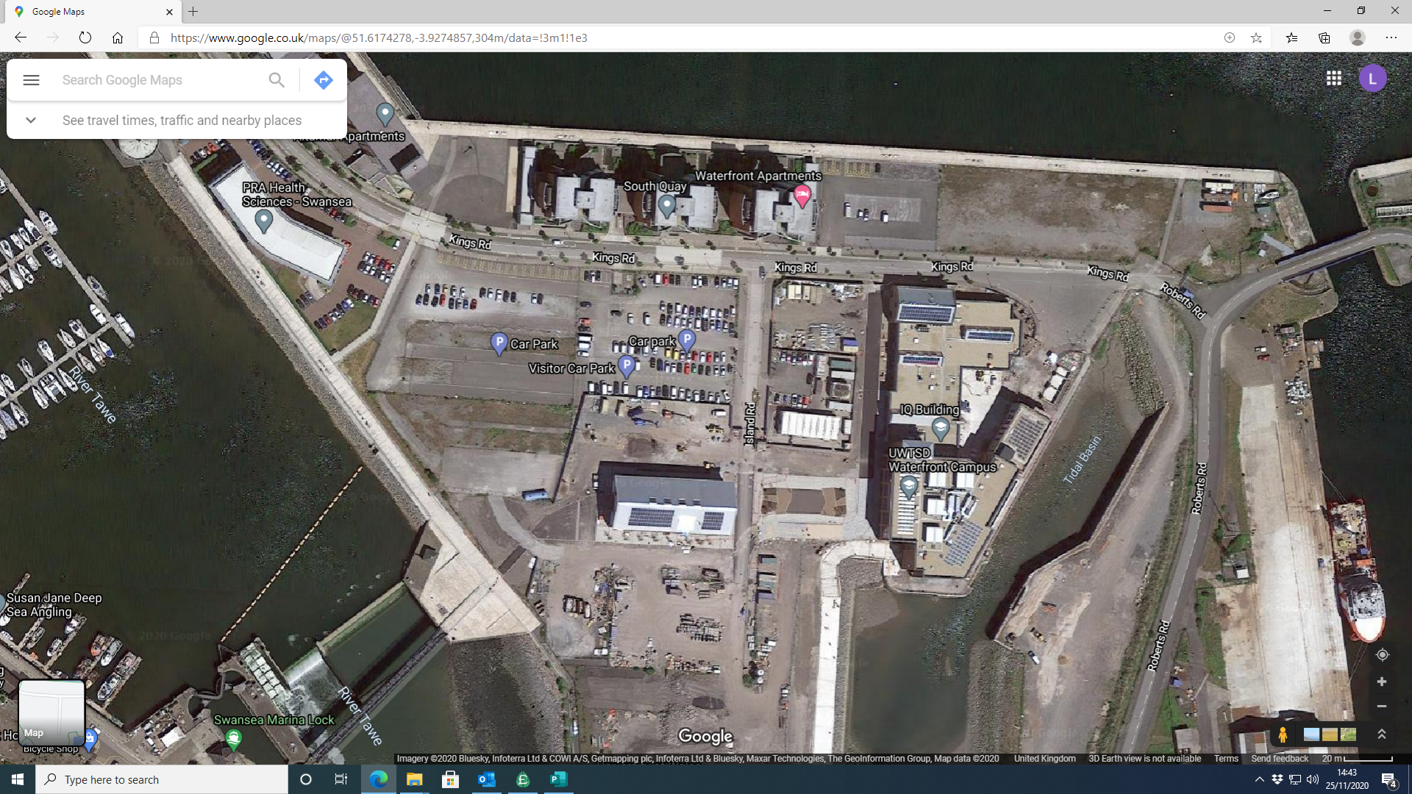

1
2
3
4
5
6

Figure 6

5.2 Site Set Up Key

 | Flow of traffic
 | Site boundary
 | Manned Gate
 | Building outline
 | Tower Crane base
 | Crane span
 | Pedestrian Crossing
 | Pedestrian walkways
1 | Site office
2 | Toilets
3 | First Aid
4 | Dry room
5 | Container
6 | Break room
 | Material Storage area
 | Lockable plant storage area
 | Wheel washing
 | Fire Assembly points
Figure 7

Accelerating the programme by 2 weeks
‘Acceleration in construction is the process of moving a project towards completion at a faster pace than originally anticipated’ (Brown, ND) In order to be able to bring the project in to completion two weeks in advance tasks on the critical path must be accelerated. It is would be of no use doing this to other items as they have float within their programme.
In ‘core clause’ 36 of the NEC3 standard form of contract it states ‘the project manager may instruct the contractor to submit an acceleration quotation. As with the JCT form, the stated aim of acceleration before the completion date’ (Brown, ND). One recommendation that could be suggested would be to implement cement concrete with admixtures/rapid setting concrete. This could be charged as a variation and due to concrete being such a big part of the build it could quash the programme considerably. Although this type of concrete is not normally used for load bearing applications its something for the client to consider. ‘Traditional concrete will harden within 48 Hours, rapid set concrete will harden within an hour’ (Total Concrete, 2020). Figure 8 below depicts the expected completion with traditional concrete.
Task Name | Duration | Start | Finish | Predecessors
Substructure | 80 days | Thu 11/11/21 | Wed 02/03/22
Augmented bored piles | 15 days | Thu 11/11/21 | Wed 01/12/21 | 29
Pour and reinforce | 15 days | Thu 11/11/21 | Wed 01/12/21 | 29
Install pile caps | 5 days | Thu 02/12/21 | Wed 08/12/21 | 45,44
Concrete ring beam | 10 days | Thu 09/12/21 | Wed 22/12/21 | 46
Excavate a formation | 5 days | Thu 23/12/21 | Wed 29/12/21 | 47
underslab drainage | 10 days | Thu 13/01/22 | Wed 26/01/22 | 56
Edge shuttering | 3 days | Thu 27/01/22 | Mon 31/01/22 | 49
Dump hardcore | 3 days | Tue 01/02/22 | Thu 03/02/22 | 50
Compact hardcore | 5 days | Fri 04/02/22 | Thu 10/02/22 | 51
DPM | 4 days | Fri 11/02/22 | Wed 16/02/22 | 52
Pull and pour concrete | 10 days | Thu 17/02/22 | Wed 02/03/22 | 53
Figure 8
Below shows the expected acceleration to the programme implementing rapid setting concrete hence bringing the programme in by two weeks.
Task Name | Duration | Start | Finish | Predecessors
Substructure | 70 days | Thu 11/11/21 | Wed 16/02/22
Augmented bored piles | 13 days | Thu 11/11/21 | Mon 29/11/21 | 29
Pour and reinforce | 13 days | Thu 11/11/21 | Mon 29/11/21 | 29
Install pile caps | 3 days | Tue 30/11/21 | Thu 02/12/21 | 45,44
Concrete ring beam | 8 days | Fri 03/12/21 | Tue 14/12/21 | 46
Excavate a formation | 5 days | Wed 15/12/21 | Tue 21/12/21 | 47
underslab drainage | 10 days | Wed 05/01/22 | Tue 18/01/22 | 56
Edge shuttering | 3 days | Wed 19/01/22 | Fri 21/01/22 | 49
Dump hardcore | 3 days | Mon 24/01/22 | Wed 26/01/22 | 50
Compact hardcore | 5 days | Thu 27/01/22 | Wed 02/02/22 | 51
DPM | 4 days | Thu 03/02/22 | Tue 08/02/22 | 52
Pull and pour concrete | 6 days | Wed 09/02/22 | Wed 16/02/22 | 53
Figure 9

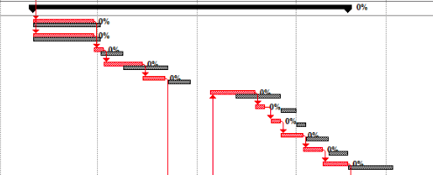

Figure 10
Figure 10 shows how the Gannt chart has been accelerated compared to our baseline. This change would be a good idea for the client and could provide a cheap way to accelerate the programme.

Another suggestion on how to accelerate the programme would be best suited as it would cause no additional charge to the client. Prior to the scaffold contractors would be working from MEWP’s etc. Brickwork requires scaffold. On the original contract programme scaffold was selected to be on the critical path and after rainwater goods. Strictly speaking there is no reason why these tasks can’t run simultaneously and work around each other opposite sides of the build.

Task Name | Duration | Start | Finish | Predecessors | Resource Names
Rainwater goods - cills, canopies & mastic | 10 days | Thu 07/07/22 | Wed 20/07/22 | 64 | Mastic sub contractor,Roofing Contractor
Perimiter scaffold | 10 days | Thu 21/07/22 | Wed 03/08/22 | 65 | Scaffolders
Exterior Masonary | 35 days | Thu 04/08/22 | Wed 21/09/22 | 66 | Brickwork Contractor
Figure 11

Figure 11 shows the original programme.
Figure 12

Figure 12 shows the impact that running these two tasks simultaneously has on the programme. This is the most effective way to get this programme accelerated without increasing cost. With careful planning these tasks can be coordinated to speed up the programme by the two week period.

The next scenario that I would suggest would be to bring in the internal trades earlier. Due to the large nature of the build, the trades could work ground floor to the top floor and instead of waiting for each trade to completely finish each trade could come in as the previous moves up a floor. This can be demonstrated throughout the Gannt chart but will be displayed at the second fix stage.
Figure 13
Utilising the lead and lag function second fix items have been able to brought forward by two weeks to work to the scenario mentioned above. This would also be of extreme interest to the client as it would not have a financial implication.

Other ways of accelerating a construction programme is as follows;
- Overtime
- Sourcing Additional labour
- Additional resources such as cranes and other plant
- Incorporate offsite manufacturing
- Early procurement of key items
(Designing Buildings Wiki, 2020)

Bibliography
Broome, J., 2002. Procurement routes for partnering: a practical guide. 1 ed. London: Thomas Telford.
Brown, C., ND. Go! Go! Go!. [Online]
Available at: www.c-link.com/blog/acceleration-in-construction/
[Accessed 07 12 2020].
Construction Scheduling, 2019. Using Microsoft Project & Scheduling Templates for Construction. [Online]
Available at: https://constructionscheduling.com/the-benefits-of-using-microsoft-project-in-the-construction-industry
[Accessed 28 11 2020].
Designing Buildings Wiki, 2020. Accekeration of Construction Works. [Online]
Available at: www.designingbuildings.co.uk/wiki/Acceleration_of_construction_works
[Accessed 08 12 2020].
Parry, R., 2019. Using incentives to drive contractor behaviour. [Online]
Available at: https://www.pinsentmasons.com/out-law/analysis/using-incentives-to-drive-contractor-behaviour#:~:text=Incentivisation%20is%20a%20term%20that,motivate%20the%20parties%20to%20it.
[Accessed 28 November 2020].
Patterson, R., 2009. Using NEC contracts to manage risk and avoid disputes. In: Management, Procurement and Law. s.l.:ICE , pp. 157-167.
Total Concrete, 2020. A Guide to rapid set Concrete. [Online]
Available at: www.totalconcrete.co.uk/newsa-guide-to-rapid-set-concrete/
[Accessed 07 12 2020].

8.0 Appendix

