

Student Name: Jordan James
Lecture Name: Morgan Lewis
Module: Engineering Design
Module Code: PSDM5010
Assignment Name: Design Presentation - CAD Model

Table of Contents
Executive Summary 14
Orthographic drawing 15
3D CAD Model 16-17
Bibliography 18

Executive Summary

This assignment will show the final design of the gear box that has been researched in assignment one and the calculations proven in assignment two. This assignment offers an orthographic drawing of the gear box design and a 3D CAD (Computer aided design) model. This information will be useful in the fabrication and installation of the product. The 3D model was completed using Autodesk Fusion 360. This is one piece of software that Autodesk offers which can be used to create mechanical models and drawings. The 2D drawing was produced of the back of completing the 3D model. Like most Autodesk software, the drawing files are often compatible with each other. The 3D model was able to be exported into AutoCAD where the orthographic drawing was created and completed. This task was carried in AutoCAD as it is a user-friendly piece of software for this type of task.

Orthographic drawing

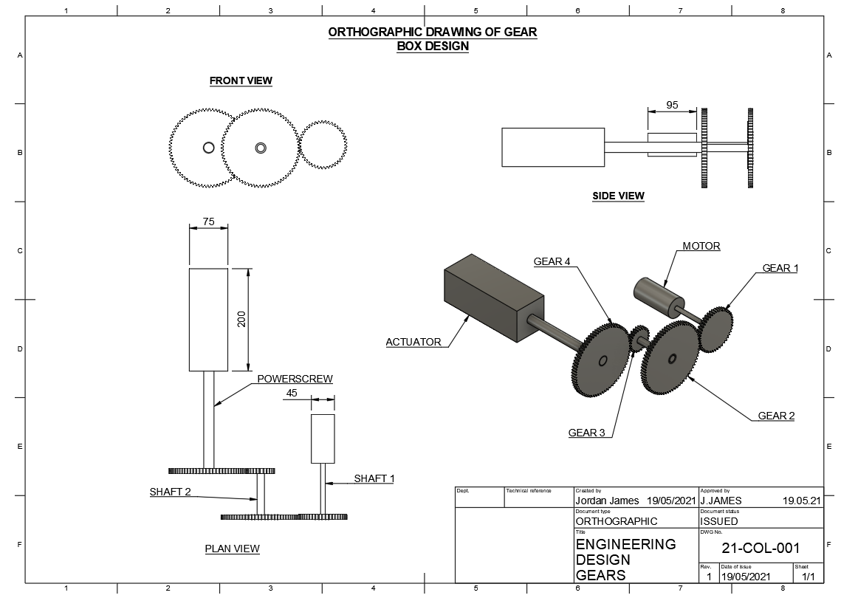

3D CAD Model

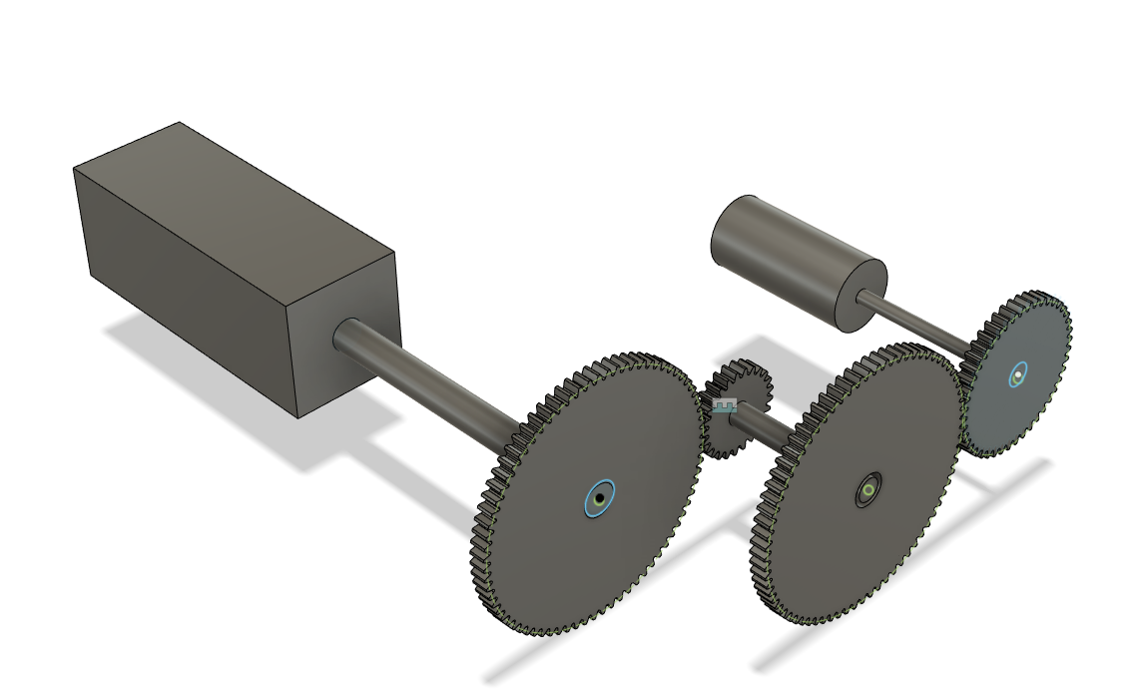

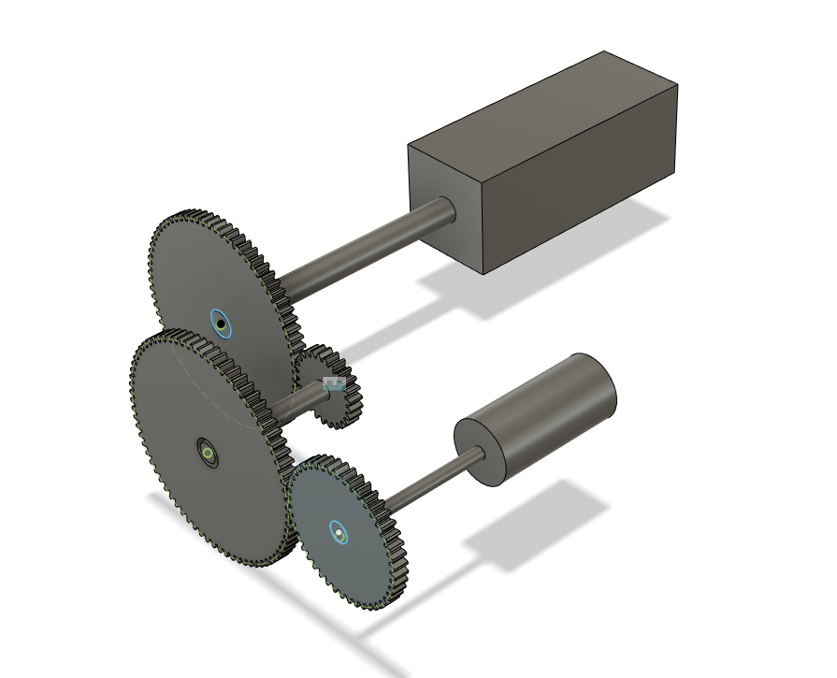

Bibliography

Bane, P (2019) How to make a gear in Fusion 360. Available at: HOW TO MAKE GEAR IN FUSION 360 WITH GEAR CALCULATION | GrabCAD Tutorials (Accessed 19/05/21)

Autodesk (2019) How to export a Fusion 360 design to a .DWG or .DXF file. Available at: How to export a Fusion 360 design to a DWG or DXF file | Fusion 360 | Autodesk Knowledge Network (Accessed 19/05/21)

