Mariah Edwards
University of Wales Trinity Saint David

Desk Top Study on Proposed Ice Cream Parlour and Manager’s Apartment

ACBA 4001

Contents
Site Details 2
History of Site 4
Geological Appraisal 5
Environmental Appraisal 5
Archaeology Appraisal 6

Site Details
  - Site Location
The site is located on the Swansea foreshore between the Swansea City and County Council and the Swansea Marriot Hotel. The proposed site would share parts of each of the adjacent facilities parking lots. The British National Grid Reference Coordinates of the approximate center of the proposed site is as follows:
British National Grid Reference: 265392, 192302
Lat/Long (Degrees): 51° 36' 48.3"N 03° 56' 43.8"W
Lat/Long (Decimal): 51.61340878 -3.94549182
The site location is indicated in figure 1.
The proposed site is to have a building of 300 square meters GIA, it is to contain multiple food stores and shops, Manager’s Apartment and staff facilities.
  - Site Description
There is a public footpath that runs from north to south through the approximate center of the site and can be accessed from Dunvant Place. It can be viewed and accessed from the beach walkway trail at Swansea Bay.

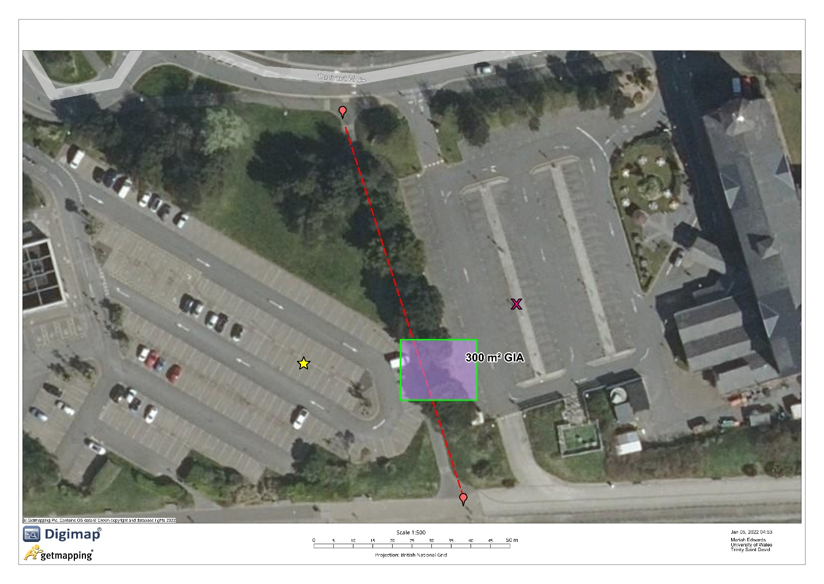
Figure 1 Aerial View of Proposed Site

History of Site
  - Former and Current Site uses of Proposed Site and Surrounding Areas
Currently parts of the proposed site is being used by the Swansea Marriot Hotel as a parking lot and and another section also as the Swansea City Council as a parking lot. Maps showing the earliest data on the site suggest that there was:
- A railway on the proposed site which was dismantled in 1960. The railway was built as an industrial horse drawn tramway in 1804, began transporting passengers in 1807. Steam locos were implemented in 1877 and then later evolved to Electric tramcars from 1929 to closure in 1960
- In 1890 at the north of the site there was a Timber yard.
- A canister works in from the period of 1910’s to the 1950’s.
- In 1950’s there was a paint factory where the Swansea City and Council is now
- Adjacent on the Swansea Marriot Hotel Property there was a Timber Yard in the 1950’s
The proposed site and areas sounding seem to be used for industrial purposes until the area was developed in 1980.
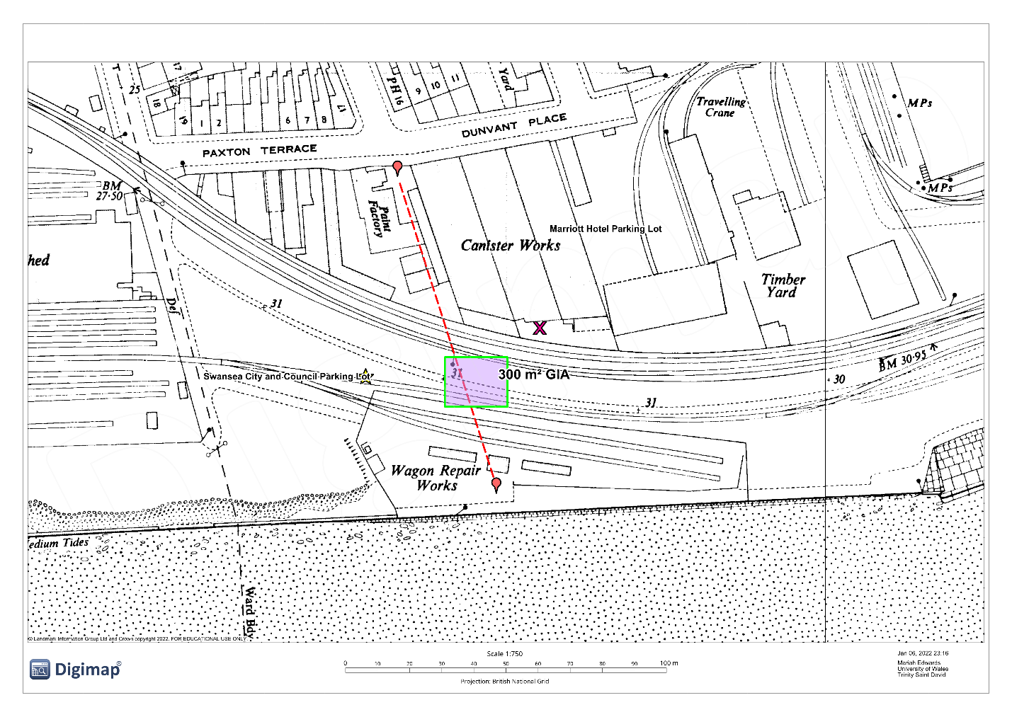
Figure 2 Map showing Prior Land Use (1940’s)
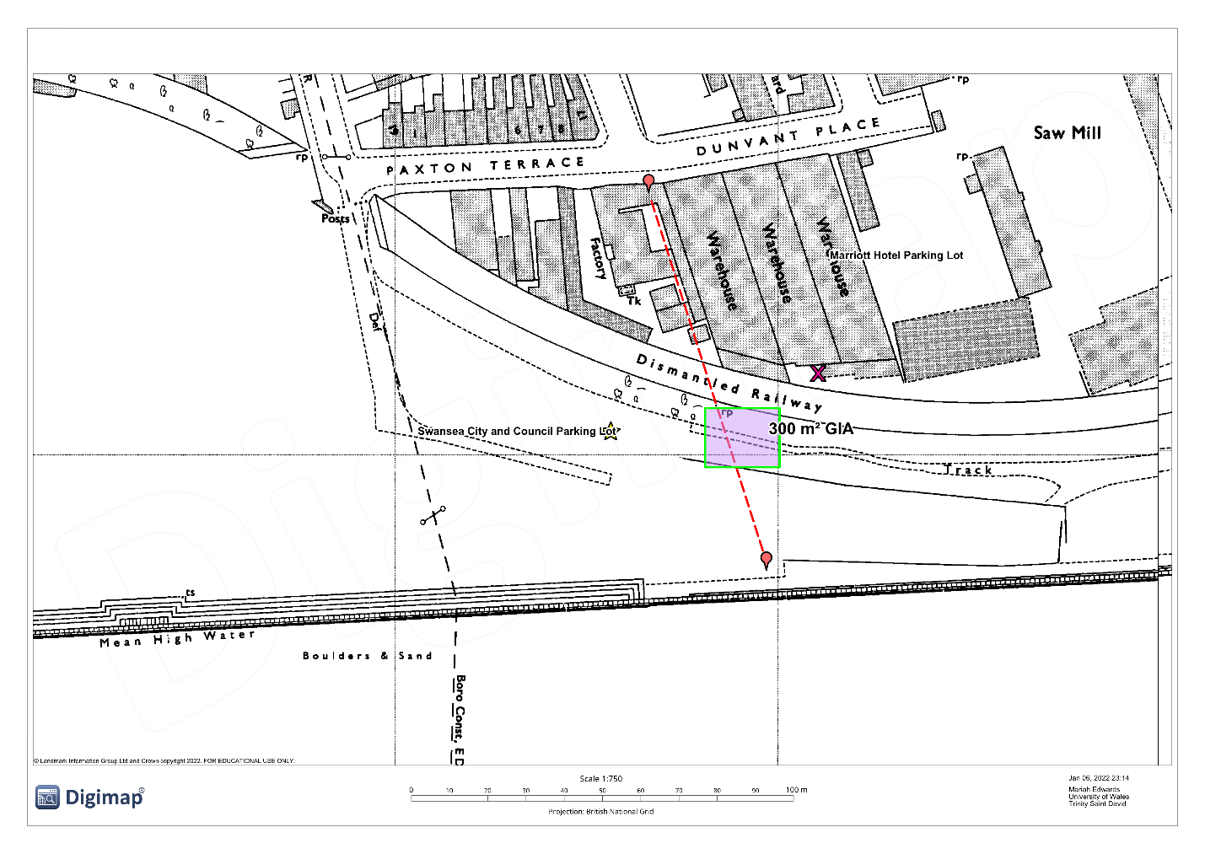
Figure 3 Map showing Land Use 1960's

Geological Appraisal
Geology shows that there is coal measures formation. Superficial deposits of blown sand- sand and beach deposits
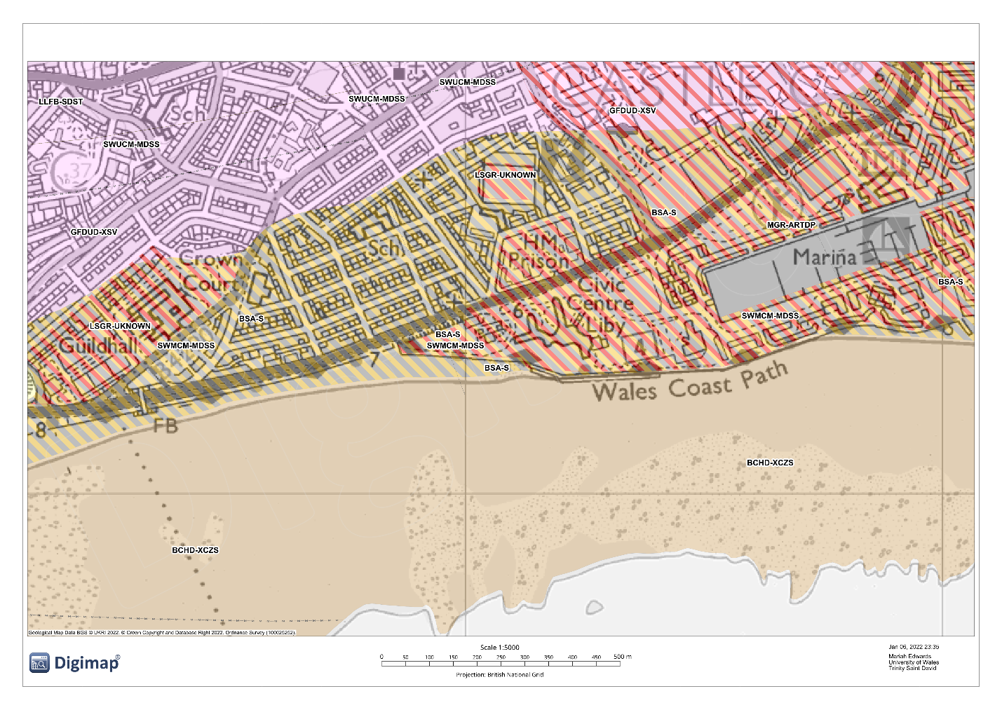
Figure 4 Map showing Geology
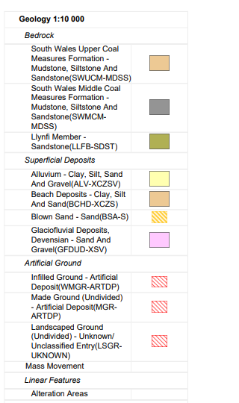

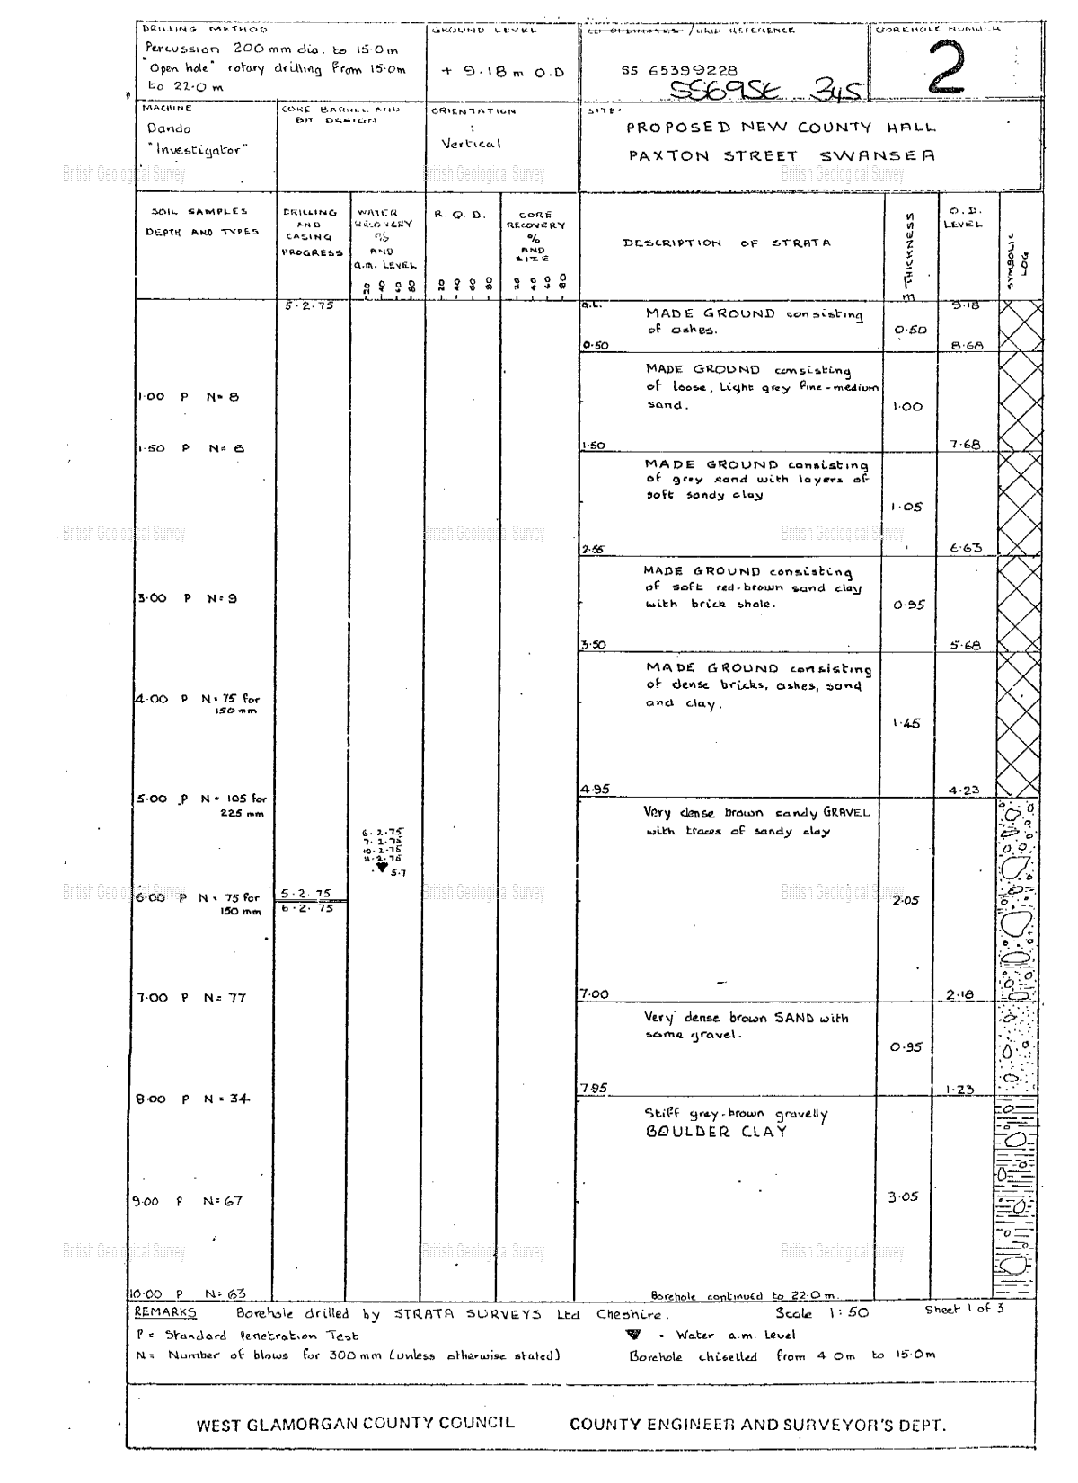
Figure 5 Bore Hole Record pg1

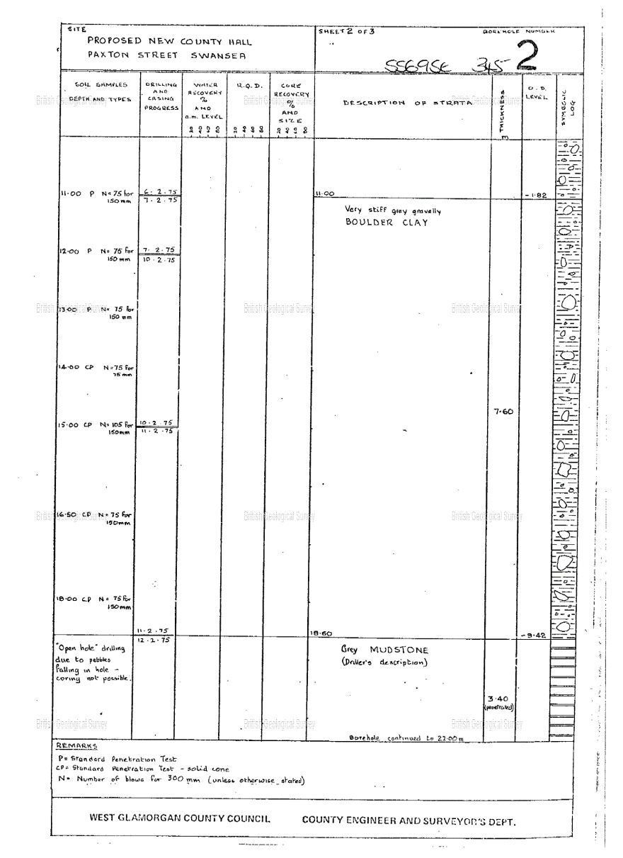
Figure 6Bore Hole Record pg 2
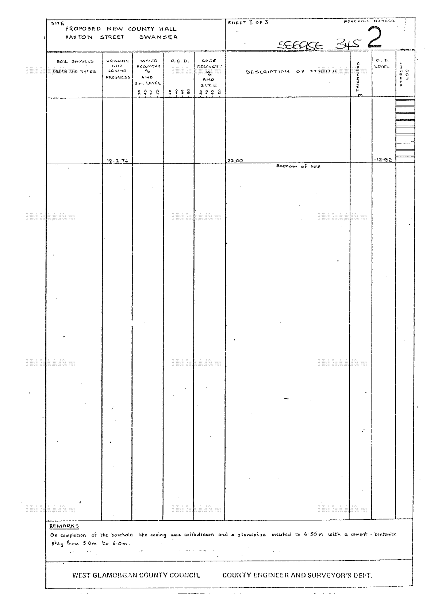
Figure 7 Borehole Record pg 3

Environmental Appraisal
The site is located along a railway that was present from up until the 1960’s. Although the track is no longer at the site potential contamination can occur from
Radon Exposure
Radon is a natural gas that is odorless, tasteless and colorless that increases the risk of lung cancer when inhaled. It is present in all soils, some building materials and water. It can also be dissolved in ground water and in some cases have high concentrations. Radon concentrations depends on location as it varies across the United Kingdom. PHE and BGS has worked together to produce maps that show radon exposure potential and can be viewed at the BGS website.
The map shows that the proposed site is located in an area that 1-3% is above action level.
Radon testing should be arranged to determine possible contamination. The recommendations and guidance for protective measures for new dwellings can be found in BR 211: 2015.
BS 10175 and BS 8576.
Methane and Carbon dioxide are other possible ground gas BS 8485: 2015 Code of Practice for the design of protective measures from methane and carbon dioxide ground gases for new building.
Hydrogeological
Records from a borehole drilled in close proximity to the site show a water strike at 5.7 meters where there is described to be very dense brown sandy gravel with traces of Sandy clay with particles measuring 2.05 meters and a depth of 2.18. Water levels would be subject to seasonal changes.
BGS Maps summarizes the area to be moderately productive aquifer
Natural Resources Wales reports very low risk of flooding from rivers and sea in the area for each year but there is a 3.3% area may be subject to flooding from surface water which can cause possible pollutants and contamination.

Archaeology Appraisal
No information was found indicating that the proposed site may have archaeological findings beneath. Maps accessed through DigiMaps show no sign of heritage at site or surrounding areas at the time of study.

Figures Table
Figure 1 Aerial View of Proposed Site 3
Figure 2 Map showing Prior Land Use (1940’s) 4
Figure 3 Map showing Land Use 1960's 5

http://mapapps2.bgs.ac.uk/geoindex/home.html?layer=BGSRadon&_ga=2.186283241.1973751068.1641434529-1065989158.1641434529
https://www.ukradon.org/information/ukmaps
https://www-ihsti-com.ezproxy.uwtsd.ac.uk/tempimg/14AAC36-CIS888614800324998.pdf
https://check-your-flood-risk.naturalresources.wales/home/GetRiskLevels?rnd=1641435160128&postcode=SA1%203SS&address=SWANSEA%20MARRIOT%20HOTEL%2C%20MARITIME%20QUARTER%2C%20SWANSEA%2C%20SA1%203SS&latitude=265486&longitude=192338&localCustodianCode=6855&culture=en-GB#results-view

http://mapapps2.bgs.ac.uk/coalauthority/home.html

