  Component One:  What are the key skills required when working in the housekeeping team? 750 words (+/- 10%)  Contribution to Overall Module Assessment: 25% | Student No: | 2125245
 | Module Title: | Operating Hotel Facilities
 | Module Code: | BMIH4006
 | Lecturer: | Laurence Blake
A housekeeper's or maid's quality is directly connected to the excellence of their housekeeping skills. These qualities may include everything from customer care to interaction, and they will fluctuate based on the specifics of a housekeeper's job and the company they work for. The hotel sector focuses heavily on the housekeeping staff to uphold the guest rooms, shared spaces, kitchen, and other service areas clean and presentable (Mullins and Dossor, 2013). Room, food, and drink sales, as well as those for peripheral services like a health club, a gymnasium, a soothing massage, Etc., are a hotel's only means of support after the hygiene and quality of its rooms and services.
The hotel's profit margin is substantially geared towards room and service revenues, which account for at least 50% of total sales (Roberts, 2022). A hotel tourist's satisfaction with their stay is generally significantly proportional to the effort and hard work put in by cleaning. The guest rooms and suites at a hotel are its lifeblood. Along with ensuring that guests' rooms are always clean and pleasant for their visit, cleaning also ensures that the hotel always looks its best, inviting guests to extend their stays and return in the future.
Time Management Skills: Housekeepers may serve independently or in small teams but are generally committed to daily goals for various tasks. A housekeeper's capability to control their time efficiently is fundamental for completing their job on time. In order to be on schedule with their housekeeping sessions and have everything done in the allotted amount of time, they may find it necessary to keep a tight check on their timetable (Tesone, 2019). Communication Skills: Housekeepers at hotels often have to continuously engage with a diverse range of customers continuously. It is in their best position to know how to communicate with them efficiently and sympathetically. Housekeepers must communicate well so that others on the team know who has accomplished their tasks and who needs assistance (Cottrell, 2019). Clients often demand towels, soap, toilet paper, and other housekeeping supplies; these experts may help them get them. Sometimes, housekeepers must advise customers to handle issues with inadequate amenities or service.
Flexibility: A housekeeper's daily routine might vary widely based on the needs of their respective guests. For instance, office building cleaners could wait for employees to clock out before starting work. Housekeepers regularly put in extensive hours, often starting their shifts in the earliest hours of the night or early morning (Raghubalan and Raghubalan, 2015). A flexible housekeeper can take on more work and make more money.
Critical thinking: The capability to think critically is necessary for the effectiveness of Hotel Housekeepers in their responsibilities as problem solvers, visionaries, and decision-makers. Someone with the critical thinking abilities of an Executive Hotel Housekeeper may determine the basis of an issue and work logically to find a workable solution. It is beneficial to practice critical thinking while dealing with Hotel Housekeepers who may have a diverse ways of looking at things. Supervising: An executive housekeeper must be able to manage personnel properly. The executive housekeeper demands this ability so that they may lead and integrate the activity of the housekeeping staff and ensure that their duties are met quickly and efficiently (O’fallon and Rutherford, 2019). High cleanliness and orderliness around the house can only be sustained with this ability. A good housekeeper will examine every little detail. One of the most valuable qualities in a housekeeper is the ability to pay meticulous focus to even the slightest of details, such as a spot or an item that does not quite match. A housekeeper must be honest about incidents while carrying out their responsibilities. If something needs to be corrected when housekeepers maintain the house, they should be frank about it. Customers and employers do not appreciate it when employees misrepresent faulty goods. Housekeepers must be friendly and outgoing since they frequently interact with customers and have to be able to get along with their teammates (indeed.com, 2020). Housekeepers must have common interpersonal qualities such as reliability, collaboration, and accountability. Organised: A housekeeper's talent to accurately label and store possessions is critical for ensuring a clean and orderly home. This requires a comprehensive set of skills (Tesone, 2019). A well-organised kitchen is as much needed as a well-stocked bar or a tidy bedroom for a child. Clothes in a closet or a drawer are good examples of goods that should be neatly tucked away, but that does not mean they should be ignored when it comes to organisation.
Word Count | 753

References
Cottrell, S. (2019) The Study Skills Handbook. 5th ed. London: Red Globe Press.
indeed.com (2020) Guide to Housekeeping Skills (With Tips and Examples) | Indeed.com, www.indeed.com. Available at: https://www.indeed.com/career-advice/career-development/housekeeping-skills (Accessed: 27 February 2023).
Mullins, L. J. and Dossor, P. (2013) Hospitality Management and Organisational behaviour. Harlow: Pearson.
O’fallon, M. J. and Rutherford, D. G. (2019) Hotel Management and Operations. Hoboken, N.J.: Wiley.
Raghubalan, G. and Raghubalan, S. (2015) Hotel Housekeeping : Operations and Management. New Delhi, India: Oxford University Press.
Roberts, D. (2022) Hotel Revenue Management. Business Expert Press.
Tesone, D. V. (2019) Principles of Management for the Hospitality Industry. 10th ed. Oxford: Butterworth-Heinemann.

ASSIGNMENT SPECIFICATION
HOSPITALITY & TOURISM MANAGEMENT
Student name: |  | Student number:
Programmes: | BA International Hotel Management
Module: | Operating Hotel Facilities | Module Level (4, 5, 6): | 4
Module code: | BMIH4006 | Contribution to Overall  Module Assessment  (%): | 25%
Lecturer: | Laurence Blake Ffion Cumberpatch Tristan Hawkins Kathryn Roberts Lisa Bassler | Internal Verifier: | Lola Villard
Assignment Title: | Assessment of Practical Tasks | Component No: | 2 of 3
Hand Out Date: | w/c 09th of January 2023 | Submission deadlines: | Friday 10th of
 |  |  | March 2023 by
Draft Deadline: | Wednesday 1st of March 2023 | Return date of provisional  marks & written feedback: | 23h55
 |  |  | 17th of April 2023

Action plan for managing customer complaints
Problems | Why did it happen? | What are you going to do? | How will you prevent this from happening in the future? | What measures would you introduce to improve team effectiveness?
Customer-compliant dirty room with a dirty floor | The cleaner regularly does not clean the room, resulting in a bad environment with a dirty floor (Brown,2013). | For this complaint, proper resources must be used to clean the room. Always, there should keep accessible space so that the housekeeper can clean easily. | I will give directions to the housekeeper to clean the room daily and sweep the free space regularly. Even the designed area will keep open space to clean freely (Brown and  Churchill, 2014) | The team members need cooperation and coordination to give the customer a clean room and floor. Measure like mopping a grabbing the cleaning remedy can be used for customer or guest satisfaction (Carmouche and  Kelly, 2013). The staff will always see that the room’s furniture is dust-free.
Damned wall and a filthy smell from the room | In the cleaning process, the cleaner did not follow the room soundings that should be complained to the manager, and dirty room surroundings were responsible for being harmful to minors. | The housekeeper needs to use various sprays regularly. Also, there should use damned observing Berger paints, which can protect unhealthy room conditions from damned walls as well as filthy smells. | For future confirmation of a clean hotel wall, there will be an oil-based painting, which can be cleaned using warm water. Moreover, different room sprays and baking soda or vinegar will prevent a filthy smell. The cleaner will be trained to clean the wall using the proper mechanism. | The measure of damage depends on the environment of the room. The team members must justify the room's surroundings through acrylic emulsion to repair and surface the wall. When the team uses, tools like antibacterial soap and open system windows can bring customer happiness, which can measure the team's effectiveness.
Unsanitary bathroom | The toilet is a critical issue in the hotel, which needs to be constantly cleaned. However, housekeeping did not use proper cleaning machines and must be adequately trained. | To clean the bathroom, there need to remove unusual spots, and also the cleaner needs to use the proper sweeping machine with acid type cleaner. The shower should be both hot and warm water. The specific employee will send to monitor the unsanitary condition and report to the team leader for unsanitary conditions. | Proper training should be provided to the toilet cleaner. Some staff when reported the unsanitary toilet, proper steps should be taken by me such as mix cleaning solution. The employee needs to check all equipment in the bathroom as a customer sees the tiler issues seriously. | The employees should be trained to provide good criteria for toilet cleaning. There is a need to use customer opinions on what they want and what challenges they face in the bathroom. Even long-lasting cleaners need to use. As a team leader, I will set specific criteria and terms to give customers comfortable and clean toilets.
Unclean carpet and scruffy bed | The cleaner did not clean attentively, so the carpet stayed nasty, and the bed became scruffy. | As a team leader, this problem should be corrected quickly. I will advise the housekeeper to clean the carpet and bed, as these are sensitive issues which can easily dissatisfy the guest (Dinnen and  Hassanien, 2013) | There need to use carpet shampoo once a week. Different carpet brushes need to use to clean the carpet. The housekeeper should regularly change the bed shit to satisfy the guest. | Re-applying the tools, which protect the carpet, can be a measure. To provide customers with clean carpets and excellent beds, there need to provide professional mats, carpets, and designed beds, which attract them to stay more and repurchase the hotel services.
Grubby equipment | The housekeepers should regularly focus on the room’s necessary equipment and proper attention. The hotel manager needed to be conscious of this maintenance issue. | The team representatives will check all the equipment in the room. They will examine the room's fan, light, refrigerator, TV, or air conditioner. As a team leader, I need to manage the safety equipment in the room with cleaning issues. | The continuous maintenance system by the mechanics should be handled by the staff responsible for room management, and it will prevent this problem from occurring in the future. | As a team leader, I must look at the other company’s condition through benchmarking. Their product quality and cleanliness should be considered to retain the employees and customers long-term. Even continuous checking and reviewing of equipment systems can make the customer repetitive, which measures the team's effectiveness (Gautam, 2014).

References
Brown, D.R. (2013) The restaurant manager's handbook: How to set up, operate, and manage a financially successful food service operation. Ocala, FL: Atlantic Pub. Group.
Brown, T.J. and Churchill, G.A. (2014) Basic marketing research: Customer Insights and Managerial action in the hotel industry. Stamford, CT, USA: Cengage Learning.
Carmouche, R. and Kelly, N. (2013) Behavioural studies in hospitality management. London: Chapman & Hall.
Dinnen, R. and Hassanien, A. (2013) “Handling customer complaints in the hospitality industry,” Managing Customer Trust, Satisfaction, and Loyalty through Information Communication Technologies, pp. 68–90. Available at: https://doi.org/10.4018/978-1-4666-3631-6.ch005.
Gautam, A. (2014) Critical analysis of the Hospitality and Tourism Industry. New Delhi, India: Axis Publications.

ASSIGNMENT SPECIFICATION
HOSPITALITY & TOURISM MANAGEMENT
Student name: |  | Student number:
Programmes: | BA International Hotel Management
Module: | Operating Hotel Facilities | Module Level (4, 5, 6): | 4
Module code: | BMIH4006 | Contribution to Overall  Module Assessment  (%): | 50%
Lecturer: | Laurence Blake Ffion Cumberpatch Tristan Hawkins Kathryn Roberts Lisa Bassler | Internal Verifier: | Lola Villard
Assignment Title: | Presentation | Component No: | 3 of 3
Hand Out Date: | w/c 09th of January 2023 | Submission deadlines: | Friday 10th of
 |  |  | March 2023 by
Draft Deadline: | Wednesday 1st of March 2023 | Return date of provisional  marks & written feedback: | 23h55
 |  |  | 17th of April 2023

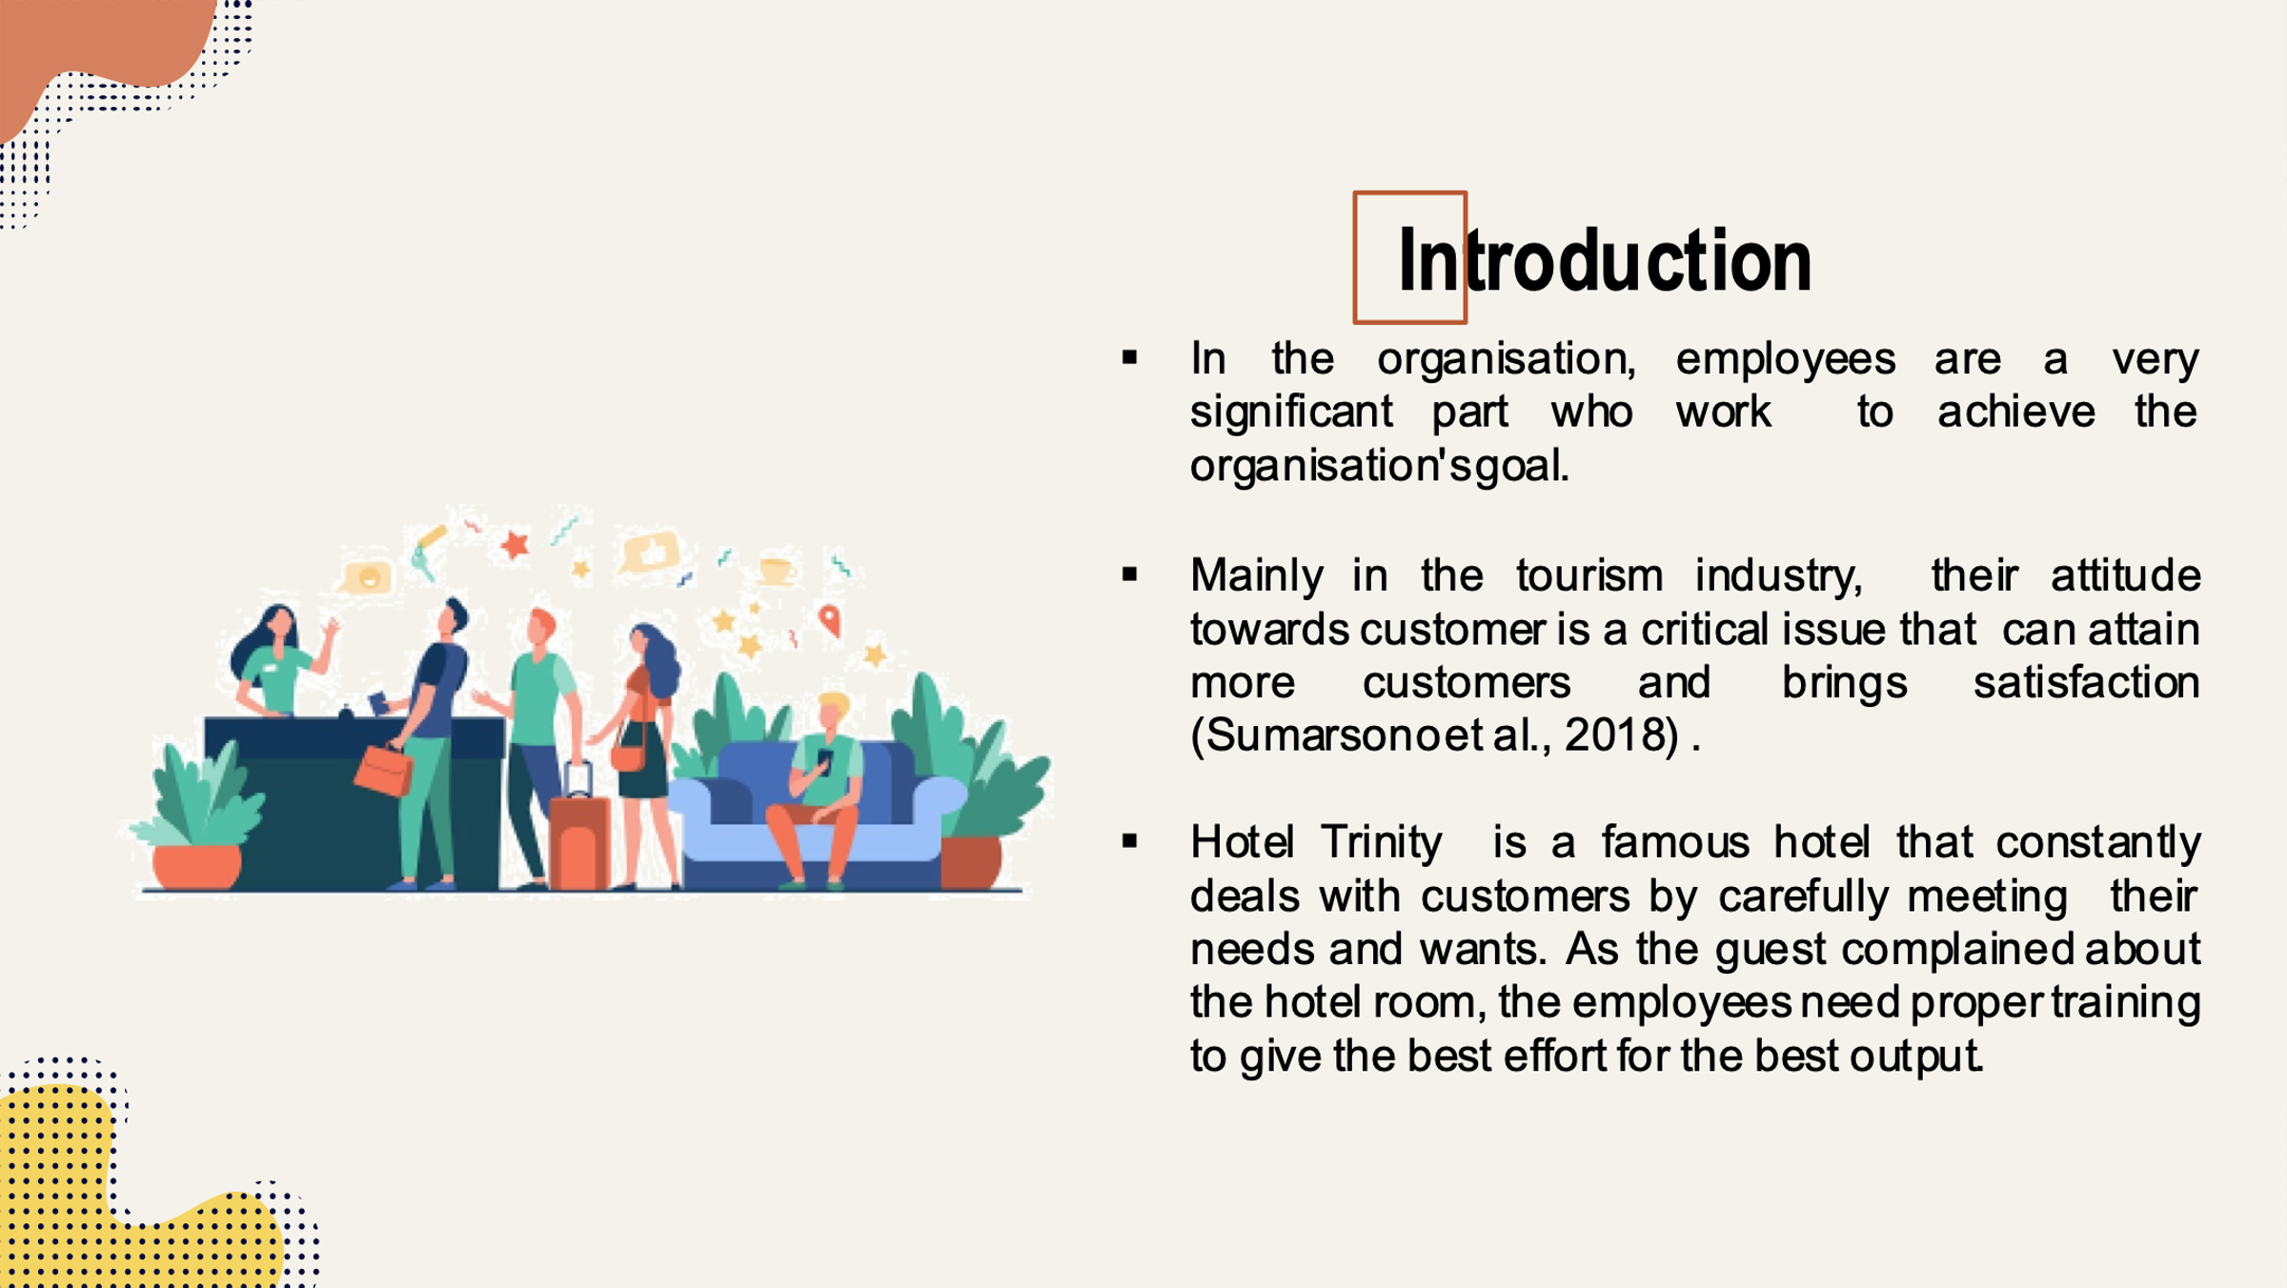
Training Notes:
In the organisation, employees are a significant part who work to achieve the organisation's goal. Mainly in the tourism industry, their attitude towards customer is a critical issue that can attain more customers and brings satisfaction. Hotel Trinity is a famous hotel that constantly deals with customers by carefully meeting their needs and wants. As the guest complained about the hotel room, the employees needed proper training to give the best effort for the best output (Sumarsono et al., 2018).
Slide 2:
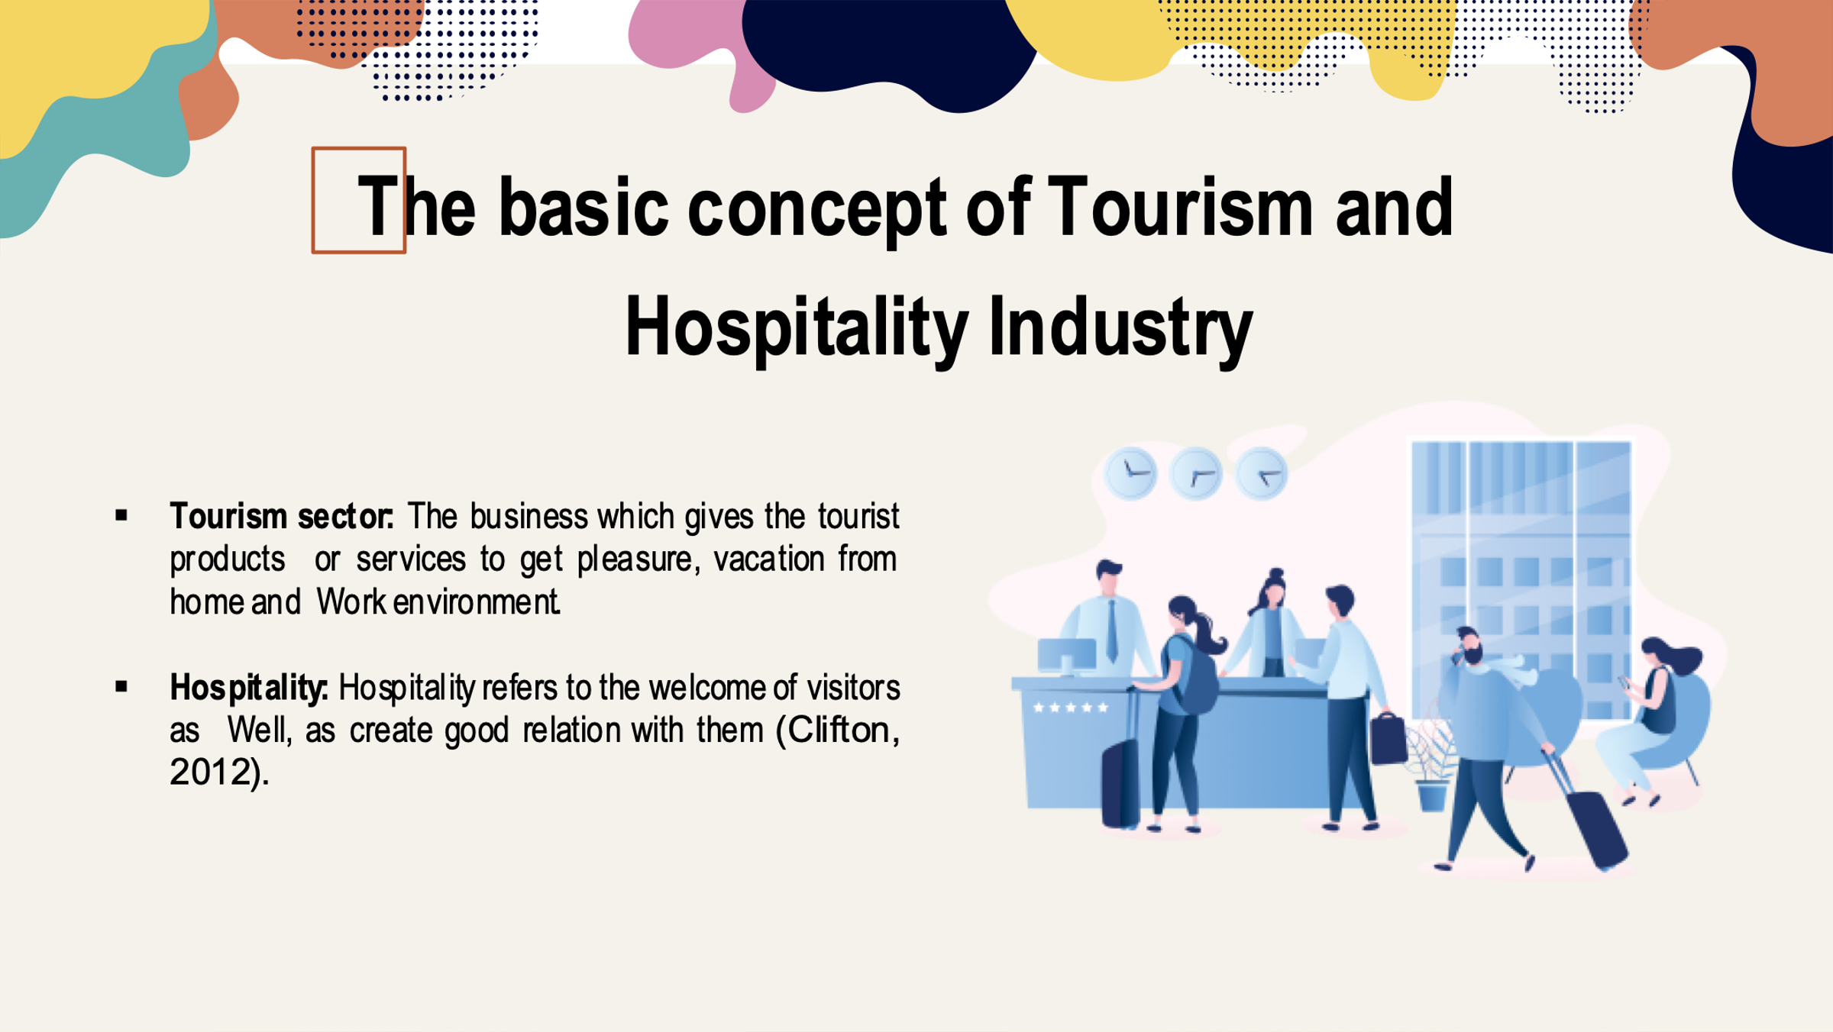
Training Notes:
The tourism and hotel industry has a more profound contribution to the economic sector, including hotels and resorts. This industry focuses on accommodation services, recreation, and entertainment. So there needs proper convention management, including private clubs or travel services. In this industry, achieving customer satisfaction demands integrity, loyalty, and commitment. In the 17th century, the tourism concept started where European visit different countries to collect historical information about art or culture (Clifton, 2012).
Slide 3:
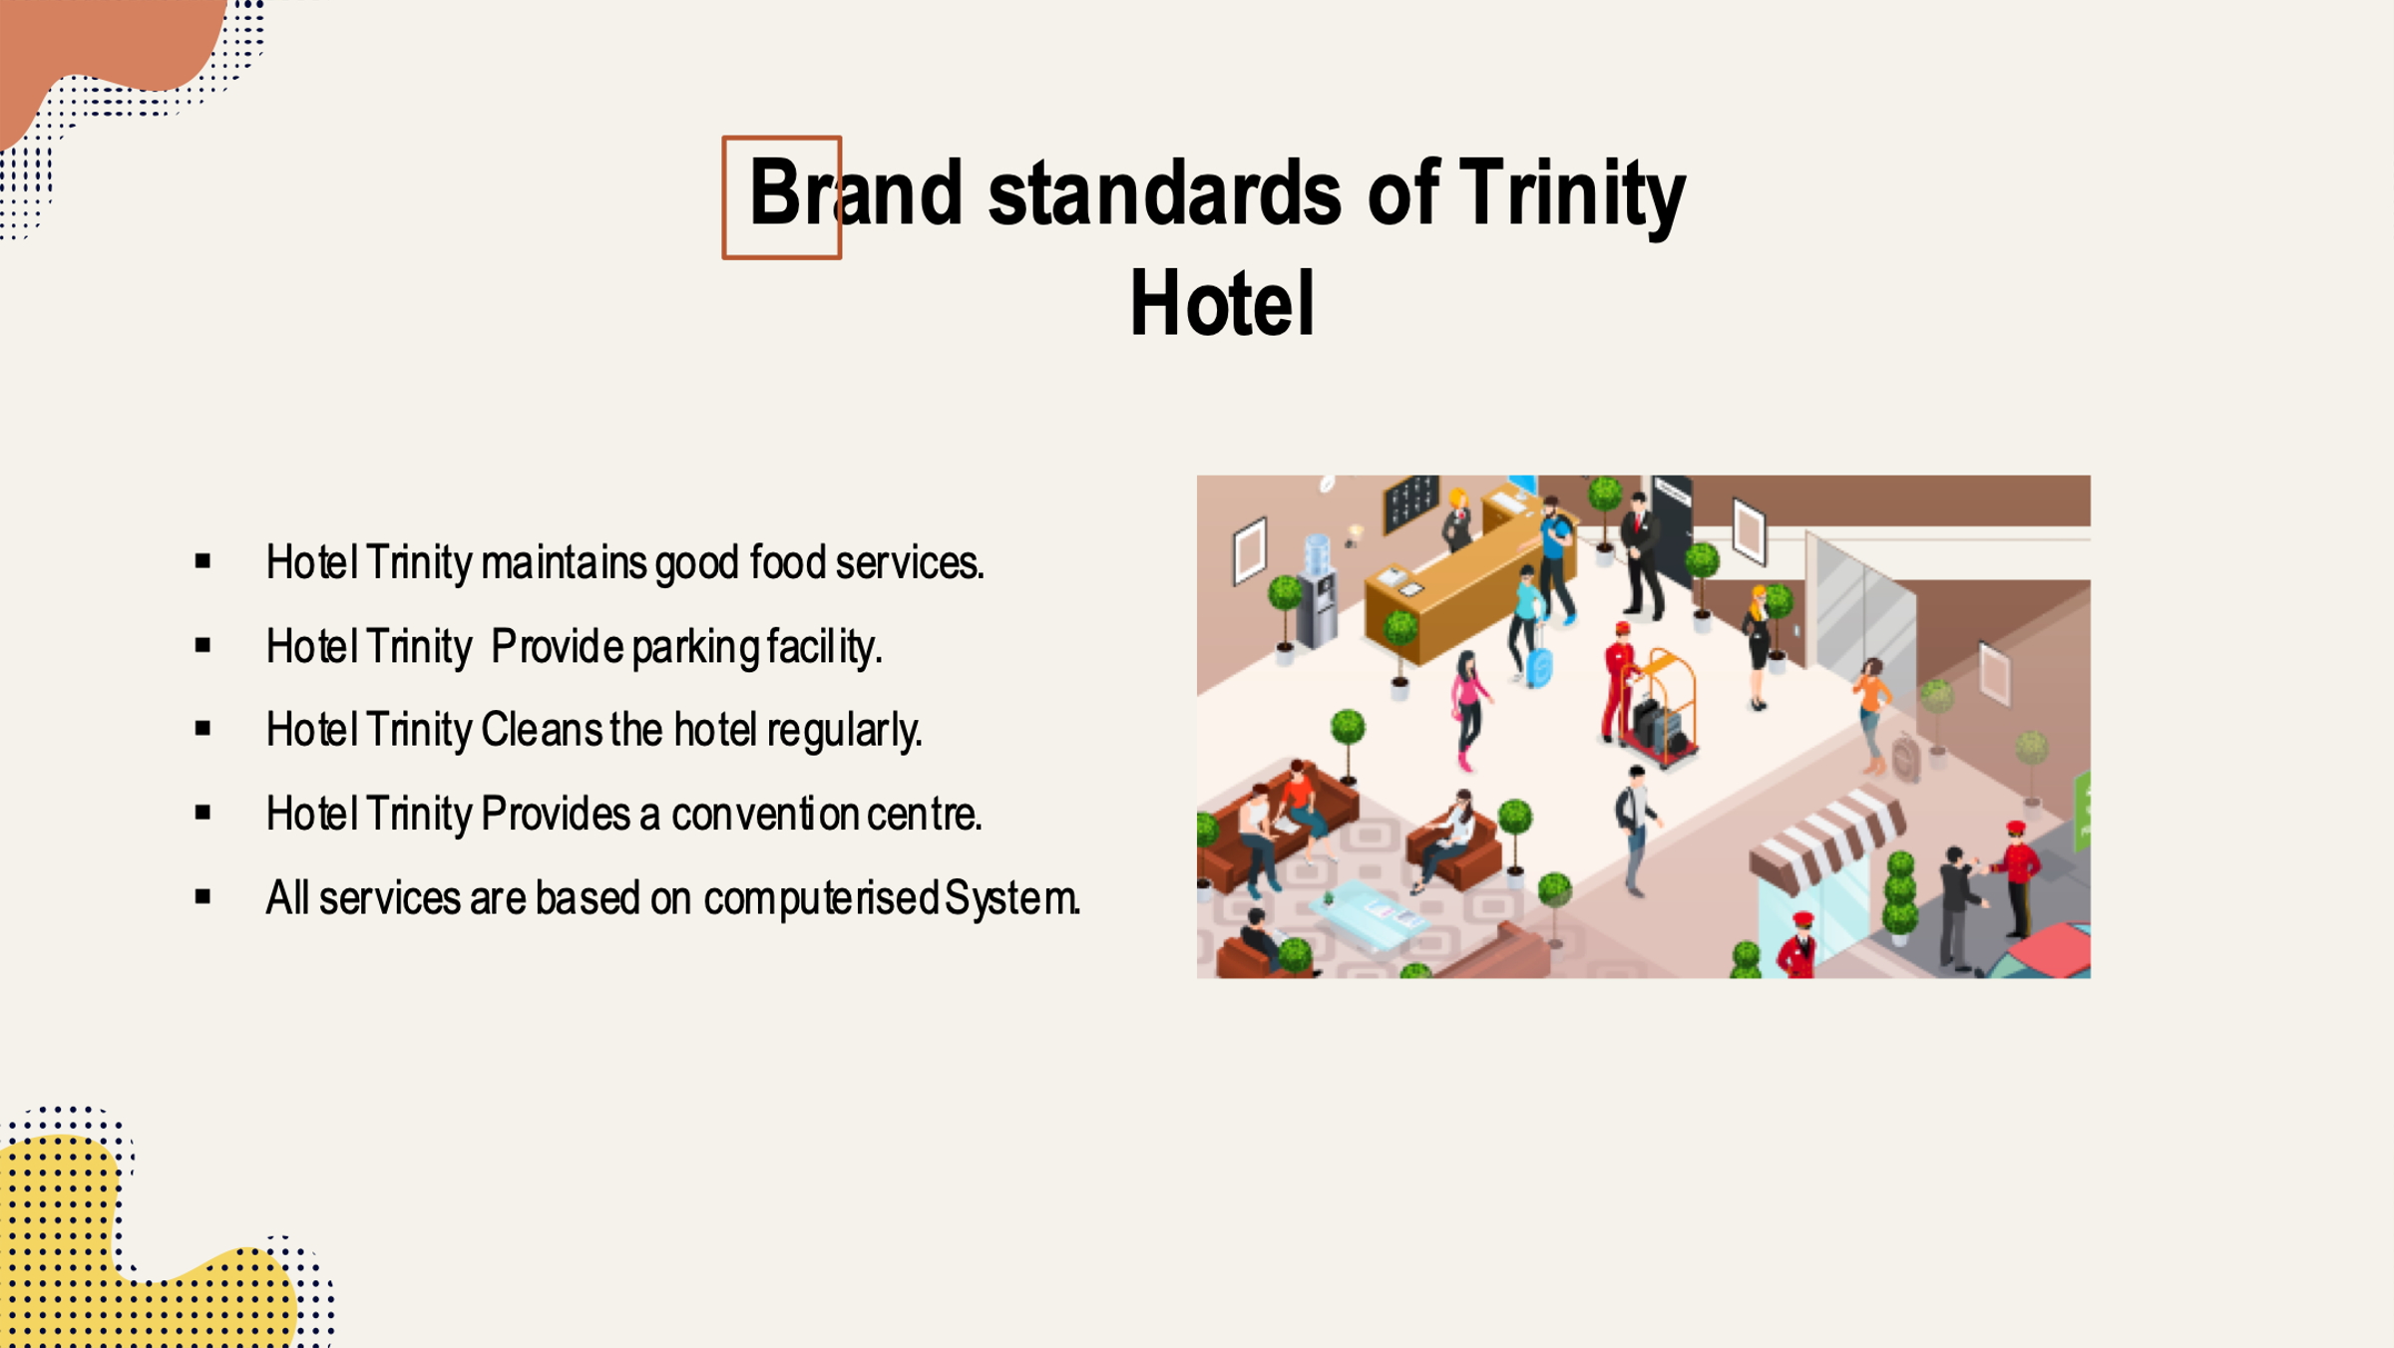
Training Notes:
As a popular hotel, Hotel Trinity always maintains good customer relations. So the hotel provides quality food services, good parking facilities, cleanliness, a convention centre, and an entertainment hall. All services provide to customers maintain computerised data systems.
The hotel manager always gets feedback from their customer about food quality, room services, Etc. (Bian and Liu, 2013).
Slide 4:
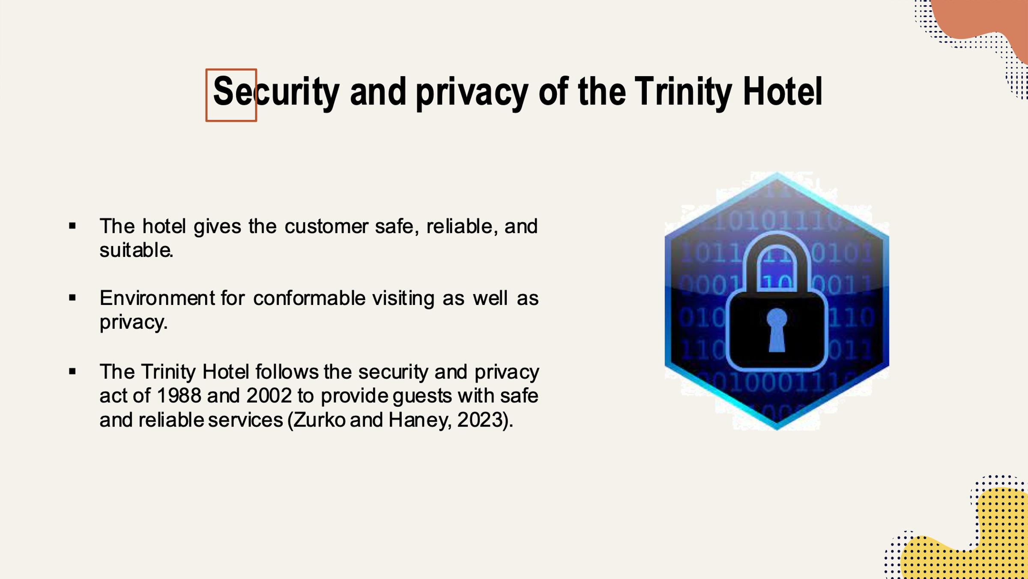
Training Notes:
The Trinity Hotel follows the security and privacy act of 1988 and 2002 to provide guests with safe and reliable services. The hotel uses a website where visitors can easily book their tickets. Even they can know the terms and conditions of the hotel from that website. The hotel protects the privacy of its customers through data management. So, the hotel maintains some specific standards for security and privacy. The leading security of the hotel includes managing customer information carefully so that nobody can know his or her private information (Zurko and Haney, 2023).
Slide 5:
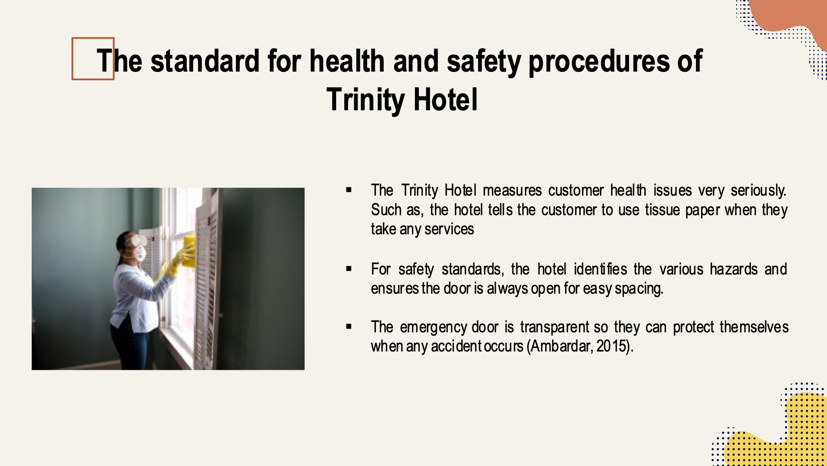
Training Notes:
The Trinity Hotel measures customer health issues very seriously. Such as, the hotel tells the customer to use tissue paper when they take any services. The surgical mask is compulsory to use for every customer. Even the customer must use washing soap to clear their hand properly to visit the hotel. For safety standards, the hotel identifies the various hazards and ensures the door is always open for easy spacing. Besides these, the hotel gives the machines and employees regular breaks so that the employees can take rest for good health. The employees have been adequately trained in using the machines and equipment. The emergency door is transparent so they can protect themselves when any accident occurs (Ambardar, 2015).

Slide 6:
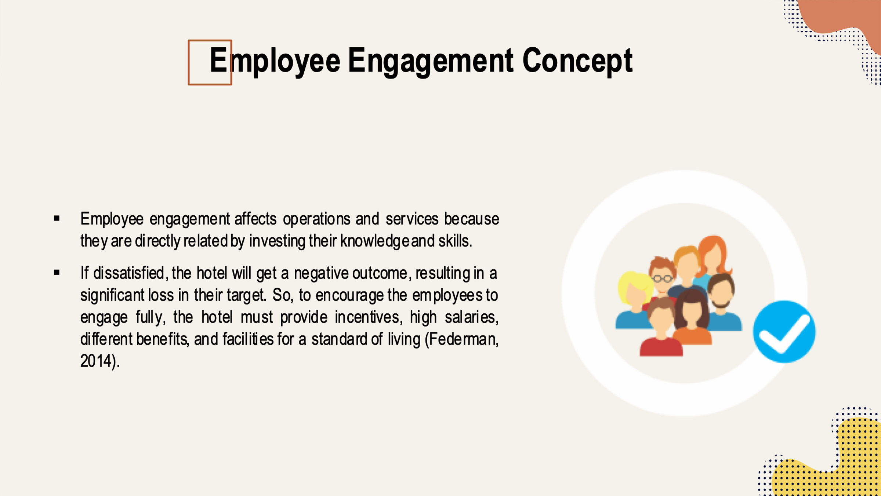
Training Notes:
Employee engagement affects operations and services because they are directly related by investing their knowledge and skills. Their attitude, knowledge, and emotions affect the actual outcome. If they are engaged with satisfaction, there is a positive outcome. If dissatisfied, the hotel will get a negative outcome, resulting in a significant loss in their target. So, to encourage the employees to engage fully, the hotel must provide incentives, high salaries, different benefits, and facilities for a standard of living (Federman, 2014).
Slide 7:
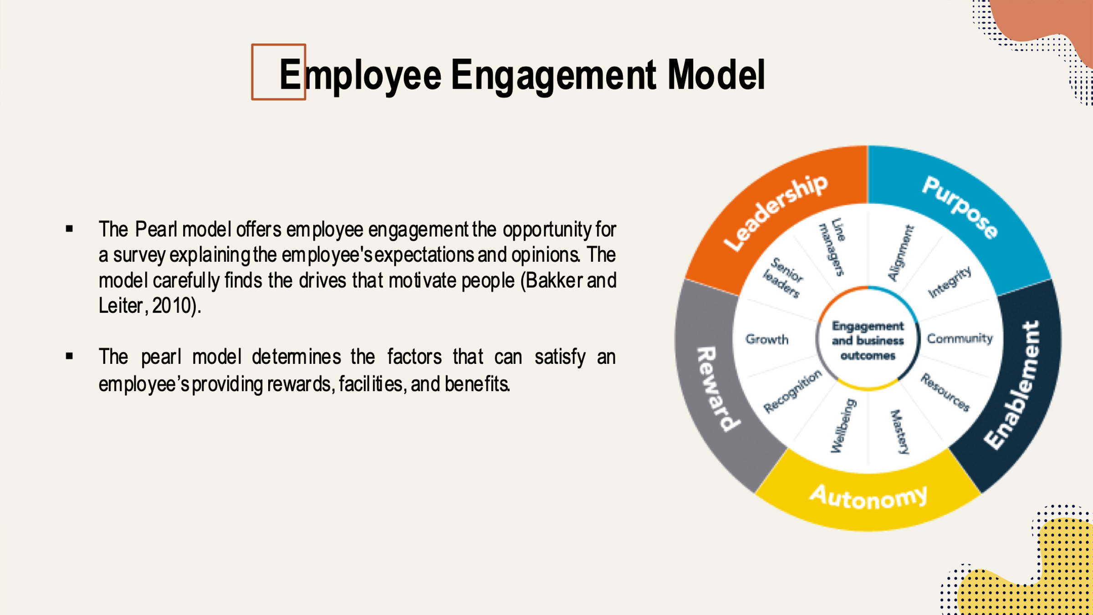

Training Notes:
The pearl model determines the factors that can satisfy an employee’s providing rewards, facilities, and benefits. The hotel can understand the employees, know their needs, and want the organisation through this model. To get motivated and encouraged employees, the hotel provides workers rewards through cash incentives or bonuses. The model also emphasises employees' freedom to make the team and express opinions. The employee will enable when he or she is involved with the organisation with full engagement and commitment (Martinez-Wayman, 2013).
Slide 8:
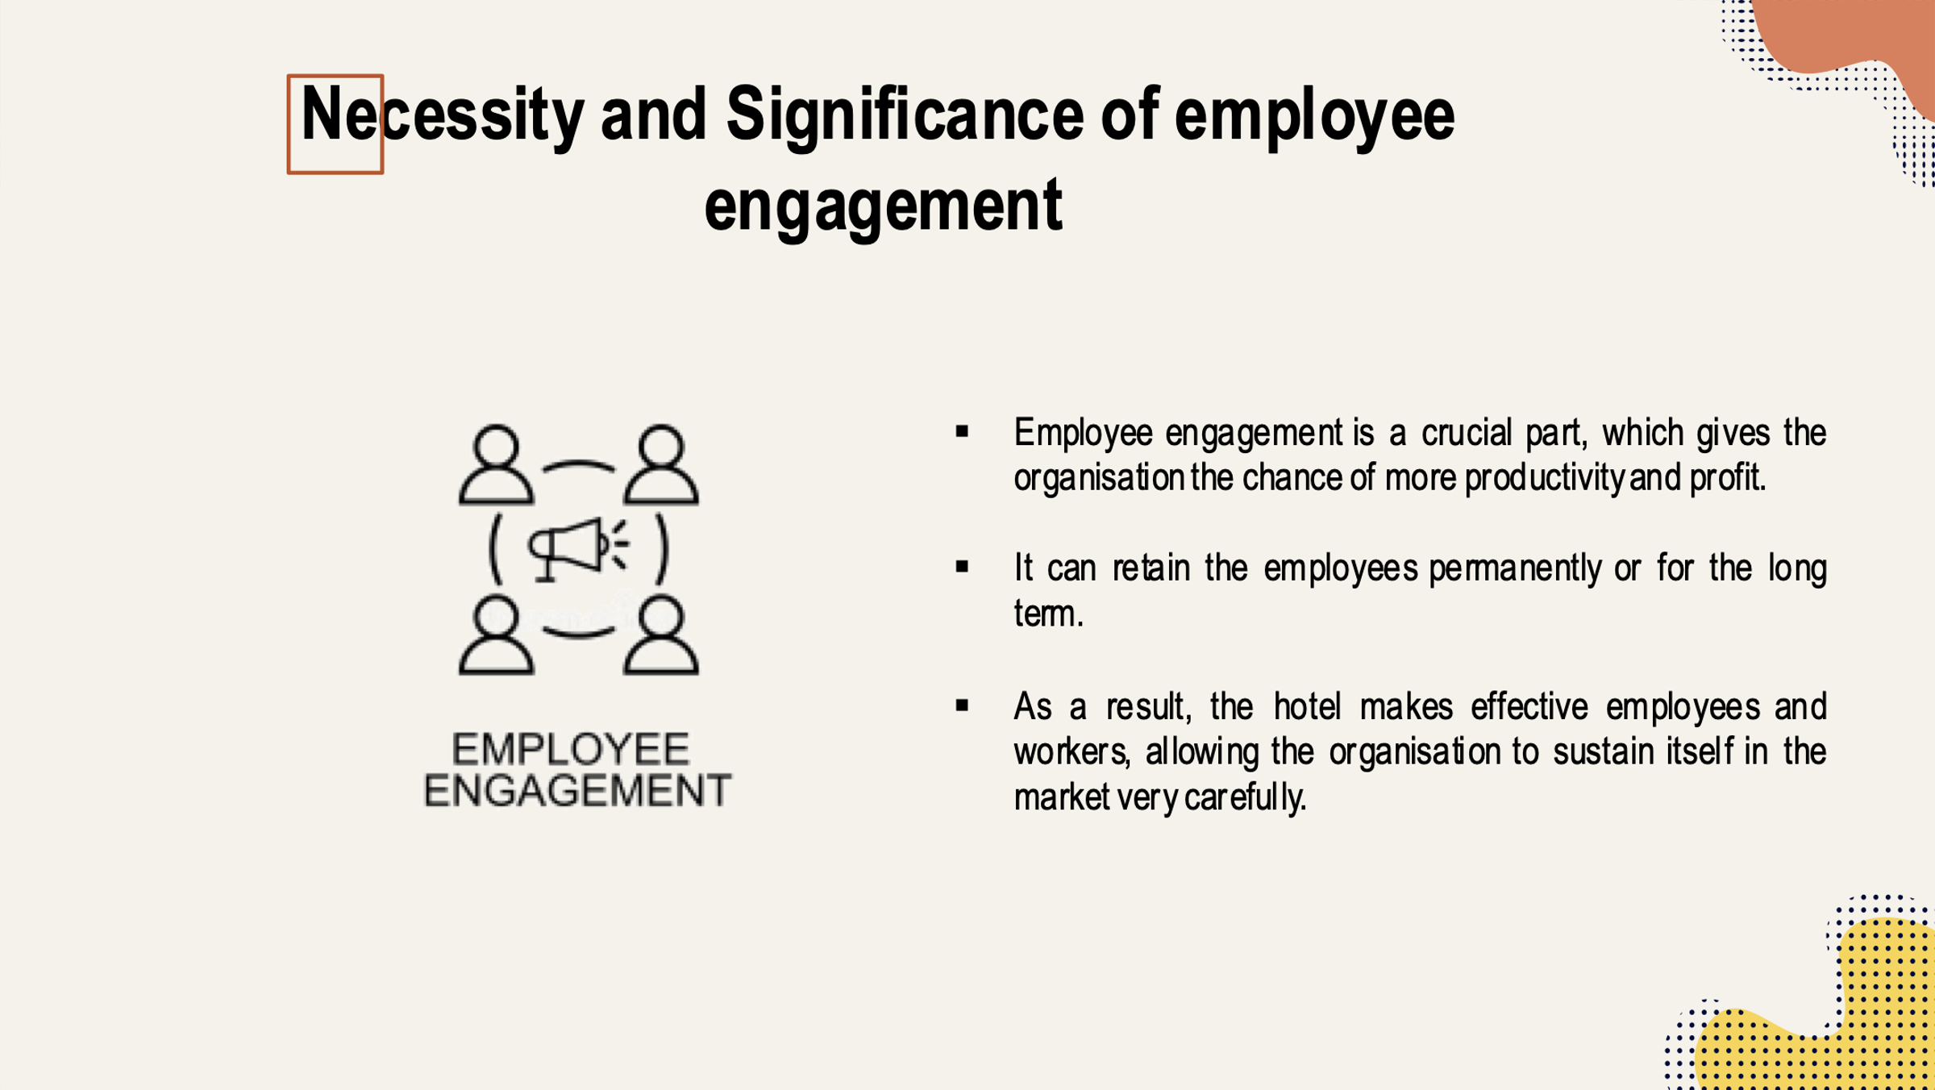
Training Notes:
Employee engagement is a crucial part, which gives the organisation the chance of more productivity and profit. It can retain the employees permanently or for the long term. As a result, the hotel makes effective employees and workers, allowing the organisation to sustain itself in the market very carefully. When the employees are engaged with full enthusiasm, it makes them skilled and creative, creating good relations among the members. The organisation gets committed workers and staff by reducing the turnover problem (Nel and Linde, 2018).
Slide 9:

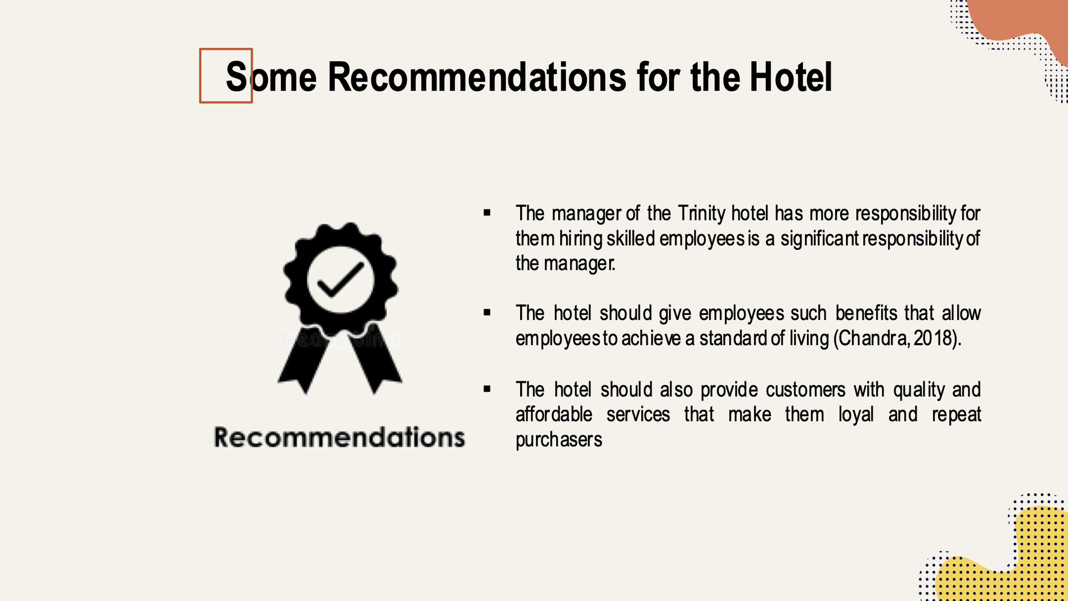

Training Notes:
The manager of the Trinity hotel has more responsibility for them hiring skilled employees is a significant responsibility of the manager. Because skilled and experienced people provide the hotel with valuable information, which will increase the hotel's image and reputation. The hotel should give employees such benefits that allow employees to achieve a standard of living (Chandra, 2018). The hotel should recognise the workers' value, making them loyal and believable. The hotel should also provide customers with quality and affordable services that make them loyal and repeat purchasers. Besides, the hotel should communicate powerfully among the employees, which affects customer relationship management (Shuck, 2019).
Slide 10:
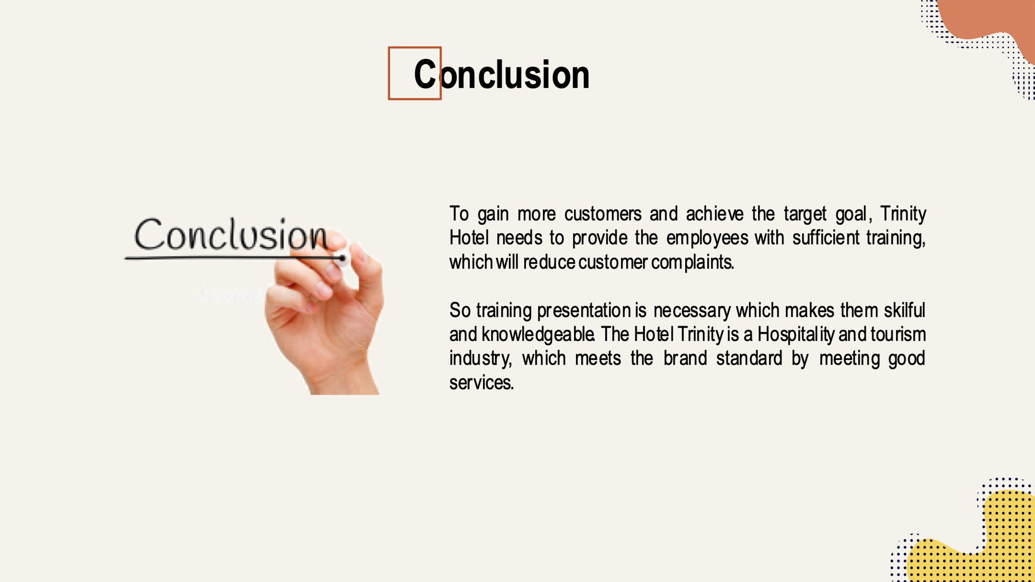
Training Notes:
To gain more customers and achieve the target goal, Trinity Hotel needs to provide the employees with sufficient training, which will reduce customer complaints. So training presentation is necessary which makes them skilful and knowledgeable. The Hotel Trinity is a Hospitality and tourism industry, which meets the brand standard by meeting good services. For this, the hotel provides its employees and customer with the safety, security, and privacy to get their services. It follows some security and privacy acts. For the best outcome, the hotel maintains some safety and health standards, which reduce risk, uncertainty, and significant loss. Employee engagement is a concept which engages employees with their work emotionally and makes them energetic, motivated and committed. The pearl employee engagement model works on retaining employees by providing them with attractive benefits and rewards. So this concept is essential for the organisation, which makes valuable assets that increase profit and productivity. At last, some recommendation has been provided to the hotel manager.

References
Ambardar, A. (2015) “Occupational Safety and health of laundry employees in Hotel Industry,” International Journal of Hospitality and Tourism Systems, 8(1). Available at: https://doi.org/10.21863/ijhts/2015.8.1.005.
Bakker, A. B. and Leiter, M. P. (2010) Work Engagement. Psychology Press.
Bian, J. and Liu, C. (2013) “Relation between brand equity and purchase intention in hotel industry,” International Journal of Services and Standards, 7(1), p. 18. Available at: https://doi.org/10.1504/ijss.2011.040640.
Chandra, M. (2018) Hotel and Tourism Management: Guest Retention Strategy. New Delhi, India: D.P.S. Publishing House.
Clifton, D. (2012) Hospitality Security: Managing security in today's hotel, lodging, entertainment, and tourism environment. Boca Raton, FL: CRC Press.
Federman, B. (2014) Employee engagement: A roadmap for creating profits, optimising performance, and increasing loyalty. Hoboken: John Wiley and Sons.
Martinez-Wayman, N. (2013) Employee engagement and retention: Practical lessons for the public sector.
Nel, J.H. and Linde, B. (2018) “The emergence of the employee engagement concept,” The Art of Engaging Unionised Employees, pp. 11–34. Available at: https://doi.org/10.1007/978-981-13-2197-9_2.
Shuck, B. (2019) "The impact of employee engagement," pp. 52–63. Available at: https://doi.org/10.4324/9781351035064-5.
Sumarsono, D. et al. (2018) “Hotel Management Strategy in Trinity City Hotel in supporting eco-tourism concept,” Proceedings of the 1st International Conference on Intellectuals' Global Responsibility (ICIGR 2017) [Preprint]. Available at: https://doi.org/10.2991/icigr-17.2018.14.
Zurko, M.E. and Haney, J. (2023) “Usable security and privacy for Security and Privacy Workers of Trinity Hotel,” IEEE Security and Privacy, 21(1), pp. 8–10. Available at: https://doi.org/10.1109/msec.2022.3221855.

