

Global Business Environment Assessment 1

Name: - Sahil Girishbhai Bhuva Student Number: - 2127449
Module Leader Name: - Dr. Rexon Nting Module Code: - LCBB4005
1

Table of Contents
Introduction 3
Introduction of the selected developing country 4
Business environment analysis of the selected country 4
Critical evaluation (opportunities and challenges) 7
Barriers experienced by other foreign businesses 8
Relevant strategies and recommendations 8
References 10

2

Introduction

Globalization nowadays has left everyone in a small world. The global business environment has evolved since the days of the industrial revolution and capitalization has forced companies to push their boundaries in search of more profit. Globalization has breached every life on the planet. Even in the remotest part of the world, people are connected. A company that manufactures in one part of the world can see its products in another part of the world (Masrani, et al., 2022). The companies have expanded their business in every nook and corner of the world. The business environment in the world has changed drastically in the past few centuries. Back in the days when goods and services were transported via ships that used to take months to reach the customers. Nowadays, the product and services reach the customers on the same day the manufacturing as the means of transport have evolved since then. People around the world nowadays are living and working together. The globalization working culture has brought all the people to work together in this world. Nowadays we can enjoy all the specialties of the world in a single place. A person living in America can enjoy Chinese delicacies and a person living in china can enjoy American Pop music. Certain services are the specialty of one place but are also available in another part of the world. Globalization has touched the lives of every individual. Not a single person is untouched by the effects of globalization (Cramer, 2017).

Here we are considering the UK automobile company Aston martin for analysis of business strategies in a developing country. The company is planning to move its production facilities to India.

3

Introduction of the selected developing country

Here, for this analysis the selected developing country is India. The business environment and the consumer market need detailed analysis for the UK automobile company to start manufacturing and production here.

- Economy -The Indian economy is a mixed economy that contains both private and public sectors. These sectors exist side by side with each other. The economic policies of the country encourage both sectors to exist together (Ramadani, et al., 2015).

- Income level- The consumers here mostly belong to the low-income group. However, it also has a small section of society that falls under the high-income group. India has one of the largest income gaps in the world among its population. Many people live below the poverty line as per the international standard, but the person who lives above it leads a very different and luxurious life.

- Cheap working force- India is one of the most populated countries in the world. It has the largest youth population in the world with an average population age of 32. Almost 50% of the country's population is below 25 years of age. This is a huge advantage for production and manufacturing as to have such a huge supply of cheap and quality labor. This fact has made India an attractive destination for multinational companies to start production here (Kumar, et al., 2014).

- Finance market- The finance market of this country keeps fluctuating and is partially stable as compared to the financial market of other developing countries.

- Government interference- Government interference is caused by some of the regulations and policies enacted by the present government. The political system of the country is a democratic republic and hence sometimes becomes unstable under certain circumstances (Cavusgil, et al., 2014).

Business environment analysis of the selected country

Application of business theories: Certain business theories such as Porter's Five forces, PESTLE, and Hofstede are applied below in this business context-

- Porter's Five forces: Porter's five forces is a business theory that can be applied to this context as follows. This includes five elements starting from

4

- The purchasing power of customers- The purchasing power of the people in India may be termed moderate. The consumer in India mostly comes from lower middle-class households. But there is also a section that deals with high income and are therefore capable of affording a luxury lifestyle (Cavusgil, et al., 2014).

- Competition in the market- The competition in the Indian market is moderate to high as far as the automobile sector is concerned. Many multinational companies are already doing business in the automobile sector. The companies that are native to the country also give tough competition to the multinational companies in this sector. They have a better understanding of the local market as compared to multinational companies. Hence they got an upper hand when it comes to understanding the consumer mentality of the Indian market.

- Replacement products- There are already many bestseller automobile vehicles in every category of vehicles. Hence, there can be many native and foreign companies that already manufacture the replacement vehicles for the Aston martin.

- New entry's potential in the market- The potential of the new company in the Indian market is huge. India is home to many billionaires and high-profile people who can afford the vehicle manufactured by Aston martin.

- Power of suppliers- There are suppliers in the Indian market who deals with vehicles of such kind. Those suppliers need to be availed to work for the company so they can distribute the vehicles manufactured by Aston martin (Luthra, et al., 2015).

- PESTLE: It contains six factors that are essential for the business environment and is relevant in this context.

- Political- The political environment in India has evolved a lot since Independence and has eased for new companies to set up manufacturing here. The government policies are also encouraging foreign direct investment in the current scenario which is good news for Aston martin (Cano, et al., 2018).

- Economical- The Indian Economy is a mixed economy where both the private and the public sectors exist simultaneously. As it is one of the fastest growing economies in the world, it will be smooth for Aston martin to set up manufacturing here.

5

- Sociocultural- India is a developing country and hence it has some sociocultural barriers including the gender gap in the working force. But still, it is negligible as compared to the other positive aspects.

- Technological- The technological culture here is good. In the automobile sector, it is moderate but that can be easily managed.

- Environmental- The environmental regulations in India are very relaxed. There are no strict guidelines regarding environmental concerns (Michie, 2019).

- Legal- The legal system in India is a bit complex and time-consuming. It is one of the downsides of setting up the manufacturing plant here. It might take up some time for the foreign company to get the necessary permits for manufacturing here (Pegoraro, et al., 2020).

- Hofstede's theory: It includes the concept to understand the difference in culture when doing business across the globe. It helped to understand the problem in the working area that stems from cultural differences. It contains the five problem areas that can be related to this context. They are-

- Identity: The identity value dimension is referred to as the attention of a group or an individual towards individual needs versus group needs. It also refers to the attention of a group or an individual towards relationships and individual achievement. This explains the difference between collectivist and individualist cultures.

- Power: The dimension of power equates to the set of rules that are set by society. It includes equality and inequality both. A hierarchical level with upward mobility is considered power within a cultural group. This dimension also explains the cultural orientation of a society.

- Gender: The gender value refers to reinforcing masculinity and femininity in roles of work. It also gives rise to gender-based roles. Even in the professional workplace, some jobs are considered to be for men and others for women.

- Uncertainty: This dimension emphasizes the cultures that are either inclined towards creating stability or towards creating uncertainty. This defines a society’s tolerance in the dimension of uncertainty.

6

- Time: The dimension of time refers to how the current societies are oriented with space and time. This includes their inclination towards tradition and their inclination towards their future. This shows how important it is for the cultures to hold on to the tradition for the present-day to day work.

Since India is a developing country with different culture the above five aspects will differ from the culture of the UK. It should be studied and well understood by the higher management of the foreign company before setting up a manufacturing plant here (Bennett & Sharpe, 2014).

Critical evaluation (opportunities and challenges)

- Corporate governance- The political environment in India has evolved a lot since Independence and has eased for new companies to set up manufacturing here. The government policies are also encouraging foreign direct investment in the current scenario which is good news for Aston martin. Also, the legal system in India is a bit complex and time-consuming. It is one of the downsides of setting up the manufacturing plant here. It might take up some time for the foreign company to get the necessary permits for manufacturing here.

- Business strategy- The purchasing power of the people in India may be termed moderate. The competition in the Indian market is moderate to high as far as the automobile sector is concerned. The native has a better understanding of the local market as compared to the multinational companies. The foreign company should research properly about the Indian market before setting up manufacturing here. There are already many bestseller automobile vehicles in every category of vehicles. But the potential of the new company in the Indian market is huge. India is home to many billionaires and high-profile people who can afford the vehicle manufactured by Aston martin. The local suppliers need to be availed to work for the company so they can distribute the vehicles manufactured by Aston martin.

- Cultural sensitivity- India is a developing country with a different culture. It should be studied and well understood by the higher management of the foreign company before setting up a manufacturing plant here. There might be issues because of the difference in culture when doing business. This should be overcome by proper understanding and research about the Indian culture and the five cultural aspects stated in Hofstede's theory. This will help the management team to overcome the problems caused by cultural sensitivity (Rawlinson & Wells, 2016).

7

Barriers experienced by other foreign businesses

There are many barriers faced by the foreign businesses that came here before Aston martin to set up manufacturing or do business in a foreign land. These are stated below:

- Infrastructure issues: The Indian roads are not very smooth when it comes to driving vehicles. Manufacturing vehicles suitable for Indian roads is a barrier for most automobile companies. For example, Harley Davidson which debuted in India in 2009, failed to survive the Indian market because its vehicle was deemed unfit as per the condition of Indian roads.

- Declining sales: This is another barrier when it comes to surviving tough competition in the Indian market. For example, companies like Datson and United motors that entered the Indian market carrying high hopes had to exit it soon because of declining sales.

- Obtaining permits and government guidelines: The legal system in India is a bit complex and time-consuming. It is one of the downsides of setting up the manufacturing plant here. For example, Fiat is one such Italian company that had to exit the Indian market due to strict Anti-lock brake system (ABS) guidelines and carbon emission guidelines issued by the government (Hashmi & Biesebroeck, 2016).

Relevant strategies and recommendations

Foreign companies need to research the Indian markets in detail before setting up a manufacturing plant in India. This will reduce strategic risk and will avoid strategic mistakes that could result in loss of revenue for the company. The cultural barrier should be overcome by proper understanding and research about the Indian culture and the five cultural aspects stated in Hofstede's theory. This will help the management team to overcome the problems caused by cultural differences. The foreign companies should well in advance deal with the legal formalities required as it could hinder manufacturing if any problem arises at a later stage. India is one of the most populated countries in the world and hence has no shortage of labor. It has the largest youth population in the world with an average population age of 32. This is a huge advantage for production and manufacturing as to have such a huge supply of cheap and quality labor. This fact has made India an attractive destination for multinational companies to start production here. This human resource potential needs to be tapped properly to be reflected in the sales and profit of the foreign company (Hashmi & Biesebroeck, 2016).
8

Conclusion

The foreign company that wishes to set up manufacturing in India needs to research the developing country where they want to do Business. They must know about the work culture and government regulations about that place to have to be working there. Foreign companies need to research the Indian markets in detail before setting up a manufacturing plant in India. This will reduce strategic risk and will avoid strategic mistakes that could result in loss of revenue for the company. The cultural barrier should be overcome by proper understanding and research about the Indian culture. The political environment in India has evolved a lot since Independence and has eased for new companies to set up manufacturing here. The government policies are also encouraging foreign direct investment nowadays.

Since the Indian Economy is a mixed economy where both the private and the public sectors exist simultaneously. As it is one of the fastest growing economies in the world, it will be smooth for foreign companies to set up manufacturing here. India is a developing country and hence it has some socio-cultural barriers including the gender gap in the working force. But still, it is negligible as compared to the other positive aspects. Also, the technological culture here is good. In the automobile sector, it is moderate but that can be easily managed. The environmental regulations in India are very relaxed. There are no strict guidelines regarding environmental concerns. The only downside is the legal system in India which is a bit complex and time-consuming. It is one of the cons of setting up the manufacturing plant here. It might take up some time for the foreign company to get the necessary permits for manufacturing here but the other positive aspects override this making India the most attractive destination for investment (Rawlinson & Wells, 2016).

9

References

Bennett, D.C. and Sharpe, K.E., 2014. Transnational corporations versus the state: The political economy of the Mexican auto industry (Vol. 424). Princeton University Press.

Cano, M., Garnett, J. and Kourouklis, A., 2018. Can Portfolio, Programme and Project Management be effective in Lean Management Implementation? In Excellence in Services: 21st International Conference (pp. 113-124). Le CNAM.

Cavusgil, S.T., Knight, G., Riesenberger, J.R., Rammal, H.G. and Rose, E.L., 2014. International business. Pearson Australia.

Cramer, J., 2017. Corporate Social Responsibility and Globalisation: an action plan for business. Routledge.

Hashmi, A.R. and Biesebroeck, J.V., 2016. The relationship between market structure and innovation in industry equilibrium: a case study of the global automobile industry. Review of Economics and Statistics, 98(1), pp.192-208.

Kumar, K.S., Reddy, G.P. and Ramaiah, G., 2014. The Importance Of Business Ethics In Globalisation-A Study. International Journal of Advancements in Research & Technology, 3(4), pp.285-298.

Luthra, S., Garg, D. and Haleem, A., 2015. Critical success factors of green supply chain management for achieving sustainability in the Indian automobile industry. Production Planning & Control, 26(5), pp.339-362.

Masrani, S.K., Morelli, C.J. and Bagchi, A.K. eds., 2022. Indian Business in the Twentieth Century: Development within an Era of Globalisation. Taylor & Francis.

Michie, J. ed., 2019. The handbook of globalisation. Edward Elgar Publishing.

Pegoraro, D., De Propris, L. and Chidlow, A., 2020. De-globalisation, value chains and reshoring. Industry, 4, pp.152-175.

Ramadani, V., Dana, L.P., Ratten, V. and Tahiri, S., 2015. The context of Islamic entrepreneurship and business: concept, principles and perspectives. International Journal of Business and Globalisation, 15(3), pp.244-261.

10

Rawlinson, M. and Wells, P., 2016. The new European automobile industry. Springer.

11







Globalization and Industrialization of
the Automobile Sector

Name:- Sahil Girishbhai Bhuva
Student id:- 2127449 Lecturer Name:- Dr. Rexon Nting Module Code:- LCBB4005







UK-based company automobile company Aston Martin is planning to expand its manufacturing base by moving to India. India is a developing country and that it has got its own opportunities and challenges. Here we will be discussing about those.



⦿Mixed economy
⦿Mixed income level people
⦿Cheap working force
⦿Opportunities in finance market
⦿Supportive government policies



⦿ Cheap labor- The labor cost for manufacturing is one of the cheapest among the other countries in the world.
⦿ Huge market- India has a huge population and hence have a huge consumer base (Cramer, 2017).
⦿ Largest youth population- Huge workforce.
No shortage of skilled labor at reasonable price.



⦿ Less environmental concerns- Less strict rules and regulations about the environmental concerns such as carbon emission and waste management.
⦿ Economy- One of the fastest growing economies of the world. It is having a mixed economy hence the private companies have adequate scope to survive and thrive (Kumar, et al., 2014).

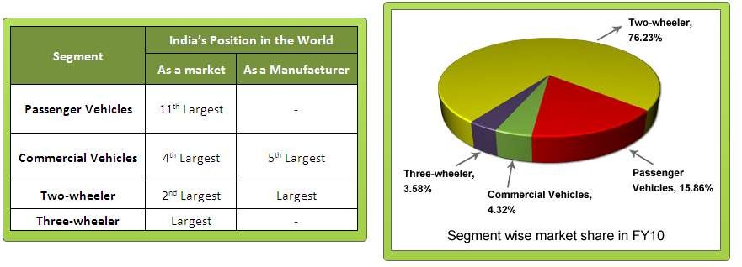

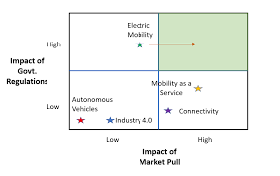
⦿ Legal system: Complex and time consuming legal system. Difficult to manage various legal disputes (Pegoraro, et al., 2020).
⦿ Poor Infrastructure: Poor roads can make foreign vehicles unfit to run in India. The poor road quality across the country has forced many foreign automobile company to quit manufacturing here. Harley Davidson is one such example.

⦿ Land acquisition: The rules and regulation regarding land acquisition is complex. Often leads to corruption.
⦿ Obtaining permits and government guidelines: Difficult to obtain various permits and frequently changing government guidelines.
⦿ Cultural barrier: Cultural difference. Less women in the work force. This might give rise to gender based discrimination at workplace.




⦿ The cheap labor should be availed at best to cut the labor cost in manufacturing. This could in turn lower the manufacturing cost of the vehicles.
⦿ The less environmental concern are also an advantage that require less post production management of waste materials. This also can cut the overall manufacturing cost (Michie, 2019).

⦿ The cultural barrier can be overcome by researching and gathering about Indian culture. It will help to manage the workforce.
⦿ Strategic risks can also be reduced by researching about the Indian market and referring to the previous example of foreign automobile companies that failed in Indian market. It will help save valuable resources of the company.

⦿ The cultural barrier should be overcome by proper understanding and research about the Indian culture and the five cultural aspects stated in Hofstede's theory
⦿ The foreign companies should well in advance deal with the legal formalities required as it could hinder manufacturing if any problem arises at a later stage.
⦿ The human resource potential needs to be tapped properly to be reflected in the sales and profit of the foreign company.


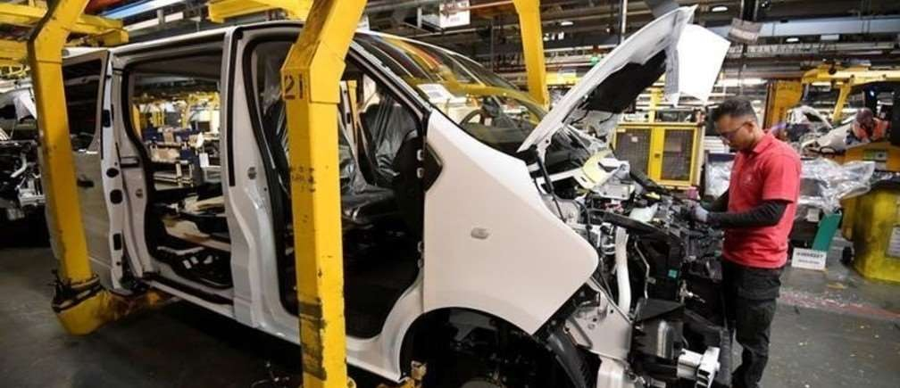
The foreign company that wishes to set up manufacturing in India needs to research the developing country where they want to do Business. They must know about the work culture and government regulations about that place to have to be working there.


⦿ Cramer, J., 2017. Corporate Social Responsibility
and Globalisation: an action plan for business. Routledge.
⦿ Kumar, K.S., Reddy, G.P. and Ramaiah, G., 2014.
The Importance Of Business Ethics In Globalisation-A Study. International Journal of Advancements in Research & Technology, 3(4), pp.285-298.
⦿ Michie, J. ed., 2019. The handbook of
globalisation. Edward Elgar Publishing.
⦿ Pegoraro, D., De Propris, L. and Chidlow, A., 2020. De-globalisation, value chains and reshoring. Industry, 4, pp.152-175.



