Blog 2:
What is the importance of a quad chart?

The quad chart is a highly effective tool when it comes to conveying complex information in a visually appealing manner that is easily understandable by your audience. This type of chart divides data into four distinct quadrants, as well as allowing you to convey more than one concept or dataset on a single slide due to the four distinct quadrants. Regardless of what industry you are working in, quad charts have proven to be an effective method for engaging your audience and communicating your message clearly and effectively. They are currently being used in businesses and marketing, research, and education.
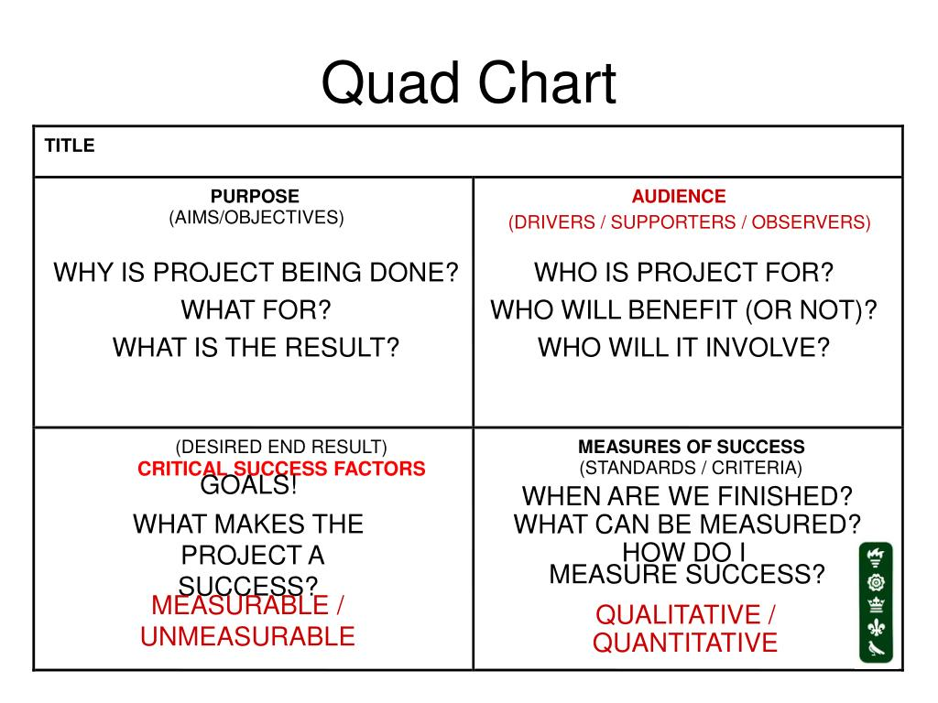

Reference: quad chart importance - Bing images

BMSW5009_SWAN
Adina Ghita
1914431

