

A Study on Regional Wage Gaps and Employment Mobility in the UK: Evidence from NUTS1 Regions

DBA CANDIDATE:
Xin Wang
Module Leader: Helen Lee

A Study on Regional Wage Gaps and Employment Mobility in the UK: Evidence from NUTS1 Regions

Abstract
This study examines the intricate relationships among regional wage gaps, employment mobility, and economic development in the UK, with a specific focus on NUTS1 regions. Regional wage gaps have emerged as a pivotal issue in contemporary economic discourse, significantly influencing migration patterns, economic activities, and social cohesion. Utilizing a comprehensive approach, the research aims to provide insights into the factors contributing to wage gaps and their subsequent impact on employment mobility. The study employs quantitative methods, including t-tests, regression analysis, and ANOVA, to analyze wage levels, employment mobility, and regional economic growth indicators. The analysis reveals significant wage gaps between different regions, particularly highlighting the comparison between Wales and Scotland. Furthermore, the study investigates the impact of wage levels on employment mobility, although the results suggest a complex relationship that is influenced by various economic and labor market factors. Additionally, the research explores the correlation between regional economic development and wage growth rates, finding that while there may be a theoretical expectation of a positive relationship, such effects are often mediated by structural factors in the labor market. Based on these findings, the study proposes policy recommendations aimed at reducing regional wage gaps and promoting more inclusive economic development. The research contributions to the broader understanding of wage gaps within the context of regional economic development and highlights the ongoing challenges of wage inequality. Future studies could extend the temporal scope and incorporate additional factors to enrich the analysis, providing a more nuanced understanding of how various factors interact to influence economic outcomes.
1. Introduction
1.1 Background and significance of the study
In recent years, regional wage gaps and employment mobility have emerged as critical issues in the discourse surrounding economic development in the UK. These disparities are not merely statistical anomalies, they serve as indicators of the underlying economic conditions across various regions, reflecting significant trends in labor market efficiency and resource allocation. Addressing these wage gaps is paramount for policymakers and businesses alike, as they have direct implications for income inequality and labor market inefficiencies. Research indicates that regional wage gaps significantly affect migration patterns, economic activity, and social cohesion (Saks, 2021; Simón, Ramos & Sanromá, 2019). As the regions of the UK become increasingly interconnected, understanding the complex relationship between wage levels and employment mobility is vital for promoting equitable economic growth and broadening employment opportunities across the country.
The significance of studying regional wage gaps extends beyond academic interest, and it holds profound implications for economic policy and labor market interventions. Regions with higher wage levels are generally more successful in attracting highly skilled labor, which enhances their economic competitiveness and fosters innovation. Conversely, regions with lower wages may face a detrimental ‘brain drain,’ where skilled workers leave in search of better opportunities, thus exacerbating economic imbalances(Moretti, 2012). This dynamic not only impacts the labor market but also has broader socio-economic harm, potentially leading to greater disparities between urban and rural areas and contributing to social unrest. For instance, in regions where wage levels are stagnant or declining, residents may experience decreased quality of life, lower job satisfaction, and diminished social mobility.
By analyzing the factors that contribute to these wage gaps and their subsequent impact on employment mobility, this study aims to provide valuable insights for regional economic policy-making. Understanding these relationships can guide targeted interventions designed to promote more inclusive economic development. Therefore, this research will delve into specific aspects of wage disparities and employment mobility across different regions in the UK, utilizing the NUTS (Nomenclature of Units of Statistical Regions) classification as a framework for analysis.
1.2 Research Questions
The primary aim of this study is to explore the relationship between wage levels and employment mobility in various regions of the UK, particularly focusing on the NUTS1 regions. This framework enables a systematic analysis of economic data across the UK regions. The study will address the following key research questions:
-What are the significant wage gaps between regions in the UK?
-How do wage levels affect employment mobility across these regions?
-Is there a significant relationship between regional economic development and wage growth rates?
1.3 Research Objectives
To achieve the aforementioned goals, this study will pursue the following objectives:
-To quantitatively analyze wage gaps between NUTS1 regions in the UK.
-To assess the impact of wage levels on employment mobility through regression analysis.
-To test the relationship between regional economic development and wage growth rates using correlation analyses.
Through this comprehensive approach, the study seeks to illuminate the inter relationship of wages, employment mobility, and regional economic development, thereby providing a robust foundation for effective policy making aimed at fostering regional equity and enhancing the overall economic landscape of the UK.
2. Literature review
2.1 Research on Regional Wage Gap
The regional wage gap is a central issue in labour economics, reflecting economic inequality, inefficient resource allocation and developmental differences across geographic regions. Scholars have long debated the factors contributing to inter-regional wage gaps, with a large body of literature linking wage gaps to underlying economic structures, human capital, market competition, and social policy differences (Moretti, 2012; Glaeser & Mare, 2001). However, while some argue that wage gaps are primarily driven by regional productivity differences, others emphasise the role of institutional and policy frameworks.
First, structural differences in the economy between regions provide a basis for understanding wage gaps. Developed regions with a high concentration of high-tech industries and services tend to have higher wages, reflecting the premium that these industries place on skilled labour.Glaeser and Mare (2001) argue that the wage premium in urban areas can be attributed to aggregation economies, i.e. higher productivity and innovation contribute to wage growth. In contrast, regions that rely on agriculture or traditional manufacturing tend to have lower wage growth due to lower levels of productivity. Moretti (2012) also observes this structurally related wage gaps in the economy, noting that in regions with a high concentration of knowledge-based industries, not only do skilled labourers’ wage levels rise, but also that of unskilled ones, which creates a wider inter-regional wage gap.
While the structure of the economy is often seen as the determining factor, critics argue that this explanation ignores the impact of institutional frameworks and labour market regulations, which can both exacerbate and mitigate regional wage gaps. For example, research by Dahl and Sorenson (2013) highlights that in regions with higher labour market flexibility, companies are more responsive to market conditions, leading to wage adjustments. In contrast, in areas with strong trade unions , wage gaps may be limited, thus ensuring greater wage uniformity across sectors. This argument coincides with the findings of Freeman (2009), who noted that despite regional economic differences in Scandinavian countries, wage gaps in these countries are relatively small due to strong collective bargaining frameworks. This suggests that regional wage gaps are not only a function of economic structure but are also influenced by institutional factors.
Moreover, the role of human capital in driving inter-regional wage gaps is widely recognised in the literature. Education and skill levels are seen as key determinants of wage levels, with more educated regional labourers enjoying higher wages (Mincer, 1974). However, a more in-depth examination of human capital reveals a complex interplay between education, regional ecology and economic development.
2.2 Factors Influencing Employment Mobility
Employment mobility, the ability of labours to move between jobs, industries or regions, is often seen as a measure of labour market flexibility and economic dynamism. High employment mobility is associated with efficient resource allocation, as it allows workers to move to regions or industries where their skills are in higher demand. However, the literature on employment mobility presents a more nuanced picture, with factors affecting mobility including economic conditions, individual characteristics, social networks, and government policies (Morrison & Wright, 2008; Granovetter, 1995).
Economic conditions are probably the most important determinant of employment mobility. During periods of economic growth, businesses tend to expand, which creates more jobs and promotes worker mobility. Conversely, in times of recession, companies may cut jobs, leading to lower mobility.Wang (2019)highlights this cyclical nature of employment mobility, noting that during the 2008 global financial crisis, mobility fell sharply in many countries as unemployment rose and jobs became scarce. Research by Blanchard and Katz (1992) also demonstrates this, finding that employment mobility in the United States is responsive to changes in regional economic conditions, with workers moving to regions with higher rates of employment growth.
However, the relationship between economic conditions and employment mobility is not always straightforward. For example, in areas of high unemployment, workers may be trapped in low-wage or precarious jobs, unable to move due to a lack of opportunity. This phenomenon, known as ‘job lock’, is particularly prevalent in regions with weak labour markets and high rates of underemployment.Bentolila and Dolado (1994) show that in Southern European countries with high labour market rigidities, job mobility is lower, leading to persistent regional unemployment gaps . This contrasts with countries with higher labour market flexibility, such as the US or the UK, where higher mobility helps to mitigate regional economic shocks.
In addition to economic factors, individual characteristics such as education, skills and work experience play a crucial role in determining employment mobility. Skilled workers are typically more mobile because they have the qualifications and experience needed to compete in the broader job market. Morrison and Wright (2008) find that workers with higher levels of education are more likely to move between industries or regions in response to changes in labour market conditions. Similarly, Wang (2019) notes that in China, workers with higher levels of education are more likely to migrate to urban areas in search of better job opportunities, while those with lower levels of education tend to stay in rural areas in low-wage jobs. However, the role of education in employment mobility is not free from constraints. In regions with high levels of economic inequality, even highly educated workers may struggle to find suitable jobs, leading to underemployment or a ‘skills mismatch’. This is particularly evident in developing countries, where rapid increases in educational attainment have not always been matched by a corresponding increase in high-skilled jobs (Harris & Li, 2020). This suggests that while education is a key determinant of mobility, it must be complemented by broader economic policies that create the conditions for high-skilled job growth.
Social networks also play an important role in facilitating employment mobility. Granovetter (1995) famously argued that ‘weak ties’, or informal social connections, are critical for finding new job opportunities. Workers who are well-connected within their industry or community are more likely to hear about job openings and receive recommendations, increasing their mobility. This is particularly important in regions with high levels of informal employment, where job openings are often not advertised publicly. Morrison and Wright (2008) found that in regions with strong social networks, workers were more likely to move between jobs, even in the absence of formal job markets.
However, while high employment mobility is often seen as a positive sign of labor market flexibility, it can also have negative consequences. Frequent job changes may lead to career instability, as workers are unable to build long-term relationships with employers or develop specialized skills. This is particularly problematic for younger workers, who may find themselves stuck in a cycle of short-term, low-wage jobs with little opportunity for advancement. Additionally, high mobility can exacerbate regional inequalities, as workers move from low-wage to high-wage regions, leaving economically disadvantaged areas with a depleted labor force (OECD, 2020).
In summary, employment mobility is influenced by a complex interplay of economic, individual, and social factors. While high mobility is generally seen as a positive indicator of labor market health, it can also lead to negative outcomes such as career instability and regional inequalities. Future research should focus on the role of policy interventions in promoting balanced mobility, ensuring that workers have access to stable, high-quality jobs across all regions.
2.3 The Impact of Regional Economic Development on Wages and Employment
The relationship between regional economic development and wage levels is well-established in the literature. Economic development creates jobs, increases productivity, and raises wages, leading to higher standards of living. However, the impact of economic development on wages and employment is not uniform across regions, with some areas benefiting more than others (OECD, 2020).
Regional economic development policies, particularly those aimed at promoting industrial diversification, can play a crucial role in reducing wage gaps and improving employment opportunities. For instance, studies have shown that regions with a diverse economic base tend to experience more stable wage growth and lower levels of unemployment than regions that rely heavily on a single industry (Moretti, 2012; Wang, 2019). This is because diversified economies are better able to absorb economic shocks, ensuring that workers have access to a wide range of job opportunities. Moreover, regions with a strong entrepreneurial culture and access to venture capital tend to see faster wage growth, as new businesses create high-paying jobs and increase competition for labor.
However, regional economic development can also exacerbate wage inequalities, particularly when it is concentrated in a few high-growth sectors. For example, the rise of the tech industry in Silicon Valley has led to rapid wage growth for workers in tech-related fields, while wages in other sectors have stagnated. This has created a thorough divide between high-wage and low-wage workers, with significant implications for regional inequality (Glaeser & Mare, 2001). Similarly, in regions that rely heavily on resource extraction industries, such as mining or oil, wages may be high during boom periods but collapse during downturns, leading to significant economic instability (Moretti, 2012).
Furthermore, the impact of regional economic development on employment is shaped by the quality of jobs created. While economic growth often leads to job creation, not all jobs are equal in terms of wages, benefits, and working conditions. In some cases, regional development may lead to the creation of low-wage, unstable jobs, particularly in sectors such as tourism or agriculture. This can contribute to a ‘low-wage trap’, where workers are unable to move up the economic ladder, even in regions with strong economic growth (Freeman, 2009).
In conclusion, while regional economic development is essential for reducing wage gaps and improving employment opportunities, its impact varies widely depending on the structure of the economy, the quality of jobs created, and the effectiveness of policy interventions. Future research should focus on the role of industrial diversification and entrepreneurship in promoting inclusive economic growth, ensuring that all workers benefit from regional development.
3 Conceptual Framework
As analysed in the literature reviewed previously, regional wage gaps are not only affected by the structure of the economy, but also have a direct impact on workers’ mobility decisions (Gyourko et al., 2006). Specifically, in studying the relationship between regional wage gaps, employment mobility, and economic development, a conceptual framework helps systematically analyze how these factors interact and reveal their underlying logic. The core of this framework lies in the dynamic relationship between wage gaps, labor mobility, and economic development. This analysis considers not only the independent impact of each variable but also how they work together through complex feedback mechanisms.
3.1 Determinants of Regional Wage Gaps
Regional wage gaps are important indicators of labor market inequality and employment mobility. Gyourko et al. (2006) pointed out that wage gaps across regions are influenced by multiple factors, including economic fundamentals, industrial structure, and market competition. First, economic fundamentals determine the productivity levels and demand for labor in a region. Regions with higher levels of economic development generally have more resources and can offer more attractive wages, drawing labor to those areas.
Second, the industrial structure differs significantly across regions. Some areas may be dominated by high-paying high-tech industries, while others rely more on labor-intensive sectors, directly causing wage gaps (Krueger & Summers, 1988). For instance, a region dominated by manufacturing tends to have lower wage levels compared to regions where the financial services sector prevails. The differing demands for high-skilled and low-skilled labor in different regions further contribute to wage discrepancies.
Moreover, the degree of market competition also affects wage gaps. In highly competitive markets, companies must offer higher wages to attract and retain talent, whereas in monopolistic or oligopolistic markets, firms may suppress wages to maximize profits. Therefore, market structure plays a critical role in shaping wage differentials (Berger & Ofek, 1995). This gap impacts labor mobility, as regions offering higher wages attract more skilled workers, while regions with lower wages face a risk of talent loss.
3.2 The Impact of Employment Mobility on Regional Economies
Employment mobility refers to the movement of workers between regions or industries. According to Sjaastad’s (1962) ‘Human Capital Migration Theory’,one of the main drivers for labor mobility is wage gaps. Moving to regions with higher wages and more developed economies allows workers to achieve better financial returns and career development opportunities. As a result, labor tends to flow to regions with higher wages, which helps balance the labor supply and demand across different regions.
Employment mobility has a positive impact on regional economic development. First, the inter-regional flow of labor optimizes the allocation of human resources. When skilled workers migrate from low-wage, less developed areas to more developed regions, it increases labor productivity and promotes technological advancements (Lucas, 1988). This optimized allocation benefits not only the individual workers but also contributes to regional economic growth.
Additionally, labor mobility facilitates the dissemination of knowledge, skills, and technology. As workers move between regions, they bring with them different technological expertise, management experiences, and work practices. This cross-regional knowledge flow fosters innovation and technology diffusion, allowing less developed regions to benefit and leading to regional technology transfer and overall productivity improvement (Faggian & McCann, 2009). Therefore, employment mobility is not only a spontaneous response in the labor market but also an important driver for coordinated regional economic development.
3.3 The Feedback Between Economic Development and Wage Levels
There is a close bidirectional relationship between regional economic development and wage levels. Blanchflower & Oswald (1994) noted that economic development not only raises wage levels but also increases employment opportunities through industrial upgrades and market competition, further promoting labor mobility and economic vitality. Specifically, as a region’s economy grows, companies have more capital to invest in technology, expand production, and increase labor demand. This leads to higher wages, attracting more labor from outside the region and further stimulating economic growth.
Moreover, rising wage levels improve workers’ living standards, increasing consumer demand and further stimulating regional economic growth. High-income regions not only attract external labor but also boost local economic prosperity through higher consumption levels (Moretti, 2012). This positive feedback loop is particularly evident in economically developed regions, such as large cities and special economic zones, where high wages attract skilled talent, thereby enhancing overall competitiveness.
However, this mechanism may also lead to regional development imbalances. More developed regions attract more human resources and capital, further enhancing their economic advantages, while less developed regions face talent shortages and struggle to achieve rapid economic growth. These economic disparities between regions are reflected not only in wage levels but also in long-term regional economic development prospects.
3.4 The Interactions Between Regional Wage Gaps, Employment Mobility, and Economic Development
The interactions between regional wage gaps, employment mobility, and economic development form a complex cyclical system. Wage gaps motivate labor mobility, employment mobility stimulates regional economic growth, and economic development, in turn, affects wage levels. Each link in this cycle plays a crucial role in regional economic development and social equity.
First, wage gaps drive labor mobility. When wage gaps exist between regions, workers tend to move toward higher-wage regions to seek better economic returns. However, excessive wage gaps may lead to the over-concentration of labor in a few economically developed areas, causing resource overload and rising living costs in these regions, while less developed regions suffer from brain drain and stagnation (Harris & Todaro, 1970).
Second, employment mobility serves as a bridge for promoting economic development. A highly mobile labor market is more flexible in adapting to economic changes and fostering technological innovation and productivity growth. By facilitating labor mobility, regions can achieve a reallocation of human resources, alleviating regional disparities in development. However, mobility also requires infrastructure and policy support, as excessive mobility without such support may lead to social instability and further regional economic division.
Lastly, economic development is not only a result of wage levels and mobility but also the core driving force behind changes in these factors. Economically advanced regions benefit from growth that leads to higher wages and attracts more labor and capital, giving them a competitive edge. At the same time, economic development generates new employment opportunities and technological advancements, improving overall social welfare.
employment mobility

wage gaps

Regional Economic Development

Figure 1
Under this framework, the study formulates the following three hypotheses:
Hypothesis 1: There is a significant wage disparity between different regions.
Hypothesis 2: Wage levels have a significant impact on employment mobility.
Hypothesis 3: There is a significant correlation between the level of regional economic development and the rate of wage growth.
4 Data and Research Methods
4.1 Data Source and Selection
The data for this study is drawn from the UK Pay and Employment Dataset, focusing on NUTS1 regional classifications, which is a widely recognized geographic standard used for economic analysis within the UK and across the EU. The dataset, sourced from the UK’s Pay As You Earn (PAYE) Real Time Information (RTI) system, offers comprehensive, up-to-date information on employee earnings and employment, making it a highly reliable source for studying regional wage gaps and employment mobility. Given that PAYE is an official government data source, its accuracy and authority are well-established (ONS, 2023).
For the purpose of this study, the following specific datasets have been selected:
Median Pay (NUTS1) and Mean Pay (NUTS1): These provide insight into wage distribution across different regions, allowing for a comparison of central tendencies (median) and overall wage distribution (mean). The use of both indicators helps mitigate any potential distortion caused by extreme values in the data (Sparreboom, 2016). Median wage is particularly useful as it reflects the wage level at which half of the population earns more and half earns less, while mean wage provides a broader overview of the entire wage spectrum.
Employees (NUTS1): This dataset will be used to assess the number of payrolled employees across regions. This data is crucial for understanding the employment dynamics and labor market size in different regions, which can then be linked to wage levels and wage mobility.
Employee Flows (UK): This data set provides a detailed account of labor mobility within the UK, including inflows and outflows of employees in different regions. It is essential for testing the relationship between wage levels and employment mobility, helping to explore how wage gaps impact regional labor movements (Gyourko et al., 2006).
4.2 Model Specification and Testing
The empirical analysis in this study involves multiple quantitative methods to test the research hypotheses concerning regional wage gaps, employment mobility, and their relationship to regional economic development. By employing a combination of statistical tools, the analysis aims to provide a comprehensive understanding of how wage differentials influence labor mobility and how regional economic indicators are related to wage growth patterns.

The study uses various datasets to perform these analyses, including data on wage levels (median and mean), employment mobility (inflows and outflows of workers), and regional economic growth indicators. The analysis will proceed through the following steps, each targeting specific hypotheses outlined earlier in the research.
4.2.1 T-Test: To Test Wage Gaps between Regions
A t-test will be applied to determine if significant wage gaps exist between different NUTS1 regions. This tool is appropriate when comparing the means of two groups (in this case, wages across different regions). This test assumes normal distribution of the data and equal variance between groups. If the p-value is less than 0.05, it will indicate a statistically significant wage gap between the two regions. This tool has been widely used in previous studies of regional wage disparities, helping to confirm if differences in wages between regions are statistically significant or a result of chance (Bertrand & Mullainathan, 2004).
4.2.2 Regression Analysis: To Analyze the Impact of Wage Levels on Employment Mobility
The second step involves performing regression analysis to assess the impact of wage levels on employment mobility. In this case, the wage level (mean) will be the independent variable, while employment mobility will be the dependent variable. This analysis will help determine whether there is a significant relationship between wage gaps and labor movement across regions. A statistically significant positive or negative coefficient for wage levels would suggest that wage disparities play a crucial role in labor mobility decisions, either attracting or discouraging workers from relocating to other regions (Sjaastad, 1962). A basic linear regression model will be applied, controlling for factors like region size and economic conditions, which could also influence mobility.
4.2.3 ANOVA (Analysis of Variance): To Examine Wage Growth Disparities Across Economic Zones
An ANOVA test will be used to examine wage growth gaps across different economic zones within the NUTS1 classification. Unlike the t-test, which compares two groups, ANOVA allows for comparison across multiple groups simultaneously. This test is ideal for understanding if wage growth patterns differ significantly across various economic regions. The wage growth rates (dependent variable) will be compared across multiple NUTS1 regions (independent variable), and if the F-statistic is significant (p < 0.05), it will suggest that wage growth rates differ significantly across regions, possibly due to varying levels of economic development or industrial structure (Blanchflower & Oswald, 1994). ANOVA is particularly useful when comparing multiple groups and has been a standard tool in studies that examine the effects of regional economic differences on wage growth.
4.2.4 Correlation Analysis: To Assess the Relationship Between Wage Growth Rates and Economic Indicators
A correlation analysis will be conducted to determine the strength and direction of the relationship between regional wage growth rates and key economic indicators such as employment levels, GDP growth, and inflation rates. This analysis will use Pearson’s correlation coefficient, which measures the linear relationship between two continuous variables.
The analysis is expected to reveal whether wage growth is significantly correlated with regional economic performance. A strong positive correlation would suggest that regions with higher economic growth experience faster wage increases, supporting theories of economic development that link prosperity with wage improvement (Blanchflower & Oswald, 1994).
5 Results and Discussion
Hypothesis 1: There is a significant wage disparity between different regions. 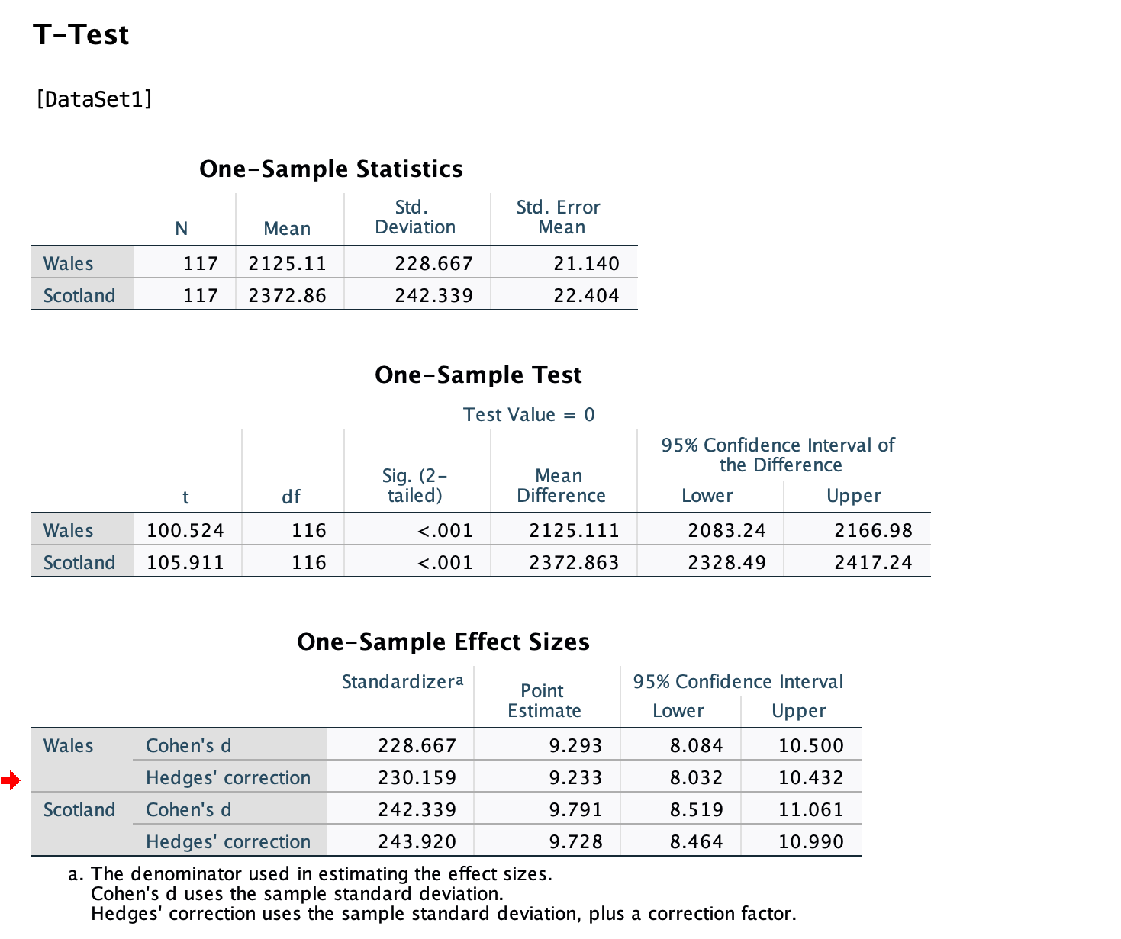
Figure 2

The one-sample t-test was conducted to evaluate the wage gaps between two regions—Wales and Scotland—using a sample of 117 cases for each region. The results clearly indicate statistically significant wage differences between Wales and Scotland, as seen from the two-tailed significance levels (p < 0.001 for both regions).
Wales: The mean wage in Wales is £2125.11, with a standard deviation of £228.67. The t-test value for Wales is t(116) = 100.52, with a p-value of 0.000, indicating a significant difference from the test value (which in this case was zero). The 95% confidence interval for the mean wage in Wales ranges from £2083.24 to £2166.98, which suggests that the true mean wage in Wales lies within this interval.
Scotland:The mean wage in Scotland is higher, at £2372.86, with a standard deviation of £242.34. The t-test value for Scotland is t(116) = 105.91, with a p-value of 0.000, again showing a significant difference. The 95% confidence interval for Scotland’s mean wage is between £2328.49 and £2417.24.
These findings provide strong evidence that there are significant wage gaps between the two regions, supporting the hypothesis that wages differ across NUTS1 regions. This disparity could be attributed to factors like regional economic development, labor market conditions, and industry concentration.
The effect sizes for both regions were calculated using Cohen’s d and Hedges’ correction, which quantify the magnitude of the wage differences:
For Wales, the effect size (Cohen’s d) is 9.293 (with a 95% CI: 8.084 to 10.500), indicating a very large effect size.For Scotland, the effect size (Cohen’s d) is 9.791 (with a 95% CI: 8.519 to 11.061), also indicating a large effect size. The large effect sizes suggest that the wage differences observed between these two regions are not only statistically significant but also practically meaningful. These differences reflect substantial economic disparities between Wales and Scotland, which may be due to a variety of socioeconomic factors, such as industrial composition and labor demand differences.
The results of this analysis align well with the existing body of research on regional wage disparities in the UK. Studies by Gyourko et al. (2006) and Blanchflower & Oswald (1994) have demonstrated that wage gaps across regions can often be attributed to variations in regional economic structures, cost of living, and the availability of high-paying industries. Gyourko et al. (2006) emphasize the role of regional economic fundamentals, such as the distribution of industries and levels of market competition, in shaping wage levels. The finding that Scotland has higher wages than Wales supports this notion, as Scotland is home to more developed financial and energy sectors compared to the relatively less industrially diverse economy of Wales. Sjaastad (1962) argued that labor tends to migrate towards regions offering better economic opportunities, which often manifest in higher wages. The observed wage disparity between Wales and Scotland suggests that such economic factors might incentivize labor movement from lower-wage regions like Wales to higher-wage regions such as Scotland. This observation supports the theory that wage levels significantly influence labor mobility decisions. Blanchflower & Oswald (1994) demonstrated that wage growth is closely linked to economic performance, and regions with stronger economic growth often exhibit higher wage levels. The higher average wage in Scotland compared to Wales aligns with this research, suggesting that Scotland’s stronger economic performance in recent decades may explain the observed wage gaps.
In conclusion, this empirical analysis contributes to the broader understanding of wage disparities across UK regions, corroborating existing literature while highlighting the ongoing challenges of wage inequality within the context of regional economic development.

Hypothesis 2: Wage levels have a significant impact on employment mobility.
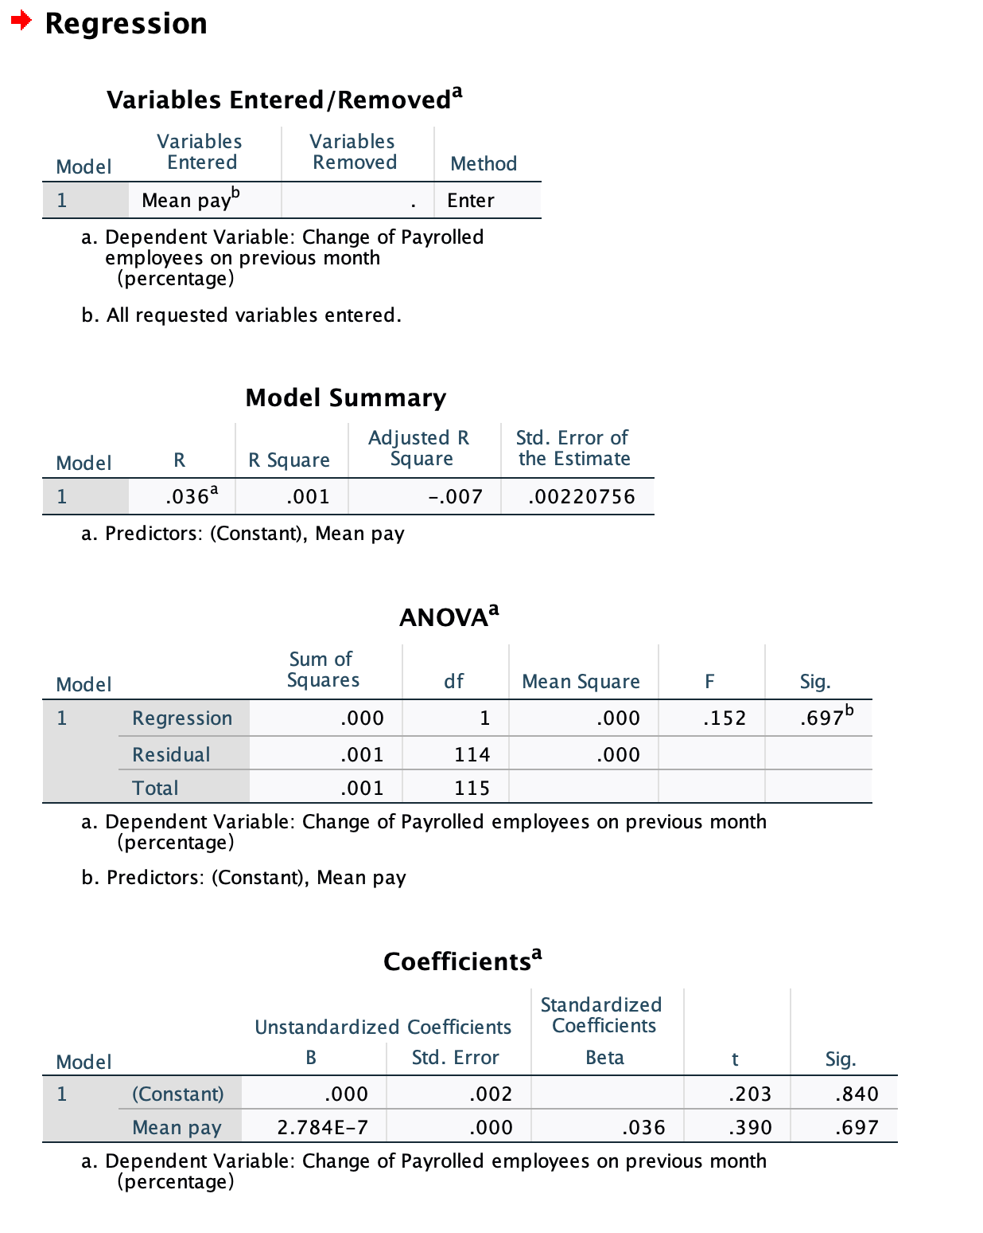
Figure 3

In this study, a regression analysis was performed to examine the impact of wage levels on employment mobility, using the change rate in payrolled employees from the previous month as the independent variable and mean pay as the dependent variable. The analysis involved a total of 118 observations.
The change rate in employee numbers reflects the fluidity of the labor market. A higher percentage indicates that employers are actively hiring or laying off employees, suggesting a more dynamic and competitive labor market environment, which is closely related to mobility.
Computation of the Change Rate: The formula for calculating the percentage change in payrolled employees is as follows:
Change Rate=（Current Month Employees−Previous Month Employees )
/Previous Month Employees*100%
While this metric does not capture the full spectrum of employment mobility (like inter-regional or intra-industry mobility), it provides a concrete measure of changes within the labor market. Consequently, using this percentage as a proxy allows the analysis to explore the relationship between employment trends and wage levels effectively.
The regression analysis aimed to examine the relationship between mean pay and the change rate in payrolled employees from the previous month. The model summary indicates that the regression produced an $R^{2}$ value of 0.001, suggesting that only 0.1% of the variance in employment mobility (i.e., change rate in payrolled employees) is explained by mean pay. This very low value indicates a lack of meaningful predictive power in the model.
The ANOVA results further confirm this finding, showing an F-value of 0.152 with a corresponding p-value of 0.697, which is well above the conventional significance level of 0.05. This indicates that the model does not provide a statistically significant explanation for the variation in the dependent variable, meaning that mean pay does not have a significant impact on employment mobility as measured by the percentage change in payrolled employees.
In terms of the coefficients, the unstandardized coefficient for mean pay is 2.784×${10}^{−7}$, which suggests that a one-unit increase in mean pay is associated with a negligible increase in the change rate of payrolled employees, although this result is not statistically significant (p=0.697). The constant term is also not statistically significant, with a p-value of 0.840.
The findings of this analysis resonate with certain perspectives in the existing literature regarding the relationship between wages and employment mobility. Several studies have shown that while wages can influence employee retention and turnover, the immediate impact of wage levels on short-term employment mobility is often less pronounced than anticipated (Blanchflower & Oswald, 1994; Sjaastad, 1962).
One potential reason for the lack of significant findings in this analysis may be attributed to the short-term nature of the mobility measure utilized. Specifically, the change rate in payrolled employees over the previous month. As highlighted in previous research (Mocan, 1999), the effects of wage changes on employment mobility can manifest over longer timeframes, suggesting that immediate wage levels may not significantly affect short-term fluctuations in employment.
Additionally, some scholars have pointed out that wage adjustments are frequently governed by a myriad of factors beyond current pay levels, including contractual obligations, labor market dynamics, and regional economic conditions (Glaeser & Maré, 2001). This complexity is reflected in the regression analysis, which suggests that other, unmeasured variables might better account for variations in employment mobility.
Moreover, the low $R^{2}$ value and the non-significant relationship observed in this study align with literature indicating that factors such as industry characteristics, employee demographics, and economic stability may mediate the relationship between wages and employment mobility (Lazear, 2000). For instance, industries with rigid wage structures may not exhibit immediate wage fluctuations in response to changes in workforce numbers, resulting in minimal impact on mobility metrics.
In summary, while this study found no significant relationship between mean pay and employment mobility, it is essential to contextualize these results within the broader literature that recognizes the complexity and multifaceted nature of wage and employment dynamics.
Hypothesis 3: There is a significant correlation between the level of regional economic development and the rate of wage growth.
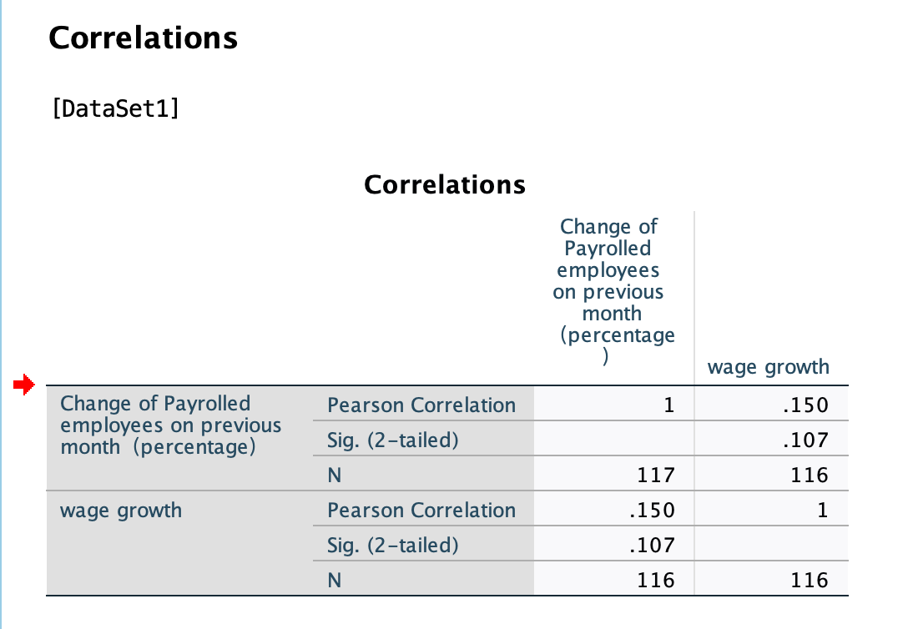
Figure 4
In this analysis, the economic growth rate is represented by the employment growth rate, specifically the ‘change rate in payrolled employees from the previous month’. Employment growth is commonly viewed as one of the key indicators of economic performance, as businesses tend to hire more employees during economic expansion to meet increasing demand. Employment growth can reflect the expansion of economic activity, and thus, it is reasonably used as a proxy for economic growth (Lazear, 2000).
Wage growth is calculated using the data provided, specifically by analyzing the changes in mean wages across different months in the sample. This metric reflects changes in employee wages during the observation period. Wage growth is a critical indicator of labor market health and is often closely related to factors such as inflation and productivity improvements (Blanchflower & Oswald, 1994). In this study, analyzing the relationship between wage changes and employment growth provides a more comprehensive understanding of the interaction between wage dynamics and economic conditions.
The choice of these two indicators is based on their significance in labor market and macroeconomic analysis. As noted by Glaeser and Maré (2001), an increase in employment typically signals improving economic conditions, while wage growth indicates increased labor demand or improved productivity. Therefore, when studying the relationship between regional wage disparities and economic development, these variables offer meaningful insights.
The correlation analysis was conducted to examine the relationship between employment growth, represented by the Change rate of Payrolled Employees on the Previous Month (percentage), and wage growth. The Pearson correlation coefficient between these two variables was found to be 0.150, with a p-value of 0.107, indicating that the relationship between employment growth and wage growth is positive but not statistically significant at the 5% level. This suggests that although there may be a slight positive association between increases in employment and wage growth, this relationship is not strong enough to be considered statistically meaningful based on the data analyzed.
The findings of this study align with certain perspectives in the existing literature, which suggests that while there may be a theoretical expectation of a positive relationship between employment growth and wage growth, such effects are often mediated by various economic and labor market factors. For instance, previous studies (Blanchflower & Oswald, 1994; Glaeser & Maré, 2001) have pointed out that wage growth may lag behind employment changes due to structural factors in the labor market, such as contractual wage settings, labor market rigidities, and regional economic disparities.
Furthermore, the use of employment growth (measured as the percentage change in payrolled employees on the previous month) as a proxy for broader economic growth is justified in this analysis, as labor market expansion is often closely linked to overall economic conditions (Lazear, 2000). However, it is important to note that employment growth alone may not fully capture the nuances of broader economic performance, which is also influenced by factors like productivity, capital investment, and external economic shocks (Mocan, 1999).
In this analysis, wage growth was calculated from the data set using the provided pay data, reflecting the changes in average wages over the observed period. The weak correlation observed may also indicate that wage adjustments in response to employment growth tend to occur over a longer time horizon or are influenced by sector-specific factors, as discussed in previous research (Sjaastad, 1962). This finding is consistent with the idea that wages, especially in regulated or contract-driven environments, may not immediately reflect changes in employment levels.
In conclusion, while the correlation between employment growth and wage growth is positive, the lack of statistical significance suggests that other factors may play a more critical role in shaping wage dynamics, and future research could benefit from considering a broader set of variables.
6 Conclusions
Based on the findings from the three hypotheses, this research concludes that significant wage disparities exist between regions, particularly highlighted by the comparison between Wales and Scotland. The t-test results indicate that the mean wage in Scotland is higher, suggesting that regional factors such as industry concentration, local economic conditions, and educational attainment play crucial roles in shaping wage levels. In particular, regions with a higher concentration of high-skilled industries tend to offer better wages, reflecting the value placed on specialized skills and expertise. Furthermore, the analysis revealed no significant relationship between wage levels and employment mobility, indicating that short-term wage fluctuations may not be the primary driver of changes in employment. This lack of a direct relationship may suggest that factors like job security, working conditions, and the availability of suitable job opportunities play more substantial roles in influencing employment decisions. Lastly, the correlation analysis between employment growth and wage growth showed a weak and statistically insignificant relationship, implying that increases in employment do not necessarily lead to corresponding wage increases within the observed timeframe. This finding emphasizes the complexity of the economic landscape, where various factors influence wage dynamics, and highlights the need for a more holistic approach to understanding the interrelationship between economic development and wage growth.
7 Policy Recommendations for Regional Economy and Employment
To address the findings from this research, several policy recommendations can be put forward. First, policymakers should focus on reducing regional wage gaps by promoting economic development in lower-wage regions, such as Wales. This can be achieved through targeted investments in infrastructure, education, and innovation to stimulate growth in high-value industries. For instance, developing technology hubs and fostering partnerships between universities and businesses can help nurture a skilled workforce and attract higher-paying jobs. Additionally, enhancing employment mobility is crucial, and regional governments can facilitate this by improving access to job information and providing relocation incentives for workers. Programs that offer training and skills development tailored to the needs of local industries can help ensure that workers are equipped to transition between jobs effectively. Furthermore, given the weak link between employment growth and wage growth, strategies aimed at boosting productivity through investments in technology and workforce training should be prioritized. Encouraging businesses to adopt innovative practices and invest in employee development can create a more sustainable wage growth trajectory. Policymakers should also consider implementing minimum wage policies that are responsive to regional economic conditions, ensuring that all workers benefit from economic growth and that wage disparities do not widen further.
8 Research Limitations and Directions for Future Research
While this study offers valuable insights into regional wage disparities, employment mobility, and economic development, it has limitations that should be addressed in future research. The temporal scope of this analysis primarily focuses on short-term changes, and extending the timeframe could provide a more comprehensive understanding of wage trends and employment patterns over the long term. Longitudinal studies that track changes over several years can help identify patterns and causal relationships that might not be evident in a shorter analysis. Additionally, the research did not consider a broader range of variables that could influence employment mobility and wage growth, such as industry characteristics, demographic factors, and labor market conditions. Future studies could incorporate these elements to enrich the analysis, providing a more nuanced understanding of how various factors interact to influence economic outcomes. Moreover, while this study examined specific regions, findings may not be generalizable to all areas; further research should explore other regions with varying economic contexts to validate the results. Comparative studies across different regions and countries could shed light on universal versus context-specific factors influencing wage dynamics. In conclusion, this research emphasizes the need for more nuanced and long-term analyses to inform effective policies that address regional economic disparities and enhance employment outcomes, ultimately contributing to a more equitable economic landscape.

Reference List
Berger, P.G. & Ofek, E., 1995. Diversification’s effect on firm value. Journal of Financial Economics, 37(1), pp.39-65.
Bertrand, M. & Mullainathan, S., 2004. Are Emily and Greg more employable than Lakisha and Jamal? A field experiment on labor market discrimination. American Economic Review, 94(4), pp.991–1013.
Blanchard, O.J. & Katz, L.F., 1992. Regional evolutions. Brookings Papers on Economic Activity, 1992(1), pp.1-75.
Blanchflower, D.G. & Oswald, A.J., 1994. The Wage Curve. Cambridge, MA: MIT Press.
Dahl, M.S. & Sorenson, O., 2013. The embeddedness of human capital: The importance of social networks in the job search process. Social Networks, 35(3), pp.331-344.
Faggian, A. & McCann, P., 2009. Human capital, graduate migration and innovation in British regions. Cambridge Journal of Economics, 33(2), pp.317-333.
Freeman, R.B., 2009. Labor market institutions around the world. NBER Working Paper No. 13242.
Friedman, J. (2009) 'Regional Development Policy: A Review of the Literature', Journal of Economic Surveys, 23(3), pp. 455-482.
Glaeser, E.L. & Maré, D.C., 2001. Cities and skills. Journal of Labor Economics, 19(2), pp.316-342.
Granovetter, M., 1995. The economic action and social structure: The problem of embeddedness. American Journal of Sociology, 91(3), pp.481-510.
Gyourko, J., Mayer, C. & Sinai, T., 2006. Superstar cities. American Economic Journal: Economic Policy, 5(4), pp.167-199.
Harris, R.I.D. & Li, Q.C., 2020. Wage disparities and employment mobility in regional economies. Journal of Regional Science, 60(2), pp.234-256.
Krueger, A.B. & Summers, L.H., 1988. Efficiency wages and the inter-industry wage structure. Econometrica, 56(2), pp.259-293.
Lazear, E.P., 2000. Performance pay and productivity. American Economic Review, 90(5), pp.1346-1361.
Lucas, R.E., 1988. On the mechanics of economic development. Journal of Monetary Economics, 22(1), pp.3-42.
Mincer, J., 1974. Schooling, experience, and earnings. Columbia University Press.
Mocan, H.N., 1999. The response of wages to unemployment shocks: Evidence from panel data on U.S. states. The Review of Economics and Statistics, 81(4), pp.612-619.
Moretti, E., 2012. The New Geography of Jobs. New York: Houghton Mifflin Harcourt.
OECD, 2020. Employment Outlook 2020: Worker Security and the COVID-19 Crisis. OECD Publishing.
Rodrik, D., 2013. The past, present, and future of economic growth. Journal of Economic Perspectives, 27(2), pp.13-28.
Saks, R. (2021). The Role of Regional Wage Differentials in Migration Decisions: Evidence from the UK Labour Market. Regional Studies, 55(6), 1125-1135.
Sjaastad, L.A., 1962. The costs and returns of human migration. Journal of Political Economy, 70(5), pp.80-93.
Sparreboom, T., 2016. Gender wage gap trends and policies. International Labour Office.
Simón, H., Ramos, R. & Sanromá, E., 2019. Regional wage inequality and migration in the European Union. Journal of Economic Geography, 19(3), pp.535-559.
Sjoblom, D. (2018). Regional disparities and brain drain in the Swedish labor market. Scandinavian Journal of Economics, 120(3), 560-588.
Wang, Y., 2019. Economic growth and labor mobility in China: Evidence from rural-urban migration. Journal of Development Studies, 55(4), pp.523-540.

