
Project submitted as part of the requirements for the award of BSc (Hons) Computing (Applied Computing)
April 21, 2023
To investigate if bespoke food service applications supersede online food delivery marketplaces- A case study.
by Ellie Rhodes
supervisor: John Williams
second marker: Andrew Green

Abstract
It is predicted online ordering food revenue will grow to 210 billion pounds within 2023, Statista (37). This is consequence to the increase of online food orders to deliver or takeaway. Since the Covid pandemic, applications facilitated as an ordering system have rocketed in popularity, with an estimated 40% of restaurant sales being online and a 54% increase within the last 2 years. With a stream of income from online sources, it seems mandatory for a business to have an online presence to remain competitive.
Giant marketplaces for food services like JustEat and Deliveroo are benefiting from the volume of business taking the online venture, however it is questionable if an alternative method of creating an owned application would be profitable for the consumer and restaurant.
The project aim is to design and develop a food ordering application for an independent Café. Carried out as a client focused case study, it follows why there is a significant margin between solo and marketplace apps, deciphers designs based on the consumer and design theorists, the development of the system, testing and feedback gathered.
The system has been created using XAMPP, MySQL, PHP and HTML to display one method of implementing an independent application while showcasing website requirements and design elements like ease of use.
Comic Coffee website was found an overall success, highlighting what intended users appreciated most, like navigation and consistency and simplicity of the interfaces, unlike previously used marketplace competitors. With more companies including Starbucks, Burger King, Dominos and smaller businesses turning to applications like such, this project can be an asset to those discovering an emerging trend of online ordering directly from the seller.

Download the code here: food-order.zip

Contents Page
Contents
Abstract 1
Contents Page 2
Project Report 3
Project Title 3
Introduction 3
Literature Review 3
Advantages and Disadvantages 3
Alternative Going-Online Methods 4
Giant Marketplaces vs Independent 4
Website Design Principles 7
Target Audience and Design 8
Feature Expectations 8
Testing Methods 9
Technology Options 10
Summery 10
Methodologies 10
Development Strategy 11
Design and Implementation 11
Design 12
Implementation 22
Evaluation Criteria 25
Primary Research 25
Observations 25
Heuristic Evaluation 28
Evaluation 28
Conclusions and Recommendations 31
Reflection 32
References 34
Bibliography 36
Declaration and Form of Consent 36

Project Report

Project Title
To investigate if bespoke food service applications supersede online food delivery marketplace applications- A case study.

Introduction
Food ordering systems have had a dramatic incline since 2017, display Statista (1). Currently, websites hosting meal deliveries have over 2.1 billion users, predicted to only progress. With continued development and countless online marketplaces, it appears logical for catering businesses to have an online presence that facilitates the consumer to stay relevant and competitive.
The client is a local café, Comic Coffee that wish to have an online site that could facilitate food deliveries and pickups. Previously, the owner had tried a marketplace giant, JustEat but concluded it lacked a user-friendly business interface and caused issues between stock and availability within the website as menu items were complex to change.
To combat this, the project aims to design and develop a food ordering application for the café with a focus on user-friendly features and useability. To accomplish this, a list of objectives has been set. Firstly, research into pioneering and popular food applications will be performed, identifying user features to include and improvements to consider. Another goal is to highlight how the application would benefit the client and ensure key aspects are included to meet expectations. Likewise, requirements and desires will be queried to corroborate the outcome of the application.
Following this, comprehensive research and learning undertook will decipher a suited platform, applications and development language to conduct the project. This should reflect the nature and scope of the website application. Post, concept designs including data diagrams, flowcharts to display the proposed system and visual outlines will be viewed by the client- ensuring a continuous role in the project development. The next objective portrays implementing concepts to create a user-friendly output that loads, processes and saves data and then test it with potential users using multiple methods. After analysing feedback, a review of the project will be conducted to extract the success and compare to aims and objectives set as well as a reflection of future improvements and methods of refinement.
This report entails several sections covering the research process, design, implementation, testing and review of the project. As it is formatted as a case study, real world problem scenario is being utilised and the development of the application will be coherent to the owners wishes and be reviewed and user tested as applicable.

Literature Review

Advantages and Disadvantages
Adithya (2), an online food ordering system enables a business to accept and manage orders online for delivery or takeaway. This additional sales channel for the company integrates into an online marketplace that could attract more customers, orders and publicity. The online system is of benefit to both the company and the consumer, as the process is independent and easy, with shorter waiting times, pre-orders and the ability to price shop.
Continuing, Saxena (3) highlights multiple reasons for the popularity. Firstly, they suggest higher profit- not only is the business now more readily available and the option to buy online a quicker alternative, but it can increase customer loyalty if the experience is successful. This could be due to customer customisations, loyalty programs or business recommendations like featured menus. Additionally, it is studied that consumers are likely to buy more online, consequence to an online interface whereby they can freely roam the menu, viewing many products in short time and display/buy products unoriginally intended. Following this, the Harris Pole (4), implies millennials (under 30) are the target audience for online food ordering- with 97% stating they use their phone for buying. Illustrating the age range and foreshadows the continuation of business structure success like food order applications. Applications also allow the business to plan affectively, with pre-ordering and online timed orders it shows the business when order peak times are and the venue can adapt accordingly, like make food ahead of lunchtime rush for deliveries.
Conversely, it is widely published ordering beforehand can bring food quality downfalls. Proposed by Saxena (3), pre-ordered is often worse than that served in restaurant. Accountably because of distance travelled (if delivered), time stood waiting and presentation in packages meant for takeaway. Displayed within marketplace giant reviews like JustEat, Deliveroo, most complaints made are relevant to this, exclaiming the food lacks the same worth, is cold or underwhelming and issues arise about missing/incorrect orders. Another disadvantage is the ‘restaurant experience’, lacking the hospitality, communication, and ordeal of sitting and eating out. Due to this, some successful online venues decide to go takeaway only to utilise space and the online service.

Alternative Going-Online Methods
14.6 billion Great British Pounds is the predicted market value of food service and deliveries in the UK alone. Li (5) suggests online services are persistently thriving. With it in high demand, it questions methods to join, from website creation to third-parties.
Simplified website creation businesses such as Wix (6) have created features to sustain restaurant owners using their platform, like order scheduling, delivery and pickup. As of 2 years ago, Wix marketed options to connect a website with POS systems to merge with their new website additions to enable users to create a functioning food ordering system, reduced to inputting few venue settings like minimum spend, minimum time for collection, contact methods including GPS, among others.
More commonly, third party platforms are used. This delivery platform uses application to connect between business and customer. Jing (7) implies the platform is available at a fee but allows the customer to showcase their products in a local marketplace. Many replicas are available, like JustEat, UberEats, Deliveroo, GrubHub and DoorDash but carry similarity business-side- images and product details are set, settings of collection and delivery and local area.

Giant Marketplaces vs Independent
Like stated previous, food delivery services are surging. With giants offering platforms and more business turning to independent website substitutes it is unclear what is more beneficial to the consumer and the business.
Firstly, Fuller (8) portrays it advertises an easy and quick set up. As digital infrastructure is already in place only data inputs are required like menu and a business account and customers can browse through in an application familiar. Additionally, it lacks investment from the business as most rely on a commission based cut or small initial payment- providing financial security for failure. Supported by Stuart (9), working with popular third parties can raise sales by 10-20% as it promotes the business locally from an already present audience, meanwhile allowing the business to outsource the delivery process, save hiring and management of data to focus on core business.
However, this can have a long-term downfall as commission rates tend to be higher the more popular the site. For example, in the UK the top 3 marketplaces that are readily available take 20-30% of each order as commission, meaning reduced, potentially negative profits for the business. Customer data is also handled by outsourced platforms, meaning potential for customer insights of audience demographics becomes non-viable which could deteriorate business. Ali (10), states 43% of restaurant professionals state using third parties interferes with customer relationships which are vital for repeating customers. Lastly, using giant marketplaces increases competition. Instead of showcasing one menu, the consumer has choice of hundreds, making smaller venues an unlikely option.

Alternatively, Mehrolia (11) suggests independent channels are better for long-term growth. This could be stunted due to commission costs but also restraints growing the platform like personalisation. By utilising an owned website, it promotes a convenient and efficient service that allows the consumer to order directly from the business to collect or delivered by an extension of the company. Displayed by Resendes (12), 70% of American customers said they would prefer to order direct, knowing money is going directly to the company.
Finance is a long-term asset for both customer and business as most companies are forced to inflate prices to cover commission costs. This route offers realistic prices for the consumer, making repeat orders probable. Despite this, short-term several expenses to create the system deter most, for example website creation, hiring professionals, hiring delivery drivers and ongoing upkeep of the process. Owned websites can be continuously developed and amended so consumer changes and features that would create a better experience can be added as necessary.
As of 2023, well-known establishments like McDonalds, Burger King and Starbucks are using their own apps to draw online orders in replace of or alongside third-parties.
Burger King was the first largely publicised UK businesses to create an online system through app. Reported by Warc (13), they found time spend waiting was a key dive in pre-ordering and delivery, pre-covid 2019. With advertisements the app reached #1 in the US offering meals for half the price than ordering within. It was noted the price decrease and app brought billions in profit compared to previous years. Similar features were facilitated by McDonalds, having pre-orders or orders made to deliver to your car outside.
Faheem (14), Starbucks found 26% of orders are made through the app and its transition from third parties have drawn greater profits than previously. By doing so, like others they encourage bigger spends by facilitating customer data making unique food advertisements to the consumer and create a loyalty program to encourage longevity. Their app makes use of a featured menu to display popular and new items, as shown below:
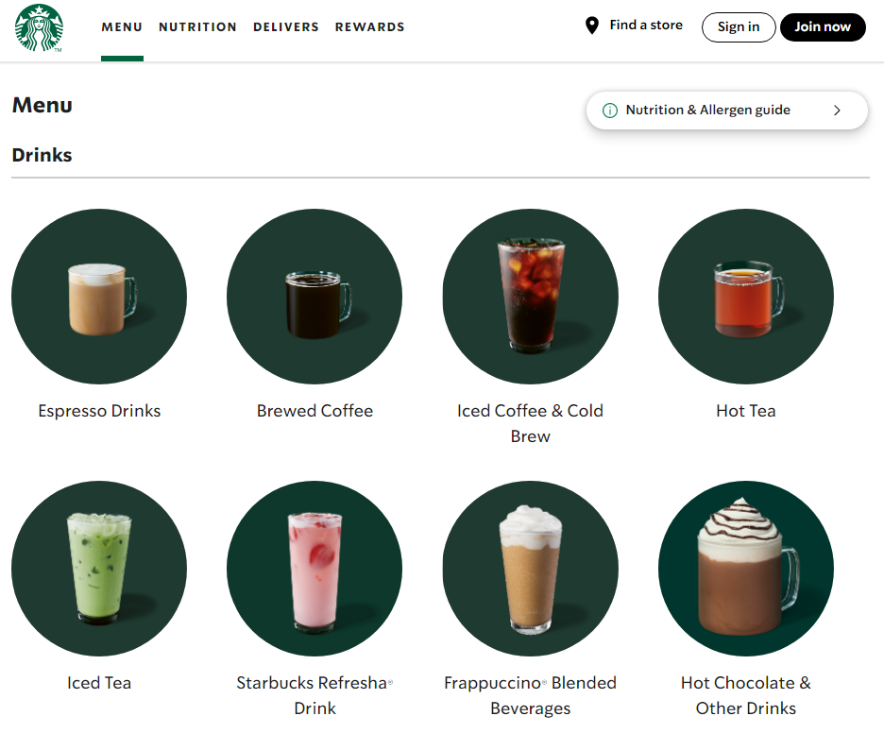
Smaller businesses, like a local ramen restaurant owned by Kenn Pluard (15) states online ordering has increased overall sales by 10% but saves 35% by using an owned ordering solution. He suggests this is due to having a focused site whereby the user intuitively understands actions- like review images or place pickup order.
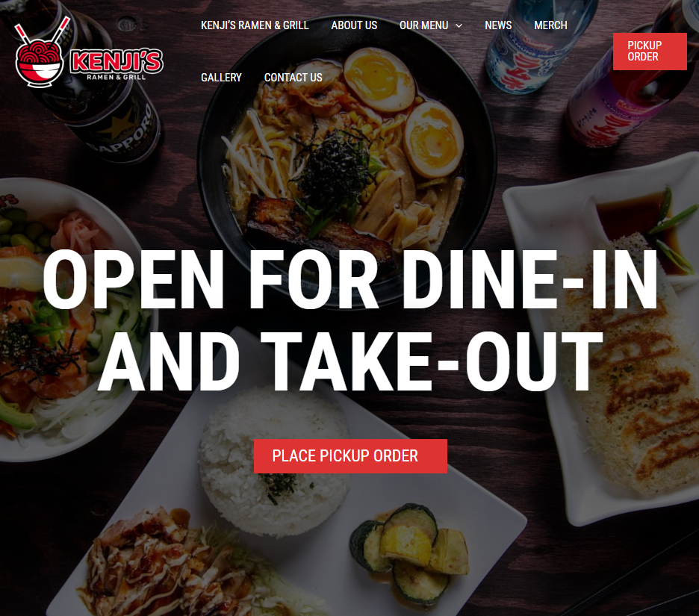

Website Design Principles
Design principles have been founded by many theorists to decipher how design effects useability and overall satisfaction of website design. These are commonly found to overlap. Three academically prominent examples are Nielson (16), Dix (17) and Schneiderman (18).
Firstly, Nielsen’s Heuristics state language should be consistent throughout the designs, whether icons, symbols or words it should have the same convention. Supported by Dix and Schneiderman (17), (18) standardising how information is conveyed allows users to apply knowledge and become familiar within the website. This is continued by Dix (17), suggesting predictability should be considered and adhered to. This permits users to have recognition over recall (16), reducing their cognitive load and memory capacity. Again, this could be icons or dropdowns. Doing so creates a user-friendly and intelligible method of completing actions.
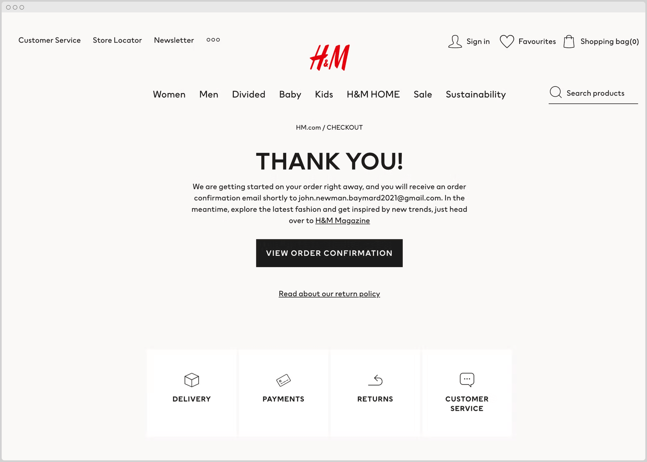
Schneiderman (18), indicates actions should offer informative feedback. The user should be aware of consequence to actions and there should be appropriate readable feedback for clarification. Nielson (16) agrees help and documentation should be understandable to novice users and identify current situation of the process. For example, order placed, order number: #084592. This reflects to the user the order has gone through and the process is complete.
Nielson (16) portrays good design should never impose but suggest actions. User control and freedom is essential to convey user independence and choice. Schneiderman (18) concurs UI should support internal locus of control and allow users to initiate actions. Doing so allows the user to roam confidently and get to where they need to be on their own accord. Examples used include multiple options, going back pages, options to edit/cancel.
Schneiderman (18) implies websites should create barberries to prevent errors. All users are likely to make mistakes using a website, for example missing a field or clicking the back button after submission of a form. Error handling, supports Nielson (16), prevents errors occurring user and business side. Doing so reassures the user of the result of the action and creates a warning to confirm decisions. Similarly, Dix (17) displays recoverability to enable corrective action after recognition should be utilised to relive any anxiety of ‘going wrong’.
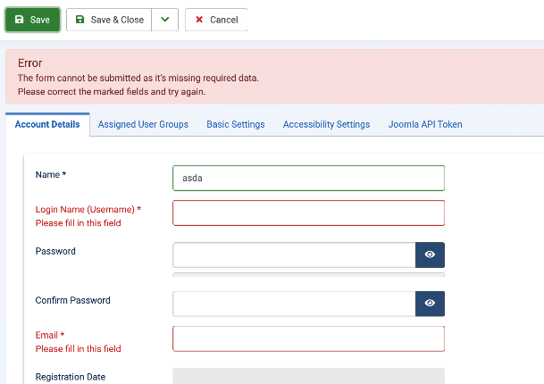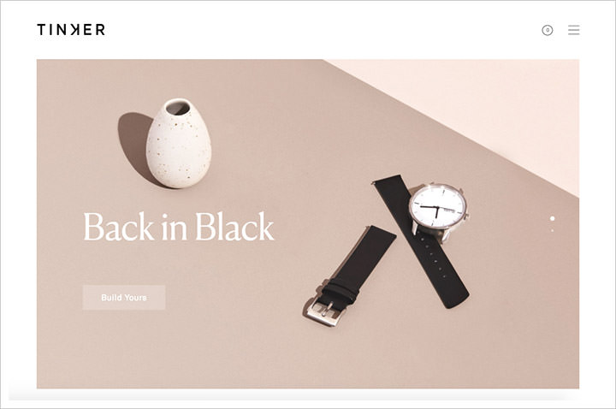
Nielson (16) promotes aesthetic and minimalist designs. Although functionality is essential, unnecessary visual elements can overwhelm and distract the user and compete with information that is indispensable. The use of white space, shorter text and icons for predictive features can reduce a website to display less but have the same functionality.

Target Audience and Design
Explained by Troyer (19), target audience should have a profound impact on the design of a site due to preference and needs. This is also coined ‘user-focused’. Page load speed should be considered with target audience as most users ordering online would be deemed technologically savvy with general websites and have an expectation elements should load at average speed. Therefore, website code should be designed to facilitate this. Additionally, appearance is a large factor in consumer interaction. With billions of websites, it appears intuition to avoid unprofessional pages. Images and content displayed should be chosen with purpose and be linked to connected interests and replicate the proposed target audience. For example, a website for a baking class would include high-quality photos of a baking class to set expectations and engage users. Continuing, colour can be used widely to portray themes, act psychologically for intuitive features and express an age group. For instance, many colours are commonly linked to kids’ websites.
Reiterating, Troyer (19) implies communication methods and the integration of social media should be level with a target audience. For example, at an age range under 30, social media sites are a common communication method for instant messaging and @-ing whereas other age group prefer a number or email to contact. Following this, social media integration levels should also mirror audiences- from logo icon links, to embedded social feeds within a website- they should reflect what the user utilises. Furthermore, navigation is a fundamental aspect of design to ensure useability but can also be influenced by audience. Direction around the site should be linked to what customers intentions are and important sections must be easily accessible for all types of users.

Feature Expectations
Websites are frequently used for a range of purposes by consumers, resulting in expectations. McKeon states (20) easy navigation is the most important feature, 94% of 612 survey takers found. Doing so provides a faster, efficient access to content desired. Easy navigation increases useability as manoeuvring between pages should be logical and clear. Success using the site will bring back visitors. The same survey highlighted 83% expect a website to be appealing and up to date, with initial information that is relevant. 50% of users admitted they would close the site after looking at only the initial page if not linked to service intended. From a restaurant menu perspective, Fiore (21) supports implying methods to order should be distinct so the actions to complete tasks are intelligible and visibility echo the brand selling. Continuing, potential buyers suggest images and item description is equally important with 91% agreeing. Although attraction is key, informative is essential too. Generically Vest (20), illustrates white space, large images and device compatibility should be deeply considered for effectiveness of text.

Testing Methods
Miller (22) highlights testing prototypes with intended users allows refinement, innovations and constructive feedback to create a customer-centric product. Implementing testing brings a host of benefits, for example catch errors, improve user experience (user satisfaction, useability), remain up to date with user requirements and gather response or ideas to amend a product. User testing consists of exercising the product in a real environment with real users and useability and website design can be tested in several methods:
Faria (23) conveys observations allow understanding of useability and user experience. An observation is the process of monitoring the participant to grasp how the intended user would behave using the site. An observation is one of the simplest test methods with great accuracy. Through observing, response is statistically more authentic than interview/question methods. Its direct format allows a quick process whereby questioning is unnecessary but behaviour and user questions or confusion is taken as reliable data- which extracts momentary opinion using the product. Conversely, lack competence or understanding on the observer’s part can cause incomplete results or missed data, it can be time consuming carrying out 1-on-1 observations and bias should be considered before execution to ensure validity and reliability.
A cognitive walkthrough is a task-based usability inspection that reviews users through each step of a task, answering set questions to identify interface elements that could be challenging, Mahatody (24). Walkthroughs take explicit accounts of the user tackling tasks and provides detailed insights from follow up questions allowing learning on improvements of useability and learnability of the system. This method is streamlined, therefore can take little time however if completed for multiple tasks or several participants this does amass.
Bailey (25), first-click testing is a form of observation to decipher where they click, how long it takes and what clicks they take after to rectify or continue. It checks the perceived usefulness of elements and identifies buttons, icons or navigation unrecognised or unnoticed. This can be used on prototypes and wireframes for development purposes however lacks motive therefore does not specify why it lacks use- possible not useful or misplaced. First-click can be carried out with software like Heatmaps that visualises user use.
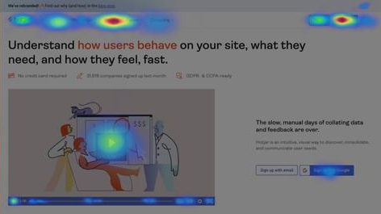
Split testing is a group-based format, Speicher (26). Users are split into multiple groups and provided with differing elements. For example, action button position, wording, navigation altered. Doing so tests combinations that statistically discover what works best, ideal for iteration testing. Additionally, it increases confidence in the website to ensure several intended users understand and recognise design. However, this method should only be used with small factors and completed repetitively to assure one element is better a different way, not the whole webpage.

Technology Options
MEAN is one of several website development stacks that can be used for website creation. Singh (27), states MEAN is a free, open-source JavaScript based software stack ideal for dynamic websites or applications. Developer knowledge can be limited as all components are JavaScript and MongoDB requires no SQL. Additionally, Express.js acts as a backend focused framework, while Angular creates front-end. Node.js is a favoured server that can be used for high-scale projects and can handle multiple concurrent requests. MEAN includes library access meaning developers can reuse code, decreasing time spend making the application. MEAN has later variations like MEVN and MERN but is still commonly used.
Alternatively, suggests Punam (28), XAMPP is a local cross-platform server including Apache, MySQL, PHP, Perl. XAMPP is praised for its uncomplex use from fewer installations and no necessary configurations to seamlessly handling local to online hosting. It hosts modules for beginners and an intuitive interface, comprises various components including phpMyAdmin, WordPress, among others and can start/stop web servers with one button.

Summery
To conclude, it seems apparent an online presence for a business should be necessity, whether through third party or independent it is statistically profitable. Depending on the business a safter first trial third-party may be beneficial. Despite this, if proven an online success, long-term independent applications seem financially viable. Moreover, successful and user-focused interfaces follow design principles, displaying knowledge of usability even for novice users. However, design can be influenced by target audience (so acknowledge who that is) and common feature expectations- to avoid disappointing. Design testing can be carried out in an array of formats, but it appears wise to consider using the intended user and differing methods to ensure detailed feedback.

Methodologies
Stumpfegger (29), suggests phenomenology can be used to understand personal experience and gather natural data. By deciphering perspective and perceptions it extracts a genuine response, ideal for gathering feedback on an application.
Dudovskiy (30) asserts, inductive reasoning utilised reconstructs observations to generalised ideas. Consequently, research findings emerge from significant themes in raw data free from restraint of perceptions generating new theories, patterns, and development of expectations. From this, organic data extracts to themes that can be used in the reflection process.
A cross-sectional time horizon implies Armstrong (31), is data captured at one instance that can be facilitated to highlight patterns from groups, like age, gender, opinions. This route is ideal for time-constrained projects to create a data overview at a relevant time.
Observations allow data collection by monitoring people, events, characteristics, displays Baker (32). Overt observations will be used to review the client using the application to gauge user struggles and make comparisons against expectations in a natural setting, making data more reliable and authentic. Additionally, Heuristic review, stated by Nielson (16), is a design evaluation using guidelines. Manipulating multiple theorists’ guidelines, testing can identify issues, improvements, and value in feedback.
A case study generates an in-depth, multifaced understanding of an issue in real-life context, Crowe (33). This methodology incorporates flexibility of methods and identifies connections between phenomena, people and context of the study. Instantaneously, it provides an unparalleled perception of the client and accommodates the scope of the project.

Development Resources
- XAMPP- Apache for website server, MySQL to host the database.
- Visual Studio Code- Code editor with PHP extensions.
- PHP and HTML languages- Simplified coding, embedded together to add functionality to webpages.
- Internet – PC – CC Images – Tutorials – Search Engine

Development Strategy

Design and Implementation
Before starting development, 7 stages were created to segment stages.
- Requirements and Wants- talks with client to gather what the website needs to do, requirements, what they would want from a finalised website.
- Defining Scope- Labelling pages, what each page will include, doing research to see how they can be accomplished.
- Sitemap, Wireframe & Flowchart Creation- Graphics to show vaguely how the website will appear, these can be shown to the client for agreement.
- Content Creation- Coding here. Making website in HTML first, then adding backend with php and adding it within website frontend
- Visual Extras- Check back with requirements, add images, make it more than just functional.
- Testing- firstly bug testing and improvements, then user testing with the client
- Launch- although a prototype so further amendments are wanted; time limit completes project.

Requirements
Prior to any design, requirements were requested from the client, Comic Coffee. These included a clear ethos of the brand. The comic theme she wanted to be represented initially to the user. Within the website it should show key information about the business for location or about queries but have a clear focus on ordering to draw customers. The main purpose of the website is to take customer orders, including their information, the menu item, quantity but these need to be able to be edited by the restaurant- update, cancel. She expressed status messages next to orders would be beneficial for employees, for example ordered, complete, cancelled and to avoid user-friendly problems with a different third-party it needs a simple business end that can add food items and make edits to them- update, delete. Although not a requirement, she suggested a form of sorting the menu items into groups to avoid having food lists for the user.

Design
Entity relationship diagrams (ERDs) are data structures providing visual database design, Song (34). ERDs enables illustrations of data situation, from entities, columns and rows and how they interact with each other. Prior to database creation, a simple non-relational structure created shows fields in each table, data type and primary keys. Non-relational has been utilised to simplify merging the database with code as code variables will be created with SQL and PHP variables.
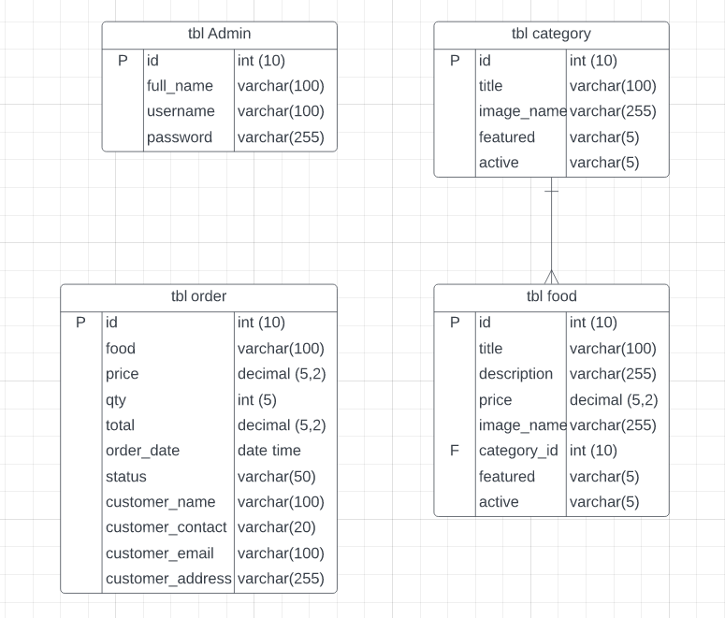
Moreover, one example of order is displayed using a flowchart. Although the method of getting to the order form varies, the flow of data remains the same. It should be considered data flow will be used when adding foods and categories to illustrate items to the consumer.
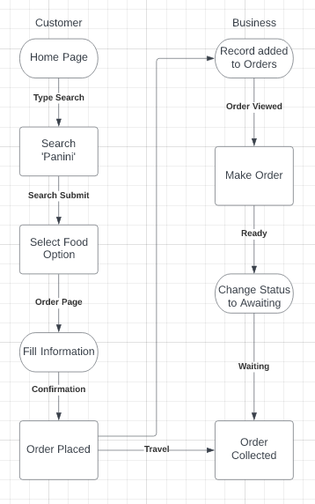
Concept designs formatted as wireframes are used to position data, information, and images. Prior to coding, it provides the developer with a visual idea of how the website is meant to appear and can act as illustration to ensure client satisfaction. Below are six wireframes of main pages; home page, categories, menu, order form, category admin dashboard, order dashboard. Other pages will be similar to ones created for example food management and category management have the same functionalities, there it was unnecessary to design.
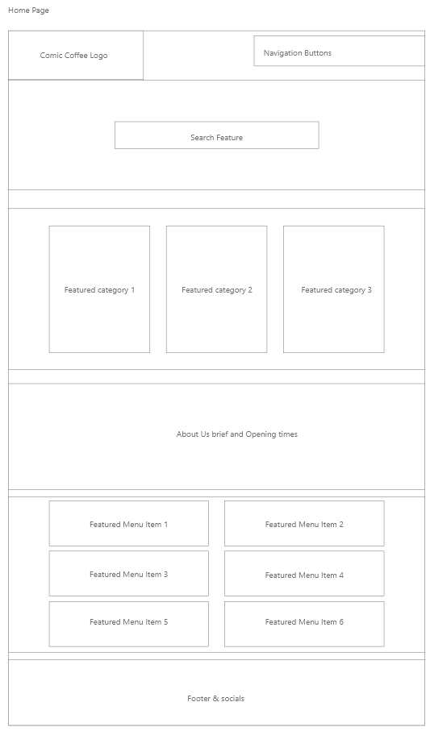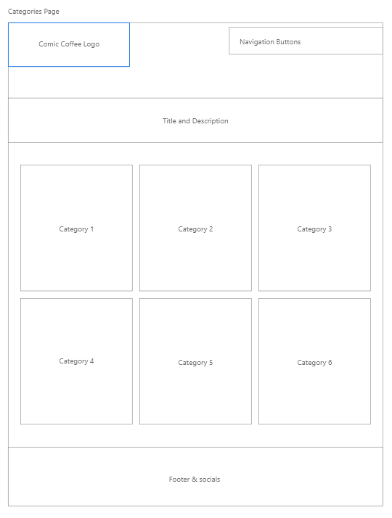

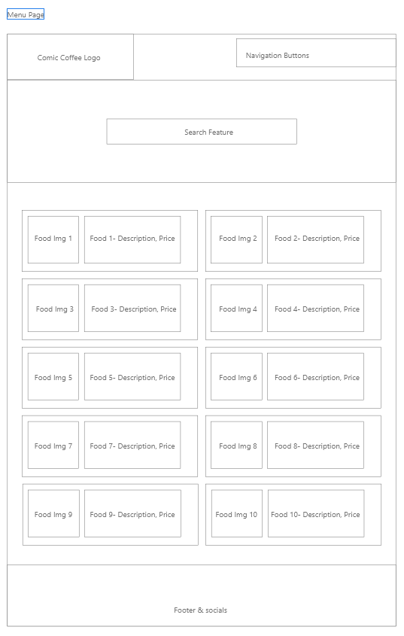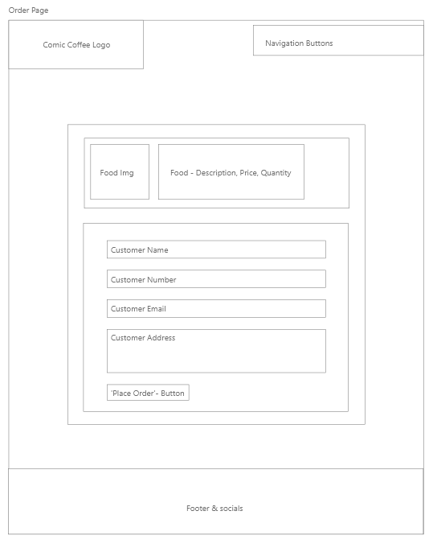
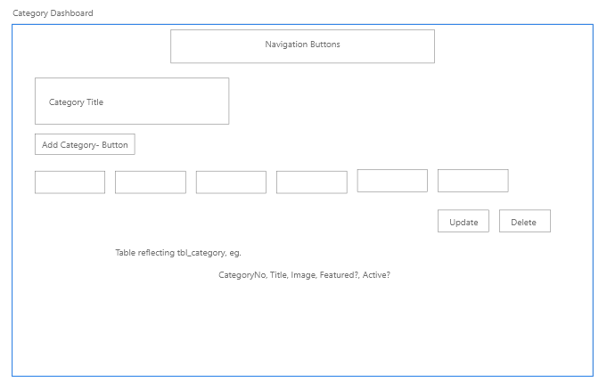
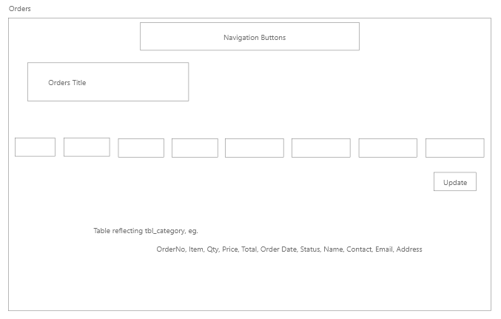

Interface Designs
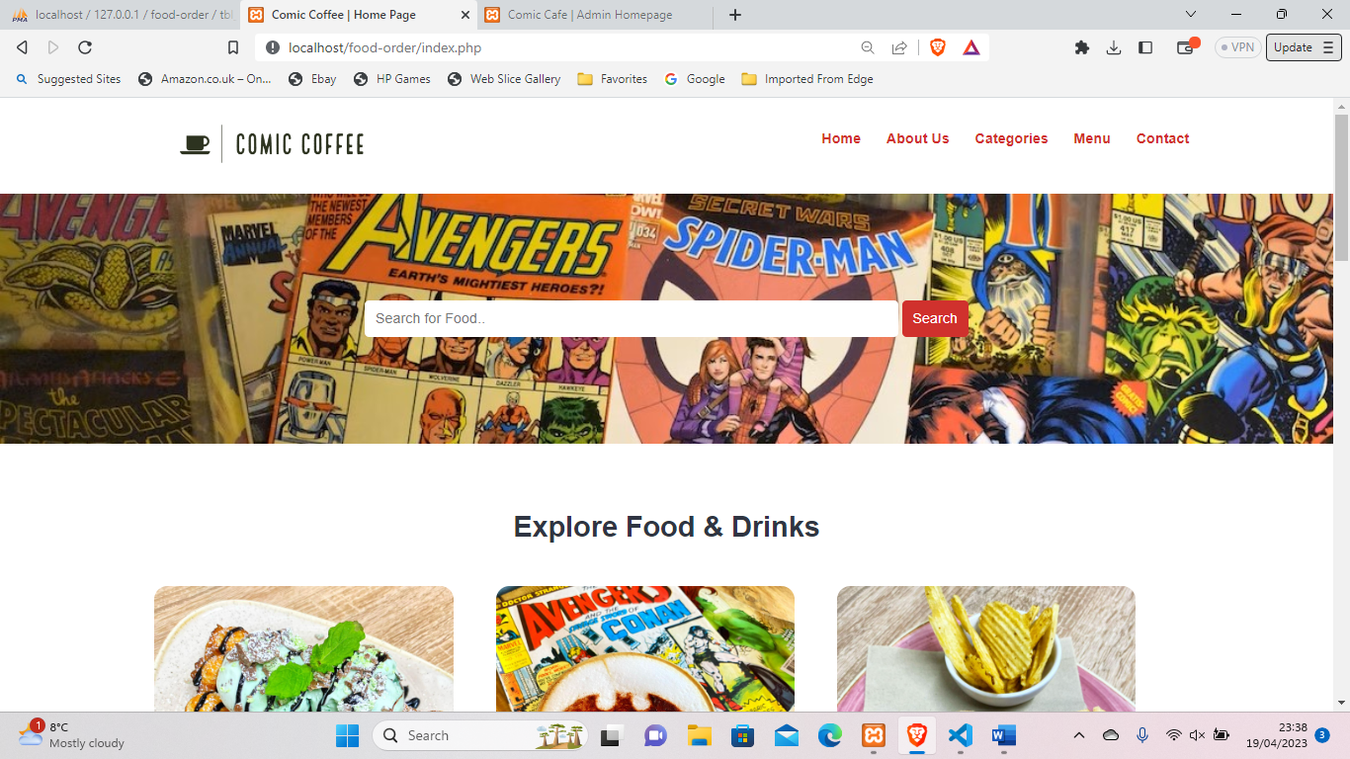
The initial page welcoming the user is the home page, displaying a clear comic theme as requested by the owner as part of set requirements. This is portrayed through the comic banner but also within the menu items selected. The navigation banner is made of the company logo and navigation tabs that can be used to switch between pages. There it is clearly visible and at the top of the page it can be predicted. The layout exercises Nielson (16) principle of consistency as all pages include the same header and footer with the same information and titles. This promotes user confidence to explore a site as they are aware how to retreat.
Gestalt’s theory of continuation (35), whereby the eye follows the smoothest path for viewing is displayed as information is place horizontally, but eyes are drawn from the top left to the search bar and down. This is due to colour manipulation attracting the user to view the page in entirety and view menus.
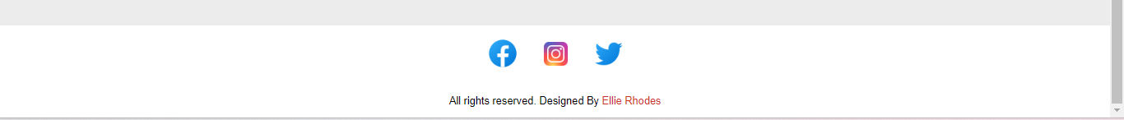
Displayed is the footer of each page containing links to social site. This could be linked to target audience as it is assumed those interested in comics, Marvel, DC and so on will have social media to keep up to date. This infers Nielson’s (16) recognition over recall as icons are used to replicate knowledge.

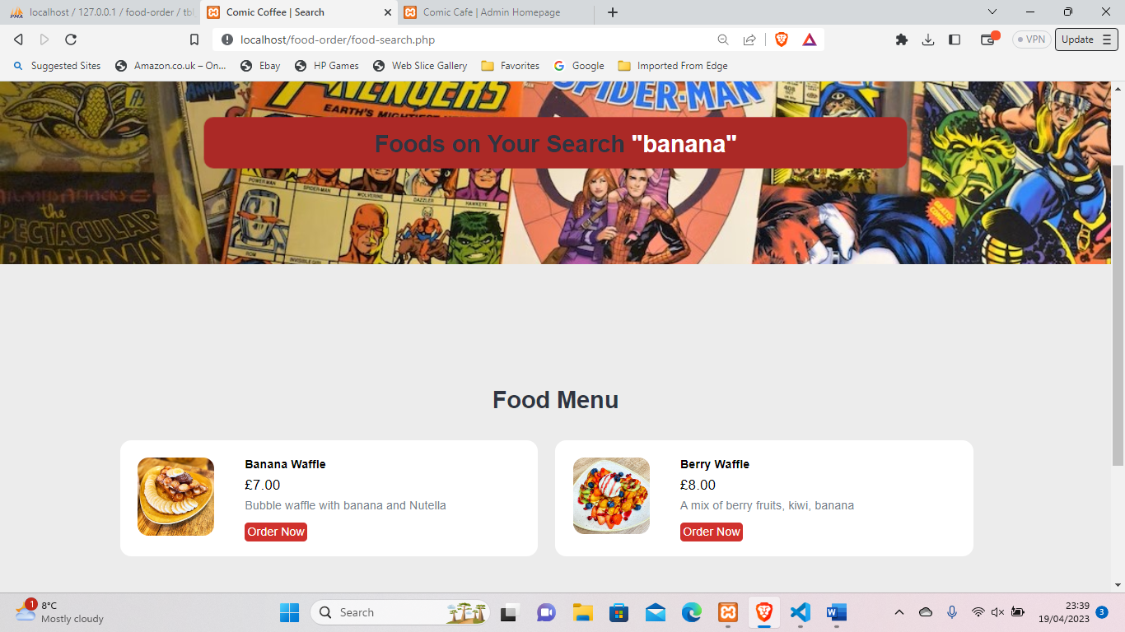
The search feature is enabled by key words. In this illustrated instance, the word ‘banana’ brought two results, one with the keyword in title, the other within the description. The layout of the page relies on consistency also to allow learnability of pages. The same format is taken for category searches however the search is made from identifying what category id is linked to the food item. The result feedback would then display, ‘foods on your search ‘hot drinks’ for hot drinks.
A search feature reflects Schneiderman’s principle of enabling frequent users to use shortcuts (18), by allowing users to directly bring the result they require, like ‘Banana waffle’. This bypasses navigation or physically searching menus. Yet can also be used for individuals with specific interests.

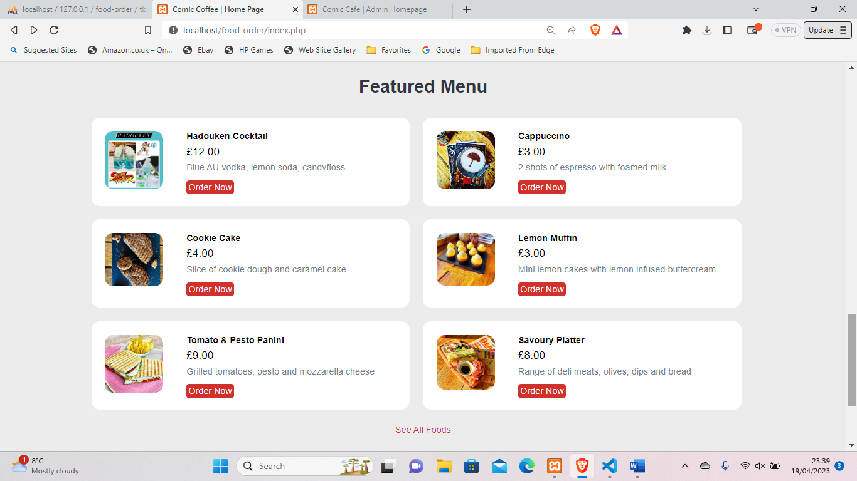
The use of featured menus appears within the home page of the website as it was suggested by McKeon (20) new users of the site and regulars looking for alternate options will view smaller menus of popular choices. The formatting of the food items is informative and visual explained by Fiore (21) to be essential for users and follows Gestalt’s theory of proximity (35) by making two columns of food contrasted to box-like visuals of information. Additionally, Nielsen’s theory of match between real world and system (16) has been facilitated to clearly suggest consequence of action, like terminology ‘order now’.
This has been replicated for categories also whereby three chosen categories are shown compared to the categories page where they are listed.
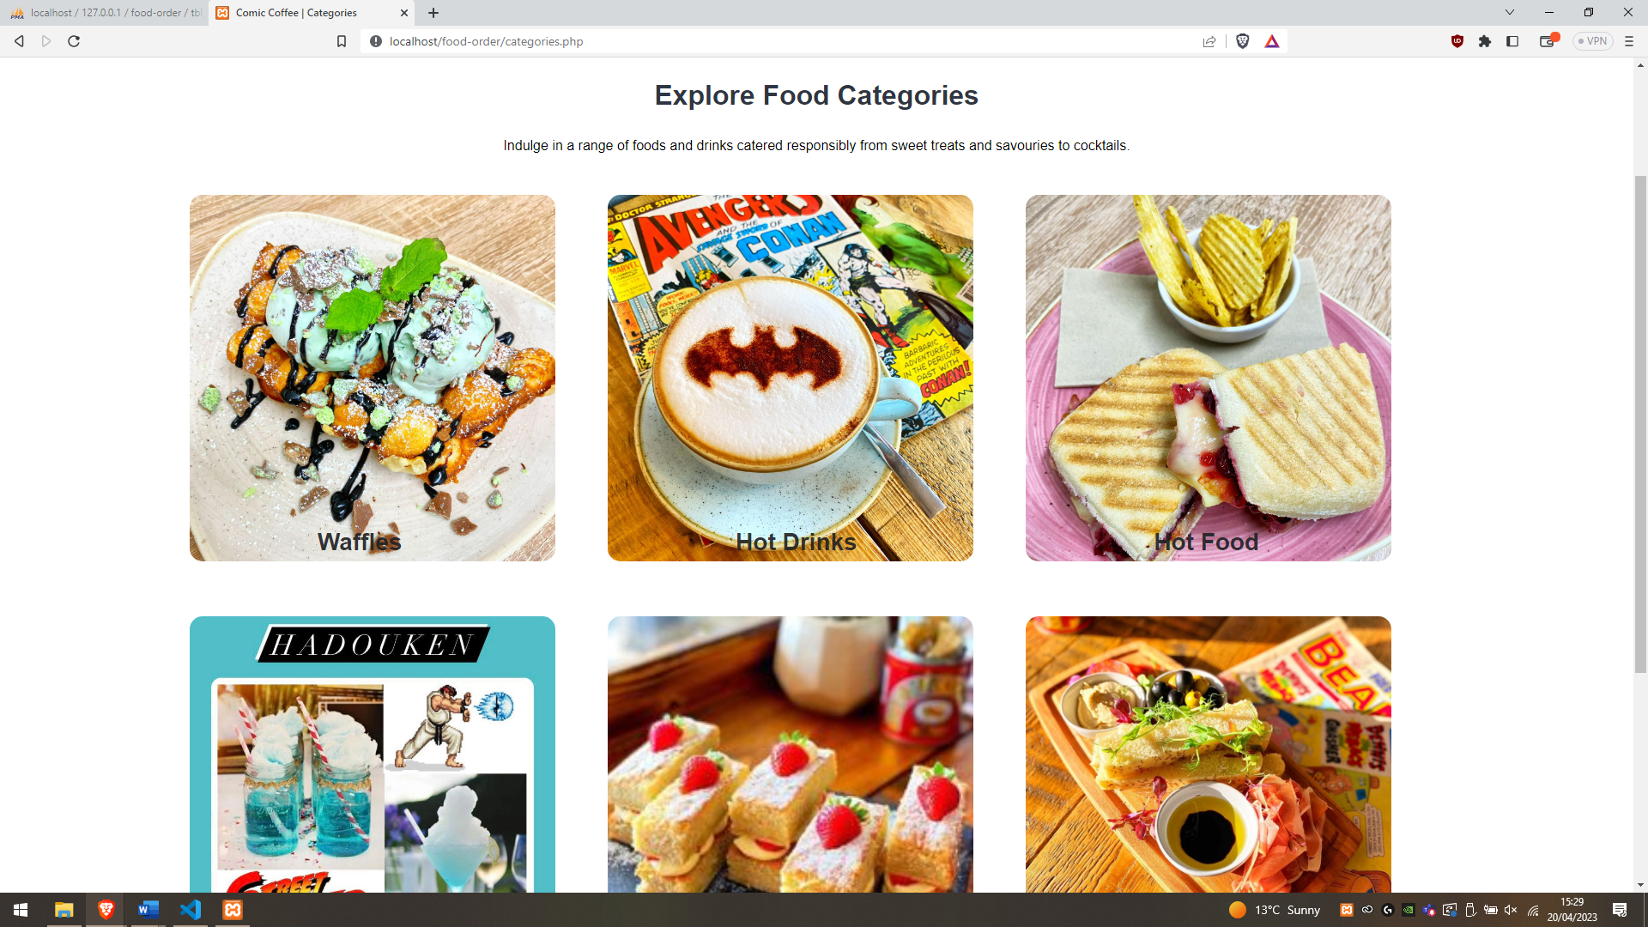
Above is the categories page, showing grouped foods. This sorting of food is inspired by Hicks Law (36), portraying that fewer options are more likely to incline the user to interact without being overwhelmed. The user can narrow the search without specifying what they want.
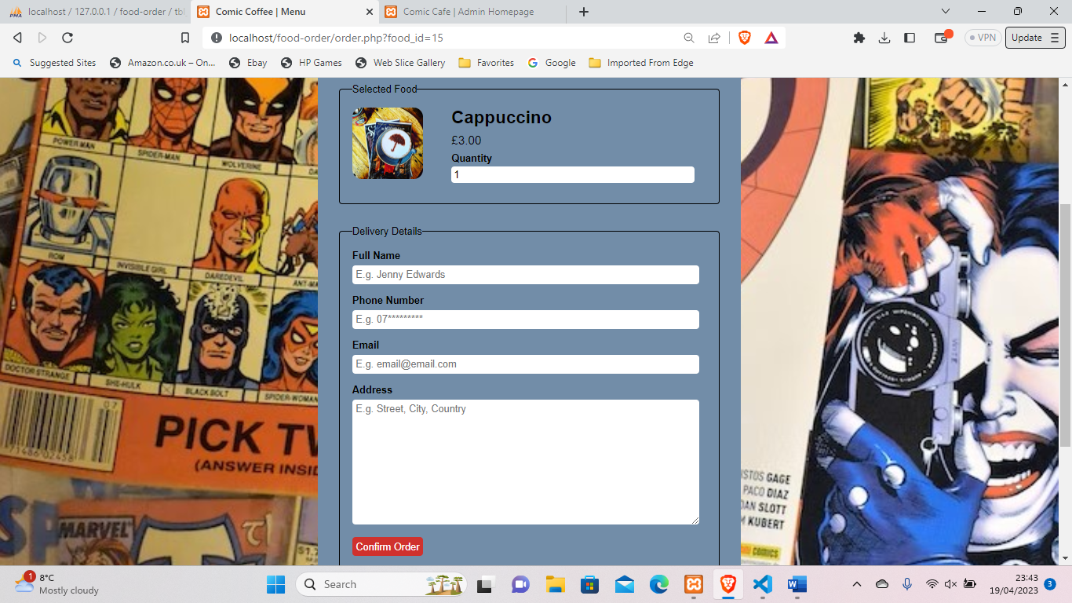
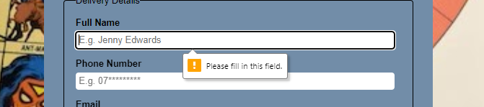
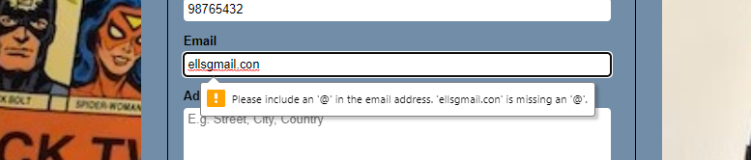
Exhibited is an order form consequence of the ‘order now’ button on every menu item. Derived is the image and details of the item with editable quantity, mirroring the choice made and giving chance to return if it was a mis-click or not what they wanted. Below they are provided familiar text box formatting to provide necessary details that have been validated to ensure data is inserted and contain required symbols. As shown in example, an @ is required in email address. Neilson’s (16) design heuristic of error prevention is executed here to prevent incorrect data, or no data being entered into the database.
Implied by Nielson (16), user control and freedom is essential to ensure the consumer feels unbound or undirected. This is achieved by having various methods of navigation, intending the user to find their own way to what they desire, whether a specific item, category or viewing all.
Recognition over recall is another Nielson (16) principle littered within the site. Buttons used all have CCS to darken the colour when hovered over to reflect it is an action button.
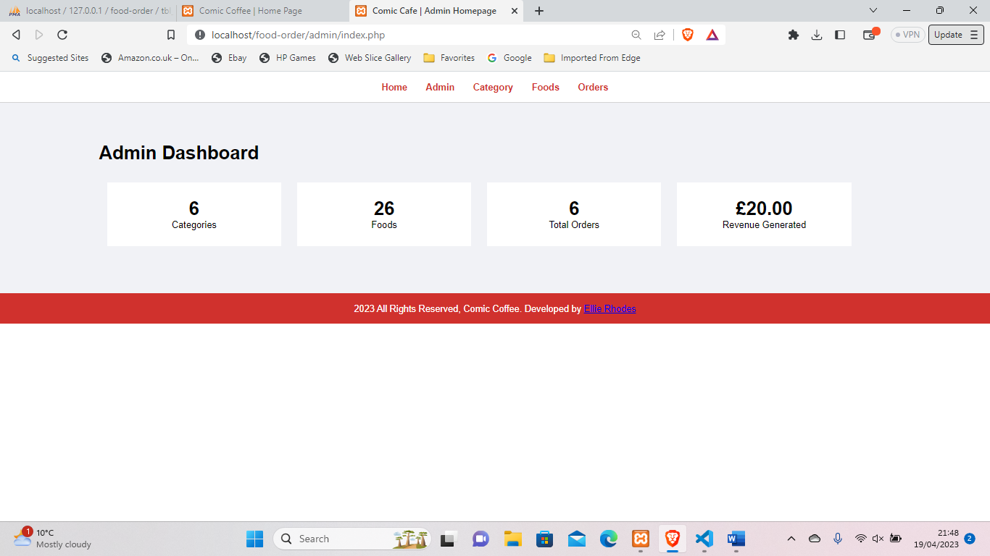
Business side, an admin dashboard has been created as a central page for users visualising the number of categories, food items, total orders as well as a calculation for revenue generated from all orders that have been marked ‘complete’. Like previous, navigation is centred on top of the page with a basic footer and is replicated within all navigated pages to continue consistency and predictability.

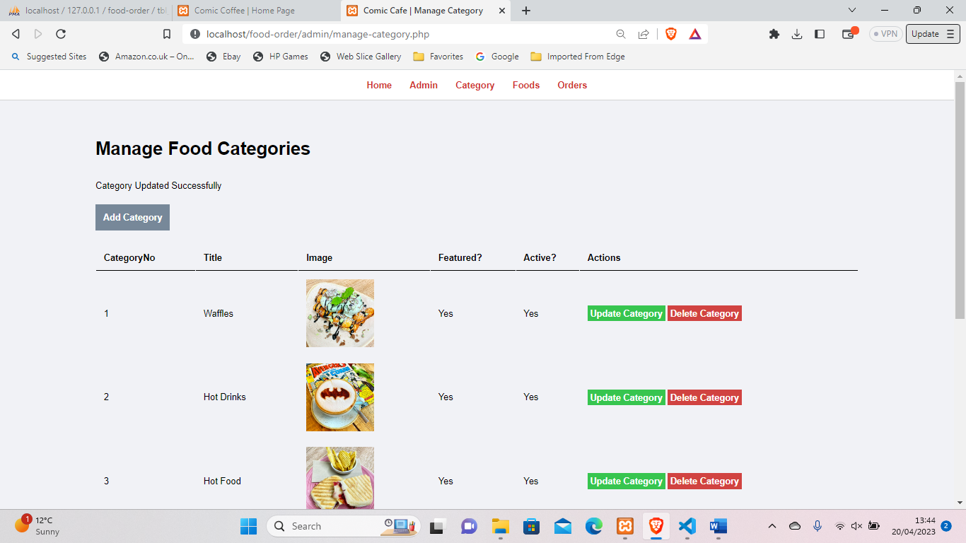
Both category and foods panes are displayed like such. Following Nielson’s minimalistic approach (16). This was chosen as the owner expressed the need for a simple business user interface. Buttons are used to allow interactivity with the data, for example add a category/food, update or delete and are colour coded to elude to consequence. The grey theme throughout carries the user to another page, green signifies good (editing) and red for deletion which is frequently used for other GUIs.
Under the main heading a feedback error is shown, this is not always there but as a result of updating a category, shown below. Messages occur when adding, updating or deleting records has been done and changes accordingly. This is suggested by Schneiderman (18), golden rule of dialog to yield closure and offer feedback. Message design allows the user to understand what process has occurred and if it was successful. To certify action, messages occur when an action fails to reiterate the operation was not successful.
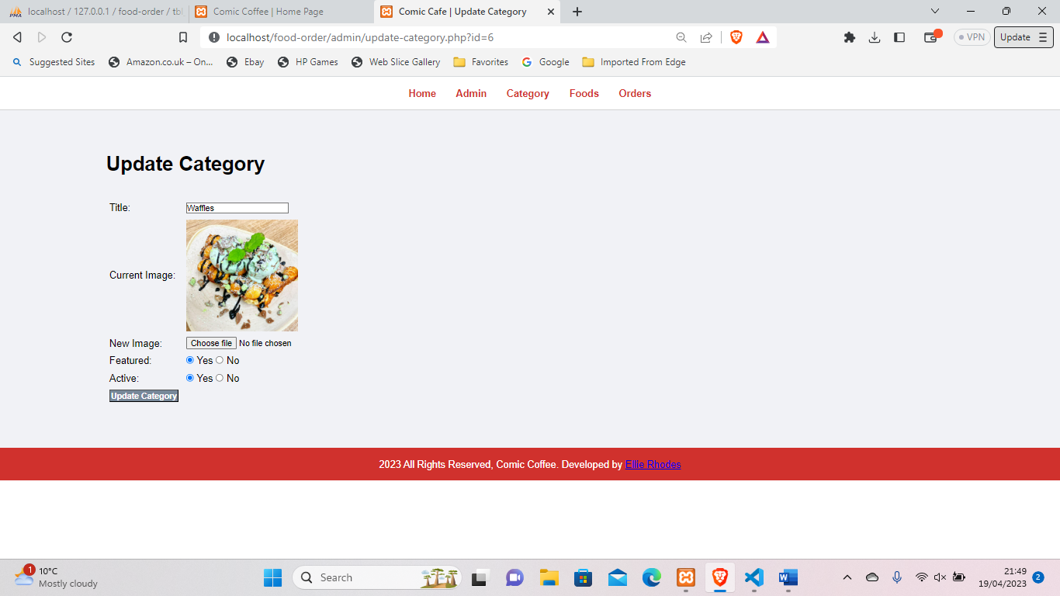
Continuing, update category/food has been designed to display current data to inform the user of what is currently there and only amend as needed. After submission, the user is redirected to previous display, manage category/food with feedback response.

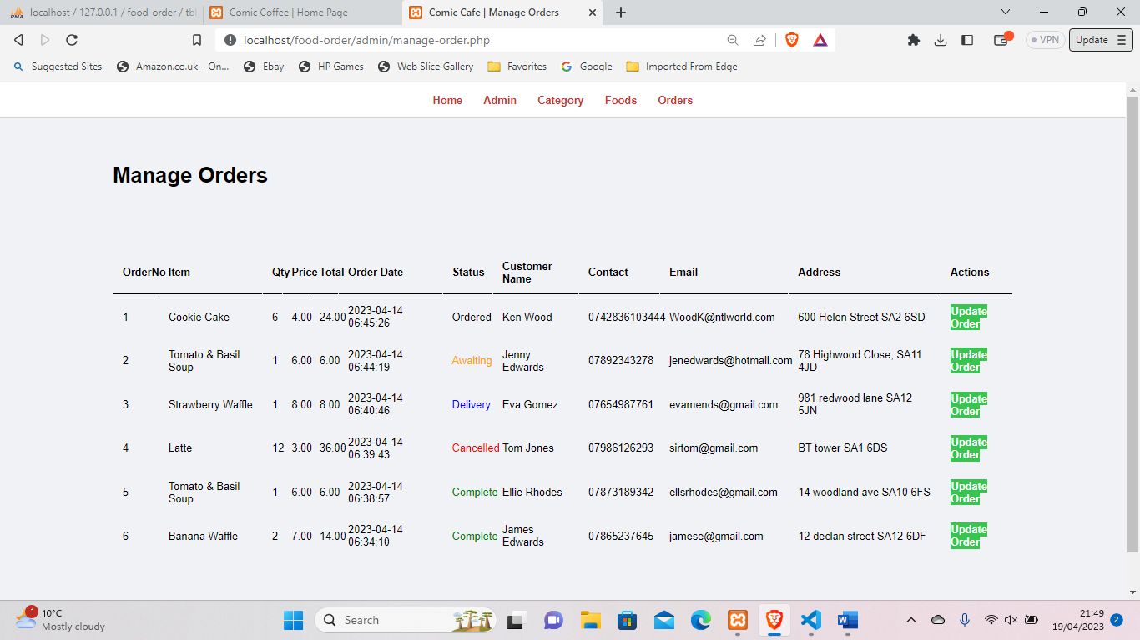
Moreover, the orders tab brings records of all orders placed, most recent appearing first. Orders are unable to be added unlike other pages but can be edited by users using the familiar green update button.
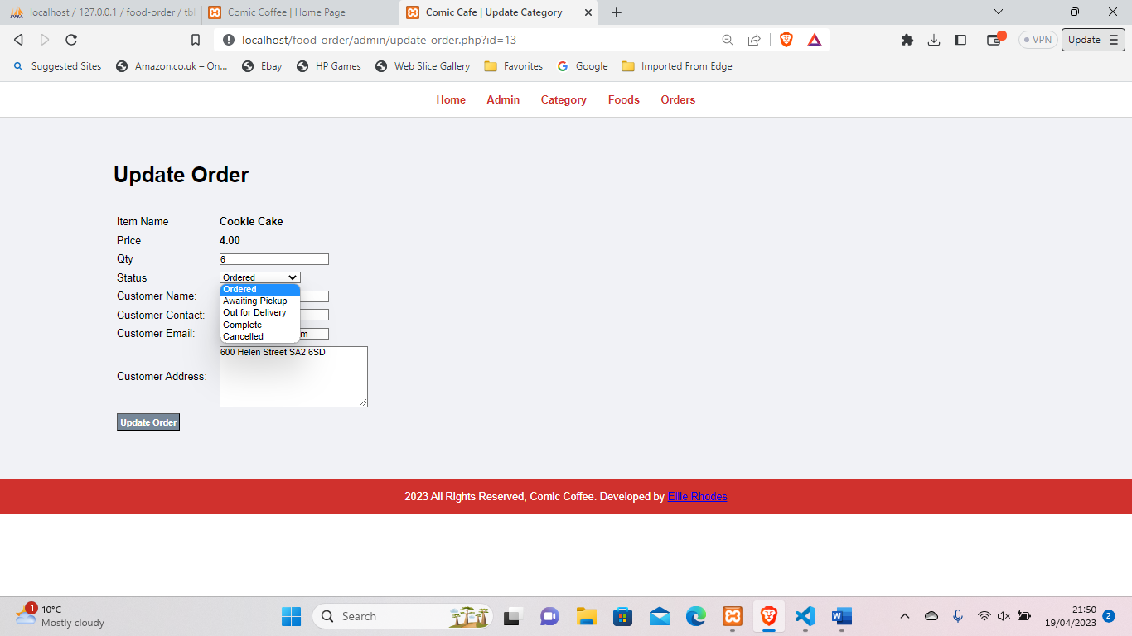
Here, users are able to edit quantity, customer details and order status. This has been designed in case of customer error filling details. Order status brings dropdown options providing a simplistic and limited key of order stages, including ordered, awaiting pickup, out for delivery, complete or cancelled.

Implementation
The process of creating the application was split into three sections: database creation, website creation using HTML, admin dashboard creation using php. These were later merged and the use of php allowed dynamic webpages with features running from the database.

Code
Below displays the connection to the database to allow data to be pulled, edited or removed through code. This was made as constants.php and added to most php pages to permit access.
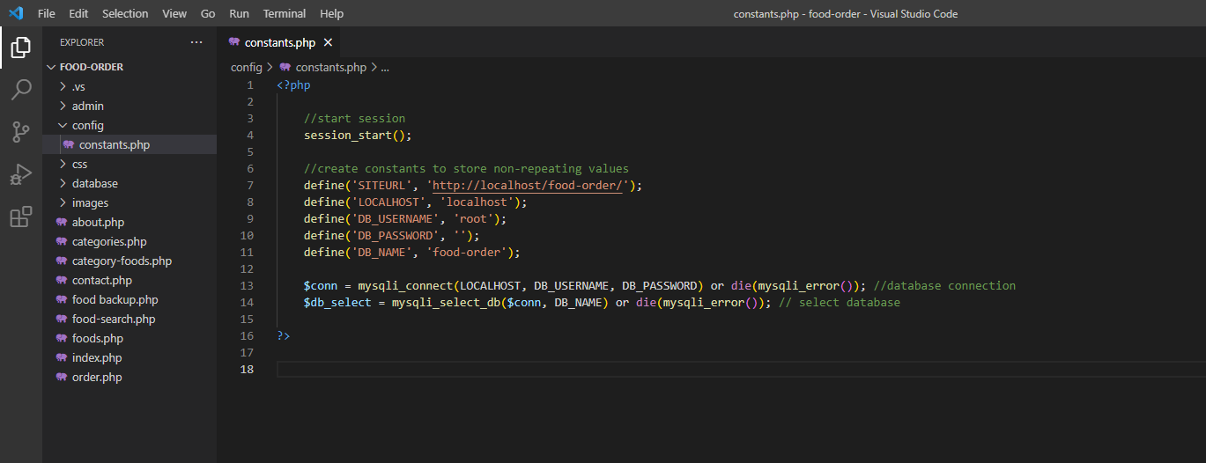
Additionally, within pages index and menu a search bar was inserted to allow the user to find items directly. This was coded in SQL whereby the search keyword was searched for in food title or description. Within the WHERE clause, wildcard LIKE was facilitated to display data equalling the search.
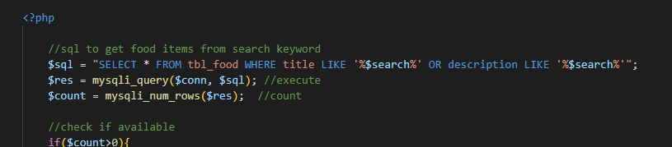
Both HTML and PHP have been consistently intertwined to provide a HTML heavy website with PHP features and inputs. These are littered throughout, for example inserting foods, hyperlinks, and categories as shown.
Most addition using PHP follow a similar format, SQL and getting values, validation to ensure if failed user is redirected and error feedback is provided or if successful displays data through echoing data from database.
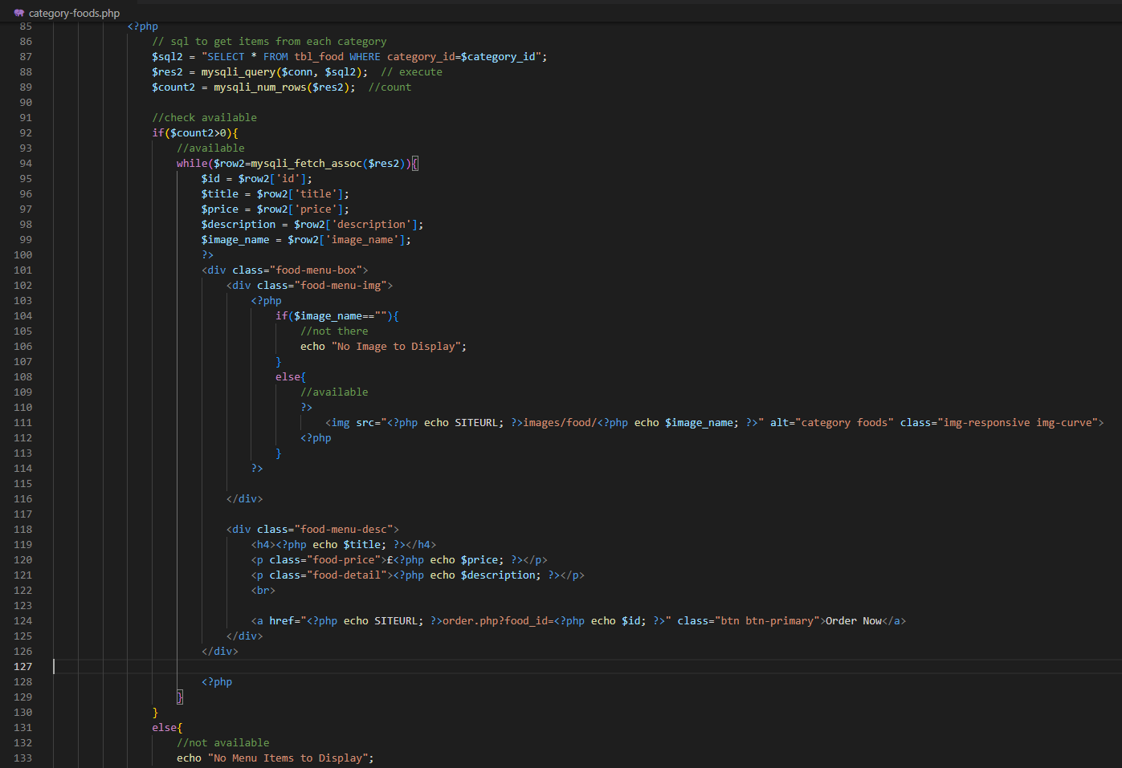

Software Testing & Iterations
As a cross-sectional time horizon was implemented, iterations were not distinct, it was a continuous trial and error approach to develop, test and solve issues. Code was tested in sections, ensuring buttons and code sections worked and narrowing cause of issues that occur. The final iteration of the application has undergone brief feature testing to assure all key elements are functional and primary research, displayed later in the format of user testing identifies useability and design problems.
As shown, feature testing was predominantly successful however there are few errors.
Test | Description | Does it Work? | Change in Database?
Visual run-through | Walkthrough ensuring visuals work and database information is being displayed | Yes | --
Category | Update | Yes | Yes
Category | Delete | Yes | Yes
Category | Add | Yes | Yes
Food | Update | Yes/No | No
Food | Delete | Yes/No | No
Food | Add | Yes | Yes
Orders Update | Alter and save order record | Yes | Yes

Problems and Successes
Initial issues with the system started with XAMPP, it was found to be unreliable, spontaneously being unable to load MySQL, meaning the website could not run and required several uninstall/reinstall processes over the duration of the project. Additionally, a personal issue was knowledge of PHP, this was self-taught through several tutorials and plenty of research.
Shown within feature testing food item management has a snag deleting previous images. Although Foods can be added to the database, when editing the image it cannot remove previous and breaks the process, displaying nothing. This was unresolved but can be amended by removing the record from the database directly. Despite this, updating data other than the image works successfully and deleting record with initial image used.
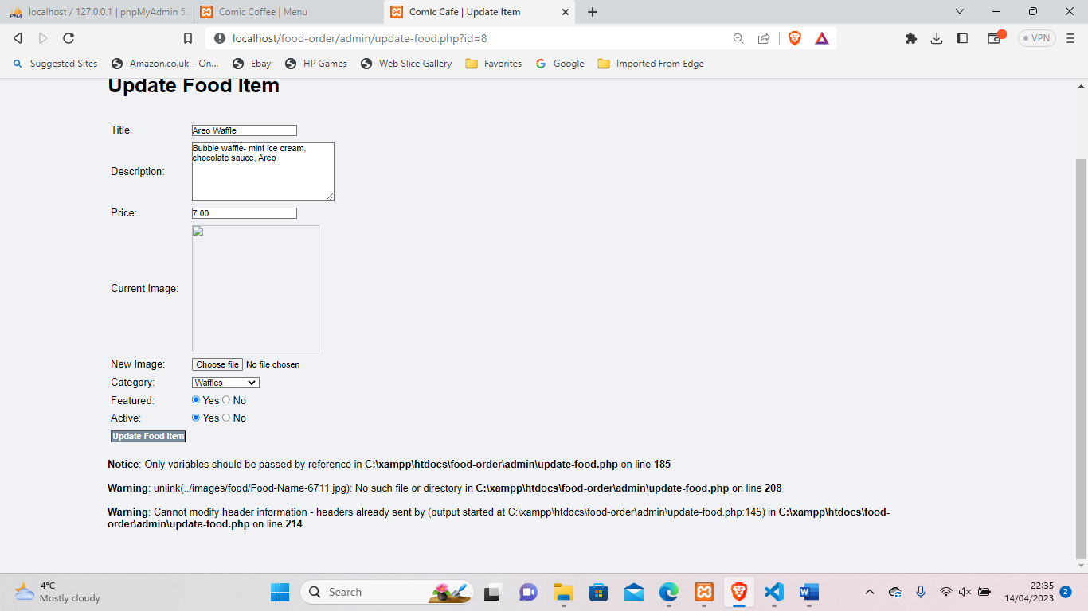
Foods.php encountered error whereby images from the database were not showing on the Menu page. It was clear data was passed as image would show in order form however not in food list. This was due to syntax error within validation that prevented the image being displayed. To solve this, the code structure was reinvented to display image using php alternatively to HTML previously.
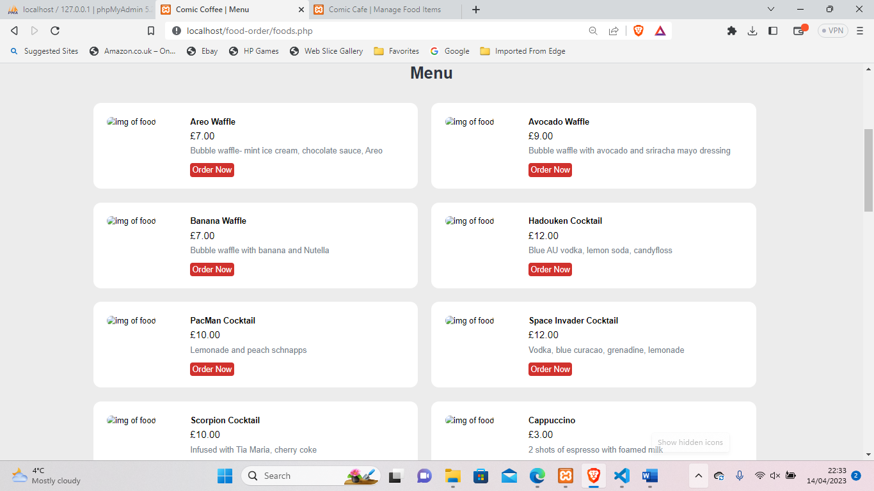
Lastly, it appears the CSS for the food item boxes potentially include error as in list format in Menu page gaps are present. Even though research has been conducted to fix this, nothing altered the appearance.
Converse to complications, a functioning application has been produced with the ability to add, edit, remove categories, foods, admins and orders via dashboard that communicates with the database to save, remove and edit records within differing tables.

Evaluation Criteria
An evaluation identifies the benchmark of success for the project. This is curated from research, expectations and client requirements. In this instance, the project outcome should be intuitive, and user-friendly. This was requested to ensure useability admin side however would be expected for customer interfaces also to allow novice users to explore the site and place orders.
Additionally, functionality is deemed a factor of success. As required it needs to load, save and display data. Although this is a minimum so additional processes would suggest a more realistic application. A test plan will be implemented to display pages work as expected.

Primary Research

Observations
Observations provide straightforward data directly from the user Faria (23). Utilizing these allows data to be extracted from actions and behaviour compared to questions. Instantaneously, observations are used on 3 intended users performing similar tasks that they would be expected to complete in their role. Having multiple users allows comparisons between different user levels and displays patterns of successes and improvements.
Within all observations the participant was placed on the home screen of the main website (task 1) or admin panel (task 2) to allow mobility from the same stance a real user.
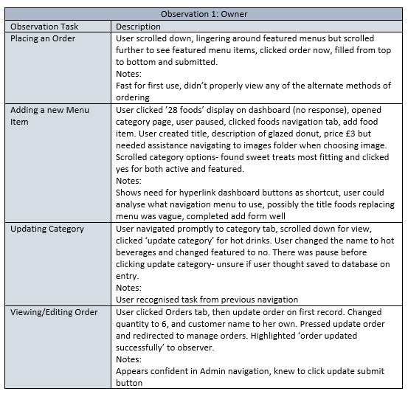
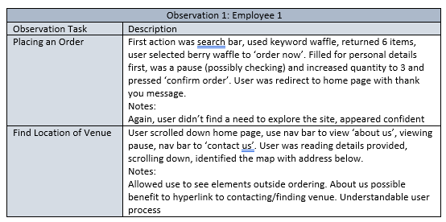
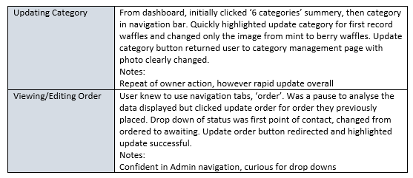
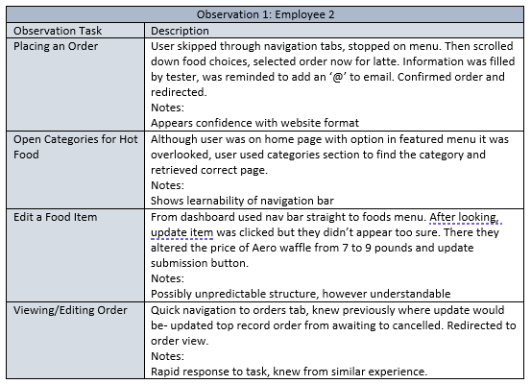

Heuristic Evaluation
The same 3 users were asked to carry out tasks using the application and answer 10 design heuristics through Windows Forms. Nielson’s prestigious design theory is widely used to showcase useability and design downfalls and elements added to assist users. The results were as follows:
Heuristic | Average: | Key Comments:
Visibility of System Status. | 1.67 | visible, does not have a situation with need.
Match between system and real world. | 1.33 | Relatable icons, map, simplified terminology
User controls and freedom. | 1 | Alternate routes using navigation available, able to search view
Consistency and standards. | 1 | Consistent design, predictable, same format through admin and website
Error prevention. | 2 | visible, does have a situation with need.
Recognition over recall. | 1 | Felt familiar, predictable and have many commonly used features
Flexibility and efficiency of use. | 1.67 | quick to use, shortcuts like search
Aesthetic and minimalist design. | 1.33 | Not too much information, carries theme of café, could be more professional appearance
Help recognise, diagnose, and recover from errors. | 1 | Error/ success messages and redirection to management page.
Help and documentation. | 2.33 | Specifies direct issue but no fixes

View Here: https://forms.office.com/Pages/AnalysisPage.aspx?AnalyzerToken=5cF2XDAcbn5WLDRKkSefViexvg9CDQiw&id=cYpHzTswzE6x6k40RHNiVDyDxxPHAY5Mi3lpZZw58PpUQzdZWU85OE9WMEJJVzhWSzU2SDFBV1JQWi4u

Evaluation
Overall, the aim of the project has been achieved, an independent café (Comic Coffee) has an online food application that has been designed, developed and tested that acts as a prototype to show how they can be online independent of third parties. To attain said aim, all objectives are also sufficiently covered, from research and requirements to designs, development and testing, suggesting a complete project.

Did It go as expected?
The project followed expectations and the format of aims and objectives set to create a working product. Despite this, errors within the process deterred the intended application. For example, some features were unable to be added due to time constraints like payment methods and a log in screen for admin accounts. Although the project was mapped, general bug and fix practice consumed more time than anticipated and resulted in less time to further the development of the prototype. In addition to this, the process of learning PHP and developing knowledge of HTML also took away from time developing as coding was heavily balanced between learning how to code within such format and actually conducting it within the application.

Testing and Feedback Conclusions
Mentioned previously, feature testing was undertaken to provide assurance all main functionalities of the site worked as expected and error free. The testing found multiple errors and issues with the admin section of the application, whereby error messages occurred when adding a food item or updating. Despite messages, the code was executed, and the data is inserted to the database. The nature of the error implies relation to acknowledging the information has been transferred or redirection. Another issue was updating food image. This was narrowed to discover the old image was not being removed, causing the clash of data. Neither were resolved for the final prototype due to time limitations. Conversely, the testing did highlight issues and otherwise working elements and directed developments to how the mishaps could be amended.
Furthermore, for useability testing and to gather an overview of how an intended user would interpret the site, observation testing was carried out to collect data by visually overlooking users carrying out tasks. Feedback collected was note taken by the developer and brought several conclusions from three users.
The first task three users completed placing an order. Two users used the home page to find food items, the first using the featured menu at the bottom of the page and other through search. This shadows the importance of relevance on the initial page as some users do not immediately opt for navigation. Third user was able to navigate to the menu tab first and placed order through ‘order now’ button with ease. All participants appeared confident filling in the generic order form, possibly due to the familiar nature of a form. Only one issue occurred between three users, as the @ button was not included in email, but this triggered an error message and the user fixed general user issue quickly. To extract better results a specific item could have been requested within testing, however it was previously decided not to influence the use of the search bar.
Two users carried out find tasks within the customer-based site. Firstly, to find location. A user did not know directly where to look for this which was evident after searching the home and about us pages. However, did find within contact us rapidly considering it was first real use of navigation. This identified a possible need for a hyperlinked text within the homepage to find location or contact details that could avoid the searching aspect as well as highlighting the unclear placement. The second user was tasked to find a category of hot foods. Despite being shown on the current page under featured category, the user overlooked and accessed hot food swiftly using the navigation buttons. This was not perceived negatively as it feedbacks the learnability of the navigation tabs and confidence that they knew the placement of desired task.
Moving to the admin aspect of the application, users were tasked to move to either categories or food pages. Two of three users try to use the summary buttons as a method to navigate (they state 6 categories’, ’26 items’. This underlines the need of hyperlinking the summery to enable navigation to related page. This could be due to their box-like shape, size or direct placement within the page. Otherwise, all navigated smoothly using top tabs as learnt previously.
Moreover, updating category or food item was overall successful, all navigating and understanding button prompts well. Update forms were all interpreted fine with data being changed by all users. One user appeared confused after changing the data, as if the asked task had been complete but realised the submit button and continued. This suggests thoughts of data entry being saved as edited, however that is not the system design, but a consideration for further development. Overall, displayed great ease of use with the simplified interface.
The last task was to view and edit orders. All confident in navigation system and method of how to update was understood. All users were able to successfully make amendments. It was noted 2/3 first points of contact were the drop-down option, highlighting it could be a favoured method of data entry and could be used for other aspects like featured, active.

Lastly, to compare between design principles and the application, Nielson’s design heuristics were used to measure aspects included from user perspective. Heuristic evaluations focus design questions and allow responses to narrow reasons for answers, positive or negative. Overall, this format of testing brought mainly successful responses, however, did identify specific conclusions.
Across all responses, all heuristics were marked highly between 1-2. Suggesting that ease of use, navigation and generally how the interface works and is portrayed follows expectations that are comprehensible for novice users. Only one heuristic scored average at 2.33 which was help and documentation, this was due to lack of direction when error messages occurred. Although they are in place for users on the order form, error messages within the admin system are limited to either a failed or successful operation and do not offer methods of recovery. This could be improved by adding additional text prompts. Furthermore, there was criticism about the overall appearance of webpages. For aesthetic and minimalistic design, it was suggested although it carried a theme of comics and was not overwhelming, it lacked a professional feel. This could be furthered by using a design framework like Bootstrap or extend the CSS to create a modern approach. Conversely, other design elements were praised, like freedom of navigation, matching simple terminology, using icons and the consistent and predictable interface which is shown between customer and admin sites. From the feedback, it suggests efficient useability, allowing functions to be utilised and common design elements to showcase and edit data.

Literature Review Comparison.
As explained by Troyer (19), target audience should reflect within application design. Within the website, the use of comics themes and many visual colours are implemented to draw attention. Despite suggestively being aimed at kids, this allowed psychology to attract all users, like the 3 intended users tested. Additionally, more icons could have been added because they were easily understood. The design included both physical links and hyperlinked logos to ensure contact was visible for technology users and novice ones. Despite this, the logos were only ones noticed as easy contact and highlighted as Nielson’s (16) match between system and real world within a heuristic evaluation, suggesting the target group of users are familiar with social sites.
Expressed by McKeon (20), easy navigation was essential, even for veteran users. This was displayed entirely through design of website and admin interface. Feedback and design theorists concur, explaining knowledge of how to travel around the application brings confidence. Users expressed the simplistic formatting of navigation within questioning and appreciation of the system mirroring McKeon’s results. Continuing, McKeon’s (20) suggested first pages need to be relevant for use. This was displayed by two test users whereby they used the main page to either search or narrow the search via categories instead of using navigation tabs. Implying focus could be on the initial screen and attention-grabbing features over navigation tabs.
Previously found XAMPP was ideal for use. Punam (28) stated it was praised for uncomplexity. Conversely, another web development stack could replace XAMPP, and possibly have less problems by doing so. A similar alternative is WAMP, this platform includes Windows, Apache, MySQL and PHP. Although XAMPP is loved for resources included and cross-platform abilities, WAMP includes all that was utilised within the project and could be more reliable to use on PC.
As expected, observations were ideal for capturing behaviours and gained data from physical sources. Examples of this was the duration of intended users using navigation, and how after use it became more rapid. As Faria (23) suggests, observations displayed some constructive data whereas alternate testing used, heuristic evaluation results, were far more positive. Moreover, it could be beneficial to utilise a different form of physical testing like split testing or first click to gather data directly from user action to analyse and compare.
However, there has been no tests conducted with the prototype implemented within the venue for genuine customer use so if the outcome would agree with literature statistics related to finance or customer experience (viewing more than 3 individuals) is unknown.

What could have been done differently?
In hindsight, there are project elements that could be conducted differently to produce a better outcome. Although previously deciding to create solo tables and link via PHP, a relational database would be more beneficial. Doing so would allow unrepeated fields, a better designed data structure that would allow additions like customer table to enable user log ins. Additionally, user-friendly features could have been implemented to further help novice users, for example more icons rather than text, a better alternate message when order is placed, possibly another screen to state order number.

Conclusions and Recommendations
To conclude, the finalised project was somewhat of a success. Despite there being few errors with code and intended features that never made it, the outcome is a working prototype that saves, edits, loads and displays database data.
Accordance to aims and objectives the application would be deemed a success and a great starting point to expand for the business for the intended use. However, continued development would be required to release for customer use. The execution and quality of code is sufficient for use and works as intended. In hindsight, there was significantly more to code than initially acknowledged. This could be due to beginner level coding habits and possibly reduced using PHP to segment webpages and features and create interfaces using specific segments. In reference to project feedback, a positive overall description was provided for the application alongside constrictive criticism and viewpoints that can be analyses for further developments.
Although the project has been a steep learning curve, there are always more opportunities for further research and knowledge. This would include finding more efficient ways of coding and developed understanding of implementing CSS to design a website that appears professional and modern. Furthermore, research into other technologies would be beneficial, like replacing XAMPP with WAMP or trying a variant of MEAN stack to inquire if it would be less problematic or beginner development friendly.

Further Developments
There are many continuations to the project to develop further and create the ideal application for a food ordering system. Firstly, it would require no errors. Currently there are unavoidable issues and error messages occurring within the admin panel. These would be amended. Additionally, the admin table could be utilised for user log ins for admin dashboard, possibly adding user access to some pages, not all. This would be a great security advantage and allow development of users that could be interlinked with a point-of-sale system or employee clock in system. Moreover, customer side, the user would benefit from having a basket feature whereby more than one item could be selected and calculated within a side panel. Suggestively, this would allow customers to make bigger purchases by having a range of food and drink items they can buy in one check out in comparison to the current system where an order needs to be placed for each menu order item, just quantified. Similarly, the prototype lacks any form of online payment. Although it can be argued the customer can pay on delivery or collection, payment before the order is made is more secure. This feature would enable users to pay online, possible options include Paypal, ApplePay, GooglePay or debit card input.

Reflection
The outcome of the project was a functional website application allowing online orders for an independent café, Comic Coffee. Within the duration, a system of research, planning, learning and implementing furthered the ability to create an application like such. Contrasting to the evaluation criteria and client set requirements the product encompasses usability features and design principles to enable a user focused interface. Additionally, despite few errors the website does function as intended and carries out the main attributes and purpose of the project.
Moreover, developer development was a key element of the project to mature knowledge creating such applications. Throughout the project, coding abilities were continuously tested and practiced, mainly in PHP and HTML but also SQL. Mentally, the initial process of repetitive errors that appeared to only be getting bigger brought doubt and questioned changing the coding language from PHP to an alternate method to create a database backed application. However, the procedure of concern and confusion became satisfaction and relief to resolve- unnoticeably learning at a rapid pace and being able to write PHP formats of code with relative ease.
There were many things to take away from the project, undeterred by the steep learning curve, the application allowed change for an independent development to be created, demonstrating knowledge and practicing newly learnt methods and theories. Moving forward product outcome could have been greater considering better preparation, like detailed website layouts, moodbaords, sitemaps to reflect to the client effectively and include them more within the design stages. Additionally, time management would have benefitted from a stricter time distribution system. Possibly in the format of a Gantt chart for specific elements of the project to narrow how time is spent. Moreover, development time should have been more considerate of developer knowledge and left bubbles of time within development as error precautions. It is questionable if alternative methods like creation a mobile application would be a better fit for purpose considering audience.

References
- Statista. Online food delivery worldwide. [2023] (accessed March 1) Available at: https://www.statista.com/outlook/dmo/online-food-delivery/worldwide
- Adithya.R. Online food ordering system. [2017] (accessed March 6) Available at: https://www.researchgate.net/profile/Roshan-Adithya/publication/321844341_Online_Food_Ordering_System/links/611df9431ca20f6f8630b883/Online-Food-Ordering-System.pdf
- Saxena.A. Online food ordering in India. [2020] (accessed March 6) Available at: http://indusedu.org/pdfs/IJREISS/IJREISS_2957_35179.pdf
- Harris Pole. Food delivery app in pandemic doubles. [2021] (accessed March 10) Available at: https://theharrispoll.com/briefs/food-delivery-services/
- Li.C. Online food delivery platforms- review. [2020] (accessed March 10) Available at: https://www.mdpi.com/2071-1050/12/14/5528
- Wix. Setting up online ordering. [2023] (accessed March 11) Available at: https://support.wix.com/en/article/wix-restaurants-setting-up-online-ordering-for-your-restaurant
- Song.Z. Self-supporting or third party? [2022] (accessed March 11) Available at: https://www.emerald.com/insight/content/doi/10.1108/K-02-2022-0216/full/html
- Fuller.G. Food product development. [1994] (accessed March 11) Available at: https://agris.fao.org/agris-search/search.do?recordID=US9524504
- Stuart. Marketplaces vs Owning. [2022] (accessed March 15) Available at: https://blog.stuart.com/en/last-mile-delivery/food-delivery-service-differences-between-marketplaces-delivery-channel
- Ali.A. Mobile food apps. [2019] (accessed March 15) Available at: https://www.sciencedirect.com/science/article/abs/pii/S0268401219302038
- Mehrolia.S. Customer response to online food delivery. [2020] (accessed March 15) Available at: https://onlinelibrary.wiley.com/doi/abs/10.1111/ijcs.12630
- Resendes.S. Online ordering statistics [2022] (accessed March 18) Available at: https://www.lightspeedhq.com/blog/online-ordering-statistics/
- Warc. How Burger King drove mobile ordering. [2019] (accessed March 18) Available at: https://www.warc.com/newsandopinion/news/how-burger-king-drove-mobile-ordering/en-gb/42233
- Faheem.M. A case study of Starbucks. [2021] (accessed March 18) Available at: https://ejournal.aibpmjournals.com/index.php/IJAFAP/article/view/1030
- Kenji. Website. [2023] (accessed March 20) Available at: https://kenjisramen.com/
- Nielson. Nielsen’s 10 design heuristics. [2007] (accessed Mar 14) Available at: https://pdfs.semanticscholar.org/5f03/b251093aee730ab9772db2e1a8a7eb8522cb.pdf.
- Dix.A. Designing for Appropriation. [2007] (accessed Mar 16) Available at: https://www.scienceopen.com/hosted-document?doi=10.14236/ewic/HCI2007.53
- Schneiderman. 8 Golden Rules- IEEE. [2022] (accessed Mar 16) Available at: https://ieeexplore.ieee.org/abstract/document/9932115
- Troyer.O. Audience driven web design. [2001] (accessed March 18) Available at: https://www.igi-global.com/chapter/audience-driven-web-design/23001
- McKeon.K. Website features people value. [2021] (accessed March 18) Available at: https://clutch.co/web-designers/resources/top-6-website-features-people-value
- Fiore.A. Profit and value from images & responses to online stores. [2005] (accessed March 18) Available at: https://onlinelibrary.wiley.com/doi/abs/10.1002/mar.20079
- Miller.E. Website Testing. [2000] (accessed March 20) Available at: http://www.lieb.com/Readings/evalid%20site%20testing.pdf
- Faria.D. Strengths and limitations to research methods. [2018] (accessed March 21) Available at: https://oapub.org/edu/index.php/ejes/article/view/1017
- Mahatody.T. State of the art cognitive walkthrough. [2010] (accessed March 21) Available at: https://www.tandfonline.com/doi/abs/10.1080/10447311003781409
- Bailey.R. Performance of useability testing [2009] (accessed March 29) Available at: https://link.springer.com/chapter/10.1007/978-3-642-02806-9_1
- Speicher.M. Ensuring web interface quality through split testing. [2014] (accessed March 29) Available at: https://link.springer.com/chapter/10.1007/978-3-319-08245-5_6
- Sinhj.P. The MEAN stack. [2017] (accessed April 2) Available at: https://d1wqtxts1xzle7.cloudfront.net/53592508/IRJET-V4I5795-libre.pdf?1497956105=&response-content-disposition=inline%3B+filename%3DThe_MEAN_Stack.pdf&Expires=1682097510&Signature=XSQzBX4LGjz8~bugdntVO9XetsSjEefzzZ3VnpbrPq-uTZ6u1ohIq8qPD0Ms1GenNdew0~Dc37X4Gc62B3PWnXyMhSnBPdIteapymkZOg2dDmvBCjv6T5jNjz5cLLIyH8WI-68kD1~rD5VQ3d1smXdbcRxG8JbigxSgHb8TfAsTMzjBnPSctluKDz9HnnUzol3BaDxbYGYkHBal05CQ4W9y~Zptwhd~Rx1VDAoLSTVy52XFwwXtGYYrwgyYhRwy0N~5gs1GW6hpwSK2qG2NOaJSn6hTSEr2aExrKD5DEIYqwpf29t19jNOSvul7LtjQknbFy75H6-0i9gkIUv0QcmQ__&Key-Pair-Id=APKAJLOHF5GGSLRBV4ZA
- Punam.K. Optimization using XAMPP/PHP. [2017] (accessed April 3) Available at: https://web.p.ebscohost.com/abstract?direct=true&profile=ehost&scope=site&authtype=crawler&jrnl=09765697&AN=124636585&h=w2BD8jj7so2%2bCBjF7AJG%2bx0KEYxgy22eKls0kzsDZfZ0ukB5O44PlHg6sZ8FUURaR0otC4Lw%2fsUmhXOIwNbpZQ%3d%3d&crl=c&resultNs=AdminWebAuth&resultLocal=ErrCrlNotAuth&crlhashurl=login.aspx%3fdirect%3dtrue%26profile%3dehost%26scope%3dsite%26authtype%3dcrawler%26jrnl%3d09765697%26AN%3d124636585
- Stumpfegger.E. Phenomenological Approach. [2013] (accessed April 3) Available at: https://link.springer.com/chapter/10.1007/978-3-319-17978-0_3#:~:text=The%20underlying%20research%20philosophy%20is,activity%E2%80%9D%20(Smith%202011)
- Dudovskiy. Inductive Approach. [2015] (accessed April 4) Available at: https://research-methodology.net/research-methodology/research-approach/inductive-approach-2/
- Armstrong.J. Extrapolation of time series and cross-sectional data. [2001] (accessed Jan 5) Available at: (https://link.springer.com/chapter/10.1007/978-0-306-47630-3_11
- Baker.L. Observation: a complex research method. [2006] (accessed April 9) Available at: https://muse.jhu.edu/article/202353/summary
- Crowe.S. The case study approach [2023] (accessed April 11) Available at: https://www.ncbi.nlm.nih.gov/pmc/articles/PMC3141799/#:~:text=Discussion-,What%20is%20a%20case%20study%3F,particularly%20in%20the%20social%20sciences
- Song.Y. A comparative of ERDs [1995] (accessed April 11) Available at: https://www.cin.ufpe.br/~in1008/aulas/A%20Comparative%20Analysis%20of%20Entity-Relationship%20Diagrams.pdf
- Gestalt, Moore. Gestalt Theory and Design. [1993] (accessed April 18) Available at: https://journals.sagepub.com/doi/abs/10.2190/G748-BY68-L83T-X02J?journalCode=jtwa
- Panchenko.M. Psychology UX. [2023] (accessed April 12) Available at: https://www.eleken.co/blog-posts/psychology-in-ux-design
- Statista. Takeaways by age. [2022] (accessed April 19) Available at: https://www.statista.com/statistics/1130672/frequency-of-eating-takeaway-food-uk/

Bibliography
- Krossing.D. Beginners guide to PHP. [2020] (accessed March 1) Available at: https://www.youtube.com/watch?v=XBj_le81sAc
- Krossing.D. Creating an MySQL database for PHP. [2020] (accessed March 17) Available at: https://www.youtube.com/watch?v=u10xZgNpfCQ
- N/A. PHP tutorial. [2021] (accessed March 1) Available at: https://www.w3schools.com/php/

Declaration and Form of Consent
DECLARATION
I, Ellie Rhodes declare that I am the sole author of this Project; that all references cited have been consulted; that I have conducted all work of which this is a record, and that the finished work lies within the prescribed word limits.
This work has not previously been accepted as part of any other degree submission.

FORM OF CONSENT
I, Ellie Rhodes hereby consent that my Project, submitted in candidature for the B.Sc. (Hons) Applied Computing degree, if successful, may be made available for inter-library loan or photocopying (subject to the law of copyright), and that the title and abstract may be made available to outside organisations.

