Technology and Environment 1
Module code: M4X01974

Friday 13th March 2020

Domestic Construction today – Design and Performance
Reflection Essay

Introduction: PROJECT BRIEF
With the advancement in modern technology and the influences of ideas in domestic construction today, the UK government has funded a competition, ‘Home of 2030’, which encourages young people to design a home that meets the changing needs of future generations, inspired by active housing, “a building that supports the energy network by intelligently integrating renewable energy technologies for heat, power, and transport.”
[www.supersolar-hub.org, 2019]
This competition supports the government’s mission to use half of the energy in buildings by 2030. As a group, our design project involves “making homes more efficient, by embracing smart technologies that will cut the energy bills, and reduce the demand for energy, while boosting the economic growth in the UK, whilst meeting targets for carbon reductions.”
[Active Buildings student guide, 2020]

Main body: PLANNING & SWANSEA BAY VISIT
Every home design should provide adequate accommodation and services, required by the building regulations and other legislations. For our planning process, we had a visit at the active house project from Swansea Bay. Where they spoke about the key features such as the “solar wall, which collects around 50% of the energy, and the printable underfloor heating that is compatible with renewables”. We used some of these features for our design, creating a solar heat energy.
[Active Buildings student guide, 2020]

Main body: DEVELOPMENT
In our group, we divided tasks between each other, focussing on the main points over ongoing meetings, such as the accessibility and services needed for a house design. For the colour schemes, we also wanted to raise awareness of the environmental issues. The idea of ‘Biomimicry’ is included in the elements of a home, using sustainable materials that supports the local wildlife. The hexagonal shapes, inspired by honeycombs, and the idea of a rooftop garden to improve air purification, along with the biodiversity of the site.

Our first precedent study was on ‘Hivehaus’, which is a modular living space inspired by modernism. This idea is similar to the design we want to achieve as the hexagonal modules are flexible and expandable, while using an alternative methods with the incorporation of panels. “Which means it can be broken down into smaller diamonds and triangular modules. With these combinations, it can provide endless configurations and can be joint together to create a cluster of connected modules.”
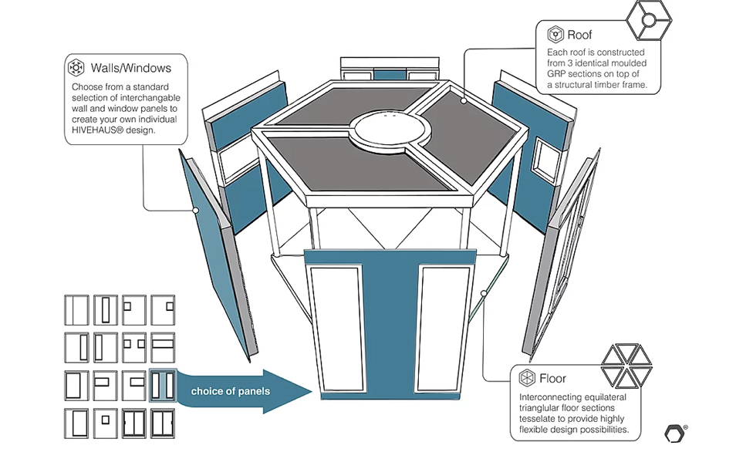
[www.hivehaus.co.uk]
[www.californiahome.me & www.thoughtco.com] – Image 1 and 2
Our other precedent study focuses on the ‘Bazette house’, which was built in 1940, created in an L-shape and based on a hexagonal grid. “The walls are constructed from redbrick and laminated redwood, which occupy 2,200 square feet. The Usonian style has a large central chimney and a carport that separates the main house from the guest wing.”

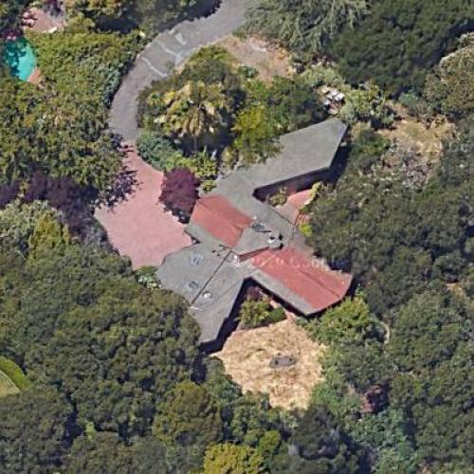
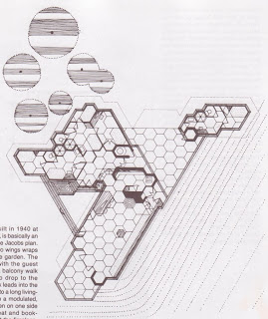
[www.pc.blogspot.com & www.virtualglobetrotting.com] - Image 3 and 4

Main body: PROJECT PROPOSAL
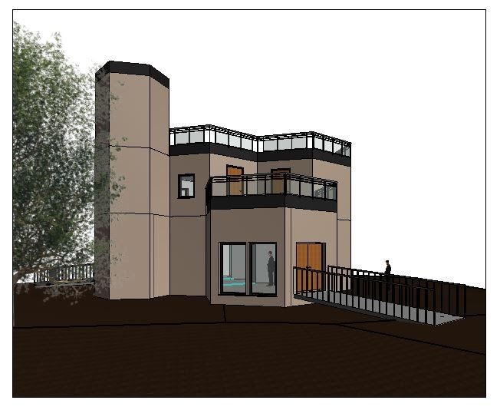
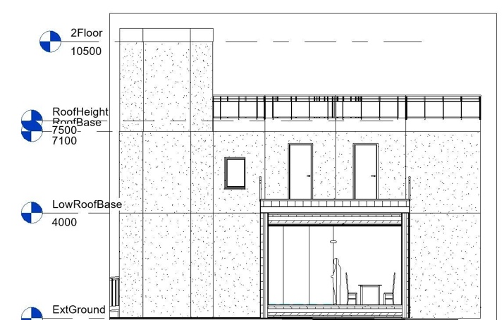
‘Poly Pods’ have been specifically designed to maximize both the physical and psychological comfort for occupants, with intuitive user controls and interactions within the buildings and its systems. The key ideas include a flexible modular design, integration of technology, and the integration of nature within its structure.
[docs.google.com/presentation] – Image 5 & 6
As for the design concept, there will be separate pods with its own space, equally the same size. The client will be able to decide the layout of the pods, meaning that it can be easily altered as a family grow in size, and their needs changed. This is targeted for a family of three to five, as they are more in demand in the UK. As a group, we have considered installing a grid for the foundation for easier movement of orientation.

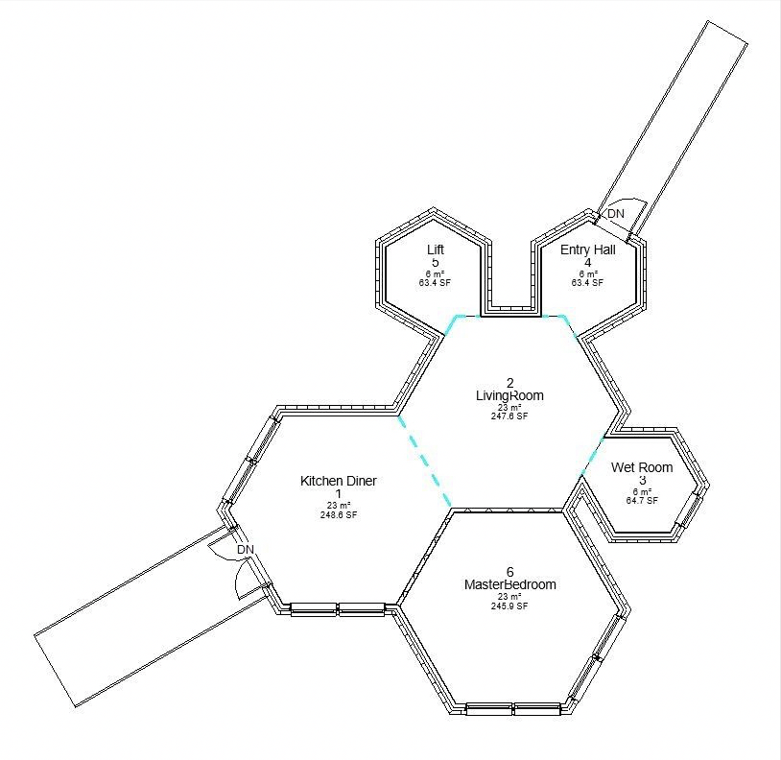
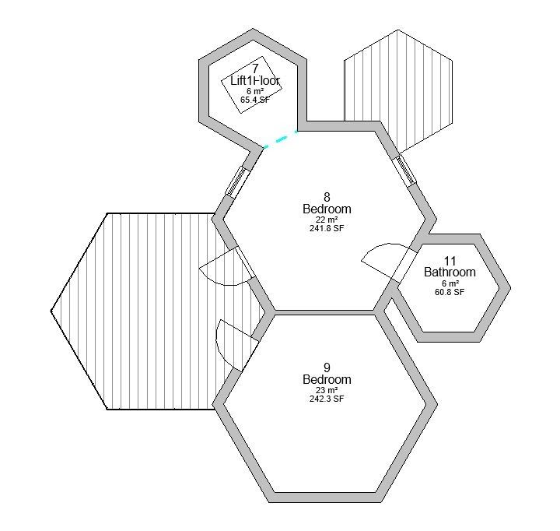
The layouts of the design should include the spaces for living, dining, and sleeping, as well as the possible layout for the interior. As my contribution to the group, I looked at the standard sizes for each room, and design considerations such as using recycled materials, such as plastic bottle, for the countertops. We will include a garden roof, to have access for the locally grown food, and the kitchen waste will be used as compost for the garden. Smart glass will be installed, which allows the glass to change colour when the electric current is applied, and to allow light and heat to enter your building. In addition, this is designed for three to four people, will include some ensuite facilities depending on the budget. Natural light throughout the building will be considered due to the orientation of the pods.
[docs.google.com/presentation] – Image 7 & 8

Technology installed within the building, will control and monitor the ongoing data, which enabling the analytics and insights into the design process, and the refinement of predictive control strategies. Examples such as a smart kitchen unit, would automatically switch off appliances when they are no longer in use. The LiFi system, which is a voice activated Al system, can be controlled for faster and optimised use is designed for user interactions, including medication reminders and monitor someone with dementia and learning disabilities.

An important service refers to the water conservation, both hot and cold must have access at all times. With the idea of low flow plumbing fixtures, PIit can be installed with a stoppable system that can stop water flow within an amount of a certain time, such as a touch-free tap. As it tends to rain in the United Kingdom, we thought about using a water drainage system, meaning that the rainwater collected, is filtered for garden irrigation. We also thought about installing rain sensors, which would result in using recycled water in gardens, etc

Renewable energy for a sustainable home, should apply passive solar design principles in planning, and solar water heating, as it “provides hot water all throughout the year, as a result, reducing the utility bills as it can provide a third of your hot water needs. It also reduces your carbon footprint by saving between 230kg and 510kg of CO2 every year.” Another renewable source are small wind turbines, and tubular natural skylights, which are panels that are situated inside the pods to have energy-efficient lights throughout the day. For extra security, a “PIR motion sensor will be added, which is an electronic sensor that measures the infrared light radiating from objects in its field of view.” Lighting throughout the building would be adjustable, making the brightness low or high depending on the user’s preference.
[www.greenmatch.co.uk & www.seeedstudio.com]

Our aim for this design is creating an easier environment and living space for all, particularly focusing on ramp and stair designs. And a singular pod specifically designed for the disability to have access on the next floor.
[docs.google.com/presentation] – Image 9

Conclusion: OVERALL EXPERIENCE
As we progress in a new world, technologies, we need to start considering the alternative solutions to overcome such problems like the increase in carbon footprint, to make home living to be green and beneficial, while providing high living standards, for both us and the environment. Overall, this competition was an interesting experience as we were given an opportunity to create a design for our own homes. I would most definitely encourage students for this competition, as it would encourage all those working within the same field. As a result, it would give a good insight, while offering a broad knowledge from other areas within the field of architecture and engineering. From doing previous projects similar to this, it has helped me to improve on my skills, especially with teamwork and my knowledge on creating the structure, while considering alternative, green features, of which I can take forward for my next project.

REFERENCES
Websites and research

- Active house definition
REGEN (July 2019)
http://www.supersolar-hub.org/wp-content/uploads/2019/07/The-Solar-Commission-web.pdf
[Accessed at: 12 March 2020, 10:47]

- Active house project
Clarke, J (January 2020)
Active Buildings student guide Version 1.0
[Accessed at: 19 January 2020, 12:45]

- Bazette House research
Alyson (June 10 2016)
https://www.californiahome.me/2016/06/frank-lloyd-wright-an-inside-look-at-some-of-his-most-iconic-california-residences/
[Accessed at: 4 March 2020, 16:12]

- Usonian style
Craven, J (July 03 2019)
https://www.thoughtco.com/usonian-style-home-frank-lloyd-wright-177787
[Accessed at: 4 March 2020, 12:54]

- Solar water heating
https://www.greenmatch.co.uk/solar-energy/solar-water-heating
[ Accessed at: 8 March 2020, 05:46]

- PIR motion sensor
Li, I (August 12 2019)
https://www.seeedstudio.com/blog/2019/08/03/pir-sensor-introduction-and-how-pir-motion-sensor-works-with-arduino-and-raspberry-pi/
[Accessed at: 23 January 2020, 18:23]

- Project proposal
https://docs.google.com/presentation/d/1vKe10Ary-BAHCaBaQKkRJtVY1gNt_lTUSsLDEcbQ1fU/edit?usp=sharing
[Accessed at: 7 March 29 2020, 19:45]

Images

- Images of HiveHause (structure and construction materials) IMAGE 1 & 2
N/A (2018)
www.hivehaus.co.uk
[Accessed at: 12 February 2020, 17:34]

- Floorplan of the Bazette house IMAGE 3
Cresswell, P
http://pc.blogspot.com/2008/09/bazett-house-frank-lloyd-wright.html
[Accessed at: 10 February 2020, 14:45]

- Bird’s eye view of the Bazette house IMAGE 4
N/A (July 03 2015)
https://virtualglobetrotting.com/map/sidney-bazett-house-by-frank-lloyd-wright/
[Accessed at: 5 March 2020, 02:45]

- Project proposal IMAGE 9 and onwards
https://docs.google.com/presentation/d/1vKe10Ary-BAHCaBaQKkRJtVY1gNt_lTUSsLDEcbQ1fU/edit?usp=sharing
[Accessed at: 6 March 29 2020, 20:45]

