MARKETING MANAGEMENT
(A Study on ASOS)

Table of Contents
1. Introduction and Company overview 3
2. Idea of marketing and communication 3
3. Explaining communication model 4
4. Integrated marketing communication 5
5. Current promotions used by ASOS 6
6. New improved promotional strategies for brand awareness 8
7. Branding and brand equity 9
8. Explanation of Keller’s Brand Equity model 10
9. Customer journey and touchpoints for ASOS 12
10. Explanation of customer journey map for ASOS 14
11. Total Engagement Model 16
12. Conclusion 17
References 19

1. Introduction and Company overview
Marketing practices expand the scope of communication between a marketer and its target audience or customers. Advertisement, branding, direct marketing, public relations management, and others are some of the ways of communication in the process of marketing. Effective management and implementation of marketing plans allow an organisation to explore the opportunities of managing and satisfying customers. The present report is expected to shed light on the marketing and branding practices of ASOS. The discussion will include a detailed analysis of the customer journey and a customer journey map will be presented based on the organisational context of ASOS. Keller's Brand Equity Model and Total Engagement Model will be discussed in this study for a comprehensive understanding of ASOS’ marketing plan.
ASOS is one of the popular British online retailers of cosmetics and fashion accessories and the retailer has consistently developed its business operation after the foundation in 2000. ASOS has revolutionised the fashion retail industry with its innovative ideas and practices, as it considers the audience as unique and provides different sizes at the same price. The company supports talent and welcomes innovative ideas, and all these aspects lead the organisation towards a creative future (ASOS, 2021). ASOS is currently shipping products to more than 200 countries worldwide and it guarantees standard shipping to everyone (ASOS, 2021). Approximately more than 3800 people are currently employed in ASOS in 8 locations and the online retailer has maintained growth in financial profitability even during the volatile stage caused by the covid-19 pandemic. ASOS is committed to maintaining the uniqueness and it offers a product line of unique shoes, clothing, gifts and accessories that help to gain a strong competitive edge over its competitors. ASOS has set its identity by maintaining individuality and it is committed to fulfilling the needs of a wide variety of customers. Availability of high-quality products at affordable prices serves ASOS' competitive advantages.

2. Idea of marketing and communication
Finne & Grönroos (2017) have merely described communication as the way of sharing and receiving information or transmission of information and effectiveness of communication significantly depends on the selected mode of communication. Marketing practices of a company also adhere to the strategy of communication because effective communication with customers is considered the main purpose of marketing. As observed in the case of ASOS that being one of the leading online fashion retailers, ASOS also relies on online marketing practices to communicate with its target audience or customers. For a long period, ASOS has been leading the fashion e-commerce sector and it has significantly evolved the strategies of online communication (Amelia Phillips, 2017).
ASOS admits that its online communication strategy has played a vital role in influencing sales, revenue, and growth. As stated by Moravcikova & Kliestikova (2017) marketing communication specifies the messages conveyed by a company about the products and services, it wants to sell. At the very preliminary stage of marketing, these strategies are also used by companies to make their target customers aware of a product or service, the company is aiming to launch. Similarly, ASOS also uses marketing platforms to reach customers and online platforms allow to maintain a direct approach. The key purpose of marketing communication is persuading customers to purchase products.

3. Explaining communication model
Communication is certainly an integrated part of marketing practices, so the selection of the most appropriate media of communication is also important for effective marketing. Olson, et al. (2018) have mentioned that as a part of marketing, companies use some common mediums like magazines, newspapers, radio, television and all for communication. Claude Shannon and Waren Weaver's macro model is one of the widely-accepted communication models that give an idea about the standard stages in effective communication.
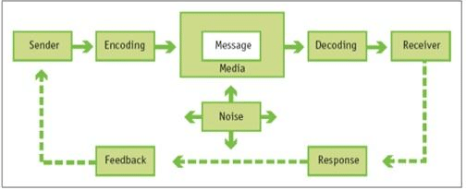
Figure 1: Claude Shannon and Waren Weaver's macro model of communication
Source: (Kotler & Keller, 2016)
The above image briefly explains that in the process of communication, two major parties are involved, sender and receiver and these parties use the tool like messages and media. Throughout the entire process of sharing and receiving a message, different communication functions include encoding, decoding, response and feedback. Apart from that, another factor is noise and as presented in the model, this factor is interrupts intended communication. This is how, this communication model gives a coherent idea about the stages of effective communication, which can be followed by a company as it may help to craft a good communication campaign. ASOS may also follow this macro model to evaluate its current strategies along with identifying tactics for improvement.

4. Integrated marketing communication
As per the viewpoint of Luxton, et al. (2015), integrated marketing communication or IMC is an approach, which is applied by business organisations for coordinating their communication efforts. This process specifically unifies elements in marketing communication. Direct marketing, advertising, sales promotion, public relations, and internet marketing are considered five primary tools while performing integrated marketing communication. The following image consists of different channels used for integrated marketing communications, companies tend to capitalise on these channels to obtain a competitive advantage.
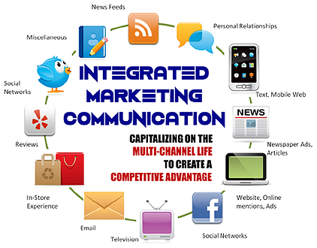
Figure 2: Different channels used for integrated marketing communication
Source: (Kitchen & Burgmann, 2015)
Integrated marketing communication has been proved to be a cost-effective method that ensures improved results in marketing. In the case of ASOS, its expanded social network significantly contributes to marketing activities. Effective communication is maintained with the customers through regular posts along with interactive comments. Moreover, “#AsSeenOnMe” is one of the inclusive ad campaigns of ASOS, which was launched in 2014 through social media platforms (Amelia Phillips, 2017). In order to carry on an IMC campaign, certain specific stages need to be followed as mentioned in the following image and these stages can be considered by ASOS for a more integrated marketing campaign.
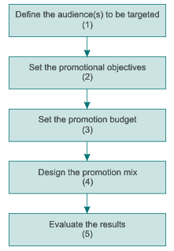
Figure 3: Stages in an IMC Campaign
Source: (Patti, et al., 2017)

5. Current promotions used by ASOS
While explaining different aspects of marketing, Thabit & Raewf (2018) have defined promotion as a way of marketing communication, which is used for sharing information with target audiences thereby making them aware of the benefits of a particular product or service. ASOS has mastered using social media channels and this online fashion retailer commonly sets trends with its innovative digital marketing strategies. Twitter is one of the social media channels, which is actively and strategically used by ASOS for promotions (Russell Chua, 2021). On a regular basis, ASOS provides myriad fashion-related suggestions to its followers through Twitter, thus the retailer ensures a higher degree of customer engagement. This engagement of followers in social media allows ASOS to draw the attention of the maximum possible customers when it promotes products and services.
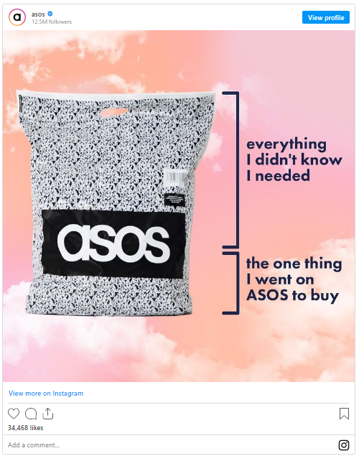
Figure 4: ASOS’ post on Instagram
Source: (Cosmetics Business, 2021)
Social media sites like Facebook and Instagram are also used by ASOS to promote its products, as the above image is an Instagram post by ASOS. These platforms provide immense freedom and scope of innovation in advertisements and promotions. However, ASOS has also been accused of misleading information or advertisement on social media. Recently, the advertising watchdog of the UK has ordered ASOS to remove its promotion campaign. ASOS used the technique of direct mail for product promotion as the customers have received an email with the subject “20% off everything + free delivery” while the main content was quite misleading (Cosmetics Business, 2021).

6. New improved promotional strategies for brand awareness
According to Nikabadi, et al. (2015), product or service advertising is one of the core organisational activities that helps in increasing brand awareness. Considering this aspect, ASOS also needs to consciously formulate its promotional strategies and it is important to be aware of the impacts of these strategies on consumers’ brand awareness. As ASOS has been accused of misleading content in promotion, the online retailer needs to make as necessary changes as possible. At the same time, ASOS needs to be aware of the rules of marketing and product promotion. At the time of email marketing, ASOS needs to avoid sharing any single misleading information along with sharing complete details of the product. The retailer needs to ensure that customers can get a complete understanding of the product’s utilisation and benefits from the email.
ASOS has innovated strategies for influencer marketing and sometimes social media influencers are involved to advertise products through brand storytelling. So, in this context, ASOS can be recommended to use influencer marketing strategies for product promotion. ASOS' expanded social network is also identified as attractive by bloggers and their social media influencers. ASOS may collaborate with bloggers or any social media influencer, and before launching a new product and promoting it in the market, that influencer can be involved in affiliate marketing. For affiliate marketing, that influencer will be provided with a particular code and the code will be shared with followers through social media. Furthermore, they will receive discount offers whenever they will buy that product promoted by ASOS.

7. Branding and brand equity
Branding refers to the process of giving meaning to a product company-specific organization or services in order to create and create the mind of target customers (Sammut-Bonnici, 2015). Brand equity refers to the value premium which a company generates from a particular service or product with a recognizable name compared to the generic equivalent in the competitive market. The companies in the current era create brand equity for the products or services by making them recognizable, easily available, and superior compared to the other competitive services for products in the market. It increases the visibility and reliability of the customers to opt for the product or service (Ameyo, 2017).
From the below image it can be identified that the brand value of Asos in 2021 stood at 1.1 billion British pounds that were comparatively 38% greater than the value estimated in 2020 (Statista, 2021). It is the second fastest-growing brand in the UK in the financial year 2021 (e-commerce DB, 2021). The tagline of the organization is very attractive as the company originally stands for as seen on-screen having the tagline of by what you see on film and TV, therefore, it reflects the customers that any product in terms of retail and cosmetics which are advertised on television are sold as imitation cloth by the organization. The organization has been the one-stop online fashion destination for the last 20 years and the online platform of the organization works by selecting the current trendy items from a variety of brands and product categorizations (Halliday, 2021).
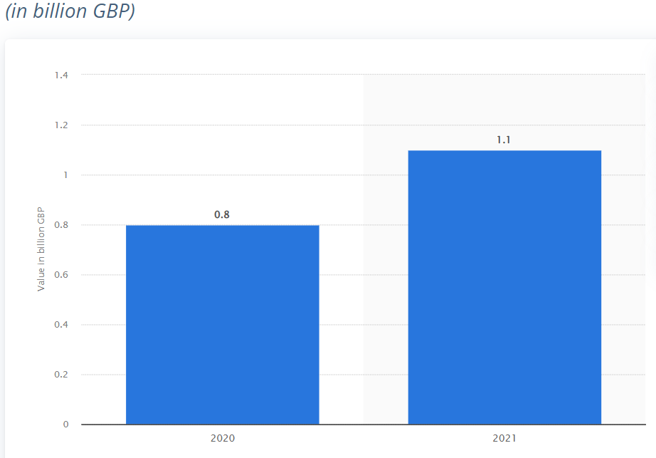
Figure 5: The brand value of Asos, worldwide
(Source: Statista, 2021)

Figure 6: Brand awareness and popularity strategy of Asos
(Source: As created by the author)

8. Explanation of Keller’s Brand Equity model
The branding and brand equity strategy of the organization for the illustration of the customer-based brand equity model can be effective to understand the strategic brand management of the organization. Therefore Keller's customer-based brand equity model can be efficient in order to shape the brand equity strategy of the organization from different levels (Kuhn, Alpert, and Pope, 2008). The brand equity pyramid has different levels that are
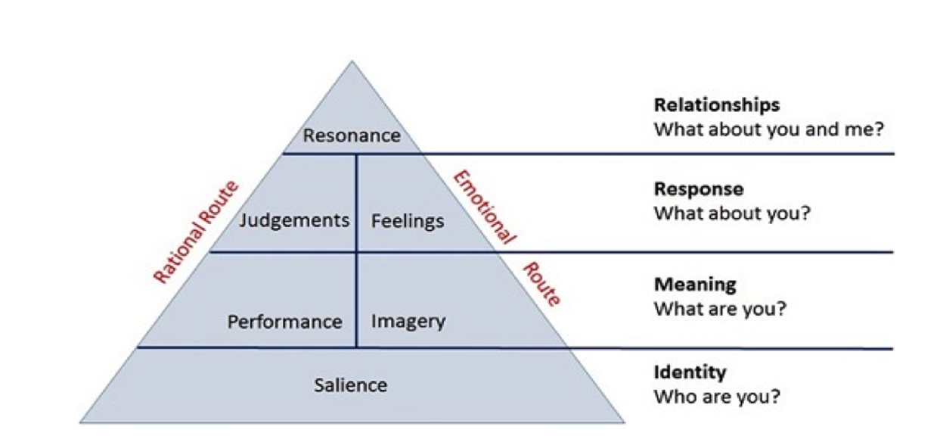
Figure 7: Keller’s Brand Equity model
Identity
By creating communities and groups on social media platforms the customers are able to be updated about the discounts and products of the organization.
Meaning
The uniqueness of the product sold by the company is based on its high quality and low cost compared to the competitors. The end-of-season saves and mid-season sales are highly attractive among millennials. As in this season, the products are available at heavily discounted prices. Apart from that for most of the online delivery, extra charges are not charged by the company except in a few cases depending on the location (Halliday, 2021).
Response
The products of the organization are segmented into different categories such as shoes, clothing accessories, and beauty products that are sold directly to the customers. The company has recently launched a new brand called little Asos for kids which have also got a huge hype in the UK market (ASOS, 2021).
Relationship
By conducting different awareness campaigns for example multi-million pound campaign in February that targeted the topman and Topshop customer elite customers in the market where targeted similarly the two week social media lead campaign was also conducted by the organization to raise awareness among the customers of US UK and Germany through different online platforms such as Facebook, Instagram, YouTube and Tiktok (Instagram, 2021; Edelson, 2021).

9. Customer journey and touchpoints for ASOS
According to the viewpoint of Lemon & Verhoef (2016), the customer journey can be explained as a path, which is followed by customers while making purchasing decisions and buying products. A customer journey is completed through myriad touchpoints. An end-to-end customer journey involves customer interactions, as, at the initial stage of this journey, the customers remain unaware of a company and its services while gradually they become aware of it. In the case of fashion retailer ASOS, the customer journey is stringently inspired and influenced by online operations and activities because ASOS actively uses online platforms to connect with customers. The main stages in a customer journey are as follows:
- Awareness
- Consideration
- Decision
- Retention
- Advocacy
Awareness – ASOS increases brand awareness among customers mainly by using social media platforms. The high price of clothing apparel in retail stores, limited stocks and variety and inconvenience in visiting multiple stores are the main problems, and ASOS can make its customers aware of these issues while purchasing from ASOS can help to avoid these problems.
Consideration – Strong presence in different social media platforms like Facebook, Instagram, Twitter and others will allow the customers to choose any of these to know about ASOS. Moreover, they can find a suitable way to buy products as well.
Decision – Transparency, detailed information of products, and convenience in purchasing are the main factors that inspire buying decisions of customers. ASOS needs to ensure the convenient use of its online application.
Retention – Customer retention is possible if ASOS’ marketing team can maintain the strategy of direct email and personalised interaction in social media applications.
Advocacy – This stage can be achieved by encouraging customers to positively share their feedback and reviews after purchasing products from ASOS.
Touchpoints are created every time when a customer interacts with a brand, and at every touchpoint, companies need to maintain creative consistency along with customer convenience. This is the way, a company can develop a positive perspective of the customers towards the brand. In the case of ASOS, the touchpoints will be – website, social media channels, customer contact centre, a platform to place an order, customer service (delivery), invoicing, receiving feedback, email, and phone.











Figure 8: Customer TouchPoints for ASOS
Source: As created by Author
ASOS websites provide clear information about the brand identity and value thereby emphasising the unique features of the online retailer. Aspiring customers can come to know about ASOS and its uniqueness through this information. Furthermore, social media channels are the most important platforms, where the customers interact with ASOS most of the time. This is how, the customers' purchasing decision is inspired through this interaction, which eventually influences their long-term relationship with that brand.

10. Explanation of customer journey map for ASOS
The main stages of the customer journey are awareness, consideration, decision, retention, and advocacy.
Stage | Description | Company strategy or response
Awareness | At this stage, the potential customers of the market are made aware of the products or services by the organization. They started actively researching the information and identifying the extent to which it is able to mitigate or solve the problem or need. The first impression of the company is made at this particular stage. | From the very beginning of the foundation, the organization has maintained a celebrity inspired fashion business among the customers that have set a benchmark among the customers to consider the company as one of the best organizations available online to provide fashionable and trendy products (Sweeney, 2018)
Consideration | As the customer searches about the product at which stage of prospect is initiated about the services and some other options are also searched by the customers to narrow down the option. At this stage, the products and services of the company are compared with the other solutions in the market. | The strong lineup of the editorial content in the magazines of the organization highlights the brand image (ASOS MAGAZINE, 2021). The leaflet and the magazine are not only filled with glossy images but subscription facilities are also made available to the customer to know about the outfit ideas, shopping tips, celebrities styles making it unique and different from other competitors. Recently the downloaded version or PDF files are also being made available on the websites allowing the customers to refer to the downloaded files as well
Decision | In the third stage of the customer journey after generating a perspective about the brand, the customer makes the purchase. The review of the customer is very crucial at this stage. | The company has never followed generic marketing campaigns instead it has developed authentic Strategies for communicating with the customers. Since the business is online the influencers are the major source of communicating the ideal message inspiring the millennials for fashionable outfits through different social media platforms (Aso's insider community, 2021). As the influencers curated attractive outfits it became irresistible for the customers to avail the services at a discounted price.
Retention | The retention of the customer refers to the ability of an organization to retain a loyal customer for a specific period of time. In this stage, loyal customers are created and retained by the company through which value is gained by the organization over time. | Now that the customers have known about the organization and its unique proposition of products and services extra take away which the organization provides is communicating through various platforms and making the customer remain informed about the upcoming discounts and sales. The advertisement regarding different corporate responsibilities emphasizes the customers to have a positive impact on youth as well (ASOS plc, 2021). It has created the ASOS foundation for building educational Infrastructures and initiatives in developing nations (Asos Foundation, 2021).
Advocacy | In the last stage of the customer journey, the customers become active about the company's brand to be advocated. They share good things about the company and positive word of mouth is automatically generated (Srivastava and Sivaramakrishnan, 2020) | By making it easy for the customer to make the purchase the organization has already built a great brand image. The high-quality content in online magazines and offering a diverse range of products make the customers share their unique experiences and respective suggestions and ideas about the company on the social media platforms and the company website.

11. Total Engagement Model
The total engagement model focuses on linking and aligning the key elements of a customer experience, a brand culture advertisement, and a customer value proposition. There are different means of promotion for the products and services that are considered by the organization and the mobile application, magazines and websites are the topmost priority among the customers (Srivastava and Sivaramakrishnan, 2020). It also sends regular emails and updates to the customers who are registered regularly for promoting the booklet and leaflets. Communities and groups are also created by the organization on different social networking sites such as Twitter and Facebook for keeping the customers updated regarding the discounts and products.
Performance management
Measurement system
Figure 9: Total Engagement Model of Asos
(Source: As created by the author)
Since the organization is a website-based company the number of human engagement for employees is very limited compared to similar-sized bricks and mortar organizations. The large marketing mix product portfolio of the organization on the website and online portal demonstrates that the company can cater to a wide range of customers. Building brand equity for an organization is one of the significant challenges faced by most organizations. However, brand equity also provides a huge opportunity for generating tremendous value and building a prominent position in the market.

12. Conclusion
From the above discussion, it can be concluded that the branding and brand equity strategy of Asos is a story of impressive popularity and growth with advanced digital marketing strategy. Difference largest online in terms of revenue selling large diversity of products at discounted prices. The volume of orders and active customers have been steadily rising resulting in an increased percentage of brand value worldwide by 38% even during the covid-19 pandemic situation. The progressive launch for online shops in different countries has laid the foundation to be significantly growing over the years and standing at a leading position in the fast fashion industry. Asos is now dominating the industry focusing on the youth market, the trendy and new styles to be widely available for the public. The affordable prices, quick availability, and accessibility are some of the user-friendly experiences stressing the core values of authenticity, individuality, and creativity.

References
Amelia Phillips, 2017. How ASOS Communicates Online. [Online]
Available at: https://medium.com/digital-society/how-asos-communicates-online-fa66450f6987
[Accessed 17 December 2021].
Ameyo, 2017. Customer Engagement Model: What It Is, Why It Matters and How to Build One. [online] Ameyo. Available at: <https://www.ameyo.com/blog/customer-engagement-model-what-it-is-why-it-matters-and-how-to-build-one> [Accessed 17 December 2021].
Asos Foundation, 2021. Home. [online] Asosfoundation.org. Available at: <https://www.asosfoundation.org/> [Accessed 17 December 2021].
Asos insider community, 2021. asos insider community. [online] asos insider community. Available at: <https://www.asos.com/discover/insiders/> [Accessed 17 December 2021].
ASOS MAGAZINE, 2021. ASOS MAGAZINE Spring Issue featuring Maisie Williams + Cole Sprouse + J Hus + Jorja Smith | ASOS. [online] ASOS. Available at: <https://www.asos.com/asos-design/asos-magazine-spring-issue-featuring-maisie-williams-cole-sprouse-j-hus-jorja-smith/prd/9723119> [Accessed 17 December 2021].
ASOS plc, 2021. Fashion with Integrity. [online] ASOS plc. Available at: <https://www.asosplc.com/fashion-with-integrity/> [Accessed 17 December 2021].
ASOS, 2021. ASOS | Online Shopping for the Latest Clothes & Fashion. [online] ASOS. Available at: <https://www.asos.com/> [Accessed 17 December 2021].
ASOS, 2021. Which countries do you ship to internationally?. [Online]
Available at: https://www.asos.com/us/customer-care/delivery/which-countries-do-you-ship-to-internationally/
[Accessed 17 December 2021].
ASOS, 2021. Who we are. [Online]
Available at: https://www.asos.com/about/who-we-are/?ctaref=aboutus|whoweare
[Accessed 17 December 2021].
Cosmetics Business, 2021. Asos ordered to remove discount campaign by advertising watchdog. [Online]
Available at: https://www.cosmeticsbusiness.com/news/article_page/Asos_ordered_to_remove_discount_campaign_by_advertising_watchdog/176528
[Accessed 17 December 2021].
e-commerce DB, 2021. Store Ranking & Overview. [online] ecommercedb. Available at: <https://ecommercedb.com/en/ranking/ww/fashion> [Accessed 17 December 2021].
Edelson, S., 2021. If You Love Topshop, Here’s How New Brand Owner Asos Plans To Give You More. [online] Forbes. Available at: <https://www.forbes.com/sites/sharonedelson/2021/02/02/if-you-love-topshop-heres-how-new-brand-owner-asos-plans-to-give-you-more/?sh=3d8aaa8b6792> [Accessed 17 December 2021].
Finne, Å. & Grönroos, C., 2017. Communication-in-use: customer-integrated marketing communication. European Journal of Marketing.
Halliday, S., 2021. Brand values soar in pandemic, Nike, ASOS, Uniqlo and Vuitton all prosper. [online] fashionnetwork. Available at: <https://uk.fashionnetwork.com/news/Brand-values-soar-in-pandemic-nike-asos-uniqlo-and-vuitton-all-prosper,1312374.html> [Accessed 17 December 2021].
Instagram, 2021. instagram. [online] instagram. Available at: <https://www.instagram.com/asos/?hl=en> [Accessed 17 December 2021].
Kitchen, P. & Burgmann, I., 2015. Integrated marketing communication: Making it work at a strategic level.. Journal of Business Strategy..
Kotler, P. & Keller, K., 2016. A framework for marketing management. Boston: Pearson.
Kuhn, K., Alpert, F. and Pope, N., 2008. An application of Keller's brand equity model in a B2B context. Qualitative Market Research: An International Journal, [online] 11(1), pp.40-58. Available at: <https://www.researchgate.net/publication/29468408_An_application_of_Keller's_brand_equity_model_in_a_B2B_context> [Accessed 17 December 2021].
Lemon, K. & Verhoef, P., 2016. Understanding customer experience throughout the customer journey. Journal of marketing, 80(6), pp. 69-96.
Luxton, S., Reid, M. & Mavondo, F., 2015. Integrated marketing communication capability and brand performance. Journal of Advertising, 44(1), pp. 37-46.
Moravcikova, D. & Kliestikova, J., 2017. Brand building with using phygital marketing communication. Journal of Economics, Business and Management, 5(3), pp. 148-153.
Nikabadi, M., Safui, M. & Agheshlouei, H., 2015. Role of advertising and promotion in brand equity creation. Journal of Promotion Management, 21(1), pp. 13-32.
Olson, E., Slater, S., Hult, G. & Olson, K., 2018. The application of human resource management policies within the marketing organization: The impact on business and marketing strategy implementation. Industrial Marketing Management, Volume 69, pp. 62-73.
Patti, C., Hartley, S., van Dessel, M. & Baack, D., 2017. Improving integrated marketing communications practices: A comparison of objectives and results.. Journal of marketing communications,, 23(4), pp. 351-370.
Russell Chua, 2021. 4 Tactics that gave ASOS the Edge in the Competitive Fashion Arena. [Online]
Available at: https://creadits.com/blog/4-tactics-asos-edge-competitive-fashion-arena/
[Accessed 17 December 2021].
Sammut-Bonnici, T., 2015. Brand and Branding. Wiley Encyclopedia of Management, [online] 12(7), pp.1-3. Available at: <https://www.researchgate.net/publication/272184078_Brand_and_Branding> [Accessed 17 December 2021].
Srivastava, M. and Sivaramakrishnan, S., 2020. The impact of eWOM on consumer brand engagement. Marketing Intelligence & Planning, [online] 39(3), pp.469-484. Available at: <https://www.researchgate.net/publication/344670476_The_Impact_of_eWOM_on_Consumer_Brand_Engagement> [Accessed 17 December 2021].
Statista, 2021. ASOS brand value 2021 | Statista. [online] Statista. Available at: <https://www.statista.com/statistics/1246129/asos-brand-value/#:~:text=In%202021%2C%20brand%20value%20of,brand%20value%20estimated%20in%202020.> [Accessed 17 December 2021].
Sweeney, E., 2018. Asos will increase marketing spend in 2019 as sales growth unexpectedly slows. [online] Marketing Dive. Available at: <https://www.marketingdive.com/news/asos-will-increase-marketing-spend-in-2019-as-sales-growth-unexpectedly-slo/544707/> [Accessed 17 December 2021].
Thabit, T. & Raewf, M., 2018. The evaluation of marketing mix elements: A case study. International Journal of Social Sciences & Educational Studies, 4(4).

