UNIVERSITY OF WALES TRINITY SAINT DAVID

London Campus

DATA HANDLING AND BUSINESS INTELLIGENCE
ASSESSMENT COMPONENT 2
LCBB5000

STUDENT NAME | FLORENTINA JOITA
STUDENT ID | 2124448
LECTURER | Xavier Matieni

Table of Contents
Introduction 3
Part 1 3
1.1 Use of Excel for Pre-processing the Data 3
1.2 Use of Excel for Analysing the Data 4
1.3 Use of Excel for Visualising the data 4
1.4 Pivot table analysis for the determination of declination or increment in the average room reservation price 5
1.5 IF function for the determination of declination or increment in the average room reservation price 6
1.6 Appropriate charts of the data set analysis 7
Part 2 9
2.1. Rate of male and female students 9
2.2. The rate of learners qualifies and does not qualify for reduced or free lunch 10
2.3. Comparison of mean and median of students who qualify and do not qualify for reduced/free lunch 12
2.4. Discuss the mean and median differences between students' pre-test and post-test scores 13
2.5. Using the dataset Student_Score.csv provided in conjunction with SPSS, give a specific example of Clustering (ex. K-Means Clustering). Show your workings with screenshots and clearly explain your results. 14
2.6. Explain the minimum 5 most common data mining and text mining methods that can be used in contemporary business 16
2.7. Discuss the advantages and disadvantages of using SPSS and Excel using relevant practical examples and present your discussions in Table 17
Conclusion 19
Reference List 20
Appendices 22
Appendix 1: Example of Excel Use for Data Analysis 22
Appendix 2: Example of the SPSS Use 24

Introduction
Data analysis is the procedure of systematically applying logical and statistical techniques to demonstrate and illustrate, reap and assess data in an efficient manner. This assignment will focus on the data analysis of the hotel reservation data set and assess the increase or decrease of the average price. A pivot table and bar chart will be present in this study for conducting this study which makes this assignment more reliable. Apart from this, the IF function will be assessed in this study for identifying the decline or increment in the average room reservation price. The study will effectively help in analysing the datasets through different Excel functions that act as an important aspect of numeracy and data analysis.
Thesis Statement: This study is going to interpret and visualize the provided data with the use of the statistical interpretation.

Part 1

1.1 Use of Excel for Pre-processing the Data
In terms of pre-processing of data, Microsoft Excel can be stated as quite a great tool for handling and pre-processing structured data. Excel has got functions and methods which assist in making it a lot easier in cleaning the structure of data. Prior, to discussion further, a few of the basic function that assists in processing large data is the IF function, IFERROR, LEFT, RIGHT, FIND, COUNT, COUNTIF and so on (Towardsdatascience, 2020).
Other than this it seems for this current study, two such functions are utilised on the given data of for the hotel data which is provided are If and Pivot tables wherever demanded necessary. It is also seen that the use of the Excel function is mostly in checking a specific condition and in return a specific kind of value accordingly. Other than this PivotTable is that it is utilised as an interactive way of quickly summarising huge amounts of information (Microsoft, 2022). Asd here too for this data the hotel details a lot of the data and quite small and precise too so, the use of PivotTable is of greater use as it can help in the analysis of the numerical data in detail and then answer unanticipated in the questions in regard to the information.

1.2 Use of Excel for Analysing the Data
As per the views of Blayney and Sun (2019), Microsoft Excel is a critical application for data analysis that could have an impact on increasing the ease of importing, exploring, analysing, cleaning, and visualising data. Analysing data in Excel allows the users to understand data through natural language that allows them to ask questions concerning the data without the involvement of complicated formulas. Therefore, excel helps in simplification of the data through understanding patterns, trends, and visualisation. Therefore, the Excel file contributes to affecting the interpretation of numerical values through the effective implementation of data in different forms. Moreover, Excel provides access to over 400 functions to users that could be analysed through the application of formulas in a simplified form. Thus, Excel undoubtedly serves as a powerful tool for performing data analysis to a critical extent.

1.3 Use of Excel for Visualising the data
As per the opinion of Mahajan and Gokhale (2019), Excel provides access to a variety of ways that could be utilised for the visualisation of data that contributes to communicating better and allowing the data that allows understanding the story it tells. For instance, from 3D models to complex 2D charts, Excel offers a variety of charts that could be utilised for the analysis and interpretation of data. Hence, Excel also provides a certain type of formatting and graphic options that could be applied for analysing the datasets within the Excel sheet. In this study, different graphical charts have been utilised for representing the data including vertical and horizontal bar charts that help in reflecting upon the changes observed within the given datasets. Therefore, the study efficiently utilises the visualisation features of Excel for utilising them for the analysis of the datasets. The bar chart used for the study contributes to providing an effective understanding of trends and patterns of the data along with reflecting upon values through making a comparative study over a specific period of time.
Therefore, the graphical representation is highly critical for interpreting complex numerical values in a simplified form that could be relatable by the reader and interpreted with increased ease. The visualisation function present in Excel has substantial relevance in introducing the users to new techniques and presentation skills that contribute to a professional presentation providing a substantial understanding of the data.

1.4 Pivot table analysis for the determination of declination or increment in the average room reservation price
Sum of Average price

Arrival_year | Total
2017 | 549304.11
2018 | 2984721.57
2019 | 18015.29
2020 | 20857.3
2021 | 19436.8
Grand Total | 3592335.07
Table 1.4: Pivot Table
(Source: Self-made)
The table given above reflects a pivot table. It can be seen that the sum of the average price table is provided. It seems that here around 5 years of data is shown, which is depicted as the arrival year for the people who logged in to the hotel. The data here shows in the year 2017 is at 549304.11, which rose to 2984721.57 in the year 2018. Then it high mitigated in the year 2019 reaching 18015.29, which rose by 2% approx. reaching at 20857.3, then again it mitigated in the year 2021 at 19436.8. The average room reservation price reflects to have increased unexpectedly in 2018 thereby reflecting a price of 2984721.57. However, in contrast, as per the analysis, the reservation prices declined significantly in 2019 and substantially kept on decreasing post-2020 due to the outbreak of the pandemic that led to substantial lockdowns on a global level.

1.5 IF function for the determination of declination or increment in the average room reservation price
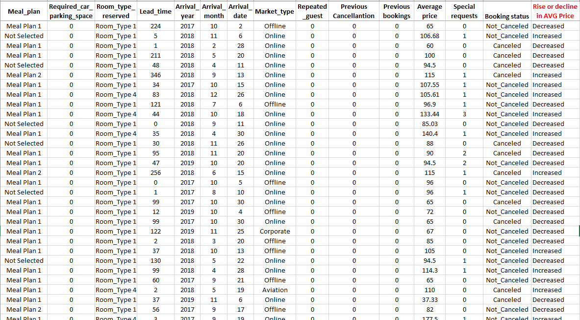
Figure 1.5: Rise and decrease in AVERAGE room reservation price
(Source: self-made)
In regards to the condition of this question, as shown in the above figure the column rise or decline in AVG price is prepared. Here if the function is utilised to depict whether the price rises or not, the formula used is “=IF(Q2>100, "Increased", "Decreased")”, here the condition is if the AVG price is more than 100 then it's increased and if it's less than that then its decreased. The feature of the function is that it allows for making logical comparisons between a value and the one that is expected. One of the merits of utilising the if function is that it lets the program or excel knew whether or not it needs to be executed in a block of code. Also, it is to be stated it helps in being able to utilise a lot of different sets of values with 1 or above formulas for exploring each of the outcomes, that can be a result of it.

1.6 Appropriate charts of the data set analysis
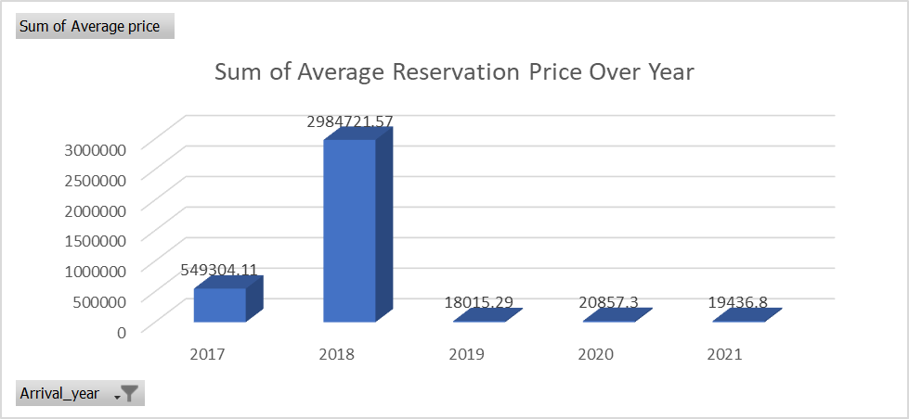
Figure 1.6.1: Average Reservation Price
(Source: Self-developed)
The above-portrayed figure 1.6.1 depicts the average reservation price from the fiscal year of 2017 to 2021. The data is portrayed in a bar graph to accurately represent the data. As stated by Passingham (2021), a bar graph is essential to show the important required information to make it comprehensible. The Pivot chart used above to portray the data is quite useful, it’s because the Arrival-year can be chosen as per choice and only its data will be shown in the graph. By analysing the data, it can be gathered that in 2018 there was a significant rise in the average reservation price as the data reached 2984721.57. On the other hand, the lower average was attained in 2019 as the data is 18015.29. Thus, it can be gathered that there was a significant change in terms of average reservation prices over the years.

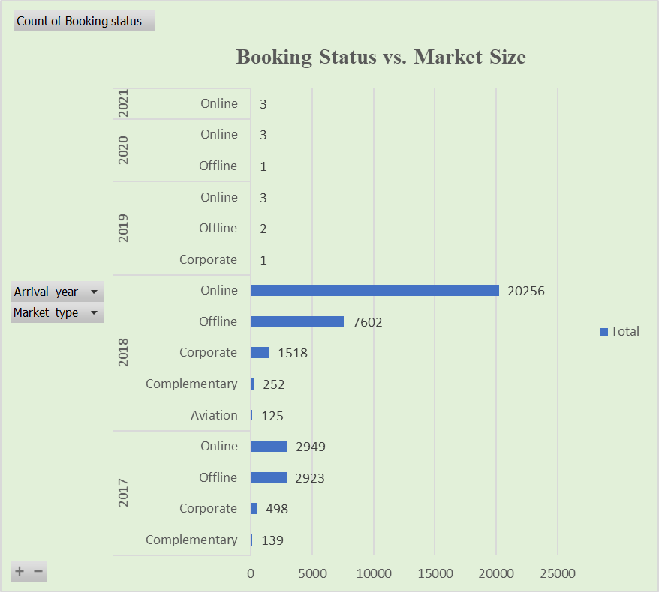
Figure 1.6.2: Graph of Booking Status VS Market Size
(Source: Self-developed)
The above figure represents the booking numbers and the approach taken to book hotel reservations. The data set accumulated the booking status from 2017 to 2021. In 2018, online reservations saw a significant rise as it reached 20256. The offline booking was also at 7602. This provides evidence towards the booking status gained a significant rise in 2018. On the other hand, in 2021, 3 bookings were done through the online mode. This is evidence towards the decline in market size for the company. In addition to this, in 2018, there were different market sizes of booking aspects such as Corporate, Complementary and Aviation aspects.

Part 2

2.1. Rate of male and female students
Sum of Student_No
Gender | Total
Female | 24160
Male | 24465
Grand Total | 48625
Table 2.1: Rate of Male and Female
(Source: Self-developed)
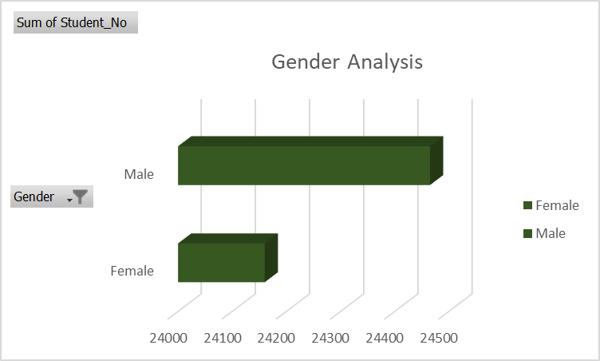
Figure 2.1: Gender Analysis
(Source: Self-developed)
The above figure portrays the number of male and female students among the school students. Through the analysis, it has been found that the majority of the students are male with a total number of 24465. On the other hand, the number of female students is 24160. This signifies that the results of the data collection regarding the participant number of 48625 are highly influenced by the male students' perspective.

2.2. The rate of learners qualifies and does not qualify for reduced or free lunch
Sum of Student_No

Gender | Lunch | Total
Female | Does not qualify | 12754
 | Qualifies for reduced/free lunch | 11406
Female Total |  | 24160
Male | Does not qualify | 13305
 | Qualifies for reduced/free lunch | 11160
Male Total |  | 24465
Grand Total |  | 48625
Table 2.2: Learners Qualification for reduced or free lunch
(Source: Self-developed)
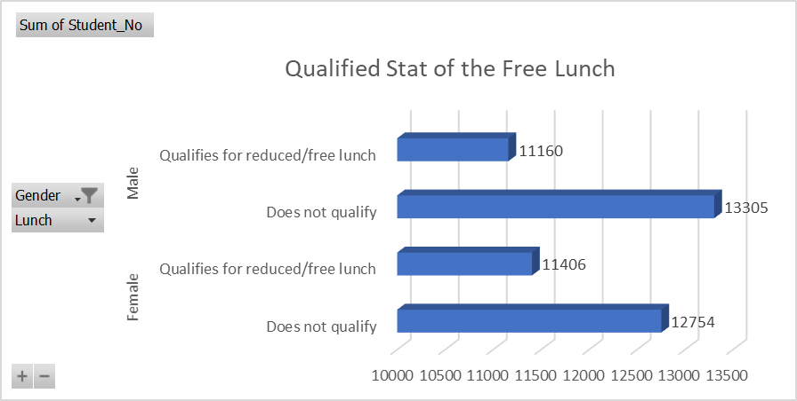
Figure 2.2: Graph of Qualified Stat for Free Lunch
(Source: Self-developed)
As provided in above Table 2.2, there are two main variables that have influenced the determination of student qualification towards free lunch and non-qualification. Among the total of 24160 female students, 12754 do not qualify for free or reduced lunch. In comparison to that, 13305 male students do not qualify for the free lunch. Thus, it is evident that there is a significant number of male students who are not qualified for free lunch. Similarly, a significant amount of people has been identified to be qualified for the reduced or free lunch. Among the female student population, 11406 people are qualified while among the male students, 11160 people are qualified. The male student population holds a larger significance in the data collection process, but more of the male students are not qualified for free lunch in comparison to the female population.

2.3. Comparison of mean and median of students who qualify and do not qualify for reduced/free lunch
Average of Student_No
Gender | Lunch | Mean
Female | Does not qualify | 21.51
 | Qualifies for reduced/free lunch | 24.63
Female Total |  | 22.88
Male | Does not qualify | 21.39
 | Qualifies for reduced/free lunch | 24.53
Male Total |  | 22.72
Grand Total |  | 22.80
Table 2.3: Mean and Median qualified for lunch
(Source: Self-developed)
The above Table 2.3 portrays the mean and median data of the students who are qualified and not qualified for the lunch in the school. Mean data represents the average of the given set value. A higher mean score represents mostly agreeable variables. For this aspect, the female total represents 22.88 while the male total represents 22.72. The data can be interpreted as a female average of 24.63 is greater than the 24.53 in terms of qualification for reduced or free lunch. This signifies that the female population is more qualified for the free or reduced lunch.

2.4. Discuss the mean and median differences between students' pre-test and post-test scores
Pretest |  | Posttest
Mean | 54.96 | Mean | 67.10
Standard Error | 0.29 | Standard Error | 0.30
Median | 56.00 | Median | 68.00
Difference in Mean and Median | -1.04 |  | -0.90
Table 2.4: Mean and Median differences between pre-test and post-test scores
(Source: Self-developed)
The above Table 2.4 evaluates the difference between the mean and median data in pre-test and post-test scores of the students. The average of the data set for the pre-test scores for the students is 54.96 and the post-test score is 67.10. While on the other hand, the median data for the pre-test is 56.00 and the post-test is 68.00. The difference between the mean and the median for the pre-test is -1.04 and the post-test is -0.90. This signifies that the post-test score has been positively changed in comparison to the pre-test scores.

2.5. Using the dataset Student_Score.csv provided in conjunction with SPSS, give a specific example of Clustering (ex. K-Means Clustering). Show your workings with screenshots and clearly explain your results.
Initial Cluster Centers
 | Cluster
 | 1 | 2
Pretest | 23 | 93
Posttest | 35 | 100
Table 2.5.1: Mean and Median differences between pre-test and post-test scores
(Source: Self-developed)
This table is prepared to depict the Initial Cluster Centres, where in the first cluster the Pre-test score was at 23 which increased to 35 in post-test. Wheeze on the 2nd cluster, the pre-set score was 93, which reached 100 post-tests, thus it can be said the students improved post-test.
Iteration Historyª
Iteration | Change in Cluster Centers
Iteration | 1 | 2
1 | 30.191 | 33.606
2 | .885 | .791
3 | .611 | .532
4 | .212 | .181
5 | .227 | .200
6 | .150 | .128
7 | .000 | .000
a. Convergence achieved due to no or small change in cluster centres. The maximum absolute coordinate change for any centre is .000. The current iteration is 7. The minimum distance between initial centres is 95.525.
Table 2.5.2: Mean and Median differences between pre-test and post-test scores
(Source: Self-developed)
In regard to the travel above it is said that the convergence was achieved because of small or no altar in cluster centres. It seems that the centre, where the current iteration is at 7 means the alteration in the centres happened 7 times.
Final Cluster Centers
 | Cluster
 | 1 | 2
Pretest | 43 | 65
Posttest | 55 | 78
Table 2.5.3: Mean and Median differences between pre-test and post-test scores
(Source: Self-developed)
In the final cluster centres, as shown above, the results seemed to have changed as shown in the table above. It seems in the first cluster, the pre-test score was at 43 but it increased to 55 post-tests, and in the 2nd cluster pre-test it was 65, and it rose to 78 in the post-test, but is low compared to the initial cluster centres.
Number of Cases in each Cluster
Cluster | 1 | 993.000
Cluster | 2 | 1140.000
Valid |  | 2133.000
Missing |  | .000
Table 2.5.4: Mean and Median differences between pre-test and post-test scores
(Source: Self-developed)
Lastly, in the case of the 1st cluster it was at 993.00 and in the 2nd cluster it's 1140.00, this state as cluster 2 had a high mean, so most of the students score high in the 2nd one.

2.6. Explain the minimum 5 most common data mining and text mining methods that can be used in contemporary business
Methods of text mining:
Information Extraction
It is the most popular text-mining technique and this procedure of extracting meaningful information from a wide range of textual data. This technique sheds light on determining the extraction of elements, attributes, and their connections from semi-structured or unstructured texts. Based on this, organisations get the opportunity to extract their important information and get an insightful picture of the business.
Information Retrieval
Information Retrieval indicates the procedure of the extracting related and involved patterns dependent on a particular set of phrases. In the text mining technique, the IR system drive utilises multiple algorithms to track and measure end-user behaviours and explore related information.
Categorization
It is a form of supervised learning whether normal language texts are allocated to a predefined group of topics relying upon its content. Therefore, Natural Language Processing is the procedure of collecting text documents and proceeding and assessing them to discover the accurate topics and indexes for every document.
Methods of data mining:
Classification analysis
As per the views of Masoodi (2021), the classification process refers to a data mining technique that could lead to determining the categories and structure within the given set of data. Classification analysis has substantial applications in machine learning, statistical modelling, and text analytics. Hence, it has a relevant role in the identification of potential risks and providing better insights into the data.
Association rule learning
As per the views of Shanghai and Shipping (2019), association rule learning refers to a technique that checks for the data items in an unsupervised manner for increasing profitability. Therefore, it is critical in understanding the interrelation between the dataset and variables along with providing cost-effective methods.

2.7. Discuss the advantages and disadvantages of using SPSS and Excel using relevant practical examples and present your discussions in Table
Advantages
Excel | SPSS
- Excel has a wide range of functions that can be influential to easily meet the requirement of data analysis. Such as the Analyse Data function in Excel, which is effective in speeding up the process to gain better value (Microsoft, 2023).  - For example, Bellabeat is a tech-based company that focuses on providing through their app. In order to summarise the long and extensive data of the company the use of formulas such as “=SUMPRODUCT(1/COUNTIF(Fitness[Id], Fitness[Id]))” is utilised with the use of unique IDs of the customers to gain data findings (Mogasale,2022). In the end, the data has been presented through the use of visualised graphs [Refer to Appendix 1]. | - SPSS data analysis provides an efficient and reliable data analysis result.  - The SPSS analysis is essential for analysing both quantitative and qualitative data.  - For instance, IBM has demonstrated the frequencies of different country variables regarding data (IBM, 2023). The SPSS statistics have been portrayed in an efficient bar graph [Refer to Appendix 2].

Disadvantages
Excel | SPSS
- Excel data analysis can be inconsistent in terms of complex data (LinkedIn, 2023).  - Excel faces significant security issues in terms of data management. | - In terms of using SPSS analysis there are significant challenges regarding large data sets.  - SPSS tool utilisation requires a high skill level to operate.  - The process is costly and time-extensive.

Conclusion
On a concluding note, the study has been elaborative towards identifying and critically evaluating data to determine the main trends. Through the data provided regarding the hotel reservation a pivot table has been analysed to determine the increase or decline in hotel reservations. In addition to this, the student data has also been calculated through the SPSS analytical tool to determine the different variables that can be effective in terms of qualifying for lunch and deciding the performance of students in pre-test and post-test. Mean and Median data are used to determine the impact in the data set.

Reference List
Blayney, P.J. and Sun, Z., 2019. Using excel and excel VBA for preliminary analysis in big data research. In Managerial Perspectives on Intelligent Big Data Analytics (pp. 110-136). IGI Global.
IBM, 2023. Tutorial: Analyzing with SPSS statistics, IBM. Available at: https://www.ibm.com/docs/en/ias?topic=spss-tutorial-analyzing-statistics (Accessed: 12 July 2023).
LinkedIn, 2023. What are the pros and cons of using Excel for data analysis?, Excel for Data Analysis: Pros, Cons, and Alternatives. Available at: https://www.linkedin.com/advice/3/what-pros-cons-using-excel-data-analysis-skills-data-analysis (Accessed: 15 July 2023).
Mahajan, K.N. and Gokhale, L.A., 2019. Advanced Charting Techniques of Microsoft Excel 2016 Aiming Visualization. Int. J. Comput. Sci. Eng, 7, pp.198-207.
Masoodi, F., 2021. Machine learning for classification analysis of intrusion detection on NSL-KDD dataset. Turkish Journal of Computer and Mathematics Education (TURCOMAT), 12(10), pp.2286-2293.
Microsoft, 2022. PivotTable. Available at: https://support.microsoft.com/en-gb/office/overview-of-pivottables-and-pivotcharts-527c8fa3-02c0-445a-a2db-7794676bce96 (Accessed: 14 July 2023).
Microsoft, 2023. Analyse data in Excel, Microsoft . Available at: https://support.microsoft.com/en-us/office/analyze-data-in-excel-3223aab8-f543-4fda-85ed-76bb0295ffc4 (Accessed: 11 July 2023).
Mogasale, P. 2022. Bellabeat case study - only Excel, Kaggle. Available at: https://www.kaggle.com/code/pratheekmogasale/bellabeat-case-study-only-excel (Accessed: 15 July 2023).
Passingham, R., 2021. Understanding the prefrontal cortex: selective advantage, connectivity, and neural operations (No. 53). Oxford University Press.
Towardsdatascience, 2020. Essential Functions in Excel for Data Pre-processing. Available at: https://towardsdatascience.com/essential-functions-in-excel-for-data-preprocessing-140f002f3ca (Accessed: 10 July 2023)

Appendices

Appendix 1: Example of Excel Use for Data Analysis
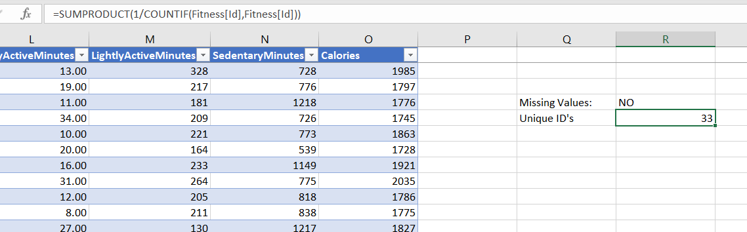
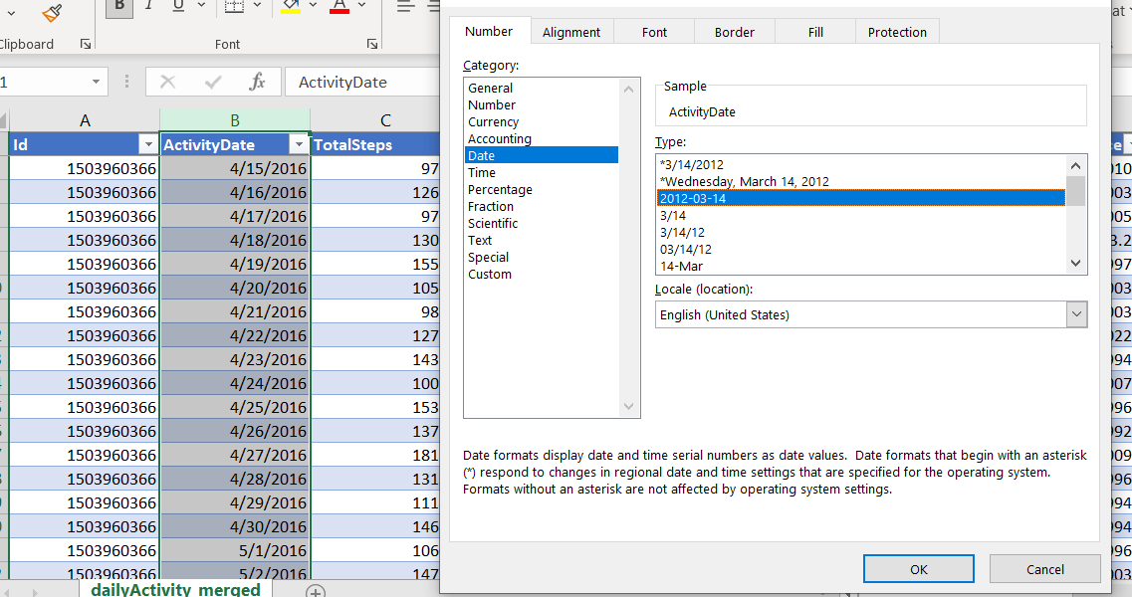
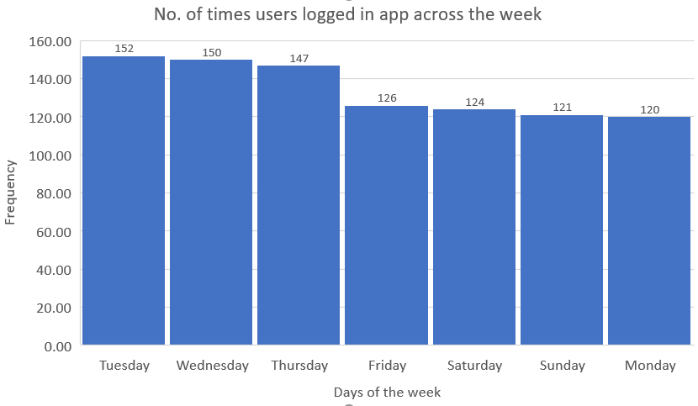
(Source: Mogasale, 2022)

Appendix 2: Example of the SPSS Use
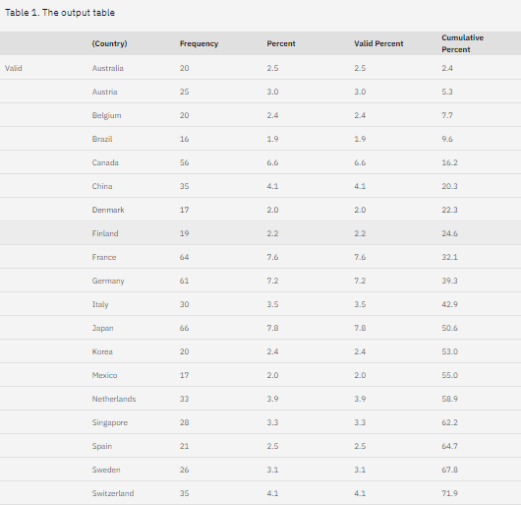
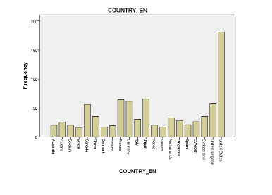
(Source: IBM, 2023)

