

The Silent Divide: Gendered Stigma and Help-Seeking Amongst Emergency Personnel

Hannah Durham
Student Number: 2116876
MSc Policing (Operational and Strategic Leadership)
Date: 21/05/2026

Dissertation Declarations

1 | This work has not previously been accepted in substance for any degree and is not being concurrently submitted in candidature for any degree.  Signed:  H.J.Durham  Date: 21.05.26
2 | This dissertation is being submitted in partial fulfilment of the requirements for the degree of MSc Policing (Operational & Strategic Leadership)  Signed:  H.J.Durham  Date: 21.05.26
3 | This dissertation is the result of my own independent work/investigation, except where otherwise stated.  Other sources are acknowledged by footnotes giving explicit references. A bibliography/reference list is appended.  Signed:  H.J.Durham  Date: 21.05.26
4 | I hereby give consent for my dissertation, if accepted, to be available or photocopying and for interlibrary loan, and for the title and summary to be made available to outside organisations.  Signed:  H.J.Durham  Date: 21.05.26

5 | I hereby give consent for my dissertation, if accepted, to be available on the University’s IT system to those who have consent to use the system.  Signed:  H.J.Durham  Date: 21.05.26

Acknowledgements

I would like to express my sincere thanks to all who have supported me on this research journey.

Firstly, my deepest gratitude to my supervisor, Jane Davies, for her unwavering support, encouragement and patience throughout. Their expertise and feedback have been key in shaping, defining and progressing this work.

I would also like to extend my thanks to UWTSD for providing the resources to support this research.

A special thank you to South Wales Police for providing the opportunity to pursue the MSc Course. Thanks, must also go to those that spared their time to discuss this sensitive topic with honesty and candour. Without their involvement this research would not have been possible.

Finally, to my husband and children, thank you for your patience and unwavering support. I could not have done this without you.

Abstract

This dissertation critically examines the influence of gendered stigma on help-seeking behaviours among emergency service personnel, with a particular focus on policing. Mental health challenges within policing are widely acknowledged, yet cultural norms and organisational expectations often perpetuate silence, discouraging individuals from accessing support. This research explores how gendered perceptions intersect with occupational culture to shape attitudes towards psychological wellbeing, revealing the barriers that inhibit proactive help-seeking.

Employing a mixed methods approach, the study integrates quantitative survey data with qualitative questioning to capture both statistical trends and lived experiences. Findings indicate that while awareness of mental health resources has improved, stigma remains deeply embedded within policing culture. Female personnel face compounded challenges, navigating dual pressures of professional identity and gendered expectations, which amplify fears of judgement and career repercussions. Conversely, male officers often experience cultural constraints linked to traditional notions of resilience, reinforcing reluctance to seek assistance.

The analysis highlights systemic issues, including confidentiality concerns, perceived organisational inaction, and inconsistent leadership support, which collectively undermine trust in available services. Respondents emphasised the critical role of supervisors and peer networks in shaping attitudes toward wellbeing, underscoring the need for leadership-driven cultural change.

Recommendations include implementing targeted training programmes, fostering inclusive organisational cultures, and developing confidential, accessible support mechanisms to dismantle stigma and promote psychological safety.
By situating these findings within the broader discourse on occupational health and organisational behaviour, this research contributes to academic understanding and offers practical strategies for reform. The study advocates for a proactive, evidence-based to mental health within policing, aiming to enhance resilience, reduce attrition, and strengthen organisational integrity.

Ultimately, addressing gendered stigma and cultural barriers is essential for creating a supportive environment that prioritises wellbeing and sustains operational effectiveness. Beyond SWP, this research offers a framework for policing across the UK to dismantle systemic barriers to help seeking.

Contents
Dissertation Declarations 2
Acknowledgements 4
Abstract 5
List of Illustrations, Charts and Graphs 11
List of Appendices 14
List of Abbreviations 15
Chapter One Introduction 16
Research Question 17
1.1 Rationale 17
1.2 Background 17
1.3 Research Aims and Objectives 19
1.4 Anticipated Outcomes 19
1.5 Research Methods and Timeline 19
1.6 Value of Research 21
Chapter Two Literature Review 22
2.0 Chapter Introduction 23
2.1 Mental Health Within Policing 25
2.2. Culture 27
2.3 Organisational / Colleague Perception 27
2.4 Leadership and Perceived Support 28
2.5 Reporting Procedures and Support 29
2.6 Emotional and Psychological Consequences 30
2.7 South Wales Police Wellbeing Strategy 31
2.8 Summary 32
Chapter Three Research Methodology 34
3.0 Introduction 35
3.1 Research Strategy 35
3.2 Research Philosophy 38
3.3 Research Approach 40
3.4 Methodical Choices 41
3.5 Time Horizon 41
3.6 Data Collection – Techniques and Procedures 42
3.7 Data Analysis 44
3.8 Ethics 45
3.9 Limitations 46
Chapter Four – Findings and Analysis 48
4.0 Survey Findings: Description, Analysis and Synthesis 49
4.1 Mental Health Within Policing - Problem Profile –South Wales Police 49
4.2 Description 51
4.3 Public Service Centre Establishment 52
4.4 Thematic Analysis of Objective 2 – Experiences & Perceptions of Mental Health Support 56
4.4.1 Impact of Role on Mental Health 57
4.4.2 Stress Level Analysis 58
4.4.3 Stress Level Contributors by Gender 60
4.4.4 Role Influence on Support Seeking 61
4.4.5 Occupational Health Support Awareness 62
4.4.6 Occupational Health Support Recommendations 64
4.4.7 SWP Wellbeing Strategy 65
4.4.8 Occupational Access of Support by Gender 66
4.5 Thematic Analysis of Objective 3 – Leadership Influence on Help-seeking 68
4.5.1 Supervisor Impact on Help-seeking 68
4.5.2 Supervisor Impact on Help-seeking 70
4.5.3 Action taken when Seeking Help 71
4.5.4 Reporting Physical Health v. Reporting Mental Health 72
4.5.5 Suffering in Silence 75
4.5.6 Suffering in Silence – Why? 76
4.5.7 Mental Health Disclosures 78
4.5.8 Barriers to Seeking Support? 79
4.5.9 Wellbeing Feedback 83
4.6 Conclusion – Integrative Analysis and Empirical Findings 85
Chapter Five Conclusion and Recommendations 87
5.1 Conclusions Against Research Objectives 88
5.1.1 Objective One: Mental Health Stigma, Gender Influences, and Help-Seeking Behaviours 88
5.1.2 Objective Two: Experiences and Perceptions of Mental Health Support 88
5.1.3 Objective Three: Leadership Influence on Help-Seeking Attitudes 89
5.1.4 Objective Four: Evidence-Based Improvements to Mental Health Support 89
5.2 Gender-Based Observations 89
5.2.1 Gender Differences in Reporting Confidence and Perceived Impact 90
5.2.2 Gendered Patterns in Help-Seeking Behaviour 90
5.2.3 Gendered Barriers to Reporting 90
5.2.4 Gender Differences in Engagement with Support Services 90
5.2.5 Gendered Organisational Challenges 91
5.3 Recommendations 91
5.3.1 Implement Comprehensive Training Programmes (Short Term) 91
5.3.2 Foster a Supportive Organisational Culture (Long Term) 92
5.3.3 Strengthening Reporting Mechanisms and Communication 92
5.3.4 Enhance Supervisor Capability and Accountability 92
5.3.5 Address Gender-Specific Barriers and Needs 93
5.3.6 Improve Occupational Health Visibility and Accessibility 93
5.3.7 Strengthen Communication and Awareness Campaigns 93
5.4 Conclusion 94
Bibliography 96
Appendix 1 – Trauma and Counselling Support 116
Appendix 2 – Wellbeing Strategy – SWP 2025-2028 126
Appendix 3 Problem Profile 135
Appendix 4 – Microsoft Forms Questionnaire – Help-Seeking 141
Appendix 5 - SWP HR Establishment DATA 156
Appendix 6 - Research Support Email 157
Appendix 7 – Analysis of Questionnaire Responses 158

List of Illustrations, Charts and Graphs

Figure 1 – The Literature Review Applied Critical Thinking Process
Figure 2 – Wellbeing Strategy SWP (2025)
Figure 3 – Research Onion Framework
Figure 4 – Steps of Thematic Analysis
Figure 5 – Description, Analysis, Synthesis and Evaluation
Figure 6 – Number of Abstractions: Mental Health vs. Other Sickness
Figure 7 – Total Referrals by Resource Type
Figure 8 – Referral Route -Police Staff
Figure 9 - HR Employment Data
Figure 10 – What is Your Gender?
Figure 11 – HR Data – Age Profile PSC
Figure 12 – Age Distribution of Respondents
Figure 13 – Grade / Rank of Participants
Figure 14 – HR Data – Length of Service
Figure 15 – Service Length of Respondents
Figure 16 – Impact of Role on Mental Health
Figure 17 – Female Stress Distribution
Figure 18 – Male Stress Distribution
Figure 19 – Stress Distribution Comparison
Figure 20 – Stress Level Contributors by Gender
Figure 21 – Impact of Role on Seeking Help – Gende Comparison
Figure 22 – Occupational Health Support
Figure 23 – Occupational Health Support – Is It Sufficient?
Figure 24 – Word Cloud – Recommendations for Occupational Health Improvement
Figure 25 – SWP Wellbeing Strategy Awareness by Gender
Figure 26 - Occupational Health Support Access by Gender
Figure 27 - Occupational Health Service Rating
Figure 28 – Supervisor Impact on Disclosure
Figure 29 – Perceived Supervisor Support if Disclosing Mental Health
Figure 30 – Gender Influence on Stigma / Help-Seeking
Figure 31 – Action Taken When Seeking Help
Figure 32 – Reporting Preferences by Gender
Figure 33 – Reporting Preference Analysis (1)
Figure 34 – Reporting Preference Analysis (2)
Figure 35 – Free Text Reporting Preference
Figure 36 – Suffering in Silence
Figure 37 - Suffering in Silence – Response by Gender
Figure 38 – Suffering in Silence – Key Themes
Figure 39 – Mental Health Reporting Preferences by Gender
Figure 40 – Barriers to Seeking Support
Figure 41 - Barriers to Seeking Support by Gender
Figure 42 – Statement Ratings
Figure 43 – Statement Ratings by Gender
Figure 44 – Wellbeing Feedback

List of Appendices

Appendix 1 – SWP Wellbeing Strategy
Appendix 2 – SLF Trauma & Counselling Presentation
Appendix 3 – Problem Profile – Mental Health Sickness September 2025
Appendix 4 – Microsoft Forms Questionnaire – Help-Seeking
Appendix 5 – South Wales Police HR Establishment Data
Appendix 6 – Research Support Email
Appendix 7 – Analysis of Questionnaire Responses

List of Abbreviations

SWP – South Wales Police
PSC – Public Service Centre
HR – Human Resources
PTSD – Post Traumatic Stress Disorder
CCDP – Chief Constables Delivery Plan
SLF – Senior Leaders Forum
GDPR – General Data Protection Regulation
DASE – Data, Analysis, Synthesis, Evaluation

Chapter One Introduction

Research Question
The Silent Divide: Gendered Stigma and Help-Seeking Amongst Emergency Service Personnel.

1.1 Rationale
This dissertation will investigate how gender influences stigma and the views on seeking help among police emergency services personnel. Emergency service staff at first point of contact face significant levels of occupational stress, due to high demand levels, excessive exposure to traumatic incidents and mental health challenges. Research indicates that the risk of PTSD among emergency personnel is ‘heterogeneous, with different trajectories of symptom development observed over time’ (Pietrzak, et al., 2014). Despite increasing awareness and efforts to improve mental health outcomes, those seeking help remain low, particularly amongst males. Bridging mental health disciplines with public health approaches, may enhance help-seeking trauma mitigation, (Tan, et al., 2023). The research aims to identify barriers that exist in seeking mental health support, specifically focused on gender, and to inform more inclusive and effective support.

1.2 Background
Police emergency service personnel are routinely exposed to traumatic incidents, placing them at heightened risk for developing mental health challenges. The construction of masculinity within police culture significantly impacts help-seeking ‘views on masculinity, shaped by hegemonic masculinity ideals, contribute to reluctance in utilising available mental health services’ (Khumalo, 2021). Help-seeking behaviours remain relatively low, particularly among men. This disparity may be attributed to a range of factors, including entrenched cultural stigma and gender norms. Research suggests that occupational culture significantly shapes both the experience of mental health difficulties and the likelihood of seeking support, with notable gender differences in uptake.
Mental health-related sickness within policing is alarmingly high, with the Police Federation, reporting that policing has become the profession with the highest rates of mental health-related sickness, with ‘four in five officers’ having experienced feelings of stress, low mood, anxiety, or other difficulties with their mental health or wellbeing in 2024 (Police Federation, 2025). It is suggested that this issue is not exclusive to front-line officers. A survey conducted by Mind (2019) revealed that poor mental health also significantly affects front-line staff too. Parkes et al. (2024) found that sickness amongst police officers and staff varies according to several sociodemographic, occupational, and health-related factors, with women, non-uniformed staff, and those experiencing poorer mental health more likely to take sick leave.
Gendered stigma plays a critical role in shaping help-seeking behaviours. Kaitz et al. (2022) identified that societal patterns of masculinity may inhibit men from discussing mental health openly. Bradbury (2020 p.933) similarly noted that “females tend to respond more positively toward mental health issues,” suggesting that women may be more open and less stigmatising in their attitudes, which could facilitate more frequent and open discussions.
The complex interplay between occupational roles, gender norms, and stigma is central to understanding help-seeking behaviours. Canfield (2019) argued that self-stigma and masculine ideals may prevent individuals seeking help, as it can often conflict with the role expectations commonly associated with male emergency workers. However, Smith et al. (2025, p295) emphasised that “mental health concerns are ubiquitous and deserving of the same compassion and support as that offered for other health problems.”
Evidence suggests that men face greater internal and external barriers to discussing mental health issues compared to women. This is reinforced by gendered communication patterns. Stattin & Eriksson (2024) found that communication trends concerning mental health struggles differ between genders, with implications for how these struggles are experienced and expressed. Danielsson et al. (2009) further suggested that men and women differ in how they experience, dissect, and communicate mental health difficulties, all of which is impacted and influenced by social, familial, and clinical factors. Men tend to face significant stigma in various social environments, not just contained to the work environment, which deters them from accessing support, (Soomro & Yanos, 2019).
Within policing, stigma surrounding mental health is deeply embedded in organisational culture. Velazquez & Hernandez (2019, p711) noted that “the stigma within law enforcement culture around seeking mental health treatment is linked to organisational and social ideologies,” which may deter officers and staff from seeking support care due to fears of being perceived as unfit for duty. Bell & Eski (2016, p95) highlighted that “discussing psychological injury is often perceived as potentially damaging to one’s career,” a perception reinforced by a macho culture, cynicism, and lack of empathy. Confidentiality concerns also play a significant role, with Newell et al. (2022) stating that employers are fearful that any disclosures made, may not remain private increasing fears of career repercussions and social exclusion.
While both men and women face barriers to help-seeking, the nature and impact of these barriers may differ. Addressing gendered stigma requires a multifaceted approach, including cultural transformation, organisational reform, and the development of gender-responsive mental health services. By understanding and addressing these nuanced dynamics, emergency service organisations can foster a more supportive and inclusive environment for mental health disclosure and care.

1.3 Research Aims and Objectives
The overall aim of this research is to explore how gender influences attitudes towards seeking help with mental health support amongst emergency workers and to explore how stigma manifests differently across genders. To identify the cultural and organisational factors that reinforce or mitigate gendered stigma and to provide recommendations for gender-specific mental health interventions and strategies. This will be achieved through the setting of specific objectives.
- Evaluate mental health stigma, gender influences, and help-seeking behaviours among police employees.
- Investigate experiences and perceptions of mental health support.
- Analyse how leadership affects help-seeking attitudes and behaviours.
- Develop evidenced-based recommendations to enhance mental-health support and reduce stigma, with a focus on gender-sensitive approaches for police personnel.

1.4 Anticipated Outcomes
An improved understanding of gendered stigma and the barriers to seeking help, leading to recommendations as to how improvements could be made to break down the barriers.

1.5 Research Methods and Timeline
Research according to Cohen and Manion (1980) is defined as that which ‘employs empirical methods and empirical statements. Cohen further states that an empirical statement is defined as a descriptive statement about what “is” the case in the “real world” rather than what “ought” to be the case. (Cohen, 1980). This proposal aims to explore and understand the real gender challenges around seeking help within the emergency services.
This proposal will adopt the research onion framework, which outlines the relevant and appropriate research phases. As Tengli (2020) states, ‘to develop sound research methodology scholarly research starts with the research question(s), the objectives followed by the series of decisions on choice of research philosophy, approach to research, then the research design.’
The research will be underlined by both interpretivism and pragmatism. Interpretivism allows for the understanding of subjective experiences and gendered stigma among emergency personnel. Pragmatism supports the integration of qualitative and quantitative methods to thoroughly explore the research question. An abductive approach will be employed, commencing with the observation of stigma and help-seeking behaviours. This will hopefully evolve into the identification of any emerging patterns or trends. The iterative process will provide opportunity to explore the complex issues and then refine through ongoing data collection.
The concurrent mixed methods design, outlined by (Creswell, 2003), explores quantitative and qualitative phases simultaneously. There are three types of concurrent mixed methods design: concurrent triangulation, concurrent nested and concurrent transformative’ (Hanson, et al., 2005). A concurrent triangulation mixed methods design will be adopted for this research. Concurrent triangulation, as described by Adu (2023) and Hanson et al (2005), involves collecting both types of data, with equal priority, and then determining whether both methods have yielded similar findings.
Quantitative method is a research instrument used to determine variables or quantify observations (Adu 2023). Quantitative research explains events by collecting numerical data that are analysed using mathematical modelling (Aliaga & Gunderson 2002). This will form part of the research. Additionally, correlation analysis will examine relationships between variables such as gender, stigma perception, help-seeking behaviour, and length of service. In respect of quantitative data, a survey strategy will be developed, distributing Likert-scale questionnaires online to a broad range of emergency service staff. The questionnaires will seek to measure stigma, help-seeking behaviours and attitudes and the perceived gender norms. Descriptive statistics will then be utilised to analyse the data. Descriptive research involves collecting data to ‘answer questions or test hypothesis concerning the current status of the situation’ (Long et al 1985).
Qualitative data is ‘descriptive information that focuses on concepts and characteristics, rather than numbers and statistics. Qualitative data analysis tries to answer questions about why people behave as they do and what motivates that behaviour’ (Sheldon, 2024). The qualitative data for this study will be collected through the questionnaire, defined by gender. This will explore experiences, stigma, barriers to seeking help and any ingrained cultural influences. Data will be analysed using thematic analysis with manual coding.
Secondary data from existing statistics, including HR data, will be reviewed to contextualise the findings and to identify any trends or patterns. A cross-sectional time horizon will be adopted, with data collected at a single point in time to capture current attitudes and behaviours. Informed consent will be obtained from all participants, with confidentiality and anonymity of participants maintained. Given the sensitivity of the topic, access to support resources will be ensured.

1.6 Value of Research
The research holds significant value for both academia discourse and practical applications within policing. Investigating and examining the factors that influence the confidence and willingness of employees to seek help when suffering with mental ill health, can significantly impact the individual and the organisation, in terms of their ability to deliver the service expected of them. The anticipated findings are expected to have practical implications for SWP, highlighting the barriers to seeking help and proposing actionable solutions to enhance take-up rates. The research has the potential to improve sickness levels and health support of key workers. By thoroughly investigating the factors that impact help-seeking, the study will allow for valuable insights into how service uptake can be increased. Importantly, it aspires to engage senior leaders within SWP, providing them with the insights that can inform policy changes and support initiatives prioritising mental health support.

Having outlined the rationale for this research, the dissertation is structured into five chapters. Chapter two reviews academic literature aligned to mental health support within policing. Chapter three details the mixed methodology, including the questionnaire approach. Chapter four analyses the findings from SWP employees, and chapter five concludes by highlighting the key insights and proposed recommendations to strengthening the support available regardless of gender.

Chapter Two Literature Review

2.0 Chapter Introduction

Singh et al (2024) asserts that a literature review is a systematic approach to analysing and synthesizing existing research on a particular topic. Similarly, Aveyard (2010) identifies a literature review as a ‘critical academic resource’ which combines research and organisational insights on a defined topic. In the context of this dissertation, this review aims to conduct a critical analysis of the factors that influence help-seeking among police personnel, with a particular focus on gender.

To ensure a comprehensive understanding of this subject area, a thematic approach will be undertaken, reviewing existing research around key themes which influence help-seeking. This methodology enables the identification and exploration of themes which impact decision making within the literature for consideration, thereby providing a structured framework to explore the complexities of the subject area. This critical thinking approach demonstrated in figure 1, will support the development of the best available evidence informing the analysis of the research topic (Machi & McEvoy, 2022).

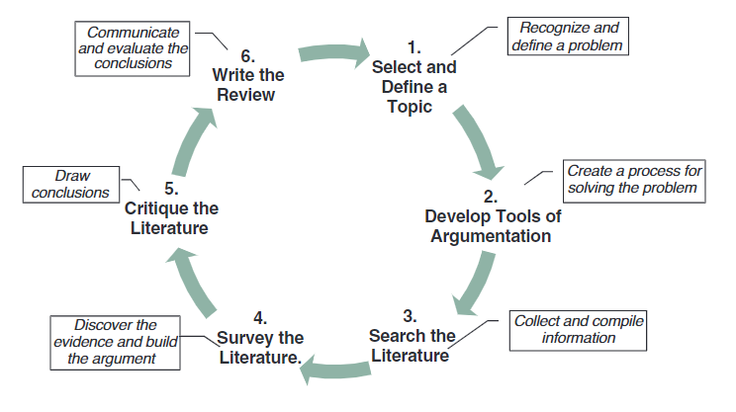
Figure 1 – The Literature Review Applied Critical Thinking Process (Machi & McEvoy, 2022)

The wellbeing of police staff and officers is fundamental to ensuring that police forces have the resilience to protect the public at first point of contact and to continue to provide a high-quality service. Research found that organisational stressors can significantly impact officers’ mental health and in turn can impact professionalism and effectiveness, (Purba & Demou, 2019). Whilst other research focused far more on the rise in absenteeism as opposed to the impact on service delivery of those officers attending work whilst suffering poor mental health.
Research indicated that forces in England and Wales between 2019 and 2023 saw a significant rise in absences attributed to frontline illness, with a mean increase in absence rates by 40% and greater, (Quin, 2024). However, other researchers argue that frontline staff are more likely to remain in work and suffer ‘sickness presenteeism’ which has been documented as remaining in work while unwell with stress being strongly associated with this behaviour, (Leineweber, et al., 2011). There appears little research, around the impact of staying within work whilst suffering poor mental health by either gender.

The upward trend within South Wales Police, appears to support Quin’s, 2019 assumption, as mental health absence continues to rise. To combat this increase South Wales Police continues to explore numerous wellbeing resources and services available, see appendix 2. However, staff must feel confident in accessing these services and have confidence that they will be supported and protected throughout the experience. This forms part of this research paper.

Despite the availability of services, engagement remains relatively low. Understanding the reasons for this form part of this research. A survey conducted to understand staff perspectives found that employees value interventions developed in consultation, (Murphy, et al., 2023). Interestingly, despite South Wales Police consulting internally regarding the Wellbeing Strategy, this is not evidenced within South Wales Police where there remains a relatively low uptake rate. This, it can be argued is influenced by several factors, including the perceptions and views of mental health and the environmental culture. Influenced by traditional norms, that reinforce toughness, self-reliance and restrictive emotionality, such norms can contribute to challenges in expressing mental health difficulties particularly amongst males, (Sharp, et al., 2022). Existing literature highlights the importance of addressing these perceptions to improve uptake rates.

Leadership plays a key role in engagement, through promoting awareness and creating the opportunities to access wellbeing services. Actual supportive behaviours of managers both contribute to reducing symptoms of common mental disorders and improving wellbeing among staff, it is suggested that organisational and team-led interventions, including leadership behaviours, are important for promoting mental health, (Petrie, et al., 2018). Supportive behaviours have been identified as key mechanisms through which leadership can protect and promote employee mental health, (Hammer, et al., 2024) Understanding the multi-faceted barriers that prevent engagement and creating an environment that encourages engagement is key. Denial of mental health challenges and insufficient psychological safety can contribute further to non-disclosure, (King, et al., 2021).

This literature review will focus on the first objective within the research framework: identifying the factors that hinder help-seeking and the barriers employees face. By examining these issues, the review aims to contextualise the dynamics influencing engagement. This awareness is essential to shape future strategies, to improve staff wellbeing, maximise capacity and improve police resilience to deliver the service our communities expect.

2.1 Mental Health Within Policing

Mental health within policing is complex, shaped by the role, culture and evolving societal expectations. Officers and staff are frequently exposed to traumatic events, which can heighten the risk of mental health disorders such as depression, anxiety and post-traumatic stress disorder (PTSD). Prolonged and continuous exposure, combined with a culture that historically stigmatises seeking help, can often result in staff feeling isolated (Porter & Lee, 2024). Interestingly this view is contradicted by Murtagh, 2010 who believes that the overall stress levels are more pronounced and heightened during the early to mid-career stages, (Murtagh, 2010). This concept will be tested within the research analysis.

Historically, policing culture has emphasised maladaptive coping mechanisms, such as alcohol and drug misuse and isolation, rather than engagement with mental health services available (Padilla, 2023). Whilst, attitudes are slowly shifting, individual coping practices vary and barriers remain. As first responders’ individuals, experience challenges in recognising and supporting those in crisis, exacerbated by limited training specific to recognising mental health issues. Managers are often at the forefront when supporting staff and creating a healthy work environment, however leaders often find addressing mental health challenging, highlighting a need for targeted training to build confidence, (Gayed, et al., 2018). ‘Officers report strong peer support but highlight the need for enhanced multi-agency collaboration and improved training to better manage these situations and reduce the impact on their own wellbeing’ (Lamb & Tarpert, 2019). This perspective is supported by (Wood, et al., 2021) who emphasised, the significance and impact that an inability to achieve positive long-term outcomes for individuals suffering mental health can have on those seeking to support them.

In respect of mental health promotion, leveraging men’s social practices and embedding mental health discussions within acceptable masculine frameworks may facilitate more effective engagement. ‘Approaches that incorporate humour or align with men’s identities and social roles have shown potential in reframing help-seeking as less threatening and more acceptable’ (Erentzen, et al., 2018). However, wider research indicates that the reluctance of men to discuss mental health is deeply ingrained and a difficult barrier to break, (Terrizzi, 2024). The complexities of length of service and varying views of mental health intervention, identify the challenges faced within policing.

A large-scale UK study conducted in 2020 involving 40,299 police staff, found depression to be the most common mental disorder (9.8%), followed by anxiety (8.5%) and PTSD (3.9%). ‘Exposure to trauma within the past six months doubled rates of anxiety and depression and increased PTSD risk six-fold’ (Stevelink, et al., 2020). In 2024 this was reinforced by a Study conducted by the University of Cambridge, who declared that ‘UK police forces are facing a mental health crisis with a record’ 17,752 officers in England and Wales signed off for stress, depression, anxiety, or PTSD, which they state was a 22% increase on the previous year. That nearly 1 in 5 officers and staff exhibit symptoms of PTSD, and 4 in 5 report experiencing low mood or anxiety, with high workloads and poor work-life balance’ (University of Cambridge, 2024)

Research highlights several occupational stressors and personal factors associated with suicidal risk in policing, which include work related stress, exposure to traumatic incidents, shift work, relationship problems and alcohol use. ‘These factors may contribute cumulatively to increased risk, although protective factors and preventative measures can mitigate these effects’ (Chae & Boyle, 2013).

Culture remains a significant barrier to help-seeking. There is a fear that admitting mental health struggles could harm career progression. Gender norms also influence help-seeking. Men are less likely to utilise services often due to stigma and role conflict. ‘Men tend to engage less in mental health service use partly because seeking help is often associated with femininity, which may create a gendered role conflict for men’ (Pattyn, et al., 2015). Research suggests that men opt to take medication over psychotherapy and actually hold more stigmatising attitudes, including shame and blame: ‘Males with affective, anxiety, or substance use disorders have lower odds than females of consulting health professionals or using self-management strategies’ (Harris, et al., 2016). This concept will be explored within the research.

Women in general seek support more than men, but patterns can vary by social role and employment status. It is argued that employment status influences service use differently by gender, with working women, more likely to use psychological services, while working men may be less likely to use general or psychiatric services. ‘These patterns suggest that societal norms linked to professional roles affect decisions to seek care’ (Drapeau, et al., 2009). Gender differences in help-seeking are shaped by social norms, stigma, service preferences and cultural expectations. Men tend to be less likely to seek support and face increased attitudinal barriers than women (McKenzie, et al., 2018).

2.2. Culture

Understanding cultural dynamics is crucial to understanding attitudes towards help seeking. Factors which can influence decision making such as guilt, perceptions of letting others down and strong camaraderie within policing can all influence help-seeking behaviours. Gender may play a key role in this decision making, as women and men may perceive mental health differently due to societal expectations (Hurless, et al., 2025). Organisational practices, such as being overlooked for promotion, can often reinforce a culture of silence and stigma. Additionally, generational changes and developing societal norms can further determine attitudes.

Cultural identity influences mental health perceptions through acculturation (adopting mainstream norms) or enculturation (retaining original cultural values). Literature indicates that racial or generational identity may not strongly predict help-seeking behaviours, cultural values and gender continue to exert significant influence (Hurless, et al., 2025). Culture and gender interact in complex ways to shape mental health attitudes and behaviour. Effective interventions must seek to address both dimensions to reduce disparities and foster support.

2.3 Organisational / Colleague Perception

Police culture significantly shapes attitudes towards seeking mental health support. A dominant masculine culture within policing promotes resilience and self-reliance, creating stigma around help-seeking and limiting perceived organisational acceptance (Meek, 2024). This environment fosters fear of being seen as “weak or incompetent”, deterring employees from accessing psychological services (Demirkol & Nalla, 2019). Concerns about confidentiality and the impact speaking out may have on career progression are worrying. Staff fear that seeking help could result in being labelled “unfit for duty” reinforcing avoidance behaviours (Demirkol & Nalla, 2019). Research indicates that male officers and staff experience higher self-stigma than female colleagues even though general attitudes toward help-seeking remain similar (Loynd, 2022).

Police officers and staff are often the first to respond to some of society’s most traumatic events, yet cultural norms often discourage seeking support. Masculinity contest culture explains these behaviours and their influence on turnover intentions (Goodijohn, 2023).
Existing studies reveal inconsistencies in help-seeking across forces, highlighting the requirement for a comprehensive review of cultural and institutional dynamics driving these barriers.

2.4 Leadership and Perceived Support

Effective leadership can set the tone and culture of the organisation. Supportive leadership, where staff feel safe and empowered, fosters trust and encourages help-seeking. It can be linked to positive outcomes such as enhanced psychological health and reduced stress, (Shabalala & Chitamba, 2026) Conversely, a lack of accountability and unrealistic expectations can create cynicism and discourage staff from speaking out. Research suggests that perceived gaps between the support offered, and the actual individual experience can impact employee confidence to engage. Supportive leadership has also been found to be a ‘facilitator of resource accumulation that enhances employee resilience and wellbeing’ (Shabalala & Chitamba, 2026).

Leadership within organisations significantly influences mental health support-seeking behaviours, with gender-specific nuances evident in research. For example, "women who had male supervisors reported less organisational support, which may indirectly affect their likelihood to seek mental health support" (Konrad, et al., 2010). Additionally, women in male-dominated units or organisations led by men reported more experiences of gender harassment and discrimination, factors that can discourage accessing support services. In contrast, for men, gender makeup and leadership gender were not associated to outcomes such as perceived fairness or discrimination, suggesting leadership impact differs by gender (Konrad, et al., 2010).

One study found that male subordinates with female supervisors tended to have more trust in leadership compared to males with male supervisors and females with female supervisors, (Garcia-Cabrera, et al., 2023). There is extensive academic research around how supervisor gender can influence staff development however there is limited research around whether supervisor gender influences the reporting of mental health concerns.
Visible and caring leadership at all levels, has been associated with better access and use of support services (Clarkson et al., 2023). This highlights that leadership style and communication strongly influence employees’ willingness to seek help. Similarly, Poddar and Chhajer, 2024 highlighted that leadership advocacy and strengthening the role of leaders as an important aspect of fostering psychological safety and encouraging disclosure of mental health challenges. This highlights that effective and strong leadership can create an environment conducive to help-seeking, though gender specific effects remain unclear.
Overall, while leadership quality and gender composition appear to impact women’s perceptions of organisational support and experiences related to mental health, evidence for a direct effect on men’s help-seeking behaviour is limited. Leadership that is visible, supportive, and actively promotes mental health may facilitate support-seeking across genders, but women may be more sensitive to leadership gender and organisational dynamics.

2.5 Reporting Procedures and Support

Assessing the effectiveness of reporting mechanisms is critical in shaping the reporting landscape. Systems perceived as inadequate or lacking confidentiality can make reporting feel futile. Establishing organisational values and transparent reporting measures can alleviate concerns. However, even the most translucent systems may fail if they are not supported by a genuine commitment from leadership to support, South Wales Police, HIVE Survey, 2025. If employees perceive a disconnect between policy and practice, their willingness to seek help may not improve, indicating that structural changes alone are insufficient without a cultural shift.
Continuous learning and awareness are essential. Employees are more likely to report when they are familiar with the process. Training alone may not address the issue; bespoke methods of outreach and addressing underlying cultural issues are necessary. While progress within SWP is commendable, it raises questions about sustainability and long-term impact. The distinction between participation in training sessions and awareness in comparison to taking the step to seek support remains a challenge (South Wales Police, HIVE Survey, 2025). This supports the argument for continuous evaluation and adaptation of training programs to ensure effective implementation and high uptake.
The availability and adequacy of social support influence mental health differently across genders. Female staff disclosed greater social interaction and attachment, however female staff experienced poorer mental health when the adequacy of attachment was low. Conversely, single male employees with poor work-related social support showed poorer mental health (Hanson & Padyab, 2023). This suggests that communication about mental health resources should consider these gender-specific nuances to be effective.
In conclusion, ensuring police staff know what mental health support is available is vital and may require gender-sensitive approaches. The relationship between social support and mental health varies between male and female employees, so tailored communication and support strategies are essential to foster a work environment that encourages officers to seek assistance when needed.

2.6 Emotional and Psychological Consequences

Unaddressed mental health issues among police employees have serious implications for individuals and organisations, such as reduced productivity, low staff morale, absenteeism, and increased turnover. As Shah (2024) notes, ‘organisations often misattribute burnout to individual failings rather than systemic factors,’ hindering effective intervention. Sickness absence is notably high among UK police staff. A study of 40,343 employees found that 54% reported sickness absence in the previous year, with 8% experiencing long-term absence (20+ days). Higher absence rates were linked to factors such as female gender, non-uniformed roles, poor mental health, and high job strain (Parkes, et al., 2024).
Absences due to psychological illness and stress have nearly doubled over a decade, reaching 8.82%, with 39% of affected staff taking repeated absences (Cartwright & Roach, 2021). Between 2019 and 2023, some forces reported over 200% increases in occupational health referrals for psychological illness (Quin, 2024).
Psychological health-related absences among police employees are rising and exceed general workforce norms. Risk factors are well-documented, and the consequences of inaction are severe. A "culture of silence" fosters stigma and internal conflict, reducing job satisfaction and increasing attrition. This underscores the need for systemic reform that prioritises engagement and support to create a healthier organisational culture.

2.7 South Wales Police Wellbeing Strategy
The South Wales Police Wellbeing Strategy, see Figure 2, reflects many of the key themes identified within the wider literature, particularly in relation to organisational culture, leadership, and the growing impact of mental health challenges on workforce resilience. Consistent with research highlighting the importance of maintaining a psychologically healthy workforce (Purba & Demou, 2019) the strategy emphasises the ambition of delivering effective policing through a “healthy, engaged and resilient workforce” (see Appendix 1). This aligns with broader literature which positions employee wellbeing as central to organisational effectiveness, particularly in high-demand professions such as policing.
The strategy also acknowledges rising levels of those absentees and those who are present, reinforcing evidence presented earlier in this review (Quin, 2024). In recognising that officers and staff may continue to attend work whilst “suffering in silence,” the policy implicitly reflects the cultural stigma and barriers to help-seeking identified throughout the literature, particularly those associated with masculinity norms and organisational expectations (Sharp et al., 2022) Furthermore, the emphasis on leadership responsibility within the strategy corresponds with research demonstrating that visible and supportive leadership plays a critical role in shaping psychological safety and encouraging disclosure (Clarkson et al., 2023).
However, despite this alignment with existing research, a critical gap remains between policy intent and practical implementation. While the strategy recognises the need for cultural change, it does not appear to fully incorporate the lived experiences of those most affected an issue highlighted within the literature as central to improving engagement with wellbeing initiatives (Murphy et al., 2023). Although consultation has taken place at a strategic level, there is limited evidence that frontline staff perspectives, particularly in relation to gendered experiences of stigma and help-seeking, have directly informed the design of interventions. This omission is significant, as the literature consistently demonstrates that perceptions of organisational support and the willingness to engage with services are shaped by how inclusive and responsive employees perceive those services to be.
Consequently, this raises important questions about whether current wellbeing initiatives sufficiently address the gendered barriers identified throughout this paper. For example, while the strategy promotes a broad culture of openness, it does not explicitly consider how masculine norms, role expectations, or differential experiences between male and female personnel may influence help-seeking behaviours. This gap suggests that, although organisational commitment is evident, the effectiveness of the strategy may be limited without a more gender-sensitive approach.

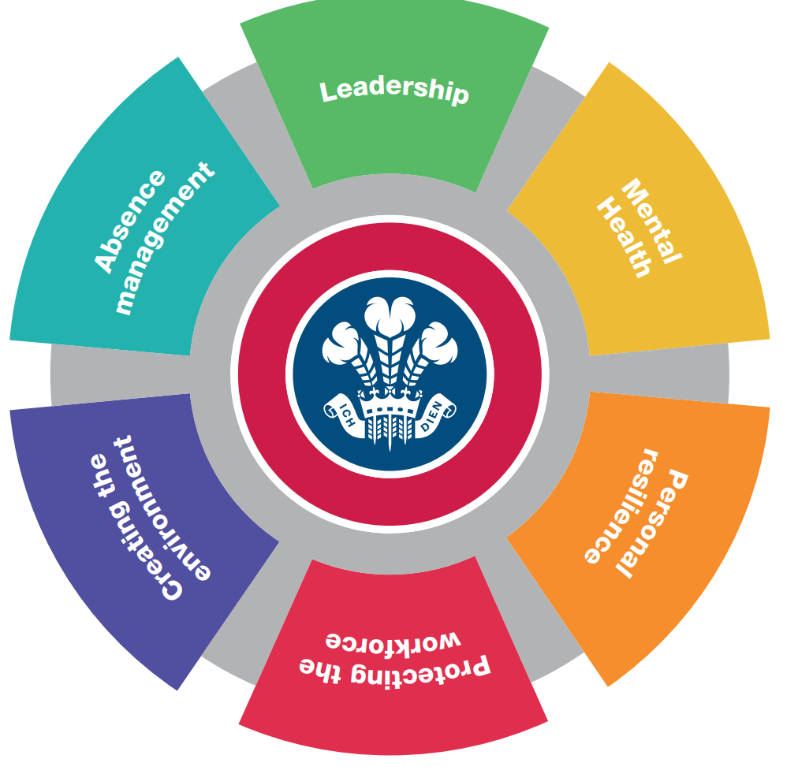

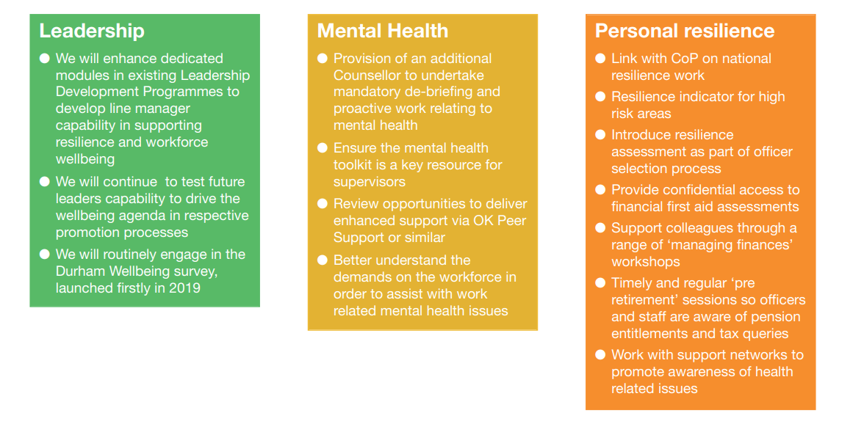
Figure 2- Wellbeing Strategy SWP (2025)

2.8 Summary
Gender remains a significant barrier to help-seeking within policing, shaped by organisational culture, psychological factors, and operational pressures. Despite well-intentioned policies, current wellbeing initiatives often fail to achieve their objectives. Understanding these complexities requires a reassessment of existing strategies and the development of targeted approaches to foster a more supportive police culture.
Further research is needed to examine the confidence and willingness of SWP personnel to report concerns. This gap raises critical questions about how organisational values and policies influence help-seeking and how victims’ experiences are acknowledged. Exploring local perceptions will provide valuable insights into the interplay between employees, victim experiences, and reporting behaviours.
The next phase of this study will detail the research methodology, including strategy, data collection techniques, and researcher involvement. The aim is to generate evidence-based recommendations to inform policy and training, improving accessibility and effectiveness of support and creating a resilient workforce.

Chapter Three Research Methodology

3.0 Introduction

Within policing, mental health challenges present a significant concern, influencing recruitment, public perception, and the force’s ability to deliver daily business effectively. To explore this issue, this chapter adopts an action research approach, which is defined as research that focuses on the engagement and leadership of people who are directly experiencing the issues under review (Cornish, et al., 2023). This method is appropriate as it is recognised for its participatory nature and its focus on seeking change, (Baum, et al., 2006), ensuring that those impacted can participate in seeking change. The methodological framework for data collection is therefore designed to address objectives two, three, and four as outlined in the introduction.

3.1 Research Strategy
Research can be understood through various perspectives. (Gomez-Diaz & Recio, 2022) identify research as a process which gathers information to answer specific and defined questions. Another perspective focuses on research quality and methodological rigor, noting that research is often assessed within relevant paradigms (Hostler, 2024). For example, a narrow definition of research quality may privilege ‘quantitative, confirmatory research grounded in scientific realism’ but potentially, disadvantaging other approaches such as ‘constructivist or qualitative research’ (Hostler, 2024).

The diversity of definitions highlights the complexities involved in research. Research according to (Cohen and Manion 1980) is defined as that which ‘employs empirical methods and empirical statements. Cohen further states that an empirical statement is defined as a descriptive statement about what “is” the case in the “real world” rather than what “ought” to be the case (Cohen, 1980). This method, supports the research objectives to be able to explore the topic in depth, identifying the reality and experiences of individuals within the ‘real world’ through the identification of lived experiences.

The concept of strategy is often viewed as ambiguous and subject to interpretation across academic and practical contexts. Cory (2024) notes that the term ‘strategy’ is often used interchangeably with several distinct concepts which ‘complicates its clear definition and application’. The lack of clarity can result in inconsistent approaches, making it vitally important to establish a precise understanding of the process. While South Wales Police have a dedicated ‘Wellbeing Strategy’ it’s interpretation can still vary. This variability may impact the delivery of objective three, where differing understandings of leadership responsibilities can lead to confusion or inconsistency.
A well-defined research strategy must align with the wider organisational framework and not operate in isolation. This means integrating business, product, and technology strategies through roadmaps that convert plans into actionable, adaptable operations. Effective strategies should remain flexible to ‘accommodate change or setbacks, rather than being rigidly fixed’ (Talonen & Hakkarainen, 2008). Clear alignment between the research strategy and the research aims and objectives ensures a focused direction and supports systematic exploration of the research question (Biggam, 2017).
This study applies both a research strategy and research methods, with distinct yet interconnected concepts (Scribbr, 2021). It adopts the ‘Research Onion’ framework to structure the methodology, as shown in Figure 3.

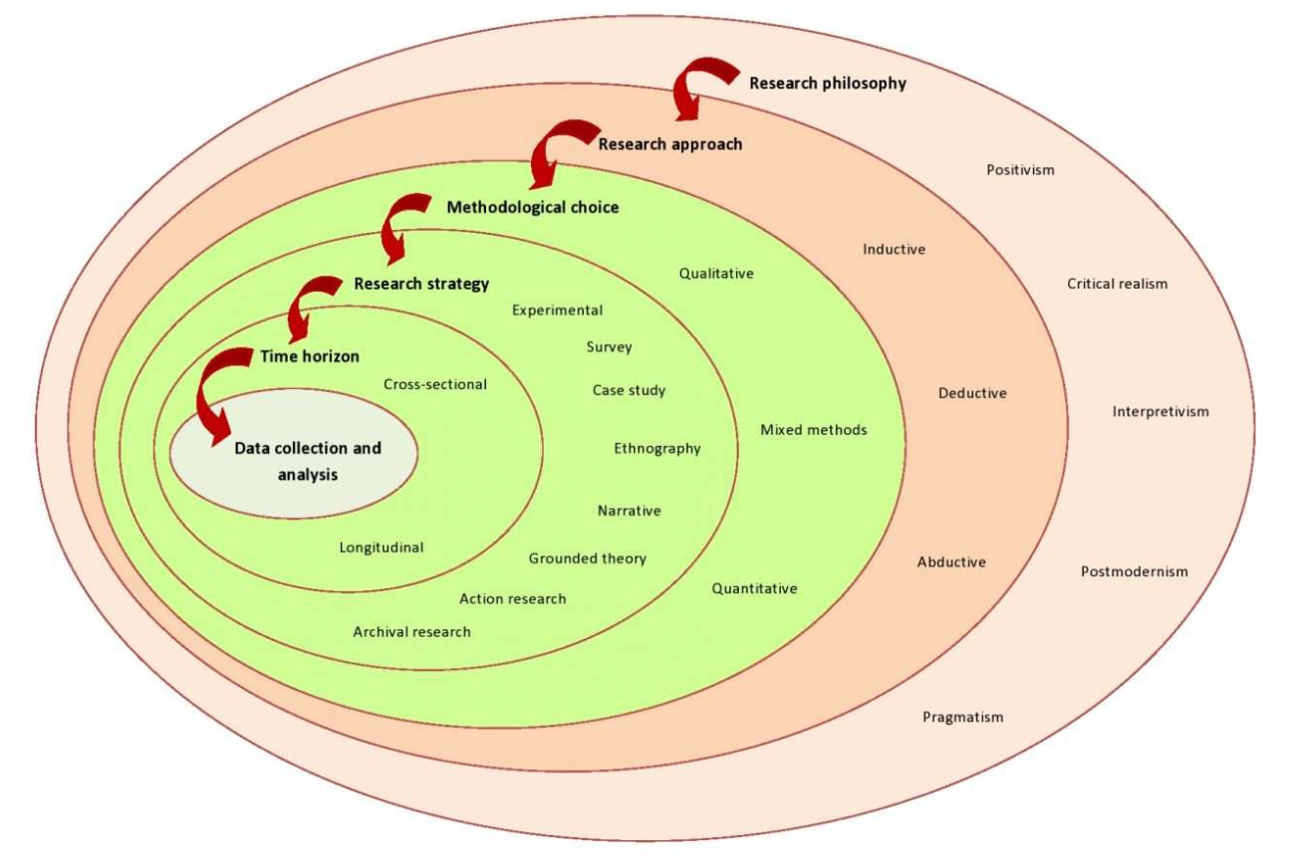

Figure 3 – Research Onion Framework, (Tengli, 2020)

The Research Onion Framework provides a ‘building block’ from which to work from, ensuring that there is clear line of sight, between the research title and the proposed data gathering methods to address it. Providing a consistent approach ensures there is systematic advancement in managing the complexities inherent in understanding mental health amongst first responders, and the impending factors that can influence help-seeking such as gender identified in the research objectives.
As outlined earlier, the research will be underlined by both interpretivism and pragmatism. Interpretivism allows for the understanding of subjective experiences and gendered stigma among emergency personnel, addressing research objective two. It is a theoretical approach that ‘emphasises understanding human action through interpretation rather than solely through natural science methods’ (Matta, 2015). Pragmatism is a philosophical perspective, that emphasises ‘the practical consequences and effects of concepts and beliefs as central to their meaning and truth’ (Schoneberger, 2016). Both methods advocate for the inclusion of qualitative and quantitative methods to investigate extensively the research question.
An abductive approach will be utilised, commencing with the observation of stigma and help-seeking behaviours. An abductive approach refers to a form of ‘reasoning that involves formulating the most plausible explanations for observed phenomena’ (Dellsen, 2024). It is often seen as a systematic approach that aims to identify the nature and purpose of explanations, (Pietarinen & Stanley, 2025). This approach will allow for the identification of any emerging patterns or trends.
The concurrent mixed methods approach, outlined by (Creswell, 2003), explores quantitative and qualitative phases concurrently. There are three types of concurrent mixed methods design: concurrent triangulation, concurrent nested and concurrent transformative’ (Hanson, et al., 2005). A concurrent triangulation mixed methods design will be adopted for this research. Concurrent triangulation, as described by Adu (2023) and (Hanson et al., 2005), involves collecting both types of data, with equal priority, and then determining whether both methods have yielded similar findings. “Quantitative method is a research tool used to help measure variables or quantify observations” (Adu 2023). Quantitative research explains phenomena by collecting numerical data that are analysed using mathematically based methods” (Aliaga & Gunderson 2002). This will form part of the research.
Additionally, correlation analysis will examine relationships between variables such as gender, stigma perception, help-seeking behaviour, and length of service. In respect of quantitative data, a survey strategy will be developed, distributing Likert-scale questionnaires online to a broad range of emergency service staff. The questionnaires will seek to measure stigma, help-seeking behaviours and attitudes and the perceived gender norms. Descriptive statistics will then be utilised to analyse the data. Descriptive research is a qualitative approach that provides straightforward summaries of phenomena in everyday language, (Doyle, et al., 2020).
Qualitative data refers to information that is collated to explore variables and phenomena that are not predetermined, (Khoa, et al., 2023). It requires careful analysis and reflection to generate understanding and theory (Maher, et al., 2018).The qualitative data for this research will be collected via qualitative questions within the questionnaire. This will explore experiences, stigma, barriers to seeking help and any ingrained cultural influences addressing objectives 1-3 of the defined objectives. Data will be analysed using thematic analysis, which is a qualitative data analysis method focused on identifying, analysing, and reporting patterns or themes within data, (Kiger & Varpio, 2020).
Secondary data from existing statistics, including HR data and gender-specific mental health support uptake will be reviewed to contextualise the findings and to identify any trends or patterns. A cross-sectional approach will be utilised, with information being assessed at a single point in time, to capture current attitudes and behaviours. Informed consent will be obtained from all participants, with confidentiality and anonymity of participants maintained.
Questionnaires were distributed to all control room and front desk staff, which included both Staff and Officers. This totalled 452 employees. Determining an acceptable sample size for preliminary analysis in questionnaire is dependent on the specific study, however it is accepted that for a pilot a minimum of around 30 respondents is often recommended, (Bujang, et al., 2024). Fugard and Potts indicate a broad range of between 2 to 400. ‘However, whilst Fugard and Potts offer a quantitative starting, researchers should consider the nature of their thematic analysis and conceptualisation of themes when deciding on sample size’ (Braun & Clarke, 2016).

3.2 Research Philosophy
There are four main research paradigms explored within research philosophy, with this research being set within pragmatism and interpretivism. ‘Pragmatism as a primary philosophical framework is characterized by its focus on the practical consequences of concepts and the use of meaning in context, rather than abstract’ (Santoro & Penco, 2012). Further work by Peirce distinguishes pragmatism from psychologism by grounding its phenomenological categories, providing a structured yet flexible philosophical foundation, (Hookway, 2012). Pragmatism as a primary philosophical framework reinforces the ‘contingent, practical, and evolving nature of knowledge and truth’ (Christensen, 2022).

Within this research pragmatism serves as the primary philosophical framework, emphasising diverse methodologies to effectively investigate sensitive and complex issues such as mental health. This aligns with the research aim to explore and understand the dynamics affecting the willingness of SWP employees to seek help and explores the practical consequences, such as the impact and possible consequence that having a male supervisor as opposed to a female supervisor can have on reporting confidence.

It is vital to recognise that each respondent’s experience of mental health and help-seeking is individual and unique to that person. That their perspective is built upon their experience and therefore their reality of the situation is individual. Reality can be understood as a ‘pattern of relations that perpetuate over time’ (DeWiel, 2013). ‘Constructivist epistemology views knowledge as actively constructed by learners rather than passively received’, (Kumar, 2018). Adopting a constructivist epistemology will allow participants to share their lived experiences. Ensuring anonymity in the responses provides reassurance and creates a supportive environment where respondents can actively express their views through qualitative questioning.

The quantitative research approach is often grounded in the positive paradigm. This assumes that ‘social phenomena can be measured and analysed similarly to natural phenomena’ (Maksimovic & Evtimov, 2023). The positivist paradigm aims to find ‘universal truths through empirical observation and measurement’ (Carminati, 2018). The focus on objectivity and replicability can also improve clarity of research findings. The paradigms focus on ‘measurable variables and statistical analysis that support the identification of patterns and relationships that might not be apparent through qualitative methods alone’, (Maksimovic & Evtimov, 2023). However, criticism of positivism, recognises the inflexibility regarding absolute objectivity. That it tends to ‘disregard the influence of the researcher’s perspective and the contextual factors that shape social phenomena’ (Ayat & Nusratullah, 2025). Whilst it offers enlightening perspectives its recognised constraints require a more concentrated approach. This research prioritises interpretivist to provide a comprehensive understanding of the subjective factors influencing help seeking. The research philosophy shapes the chosen methodology to gather a robust understanding of the research topic.

3.3 Research Approach
Inductive methodology refers to an approach where conclusions or theories are developed based on the analysis of empirical data, moving from specific observations to broader generalisations’ (Bendassolli, 2013). Inductive research generally includes formulating concepts based on the data, rather than starting from an established theory, (Barroga, et al., 2023). It generally provides a systematic approach to reviewing raw qualitative data into summary, and establishing clear links between research objectives and findings, and develop frameworks that represent underlying experiences, (Thomas, 2006). However, it is recognised that this approach may not be as strong as some analytic strategies for theory or model development. In contrast deductive methodologies refer to an approach that starts with an existing theory or hypothesis, which is then tested or applied to data to confirm, refine or expand the theory, (Fife & Gossner, 2024).

Both approaches present an opportunity to gather and present detailed information. Inductive reasoning is a cognitive approach involving existing data, that allows for inferences or predictions to be made from the available information. This form of reasoning projects from what is known to what is not known, allowing generalisation, (Heit, 2000). In contrast, deductive reasoning is a cognitive approach through which conclusions are logically derived from given premises or rules, which is considered a foundational skill that supports everyday problem solving and is believed essential for acquiring more advanced logical expertise, (Johnson-Laird, 1999).

To address the research question, both research approaches were utilised, forming the foundation from which the conclusions and recommendations were derived. The deductive approach was depicted in addressing objective 1, following an extensive literature review. Objective 2 and 3 was addressed using the inductive approach, generating theories and concepts from data gathered.

Quantitative and qualitative primary data was obtained via staff questionnaires, to gain a thorough understanding of the respondent’s views of the mental health support available and their thought and feelings regarding help-seeking. Utilising this approach allows for evidence to be gathered and recommendations to be made. By utilising inductive and deductive reasoning, insights and theories from the collected data can be drawn. This multidimensional approach allows for extensive data to be gathered while supporting the overarching goal of fostering a greater understanding of mental health reporting and help-seeking.

3.4 Methodical Choices
The preference of research methodologies is enlightened by the six layers of the research onion strategies (Saunders et al, 2019). The primary research is survey research. Survey research is a methodological approach, which is utilised to gather data that reflects societal changes by gathering information from individuals. It involves creating surveys to obtain responses that can be analysed to understand patterns, attitudes, or behaviours within a population, (Tourangeau, 2004).
The design phase of the survey is crucial to ensure that it effectively addresses the research objectives. Technological advancements have introduced new methods of data collection. Whilst these offer advantages, such as cost-effectiveness and timeliness, (Evans & Mathur, 2005), it is also recognised that it presents challenges such as non-response errors, confidentiality concerns and technical difficulties, (Sills & Song, 2002).
Action research is a methodological approach, that combines both the creation of knowledge and practical action. It is characterised by its cyclical process of planning, acting, observing and reflecting to address problems whilst also gaining actionable insights, (Guy, et al., 2020). In respect of the research topic this will allow the respondents to outline the problem as to why take-up rates are low in help-seeking and the challenges that are faced. It will also allow them an opportunity to discuss possible solutions designed to enhance individual help-seeking. By combining methodologies, the research addresses the complexities of help-seeking. This framework encourages respondents to share their lived experiences and to actively be involved in proposed solutions.
Quantitative data collection methods, via the use of questionnaires, were employed to gather information regarding the confidence and willingness of SWP employees to seek help and report poor mental health. This quantitative approach enables the analysis of statistical data and reporting behaviours across SWP. However, by engaging respondents through a comprehensive, exhaustive and well-designed questionnaire, the research provided an opportunity to explore their experiences, thoughts and views regarding reporting and seeking help for poor mental health and to identify the challenges and barriers faced.

3.5 Time Horizon
‘A cross-sectional time horizon involves collecting data at one or over a limited period to provide a snapshot of the research subject’, (Vasconcelos, 2020). A cross-sectional time horizon will be adopted, allowing for a dedicated examination of the factors influencing help seeking at a specific point in time. This approach allows for data collection at a given point in time, in respect of the individuals, views and experiences. It serves as a tool for evaluating practices and data availability, (Prager, et al., 2020).

Cross-sectional data can often effectively be paired with longitudinal data to enhance understanding of dynamic processes. Longitudinal studies are observational or interventional research design in which individuals are tracked over a set time to observe associations between exposures and outcomes, (Prager, et al., 2020).Whilst longitudinal studies offer greater insights into changes and developments over a sustained period of time, they also present numerous drawbacks and challenges. One limitation being the sheer complexity and difficulty in conducting such research. They often need significant time for data collection, which can lead to issues such as participant attrition or changes in technology that lead to issues that affect data retrieval, (Kuula & Putkiranta, 2012).This was not practical or achievable within the given timescales of this research project. The cross-sectional data collection within this research allows for data to be collected within a narrow time frame, making it possible to analyse the results from a large data pool of 97 respondents. This allows for meaningful data to be collected within set parameters.

3.6 Data Collection – Techniques and Procedures
Structured questionnaires offer several benefits, such as standardised data collection which can improve the accuracy and completeness of the information gathered, (Payne, et al., 2017). Additionally, structured questionnaires, especially when digitised, can enhance data quality and participation, (Heiervang & Goodman, 2011). Structured questionnaires were designed to gather measurable insights into help-seeking behaviours using Microsoft Forms.

Anonymising questionnaires offer numerous advantages, primarily protecting the confidentiality and identity of research participants. Anonymisation helps safeguard respondents against discrimination or harm that could arise from disclosure of sensitive or personal information, (Jamal, et al., 2014).It also facilitates data sharing and fosters trust and participation in research. The questionnaire allows for statistical data to be obtained from the
targeted participants. The questionnaires allowed employees with varying lengths of service and gender with diverse experiences of mental health seeking, to provide views ensuring a representation from a cross-section of staff whilst protected by anonymity.

Questionnaires traditionally, include two types of questions, open-ended and closed-ended.
Open-ended questions allow respondents to provide free text which can create an opportunity for respondents to reveal new issues that perhaps had not been considered or captured by the researcher. However, they can also present challenges in analysis and reporting due to their ambiguous status between qualitative and quantitative data, (O'Cathain & Thomas, 2004). Closed-ended questions in comparison can provide pre-defined response options, facilitating easier quantification and analysis, (Stefkovics, et al., 2025). Each however serve distinct purposes and present different challenges, both open and closed questions have been chosen for the questionnaire having considered the goals and the respondents. Open ended questions were employed to explore lived views and experiences in greater detail, in contrast closed questions were utilised to clarify clear points.

Likert questions are structured questions designed to capture ‘the intensity of respondent’s attitudes or opinions through ordered response categories’, (Ferrando, et al., 2025). Such questions can vary in the number of response categories. Likert questions were utilised throughout the questionnaire to obtain quantifiable data, from which trends and patterns could be drawn out, thus gathering a clear picture of staff thoughts and feelings regarding help-seeking and the barriers presenting, addressing the research objectives 1-3.

Throughout the research a conscious decision was made to utilise both primary and secondary data as each has a clear purpose and role. Collecting primary data through questionnaires offers several operational and methodological advantages, providing time efficiency and cost-effectiveness, (Bolaji, et al., 2025), it also provides essential awareness of respondents’ views and experiences regarding help-seeking, ensuring that the findings are contextually relevant and current.

Conversely, secondary data from existing sources offers several benefits. The growing accessibility of data, supported by efforts to develop open and well-maintained datasets along with advances in statistical software, has made secondary data analysis more feasible and attractive for researchers, (Rodriguez, 2021). Utilising existing secondary data affords the ability to address new questions or critiques as per this research top. It allows an opportunity to assess current views and feelings against tangible historic data. This two-pronged approach allows for a greater situational awareness within the broader discourse on police help seeking specific to gender.

3.7 Data Analysis
Data analysis involves ‘examining, processing, and interpreting data to uncover hidden patterns, relationships, and insights that support decision-making and predictions’, (Kotu & Deshpande, 2015). Data analysis is a multi-faceted process, that involves ‘data preparation, application of statistical and machine learning methods, and interpretations of results to inform decisions across different domains’ (Grady, et al., 2023). Data analysis can be categorised into several types. The main categories include ‘descriptive, explanatory, inferential, qualitative analysis, and specialised methods’ (Taherdoost, 2020).

Descriptive analysis involves summarising and organising data. It plays a vital role in study analysis by ensuring data is easier to understand and interpret, (Harbison & Simmons, 2024). In contrast, qualitative data analysis is a ‘systematic, iterative process focused on identifying patterns and themes with qualitative data to provide meaningful descriptions and potentially develop theory, while addressing methodological rigor and practical challenges’, (Flick, 2013).
The data gathered through the questionnaire process must be evaluated, to ensure that it is completed correctly. The data is then analysed via Microsoft Forms software, allowing for a variety of statistical methods, including descriptive statistics to summarise the data to identify correlations and patterns.
Qualitative and quantitative data analysis differ in their nature, purpose and methodological approach. Qualitative data analysis focuses in uncovering new aspects hidden within the data, interpreting meanings and patterns (Schoonenboom, 2023). In contrast, quantitative data analysis deals with numerical data. The two approaches differ in their aims, qualitative research seeks ‘depth of meaning’ whereas quantitative research emphasises ‘objectivity and generalizability’ (Sandelowski, 2000).
Statistical data refers to the process of ‘examining data to discern patterns, relationships, and insights that can inform decision making and understanding, (Nisbet, et al., 2009). Information obtained from the respondents via the questionnaires, were dissected into core areas, to ensure that the responses could be effectively analysed.
Thematic analysis is a qualitative data analysis approach concerned with identifying trends. A popular framework involves six steps, which guide researchers through ‘data familiarisation, coding, theme development, and refinement’ as illustrated below:
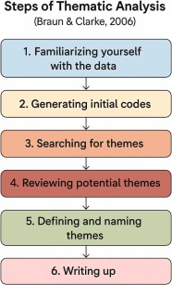
Figure 4 – Steps of Thematic Analysis - Braun and Clarke, 2006
Braun and Clarkes six step framework is widely recognised. The first stage involves familiarisation with the data to have a detailed understanding of the content, recognising any patterns. This sets the groundwork for subsequent coding.
The second stage of analysis is coding, systematically identifying features of the data relevant to the research topic. This coding ‘is not merely mechanical but involves interpretive engagement with the data’, (Campbell, et al., 2021).
The third stage constructing themes, ensures that the codes are determined into broader patterns that capture the data. This process is ‘iterative and reflexive, allowing themes to evolve as understanding deepens’, (Campbell, et al., 2021). The fourth stage involves checking the consistency of themes, to ensure that the accurately reflect the data. The fifth stage, defining and naming themes, focuses on articulating accurately each theme and how it aligns to the research question. The sixth and final stage, involves combining the ‘analytic narrative and data extracts to present a coherent and persuasive account of the findings’ (Campbell, et al., 2021).

3.8 Ethics
Ethical behaviour is essential as it reflects norms, standards and values that ensure respectful and responsible interactions amongst individuals, (Al Halbusi, et al., 2021). Leadership has been shown to influence ethical behaviour. Ethical leadership positively impacts employees ethical conduct by establishing an ethical climate within organisations, (Mehra & Narwal, 2025). Ethics are key to this research. Throughout, compliance with the University of Wales Trinity Saint David, Research Ethics & Integrity Code of Practice (2022) is scrutinised. The submission of an ethics form and subsequent approval is a key component prior to commencing research.

Given the sensitive nature of the research, ensuring confidentiality was vitally important. Respondents were made aware of their purpose and role and that their involvement would be anonymous. Mental health is recognised as a sensitive topic, talking about it can have an impact on individuals which is recognised. To reduce the risk of triggering staff, support networks were made available, when the request for completion was sent. Similarly, staff were advised that completing the questionnaire was optional and at any point they could withdraw from the process.

Complying with the General Data Protection Regulation (GDPR) is vitally important for reasons that extend beyond the legal obligation. The development of GDPR platforms aims to support organisations in managing the complex legal and technical requirements, (Issaoui, et al., 2023). All data collected within this research project is securely stored, with access limited to the researcher. All data that is no longer required is disposed of according to data protection regulations. Having focus on key aspects highlights the commitment to ensuring that ethical research is conducted.

3.9 Limitations
Limitations in research encompass methodological weaknesses in study design and conduct, biases inherent in observational data and practical challenges in data collection, (Munthe-Kaas, et al., 2018). In observational research, limitations often are time related.

Given the sensitive topic, respondents may be reluctant to disclose their true feelings or experiences, thus, they may not respond honestly. Similarly, they may agree with or endorse comments regardless of their true opinion. This is often referred to as ‘acquiescence bias’. Acquiescence bias can have a significant impact as it can distort outcome findings. Additionally, careless responding can impact on findings. Within this research, the fact that the ‘researcher’ is a senior officer could also impact the willingness and openness of respondents to engage truthfully. Respondents may be weary and sceptical around pushing back against current policies and procedures. To attempt to alleviate this risk, it is essential that respondents are aware of the confidentiality and anonymity to encourage openness.

Conducting research within a 24/7 emergency control room, who are operating under high demand can have constraints in respect of respondent’s ability, appetite and time to complete questionnaires, creating an impact on return rates. The research captures a moment in time, limiting the ability to draw conclusions around sustained patterns and trends. This research could be enhanced through longitudinal research, which offers several benefits that enhance the understanding of changes and outcomes over time, (Evans, et al., 2010).

The next chapter will analyse the empirical findings of the 97 questionnaires and the information gathered.

Chapter Four – Findings and Analysis

4.0 Survey Findings: Description, Analysis and Synthesis

This chapter evaluates the results identified from Chapter three. The investigation centres on research objectives two and three, which sought to:
- Investigate experiences and perceptions of mental health support.
- Analyse how leadership affects help-seeking attitudes and behaviours.
Guided by the framework of Description, Analysis, Synthesis and Evaluation, illustrated in Figure 5, this allows for the systematic evaluation of patterns and trends, (Lewandsowki & Dilworth, 2010).

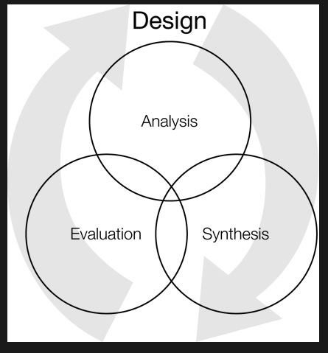

Figure 5 – Description, Analysis, Synthesis and Evaluation

4.1 Mental Health Within Policing - Problem Profile –South Wales Police

In August 2025, a detailed analysis of Mental Health Sickness absence in South Wales Police was undertaken force-wide with a particular focus on current absence rates and an analysis of mental health absence trends over the previous 12 months. The analysis considered absence trends by gender, see appendix 3.

The analysis also focused on the management of mental health related absences and utilisation of supportive interventions including Occupational Health and Counselling Services.

The report highlighted that the total time lost due to Mental Health Absence:

- Had increased month on month since Feb 2025.

- That the total time lost due to mental health absence had now exceeded time lost to all other absence reasons combined.

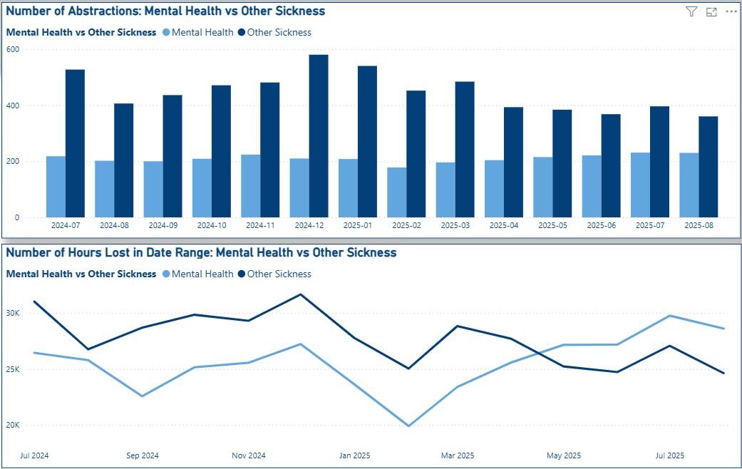

Figure 6 – Number of Abstractions: Mental Health vs Other Sickness

Further to the above findings, it was established that:
- Mental Health absence counted for over 50% of all sickness absences for police officers and 51% for police staff members across the workforce.
- Mental Health absence rates are higher among female officers (61.5% of total time lost due to sickness) vs. males (54.7%)

Within South Wales Police counselling referrals have fluctuated see Figure 8:

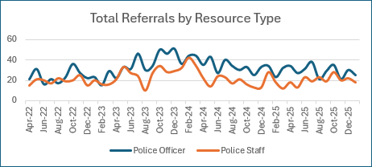
Figure 8 – Total Referrals by Resource Type

The data shows that demand for counselling has remained consistent. This supports the literature review which highlights that whilst consistent, engagement remains relatively low. Whilst referrals remain static mental health sickness continues to increase year on year, in line with the national picture. The foundation for this report was to explore further the impact gender has on help seeking specifically at the first point of contact within the Public Service Centre (PSC). To review the local findings against the national picture around mental health absence and support.

4.2 Description

The study employed a mixed-methods online questionnaire, distributed via Microsoft Teams, to examine the experiences and perceptions on the influence of gendered stigma on help-seeking behaviours among police emergency service personnel. A voluntary sampling strategy was adopted, which is a type of ‘non-probability sampling strategy where participants self-select to be part of a study’ responding to an open invitation (Ene-Margit, 2021). This survey targeted all police control room employees, 452 in total. This involved purposive sampling, whereby the selection of the participants were guided by the specific aims and objectives of the study rather than random selection’ (Campbell, et al., 2020) The questionnaires were designed to include both closed and open-ended questions (Appendix 4). This allowed for the gathering of qualitative and quantitative data and for the participants to freely express their thoughts and personal experiences.
A deductive approach, utilising research design, hypotheses, and analysis and the findings from evidence and data gathered from sources including HR data and the literature review allowed for a detailed and reliable understanding.

A feedback rate of 97 respondents was attained reflecting healthy engagement with the research topic, see Appendix D. Questionnaire data analysis followed Braun & Clarke, (2006) inductive thematic analysis method, this allowed for ‘themes related to experiences’ to be extracted from the data. Responses were examined comprehensively across key groups including age, gender, rank or police staff grade and service, enabling intricate distinctions and comparisons to be made.

Significantly, the questionnaire compilation was intended to test both conceptual understanding of health seeking as well as capture the views of those that had sought help. This provided an opportunity to establish how lived experiences impacted the confidence and willingness of individuals to report and seek help for mental health worries. This approach matches the study’s aims of bridging gaps between assumptions and realities.

4.3 Public Service Centre Establishment
The PSC has a current establishment of 452 employees, see appendix 5, of which females account for approximately 75.6% of the workforce and males approximately 24.34%, see Figure 9:
 | Headcount
Female | 342
Male | 110
Grand Total | 452

Figure 9 – HR Employment Data 12.03.25

Nintey-seven questionnaires were returned, a return rate of 21.5% of the workforce. Of the 97 questionnaire responses received from SWP employees, 61 identified as female (13.5%) and 36 as male (8.0%), see Figure 10:

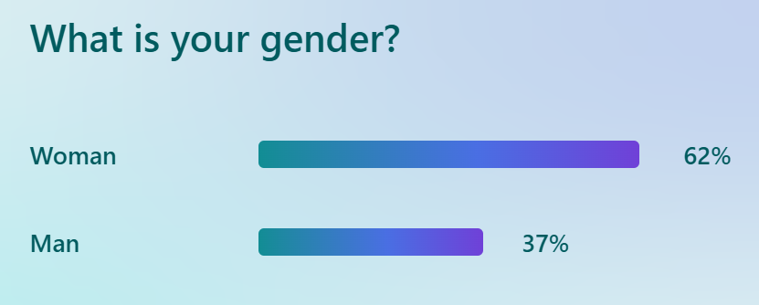
Figure 10 – What is your gender?

Interestingly the gender split among participants closely mirrored the staff compilation in the control room. This somewhat contradicts the literature review that males are less likely to engage. However, it can be argued that the anonymity of the questionnaire encouraged greater participation.

The age demographic of the workforce, as of 12 March 2026, is shown in Figure 11:

 | Headcount
Under 26 | 60
26 - 40 | 170
41 - 55 | 133
Over 55 | 89
Grand Total | 452

Figure 11 HR Data – Age Profile PSC

The age distribution of respondents reflects the demographic profile of the department. Of the respondents, 6% were aged 18-24, 36% were aged 25-39, 30% were aged 40-49, 11% were aged 50-55, and 16% were aged 56 or over.

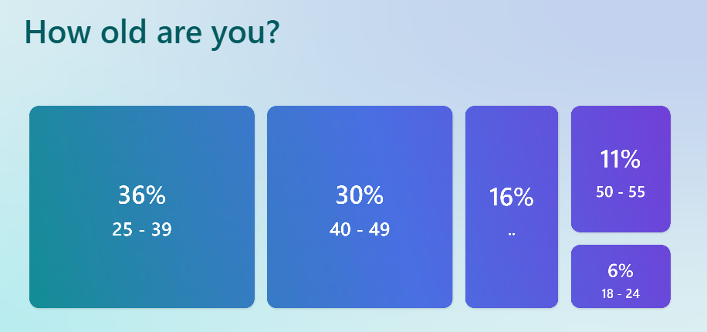
Figure 12 - Age Distribution of Respondents

In terms of roles, most respondents (62%) were police staff members grade 2-5. A further 22% were police staff members grades 6, while 4% were police staff members grades PO1-PO3. Police Officers, ranging from Police Constable to Chief Inspector, accounted for the remaining 4% of respondents, as illustrated in Figure 13:
What is your Rank of Police Staff Grade?
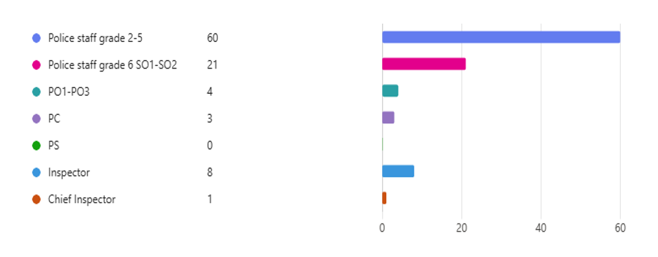
Figure 13 -Grade / Rank of Participants

An analysis of the department identified that the length of service of the department, ranged from under 2 years to 20yrs plus, see Figure 14:

 | Headcount
Under 2 yrs | 108
2 - 5 yrs | 109
6 -10 yrs | 75
11 - 15 yrs | 24
16 - 20 yrs | 40
Over 20 yrs | 96
Grand Total | 452

Figure 14 – HR Data Length of Service

Questionnaire respondents exhibited a broad range of professional experience as illustrated in Figure 15:

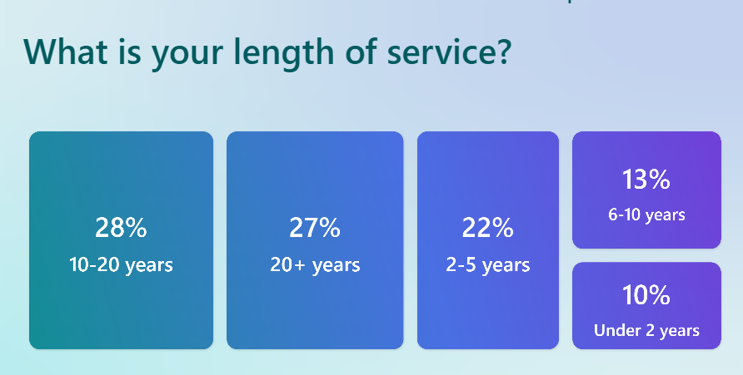
Figure 15 - Service Length of Respondents
Interestingly, this distribution indicates that there is a higher respondent rate amongst those with greater service. This contradicts existing literature which suggests that our younger workforce is more open to discussing mental health. Alternatively, it may indicate that more experienced employees feel greater confidence and security in providing feedback. This insight is important for SWP, as it highlights the potential to foster a more transparent organisation culture, ultimately enhancing trust and confidence.

4.4 Thematic Analysis of Objective 2 – Experiences & Perceptions of Mental Health Support

Having identified the demographics and methodological framework, this section thematically evaluates gender stigma and help seeking amongst emergency service personnel, directly addressing research objective two.

Whilst questionnaires offer a meaningful insight, it cannot be forgotten that the responses may be subject to bias, there is a suggestion that ‘respondents tend to answer based on the positive or negative polarity of questions rather than their specific content’, (Camara-Costa, et al., 2026). Similarly, perceptual questionnaires can be vulnerable to ‘emotional valence, item wording, respondent interpretation and personality traits’ (Hill, et al., 2019) which can also impact the reliability.

The analysis identified numerous organisational challenges that deter individuals from reporting poor mental health within SWP. These obstacles align with the literature confirming that mental health within policing is complex. The data highlights systemic challenges that create organisational barriers and result in under-reporting.

The findings identified an awareness of policy and available support but a need for targeted communication and greater leadership accountability to address perceived awareness gaps. The review highlights the importance of tailoring messages to specific audiences. Concerns related to seeking help, encompass a range of barriers, one prominent concern, is stigma. This stigma ‘is influenced by social support dynamics and coping strategies, as well as how mental health is framed, whether psychologically or biologically, which can either mitigate or exacerbate perceived stigma’ (Talebi, et al., 2016).

4.4.1 Impact of Role on Mental Health
Most respondents across the workforce (59.8%) reported that their role had an impact on their wellbeing and mental health, see Figure 18.
The results indicate that males are more than twice as likely as females to respond ‘No’, this suggests that there are gendered differences in perception and confidence in reporting. In comparison females, are considerably more likely to respond 'Maybe', indicating uncertainty or mixed experiences that may require deeper qualitative exploration. These patterns show organisational-level themes and highlight opportunities for targeted support.
Overall, the data suggests, that there is a widespread perception that the role impacts mental health across genders and that gender does in fact shape how respondents interpret the impact, this is in line with the literature review. Research indicates that males tend to exhibit higher levels of stigma compared to females which may contribute to a reluctance to acknowledge the impact of their role on their mental health, (Bailey, 2021).
Impact of Role on Mental Health
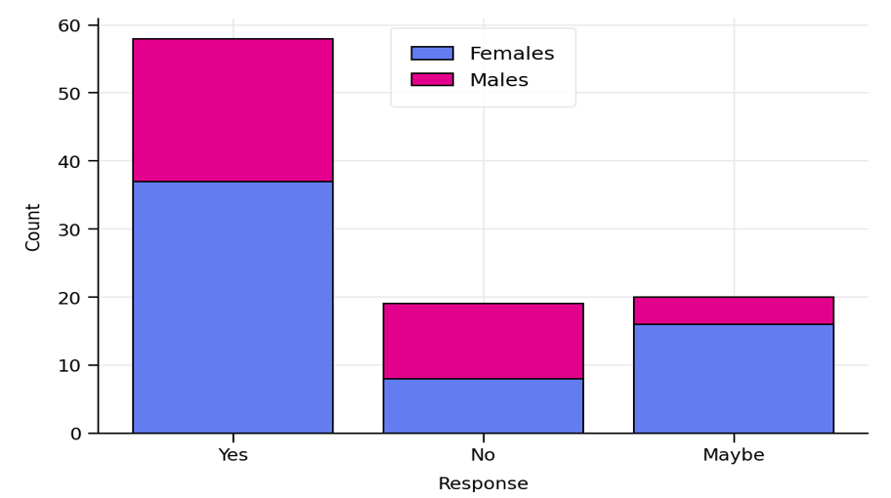
Figure 18 – Impact of Role on Mental Health

4.4.2 Stress Level Analysis
Respondents were asked to rate their stress level, on a scale of 1-10. The results reveal that peak stress levels differ by gender. Female respondents display a bell-shaped distribution centred on moderate stress levels, see Figure 19.

Female Stress Distribution
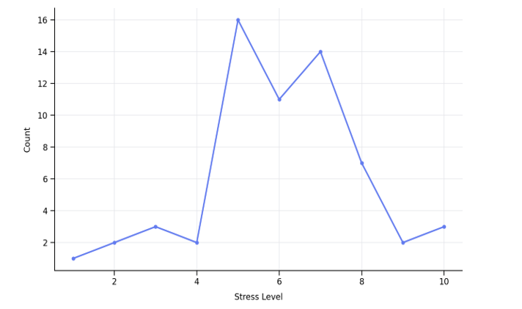

Figure 19 – Female Stress Distribution
Female respondents display their peak stress level at level 5 (16 respondents), with a clustering across moderate to high levels (5-7). Levels 6 and 7 also remain elevated, forming a bell-shaped trend. This implies sustained mid-range pressure across the female group.
In contrast male respondents display a right-skewed distribution with higher stress levels dominating. The peak occurs at level 8 (9 respondents) and shows high-stress clustering, at levels 7-8. This indicates that higher-intensity stress episodes are more common among male respondents, see Figure 20:

Males Stress Distribution
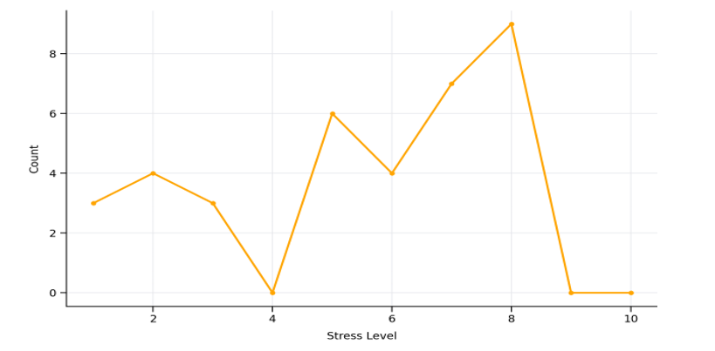
Figure 20 – Male Stress Distribution

When comparing stress levels, females more often report low-to-moderate stress whereby males more often report higher stress levels, see Figure 21:

Stress Distribution Comparison
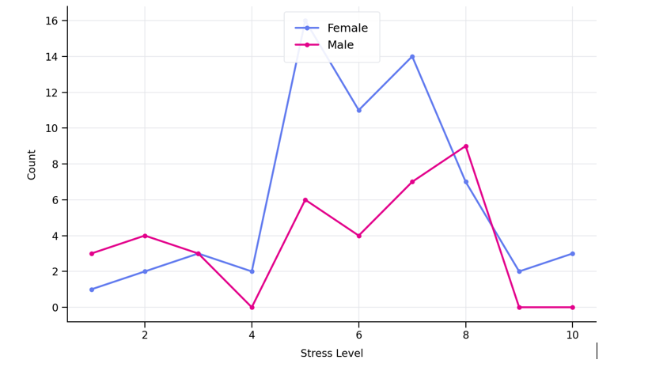
Figure 21 - Stress Distribution Comparison

This indicates differing stress profiles: females tend to experience moderate levels of stress, while males experience sharper, higher-intensity peaks. When supporting females’ wellbeing, consideration should be given to workload balance and sustained support for moderate stress, in comparison if focusing on male wellbeing, it is important that there is focus on burnout prevention and support for managing episodes of high-level stress. This supports the view of Lamb and Tarpert (2019) as highlighted in the literature review which outlines the need for multi-agency collaboration and improved training.

4.4.3 Stress Level Contributors by Gender

The chart below presents a summary of responses across the different stress categories, broken down by gender, Figure 22:
Stress Level Contributors by Gender
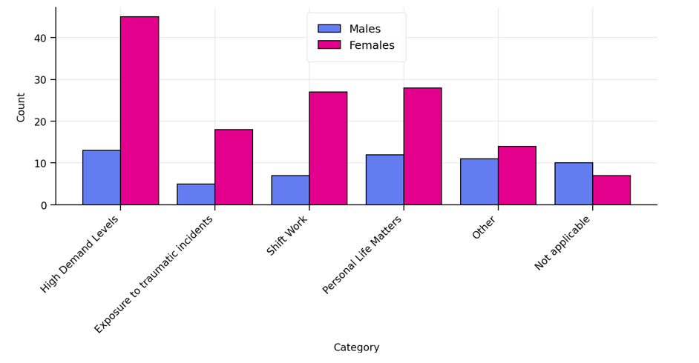
Figure 22 – Stress Level Contributors by Gender

The data illustrates gender-based differences in reported stress levels. Females consistently report higher levels of stress across all key categories. This is particularly evident within High Demand Levels, Shift Work, and Exposure to Traumatic Incidents. In contrast males were more likely to state that certain stressors were Not Applicable, suggesting reduced perceived impact or lower reporting levels.
Possible recommendations to overcome such differences, could involve conducting focused listening groups with female members of staff to improve understanding of the underlying issues affecting them, alongside a review of workloads.
Shift patterns should be reviewed to ensure sufficient rest periods between duties, Meta-analyses of longitudinal studies has indicated that shift workers have a higher overall risk of adverse mental health outcomes, in comparison to non-shift workers, with effect sizes showing increased depressive symptoms notably amongst female shift workers’ (Torquati, et al., 2019) which is evidenced within SWP analysis.
In addition, the lower reporting trends among male staff should be examined further to identify cultural or organisational blockers that are perhaps influencing engagement. This is in line with the literature that indicates stigma impacts the confidence in reporting, particularly amongst men, which is influenced by the traditional ‘masculine norms’ (Jampel, et al., 2019).

4.4.4 Role Influence on Support Seeking

Analysis of the questionnaire responses indicates that both the role and the gender of the person undertaking the role, influence the probability of seeking support, see Figure 23. Female respondents were more likely to answer “Yes”, recording 23 responses compared to 12 from males. This suggests that role-related support barriers or motivators may be more pronounced among female staff.
Existing literature supports that frontline policing, regardless of gender, is a psychologically demanding profession that routinely exposes officers and staff to emotionally challenging situations (Harkin et al., 2025). It also highlights that male individuals are generally less likely to recognise or acknowledge the need for mental health support (Goodijohn, 2023).
Despite this, the most frequent response across both genders was “No”. Males recorded 19 'No' responses and females 24, indicating that a large portion of staff do not feel their role limits their willingness to seek support, this contradicts the literature review. Female respondents reported a higher number of “Maybe” responses (14 compared with 5 for males), suggesting greater uncertainty about role-based constraints or differences in experiences within the organisation.

Overall females accounted for a larger proportion of responses, (61 compared to 36 from males), despite this, proportional patterns remain, showing more complexity in the perception of female respondents. Female responses were more evenly spread across all three category areas. This perhaps suggests that female staff may experience role influence as more nuanced or context dependent.
These findings, indicate potential role-related barriers affecting female employees. The higher level of ambivalence among female respondents highlights a need to potentially review role expectations, culture, leadership and the awareness and accessibility of support pathways.

Responses by Gender
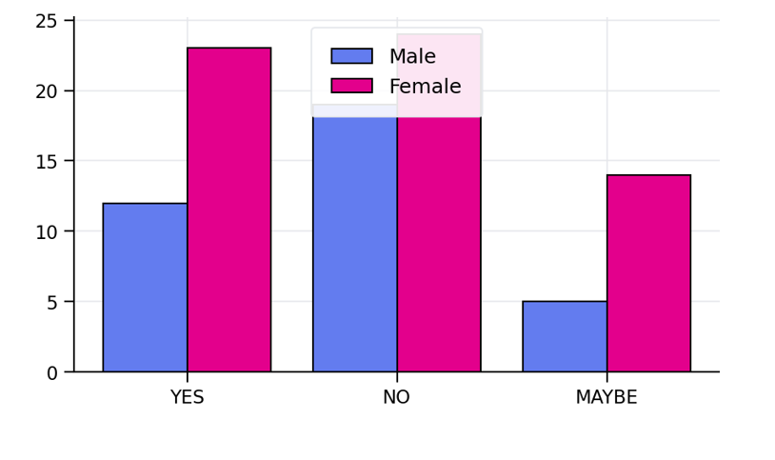
Figure 23 – Impact of Role on Seeking Help – Gender Comparison

4.4.5 Occupational Health Support Awareness

Questionnaire responses demonstrated a high level of awareness amongst staff regarding the occupational health support available to them. Only 14 respondents indicated that they were either unsure or did not understand the support on offer, see Figure 24:

Are you aware of Occupational Health and the Support they can Offer you?
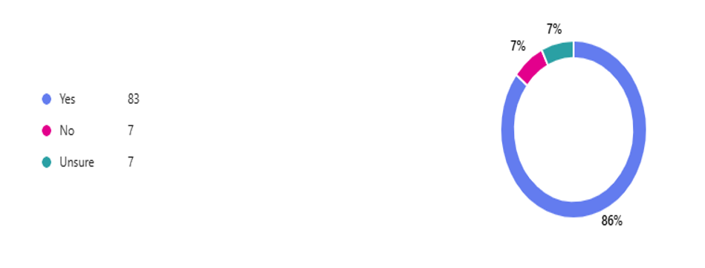
Figure 24 – Occupational Health Support

Interestingly, whilst a significant number of employees understood the support available, either through personal experience or general awareness, the perceptions of the adequacy of the support differed notably. When asked if the support was sufficient only 27 respondents reported ‘yes’ while 58 individuals reported either being unsure or believed the support to be insufficient, see Figure 25.
This suggests that lived experiences play a key role in shaping perceptions, with those who had accessed the support more likely to report it as inadequate. There is also an indication that the views of individuals who had not accessed the service may have been influenced by wider social or organisational factors, (Bond, 2005).

If you answered yes, is the Support Sufficient?
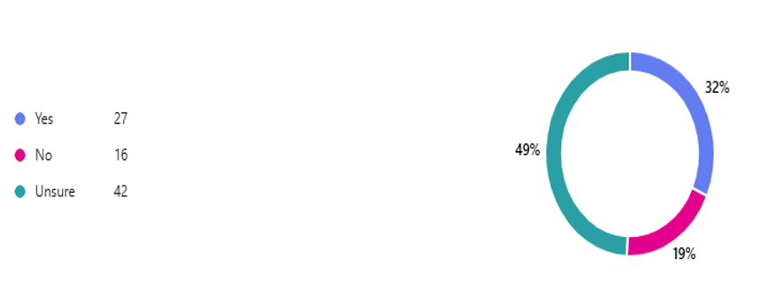
Figure 25 –Occupational Health Support – Is It Sufficient?
The disparity highlights an organisational gap between the general awareness of available resources and the confidence in their effectiveness. These quantitative findings are strengthened by the qualitative analysis, which identified organisational failings relating to the consistency of training, and equity of access to occupational support. Respondents frequently drew on their own personal experiences, offering an insight into the reality and practicality of seeking support. Furthermore, several respondents raised concerns regarding barriers that were presented when reporting, suggesting that these challenges may undermine the reliability and effectiveness of the reporting framework, these views were supported in the literature review, by Shabalala and Chitamba (2026).
Preferences around the reporting process were also evident, indicating a need to review and adapt existing processes to better meet employee needs.

4.4.6 Occupational Health Support Recommendations

Respondents were asked if they had any recommendations as to how their service could be improved, the below word cloud was created from the responses, see Figure 26:

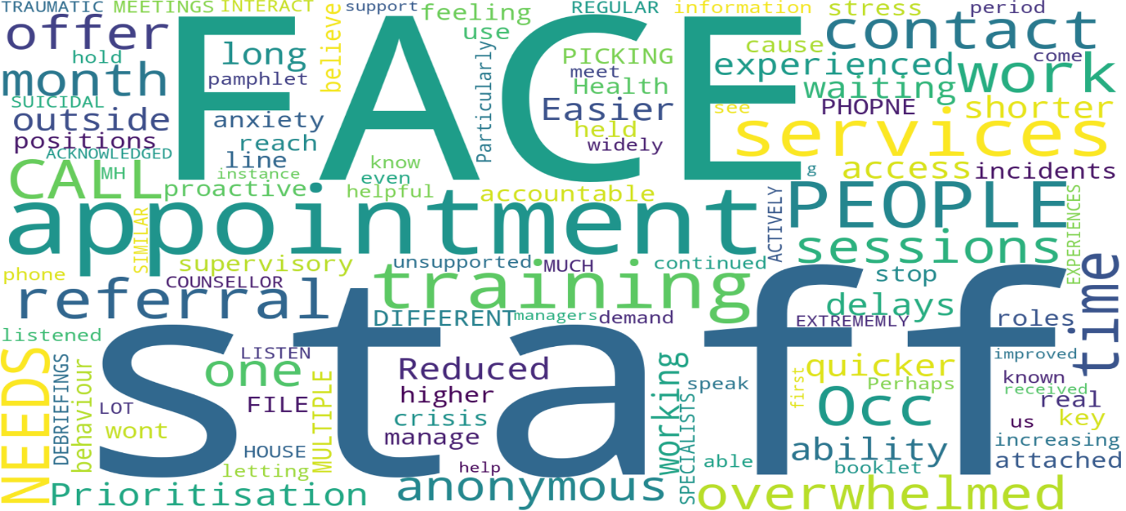

Figure 26 – Word Cloud – Recommendations for Occupational Health Improvement
The recommendations for occupational health improvement highlight several recurring themes through the word cloud analysis, including the benefit of face-to-face support, access to staff wellbeing and mental health specialists, reduced waiting times with quicker access to services, and more pro-active outreach from Occupational Health. Additional priorities include improved accountability and training for managers, increased resourcing greater consistency in provision and ongoing contact with staff, all of which will be documented in the proposed recommendations. This supports the views of Shabalala Chitamba (2026) who highlighted that there were perceived gaps in the support offered compared to the actual individual experiences.

4.4.7 SWP Wellbeing Strategy
Overall awareness of the Wellbeing Strategy was mixed amongst respondents. Out of the participants who took part, 41 people confirmed that they were aware of the strategy, while 38 stated they were not aware. An additional 13 respondents indicated they were unsure, suggesting a level of uncertainty around the visibility and communication of the strategy, see Figure 27.
When analysed by gender, notable differences were evident. 30% of male respondents stated that they were aware of the strategy, compared with 54% of the females who responded. Conversely 54% of males stated that they were not aware, compared with 35% of females. The degree of uncertainty was also greater amongst males, with 16% unsure compared to 10% of the female respondents.
Overall, females demonstrated a greater understanding and awareness of the strategy. While levels of non-awareness were broadly similar, the disparity in awareness highlights possible communication gaps, particularly in reaching male staff. To address these findings, it is recommended that communication is enhanced towards male staff. In addition, a review of current communication channels should be undertaken to ensure that the Wellbeing Strategy is effectively promoted and accessible within the organisation.

SWP Wellbeing Strategy Awareness by Gender
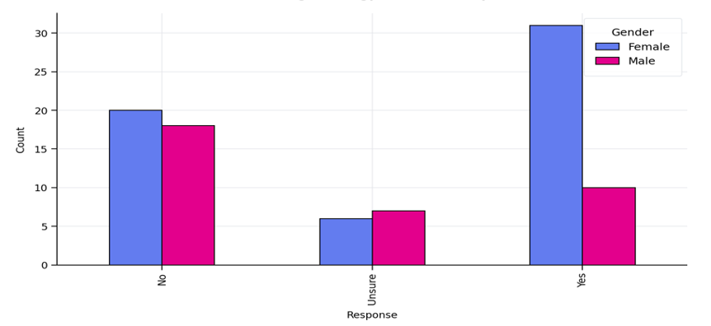
Figure 27 – SWP Wellbeing Strategy Awareness by Gender

4.4.8 Occupational Access of Support by Gender

The responses indicate that twice as many respondents did not access support compared with those that did and that females are more likely to access support than males. With 38% of females reporting engagement compared to 25% of males. Non-engagement amongst males was notably high at 75%, this supports the literature review, observations of Drapeau et al (2009) and McKenzie et al (2018), see Figure 28:

Occupational Health Support Access by Gender
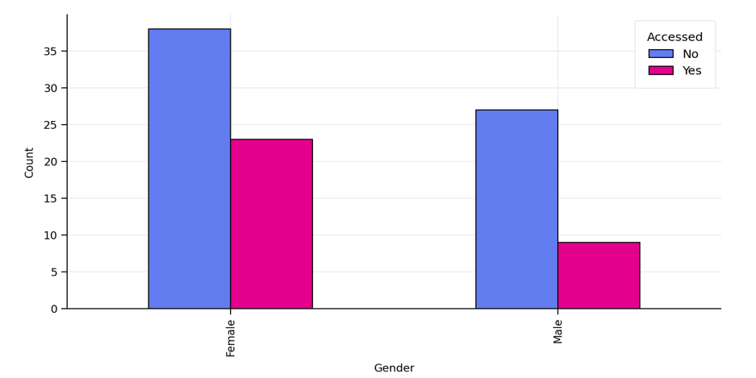

Figure 28 – Occupational Health Support Access by Gender

Among those that did access the support available, satisfaction with the service provided was predominantly positive, see Figure 29:

How did you Rate the Service Provided?
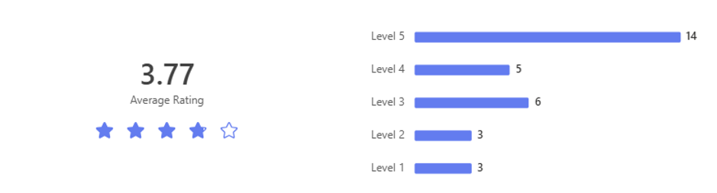
Figure 29 – Occupational Health Service Rating

4.5 Thematic Analysis of Objective 3 – Leadership Influence on Help-seeking

4.5.1 Supervisor Impact on Help-seeking
The impact of leadership responsiveness and supervisory engagement on organisational reporting cultures and employees trust has been widely examined. Respondents rated their confidence in receiving constructive professional guidance and support from their line manager. This highlighted the extent to which supervisory behaviour influences help-seeking, openness and trust within the organisation.
Transparent leadership offers numerous benefits to organisations, by fostering open communication, trust and positive relational dynamics, (Salvatico, 2006). Similarly transparent communication contributes to quality employee-organisation relationships, this plays a vital role in shaping the organisations internal reputation, as employees’ positive evaluations are linked to authentic leadership and transparent communication, (Men, 2014). Respondents consistently emphasised the critical role of transparent communication and consistent support from leaders.
In examining the correlation between supervisory support and reporting intentions, it was recognised that, of the 97 respondents, 67 reported having female supervisors while 30 reported having male supervisors. Respondents were asked whether they felt that the gender of their supervisor would influence their decision to seek help. The responses from both male and female respondents have been separated, to show the differing views, see Figure 30:

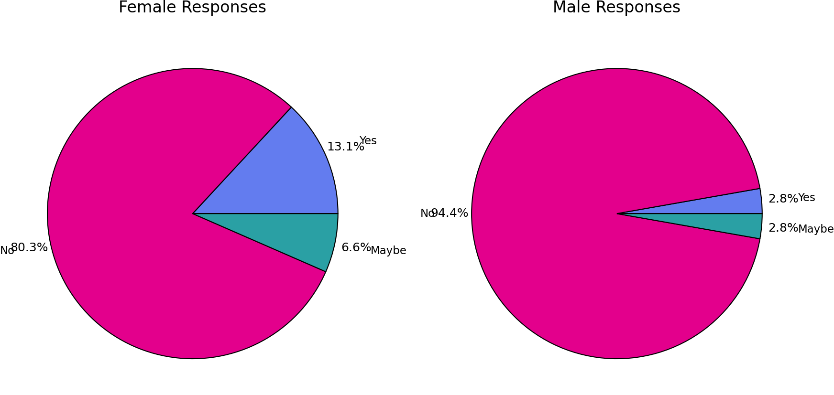
Figure 30 – Supervisor Impact on Disclosure
Overall, most respondents (both male and female) indicated that supervisor gender does not influence their decision to seek help, this contradicts the literature review, whereby Konrad et al (2010) all indicated that supervisor gender can influence seeking support. However, female respondents were more likely than male respondents to indicate that gender may influence their decision. Females also expressed greater uncertainty, with a higher proportion selecting ‘Maybe’. In contrast, male respondents gave more definitive answers, with 95% choosing ‘No’.
Despite these differences, overall confidence in support remains high. Approximately 75% of respondents selected “Yes,” indicating strong levels of trust. This aligns with existing literature, which suggests that staff generally perceive leadership support positively, while also highlighting the need for enhanced management training to improve effectiveness (Lamb and Tarbert, 2019).This finding is also consistent with Konrad et al. (2010), who identified that female employees, particularly those with male supervisors, may be more cautious about reporting concerns, although overall reporting confidence remains high.
Interestingly, gender differences are evident in levels of certainty. Females showed higher uncertainty (21%) compared to males (7%), while males were more decisive in their responses, both positive and negative. Importantly, the ‘unsure’ responses appear to be due to a lack of clarity rather than negative perceptions. This again highlights a potential for targeted communication, to reduce gender-based uncertainty, see Figure 31:
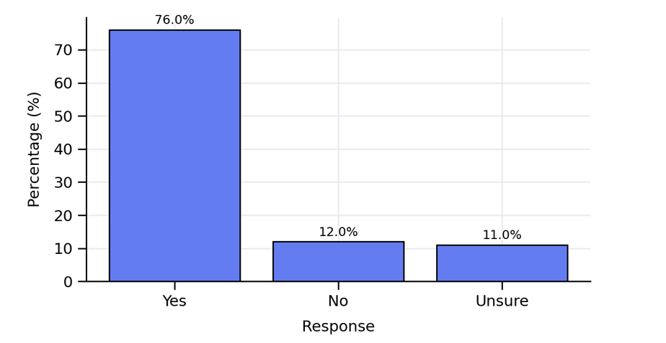
Figure 31 – Perceived Supervisor Support if Disclosing Mental Health
Potentially there is an opportunity to share practical examples of supportive supervision amongst the supervisor cohort and to raise awareness of available resources. A priority is closing the ‘uncertainty gap’ by publishing a simple explanation as to what happens when someone is referred to manage expectations. Alongside this, organisations must ensure that there is ongoing support for supervisors, through refresher training on dealing with trauma, supporting staff, active listening, confidentiality and appropriate signposting.
Evaluating the effectiveness of support systems is key within the organisation to ensure there are improvements in the experiences of individuals reporting mental health concerns. Evidence suggests that when leaders actively promote supportive behaviours and display a genuine commitment to supporting poor mental health staff feel more empowered to raise concerns (Siami, et al., 2023). However, Interestingly, despite staff having confidence in their supervisors, very few would approach their supervisor and disclose they were suffering, as can be seen later in the research findings.

4.5.2 Supervisor Impact on Help-seeking
Interestingly when asked if supervisor gender influences stigma or help-seeking behaviours, most respondents reported that it didn’t, 54.1% of females and 63.9% of males. Reponses indicating that gender does influence stigma or help-seeking where similar, with 27.87% of females and 30.56% of males responding ‘yes’, see Figure 32:
Clustered Bar Chart: Responses by Gender
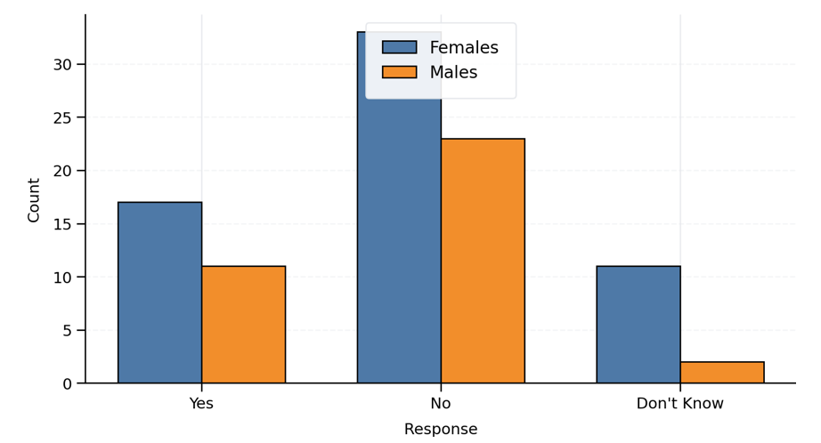
Figure 32 – Gender Influence on Stigma / Help-Seeking
Males show slighter higher agreement that stigma influences help-seeking (30.6% vs 27.9%). Although the difference is slight, it does suggest that males may perceive stigma marginally more often as a barrier than females. There is limited literature regarding supervisors specifically, however studies emphasise that stigma around mental health is pervasive in policing culture, ‘influenced by factors such as hegemonic masculinity and organisational culture, which are often more pronounced in male-dominated and hierarchical environments’ (Buhrig, 2023).
Male responses appear to be more decisive, whereas female respondents demonstrate greater uncertainty, which may reflect greater nuanced complexities. Overall, however, both genders do not believe that the gender of their supervisor influences help-seeking.

4.5.3 Action taken when Seeking Help
Respondents were asked to outline what action they would take if experiencing poor mental health. The most common action for both genders was ‘seek help’, see Figure 33:

Mental Health Actions by Gender
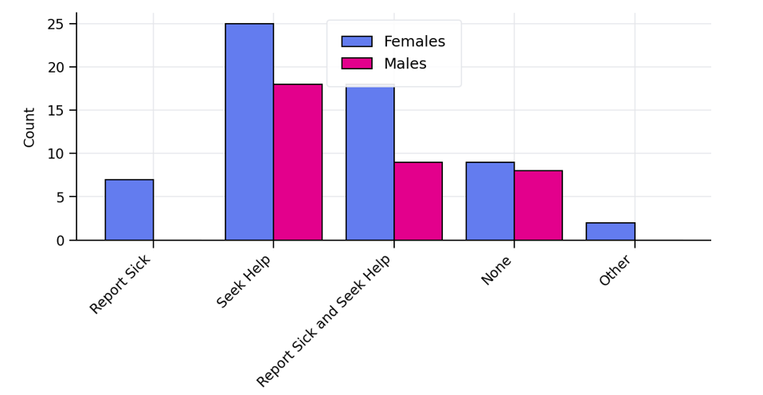
Figure 33 – Action Taken when Seeking Help

Overall females were more likely than their male counterparts to take supportive or proactive action to address poor mental health. Female respondents recorded higher counts across all categories. Notably, only females reported solely taking sickness absence, (females 7 / males 0). Taking combined action (reporting sick and seeking help) was common amongst both genders, although females did so more frequently. Responses indicating ‘no action’ were slightly greater among male respondents though the difference was minimal. In summary, females consistently and frequently demonstrated greater engagement with support-seeking behaviours, including higher levels of seeking help, combined actions and all responses recorded under ‘other’. These findings again reinforce the need for greater targeted communication towards males as they are less likely to report sickness or undertake combined actions. However, their relatively high tendency to seek help along indicates a preference for less formal routes of support.
4.5.4 Reporting Physical Health v. Reporting Mental Health
The questionnaire explored the discord between perceived organisational norms and actual reporting behaviours. It is widely recognised that organisational trust is crucial. Trust is conceptualised as a ‘relational, risk-informed construct that is both an individual and collective phenomenon’ (Mayer, et al., 1995) and is ‘critical to aligning stakeholder expectations and ensuring safety in complex environments’, (Dietz & Den Hartog, 2006).
Respondents were asked if they would be more likely to report a physical condition than a mental health condition. The results indicated that there was a strong overall tendency to report physical conditions. This pattern was evident across both genders. A total of 61 Females and 36 Males selected either ‘yes’ or ‘maybe’. Overall, 72% of females and 86% of males indicated a preference for reporting physical conditions over mental health conditions. Twenty-seven respondents (16 females and 11 males) expressed a willingness to engage in further research through interviews or focus groups, indicating a workforce that is eager for engagement.
Gender-based differences were evident in response patterns. Males indicated a higher reluctance to respond ‘no’, with only 12% selecting this option compared to 23% of females. This suggests that males are less likely to explicitly state that they would not favour reporting physical conditions. In contrast, females, displayed higher levels of uncertainty, reflected in a greater proportion of ‘maybe’ responses.
The most distinguished gender difference appeared in the ‘no’ category, where females selected ‘no’ nearly three times more often than their male counterparts. This may suggest females are more open to the possibility of reporting mental health conditions. Overall, female responses were more evenly distributed across categories, whereas male responses centred pre-dominantly around ‘yes’. However, both genders overwhelmingly favoured
reporting physical health conditions over mental health conditions, this potentially indicates that there is a stigma associated with mental health reporting, particularly among male respondents. see Figure 34:
Reporting Preference by Gender
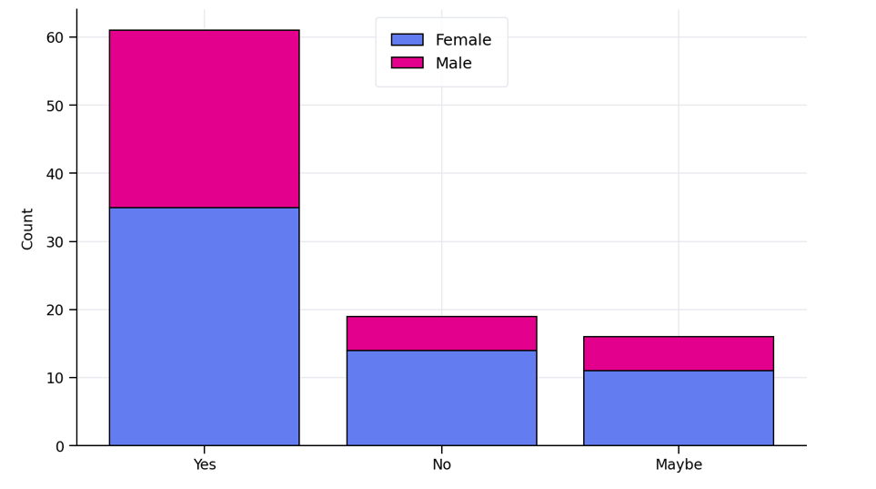Figure 34 – Reporting Preference by Gender
We supplemented this question, with a follow-up question asking respondents to explain why they would be more likely to report physical illness rather than a mental illness. Sixty-five free-text responses were analysed and grouped into common themes using a keyword-based approach, See Figure 35 & Figure 36:
Theme | Count
Visibility / easier to explain physical | 23
Stigma | 14
Supervisor/management & culture | 14
Support networks & therapy | 12
Self-management / coping / carry on | 8
Career / opportunity concerns | 7
Fear of being judged | 7
Workload / busyness / stress levels | 7
Believability / validity concerns | 6
Impact on role / safety / performance | 6
Diagnosis / recognition / threshold | 5
Gendered factors (men/menopause) | 3

Figure 35 –Reporting Preference Analysis (1)
Themed Analysis of Reasons: Mental vs. Physical Reporting
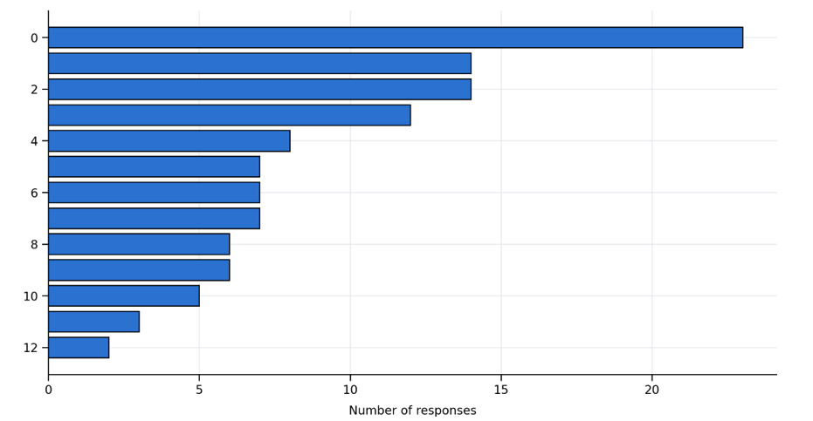
Figure 36 –Reporting Preference Analysis (2)
The most frequently reported themes were visibility and the relative ease of explaining physical illness (23 responses), stigma (14, support networks and therapy (12) and self-management or ‘carrying on’ (8). It should be noted that each response could map to multiple themes, see Figure 37:
Some respondents highlighted that there was very little support and a lack of confidentiality, this was supported in the literature review by Demirkol and Nalla (2019) who raised concerns regarding confidentiality.
Respondents highlighted a stigma around disclosure alongside fears that in doing so might negatively affect perceptions of their ability to perform their role. Interestingly, male respondents appeared to take longer to request help.
There's still a strong stigma around mental health, and I felt that keenly. Mine deteriorated significantly, but because I was on the promotion pathway and in a position of influence, I convinced myself it was better to bury it'
I thought showing any vulnerability might undermine trust or credibility'
Physical conditions are clear and obvious with proven medical solutions. Mental Health is a problem which one feels that you can sort out yourself'
It is easier to show people a physical condition'
More likely to be taken seriously'
Fear of being judged'

Figure 37 – Freetext Reporting Preference

4.5.5 Suffering in Silence

Respondents were asked whether they had ever remained silent, when suffering with poor mental health, see Figure 38 and 39:

Have you ever remained silent, when suffering with poor mental health?
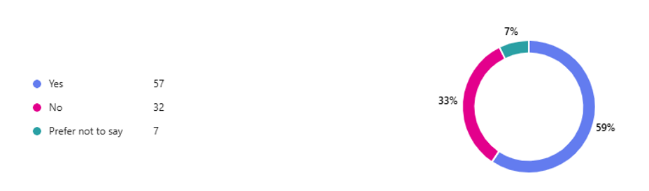
Figure 38 – Suffering in Silence

Responses by Gender
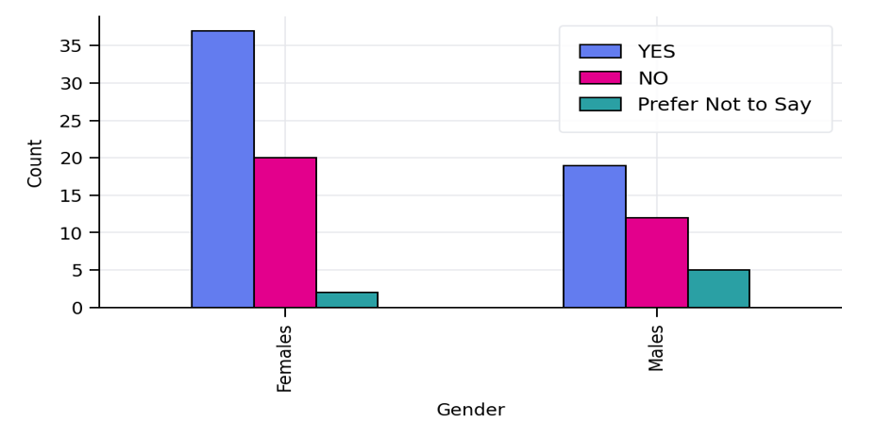
Figure 39 – Suffering in Silence – Responses by Gender
The findings show that women report remaining silent almost twice as often as men. Female respondents chose ‘yes’ to remaining silent on 37 occasions, compared to 19 occasions for men. This may suggest gender differences in the willingness or ability to disclose mental-health struggles. The findings also show that men are more likely to choose ‘prefer not to say’. Men are 2.5 times more likely to avoid answering the question. This may indicate a higher discomfort discussing mental health, stronger stigma or a reluctance to disclose even anonymously. Silence emerged as the most common response for both genders, with nearly 60% of participants reporting that they stayed silent at some point. This suggests that silence around mental health issues is a major cultural or organizational challenge.
Females displayed a wider spread of responses and appeared more comfortable choosing clear “Yes” or “No” answers. This pattern commonly appears when a group experiences greater stigma or fear of judgement. Males have a higher “silence-to-speaking” ratio. Although, women report silence more frequently.

4.5.6 Suffering in Silence – Why?
Respondents were asked to share their reasons for remaining silence. There were several key themes identified, see Figure 40:

Key Themes from Responses
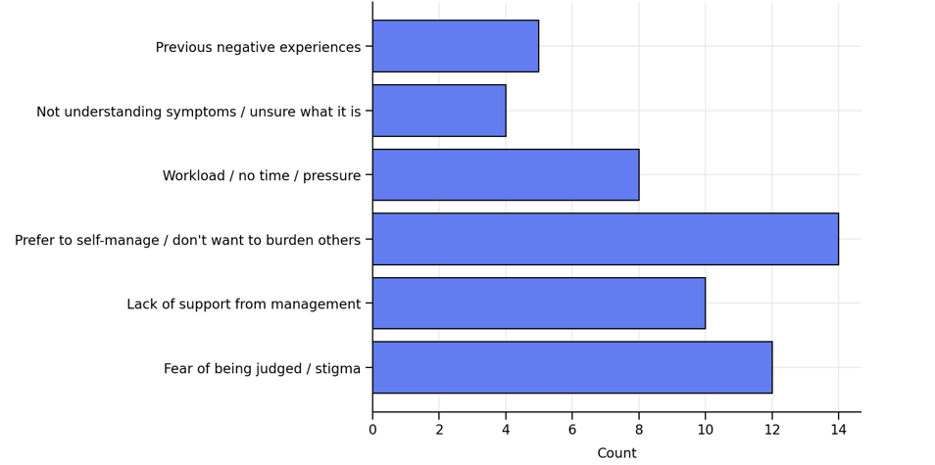
Figure 40 – Suffering in Silence – Key Themes
The dominant barrier to disclosure is fear of judgement. Respondents reported concerns about being perceived as weak, not being believed or having their professional credibility questioned if they admit they are struggling. This aligns with existing literature, which identifies fear of negative labelling, such as being perceived as ‘dramatic’ or ‘unstable’, as a significant deterrent to disclosure (Akademika, 2025).
A further key theme is a lack of confidence in managerial support. Many respondents reported feeling unsupported by their supervisors, citing poor listening skills, limited empathy, or a lack of availability. Some participants referenced previous experiences where support had been denied, contributing to a sense of mistrust. Research highlights the importance of organisational support, demonstrating that where employees perceive their organisation to provide accessible resources, social support, and a low-stigma environment, they are more likely to disclose mental health concerns (Lyubykh et al., 2025).
A notable proportion of respondents reported a tendency to self-manage their wellbeing, to avoid burdening others. A recurring belief was that individuals should cope independently, leading many to mask symptoms or attempt to resolve issues alone. This finding is well supported within the literature, which highlights the complex and often isolating experiences of individuals managing mental health difficulties without formal support (Landquist et al., 2025).
Workload and operational pressures were also significant. High demand and low staffing levels discouraged staff from reporting concerns, as they feared ‘letting the team down’. Several respondents indicated that reporting workload pressures felt ineffective, due to a perceived lack of viable solutions. This is consistent with research demonstrating that excessive workload and resource constraints contribute to occupational stress and reduce reporting behaviours (Gilbert et al., 2024).
More personally, staff felt that there was just a general lack of understanding of mental health symptoms. Some staff reported difficulty recognising their own symptoms or articulating their experiences, suggesting a gap in mental health literacy. This reflects wider research indicating that limited understanding of mental health can impede early identification, help-seeking, and effective self-management (Buta et al., 2024).
Previous negative experiences or dismissive responses further reduced willingness to seek help. Some simply had privacy concerns, stating a preference to keep their personal lives separate from work. Overall, the data indicates a culture in which staff continue to struggle in silence. Stigma, lack of managerial consistency and workload pressure contribute to delayed disclosure, increasing the risk of burnout, presenteeism and late crisis-point disclosures. Organisations would benefit from strengthening and standardising manager training to enhance confidence, understanding, and capability in supporting staff mental health.
There is increasing evidence within the literature highlighting the need for tailored, context-specific training programmes, rather than generic approaches, to enable managers to provide more effective and meaningful support (Milner et al., 2018).

4.5.7 Mental Health Disclosures
Respondents were asked, that if they were to report concerns regarding their mental health then who would they look to approach first, see Figure 41:

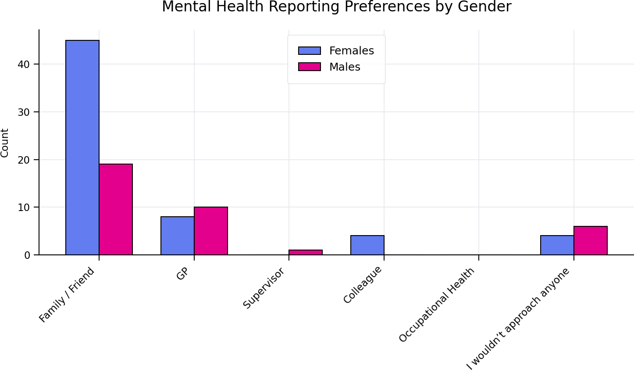
Figure 41 – Mental Health Reporting Preferences by Gender
The results captured how respondents would choose to report concerns about their mental health, with set categories outlined. The most preferred option was speaking with family or friends. This option was overwhelmingly the choice of both genders. Females are more than twice as likely as males to choose this route. This shows that help-seeking is heavily informal. This is supported by literature, with evidence suggesting that informal help-seeking is more commonly accessed and perceived as more helpful (Edwards & Crisp, 2017 ).
The results show that the option of consulting with the GP is higher among males. While females report visiting the GP more overall, males are proportionally more likely to visit their GP than females. This may suggest that males take greater comfort speaking with medical professionals and have less reliance on personal networks.

Approaching supervisors as first contact is rare amongst both genders. This may indicate a lack of trust, concerns around stigma or fear of career impact. Leadership visibility in mental-health culture may need improvement. Interestingly, females are more likely to approach a colleague, which may reflect a greater peer support network or more open communication patterns amongst colleagues. Interestingly, evidence suggests that peer support does show some benefit in recovery related outcomes however it is recognised that further high-quality research is needed to clarify the effectiveness of peer support, (LLoyd-Evans, et al., 2014).
Surprisingly, no one selected occupational health, despite occupational health being a formal support route. This suggests lack of awareness, perception of limited confidentiality or lack of trust or visibility. This is not surprising and correlates with literature which recognises that staff refrain from seeking help through formal processes for several reasons ‘including personal, social and institutional factors’ (Nir, 2009). Worryingly, males are 50% more likely to not approach anyone at all. This aligns with commonly observed patterns of lower help-seeking among males. Male staff appear more hesitant to seek help, shown by the higher GP preference and the “I wouldn’t approach anyone” responses.

4.5.8 Barriers to Seeking Support?
Respondents were asked to identify the barriers to seeking support, see Figure 42:

What are the Barriers to Seeking Support?
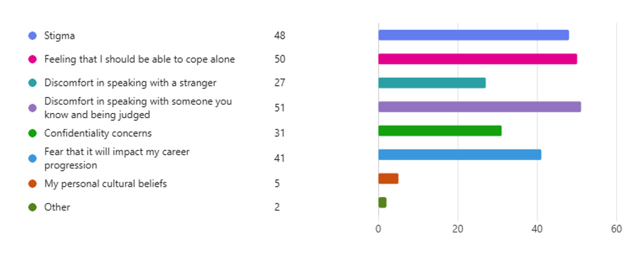
Figure 42 – Barriers to Seeking Support
The chart below visualises the barriers to seeking support by gender, Figure 43:

Barriers to Seeking Support by Gender
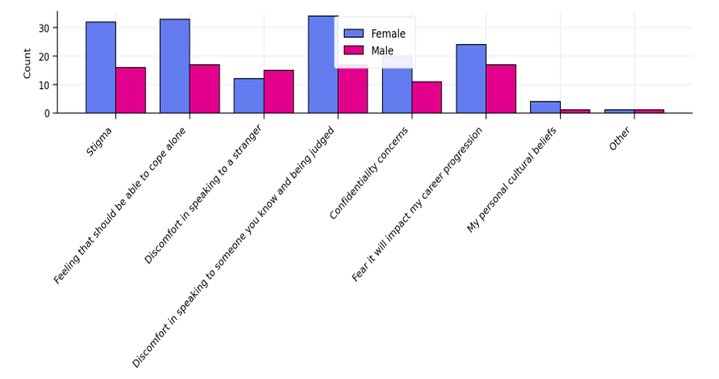
Figure 43 – Barriers to Seeking Support by Gender

Eight key barriers are listed and compares how often female and male respondents selected each option. Overall, women report higher barriers across almost all categories. For every barrier except one (“Discomfort speaking to a stranger”), female respondents selected the barrier more frequently than male respondents. This suggests, that women perceive greater obstacles in seeking support. Men’s barrier profile is flatter, with fewer high peaks. Fear of judgement and self-expectation to cope alone are major factors for women. Men’s barriers cluster more evenly, but expectation to cope alone is the most significant.Women consistently report higher fear of judgement, stigma, and internal expectations to cope. Interestingly, emotional and social factors dominate for both groups, fear of judgment, expectation to cope alone and stigma. These outrank practical or structural concerns. Men report more comfort speaking to strangers than women. This is the only barrier where males score higher.
Staff were asked a series of questions to ascertain feelings around several key areas, see Figure 44:

How would you rate the following Statements?
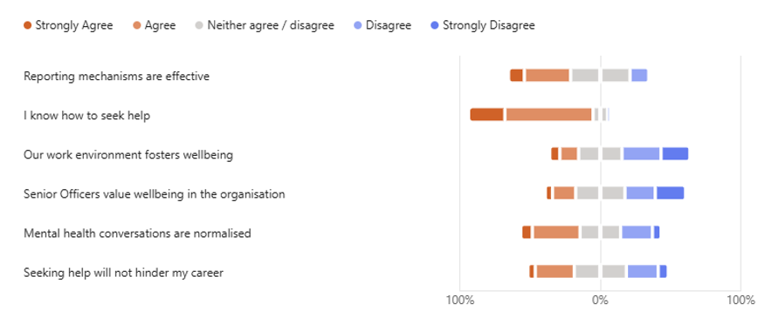

Figure 44 Statement Ratings
This was further broken down by gender, figure 45:

% Positive (Strongly Agree + Agree) by Gender and Question
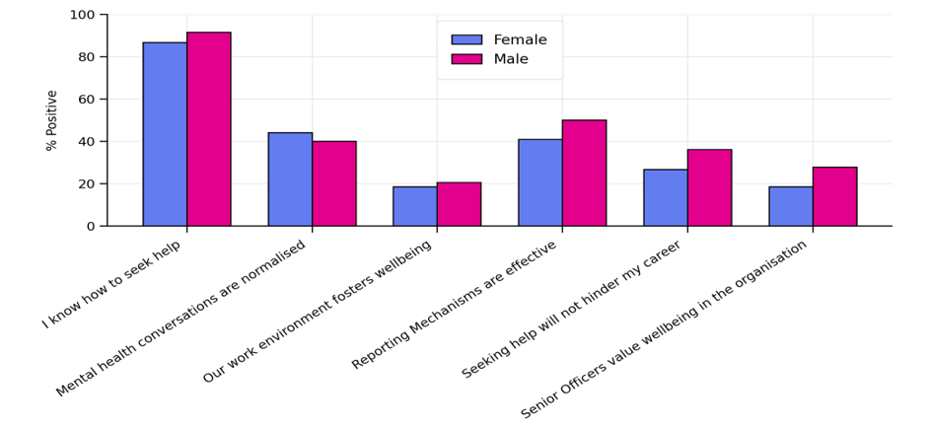
Figure 45 – Statement Ratings by Gender

Male respondents show higher sentiment index than females. Help-seeking awareness shows a high positivity score for both genders. Of note wellbeing, environment and senior officer support are key concern areas. Neutral responses are consistently higher for females on the lowest-scoring items (reporting mechanisms, career safety), hinting at uncertainty or low psychological safety rather than outright rejection. Leadership is the largest drag on sentiment, especially for females.
Respondents were asked to identify the main barriers to reporting poor mental health:

- Stigma, Judgment & Perception of Weakness
Seeking support is often viewed negatively. Staff fear being judged, labelled, or seen as weak. Many believe that the position they carry, holds an expectation that they should be resilient, which discourages openness.
2. Lack of Time & High Workload
High demand, performance pressure, and limited breaks mean staff struggle to find time to seek help. Busy environments normalise stress and reduce opportunities for support.
3. Confidentiality & Trust Concerns
Some respondents raised concerns about who could see their personal information and whether disclosures might lead to redeployment, monitoring, or negative career impact. This erodes trust in help‑seeking.
4. Inconsistent Management Support
Respondents indicated that managerial support varies widely. Some leaders are empathetic and informed, while others lack time, training, or awareness. Some respondents feel this actively discourages them from seeking help.
5. Long Waiting Times & Limited Capacity
Respondents indicated that delays in Occupational Health, TRIM referrals, and counselling availability are common. Limited counsellor capacity means support isn't always available when needed most.
6. Awareness & Clarity of Processes
Some respondents indicated that they are unsure what help is available, how to access it, or what happens after they seek support. Lack of clear pathways creates confusion and hesitation.
7. Organisational Culture
Some respondents feel undervalued. Gossip culture, lack of meaningful wellbeing action, and inconsistent leadership messaging appear to contribute to scepticism.
8. Personal Barriers
Some individuals struggle with simply starting the conversation around their mental health concerns, with underlying thoughts that they should be able to cope independently.
The most significant barriers are stigma, workload pressure, and delays in support access. While support exists, cultural and structural barriers reduce confidence in using it.

4.5.9 Wellbeing Feedback
Respondents were asked if they had any suggestions as to how wellbeing service could be improved, see Figure 46:

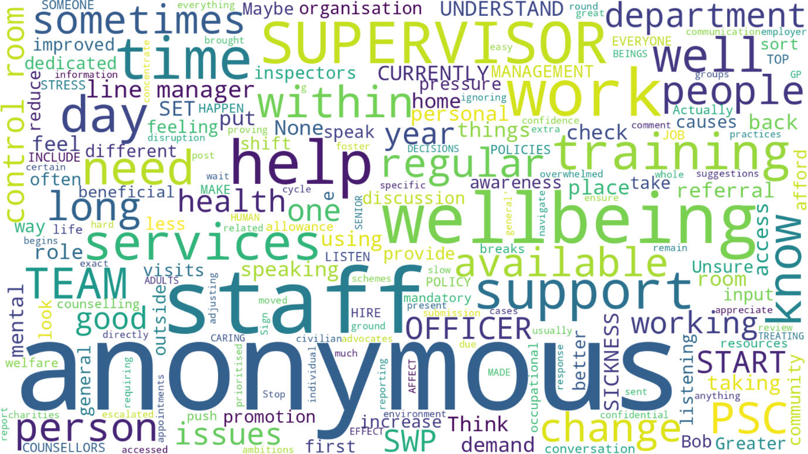

Figure 46 – Wellbeing Feedback

The responses highlight consistent themes around wellbeing, support, and workplace culture, with several key points identified:

- Access to Wellbeing Services
Respondents feel that wellbeing services are hard to access with long waiting times for referrals and counselling. This impacts decision making around reporting. Staff report a desire for more counsellors and more diverse wellbeing options, such as regular check-ins, annual wellbeing conversations, and trauma support sessions.

- Need for Better Visibility and Communication
Respondents frequently mentioned that information around wellbeing services is difficult to obtain and poorly advertised. Staff that they would benefit from greater promotion of options available. Suggestions included, clear accessible list of available services, more regular communication and reminders, more wellbeing visits in the department, drop-in sessions, training day inputs and being more physically present.

- Management Culture and Support
A significant number of respondents reported concerns regarding management behaviours and organisational issues. Respondents indicated a desire for listening, empathy and consistency from supervisors, with a request that staff rotating too often disrupts stability. Staff raised a concern that supervisors were often ‘too busy’ to support staff with competing demands and that often wellbeing isn’t genuinely prioritised. Many respondents indicated a desire to receive ‘proper’ training for difficult conversations and wellbeing related responsibilities.

- PSC Working Conditions and Environment
Several respondents cited that organisational pressures impacted their ability to take wellbeing breaks, and that they held feelings of guilt if they did due to high workloads.

- Desire for Human Connection
Interestingly, several respondents indicated a desire, to have leaders sit with staff, talk with them and just generally be approachable, emphasising the importance of being seen, heard and valued.

- Training, Education and Prevention
Respondents indicated a desire for regular training around mental health and wellbeing. Normalising conversations would make help-seeking more attractive and ensuring that professional help was available when needed would reinforce the organisations commitment.

4.6 Conclusion – Integrative Analysis and Empirical Findings
In examining the culture and structural frameworks shaping mental health reporting within SWP and reviewing primary and secondary data with theoretical frameworks, several patterns emerge. The research indicates that while respondents are generally aware of mental health policies and services available, many lack confidence in how effective or accessible that support is. Gaps in communication, inconsistent training and limited leadership, contribute to uncertainty, stigma and overall reluctance to report across both genders.

Gender differences are evident, female respondents show higher engagement with support services but greater uncertainty and a fear of being judged, while males are more likely to stay silent avoid formal reporting and rely on medical professionals or no one at all. Overwhelmingly, both genders prefer informal help-seeking, notably from family or friends and very few would approach supervisors or the Occupational Health Department, highlighting trust and cultural barriers. Silence is a major theme, with nearly 60% of staff having stayed silent having experienced poor mental health. Many struggle to understand and recognise symptoms reinforcing the need for greater education, clearer pathways and more proactive support.

Respondents consistently requested improved communication, stronger and consistent training, and increased and accessible support services. Targeted approaches for male and female respondents, clearer reporting methods and enhanced leadership support are key areas for improving mental health outcomes.
The next chapter will present findings and recommendations in detail based on the analysis provided in this paper.

Chapter Five Conclusion and Recommendations

5.1 Conclusions Against Research Objectives

5.1.1 Objective One: Mental Health Stigma, Gender Influences, and Help-Seeking Behaviours
The results indicate that organisational culture significantly outlines employee’s confidence and readiness to report mental health concerns. A significant proportion of staff, believed that underreporting occurs, indicating weariness to report and therefore selective reporting practices. These findings align with literature which indicated that peer loyalty and operational norms strongly influence reporting behaviours.
Gender arose as a key determinant. Male respondents were more likely to deny the impact of their role on their mental health, and therefore more likely to avoid reporting, aligning with literature suggesting higher stigma among men (Bailey 2021). Female respondents in comparison exhibited greater uncertainty and higher engagement with support-seeking behaviours.
Overwhelmingly, both genders favoured informal help-seeking, particularly speaking with family or friends. Silence remained prevalent, with nearly 60% of respondents reporting that they had remained silent at some point throughout their service. This highlights a deep-rooted organisational and cultural challenge within policing.
These findings reinforce Aveyard’s (2010) assertion that understanding the complexities of reporting behaviour is essential for fostering accountability.

5.1.2 Objective Two: Experiences and Perceptions of Mental Health Support
The study identified institutional barriers that impact reporting, including fear of stigma, inconsistent training, lack of awareness of support pathways, and perceived ineffectiveness of reporting systems. Staff highlighted insufficient training and a lack of understanding of mental health symptoms, with some employees struggling to recognise or articulate their experiences.
A clear gap exists between awareness of support and confidence in its effectiveness. Notably, no respondents selected Occupational Health as a first point of contact, suggesting significant trust and visibility issues. These findings support the need for improved communication, leadership accountability, and more accessible support mechanisms.

5.1.3 Objective Three: Leadership Influence on Help-Seeking Attitudes
Leadership surfaced as a crucial factor in shaping reporting behaviours. While 73% of respondents expressed confidence in reporting channels, many reported fear and uncertainty regarding outcomes. This indicates a disconnect between procedural confidence and emotional safety.
Institutional trust was identified as critical for improving reporting confidence. The findings support Walsh & Vito’s (2018) argument that strong leadership fosters environments where employees feel empowered to report concerns. However, despite confidence in supervisors, very few employees indicated they would approach their supervisor directly, suggesting a lack of psychological safety and concerns about career impact.

5.1.4 Objective Four: Evidence-Based Improvements to Mental Health Support
Staff with lived experiences, who experienced negative outcomes, reported reluctance to engage in future reporting.
Three key areas for consideration were identified:
- Cross-sectional limitations - attitudes may change over a period, longitudinal research is needed.
- Cultural barriers - silence, stigma, and mistrust remain embedded.
- Training inconsistencies - significant differences in delivery and access reduces confidence.
These findings accentuate the need for systematic interventions that address both structural and cultural barriers.

5.2 Gender-Based Observations
The analysis identified significant gendered differences in perceptions, behaviours, and experiences relating to mental health reporting. Highlighting the requirement for customised organisational strategies that identify how gender shapes help-seeking patterns, stigma and confidence in reporting.

5.2.1 Gender Differences in Reporting Confidence and Perceived Impact
Male respondents were more than twice as likely as females to respond “No” when asked whether they would report mental health concerns, implying a greater reluctance to recognise or disclose difficulties. Females were considerably more likely to respond “Maybe”, indicating greater uncertainty and more nuanced experiences.
Both genders recognised that policing does impact mental health, however the impact was interpreted differently. Females displayed greater openness to recognising mental health challenges, whereas males showed a stronger tendency toward self-reliance and emotional suppression.

5.2.2 Gendered Patterns in Help-Seeking Behaviour
Help-seeking behaviours differed between genders. Female respondents were more than twice as likely as males to seek support from family or friends. In contrast, males were proportionally more likely to consult a professional, GP. Indicating a preference for confidential and professionalised support. Worryingly, males were also 50% more likely not to approach anyone, reinforcing patterns of silence and self-support.
These findings highlight that while females engage more frequently in help-seeking, males may require targeted interventions to reduce barriers associated with stigma and expectations to cope alone.

5.2.3 Gendered Barriers to Reporting
Both genders recognised emotional and social barriers, fear of judgement, stigma, and expectations to cope alone, as the most significant barriers. Female respondents continually and persistently reported higher levels of fear of judgement and internalised expectations to cope. Males reported greater solace in speaking to strangers, indicating a preference for anonymity and emotional distance.

5.2.4 Gender Differences in Engagement with Support Services
Analysis showed that 38% of female respondents accessed support, compared with 25% of males. No respondents selected Occupational Health, suggesting systematic issues with trust or visibility. Females exhibited greater levels of engagement with combined actions, whereas males showed lower overall engagement.

5.2.5 Gendered Organisational Challenges
Female respondents’ higher levels of uncertainty indicate that organisational culture, leadership visibility, and recognised support pathways may not be meeting their needs. Male underreporting appears linked to cultural norms around masculinity, emotional restraint, and fear of stigma. These patterns spotlight the need for gender-specific interventions to address distinct psychological and cultural pressures.

5.3 Recommendations
The following recommendations are designated to address the structural, cultural, and psychological barriers recognised in this study. They aim to strengthen reporting mechanisms, enhance psychological safety, and foster a more supportive and accountable organisational culture.

5.3.1 Implement Comprehensive Training Programmes (Short Term)
Training should be remodelled to ensure uniformity, relevance and accessibility. Key areas of focus should include:
- Strengthened Mental Health Awareness: improving understanding of symptoms, early warning signs, and the impact of policing on wellbeing.
- Ensure clear guidance on reporting processes: simplifying procedures and expectations to reduce uncertainty.

Gender Specific Considerations:
Males:
- Within training include stigma content: addressing cultural norms that discourage help-seeking and attempt to normalise help-seeking and challenge self-reliance.

Females:
- Ensure staff are aware of the importance of confidentiality and address the worry of ‘being judged’.
- Improve trauma informed work
- Provide additional resilience training, with practical tools to manage stress.
This recommendation directly addresses the widespread concerns about inconsistent training and limited understanding of mental health highlighted in the findings.

5.3.2 Foster a Supportive Organisational Culture (Long Term)
Cultural change requires visible, sustained leadership commitment. It is important that there is accountability at all levels. At a leadership level it is important to re-invigorate conversations around mental health, ensuring the conversations remain meaningful. It is also important that there is peer-led engagement, aiming to reduce stigma. Strengthening communication around confidentiality and career safety is important. Visibility will seek to achieve this, building trust and confidence.
This recommendation responds to the finding that employees trust supervisors in principle but do not feel safe approaching them in practice.

5.3.3 Strengthening Reporting Mechanisms and Communication
To increase confidence in reporting consideration should be given to the following:
- Map the reporting journey end-to-end.
- Improve transparency and encourage feedback, ensuring employees understand the stages of reporting.
- Communicate confidentiality safeguards clearly and repeatedly.
- Publish simple explanations of referral processes to close the “uncertainty gap”.
- Highlight positive reporting outcomes to counteract fear-based narratives.
These actions address the widespread perception that reporting systems are ineffective or unclear.

5.3.4 Enhance Supervisor Capability and Accountability
Supervisors play a pivotal role in creating psychological safety. Consideration should be given to:
- Providing refresher training on trauma, active listening, confidentiality, and signposting.
- Offer practical tools for daily wellbeing support.
- Share examples of supportive supervision to model best practice.
- Ensure supervisors receive ongoing development in mental health and wellbeing.
This recommendation responds to the finding that supervisors are rarely approached despite high confidence ratings.

5.3.5 Address Gender-Specific Barriers and Needs
Given the clear gender differences identified, consideration must be given to tailored support:
For Women:
- Emphasise emotional safety, confidentiality, and non-judgement.
- Provide trauma-informed support and resilience training.
- Offer female-only listening groups to explore experiences.
For Men:
- Normalise help-seeking and challenge self-reliance norms.
- Promote confidential 1:1 support option.
- Increase targeted communication to address underreporting.
- Highlight male role models who model help-seeking behaviour.
These actions address the gendered patterns of silence, stigma, and help-seeking identified in the findings.

5.3.6 Improve Occupational Health Visibility and Accessibility
Given that neither gender selected Occupational Health as a first point of contact, consideration should be given to:
- Increase visibility of Occupational Health Services available.
- Improve access routes to mental health professionals.
- Provide pro-active outreach rather than reactive support.
- Address concerns about confidentiality and independence.
This recommendation responds to the perception that Occupational Health is ineffective or untrustworthy.

5.3.7 Strengthen Communication and Awareness Campaigns
It is recommended that communication should be strategic, targeted, and ongoing, through:
- Specific and tailored messaging to specific audiences.
- Normalise help-seeking through positive narratives and live studies.
- Promote wellbeing strategies and available resources more effectively.
- Review communication channels to ensure the Wellbeing Strategy is accessible and understood.
- Increase peer-normalisation messaging to reduce stigma.
This recommendation addresses the gap between awareness of support and confidence in its effectiveness.

5.4 Conclusion
The findings of this study identify a steadfast and rooted “silent divide” within emergency services, where gendered stigma and organisational culture cross to define help-seeking behaviours.
The analysis identified that ‘silence’ is a defining feature of employee experience, with almost 60% of respondents reporting that at some point throughout their service they had withheld their concerns. It is arguable that this silence was not solely individual hesitation but a result of structural and cultural norms in existence, such as loyalty to colleagues, fear of judgement and mistrust in the process. The impact of which suppresses conversations around mental health. The analysis reinforces the wider literature on policing culture and highlights the need for systemic change to dismantle barriers that inhibit transparency and psychological safety.
The analysis identified that gender plays a key role in defining how employees navigate mental health challenges. Male respondents displayed a greater degree of denial, self-reliance, and reluctance to report, reflecting embedded masculine norms that corelate vulnerability with weakness. Female respondents, while more open to recognising mental health impacts, reported greater fear of judgement and uncertainty, suggesting that organisational structures still fail to meet their needs for emotional safety and confidentiality.
These gendered differences emphasise the intricacy of stigma within emergency services and demonstrate how cultural expectations define not only whether individuals seek help, but how they seek it, from whom, and at what personal cost.
The study demonstrates that improving mental health reporting within the police service does require procedural refinement but in addition and more importantly requires cultural transformation.
The study demonstrated the importance of having confidence in supervisory support, recognised and consistent training, clear leadership and gender-responsive interventions to bridge the silent divide.
While the recommendations developed for SWP reflect its operational context, the methodological rigour of this research positions its conclusions for wider relevance across UK policing and emergency services. Tackling gendered stigma is not solely a matter of wellbeing; it is a matter of organisational integrity, ethical responsibility, and employee trust.
By addressing the cultural and structural barriers that maintain silence, emergency services can migrate toward a more accountable, supportive, and psychological safe environment for all employees.

Bibliography
Adeoye-Olatunde, O. A. & Olenik, N. L., (2021) 'Research and Scholarly Methods: Semi-Structured Interviews' Journal of the American College of Clinical Pharmacy , 4(10), pp. 1358-1367. https://doi.org/10.1002/jac5.1441.
Adu, P. & Miles, A. D., (2023) Dissertation Research Methods: A Step-by-Step Guide to Writing Up Your Research in the Social Sciences. 1st ed. London: Routledge.
Ahmed, S. K., Mohammed, R. A., Nashwan, A. J., Ibrahaim, R. h., Abdalla, A. Q., M.Ameen, B.M, & Khdir, R. M. (2025) Using Thematic Anaylsis in Qualitative Research. JourNal of Medicine, Surgery, and Public Health, Volume 6, Article 1000198. https://doi.org/10.1016/j.glmedi.2025.100198.
Al Halbusi, Hussam; Williams, Kent A; Mansoor, Hamdan, O; Hassan, Mohammed Salah; Hamid, Fatima Amir Hammad (2020) 'Examining the Impact of Ethical Leadership and Organizational Justice on Employees' Ethical Behavior: Does Person-Organization Fit Play a Role?' Ethics and Behavior, 30 (7), pp. 514-532. https://doi.org/10.1108/PR-09-2019-0522.
Al Halbusi, Hussam; Williams, Kent A; Ramayah, Thurasamy; Aldieri, Luigi; Vinci, Concentto Paolo., (2021) 'Linking Ethical Leadership,and Ethical Climate to Employees' Ethical Behavior: The Moderating Role of Person-Organization Fit' Personnel Review, 50(1), p. 159. https://doi.org/10.1108/PR-09-2019-0522.
Alhaidani, H., Halbusi, H. A., Alharbi, K. K. & Alshaer, W., (2024). Navigating Organizational Justice and Ethical Leadership: Empirical Evidence from Saudi Arabia. Sage Open, 14(2). https://doi.org/10.1177/21582440241257378.
Audemard, J., (2020). 'Objectifying Contextual Effects. The Use of Snowball Sampling in Political Sociology' Bulletin of Sociological Methodology, 145(1), pp. 30-60. https://doi.org/10.1177/0759106319888703.
Aveyard, H., (2010). Doing a Literature Review in Health and Social Care: A Practical Guide. 2nd edn. Berkshire: Open University Press.
Ayat, M. & Nusratullah, N. R., (2025). 'Post-Positivism as a Research Approach in Public Law. Public Law' 26(5), p. 30. https://doi.org/10.22054/qjpl.2023.70022.2821.
Bailey, M. B., (2021). The Influential Role of Culture in the Perceptions of Mental Health in Police Officers, Californian Lutheran University.
Barroga, E., Matanguihan, G. j., Furuta, A., Arima, M., Tsuchiya, S., Kawahara, C., Takamiya, Y., & Izumi, M. (2023). 'Conducting and Writing Quantitative and Qualitative Research'. Journal of Korean Medical Science , 38(37), p. 291. https://doi.org/10.3346/jkms.2023.38.e291.
Baum, F., MacDougall, C. & Smith, D., (2006). 'Participatory Action Research'. Journal of Epidemiology and Community Health (1979), 60(10), 854-857. https://doi.org/10.1136/jech.2004.028662.
Bell, S. & Eski, Y., (2016). 'Break a Leg - It's All in the Mind Police Officers' Attitudes Towards Colleagues with Mental Health Issues'. Policing: A Journal of Policy and Practice, 10(2), 95-101. https://doi.org/10.1093/police/pav041.
Bendassolli, P. F., (2013). Theory Building in Qualitative Research: Reconsidering the Problem of Induction. Qualitative Social Research, 14(1).
Biggam, J., (2017). Succeeding with your Master's Dissertation; A step-by step handbook. 4th ed. London: Open University Press.
Bjorkelo, B., (2013). 'Workplace bullying after whistleblowing: future research and implications'. Journal of Managerial Psychology, 28(3), pp. 306-323. https://doi.org/10.1108/02683941311321178.
Bolaji, O., Yusuf, A. & Adeyinka, T., (2025). Traditional Surveys Versus Digital Surveys: Perspectives of Library and Information Science Researchers on Best Method for Data Collection in Research. Folia Toruniensia, Volume 25, 13-37. https://doi.org/10.12775/FT.2025.001
Bond, R., (2005). Group Size and Conformity. Group Processes and Intergroup Relations , 8(4), p. 331-354. https://doi.org/10.1177/1368430205056464.
Bradbury, A., (2020). Mental Helath Stigma: The Impact of Age and Gender on Attitudes. Community Mental Health Journal 56(5), 933-938. https://doi.org/10.1007/s10597-020-00559-x.
Bradbury, H., (2015). The Sage handbook of action research. 3rd edn. Thousand Oaks: Sage Publications.
Braun, V. & Clarke, V., (2006). 'Using thematic analysis in psychology'. Qualitative research in psychology, 3(2), pp. 77-101. https://doi.org/10.1191/1478088706qp063oa.
Brew, A. & Mantai, L., (2017). Academics Perceptions of the Challenges and Barriers to Implementing Research-based Experiences for Undergraduates. Teaching in Higher Education, 22(5), pp. 551-568. https://doi.org/10.1080/13562517.2016.1273216.
Brutus, S. & Aguinis, H. &. Wassmer, U (2013) Self-Reported Limitations and Future Directions in Scholarly Reports: Analysis and Recommendations. Journal of Management , 39(1), pp. 48-75. https://doi.org/10.1177/0149206312455245
Buhrig, R., (2023). The Intersection of Masculinity and Mental Health in Police Organizational Culture. Journal of Police and Criminal Psychology, 38(3), p. 743-753. https://doi.org/10.1007/s11896-023-09603-4.
Bujang, M. A., Omar, E. D., Foo, D. H. P. & Hon, Y. K., (2024). Sample Size Determination for Conducting a Pilot Study to Assess Reliablity of a Questionnaire.; Restorative Dentistry and Endodontrics, 49(1), pp. 1-8. https://doi.org/10.5395/rde.2024.49.e3.
Buta, B. O., Mota, A. C. P., Couto, V. V. D., & Tabak, B. M., (2024). Mental Health Literacy for Public Employees. BMC Public Health, 24(1), Article 2593. https://doi.org/10.1186/s12889-024-19937-1.
Camara-Costa, H., Chevignard, M., Azouvi, P. & Dellatolas, G., (2026). What do the Main Reported Findings from the 20-item Dysexecutive Questionnaire (DEX) Tell Us? The Valence-bias Hypothesis. Neuropsychological Rehabilitation , Volume 2, pp. 1-33. https://doi.org/10.1080/09602011.2026.2621832.
Campbell, A., Taylor, J. B. & McGlade, A., (2019). Research Design in Social Work: Qualitative, Quantitative & Mixed Methods. London: Sage Academic Books.
Campbell, K., Orr, E., Durepos, P., Nguyen, L., Li, L., Whitmore, C., Gehrke, P., Graham, L., & Jack, S. (2021) Reflexive Thematic Analysis for Applied Qualitative Health Research. The Qualitative Report, 26(6) 2011-2028. https://doi.org/10.46743/2160-3715/2021.5010.
Campbell, S., Greenwood, M., Prior, S., Shearer, T., Walkem, K., Young, S., Bywaters, D., Walker, K. (2020). Purposive Sampling: Complex or Simple? Research Case Examples. Journal of Research in Nursing , 25(8), pp. 652-661. https://doi.org/10.1177/1744987120927206.
Canfield, B., (2019). Dissertation - Understanding The Role of Stigma, Gender and Secondary Traumatic Stress on Emergency Department Healthcare Providers.
Cao, L., (2018). Data Science: A Comprehensive Overview. ACM Computing Surveys, 50(3), pp. 1-42. https://doi.org/10.1145/3076253.
Carminati, L., (2018). Generalizability in Qualitative Research: A Tale of Two Traditions. Qualitative Heath Research, 28(13), p. 2094-2101. https://doi.org/10.1177/1049732318788379.
Cartwright, A. & Roach, J., (2021). The Wellbeing of UK Police: A Study of Recorded Absences from Work of UK Police Employees Due to Psychological Illness and Stress Using Freedom of Information Act Data. A Journal of Policy and Practice, 15(2), 1326-1338. https://doi.org/10.1093/police/paaa033.
Chae, M. H. & Boyle, D. J., (2013). Police Suicide: Prevalence, risk, and Protective Factors. Policing: An International Journal of Police Strategies & Management, 36(1), 91-11. https://doi.org/10.1108/13639511311302498.
Christensen, J. H., (2022). Enhancing Mixed Methods Pragmatism with Systems Theory: Perspectives from Educational Research. Systems Research and Behavioral Science , 39(1), 104-115. https://doi.org/10.1002/sres.2751.
Clarkson, C., Scott, H. R. & Hegarty, S., Souliou,E., Bhundia, R., Gnanpragasam, S., Docherty, M.J., Raine, R., Stevelink, S.A., Greenberg, N., Hotopf, M., Wessely, S., Madan, I., Rafferty, A. M., & Lamb, D. (2023). 'You Get Looked at Like You're Failing': A Reflexive Thematic Analysis of Experiences of Mental Health and Wellbeing Support for NHS Staff. Journal of Health Psychology, 28(9), 818-831. https://doi.org/10.1177/13591053221140255.
Cohen, L., Manion, L., & Morrison, K (2018) Research Methods in Education (eighth edition). Routledge.
College of Policing, (2018). Strategic Planning. Available at www.college.police.uk/app/operations/operational-planning/strategic-planning. (Access date 20/12/2026).
Collins, H., (2025). Creative Research: Research Theory and Practice for the Creative Industries. 3rd edn. London: Bloomsbury Publishing Plc.
Nature Reviews: Methods Primers (2021). Nature Research. Available at www.nature.com/nrmp/articles. (Access date 23/12/26).
Creswel, J. W. & Plano-Clark, V. L., (2018). Designing and Conducting Mixed Methods Research. 3rd edn. Thousand Oaks: Sage.
Creswell, J. W & Creswell, J. D. (2024). Research Design: Qualitative, Quantitative, and Mixed Methods Approaches. (Sixth Edition). Sage Publications.
Crotty, M., (1998). The foundations of social research: meaning and perspectives in the research process. London: Sage.
Cupit, C., Mackintosh, N. & Armstrong, N., (2018). Using Ethnography to Study Improving Healthcare: Reflections on the 'Ethnographic' Label. BMJ Quality and Safety, 27(4), 258-260. https://doi.org/10.1136/bmjqs-2017-007599.
Cyr, J., (2016). The Pitfalls and Promise of Focus Groups as a Data Collection Method. Sociological Methods & Research, 45(2), pp. 231-259. https://doi.org/10.1177/0049124115570065.
Danielsson, U., Bengs, C., Lehti, A., Hammarstrom, A., & Johansson, E. E. (2009). Struck by Lightning or Slowly Suffocating - Gendered Trajectories into Depression. BMC Family Practice, 10(1), Article 56. https://doi.org/10.1186/1471-2296-10-56.
Darnton, G., (2023). Likert scales and questions - uses and abuses. European Conference on Research Methodology for Business and Management Studies, 22(1), pp. 44-49. https://doi.org/10.34190/ecrm.22.1.1748.
Dechalert, A., (2024). Thematic Analysis Examples In Action. https://getthematic.com/insights/thematic-analysis-examples/
Dellsen, F., (2024). Abductive Reasoning in Science. Cambridge: Cambridge University Press.
Demirkol, I. C. & Nalla, M. K., (2019). How Does Police Culture Shape officers' Support for Community Policing? Policing & Society, 29(6), 692-705. https://doi.org/10.1080/10439463.2017.1410149.
Dickens, L. & Watkins, K., (1999). Action research: Rethinking Lewin. Management Learning, 30(2), pp. 127-140. https://doi.org/10.1177/1350507699302002.
Dietz, G. & Den Hartog, D. N., (2006). Measuring Trust Inside Organisations. Personnel Review, 35(5), p. 557-588. https://doi.org/10.1108/00483480610682299.
Doyle, L., McCabe, C., Keogh, B., Brady, A., & McCann, M. (2020). An Overview of the Qualitative Descriptive Design within Nursing Research. Journal of Research in Nursing , 25(5), p. 443-445. https://doi.org/10.1177/1744987119880234.
Drapeau, A., Boyer, R. & Lesage, A., (2009). The Influence of Social Anchorage on the Gender Difference in the Use of Mental Health Services. The Journal of Behavioral Health Services and Research, 36(3), 372-384. https://doi.org/10.1007/s11414-009-9168-0.
Dykema, J., Jones, N. R., Piche, T. & Stevenson, J., (2013). Surveying Clinicians by Web: Current Issues in Design and Administration. Evaluation and the Health Professions , 36(3), pp. 352-381. https://doi.org/10.1177/0163278713496630.
Edmondson, A., (1999). Psychological safety and learning behavior in work teams. Administrative Science Quarterly, 44(2), pp. 350-383. https://doi.org/10.2307/2666999.
Edwards, J. L. & Crisp, D. A., (2017). Seeking Help for Psychological Distress: Barriers for Mental Health Professionals. Australian Journal of Psychology , 69(3), p. 218-225.https://doi.org/10.1111/ajpy.12146.
Ene-Margit, T., (2021). Impact of Voluntary Sampling on Estimates. Papers on Anthropology, 30(2), pp. 9-13. https://doi.org/10.12697/poa.2021.30.2.01.
Erentzen, C., Quinlan, J. A. & Mar, R. A., 2018. Sometimes You Need More than a Wingman: Masculinity, Femininity, and the Role of Humor in Men's Mental Health Help-Seeking Campaigns. Journal of Social and Clinical Psychology , 37(2), pp. 128-157. https://doi.org/10.1521/jscp.2018.37.2.128.
Evans, E., Grella, C. E., Murphy, D. & Hser, Y.-I., (2010). Using Administrative Data for Longitudinal Substance Abuse Research. The Journal of Behavioural Health Services and Research, 37(2), p. 252-271. https://doi.org/10.1007/s11414-008-9125-3.
Evans, J. R. & Mathur, A., (2005). The Value of Online Surveys. Internet Research , 15(2), p.195-219. https://doi.org/10.1108/10662240510590360.
Ferrando, P. J., Morales-Vives, F., Casas, J. M. & Muniz, J., (2025). Likert Scales: A Practical Guide to Design, Construction and Use. Psciothema, 37(4), 1-15. https://doi.org/10.70478/psicothema.2025.37.24.
Fife, S. T. & Gossner, J. D., (2024). Deductive Qualitative Analysis: Evaluating, Expanding and Refining Theory. International Journal of Qualitative Methods, Volume 23, pp. 1-12. https://doi.org/10.1177/16094069241244856.
Flick, U., (2013). The Sage Handbook of Qualitative Data Analysis. London: Sage Publications .
Fugard, A. J. B. & Potts, H. W., (2015). Supporting Thinking on Sample Sizes for Thematic Analyses: a Quantitative Tool. International Journal of Social Research Methodology, 18(6), 669-684. https://doi.org/10.1080/13645579.2015.1005453.
Garcia-Cabrera, A. M., Suarez-Ortega, S. M., Gutierrrez-Perez, F. J. & Miranda-Martel, J., (2023). The Influence of Supervisor Supportive Behaviours on Subordinate Job Satisfaction: The Moderating Effect of Gender Similarity. Frontiers in Psychology , Volume 14, p. 1233212. https://doi.org/10.3389/fpsyg.2023.1233212.
Gayed, A., Bryan, B. T., Petrie, K., Deady, M., Milner, A., LaMontagne, A.D., Calvo, R,A., Mackinnon, A., Chrsitensen, H., Mykletun, A., Glozier, N., & Harvey, S.B. (2018). A Protocol for the HeadCoach Trial: The Development and Evaluation of an Online Mental Health Training Program for Workplace Managers. BioMed Central; BMC Psychiatry , 18(1), Article 25. https://doi.org/10.1186/s12888-018-1603-4.
Gilbert, M.-H., Dextras-Gauthier, J., Boulet, M., Auclair, I., Dima, J., & Boucher, F. (2024) Leading Well and Staying Psychologically Healthy: The Role of Resources and Constraints for Managers in the Healthcare Sector. Journal of Health Organization and Management, 38(1), p. 70-91. https://doi.org/10.1108/JHOM-12-2021-0442.
Gioia, D. A., Corley, K. G. & Hamilton, A. L., (2013). Seeking Qualitative Rigor in Inductive Research: Notes on the Gioia Methodology. Organizational Research Methods, 16(1), pp. 15-31. https://doi.org/10.1177/1094428112452151.
Goldrosen, N., (2025). Social Embeddedness and Organisational Justice in a UK police force. Policing: an International Journal of Police Strategies & Management, 48(1), pp. 175-193. https://doi.org/10.1108/PIJPSM-04-2024-0048.
Gomez-Diaz, T. & Recio, T., (2022). Research Software vs. Research Data: Towards a Research Data Definition in the Open Science Context. F1000 Research, 11, 118. https://doi.org/10.12688/f1000research.78195.2.
Goodijohn, L. E., (2023). Police Culture and Officer Help-seeking: Examining Stigma and Culture, University of Nebraska at Omaha.
Gotz, M., Bollmann, G. & O'Boyle, E. H., (2019). Contextual Undertow of Workplace Deviance by and Within Units: A Systematic Review. Small Group Research, 50(1), pp. 39-80. https://doi.org/10.1177/1046496418790044.
Grady, S. K., Dojcsak, L., Harville, E. W., Wallace, M.E., Vilda, D., Donneyong, M.M., Hood, D.B., Valdez, R.B., Ramesh, A., Im, W., Matthews-Juarez, P., Juarez, P.D., & Langston, M.A (2023) Seminar: Scalable Preprocessing Tools for Exposomic Data Analysis. Environmental Health Perspectives , 131(12), 124201-124207. https://doi.org/10.1289/EHP12901.
Grigoriev, S., (2022). History, Informally Speaking: Margolis' Cultural Pragmatism. Contemporary Pragmatism, 19(2), 113-125. https://doi.org/10.1163/18758185-bja10036.
Guy, B., Feldman, T., Cain, C., Leesman, L., & Hood, C. (2020) et al., 2020. Defining and Navigating 'Action' in a Participatory Action Research. Educational Action Research , 28(1), p. 142-153. https://doi.org/10.1080/09650792.2019.1675524.
Hammer, L. B., Dimoff, J., Mohr, C. & Allen, S. J., (2024). A Framework for Protecting and Promoting Employee Mental Health through Supervisor Supportive Behaviours. Occupational Health Science , 8(2), pp. 243-268. https://doi.org/10.1007/s41542-023-00171-x.
Hammersley, M., (2006). Ethnography: problems and prospects. Ethnography and Education, 1(1), pp. 3-14. https://doi.org/10.1080/17457820500512697.
Hammersley, M., (2018). What is Ethnography? Can it Survive? Shoulf it?. Ethnography and Education, 13(1), 1-17. https://doi.org/10.1080/17457823.2017.1298458.
Hanson, J. & Padyab, M., (2023). How The Availability and Adequacy of Social Support Affect the General Mental Health of Swedish Police Officers. Frontiers in Psychology., 14, 1196320. https://doi.org/10.3389/fpsyg.2023.1196320.
Hanson, W., Creswell, J., Plano, C. V. L. & Petska, K. &. Creswell. J. D., (2005). Mixed Methods Research Designs in Counseling Psychology. Journal of Counseling Psychology, Volume 52(2), p. 224-235. https://doi.org/10.1037/0022-0167.52.2.224.
Harbison, L. & Simmons, K., (2024). Fundamentals of Descriptive Statistics. Journal of Dental Hygiene, 98(5), p. 51-54.
Harkin, B., Rawlinson, L., Davies, L. E. & Yates, A. J., (2025). Beyond the Badge: Organizational Barriers to Police Anxiety and Mental Helath Support. A Journal of Policy and Practice, 19(1). https://doi.org/10.1093/police/paaf039.
Harris, M. G., Baxter, A. J. & Reavley, N., Diiminic, S., Pirkis, J., & Whiteford, H.A. (2016). Gender-related Patterns and Determinants of Recent Help-seeking for Past-year Affective, Anxiety and Substance Use Disorders: Findings from a National Epidemiological Survey. Epidemiology and Psychiatric Sciences, 25(6), 548-561. https://doi.org/10.1017/S2045796015000876.
Heiervang, E. & Goodman, R., (2011). Advantages and Limitations of Web-Based Surveys: Evidence from a Child Mental Health Survey. Social Psychiatry and Psychiatric Epidemiology, 46(1), p. 69-76. https://doi.org/10.1007/s00127-009-0171-9.
Heit, E., (2000). Properties of Inductive Reasoning. Psychonomic Bulletin and Review , 7(4), p. 569-592. https://doi.org/10.3758/BF03212996.
Hill, N. L., Mogle, J., Whitaker, E.B., Gilmore-Bykovskyi, A., Bhargava, S., Bhang, I. Y., Sweeder, L., Tiwari, P. A., & Van Haitsma, K. (2019). Sources of Response Bias in Cognitive Self-Report Items: "Which Memory Are You Talking About?". The Gerontologist, 59(5), p. 912-924. https://doi.org/10.1093/geront/gny087.
Hookway, C., (2012). The Pragmatic Maxim: Essays on Peirce and Pragmatism. 1 edn. Oxford: Oxford University Press.
Hostler, T., (2024). Research Assessment Using A Narrow Definition of "Research Quality" is an Act of Gatekeeping: A Comment on Gartner et al (2022). Meta-Psychology (Vaxjo), 8. https://doi.org/10.15626/MP.2023.3764.
Hurless, N., Logos, V. & Auillo, E. J., (2025). The Relationship Between Cultural Identity, Help-Seeking Attitudes, and Mental Health. Jounral of Racial and Ethinc Health Disparities. https://doi.org/10.1007/s40615-025-02626-z.
Hyde, K. F., (2000). Recognising Deductive Processes in Qualitative Research. Qualitative Market Researchc, 3 (2), 82-90. https://doi.org/10.1108/13522750010322089.
Issaoui, A., Ortensjo, J. & Islam, M. S., (2023). Exploring the General Data Protection Regulation (GDPR) Compliance in Cloud Services: Insights from Swedish Public Organisations on Privacy Compliance. Future Business Journal, 9(1), Article 107. https://doi.org/10.1186/s43093-023-00285-2.
Jamal, L., Sapp, J. C., Lewis, K., Yanes, T., Facio, F. M., Biesecker, L. G., & Biessecker, B. B. (2014). Research Participants Attitudes Towards The Confidentialty of Genomic Sequence Information. European Journal of Human Genetics, 22(8), p. 964-968. https://doi.org/10.1038/ejhg.2013.276.
Jampel, J. D., Gazarian, D., Addis, M. E. & Hoffman, E., (2019). Traditional Masculinty Ideology and Diagnostic Aversion Predict Symptom Expression in a Community Sample of Distressed Men. Sex Roles, 82 (11-12), 704-715. https://doi.org/10.1007/s11199-019-01083-3.
Januszewski, A. S., O'Connell, R. L., Sullivan, D. R., Jenkins, A. J., & Keech, A, C. (2025) . Online Tool for Cross-Sectional and Longitudinal Comparison of Socio-Economic Status Indices Based on Postcodes in Australia. Internal Medicine Journal , 55(8), pp. 1360-1366. https://doi.org/10.1111/imj.70117.
Johnson-Laird, P. N., 1999. Deductive Reasoning. Annual Review of Psychology , 50(1), pp. 109-135. https://doi.org/10.1146/annurev.psych.50.1.109.
Jones, S., Papworth, S., Keane, A. M., Vickery, J., St John, F. A.V. (2021) The Bean Method as a Tool to Measure Sensitive Behavior. Conservation Biology, 35(2), pp. 722-732. https://doi.org/10.1111/cobi.13607.
Kaitz, J. E., Steinhilber, K. M. & Harris, J. I., (2022). Influence of Provider Gender on Mental Health Stigma. Community Mental Health Journal, 58(3), 536-540. https://doi.org/10.1007/s10597-021-00849-y.
Kam, C. C. S. & Meyer, J. P., (2015). How Careless Responding and Acquiescence Response Bias Can Influence Construct Dimensionality: The Case Of Job Satisfaction. Organizational Research Methods, 18(3), pp. 512-541. https://doi.org/10.1177/1094428115571894.
Khoa, B. T., Phu, B. & Hejsalem-Brahmi, M., (2023). Qualitative Research in Social Sciences: Data Collection, Data Analysis and Report Writing. International Journal of Public Sector Performance Management, 12(1), p.187.
Kiger, M. E. & Varpio, L., (2020). Thematic Analysis of Qualitative Data: AMEI Guide No. 131. Medical Teacher, 42(8), p. 846.
King, A. J., Fortune, T. L., Byrne, L. & Brophy, L. M., (2021). Supporting the Sharing of Mental Health Challenges in the Workplace: Findings from Comparative Case Study Research at Two Mental Health Services. International Journal of Environmental Research and Public Health, 18(23), p. 12831. https://doi.org/10.3390/ijerph182312831.
Konrad, A. M., Cannings, K. & Goldbert, C. B., (2010). Asymmetrical Demography Effects on Psychological Climate for Gender Diversity: Differential Effects of Leader Gender and Work Unit Gender Composition among Swedish Doctors. Human Relations (New York), 63(11), 1661-1685. https://doi.org/10.1177/0018726710369397.
Kotu, V. & Deshpande, B., (2015). Predictive Analytics and Data Mining: Concepts and Practice with RapidMiner, ProtoView, 2 (23).
Kumar, M., (2018). Constructivist Epistemology. Journal of Educational Thought, 40(3), p. 247. https://doi.org/10.3390/ijerph182312831.
Kuula, M. & Putkiranta, A., (2012). Longitudinal Benchmarking Studies in Operations Management: Lessons Learned. Benchmarking: an International Journal, 19(3), p. 358-373. https://doi.org/10.1108/14635771211243003.
Lamb, V. & Tarpert, E., (2019). It's Not Getting Them The Support They need: Exploratory Research of Police Officers' Experiences of Community Mental Health. Police Journal (Chichester, 92(4), 277-295. https://doi.org/10.1177/0032258X18812006.
Landquist, R., Oster, C., Isaksson, M. & Wolf-Arehult, M., (2025). The Path of Loneliness for Psychiatric Patients: A Qualitative Study of a Journey Marked by Pain, Hopelessness, Prosocial Signaling Deficits, and Coping Strategies That are not Effective. Scandinavian Journal of Psychology, 66(3), p. 399-410. https://doi.org/10.1111/sjop.13089.
Lavidas, K., Papadakis, S., Manesis, D., Grigoriadou, A.S., & Gialamas, V. (2022) The Effects of Social Desirability on Students’ Self-Reports in Two Social Contexts: Lectures vs. Lectures and Lab Classes. Information, (Basel), 13(10), p. 491. https://doi.org/10.3390/info13100491.
Leineweber, C., Westerlund, H., Hagberg, J., Svedberg, P., Luokkala, M., & Alexanderson, K. (2011) Sickness Presenteeism Among Swedish Police Officers. Journal of Occupational Rehabilitation , 21(1), p. 17-22. https://doi.org/10.1007/s10926-010-9249-1.
Lewandsowki, J. & Dilworth, J., (2010). Addendum to "Getting More From Analysis". https://blog.davingranroth.com/2011/01/addendum-to-getting-more-from-analysis-by-lewandoswki-and-dilworth/
Liamputtong, P., (2008). Researching the Vulnerable. Nurse Researcher, 15(2), pp. 86-87.
LLoyd-Evans, B., Mayo-Wilson, E., Harrison, B., Istead, H., Brown, E., Pilling, S., Johnson, S., & Kendall, T. (2014) A Systematic Review and Meta-Analysis of Randomised Controlled Trials of Peer Support for People with Severe Mental Illness. BMC Psychiatry, 14(1), Article 39. https://doi.org/10.1186/1471-244X-14-39.
Lyubykh, Z., Turner, N., Weinhardt, J. M., Davis, J., & Dumaisnil, A. (2025). Faciltitating Mental Health Disclosure and Better Work Outcomes: The Role of Organizational Support for Disclosing Mental Health Concerns. Human Resource Management, 64(5), p. 1243-1262. https://doi.org/10.1002/hrm.22310.
Machi, L. A. & McEvoy, B. T., (2022). The Literature Review; 6 steps to success. 4th edn. London: Sage.
Maher, C., Hadfield, M., Hutchings, M. & De Eyto, A., (2018). Ensuring Rigor in Qualitative Data Analysis: A Design Research Approach to Coding Combining NVivo With Traditional Material Methods. International Journal of Qualitative Methods, 17(1), p. 12. https://doi.org/10.1177/1609406918786362.
Maksimovic,Jelena., & Evtimov, J., (2023). Positivism and Post-Positivism as the Basis of Quantitative Research in Pedagogy. Research in Pedagogy, 13(1), p. 208-218. https://doi.org/10.5937/IstrPed2301208M.
Martin, W. C., Engelland, B. T. & Collier, J. E., (2011). Assessing The Impact Of Acquiescence Response Bias on Marketing Data. Marketing Management Journal, 21(1), pp. 31-46.
Matta, C., (2015). Interpretivism and Casual Explanations: A Case from Educational Research. Philosophy of the Social Sciences , 45(6), pp. 543-567. https://doi.org/10.1177/0048393115595961.
Mayer, R. C., Davis, J. H. & Schoorman, F. D., (1995). An Integrative Model of Organizational Trust. Academy of Management, The Academy of Management Review, 20(3).
McKee, R. A., (2024). Unleashing the Voice Within: Managerial Insights for Empowering Open Upward Communication. Management Research News, 47(11), pp. 1792-1804. https://doi.org/10.1108/MRR-04-2024-0300.
McKenna, L., Copnell, B. & Smith, G., (2021). Getting the Methods Right: Challenges and Appropriateness of Mixed Methods Research in Health-Related Doctoral Studies. Journey of Clinical Nursing, 30(3-4), pp. 581-587. https://doi.org/10.1111/jocn.15534.
McKenzie, S. K., Collings, S. & Jenkin, G., (2018). Masculinty, Social Connectedness, and Mental Health: Men's Diverse Patterns of Practice. American Journal of Men's Health, 12(5), 1247-1261. https://doi.org/10.1177/1557988318772732.
Meek, C. D., (2024). The Barriers and Challenges Associated with Mental Health Help-Seeking Behaviours of Police Officers in the United States: A Descriptive Study.
Mehra, H. & Narwal, M., (2025). Impact of Ethical Leadership on Employees' Ethical Behavior: Mediation of Ethical Climate Using PLS-SEM. Humanomics, 41(3), p. 761.
Men, L. R., (2014). Internal Reputation Management: The Impact of Authentic Leadership and Transparent Communication. Corporate Reputation Review , 17(4), p. 254-272. https://doi.org/10.1057/crr.2014.14.
Milner, J., McCarthy, G. & Milner, T., (2018). Training for the Coaching Leader: How Organisations Can Support. The Journal of Management Development, 37(2), pp. 188-200. https://doi.org/10.1108/JMD-04-2017-0135.
Mind, 2019. Mind 2019, Mental Health in the Emergency Services.Available at
https://www.mind.org.uk/media-a/4849/2019-survey-police-service-summary.pdf. (Access date 23/01/26)
Mirahmadizadeh, A., Hamed, D., Mozhgan, S. & Reyhaneh, B., (2018). Designing, Constructing, and Analysing Likert Scale Data. Hamadan University of Medical Sciences , 5(3), pp. 63-72. https://doi.org/10.21859/jech.5.3.63.
Mnuthe-Kaas, H., Bohren, M. A., Glenton, C., Lewin, S., Noyes, J., Tuncalp, O., Booth, A., Garside, R., Colvin, C. j., Wainwright, M., Rashidian, A., Flottopr, S., & Carlsen, B. (2018). Applying Grade-Cerqual to Qualitative Evidence Synthesis Findings - Paper 3- How to Assess Methodological Limitations. BioMed Central; Implementation Science, 13(1), Article 9. https://doi.org/10.1186/s13012-017-0690-9.
Murphy, J. K., Noble, J.M., Chakraborty, P. A., Michlig, G., Michalak, E. E., Greenshaw, A. J., & Lam, R. W. (2023). Values and Preferences Related to Workplace Mental Health Programs and Interventions: An International Survey. Public Library of Science , 18(9), pp. e283,057. https://doi.org/10.1371/journal.pone.0283057.
Murtagh, C., (2010). Dissertation: Police Stress and Alcohol Abuse.
Nen, Salina., (2025) 'Understanding Openness: Factors Influencing Individuals' Willingness to Share Mental Health Experiences' Scholarly Journal, 95(3), p. 630. https://doi.org/10.17576/akad-2025-953-34.
Newell, C. J., Ricciardelli, R. & Czarnuch, S. M., (2022). Police Staff and Mental Health: Barriers and Recommendations for Improving Help-seeking. Police Practice and Research, 23(1), 111-124. https://doi.org/10.1080/15614263.2021.1979398.
Nir, A. E., (2009). To Seek or Not to Seek Professional Help? School Leaders' Dilemma. Journal of Educational Administration, 47(2), p. 176-190. https://doi.org/10.1108/09578230910941039.
Nisbet, R., Elder, J. F. & Miner, G., (2009). Handbook of Statistical Analysis and Data Mining Applications. Burlington: Academic Press/ Elsevier.
O'Cathain, A. & Thomas, K. J., (2004). "Any Other Comments?" Open Questions on Questionnaires - A Bane or a Bonus to Research?. BMC Medical Research Methodology, 4(1), Article 25. https://doi.org/10.1186/1471-2288-4-25
Padilla, K. E., (2023). A Descriptive Study of Police Officer Access to Mental Health Services. Journal of Police and Criminal Psychology, 38(3), 607-613. https://doi.org/10.1007/s11896-023-09582-6.
Parkes, S., Irizar, P. & Greenberg, N., Wessely, S., Fear, N. T., Hotopf, M., & Stevelink, S. A.M (2024). Sickness Absence Associations with Sociodemographic Factors, Health Risk Behaviours, Occupational Stressors and Adverse Mental Health in 40,434 UK Police Emoplyees. Epidemiology and Psychatric Sciences, 33, Article 26. https://doi.org/10.1017/S2045796024000283.
Patton, M. Q., (2015). Qualitative Research & Evaluation Methods: Integrating Theory and Practise. 4th edn. London: Sage publications.
Pattyn, E., Verhaeghe, M. & Bracke, P., (2015). The Gender Gap in Mental Health Service Use. Social Psychiatry and Psychiatric Epidemiology, 50(7), 1089-1095. https://doi.org/10.1007/s00127-015-1038-X.
Payne, M., Janzen, S., Earl, E., Deathe, B., & Viana, R. (2017) Feasibility Testing of Smart Tablet Questionnaires Compared to Paper Questionnaires in an Amputee Rehabilitation Clinic. Prosthetics and Orthotics International , 41(4), p. 420-425. https://doi.org/10.1177/0309364616661257.
Petrie, K., Gayed, A. & Bryan, B. T., (2018). The Importance of Manager Support for the Mental Health and Well-being of Ambulance Personnel. Plos One, 13(5).
Petrova, E., Dewing & J & Camilleri, M., (2014). Confidentiality in Participatory Research: Challenges from One Study. Nursing Ethics, 23(4), pp. 442-454.
Petrova, E., Dewing, J. & Camilleri, M., 2014. Confidentiality in participatory research: Challenges from one study. Nursing Ethics, 23(4), pp. 442-454. https://doi.org/10.1177/0969733014564909.
Pietarinen, A.-V. & Stanley, D. E., (2025). The Logic of Medical Reasoning: Toward an Integrated Inductive, Deductive, and Abductive Approach to Clinical Practices. Philosophy, Ethics, and Humanities in Medicine, 20(1), Article16. https://doi.org/10.1186/s13010-025-00178-y.
Pietrzak, R., Feder, A., Singh, R., Schechter, C.b., Bromet, E. J., Katz, C. L., Reissman, D. B., Ozbay, F., Sharma, V., Crane, M., Harrison, D., Herbert, R., Levin, S. M., Luft, B. J., Moline, J. M., Stellman, J. M., Udasin, I. G., Landrigan, P. J., & Southwick, S. M. (2014). Trajectories of PTSD Risk and Resilience in World Trade Centrer Repsonder: an 8 Year Prospective Cohort Study. Psychological Medicine, 44(1), 205-219. https://doi.org/10.1017/S0033291713000597.
Poddar, A. & Chhajer, R., (2024). Detection and Disclosure of Workplace Mental Health Challenges: An Exploratory Study from India. BMC Public Health, 24(1), Article 1874. https://doi.org/10.1186/s12889-024-19422-9.
Police Federation, (2025). Pay and Morale Survey 2024 - Headline Report January 2025. https>//polfed.org/media/19812/pay-and-morale-survey-report-2024-final-v10.pdf.
Porter, C. N. & Lee, R., (2024). The Policing Culture: An Exploration into the Mental Health of Former British Police Officers. Current Psychology (New Brunswick, N.J.), 43(3), 2214-2228. https://doi.org/10.1007/s12144-023-04365-y.
Prager, K. C. et al., (2020). Linking Longitudinal and Cross-sectional Biomaker Data to Understand Host-Pathogen Dynamics: Leptospira in California Sea Lions (Zalophus Californianus) as a Case Study. PLoS Neglected Tropical Diseases , 14(6), e0008407. https://doi.org/10.1371/journal.pntd.0008407.
Purba, A. & Demou, E., (2019). The Relationship Between Organisational Stressors and Mental Wellbeing within Police Officers: a Systematic Review. BMC Public Health , 19(1), Article1286. https://doi.org/10.1186/s12889-019-7609-0.
Quin, E., (2024). Trends in Absences Owing to Psychological Illnesses in 'Frontline' and 'Response' Officer in England and Wales. Police Practice and Research , 25(6), p.763-771. https://doi.org/10.1080/15614263.2024.2375500.
Resnik, D. B., (2019). Is it Time to Revise the Definition of Research Misconduct?. Accountability in Research, 26(2), pp. 123-137. https://doi.org/10.1080/08989621.2019.1570156.
Rodriguez, L., (2021). An Interdisciplinary Approach to Secondary Qualitative Data Analysis: What Why and How. In Handbook of Qualitative Research Methodologies in Workplace Contexts. Edward Elgar. https://doi.org/10.4337/9781789904345.
Salomao, A., (2023). Mind The Graph: The Art of Interpretation: A Journey through Thematic Analysis. https://mindthegraph.com/blog/thematic-analysis
Salvatico, R., (2006). Enabling Transparent Leadership: A Small Business Manager's Perspective. The Journal of Management Development , Volume 25 (10), 1018-1020. https://doi.org/10.1108/02621710610708658.
Sandelowski, M., (2000). Combining Qualitative and Quantitative Sampling, Data Collection, and Analysis Techniques in Mixed-Method Studies. Research in Nursing and Health, 23(3), p. 246-255. https://doi.org/10.1002/1098-240X(200006)23:3<246::AID-NUR9>3.0.CO;2-H.
Santoro, D. & Penco, C., (2012). New Perspectives on Analytic Pragmatism. Philosophia, 40(1), 1-11. https://doi.org/10.1007/s11406-012-9360-y.
Saunders, M., Lewis, P. & Thornhill, A., (2019). Research Methods for Business Students. Eighth edn. Essex: Pearson Education Limited.
Schoneberger, T., (2016). Behavioural Pragmatism: Making A Place for Reality and Truth. Perspectives on Behaviour Science, 39(2), pp. 219-242.
Schoonenboom, J., (2023). The Fundamental Difference Between Qualitative and Quantitative Data in Mixed Methods Research. Forum, Qualitative Social Research , 24(1). https://doi.org/10.17169/fqs-24.1.3986.
Scribbr, (2021). When to Use Mixed Method Research.Available at
https://www.scribbr.com/methodology/mixed-methods-research. (Access date 27/02/26).
Scribbr, 2022. Your path to academic success. https://www.scribbr.com
Shabalala, Z. A. & Chitamba, A., (2026). From Leadership to Well-being: The Mediating Role of Employee Resilience: An Integrative Review. International Journal of Research in Business and Social Science, 14(9), pp. 158-165. https://doi.org/10.20525/ijrbs.v14i9.4629.
Sharp, P., Bottorff, J. L. & Rice, S., Oliffe, J.L., Schulenkorf, N., Impellizzeri, F., & Caperchione, C. M. (2022). "People Say Men Dont Talk, well that's Bullshit": A Focus Group Study Exploring Challenges and Opportunities for Men's Mental Health Promotion. Plos One, 17(1), e0261997. https://doi.org/10.1371/journal.pone.0261997
https://www.techtarget.com/searchcio/definition/qualitative-data
Siami, S., Gorji, M. & Martin, A., (2023). Psychological Safety Climate and Supportive Leadership as Vital Enhancers of Personal Hope and Resilience during the Covid-19 Pandemic. Stress and Health, 39(2), p. 404-413. https://doi.org/10.1002/smi.3192.
Sills, S. J. & Song, C., (2002). Innovations in Survey Research: An Application of Web-Based Surveys. Social Science Computer Review, 20(1), p. 22-30. https://doi.org/10.1177/089443930202000103.
Simon, M. K., (2011). Assumptions, Limitations and Delimitations. https://d1wqtxts1xzle7.cloudfront.net/63928872/AssumptionslimitationsdelimitationsX20200715-47573-vnzy6b-libre.pdf?1594829910=&response-content-disposition=inline%3B+filename%3DAssumptions_Limitations_and_Delimitation.pdf&Expires=1739961729&Signature=YKDIF
Singh, S. & Dhir, S., (2024). Knowledge Transferand Innovation in Multinationals: A Review of the Literature using SCM-TBFO Framework. Benchmarking: An Interational Journal, 31(2), 508-534. https://doi.org/10.1108/BIJ-07-2022-0485.
Sjetne, I. S., Bjertnaues, O. A., Olsen, R. V., Iversen, H. H., Bukholm, G.(2011) The Generic Short Patient Experiences Questionnaire (GS-PEQ): Identification of Core Items from a Survey in Norway. BMC Health Services Research, 11(1), Article 88.
https://doi.org/10.1186/1472-6963-11-88.
Smart Survey, (2025). Does GDPR apply to your business?Available at https://www.smartsurvey.co.uk/articles/gdpr-compliant-with-data-collection. (Access date 27/02/26).
Smith, J. A., (2015). Qualitative psychology: a practical guide to research methods. 3rd edn. London: Sage.
Smith, J. M., Knaak, S. & Smith, J., Horn, S., Mustapha, W., Hilton, E., Brudnyi, S., & Sass, S. C. (2025). An Exploration of Mental Health-Related Stigma in an Emergency Setting. International Journal of Mental Health and Addiction, 23(3), 2357-2379.
https://doi.org/10.1007/s11469-023-01233-5.
Solga, H., (2001). Longitudinal Surveys and the Study of Occupational Mobility: Panel and Retrospective Design in Comparison. Quality and Quantity, 35(3), pp. 291-309. https://doi.org/10.1023/A:1010387414959.
Soomro, S. & Yanos, P. T., (2019). Predictors of Mental Health Stigma Among Police Officers: the Role of Trauma and PTSD. Journal of Police and Criminal Psychology, 34(2), 175-183. https://doi.org/10.1007/s11896-018-9285-x.
Srivastava, K. N., (2021). Constructivist Theory of Learning. Techno Learn, 11(1), 19-21. https://doi.org/10.30954/2231-4105.01.2021.4.
Stattin, H. & Eriksson, C., (2024). Person-Oriented Profiles Can Clarify Variable-Oriented Associations: The Example of Communication with Parents and Adolescents' Mental Health Problems. Youth, 4(1), 42-55. https://doi.org/10.3390/youth4010004.
Stefkovics, A., Batiz, K., Zsofia, G. B. & Sara Ligeti, A., (2025). What Types of Survey Questions are Prone to Interviewer Effects? Evidence Based on 29,000 Intra-Interviewer Correlations From 28 Countries of the European Social Survey. Sociological Methods and Research. https://doi.org/10.1177/00491241251372509.
Stevelink, S. A. M., Opie, E., Pernet, D., Gao, He; Elliott, Paul; Wessely, Simon; Fear, Nicola, T., Hotopf, Matthew; Greenberg, Neil. (2020). Probable PTSD, Depression and Anxiety in 40,299 UK Police Officers and Staff: Prevalence, Risk Factors and Associations with Blood Pressure, Plos One, 15(11), e0240902. https://doi.org/10.1371/journal.pone.0240902.
Stuifbergen, A. K., Becker, H., Kullberg, V., Palesh, O., & Kesler, S. R. (2024) Nurturing Longitudinal Samples 2.0. Western Journal of Nursing Research, 46(10), pp. 831-836. https://doi.org/10.1177/01939459241273328.
Taherdoost, H., (2020). Different Types of Data Analysis; Data Analysis Methods and Techniques in Research Projects Authors. International Journal of Academic Research in Management, 9(1), p. 9.
Talebi, M., Matheson, K. & Anisman, H., (2016). The Stigma of Seeking Help for Mental Health Issues: Mediating Roles of Support and Coping and the Moderating Role of Symptom Profile. Journal of Applied Social Psychology, 46(8), p. 470-482. https://doi.org/10.1111/jasp.12376.
Talonen, T. & Hakkarainen, K., (2008). Strategies for Driving RD and Technology Development: No Matter How Well Defined and Articulated, an RD Strategy Cannot be Independent from the Rest of the Organisation. Research Technology Management, 51(5), 54.
Tan, L., Deady, M. & Bryant, R. A., (2023). Adaptive and Maladaptive Cognitive- Emotional Strategies Associated with PTSD in First Repsonders: A Cross-Sectional Study. Journal of Occupational and Environmental Medicine, 65(6), e372-37.
doi: 10.1097/JOM.0000000000002829.7.
Tasos, T., (2024). Behaviorism, Positivism and Vygotskian Critique. Science and Society (New York 1936), 88(3), 395-421. https://doi.org/10.1521/siso.2024.88.3.395.
Tengli, M. B., (2020). Blog 132- Research Onion: A Systematic Approach to Designing Research Methodology. https://aesanetwork.org/research-onion-a-systematic-approach-to-designing-research-methodology.
Terrizzi, J., (2024). Dissertation: Exploring the Role of Self-Stigma, Organizational Support, and Help-Seeking Attitudes in the Relationship Between Masculinity Ideology and Police Officer Psychological Distress.
Thomas, D. R., (2006). A General Inductive Approach for Analysing Qualitative Evaluation Data. The American Journal of Evaluation, 27(2), p. 237-246. https://doi.org/10.1177/1098214005283748.
Torquati, L., Mielke, G. I., Brown, W. J., Burton, N. W., & Kolbe-Alexander, T. L. (2019). Shift Work and Poor Mental Health: A Meta-Anaylsis of Longitudinal Studies. American Journal of Public Health, 109(11), pp. 13-20. https://doi.org/10.2105/AJPH.2019.305278.
Tourangeau, R., (2004). Survey Research and Societal Change. Annual Review of Psychology, 55(1), p. 775-801. https://doi.org/10.1146/annurev.psych.55.090902.142040.
Uche Iheanetu, C., Tamasova, V. & Tandlich, R., (2024). Speed, HumaN Reality, and the Ribovirocell of Human Existence in the COVID19 and post-COVID19 Space-time. Academicus International Scientific Journal, 29(9), 38-61. https://doi.org/10.7336/academicus.2024.29.03.
University of Cambridge, (2024). Police Workforce: Almost One in Five Suffer With a Form of PTSD. https://www.cam.ac.uk/stories/police-ptsd
University of Wales Trinity Saint David, (2022). Research Ethics. /file:///C:/Users/swp3979/Downloads/REICoP-July-2022.pdf
Vanclay, F., Baines, J. T. & Taylor, N. C., (2013). Principles for Ethical Research Involving Humans: Ethical Professional Practice in Impact Assessment Part I. Impact Assessment and Project Appraisal, 31(4), pp. 243-253.
Vasconcelos, A. F., 2020. Workplace Incivility: A Literature Review. International Journal of Workplace Heath Management , 13(5), p. 513. https://doi.org/10.1080/14615517.2013.850307.
Velazquez, E. & Hernandez, M., (2019). Effects of Police Officer Exposure to Traumatic Experiences and Recognizing the Stigma Associated with Police Officer Mental Health. Policing: An International Journal of Police Strategices and Management, 42(4), 711-724. https://doi.org/10.1108/PIJPSM-09-2018-0147.
Walsh, W. F. & Vito, G. F., (2018). Police Leadership and Administration: A 21st Century Strategic Approach. 1 edn. London: Taylor & Francis Group.
Wilkinson, S., (1999). Focus Groups: A Feminist Method. Psychology of Women Quarterly, 23(2), pp. 221-244. https://doi.org/10.1111/j.1471-6402.1999.tb00355.x.
Wood, J. D., Watson, A. C. & Barber, C., (2021). What Can we Expect of Police in the Face of Deficient Mental Health Systems? Qualitative Insights from Chicago Police Officers. Journal of Psychiatric and Mental Health Nursing, 28(1), p. 28-42. https://doi.org/10.1111/jpm.12691.
Zelekem, A. A., Naziyok, T. & Fritz, F., Christianson, L., & Rohrig, R. (2021). Data Quality and Cost-effectiveness Analyses of Electronic and Paper-based Interviewed Administered Public Health Surveys: Systematic Review. Jounral of Medical Internet Research, 23(1), e21382. https://doi.org/10.2196/21382.

Appendix 1 – Trauma and Counselling Support

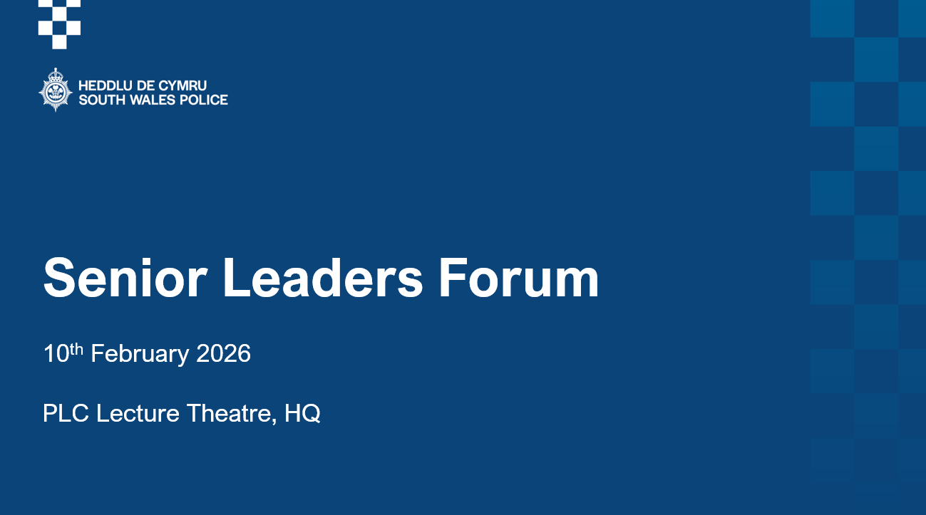
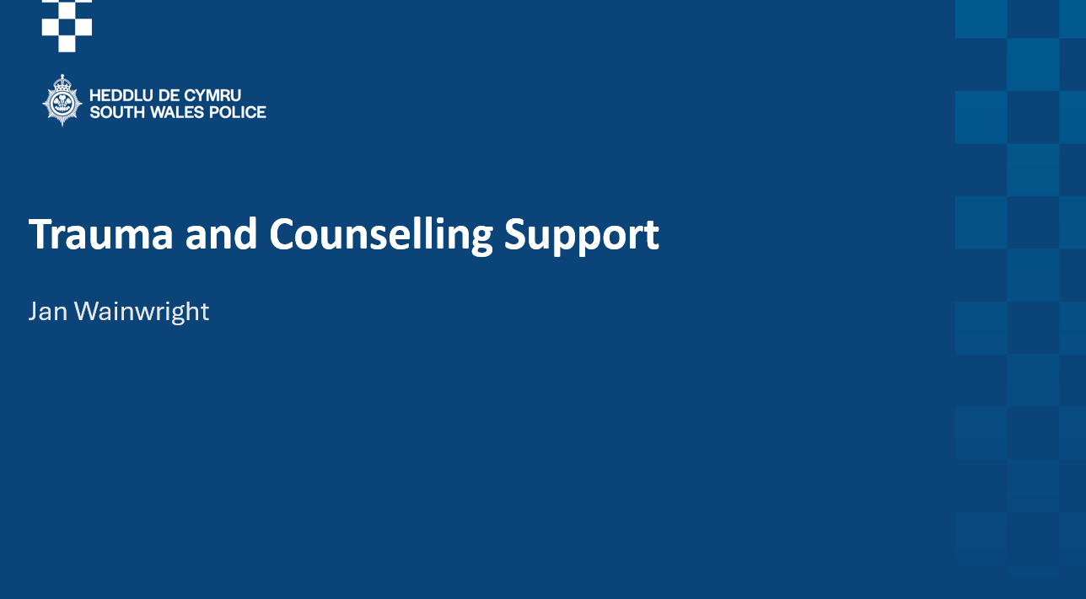
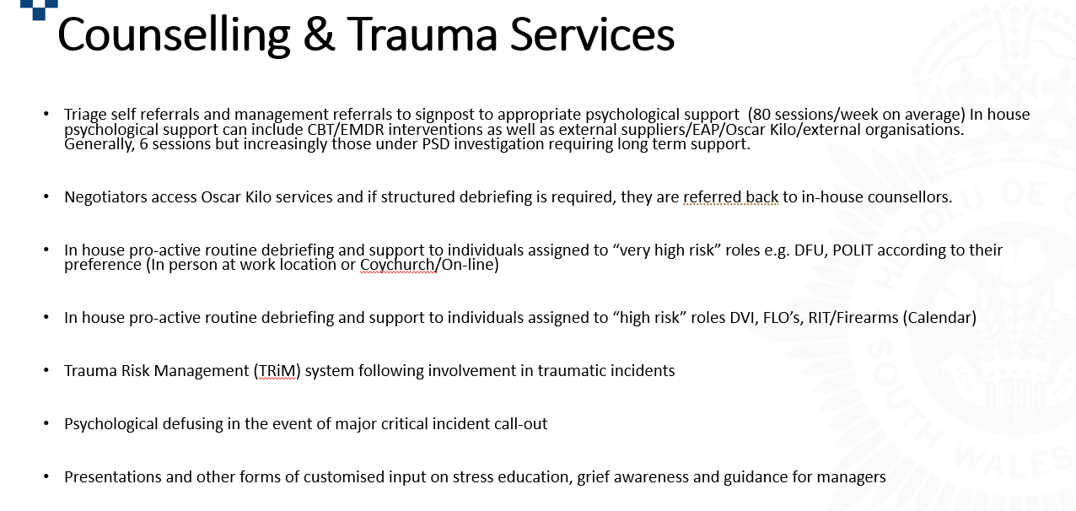
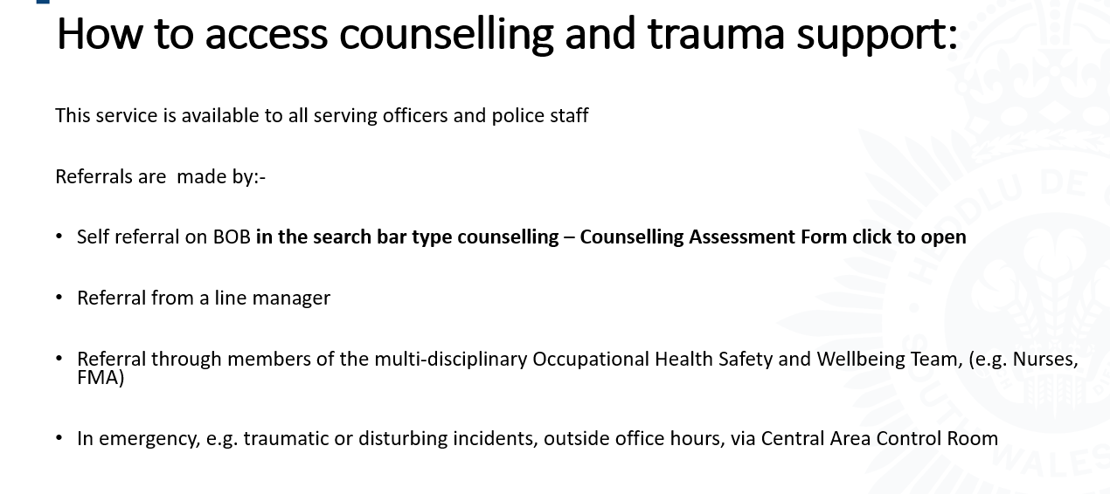

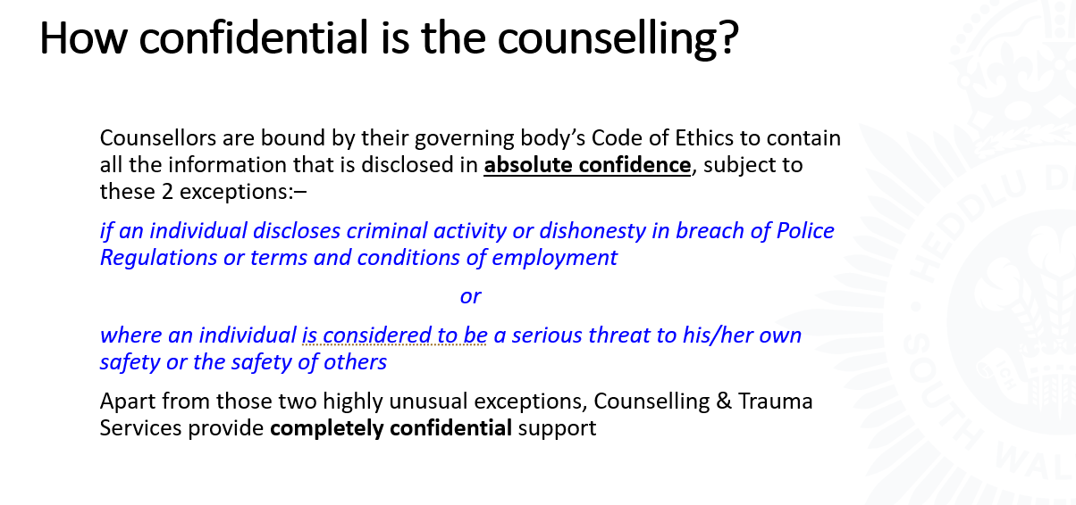

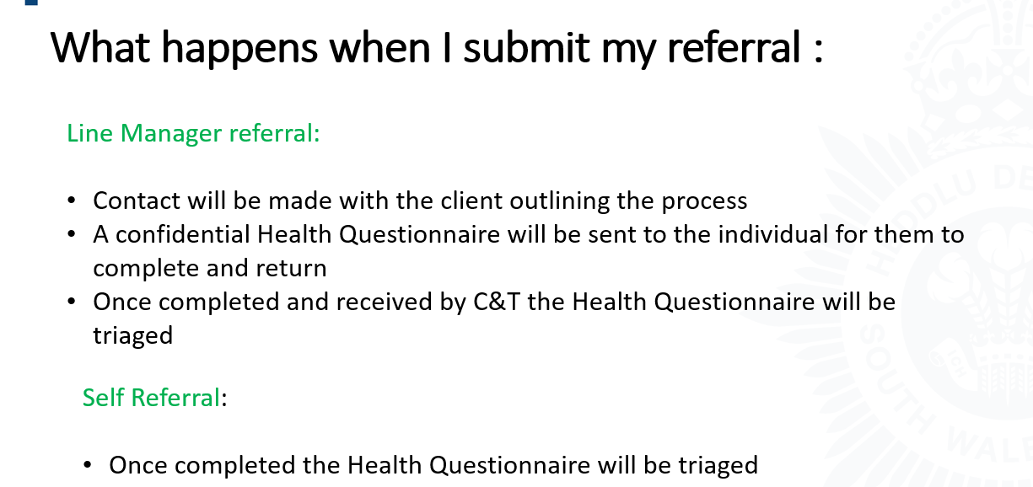

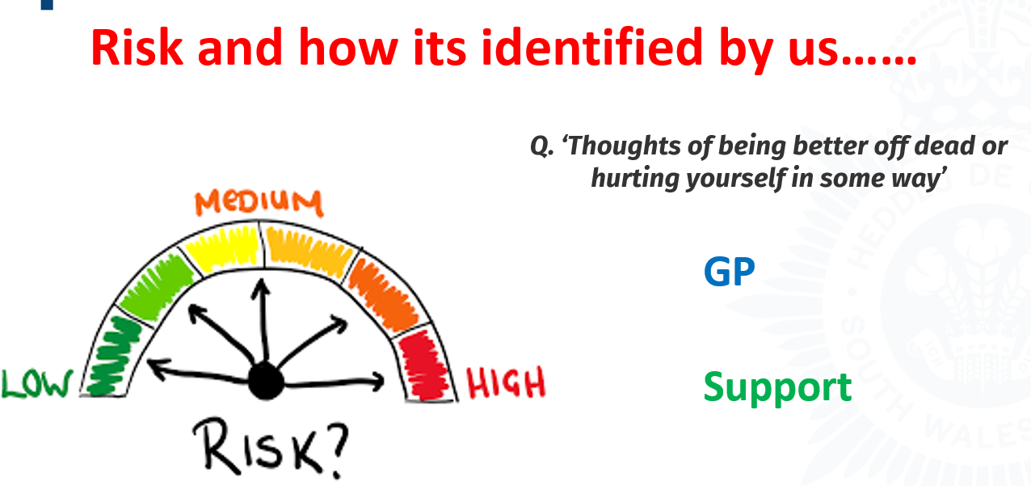

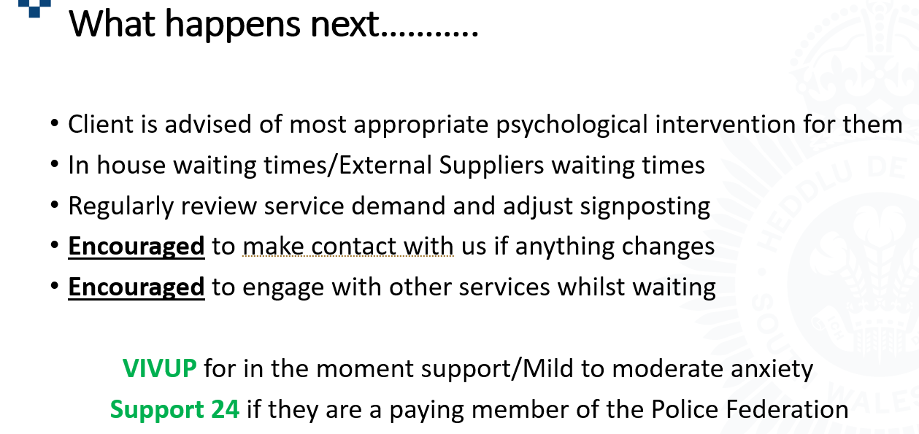

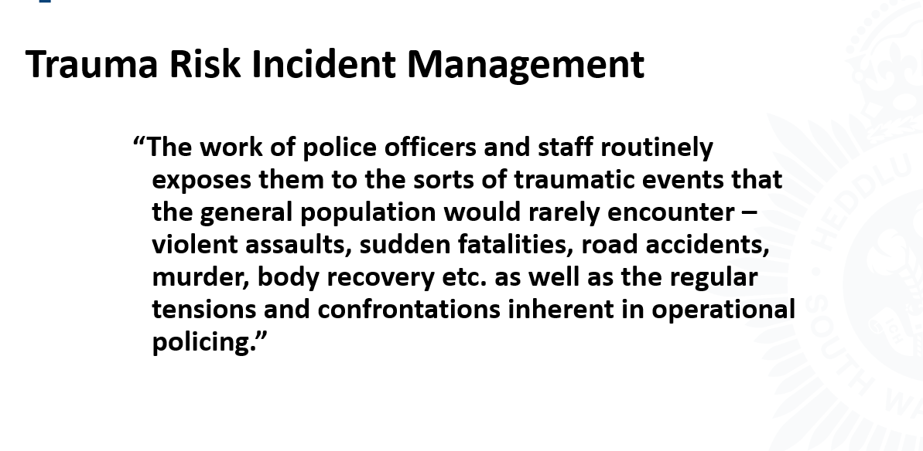

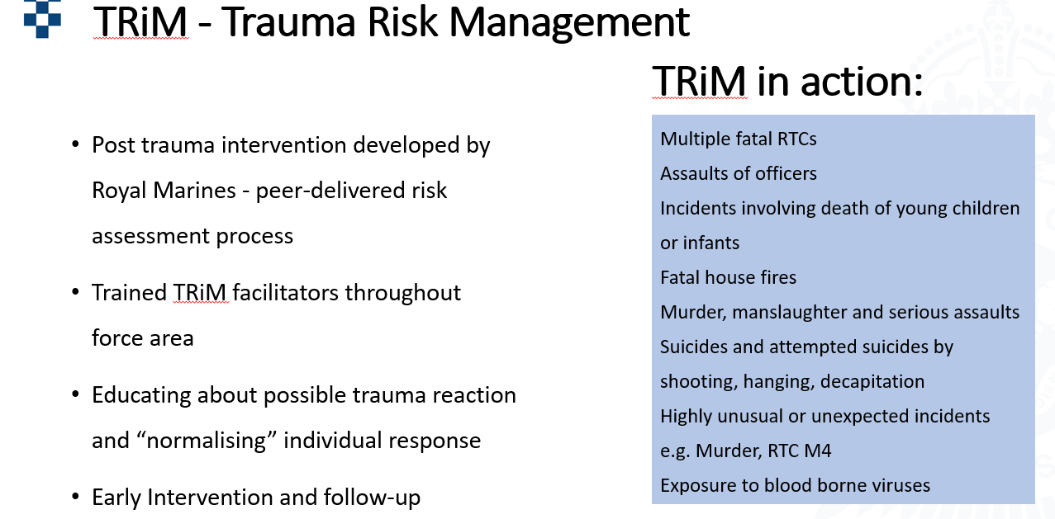

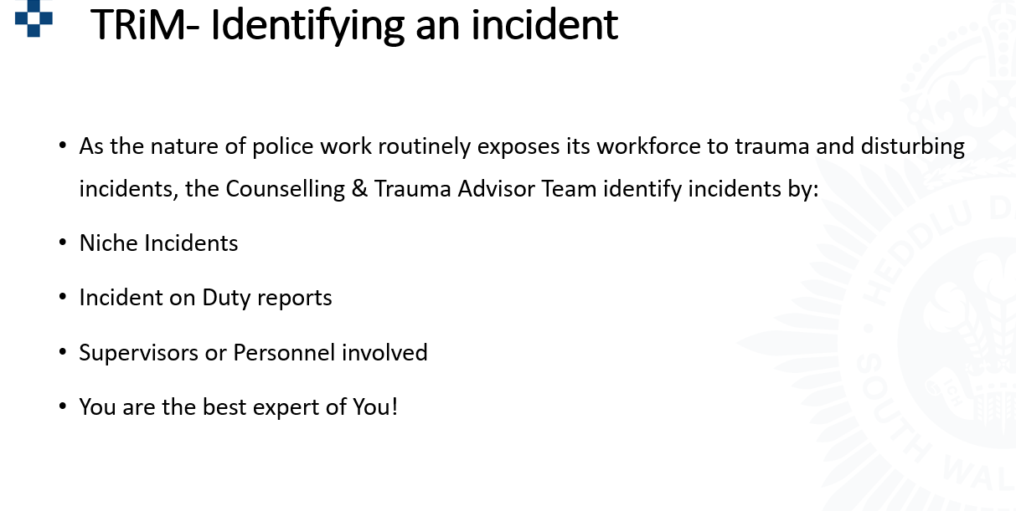

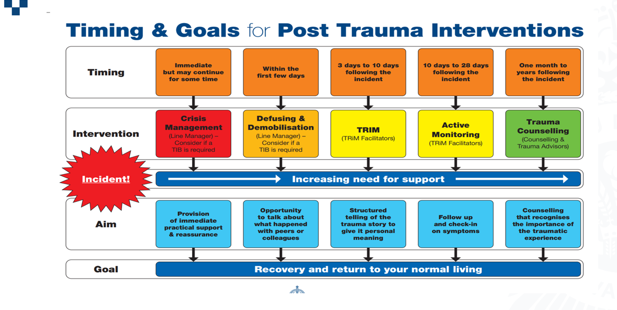

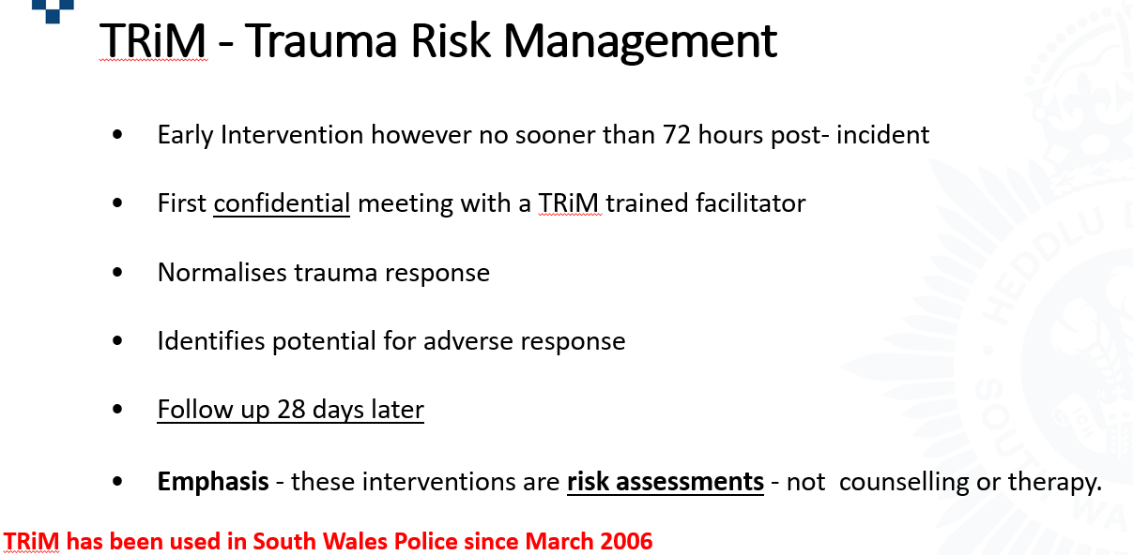

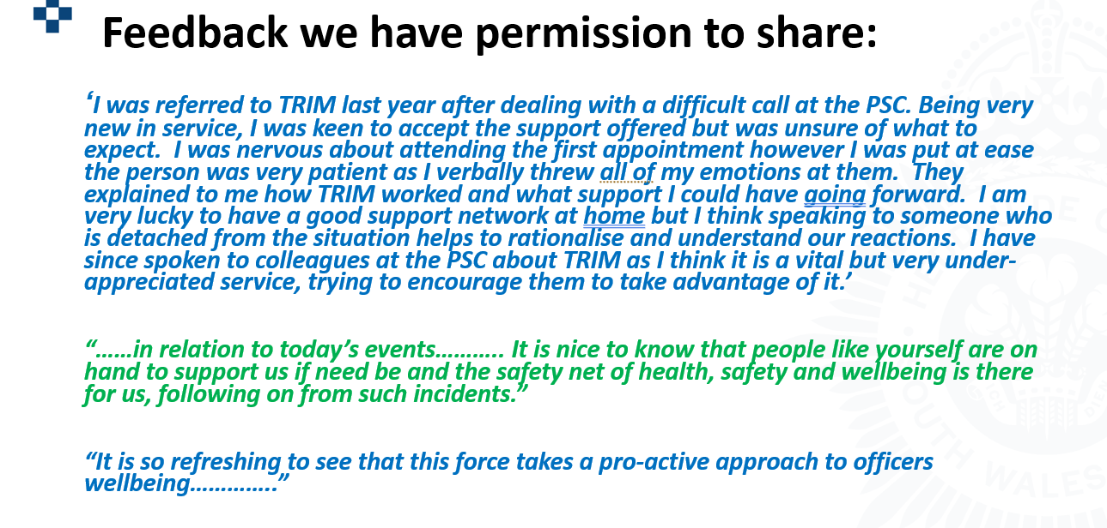

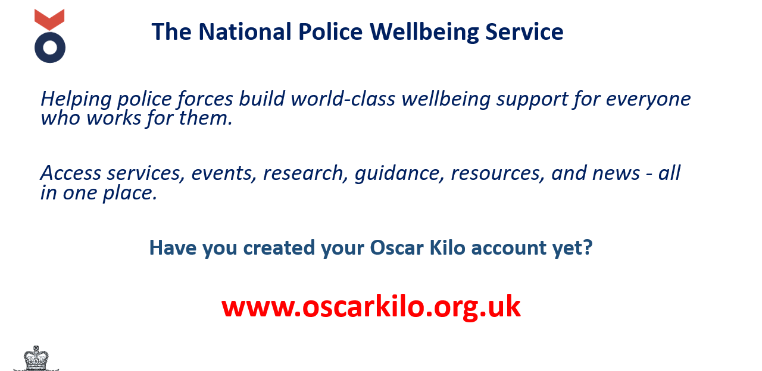

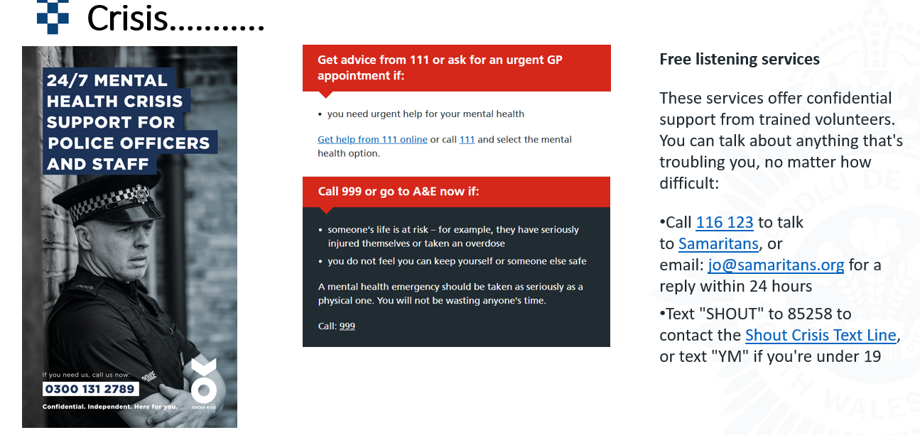
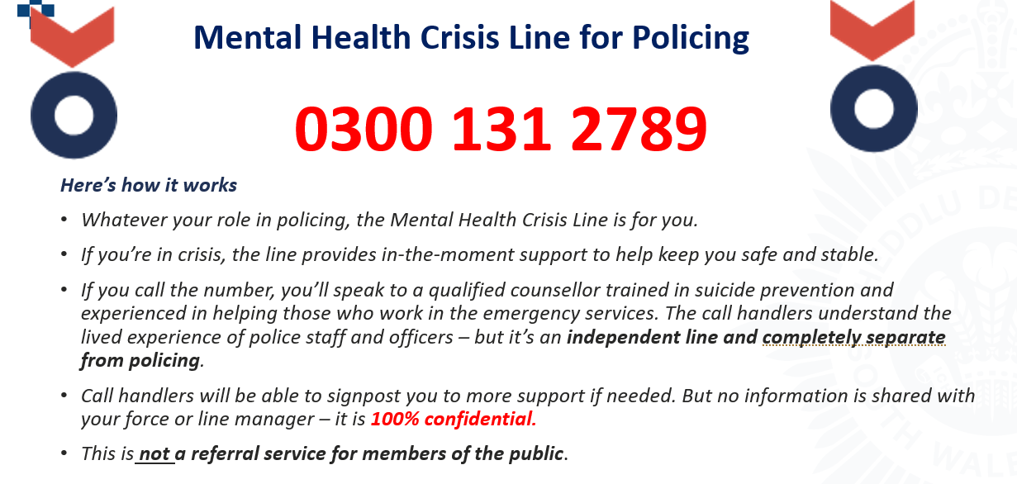

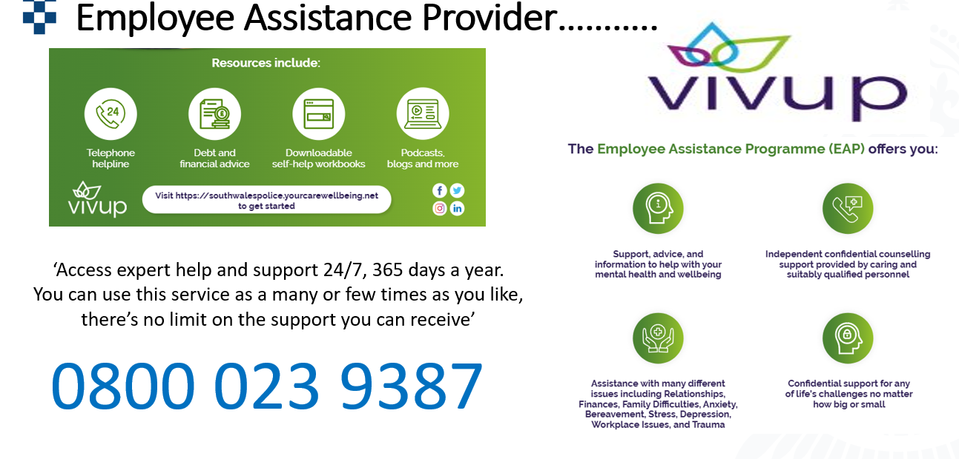

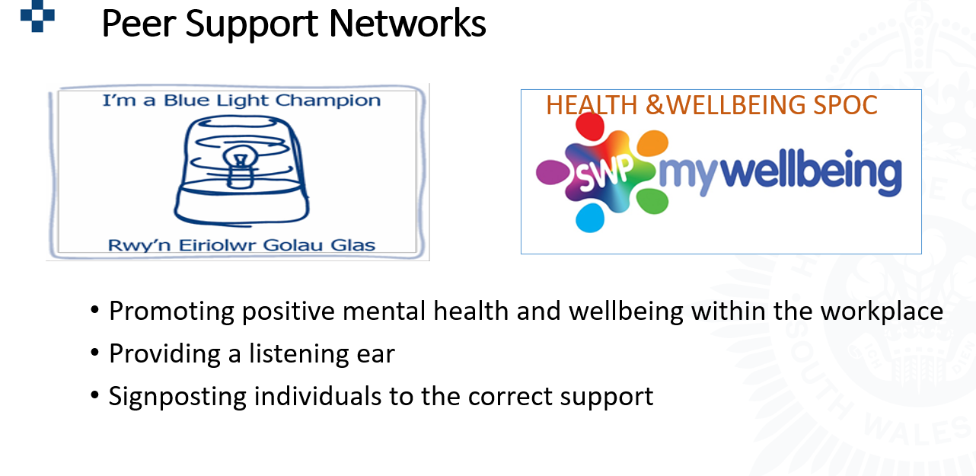

Appendix 2 – Wellbeing Strategy – SWP 2025-2028

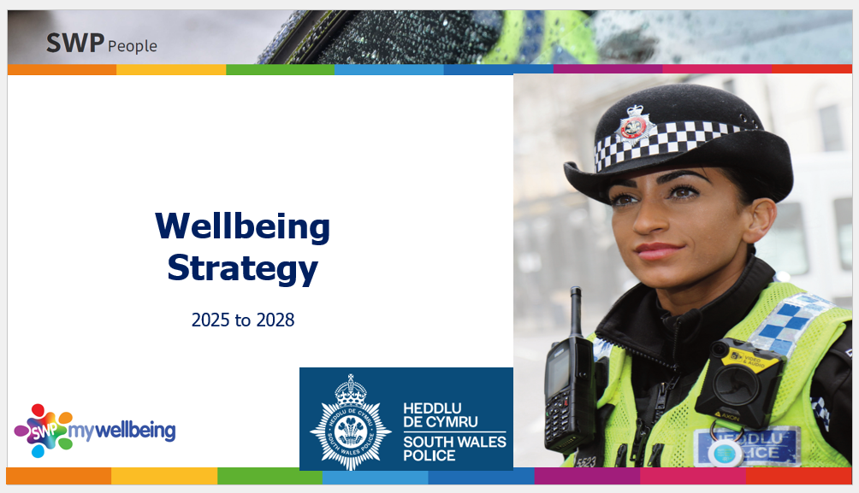

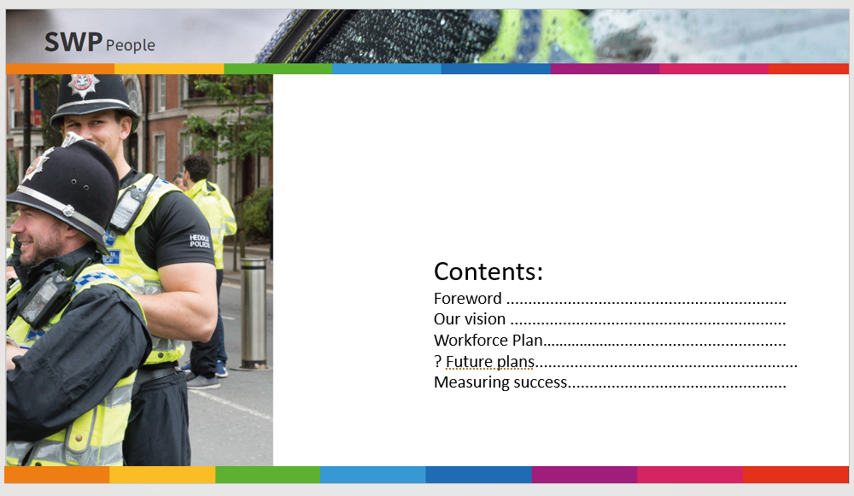

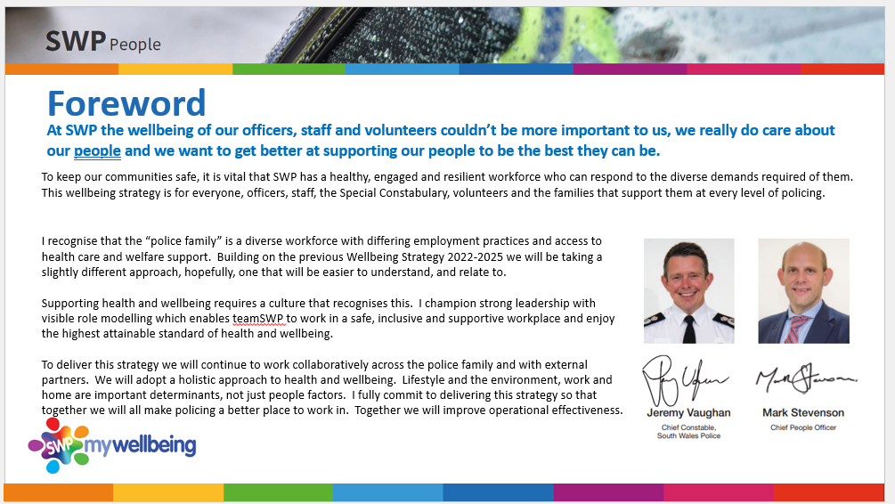

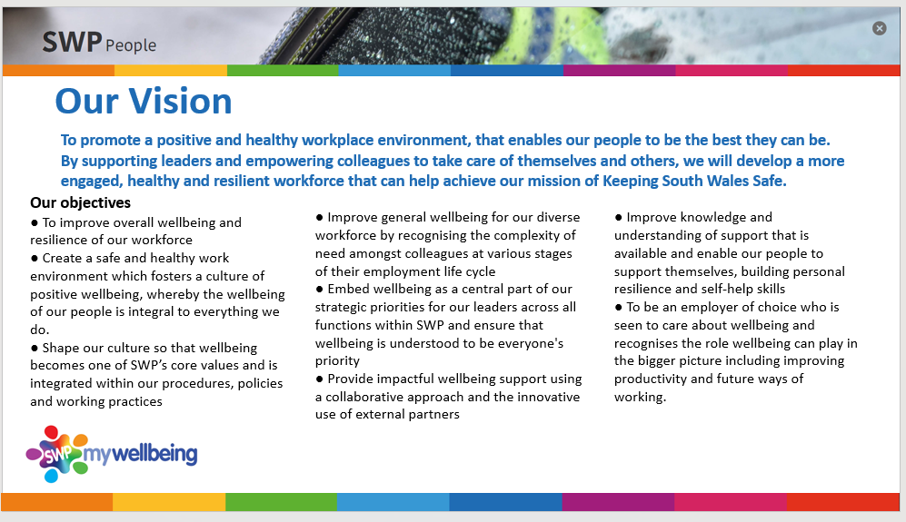
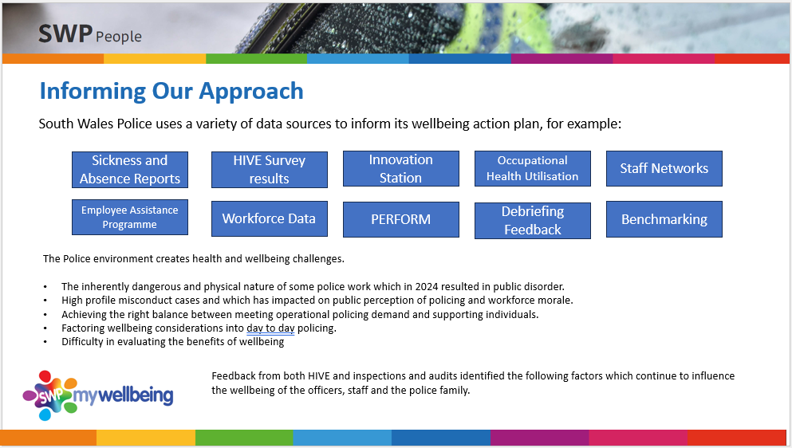

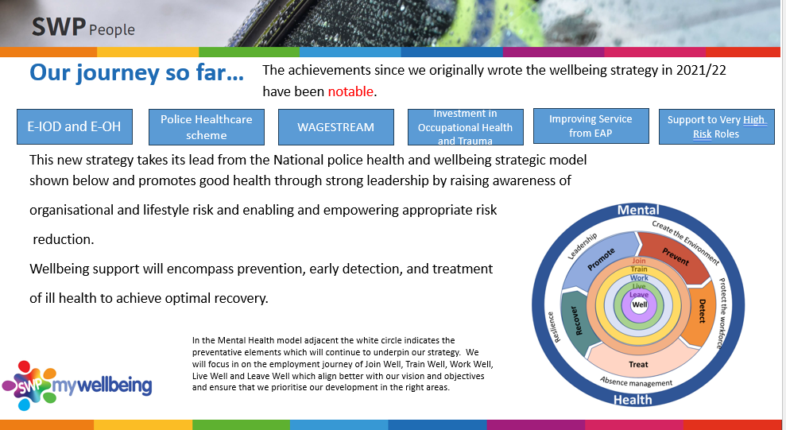

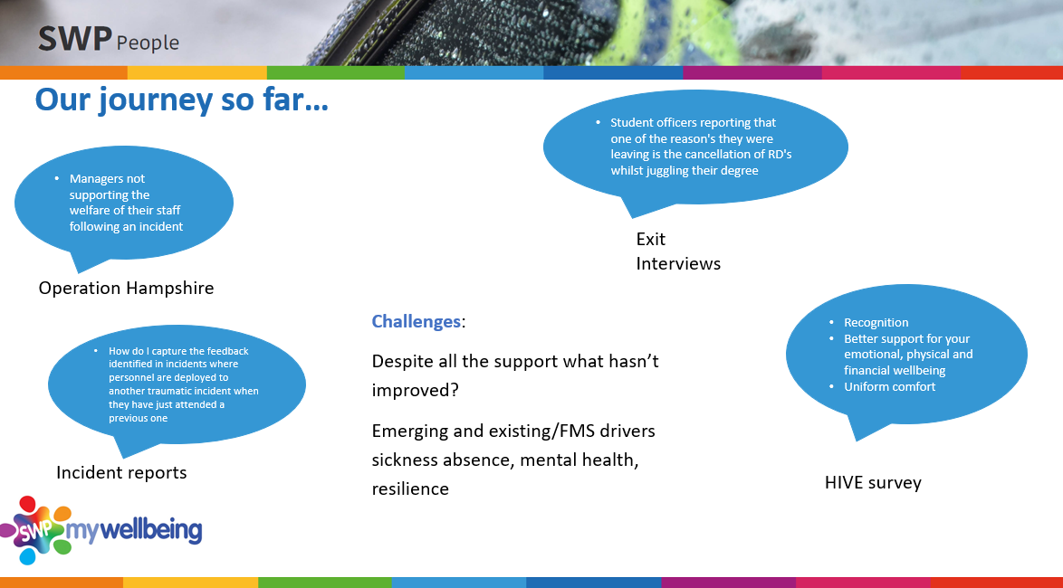

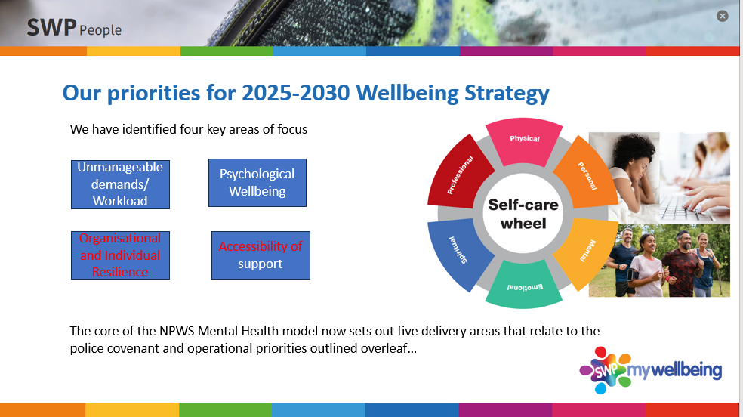

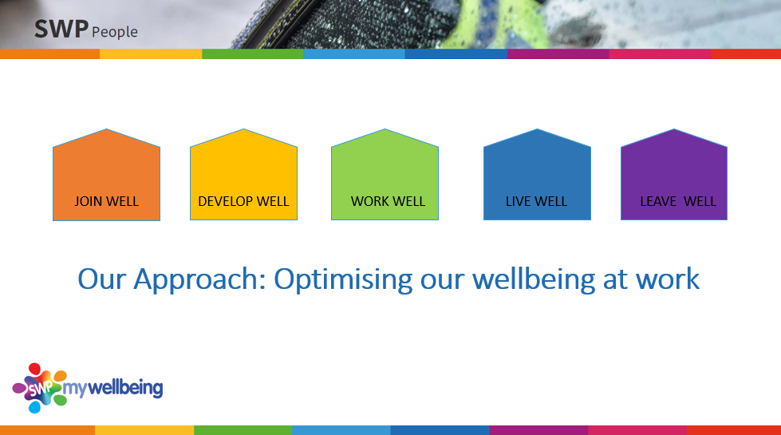

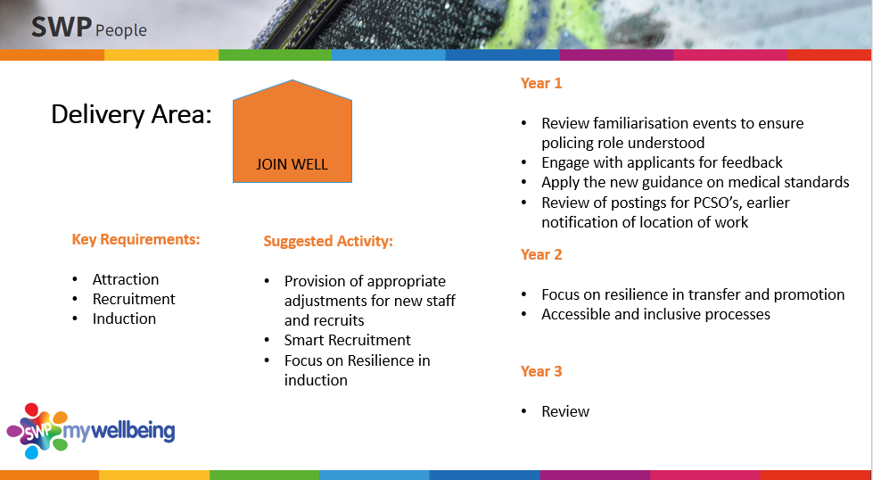

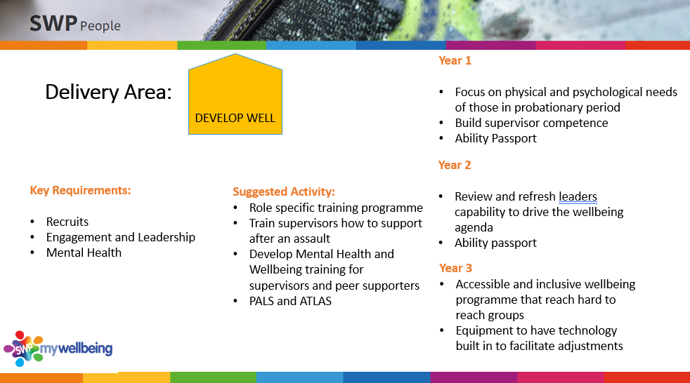

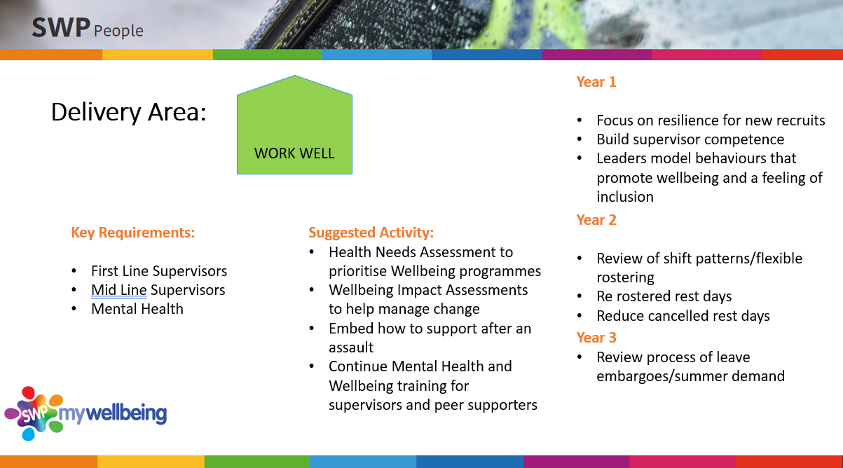

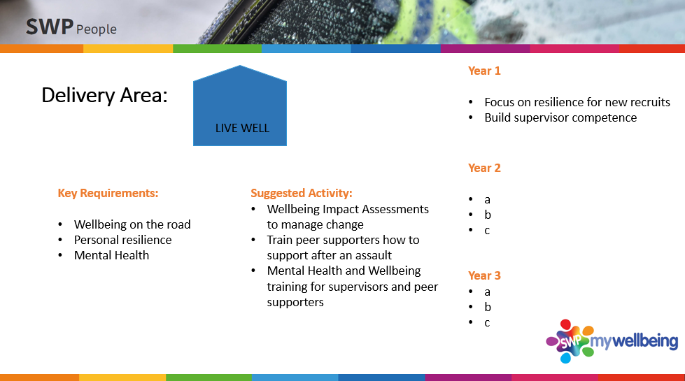

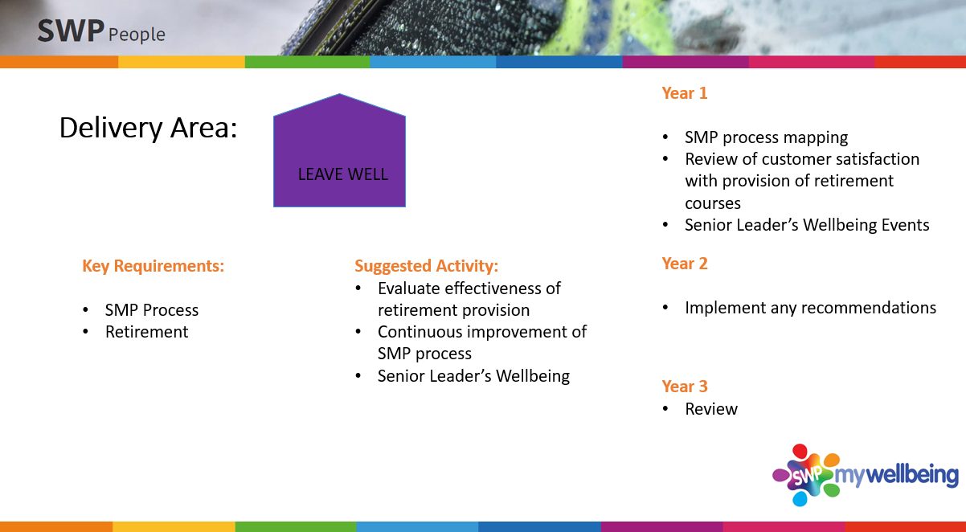

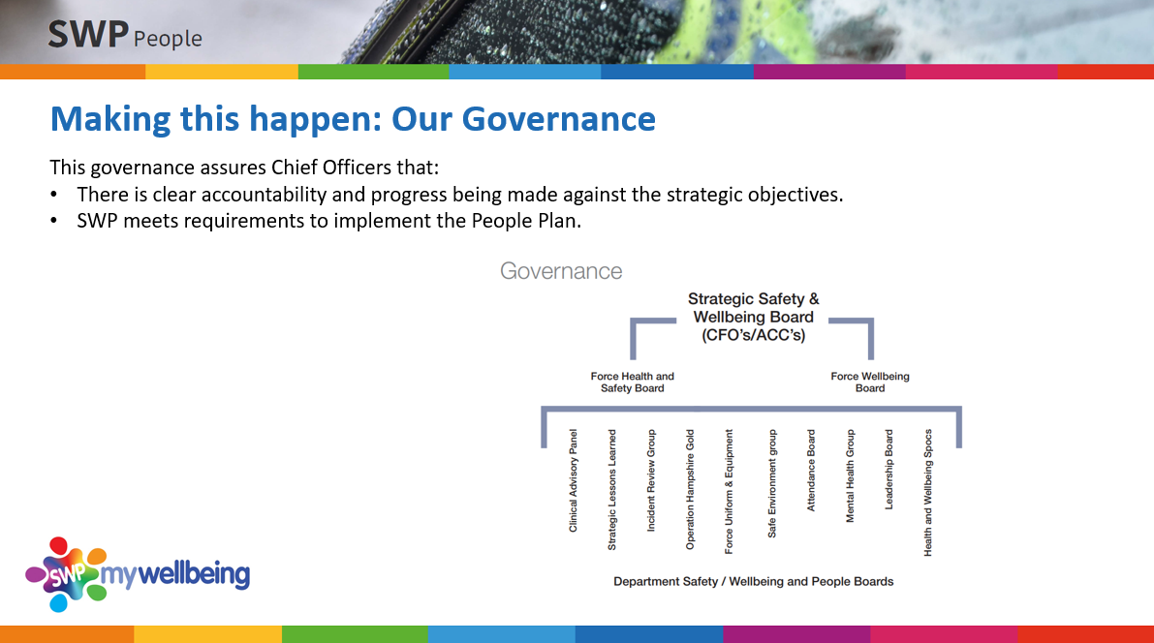

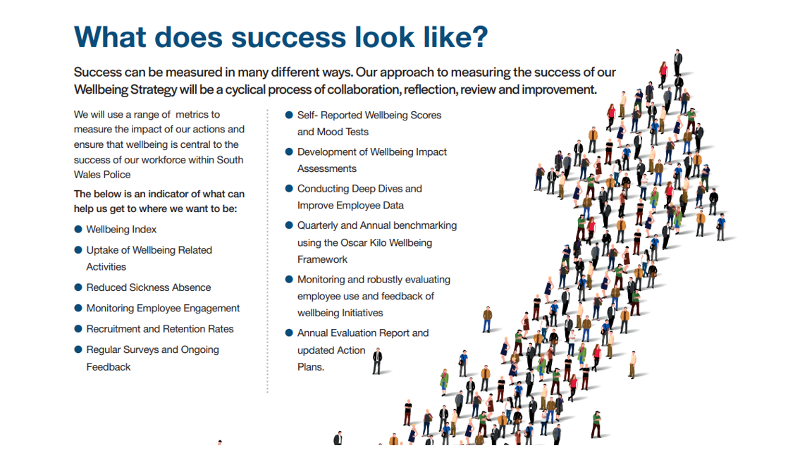

Appendix 3 Problem Profile
Mental Health Sickness Sept 2025
Overview
This report provides a detailed analysis of Mental Health sickness absence in South Wales Police, with a specific focus on current sickness absence rates (up to 30th August 2025) and an analysis of MH absence trends over the previous 12 months.

The analysis will also include consideration of absence trends by:
- Gender
- Age and length of service
- Resource type – Officer/Staff/PCSO
- Role type
- Causes of MH absence

The report will also focus on the management of MH related absences, including compliance with Absence Management processes and utilisation of supportive interventions including Occupational Health and Counselling Services.

Current Mental Health absence – August 2025

Total time lost due to MH Absence
- Number of Mental Health related absences per month have increased each month since Feb 2025
- Total time lost due to MH absence now exceeds time lost to all other absence reasons combined

Officer Key Findings:
- Mental health absence accounts for over 50% of all sickness absence across the Officer workforce.

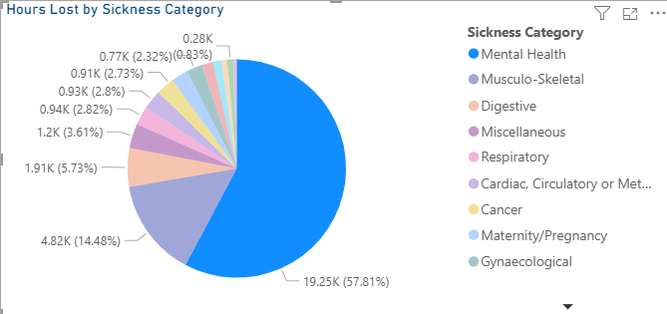

- 3.5% of Police Officer available hours were lost to MH related absence in August 2024.

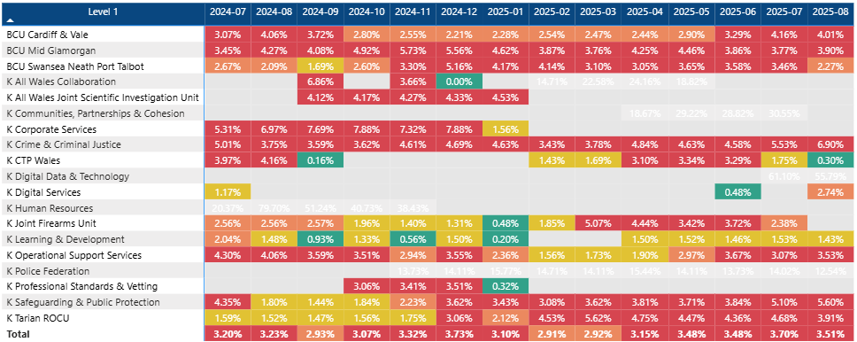

- The above Heatmap, detailing Dept MH absence levels over the last 12 months, shows that MH absence rates are highest in Crime & Criminal Justice (6.9%), Safeguarding & Public Protection (5.60%).
- This trend of absence being high in Investigative functions has also been identified through the Detective Resilience project – the below graph demonstrates a rise in overall sickness absence for Officers in PIP2 posts, with absence rates for all absence (not just MH absence) sitting at 8.4% in July 25 (significantly higher than 6.5% Force rate)
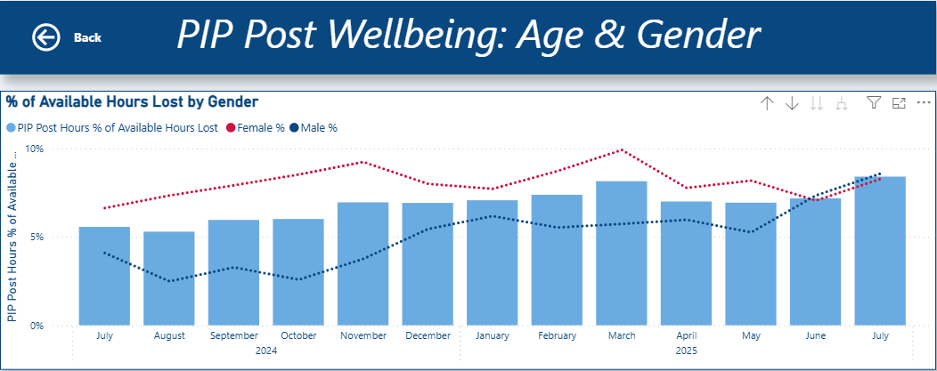

Work has been recently been commissioned, via the NPCC Recruitment, Retention & Wellbeing of Investigators group, with Durham University to further analyse the recent absence trends amongst PIP2 post holders to identify potential triggers (length in service/role etc). It is hoped this work will assist in identifying effective interventions to improve overall Investigator wellbeing – some of which may be transferrable across the workforce.

Recommendation 1 : Continue to support the partnership working with Durham University, through NPCC, to further analyse Investigative wellbeing data.

- Mental Health absence rates higher among females (61.5% of total time lost due to sickness) vs. males (54.7%)
- Officers with more than 10yrs Service (10-20 and 20+) accounted for 56% of total time lost due to Mental Health absence, while only accounting for 43% of the Officer headcount. In comparison, 32.1% of our current Officers have less than 5 years service, but this group only account for 23% of total time lost due to Mental Health

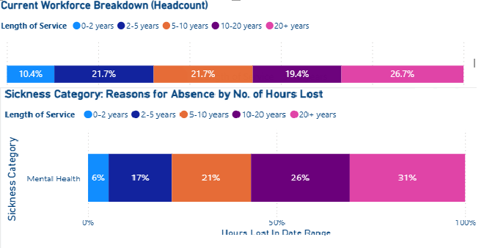

Recommendation 2 : Further explore themes behind MH absence for Female Officers and those later in service to understand impact of work/personal circumstances and consider suitable interventions

Police Staff Key Findings:

- Mental Health related absence accounted for 44% of hours lost for Police Staff in July 25.
- Like Police Officers, it is apparent that MH related absence accounts for more time lost for Females (51% of time lost in July) than Male (29.5% of time lost in July) staff.
- 54% of all time lost due to Mental Health absence for Males is attributed to staff over the age of 55, with those aged under 40 only accounting for 12% of time lost due to MH.

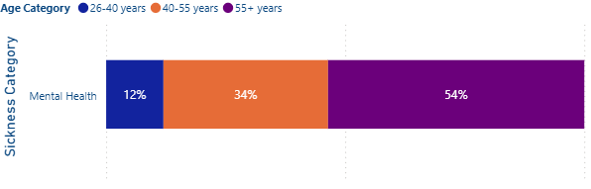
- This is markedly different to Female staff, where 40.5% of total time lost to Mental Health absence is attributable to females under the age of 40.

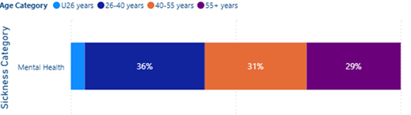

Recommendation 3: Further analyse themes behind MH absences for Males over 55 and females under 40 to understand impact of work/personal circumstances.

PCSO Key Findings:
- Mental Health related absence accounted for 44.9% of all time lost due to sickness for PCSOs in July 2025.
- Mental Health related absence has gradually reduced for PCSOs over the last 12 months.

- The below Heatmap demonstrates a positive reduction in Mental Health absence across all BCUs in July.

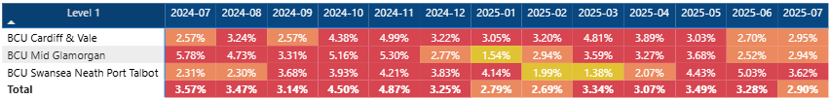

- There is a noticeable difference in the profile of Mental Health absence by length of service for Male and Female PCSOs. Similar to the trend seen amongst Police Staff, Female PCSOs early in service (<5yrs) account for 55% of total time lost due to MH absence in July 25.

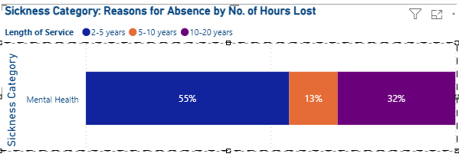

- In comparison, Male MH sickness was mostly attributable to PCSOs with 10-20yrs service (accounting for 84% of time lost)

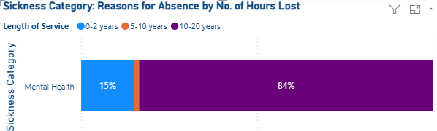

Recommendation 4 : Explore MH related absence amongst PCSOs through the PCSO Sickness working group already established.

Compliance with Absence Procedure for Mental Health Absences

- The Force attendance management policy recommends that any long term MH absence should be referred to Occupational Health promptly post 28 days.
- The attendance management policy also stipulates that absence triggers should be promptly managed through Supportive or Formal Attendance Plans.
- Of the 133 long term absences currently live at the start of August 2025, 90 had been referred to OH for review (68%)
- For the same 133 cases, who all would have triggered an absence plan due to the protracted nature of the sickness, only 57.9% of triggers had been actioned with a plan set.

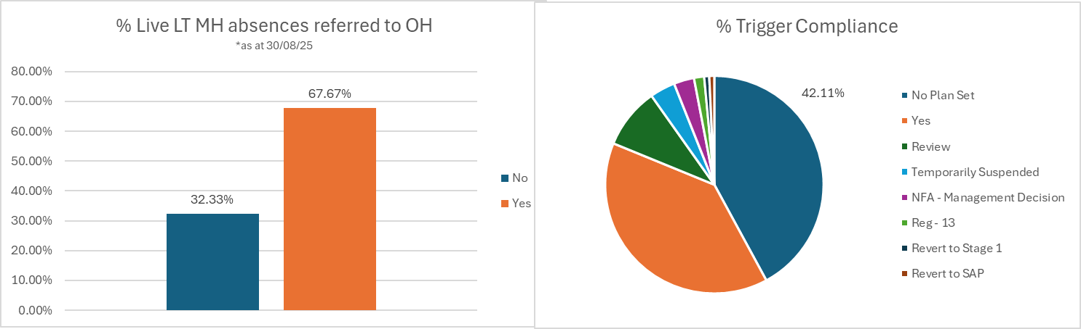

- Further analysis is required to understand the correlation between effective use of the sickness absence policy and OH interventions and length of MH absence.
- Counselling referrals have fluctuated over the last 12 months but there has been a sustained increase in Officer referrals across the last 3 months.

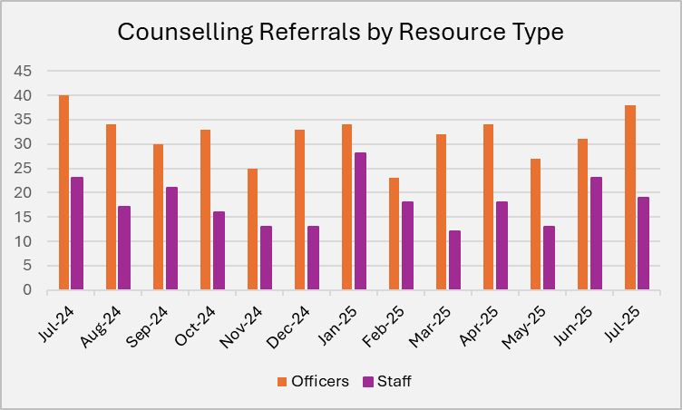

- The majority of Officer referrals still originate from Line Manager referral, although there have been more TRIM related referrals that in previous years

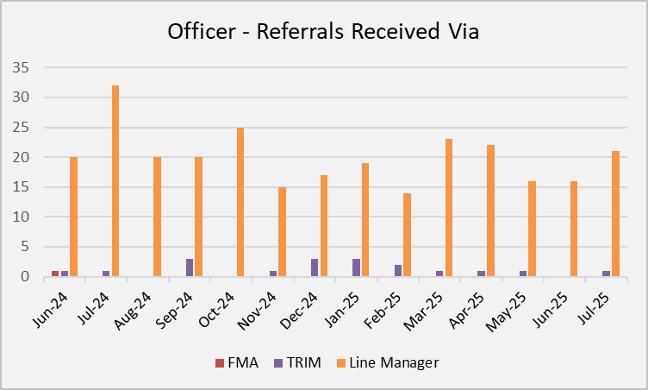

- On average, Counselling waiting times are around 4-5 weeks, although referrals are always triaged based on highest risk and prioritised accordingly (this includes TRIM related referral
Recommendation 5 : Further analyse the correlation between compliance with absence procedure (i.e. timely referral to OH/Counselling, effective use of Sickness Action Plans) and average length of absence.

Appendix 4 – Microsoft Forms Questionnaire – Help-Seeking

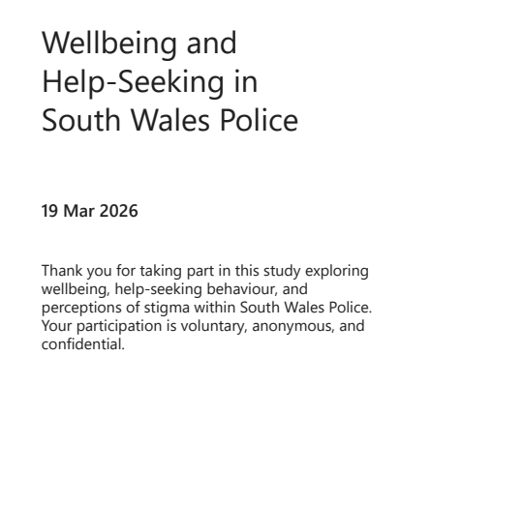
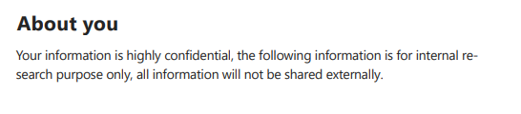

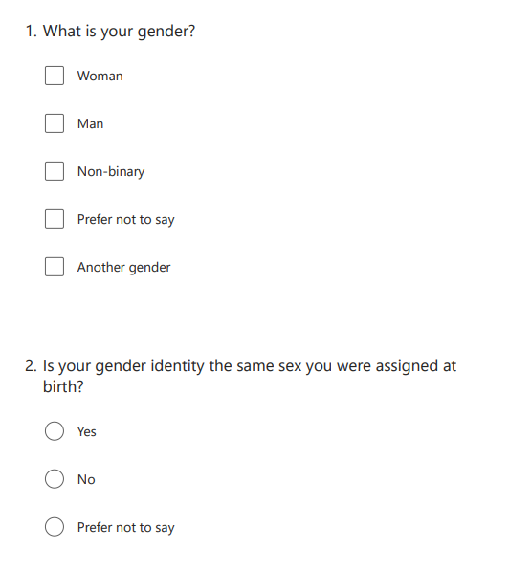
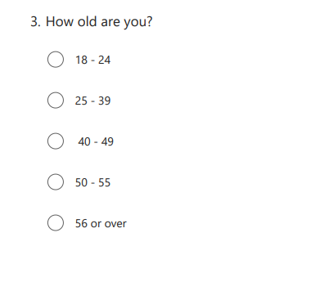
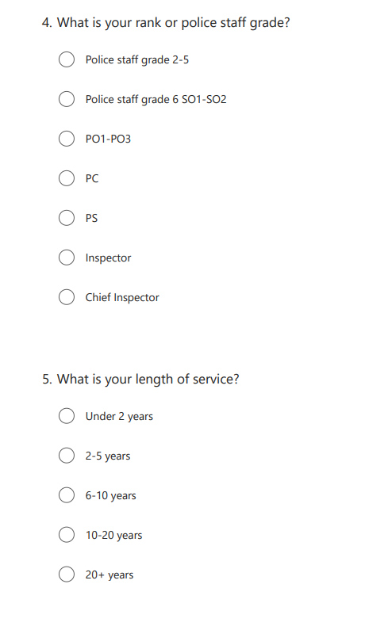
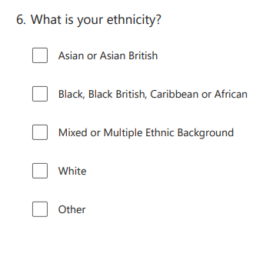

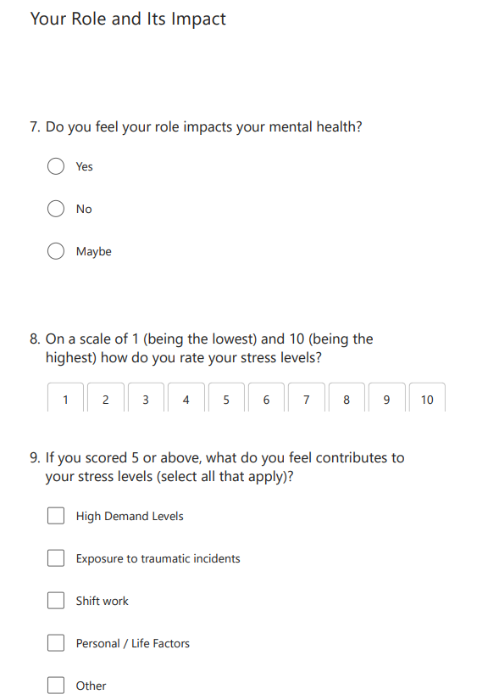

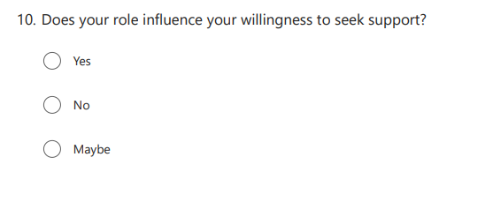
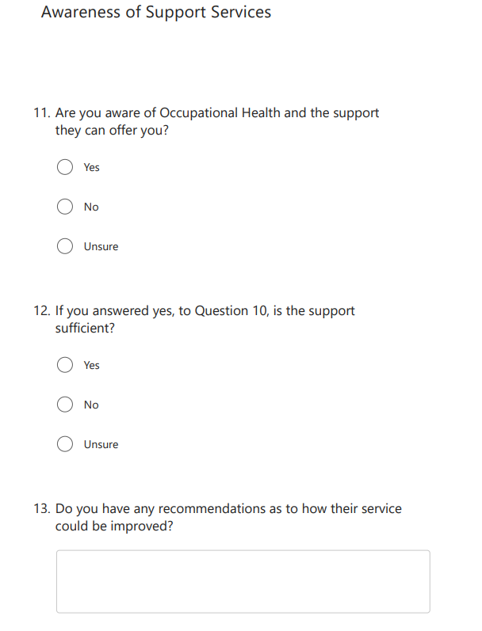

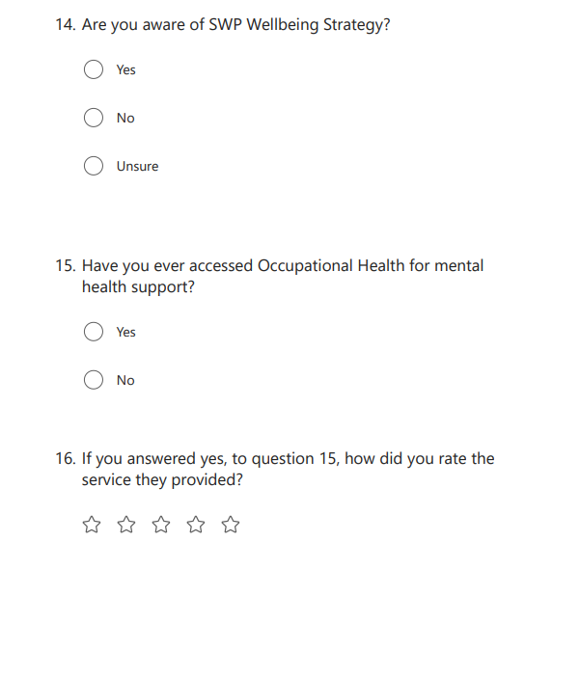

Gender and Help-Seeking
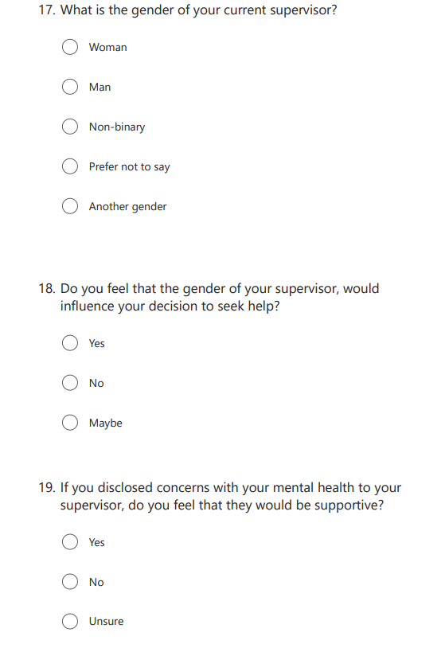

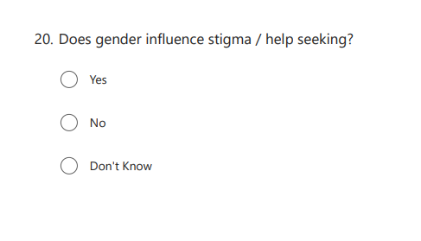
Experiences and Attitudes

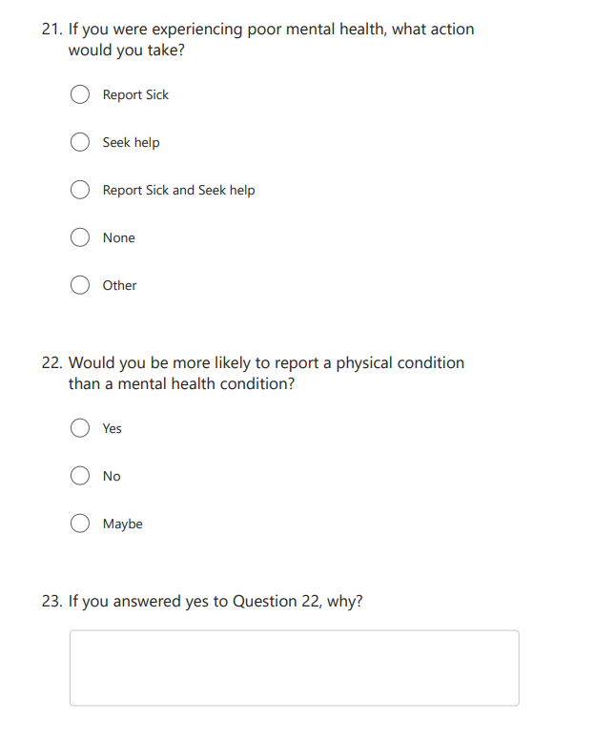

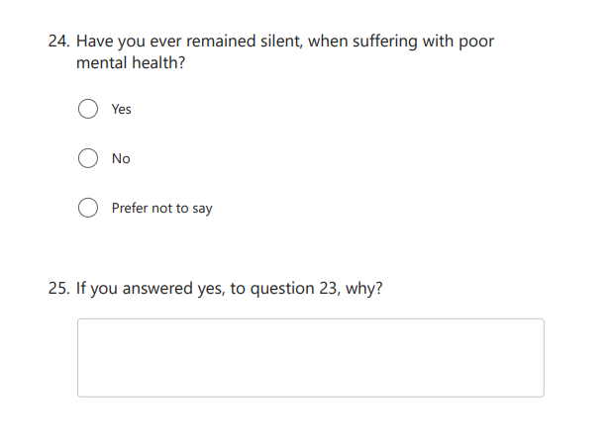

Help-Seeking Preferences
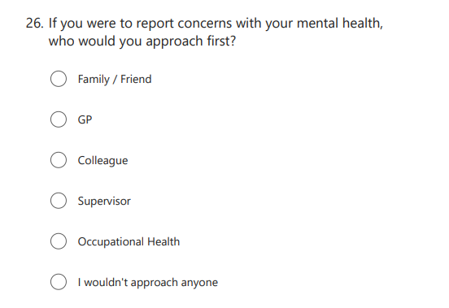

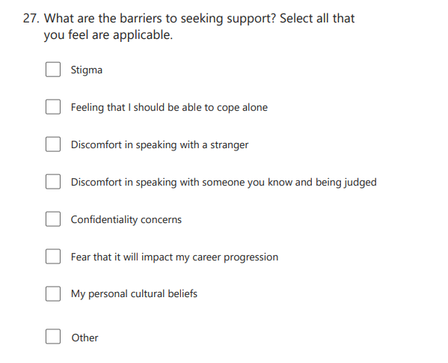
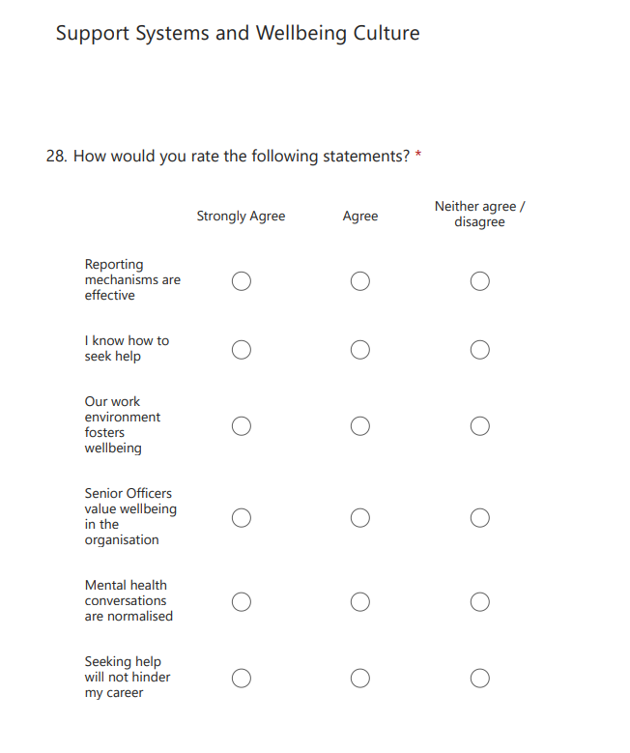

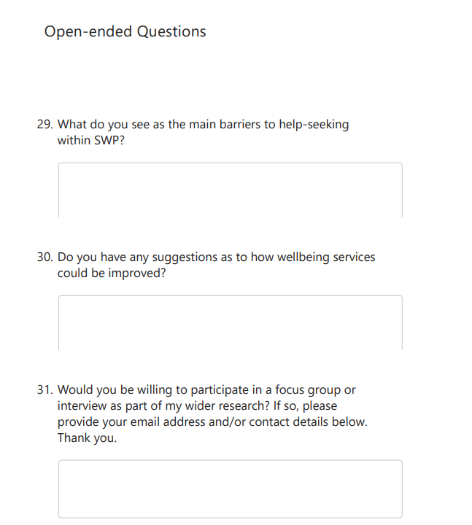

Appendix 5 - SWP HR Establishment DATA

Please see below figures for PSC as at 28-02-26:(Staff only)

Sex:

 | Headcount
Female | 342
Male | 110
Grand Total | 452

Gender:

 | Headcount
Man | 40
Prefer to Self-Describe | 1
Unknown | 272
Woman | 139
Grand Total | 452

Age Category:

 | Headcount
Under 26 | 60
26 - 40 | 170
41 - 55 | 133
Over 55 | 89
Grand Total | 452

Length of Service: (Only able to provide length of service in force, not in department)

 | Headcount
Under 2 yrs | 108
2 - 5 yrs | 109
6 -10 yrs | 75
11 - 15 yrs | 24
16 - 20 yrs | 40
Over 20 yrs | 96
Grand Total | 452

Appendix 6 - Research Support Email

Request for Your Help with My Research
Hi, I am currently undertaking my MsC in Policing with the University of Wales Trinity Saint David (UWTSD). I am reaching out to request your assistance with my dissertation research, which focuses on wellbeing and help-seeking particular the impact on staff at the first point of contact.
I would greatly appreciate it if you could take about 5-10 minutes of your valuable time to complete this short questionnaire. Many of the questions are in a tick box format making it quick and easy to respond.

Additionally, if you would be open to it, I would be grateful if you would consider participating in a focus group or an interview to assist in my research. Your insights are incredibly valuable and will contribute significantly to my study.

Please be assured that all information will always be treated with the upmost confidentiality.

Your participation could help shape future changes within our organisation and I truly appreciate your time and support.
Thank you so much.

Hannah Durham

Wellbeing and Help-Seeking in South Wales Police – Fill in form

Appendix 7 – Analysis of Questionnaire Responses



