Understanding Change Management
On the job training record

- In the new CIPD Profession Map, Change is one of the core knowledge areas. Evaluate your knowledge, skills and ability in relation to this area, using the definitions from the Profession Map and discuss any development needs with your manager. Record your discussion (300 words approximately).

The ’change’ area of the Profession Map covers the core knowledge needed for people professionals to deliver sustained change in an effective way.

A self-assessment undertaken against this behaviour indicates that my knowledge and skills in this area are currently at foundation level. I have experience and knowledge of project managing change through my previous role as Principal Project Manager and through the PRINCE2 and MSP qualifications.

Whilst I meet some aspects of the Profession Map at Associate level, such as how to use data as a case for change and planning and delivering activities for change, I have less experience of the people management side of change. Therefore, I believe my development needs are to understand:

- The different change management approaches and their advantages and disadvantages from a people perspective;
- How to apply continuous improvement tools, and;
- How to explain why change is happening and basic models for how people experience change.

I intend to apply the learning from the Understanding Change Management module during the transition of provider contract for the delivery of agency AHP / HSS Direct Engagement services during October 2021. Following discussion with my line manager on 12th October 2021, I will have the opportunity to apply the learning to a future change initiative which will impact heavily on our own staff (as oppose to the service change initiative that I am operationally leading on). The department will be moving to new accommodation, trialling new ways of agile working which will require significant engagement and planning with the team and with external stakeholders including estates and landlords.

I have also agreed with my line manager that, once I have finished this module, we will consider the skills required at chartered level, identify gaps and consider what I could get involved in to build my knowledge in these areas. One such suggestion is to ‘buddy up’ with an Operational Workforce colleague to manage an change under the Organisational Change Policy.
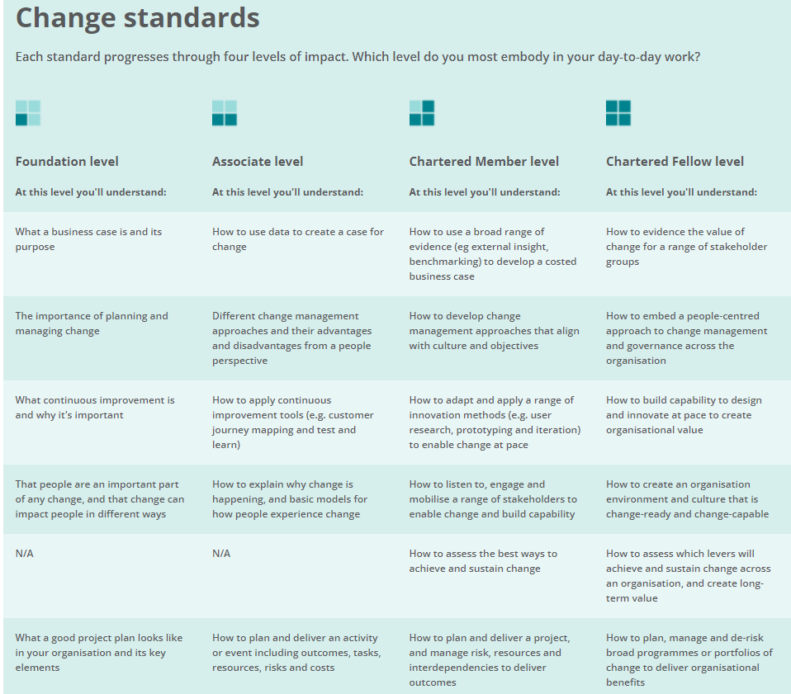

- Complete a SWOT analysis of an impending change in your organisation. Clearly list the strengths, weaknesses, opportunities and threats represented by the change. Discuss the HR implications of the change with your line manager and submit a summary of your discussion plus SWOT.

The Health Board is undergoing a change in in contract provider for its Allied Health Professional agency staff. As lead manager for the Health Board on this change initiative, I have undertaken a SWOT analysis (CIPD, 2020) (Appendix A). I discussed the change and the SWOT analysis and our approach to this change with my line manager on 12^{h} October 2021.

The case for change was driven by a procurement process that did not allow us to continue with our current provider under the same contract. Our options were further limited due to the timescales that we were working to, after several attempts to engage with the procurement team early on did not receive a response. This resulted in the need for a quick turnaround in terms of a decision as to the procurement route which meant that we were unable to engage with the services who will be affected by the change at an early stage. We acknowledge that this may impact on how services embrace the change and may create some anxiety around service continuity. We will note this as a lesson learned and ensure that in future change initiatives we seek to prepare for engagement at an early stage so that when we are in a position to communicate we can do so without delay.

Again, due to time constraints, a key risk is the additional workload generated by a change in supplier, particularly in terms of building new relationships and training staff on a new system where capacity is already stretched. To help alleviate some of this pressure, the new providers are working closely with the current provider and with supplier agencies to ensure a smooth transition of service from current to new arrangements. We will try to reassure services that we do not anticipate that the change in contract will impact on supply as the new provider are already engaged with the majority of agencies we have engaged with over the last two years. We intend to also share the benefits of a new Client relationship Manager to the service who will help manage the interface with agencies and provide full management of the supply chain, which is a significant additional benefit in the long-term.

Another key risk is the continued supply of agency workers to our services. If supply were to deteriorate, this would have a significant impact on service provision and business continuity, potentially requiring our substantive staff to take on additional shifts and work long hours to cover shortfalls. This could have a detrimental effect on staff well-being, resulting in deteriorating mental health issues (Afonso et al, 2017) which could result in increased absence and higher demand for Occupation Health support.

An area that we have yet to consider is how we evaluate the change process and the effectiveness of the change itself. We have agreed that a set of Key Performance Indicators (KPI.org, n.d.) will assist us in evidencing how successful we have been in achieving our objective of transitioning to a new provider. Whilst some of these KPIs will inevitably focus on efficiency and effectiveness, such as financial savings, improved fill rates and improved compliance, we also need to consider how we measure the impact of the change on our staff.

Once the change has been embedded, feedback will be collected from stakeholders to assess the impact of change in terms of implementation, supply and service satisfaction and also to understand their experience of the change process so that we apply this learning to future change initiatives.

References
Afonso, P, Fonseca, M, Pires, J F (2017) Impact of working hours on sleep and mental health. Available at Impact of working hours on sleep and mental health | Occupational Medicine | Oxford Academic (oup.com). (Accessed 12th October 2021)

CIPD (2020b) SWOT analysis. Available at https://www.cipd.co.uk/knowledge/strategy/organisational-development/swot-analysis-factsheet. (Accessed: 19th February 2021)

KPI.org (n.d.) What is a key performance indicator? Available at What is a Key Performance Indicator (KPI)?. (Accessed: 12th October 2021)

NIBusinessinfo (n.d.) Choosing suppliers for your business. Available at Choose between single or multiple supplier strategy | nibusinessinfo.co.uk (Accessed: 11th October 2021)

Appendix A

SWOT analysis

Strengths | Weaknesses
Adding these staff groups to the current medical DE contract is compliant with procurement rules and we would not be open to any form of challenge from the current AHP provider. | Concerns whether this is the most appropriate option in terms of a robust and fair process for the current provider.
Without the need for a procurement activity, the transition to a new provider can be managed earlier and is anticipated to be less problematic as we have strong existing relationships with the provider of medical agency staff. | Unsure if the cost in terms of the time and commitment required of services to implement a new system for potentially only a 1-year period is proportionate to any potential saving. Managers will need to be re-trained for a new system this Autumn and potentially another new system leading up to Aug22.
Anticipated lower management fee, giving a savings benefit of c£45k based on 12mth spend. | Introducing a new supplier will create additional work in terms of building new relationships and training all our end users with a new system for timesheet authorisation (c. one hour training) where capacity is already stretched.
Existing good relationships with current provider for medical agency, with performance management and regular SLA review meetings well embedded.
Managing the service level agreement meetings with one supplier instead of two.
Possibility of further savings linked to ‘value based commission discount’ commission rates will be less.
New provider have confirmed that they are able to offer a ‘like for like’ service for a lower management fee.
Opportunities | Threats
Aligns to the Welsh Government’s aspiration for one supplier across Wales and brings all Direct Engagement services under one supplier. | Potential challenge to contract change from current provider.
Other Welsh Health Boards use the new provider for the supply of agency workers for Medical & Dental as well as AHP / HSS. It is understood that there are no issues with the quality of service delivery for these two new staff groups. | Reliance on a single provider has risks in terms of business continuity should their operations be disrupted. (NIBusinessinfo, n.d.)
When the AW contract is re-let it will make the overall business on offer more attractive to potential bidders. | The new provider is unable to supply enough agency workers.
New provider offer a full ‘managed service’ provision. This is considered to be a significant additional benefit. | Agencies disengage as reductions in commission rates are

Stakeholder Mapping Worksheet

Stakeholders
Providers (current and future)
Supply agencies
Agency workers
Executive Directors for Therapies and Operations
Assistant Directors of Therapies
Service Managers
Service Administrators
Payroll
Finance
ESR Team

Stakeholder Influence/Interest Matrix
For each key stakeholder, characterize them using the following stakeholder influence grid.

Influence | High | Keep Satisfied | Key Players
Influence | Low | Minimal Effort | Keep Informed
 |  | Low | High
 |  | Level of Interest

Stakeholder Grouping
Using the Stakeholder Influence/Interest Matrix, complete the table below. This will help determine stakeholder’s grouping for change communications.

Stakeholder Name | Influence Level | Level of Interest | Stakeholder Grouping
Providers | High | High | Key players
Supply agencies | High | High | Key players
Agency worker | Low | High | Keep informed
Executive Directors for Therapies and Operations | High | Low | Key satisfied
Assistant Directors of Therapies | High | High | Key players
Service Managers | Low | High | Keep informed
Service Administrators | Low | High | Keep informed
Payroll | Low | High | Keep informed
Finance | Low | High | Keep informed
ESR Team | Low | High | Keep informed
Procurement | High | High | Key players

