Module: Strategic Management & Sustainability
Written Report
Student Name: George Nitulescu Name of University: UWTSD
Student ID:2123688

Executive Summary
NEXT PLC is a large British multinational retailer set up in the fashion, footwear and home market that should be familiar to all listed on the London Stock Exchange. NEXT, known for its classically styled affordable fashion and high-quality products- has achieved a consistent market position in the UK as well as globally. Targeted efforts around digital transformation, sustainable supply chains and customer-focused operations have certainly helped the retailer to thrive in a changing retail environment. Strategic analysis revealed that NEXT PLC has been delivering strong financial performance consistently across the years, achieving revenue growth as well as profitability in the share of the market. Its operational efficiency, underpinned by sophisticated supply chain management and technological investments also helped maintain its competitive advantage. NEXT is on the next level in sustainability as it has many ambitious targets and achievements expected by 2020 through the Better Cotton Initiative which allows better cotton sourcing to decrease the carbon footprint of cotton. The strategy implementation evaluation showed that NEXT was able to accurately match its resources and potential with its strategic direction. Further, NEXT PLC has a strong set-up that ought to allow it to deliver on growth prospects and make increasingly innovative use of technology while also bolstering its credentials with sustainability initiatives, which should serve as critical stepping stones in securing an enduring competitive edge.

Table of Contents
Introduction 4
Identification of Business and Corporate Strategies 5
Resources and Capabilities Analysis 9
Evaluation of Strategy Implementation 14
Competitiveness and Sustainability 18
Future Strategic Direction and Recommendations 19
Conclusion 22
References 23

Introduction
The report aims to strategically review NEXT PLC, a British PLC company publicly owned which is on the listing on the London Sticks of Exchange. This report specifically looks into the company's corporate strategy and business strategies and how successfully the company is implementing its strategies. To do a critical investigation, the following major parts are covered in the report. They include first the identification of the company’s core business and corporate strategies, second, the critical analysis of matching the company’s resources and capabilities with its adopted strategies, third’s evaluation of how well the strategies are being achieved in parallel in addition the competitiveness and the sustain efforts of the company. The use of SWOT and PESTEL analysis was used, and the position of the company was determined through Porter's five force analysis to explain the avenue where NEXT PLC can profit.

Identification of Business and Corporate Strategies
Corporate Strategy
Growth Strategy: Analysis Using the Ansoff Matrix
Market Penetration: NEXT PLC focuses on improving its existing operations within the same market through market penetration strategies (Wood et al. 2021). The company has also improved its performance by strengthening customer loyalty programs and enhancing in-store experiences.
Market Development: NEXT PLC has entered into new regions altogether growing its brand presence (Wood et al. 2021). The entry into Europe and the Middle East market (s) are just examples of this strategy at work; NEXT has been able to benefit from these emerging markets, by tailoring its products according to local tastes and opening new stores tapping into this customer market that accounts for a large chunk of the entire sales.
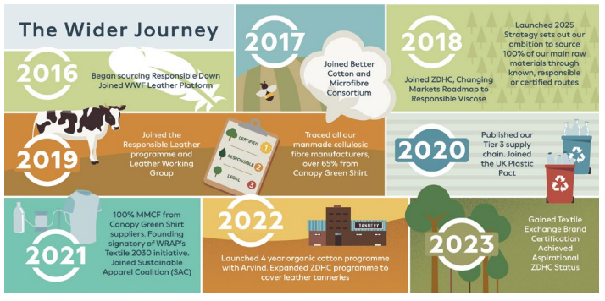
Figure: Journey of NEXT PLC
Source: (NEXT PLC, 2024)
Product Development: NEXT's strategy revolves around product development; the company is invested in growing its offering to cater for changing consumer tastes (Wood et al. 2021). The brand always brings new styles and fashion trends in its line.
Diversification: NEXT has undertaken related and unrelated diversification strategies (Wood et al. 2021). It has diversified with related products (home furnishings, children) that build upon the strength of its brand.
Competitive Strategy: Porter’s Generic Strategies
Cost Leadership: NEXT PLC has been able to achieve Cost leadership in its industry through effective supply chain management and economies of scale (Wood et al. 2021). After streamlining its operation and through negotiations with the supplier NEXT can maintain competitive pricing.
Differentiation: As another one of NEXT's strategic initiatives, differentiation aims to provide customers with the best products and highest services so that they receive unique values which none of their competitors can (Wood et al. 2021). What separates NEXT is their brand identity, unique product lines and excellent online store experience.
International Strategy: Global Expansion and Market Strategies
International strategy at NEXT PLC involves highly selective choice of international markets, and adaptation to local preferences. This consists of owned stores, franchised units and online touchpoints to expand out of their home market (Wood et al. 2021). Its market itself is boosted by strategic alliances and partnerships, for example, collaborating with local brands.
Business Strategy
Branding and Customer Focus: STP Strategy
Segmentation: This enables us to create a robust user profile, and with that information in mind we segment the audience of NEXT based on demographics, psychographics, behaviour etc (Le, 2023). It focuses on diverse segments such as young professionals, families and fashion-obsessed individuals to provide product lines that suit different tastes and lifestyles.
Targeting: The company tracks browsing data for targeted marketing efforts towards certain groups of consumers Marketing for each segment is unique and data-driven, closely analyzing customer behaviour to meet the needs of consumers consistently watching out various category-content preferences (Le, 2023).
Positioning: NEXT positions itself as the supplier of trendy, high-calibre goods at insignificant costs (Le, 2023). The brand image is represented by the three basic attributes: dependability, modern design and customer satisfaction.
Digital Transformation: E-commerce and Digital Marketing Strategies
The host of a connected e-commerce show, NEXT took the theme of harnessing digital transformation to serve customers further (Le, 2023). The company has a strong omnichannel proposition: A physical store in select cities, as well as a website and mobile app boasting features such as personalised recommendations, virtual tryouts and easy returns.
Sustainability Initiatives: Responsible Sourcing, Circularity, and Environmental Policies
Sustainability is two-fold at NEXT, with the terms and aspects highlighted in the company’s responsible sourcing and circularity (Le, 2023). On one part, NEXT ensures that it sources its materials and resources from certified and ethical sources to promote traceability and compliance with set environmental standards. The company also observes circular economy approaches by recycling and reusing its materials.

Resources and Capabilities Analysis
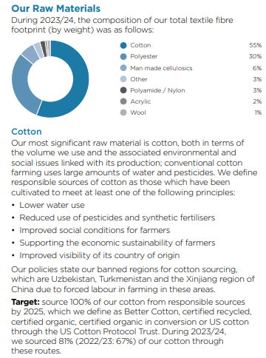
Figure: Resources
Source: (NEXT PLC, 2024)
Resource-Based View (RBV)
Tangible Resources
Financial Resources: Next PLC will take on a lot of financial resources to keep up with the trend. These funds give the company room to invest in new technologies and enter new markets, or survive when it is a thin month (Torres and Jasso, 2022).
Physical Resources: NEXT has a large chain of retail outlets, which are complemented by substantial networks of distribution centres and offices (Torres and Jasso, 2022). The company continues to demonstrate strong store throughput located in high visibility and easily accessible prime retail locations.
Technological Resources: NEXT uses the latest technological resources to improve its operational efficiency as well as enhance customer experience (Torres and Jasso, 2022). This includes state-of-the-art e-commerce platforms, customer relationship management (CRM) systems and data analytics tools.
Intangible Resources
Brand Reputation: NEXT has a strong brand reputation based on quality, trendiness, and affordability (Laasonen, 2023). The company has a strong reputation as an environmentally friendly and ethically sourced fashion brand which only enhances the consumer outlook on Dickies.
Intellectual Property: NEXT technologies include intellectual property, proprietary designs, trademarks and Copyrights (Laasonen, 2023). Those products are very inward-looking and recognisable, with trademarked designs differentiating them from the competition. In addition to consumer companies, NEXT also backs retail technologies that enhance the shopping experience, such as virtual try-on tools and in-store interactive displays.
Customer Loyalty: Customer loyalty is an important intangible asset of NEXT. With consistently good products, reliable deliveries and attractive loyalty schemes the three brands have created a loyal following (Laasonen, 2023). Customers can increase engagement and loyalty to a brand with initiatives such as the NEXT.
Core Competencies
Value Chain Analysis
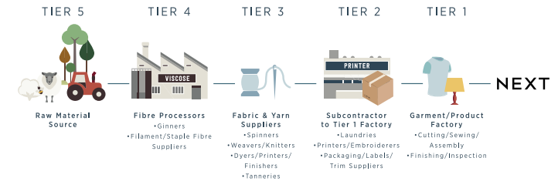
Figure: Value Chain
Source: (NEXT PLC, 2024)
Primary Activities:
- Inbound Logistics: Proper supply chain management ensures that you receive raw materials and goods in time, which means lower costs for storage reasons (Gomes et al. 2022).
- Operations: Defined manufacturing operations and QC systems to maintain consistent product quality.
- Outbound Logistics: Complex distribution centres and efficient logistics systems offer high-speed precision fulfilment (Gomes et al. 2022).
- Marketing and Sales: Strong marketing practices help increase sales by generating brand awareness as well as engaging customers on digital platforms.
- Service: Great customer service (including hassle-free returns and helpful support) improves overall satisfaction.
Support Activities:
- Firm Infrastructure: The strong organisational structure and management practices that enable the ambitions of a business (Gomes et al. 2022).
- Human Resource Management: Investing in your people and creating an all-round positive work culture that attracts top talent.
- Technology Development: Continuous retail technology and e-commerce platform updates that improve operational capabilities, as in the efficiency of operations & customer experience (Gomes et al. 2022).
- Procurement: The appearance of its product is convincing and cost-effective due to the strategic sourcing with sustainable partner status.
VRIO Framework
VRIO Criteria | Description
Value | - Enhances operational efficiency  - Improves customer satisfaction (Gomes et al. 2022)  - Supports sustainable practices  - Contributes to a strong market position and competitive advantage
Rarity | - Strong brand reputation  - Extensive physical and technological resources  - Loyal customer base (Gomes et al. 2022)  - Commitment to sustainability and ethical sourcing
Imitability | - Physical infrastructure and technologies can be imitated  - Brand reputation, customer loyalty, and sustainable practices are challenging to replicate (Gomes et al. 2022)  - Intangible resources are deeply ingrained in corporate culture and require significant time and investment to develop
Organisation | - Well-organised to exploit valuable, rare, and inimitable resources  - Effective strategic planning (Gomes et al. 2022)  - Efficient operations  - Strong leadership

Evaluation of Strategy Implementation
Success in Strategy Implementation
Financial Performance
Revenue Growth: NEXT PLC is a script which has maintained an upward trend of its total revenue items for the past years (Lane et al. 2022). Its e-commerce presence and investments such as partnerships with Amazon Pick-Up locations at Whole Foods stores show that sending a few emails has paid off, despite the tough retail climate.
Profitability: NEXT has always had strong profitability with healthy margins Managing cost-efficiently, and Operating improvement focus (Lane et al. 2022). This corporation has been doing well profitwise.
Market Share: NEXT has maintained or grown its market share in a fiercely competitive fashion retail environment (Lane et al. 2022). With the constant evolution of its product lines and improved customer engagement through digital.
Operational Efficiency
Supply Chain Management: NEXT has made material process improvements to its supply chain management to increase operational efficiencies (Lane et al. 2022). The corporation has established and utilised logistics in addition to advanced inventory control systems that have decreased lead times plus enhanced stock ranges.
Operational Improvements: Incorporating lean manufacturing techniques and continuous improvement initiatives has led to significant improvements in processes (Lane et al. 2022). Being able to iterate and adapt at the same pace as evolving consumer tastes is one of NEXT's key strengths and a factor in the performance of its ongoing operations.
Customer Satisfaction
Customer Feedback: NEXT is specifically designed to generate and respond to customer feedback on a sweeping level, leading it to produce better products. Researchers survey, read reviews and engage in social media conversations to identify customers' likes and dislikes (Miller et al. 2021).
Loyalty Programs: The NEXT Unlimited loyalty program, which provides unlimited deliveries for a fixed annual fee has helped to further drive customer retention (Miller et al. 2021). Such programs increase customer loyalty as the customer perceives added value and hence will be encouraged to make repeat purchases long-term Sale -
Market Perception: NEXT is very profitable as the market perceptions for brand-name companies have largely been positive in terms of quality, style and dependability (Miller et al. 2021). Its dedication to ethical sourcing and sustainability also delivers very favourably with an increasingly eco-conscious consumer base, elevating it in the market ranks and strengthening its customer loyalty.
Competitive Advantage
SWOT Analysis
Category | Factors
Strengths | - Strong brand reputation and market presence  - Advanced technological infrastructure  - Robust financial health and profitability (Bernhardsson et al. 2022)  - Effective supply chain management  - to sustainability and ethical practices
Weaknesses | - Dependence on the UK market for a significant portion of revenue  - Exposure to fashion industry trends and consumer behaviour shifts (Bernhardsson et al. 2022)  - High operational costs associated with maintaining physical stores
Opportunities | - Expansion into emerging international markets  - Diversification into new product categories  - Leveraging technology for further digital transformation (Bernhardsson et al. 2022)  - Enhancing sustainability practices to attract eco-conscious consumers
Threats | - Intense competition from both physical stores and online retailers  - Economic downturns affecting consumer spending  - Rapid changes in fashion trends leading to inventory obsolescence (Bernhardsson et al. 2022)  - Regulatory challenges related to sustainability and ethical sourcing
Benchmarking
Comparison with Key Competitors: Performance Benchmarking NEXT PLC competes with Marks & Spencer, ASOS and Zara among others (Bernhardsson et al. 2022). NEXT has substantially outperformed Marks & Spencer in terms of profit margins and revenue growth, reflecting its stronger multichannel proposition supported by more effective e-commerce capabilities after a successful supply chain transformation.

Competitiveness and Sustainability
Sustainability and Environmental Initiatives
Sustainability Goals: NEXT PLC has established its core material sustainability goals, committing to source 100% of its cotton products responsibly and have no hazardous discharge by 2025 (Huggins, 2021). With 81% of its cotton already responsibly sourced, there is a long way to go, but the company has made significant inroads.
Environmental Impact: NEXT acts to minimize its CO2 footprints and create a circular economy (Huggins, 2021). The company committed to reducing 50% of greenhouse gas emissions by the WRAPs Textiles 2030 program, also explained that being close to large export markets allowed them to meet its pledge and Develop Local Recycling Projects.
Corporate Social Responsibility (CSR)
Community Engagement: The CSR activities by NEXT further add to the value built around the brand (Sellitto, 2020). The long-term ‘charter’ partnership between NEXT and the British Heart Foundation (BHF) has seen customers donating furniture worth over £1.79 million from stores since 2016, which is incredible for our charity partners but also goes a step further; as part of its charter commitments it allows NEXT to work with education programs and offer local employment opportunities back into your area.
Stakeholder Management: The NEXT governance model makes effective stakeholder management a cornerstone of its governing process (Thorisdottir and Johannsdottir, 2020). The company gets involved with key stakeholders - customers, employees supply chain partners so forth to outspokenly have conversations about sustainability concerns.

Future Strategic Direction and Recommendations
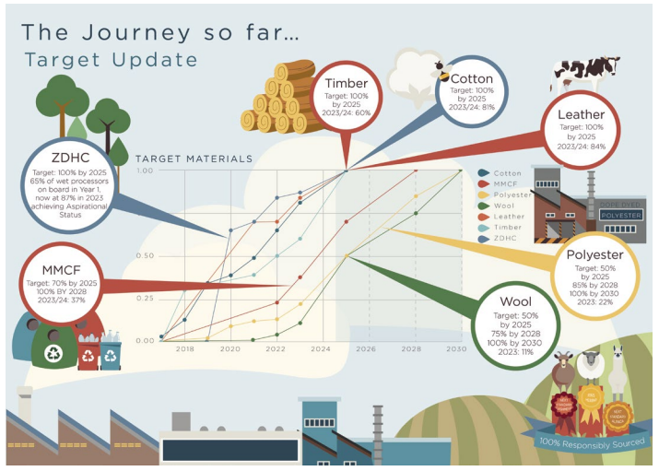
Figure: Company Growth
Source: (NEXT PLC, 2024)
Strategic Options
Growth Opportunities: NEXT PLC has the opportunity to move into developing markets in Asia and Latin America, where disposable incomes are growing as well as the size of middle-class society (Neely Jr, 2020). Further, creating new product verticals like athleisure or eco-home goods can help extend reach to a wider spectrum of consumers and benefit from prevailing market trends.
Innovation and Technology: NEXT must focus its efforts on developing advanced technologies - such as AI (Artificial Intelligence) & Machine Learning for predictive analytics in Inventory Management, Personalised Customer Experience etc. Making use of augmented reality for virtual try-ons, and enabling a more enriched customer shopping experience online are other points where NEXT could separate itself from the competition (Neely Jr, 2020). Transparency through blockchain technology There is more that can be done using the best new technologies to enhance trust and efficiency.
Sustainability Practices: NEXT should improve the share of renewable energy in operations and supply chains (Neely Jr, 2020). Its efforts with a circular economy, like take-back and in such an instance recycling clothing too can help reduce waste and appeal to consumers that have sustainability as a priority. More strategic partnerships with sustainable material innovators will further support the company in establishing itself as a greener brand.
Strategic Recommendations
Short-term Recommendations:
- Market Penetration: To increase the market share by launching targeted campaigns and promotions within the current markets (De Vries, 2021).
- Digital Transformation: AI/AR Technology enhancement on customer shopping experience and operational efficiency.
- Sustainability Initiatives: Deploy awareness campaigns to highlight the company's sustainability efforts and future green projects to increase brand loyalty (De Vries, 2021).
Long-term Recommendations:
- Global Expansion: Develop a strategic roadmap to enter Asian and Latin American emerging markets; with market research, partnership options, in country marketing (Conners, 2023).
- Product Diversification: Spend the money on R&D to come up with new product lines that match consumer trends (sustainable fashion and home goods) streams (Conners, 2023).
- Sustainable Practices: Set net-zero carbon emissions targets for 2040 by enhancing renewable energy utilisation and reducing waste through aggressive conservation standards, coupled with regular tracking of outcomes, as well as involving stakeholders.

Conclusion
This report has reviewed a detailed strategic analysis considering both internal and external factors of NEXT PLC, which includes its corporate strategy, business model, resources & capabilities and recent market deals for success. The key learnings were that NEXT PLC relied on its trusted brand image and high-end technology to operate effectively in the market, ensuring they still met sustainable guidelines for business efficiency by using adaptation processes greatly. Its competitive advantage is in part due to the company's strategic emphasis on market penetration, product development and international expansion. NEXT, which is further added to the mix due to an effective deployment of digital transformation and sustainability projects has helped bolster customer satisfaction Trusted Customer Scoresemeaningly dequeuing Lifetime Value. SWOT and Benchmarks showed what the company was doing well, but also areas good have growth room for improvement; while their Sustainability Practices Evaluation displayed stewardship over a responsible care®public commitment.

References
Bernhardsson, S., Boman, C., Lundqvist, S., Arvidsson, D., Börjesson, M., Larsson, M.E., Lundh, H., Melin, K., Nilsen, P. and Lauruschkus, K., (2022). Implementation of physical activity on prescription for children with obesity in paediatric health care (IMPA): protocol for a feasibility and evaluation study using quantitative and qualitative methods. Pilot and Feasibility Studies, 8(1), p.117.
Conners, E.E., (2023). Screening and testing for hepatitis B virus infection: CDC recommendations—United States, 2023. MMWR. Recommendations and Reports, 72.
De Vries, L.P., Baselmans, B.M. and Bartels, M., (2021). Smartphone-based ecological momentary assessment of well-being: A systematic review and recommendations for future studies. Journal of Happiness Studies, 22(5), pp.2361-2408.
Gomes, S.B., Santoro, F.M. and da Silva, M.M., (2022). A Bibliometric Analysis of Business Process Capabilities: Towards a Conceptual Model. In PoEM (Forum) (pp. 31-40).
Huggins, R., Prokop, D. and Thompson, P., (2021). UK competitiveness index 2021.
Laasonen, V., (2023). Exposing the role of relational capabilities in business–research–government cooperation: examples from the transition towards a bioeconomy in Finland. European Planning Studies, 31(6), pp.1226-1246.
Lane, C., Wolfenden, L., Hall, A., Sutherland, R., Naylor, P.J., Oldmeadow, C., Leigh, L., Shoesmith, A., Bauman, A., McCarthy, N. and Nathan, N., (2022). Optimising a multi-strategy implementation intervention to improve the delivery of a school physical activity policy at scale: findings from a randomised noninferiority trial. International Journal of Behavioral Nutrition and Physical Activity, 19(1), p.106.
Le, T.T., (2023). Corporate social responsibility and SMEs' performance: mediating role of corporate image, corporate reputation and customer loyalty. International Journal of Emerging Markets, 18(10), pp.4565-4590.
Miller, C.J., Barnett, M.L., Baumann, A.A., Gutner, C.A. and Wiltsey-Stirman, S., (2021). The FRAME-IS: a framework for documenting modifications to implementation strategies in healthcare. Implementation Science, 16, pp.1-12.
Neely Jr, B.H., Lovelace, J.B., Cowen, A.P. and Hiller, N.J., (2020). Metacritiques of upper echelons theory: Verdicts and recommendations for future research. Journal of Management, 46(6), pp.1029-1062.
NEXT PLC (2024) Our Customers and Products. Available at: https://www.nextplc.co.uk/corporate-responsibility/our-customers-and-products (Accessed: 20 July 2024).
Sellitto, M.A., Camfield, C.G. and Buzuku, S., (2020). Green innovation and competitive advantages in a furniture industrial cluster: A survey and structural model. Sustainable Production and Consumption, 23, pp.94-104.
Thorisdottir, T.S. and Johannsdottir, L., (2020). Corporate social responsibility influencing sustainability within the fashion industry. A systematic review. Sustainability, 12(21), p.9167.
Torres, A. and Jasso, J., (2022). Capabilities, innovation, and entrepreneurship: Startups in Latin America. In The Emerald Handbook of Entrepreneurship in Latin America: Unleashing a Millennial Potential (pp. 177-200). Emerald Publishing Limited.
Wood, D.J., Mitchell, R.K., Agle, B.R. and Bryan, L.M., (2021). Stakeholder identification and salience after 20 years: Progress, problems, and prospects. Business & Society, 60(1), pp.196-245.

