

Student name: Joyce Ebihor
Student ID: 2323239
Module name: Methodology Poster
Module code: BMHP6020-LON
Supervisor’s name: Bianca Sanfilippo

 |  | INTRODUCTION  My project title:  HEALTHCARE ACCESS AMONG ETHNIC MINORITY COMMUNITIES - BARRIERS TO HEALTHCARE ACCESS AMONG ETHNIC MINORITY POPULATIONS IN THE UNITED KINGDOM  Aim:  The objective of this study is to explore why ethnic minorities are disadvantaged in accessing health care services in the UK..  Objectives:  - This research has the following objectives:  - To understand the primary issues that are impacting ethnic minority groups in the UK when accessing healthcare.  - To look at the role language differences, cultural beliefs, socio-economic status and discrimination play in the use of health services.  - To learn about the experiences and perceptions of ethnic minority people about health services.  - To assess current policies and initiatives to reduce inequalities in health and healthcare. |  | 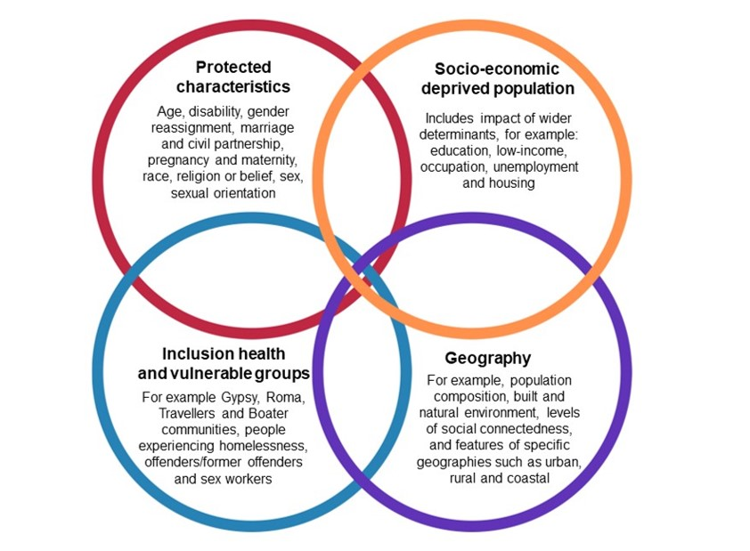
Methodology  This study will be qualitative research with a literature review method. Secondary data will be gathered from peer-reviewed journal articles, in the past 10 years, which can enhance the research (Ellram and Tate, 2016).  Electronic searching of literature using the PubMed, CINAHL, Scopus and Google Scholar databases will be conducted to identify relevant literature. The following words and phrases will be used: ethnic minority communities, access to healthcare, health inequalities, barriers and in the United Kingdom (Kelly et al., 2016). |  |  |  | Data analysis  Thematic analysis is used to identify common patters.  Ethical considerations  Ethics for secondary research include honest reporting of data and academic integrity.

References
Cookson, R., Asaria, M., Ali, S., Ferguson, B., Fleetcroft, R., Goddard, M., Goldblatt, P., Laudicella, M. and Raine, R. (2016) ‘Health Equity Indicators for the English NHS: a longitudinal whole-population study at the small-area level’, Health Services and Delivery Research, 4(26), pp. 1–224. Available at: https://doi.org/10.3310/hsdr04260.
Delara, M. (2016) ‘Social Determinants of Immigrant Women’s Mental Health’, Advances in Public Health, 2016(1), pp. 1–11. Available at: https://doi.org/10.1155/2016/9730162.
Ellram, L.M. and Tate, W.L. (2016) ‘The use of secondary data in purchasing and supply management (P/SM) research’, Journal of Purchasing and Supply Management, 22(4), pp. 250–254. Available at: https://doi.org/10.1016/j.pursup.2016.08.005.
Kelly, S., Martin, S., Kuhn, I., Cowan, A., Brayne, C. and Lafortune, L. (2016) ‘Barriers and Facilitators to the Uptake and Maintenance of Healthy Behaviours by People at Mid-Life: A Rapid Systematic Review’, PLOS ONE. Edited by Y. Wang, 11(1), p. e0145074. Available at: https://doi.org/10.1371/journal.pone.0145074.
Memon, A., Taylor, K., Mohebati, L.M., Sundin, J., Cooper, M., Scanlon, T. and de Visser, R. (2016) ‘Perceived Barriers to Accessing Mental Health Services among Black and Minority Ethnic (BME) communities: a Qualitative Study in Southeast England’, BMJ Open, 6(11), p. e012337. Available at: https://bmjopen.bmj.com/content/6/11/e012337.

