Research Proposal for Dissertation

Child Sexual abuse and Groomers online, how should UK child protection agencies respond?

Name: Marlene Roderick

Date: 24 of November 2017

Tutor: Tania Davies

Supervisor: Karen Burton

Section 1 Chapter One

Child Sexual abuse and Groomers online, how should UK child protection agencies respond?
Introduction
Child sexual abuse is a concern worldwide, this is due to it being constant, insidious and a serious problem to society (Johnson, 2004). A child recovers from physical abuse in the short term but sexual abuse can leave the child with a persistent psychological or medical problem, however Child sexual abuse infrequently results in death. This kind of abuse can be associated with pregnancy, sexually transmitted diseases or suicide (Maniglio, 2009). It is very difficult to measure the exact figure of how many children have been sexually abused in the world. This is due to different reasons such as the victim has not reported it, sometimes the child is too young and does not have the skill to communicate or report it, or the child does not recognize the abuse as improper (Johnson, 2004). Children also tend to not say what has happened, tending to keep it a secret or are told to keep it secret. Finally, in developing countries where the economy is low and there are limited resources, frequently, the infrastructure is not there to allow the collection of data about all the suspected child abuse cases (Johnson, 2004).
In the UK in a decade between 2005-2015 sexual offences against children has risen from 15.5 (per 10,000 children aged under 16) to 34.05 (per 10,000 children aged under 16). In 2015 to 2016 sexual offences had the most number of offences than in the past decade (Bentley, et al., 2017). This measure was reported and recorded by the police across the UK. The figures cover ranges of sexual offences such as rape, sexual activity with a minor, sexual assaults and child grooming (Bentley, et al., 2017).
Online
The internet is a modern system that has a wide ranging technical and a positive impact on society. The online environment allows people access to a wider community and information across the world in both distance and time, providing a good source to learn, however it’s also a double-edged sword with negative and positive consequences (Valkenburg & Soeters, 2001). Children are particularly vulnerable when using the internet as sexual predators are looking for different opportunities to connect with them. Some of these connections are; online, social media, text, which can lead to face to face encounters. (Livingstone, et al., 2010). Online is one of the easy way for sexual offenders to connect with children because children being unprotected to sexual messages from adults (Kierkegaard, 2007).
In the UK 67% of children at the age 9 to 16 have access to the internet and have a profile on a social networking site. From this figure 28% of children (1 in 4) at the age 11 to 16 have had an upsetting experience on a social networking site (Livingstone, et al., 2010).
The figures of child sexual abuse online are increasing, that is the reason the government setup WePROTECT. This is a Global Alliance to eliminate and prevent the online child sexual abuse and sexual exploitation. The aim is to identify the victims and safeguard them. It also tries to identify the sexual offenders and to act against the abusers. The aim is to create a world free of online child sexual abuse and sexual exploitation (MP & OBE, 2016).
Justification
This topic was chosen because it is an interesting subject to research. It also was chosen because the research focusses on something that is relevant to future career prospects. It has been identified as a problem to society as the figures shows that online child abuse has increased and is linked to an expected pregnancy, sexually diseases or suicide. It has been proven to damage children physically and psychologically for the later life.
The purpose of this research is to provide a wider investigation about child sexual abuse and groomers online and how it affects children in the UK. It will investigate the strengths and weaknesses of how child protection agencies respond with the purpose of achieving the necessary research to benefit society to consider some recommendations which could help to minimalize online child abuse in the future.
Aim
The aim of this study is to investigate child sexual abuse and groomers online and how UK child protection agencies respond. It will make recommendations for possible solutions that child protection agencies could adopt.
Objectives
The objective of this dissertation will be: -
- To describe what is child sexual abuse and how groomers connect with children.
- Define the child protection policies that exist and how they are utilized to protect children in the UK.
- Use all available resources to critically analyse current research on child protection best practices.
- Answer the question using collated data to propose improvement protection measures against groomers.

Section 2 Chapter Two
Systematic Review
The purpose of a systematic review is to find as wide a scope of research as is possible which is related to a specific research question. Systematic reviews will give the researcher the essential knowledge to be able to answer the question and allow for some recommendations to be made. Often it will include meta-analysis which uses statistical data to thoroughly assess previous research (Haidich, 2017). A literature review is a type of systematic review which collects data to enable critical analysis, using methods to achieve the necessary knowledge to be able to answer the formulated question (Uman, 2011).
The rationale for choosing the research method is to attempt to mitigate gaps in the current literature. Previous studies have been conducted regarding child sexual abuse and groomers online but due to the evolution of new technology and social behaviour, research is needed to have an improved understand and develop enhanced preventions. This methodology will follow a protocol before the work is undertaken, it is explicit and attempts to give a framework so that exhaustive searches on relevant research can be conducted. It is felt that this dissertation will therefore be produced to a higher standard.
The advantages of using a systematic review is that it will aid the researcher in gaining an overview on child sexual abuse and groomers online; and how child UK protection could respond. It will allow for the identification of gaps and limitations within the dissertation by providing a solid framework to follow and help to reduce researcher bias (Hillegass, 2010).
The disadvantage of using a systematic review is that it can lengthen the review and be time consuming. The researcher needs to be an expert on the chosen subject, it involves a formal research protocol and will only answer or be relevant to the one question (Hillegass, 2010).
Methodology and Justification
Methodology is the process of how the researcher gains the knowledge (Grix, 2002). It is linked to epistemology, which is a theory of knowledge that refers to the question about how and what the researcher knows. Epistemology states how the researcher can or cannot know what is true. It can be considered as a stance on what should be permissible as acceptable knowledge (Tennis, 2008). Methodology also is linked with ontology, this is the theory that refers to the question about what is meant by existence, what is in the field of what is known (Grix, 2002).
The researcher chose to follow the Critical Appraisal Skills Programme (CASP) methodology. This will help the researcher to critically analyse the research and enable relevant information to be carefully selected. CASP will question the findings in more detail to benefit the researcher to measure the strengths and limitations of the values or merits of what the researcher investigates. The researcher will able to justify their own conclusions (Woolliams, et al., 2011).
CASP is very beneficial to the researcher to conduct the critical analysis, it will help to validate reliable sources, it will facilitate the researcher to make sense of the results and the context showing the meaning of the results for decision-making. It will increase the value of the research reducing waste (CASP, 2017). The negative part of using CASP is this methodology can be biased against unpublished studies. It can be constricted by the selection reviewed by the researcher, by the time available and by the limited languages researched (CASP, 2017).
After initial investigating and researching it is felt that this is the best way to approach answering the question of the dissertation.
Methods and Justification
Methods are the process and strategies for collecting, analysing and interpreting data sources (Neale, 2009). The Methods used in the dissertation will be; CASP questionnaire.

Chart of articles were analysed
Journal Article | Q1 | Q2 | Q3 | Q4 | Q5 | Q6 | Q7 | Q8 | Q9 | Q10
1 | DK | Y | XN | XN | XN | Y | Y | DK | Y | DK
2 | Y | XN | Y | Y | Y | Y | XN | DK | DK | XN
3 | DK | Y | Y | XN | Y | DK | XN | Y | Y | Y
4 | Y | XN | XN | XN | Y | Y | Y | Y | DK | DK
5 | DK | Y | Y | XN | XN | Y | DK | Y | Y | DK
6 | Y | XN | XN | Y | Y | Y | Y | Y | Y | DK
7 | Y | DK | XN | Y | XN | DK | DK | Y | Y | Y
8 | DK | DK | Y | Y | XN | XN | Y | XN | Y | DK
9 | DK | Y | Y | XN | Y | Y | Y | Y | DK | DK
10 | Y | XN | XN | Y | DK | Y | Y | Y | Y | Y

Ethical Consideration
The ethics that need to be considered whilst conducting the dissertation are that the subject matter could be sensitive especially as it involves looking at information around vulnerable persons (namely children). It could affect the way information is collected and as secondary information is used it could have affected the information already gathered due to the age of the subjects. It could also be affected by the researcher having a biased view on the subject matter and not being able to research effectively (Gardner, 2011). The literature reviewed must be obtained from an ethically sound position.
Chapter Three
Planning
As Appendices 1.1-1.3 shows the Gantt chart has been broken down all the stages that are needed to complete the dissertation. Each piece of work has been assigned a unit of time (the granularity has been set as 1 day). As the Gantt chart shows it has not only the work needed to be completed for the dissertation but also has the journal assignment and holidays built in to show a true picture of the time available and how that time will be managed. Attached to this is also the resources that will be used to complete each section. Large pieces of work have been broken down into more manageable parts.

References
Bentley, H. et al., 2017. How safe are your children?, United Kingdom: NSPCC.
CASP, 2017. Critical Appraisal Skills Programme (CASP) Making sense of evidence. [Online]
Available at: http://www.casp-uk.net/news
[Accessed 11 November 2017].
Gardner, J., 2011. Ethical Guidelines for Educational Research. [Online]
Available at: https://www.bera.ac.uk/wp-content/uploads/2014/02/BERA-Ethical-Guidelines-2011.pdf?noredirect=1
[Accessed 11 November 2017].
Grix, J., 2002. Introducing Students to the Generic Terminology of Social Research. Wiley Online Library, 22(3), pp. 175-186.
Haidich, A. B., 2017. Meta-analysis in medical research. Hippokratia, 14(1), pp. 29-37.
Hillegass, A. A. B. a. W. B., 2010. overview, strengths and Limitations of Systematic Reviews and Meta-Analyses. In: C. F., ed. Evidence=Based Practice: Toward Optimizing Clinical outcomes. Bimingham, USA: Springer Link, pp. 17-33.
Johnson, C. F., 2004. Child Sexual Abuse. The Lancet, 364(9432), pp. 462-470.
Kierkegaard, S., 2007. Elsevier. Cybering, online grooming and ageplay, 24(1), pp. 41-45.
Livingstone, S., Haddon, L., Görzig, A. & Ólafsson, K., 2010. Risks and safety for children on the internet: the UK report, London: LSE.
Maniglio, R., 2009. The impact of child sexual abuse on health: A systematic review of reviews. Clinical Psychology Review, 29(7), pp. 647-657.
MP, T. R. H. T. M. & OBE, B. S., 2016. WePROTECT: fighting online child sexual exploitation. [Online]
Available at: https://www.gov.uk/government/news/weprotect-fighting-online-child-sexual-exploitation
[Accessed 03/11/17 November 2017].
Neale, J., 2009. Research Methods for Heath and Social Care. first ed. London: Palgrave Macmillan.
NHS Choices, 2017. HIV and AIDS. [Online]
Available at: https://www.nhs.uk/conditions/hiv-and-aids/
[Accessed 02 11 2017].
Tennis, J. T., 2008. Epistemology, Theory and Methodology in knowledge Organization: toward a classification, Metatheory, and Reserach Framework. Knowledge Organization, 35(2/3), pp. 102-112.
Uman, L. S., 2011. Systematic Reviews and Meta-Analyses. J can Acad child Adolesc Psychiatry, 20(1), pp. 57-59.
Valkenburg, P. M. & Soeters, K. E., 2001. Children's Positive and Negative Experiences with Internet. Sage Journals, 28(5), pp. 652-675.
Woolliams, M., Williams, K., Butcher, D. & Pye, J., 2011. Be More Critical; Apractical guide for Health and social Care students. [Online]
Available at: https://www.nottingham.ac.uk/studentservices/documents/oxfordbookesuni-bemorecritical2.pdf
[Accessed 10 November 2017].

Appendix
Search strategy
The Methods used in the dissertation will be; Systematic review of the literature which includes a mixed method approach combining quantitative and qualitative data. It will utilize secondary research such us; University sources, Journals, books, surveys, reports, internet sources such as; Google scholar, Government websites, ProQuest, Cochrane Library, Elsevier, NHS, the library, and ICT (Neale, 2009).
This method will link to the dissertation question as it allows for the research to take into consideration many different sources and enables the creation of multiple arguments. It allows for the strengths of one type of method to overcome the weaknesses of another method and gives the researcher a more complete knowledge to gain a better understanding (Neale, 2009).

Thesis Search Sheet

My research question / aim / objective: |  | Child Sexual abuse and Groomers online, how should child UK protection agencies respond?  Aim  The aim of this study is to investigate child sexual abuse and groomers online, in the UK; how should child protection agencies respond? to recommend possible solutions for child protection agencies to follow.  Objectives  The objective of this dissertation will be: -  - To describe what is child sexual abuse and how groomers connect with children.  - Define the child protection policies that exist and how they are utilized to protect children in the UK.  - Use all available resources to critically analyse current research on child protection best practices.  - Answer the question using collated data to propose improvement protection measures against groomers.
Places to search for information: |  | University sources, Journals, books, surveys, reports, internet sources such as; Google scholar, Government websites, ProQuest, Cochrane Library, Elsevier, NHS, the library, and ICT
Date | Database Name |  | Search Terms | No of Results | Comments
11/11/17 | Google |  | CASP | 388.000 | No all have been updated.
11/11/17 | The Lancet |  | Child Sexual abuse | 1338 | No all are free.
12/11/17 | Wiley Online |  | Social Research Terminology | 73613 | No all are free.
13/11/17 | Elsevier |  | online grooming | 107 | No all are free.

1.1 Gantt Chart
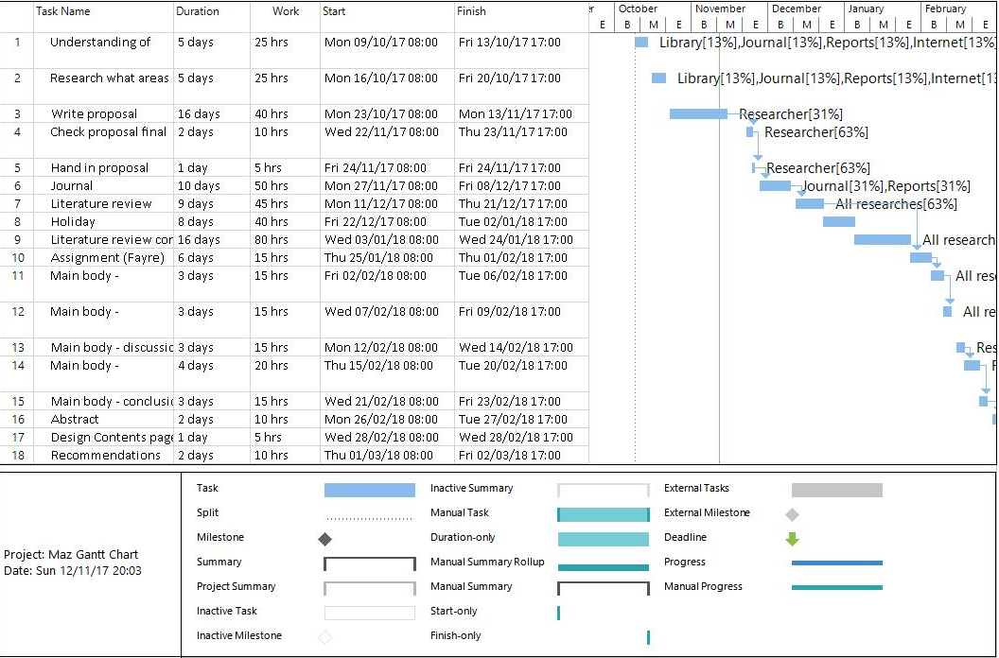

1.2 Gantt Chart
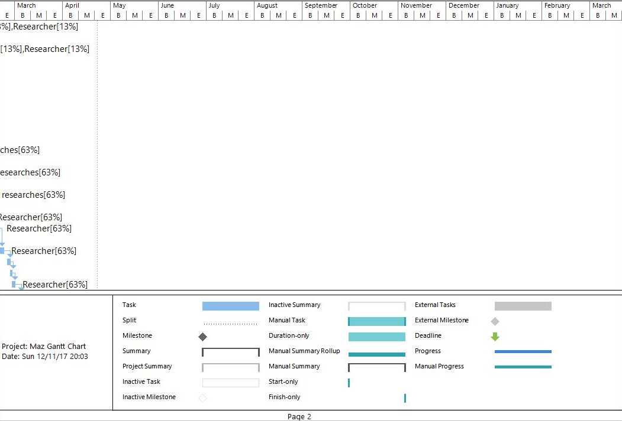

1.1 Gantt Chart


