A Case Study of Hilton Hotel, UK

UNIVERSITY OF WALES TRINITY SAINT DAVID
IMPACT OF ECONOMIC ISSUES ON THE SUSTAINABLE
DEVELOPMENT OF THE HOSPITALITY SECTOR

Diana Lima (1815043)
Lecture: Mr. Dale Clarke

Table of Contents
1. Introduction 2
1.1 Introduction to the topic 2
1.2 Background of the chosen organisation 2
1.3 Research aim and objectives 3
2. Literature Review 3
2.1 Economic issues faced by the UK hospitality industry 3
2.2 Impact of the economic issues on the sustainable development of the hospitality industry in the UK 4
3. Methodology 5
4. Primary Data Analysis 5
5. Conclusion and recommendations 6
6. Conclusion 7
7. Reference List 8

1. Introduction

1.1 Introduction to the topic
UK has faced various economic issues in recent years such as Brexit and COVID-19 pandemic being the most important issues. Brexit has impacted the economy of the UK drastically and negatively. The GDP for the country shrank and the UK failed to achieve an open investment and trading with the EU after Brexit. The country faced economic losses as the productivity levels suffered. The hospitality sector also suffered as it has employed more than 400,000 European migrant workers. Before Brexit, these workers did not require any visa or work permit to enter the country and get employment. The pound also depreciated which means the import costs rose and the tourism also suffered.

Apart from this, the latest economic issue faced by the global world is COVID-19 pandemic. The hospitality industry is also affected due to the pandemic as travel was shut down and people stopped visiting hotels and restaurants. The UK employs a large part of the workforce in the hospitality sector and due to the shutdown, the businesses suffered greatly. This research will be undertaken to understand the impact of the economic issues on the hospitality industry and its sustainable development and the chosen organisation for this research is the Hilton Hotel, UK.

1.2 Background of the chosen organisation
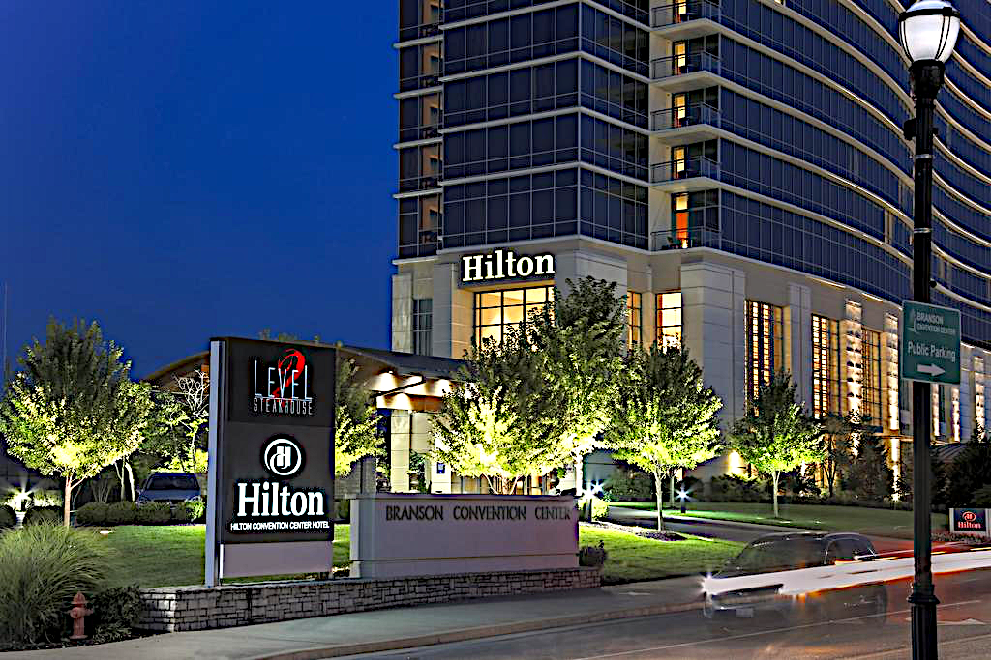
Hilton Worldwide Holdings Inc, formerly known as the Hilton Hotels Corporation is a global chain of hotels comprising of hotels and resorts. The hotel chain was established by Conrad Hilton in 1919 and is headquartered in Virginia, USA. As per the report in 2020, Hilton has around 977,000 rooms in 6110 properties and operates in 120 countries. Out of the total number of properties, 4847 are franchises and 689 are wholly owned (Hilton, 2020). It is one of the leading global hotel chains and has around 18 different brands. For this research, the Hilton hotel in the UK is selected and the study will be done as per the data available here.

1.3 Research aim and objectives
Aim
To find out the impact of economic issues on the sustainable development of the hospitality sector with the case study of Hilton hotel, UK
Objectives
- To find out the economic issues faced by the hospitality industry in the UK
- To understand the impact of the economic issues in the hospitality industry in the UK
- To analyse the sustainable development in the hospitality industry in the UK
- To perceive the impact of the economic issues on the sustainable development of the hospitality sector in the UK

2. Literature Review

2.1 Economic issues faced by the UK hospitality industry

Brexit and COVID-19 have created various economic issues for the hospitality industry in the UK. The depreciation of the pound, rise in import costs, inflation rates and the nationwide shutdown has impacted the chosen industry negatively. In the words of Tetlow and Stojanovic (2018), the weakening of the pound has led to losses for the hospitality industry as the import costs for goods has risen. The main economic concern is the availability of labour for the industry as most of the workforce was migrant labourers from the EU. Now the migrants must have a visa or work permit to work in England. According to Chang (2018), the hospitality industry will also lose investors and this will affect the foreign direct investment in the sector as well as the country. Inflation is another economic issue faced by the industry as there will be a rise in food and beverage prices. Retaining the skilful and experienced staff members is another economic impact faced by the hospitality industry as most of the workers belong from the EU region and now the organisations have to pay huge sums of money to get their work permit and visa done.
Another economic issue that has risen is due to the outbreak of the COVID-19 pandemic. The pandemic has led to the mass cancellation of many foreign and national tours, corporate and business events, social events, sports event and various others. There were bans on international travel along with strict lockdown measures and social distancing. The hospitality industry has been vastly impacted due to this. As per the data, the hospitality industry of the UK contributes around 5 per cent to the national GDP and a huge percentage of the workforce is employed in this sector (Hospitality Net, 2020). Nevertheless, the lockdown has stopped the travel for leisure and business thereby affecting the tourism in the UK. The UK is among the worst-affected areas by the COVID-19 outbreak and international travel will fully resume depending upon the condition of the pandemic and travel restrictions. The hospitality industry is facing losses in their business, they are unable to provide remuneration to their staff members properly, many employees are resigning from the jobs or they are being sacked. Many small hotels and restaurants are shutting down permanently as they are unable to bear the losses and it will be difficult for them to recover after this period as well.

2.2 Impact of the economic issues on the sustainable development of the hospitality industry in the UK
In the words of Jones et al., economic sustainability “refers to practices that support long-term economic growth without negatively impacting social, environmental and cultural aspects of the community.” Sustainability is an important factor for the development of the hospitality industry as it will ensure that the hotel can gain profitability and increased revenue for the long-term. The economic issues discussed above such as Brexit and COVID-19 has an impact on the sustainable development of the hospitality sector. The rise in the import costs will reduce the cost efficiency for the hospitality industry as they will have to pay more for import. This will impact the efficiency of the process of the workplace. The increase in the inflation rates has increased the rates of all the products such as furnishing, lighting and others. The hospitality industry is trying to use renewable sources of energy for their operations. This has aided in the sustainable development for the industry.
The generation of wastes and the carbon footprint of the hospitality industry are larger than in other industries. The labour costs issues also add up to the economic issues for the hospitality industry. The biggest expense for the hospitality industry is the cost of labour and the remuneration provided to them. This means that if the hotels are not able to manage this properly, they will face increased costs thus affecting the economic sustainability of the industry.

3. Methodology
This section will discuss the processes and methods through which the data will be collected to complete the research and gain significant outcomes. The first step is to determine the research philosophy. This will depend on the type of data that will be gathered and how it will be analysed. The philosophy for this research will be the positivism philosophy as it adheres to only “factual knowledge” that will be gained with the help of observation (Bryman, 2016). As per this philosophy, the data will be collected and analysed objectively. Along with this, the deductive approach will be utilised as it aids in developing a hypothesis and then the research is carried out to test the hypothesis. The data is measured quantitatively with the help of this approach. Between the two data collection methods, the researcher will be employing the primary data collection method to gather fresh data from the respondents (Bell et al., 2018). The employees of Hilton Hotel in the UK will be surveyed through a questionnaire as the researcher believes that the employees get the maximum blow of any issues or changes within the organisation or the industry.
The simple random probability method is selected for choosing the sample respondents. A total of 25 employees were selected and asked to participate in the research. The quantitative data collection method has been selected as the questionnaire contained close-ended questions. By analysing the data collected, the researcher will be able to gain significant results related to the topic of the research.

4. Primary Data Analysis
As per the data gathered, it can be observed that most of the respondents (68 per cent) agreed that Brexit and COVID-19 have created economic issues for the entire hospitality industry. This means that there is a negative impact on the hospitality industry as they faced losses. Various issues have impacted the chosen organisation as well as the hospitality industry in the UK. Among these 36 per cent of the respondents stated that the rise in inflation hurt the organisation. Along with this, the depreciation of the pound, rise in import costs and the migration of labour were also the issues due to the economic factors for the firm. The organisation has also undertaken various sustainability practices to address economic issues. 24 per cent of the employees said that conserving energy and cutting down on food waste has helped the organisation to tackle the economic issues and aim for sustainable development. 60 per cent of the employees agreed that by tackling the economic issues, the organisation can practice sustainability in its development process.

5. Conclusion and recommendations
From the above analysis, it can be said that the impact of economic issues has created a hindrance in the sustainable development of the hospitality industry and the Hilton hotel in the UK. Brexit and COVID-19 have led to certain economic issues for the hospitality industry as they are facing losses and a loss of guests. Organisations must develop strategies for sustainable development.
- Creating a paperless hotel will ensure the reduction in deforestation thus making way for sustainability. It will also reduce the contact between the individuals which will help in curbing the spread of the COVID-19 virus. All the operations can take place digitally
- Sustainability can also be incorporated into the development of new buildings for hotels. Using the “three zero concepts” approach will aid in cutting done the operating costs for the hotel.
- The organisations can use local construction materials which will mean they do not have import raw materials
- Proper waste management and minimising the energy use will also lead to sustainable development for the organisation and the industry
- The menu can be modified in a way where only local and homegrown food items are served. The items can be sourced sustainably and it will also help the organisation to build better connections with their guests as they will be able to experience the local culture and cuisine.

6. Conclusion
The above research report evaluated the impact of economic issues on the sustainable development of the hospitality industry. A case study was done on the Hilton group of hotels in the UK. The literature review helped in understanding the background information required for this research and how the research will be carried out. The main causes for the economic issues were Brexit and the COVID-19 pandemic. The various economic issues were the depreciation of the pound, rise in the inflation rates and import duties and work permit for the migrant labours. The participants were the employees of the Hilton hotel were chosen through the simple random sampling method and there were 25 participants. The chosen organisation has undertaken different sustainability practices to ensure that the economic issues are tackled properly and ensure sustainable development for the organisation as well as the industry.

7. Reference List

Bell, E., Bryman, A. and Harley, B., 2018. Business research methods. Oxford university press.

Bryman, A., 2016. Social research methods. Oxford university press.

Chang, W.W., 2018. Brexit and its economic consequences. The world economy.

Filimonau, V. and Mika, M., 2019. Return labour migration: an exploratory study of Polish migrant workers from the UK hospitality industry. Current Issues in Tourism.

Gössling, S., Scott, D. and Hall, C.M., 2020. Pandemics, tourism and global change: a rapid assessment of COVID-19. Journal of Sustainable Tourism,

Net, H. (2020) COVID-19 Outbreak Has Jeopardized UK Hospitality Sector, Says GlobalData, Hospitality Net. Available at: <https://www.hospitalitynet.org/news/4098446.html>.

Stylos, N. and Vassiliadis, C., 2015. Differences in sustainable management between four-and five-star hotels regarding the perceptions of three-pillar sustainability. Journal of Hospitality Marketing & Management, 24(8),

Tetlow, G. and Stojanovic, A., 2018. Understanding the economic impact of Brexit. Institute for government,

The Story Behind Hilton Hotels and Resorts (2020). Available at: <https://www3.hilton.com/en/about/hilton/index.html>.

Walliman, N., 2017. Research methods: The basics. Routledge.

Wikhamn, W., 2019. Innovation, sustainable HRM and customer satisfaction. International Journal of Hospitality Management,

