
Construction Portfolio
Fundamentals of Construction

April 28, 2022
Gavin Traylor
UWTSD 2114475

The roof structure chosen is a trussed rafter, King to be exact with metal profile sheeting installed on Oriented Standard Board (OSB) sheathing.
A King trussed rafter roof as shown in drawing 1 and the King post truss itself is in Figure 1 below.
Figure 1
Showing an image of a King post truss
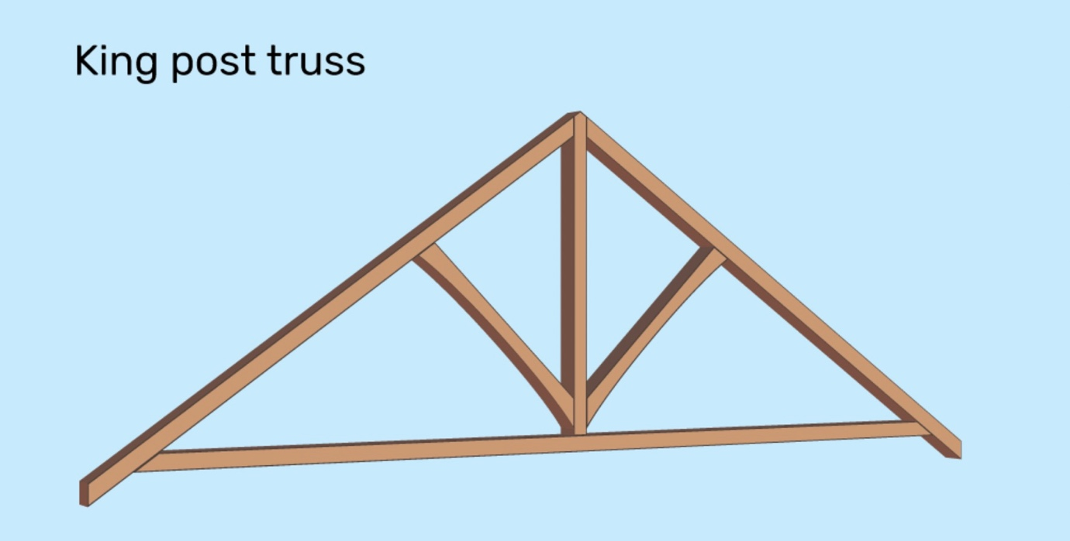
(Lane, 2022)

A truss is a framework made of timber that is used to support a roof by using rafters, struts, posts etc to support it, along with compression and tension. Trusses can be designed for different roofs such as monopitch, asymmetrical, symmetrical among others.

The advantages and disadvantages are as follows:
ADVANATAGES | DISADVANTAGES
Environmentally friendly | Little to no loft storage place
Prefabricated | Delivery, Handling and Storage can affect the performance
Have very large spans | Timber invites pests
Versatile
Faster Installation
Quality Control

ADVANTAGES
Truss roofs are environmentally friendly because timber requires less energy than that of other materials to manufacture which in turn decreases air and water pollution and, timber is a renewable material.
Trusses are also prefabricated which in turn cuts down on the onsite construction time. Prefabrication is the reason why the use of truss roof accounts for faster construction because there is no time spent on the construction of the actual truss on site and, with less time less money is spent on labour. Also, due to prefabrication the quality is better and more easily controlled because the truss is made in a factory where all variables are controlled, thus producing a higher grade with higher quality and leaves little room for human error because the finished product will be inspected before offered for sale. Factory production also denotes mass production which also gives ease of accessibility. Prefabrication also cuts down on wasted material and if material is left over, it will be incorporated in the construction of another material, whereas wasted material on site would not be or not as easily be recycled on site when constructing the trust.
Trusses have a triangular shape which contributes to their span being quite wide and the shape contributes to stability. Where regular solid wood beams would have a maximum span of less than 25meters trusses roofing can have a span up to 70m. (Moehring, 2010)

DISADVANTAGES
Trusses use compression and tension to distribute the load because of this this can stress the material and cause wear and tear on it leading to fast tracked deterioration causing structure failure. Also, because it uses compression and tension it must be constructed accurately to spread the load evenly or an imbalance may cause one part or side to be worn or to deteriorate faster than the other.
Timber is an open invitation to pests so timber used should be treated which in the event it gets overran by pests it needs to be treated and replaced.
Trusses because they are prefabricated need to be transported to the site, during the transportation from factory to site the quality of the truss can drop which can cause roof structural failure for example improper transport can cause pieces to become dislodged and if upon installation it is not noticed failure will occur. Trusses have webbing which is what allows for its tension and compression however, these get in the way and leave little to no loft storage space.

Metal profile sheeting was also used which were installed on OSB sheathing boards here are the advantages and disadvantages:

ADVANTAGES | DISADVANTAGES
Environmentally Friendly | More expensive to install and replace
Light Weight | May dent
Low Maintenance | Metal expands and contracts
Heat Management
Durable

Metal profile sheeting (MPS) is very economically friendly because it can be recycled and be made from other recycled material, thus reducing the amount that goes into the landfill and decreasing its carbon footprint.
It is light weight much lighter than other materials per square foot, metal profile covers a bigger area when you combine a different material such as clay or concreate tile to accumulate to the size one metal profile sheeting will over the other material will be much heavier.
MPS is also excellent and heat management because the metal reflects some the sun’s radiant heat cutting down on costs during summer to cool down. The MPS itself is a Class A as it regards fire resistance however it is installed on OSB sheathing which has a class of C.
MPS is more durable and has a lower maintenance where martials such as timber worry about pests’ metal profile sheeting doesn’t, it also lasts much longer and may not need to be replaced in a homeowner’s lifetime.

DISADVANTAGES
Overall, it is typically more expensive than other roofing material, so the installation costs would be much higher. It is also more expensive to replace where you can replace one tile which is quite small of there is a problem with one sheet of metal profiling no matter hose small the entire thing needs to be replaced.
MPS is also susceptible to rusting which can shorten the life span, but most are given an anti-rust coating to prevent this.
Due to heat, it can cause the metal to expand and contact which can cause screws or bolts to come free however this can be fixed easily with fastening systems to accommodate movement.
To conclude trussed roofs are a great option and it depends on what the project is, for this it will be a good option the only fact that negates it being a perfect option is the lack of space for storage, in that case an alternative roof structure will be a pitched roof.

ROOF STRUCTURE ALTERNATIVE
A Pitched roof, double pitched to be exact will be a great alternative because it includes the space for loft storage or even for a small room.
Krunal Rajput. Civil engineer defines a pitched roof as “a roof that slopes downwards, typically in two parts at an angle from a central ridge, but sometimes in one part, from one edge to another.” (Rajput, 2021)

A Pitched roof is shown in fig 2
Fig 2
Showing an image of a pitched roof
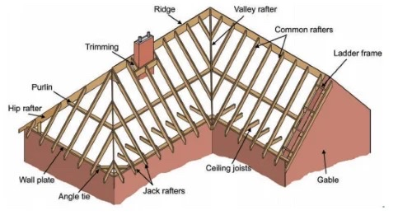
(Rajput, 2021)
A double pitched roof has its advantages such as that the design, this type of roof structure is best known for its aesthetic because it is quite appealing to the eye, even though the structure is quite appealing the construction in not complicated it has a very simple yet effective design.
A double couple roof because of the angle of the slope being between 45$°$- 60$°$ it has excellent drainage for heavy rainfall or snowfall. The angle of the slope allows for better rainwater collection once the drainage system is modified correctly and is also easily maintained. The slope also helps redirect rainfall in the event of heavy rainfall.
This roof is also quite thermally efficient because of the height of the roof it allows for natural ventilation. Keeping the building cool when it needs to be and warm when it should.
This roof though more expensive than normal roofs may turn out to be cheaper in the long run as it regards guttering. As mentioned, the angle of the slope allows for redirection of water lightening the load of the guttering when it comes to heavy rain. In a lifetime once constructed right should not need a replacement.
The major perk of this roof apart from its life span is the loft space it affords the homeowner which can be used as storage or even as an additional living space without having to add an extra floor.

DISADVANTAGES
The cost to construct this beauty is much higher than other roof constructions however be if the home incorporates sustainability this can be a very good investment and save the homeowner more money. Meaning the rainwater can be used within the home cutting down on the water bill and solar panels can be installed because of the wide area of the roof covers this cut down on electricity.
The foundation of the house needs to be exceptional to carry the load that this roof puts on the foundation requiring deeper footings. This roofing type also uses a lot of material
It’s more geared towards flat one storey homes, it can still be used on this two-storey building with careful thought and design.

ALTERNATIVE ROOF FINISHING
Alternative roof finishing is Asphalt Shingle Roof Finishing.

ADVANTAGES
The primary pro of this material is its cost it is by far the most affordable roofing material available on the market and is installed and maintained correctly it can last between 25- 30 years. They are quite quick and easy to install and because of its popularity professionals will be easily found to install, their affordability also comes with the fact that no special tools are needed to install them.
They are also quite easy to tear down when they need to be replaced. Due to their popularity they can be found in many different shapes and colours giving persons a wide catalogue to choose from, allowing for a pleasing asthenic. Unlike metal profiles where rust is an issue asphalt shingles do not have that problem. They are also very compatible with most roofs.

DISADVANTAGES
These shingles are very light weight and can become loose when strong winds occur which will tear the shingles quite easily. Also, where cost goes down quality does as well when compared to other materials, they have a short life span and, when damaged leaves the roof structure underneath suspectable to the environmental elements. The excess moisture can cause moss to grow.

OFFSITE CONSTRUCTION
Off-site construction is a form of MMC which stands for Modern Methods of Construction which basically are all the approaches that aim to optimise the construction process to obtain more higher quality products in less time.
Off-site construction is a method that reduce the on-site construction time, it allows for elements of buildings or structures to be planned, designed, prefabricated, and assembled off site and transported to the site where all that needs to happen is the actual installation.
Off-site construction not only cuts down on construction time it can also cut down on labour cost when instead of paying someone to build the component which will take time and materials and the quality of the item depends of the quality of work the labourer puts out whereas off site construction when done in a factory setting and would then have the same quality straight across the board.

There are four types of off-site Construction:
- Panelised Systems
- Sub-assemblies and components System
- Volumetric System
- Hybrid System
Panelised systems in off-site manufacturing may or may not have a structural function, it can be open which is usually non insulated which is cheaper, they can also be closed when it comes with the insulation and service zone included or it can be SIPs ( Structural Insulated Panels) which is a variation of closed panels in this instance will be the timber frames that are used to create the house frame they will come assembled and will just need to be attached to the foundation, saving a lot of on-site construction time the timber frame will also come with the space for the services.
Sub-assemblies and components will be in the form of the truss where the king truss will come prefabricated and only require installation the same can be done for the joists. These were used in the house and will get the construction done quite quickly the actual frame of the building will be erected in quick time

Volumetric was not used here but it could’ve been used for the conservatory it’s basically a three-dimensional unit that are usually used where construction needs to be done in quick time example if a school needs to be relocated for whatever reason. They can be things like the entire bathroom including the toilet and sinks and come fully furnished.
There is also Hybrid System basically deals with concreate a great example is a floor slab or used in flooring.

Drawings
- Main Roof Structure
- Eaves Detailing and Roof Covering
- Ground Floor
- First floor
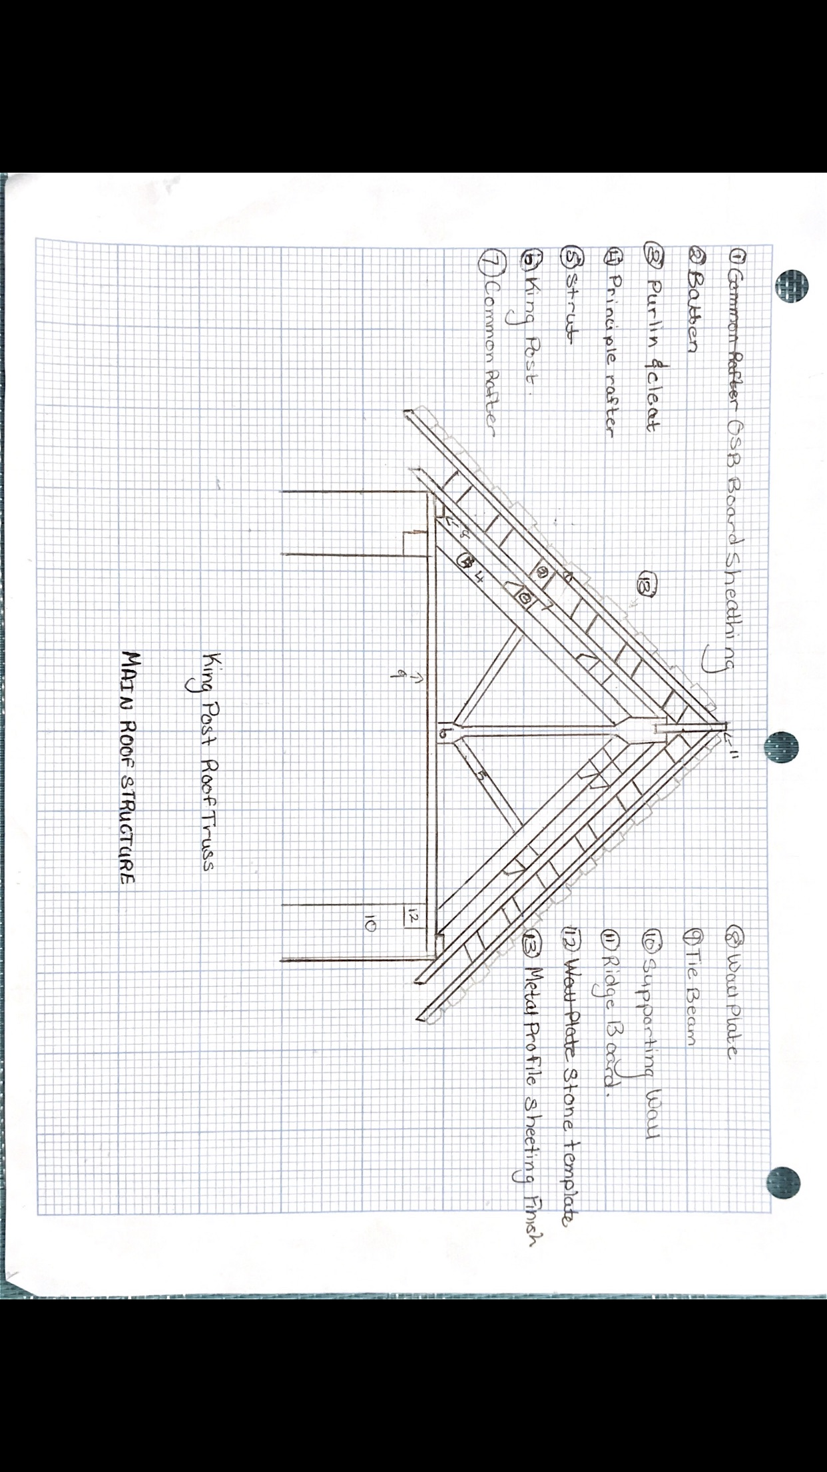
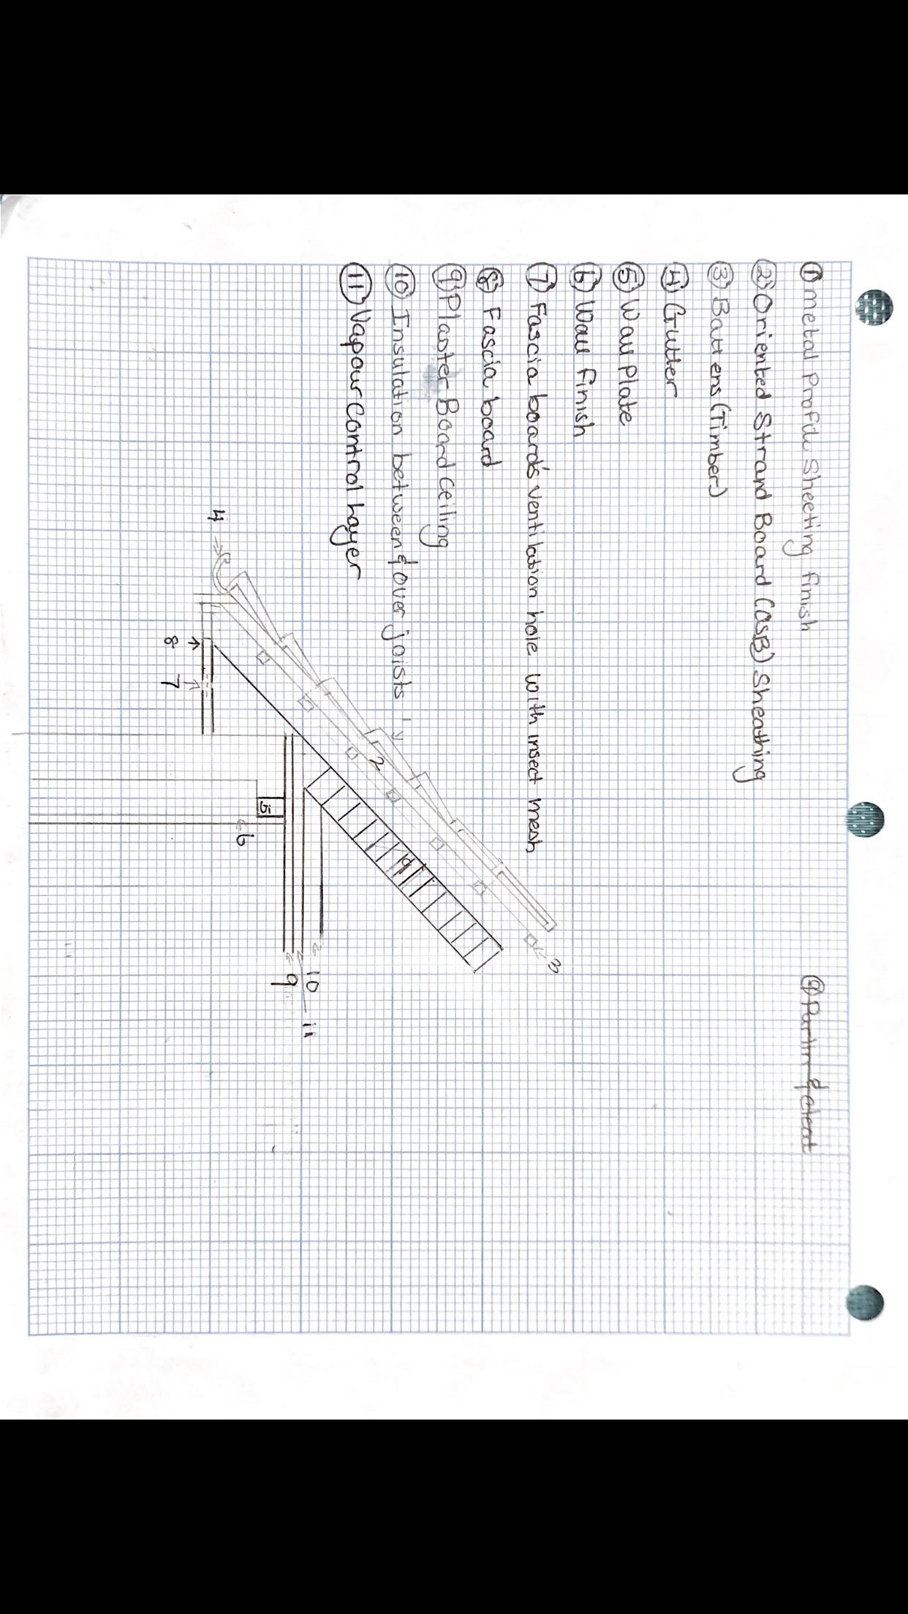
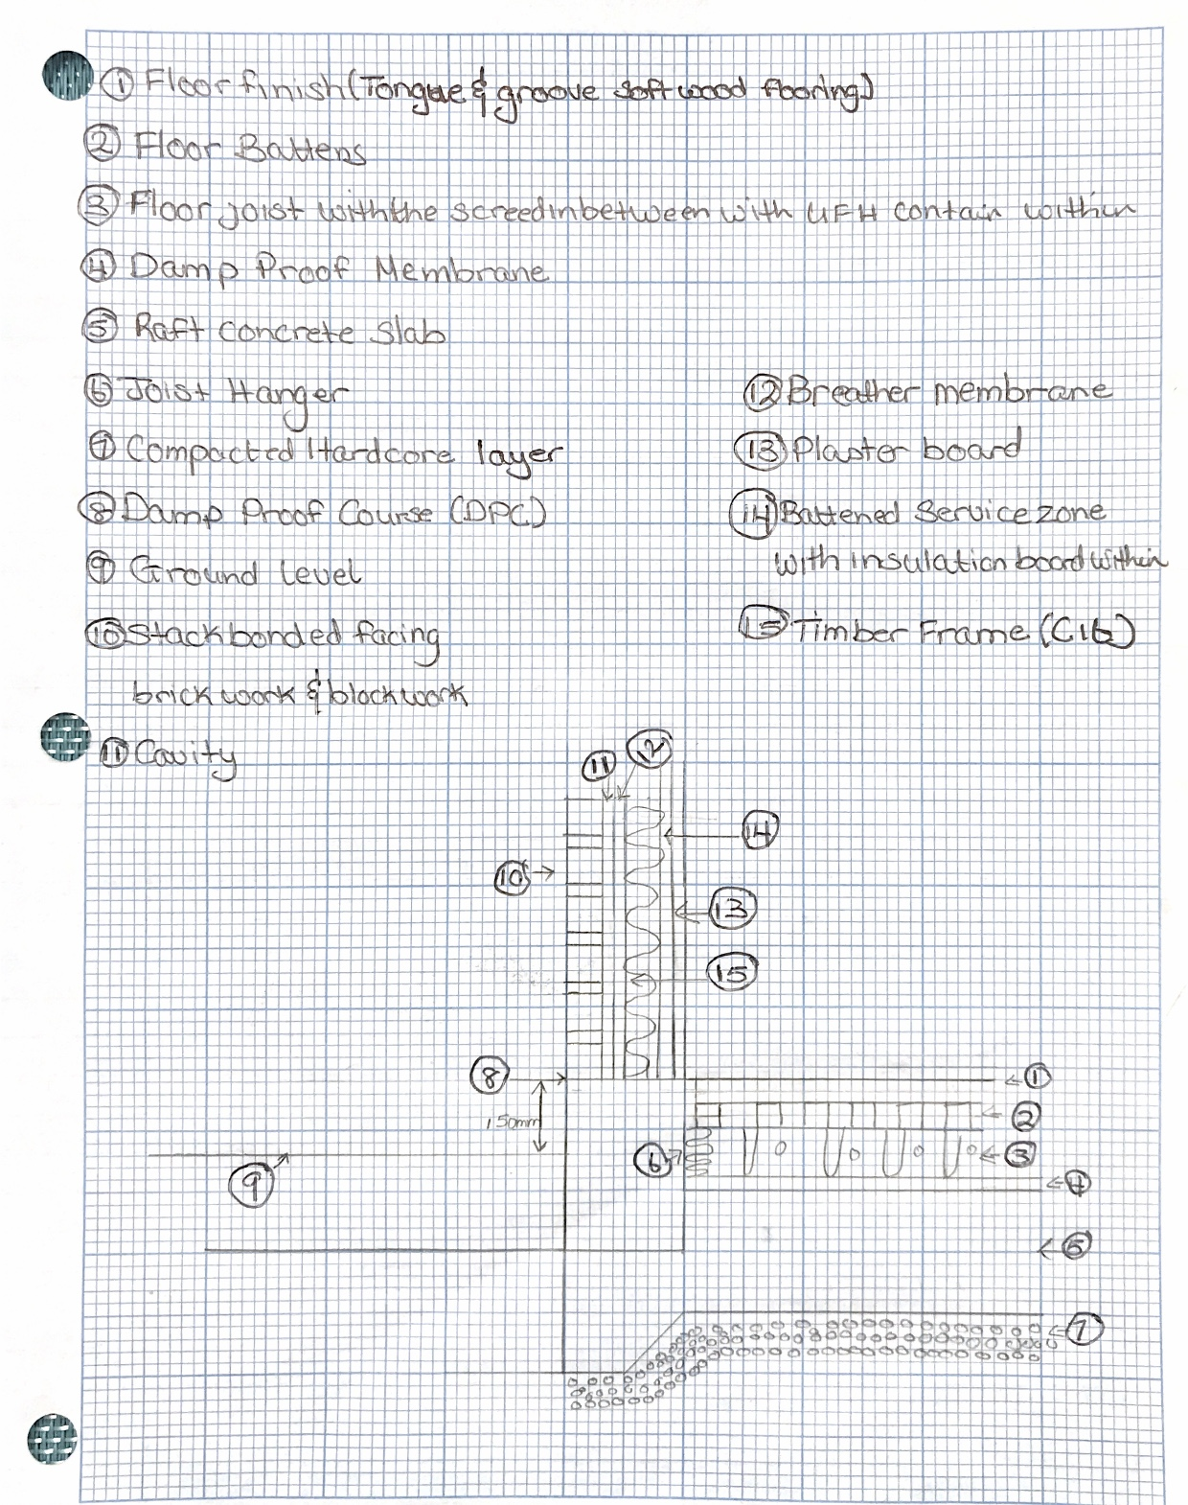

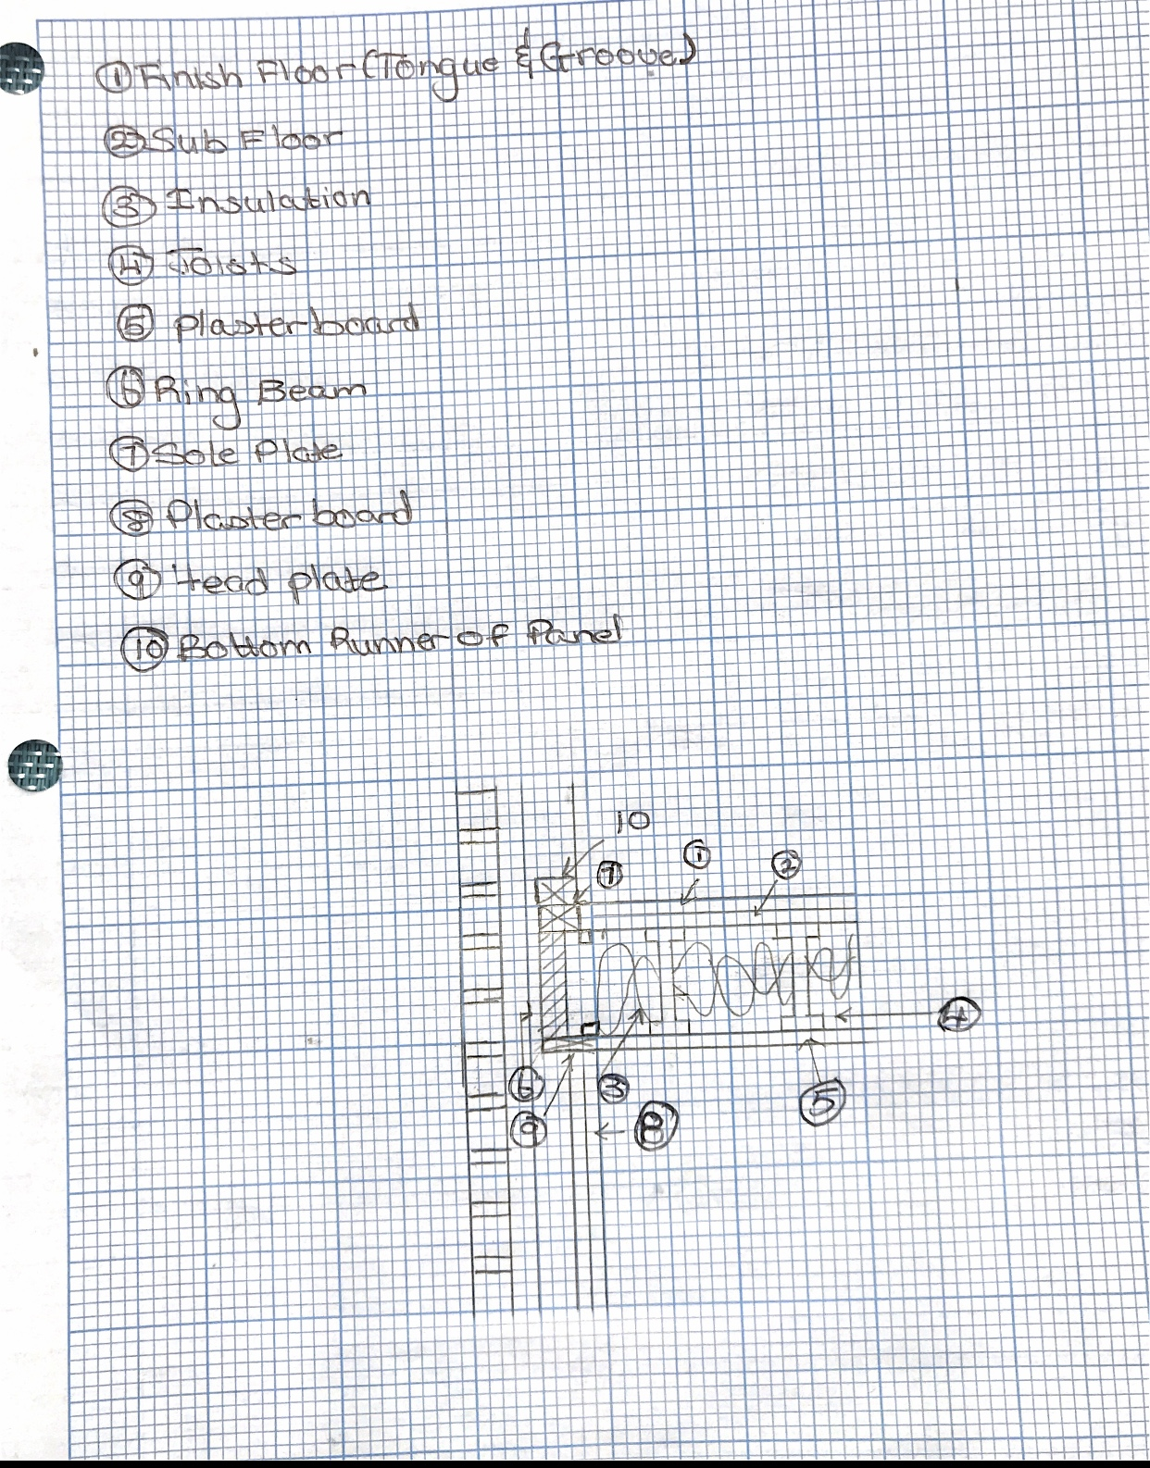

Reference

- Diya (2019). Trusses and Types of trusses. [online] Basic Civil Engineering. Available at: https://basiccivilengineering.com/2019/06/trusses-types-trusses.html.
- Gharpedia.com (2018). What is Couple Roof? [online] Gharpedia.com. Available at: https://gharpedia.com/blog/couple-roof/.

- Lane, C. (2022). 6 Common Roof Trusses: Everything You Need to Know. [online] roofingcalculator.com. Available at: https://roofingcalculator.com/news/all-about-roof-trusses.

- Moehring, J. (2010). The Versatility And Design Of Wood Trusses. [online] www.brighthubengineering.com. Available at: https://www.brighthubengineering.com/structural-engineering/65068-versatility-and-design-of-wood-trusses/#the-versatility-of-wood-trusses [Accessed 28 Apr. 2022].

- Rajput, K. (2021). What Is Pitched Roof | 8 Types of Pitched Roof | Advantages of Pitched Roof. [online] CivilJungle. Available at: https://civiljungle.com/pitched-roof/.

- Vandervort, D. (2019). Pros & Cons of Metal Roofing. [online] HomeTips. Available at: https://www.hometips.com/buying-guides/metal-roofing-drawbacks.html.

