MARKS & SPENCER FOODS UK
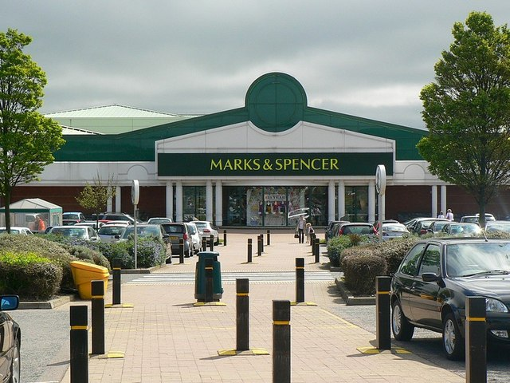
This Photo by Unknown Author is licensed under CC BY-SA

MARKS & SPENCER FOODS REPORT

MODULE: BA LEADERSHIP & MANAGEMENT LEVEL 5
MODULE CODE: BUILDING A SUSTAINABLE MARKETING RELATIONSHIP
MODULE LEAD: GWYNETH JONES
STUDENT NAME: DRE STEELE
STUDENT NUMBER: 2332005
DATE: 24/11/2025

EXECUTIVE SUMMARY
Core Appeal & Modernisation
M&S aims to retain its high-quality food reputation while improving supply chains and store infrastructure.
Broadened Appeal
The strategy positions M&S Food as a daily choice rather than just for special occasions, with customer perceptions of quality at a decade high.
Product Innovation
Focus on own-brand, easy-to-cook products sourced from trusted suppliers.
Strategic Partnerships
Growth through partnerships, especially with Ocado Retail for online grocery delivery.
Performance & Objectives (2024/2025)
Market share increased to 3.9%, with a goal of an additional 1% by FY28.
Food sector significantly contributes to overall revenue (£13.9bn). The sustainability plan aims for net zero by 2040.

TABLE OF CONTENTS
Contents
MARKS & SPENCER FOODS UK 1
MARKS & SPENCER FOODS REPORT 2
EXECUTIVE SUMMARY 3
TABLE OF CONTENTS 4
INTRODUCTION 5
Section 1 7
M&S Vision & Purpose Statements 8
Section 2 9
SECTION 3 12
REFERENCE LIST 14

INTRODUCTION

This report provides an overview of Marks and Spencer Foods (M&S), a prominent British food retailer known for its exceptional quality and premium-grade products. As a marketing consultant, the focus is on how customer relationship marketing (CRM) influences business performance, particularly in encouraging sustainable customer relationships that build up customer retention and loyalty within the UK grocery sector.
Customer Relationship Management (CRM) aims to build and maintain meaningful relationships between M&S and its customers by utilising customer data to offer personalised experiences, both online and in-store. M&S focuses on exceptional quality, trusted products, and reliability, transforming customer interactions into ongoing partnerships (Guerola-Navarro, V. et al. 2024).
By placing customers at the heart of its operations, M&S strengthens customer lifetime value through a strategy known as customer centrality, which revolves around creating a seamless customer journey. Competing against larger supermarkets like Tesco and Sainsbury's, M&S distinguishes itself not by price, but by targeting upper-class consumers who seek high-quality products.
According to Ishizuka, C. and Aoki, K. (2024), customer centrality, understood as the degree to which customers are engaged and integrated into the brand experience, plays a significant role in influencing brand loyalty and customer retention.

(M&S Corporate website Annual Report 2025) M&S Food's current market position is growing, with its food sales increasing by 8.7% to reach nearly 9 billion. According to the retailer, their food division has had another successful year, indicating that more customers are choosing to purchase food from their food halls.
M&S. (2025). ‘Reshaping M&S’. Available at https://corporate.marksandspencer.com/sites/marksandspencer/files/2025-05/Marks-and-Spencer-Group-plc-Annual-Report-and-Financial-Statements-2025_INTERACTIVE_FINAL.pdf (Accessed 18/11/2025).

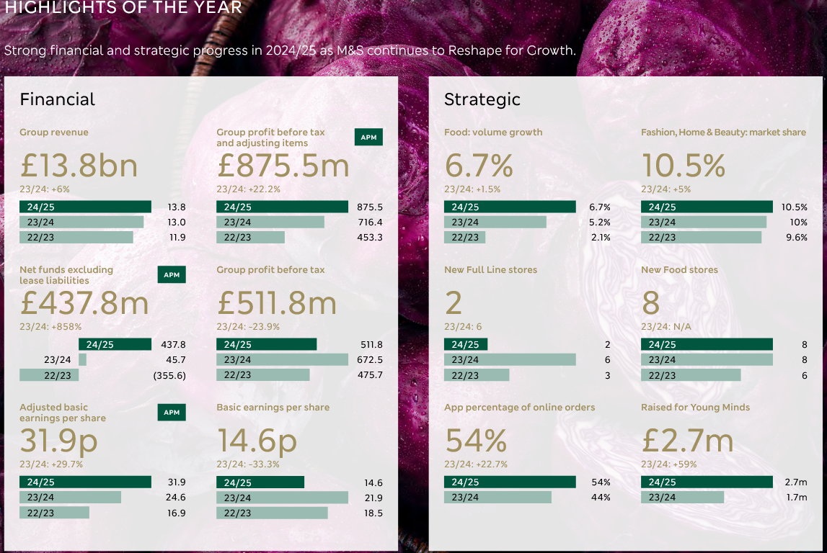

Section 1

M&S FOOD – Organisation Overview
Marks and Spencer, established in 1884 by Michael Marks and Thomas Spencer, has evolved from a market stall into one of the UK's largest retailers. The first dedicated food hall opened in 1965, and today M&S operates around 316 food halls, known for the slogan “This is not just food, this is M&S food.” The company offers a wide range of products, including clothing, groceries, and beauty items. M&S. (2025) ‘M&S Archives.’ Available at https://archive.marksandspencer.com/?extid=ps_ps-bg_ggl_mw_ch_allcategories_-_UK_-_-_modernsearch&cq_src=google_ads&cq_cmp=22933324953&cq_con=184672996779&cq_term&cq_med&cq_plac&cq_net=g&cq_plt=gp&gclsrc=aw.ds&gad_source=1&gad_campaignid=22933324953 (accessed 18/11/2025)

As of 2025, M&S reported an 8.7% increase in food sales, reaching £9.0 billion, and an operating profit of £484.1 million, up from £388.4 million the previous year. This growth reflects the success of their 'Reshaping for Growth Strategy,' leading to a market share of approximately 3.9% - 4.3%. This means that for every £100 spent in the industry, £3.9 is spent at M&S (Fahy, M. 2024).

This diagram illustrates M&S food current market position 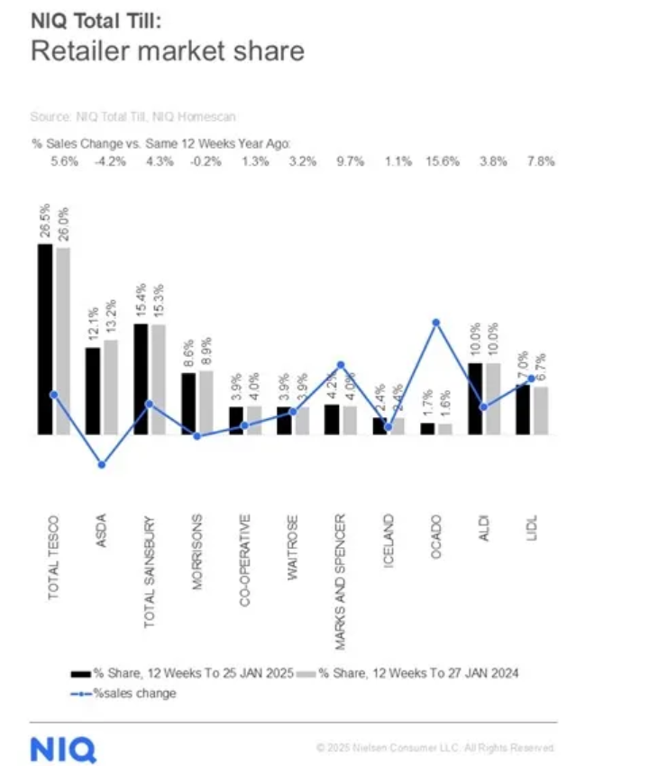

https://nielseniq.com/global/en/news-center/2025/growth-in-food-retail-steady-as-brits-turn-to-scratch-cooking-to-save-costs/

M&S Vision & Purpose Statements

M&S Mission is “To bring the magic of M&S through exceptional quality, value, service and innovation to every customer, wherever, whenever and however they want to shop with us Their vision is “To be the most trusted retailer doing the thing for our customers, with quality products at the heart of everything we do.”

To be the most trusted retailer, M&S focuses on quality products for customers, providing exceptional value, service, and innovation whenever and wherever they shop.
According to David, F. (2020), a vision statement outlines an organisation's aspirations, guiding decision-making and planning. M&S aims to be the most trusted retailer in the UK supermarket sector by maintaining high sourcing standards, such as ensuring all fresh poultry and meat come from British farms that meet strict animal welfare guidelines (Feringa, B.L. 2020).
The ‘Eat Well’ seal assures customers that products are healthy and tasty, while the launch of a new value range demonstrates M&S’s commitment to customer needs amid the cost-of-living crisis (Re-Marks-able). Additionally, in 2023, M&S partnered with Young Minds and raised £4.4 million to support mental health initiatives, reinforcing its focus on community impact.
In an article published in The Grocer, Quinn, I. (2023), Marks & Spencer director of food George Wright is to become the next CEO of food redistribution charity Fare Share. He has also warned that the impact of the cost-of-living crisis has meant it still does not get enough food to meet demand from food banks. It has been campaigning for the government to provide £25m of funding towards the costs of suppliers transporting food surplus.

Section 2

Data and Customer Relationship
According to Ferrer-Estévez and Chalmeta (2023), sustainable customer marketing means connecting business strategies with wider sustainability goals, considering loyalty to the brand. This is shown in sustainable customer relationship management (SCRM), which blends business strategies, customer-focused processes, and technology to incorporate sustainability into customer practices. SCRM aims to make business processes and products more sustainable while promoting ethical customer behaviour.
M&S engages customers in sustainability through its Sparks loyalty program, which encourages healthy and sustainable choices. Programs like the "Sparking Change National Challenge" and the "Shwopping" clothes recycling campaign motivate customers to participate. Sparks customers can also receive special discounts and offers, alongside opportunities for charitable donations. This makes shopping feel meaningful, as customers contribute to positive social and environmental efforts, like supporting conservation work with WWF. Loyalty programs and personalised communications, such as email newsletters and targeted offers, provide tangible incentives that reinforce customer centrality and, by rewarding repeat purchases and encouraging ongoing engagement, support long-term retention and loyalty (Akter, T. 2024).
The term CRM was first introduced and popularised around 1995 by an American firm, Gartner the concept According to Mumtaz Awan, T. (2024), Customer relationship management (CRM) refers to a business management strategy and technology solution aimed at managing and enhancing interactions with customers. It covers a range of practices, tools, and systems designed to improve customer relationships, loyalty, retention, and satisfaction by structuring business processes with customer needs and expectations.

The relationship between CRM and customer satisfaction is also linked to customer retention and loyalty. For example, M&S Food’s customer relationship management (CRM) strategies emphasise integration between marketing campaigns and loyalty programs to enhance customer engagement and retention. A notable example is the collaboration with Tom Kerridge on a six-part ITV show, where M&S Food incorporated brand idents during ad breaks and shared recipes and food products featured in each episode with members of its Sparks loyalty scheme.

According to Calnan, M. (2024), linking content marketing with customer incentives promotes closer relationships through exclusive engagement. Effective Customer Relationship Management (CRM) improves retention and loyalty by adopting a customer-centric approach, improving satisfaction with tailored services, and strategically managing relationships for long-term profitability (Dwivedi, R.K. et al., 2024).

A company's reputation, closely tied to customer satisfaction, is crucial for sustaining loyalty, especially in turbulent markets (Khan, R.U. et al., 2022). Customer relationships have a significant impact on business success, influencing loyalty and satisfaction. Research shows that relationship marketing, including commitment, service reliability, and technology, influences customer loyalty and satisfaction, with different impacts on individual versus corporate customers (Hoang, D.P., 2024).

Marks & Spencer (M&S) collects and analyses customer data primarily through its Sparks loyalty program, tracking purchase history, product preferences, and GPS from cardholders. Additional data comes from the M&S website and app, including browsing habits and wish lists.

M&S utilises advanced analytics and predictive models to forecast customer behaviour and product demand, enabling data-driven decisions for product development and pricing. They have also implemented AI technology to advise shoppers on fashion choices based on body shape, aimed at boosting online sales.
In partnership with First Insight, M&S is enhancing customer engagement and accelerating digital transformation. The retailer has also launched the world's first data science and AI academy in grocery, offering a 15-month course for employees to achieve advanced level 7 status, focusing on modelling, machine learning, and AI solutions to unlock significant value for the business.
‘M&S claims first with launch of data science and AI academy’ (2021) Grocer, p. 7.
The emphasis is on refining strategies and showcasing value to customers to encourage loyalty. Insights from data analysis enable personalised offers through the Sparks program and email campaigns, making customers feel valued. M&S addresses privacy concerns by ensuring compliance with regulations like GDPR and maintaining transparency, which is essential for customer trust.
However how safe is customers data earlier this year M&S suffered a damaging cyber-attack catastrophe unfolded as hackers embedded in its IT systems began to take control Farrell, S. and Nott, G. (2025) Stock deliveries to both Ocado and its own stores have been hit resulting, M&S admitted on Wednesday, in "pockets of limited availability in some stores") as have donations of surplus food to charities.
CRM systems can encounter problems, as noted by Bojanowska et al. (2025), including risks of failure linked to organisational factors and coordinating CRM with business processes. While larger companies often adopt CRM systems, implementation risks remain. The advantages of CRM, such as enhanced decision-making and loyalty, rely on continual updates and organising with business needs.
Data management systems also face challenges, particularly regarding the protection and reliability of data. Subjects, particularly in terms of transparency and accountability in personal data flows. This lack of transparency can undermine trust and complicate ethical and legal compliance in data handling, especially with the rise of decentralised data management technologies (Asgarinia, H. et al. 2023).
The M&S data breach is part of a broader pattern of cyberattacks affecting luxury brands and retailers. These incidents have resulted in the theft of customer data and operational disruptions. Cybercriminals are attracted to such brands due to the large volumes of valuable customer information they hold. This trend highlights the importance of cyber risk management as a priority for these organisations. Experts suggest that while no organisation can guarantee complete immunity from compromise, there are immediate and impactful security measures that companies can implement to reduce the likelihood of breaches significantly.
‘Cyber Risk Management a Top Priority Following Widespread Data Breaches in Luxury and Retail’ (2025) Sourcing Journal (Online) [Preprint].
The ransomware attack on Marks & Spencer halted online orders and hiring, marking another breach in the UK retail sector. The Government plans to announce measures to enhance cybersecurity, including investment in CHERI, a “magic chip” and a new cyber security and resilience bill for improved memory safeguards, and a new software security code of practice for organisations. M&S has issued an apology to its loyal customers.
‘UK Government coming up with new cybersecurity after M&S, Harrods attacks’ (2025) Apparel Resources [Preprint]

SECTION 3
According to Suh, Y. (2025), Segmentation, Targeting, and Positioning (STP) is a key marketing process that divides markets into distinct customer groups, enabling marketers to tailor their offerings to meet specific needs. M&S utilises market research to target segments such as health-conscious and ethical consumers. They leverage data from the Sparks loyalty program to send targeted communications about products, such as their 'Eat Well' range, thereby fostering customer loyalty by aligning with personal values.
According to Islami, X., Mustafa, N. and Topuzovska , M. (2020), Porter’s Generic Strategies, M&S primarily adopts a Differentiation strategy, focusing on a premium market segment by offering unique products that distinguish it from competitors.
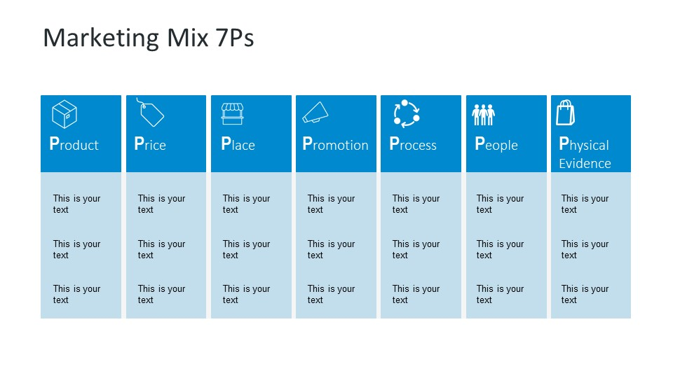
Product -- Premium high-quality Food item.
Price – Mid to premium pricing.
Place – Strategic Store location + Delivery options.
Promotion – Advertising Campaign to connect with customers more.
People – Customer Centric Staff.
Process –Seamless Operating Process to aid Customer Journey.
Physical Evidence – Modern stores “Eat Well” seal of approval.
M&S Food effectively uses the 7Ps to foster strong customer relationships and loyalty, focusing on unique, high-quality products, well-trained staff, and a smooth customer process. Balancing premium pricing and an extensive distribution network with competition from discounters and the need for ongoing investment in digital and physical infrastructure to ensure customer satisfaction.
The 4Cs model in marketing is a customer-centric framework that reinterprets the traditional 4Ps marketing mix by focusing on the consumer's perspective. It consists of four elements: Customer Huang, M.-H. and Rust, R.T. (2021) (needs and wants), Cost to the customer, Convenience, and Communication.
M&S is recognised for its quality and trust, highlighted by innovative offerings like "Dine In" meal deals and the "Remarksable Value" range, which includes over 100 everyday staples at competitive prices.
With a customer database exceeding 20 million, Sparks enables personalised marketing, where customers receive tailored offers based on their shopping habits across various touchpoints, improving their shopping experience.
M&S operates numerous convenience format stores in high-traffic locations like city centres, railway stations, hospitals, and airports, making it easy for commuters and travellers to grab food quickly.
For those seeking quick meal solutions at home, M&S provides a variety of ready meals and the popular "Dine In" meal deals. These offer restaurant-quality food with minimal preparation, catering to the need for both convenience and a premium dining experience.
"Click & Collect" service allows customers to order items online (including clothing and home goods) and pick them up at their chosen food store location, often with options for next-day collection, providing a flexible and efficient service.
According to Jaganjac, B. et al. (2024), ethics can be understood as a system of moral principles that guide human behaviour, often involving considerations of sustainability. Sustainability involves various dimensions like ecological, political, ethical, socio-economic, and cultural aspects. It represents a principle of ongoing viability shaped by obligations and values that guide decision-making. Ramsey (2015) argues that sustainability is linked to normative structures, emphasising the ethical considerations in its understanding.
M&S employs the triple bottom line (TBL) approach—People, Planet, and Profit—through its "Plan A" sustainability program, integrating these principles into its core operations to achieve social, environmental, and financial benefits.

The "Plan A" initiative addresses commitments in its food business, focusing on high animal welfare standards and fair supplier relationships. This fosters brand loyalty among ethical consumers; however, failure to uphold these standards could lead to reputational damage and scepticism about the company's messaging.
Sustainable marketing also boosts brand image, as noted by Gong et al. (2023), which leads to better customer engagement and intentions to make sustainable purchases. Corporate social responsibility (CSR) strengthens this connection between company image, customer engagement, and sustainable buying behaviour.
These factors suggest that sustainable marketing initiatives lead to positive results for organisations, particularly in the UK supermarket sector. M&S upholds sustainable customer marketing relationships by following Responsible Food Marketing Principles. They ensure that most of their products meet high standards, such as being Fairtrade-certified or sustainably sourced, which helps make sustainability a natural part of shopping for consumers.

Conclusion
In Conclusion, M&S's strategic Reshaping plan has led to the retailer's success; however, the problem around the recent cyber attack has left many customers in doubt.

REFERENCE LIST

Akter, T. (2024) ‘Ensuring Customer Relationships for the Long Term’, Journal of internet banking and commerce : JIBC, 29(5), pp. 1–3.
Asgarinia, H. et al. (2023) ‘“Who Should I Trust with My Data?” Ethical and Legal Challenges for Innovation in New Decentralised Data Management Technologies’, Information (Basel), 14(7), p. 351. Available at: https://doi.org/10.3390/info14070351Bintarti, S. and Pirdaus, A.A. (2024) ‘Customer Journey Mediates the Role Of 4C Marketing Mix 4.0 on Customer Loyalty with User İnterface Moderation’, APMBA (Asia Pacific Management and Business Application), 12(3), pp. 299–314. Available at: https://doi.org/10.21776/ub.apmba.2024.012.03.5.
Fahy, M. (2024) ‘Food arm helps M&S to serve up higher profit’, Investors Chronicle, p. 47.
Guerola-Navarro, V.; Gil-Gomez, H; Oltra-Badenes, R.; Soto-Acosta, P. (2024) ‘Customer relationship management and its impact on entrepreneurial marketing: a literature review’, International entrepreneurship and management journal, 20(2), pp. 507–547. Available at: https://doi.org/10.1007/s11365-022-00800-x.
https://corporate.marksandspencer.com/cyber-update
https://corporate.marksandspencer.com/delivering-trusted-value-our-ms-customers-summer
https://corporate.marksandspencer.com/media/press-releases/marks-spencer-continues-invest-trusted-value-family-shoppers
https://corporate.marksandspencer.com/media/press-releases/ms-food-invests-delivering-trusted-value-its-customers#:~:text=Member%20for%20Retailer%20announces%20new%20lower%20prices,quality%20or%20leading%20welfare%20and%20sourcing%20standards
https://corporate.marksandspencer.com/media/press-releases/ms-helps-customers-spark-change-and-enjoy-lower-carbon-diets-2022
https://corporate.marksandspencer.com/rspca-assured-dairy-farms
https://corporate.marksandspencer.com/sites/marksandspencer/files/2025-05/Marks-and-Spencer-Group-plc-Annual-Report-and-Financial-Statements-2025_INTERACTIVE_FINAL.pdf
https://corporate.marksandspencer.com/sites/marksandspencer/files/Annual%20reports/plan-a-2025-commitments.pdf
https://corporate.marksandspencer.com/sites/marksandspencer/files/2024-06/ESG_Report_2024.pdf
M&S. (2025).https://corporate.marksandspencer.com/sites/marksandspencer/files/marks-spencer/policies/supply-chain-and-responsible-sourcing-new.pdf. (Accessed on 18/11/2025)
M&S. (2025) https://corporate.marksandspencer.com/sustainability/human-rights-our-supply-chain/supporting-our-food-supply-chain. (Accessed on 19/11/2025)
M&S. (2025) https://corporate.marksandspencer.com/sustainability/our-products/health-wellbeing#:~:text=Our%20Eat%20Well%20seal%20of%20approval%20shows,you%20should%20have%20to%20compromise%20on%20taste.
M&S. (2025) https://corporate.marksandspencer.com/sustainability/our-products/responsible-marketing. (Accessed on 19/11/2025)
M&S. (2025) https://corporate.marksandspencer.com/sustainability/plan-a-our-planet.(Acessed on 20/11/2025)
M&S. (2025) https://corporate.marksandspencer.com/sustainability/reports-quick-reads/our-animal-welfare-standards#:~:text=Today%2C%20our%20M&S%20Select%20Farms,standards%20to%20produce%20M&S%20Food.(Accessed on 20/11/2025)
https://nielseniq.com/global/en/news-center/2025/growth-in-food-retail-steady-as-brits-turn-to-scratch-cooking-to-save-costs/
https://www.firstinsight.com/press-releases/first-insight-expands-partnership-with-ms-to-drive-digital-transformation-and-customer-centric-growth-across-all-ms-clothing-home-categories
FSA. (2025) https://www.food.gov.uk/news-alerts/alert/fsa-prin-04-2025. (Accessed on 22/11/2025)
GOV.UK (2025).https://www.gov.uk/government/collections/cyber-security-and-resilience-bill.(Accessed on 21/11/2025)
M&S. (2025) https://www.marksandspencer.com/content/discover-tom-kerridge-kitchenware-range. (Accessed on 21/11/2025)
M&S. (2025) https://www.marksandspencer.com/food/c/ready-to-cook/mands-dine-in. (Accessed on 22/11/2025)
M&S. (2025) https://www.marksandspencer.com/food/l/food-on-the-move?page=4. (Accessed on 22/11/2025)
M&S. (2025) https://www.marksandspencer.com/mysparks/about.(Accessed on 23/11/2025)
(2024) The Guardian. https://www.theguardian.com/business/article/2024/sep/05/m-and-s-using-ai-to-advise-shoppers-body-shape-style-preferences. (Accessed on 23/11/2025)
https://www.wwf.org.uk/who-we-are/who-we-work-with/marks-and-spencer
Huang, M.-H. and Rust, R.T. (2021) ‘A strategic framework for artificial intelligence in marketing’, Journal of the Academy of Marketing Science, 49(1), pp. 30–50. Available at: https://doi.org/10.1007/s11747-020-00749-9.
Husna, N., Hartoyo, H. and Hasanah, N. (2024) ‘Redesigning Digital Marketing Strategy for Increasing Sales of Small Business: A Case Study in Pinescarf’, Binus business review, 15(3), pp. 239–249. Available at: https://doi.org/10.21512/bbr.v15i3.11355.
Ishizuka, C. and Aoki, K. (2024) ‘Drivers of sustained brand engagement: cases of long-term customers of hedonic and utilitarian brands in Japan’, Journal of marketing analytics, 12(4), pp. 979–989. Available at: https://doi.org/10.1057/s41270-023-00242-6.
Islami, X., Mustafa, N. and Topuzovska Latkovikj, M. (2020) ‘Linking Porter’s generic strategies to firm performance’, Future Business Journal, 6(1). Available at: https://doi.org/10.1186/s43093-020-0009-1.
Jaganjac, B. Abrahamsen, M. ; Olsen, S. ; Hunnes, A.Dordrecht: S Netherland. (2024) ‘Is It Time to Reclaim the “Ethics” in Business Ethics Education?’, Journal of business ethics, 190(1), pp. 1–22. Available at: https://doi.org/10.1007/s10551-023-05400-5.
Quinn, I. (2023) ‘MS director of food named FareShare CEO’, Grocer, p. 66.
Ramsey, J.L. (2015) ‘On Not Defining Sustainability’, Journal of agricultural & environmental ethics, 28(6), pp. 1075–1087. Available at: https://doi.org/10.1007/s10806-015-9578-3.
Retnaningsih, Y and Febriantina D (2023) ‘How Does the Implementation of Social Entrepreneurship Business-to-Business Marketing Strategy?’, Journal of Consumer Sciences (Online), 8(3), pp. 318–339. Available at: https://doi.org/10.29244/jcs.8.3.318-339
Russell, H. (2019) ‘M&S joins forces with Ocado’, Investors Chronicle, p. 9.
Suh, Y. (2025) ‘Discovering customer segments through interaction behaviours for home appliance business’, Journal of big data, 12(1). Available at: https://doi.org/10.1186/s40537-025-01111-y.

