ECIE4012
The Principles of Learning and Teaching

Portfolio

Student Number:
2307229

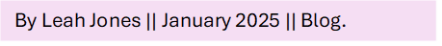
B. F. Skinners Operant Conditioning Simplified.
If you are anything like me and struggle to read in-depth blogs about theories, this is the blog for you. In this blog I will introduce you to B. F. Skinner and his theory of Operant Conditioning without the big words and without making you read a million pages. In this blog I will aim to give you a summary of how Operant Conditioning came about, who influenced it and an example of how it was researched. Furthermore, I will briefly touch upon how it works in today’s pedagogy. Okay, maybe one or two big words I couldn’t resist! Let’s begin.

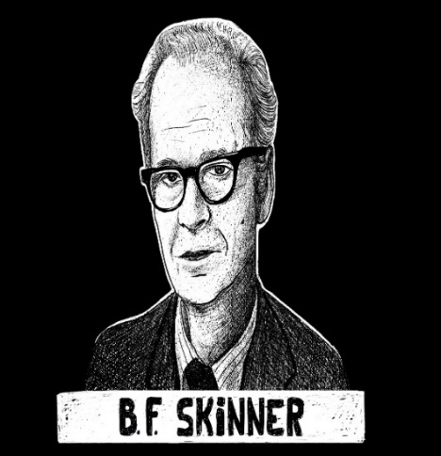
Where it began.
Operant Conditioning was constructed by B. F. Skinner (1953), an American Psychologist. Skinner’s theory is derived from a theoretical approach to pedagogy known as Behaviourism. The approach was developed in the early 20th century through the work of psychologists (Bartlett and Burton, 2016) and focuses on observable behaviours. A considerate number of principles of Behaviourism were originally developed through working with animals, this knowledge was then applied to humans. Bates (2019) describes Behaviourism as a reward and punishment system that promotes a child to respond in ways we (teaching staff) deem appropriate, also known as learnt behaviour.
(Practicalpie, 2020)
Influences and Operant conditioning.
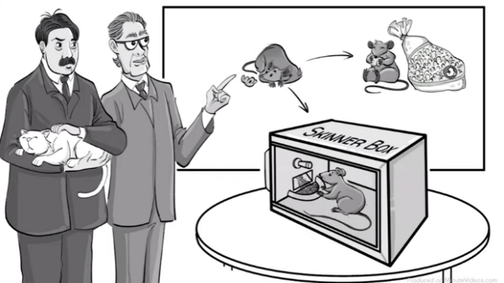
Skinner built upon the theories of his predecessors, Thorndike – Law of effect (McLeod, 2024a) and Pavlov – Classical Conditioning (McLeod, 2024b). Thorndike put cats in cages and observed their attempts to escape through trial and error, placing food outside the cages as a reinforcer (McLeod, 2024a). Sound familiar? Pavlov conditioned dogs to associate the sound of a bell with food (Bates, 2019). Skinner is considered one of the most influential behaviourists of the 20th century and is highly praised amongst his peers for his theory of Operant Conditioning and the influence that it has had on our understanding of child development (Schlinger, D. 2021). Operant Conditioning can be found embedded throughout schools today an example would be teaching staff using positive reinforcement such as rewards or praise to promote positive behaviour (Pwll Primary School, 2020).
Gaggelli, (2020).

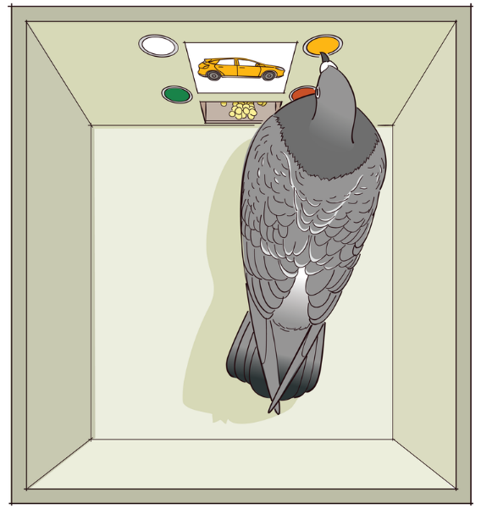
SKINNER BOX.
Skinners most infamous experiment was the Skinner Boxes. Rats were placed inside a box where they would be conditioned to press a lever to release food or water, this is known as positive reinforcement (Bouton, 2024). He then developed the theory further by placing grids in the boxes that gave the rats electric shocks, to act as a negative reinforcement. Skinner believed that positive reinforcement had a longer lasting impact on behaviour comparatively to negative reinforcement. Skinner also placed pigeons in the boxes and conditioned them to peck at a target and turn in segments until they could turn in a full circle, varying how often he reinforced the pigeons (Harvard University, 2007).
(Noba Project, 2024)

Video: An example of Operant Conditioning: a The hungry rats. (The Psychology Channel, 2015).

HOW IS IT USED IN PEDAGOGY?
Now I know what you must be wondering, Leah this is all based off work with animals! How does this have anything to do with teaching? Well, Skinner considered this learnt behaviour to be transferable to how we teach children to do many things, such as speak. A child mimics a word we say, and we provide them with positive reinforcement. We continue this process of positive reinforcement until the child can say the word (PBS, 2020). Additionally, you could extinguish an unwanted behaviour through negative reinforcement. If a child is displaying unwanted behaviours, you could use a planned ignore or distraction to reduce the amount that the behaviour occurs until it is extinguished (Robertson, 2018).
Example: A child that swears.
Positive reinforcement: Teach the child to use appropriate language, use examples. Give praise and reinforcers for the child when using appropriate language instead of swearing.
Negative reinforcer: The child swears, utilise a planned ignore and when the child displays appropriate behaviour or corrects themselves then provide praise and positive reinforcement.

Food For thought.
- How and when do you use Operant Conditioning in your teaching? Is it effective?
- Does Operant Conditioning create learners that depend on rewards? (Aubrey and Riley, 2019)

Blog 1 References.

Aubrey, K. and Riley, A, (2019). Understanding and Using Educational Theories. 2nd ed. London : Sage.
Bartlett, S. and Burton, D. (2016). Introduction to education studies. London: Sage.
Bates, B. (2019). Learning Theories Simplified. London: Sage Publishing.
Harvard University. (2007). B. F. Skinner. [online] Available at: https://psychology.fas.harvard.edu/people/b-f-skinner. (Accessed: 19th December 2024).
Bouton, M.E. (2024). Conditioning and Learning, Noba textbook series: Psychology [Online] Available at: https://nobaproject.com/modules/conditioning-and-learning. (Accessed: 20th December 2024).
McLeod, S. (2024a). Edward Thorndike – Law of Effect. [Online]. Available at: https://www.simplypsychology.org/edward-thorndike.html. (Accessed: 15th December 2024).
Mcleod, S. (2024b). Pavlov’s Dogs Experiment and Pavlovian Conditioning Response. [Online] Simply Psychology. Available at: https://www.simplypsychology.org/pavlov.html. (Accessed: 15th December 2024).
Robertson, N. (2018). What is Planned Ignoring? - Teaching Autism. [Blog] Available at: https://teachingautism.co.uk/planned-ignoring/. (Accessed: 22nd December 2024).
Nobaproject.com. (2024). Skinner Box Image. [Online]. Available at: https://nobaproject.com/images/shared/images/000/000/160/original.png. (Accessed: 20th December 2024).
Gaggelli, P. (2020). Skinner’s Operant Conditioning: Rewards & Punishments. YouTube. [Online]. Available at: https://www.youtube.com/watch?v=ne6o-uPJarA. (Accessed: 19th December 2024).
PBS. (2020). A Science Odyssey: People and Discoveries: B.F. Skinner. [Online] Pbs.org. Available at: https://www.pbs.org/wgbh/aso/databank/entries/bhskin.html. (Accessed: 20th December 2024).
Practicalpie. (2020). B. F Skinner (Psychologist Biography). [Online]. Available at: https://practicalpie.com/bf-skinner/ (Accessed: 12th December 2024).
Pwll Primary School (2020). Policies | Pwll CP School. [online] Available at: https://primarysite-prod-sorted.s3.amazonaws.com/pwll-cp-school/UploadedDocument/3e0bcb41-f9e7-4d32-8a25-599f155d8ed3/positive-behaviour-policy-sept-2022.pdf. (Accessed: 12th December 2024).
Schlinger, H. D. (2021) ‘The impact of B. F. Skinner’s science of operant learning on early childhood research, theory, treatment, and care’, Early Child Development and Care, 191(7–8), pp. 1089–1106. doi: 10.1080/03004430.2020.1855155.
Skinner, B. F. (1953). Science and Human Behaviour. New York: The Free Press.
The Psychology Channel (2015). An example of Operant Conditioning: a The hungry rats. YouTube. [Online] Available at: https://www.youtube.com/watch?v=L6MamDfrH-I. (Accessed: 22nd December 2024).
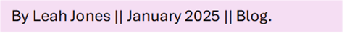
Vygotsky’s Zone of Proximal Development. Simplified.

In good old Leah fashion, I am once again here to save you from reading a billion pages and goodness knows how many big words (you can thank me later ) about the outstanding Lev Vygotsky. In this blog I will introduce you to Lev Vygotsky (1978) and The Zone of Proximal Development, a collaborative learning approach between teacher and learner. I will highlight the use of most knowledgeable others and Scaffolding (David, Goouch and Powell, 2016). Furthermore, looking at the stages of The Zone of Proximal development in further detail.
(Shutterstock, 2018)
Where it began:
Lev Vygotsky was a Russian Psychologist who in his short lifespan developed numerous valuable theories, such as The Zone of Proximal Development (ZPD) and Most Knowledgeable Others (MKOs). His theoretical approach to pedagogy is known as Cognitivism, it is believed that the theory emerged from the discontent of the Behaviourist approach to pedagogy (Bates, 2019). Cognitivism can be split into 2 approaches, Cognitive Constructivism and Social Constructivism (Nassaji and Tian. 2018). Unlike Piaget (McLeod, 2024) a Cognitive Constructivist, Vygotsky a Social Constructivist believed that social interaction such as a child’s community and culture played a key role in the learning process (Bates, 2019).

The Zone of Proximal Development (ZPD):
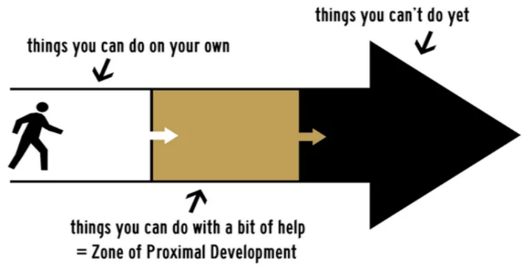
Vygotsky believed that the role of the teacher was to facilitate learning, and the role of the learner was to problem solve and they would do so collaboratively (Bartlett and Burton, 2016). The Zone of Proximal Development can be described as the zone where a child can develop through the help of Most Knowledgeable Others but are not yet capable of doing so independently. Vygotsky believed that learning in this zone with the help of MKOs allowed the pupil to achieve a higher level of learning (Aubrey and Riley, 2019) and deemed the language MKOs used important to the ZPD. Furthermore, he developed the idea of scaffolding to help teachers and MKOs to understand their role of facilitating in the ZPD.
(Adobe Stock, 2024)

The stages of ZPD:
There are three key factors to the ZPD, and it is important that the teacher understands these steps to be able to facilitate support and learning to the individual in a collaborative process (Wass and Golding, 2014).
- What the learner can do independently: This is where the learner has mastered a skill and can independently do tasks. There is opportunity here to progress to the next level of the skill and find the learners new ZPD (Harland, 2003).
- What the learner can do with the help of MKOs / ZPD: In this stage the learner needs the support of MKOs to help them master a task. This is considered the ZPD, in this zone the MKOs would utilise scaffolding to help the learner (Eun, 2017). The MKOs will then reduce or remove scaffolding as the learner progresses.
- What the learner cannot yet do: The learner is not capable of mastering the task with or without the help of the MKOs.
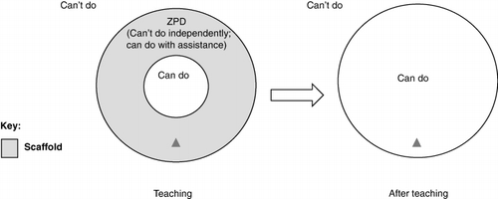
(Wass and Golding, 2014)

How is it used in pedagogy?
In the classroom teachers will understand what each individual learner is capable of and where they may need help. MKOs will help a learner when they are in the ZPD through scaffolding, helping the learner master a skill that they are unable to on their own. Visual aids, breaking the work into more manageable sections, modelling how to do the work are all examples of scaffolding (Gershon, 2022). Does this sound familiar? Is this something you use in your classroom? The overall aim of ZPD is to collaboratively help the learner master a skill, when this is completed, the learner can then move onto the next step.

Video: ZPD and an example of scaffolding and modelling. (SVL: Effective Teaching and Learning, 2022).

Food for thought.
- How often do you use ZPD, MKOs and scaffolding in your teaching?
- Is The Zone of Proximal Development effective?
- Can you use ZDP alongside other pedagogical theories?

Blog 2 References.
Adobe Stock. (2024). Zone Of Proximal Development Images. [Online]. Available at: https://stock.adobe.com/uk/search?k=zone+of+proximal+development&search_type=usertyped&asset_id=509815314. (Accessed: 29th December 2024).
Aubrey, K. and Riley, A. (2019). Understanding and Using Educational Theories. Thousand Oaks, CA: Sage Publications.
Bartlett, S. and Burton, D. (2016). Introduction to education studies. London: Sage.
Bates, B. (2019). Learning Theories Simplified. London: Sage Publishing.
David, T. Goouch, K. and K. Powell, S. (2016). The Routledge international handbook of philosophies and theories of early childhood education and care. New York: Routledge, Taylor & Francis Group.
Eun, B. (2017). ‘The zone of proximal development as an overarching concept: A framework for synthesizing Vygotsky’s theories’, Educational Philosophy and Theory, 51(1), pp. 18–30. doi: 10.1080/00131857.2017.1421941.
Harland, T. (2003). ‘Vygotsky’s Zone of Proximal Development and Problem-based Learning: Linking a theoretical concept with practice through action research’, Teaching in Higher Education, 8(2), pp. 263–272. doi: 10.1080/1356251032000052483.
Mcleod, S. (2024c). Piaget’s Theory and Stages of Cognitive Development. [Online] Simply Psychology. Available at: https://www.simplypsychology.org/piaget.html. (Accessed 29th December 2024).
Gershon, M. (2022). Scaffolding and Modelling: Strategies and Techniques Guide 5 2. [Online] Available at: https://supportingvulnerablelearners.cymru/wp-content/uploads/2022/11/Guide-5-Scaffolding-and-Modelling-min.pdf. (Accessed: 29th December 2024).
Nassaji, H. and Tian, J. (2018). ‘3 Constructivism’, In Issues in Applying SLA Theories toward Reflective and Effective Teaching, Leiden, The Netherlands: Brill. Volume 7 pp. 23-36. Available at https://doi-org.ezproxy.uwtsd.ac.uk/10.1163/9789004380882_003 (Accessed: 28th December 2024).
Shutterstock (2018). Lev Semyonovich Vygotsky Vector Sketch Portrait Stock. [Online]. Available at: https://www.shutterstock.com/image-vector/lev-semyonovich-vygotsky-vector-sketch-portrait-1196205049. (Accessed: 28th December 2024).
Vygotsky, L.S. (1978). Mind in Society. Cambridge, MA: Harvard University Press.
SVL: Effective Teaching and Learning. (2022). What makes scaffolding and modelling effective? [Online] YouTube. Available at: https://www.youtube.com/watch?v=hjlPRZVbeC0. (Accessed: 29th December 2024).
Wass, R. and Golding, C. (2014). ‘Sharpening a tool for teaching: the zone of proximal development’, Teaching in Higher Education, 19(6), pp. 671–684. doi: 10.1080/13562517.2014.901958.

Skinner Vs Vygotsky.
By Leah Jones || January 2025 || Blog.

Once again, I am back to save you from reading an absurd amount of writing and to avoid all those big words. How great am I? I’ll accept thanks in the form of chocolates . In today’s blog I’m going to compare 2 theorists, Skinner (1953) and Vygotsky (1978). Skinner and Vygotsky are Psychologists that have different theoretical approaches to pedagogy. Skinner is a Behaviourist and Vygotsky is a Constructivist. In this blog I am going to look at the differences of these pedagogical approaches and compare their theories.

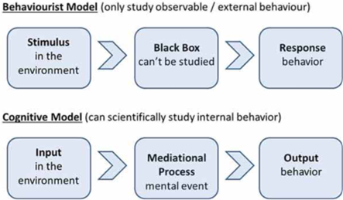
Behaviourism VS Constructivism.
The principle of Constructivism is that the pupil learns through social-interaction, exploration and collaboration, they actively process the information (Obikwelu, C and Read, J. 2012). The theory looks at the internal behaviour of the learner comparatively to Behaviourism which focuses on observable behaviours and environmental factors (Chandler and Munday, 2020). They each play an integral role in pedagogy.
(McLeod, 2024)

Operant Conditioning VS The Zone of Proximal Development.
(Bates, 2019)
Cognitive behaviour.

Although Operant Conditioning and The Zone of Proximal Development (ZPD) are very different in how each theory is taught, they both have common denominator. A member of teaching staff will provide the learner with a reward or reinforcer in Operant Conditioning to encourage a wanted behaviour. In ZPD the teaching staff with facilitate learning in a collaborative process (Miller, 2011). Both need a facilitator whether it be to facilitate a reward or learning.

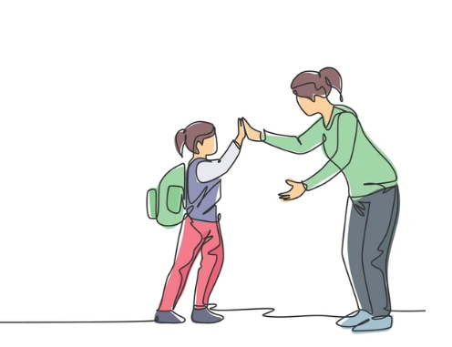
In pedagogy.
Both theories work well in inclusive education and are utilised in numerous different ways. Operant Conditioning can be found in the use of class dojo, point systems, praise and rewards (Pwll Primary School, 2020). While ZPD can be used through MKOs such as teaching staff and peers, understanding their individual needs to ensure that the pupil has the opportunity to reach their full potential (Estyn, 2018). Both approaches should be individually tailored to the learner, this is considered time-consuming but is beneficial to the individual learner and every child has the right to an inclusive education (UNESCO Education Sector, 2020).
(Shutterstock, 2025)

When it doesn’t work.
If you have used either of these approaches you will know consistency is key for both and this is not always achievable due to staff and pupil illnesses, staff shortages and many other factors. Many of these factors will lead to a lack of consistency in these approaches, in Operant Conditioning it will likely result in the unwanted behaviours continuing (Welsh Government, 2012). In ZPD it could lead to the learner not being in the ZPD zone or the approach may be followed incorrectly by a staff member that does not usually work in the classroom.
Here are some other factors of why the approaches may not work:
- The learner feels the reward is unachievable.
- The learner is not in the ZPD zone.
- The learner finds reinforcement from social disapproval.
- When the facilitator is unaware of the individual needs of the learner.

Can they be used together?
Although these are two varying approaches from two different major theories, I believe that there is opportunity to use both simultaneously. I believe that most of us are already doing so without thinking about it. How many times do you use ZPD and once the learner has mastered the skill you give them a high five or praise? And if you were to do so every time, would that learner feel motivated to keep mastering the skills and learning new ones? Do you see what I’m getting at? I believe that by using both, you really could encourage the learner to reach their full potential.

I agree with (Tobias and Duffy, 2010) that there are some flaws with each theory, however there is a place in inclusive pedagogy for both Behaviourism and Constructivism. They are very important approaches that each of us keep in our tool kits ready to facilitate learning.

Blog 3 References.

Bates, B. (2019). Learning Theories Simplified. London: Sage Publishing.
Chandler, D. and Munday, R. (2020). Dictionary Of Media And Communication. 3rd ed. S.L.: Oxford Univ Press.
Estyn (2018). Ensuring the best provision for pupils with additional learning needs - Estyn. [Online]. Available at: https://estyn.gov.wales/improvement-resources/ensuring-the-best-provision-for-pupils-with-additional-learning-needs/. (Accessed: 1st January 2025).
McLeod, S. (2024). Albert bandura’s Social Learning Theory. [Online] Simply Psychology. Available at: https://www.simplypsychology.org/bandura.html. (Accessed: 29th December 2024).
Miller, R. (2011) Vygotsky in perspective. 1st ed. Cambridge: Cambridge University Press.
Obikwelu, C and Read, J. (2012). ‘The Serious Game Constructivist Framework for Children’s Learning’ Procedure Computer Science, 15, pp. 32 – 37. https://doi.org/10.1016/j.procs.2012.10.055.
Pwll Primary School (2020). Policies | Pwll CP School. [online] Available at: https://primarysite-prod-sorted.s3.amazonaws.com/pwll-cp-school/UploadedDocument/3e0bcb41-f9e7-4d32-8a25-599f155d8ed3/positive-behaviour-policy-sept-2022.pdf. (Accessed: 1st January 2024).
Shutterstock. (2025). One Line Drawing Female Teacher Meet Stock Vector [Online] Available at: https://www.shutterstock.com/image-vector/one-line-drawing-female-teacher-meet-2234402783. (Accessed: 1st January 2025).
Skinner, B. F. (1953). Science and Human Behaviour. New York: The Free Press.
Tobias, S., Duffy, T.M. and Routledge (2010). Constructivist instruction : success or failure? New York ; London: Routledge Taylor & Francis Group.
Unesco Education Sector. (2020). Right to education handbook. Paris: Unesco And Right To Education, Dl.
Vygotsky, L.S. (1978). Mind in Society. Cambridge, MA: Harvard University Press.
Welsh Government (2012). Practical approaches to behaviour management in the classroom A handbook for classroom teachers in primary schools Information. [Online] Available at: https://www.gov.wales/sites/default/files/publications/2018-12/practical-approaches-to-behaviour-management-in-the-classroom-a-handbook-for-classroom-teachers-in-primary-schools.pdf. (Accessed: 1st January 2025).

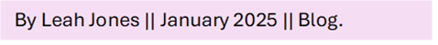
Skinner and Vygotsky in 21st century Inclusive Pedagogy.

By Leah Jones || January 2025 || Blog.

You know the drill by now, I am here to save the day and save you from pages of reading and (let’s say it together) big words. In today’s blog I am going to explain how I personally use Skinners – Operant Conditioning theory and Vygotsky’s – Zone of Proximal Development (ZPD) in an Autistic Unit in a Primary School setting. In the unit we are fortunate enough that the class sizes are small (ranging from 6 – 10 pupils) and each class is staffed well. We prioritise a child centred approach to pedagogy and actively remove any barriers that may prohibit a child learning (Pwll Primary School).
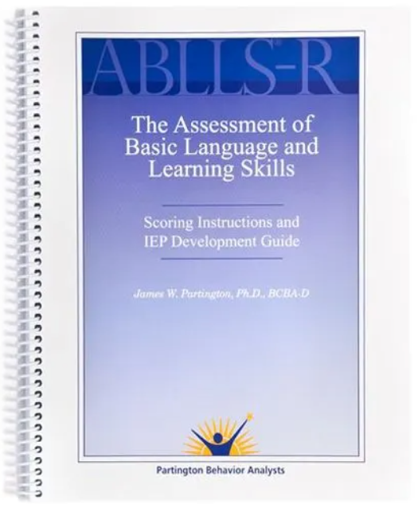
Understanding where the learner is at.
Before we begin implementing the approaches, we first asses what level the pupil is at. We use a range of different resources such as Assessment of Basic Language and Learning Skills (ABLLS) (Partington, 2018), Assessment of Functional Living Skills (AFLS) (Middletown Centre for Autism, 2012) this provides teaching staff with an understanding of the pupils capabilities (Estyn, 2024). From here a tailored programme for each child is made and this is where we utilise the approaches. At the start of each year pupils and staff time pairing, this allows teaching staff to find out what the learner likes and dislikes.
(Partington, 2006).


Operant Conditioning.
Positive reinforcement is everywhere you look throughout the unit. It varies in form depending on what class you visit and the individual needs of the child (Aubrey and Riley, 2019), but it is a pedagogical approach that it is firmly embedded in out teaching. Each learner in the class has their own individual programmes (Welsh Government, 2022), Operant conditioning is utilised whilst working through the programme, the teacher is always facilitating positive reinforcement when they see the wanted behaviour (Pwll Primary School, 2020). We use a range of varying positive reinforcers, such as: tickles, high fives, running, ball pool, a weighted blanket, toy or a point if using a points system to work towards reinforcers. They will vary for each learner and change over time.
(Adobe Stock, 2025)

How it is taught.
Example: A learner is unable to wait.
You would begin by modelling, then allowing the learner to take over. Starting at an appropriate level for your learner, it could be 5 seconds, or it could be 20 seconds. Reinforcing when you see the wanted behaviour, when they have mastered waiting for the 5 seconds you can then progress to the next step in the programme. You can use a timer as a prompt to help the learning through this process. Ensure that you are aware of what reinforces your learner and changing it when needed.
ZPD:
ZPD is another approach that is embedded throughout our teaching, we utilise this approach to allow our pupils to reach their full potential by removing barriers and facilitating learning (Welsh Assembly Government, 2004). When working through this approach it is imperative to understand the appropriate language to use for the pupil, to allow you to successfully facilitate learning to the pupil (Aubrey and Riley, 2019). Through a collaborative process we then help the pupil master their targets, using scaffolding or modelling to help them through this approach (Bates, 2019). Once these targets are mastered, we then move on to work in their new ZPD.


How it is taught.
Example: A learner is working on a puzzle.
The size of the puzzle changes where you may start in this approach. If it’s a 2-piece puzzle you could begin by modelling, teaching the learner how to put the pieces together. As this progresses, you can begin to explore different scaffolding ideas. Such as, finding the corners and the outside pieces first and building the puzzle from the outside in. It could be as simple as putting an image of the finished puzzle in front of the learner to follow.
(Shutterstock, 2025)

I hope that this blog has given you an understanding of how these two approaches by phenomenal theorists are used in today’s inclusive pedagogy. How different would education be without the influence of these 2? I guess we’re lucky we’ll never have to know .

Blog 4 References.

Adobe Stock. (2025). Tickle Images. [Online] Available at: https://stock.adobe.com/uk/search/images?filters%5Bcontent_type%3Aillustration%5D=true&filters%5Bcontent_type%3Aphoto%5D=0&hide_panel=true&k=tickle&search_type=recentsearch&asset_id=914727987. (Accessed: 4th January 2025).
Aubrey, K. and Riley, A. (2019). Understanding and Using Educational Theories. 2nd ed. London : Sage.
Bates, B. (2019). Learning Theories Simplified. London: Sage Publishing.
Estyn. (2024). Learning Support Assistants lead on intervention programmes - Estyn. [Online] Estyn. Available at: https://estyn.gov.wales/improvement-resources/learning-support-assistants-lead-on-intervention-programmes/. (Accessed: 4th January 2025).
Middletown Centre for Autism (2012). Life Skills Resource. [online] Life Skills Resource. Available at: https://life-skills.middletownautism.com/background/assessment-life-skills/assessment-functional-living-skills-afls/. (Accessed: 3rd January 2025).
Partington, J. (2006). (ABLLS-R) Assessment of Basic Language and Learning Skills. Behavior Analyst, Inc.
Partington, J. (2018). (ABLLS-R) Assessment of Basic Language and Learning Skills, Revised. [Online] WPS. Available at: https://www.wpspublish.com/ablls-r-assessment-of-basic-language-and-learning-skills-revised. (Accessed: 3rd January 2025).
Pwll Primary School (2020). Policies | Pwll CP School. [online] Available at: https://primarysite-prod-sorted.s3.amazonaws.com/pwll-cp-school/UploadedDocument/3e0bcb41-f9e7-4d32-8a25-599f155d8ed3/positive-behaviour-policy-sept-2022.pdf. (Accessed: 3rd January 2024).
Pwll Primary School (2024). Policy on Inclusion Pwll Primary School Pwll Primary School Inclusion Policy. [Online] Available at: https://primarysite-prod-sorted.s3.amazonaws.com/pwll-cp-school/UploadedDocument/9a34360d-9d6f-435f-bba3-46a20d7b93ce/inclusion-policy-2024.pdf. (Accessed: 3rd January 2025).
Shutterstock. (2025). Two Hands Hold Puzzle Pieces. [Online]. Available at: https://www.shutterstock.com/image-vector/two-hands-hold-puzzle-pieces-solution-2148622427. (Accessed: 5th January 2025).
Welsh Assembly Government, (2004). Special Educational Needs Code of Practice for Wales. [Online] Available at: https://www.gov.wales/sites/default/files/publications/2018-03/special-educational-needs-code-of-practice-for-wales.pdf. (Accessed: 3rd January 2025).
Welsh Government, (2022). Developing a vision for curriculum design - Hwb. [Online] hwb.gov.wales. Available at: https://hwb.gov.wales/curriculum-for-wales/designing-your-curriculum/developing-a-vision-for-curriculum-design/#curriculum-design-and-the-four-purposes. (Accessed 4th January 2025).

