
E-Portfolio
Evidence of Learning

Achia Khan (2026002)
Changemakers: Building your Personal Brand for Sustainable Employment
Module code: BMHP 5015
Lecturer: Kennedy Obohwem

Content Page
Personal Statement ...................................................................................................3
Curriculum Vitae ….....................................................................................................5
Pitch …........................................................................................................................8
References …............................................................................................................12

Personal statement

Achia Khan
104 Briar Way
Bristol,
BS16 4JL
07522110749
achia_khan@yahoo.com
10/10/2022
University of Birmingham
Edgbaston
Birmingham
B15 2TT
I am applying for post graduate degree in teaching young children at the university of Birmingham. I am extremely interested in the topic psychology and teaching. My interest in some of these sectors was sparked during my undergraduate studies at the University of Wales Trinity Saint David’s, where I majored in health and social care and chose physiology as my final year research topic. During my research, I gathered documents on psychology and further reading piqued my interest. This course will not only cover the topics listed above but will also introduce me to new areas of study that will broaden my knowledge and understanding of the subject. I received an exceptionally high grade on my doctoral thesis, and I am eager to expand on my interest in the dissertation part of the course that requires research. I expect to earn a high 2.1- or first-class degree, proving my educational capacity to learn at this standard. The department's international credibility attracts a diverse range of students, and I genuinely think it will be exceptionally high for students to pursue a master's degree. This university also supplies positive technical and recreational opportunities for postgraduates, showing dedication to the bachelor's degree student population.
I am currently a university student with a completed level 4 in health and social care and working on level 5. I enjoy working with children of all ages. For several years, I worked in my family's catering business, which will be useful in the food and hygiene areas. I am a hardworking, self-motivated, and committed individual who feels most at ease in a position where pressure is an everyday occurrence. I applied for this course because I am confident that, as a learner, the opportunity of analysing cognitive science transformation at the University of Birmingham is highly intriguing. I exceed in tough circumstances and am looking forward to the opportunity of aiding my peers/colleagues, and a career in this course will allow me to incorporate and utilise my honest hard-working characteristics.
I believe I can find great benefits from this course and, by standard, exceed expectations. When I commit to doing a job, I am always punctual and do not like to let anyone down. My skills and qualifications to date will be beneficial to completing this course. Throughout each team project, I have always ensured that I performed my own position to a high standard while also aiding other team members in completing their own tasks.
This position is a good fit for what I am looking for. It would aid me in expanding my knowledge as I pursue a career in healthcare. I am always dedicated to my obligations.
I am looking forward to meeting with you for an appointment. An intellectual, qualified, and experienced viewpoint is usually considered, and in some cases is a key factor of the admission criteria. I wish to keep pursuing my desire to take part in studying my field of study by pursuing a PhD or conducting research with a governmental agency or even another civil service.
However, I view the Doctor of Philosophy as a capstone experience in and of itself as well as a professional steppingstone; I eagerly anticipate reading articles for the purpose of reviewing philosophies and hope to continue my research there to the standard expected by the PhD programme.
I appreciate you considering my application and thank you. I hope to hear from you as soon as possible.
Sincerely,
Achia Khan

Curriculum Vitae
Achia Khan
ADDRESS
Briar way
Bristol, Bs16 4jl
United Kingdom
PHONE: 07522110749
EMAIL: achia_khan@yahoo.com

OBJECTIVE
Work-related management experiences in a family business. Develop trusted relationships with consumers and employees by using your communication abilities. Experience leading teams to routinely meet goals while supplying useful administrative and communication skills. With more than ten years of experience helping with, having to implement, and handling different projects, a skilled project leadership competent. Capable of successfully completing high-level projects and always preserving clear communication. Very competent analyst with a keen attention to detail. Keeping track of your time effectively and giving all your work-related responsibilities your full attention.
EXPERIENCE
Managed Catering Company – (February 2008–April 2019) Delegating health and safety norms and regulations, I have helped staff and customers find their products. Enhanced customer consultations and shown determination through team leadership. Effective time management techniques were used to speed up task completion and minimise mistakes. Life has given me a wide variety of lessons that I have gained via my full-time mothering and housekeeping responsibilities. My experience working in a team has given me self-confidence and a positive outlook on teamwork.
Working closely with other employees every day. Aiding people in changing their lives for the better. Helping abusive parents develop new routines and trends. These are a few areas where I have personal experience.
SKILLS
• Managed Professional Clients
• Profound work ethic
• Interacting with children and planning activities
• Time keeping
• Monitored behaviour, met problems, and corrected using constructive methods or disciplinary action
• Helped youngsters develop their social skills through a balanced approach that included learning and unstructured play.
• Recent first aid training
• Study skills training in digital skills
• Hardworking, self-motivated, and committed individual
To accommodate various learning styles, supplied healthy learning environments through a variety of activities like games, storytelling, and movies. Promoted good hygiene by supplying guidance on proper methods, ongoing observation, and personal support. I would be able to aid people in emergencies since I am a first aider. I have completed health and hygiene courses to gain practical knowledge for the workplace.
When I must make decisions on my own without consulting a manager, I have no fear. The capability of taking prompt action to safeguard vulnerable service users. willing to take on responsibility for care plans' execution. I can perform well under pressure. Driven by a desire to rank among the best. Contributing to the group a captivating presence by profession. Reliability and care for every detail.
EDUCATION
1987 NVQ level in caring at Josiah Mason College, Birmingham
1990 B-tec Pharmacy level 1 Mathew Boulton College, Birmingham
1999 B-tech National Diploma (Nursery Nursing) Handsworth College, Birmingham
May 2022 Certificate of Higher Education in workplace skills (Health and Social Care) University of Wales Trinity Saint David
October 2022 First Aid training course
October 2022 Microsoft Essential skills training
October 2022 Building a Brand: from concept to Canva
Presently completing my Bachelor of Science (Honours) in Health and Social Care.
ACCOMPLISHMENT
Staff handling evaluations and have improved because of successfully resolving customer complaints and offering monthly staff training. Highcroft Hospital in Erdington was the location of one of my first nursing jobs. It was my most memorable experience because it taught me to be more considerate and accepting of people from all social classes. In the past, I have worked with multicultural societies. I received an education that exposed me to concepts from religions other than my own while I was a student at a Catholic school, where I found a valuable experience from.
INTERESTS
I like working out and listening to music. I go to the gym and go for walks frequently. I enjoy socialising with my friends in my spare time. I enjoy going to novel places to explore, going to museums, and going to public museums and galleries. Along with my love of books and thrillers, I also like taking long drives to see tourist places.
REFERENCES
Available if asked.

Pitch
Healthy lifestyle? Quit smoking!
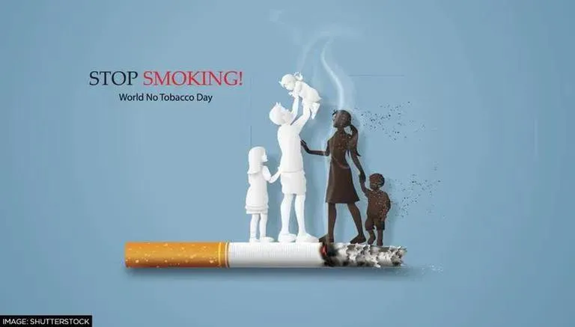
Image: world r (2022)

This pitch is focusing to the audience to raise awareness on how smoking can be dangerous for all ages. TV commercial for "NO SMOKING" directed to all smokers. The message is to convey how threatening it is to the wellbeing and the respiratory disease it generates, as well as how damaging it is to the respiratory system, chest, and all organs within the body, including the heart. The Department of Public Health has anti-smoking campaigns.
The public is never adequately educated about the quit smoking campaign, which aims to prevent health conditions.
Time: Between (9pm and 11pm) To be televised after 9 p.m. with an eye on mature audiences.

Duration: 2-3 minutes weekday (Monday 25th October 2022, Wednesday 27th October 2022 and Friday 29 October 2022)
The advertisement will last 2-3 minutes and will be broadcasted on channel 5. It will be clear, concise, and compelling to grab the audience's attention.

Day 1 Monday 25th October
Time slot: 9:15 pm – 9:17 pm (T.V. advertisement)
Duration: 2 minutes
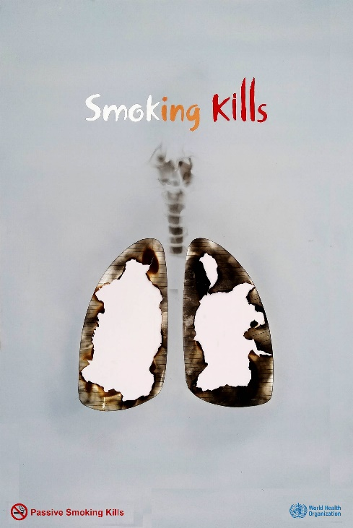
Anti-smoking marketing messages include an added boost for smokers to quit
image: No smoking • ADS OF THE WORLD™: accessed (23 October 2022)
How do I promote giving up smoking?
Among these strategies are smoking taxes, media-wide television ads, peer awareness programmes, community mobilisation techniques, behavioural interventions, warning labels on nicotine products, promotional limitations, and smoking bans in public places.
As mentioned by Harris (2018), Numerous substances found in cigarettes, including nicotine and toxic gases, are poisons that, in large doses, can be fatal. The body is intelligent to recognise when poisoned, it goes on the defensive. The first times an individual tries tobacco, they often experience pain, or it is going to burn in their lungs and throat while others even experience nausea.
Smoking causes:
Cardiovascular conditions,
Cancer,
Chronic obstructive pulmonary disorder (COPD), and
Poor women's health care effects.
For further information: contact me on / 0121 3246789 (Achia Khan)
Email: info@no_smoking.org.uk
Facebook or twitter
Day 2 Wednesday 27th October
Time slot: 9:37 pm- 9:39 pm (T.V. advertisement).
Duration: 2 minutes
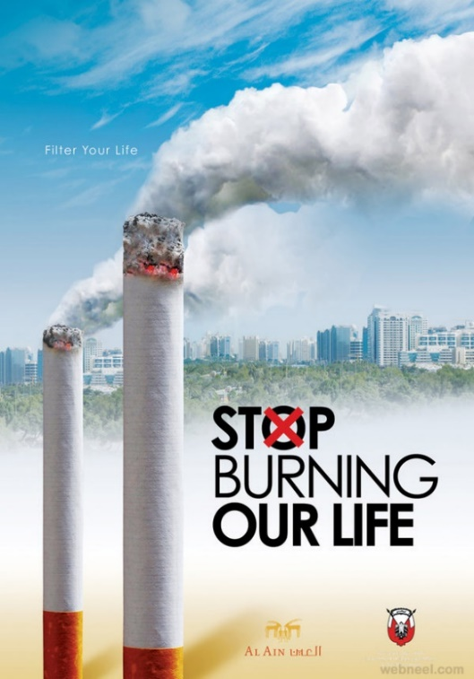
Smoking should be avoided. The goal is to target young teenagers and adults who are already struggling from difficulty breathing but continue to smoke despite having respiratory problems.

Image: (30 Brilliant Anti-Smoking Advertisements for your inspiration - Best Posters and Campaigns, 2022)
Smoking among teenagers may start out casually, but it can develop into a chronic issue. Most adult smokers began when they were teenagers. Use these suggestions to prevent your teen from becoming addicted.
By setting an example
Teenagers whose parents smoke are more likely to smoke themselves. Quit smoking if you do. Consult your doctor for advice on quitting smoking.
In the interim, avoid smoking in front of your teen and clear your home of any traces of smoking. Inform your teen of your dissatisfaction with cigarettes, the challenges of quitting, and your commitment to persisting there till users give up permanently.
According to Kobus (2003), peer pressure and elements of childhood and adolescent social connections, such as the closest bonds of friendship, romantic partners, peer groups, and social gatherings, contribute to teen smoking.
For further information: contact me on 0121 3246789 (Achia Khan)
Email: info@no_smoking.org.uk
Facebook or twitter
Day 3. Friday 29th October
Time slot: 10:45 pm- 10:47pm (T.V. advertisement).
Duration: 2 minutes (viewers discretion is advised, due to the image may scare the audience).
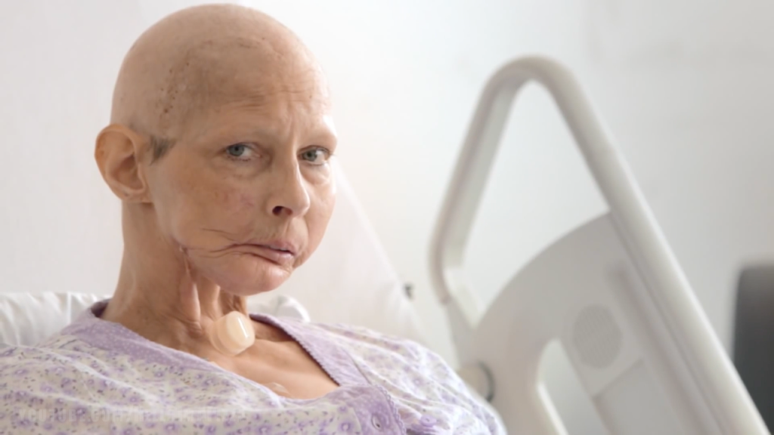
Image: (TOP 40: SCARIEST ANTI-SMOKING COMMERCIALS – HelloImAPizza, 2022)
According to HellolmAPizza (2022), a quick summary of the Clock ticking down: Cigarettes are the leading cause of cancer in the world, killing 6 million people each year, with half of those who use them eventually dying from smoking-related diseases. Painful anti-tobacco ad campaigns have been created to visually depict the repercussions of smoking to combat cigarette use and illustrate the repercussions of inhaling not only on people who smoke but also on those around them. These 40 anti-smoking advertisements are among the most graphic, shocking, and potent ever produced (Castaldelli, Ventriglio, and Bhugra 2016).
This is what your body could really expect after giving up smoking is reduced skin darkening and discoloration. One of the most obvious differences between your skin prior to and after giving up smoking is that your complexion will appear less grey and pale due to increased blood flow. As Lv et al. (2015) states that after you withdraw, your facial expression might even seem brighter with a natural glow as your skin receives more oxygen and minerals.
For further information: contact me on 0121 324 6789 (Achia Khan)
Email: info@no_smoking.org.uk
Facebook or twitter
Soon, a web page will be created for posting everyone's blogs and comments.

References

Castaldelli‐Maia, J.M., Ventriglio, A. and Bhugra, D., (2016). Tobacco smoking: From ‘glamour’to ‘stigma’. A comprehensive review. Psychiatry and clinical neurosciences, 70(1), pp.24-33.
Harris, C.C., (2018). Tobacco smoking, E-cigarettes, and nicotine harm. Proceedings of the National Academy of Sciences, 115(7), pp.1406-1407.
Helloimapizza.com. (2022). TOP 40: SCARIEST ANTI-SMOKING COMMERCIALS – HelloImAPizza. [online] Available at: <https://helloimapizza.com/2014/12/07/smoking/> [Accessed 15 October 2022].
Kobus, K., (2003). Peers and adolescent smoking. Addiction, 98, pp.37-55.
Lv, X., Sun, J., Bi, Y., Xu, M., Lu, J., Zhao, L. and Xu, Y., (2015). Risk of all-cause mortality and cardiovascular disease associated with secondhand smoke exposure: a systematic review and meta-analysis. International journal of cardiology, 199, pp.106-115.
Webneel.com. (2022). 30 Brilliant Anti-Smoking Advertisements for your inspiration - Best Posters and Campaigns. [online] Available at: <https://webneel.com/30-brilliant-anti-smoking-advertisements-your-inspiration-best-print-ads-and-posters> [Accessed 15 October 2022].
Who: No smoking • ADS OF THE WORLD™: Part of the clio network (no date) Ads of the World™. Available at: https://www.adsoftheworld.com/campaigns/no-smoking (Accessed: October 23, 2022).
World, R. (2022). On World No Tobacco Day, Health experts urge govt to ban advertisement of tobacco products. [online] Republic World. Available at: http://www.republicworld.com/lifestyle/health/on-world-no-tobacco-day-health-experts-urge-govt-to-ban-advertisement-of-tobacco-products-articleshow.html [accessed1 Nov. 2022].

