OOP Programming (C++)
Student Name: Timothy Edwards, Student number: 2004445, Course name: Computing (Software Engineering), Module name: Advanced Software Development (ACCB5011), Submission Date: 10/12/2021

Contents
Introduction 2
Video 3
OOP report 4
Testing 6
Conclusion 13
References 14
Appendix 15

Introduction
In this report we will look at the code for the report (the game treasure hunt) in a video, importance of Object-Orientated Programming (OOP). We will also do testing of the game.

Video
Below is a video, going through code step by step and demonstrates the players winning and the instance of a draw between the player and a CPU or bot
https://youtu.be/QhGX6uDAdbY

OOP report
For this section of the report, we will explore the concepts behind Object Oriented Programming and their importance. We will also be looking at Appendix 1 for examples of where Object Orientated Programming exists.
What is OOP?
Object Orientated Programming is a variant of programming, and it is based around the concept of classes and objects. [1][2] There are then a magnitude of things that OOP will achieve, including polymorphism, and inheritance. This report will demonstrate both of these concepts.
The biggest concept for OOP as stated previously is the concept of classes and objects. The best way to think of this is like a database of sorts. Each time we make a class we fill it with attributes and methods like fields, then when we make a new instance of that class we may then populate that new instance with new information, this is what is called an object A good example of this is registering a car as we can see below:
Class: Car
Attributes:
-colour
-brand
-model

Methods:
-makenoise().

Object: a_Car | Object: b_Car
Attribute:  -colour=Orange  -brand=Audi  -model=A4  Methods:  -makenoise() | Attribute:  -colour=Pink  -brand=Toyota  -model=Rav-4  Methods:  -makenoise()

Thanks to the way Object Orientated Programming is, it is easier to reproduce, as all that is required is the class, and the attributes. The Classes may be used across projects too. And they are significantly easier to debug as classes often contain only information applicable to them. [1][2]
Are there instances of OOP concepts in the appendix?
There are a few instances of OOP concepts with appendix 1, and for this section of the report we will examine them.
Appendix 1 – humanOrCPU class
Between the lines 15 to 18 in the appendix 1 is a class named “humanOrCPU” this is an instance of a base class or otherwise known as a parent class, this is because humanOrCPU is shared among other classes these classes are known as a derived class or a child class. This class in particular is used to store whether the player is a human or a bot/CPU.
Appendix 1 – player class
Between the lines 21 and 25 there is another class known as “player”, this is one of 2 classes that has inherited from humanOrCPU, thus making it a derived or child class. This class is used for holding information about the player, more specifically, the player name and if the player is a bot or human, this is always true.
Appendix 1 – cpu class
Between the lines 27 and 31 is the “cpu” class. This class is the other instance of inheriting the humanOrCPU class, making this another case of a derived or child class. This class only cares about one detail and that is if the second player is a cpu or not.
Appendix 1 – rules class
Between the lines of 34 and 52 is the class for the rules. This is mainly for player reading the rules. But also acting as some form of start screen too as the player will see the rules as the first thing they will load into. Because of this the class is populated by a series of stings and a single method for pausing the rules or rather pausing the game.
Appendix 1 – turn class
Between the lines 55 and 58 is the class for turn. For this class it’s a simple integer and that integer is named turns, this integer could have been in the main program on 3 occurrences however, with it in a class it allows turns to be used anywhere that it needs to be used.

Testing
In this section of the report, we will perform tests on the code from the appendix. Each test will be performed individually, and will be laid out in the following format:
Test number.
Test description
Expected result
Actual result (pass or fail)
Screenshot of result

Test 1
This test will be a simple test to load the program and to see if the opening screen or rules screen loads correctly
The expected result should be that the program will load, and the opening screen or rules screen loads with the program starting.
The actual result is that the test was a success, the screen loaded, and the rules all loaded in with it. The test has passed
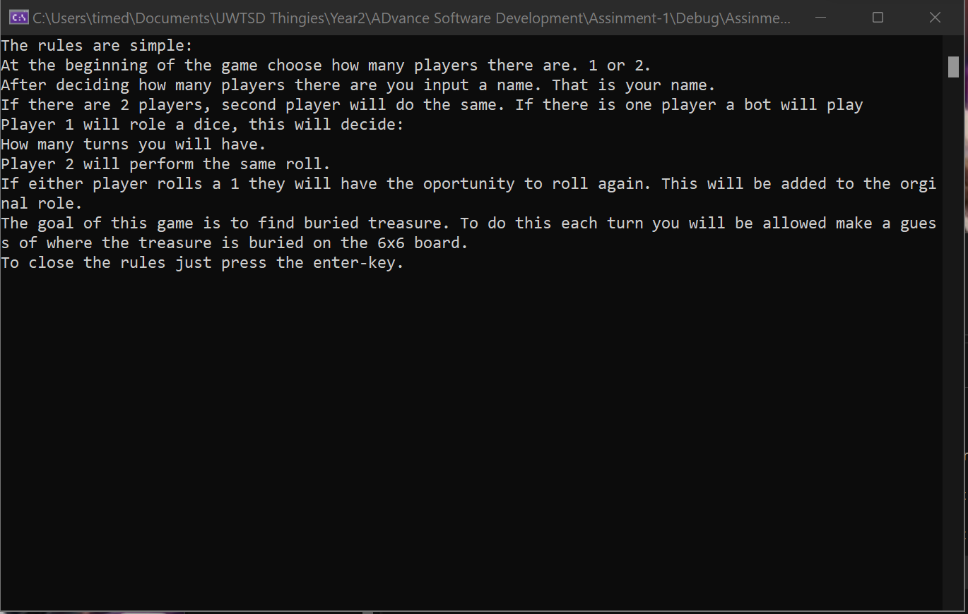

Test 2
This next test is to see if when the player hits enter the game will progress to ask the player how many players are playing today.
The expected result is that the player is able to progress on the press of the enter key, they should then be asked how many players are playing today.
The actual result is that on the press of the enter key the player is asked how many players are playing today. This means that the test passed.
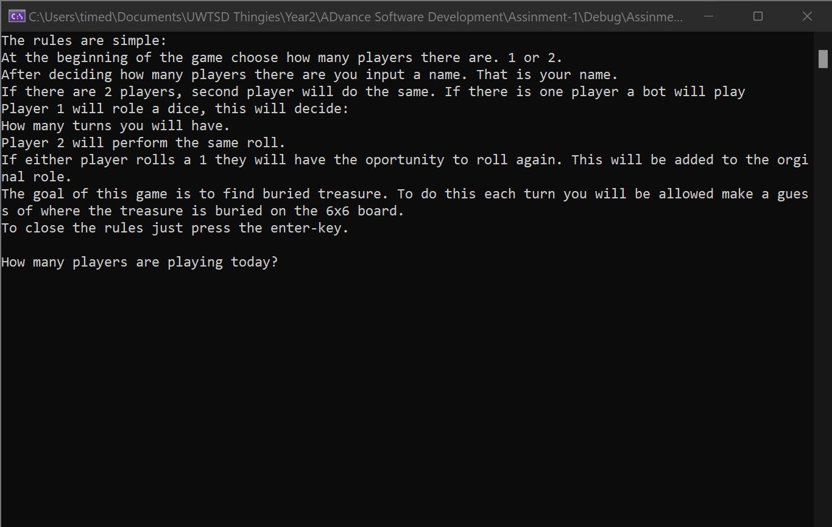

Test 3
In this test we will be exploring what will happen if the user inputs a number that is lower than 1 or a number higher than 2 into the number of players question
The expected result is that the player is thrown into a loop until they input a valid number of 1 or 2.
The actual result is that the player is put into a loop and cannot leave until they input a 1 or 2. The test was a success.
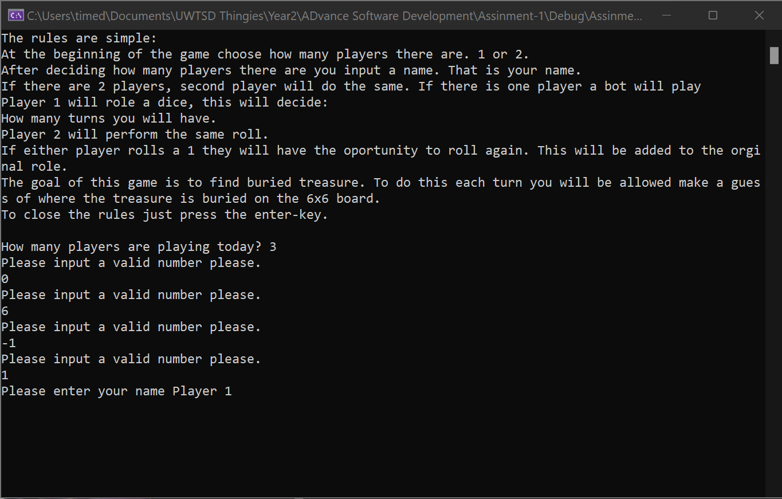
Test 4
This is a test to see if the game will roll validate the players “r” press for the
The expected result is if the player inputs any letter/word other than r they will put into a loop to correct it. The exception being to roll and Roll
The actual result is the player is put into a loop until they give a valid response. The test was a pass.
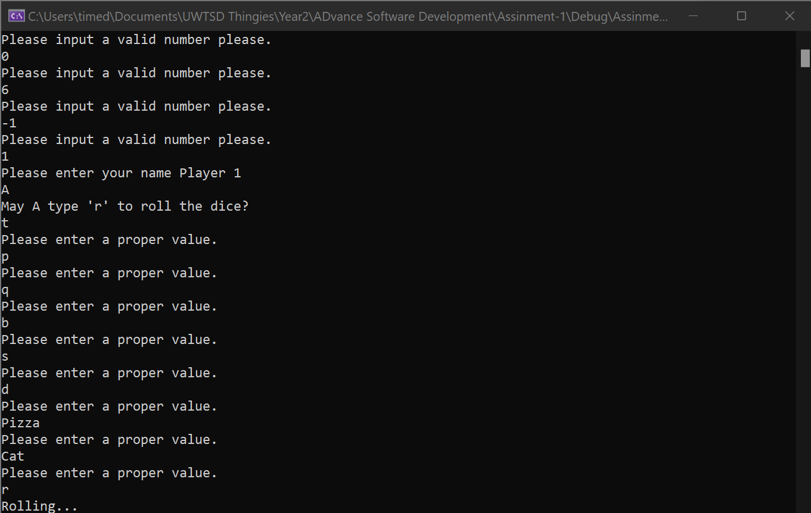
Test 5
This test is to see if the roll performs a second roll if the player or CPU rolls a 1
The expected result is when it does roll a 1 it will perform a second roll to increase the number displayed on the dice.
The actual result is exactly that, the dice is rerolled if the player or the bot rolls a 1. So the test Passed.
Before reroll
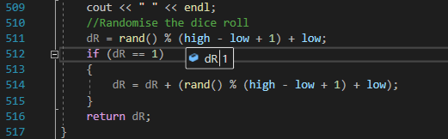
After reroll
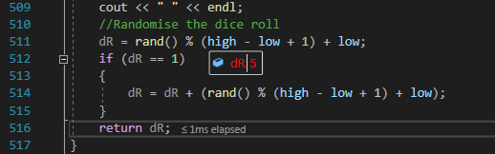
Test 6
This is a test to see if the bot will take multiple guesses if their random equation lands in a spot that is already taken.
The Expected result is that the bot will take multiple guesses as the spot they chose is already taken.
The actual result is bot will take as many guesses as it needs to land a spot on the board. The test is a pass.
Before
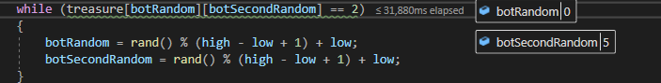
After
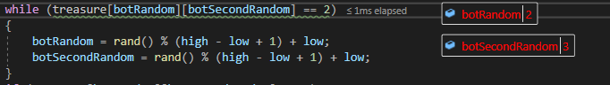
Test 7
This is a test to see if the player may input a number not on the grid.
Expected result is that the player will be requested to try a different number.
The actual result is that the player was asked for a different number, and was asked on both guesses. Test is a pass.
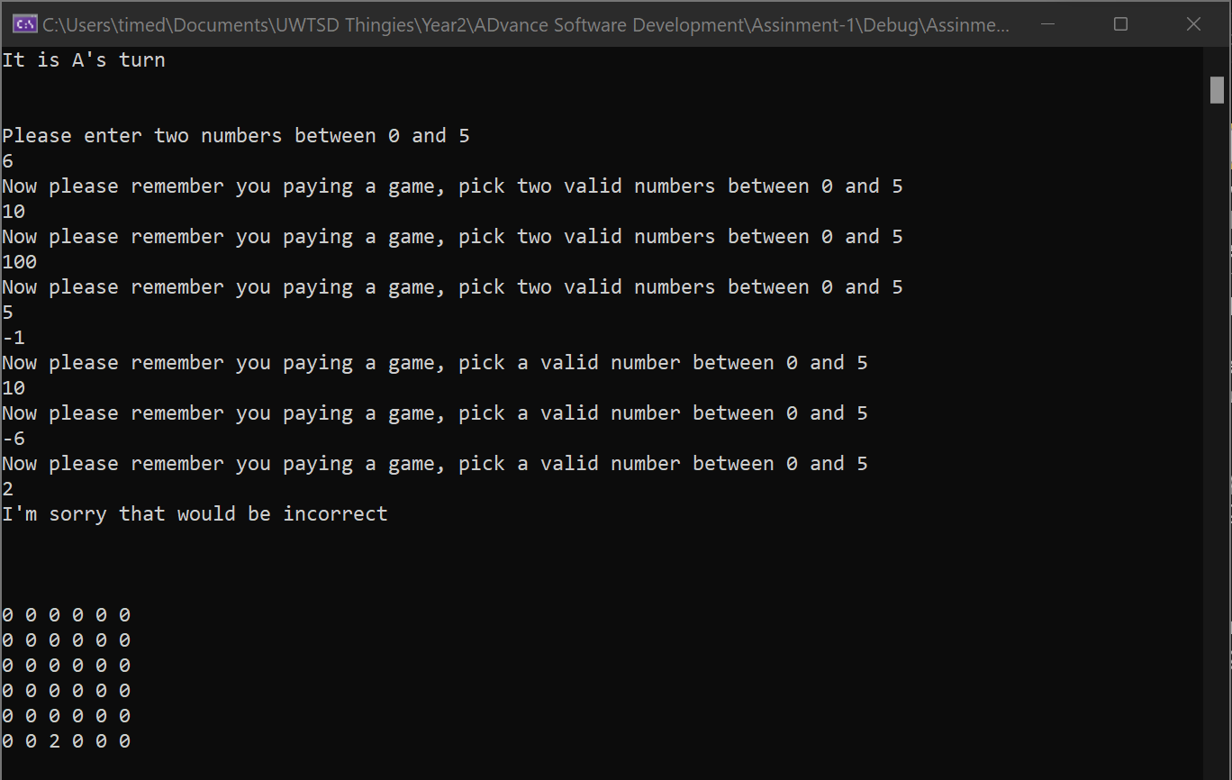
Test 8
This next test is to see if it is possible for both players to end with a draw.
The expected result both players (human or bot) will run out of moves on and will ultimately end the game resulting in a draw.
The actual result is that both players ran out of moves and the game ended with a tie and the game ended showing a message and then the owner of the code’s message.
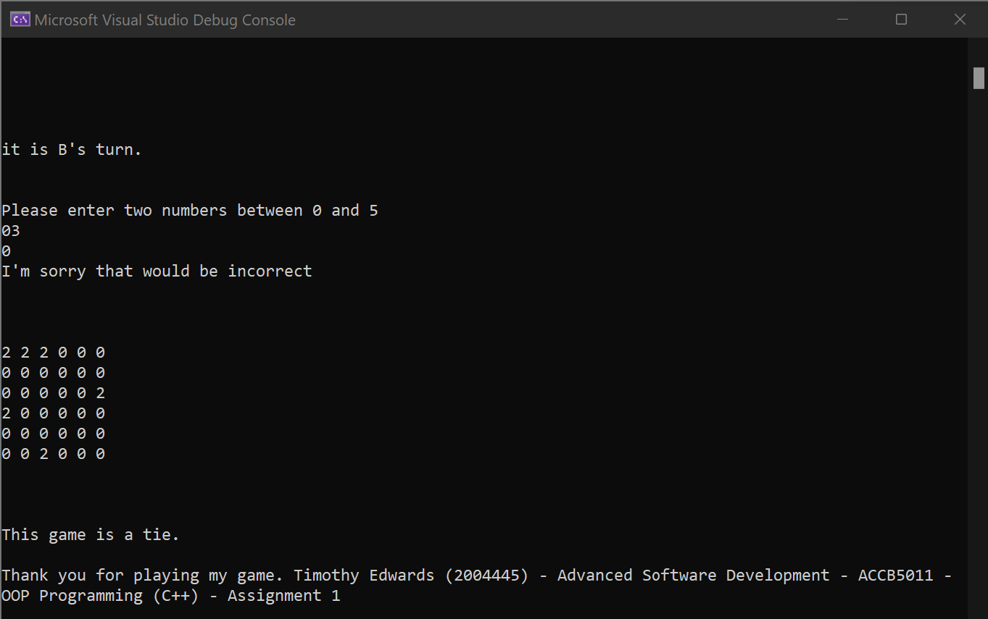
Test 9
The purpose of this test to show that player 1 may win against either player 2 or the cpu.
The expected result is that player 1 will win and will get a congratulatory message and the final board will print.
The actual result is a little interesting there was a minor error in the presentation, however the end result is still the same. Player 1 received a congratulatory message, and the final board did print however the final board began to print while on the same line as the congratulatory message.
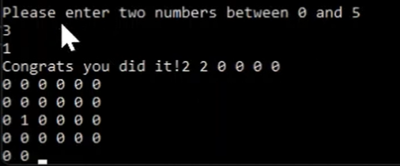
To fix this its as easy as adding some “endl”s or “\n” and this is the new result after resolving this:
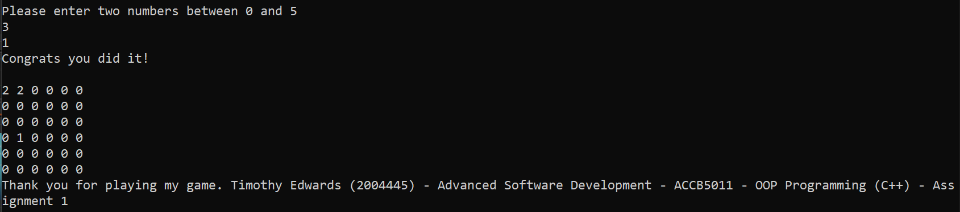
Test 10
The purpose of this test is so that we can see Player 2 winning against Player 1.
The expected result is that Player 2 will get a congratulatory message and will see the final board.
The actual result was that Player2 won the game so they saw the congratulatory message and they also saw the final board.
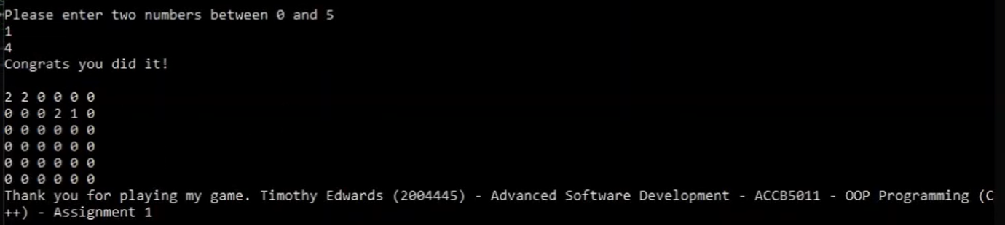
Test 11
The purpose of this test to see if the CPU or the Bot is able to beat Player 1. If they are they should get a congratulatory message or a confirmation message, and a final board should appear.
The expected result is, yes they will be able to beat the player, the player will see a message confirming the victory to the bot and the final board will be display.
The actual result is that the player loses, the confirmatory message to that effect is displayed and the final board is then presented to the player.
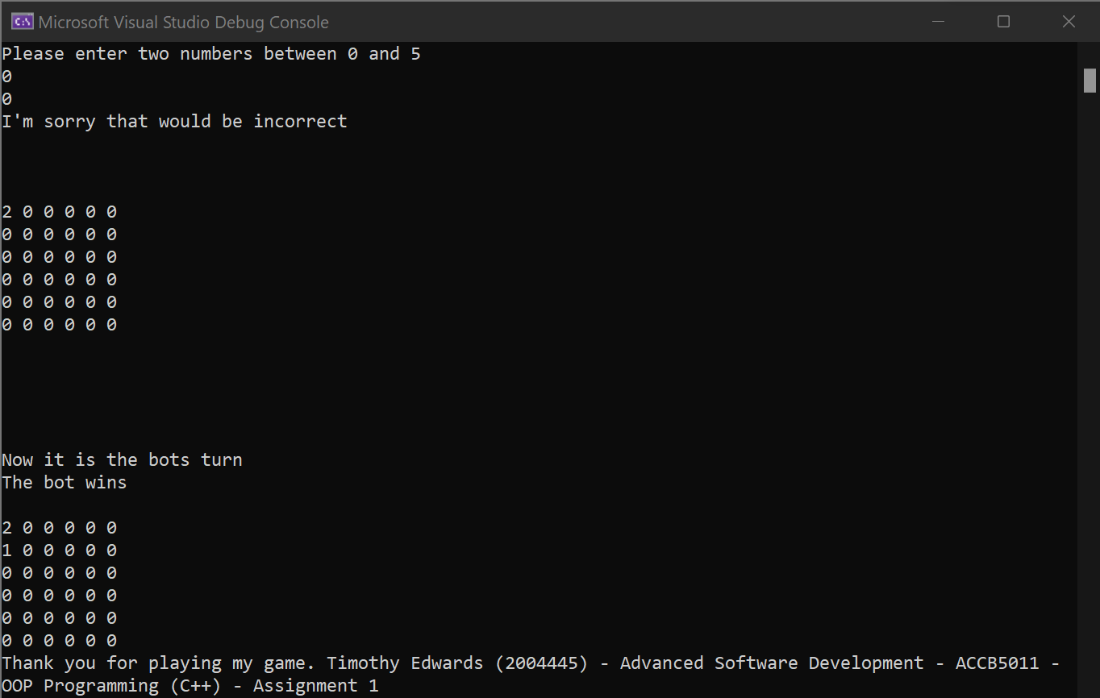

This concludes the testing of this game.

Conclusion
From the testing performed seems to imply that the game the game seems to run decently well. The importance of Object Orientated Programming has been stated and of course at the beginning of this report is the video. With this comes the conclusion to this report. The whole code, as found in the importance of OOP, is in the Appendix section.

References
[1] E. Doherty, “What is Object Oriented Programming”, Educative, 15/04/2020, [Online], https://www.educative.io/blog/object-oriented-programming, [05/12/2021]
[2] w3School, “C++ OOP”, W3School, [Online], https://www.w3schools.com/cpp/cpp_oop.asp, [05/12/2021]

Appendix

Appendix 1:
#include <string>
#include <iostream> // For cin, cout and getline()
#include <sstream>

using std::cout;
using std::cin;

using namespace std;

//Array to hold the board
int treasure[6][6];

//Class for humanOrCPU
class humanOrCPU {
public:
bool player_human = true;
};

//Class for the player
class player : public humanOrCPU {
public:
string playerName;
bool player_human = true;
};

class cpu : public humanOrCPU {
public:

bool player_human = false;
};

//Class for rules
class rules {
public:
//The rules for the game are listed here
string rule1 = "Welcome to the treasure hunting game.\n";
string rule2 = "The rules are simple:\n";
string rule3 = "At the beginning of the game choose how many players there are. 1 or 2.\n";
string rule4 = "After deciding how many players there are you input a name. That is your name.\n";
string rule5 = "If there are 2 players, second player will do the same. If there is one player a bot will play\n";
string rule6 = "Player 1 will role a dice, this will decide:\n";
string rule7 = "How many turns you will have.\n";
string rule8 = "Player 2 will perform the same roll.\n";
string rule9 = "If either player rolls a 1 they will have the oportunity to roll again. This will be added to the orginal role.\n";
string rule10 = "The goal of this game is to find buried treasure. To do this each turn you will be allowed make a guess of where the treasure is buried on the 6x6 board.\n";
string rule11 = "To close the rules just press the enter-key.\n";

void rulePause() {
cin.get();
}
};

//Class for turns
class turn {
public:
int turns = 0;
};

//Declaration of function printBoard
void printBoard(int, int);

//Declaration of the function diceRoll
int diceRoll(int);

int main(int argc, char* argv[])
{
//Variable for random placement
int myRandom, mySecondRandom;

//Variable for how random it may be
int low = 0;
int high = 5;

//Variables for loops
int i, j;

//Variable to hold the guess of the user
int guessOne = 0;
int guessTwo = 0;

//Variable to hold the players dice roll
int diceRollsP1 = 0; //Set to 0 as the player may only roll 1-6, and because due to the rules of the game a player may roll twice if they role 0 and is added on. Thus, they're highest roll may be 7.
int diceRollsP2 = 0;

//Variable to hold number of turns
turn myTurns;
turn p1Turns;
turn p2Turns;

//Strings for player decision
string player1Decision;
string player2Decision;

//Variable for the number of players
int numPlayers = 1;

//Make the players
player player1;
player player2;

//Make the cpu
cpu bot;

//Rules
rules manual;

//bool for if the user guessed correctly or not and bool for validation
bool correct = false;

//display rules
cout << manual.rule1 << manual.rule2 << manual.rule3 << manual.rule4 << manual.rule5 << manual.rule6 << manual.rule7 << manual.rule8 << manual.rule9 << manual.rule10 << manual.rule11;
manual.rulePause();

//Make players: Ask how many there are.
cout << "How many players are playing today? ";
cin >> numPlayers;
while (numPlayers < 1 || numPlayers > 2)
{
cout << "Please input a valid number please." << endl;
cin >> numPlayers;
}

//Make Players: Who are they?
cout << "Please enter your name Player 1" << endl;
cin >> player1.playerName;

if (numPlayers == 2)
{
cout << "Player2, please input your name" << endl;
cin >> player2.playerName;
}

//Randomise based on time
srand(time(NULL));

//Ask both players to roll a 6-sided dice
cout << "May " << player1.playerName << " type 'r' to roll the dice?" << endl;
cin >> player1Decision;
//Validate answer given by Player1
while (player1Decision != "r")
{
if (player1Decision == "roll" || player1Decision == "Roll")
{
break;
}
cout << "Please enter a proper value." << endl;
cin >> player1Decision;
}
diceRollsP1 = diceRoll(diceRollsP1);
cout << player1.playerName << " rolled: " << diceRollsP1 << endl;

//Check the number of players
if (numPlayers == 2)
{
//If there are 2 players, ask them to roll
cout << endl << "Now may " << player2.playerName << " please type r to roll the dice" << endl;
cin >> player2Decision;
//Validate their answer
while (player2Decision != "r")
{
if (player2Decision == "roll" || player2Decision == "Roll")
{
break;
}
cout << "Please enter a proper value." << endl;
cin >> player2Decision;
}
diceRollsP2 = diceRoll(diceRollsP2);
cout << player2.playerName << " rolled: " << diceRollsP2 << endl;

}
else
{
diceRollsP2 = diceRoll(diceRollsP2);
cout << "The Bot rolled: " << diceRollsP2 << endl;
}

//Loop for populating the board
for (i = 0; i <= 5; i++)
{
for (j = 0; j <= 5; j++)
{
treasure[i][j] = 0;

}
}
//Set the properties for treasure location
myRandom = rand() % (high - low + 1) + low;
mySecondRandom = rand() % (high - low + 1) + low;
//Set the location of Random to 1
treasure[myRandom][mySecondRandom] = 1;

printBoard(myRandom, mySecondRandom);

cout << "\n\n\n\n";

//Start game
while (correct == false)
{
//At the start of each pass, increase turn count
myTurns.turns++;

cout << "\n\n\n";

if (p1Turns.turns == diceRollsP1 && p2Turns.turns == diceRollsP2)
{
cout << "This game is a tie.\n\n";
break;
}

if (numPlayers == 2)
{
if (myTurns.turns % 2 != 0)
{
if (p1Turns.turns < diceRollsP1)
{
cout << "It is " << player1.playerName << "'s turn" << endl;
//Allow the user to make a guess
cout << "\n\nPlease enter two numbers between 0 and 5\n";
cin >> guessOne;
//Loop if the number is invalid
while (guessOne > 5 || guessOne < 0)
{
//Light scold then request a new number
cout << "Now please remember you paying a game, pick two valid numbers between 0 and 5\n";
cin >> guessOne;
}
cin >> guessTwo;
//Loop if the number is invalid
while (guessTwo > 5 || guessTwo < 0)
{
//Light scold then request a new number
cout << "Now please remember you paying a game, pick a valid number between 0 and 5\n";
cin >> guessTwo;
}

//Compare to see if the user managed to guess the location of the treasure
if (treasure[guessOne][guessTwo] == 1)
{
//If guessed correctly change the bool for correct to true and print congratualatory message.
correct = true;
cout << "Congrats you did it!\n\n";
//print the final board
for (i = 0; i <= 5; i++)
{
for (j = 0; j <= 5; j++)
{

cout << treasure[i][j] << " ";

//If the loop arrives at the edge of the board go to the next line
if (j >= 5)
{
printf("\n");
}
}
}
}
else
{
//If guessed wrong tell the user they guessed wrong. Change the mark on the boared to 2
cout << "I'm sorry that would be incorrect";
treasure[guessOne][guessTwo] = 2;
cout << "\n\n\n\n";
//Print the new board through a function
printBoard(myRandom, mySecondRandom);

}
p1Turns.turns++;
}
}
else
{
if (p2Turns.turns < diceRollsP2)
{
//State whose turn it is
cout << "\n\nit is " << player2.playerName << "'s turn." << endl;

//Allow the user to make a guess
cout << "\n\nPlease enter two numbers between 0 and 5\n";
cin >> guessOne;
//Loop if the number is invalid
while (guessOne > 5 || guessOne < 0)
{
//Light scold then request a new number
cout << "Now please remember you paying a game, pick two valid numbers between 0 and 5\n";
cin >> guessOne;
}
cin >> guessTwo;
//Loop if the number is invalid
while (guessTwo > 5 || guessTwo < 0)
{
//Light scold then request a new number
cout << "Now please remember you paying a game, pick a valid number between 0 and 5\n";
cin >> guessTwo;
}

//Compare to see if the user managed to guess the location of the treasure
if (treasure[guessOne][guessTwo] == 1)
{
//If guessed correctly change the bool for correct to true and print congratualatory message.
correct = true;
cout << "Congrats you did it!\n\n";
//print the final board
for (i = 0; i <= 5; i++)
{
for (j = 0; j <= 5; j++)
{

cout << treasure[i][j] << " ";

//If the loop arrives at the edge of the board go to the next line
if (j >= 5)
{
printf("\n");
}
}
}
}
else
{
//If guessed wrong tell the user they guessed wrong. Change the mark on the boared to 2
cout << "I'm sorry that would be incorrect";
treasure[guessOne][guessTwo] = 2;
cout << "\n\n\n\n";
//Print the new board through a function
printBoard(myRandom, mySecondRandom);

}
p2Turns.turns++;
}
}
}

if (numPlayers == 1)
{
if (myTurns.turns % 2 != 0)
{
if (p1Turns.turns < diceRollsP1)
{
cout << "It is " << player1.playerName << "'s turn" << endl;
//Allow the user to make a guess
cout << "\n\nPlease enter two numbers between 0 and 5\n";
cin >> guessOne;
//Loop if the number is invalid
while (guessOne > 5 || guessOne < 0)
{
//Light scold then request a new number
cout << "Now please remember you paying a game, pick two valid numbers between 0 and 5\n";
cin >> guessOne;
}
cin >> guessTwo;
//Loop if the number is invalid
while (guessTwo > 5 || guessTwo < 0)
{
//Light scold then request a new number
cout << "Now please remember you paying a game, pick a valid number between 0 and 5\n";
cin >> guessTwo;
}

//Compare to see if the user managed to guess the location of the treasure
if (treasure[guessOne][guessTwo] == 1)
{
//If guessed correctly change the bool for correct to true and print congratualatory message.
correct = true;
cout << "Congrats you did it!\n\n";
//print the final board
for (i = 0; i <= 5; i++)
{
for (j = 0; j <= 5; j++)
{

cout << treasure[i][j] << " ";

//If the loop arrives at the edge of the board go to the next line
if (j >= 5)
{
printf("\n");
}
}
}
}
else
{
//If guessed wrong tell the user they guessed wrong. Change the mark on the boared to 2
cout << "I'm sorry that would be incorrect";
treasure[guessOne][guessTwo] = 2;
cout << "\n\n\n\n";
//Print the new board through a function
printBoard(myRandom, mySecondRandom);

}
//increase number of turns the player has had
p1Turns.turns++;
}
}

else
{
if (p2Turns.turns < diceRollsP2)
{
cout << "\n\nNow it is the bots turn" << endl;

//Variable for random placement
int botRandom, botSecondRandom;
//Set the properties for treasure location
botRandom = rand() % (high - low + 1) + low;
botSecondRandom = rand() % (high - low + 1) + low;
//Check to see if the position the bot is going for is already a 2
while (treasure[botRandom][botSecondRandom] == 2)
{
botRandom = rand() % (high - low + 1) + low;
botSecondRandom = rand() % (high - low + 1) + low;
}
if (treasure[botRandom][botSecondRandom] == 1)
{
//If guessed correctly change the bool for correct to true and print congratualatory message.
correct = true;
cout << "The bot wins\n\n";
//print the final board
for (i = 0; i <= 5; i++)
{
for (j = 0; j <= 5; j++)
{

cout << treasure[i][j] << " ";

//If the loop arrives at the edge of the board go to the next line
if (j >= 5)
{
printf("\n");
}
}
}
}
else
{
//If guessed wrong tell the user they guessed wrong. Change the mark on the boared to 2
cout << "Bot guessed incorrectly.";
treasure[botRandom][botSecondRandom] = 2;
cout << "\n\n\n\n";
//Print the new board through a function
printBoard(myRandom, mySecondRandom);

}
p2Turns.turns++;
}
}
}

}
cout << "Thank you for playing my game. Timothy Edwards (2004445) - Advanced Software Development - ACCB5011 - OOP Programming (C++) - Assignment 1" << endl;
cin.get();

}

void printBoard(int mR, int sR)
{
int i;
int j;
//Print the newly updated board
for (i = 0; i <= 5; i++)
{
for (j = 0; j <= 5; j++)
{

//When the loop arrives at the loaction of the treasure hide the treasure and print "0 " instead Otherise keep printing the board
if (treasure[i][j] == treasure[mR][sR])
{
printf("0 ");
}
else
{
cout << treasure[i][j] << " ";
}

//If the loop arrives at the edge of the board go to the next line
if (j >= 5)
{
cout << "\n";
}
}
}
}

int diceRoll(int dR)
{
//variables for loops
int i;
int high = 6, low = 1;
//Randomise based on time
srand(time(NULL));
//Saying what is going on
cout << "Rolling";

//Loop for a delay
for (i = 0; i <= 1000000000; i++)
{
if (i == 1000000000 / 3 || i == 1000000000 / 2 || i == 10000000 / 1)
{
cout << ".";
}
}
cout << " " << endl;
//Randomise the dice roll
dR = rand() % (high - low + 1) + low;
if (dR == 1)
{
dR = dR + (rand() % (high - low + 1) + low);
}
return dR;
}

