Unit Run
[Company name] | [Company address]
[Document subtitle]
Andrew Rideway
Table of Contents
Introduction 2
Design 2
Brief description 2
Rules of the game 2
How to play 2
The gameplay 2
The goal 2
Implementation 3
Script 3
Screen shots 14
Evaluation 20
Errors and challenges 20
Testing table 20
References 21

Table of Figures
Figure 1 - The main menu 14
Figure 2 - The level one 15
Figure 4 - The level three 15
Figure 5 - The finished level 15
Figure 6 - The jamp and coin 16
Figure 7 - The spikes and enemy 16
Figure 8 - The next level portal 17
Figure 9 - The pause menu 17
Figure 10 - The damage health by enemy 18
Figure 11 - The whole may of level one 18
Figure 12 - The whole may of level two 19
Figure 13 - The whole may of level three 19

Introduction
This report will contain a section telling the end user the design about the game such as brief description, rules of the game, how to play, the gameplay and the goal of the game. There will be an implementation section about the script and screenshots of the game. There will be a section of valuation such as errors and challenges and testing table. All the texture assets were created in Microsoft paint and Piskel[1].

Design

Brief description
The game is a very basic 2D platformer game, so this means the player can jump from one side to the other side and jump on each platform to reach the designated area such as the portal can take them to the next area. There are three levels within the game and once the player completes all three levels they will go to a finish screen and this will allow them to return to the main menu.

Rules of the game
The rules are very simple in this game all the player must do is get past the spikes and enemies within the game to reach to the portal. The player can choose to collect coins within the game to increase the score and if the player dies they will go back to the start depending on what level they are on.

How to play
The controls for this game are also very simple, for example, the player can either use the arrow keys or the “A” and “D” keys to control the movement of the player to go left and right. The player can jump within the game by pressing spacebar and there is a pause feature within the game by pressing the “Q” key to bring up the pause menu.

The gameplay
The player must get his character to the next area by reaching the portal, but the player must go through enemies and obstacles within the game. The obstacles are the spikes which will instantly kill the player if they touch it and there is some jumping platform within the game which the player must jump onto platform to make sure they do not hit the spikes. There are enemies within the game and if the player gets touched by the enemy too many times the player will die and restart at the start of the level they are currently on.

The goal
The goal within the game is very simple the player has to reach the end of the level to go through a portal and they have to do t three times to complete the game.

Implementation

Script
Here are these lines of code that was used for developing this games attributes.

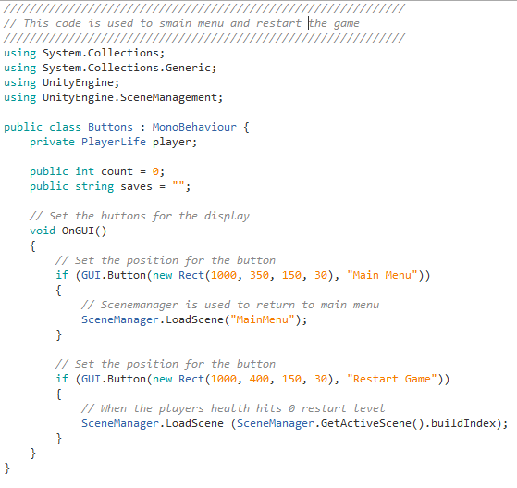
This line of code is used to return to the main menu or restart the game.

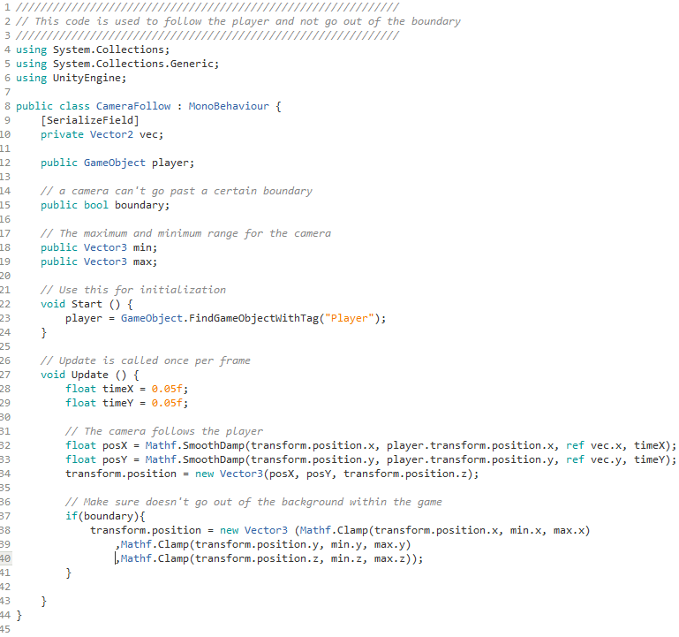
This line of code is used to allow the camera to follow the player around and it also used to stop the camera to go out of the certain boundary areas within the game[2][3].

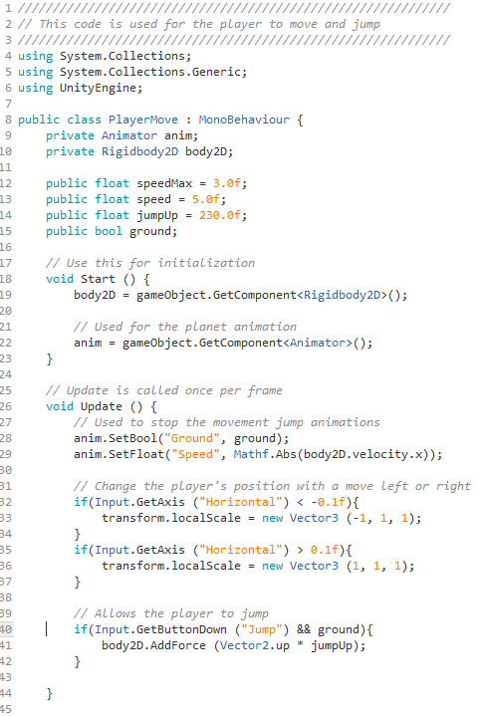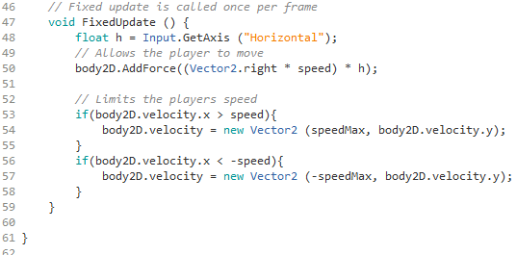
This line of code is used for the controls for the character to allow to go left and right. This also does the movement for the character to allow the character to run across the area within the game and it gives the player the capability to allow the character to jump[4][5][6].

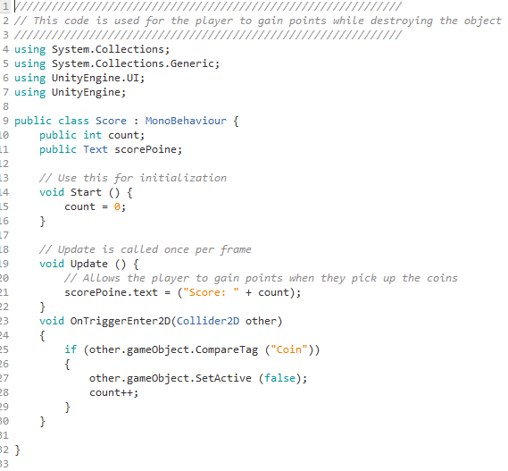
This line of code is used for the point system in the game and when the player touches the certain object is delete.

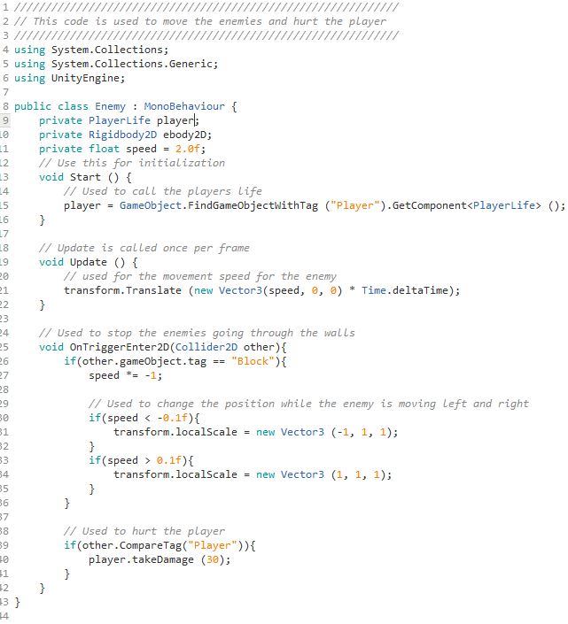
This line of code is used for the enemies to move and when the enemies hurt player the player loses some health[7].

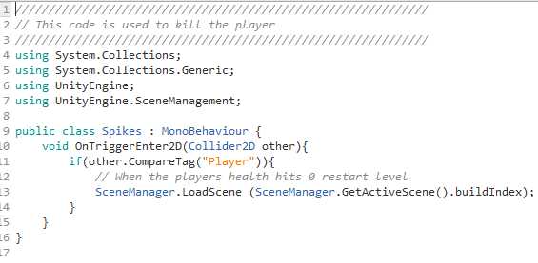
This line of code is used to instant kill the player once the player touches a certain object in the game.

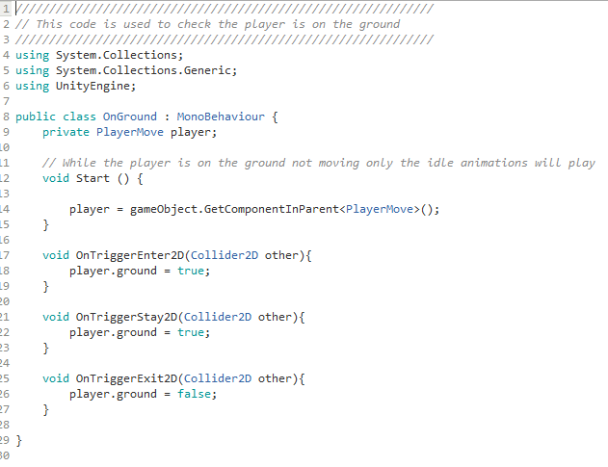
This line of code is used when the player is not jumping it stops the animation of the jump.
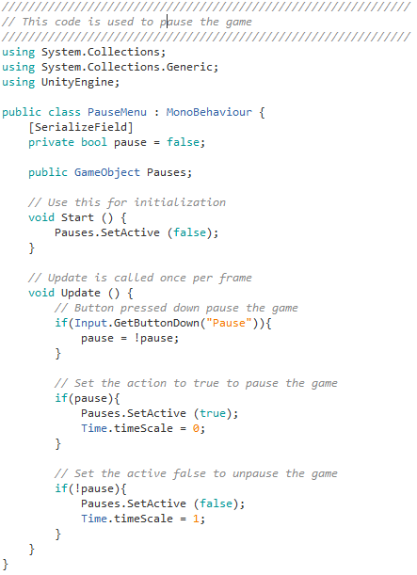
This line of code is used to give the player the capability to pause the game[8][9].

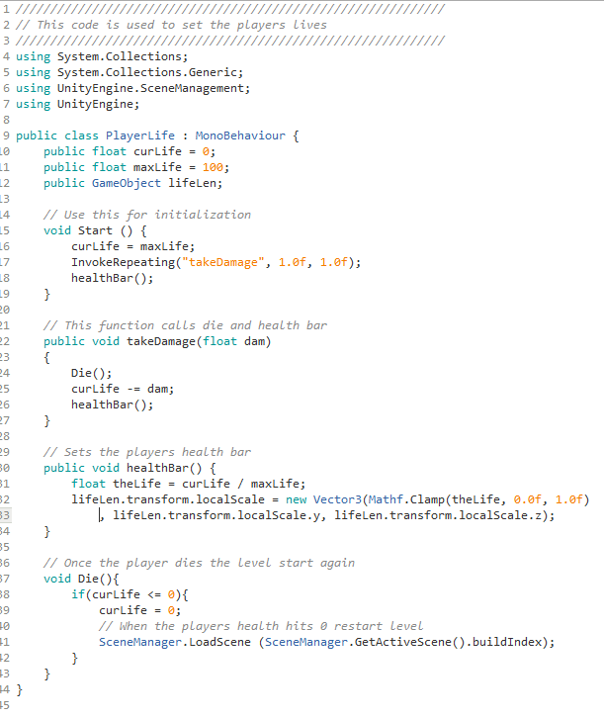
This line of code is used to give the character his lives and is used with other objects in the game to allow to kill the player.

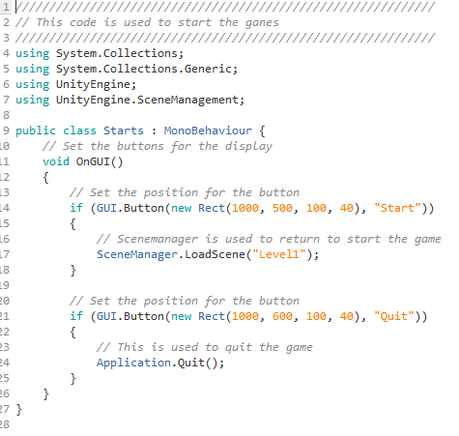
This line of code is used to start the game or quit the application.

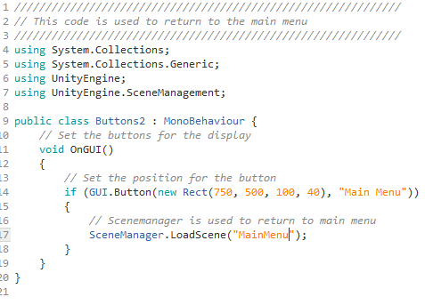
This line of code is used to return to the main menu.

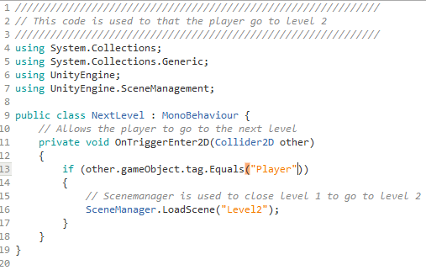
This line of code is used to go to level 2 once the character completes the level.

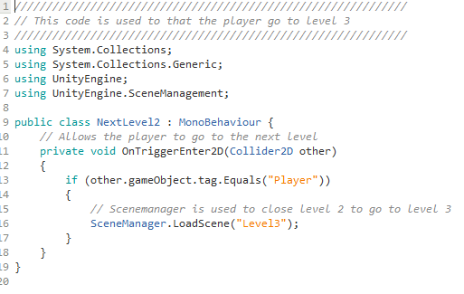
This line of code is used to go to level 3 once the character completes the level.

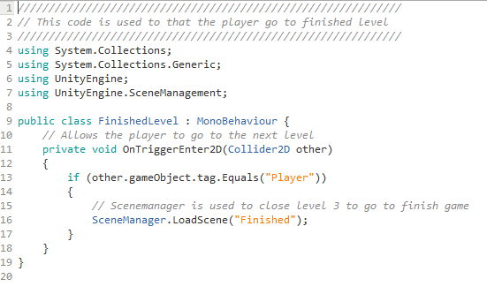
This line of code is used to go to finish game once the character completes the level.

Screen shots
Here are several screenshots of the game and the screenshots shows what in the game, such as what the main menu looks like and what each level looks like.
Here is a screenshot of the main menu and the main menu contains two buttons, such as start there is used to start the game and quit there is used to quit the game.
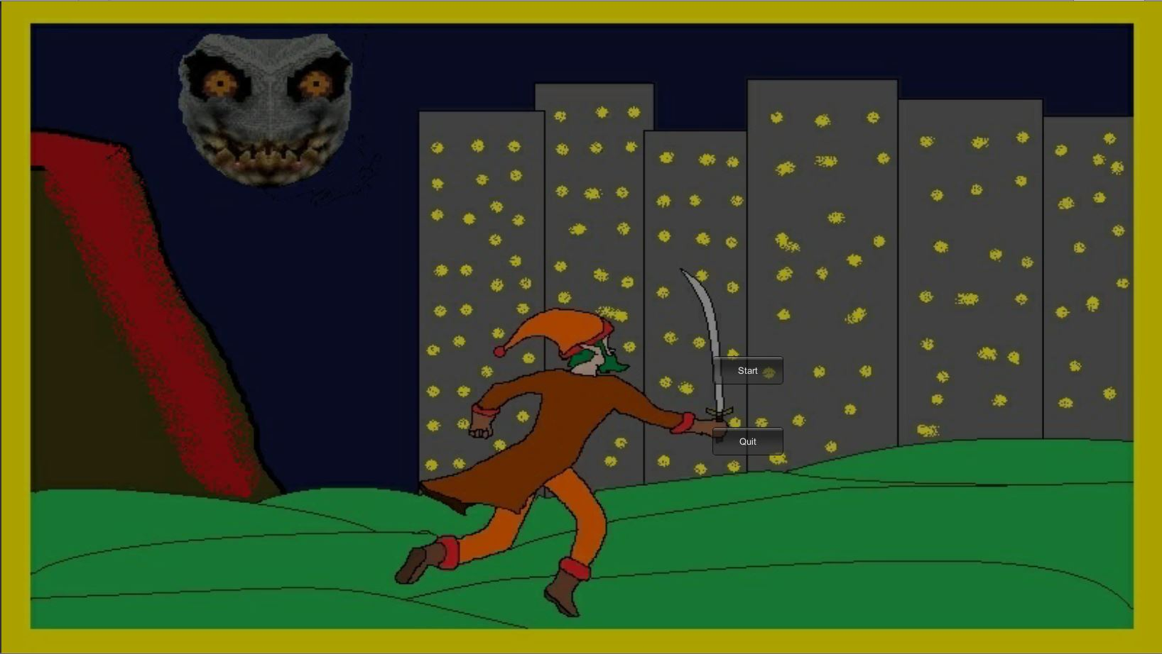
Figure 1 - The main menu

Here is a screenshot of what the game looks like when it's running the application, and this is what level one looks like.
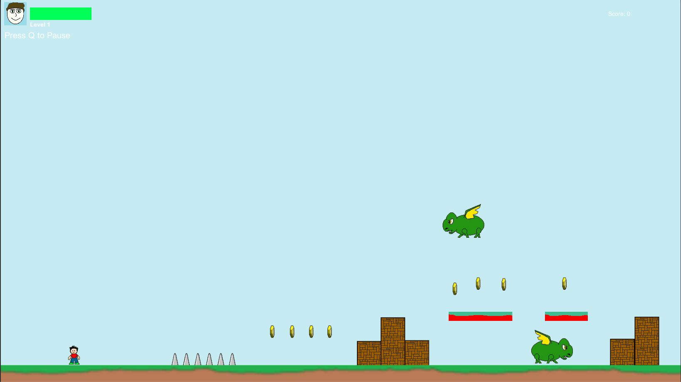
Figure 2 - The level one
Here is a screenshot what level two looks like while the applic
Figure 4 - The level three
Here is a screenshot of when the player finished the game and in the game, it gives you only one button to return to the main menu.
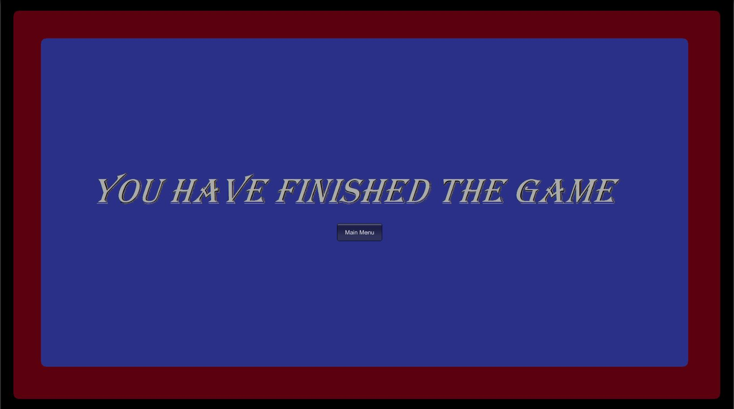
Figure 5 - The finished level

Here is a close-up of the player jumping and the coins with in the game.
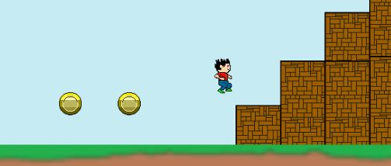
Figure 6 - The jamp and coin
Here is a close-up of the enemies and spikes within the game and the spikes are instant kill while the enemy decreases your health.
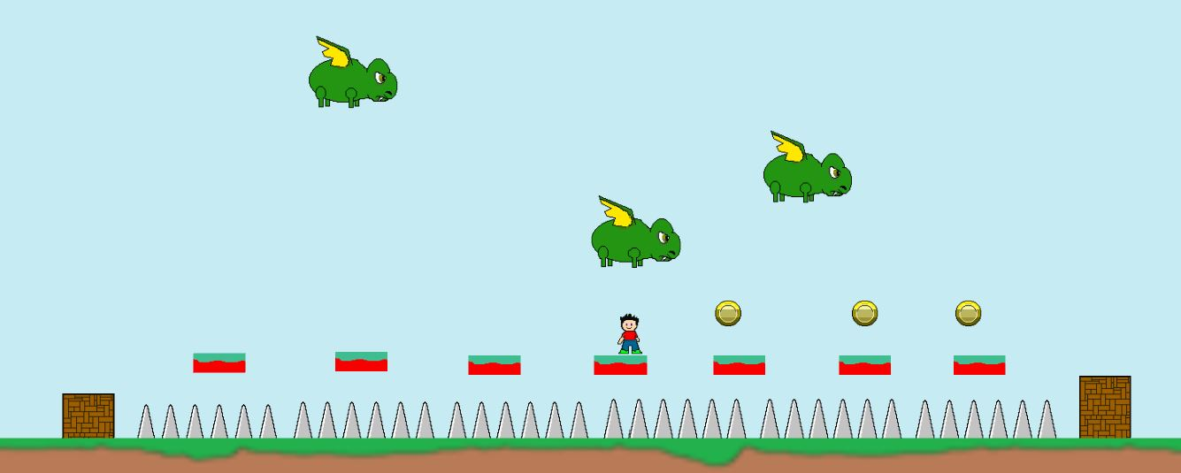
Figure 7 - The spikes and enemy

Here is a screenshot of the portal what takes you to the next level.
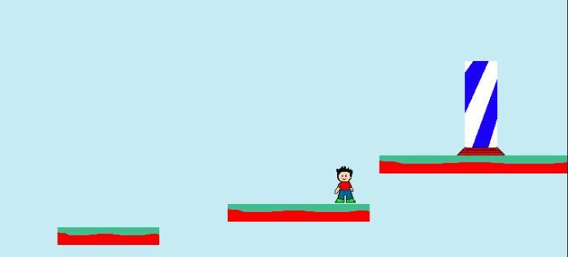
Figure 8 - The next level portal
Here is a screenshot of the pause menu for the player, such as return to main menu, restart the game, save the game and loads where are you save.
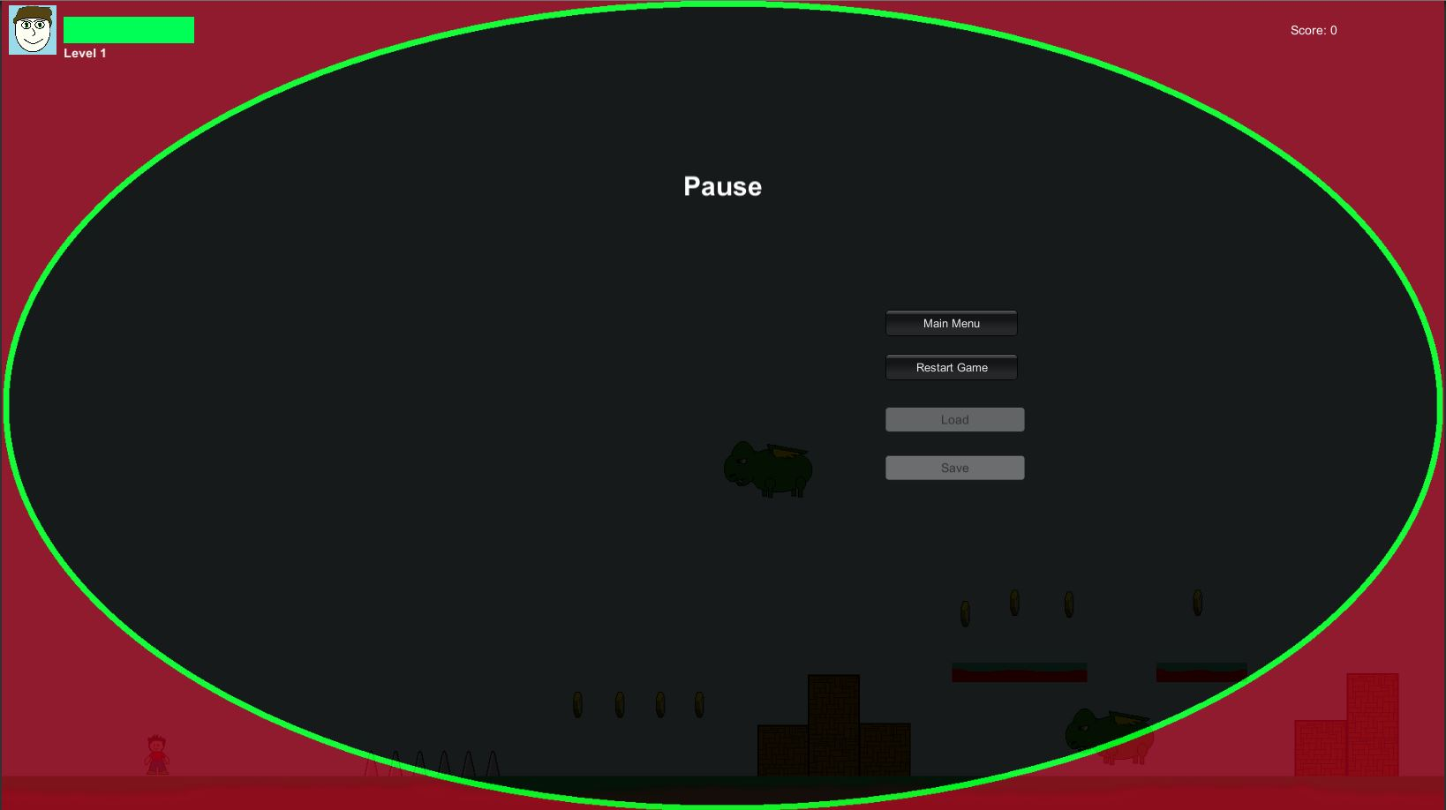
Figure 9 - The pause menu

Here is a screenshot of the health decreasing when the player gets hit by the enemy.
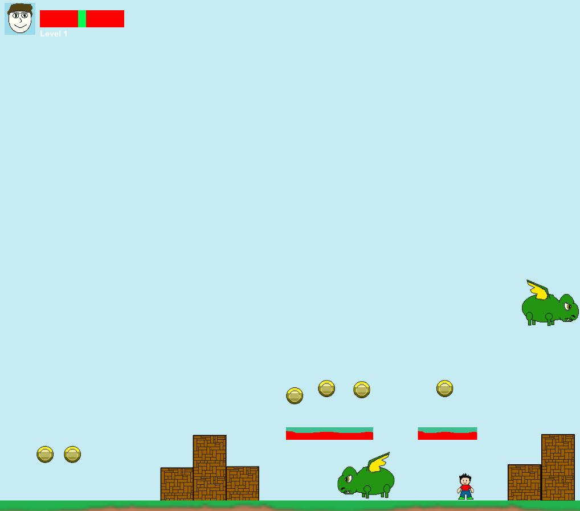
Figure 10 - The damage health by enemy
Here is a screenshot what level one looks like.
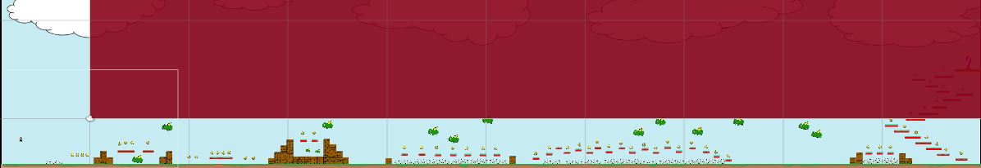
Figure 11 - The whole may of level one

Here is a screenshot what level two looks like.
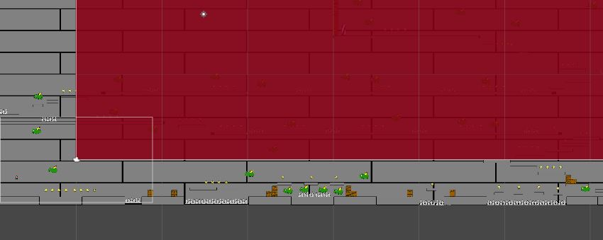
Figure 12 - The whole may of level two
Here is a screenshot what level three looks like.
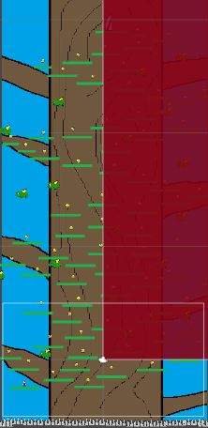
Figure 13 - The whole may of level three

Evaluation

Errors and challenges
One of the challenges within the game was doing moving platforms but this was found too difficult to figure out how to do so it was scrapped from the game, because when trying to make the moving platforms it would cause the game to glitch and crash, so therefore it was removed. Another challenge within the game was the animation was becoming weird when moving but this was resolved by fixing it in the animator window, by looking at what was done in the previous lesson in class by using help to fix this problem[reference in here].

Testing table
No. | Test | Expected Results | Actual Results | Pass/Fail
1. | The jumping. | To see if the jumping is working. | The player is jumping. | Pass
2. | Moving left and right. | To see if the moving left and right is working. | The player is moving left and right. | Pass
3. | Collecting coins. | To see if the collecting coins is working. | The player is collecting coins. | Pass
4. | Gaining points while collecting coins. | To see if the points are going up by collecting the coins is working. | The point is going up with the coin are collecting. | Pass
5. | Health bar. | To see if the health goes down with the player get hit is working. | The health is going down with the player get hit. | Pass
6. | Instant kill by spikes. | To see if the spike kills the player is working. | The spike kills the player. | Pass
7. | Portal. | To see if going in the portal go to next level is work. | The portal takes the player to the next level. | Pass
8. | Animations. | To see if the player jumping, moving and stop animations is work. | The player jumping, moving and stop animations is work. | Pass
9. | Enemies animations. | To see if the enemies moving animations is work. | The enemies moving animations is work. | Pass
10. | Portals animations. | To see if the portal animations is work. | The portal animations are work. | Pass
11. | The pause menu. | To see if the pause menu is work. | The pause menu is work. | Pass

References
[1] Piskel, “Piskel is a free online editor for animated sprites & pixel art,” piskelapp. .
[2] D. Unity3D, “Camera.ViewportPointToRay,” Unity Technologies, 2018. [Online]. Available: https://docs.unity3d.com/ScriptReference/Camera.ViewportPointToRay.html.
[3] Unity3D, “Boundary,” Unity Technologies, 2018. [Online]. Available: https://unity3d.com/learn/tutorials/projects/space-shooter-tutorial/boundary.
[4] Maniac222, “2D Player Movement C#,” answers unity. [Online]. Available: https://answers.unity.com/questions/218639/2d-player-movement-c.html.
[5] Unity3D, “PlayerPlatformerController,” Unity Technologies, 2018. [Online]. Available: https://unity3d.com/learn/tutorials/topics/2d-game-creation/player-controller-script.
[6] Unity3D, “Controlling the Player,” Unity Technologies, 2018. [Online]. Available: https://unity3d.com/learn/tutorials/projects/2d-ufo-tutorial/controlling-player.
[7] Unity3D, “EnemyAttack,” Unity Technologies, 2018. [Online]. Available: https://unity3d.com/learn/tutorials/projects/survival-shooter/player-health.
[8] 777Vortex777, “in-game-pause-menu @ answers.unity.com,” answers unity, 2014. [Online]. Available: https://answers.unity.com/questions/30858/in-game-pause-menu.html.
[9] J. Dansie, G. Production, and G. Mechanics, “Game Development in Unity,” no. August, 2013.

marking criteria and Student FEEDBACK

This section details the assessment criteria. The extent to which these are demonstrated by you determines your mark. The marks available for each criterion are shown. Lecturers will use the space provided to comment on the achievement of the task(s), including those areas in which you have performed well and areas that would benefit from development/improvement.

Common Assessment Criteria Applied (Assignment 2) | Marks available | Marks  awarded
1. Research-informed Literature
Extent of research and/or own reading, selection of credible sources, application of appropriate referencing conventions.
Much better referencing for the script sources used in this assignment. (Grade mark: 80.00%) | 5 | 4
2. Knowledge and Understanding of Subject
Extent of knowledge and understanding of concepts and underlying principles associated with the discipline.
Demonstrates good knowledge of the concepts and principles used to build a game. You have mostly just found code sources on the Internet to reuse, but you have put these together well to implement a good game. I would, however, still like to see more evidence of your own work and coding ideas and also see you adopting the good practices you have been taught instead of just copying and reusing code found on the Internet. As mentioned in your last assignment feedback, avoid making class fields public but instead use the SerializeField attribute to expose these fields to the Inspector window and/or accessor property methods to expose them to other classes, as well as the use of events. Additionally, some script classes could be refactored (see examples in your report). (Grade mark: 55.00%) | 20 | 11
3. Analysis
Analysis, evaluation and synthesis; logic, argument and judgement; analytical reflection; organisation of ideas and evidence
Detailed description of the challenges faced has been provided, but you have not provided an evaluation of the implemented game or any recommendations for future improvements. (Grade mark: 26.67%) | 15 | 4
4. Practical Application and Deployment
Deployment of methods, materials, tools and techniques; application of concepts; formulation of innovative and creative solutions to solve problems.
A very good attempt featuring a simple game that has been given a lot of thought. The main area for improvement is being able to code your own ideas and adopt good coding practices. (Grade mark: 74.55%) | 55 | 41
5. Skills for Professional Practice
Attributes in professional practice: individual and collaborative working; deployment of appropriate media; presentation and organisation.
The report is satisfactory, but you need to work at improving your writing style. Specific areas to take note of include grammar construction and common errors with similar sounding words. (Grade mark: 40.00%) | 5 | 2

Assignment Mark (Assessment marks are subject to ratification at the Exam Board. These comments and marks are to give feedback on module work and are for guidance only until they are confirmed. ) | Late Submission Penalties (tick if appropriate) |  | 62%
 | Up to one week late |  | 62%
 | 1st/2nd/3rd attempt? |  | 62%

