

Certificate of Higher Education in Skills for the Workplace

Module Professional Career Development
Module Code BMSW4005
Lecturer Akinseye Aluko
Student Maria Ignat 2028007
Task 2 – Report

Personal Reflection
Career development is defined as a lifelong process of balancing living, learning, earning, working, leisure, and transitions to get to where you want to be (to move toward a personally determined and evolving preferred future).
It's not just about the tasks you want to do; it's about how you want to spend your life. This definition contains several significant features: Reflective writing is very important in terms of self-evaluation (Schon 1983) and learning from past experiences (Gibbs 1983).
Professional development can no longer be reduced to a single decision. A simplified vision of professional development would have a young person determine what they want to "be" and what education they need to get there — end of the story.
The true story, on the other hand, usually has numerous chapters with unique goals, tasks, impacts, and transitions over time. Early career development is often about the investigation, establishing a future self-experience, and expanding horizons in terms of what that future self could want to include. Career development later in adolescence focuses on exposure, experience, reflection, and the development of personal/career management and employability skills. Those abilities are polished, expanded, and deployed throughout adulthood to navigate an ever-changing labor market.
Career advancement requires planning. When done correctly, it guarantees that our decisions regarding learning and work are informed by our understanding of ourselves (personal interests, traits, values, and abilities), as well as our understanding of educational and labor market realities (conditions, finances, prospects, entry requirements, progression and pathways).
When done correctly, it guarantees that you are prepared for the realities of your choices, that you have the skills and resources to manage them, and that you are clear about why the option is right for you, all of which fuel your motivation, focus, and success.
Reflection

The reflection is also incorporated into our professional development qualifications. Candidates should be exposed to reflective practice models and encouraged to think of reflection as a continual process. Candidates should be mentored and supported during this process, as well as given examples of how to successfully document this process in their portfolio. The following topics are covered in this resource:
Reflection is commonly mentioned as a critical component of personal and professional development.
Reflection is a process in which candidates become aware of, or are encouraged to become aware of, their strengths and weaknesses.
Changing future preferences
This reflective experience will include description, feelings, evaluation, analysis, conclusion, and action plan, as seen below:
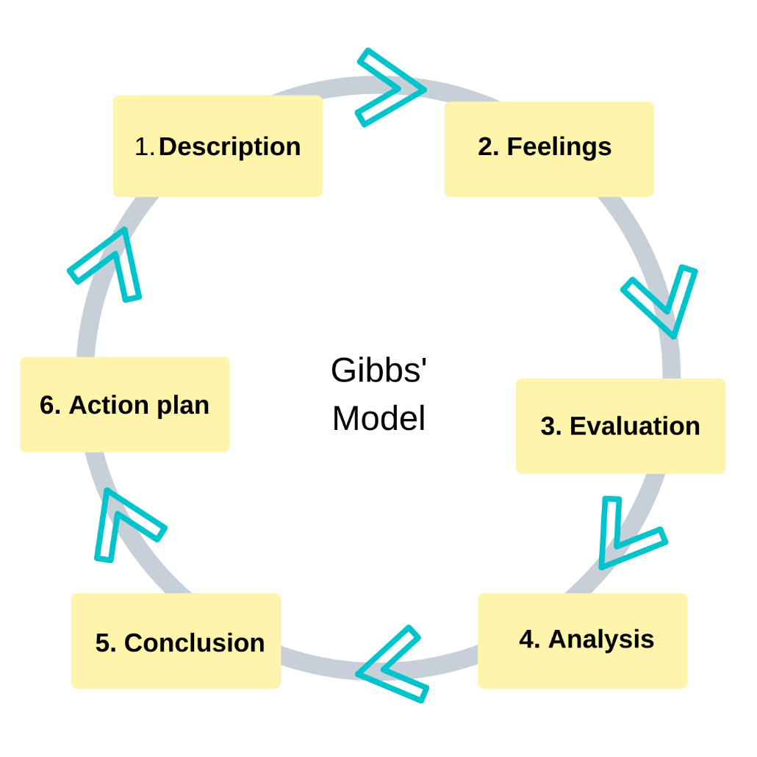

Overview
This role play is designed to enlarge students’ appreciation and self-assurance in preparing for the actual interview. The interview environment is simulated through a facilitator asking the pupil a set of questions (usually lasting 10-15 minutes) followed by means of a length of comments and an opportunity for the interviewee to ask questions, which consumes the rest of the appointment.

Preparing for the role play
I reviewed the popular interview questions listed below:
I reviewed these helpful pointers for answering questions. I also identified my skills, talents, and knowledge to become a successful medical receptionist.
I dressed professionally. This is an exact probability for the interviewee to practice interviewing in formal attire.
I also had on hand a job description and a cutting-edge resume (optional; however beneficial for the interviewer). These documents can be provided when the appointment is firstly made to help the interviewer have a unique interview experience.
I have arrived at the interview location a few minutes early.
I will use a reflective model to discuss how I have achieved the necessary level of competence in my nurse training programme. The reflective model I have chosen to use is Gibbs model (Gibbs 1988).
Gibbs model of reflection incorporates the following: description, feelings, evaluation, analysis, conclusion and an action plan (Gibbs 1988).

Examples of Popular Interview Questions

Warm-Up Questions

What made you apply for this position? Tell me about yourself. Briefly, would you summarize your work history and education for me?

Work History

What is important to you in a company/organization? Describe one or two of your major accomplishments. Give an example of when you worked under pressure to meet a deadline.

Oral Presentation Skills

Have you ever done any group presentations? How comfortable are you speaking in front of groups? What is your experience with making presentations?

Leadership

How do you facilitate group communication? Describe a time when you delegated responsibilities to group members. How do you set an example to others? How would you describe your basic leadership style? Describe a time when you worked in a team.

Stress Tolerance

How do you cope with the pressure? Give an example of a time when you worked well under pressure.

Job Performance

What would you say are some areas that you need to improve on? Do you prefer working alone or in groups? How do you receive feedback? Describe a time when you explained something complex to a colleague successfully.

Creativity

Of your creative accomplishments, what gave you the most satisfaction and why? What kind of problems has people recently called on you to solve? Tell me how you solved them. What methods do you employ while brainstorming?

Decisiveness

The last time you did not know what decision to make, what did you do? What was the last major problem that you were confronted with? What action did you take? How do you determine or evaluate success?

Questions to ask employers

What do you (the interviewer) like best about your job/company? What is the next step in the selection process? What kind of assignments might I expect during the first six months on the job? Describe the company culture.

Feedback on Mock Interview

The following items are important during the interview process. The peer interviewer will provide feedback on:

Introduction
Firm handshake and smile

Presence
Posture Projected warmth/enthusiasm

Avoided annoying mannerisms.

Communication
Voice tone and volume

Proper use of diction
Attentive listening Eye contact

Interaction
Answered questions directly provided specific examples
Asked questions when appropriate
Demonstrated interest in the position

Closing
Asked the interviewer thoughtful questions
Avoided questions on salary and benefits

Thanked the interviewer for her time and inquired about the hiring timeline/process finished with a firm handshake and smile.

The most important lesson I learned throughout the interview was that we need to be flexible. The questions I answered varied a lot, and it taught me something about myself, which is the first of many lessons I learned from a job interview. When you apply for a job, you are telling an employer that you are the best candidate for the job. Unfortunately, employees don't always agree with you, so changing the questions around is important for a few reasons.
This interview was quite informative and instructive. The interview opened new perspectives in my life and exposed me to new realities.
This event taught me that you should always look at life positively and tackle problems with courage. The main takeaway from this conversation that I will carry with me is to be positive, tackle obstacles head-on, accept reality, and face adversity with courage. It also demonstrated to me that all of life's hard situations pass and do not remain continuous. I will undoubtedly apply the lessons I have gained from this role play.
My interview went exceptionally well.

Emotionally mature people can speak objectively and honestly about poor experiences and interpret them into tremendous experiences. A true interviewer can confidently shape a proper impact of any interview who shows excellent emotional maturity how would you reply if you were presented the job think earlier than the interview and all through the interview how would you respond to this question if you do not take delivery of the job and you are really joyful and free to do so then say so you have little to reap from being evasive.
In conclusion, I realized how elaborate interviewing really is.
Remaining positive is important throughout the entire process to maintain eagerness and to continue moving from to employment a successful interview requires skill calculating advanced planning careful observation and a bit of luck.

References

Boud, D., Keogh, R. and Walker, D. (eds) (1985)
Reflection: Turning Experience into learning Kogan Page New York.

Chesney, M. (1996) Sharing Reflections on Critical Incidents in Midwifery Practice.
British journal of Midwifery 4(1) 8-10.

Crouch, S. (1991) Critical Incident Analysis. Nursing 4(37) 30-31
Ghaye, T. and Lillyman, S. (1997) Learning Journals and Critical Incidents: Reflective Practice for Health Care Professionals. Mark Allen Pub. Dinton
Ghaye. T. and Lilly man, S. (eds) (2000) Caring Moments the Discourse of Reflective Practice. Mark Allen Pubs. Dinton
Ghaye, T., Cutherbert, S., Danai, K and Dennis, D. (1996) Learning through Critical Reflective Practice. Self-Supported Learning Experiences for Health Care Professionals
. Tyne Pentaxion Ltd. Newcastle Upon Tyne

