

Assessment 1

Student Name: Jowher Ahmed
Student ID: 2437456

Module Name: Human Capital Management
Module Code: LCMB7023_LON
Lecturer: Dr Gladius Kulothungan
Word Count: 2694

Term 1

Table of Contents
1. Introduction 1
2. Technological Driven Labour Market Transformation: HRM and IHRM Implications 1
3. Demographics and Geopolitics: Challenges for Global HR Management 3
4. Bridging Skills Gaps: Strategic HRM Solutions for Talent Shortages 6
5. Global Employability: Reflecting on Skills, Strengths, and Growth 8
6. Conclusion 11
7. References 12

1. Introduction
The operation and composition of national and international labour force are changing fundamentally. The swift development of technologies, especially artificial intelligence (AI), automation, and online solutions are transforming the way, location, and identity of work (World Economic Forum, 2025). Simultaneously, demographic shifts, geopolitical unrest, and post-pandemic labour markets have shifted the global trends in labour mobility, labour demand and skills supply (OECD, 2023a). Such changes are challenging Human Resource Management (HRM), as well as International Human Resource Management (IHRM), that now need to find a balance between efficiency, equity, and adaptability in an ever-more volatile environment (Reische, 2023).
This report looks at the impact of the external labour-market dynamic on the HRM and IHRM strategies with a concentration on technological change, demographic and geopolitical factors as well as how organisations respond to the workforce skills shortages. It also entails individual reflection on international employability, strengths, weaknesses and growth in the various areas of major concern, namely; technology, communication, teamwork, leadership and lifelong learning. On the whole, it underscores the need by the organisations and individuals to survive in the changing world of work globally.

2. Technological Driven Labour Market Transformation: HRM and IHRM Implications
One of the most disruptive forces in national and international labour markets is technological development that has been predominantly in the area of artificial intelligence (AI), automation, robotics, and digital platforms (OECD, 2023a). Job structures are being redefined by the growing pace of AI and automation integration into business operations and reshaping employment relations, and forcing human resource management (HRM) and international human resource management (IHRM) to seek new strategic options.
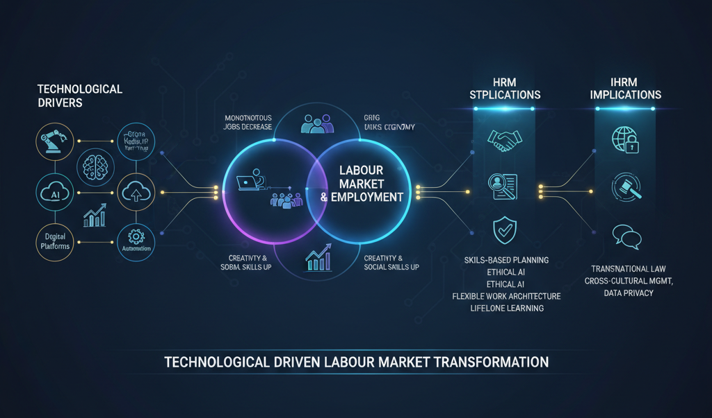
Source: (OECD, 2023)
New evidence shows that technological change has re-ordered the labour demand, instead of causing massive unemployment. According to the OECD Employment Outlook 2023, AI technologies are replacing monotonous jobs, and at the same time, new and more valuable jobs that require creativity, sophisticated thinking, and social skills are emerging (OECD, 2023). In the same manner, Eloundou et al. (2023) discovered that big language models like GPT-4 influence various occupations, even knowledge-intensive ones, so employees should learn to adapt to digital tasks. This has compelled human resource practitioners to shift off the mainline workforce planning model to one centred on skills and tasks to ensure that the ability of humans and emergent technological demands are synchronised.
As well, automation and digital labour platforms are transforming the formations of employment. Working platforms, which digital intermediaries like Uber, Fiverr, and Upwork provide, have made work more flexible and more globally connected, but have also introduced new problems in terms of job security, salary parity, and health (Jones and Manhique, 2022). To HRM, this change demands development of flexible workforce architecture, inclusion of contingent and gig workforce into the organisational culture and management of algorithmic performance systems. Geographical boundaries have been obscured by global digital platforms in the IHRM environment and the global HR practitioner must consider transnational legal requirements as well as cross-cultural management and data-privacy norms in more than one jurisdiction (Bachir and Zeghdi, 2024).
Another important trend is the development of AI in HR functions. Recruitment, talent analytics, and performance evaluation are increasingly being handled through intelligent systems, which generate efficiency increases but raise ethical issues like algorithmic bias and transparency (Tyagi et al., 2025). Therefore, HRM policies need to incorporate ethical AI control and manage human control in decision making. Human resource professionals have become the intermediaries between technology and humans, where fairness and trust are encouraged, and the analytics is used to gain strategic benefit.
Overall, the technological innovations are transforming labour markets by changing the nature of work and labour relations, as well as, skill requirements. In the case of HRM and IHRM, this change will require a strategic re-orientation on the digital integration, ethical management of technologies, and lifelong learning. Those organisations that take the lead to actively adopt AI and automation, but retain a human-centred focus, will be in a better position of remaining successful in the increasingly digital and the globally connected workforce.

3. Demographics and Geopolitics: Challenges for Global HR Management
The two forces are closely connected and have become increasingly influential in the modern labour markets, both the demographic changes and the geopolitical processes redefine the supply of labour and the mobility of talent as well as the organisational human-resource policies (Tyagi et al., 2025). HRM and IHRM practitioners should consequently not only take into consideration technological change but the structural pressures that the ageing of populations, the migration flows, and the rise in geopolitical fragmentation pose (OECD, 2025).
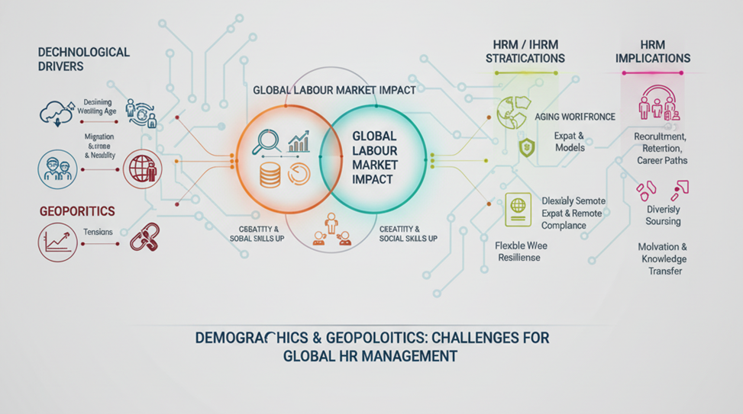
Source: (UNECE, 2025)
One of the most salient forces in the labour-market is the demographic changes. With low fertility levels and lifespan, many developed economies are facing a declining working-age (15-64 years old) population (OECD, 2025). In members countries the working-age population will shrink in a number of countries straining labour supply, wage inflation and productivity growth. In parallel, cohorts of older age are working longer, although their participation is patchy and will be determined by skills and health and policy. For HR professionals, it indicates that strategic workforce planning should include policies of ageing-workforce, in terms of such policies being adaptive to recruitment, retention and career-path architectures to represent a multigenerational workforce (OECD, 2024).

Other than age structure, there are migration and mobility as important demographic dimensions. Falling domestic labour-pools have prompted numerous organisations and nations to depend more on the international talent flows. But geopolitical tensions, immigration controls and the changing visa regimes bring predictability in talent supply. According to one of the analyses, the decades to come will be characterised by geopolitics, migration and new talent market sourcing of the workforce. My Consulting Toolbox HRM and IHRM thus have the double task of developing global talent-mobility models (expatriates and remote global talent) and also making sure that they are in line with different national labour and data-privacy laws (UNECE, 2025).
There is additional complexity due to geopolitics. The material risks to the labour-market strategies are trade fragmentation, nationalist labour-policies, regional conflicts and supply-chain disruptions. The recording of geo-economic fragmentation and geopolitical tensions as one of the key trends redefining job-markets underscores the necessity of HR to be strategic in managing global talent-risks: organisations need to diversify their talent-sourcing locations, need to internalise the workforce-resilience mechanisms against country-specific labour-shocks, and be able to move talent around or relocate operations across borders (Mercer, 2025).
On the part of human-resources, these demographic and geopolitical forces create a number of certain problems:
- Shortages of talent & wage pressures: With the declining age of the working age population in most of the developed economies, organisations are exposed to competitive pressures of attracting and maintaining talent. This increases strategic significance of the value propositions in employer-branding, flexible working and inclusive practises towards older employees. HRM then has to leave conventional recruitment behind and proceed to profiling future talent-gaps and devising retention approaches to non-traditional labour-groups (Mercer, 2025).
- Multi-generational workforce management: age-diversity creates a layer of complexity to HR practise: various cohorts (Gen Z, Millennials, Gen X, Baby Boomers) have diverse expectations of flexibility, career advancement and meaning of work. The control of motivation, cross-temporal career patterns and knowledge dissemination (in particular, between the older and the younger generations) becomes an issue of HRM concern (UNECE, 2025).
This makes management of expatriates difficult, integration of remote global teams and fair compensation across borders. Altogether, the demographic and geopolitical influences are transforming national and international labour market in such a way that HRM and IHRM must be more strategic, proactive, and globally-focused.

4. Bridging Skills Gaps: Strategic HRM Solutions for Talent Shortages
The continuing skills gaps and severe talent deficits in the main area of technology are also major organisational matters and issues to HRM strategy. Its character is not only a quantitative one (i.e., the deficit of bodies) but quantitative-qualitative (i.e., the lack of required and offered skills and poor fit between HR strategy and labour-market processes) (Bachir, 2024). Therefore, effective strategic HRM has to be multi-pronged, proactive and systemic in its approaches towards the supply of talents and development of capabilities.
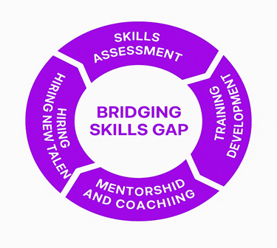
Source: Axero Solutions
First, organisations need to change their reactive hiring to proactive workforce planning that is based on skill-mapping and predictive labour market analytics. As an example, the HR functions are expected to conduct frequent skills audit and balance their available workforce capacities with the business eventualities and the growing sector needs (SHRM, 2024). Talent management software, people analytics tool allow HR to determine internal job gaps, emerging new jobs, and future movement of employees to new tasks. It is possible to do such data-driven planning to implement specific interventions instead of hiring spur of the moment (SHRM Advisor, 2025).
Second, upskilling and reskilling programmes take a centre stage. As industries like technology are changing and transforming fast, employees are forced to acquire more and more digital, cognitive and higher-order interpersonal (social/ emotional) skills (Bachir, 2024). Organisations have the opportunity of collaborating with education organisations, training organisations and e-learning platforms to create flexible learning channels. An example is micro-certifications, bootcamp and certificate programmes that allow building capability swiftly in accordance with the business requirement (Bone, Ehlinger and Stephany, 2023).
Third, talent attraction and retention should be adjusted to the new reality on the labour market. Employer branding, value proposition, inclusive recruiting and flexible work models are of importance in areas where there are shortages. The organisations are to widen the talent pools by focusing on so-called hidden and non-traditional labourers (e.g., returners, veterans, part-time talent) and by considering remote/global talent sourcing (PersolHongKong, 2025).
Fourth, strategic HRM needs to adopt skills-based hiring and job designing as opposed to qualification-based hiring. There is an indication that formal degrees are replaced by specific skills, particularly in technical and green-economy roles, which are now appreciated more in organisations (Bone et al., 2023). HR may redesign job specifications based on clusters of capability, embrace assessment technologies to identify transferable skills, and build bridge positions to facilitate internal mobility. This increases the pool of talent and agility in organisations.
Fifth, teamwork and eco system establishment is urgent. Internal HR strategies cannot completely bridge shortages in organisations. Strategic HRM implies collaboration with the educational system, governmental training programmes, employers and international labour-market intermediaries (SHRM, 2025). These partnerships could be used to influence curricula, build apprenticeships and internships and impact regional talent pipelines thereby lessening dependence in the long-term.
When it comes to international HRM (IHRM), organisations with global operations need to make sure that talent strategies are based on cross-border mobility, global skill pipelines, cross-cultural competence and standardised competency models amongst various locations. Strategic HRM must be responsive, informed, and active and integrated in a business strategy to deal with the recurrent skills gaps and talent shortages. HR needs to be far more strategic partner than administrative, i.e. anticipating talent requirements, encouraging lifelong learning, redesigning jobs, building talent pipelines across the world, and working across ecosystems. Companies that use this form of strategic HRM would be in a better position to gain long-term competitiveness in areas that experience serious talent crises.

5. Global Employability: Reflecting on Skills, Strengths, and Growth
Employability in the contemporary globalised and technologically dynamic labour market is becoming highly reliant on the capacity to work efficiently across the culture, digital, as well as organisational borders. According to International Human Resource Management (IHRM), the key competencies of globally competent employees include flexibility, cross-cultural understanding, digital literacy, teamwork, and personal learning throughout the life (Reiche, Stahl and Harzing, 2023). This reflective report explores my strengths and learning opportunities in five key areas namely: technology, communication, teamwork, leadership, and self-directed learning based on academic experiences, group projects and professional exposure.
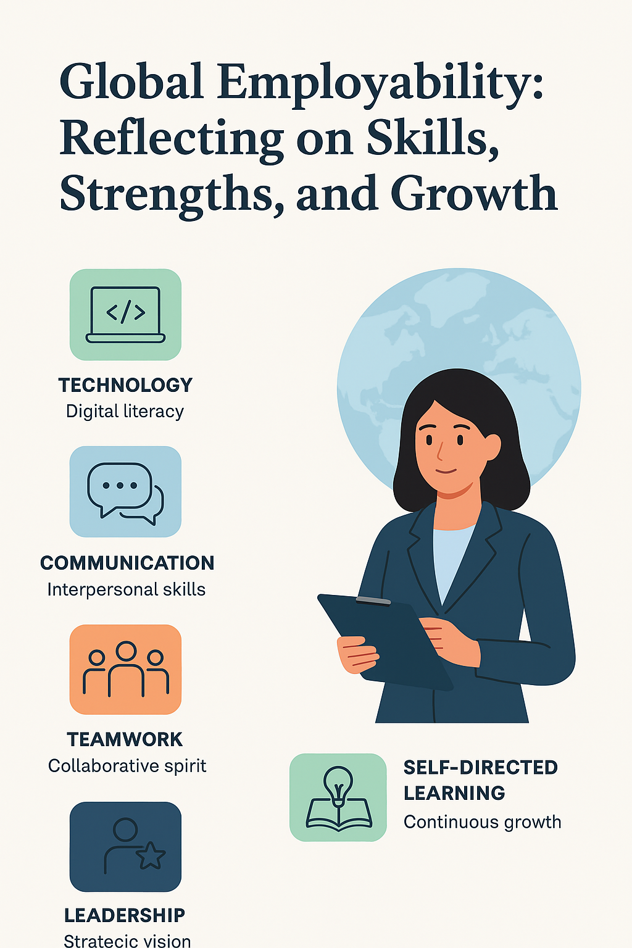
Source: (Deloitte, 2024)
Technological Competence has become a core employability trait with the integration of AI, digital collaboration platforms, and data-driven decision-making tools by organisations (Deloitte, 2024). In the course of my recent coursework, I gained skills in using tools like Microsoft Teams, Excel analytics, and AI-powered platforms, including ChatGPT and Zotero. In one of my group HR analytics projects, I used such tools to visualise workforce diversity data. I have a strength in learning new software and utilising tools of analysis in problem-solving quickly, which displays digital agility in line with the newest HRM trends (KPMG, 2023). Nonetheless, I acknowledge a low awareness of AI-based Hr apps, including predictive recruitment and algorithmic performance analysis that can act as a limitation to my input to the strategic role in technology-enabled HR processes. In this regard, I will engage in short online courses on AI in HRM, data ethics, and certifications in HR analytics, so that I can stay up to date with the current practises in the global workforce (SHRM, 2024).
Successful team work in global organisations is based on communication skills especially intercultural and virtual communication skills. My virtual projects with classmates that were located across different countries helped me to become more attentive to high and low-context communication styles. The positive aspects are verbal and written communication in English, active listening, and assertiveness in presenting ideas through video conferencing. Nevertheless, I tend to focus on the accomplishment of tasks at the cost of relationship work, as well as I am slow to offer constructive feedback in difficult circumstances (Reiche et al., 2023).
Teams and group work are becoming necessary as organisations work in cross-functional teams, multicultural teams, and virtual teams more (CIPD, 2024). I am reliable, accountable, and inclusive which also makes me a valuable team player in terms of great coordination of tasks and making decisions. Being conscious of the team roles as developed by Belbin will help me to adjust to various team demands. Difficulty in asserting leadership in case of conflict and engagement maintenance among dispersed team members are some of the weaknesses. In this regard, I would like to train facilitation skills, employ agile techniques and combine formal feedback processes to improve team performance (Deloitte, 2024).
In the global environment, leadership skills demand cultural competence, emotional intelligence, and motivation skills to manage various teams (Northouse, 2022). My leadership as a leader of a project team was successful as I was able to delegate by assigning tasks, encourage involvement and creativity, which are characteristics of transformational leadership (Bass and Riggio, 2021). The aspects that should be improved are aggressive decision-making and alignment of team objectives with the overall organisational objectives.
Employability in fast changing industries is grounded on self-directed learning and lifelong adjustability. I identify the gaps in knowledge and find the learning opportunities proactively following the experiential learning model offered. I have such strengths as my initiative, reflective practise, and growth mindset (Dweck, 2020). Unstructured learning and sporadic procrastination are some of the weaknesses. In order to be better, I will set SMART goals, rely on digital planning tools, gain the help of mentors, and engage in professional communities to make sure that my skills constantly improve (Locke and Latham, 2019).
Altogether, my strong sides are in digital literacy, teamwork, and transformational leadership potential, whereas the areas of improvement are in AI knowledge, intercultural communication, and structured self-directed learning. The ability to match personal growth with industry requirements increases national and international labour markets employability. In the ever-changing and rapidly advancing global HRM landscape, I want to succeed by developing flexibility, understanding, and life-long learning (World Economic Forum, 2025).

6. Conclusion
Rapid changes in technology, demographics, as well as geopolitical factors are radically transforming the dynamics of national and international labour markets. These forces are compelling Human Resource Management (HRM) and International HRM (IHRM) to be more agile, evidence-based and globally integrated. To manage shortages of skills, organisations should invest in end-to-end learning, digitalisation, and inclusive talent pipelines to remain competitive.
Personally, self-reflection in assessing the major areas of employability, including technology, communication, teamwork, leadership, and self-directed learning, reveals the strengths as well as the most obvious areas of development. As a lifelong learner, intercultural aware person, and technologically flexible individual, I will be able to become a more globally employable person and match the future HRM requirements. In general, sustainable success in the current labour markets necessitates organisations and individuals to be flexible, creative and goal-oriented in addressing the issues and opportunities of the fast changing world of work.

7. References

- Bachir, B.M. and Zeghdi, A. (2024) ‘The role of artificial intelligence and automation in reshaping labour markets’, Journal for ReAttach Therapy and Developmental Diversities, 7(6), pp. 406–413. doi: 10.53555/jrtdd.v7i6.3305
- Bass, B. M. & Riggio, R. E. (2021) Transformational Leadership, 3rd edn. New York: Routledge.
- Bone, M., Ehlinger, E. & Stephany, F. (2023) ‘Skills or Degree? The Rise of Skill-Based Hiring for AI and Green Jobs’, arXiv pre-print. Available at: https://arxiv.org/abs/2312.11942 (Accessed: 2 November 2025).
- CIPD (2024) The Skills Outlook 2030: Preparing for the Future Workplace. Available at: https://www.cipd.org (Accessed: 2 November 2025).
- Deloitte (2024) Global Human Capital Trends: Thriving in a Boundaryless World. Available at: https://www.deloitte.com (Accessed: 2 November 2025).
- Dweck, C. (2020) Mindset: Changing the Way You Think to Fulfil Your Potential, updated edn. London: Robinson.
- Eloundou, T., Manning, S., Mishkin, P. and Rock, D. (2023) ‘GPTs are GPTs: An early look at the labour-market impact potential of large language models’, arXiv pre-print. Available at: https://arxiv.org/abs/2303.10130 (Accessed 2 November 2025).
- Hall, E. T. (1976, updated 2020) Beyond Culture. Anchor Books.
- Jones, S. and Manhique, I. (2022) ‘Digital labour platforms as shock absorbers: Evidence from COVID-19’, UNU-WIDER Working Paper 2022/108, Helsinki: UNU WIDER. Available at: https://hdl.handle.net/10419/273892 (Accessed 2 November 2025).
- KPMG (2023) The Future of HR 2023: Human-Led, Tech-Powered. Available at: https://kpmg.com (Accessed: 2 November 2025).
- Locke, E. A. & Latham, G. P. (2019) Goal Setting Theory: The Current State. Organizational Behavior and Human Decision Processes, 152, pp. 69–79.
- Mercer (2025) ‘Aging workforce solutions: Adapting rewards for changing needs.
- Northouse, P. G. (2022) Leadership: Theory and Practice, 9th edn. Sage Publications.
- OECD (2023) Artificial Intelligence and the Labour Market: OECD Employment Outlook 2023, Paris: OECD Publishing. doi: 10.1787/08785bba-en.
- OECD (2025) Employment Outlook 2025: From job shortage to labour shortage: The new challenge of population ageing. Paris: OECD Publishing.
- OECD (2024) ‘Ageing and employment’, available at: https://www.oecd-ilibrary.org/en/topics/ageing-and-employment.htm (Accessed: 2 November 2025).
- UNECE (2025) Unlocking the Potential of an Ageing Workforce: Policy Brief No. 30. Geneva: United Nations Economic Commission for Europe.
- Get HR Ready (2025) ‘The forces acting on labour markets: generational differences, diversity and disruptions’, available at: https://gethrready.com/the-forces-acting-on-labor-markets/ (Accessed: 2 November 2025)
- PersolHongKong (2025) ‘How Can Companies Combat the Talent Shortage?’, Available at: https://www.persolhongkong.com/articles/how-can-companies-combat-the-talent-shortage (Accessed: 2 November 2025).
- Reiche, B. S., Stahl, G. K. & Harzing, A.-W. (2023) International Human Resource Management, 6th edn. Sage Publications.
- SHRM (2024) How Technology Is Transforming the HR Profession. Available at: https://www.shrm.org (Accessed: 2 November 2025).
- SHRM Advisor (2025) ‘7 Strategies to Tackle Skills Shortages with Talent Management Software’, SHRM Advisor Blog. Available at: https://www.shrm.org/in/topics-tools/news/blogs/7-strategies-to-tackle-skills-shortages-with-talent-management-s (Accessed: 2 November 2025).
- Suresh, R. and Shanmugapriya, S. (2024) ‘The combination of artificial intelligence (AI) and automation is altering the human-resource-management environment’, International Journal of Research in Human Resource Management, 6(2), pp. 419–423. doi: 10.33545/26633213.2024.v6.i2e.245
- Tyagi, A., G Y, S., Pathak, S., Paya Santos, C. and Meshram, J. (2025) ‘AI and automation in human resource management: Evaluating opportunities for efficiency and the emerging threats to workforce dynamics’, Lex Localis – Journal of Local Self-Government, 23(S6), pp. 1223–1235. doi: 10.52152/801920
- World Economic Forum (2025) The Future of Jobs Report 2025. Available at: https://www.weforum.org (Accessed: 2 November 2025).

