BMIH5003 Foreign Languages & Cultural Awareness
Lecturer Name: Guilia Chifari
Student Name: Sebastiao Clemente Fernandes
Student ID:2243325

Table of Contents
Introduction 3
Component 1 - Professional reflection 4
Component 2 - Training plan 5
Component 3 - Student self-reflection 7
Conclusion 8
References 9
Appendix 10
Component 4 – Training presentation 10
Multilingualism and language awareness in the hotel industry 12
Benefits of Multilingualism 13
Importance of language awareness skills for hotel staff 14
European Language - Spanish 15
Polite and impolite language in the hotel industry 16
Conclusion 17

Introduction
The following assignment will be on Foreign Languages & Cultural Awareness where the Spanish language and Premier Inn London will be focused. Component 1 will provide a professional reflection on the hotel placement and Component 2 will create a training plan. Component 3 will be a reflection on professional experience and component 4 will create a training presentation.

Component 1 - Professional reflection
In my current placement at Premier Inn London Hayes, Heathrow 362 Uxbridge Road, Hayes UB4 0HF, I have been able to develop an in-depth understanding of cultural sensitivity and misunderstandings with a hotel guest. F&B employees are the ones encountering cultural misunderstandings as they have to interact frequently with guests. Culture is an extremely sensitive factor that has a great influence on the performance of the business (Maheshkar and Sharma, 2018). Language is one of the major cultural factors that creates misunderstandings in the hotel with guests. Differences in language spoken by the staff and the guest is one of the scenarios where cultural misunderstanding can occur in the hotel. In my placement at Premier Inn, I encountered such a situation while serving a Spanish guest in the hotel bar. However, I did not speak Spanish which created a barrier in our communication creating a certain misunderstanding. The major problem arose due to the differences in languages we speak. I did not understand Spanish whereas the guest was not speaking English as well. It resulted in misunderstanding the request put forward by the Spanish guest. As a result of this, the guest was annoyed because of my mistake in taking his order. Language is an important cultural factor whose differences can create misunderstandings among individuals speaking different languages (Christiansen et al., 2020). The lack of ability to fulfil the order of the guest created a negative reputation in the customer service of Premier Inn London. I consider the situation to be unprecedented as it was my first interaction with a guest speaking Spanish. An individual speaking different languages is a valuable asset or human resources for a hotel including Premier Inn London. It also highlighted my lack of ability to respond in difficult or unprecedented situations.
In the following circumstance, I need to build abilities and habits to be competent. Cultural fluency is a crucial area for improvement. Cultural fluency involves understanding cultural differences, including languages. Work and interaction with individuals from diverse cultures are also easier with the skill. Spanish and other widely spoken languages are also accessible to me. My conduct must also alter to be adaptable and reliable. In unexpected hotel situations, adaptability is needed. Considering the cultural misunderstanding situation, problem-solving skills are essential. Problem-solving abilities assist people minimise the negative effects of situations. It is also a vital employability skill for company contributors (Middleton, 2020). I need an effective action plan to enhance these areas for improved productivity and performance. Improving cultural awareness and misconceptions at the hotel requires more work.

Component 2 - Training plan
From the above analysis, cultural misunderstanding was found to be a major threat to organisational reputations. An effective training plan needs to be implemented in Premier Inn London for all employees. The primary aim of the training plan will be to spread cultural awareness and possible cultural misunderstanding created by differences in languages. The training program is to be conducted both online and offline to increase accessibility. The training program will cover areas of cultural misunderstanding which greatly affects the customer service delivered by the hotel (Liu et al., 2022). Employees will be trained to lower the case of cultural misunderstanding and improve their competencies to address one of the encounters in the organisation. The objective of the training will be to enhance employees’ ability to deal with cultural diversity and language barriers in the hotel. It will also focus on training employees in the Spanish language. To accomplish this objective, training sessions and programs will be promoted among employees of Premier Inn London.
Culture is an extremely sensitive factor for people, especially in hotels where customers from different backgrounds come for the hospitality service. As a result of this, traditions and customs of guests need to be appreciated and respected in the hotel. Employees should be trained in these areas to enhance their ability to deliver improved customer service to guests. Spreading cultural awareness is an effective strategy to educate employees on the need to respect cultural diversity (Abramson and Moran, 2018). Employees will be taught about factors and elements of culture which could lead to cultural misunderstanding.
Employees will be trained to understand the impact and sensitivity of language while interacting with guests. Communication is an important element in a hotel used to interact with guests creating a positive impression (Chung and Byrom, 2021). Employees with the ability to speak different languages will be focused more by the training program. They have a higher ability to deal with customers speaking foreign languages including Spanish in the hotel. Training employees to speak different languages reduces the impact of cultural misunderstanding resulting from language barriers.
Apart from cultural factors, employees need to be trained in certain skills required to address and solve problems associated with cultural misunderstanding. Active listening is one of the major skills for which employees are to be trained. Active listening skills will help them to clearly understand and comprehend the requests of guests in the hotel. Cultural intelligence is an important area where employees need to be trained for higher cultural competency. Training employees for cultures increases the ability of the business to deliver better customer service and reduce cultural misunderstanding (Deresky, 2017). Problem-solving skills and adaptability are also essential skills that need to be developed by employees to accomplish the objective of the training plan.
The training plan will require various resources like funds, trainers, time and effective strategies. Strategies and approaches have been discussed in the above section which focused on cultural sensitivity and diversity in languages. External trainers are to be recruited for training programs and campaigns. Weekly and monthly training sessions need to be developed considering the working hours and responsibilities of employees in the hotel.

Component 3 - Student self-reflection
Gibbs Reflective Model
Description
The placement at Premier Inn London Hayes, Heathrow 362 Uxbridge Road, Hayes UB4 0HF, has offered me a great opportunity to learn about the importance of cultural awareness. I have developed a great understanding on the importance of cultural awareness in the hotel industry. Culture is one of the core elements of an organisation which greatly impacts its business operations and customer services (Hampden-Turner and Trompenaars,2020). A positive culture of Premier Inn creates a better brand reputation in the market attracting more customers.
Feelings
I felt that my understanding of the importance of cultural awareness has changed over time. Initially, I was nervous to take on the responsibility at Premier Inn London with a limited knowledge of cultural diversity. However, my time in the hotel has presented various scenarios like cultural misunderstanding with a Spanish-speaking guest. Over the period, I feel that it is extremely important for hotel organisations to spread cultural awareness among employees to deliver better customer service to guests.
Evaluation
The positive outcome of my experience in the hotel placement was an enhancement in knowledge regarding the importance of cultural awareness. Considering the contemporary hospitality industry, it remains pivotal to train hotel staff in relation to cultural differences and diversity (Srivastava et al., 2020). During my placement I have been able to improve cultural fluency skills at Premier Inn, Hayes. It has been an essential skill to deal with different people of various backgrounds. Additionally, I have been able to interact well with guests at the hotel.
Analysis
The placement at Premier Inn, Hayes have been a huge learning experience for me to enhance my employability skills and knowledge related to the hospitality. The support and encouragement showed by trainers and colleagues have contributed to my overall skill development. Training sessions on a regular basis was another factor allowing me to comprehend cultural awareness in the hotel sector. Nevertheless, I lack multilingualism skills that created difficulties to communicate with different guests from different backgrounds.
Conclusion
Through cultural awareness initiatives at the hotel, I have been able to acknowledge cultural diversity and inclusion. The staff of the hotel also needs to be trained to value and acknowledge diversity in cultures accepted by the hotel guests. It stated that people belonging to different cultures follow different customs and traditions that need to be respected in the hotel industry (Hofstede et al., 2010). I was also able to acknowledge the need to develop cultural fluency and learn different languages for better workplace outcomes.
Action Plan
From the above analysis, I need to improve cultural fluency, adaptability and problem-solving skills. I need to create a suitable and effective action plan which considers appropriate resources and activities to improve the above skills. I will attend workshops, training programs and conferences to improve my knowledge and skills in cultural intelligence. For theoretical knowledge, resources like books, journals and magazines will be extremely useful and effective for me.

Conclusion
The assignment was on Foreign Languages & Cultural Awareness where the Spanish language and Premier Inn London were focused. Component 1 provided a professional reflection on the hotel placement and Component 2 created a training plan. Component 3 reflected on professional experience and Component 4 created a training presentation.

References
Abramson, N.R. and Moran, R., (2018). Managing Cultural Differences: Global Leadership for the 21st Century. 10th Ed. Abingdon: Routledge.
Christiansen, B., Branch, J.D. and Karmowska, J., (2020). Cultural Factors and Performance in 21st Century Businesses. Hershey : IGI Global.
Chung, S.Y. and Byrom, J., (2021). Co-creating consistent brand identity with employees in the hotel industry. Journal of Product & Brand Management, 30(1), pp.74-89.
Deresky, H., (2017). International Management: Managing Across Borders and Cultures: Text and Cases. 9th Ed. Harlow: Pearson Education Ltd.
Hampden-Turner, C. and Trompenaars, F., (2020). Riding the Waves of Culture. 4th Ed. London: John Murray Press.
Hofstede, G., Hofstede, G.J. and Minkov, M., (2010). Cultures and organizations: software of the mind. 3 rd Ed. New York: McGraw-Hill.
Liu, Y., Liu, J. and King, B., (2022). Intercultural communicative competence: Hospitality industry and education perspectives. Journal of Hospitality, Leisure, Sport & Tourism Education, 30, p.100371.
Maheshkar, C. and Sharma, V., (2018). Handbook of Research on Cross-Cultural Business Education. Hershey: IGI Global.
Middleton, H., (2020). Developing problem-solving skills. In Developing vocational expertise (pp. 135-152). Routledge.
Srivastava, S., Singh, S. and Dhir, S., (2020). Culture and International business research: A review and research agenda. International Business Review, 29(4), p.101709.

Appendix

Component 4 – Training presentation
Introduction
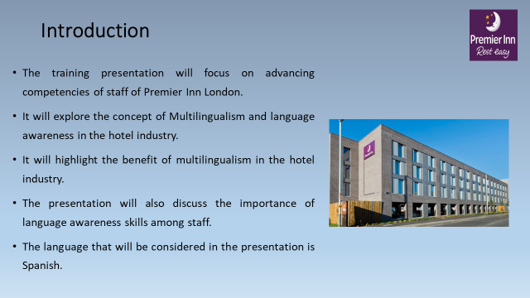
The following presentation will discuss the concept of multilingualism and language awareness in the hotel industry. It will highlight benefits and importance of multilingualism and language awareness respectively. The Spanish language will be focused on in the training presentation while training staff of Premier Inn London.

Multilingualism and language awareness in the hotel industry
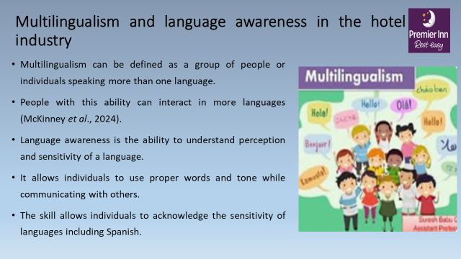
Multilingualism refers to the use of more than one language for interaction by a group of people or an individual. It can also be defined as the ability of individuals to use more than one language in their daily interaction (McKinney et al., 2024). Language awareness, on the other hand, refers to the explicit knowledge and capability of an individual on language and its sensitivity. It is also understood as the ability of the individual to use words and language appropriately considering its conscious sensuality and perception.

Benefits of Multilingualism
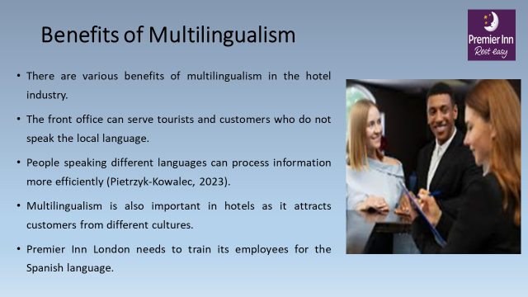
Multilingualism in the hotel industry offers various benefits and advantages that have a direct impact on customer service. It will enhance the ability of the front office to address tourists and customers who do not speak the local language. People speaking different languages can process information more efficiently while serving customers (Pietrzyk-Kowalec, 2023). The hotel industry attracts customers from across the world speaking different languages. Thus, it is important for the organisation to ensure multilingualism among employees. Premier Inn London needs to train its employees for the Spanish language.

Importance of language awareness skills for hotel staff
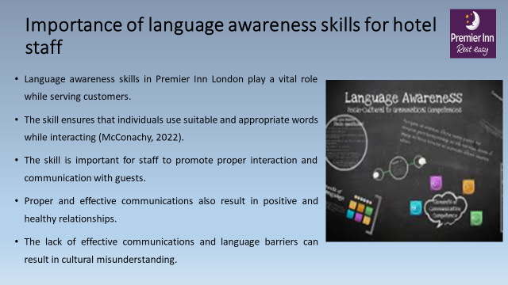
Language awareness skills for hotel staff is also extremely important while delivering customer service. Language awareness skills allow individuals to use appropriate words and phrases considering its sensitivity to the guest (McConachy, 2022). The skill is important for staff to promote proper interaction and communication with guests. Effective communication helps in building positive and healthy relationships with guests. The lack of effective communications and language barriers can result in cultural misunderstanding. To address this, the hotel staff needs to be trained in language awareness skills.

European Language - Spanish
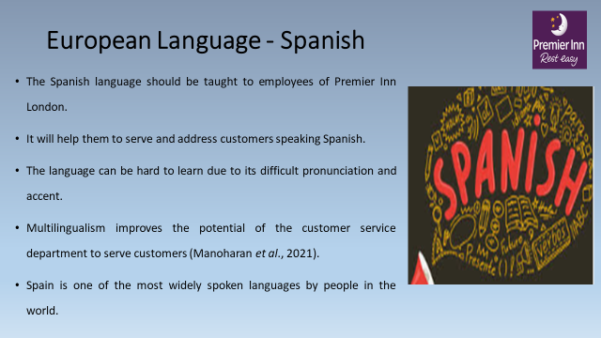
Spanish is a European language spoken in Spain and its people. The language can be hard for new learners due to its difficult and different pronunciation and accent. All Staff of Premier Inn London needs to be trained for speaking, writing and understanding Spanish. It will create a culture of multilingualism in the hotel strengthening the ability of the workforce to serve foreign customers. Multilingualism improves the potential of the customer service department to serve a wider range of customers (Manoharan et al., 2021). Spanish is also one of the most widely spoken languages in the world.

Polite and impolite language in the hotel industry
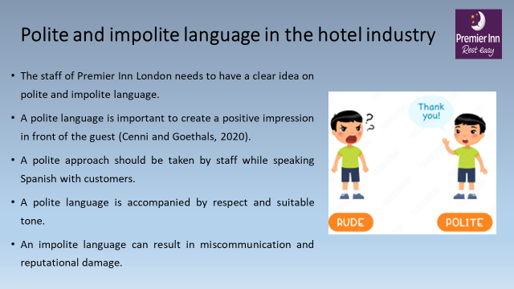
Languages including Spanish can be polite and impolite while used in the hotel industry. A polite language is important to create a positive impression in front of the guest (Cenni and Goethals, 2020). A polite language is accompanied by respect and suitable tone which should be used by the staff while speaking spanish. An interaction with a rude attitude and indifference can be understood as a form of impolite language.

Conclusion
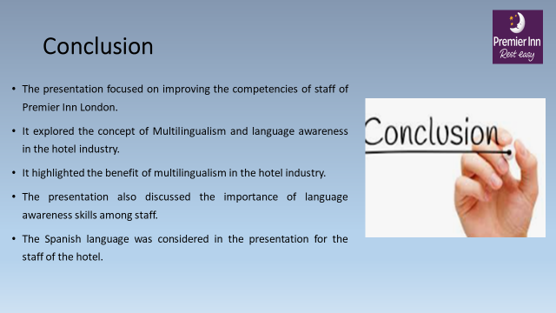
The above training presentation discussed the concept of multilingualism and language awareness in the hotel industry. It highlighted the benefits and importance of multilingualism and language awareness respectively. The Spanish language was focused in the presentation while training staff of Premier Inn London.

