Problem solving and innovation
Module code: (BMSW4014-CART)
The Decline of the retailer Wilko

Student Name: Aliaa Nabhan Danouni
Student ID: 2309830

Executive Summary:
The purpose of this repot is to discuss about the problem of decline of the retailer Wilko.Inaddition to shedding light on nature, scope, and impact of problem faced by Wilko. In this robot, we also analyse the problem related to Wilko using SWOT theory, which is known as the (SWOT Matris). It is an analysis framework for evaluating any company by identifying the strengths, weaknesses, opportunities, and threats that the company is exposed to in relation to business.
Analysing the decline of a company like Wilko requires a comprehensive evaluation. Utilising a PESTLE analysis can help understand the external factors impacting the business. This acronym stands for Political, Economic, Social, Technological, Legal, and Environmental Factors.
(Traynor ,2023).

Introduction.

Initially the first Wilko store was opened in 1930 by JK Wilkinson in Leicester and then expanded across the Mainlands and by 1990 it became one of the fastest growing stores in Britain until it reached 400 stores.These successes continued when Wilkinson was able to trademark Wilko in 2012, and in 2014 this wonderful name was on the storefront.Wilko was a distinguished store with a variety of distinctive goods. It achieved great success despite the presence of many competing companies such as B&M and Poundland.
Wilko saw its first major success in the 1950s, when they made affordable DIY products available on the high street, and this remained at the core of their core product offering even as they expanded to discount wares .Also, they have been a fixture of high street for decades with large stores selling a wide range of goods and the presence of 403 locations as well.(Claire,2023).

The Nature, Scope, and Impact of the problem faced by Wilko.

What went wrong?
As with most large corporate collapses, there was more than one contributing factor to Wilko's downfall.
First: It began to face a supply problem after the United Kingdom left the European Union and also the presence of new economic borders that led to the destruction of supply chains.
Second: The emergence of the Corona virus made the situation worse because they were unable to store common items reliably. Consequently, the presence of this virus led to a decrease in the number of purchases on the main street as a result of the decrease in demand, as most people turned to shopping via the Internet. Although Wiklo had an online store, it relied heavily on shoppers who shopped in person.
Third: The high rents for the Wilko store are a result of its presence on the main streets, in addition to the lack of Wilko’s parking spaces. This in turn led to a reduction in the number of purchases by customers, especially during the closure period during Corona.
Fourth: Competing chains move their stores outside the city, thus making rents cheaper and workers’ wages as well.In addition to all the previous factors, there was instability in the company's senior leadership roles, as Alison Heads left in January 2023, and then Jerrod Saint-Marc, CEO, left in December 2022, and Alex Rousseau, the chief financial officer, also left.(May,2022)

Conduct a SWOT analysis on Wilko.

SWOT analysis is also known as the (SWOT MATRIX)or(SWOT analysis tool).It is an analysis framework for evaluating any company by identifying the strengths, weaknesses, opportunities and threats that the company is exposed to in relation to business.(Lazzaro Blasbalg,2021)When we apply this theory to Wilko, firstly ,we start with the strengths.
*Strength points of Wilko:

- Wilko is not just a shop but a magical portal to essential British.
- Inclusive,Wilko is a one-stop shop that sells home and garden supplies, detergents, pet food, and paint in addition to cosmetics.

- Reasonable prices: As the goods in Wilko have reasonable prices compared to their quality, this in turn attracts the consumer to this place, and with time there has become a strong relationship linking them with Wilko, which provides all their supplies and makes them feel satisfied and grateful.

*Weaknesses:
- Lack of diversity: Wilko offers a limited variety in the range of available products, which leads to customers not meeting their needs and directing them to other stores.
- Competition: Wilko operates in a strong competitive market and strong travellers, the most famous of which are B&M and Poundland.Competitors resort to selling competitive goods at lower prices, with the aim of attracting the consumer.
- Barking: The Wilko store does not have a private parking lot, and this greatly affects the rate of consumption and purchases.
*The Opportunities:

- Easy access: It is easy to reach any Wilko branch, as it is widely spread on public streets.
- Diversity: Diversity in the goods offered and displaying them clearly to the consumer.

* Threats.
The economic situation of the Wilko store has gradually begun to deteriorate during the Covid-19 pandemic ,This led to
- Reducing the number of workers in addition to the negative impact on the import of goods and their settlement as well.
- High cost, high rental costs, as Wilko is located on the main streets, has also increased financial pressure.
- The strength of competition :Wilko has been exposed to competition from several companies in the recent period, the most important of which have been mentioned previously, for instance: B&M,HomeBargains and Poundland .Thus, we see through SWOT analysis that we were able to build a comprehensive picture of the situation and thus showed the positive and negative aspects of the situation. Thus, the organization is able to avoid threats by taking advantage of opportunities.
(Gurl, E, 2017).( Masud,Simpson, Race &Espiner ,2023).

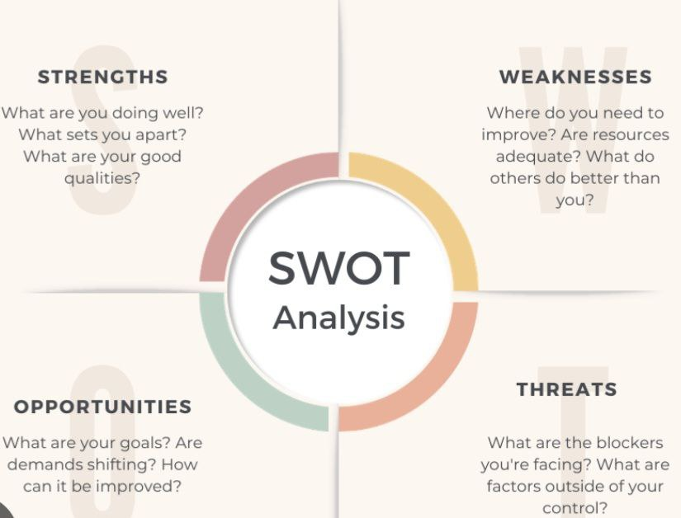

PESTLE analysis:

Analysing the decline of a company like Wilko requires a comprehensive evaluation. Utilising a PESTLE analysis can help understand the external factors impacting the business. This acronym stands for.
, legal, and environmental factors (KENTON, 2023).
Certainly. The decline of Wilko can be explained through a PESTLE analysis, which considers the following factors:

1-political: The changes that took place in government policies and raising taxes are among the most important political factors that affected Wilko. For example, import and export regulations. Changes in business taxes led to a profound impact on Wilko.

2- Economic: Inflation, consumer spending, and employment rates are economic factors that likely influenced Wilko's sales. Moreover, during the pandemic, Wilko incurred high costs from renting stores on the main streets and employees as well. On the otherwise, many competing, companies took advantage of the opportunity and moved to the outskirts of the city. (DAVEY,2023). (Cooper,2017)

3-Social : Demographic trends, lifestyle changes, and shifts in consumers' behaviour could have affected Wilko 's products and services .Consequently, there was a change in shopping habits, as the consumer preferred to shop in a place with a variety of services, such as a café or a place suitable for children, thus spending an enjoyable time. These options are not available in Wilko stores, whether small or large, and on the other hand, they are available in competing companies, and this has greatly affected the sales movement in Wilko.

4. Technological: Evaluate how technological advancements or shifts in consumer technology usage could impact Wilko's operations and competitiveness. We find that, unfortunately, the technology aspect is not strong in Wilko stores, as this aspect must be worked on to attract customers and provide competitive offers.

5.Legal: Which in turn includes consumer laws and employment regulations in addition to industry-specific regulations, import and export operations, and costs, which in turn affect Wilco’s ability to adapt due to changing market conditions in light of the pandemic due to covid.

6.Environmental:There was a failure to adapt to changes in the surrounding environment, in addition to the lack of a strategy in displaying their products, and also not taking advantage of the demand for the most widely used goods in the conditions of closure, unlike competing companies.Moreover Covid-19 has also played a major role in the continued decline in foot traffic on the High Street which in turn has directly impacted Wilko's sales as consumers are unable to go to the store and this is also a shift in consumer behaviour towards online shopping.(Traynor,2024)(Lee&Mckinney,2023)
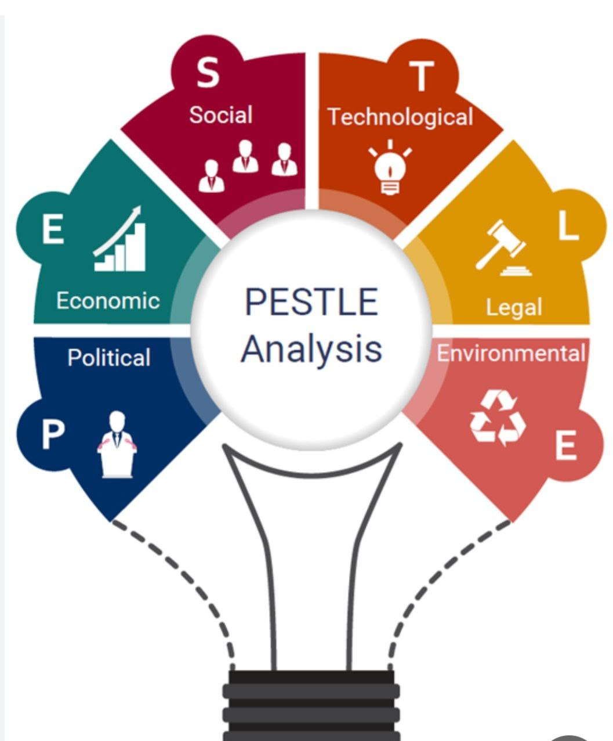

...Conclusion:
After a comprehensive evaluation using SWOT and PESTLE analysis of Wilko, it appears that internal factors such as poor organisation and management contributed to the deterioration of the company's performance. External factors, such as changes in the market and legislation, led to increased challenges for Wilko. Strengths such as the brand’s reputation can also be enhanced and external challenges such as legal and economic changes can be reviewed, as Wilko could have remedied the decline by reviewing its strategy and adapting to the changing business environment.

Recommendation:

Based on the previous analysis, I would like to give some advice to Wilko.
1)Firstly, develop digital marketing strategies, improve online presence, and use social media effectively to interact with customers, which in turn leads to a better understanding of customer needs and making informed strategic decisions.
2)Secondly, Improving the retail shopping experience, that is, improving the shopping experience in Wilko’s stores, starting from the store evaluation all the way to customer service, as it is great that Wilko seeks to develop its store to attract consumers, as it opens a Cafe that serves drinks and simple snacks, where shoppers can spend an enjoyable time in For shopping, in addition to the most important thing, which is providing free parking, this will play a major role in increasing sales and improving the economic situation.Thus we have provided a comprehensive idea of ​​Wilko's decline.

Reference List:

*Claire Chappet-Marie. (2023). Wilko isn’t just a shop – it’s a magical portal to essential British tat. [Online]. INDEPENDENT. Last Updated: 10th of August. Available at: https://www.independent.co.uk/ [Accessed 30th of January.
*Cooper, Benedict. (2017). Wilko blames 'severe economic headwinds' for profit slump. [Online]. Crocer. Last Updated: 27th of July. Available at: https://www.thegrocer.co.uk/discounters/wilko-blames-severe-economic-headwinds-for-profit-slump/5558 [Accessed 6 February 2024].
*DAVEY, ToM. (2023). Analysis: Wilko collapse is the Woolworths of this financial crisis. [Online]. CITYA.M.. Last Updated: 10th August. Available at: https://www.cityam.com/analysis-wilko-collapse-is-the-woolworths-of-this-financial-crisis/ [Accessed 1st of February].
*Gurl, E., 2017. SWOT analysis: A theoretical review.

*KENTON, WILL. (2023). What Is PEST Analysis? Its Applications and Uses in Business. [Online]. Investopedia. Last Updated: 13rd of June. Available at: https://www.investopedia.com/terms/p/pest-analysis.asp [Accessed 6 February 2024]..

*Lazzaro Blasbalg, Cecilia. (2021). SWOT analysis: what is it and how to do it for your business. [Online]. WixBlog. Last Updated: 27th of June. Available at: https://www.wix.com/blog/how-to-do-a-swot-analysis?utm_source=google&utm_medium=cpc&utm_campaign=137 [Accessed 6 February 2024].

*Lee&McKinney. (2023). Environmental Factors of Business | Definition & Examples. [Online]. Study.Com. Last Updated: 21st of November. Available at: https://study.com/academy/lesson/environmental-factors-of-business-lesson-quiz.html#:~:text=Environm [Accessed 6 February 2024].
*May, Peter. (2022). The sudden decline of variety retailers. [Online]. Progressive Pluse. Last Updated: 2nd of December. Available at: https://www.progressivepulse.org/economics/the-sudden-decline-of-variety-retailers [Accessed 6 February 2024].
*Masud Faarea,Simpson Emma,Race Michael&Espiner Tom. (2023). What Will happen nest for Wilko and it's Workers. [Online]. BBC. Last Updated: 17th of September. Available at: https://www.bbc.co.uk/news/business-66474218 [Accessed 30 January 2024].

*Traynor Rory. (2023). Wilko: What Went Wrong And What Will Happen?. [Online]. Articles. Last Updated: 22nd of Augest. Available at: https://www.redflagalert.com/articles/risk/wilko-what-went-wrong-and-what-will-happen [Accessed 30 January 2024].
17th of September. Available at: https://www.bbc.co.uk/news/business-66474218 [Accessed 30 January.

