

BMMB7007
HUMAN RESOURCE MANAGEMENT

Air Canada HRM Analysis
Student name: Kai Wang
Student number: 2228150
Lecturer: James Moore
Date: March 26, 2023
Word count:2659

Executive summary
This report provides an overview of Air Canada's organizational structure, highlighting the company's focus on diversity, equity, and inclusion. Committed to managing equality, diversity, and equity within Air Canada is the priority area of this report. Air Canada is a leading airline company with a workforce of over 30,000 employees who work in a diverse range of roles. Human resources are essential for the success of Air Canada, and the company continuously strives to improve HR policies and practices to create a better work environment for employees. This report focus on Air Canada managing equality, diversity, and equity such as attracting top talent, improving business performance and provides an overview of the Air Canada HRM function operation. Moreover, this report including identifying the benefits and addresses some weaknesses the company has faced, including discrimination and harassment incidents, and the potential negative impact these can have on the company. The report concludes that while Air Canada has taken several steps to promote diversity and inclusion, there is still room for improvement to ensure that all employees are treated fairly and equitably. The feasible recommendations will provide and discuss both advantages and disadvantages at the last part. Implementing these recommendations can help Air Canada create a more diverse, inclusive, and equitable workplace.

Table of contents

Executive summary 1
1.0 Introduction 3
2.0 Organizational overview 4
3.0 Main discussion 5
3.1 Current shortfalls discussion 7
4.0 Conclusions 9
5.0 Recommendations 11
6.0 Reference list 14
7.0 Appendices 16

1.0 Introduction
Air Canada is a global airline industry leader, operating flights to over 200 destinations across six continents and serving more than 50 million passengers annually. The company has a diverse workforce of over 30,000 employees, with a strong focus on promoting diversity, equity, and inclusion. “Removal of obstacles to the full participation and contribution of employees in organizations” (Roberson, 2006, p. 217). Air Canada is a leading global airline that recognizes the importance of managing equality, diversity, and equity within its organization. This report explores Air Canada's efforts to manage equality, diversity, and equity, identifying potential challenges and areas for improvement. Despite the company's initiatives to promote diversity and inclusion, there are some shortcomings, including representation at leadership levels, retention of diverse talent, and unconscious bias. These issues can have negative impacts on employee morale, turnover, and reputation, and addressing them is crucial for the company's continued success. “Air Canada has been rated one of Canada’s Top Diversity Employers for the last six years. We understand that diversity is fundamental to our success, ensuring that the cultural sensitivities of customers are respected while stimulating creativity and passion in our workforce.” (Diversity, Equity and Inclusion - Air Canada Careers EN - Jobs in MONTREAL, QC, no date) Air Canada believes that a diverse workforce is essential to its success and understands the benefits of having a team that reflects the rich diversity of the communities it serves.

2.0 Organizational overview
Air Canada is the largest airline in Canada and a major player in the global airline industry. The company operates flights to over 200 destinations in six continents and serves more than 50 million passengers annually. Air Canada is headquartered in Montreal, Quebec and has its main hub at Toronto Pearson International Airport.
As of 2021, Air Canada has a workforce of over 30,000 employees, with a diverse demographic that includes individuals from various ethnicities, genders, and age groups. The company has a strong focus on diversity, equity, and inclusion and has implemented various initiatives to promote these values.
Air Canada's HR function operates through a dedicated HR team, which is responsible for managing various HR functions such as recruitment, training and development, employee relations, and compensation and benefits. The HR team reports to the Chief Human Resources Officer (CHRO), who sits at the executive level and reports directly to the CEO. “Air Canada’s HR department is led by Arielle Meloul-Wechsler (Executive Vice President, Chief Human Resources and Communications Officer) and has 233 employees.”(Air Canada HR department, no date) Air Canada's HR function is integral to the company's success and plays a critical role. The HR team works closely with other departments and business units to develop and implement HR policies and practices that support the company's goals and objectives.

3.0 Main discussion
Managing equality, diversity, and equity is a priority area for Air Canada for several reasons. Firstly, Air Canada is a global organization with customers and employees from diverse backgrounds, and it is essential to ensure that all individuals are treated fairly and with respect. “There are an estimated 80 languages spoken by Air Canada employees and 22 per cent of employees belong to visible minorities, up from 14 per cent a decade ago, and represented 31.6 per cent of all newly hired employees in 2016.”(Canada, 2018)
Secondly, promoting diversity and equity within the organization can lead to a more inclusive workplace, which can improve employee engagement and retention, foster innovation and creativity, and ultimately improve business performance.(see Appendix A for Employment equity in the core public administration 2018~2019)
Value is also added through internal and external diversity, equity and inclusion initiatives, such as the Girls in STEM program, where middle-school students visit Air Canada and meet women in non-traditional roles such as engineers and pilots. “Diversity is part of Air Canada’s DNA, with our employees speaking more than 50 languages,” says Meloul. “We fly to multiple countries, and our customers and employees reflect that.”(Air Canada, 2023)
There are several benefits to managing equality, diversity, and equity at Air Canada. Firstly, it can help the organization attract and retain top talent from diverse backgrounds, which can bring new perspectives and ideas to the organization. Secondly, promoting diversity and equity can help Air Canada better understand and serve its diverse customer base, which can lead to increased customer loyalty and revenue. Additionally, promoting diversity and equity can help Air Canada mitigate the risk of discrimination and harassment claims and improve its reputation as a socially responsible organization.
Despite its efforts to promote equality, diversity, and equity, Air Canada has faced some weaknesses in this area. For example, “A Canadian man of Lebanese origin who was kicked off an Air Canada flight to England before it got off the ground in Halifax has won a judicial review of his human rights case.”(Lambie, 2021) This incident highlighted the need for Air Canada to improve its diversity and equity practices to ensure that all employees are treated fairly and equitably. For example, “Air Canada Occupational Health and Safety (OHS) Program is designed to protect employees from occupational hazards, minimizing risks to their health and well-being. The program establishes procedures for dealing with workplace hazards and meeting our obligations under applicable laws and regulations.” (2021 Corporate Sustainability Report, 2021)
The negative impact of these weaknesses can be significant for Air Canada. Discrimination and harassment can lead to decreased employee morale, increased turnover, and reputation damage. Additionally, such incidents can lead to legal and financial liabilities, which can be costly for the organization. Finally, failing to promote diversity and equity can lead to missed opportunities for innovation, growth, and revenue generation.

3.1 Current shortfalls discussion
Air Canada has taken several steps to manage equality, diversity, and equity in its workplace and operations, including the initiatives mentioned in my previous response. However, like any organization, there may be areas where Air Canada's efforts to promote diversity and inclusion have fallen short or not been effective. Here are some potential challenges or areas of improvement for the company:
Representation at leadership levels: Although Air Canada has established a Diversity and Inclusion Council, it is important to ensure that diversity is represented at all levels of leadership within the company. This can help to create a more inclusive culture and ensure that diverse perspectives are included in decision-making processes.
Retention of diverse talent: While Air Canada has made efforts to recruit a diverse workforce, it is important to also focus on retaining that talent. This may involve creating a more inclusive and supportive work environment or providing opportunities for career development and advancement. “Attract diverse talent by building partnerships with external organizations and by participating in diverse career fairs and events, and through close collaboration with our internal Talent Acquisition team.”(Diversity, Equity and Inclusion - Air Canada Careers EN - Jobs in MONTREAL, QC, no date b)
Unconscious bias: Despite efforts to promote diversity and inclusion, unconscious biases can still affect decision-making and interactions within the workplace. For example, Despite evidence from the recruitment process that the female applicant was more qualified, a male manager chooses not to hire her because of his belief that men work harder, and instead selects a male candidate for the position.
(Dealing with unconscious bias: Improving equality, diversity and inclusion in your workplace, no date)
Air Canada could consider implementing unconscious bias training for employees to help them recognize and overcome their biases.
Inadequate feedback mechanisms: Air Canada may not have adequate feedback mechanisms in place to measure the effectiveness of its diversity and inclusion initiatives. To ensure that these efforts are making a meaningful impact, the company could consider implementing surveys or other feedback mechanisms to gauge employee perceptions and identify areas for improvement.
In summary, while Air Canada has taken important steps to promote diversity, equity, and inclusion, there may be areas where the company can improve. It will be important for Air Canada to continue to evaluate and refine its efforts to create a more inclusive and equitable workplace for all employees.

4.0 Conclusions
Air Canada has a comprehensive inclusion and diversity strategy that focuses on promoting an inclusive workplace culture that values diversity and promotes equity. To ensure the implementation of this strategy, the company has established a Diversity and Inclusion Council, provides training and awareness programs for employees on diversity and inclusion topics, actively seeks to recruit and retain a diverse workforce, provides accommodations for employees with disabilities, has established Employee Resource Groups (ERGs) for employees from diverse backgrounds, and regularly measures and reports progress towards achieving diversity and inclusion goals.
There are several areas that Air Canada can focus on to improve their management of equality, diversity, and equity:
Inclusion: It's important to create an inclusive culture where all employees feel valued, respected, and supported. This can involve promoting a sense of belonging among diverse groups, providing cultural competency training to managers, and ensuring that everyone has equal access to opportunities for growth and development.
Recruitment and hiring: To ensure diversity in the workforce, it's important to focus on inclusive recruitment and hiring practices. This can involve ensuring job descriptions and advertisements are inclusive and free from bias, actively seeking out diverse candidates, and ensuring that interview processes are fair and objective.
Training and development: Offering training and development opportunities to employees that promote equity, diversity, and inclusion in the workplace can help to ensure that all employees are equipped with the skills and knowledge necessary to work effectively with diverse colleagues and customers.
Accountability: To make meaningful progress towards equity and diversity, it's important to hold leadership accountable for progress in these areas. This can involve setting measurable goals, tracking progress, and regularly reporting on progress to stakeholders.
Employee engagement: Engaging employees in the process of promoting equality, diversity, and equity can help to ensure that everyone is invested in creating a more inclusive workplace. This can involve soliciting feedback from employees, creating employee-led diversity committees, and providing opportunities for employees to share their own experiences and perspectives.
By focusing on these areas, Air Canada can continue to improve its management of equality, diversity, and equity in the workplace, and create a more inclusive and supportive culture for all employees.

5.0 Recommendations
Here are some recommendations for Air Canada to continue to improve its management of equality, diversity, and equity:
Set measurable goals and track progress: Air Canada could set specific and measurable goals for diversity and inclusion, such as increasing the representation of certain underrepresented groups within the company. Regularly tracking progress towards these goals can help the company to identify areas where it needs to focus its efforts.
Provide regular diversity and inclusion training: Ongoing training and education can help to reinforce the importance of diversity and inclusion within the company. Air Canada could consider providing regular training to employees at all levels, including managers and executives.
Foster a culture of inclusion: Air Canada could create a culture that actively values and promotes diversity and inclusion. This could include celebrating diversity, encouraging open and honest communication, and creating opportunities for employees to share their perspectives and experiences.
Engage with diverse communities: Air Canada could engage with diverse communities to better understand their needs and perspectives. This could involve partnering with community organizations or seeking input from diverse customers and stakeholders.
Address unconscious bias: Air Canada could address unconscious bias within the company by providing training and resources to help employees recognize and overcome their biases.
Some potential issues that Air Canada may face in managing equality, diversity, and equity include resistance to change from some employees, difficulty in measuring progress, and the potential for biases to continue to affect decision-making.
There are also several ethical considerations that Air Canada should keep in mind while implementing these recommendations:
Avoid tokenism: Air Canada must ensure that it does not use diversity and inclusion initiatives as a way of simply checking off boxes. The company should focus on creating a genuine and meaningful change in its workplace culture.
Fairness and equity: Air Canada must ensure that all employees are given equal opportunities to participate in diversity and inclusion programs, and that these initiatives do not discriminate against any particular group.
Respect for diversity: Air Canada must respect the diversity of all individuals and not impose a particular view of diversity on its employees. The company must recognize that people come from different backgrounds and experiences, and ensure that its diversity and inclusion initiatives are inclusive of all perspectives.
Avoiding stereotypes: Air Canada must avoid promoting stereotypes or reinforcing biases while implementing its diversity and inclusion initiatives. The company should focus on creating an environment that encourages open and honest communication, where all employees feel comfortable sharing their experiences and perspectives.
Protecting privacy: Air Canada must respect the privacy of its employees while implementing its diversity and inclusion initiatives. The company should ensure that any data collected about its employees is used in a responsible and respectful manner, and that it is not used to discriminate against any individual or group.
By keeping these ethical considerations in mind, Air Canada can implement its diversity and inclusion initiatives in a way that is respectful, fair, and effective for all employees.

6.0 Reference list
Air Canada HR department (no date). Available at: https://rocketreach.co/air-canada-hr-department_b5c60b53f42e0c52.
news (no date). Available at: https://www.newswire.ca/news/air-canada/.
Lambie, C. (2021) Halifax discrimination case against Air Canada not “trivial,” says judge in saga of son trying to reach sick father in Lebanon. Available at: https://www.saltwire.com/atlantic-canada/news/halifax-discrimination-case-against-air-canada-not-trivial-says-judge-in-saga-of-son-trying-to-reach-sick-father-in-lebanon-100653012/.
Diversity, Equity and Inclusion - Air Canada Careers EN - Jobs in MONTREAL, QC (no date). Available at: https://careers.aircanada.com/pages/inclusion-and-diversity.
2021 Corporate Sustainability Report (2021). Available at: https://www.aircanada.com/content/dam/aircanada/portal/documents/PDF/en/corporate-sustainability/2021-cs-report.pdf (Accessed: March 18, 2023).
Canada, A. (2018) Air Canada Named One of Canada’s Best Diversity Employers for Third Consecutive Year. Available at: https://www.newswire.ca/news-releases/air-canada-named-one-of-canadas-best-diversity-employers-for-third-consecutive-year-675668913.html.
Air Canada (2023) Top Employer: Available at: https://reviews.canadastop100.com/top-employer-air-canada.
Roberson, Q.M. (2006), “Disentangling the meanings of diversity and inclusion in organizations”, Group and Organization Management, Vol. 31 No. 2, pp. 212-236.
Dealing with unconscious bias: Improving equality, diversity and inclusion in your workplace (no date). Available at: https://www.acas.org.uk/improving-equality-diversity-and-inclusion/unconscious-bias.
Secretariat, T.B. of C. (no date) Employment Equity in the Public Service of Canada for Fiscal Year 2018 to 2019 - Canada.ca. Available at: https://www.canada.ca/en/government/publicservice/wellness-inclusion-diversity-public-service/diversity-inclusion-public-service/employment-equity-annual-reports/employment-equity-public-service-canada-2018-2019.html.

7.0 Appendices
Employment equity in the core public administration (2018 to 2019)
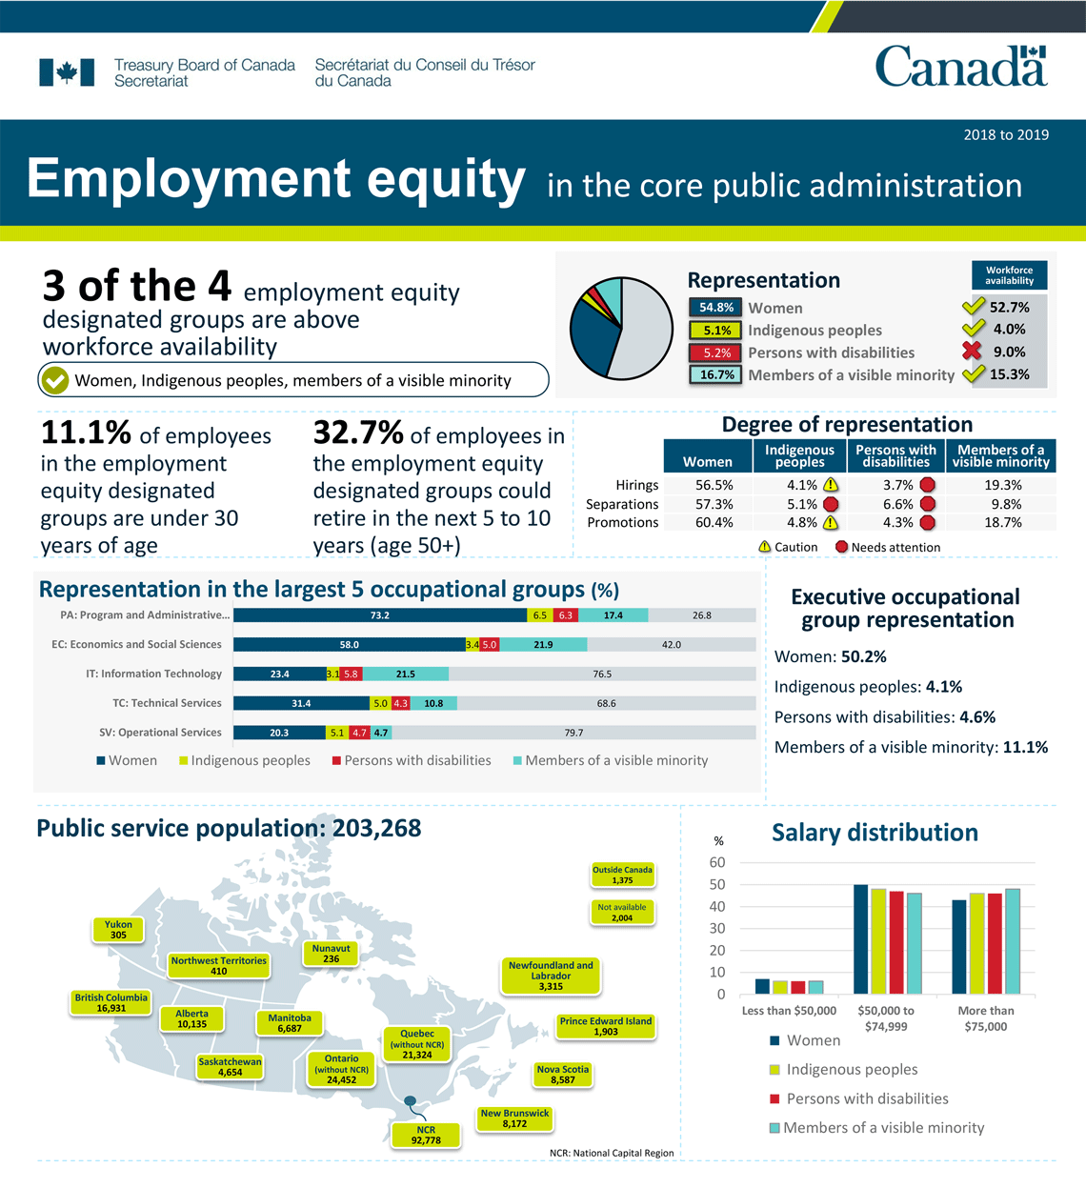
(The source of the data is the Treasury Board of Canada Secretariat Employment Equity Data Bank)

