web and database
Mathis Villa (2501611)

Table of Contents
Introduction 2
Requirements 2
Implementation 2
Validation 4
Evaluation A 10
Evaluation B 11
Comparison of two live websites 11
References 14
Appendices 14

Introduction
This report will examine the requirements of an HTML website and will consider how its intended purpose influences key design and development features when creating such sites. This report will explain the design decisions made when creating a website which I coded. It will explain the process followed to reach the final version of my HTML and CSS files, while still taking into account the usability and the design standards of an intuitive website. To show the following, I will be including screenshots of my work with my HTML and CSS files which have been validated through W3Schools. Furthermore, this report will also look at the usability, accessibility and search engine optimisation and consider why it is important with reference to relevant sources. In addition to this, there will be an analysis of two live websites which both offer similar services. This report will then consider improvements that could be made to further improve the sites.

Requirements
The chosen topic for my website was a sporting competition. The goal was to inform potential visitors about the 2026 mountain biking World Cup, held in the French town of Les Gets. This event happens every year, and I decided to create a website for the 2026 season, introducing the event to the general public. The website greets the reader with the homepage which introduces the competition and the two categories of events: downhill and cross country. The intended audience is any individual from mountain biker to tourists who does not know anything about mountain biking, and simply wants to attend the event to experience the thrill of this sport.

Implementation
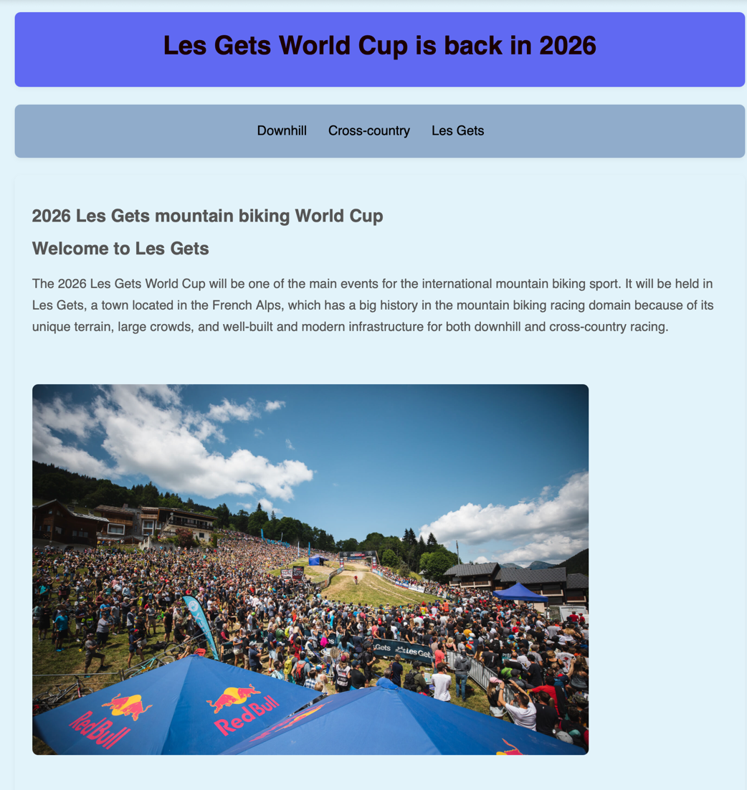
Homepage

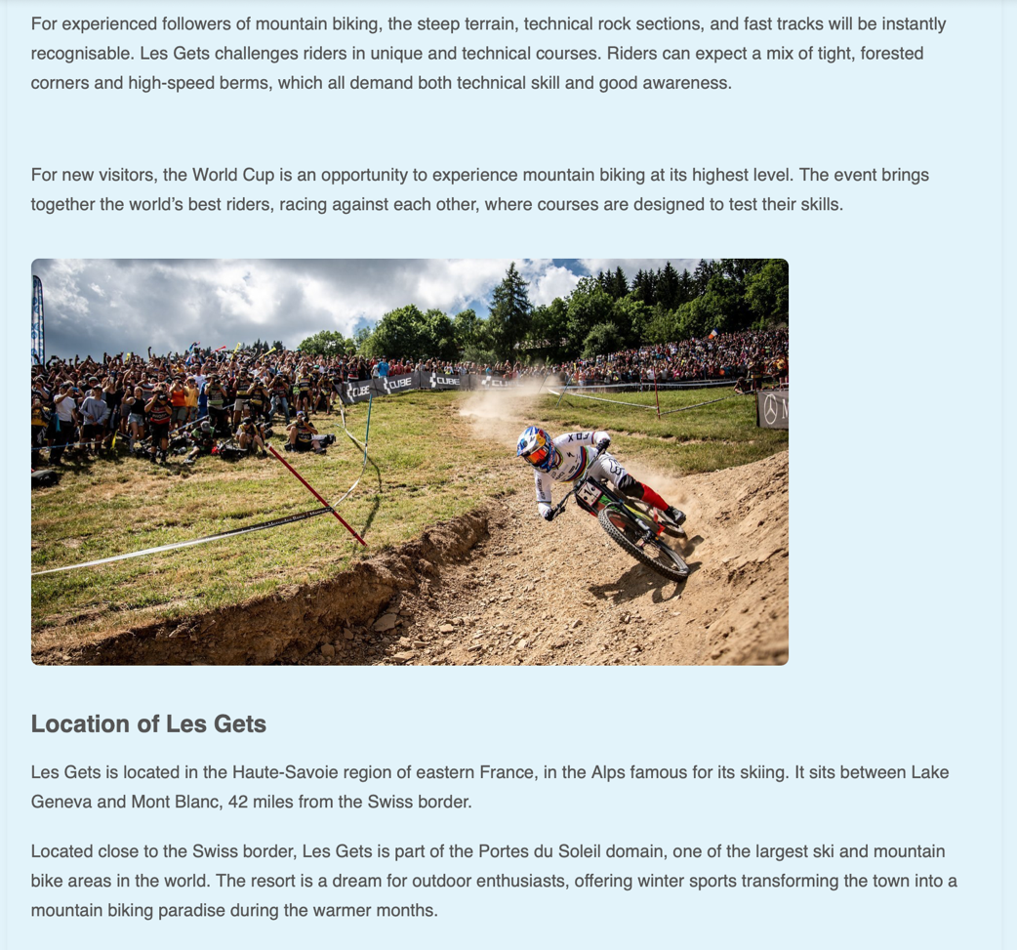

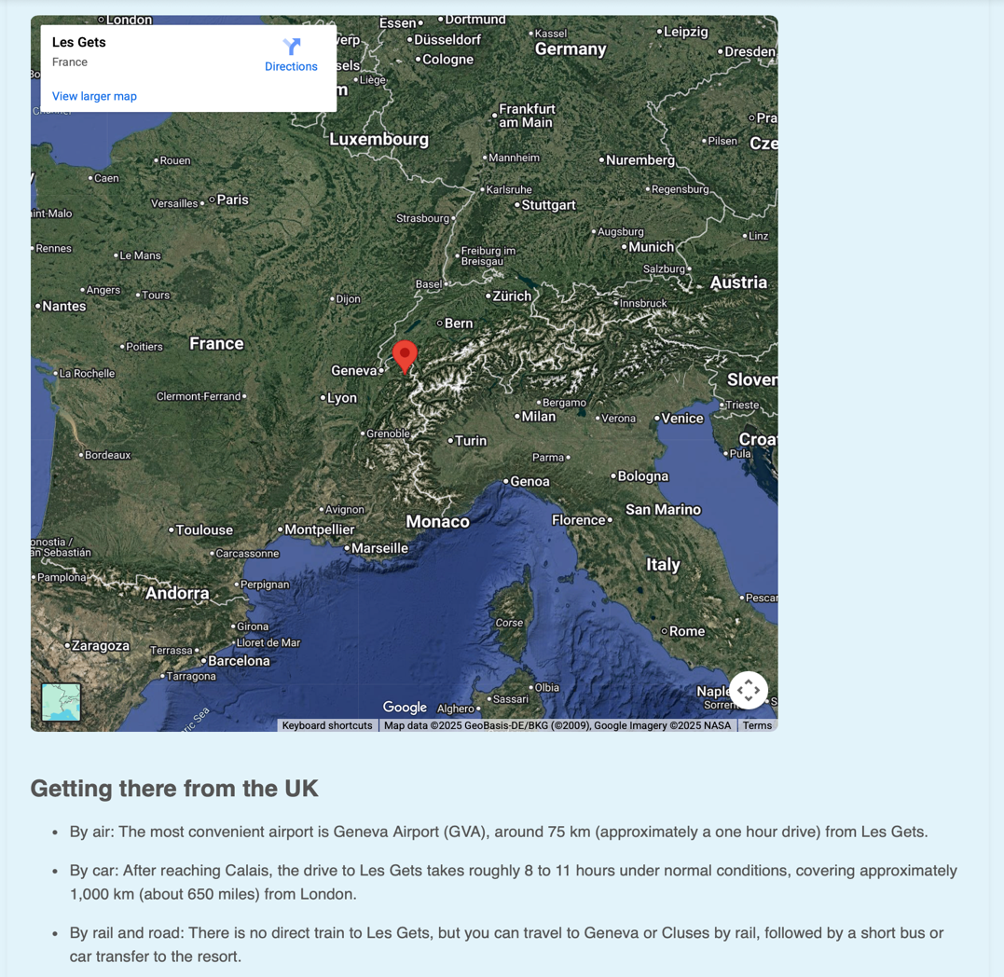

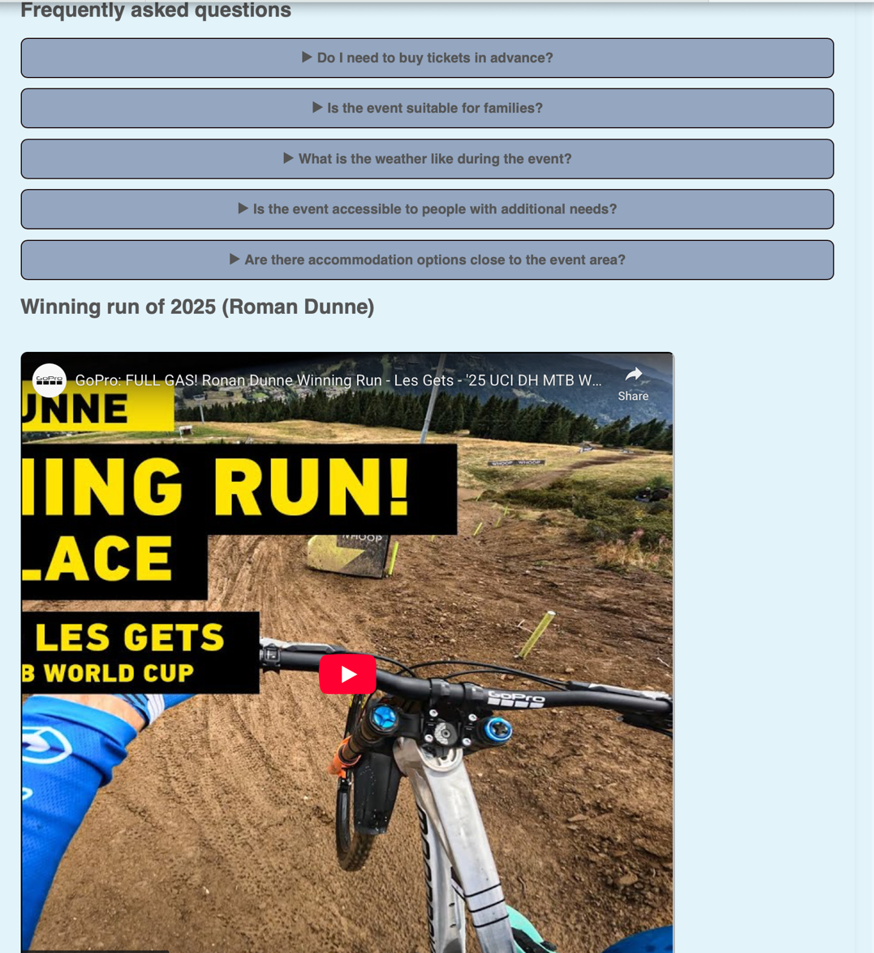

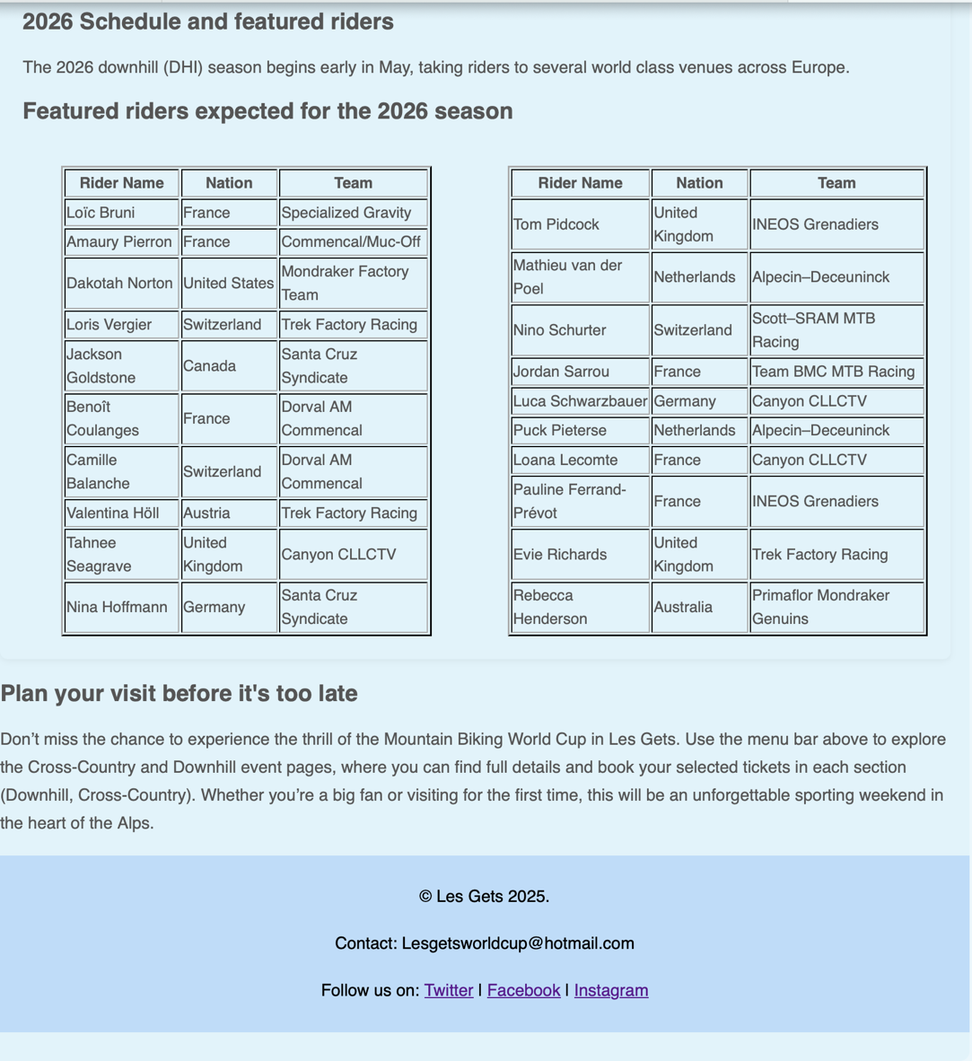
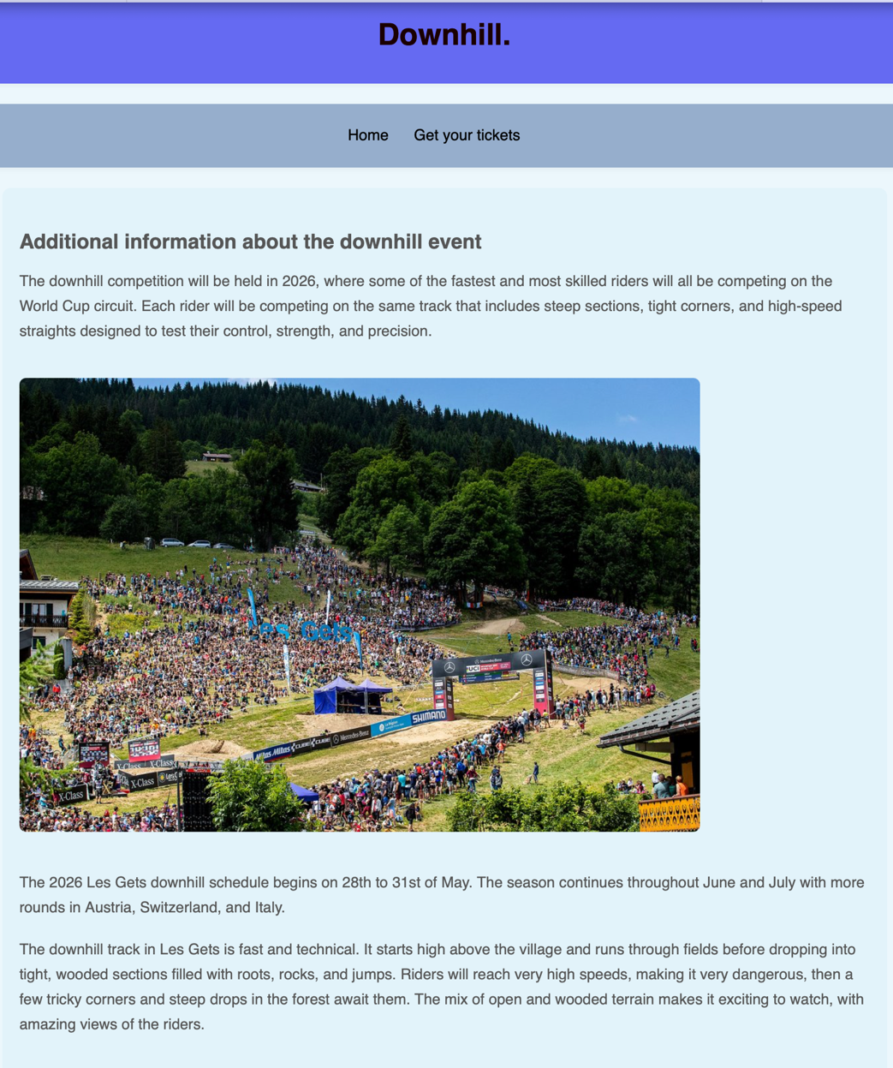
Downhill section

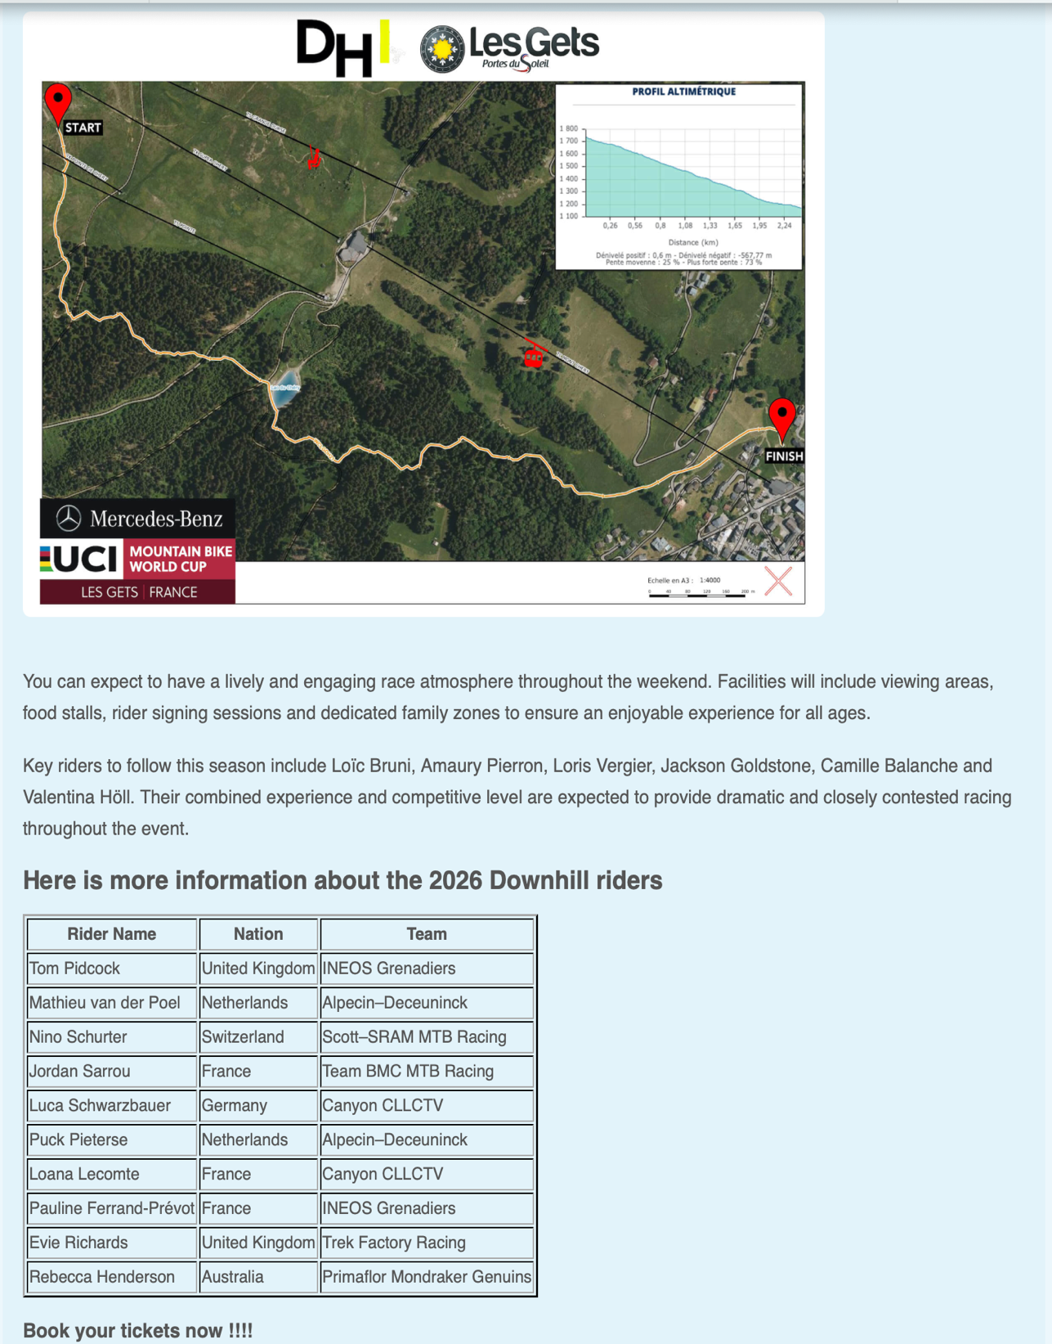
Downhill / cross country tickets (each are on a different page)
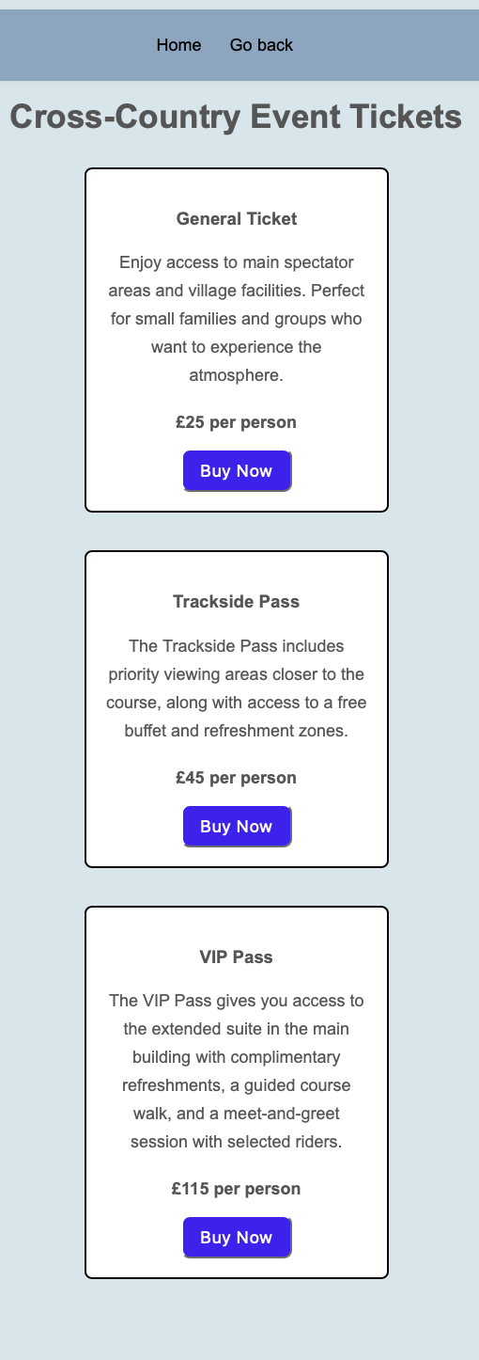
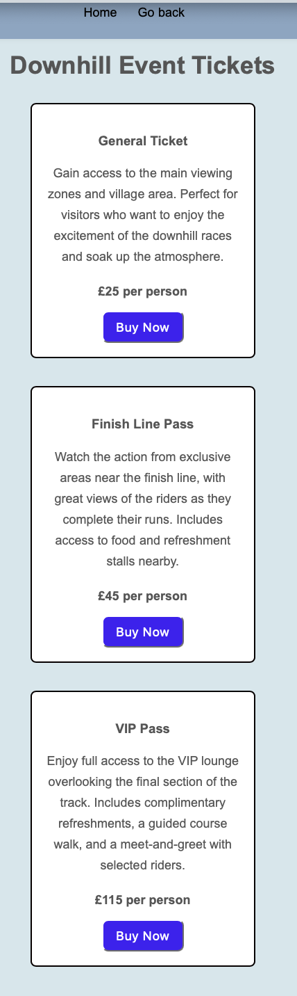
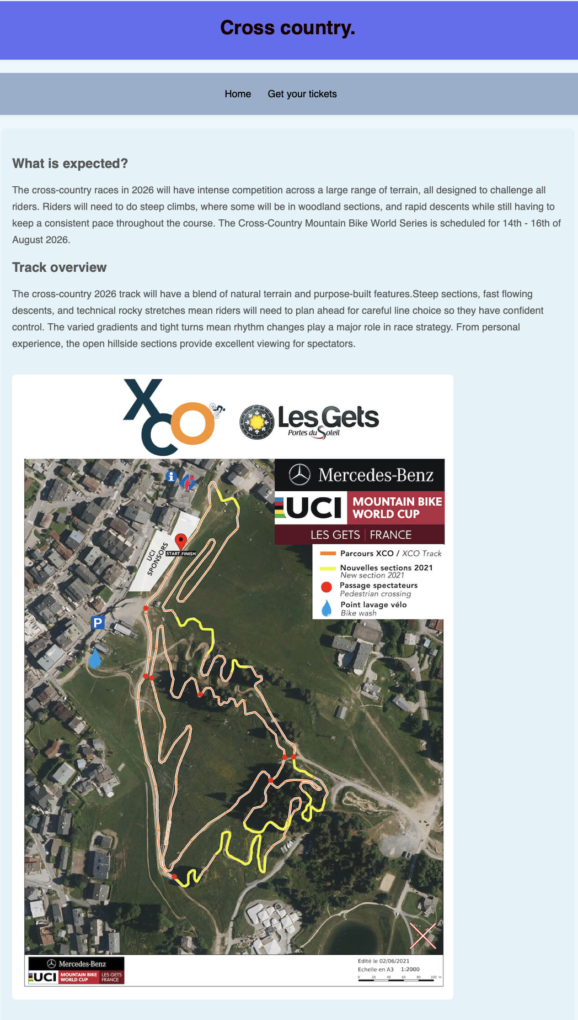
Cross country event
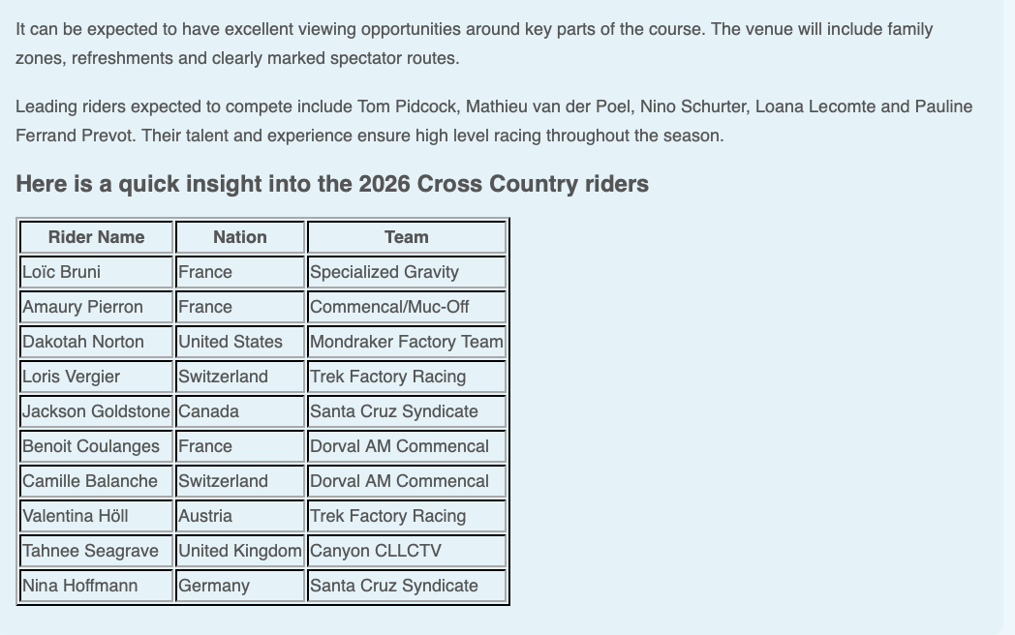
More about the town of Les Gets
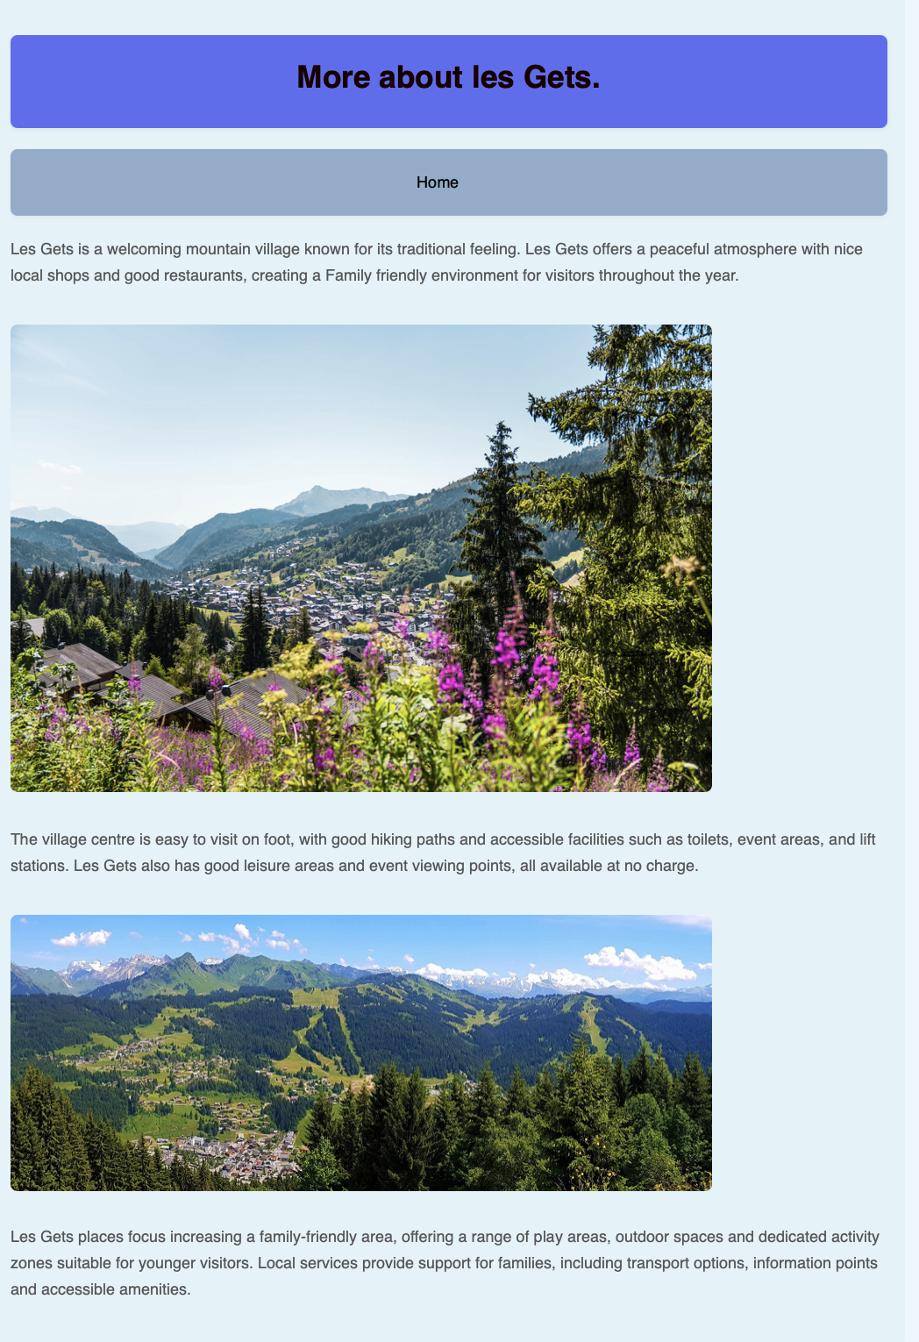

Validation
After putting my HTML through the W3School validator generated a total of 7 warnings which were minor and did not affect the code. These warnings included issues such as using extra <h1> headings inside the page, where <h1> should only be used once as the main page title. Furthermore, there were 2 errors including forgetting to close a <body> element and also an unclosed div element. Some mistakes could have been fixed by double checking the code. On the other hand, my CSS only had 3 errors: the first one was because a semicolon was missing between the style for the font family and font size. Because of that, it reported a “value error”. The final error was because there were extra bracket symbols which interrupted the rest of the code. All these errors for both the HTML and CSS have now been fixed.

Evaluation A
In the last 15 years, websites have evolved significantly, and users now prioritise a smooth and well-designed website over the product itself. A good website can be evaluated through different key factors, including its usefulness, its search engine optimisation techniques and its accessibility, following well known standards such as WCAG 2.1. Factors such as user experience, minimalist design, and effective search engine performance can all contribute to the satisfaction of the user, which can influence the customer’s desire to purchase the service being sold.
Usability can be described as how effectively and efficiently a user can interact and navigate on the website. This can range from the layout, design, navigation and responsiveness in all types of devices from a computer to a phone. A study carried out by Nielsen and Loranger (2006) in peer review usability has shown that users form quick impressions about whether a website is usable or not. These impressions are often based on the way website feels and whether it is designed appropriately with features such as well-placed menu bars and well-structured homepages. Such features make the user feel more comfortable and help them find the information desired more easily. This study highlights the importance of prioritising user friendly design methods where a website should feel fast, with appropriate placement of text which creates a frustration free interaction for the user.
Another factor which plays a vital role is SEO, also known as Search Engine Optimisation, as it focuses on the website’s visibility on the web by the use of meta tags, simple URLs and effective headings. A study focusing on the impact of meta tags on visibility of the website on the search list was carried out by J. Zhang in 2005. It highlights how the use of SEO on pages can have a positive effect on the visibility of the website. The study shows that relevant titles and accurate meta descriptions can affect the website position in the search results on the web. This therefore demonstrates the importance of writing good tags that can be searched easily by web users.

Evaluation B
My completed website performs smoothly, and the presented information is clear and well placed. Its structure is clear and well organised - there is a homepage with a navigation bar on each page where the user has the option to go back or return to the homepage. From a usability point of view, the layout is always the same and the content is always clear and readable on different screens. For future improvement, connecting the website to a server could be useful and would give the opportunity to add more devices such iPads, and to ensure that the final appearance can be viewed in the format originally intended. This would allow me to have a fully functioning purchase section for tickets where, if bought, the user would receive a ticket.
Several SEO practices have been used in the coding. For instance, I used headings such as H1, H2, H3 which gives structure to the code. I have also used keywords which indicate the purpose of the website that appears in the heading and meta tags. I have also added alt text to the images, improving the usability of the website as if the image did not load, the user would still understand the content. All of these factors improve the usability and also ranking potential, making it easier to find my website.

Comparison of two live websites
My two chosen website for this task are:
BBC — https://www.bbc.co.uk/
and
The Guardian — https://www.theguardian.com/uk

A. Usability
BBC
When the BBC homepage is opened, many features stand out, particularly the clean and well organised layout. For instance, there is a navigation bar where there are six categories with a home button and a search bar, greatly improving the usability. On other hand, the homepage itself does feel a bit cramped as there are multiple breaking news blocks that are of different sizes. Nevertheless, the readability is still high due to the use of consistent fonts, spacing and also colours which are soft on the human eye and is colour blind friendly (white and black). Overall, it can be said that the BBC website provides a relatively good user experience suitable for every individual.
Guardian
The Guardian has a more text heavy layout with fewer images and article lists on the user’s screen. It feels harder to read as the text font is smaller with large paragraphs for each section. Also, the fact there are fewer images makes the reading feel long and harder to understand, especially for new users. Furthermore, The Guardian also uses light grey text, which may pose an issue for users with disabilities such as dyslexia and colour blindness. On the other hand, it can be said that this layout may appeal more to readers who feel more comfortable with longer headlines as it quicker to read because there are less distractions.
Comparison
It can then be said that both sites are user friendly, but the BBC tends to be easier to navigate and read through as it is simpler with more images, while on the other hand The Guardian has a denser layout, but this does affect the readability.

B. Accessibility
BBC
The BBC got a 9.5/10 AIM score on WAVE suggesting that this website is compliant with WCAG 2.1. This is mostly due to the fact it includes alt text for images, as if the images do not load the user can still understand the message it is trying to pass. In addition to that, the BBC has consistent headings and good colour contrast. Furthermore, its functions such as the search bar work with computer and phone keyboards, supporting all users.
Guardian
The Guardian only got a score of 5.7 AIM score on WAVE and this is due to numerous issues. For instance, there are some skipped heading levels and some images missing with no alt-text issues. Furthermore, the colour contrast is not optimal as the use of light grey for text may be difficult for users with disabilities to read. While these are only minor issues, they do play an important role as they affect the user’s experience and accessibility.
Comparison
In conclusion, the BBC has a higher score rating for accessibility, offering clearer support.

C. SEO (search engine optimisation)
BBC
The BBC has clear page titles for each news page and also has well-structured headings (H1, H2 etc.) and good metatags. When searching up breaking news on the web, the BBC is one of the top websites, suggesting that it is a high ranked and well-known domain.
The Guardian
The Guardian also uses well designed titles, metatags and on each page there are structured headings (H1, H2 etc.). The news and content are also updated when new information comes in, helping with the visibility of the website. However, it can be argued that because of the high density of content on some pages, it may force the user to search for exact keywords to find the website on the web.
To conclude, while both websites have good SEO, the BBC does score slightly higher as it has clearer content and can be found on the web more easily than The Guardian, which may require more specific keywords for its content.
D. Mobile friendliness
BBC
The BBC adapts to mobile devices with small screens; the website runs very smoothly with clear and big text to read. The menu bar folds in and out when clicked on it with clear icons. The images remain the same, making the reading enjoyable. The load time when clicking on an article still remains fast.
The Guardian
The Guardian mobile site feels very responsive and adapts with a new layout compared to the computer website. However, it can be said that the layout feels very cramped with a high number of articles and images. It feels harder to read content and is also longer to scroll down. Consequently, if the connection is weak, it will take longer to load.

In conclusion
Both websites offer a high quality mobile experience for the user, but the BBC feels less cramped and easier to navigate through the content.
Final Conclusion
In conclusion, both websites, the BBC and The Guardian, are reliable and can be accessed online easily. However, it can be argued that in terms of usability, SEO and responsiveness, the BBC website offers a more user friendly and clearer experience for the user. Furthermore, the BBC has a simpler layout, making it easier for the intended audience to read. It can also be found on the web more easily, where it is always in the top results, whereas sometimes The Guardian does not even appear. The Guardian still remains a good website, particularly for readers who like to read in depth content, however, its content heavy design can throw off some users who prefer a more minimalist and less content heavy read.

References
J. Nielsen and H. Loranger, Prioritizing Web Usability. Berkeley, CA: New Riders, 2006.
J. Zhang and A. Dimitroff, “The impact of metadata implementation on webpage visibility in search engine results (Part II),” Information Processing & Management, vol. 41, no. 3, pp. 691–715, 2005
BBC, “Homepage,” BBC Online, [Online]. Available: https://www.bbc.co.uk/. [Accessed: 8-Nov-2025].
The Guardian, “UK edition – News, sport and opinion,” The Guardian Online. [Online]. Available: https://www.theguardian.com/uk. [Accessed: 8-Nov-2025].

Appendices
HTML

<!-- All re used from main code -->

<!DOCTYPE html>
<html>
<head>
<link rel="stylesheet" type="text/css" href="les gets.css">
</head>

<body>

<header id="main-title">
<div class="container">
<h1> Downhill. </h1>
</div>
</header>

<nav id="navbar">
<div class="container">
<ul>
<li><a href="Html project les gets.html"> Home</a></li>
<li><a href="Tickets cs2.html">Get your tickets</a></li>
</ul>
</div>
</nav>

<section class="page-style">

<h2>Downhill event additional information</h2>

<p>The downhill competition will be held in 2026, where some of the fastest and most skilled riders will all be competing on the World Cup circuit. Each rider will be competing on the same track that includes steep sections, tight corners, and high-speed straights designed to test their control, strength, and precision. </p>

<img src="over veiw.jpg">

<p>The 2026 Les Gets downhill schedule begins on 28 to 31 May. The season continues throughout June and July with more rounds in Austria, Switzerland, and Italy.</p>

<p> The downhill track in Les Gets is fast and technical. It starts high above the village and runs through fields before dropping into tight, wooded sections filled with roots, rocks, and jumps. Riders will reach very high speeds, making it very dangerous, then a few tricky corners and steep drops in the forest await them. The mix of open and wooded terrain makes it exciting to watch, with amazing views of the riders, but make sure you stay in the prepared watching areas so no lives are put at risk.</p>

<img src="DH track.jpeg" width="350" height="600">

<p>Spectators can expect a lively and engaging race atmosphere throughout the weekend. Facilities will include viewing areas, food stalls,
rider signing sessions and dedicated family zones to ensure an enjoyable experience for all ages.</p>

<p> Key riders to follow this season include Loïc Bruni, Amaury Pierron, Loris Vergier, Jackson Goldstone, Camille Balanche and Valentina Höll.
Their combined experience and competitive level are expected to provide dramatic and closely contested racing throughout the event.</p>

<h2> Here is more information about the 2026 Downhill riders </h2>

<table border="2">
<thead>
<tr>
<th>Rider Name</th>
<th>Nation</th>
<th>Team</th>
</tr>
</thead>

<tr>
<td>Tom Pidcock</td>
<td>United Kingdom</td>
<td>INEOS Grenadiers</td></tr>
<tr>
<td>Mathieu van der Poel</td>
<td>Netherlands</td>
<td>Alpecin–Deceuninck</td></tr>
<tr>
<td>Nino Schurter</td>
<td>Switzerland</td>
<td>Scott–SRAM MTB Racing</td></tr>
<tr>
<td>Jordan Sarrou</td>
<td>France</td>
<td>Team BMC MTB Racing</td></tr>
<tr>
<td>Luca Schwarzbauer</td>
<td>Germany</td>
<td>Canyon CLLCTV</td></tr>
<tr>
<td>Puck Pieterse</td>
<td>Netherlands</td>
<td>Alpecin–Deceuninck</td></tr>
<tr>
<td>Loana Lecomte</td>
<td>France</td>
<td>Canyon CLLCTV</td></tr>
<tr>
<td>Pauline Ferrand-Prévot</td>
<td>France</td>
<td>INEOS Grenadiers</td></tr>
<tr>
<td>Evie Richards</td>
<td>United Kingdom</td>
<td>Trek Factory Racing</td></tr>
<tr>
<td>Rebecca Henderson</td>
<td>Australia</td>
<td>Primaflor Mondraker Genuins</td></tr>
</table>

<h3> Book your tickets now !!!!</h3>

</div>
</section>
</body>
<!DOCTYPE html>
<html lang="en">
<head>
<title>Downhill Event Tickets</title>

<link rel="stylesheet" type="text/css" href="les gets.css">

<nav id="navbar">
<div class="container">
<ul>
<li><a href="Html project les gets.html">Home</a></li>
<li><a href="Downhill.html">Go back</a></li>

</ul>
</div>
</nav>

<link rel="stylesheet" href="Prices.css">
</head>

<body>
<h1>Downhill Event Tickets</h1>

<div class="Ticketcon"> <!-- Allows the Css to style the boxes-->
<h3>General Ticket</h3>
<p>Gain access to the main viewing zones and village area. Perfect for visitors who want to enjoy the excitement of the downhill races and soak up the atmosphere.</p>
<p class="price">£25 per person</p> <!-- The price class allows the CSS to make this text bold and spaced correctly-->
<button>Buy Now</button> <!-- Gives the color of the Buy now button-->
</div>

<div class="Ticketcon">
<h3>Finish Line Pass</h3>
<p>Watch the action from exclusive areas near the finish line, with great views of the riders as they complete their runs. Includes access to food and refreshment stalls nearby.</p>
<p class="price">£45 per person</p>
<button>Buy Now</button>
</div>

<div class="Ticketcon">
<h3>VIP Pass</h3>
<p>Enjoy full access to the VIP lounge overlooking the final section of the track. Includes complimentary refreshments, a guided course walk, and a meet-and-greet with selected riders.</p>
<p class="price">£115 per person</p>
<button>Buy Now</button>
</div>
</body>
</html>

CSS

body {
font-family: Arial, sans-serif;
background-color: #d5e6ec;
text-align: center;
margin: 20px; /* add small 20 pixels space in between text*/
}

h1 {
margin-bottom: 40px; /* Adds extra space below the main heading so it does not sit too close*/
}

.Ticketcon { /* creates ticket container*/
background-color: white;
border: 1px solid #000000;
border-radius: 8px;
width: 280px;
margin: 40px auto;
padding: 20px;

}

.Ticketcon h3 { /*header for titles in the ticket containers*/
margin-top: 0;
}

.price {
font-weight: bold;
margin: 12px 0;
}

button { /*used to create botton "buy now" */
background-color: #4600f5;
color: white;
padding: 10px 18px; /*Adds space inside the button so it is larger and easier to click.*/
border-radius: 9px; /*Rounds the corners of the button.*/
}

button:hover { /*chnages color when hovering over it*/
background-color: #005fa3;
}

J. Nielsen and H. Loranger, Prioritizing Web Usability. Berkeley, CA: New Riders, 2006.
J. Zhang and A. Dimitroff, “The impact of metadata implementation on webpage visibility in search engine results (Part II),” Information Processing & Management, vol. 41, no. 3, pp. 691–715, 2005

