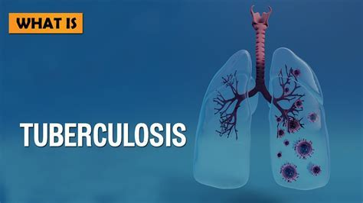

Student Name : Farzana Bi
Student Number: 2127508
Module Code: LCHS4003
Lecturers Name: Mr Hossain

Table of Contents
Introduction 3
Public Health Measures Available 3
3P’s Public Health 4
Risk Factors of TB 4
Short-Term Public Health Consequences of TB 5
Long-Term Public Health Consequences of TB 6
Conclusion 7
References 9

Introduction
Tuberculosis is a highly active infectious disease that affects the lungs severely. Tuberculosis, also referred to as "TB," is a common disease that spreads through the inhalation of molecules transferred from a person with active TB to anyone he has contact with. The molecules spread into the air through coughing and sneezing. The disease is not restricted to having an impact on the lungs only, as it can impact any part of the body, including the bones (NHS, 2017). TB is a severe disease, and its severity can be measured by the fact that in 2020, there were 43% new cases in the South-East Asia region, 25% new cases in the African region, and 86% new cases from the previous year in the TB-heavy cities (WHO, 2021).A total of 1.6 million people will have died globally due to TB in 2021 (Who, 2021).
Among the countries on the global scale, there are three main cities that have the highest ratios, and these are Afghanistan, Algeria, and Angola. These countries have more than 40 cases per 100,000 people (NSW, 2021). In the UK, TB is not very severe, as it has been declared a low-incidence country. There are fewer than 10 patients per every 100 000 people in the UK; immigrants to the UK accounted for 72.8% of the notifications in the year 2020 (GOV.UK, 2022). The current report has been aimed at analysing tuberculosis in depth, considering the risks, key determinants, and government measures for the disease.

Public Health Measures Available

The UK government is strengthening its capabilities in order to take a more significant approach to addressing the TB problem. WHO has worked on the mission to finish TB by 2035, and in that consideration, the UK government has also collaborated with UKAHS and the NHS to work for the control of TB. A five-year plan has been developed, and five different actions have been considered in that plan to work toward the COVID-19 recovery. TB prevention and protection will be planned, and early detection will be encouraged. The detection of TB is also included in this plan, and moreover, the workforce will be required to maintain itself in such a way that they should be working toward helping people fight their disease (Gov. UK, 2022).

The major consideration of TB patients is in London, as there are almost 4000 cases in the UK, and in London, there are 1500 patients (GOV.UK, 2022). Therefore, consideration of the sections that ensure development and suitability for workers must be addressed, as well as
analysing the stages of development to make people aware and receive appropriate treatment. As a result, on the government level, the approaches have been maintained to reduce the impact of tuberculosis and ensure that they are reduced by 2035.

3P’s Public Health

Ndzi et al. (2019) define public health as "the different stands of the three Ps, such as health promotion, health protection, and the prevention of bad health conditions." Furthermore, for the chosen infectious disease, TB, health promotion can be done through community empowerment, individual empowerment, interagency partnerships, health system strengthening, and intersectional collaboration. According to Rodriguez et al. (2020), it is also important to take precautionary measures to keep tuberculosis at bay, which can be accomplished by providing adequate ventilation, as TB is known to remain suspended in the surrounding air for several hours when there is no ventilation. Furthermore, natural light, which has the ability to kill the Tb bacteria, combined with good hygiene, such as properly covering the nose and mouth when sneezing, can reduce its symptoms. On the other hand, Sun et al. (2021) claimed that one of the best ways to prevent the bad health conditions caused by TB is limiting its spread, as the spread of TB is highly dependent on the identification of the patients with this disease in order to prevent them from passing this illness to other individuals. For example, surgical masks, waste receptacles in communal areas, and hand hygiene products are simple ways to prevent the spread of TB and allow people with TB symptoms to continue sneezing and coughing without putting others at risk.

Risk factors for TB
The risk of disease and infection development has two different aspects. According to Laghari et al. (2019), proper knowledge and understanding of the factors are required in order to develop TB control strategies. Moreover, many people develop TB right after getting infected, even before their immune system is able to fight the bacteria of TB. On the other hand, some individuals experience Tb symptoms years later, presuming that the older you get, the weaker your immune system is. As a result, one of the main factors that cause individuals to be easily attacked by this infection is a weak immune system. Shah et al. (2021) have identified that small infants have weak immune systems; therefore, they are more likely to suffer from TB than older individuals. However, there are a large number of medical conditions that have a huge contribution to making the immune system of individuals weak, such as HIV infections, which are considered to be a virus that causes AIDS; silicosis; substance abuse; organ transplant; severe kidney disease; diabetes mellitus; low body weight; head and neck cancer; and other medical treatments, including corticosteroids and Crohn’s disease. On the contrary, Saifullah et al. (2021) identified that the strongest element or factor that contributes to the progression of TB infection and converts it into TB disease is HIV infection. Furthermore, if left untreated, people with HIV and weakened immune systems can contract tuberculosis. Therefore, it is necessary to identify the symptoms of the infection and take the right treatment to prevent TB.
disease. In the study by Aung et al. (2019), it was further highlighted that other health factors that aid in the progress and growth of TB infection are the use of drugs, excessive alcohol use, old age, and many others. These factors can lead to serious consequences, as discussed by Kapwata et al. (2022); if the TB bacteria get access to the human bloodstream, they are then able to spread in the body of an individual in the form of tiny nodules and can destroy a large number of organs at a time, which ultimately leads to death. Therefore, it is important to take precautionary measures in order to prevent these factors from assisting in the development of TB infection and disease.

Short-Term Public Health Consequences of TB
The basic short-term symptoms of TB involve feelings of weakness or normal sickness, fever, night sweats, weight loss, and many others. Togun et al. (2020) highlighted that Tb could also contribute to the worst symptoms in the lungs of individuals in the form of excessive coughing, coughing up blood, and chest pain. Moreover, it was further noticed that the other short-term effects of this disease on other body parts depend on the affected area. In the same manner, Zenner et al. (2015) addressed the fact that excessive coughing, which lasts for more than three weeks, indicates the existence of this infection in any individual; however, it is further observed that feeling pain while breathing is another effect of TB, which is on a short-term basis. Kaku et al. (2016) described that the short-term impacts of this infection could be caused by inhaling the air of patients who are already diagnosed with this disease. Moreover, this infection has been identified for thousands of years, but it was not as prominent and dangerous as it became after the industrial revolution. Industrial fumes and cramped living conditions exacerbate the short-term effects on individuals and are one of the main reasons why this disease has become one of the most serious and deadly. According to a report by Statista, the number of TB cases in the year 2020 by age group between 25 and 44 years old was estimated to be 1.7 thousand. The report also stated that the cases registered by other age groups, such as 45 to 64 years old, totaled 1133.

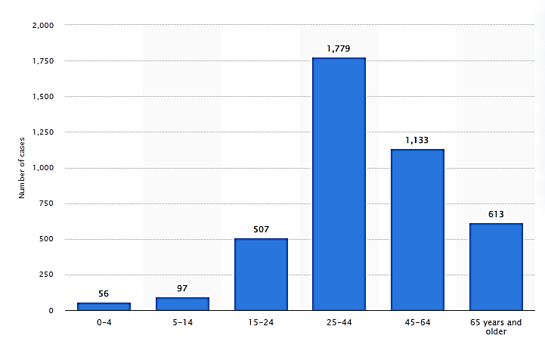
Source: (Statista, 2020)
Hence, this disease not only has effects on individuals but also has a severe influence on public health. It is important to take these short-term effects of this infection seriously in order to avoid the development of TB disease, which has more severe and long-term effects.

Long-Term Public Health Consequences of TB
TB is considered a chronic health illness caused by the bacillus Mycobacterium tuberculosis. Therefore, it affects the lungs in the worst way possible. Tola et al. (2015) emphasise that the long-term effects of TB are not only limited to the lungs, but it also has a severe influence on other body organs in the long run, such as the intestines, brain, spine, and especially the kidneys. However, these effects cannot be seen immediately; they can only be observed after suffering from TB for a long time. The effects of TB on any specific area of the body completely depend on its bacterial growth. Sharma et al. (2017) stated in their study that if Tb is treated in the right manner on an earlier basis, then there are higher chances of long-term lung damage. Moreover, the infection can further spread to the lymph glands, bones, and many other organs, causing permanent effects from the damage done by it. On the contrary, Rodriguez et al. (2020) further claimed that one-third of the individuals with TB, although they have been cured of this illness, are likely to have permanent damage to their lungs due to the development of large holes in their lungs, which are commonly known as "cavities." Oni and Unwin (2015) elaborated that in the case of uncontrolled TB, death becomes the consequence of this disease, which is one of the reasons for the increasing death ratio worldwide. According to a report issued by Statista (2019), tuberculosis is responsible for causing 1.2 million deaths in a single year, which is more than other infectious diseases such as malaria, cholera, hepatitis C, HIV, and many others.

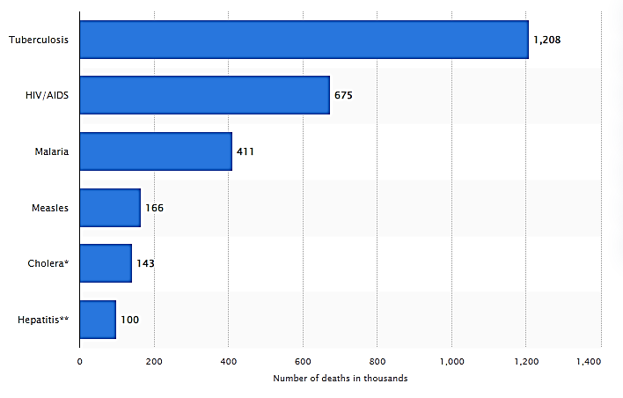
Source: (Statista, 2019)

However, Kaku et al. (2016) discussed that due to being the most prominent infection in current times, the disease has also had an impact on the health sector, as its long-term effects have led to patients visiting emergency departments more frequently, with a significant impact on the provision of health services.

Conclusion
This report has discussed the chosen infectious disease, TB, which is one of the most renowned diseases in the world and has affected a large number of people throughout the world, as discussed in the above study. Moreover. This report describes the actions taken by the UKAAHS, NHS, and government to contain the spread of this infectious disease. This study also drew the three Ps for public health in relation to tuberculosis and addressed how sunlight and improved ventilation can help prevent the spread of this disease. Moreover, the risk factors associated with Tb were further explained. It was noticed that there are a large number of medical conditions that have a huge contribution to making the immune system of individuals weak, such as HIV infections, silicosis, substance abuse, organ transplants, severe kidney disease, diabetes mellitus, low body weight, head and neck cancer, and other medical treatments.
including corticosteroids and Crohn’s disease. Furthermore, Tb's short-term effects may contribute to the worst symptoms in people's lungs, such as excessive coughing, coughing up blood, and chest pain. On the other hand, Tb can also cause long-term health effects for the individuals, such as long-term lung damage; the infection can further spread to the lymph glands, bones, and many other organs, causing permanent effects of the damage. Finally, the report emphasised the impact of tuberculosis on public health.

References
‌ Aung, Z.Z., Saw, Y.M., Saw, T.N., Oo, N., Aye, H.N.N., Aung, S., Oo, H.N., Cho, S.M., Khaing, M., Kariya, T. and Yamamoto, E., 2019. Survival rate and mortality risk factors among TB–HIV co-infected patients at an HIV-specialist hospital in Myanmar: A 12-year retrospective follow-up study. International Journal of Infectious Diseases, 80, pp.10-15.
‌ Laghari, M., Sulaiman, S.A.S., Khan, A.H., Talpur, B.A., Bhatti, Z. and Memon, N., 2019. Contact screening and risk factors for TB among the household contact of children with active TB: a way to find source case and new TB cases. BMC public health, 19(1), pp.1-10.
GOV.UK. (2022). What is TB and what are we doing to combat it? - UK Health Security Agency. [online] Available at: https://ukhsa.blog.gov.uk/2022/03/23/what-is-tb-and-what-are-we-doing-to-combat-it/.
Kaku, T., Minamoto, F., D'Meza, R., Morose, W., Boncy, J., Bijou, J., Geffrard, H., Yoshida, M. and Mori, T., 2016. Accuracy of LAMP-TB method for diagnosing Tuberculosis in Haiti. Japanese Journal of Infectious Diseases, 69(6), pp.488-492.
Kapwata, T., Breetzke, G., Wright, C.Y., Marcus, T.S. and Eales, O., 2022. Demographic and socio-economic risk factors associated with self-reported TB. The International Journal of Tuberculosis and Lung Disease, 26(1), pp.33-37.
Ndzi, E.N., Nkenfou, C.N., Mekue, L.M., Zentilin, L., Tamgue, O., Pefura, E.W.Y., Kuiaté, J.R., Giacca, M. and Ndjolo, A., 2019. MicroRNA hsa-miR-29a-3p is a plasma biomarker for the differential diagnosis and monitoring of Tuberculosis. Tuberculosis, 114, pp.69-76.
NHS (2017). Tuberculosis (TB). [online] nhs.uk. Available at: https://www.nhs.uk/conditions/tuberculosis-tb/#:~:text=Tuberculosis%20(TB)%20is%20a%20bacterial.
Nsw.gov.au. (2019). High TB incidence countries. [online] Available at: https://www.health.nsw.gov.au/Infectious/tuberculosis/Pages/high-incidence-countries.aspx.
Oni, T. and Unwin, N., 2015. Why the communicable/non-communicable disease dichotomy is problematic for public health control strategies: implications of multimorbidity for health systems in an era of health transition. International health, 7(6), pp.390-399.
Rodriguez, A., Douphrate, D., Gimeno Ruiz de Porras, D., Prot, E., Perez, A., Hagevoort, R. and Nonnenmann, M., 2020. Bovine Tuberculosis Case Intervention Using the T. SPOT. TB Assay to Screen Dairy Workers in Bailey County, Texas. Frontiers in public health, 8, p.479.
Saifullah, A., Mallhi, T.H., Khan, Y.H., Iqbal, M.S., Alotaibi, N.H., Alzarea, A.I. and Rasheed, M., 2021. Evaluation of risk factors associated with the development of MDR-and XDR-TB in a tertiary care hospital: a retrospective cohort study. PeerJ, 9, p.e10826.
Shah, G.H., Ewetola, R., Etheredge, G., Maluantesa, L., Waterfield, K., Engetele, E. and Kilundu, A., 2021. Risk factors for tb/hiv coinfection and consequences for patient outcomes: Evidence from 241 clinics in the Democratic republic of Congo. International Journal of Environmental Research and Public Health, 18(10), p.5165.
Sharma, S.K., Ryan, H., Khaparde, S., Sachdeva, K.S., Singh, A.D., Mohan, A., Sarin, R., Paramasivan, C.N., Kumar, P., Nischal, N. and Khatiwada, S., 2017. Index-TB guidelines: guidelines on extrapulmonary Tuberculosis for India. The Indian journal of medical research, 145(4), p.448.
Statista. (2019). Deaths communicable diseases annually worldwide 2019 | Statista. [online] Available at: https://www.statista.com/statistics/282715/deaths-from-communicable-diseases-worldwide/ [Accessed 11 Nov. 2022].
Statista. (2020). Number of new TB cases & relapses in the UK 2020, by age | Statista. [online] Available at: https://www.statista.com/statistics/918486/number-of-new-tb-and-relapses-cases-by-age-in-uk/ [Accessed 11 Nov. 2022].
Sun, Q., Shen, X., Ma, J., Lou, H. and Sha, W., 2021. LncRNA NEAT1 participates in inflammatory response in macrophages infected by mycobacterium tuberculosis through targeted regulation of miR-377–3p. Microbial Pathogenesis, 150, p.104674.
Togun, T., Kampmann, B., Stoker, N.G. and Lipman, M., 2020. Anticipating the impact of the COVID-19 pandemic on TB patients and TB control programmes. Annals of clinical microbiology and antimicrobials, 19(1), pp.1-6.
Tola, H.H., Azar, T.O.L., Shojaeizadeh, D. and Garmaroudi, G., 2015. Tuberculosis treatment non-adherence and lost to follow up among TB patients with or without HIV in developing countries: a systematic review. Iranian journal of public health, 44(1), p.1.
World Health Organization (2021). Tuberculosis. [online] World Health Organization. Available at: https://www.who.int/news-room/fact-sheets/detail/tuberculosis.
Zenner, D., Abubakar, I., Conti, S., Gupta, R.K., Yin, Z., Kall, M., Kruijshaar, M., Rice, B., Thomas, H.L., Pozniak, A. and Lipman, M., 2015. Impact of TB on the survival of people living with HIV infection in England, Wales and Northern Ireland. Thorax, 70(6), pp.566-573.

