Human Development
Contents:
- Infographic
- The Concept of Holistic Child Development
- Maslow’s Significance in Understanding Child Development
- Reference lists.
I can confirm that I have not used any form of assisted intelligence within this assignment.

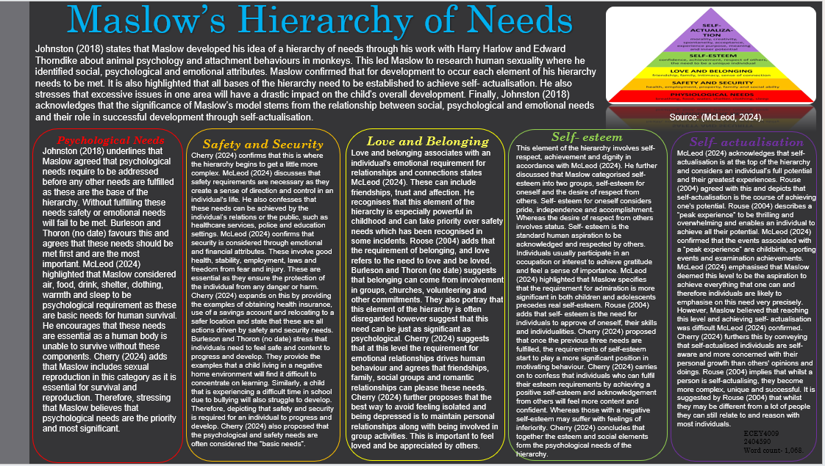

The Concept of Holistic Child Development
Holistic development concerns all aspects of the child’s growth according to Schenk (2022). Including their physical, social, emotional, intellectual and mental development. They confirm that having a holistic approach to education involves concentrating on all features of a child’s growth and not just their intellectual enhancements. They confess that most significantly; it is about determining the individual’s general welfare. This essay will discuss holistic development in early years and the importance of it. Including different theorist’s opinions whilst focusing on Maslow and any concerns in relation to his theory.
Early Years Matters (2023) also agrees that holistic development is all about concentrating on the complete development of the child. They simplify this and explain the different aspects of the overall development in further detail. It is emphasised that physical development involves fine and gross motor skills. Fine motor skills concern the use of the child’s finger tips whereas gross motor requires the use of the whole body. Intellectual skills include the use of the brain, the ability to process information and the use of imagination. Emotional development takes into consideration the capability to effectively express their feelings whether this be positive or negative. Language skills consist of an individual expressing themselves through verbal and non-verbal communication. Social skills involve interacting with others effectively to build positive relationships. Finally, spiritual and cultural skills concerns being aware of their beliefs and having a sense of who they are. Portraying that there are multiple factors to take into consideration to ensure a child can develop holistically.
Birth to 5 matters (no date) depicts that each child is individual with different personalities and interests who are always adapting. Highlighting that all encounters are an opportunity for holistic development. They use the example of a simple task, a toddler eating a snack and explore that personal, social, emotional and physical development can be enhanced throughout this experience along with improving their communication, language, literacy and understanding. Therefore, depicting that even simple tasks can promote development as a whole for children.
The importance of holistic development is highlighted by Schenk (2022) as they convey that effective knowledge, and understanding is not possible without efficient wellbeing. They stress that for children to develop and learn they initially need to feel secure, loved and be healthy. All Hallows School (2024) encourages that by having a holistic approach to developing it allows children to be better prepared for the future. They also stress that because a holistic approach is more individualised to the child’s requirements it further enhances their general engagement, learning and abilities. They concur that holistic development assists children to be more independent and secure whilst ensuring they improve across all areas and not just intellectually. Providing children to feel a better sense of association and belonging. Suggesting that holistic development enables children to feel safe, included and have a better understanding about themselves.
Brodie (2024) indicates that Maslow’s theory is fundamental in early years practise for numerous reasons and one being the holistic approach. This is because it promotes the significance of children’s physical, emotional and psychological needs. Brodie (2024) also underlines that Maslow’s theory has influenced policies and curriculum in education all over the world. In relation with holistic development the English early years foundation stage framework considers fulfilling the children’s physical, social and emotional requirements. Brodie (2024) portray that both Maslow and Erikson regard development as a holistic procedure involving social, emotional and cognitive features.
Folu (2023) indicates that Erikson’s psychological theory maintains a holistic approach to human advancement. It enables the exploration of adaption and progress through emotional, social and cognitive aspects. Kim (2011) confesses that developing holistically encourages a child to be perceived as more than what they can achieve intellectually. They also depict that Rudolf Steiner formed the ‘Waldorf Curriculum’ and indicates that holistic development especially in the early years needs an efficient and suitable routine of development that can be labelled four-fold individual with twelve distinct senses.
Whilst Maslow’s Hierarchy of needs is thoroughly recognised and put into practise, Mohammad (2022) suggests that the theory holds some disadvantages. One being that due to the requirements being individual, it is difficult to determine when it is acceptable to proceed to the following level. Indicating that individuals may struggle to recognise when it is appropriate for them to progress to the next stage of the hierarchy. A second concern being similar and portraying that the hierarchy of needs is not factual as the adequate level cannot be verified. Portraying that it is difficult for people using the hierarchy of needs to establish what level of effort and completion is acceptable to proceed. Lastly, Mohammed (2022) depicts that Maslow’s hierarchy of needs is difficult to put into practise in specific workplaces as not all employees will have the same requirements as everyone has different traits and priorities. Therefore, implying that employers may struggle to implement this theory to support their employees. Whilst it is a highly beneficial and a positive concept to motivate people, it is more individual. Cherry (2024) proposed further concerns with Maslow’s hierarchy of needs including the fact that the theory is awkward to determine. She highlighted the issue with individuals recognising whether they have reached the point of self-actualisation. She also discussed that her and other researchers believe that these basics and requirement should not follow a hierarchy. Exposing that everyone has opposing priorities on specific needs and therefore it is difficult to place them into a hierarchy to follow step by step.
The arguments presented indicate that holistic development allows children to progress in all areas and not just intellectually. It is also explicit that numerous theorists support a holistic approach to development including Maslow. As a final point, whilst Maslow’s theory is widely recognised and used it also has concerns in relation to it.

Maslow’s Significance in Understanding Child Development
Maslow’s Hierarchy of Needs has a significant impact on the understanding of a child’s progress and development through the framework of basic psychological requirements through to one achieving self-actualisation, according to Brodie (2024). This essay will discuss common issues in relation to early years practise and how Maslow and his theory has an impact on them.
Birth to 5 Matters (2021) highlight that transitions are not always “linear” and can often be more “horizontal” suggesting that they can be more complex. They discuss that transitions can be made within the same setting involving different rooms for different activities or from the classroom to the canteen for lunch. However, they also underline that transitions can also be from home to the setting. Indicating that children are constantly being transitioned from one area to another each day. Vogler et al. (2008) claims that there are three different forms of transitions. These involve vertical, horizontal and educational- associated transitions. It is suggested that vertical transitions are labelled as “key changes” and involve situations such as moving from primary to secondary school. This is why they are referred to as moving upwards. Implying that these are significant changes in a individuals childhood experience. Horizontal transitions are described as less significant and associated with everyday and regular events that occur. For instance, a child’s regular routine and what adaptations are made daily such as going to and from school. Finally, educational- associated transitions are considered less formal as they are more of a social experience. However, they are still considered important as they play a key role in a child’s development.
Ghaye and Pascal (1998) and Meggitt (2003) all agree that transitions are difficult for not only the children but also for the parents, guardians and practitioners. It has been recognised as one of the major challenges of early childhood due to the distress it causes. Therefore, research has been undertaken to ensure that transitions are more straightforward and less stressful for children and all those involved. It concerns assisting the children to be resilient to cope with change, obtaining a positive self-esteem, to have realistic expectations, recognise new routines and further develop their independence. This holds a connection with Maslow’s Hierarchy of Needs as his fourth level discusses self-esteem. Some proposed strategies include the practitioner’s providing parents with clear information on how they can best support and prepare the child for the transition along with allowing plenty of opportunities for the child to visit the setting, so they get used to the surroundings and noises. Indicating that if all those involved with the transition is prepared and has the correct information and guidance to follow it should be a more straightforward experience.
Masten & Coatsworth (1998) state that the capability to establish relationships with compassionate adults along with the ability to self- regulate enables an individual to face less challenges in the future. Suggesting that ‘attachment’ has potential to be a further challenge in early years practise. John Bowlby developed an “attachment theory” which highlights the attachment between a child and their primary attachment figure which is often the mother. Confessing that if a child maintains an ambivalent, avoidant or disorganised attachment with their primary figure it will be difficult to develop a positive relationship with them. This is because they may be insecure, withdrawn or depressed and passive. This will leave the child with a lack of trust and respect for adults and therefore unable to easily form healthy relationships. Bowlby (2007) portrays the significance of the practitioner's relationships with the children to ensure they feel protected and secure in the setting. This has relation to Maslow and his theory as it meets his second level of his hierarchy safety and security. Wilson-Ali (2019) proposes that it is critical that practitioners acknowledge the attachment theory and hold an understanding of how to assist the development of attachment relationships to maintain positive development.
A further key element of early years practise is the curriculum, which can often be challenging to maintain whilst meeting diverse requirements of all the children portrays Foundation Years (2012). They also imply that effective education and development requires a relevant curriculum and practitioners who value and are able to implement the curriculum requirements. Welsh government (no date) proposed a poster emphasising the ‘four purposes of the curriculum for Wales’. The initial element confesses that the curriculum should encourage determined and able leaners who set themselves high standards, are able to communicate efficiently and are ready to progress throughout their lives. This relates to Maslow’s hierarchy of needs as this theory motivates individuals to reach self-actualisation which requires a lot of effort and determination. It also relates to his third level of love and belonging as this concerns effective relationships and to achieve successful relationships it requires efficient communication skills. The second purpose

Reference List Part 1 and 2
McLeod, S. (2024) Maslow’s Hierarchy of Needs. Available at: https://www.simplypsychology.org/maslow.html?ez_vid=2cae626a2fe896279da43d587baa3eb663083817 (accessed: 4th November 2024).
Cherry, K. (2024) Maslow's Hierarchy of Needs - Maslow believed that physiological and psychological needs motivate our actions. Available at: https://www.verywellmind.com/what-is-maslows-hierarchy-of-needs-4136760 (accessed: 6th November 2024).
McLeod, S. (2024) Erik Erikson’s Stages of Psychosocial Development. Available at: https://www.simplypsychology.org/erik-erikson.html (accessed: 27th November 2024).
Mohammed. (2022) Maslow’s Hierarchy of Needs: Definition, Example, Pros & Cons. Available at: https://parsadi.com/maslows-hierarchy-of-needs/ (accessed: 20th November 2024).
Folu. (2023) Erikson’s Stages of Development: The Path to Personal Growth. Available at: https://medium.com/@folu3398/eriksons-stages-of-development-the-path-to-personal-growth-9c20dea170c5 (accessed: 18th November 2024).
Rouse, G. (2004) BEYOND MASLOW'S HIERARCHY OF NEEDS: What Do People Strive For? Available at: https://www.proquest.com/docview/237236046?pq-origsite=gscholar&fromopenview=true&sourcetype=Scholarly%20Journals (accessed: 6th November 2024).
Early Years Matters TV. (2023) Holistic Development in Early Childhood Explained. Available at: https://www.youtube.com/watch?v=InM-Iemhytg&t=248s (accessed: 20th November 2024).
All Hallows School. (2024) What Is Holistic Development in Early Years? Understanding Comprehensive Child Education. Available at: https://allhallowsschool.co.uk/all-hallows-blog/what-is-holistic-development-in-early-years-understanding-comprehensive-child-education/ (accessed: 18th November 2024).
Kim, J. (2011) Holistic Development of the young child through an Integrated Curriculum: Rudolf Steiners Anthroposophical Research. Available at: https://www.modernwaldorfonline.com/uploads/1/2/5/6/125640780/holistic_development_of_the_young_child.pdf
Johnston, J., Nahmad-Williams, L., Oates, R. and Wood, V. (2018) Early Childhood Studies – Principles and Practice. 2nd edn. London: Routledge.
Schenk, S. (2022) What is Holistic Development? Available at: https://www.heischools.com/blog/what-is-holistic-development (accessed: 14th November 2024).
Brodie, K. (2024) Maslow’s Hierarchy of Needs. Available at: https://www.earlyyears.tv/maslows-hierarchy-of-needs/#:~:text=Maslow%20%281954%29%20proposed%20that%20human%20needs%20can%20be,esteem%20needs%20%E2%80%93%20are%20categorised%20as%20deficiency%20needs. (accessed: 18th November 2024).
Birth to 5 Matters. (no date) Holistic development and learning. Available at: https://birthto5matters.org.uk/holistic-development-and-learning-2/ (accessed 18th November 2024).
Reference List Part 3
Birth to 5 Matters. (2021) Transitions. Available at: https://birthto5matters.org.uk/transitions/ (accessed 20th November).
Vogler et al. (2008) Early childhood transitions research: A review of concepts, theory, and practice. Available at: file:///C:/Users/megan/Downloads/Vogler_et_al_Transitions_PDF.DAT.pdf (accessed 22nd November 2024).
Trotter, J. (2011) Early Years Leaner Support Handbook.
Wilson-Ali, N and Barratt-Pugh, C and Knaus, M. (2019) Multiple perspectives on attachment theory: Investigating educators’ knowledge and understanding. Foundation Years. (2012) Principles for Early Years Education. Available at: https://foundationyears.org.uk/files/2012/10/Curriculum-guidance-for-the-foundation-stage-Principles-for-early-years-education.pdf (accessed: 28th November 2024).
Brodie, K. (2024) Maslow’s Hierarchy of Needs. Available at: https://www.earlyyears.tv/maslows-hierarchy-of-needs/#:~:text=Maslow%20%281954%29%20proposed%20that%20human%20needs%20can%20be,esteem%20needs%20%E2%80%93%20are%20categorised%20as%20deficiency%20needs. (accessed: 18th November 2024).

