A comparison of the marketing methods of two multinational hotel brands

Student Name: Ioana Mirela Bumbu
Student Id number: 2227453
Module: Marketing Essentials BMIH4005
Lecture’s name: Christopher Wilkin
Word count: 1646

There are numerous aspects that can be used to characterise how a firm presents itself to the public by analysing factors such as marketing strategy, the seven PS and the evolution in time based on the target audience. There are two distinct hotel brands, Moxy hotels and Six Senses, each with a unique concept to present to the world. Both hotels are new to this industry and are vastly distinct from one to another. In that situation, they can be distinguished. According to their website Six Senses, (2023), the hotel was founded in 1995 and it had an incredible expansion, operating in around 20 countries. The hotel was created for people who prefer to enjoy a peaceful experience. Neil Jacobs, (2023) chief executive officer at Six Senses, states that hospitality is not limited for providing a place to stay. They want the locations and spaces to facilitate everyone’s reconnection and exploration of what it means to be cognitively, physically, spiritually, and emotionally fulfilled. The best way of describing an experience is by activating all the feelings. When travelling around the world, a person's experience can be defined by the hotel they select. Everyone is aware that a good night's sleep can alter how a person feels during the day. According to Grimaldi (2014), In 2014, the first Moxy opened in Milan. The attention was captured by the travellers because to its clean look, unobtrusive but kind service, lively restaurants and bars, and inexpensive accommodations. The audience immediately admired the style's originality. Its unique design attracts customers with a desire for relaxation and enjoyment. Biswas, (2016) argues that the authenticity is the capacity to produce something that has not been replicated by anyone.

Every company has its own style to present itself to the world. The marketing strategy represents the plan that a company has to gain potentially customers of their goods (Barone, 2022). The Strategy Clock by Bowman is a marketing concept that focuses on strategic positioning. The concept was created by Cliff Bowman and David Faulkner. Based on price and perceived worth, a company or brand might position a product. Bowman's Strategy Clock illustrates that pricing and value determine product positioning (Gordon,2022). In this case Moxy hotel is situated between 3-4 and Six Senses between 5-6 (See Diagram B). For Moxy hotel Hybrid and Differentiation, shows that the hotel is offering moderate prices for a different product, creating a unique form of their service. Compared to Six Senses, Focused Differentiation and Risky/High Margins, shows that the product's value offer justifies a higher price. Given the expense of distinguishing the product, the company will want to make sure the higher price represents a larger margin. But the consumer value does not justify the additional price. The SWOT analyse made between Moxy and Six Senses can present a description, after comparing both companies, which it shows the weakness spots and strengths that can help or not a company to be successful. (See Diagram A).

According to McCarthy (1960), Marketing Mix has in its compound: product, price, place and promotion. Since the 1950s, there has been discussion about the four Ps. As the marketing industry has evolved, more Ps have been identified: people, process, and tangible evidence (Twin, 2022).
Every hotel has chosen to offer the best product to the world. The main product that Six Senses is offering is an extravagant experience with luxury facilities. Sonu Shivdasani, founder, and CEO of Six Senses Resorts & Spas, explains how he created some of the world's most opulent hotels while being environmentally conscious (Lay, 2010). The product is represented, at the same time by the brand name. Under many other names, the hotels are in some of the world's most exotic locales in over 20 countries. The luxury brand differentiates luxury hospitality via health and environmental ideals. To become the most ethically responsible hospitality brand, the company prioritises wellness, community, sustainable design, and smiles. The Six Senses brand aspires to be a story-maker rather than a storyteller (Basak, 2021). According to The Luxury Travel Expert, (2020) the bulk of Six Senses' consumers would be the public interested in travelling to nations that provide opportunities for new experiences, such as: winemaker for the day during harvest, take part in the traditional stomping of the grapes at Six Senses Douro, Portugal; Impressive rock formations, a coral reef, a golden sand beach, a playful stream and the towering mountains behind at Six Senses Ninh Van Bay, Vietnam; hikes and treks through pristine forests at Six Senses Brutah, etc.
According to Miceli, (2022), Europe, North America, and Asia are the continents on which Moxy Hotels is present. With 15 sites throughout Asia, Moxy Hotels can be found in all major cities, including Tokyo, Shanghai, Kyoto, and Osaka. In Europe, various Moxy Hotels can be found in countries such as Germany, France, The United Kingdom, including Portugal, Ireland, Greece, Italy, and Romania. Compared to Six Senses Moxy can be found in places more accessible around the world. Because we live in a value-driven society, pricing reflects everything a firm does, from product creation to website links. There is nothing else more defining of a company and a product (Campbell, 2022).
The easiest way of comparing two brands is looking at the price. It would be incorrect to consider Moxy a standard inexpensive hotel. Instead, the company concentrates on what is truly essential for sophisticated Gen X and Gen Y travellers (Qubein, 2020). Six Senses instead has a different approach. Six Senses created hotels in regions that are inaccessible daily only if a person chooses to go on a trip for a higher budget.
Early in 2019, InterContinental Hotels Group (IHG) announced that it will buy Six Senses. As a result of the incorporation of twelve Six Senses properties into the IHG One Rewards programme, members may now collect and rewards points, as well as take advantage of some elite privileges, when staying at Six Senses properties (Schlapping, 2022). This can be considered a different approach taken to put in advantage the company. The location refers to distribution and the way how a product it has been operated. Moxy hotel opted for a different strategy to provide travellers with a very accessible lodging option in a variety of well-known cities and countries. Many hotels are using OTA (see diagram C) as a distribution strategy to be more accessible for the public. According to Sperance (2022), the hotel industry responded to the disruption caused by OTAs by placing a larger focus on loyalty programmes and direct reservations. The development of a successful brand strategy begins with market research and business information. Everyone must consider their desired market position and develop a value offer based on this positioning. This value proposition will then be transformed into their story, which must be consistent across the whole client journey, from pre-trip to post-trip (Lacalle, 2021). By promoting or advertising in a certain manner, the audience is shown the services and possibilities available to them. In this scenario, what a hotel can provide and how it presents itself are distinguishing features. Using strategies as offering a discount and presenting the facilities is considered a marketing strategy used by Six Senses. (See picture D). Moxy is using the same strategy but adding a fun concept to it. (See picture E) McCabe, (2020) states that, "people" indicates in the marketing mix, means all those involved in the company's business. That comprises salespeople, designers, marketers, managers, customer reps, recruiters, and trainers. Six Senses provides a service which shows that the reputation is based on the quality of it. The result is a tangible experience based on the feedback after visiting the hotel. Comparing two hotels like Six Senses Fiji (see picture F) and Moxy Edinburg (See picture G), a result can be made as people enjoyed all the services offered from Six Senses more that Moxy Edinburg. In that case, the feedback is more favourable for Six Senses as positive tangible experience. Analysing the tangible experience, the process can be determined as how the services were delivered and received to the customer.

Sis Senses compared to Moxy is considered as being more popular. (See Diagram D). This may be the result of focusing on a different age categories or different concept. Designed for young travellers and digital nomads who are eager to meet new people and crave thrilling new experiences (Miceli, 2022).
The distinction between these two is that the Moxy hotel targets to the younger generation by being conveniently accessible and providing the opportunity to go to large cities while staying in a modern hotel with an emphasis on a fun environment, surrounded by the technology .According to Nickson (2021), when something is a part of your surroundings from a young age, it is inevitable that you will adjust to it and accept it as a normal part of your existence.
The Six senses offer as a service a luxurious link between the modern and the natural world. The hotel focused the attention on the resorts and spas keeping the atmosphere in a green way.

In conclusion, by analysing each hotel: the marketing strategy, the process through all the 7Ps and the result based on the audience targeted, a distinguished can be made. The expansion of a hotel indicates that its marketing strategies were successful. Since 2014, the rapid expansion of the Moxy hotel is a notable illustration. Otherwise, the hotel should focus the attention not only for the new generation if the desire for expansion is real in a shorter time. At the same time, Six Senses should improve their accessibility to the entire public but keeping the prestige of a luxury choice. Moxy Hotel and Six Senses Hotel had an intriguing approach to their job based on the marketing strategies they employed to showcase to the globe their exceptional hospitality services in a very different way by focusing on being special.

References:

Barone, A.,2022 ‘Marketing Strategy: What It Is, How It Works, How To Create One’ 13 June. Available at: https://www.investopedia.com/terms/m/marketing-strategy.asp [Accessed at: 27.01.23]

Basak, S.,2021 ‘Interview: The Story of Six Senses’ Available at: https://www.travelinsightpedia.com/interview-the-story-of-six-senses [Accessed at: 27.01.23]
Biswas, M. 2016 ‘Discover the value for culture of Originality in a Workplace: Originality is defined as the ability to create something that isn’t copied’ 28 November. Available at: https://www.indusnet.co.in/discover-the-value-for-culture-of-originality-in-a-workplace/ [Accessed at: 27.01.23]

Campbell P.,2022 ‘Importance of pricing: Why pricing is important for SAAS and beyond’ 29 April. Available at: https://www.priceintelligently.com/blog/bid/157964/two-reasons-why-pricing-is-the-most-important-aspect-of-your-business [Accessed at: 28.01.23]

Grimaldi, L.A., 2014 ‘Marriott's First Moxy Hotel Debuts in Milan’ 10 September. Available at: https://www.meetings-conventions.com/News/Hotels-and-Resorts/Marriott-s-First-Moxy-Hotel-Debuts-in-Milan [Accessed at: 27.01.23]

Gordon, J., 2022 ‘How was Bowman's Clock Developed?’ 14 April. Available at:

https://thebusinessprofessor.com/en_US/business-management-amp-operations-strategy-entrepreneurship-amp-innovation/bowmans-clock [Accessed at: 28.01.23]

Lacalle, E., 2021 ‘The importance of hotel branding and how to build an effective strategy’ 22 January. Available at: https://www.mews.com/en/blog/hotel-branding [Accessed at: 29.01.23]

Lay, C.F., 2010 ‘Sonu Shivdasani, the founder and CEO of Six Senses Resorts & Spas, on staying green in the luxury hotels market.’ 12 January. Available at: https://www.arabianbusiness.com/industries/travel-hospitality/the-sixth-sense-27243 [Accessed at: 27.01.23]

Neil J., 2023, chief executive officer. ‘ABOUT US’ Available at: https://www.sixsenses.com/en/about-us [Accessed at: 27.01.23]

Six Senses, (2023) ‘Development’, Available at: https://www.sixsenses.com/en/about-us/development [Accessed at:03.02.2023]
Morantis N.S., 2018 ‘HOW DOES A HOTEL’S LOCATION AFFECT ROOM RESERVATIONS?’

Available at: https://www.hotelieracademy.org/hotel-location-affects-room-reservations/ [Accessed at: 03.02.23]
Miceli, C., 2022 ‘Everything You Need To Know About Moxy Hotels: Are They Worth It?’ 9 February. Available at: https://www.pilotplans.com/blog/moxy-hotels-review [Accessed at: 29.01.23]

McCabe, A.,2022 ‘The 7Ps of the Marketing Mix: Streamline your Strategy’ .11 October. Available at: https://blog.hurree.co/blog/marketing-mix-7ps [Accessed at: 27.01.23]

Nickson, C., 2021 ‘How a Young generation Accepts Tehnology’ 10 June. Available at: https://www.atechnologysociety.co.uk/how-young-generation-accepts-technology.html [Accessed at: 04.02.23]

Quibein, R.,2020 ‘Moxy Hotels: A Marriott Bonvoy Guide’ Ramsey’ 23 December. Available at: https://www.nerdwallet.com/article/travel/your-guide-to-marriott-bonvoys-moxy-hotels [Accessed at: 29.01.23]

Schlappig, B.,2022 “Earn & Redeem IHG Points At Six Senses Resorts’ 21 August. Available at: https://onemileatatime.com/guides/ihg-six-senses/ [Accessed at:03.02.23]
Sperance, C., 2022 ‘The future of the hotel guest experience? Less Moxy, more Airbnb’ 18 July. Available at: https://thepointsguy.co.uk/news/hotels-need-better-airbnb-strategy/ [Accessed at: 29.01.23]

Twin, A., 2022 ‘The 4 Ps of Marketing and How to Use Them in Your Strategy’ 14 December. Available at: https://www.investopedia.com/terms/f/four-ps.asp [Accessed at: 27.01.23]

The Luxury Travel Expert, 2020 ‘Top 10 best Six Senses Hotels & Resorts in the world’ 3 February. Available at: https://theluxurytravelexpert.com/2020/02/03/top-10-best-six-senses-hotels-resorts/ [Accessed at: 29.01.23]

Appendices:

Diagram A:

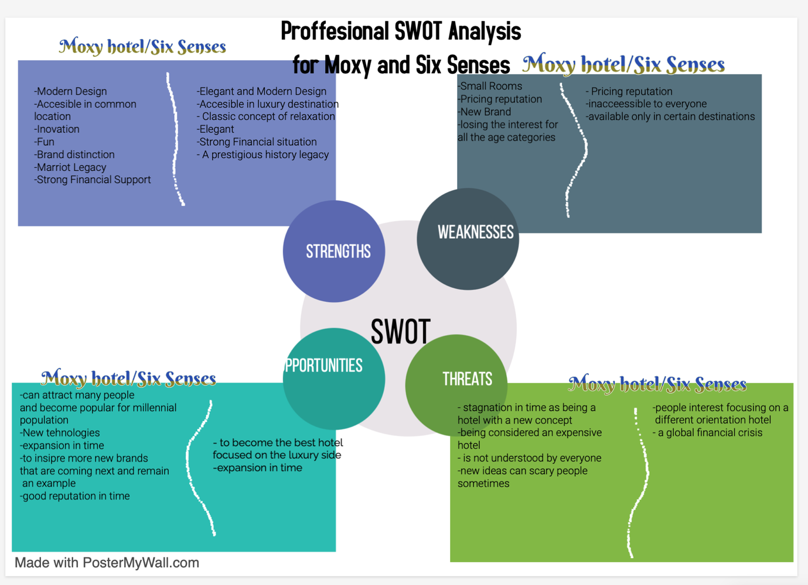

Diagram B:

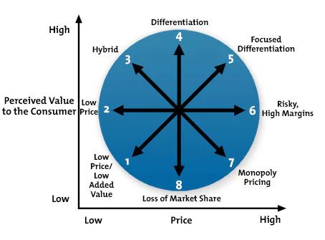

Diagram C:

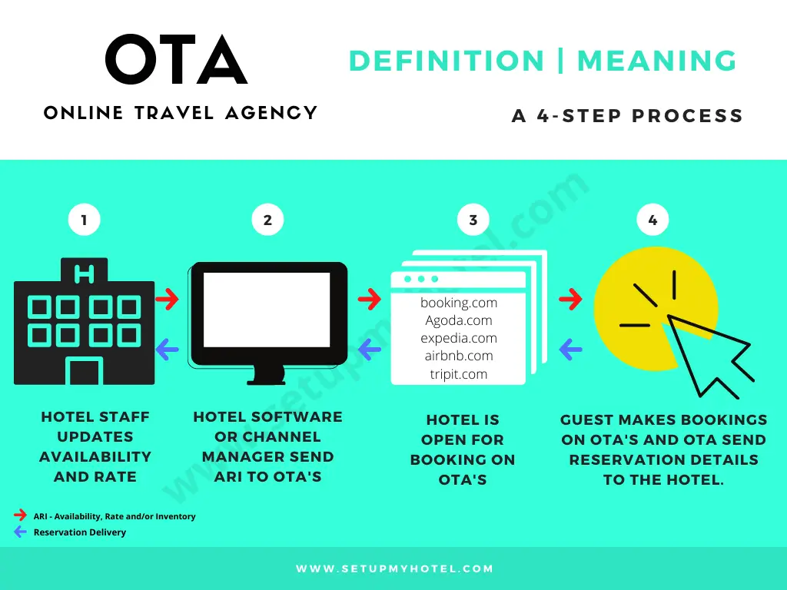
Diagram D:
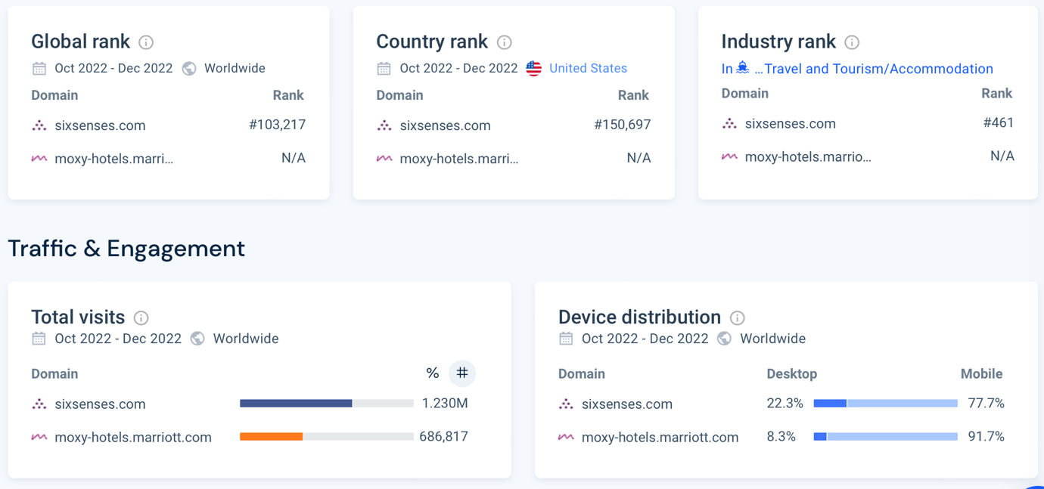

Picture D:
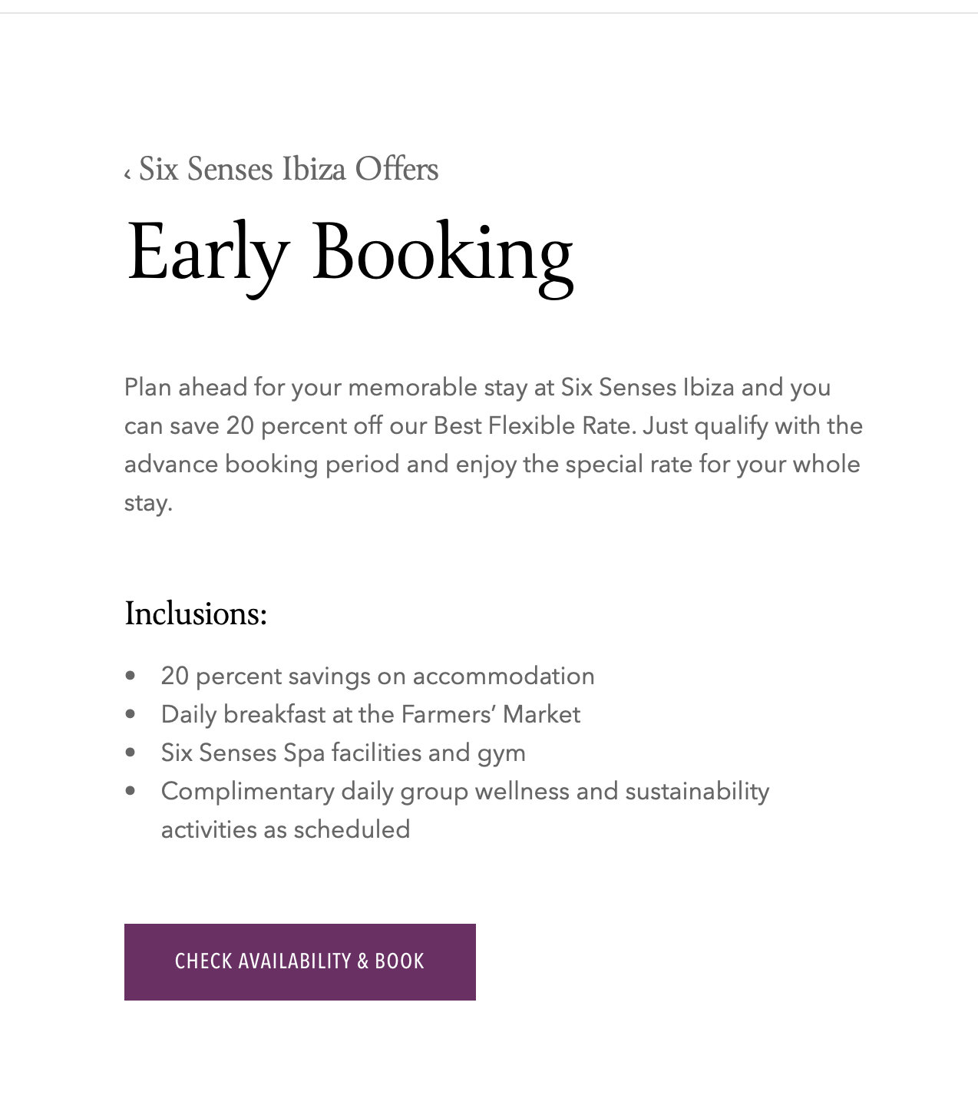

Picture E:
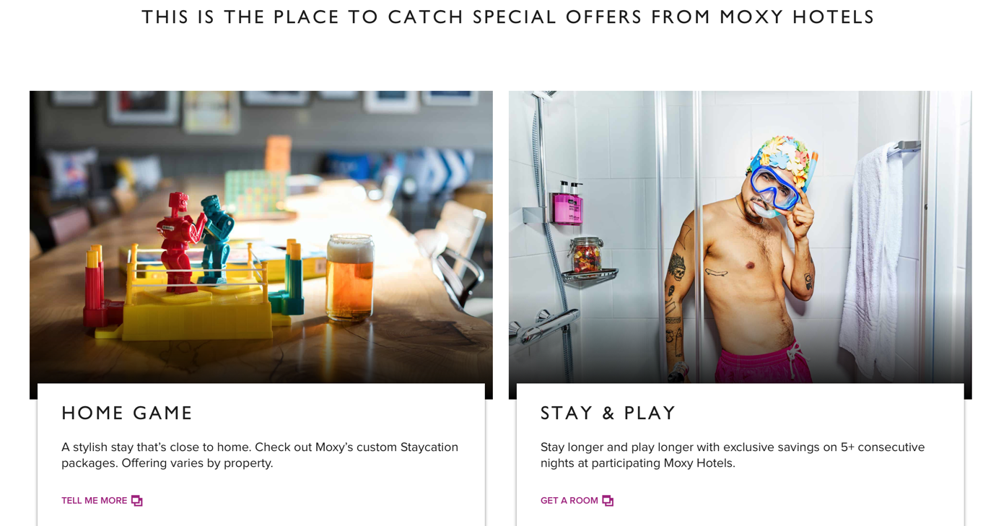

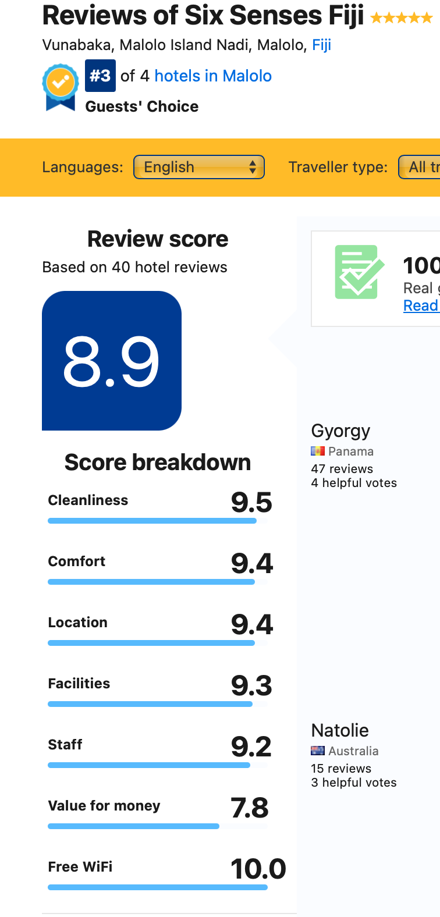
Picture F:
Picture G:


