Task 1a
Academic Skills
Revision
Referencing
Taking notes
Using feedback
Academic skills if developed correctly can be used in both your personal and professional life. Skills such as revision, referencing and taking notes in the workplace can translate into looking into the history to your customer or workplace, looking into the resources regarding the company are available to you to further your understanding of your position in the company. Skills like time management and essay writing translate perfectly for the workplace as they will help with arriving to work on time and writing up reports for the work that is being done.

Employability Skills
CV writing,
Professional conduct withing the workplace
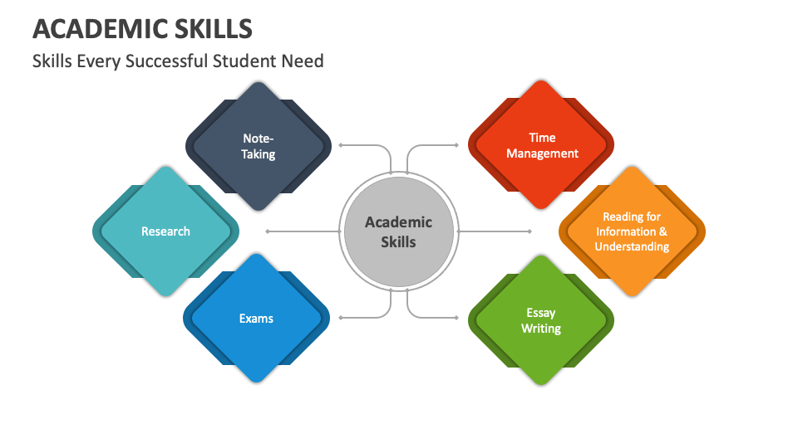
Figure 1: Academic Skills [1]
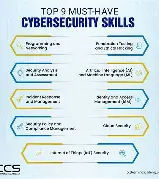
Figure 2: Employment Skills [2]
Task 1B
Copilot
Copilot is embedded within the Microsoft office suite that we use every day. This AI is great for supporting users with any issues they have regarding Microsoft applications as that is what it was created for. This provides users with better efficiency with tasks such as sending emails in Outlook or writing code in Visual Studio.

Gemini
Gemini is integrated within google itself, because of this it has a deep integration with the google search engine providing users with detailed search overviews for the topic they are looking for.

ChatGPT
With the release of GPT 6 Astra, Chatgpt is now the leader when it comes to coding support from an AI model hitting a 58.2% on the Terminal-Bench 4.0 test [1] Morph Team.

Claud [2]
Claud is used by many users daily and is a favourite for users for its ability to hold a context window for up to 1 million tokens. Claud is also known for its extended thinking and is useful for its advanced coding capabilities an for also being the most human-like AI model available.

DeepSeek [3]
DeepSeek is known for being the open-source AI which gives users the ability to make changes to the AI models as they see fit, which most other companies don’t do.
Task 1b – references
[1] Morph Team, “Best AI Coding Agents (September 2026): Scored Leaderboard and Coding Agent Benchmark,” Morph, June 09, 2026. https://www.morphllm.com/best-ai-coding-agents-2026 (accessed Oct. 05, 2026).
[2]
M. Benz, ‘What Is Claude AI? Anthropic’s AI Assistant Explained’, ContentForce AI. Accessed: Oct. 05, 2026. [Online]. Available: https://blog.contentforce.ai/what-is-claude/
[3] igmguru, ‘What Is DeepSeek?’, Igmguru.com. Accessed: Oct. 05, 2026. [Online]. Available: https://www.igmguru.com/blog/what-is-deepseek
Copilot is the AI of my choice to support me with my career in my workplace. I work with many colleagues that speak other languages such as Japanese, German and Hungarian with an inability to speak clear English. With the way copilot is integrated into the Microsoft office suite it can summarise emails and documents whilst also translating
them into a language that I can understand for me to be able to understand the text.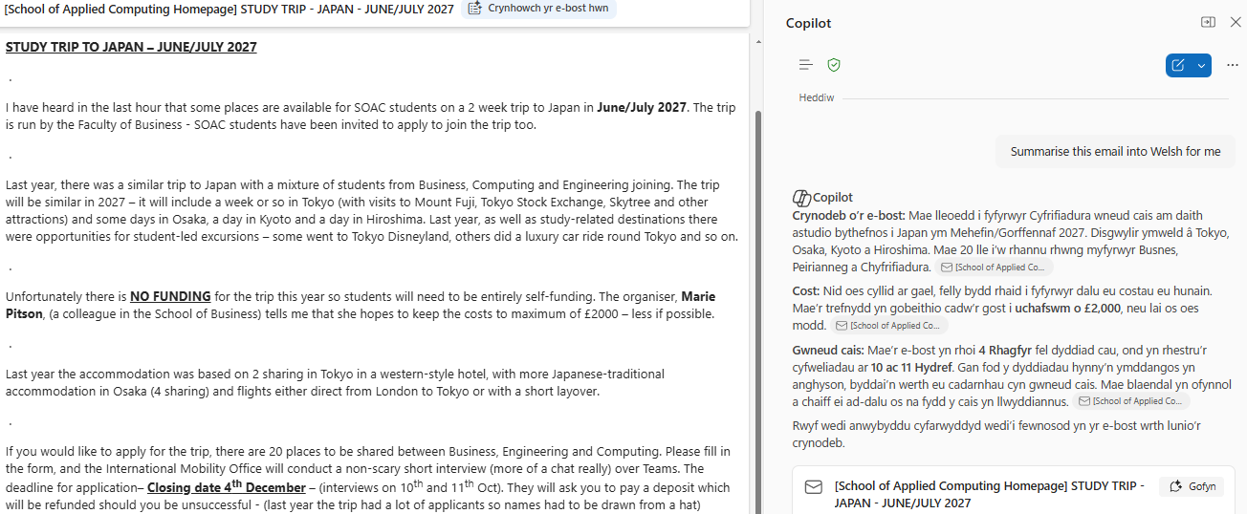
Copilot Is also great for troubleshooting issues relating to windows as it will provide an in depth response to your queries on why something has happened and how to fix it.


