ECAD6006C: Yr Iaith ar Daith 3: Portfolio
This assignment aims to reflect on ECAD5002C and to demonstrate how the writer has developed their Welsh language skills over the previous year. Specific progression steps will be highlighted to determine how the writer will improve their personal oracy skills further within a classroom situation. The video from last year was taken in a reception class and shows the writer reading ‘Nadolig Tedi Twt’, followed by an activity where the children write letters to Sion Corn in Welsh. To ensure that the children are given the best opportunity to improve their Welsh, it is the teacher’s responsibility to develop their own knowledge, so they comply with the appropriate level from the Welsh Language competency framework for education practitioners. This reflection uses the framework to discuss how the writer has improved their linguistic skills since this video activity and how they will develop their skills further. The writer will refer to the future curriculum for 2022 when assessing areas for progression.
During the video activity, questions were asked regularly to keep the children engaged about the story, however, these questions were asked in English. Praise and feedback from the responses during these questions were also given in English. The writer did not provide children feedback or ask any questions in Welsh. Praise and regular comments would have contributed towards to use of incidental Welsh during this activity. Despite the writer’s ability to read the story to the children in Welsh, the lack of incidental Welsh suggests they are less competent with their oracy skills. Basic comments were made such as “Da iawn”, “Gwych”, and “Dim siarad”. Key phrases that will be used during future lessons can be found in Lesson Plans 1 and 2. According to the Welsh Language competency framework, giving basic feedback and providing simple information in Welsh, puts the practitioner at Foundation Level. To overcome this, the writer must use incidental Welsh frequently. Incidental Welsh refers to “interactions between adults and children that arise naturally in an unstructured situation where adults transmit new information or give children practice in developing a communication skill” (Estyn, 2013, p.35). Estyn (2012) suggest that incidental Welsh can help to prepare children for a bilingual society as they learn to use Welsh daily and can also improve provision and learner’s standards. Based on this evidence, the writer believes the use of incidental Welsh will improve personal oracy skills to contribute to moving towards the Intermediary Stage. Since this video activity the writer has improved the quality and quantity of incidental Welsh used while on teaching practice. This was achieved by using prompt notes around the classroom which helped to remind the writer about which phrases they should be using and when. The writer aims to take specific steps to ensure progress is maintained and developed further. As well as using prompt cards, the promoting Welsh planning sheet, provided by University of Wales Trinity St David (UWTSD), will be used to focus on two specific Welsh phrases per day. Examples of how the Promoting Welsh Planning sheet was used on previous teaching practice can be found in Appendix 1. Unfortunately, on past practice, this planning sheet focused on basic words due to lack of confidence. For future progression, the writer aims to use vocabulary provided by UWTSD shown in Appendix 2, which is specifically for year three trainee teachers. Concentrating on more advance Welsh terminology by using the promoting Welsh planning sheet, will help the writer to improve personal oracy skills within the classroom and increase confidence by monitoring progress regularly.
Another area of improvement that the writer aims to focus on is to use different methods and strategies when teaching Welsh within a classroom setting. For example, reading stories and singing. Using different methods to introduce Welsh when on teaching practice would also contribute towards developing the writers oracy skills. Referring to the Welsh Language competency framework, as mentioned previously the writer aims to develop their oracy skills from Foundation level to Intermediary. Achieving an Intermediary level suggests that the writer can hold a conversation on familiar subjects related to school life, which can be taught through songs. The writer aims to use songs and rhymes to benefit their practice, but also to improve their personal oracy skills and to be confident at an Intermediate level before moving onto Higher. Recent studies from Estyn (2018) suggest that using action songs when teaching children Welsh provides a greater understanding and familiarity of the vocabulary introduced. This method is also used to teach children about Welsh culture by reading stories and poems. However, songs and poems are more commonly used in Foundation Phase, despite research provided by Ludke (2009) and Spicher and Sweeney (2007), who state that songs in the classroom can enhance learning for students at different stages and ages of learning. Using songs and poems will help to educate children about Welsh culture which supports one of Donaldson’s four purposes of the future curriculum. He states that education should allow children to become ethically informed citizens who are acknowledgeable about their culture (Donaldson, 2015). The future curriculum for languages literacy and communication also states that providing language lessons in a meaningful context such as stories can stimulate learners interest to acquire language skills (Gov, 2019). Unfortunately, on previous experiences, the writer has not made use of songs and rhymes to aid children’s progression in Welsh language. Since last year’s video activity, the writer has regularly been using simple songs such as ‘Bore da ffrindiau’ and ‘Mae amser tacluso’ with actions to provide greater understanding in the Foundation Phase. These songs were used daily by the writer to improve children’s Welsh vocabulary. To ensure these songs are not overlooked, they were cited in introductions and plenaries of lesson plans. Rhymes and poems were also used in Key Stage 2 by the writer. This will help to develop knowledge on Welsh culture. Examples of how the writer is going to implement more songs and rhymes into practice can be found in Lesson Plan 1.
After reviewing the video activity from the previous year, the writer also aims to use a different approach when teaching Welsh to enhance their personal linguistic skills and overall to improve their teaching practice. The video activity shows the writer doing a Welsh writing-based task where instructions and feedback are given in English. This activity enabled the children to develop their handwriting skills in Welsh, they were also able to practice their pronunciation. As these children were in reception, the words were spelt phonically which at times became difficult as they confused the English sounds with the Welsh. This showed the writer that the writing task had been introduced too quickly and was not beneficial to the children’s learning. The writer aims to use an Audio-lingual approach when new topics in Welsh are introduced. Audio-lingualism is a strategy used by educators to teach foreign languages by emphasising on speaking and listening by relying on reputation (BBC, 2020). The purpose of this is, to breakdown larger sentences that children may find difficult and repeat structured patterns through oral practice which allows the teacher to rectify mistakes quicker opposed to a written task. Both Brown (1998) and Larsen-Freeman (2000) emphasise the importance of repetition and drilling when using an audio-lingual approach. This will allow the writer to develop their own oracy skills and gain a greater understanding of language patterns during teaching practice. To ensure that this method is put into practice, the writer aims to use an audio-lingual approach when new Welsh vocabulary is introduced. This will enable a greater understanding for both the teacher and the children before moving onto written tasks. It will also allow the writer to provide specific differentiation tasks as audio-lingualism allows the teacher to clearly distinguish different levels of ability earlier on in the process. Examples of how an audio-lingualism approach will be put into practice can be found in Lesson Plan 1 as this is a discussion-based task. Despite this, the What matters statement for languages, literacy and communication recommends that speaking and writing should exist in relation to each other (Gov, 2019). As a result of this, the follow-on lesson, found in Lesson plan 2, is a writing task which links to the skills and previous learning achieved in Lesson plan 1. The writer aims to use the audio-lingual approach to contribute to achieving Intermediary Level in Oracy based on the Welsh Language competency framework. However, this approach also intends on improving the writers listening skills. Currently, the writer has achieved a Foundation level as they are able to understand and respond to simple questions. Using an audio-lingual approach will allow the writer to improve their listening skills as this focuses initially on speaking and listening, then later move onto reading and writing. With this in mind, the writer aims to achieve an Intermediate level for listening skills in Welsh Language based on the Welsh Language competency framework.
Overall, the writer has three main focuses to continue to improve their Welsh Language skills within the classroom. These are, to increase the use of incidental Welsh on a daily basis, to make use of all resources such as songs, books and rhymes in both Foundation Phase and Key Stage 2, and finally use an audio-lingual approach which focuses on speaking and listening before moving onto written tasks. With the new curriculum being introduced in September 2022, the writer must make every opportunity to ensure that they are continuing to improve their linguistic skills. Gaining a good understanding of language can enable children to develop a strong sense of identity and citizenship within their local community and the wider world (Gov, 2019). This is supported by the; what matters statements for this area of learning. These suggest that literature fires imagination and creativity and learning about identity and culture through language and prepares learners to be citizens of Wales and the wider world which can only be achieved if the educators have a good understanding of the Welsh Language. To conclude, achieving these aims will prepare the writer for the introduction of the future curriculum in 2022.

References
BBC (2020) Audio-Lingualism. Available at: https://www.teachingenglish.org.uk/article/audio-lingualism#sidr-0 [Accessed: 21st of April 2020].
Brown, A. and Dowling, P. (1998) Doing Research/Reading Research: A mode of interrogation for education. London: The Falmer Press.
Estyn (2012) Welsh Second Language comes first. Available at: https://www.estyn.gov.wales/effective-practice/welsh-second-language-comes-first [Accessed April 12th 2020].
Estyn (2013) Welsh Language Development in the Foundation Phase. Available at: https://www.estyn.gov.wales/sites/www.estyn.gov.wales/files/documents/Welsh%20Language%20Development%20in%20the%20Foundation%20Phase%20-%20January%202013.pdf [Accessed: April 12th 2020].
Esyn (2018) Developing Welsh Skills for Early Years Learning. Available at: https://www.estyn.gov.wales/effective-practice/developing-welsh-language-skills-early-years-learning [Accessed: 17th of April 2020].
Donaldson, G. (2015) Successful Futures: An independent review of curriculum and assessment arrangements in Wales. Available at: file:///C:/Users/molly/Downloads/Donaldson%20Report%20%20Successful%20Futures%20-%20Independent%20Review%20of%20Curriculum%20and%20Assessment%20Arrangements%20in%20Wales%20(32).pdf [Accessed: 17th of April 2020].
Spicher, L. & Sweeney, F. (2007) Folk music in the L2 classroom: Development of native-like pronunciation through prosodic engagement strategies.
Larsen-Freeman, D. (2000) Techniques and Principles in Language Teaching. Oxford: Oxford University Press.
Ludke, K. M. (2009) Teaching Foreign Languages Through Songs. IMHSD: University of Edinburgh.
Welsh Government (2019) Draft Statutory Guidance Area of Learning and Experience: Languages, Literacy and Communication. Cardiff: Crown.
Welsh Government (2019) Welsh Language Competency Framework. Cardiff: Crown.
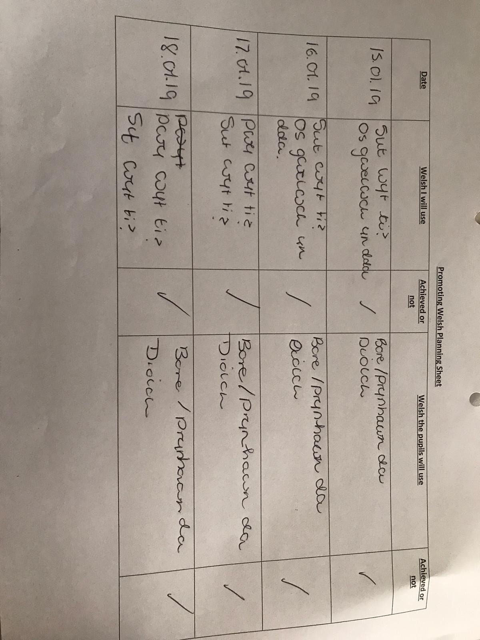
Appendix 1

Appendix 2

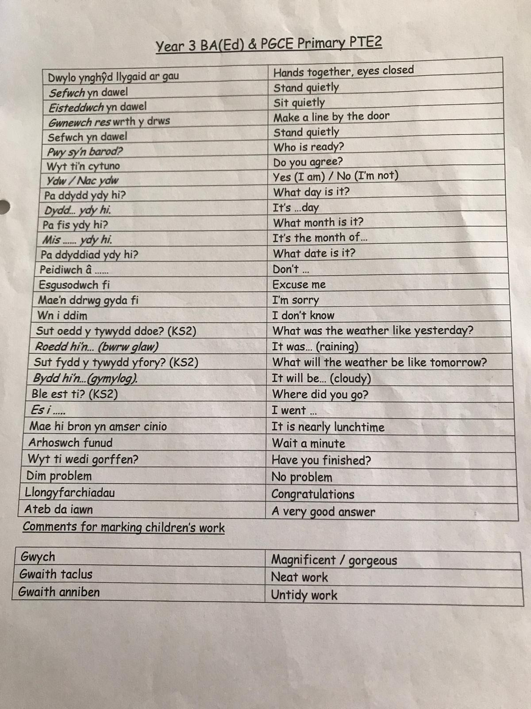

Lesson Plan 1
Student-teacher | Molly Green | Class: | Year 1
AoLE/Subject | Languages, Literacy and Communication and  Health and Well-being | Date: | 11.05.2020
Lesson Focus: | Developing new vocabularly in Welsh relating to this terms theme; Healthy eating, to discuss whether food is healthy or unhealthy.
Relevant/meaningful links to:  Curriculum  Cross-curricular responsibilities | Languages Literacy and Communication (Welsh)  Speaking:  - I can pronounce words and phrases clearly.  - I can contribute to a group discussion, taking turns appropriately.  Listening:  - I can listen to others and attempt to copy their vocabulary, syntax, grammar structures and pronunciation to improve my own communication.  Health and Well-being  - I understand that a balanced died contributes to physical well-being.
Personal Targets  (Linked to QTS and identfied in weekly review) | Pedagogy...Teaching and Learning is Paramount – Cross-curricular themes:  Use cross-curricular themes used to build links between areas of learning and the learning within each component can be articulated.

Learning Objectives (Focus on Learning) | W.A.L.T Pronounce new words and phrases related to healthy eating in Welsh.
Success Criteria  (process/product) | I can pronounce familiar words and phrases in Welsh clearly e.g. Iach ac afiach.  I understand which foods are considered healthy and unhealthy.  I can contribute to group discussion, taking turns appropriately.

Key Resources Health & Safety | Y Fasged Siopa - https://www.youtube.com/watch?v=5jSaVx70N2c  Bingo Bwyd Cards

Time | Content, Pedagogy & Assessment Opportunities (key teaching points and questions)
Links to Previous Learning | P4C session on the Eatwell Plate – The children considered which foods contribute to a healthy lifestyle.  Introduction to meanings of Iach and Afiach.
Opening Phase | (5 Minutes) Group Activity to Assess Prior Knowledge:  - Children will be shown flashcards of apples (afal), pinapples (pîn-afal) crisps (creision) etc to assess which words they are competent with.  - AFL: Thumbs up thumbs down  (10 Minutes) Sing Y Fasged Siopa song: https://www.youtube.com/watch?v=5jSaVx70N2c  Key Questions:  - Ydy afal yn iach neu afiach?  - Ydy pîn-afan yn iach neu afiach?  - Beth yw oren yn Saesneg?
Teaching & Core Learning | (40 Minutes) Children will be given pictures/words of foods to decide as a group if they are iach or afiach, then put them into two separate piles.  Key Phrases:  ‘Afal yn Iach’  ‘Creision yn afiach’  ‘Iach neu afiach?  “Oes, ond...”  “Pam?”  MAT Ability: 10 food terms (afal, creision, bara, pysgod a sglodion, caws, selsig, brechdan, pys, wy a pitsa) with the pictures separate.  - Children will have to pair the term with the picture for 10 pictures.  - Children will have to decide if each term is iach/afiach by discussing as a group.  - Children will be encouraged to use Welsh language patterns to carry out discussions as a group e.g. “ydy...yn iach neu afiach?’  - Children will also be encouraged to debate decisions. E.g. brechdan ham yn iach, ond brechdan selsig yn afiach.  OT Ability: 8 food terms (afal, creision, bara, caws, selsig, brechdan, pys, a pitsa) 2 with the terms attatched to the pictures and 6 without.  - Children will have to pair 6 pictures with the Welsh terms, they will be given 2 examples.  - Children will have to decide if the food is iach/afiach by discussing as a group.  - Children will be encouraged to use Welsh language patters to carry out discussions as a group e.g. “ydy...yn iach neu afiach?”  BS Ability: 8 pictures of food with the names attatched (afal, creision, bara, caws, selsig, brechdan, pys, a pitsa).  - Children will have to decide if the food is iach/afiach by discussing as a group.  - Children will be encouraged to use Welsh language patters to carry out discussions as a group e.g. “ydy...yn iach neu afiach?”  ALN Ability: 5 Pictures of food with the names attatched (afal, creision, bara, caws, selsig, brechdan, pys, a pitsa). * Support staff member will monitor this group discussion*  - Children will have to decide if the food is iach/afiach by discussing as a group.  - Children will be encouraged to use Welsh language patters to carry out discussions as a group e.g. “ydy...yn iach neu afiach?”  - TA will focus on quality of discussion by encouraging children to use the key phrases.
Plenary | (15 Minutes) Bingo Bwyd (AFL)  - Each ability group will have a food item bigno card.  - Each bigno card willl vary depending on the ability of the group. E.g. MAT and OT will not be given the names of the food on the card, BS and ALN will be given the names.  - The teacher will call the foods in Welsh and the children will be instructed to stamp the item if they have it on their card.  - AFL – Children who do not stamp items which have been called out signify that they have not met the success criteria of this lesson and more support is needed.

Lesson Plan 2

Student-teacher | Molly Green | Class: | Year 1
AoLE/Subject | Languages, Literacy and Communication | Date: | 14.05.2020
Lesson Focus: | Writing meal diaries in Welsh to develop words and phrases.
Relevant/meaningful links to:  Curriculum  Cross-curricular responsibilities | Languages Literacy and Communication (Welsh)  Writing:  - I can write independently in a familiar form using familiar words and phrases appropriately.  - I can write simple words and phrases by using knowledge of letters and the sounds they represent.  Reading:  - I can use translanguaging skills in Welsh and English.
Personal Targets  (Linked to QTS and identfied in weekly review) | Pedagogy...Teaching and Learning is Paramount – Cross-curricular themes:  Use cross-curricular themes used to build links between areas of learning and the learning within each component can be articulated.

Learning Objectives (Focus on Learning) | W.A.L.T Write simple terms and phrases in Welsh to keep a food diary.
Success Criteria  (process/product) | I can use the term “...ges i” to describe what I had at breakfast, lunch and dinner time.  I can use vocabulary I have read to improve my speaking and writing.  I can independently write familiar phrases in Welsh and use them appropriately.

Key Resources Health & Safety | Fflic a Fflac Siopa - https://www.dailymotion.com/video/x6hafse  Meal diaries (Resource 1)

Time | Content, Pedagogy & Assessment Opportunities (key teaching points and questions)
Links to Previous Learning | Previously, the children learnt new vocabularly relating to this term’s theme; healthy eating.This vocabularly will enable them to complete the food diary.
Opening Phase | (10 Minutes) Fflic a Fflac Siopa - https://www.dailymotion.com/video/x6hafse  - Recap food vocabularly from previous lesson.  - Pause video when food items are shown and ask children if they know the names before playing video in full.  - Use drilling technique to ensure pronounciation is correct before moving on to writing task.
Teaching & Core Learning | Key Phrases:  “...ges i”  “Cinio”  “Brecwast”  “Te”  “Swper”  “Ond”  “Achos”  “Di Iawn”  (40 Minutes) – Food diaries  All children will be introduced to the term ...ges i (...I had). This phrased will be used with meal times (Brecwast, Cinio, Te/Swper) for the children to write what they ate. Vocabularly learnt in the previous lesson will be paired with this phrase to complete the sentence.  MAT Ability: Complete 1 Food Diary in Welsh.  - Children will have to use vocabularly from the previous lesson e.g. pysgo a sglodion and pair them ‘...ges i’ phrase.  - Children will be encouraged to say the phrase to their partner before writing it down.  OT Ability: Complete 1 Food Diary in Welsh with pictures of food for support  - Children will use the pictures of foods as que cards and pair terms with ‘...ges i’ to explain what they had for each meal.  - Chidlren will be encouraged to say the phrase to their partner before writing it down.  BS Ability: Children will complete 1 Food Diary with sound cards to support pronounciation and pictures of foods.  - Welsh sound cards will help children link the sound to the writen word.  - Children will use the pictures of foods as que cards and pair terms with ‘...ges i’ to explain what they had for each meal.  - Children will be encouraged to say the phrase to their partner before writing it down.  ALN Ability: *Supporting Adult will be with this group* Children will complete 1 Food diary. Prompt cards with the Welsh vocabularly for the food will be provided fror this group.  - Prompt cards will allow children to focus on the key phrase.  - Chidlren will be encouraged to say the phrase to their partner before writing it down.  - Children will use the pictures of foods as que cards and pair terms with ‘...ges i’ to explain what they had for each meal.  Mini Plenary – Random selection App  - Choose a child as ask them what they had for brecwast/cinio/te on selected day.  - This will determine if children have achieved the success criteria.
Plenary | (15 Minutes) – Kahoot Quiz with mini whiteboards  - In groups children will take part in a Kahoot quiz to test their knowledge on the vocabularly learnt in the past two lessons.  - The quiz will ask test children’s ability to write down the anwers in Welsh opposed to saying them.

Resource 1

 | Dydd Llyn | Dydd Mawr | Dydd Mercher | Dydd Iau | Dydd Gwener | Dydd Sadwrn | Dydd Sul
Brecwast
Cinio
Te/Swper

