

Shammah Begum
2323587
Portfolio

Task 1 – Personal Brand
My personal brand is based on who I am, what I value, and what I want to achieve in the future. As a mother of three, my priority is always my children and family, and this has taught me patience, organization, and responsibility. My religion, Islam, also guides me to be caring, honest, and respectful to others. These qualities are very important to me and will also help me in my future career.
I am working towards completing my Level 6 qualification in Health and Social Care because I want to work with children in the future. To develop my personal brand, I need to show my strengths and values clearly to employers. This includes being professional in the way I present myself, for example through my CV, interviews, and online platforms like LinkedIn. Peters (1997) explains that personal branding is about managing how people see you, so I must be consistent in showing that I am motivated, caring, and reliable.
I will also continue to develop my skills and knowledge through study and experience. Arruda (2009) says that personal branding works best when it is authentic, so by staying true to my values, I can build a strong brand that supports my goal of working with children.

Task 2 - Network Map and Rationale

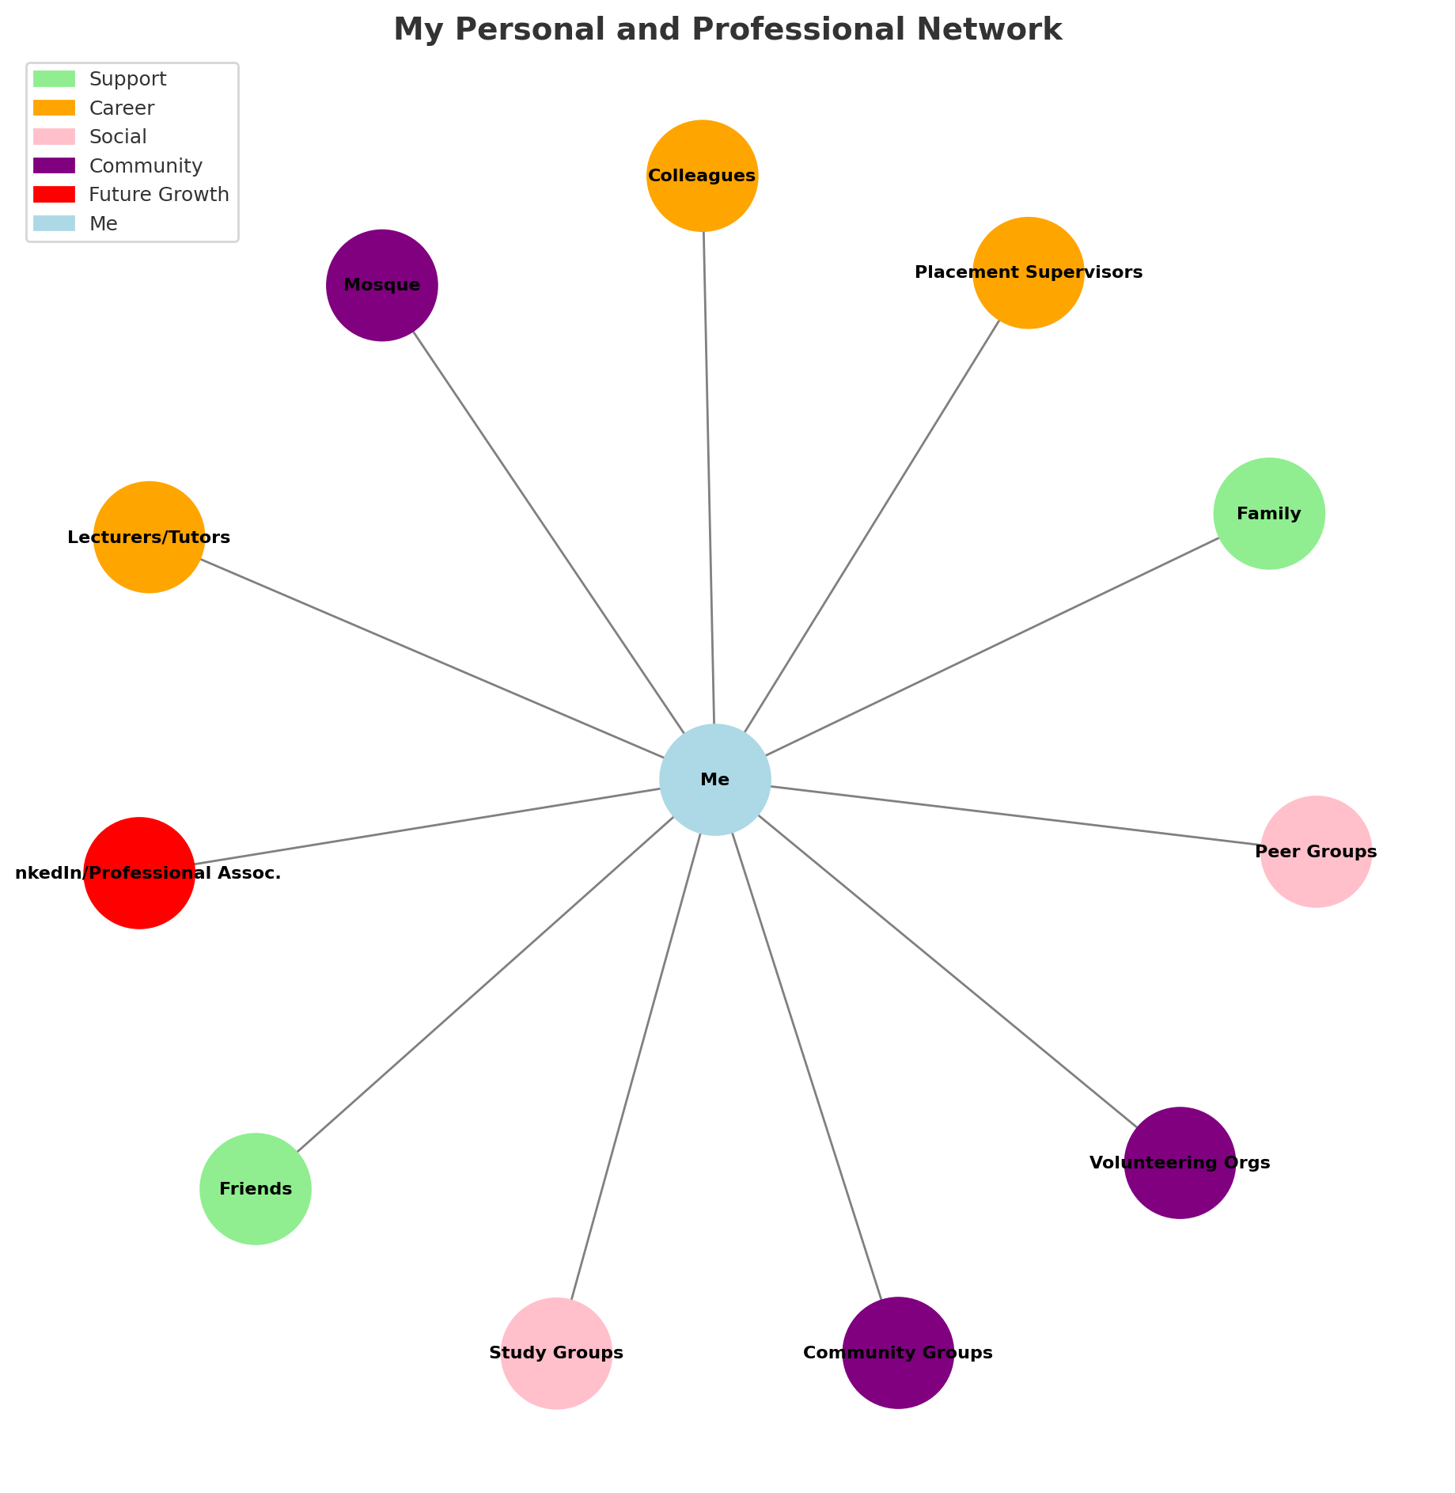

Network Map
Career: Tutors, lecturers, placement supervisors, professional colleagues in health and social care.
Support: Family (husband, children, extended family), close friends.
Social: Peer groups from university, friends from my community, online study groups.
Community: Local mosque, faith-based groups, volunteering networks, community health and childcare organisations.

Rationale and Critical Assessment
My personal and professional network is made up of different groups that provide support in career, personal, and community aspects of my life. Family is at the centre of my support system, offering emotional encouragement and motivation to achieve my career goals. My lecturers and classmates are important for my career development because they provide guidance, feedback, and opportunities to build skills and experience in health and social care.
Social connections, such as peers from my course and study groups, help me share knowledge and stay motivated. According to Granovetter (1973), weak ties, such as acquaintances or wider community contacts, can be just as valuable as close relationships because they often provide access to new opportunities. Community networks, including my mosque and volunteering organizations, not only support my values and faith but also allow me to connect with others who share similar goals in supporting children and families.
Critically, while my network is strong in personal and community support, I recognize I must expand my professional connections further. Developing links through LinkedIn and professional associations will strengthen my career opportunities. Networking, as Forret and Dougherty (2001) suggest, is a vital tool for employability and career progression.
Task 3- Blog

The Workforce Crisis in UK Health and Social Care: Why It Matters to All of Us
If you work in health or social care, you've definitely felt the strain of longer shifts, fewer colleagues, and customers waiting longer for assistance. Unfortunately, this is not just your workplace; it is a national crisis. The UK's health and social care industry is experiencing a severe personnel crisis, and the consequences are far-reaching.
Across England, around 8.3% of adult social care roles are vacant, accounting for over 131,000 unfilled positions (House of Commons Library, 2024). The NHS is in a similar situation, with thousands of nurse, doctor, and therapist positions still open (The King's Fund, 2024). It's no surprise that staff turnover in social care is so high—one out of every three workers leaves each year, frequently due to low pay, stress, or insecure hours (Health Foundation, 2024).
But this isn’t just about numbers; it’s about people who both care and those who rely on them. The staff report that they feel burnt out and undervalued, while service users face delays, shorter visits, and unmet care needs (Nuffield Trust, 2024). And depending on where you live, getting the right support can be a real postcode lottery. So, what can be done? Experts suggest that improving pay, training, and job security could make a real difference (The King’s Fund, 2024). Long-term, the UK also needs to invest in domestic training and retention, rather than relying so heavily on overseas recruitment (Health and Social Care Policy Network, 2025).
Ultimately, fixing the workforce crisis isn’t just about filling vacancies it’s about valuing care itself. Because when we invest in carers, we invest in the wellbeing of everyone.

Task 4- NHS Equality, Diversity and Inclusion Quiz
- What is the primary goal of the NHS Equality, Diversity, and Inclusion Improvement Plan?
The NHS EDI Improvement Plan aspires to create a more equitable and inclusive NHS in which all employees are valued and supported. It aims to reduce discrimination, improve representation, and integrate equality into care and culture (NHS England, 2023).

- How does the NHS EDI Improvement Plan propose to tackle the gender pay gap?
The NHS EDI Improvement Plan seeks to close the gender pay gap by increasing pay transparency, encouraging equal career advancement opportunities, and guaranteeing fair recruitment and promotion processes (NHS England, 2023).

- What is meant by the term ‘intersectionality’ as used in the NHS EDI Improvement Plan?
Intersectionality means recognizing overlapping identities—like race, gender, and disability—combine to shape people’s experiences of inequality and discrimination (NHS England, 2023).

- Why is it important for the NHS to create a psychologically safe work environment?
It is important for the NHS to create a psychologically safe work environment, so staff feel confident to speak up about concerns, share ideas, and learn from mistakes without fear, leading to better teamwork, wellbeing, and patient care. (NHS England, 2023).

- How does the NHS EDI Improvement Plan suggest improving the experience of internationally recruited staff?
The NHS EDI Improvement Plan intends to help internationally recruited employees by guaranteeing equitable treatment, career development, and greater workplace integration (NHS England, 2023).

- What role does leadership play in advancing EDI objectives according to the NHS Improvement Plan?
Leadership is crucial for advancing EDI by setting the tone, holding teams accountable, and embedding inclusive practices across the organisation (NHS England, 2023).

- Identify one way the NHS EDI Improvement Plan aims to reduce health inequalities within the workforce.
The NHS EDI Improvement Plan aims to reduce health inequalities within the workforce by promoting equitable access to career development and progression opportunities for all staff (NHS England, 2023).

- Why does the NHS EDI Improvement Plan emphasise the importance of collecting and analysing data on protected characteristics?
The NHS EDI Improvement Plan emphasises collecting and analysing data on protected characteristics to identify inequalities, monitor progress, and inform targeted actions that promote fair treatment and inclusion for all staff (NHS England, 2023).

- Explain how flexible working policies can contribute to equality and inclusion in the NHS workforce.
Flexible working policies support equality and inclusion by allowing staff with different needs to balance work and personal life while accessing career opportunities (NHS England, 2023).

- What is one strategy mentioned in the NHS EDI Improvement Plan to combat bullying and harassment in the workplace?
Implementing clear reporting procedures and holding leaders accountable for responding to occurrences quickly and fairly is one strategy in the NHS EDI Improvement Plan to prevent bullying and harassment (NHS England, 2023).

Task 5- A Letter to Yourself
Dear Me,
I remember how frightening it was after giving birth, when what should have been a joyful time became a medical emergency. You were told you had blood clots and needed a blood transfusion, yet no one really explained what was happening or why. You felt confused, scared, and powerless—just trying to hold yourself together for your baby. Looking back, I wish you had the tools of emotional intelligence and resilience to help you through that moment.
Emotional intelligence would have helped you recognize and process your fear instead of pushing it down. It might have given you the confidence to ask questions and express that you didn’t understand what was happening. You would have realized that your feelings were valid, and that seeking clarity and emotional support was your right, not a weakness.
Resilience would have reminded you that healing both physically and emotionally takes time, and that strength doesn’t mean staying silent. Each day you got through showed courage, even when you felt broken. Resilience could have helped you focus on recovery and the hope that things will get better.
Although you didn’t know it then, that experience taught you empathy, patience, and the importance of communication in healthcare. You now understand how emotional awareness and resilience can empower you and others to face even the most uncertain moments with strength and self-compassion.
Task 6- GANTT
Gantt Chart Description – Future Employment Goals
The Gantt chart outlines a three-year plan to achieve my future career goals in health and social care. From Year 1 to Year 2, my main focus will be completing Level 5 studies in Health and Social Care. This includes attending classes and completing assignments. In Year 2 to Year 3, I will progress to Level 6, focusing on advanced modules, a dissertation, and developing professional skills to be awarded a full degree.
Alongside my studies, I will begin working part-time in my family restaurant starting immediately. This will help me develop interpersonal, teamwork, and leadership skills, as well as gain experience in managing responsibilities.
To prepare for future employment, I will also work on building self-confidence throughout the timeline. This will involve attending workshops, practicing interviews, engaging in public speaking opportunities, and seeking feedback from mentors.
By the end of Year 3, I aim to have completed my degree, gained valuable work experience, and improved my confidence—placing me in a strong position to pursue a professional role in the health and social care sector.
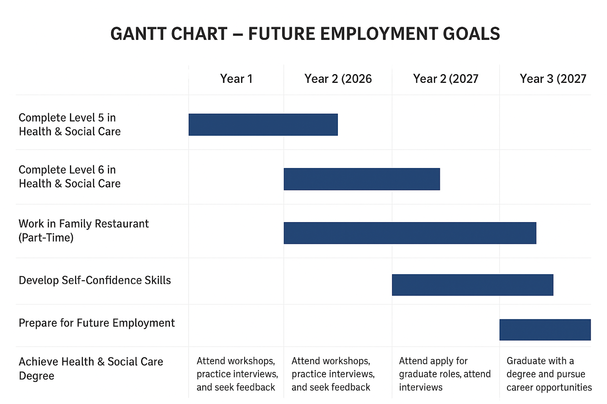

Task 7- Making Changes- Report

Report on Implementing Change in the Workplace
Title: Improving Infection Control Practices in the Care Home
As the manager of a care home, I plan to improve infection control methods to protect the safety and well-being of residents and staff. The COVID-19 pandemic underlined the significance of strict cleanliness, wearing personal protection equipment (PPE), and following proper handwashing procedures. To successfully implement this change, I will follow Kurt Lewin's (1951) Three-Step Change Model, which includes Unfreeze, Change, and Refreeze.
I will use data of infection risks and existing practice gaps to convey the need for improvement throughout the Unfreeze step. Increased awareness and motivation for change will be facilitated via staff meetings and visual reminders. I will plan training sessions on trash disposal, PPE use, and good hand hygiene during the Change period, with ongoing supervision and feedback. Employees will be encouraged to confidently adopt the new practices through role modelling and practical demonstrations.
Lastly, infection control policies will be revised to match the new requirements during the Refreeze stage, and audits and refresher training will be used to create continuous monitoring. To sustain long-term improvement and enforce compliance, staff accomplishments will be acknowledged.
Teamwork, leadership, communication, and training are critical abilities for this procedure. Potential obstacles—like employee opposition, scheduling restraints, or a lack of
Resources can be addressed through clear guidance, accessible materials, and management support.

Task 8- Self-Reflection

Task 8 – Self-Reflection (Using Gibbs’ Reflective Cycle, 1988)
During this module, I have learned a great deal about self-branding and how it influences professional identity and employability. According to Gibbs’ (1988) Reflective Cycle, reflection involves six stages: description, feelings, evaluation, analysis, conclusion, and action plan.
Description: The module encouraged me to explore how individuals can present themselves effectively to employers through personal branding, including professional communication, CV writing, and confidence building.
Feelings: Initially, I felt uncertain about how to define my strengths and promote myself confidently. I was nervous about self-presentation and worried about how others might perceive me.
Evaluation: As the lessons went on, I realised that self-branding is about genuinely showcasing my values, abilities, and accomplishments rather than embellishing them. I felt more confident after receiving feedback from tutors and peers.
Analysis: I came to the conclusion that professionalism, communication abilities, and self-awareness are necessary for creating a powerful personal brand. These are critical for professional success in the health and social care sectors, where establishing credibility and trust is crucial.
In conclusion, this educational experience increased my confidence and inspired me to consistently enhance my online and offline self-representation.
Action Plan: To build my personal brand, I'll update my professional portfolio, improve my LinkedIn page, and look for leadership and public speaking opportunities.

Reference List
Peters, T. (1997). The brand called you. Fast Company.
Arruda, W. (2009). Career distinction: Stand out by building your brand. Wiley.
Granovetter, M. (1973). The strength of weak ties. American Journal of Sociology, 78(6), 1360–1380.
Forret, M., & Dougherty, T. (2001). Correlates of networking behavior for managerial and professional employees. Group & Organization Management, 26(3), 283–311.
Health and Social Care Policy Network (2025) Workforce Challenges and Solutions in UK Health and Social Care 2025. Available at: https://hscpn.org
Health Foundation (2024) Health and Social Care Workforce. Available at: https://www.health.org.uk
House of Commons Library (2024) Health and Social Care Workforce. Available at: https://commonslibrary.parliament.uk
Nuffield Trust (2024) Older People are Paying the Price for Cuts to Social Care. Available at: https://www.nuffieldtrust.org.uk
The King’s Fund (2024) Making Careers in Health and Social Care More Attractive. Available at: https://www.kingsfund.org.uk
Lewin, K. (1951). Field Theory in Social Science. Harper & Row.

Mitchell, G. (2013). Selecting the Best Theory to Implement Planned Change. Nursing Management, 20(1), 32–37.
Gibbs, G. (1988). Learning by Doing: A Guide to Teaching and Learning Methods. Oxford Polytechnic.

