ACKNOWLEDGEMENTS
Firstly, I would like to thank all the participants, without whom there would be no study. The RSPB staff who took interest in this work and gave up their time to enable this to happen. The parent and daughter who enabled the completion of phase 2. The teachers and children who completed the phase 3 data collection. Thank you for giving your time, thoughts and answers to this research.
Next, I would like to thank my supervisor, Dr. Andy Williams, and the other tutors who have taught me across the master’s programme. Including Dr. Amanda John, who supported my understanding of SPSS and its’ tools. Thank you for guiding me through a journey from enjoying outdoor education, to understanding the complexities and theories behind it and what it can achieve.
Thank you to Victoria Carr and Joelene Hughes, who supported my earlier thinking process. Sharing learnings from their work with connection to nature and adults, enabling me to think of the processes needed for this study to be successful with children and the quantitative process to follow.
Thank you to my friend, Charlotte, we started our master’s journey together. The moral support and challenge you provide kept me on track.
Finally, thank you to my family, without whom my love of the natural world would not exist. My grandparents, John and Ruth and my mum, Jill, my love of nature comes from you all. Without my childhood exploring the countryside and garden, loving animals and holiday walks to see the birds, I would not be who I am today.
Thank you all.

Contents
Glossary of terms | 7
Abstract | 8
List of figures and tables | 9
Chapter 1: Introduction | 11
1.1: Background | 11
1.2: Research Focus | 12
1.3: Overall research aims and individual research objectives | 13
1.4: Methods and timescales of research | 14
1.5: Chapter Summary | 15
Chapter 2: Literature Review | 16
2.1: What is a connection to nature? | 16
2.2: Importance of connection to nature | 21
2.2.1: The importance of climate change | 21
2.2.2: How are connection to nature and climate change connected? | 23
2.2.3: How do conservation organisations use connection to nature? | 26
2.2.3.1: The RSPB as an example of a conservation organisation using connection to nature interventions | 27
2.3: Theoretical Frameworks: Changing people’s behaviours | 28
2.3.1: Theory of change | 29
2.3.2: Behaviour Change Theory | 32
2.4: Experiential learning theory | 38
2.5: The relationship between experiential learning theory and connection to nature | 42
2.6: How can we measure a connection to nature in children? | 48
2.7: Summary and emerging issues | 49
Chapter 3: Research Methods | 51
3.1: Research aims and objectives | 51
3.2: Research paradigm | 51
3.3: Research strategy | 53
3.4: Data collection | 54
3.4.1: Timelines, phases and impact of covid-19 | 54
3.4.2: Methods of sampling | 57
3.5: Research Methods | 59
3.6: Framework for data analysis | 60
3.7: Limitations and potential hurdles | 61
3.8: Ethical concerns | 64
3.9: Chapter summary | 65
Chapter 4: Findings, analysis and discussion | 66
4.1: Pre-phase 1: The findings of the literature review of current measurement tools | 66
4.2: Phase 1: Does the participant's understanding match the literature? | 68
4.3: Phase 1: Which statement should be used in the new measurement tool? | 70
4.4: Phase 2: How suitable is the new measurement tool for a child? | 73
4.5: Phase 3: How does experiential learning impact a child's the connection to nature? | 81
4.6: Phase 3: What extraneous variables may have impacted the results? | 83
4.7: Phase 3: How does experiential learning impact the different sub-sections? | 87
Chapter 5: Conclusion | 94
5.1: Introduction | 94
5.2: Research objectives: Summary of findings and conclusions | 94
5.3: Strengths and limitations | 96
5.4: Recommendations | 96
5.5: Self reflection | 97
Reference List | 98
Appendices | 120
Appendix A: New measurement tool used in phase 3 | 120
Appendix B: Ethical approval form | 124
Appendix C: ‘Google JamBoard’ online survey for phase 1 | 138
Appendix D: Session leader questionnaire for phase 3 | 144
Appendix E: Parent-led interview prompts for phase 2 | 146
Appendix F: Hand-analysis of statements from connection to nature measurement tools | 151
Appendix G: Thematic analysis of phase 1 data | 156
Appendix H: Adaptations to statements used in new tool (phase 3) | 165

Glossary of terms:

AC: Abstract Conceptualisation
AE: Active Experimentation
AfN: Action for Nature
ANOVA: Analysis of Variance
CE: Concrete Experience
CNI: Connection to Nature Index
CNS: Connection to Nature Scale
CommGAP: Communication for Governance and Accountability Program
CtN: Connection to nature
CWN: Connection with Nature
EAN: Emotional Affinity to Nature
EBS: Environmental Behaviour Scale
EID: Environmental Identity
EINS: Extended Inclusion of Nature in Self-scale
EIS: Environmental Identity Scale
ELT: Experiential Learning Theory
ENACT: Evaluating Nature Activities for Connection Tool
EPS: Ecological Paradigm Scale
EWAC: Ecological Worldview and Awareness of Consequences
FITB: Fill in The Blank
GDPR: General data protection regulation
IAT: Implicit Association Test (Self-Nature)
INS: Inclusion of Nature with Self
IPCC: Inter-governmental Panel on Climate Change
Lancswt: Lancashire Wildlife Trust
LCN: Love and Care for Nature
N.D.: No date
NCI: Nature Connectedness Inventory
NEP: New Ecological Paradigm Scale
NR: Nature Relatedness
NR6: Nature Relatedness Scale, short version
PEB: Pro-environmental behaviours
RO: Reflective Observation
RSPB: Royal Society for the Protection of Birds
SCT: Social Cognitive Theory
SoR: Schools on Reserves
TPB: Theory of Planned Behaviour
TTM: Transtheoretical Model
UN: United Nations
WWF: Worldwide Fund for nature

Abstract

Connection to nature (CtN) defines the relationship people have with nature. To save the planet from its current climate crisis, conservation organisations use activities and experiential learning to impact a person’s CtN and their pro environmental behaviours (PEB), lots being aimed at children. As there are currently limited evaluation/measurement tools available to measure a child’s CtN state, most activities are not evaluated through quantitative data. This study arises out of this need for quantitative evaluation data, acknowledging the impact of behaviour change theory, theory of change and other extraneous variables. This research moved through three phases of data collection. First quantitative and qualitative data were collected through an online survey of RSPB staff to collate the new measurement tool’s statements from those available in the literature, using thematic analysis and descriptive statistics (mean, mode, median, range). In phase two, an 8-year-old girl completed a parent led interview, with analysis showing the tool’s understandability and suitability. Finally, phase three collected data from 120 school children attending School’s on reserve (SoR) sessions through pre- and post- questionnaires. Parametric and non-parametric testing was used on the quantitative data. The findings showed a significant difference between pre/post scores for the whole sample. No significant differences were found between reserve groups or year groups. The main conclusion drawn was ‘participating in a nature focused, experiential learning opportunity, led to a significant increase in CtN’, with a secondary conclusion of ‘no significant difference being found between extraneous variables caused by year group or group location’. Stemming from these conclusions, future studies should be completed to further prove the reliability and validity of the new measurement tool, an increased sample size from different locations and countries and experiencing different experiential learning opportunities would build a wider understanding of the impact of experiential learning on a child’s CtN.

Key Words: Connection to nature, action for nature, experiential learning, extraneous variables, behaviour change theory, theory of change

List of figures and tables
Figure Title | Page number | Table Title | Page number
Figure 1: A model representing connection to nature and the pathways used to enhance it (Richardson, Lumber and Sheffield, 2017). | 17 | Table 1: The seven pathways to nature connection (Lumber, Richardson and Sheffield, 2018) | 19
Figure 2: A link between connection and action (Richardson and Chapple, 2021). | 24 | Table 2: Theory of change for SoR and experiential learning. | 31
Figure 3: The spiral of connection and action | 25 | Table 3: Different elements part of behaviour change theory (CommGAP, N.D.) | 33
Figure 4: RSPB reserves which offer school trips | 28 | Table 4: Potential extraneous variables, their input and how they are considered in this study | 44
Figure 5: The Theory of Change Model | 30 | Table 5: The different Connection to Nature Measurement Tools available and their main use | 48
Figure 6: Social cognitive theory model (CommGAP, N.d.) | 35 | Table 6: A description of the phases and timelines used | 55
Figure 7: Model of TPB (CommGAP, N.D.) | 35 | Table 7: Participants involved in phase 3 of the study | 58
Figure 8: Stages of change | 36 | Table 8: The current CtN measurement tools | 66
Figure 9: Combining several behaviour change models with theory of change model | 37 | Table 9 – The sorted statements from different CtN measurement tools | 68
Figure 10: Behaviour change and theory of change model of how experiential learning may impact a child’s CtN and their PEB | 38 | Table 10: Thematic analysis of RSPB staff thoughts | 69
Figure 11: The experiential learning cycle (Kolb and Kolb, 2017) | 40 | Table 11: The number of statements used in the new measurement tool and how they were chosen | 71
Figure 12: Jarvis’ model of experiential learning theory (Kuk and Holst, 2018) | 41 | Table 12: Thematic analysis of participant views on the sub-section’s questions. | 72
Figure 13: The cycle of Experiential Learning and how RSPB activities implement it (Chomolova, 2015). | 43 | Table 13: The analysis of suitability of the new measurement tool | 73
Figure 14: Histogram of postscore minus prescore data | 81 | Table 14: Means and standard deviation of the prescore and postscore data | 83
Figure 15: Boxplot of postscore minus prescore data | 81 | Table 15: The session leaders’ responses | 83
Figure 16: Histogram of postscore minus prescore data | 82 | Table 16: Descriptive statistics for the prescore and postscore data across the different sites | 86
Figure 17: Boxplot of postscore minus prescore data | 82 | Table 17: Descriptive statistics for the prescore and postscore data across the different years | 86
Figure 18: Comparing the pre and post histograms for each sub-section | 87 | Table 18: Wilcoxon signed rank test for each sub-sections prescore and postscore. | 88
Figure 19: Related-samples Friedman’s two-way analysis of variance by ranks | 93 | Table 19: Mann Whitney test on the distribution of post minus pre scores for each sub-section for the different year groups | 89
 | 93 | Table 20: Mann Whitney test on the distribution of post minus pre scores for each sub-sections for the different groups | 91

Chapter 1
Introduction
This chapter will provide background information, identify key issues and themes, and briefly explain theoretical frameworks. These will clarify the focus of the study and locate the study in current literature, whilst explaining the overall rationale and motivations. It will outline the research aims and independent objectives, and briefly introduce the method, participants and location.
  - Background
Currently we find ourselves in a world facing the existential threat of climate change or a climate crisis (Houghton, Callander and Varney, 1992; Repetto 2008; ITV News, 2022). Many conservation organisations believe the way to protect the planet from the changing climate is through people (WWF, N.Da.; NOAA, 2021; Carbon Disclosure Project, 2023). Research shows that connecting people to nature leads to an increase in pro-environmental behaviours (PEB) (Mayer and Frantz, 2004; Restell and Conrad, 2015; Carr and Hughes, 2020; Liu et al, 2022; Frantz and Mayer, 2014), and that connecting children under 11 years old can have a returned impact when they are older, even if there is a dip in the teenage years (Otto and Pensini, 2017; Mackay and Schmidt, 2019; Piccininni et al, 2018).
As connecting children to nature is important to solving the climate crisis (Richardson et al, 2015; Mayer and Frantz, 2004; Howell et al, 2011; Nisbet and Zelenski, 2013; Capaldi, Dopko and Zelenski, 2014; Zelenski and Nisbet, 2014; RSPB, 2015), many conservation organisations, such as the Royal Society for the Protection of Birds (RSPB), hold connection to nature (CtN) events for children and families (RSPB, 2023a). Experiential learning is often used in these events, utilising hands on, living experiences based on children’s interests, encouraging reflections on what they have learnt and felt, encouraging them to think wider and where possible experiment with their thoughts, to connect children to nature (Kolb and Kolb, 2017; Beard and Wilson, 2002). To ensure these events have the best impact they can, they need to be evaluated, which leads us to the issue this study hopes to solve.
Many tools have been created to measure a person’s CtN, but not many are shown as suitable for measuring a child’s CtN, and those that do measure a CtN trait rather than state (Bragg et al, 2013). To answer the research question ‘how does experiential learning impact a child’s connection to nature?’, this study will move through several phases, with the first three focussing on the creation of a tool to measure a child’s CtN state and the fourth phase using this tool to answer the question. There will be two aims and four objectives used to complete this study, these will be shared in chapter 1.3. These areas will be considered in greater detail in chapter 2.
  - Research Focus
Due to current CtN measurement tools not being suitable for measuring a child’s CtN state (Bragg et al, 2013), this study aims to fill that gap with its secondary focus of creating a suitable measurement tool.
The primary focus of this study is to explore the impact of experiential learning on children’s CtN. This is important because CtN has a positive impact on PEB (Richardson et al, 2015; Mayer and Frantz, 2004; Howell et al, 2011; Nisbet and Zelenski, 2013; Capaldi, Dopko and Zelenski, 2014; Zelenski and Nisbet, 2014; RSPB, 2015) and the respect people show to our environment (Earthwatch, 2022). This is more relevant than ever given the current climate, with pressure to keep the average temperature to well below 2°C above pre-industrial levels with a 43% decline in greenhouse gas emissions by 2030 (United Nations, 2015).
If the tool created and piloted in this study proves effective, it will enable organisations to gather quantitative data to evaluate and compare the impact their experiential learning sessions have on a child’s CtN. This would enable them to compare cost and impact, enabling them to decide which are the correct ‘interventions’ to use for the largest impact or the most cost-effective impact (Carr and Hughes, 2020).
With limited research attention into the problem of childhood disconnection to nature (Richardson et al, 2015), few robust scientific attempts to measure and track CtN change in children (Bragg et al, 2013) and the need for more quantitative data in this area, this study fits a gap in the currently available work.

  - Overall research aims and individual research objectives
This study has two overall research aims:
- Creation of a measurement tool which can measure the state of a child’s CtN, i.e., the change in a child’s CtN over time.
- Investigation of how experiential learning impacts a child’s CtN
These aims will enable the research question ‘how does experiential learning impact a child’s CtN?’ to be answered. Two main research vehicles will be utilised to achieve the aims, which are: a review of current thinking and tools through literature analysis and data collection and analysis via a CtN measurement tool. It is important to remember the current gap in tools available to quantitatively measure the child’s CtN state and therefore to acknowledge the need of tool creation to answer this research question fully. Therefore, the first part of this study focusses on the creation of this needed measurement tool.
The following objectives outline the process used to achieve the aims and answer the research question:
- Creation of a measurement tool through analysis of current tools available during a literature review in combination with an online survey with staff members involved in experiential learning.
- Evaluation and improvement of tool through parent-led interviews with children.
- Comparison of child’s CtN scores pre- and post- experiential learning experience to explore the impact.
- Consideration of extraneous variables and their impact on CtN scores.
Objective 1 enables the research to measure a child’s CtN state, while objective 2 checks the tools suitability for use with children. Objective 3 will allow the researcher to answer the research question (shared above), whilst objective 4 considers the variables that may have impacted any change in CtN score.
This study is timely and relevant due to the current energy being around climate change (United Nations, 2015; ITV News, 2022). It is valuable due to the creation and trialling of a new measurement tool (appendix A). If the tool is found to be effective at measuring a child’s CtN state, then many organisations/people can use it to measure the effectiveness of their interventions or evaluate their projects. This is the long-term value, in the short term it will also give an insight into whether a child’s CtN is impacted by the experiential learning experiences offered through the RSPB’s Schools on reserves (SoR) programme and whether there are any significant differences between year group (year 4 vs 6), site location (3 reserves, 2 countries) or sessions delivered (pond dipping or pond habitat study, investigating rivers, discovering birds, living things and their habitats). All giving the RSPB information on the impact and effectiveness of the sessions delivered.
  - Methods and timescale of research
In chapter 3, methodology and research design are considered. The methodology used in this study comes from a multi-paradigm world view, as the researcher agrees with Blaikie and Priest (2017), that combining paradigms, even when imbalanced, helps to reduce or combat each other’s limitations. Specifically, a neo-positivism paradigm was chosen as the dominant paradigm, leading to mixed method surveys being used to collect data. The primary data type was quantitative with qualitative used to provide a deeper/wider understanding of the extraneous variables impacting any changes seen. The secondary, less dominant, paradigm was critical realism (Blaikie and Priest, 2017). This was utilised mainly in the creation of the tool due to the unknown direction it was going to take, therefore relying on a retroductive logic (Blaikie and Priest, 2017), this was the same for the extraneous variables which were unknown (or simply assumptions) before being collected through open-ended questioning.
Throughout the different phases of data collection, both convenience and purposive sampling techniques were utilised. The main data (phase 3) was collected using pre- and post- survey scores from 120 children recruited through purposive and convenience sampling; they were already attending the experiential learning session. These were attending 4 sites across England and Wales, figure 4 in chapter 2.2.3.1 shows the locations. Prior to this, a purposive sample of 5 RSPB staff/volunteers were recruited for phase 1, they completed an online JamBoard survey to aid the creation of the tool. Then a convenience sample of 1 child/parent were recruited through social media for phase 2, enabling the tool to be checked for a child’s understanding via a parent-led interview.
This study passed its project proposal in January 2021, which included ethical approval (appendix B), leading to a literature review occurring from then onwards throughout the whole study. There was a delay to data collection due to Covid-19 pausing SoR delivery between March 2020 and September 2021, when we originally hoped to reopen in Summer 2021. Phase 1 was completed in Spring 2022, phase 3 between Summer and Autumn 2022 and due to recruitment complications data for phase 2 was completed in December 2022. The study was finalised in September 2023. Chapter 4 will present the findings, analysis and discussion, with chapter 5 sharing the conclusions from the study, including limitations and recommendations.
  - Chapter Summary
The introduction chapter has introduced you to several stages of the study: the background, research focus, overall research aims and individual research objectives, methods and timeline. The next chapter, literature review, will delve more into the background and reasons for this study, focusing on connection to nature, climate change, theory of change, behaviour change theory, experiential learning and measurement tools for CtN.

Chapter 2
Literature Review
Throughout this paper, we seek to address the research question “how does experiential learning impact a child’s CtN?”. This chapter explores and critically evaluates the available literature detailing three main focusses: CtN, changing people’s behaviours and experiential learning theory (ELT). It will begin by defining a CtN, the link between CtN and climate change, and its importance in our current world. Next it will explore theoretical frameworks explaining behaviour change to critically evaluate the link between CtN and protecting the environment as well as CtN and ELT. The chapter will end by considering a range of variables which impact a person’s CtN, with a more detailed focus on experiential learning.
The review of literature, outlined above, will present the work of others linked with the study’s aims and objectives, consider pertinent and emergent issues linked with the research area, critically evaluate the need for this study and locate it in the current literature. By doing this it provides a theoretical background which supports understanding of key knowledge areas, as well as providing stronger ability to analyse data collected, thus addressing part of objective 1 and underpinning the remaining objectives. All the objectives form part of the data collection stages of this study so will be outlined in more detail throughout chapter 3: and presented more fully in chapter 4.
2.1 What is a connection to nature?
Wilson’s biophilia hypothesis (1984) argues that humans have an innate tendency for an affiliation for natural life or life-like processes linking back to the origin of the human species on the Savannahs of Africa hundreds of thousands of years ago (Gullone, 2000; Kahn Jr., 2011; Lumber, Richardson and Sheffield, 2018). Another concept is ‘Friluftsliv’, which has existed since the medieval times and is still prominent in Scandinavia. It refers to spiritual connectedness with nature through a lifestyle of joy, freedom and experience (Beery, 2013; Lumber, Richardson and Sheffield, 2018). As we move further from our previous nature-filled lifestyles to an urban setting, humanity often perceives itself as separate from nature (Vining, Merrick and Price, 2008; Lumber, Richardson and Sheffield, 2018). This leads to the need for a human-nature relationship to be developed through the sensation of being connected with nature (Mayer and Frantz, 2004; Lumber, Richardson and Sheffield, 2018). From biophilia hypothesis, to ‘Friluftsliv’, to CtN, there have been a wide variety of terms and definitions used, some are shown in figure 1.
Figure 1: A model representing connection to nature and the pathways used to enhance it (Richardson, Lumber and Sheffield, 2017).
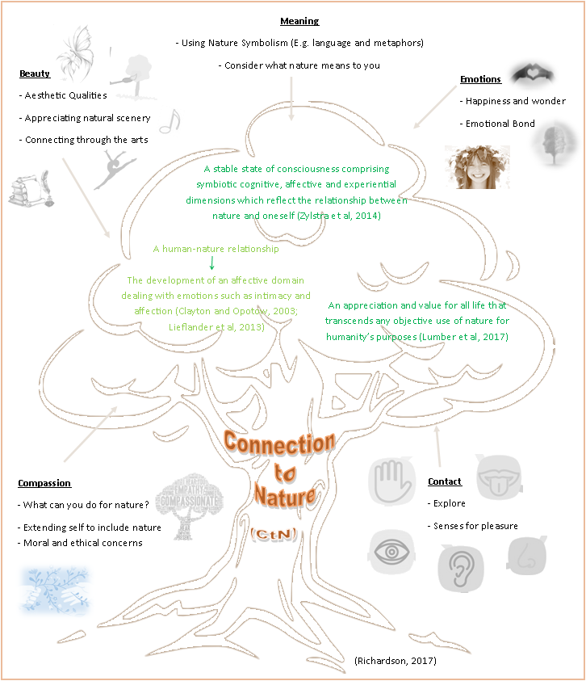
As the figure shows, CtN can be described as a human-nature relationship linked to the development of an affective domain linked to emotions such as intimacy and affection (Clayton and Opotow, 2003; Lieflander et al, 2013), or an appreciation and value for all nature (Lumber et al 2017), or a relationship between nature and oneself through cognitive, effective and experiential dimensions (Zylstra et al, 2014). These definitions are similar in their link between humans and nature through cognitive and emotional connections. They are different because they are described as a domain development or state of consciousness or appreciation and value. The first suggests the creation of something physical, whereas the last two suggest an emotional or cognitive link instead.
Two further ways to describe a CtN are:
- A physical interaction with the natural environment. An active first-hand experience which lasts for at least 30 minutes, enabling the child to learn and have fun (RSPB, 2023b).
- A person’s sense of their relationship with nature, a mix of positive feelings and attitudes. It is cognitive and emotional influenced by emotions, behaviour and knowledge. It unites nature and human’s well-being, is malleable and can be measures (Richardson, 2023).
These two contrast each other with the second aligning with those shared in figure 1, with CtN being a psychological construct. The first differs as it refers to a CtN experience, designed specifically for the organisation to measure the impact of their activities rather than focused on the individuals.
As there are differences between these definitions, it is important for this study to be clear on the definition understood and used by the researcher. For this study, a CtN is the cognitive relationship with nature developed through emotionally connecting with nature, physically and cognitively exploring nature, and the empathy and compassion created for nature. It is measurable and malleable: changes over time (Richardson, 2023). This definition is the most appropriate for this study, as it aligns with what the RSPB use, along with it being measurable and malleable, which is an important assumption for this study to be able to measure the change in it.
Richardson, Lumber and Sheffield (2017) shows that a CtN can be developed and enhanced through five pathways shown on figure 1. Research shows that experiencing nature through one of more of these pathways increase the CtN over time (Richardson, Lumber and Sheffield, 2017; Pocock et al, 2023). Exploring nature through hands on activities which use the senses (sight, smell, feel, heart, taste) fits with the contact pathway, whereas activities which focus on happiness, wonder and creating an emotional bond between the person uses the emotion pathway. Admiring the aesthetic qualities, appreciating the natural scenery or connecting through the arts utilises the beauty pathways, in contrast considering what nature means to the person and the use of language and metaphors uses the meaning pathway. Focusing on understanding what they can do to help save nature, extending themselves as part of nature and becoming aware of moral and ethical concerns connects people through the compassion pathway. One or more pathways can be used at once or in sequence to increase a person’s CtN (Richardson, Lumber and Sheffield 2017; Richardson and Chapple, 2021; Pocock et al, 2023; Lengieza and Swim, 2021).
A different view to consider is the seven pathways to nature connection, see table 1.
Table 1: The seven pathways to nature connection (Lumber, Richardson and Sheffield, 2018)
Biophilia Mapping | Pathway | How Nature Connectedness is Facilitated
Ecologist Scientific | Scientific enquiry of nature | Investigating nature with scientific methodology to create an appreciation of life’s interconnectedness, including humans.
Naturalistic | Engaging the senses | Feeling connected by engaging touch, smell, hearing and sight.
Dominionistic | Creating idyllic nature | Using the ‘ideal’ to facilitate restoration of nature by shaping natural spaces.
Aesthetic | Noting nature through artistry | Noticing nature, preserving the experience through expression in art.
Moralistic | Conservation of nature | Emotional attachment to habitats conserved and protected from human caused harm.
Utilitarian | Growing food | Increasing value of nature through growth of produce.
Humanistic | Engaging with wild nature | Emotional attachments to non-domesticated wild nature/animals formed through positive interactions.

When considering the 5 and 7 pathways, there are some similarities and differences. Engaging the senses aligns with contact, engaging with wild nature aligns with emotion, noting nature through artistry aligns with beauty and scientific enquiry of nature aligns with compassion. Conservation of nature appears to link with emotion but also includes action for nature (AfN). The remaining two loosely align with AfN rather than one of the 5 pathways (creating idyllic nature and growing food), although you could argue they are more focused on human need or use of nature than the sole protection of nature, which contrasts with research that has shown the practical use of natural materials for sustaining life or security has less positive impact on CtN (Richardson and Chapple, 2021). Meaning is not considered in the 7 pathways.
Due to the 5 pathways focusing solely on the CtN and not the use of nature, the importance of meaning, and the 15,000-word limit of this dissertation precluding the more complex 7 pathways model from being discussed in more detail, this study will include the 5 pathways as sub-sections of the measurement tool to explore how experiential learning impacts these as well as the overall CtN. The 6th sub-section will be AfN. AfN is a term used by a range of conservation organisations (RSPB, N.Da; United Nations, N.D.; Lancswt, N.D) to describe the wide range of actions people can take to save nature, from building homes for nature to campaigning for larger changes. It is not a term which has been widely used in literature, as terms such as PEB, eco-friendly behaviours and conservation action are more commonly chosen (Mallett, 2012; McClanahan et al, 2008; Knight, Cowling and Campbell, 2006; Schultz and Kaiser, 2012; Li et al, 2019). As this study is using a sample recruited through the RSPB, AfN will describe any suitable actions that a person could complete or participate in.

2.2 Importance of connection to nature (CtN)
Now we know what CtN is, the definition this study uses and understand the pathways to develop CtN, we need to consider why it is important and relevant. To understand it’s importance, we first need to consider climate change and the state of our planet, then explore the link between CtN and climate change. Finally, this section will consider how and why conservation organisations use CtN in their work.
2.2.1 The importance of climate change
To fully understand the importance of CtN, we first need to consider the current situation of climate change. Since the industrial revolution in the 1800s, scientists have been researching changes in the world, with a reference to climate change being used in 1859 (Weart, 2023), with a variety of phrases used since. Tipping point, climate crisis and existential threat are phrases describing the current climate emergency our world is threatened with (Houghton, Callander, and Varney, 1992; Repetto, 2008; ITV news, 2022), as well as hoax (Cook, 2022; Blankenship, 2023) and fabricated (Schwartz, 2023). In 2016 a world climate crisis was acknowledged by the Inter-governmental panel on climate change (IPCC) (CACE, 2020; Darebin, 2016), yet in 2023 there is still discourse between governments and the wider populations.
The first reference climate change was in 1859 (Weart, 2023), with evidence of theories around weather being falsely concocted in 1863 by a Chinese Emperor (Schwartz, 2023), and further fabrication of scientists and papers since (Schwartz, 2023) with data and comments being modified or deleted to change the overall tone of information shown (Cook, 2022; DiChristopher, 2017; Blankenship, 2023). The IPCC reported a 1°C increase since pre-industrial era (Kramerbeck, 2023), but other measurements show a 0.13°C cooling between 1979 and 1994 as well as Arctic temperature dropping by 0.88°C in the past 50 years (Gardner, 1998). Some argue that the data showing the increase in temperature is created through modified data (Cook, 2022) and that those claiming it are paid to do so (Blankenship, 2023), but this can be argued both ways, so it is important to be sceptical of what you hear and read. Although there are still differing views, there has been a clear increase in the drive for change (Fridays for future, 2020).
As change in human behaviours and government policies is needed to reduce the negative impact on the planet, the IPCC was established. Since 1988, they provide regular scientific assessment surrounding climate change to policy makers, with their first report in 1990 and most recent in March 2023 (IPCC, 2023; Renowden, Beer and Mata, 2022). Since their creation, the state of climate change has continued to worsen, with increased negative effects on human populations: 2003 heat wave in Europe killing thousands, extreme weather killing over 50,000 in Russia in 2010 and Greek fires in 2023 (UKRI, 2021; UNCC, 2021; Malba and Banjo, 2023). Alongside these examples, it is important to consider evidence of record cold temperatures, ice and snowfalls (Blankenship, 2023), along with data showing the Earth’s surface as cooling (DiChristopher, 2017). Some argue that global warming cannot be real if there is evidence of cooling, but through repeated adjustments of data to make it more accurate, cherry picking of data and choosing where to measure the temperature (earth vs water vs air) people can create storylines to show what they like (DiChristopher, 2017; Blankenship, 2023; Schwartz, 2023). Which increases the importance of peer review and honest, trustworthy reporting.
Alongside the IPCC and conservation organisations asking for change, there has recently been increased attention from the public, notably young people. Partially this can be linked to the 2018 ‘Fridays for future’ movement, where 15-year-old Greta Thunberg began a school strike for climate (Fridays for future, 2020). This raises the question: why has it taken one child to bring about a change in many people’s thoughts that charities, governments and international organisations have spent years trying to provoke? Does this suggest their programmes do not work? Though this question is beyond the scope of this study.
The world's focus will shift from one emergency to another, but it keeps coming back to the changes in climate do not exist from the fire in Australia (Aljazeera, 2021) to floods and droughts in Somalia (ActionAid, 2023), to the rising sea levels and melting ice caps to bird flu (Ashworth, 2022) and potentially covid. The world is clearly struggling to cope with the chaos and the change (UKRI, 2021; Riley, 2022; Gilbert, Slingenbergh and Xiao, 2009; Ford et al, 2022; Gupta, Rouse and Sarangi, 2021). Whether these changes are caused by global warming or the natural relational cycles of the sun (Cook, 2022; Muller, 2012; WWF, N.D.b) and if they are felt now or in the future (Dasgupta, 2008; WWF, N.D.b), some people and organisations want to work on saving nature and the planet. This study’s research cares for and appreciates nature, so agrees with helping to protect the environment from human impact, whether it is linked to climate change, global warming, or neither.
2.2.2 How are connection to nature and climate change connected?
As Pierre et al (2016) explained, if humans have no separate existence, if we are completely entangled with the world, then we are completely responsible to and for the world (Humberstone and Prince, 2020). A lot of beliefs, current and in the past, focused on humans being the masters of the universe (Pierre et al, 2016; Humberstone and Prince, 2020; Vikstram, 2009). The researcher of this study believes the opposite, they believe we are part of the planet, we cannot ignore it as if it is inert, passive or dead. It is alive whether we destroy or protect it (Pierre et al, 2016; Humberstone and Prince, 2020). This belief is centred in their personal connection to nature, but also in their cautious realist ontological assumptions and neo-positivist paradigm (Blaikie and Priest, 2017).
The separation of humanity and nature is central to the climate crises facing Earth (Zylstra et al, 2014). Evidence from 75 studies shows a causal link between CtN and pro-environmental behaviours (PEB) (Richardson and Chapple, 2021; Mackay and Schmitt, 2019; Renowden, Beer and Mata, 2022), with one study showing that environmental knowledge led to 2% of PEB whereas CtN explained 69% in children aged 9-11 years (Richardson and Chapple, 2021; Otto and Pensini, 2017). Social norms and education do not lead to PEB alone (Schultz, 2011), achieving sustainable lifestyles is achieved by increasing people’s CtN, see figure 2. A high level of CtN makes someone 3.5% more likely to do good for nature (Richardson and Chapple, 2021). Educating or persuading individuals to make different decisions is not how PEB’s come about, instead it’s about transforming practices to make them more sustainable (Hargreaves, 2011).
Figure 2: A link between connection and action (Richardson and Chapple, 2021).
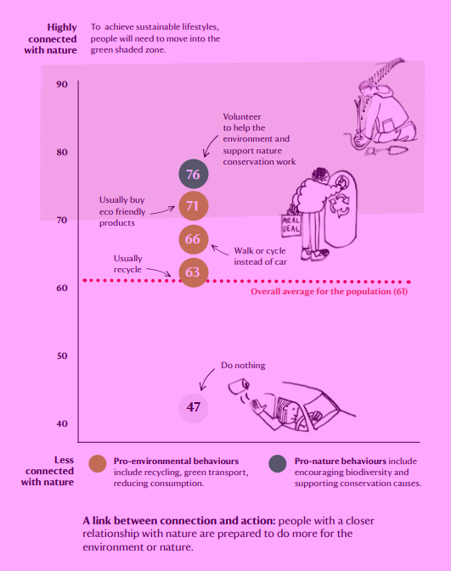
Many conservation organisations strive to save nature and its habitats. Initially they worked by their ‘experts’ saving nature and the public supporting with a financial focus, with an expert-based approach to participatory conservation and management (Berkes, 2004; Bradshaw and Bekoff, 2001; Ludwig, 2001). For example, nature reserves and areas where nature is separate to humans (Berkes, 2004; Berkes, Folke and Colding, 2000) Recently, there is a clear shift to the recognition that they cannot save nature alone, therefore the best way to protect the planet from climate change is by working with and through people, with general agreement that we can no longer separate humans from nature (Berker, 2004; Berker, Folke and Colding, 2000). Some examples of communities and conservation working together are protecting habitat by employing locals or investing the local communities through stories and connection (Community conservation, N.D.), using gardens and local spaces to provide green pathways for animals like hedgehogs to roam (RSPB, N.D.b) and the national education nature park (Natural History Museum, 2023). This direction of thinking aligns with the link between CtN and PEB in research.
As well as the link between CtN and PEB, an increased CtN is shown to have a positive impact on health, well-being and mood (Birch, Rishbeth and Payne, 2020), cognition (Wells, 2000), autonomy (Richardson and Chapple, 2021), personal growth and purpose (Lanza et al, 2023). This is important as happy, thriving people are more likely to have the drive and motivation needed for behaviour change to occur and to make lifestyle changes needed to save the planet, especially Western-style consumers who need to change their lifestyles to reduce their negative impact on the planet (Gabriel and Lang, 2006).
To have the change and people-powered movement needed, organisations need to move people from a place of supported work with the need for strong direction, to that where they have the confidence, knowledge and capability to go it alone. The spiral of connection is a model which shows how that can occur, figure 3. Starting in the middle, people connect to nature, act for nature and spiral outwards the more they do. In the middle, support and direction are given, before they ‘shoot off’ the spiral to continue their work independently.

Figure 3: The spiral of connection and action
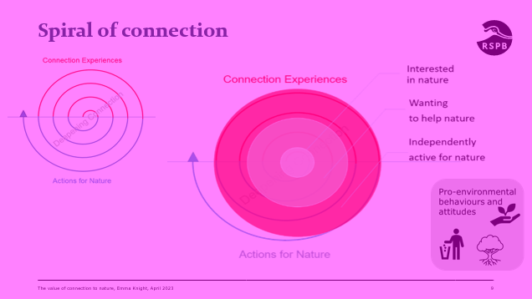

    - How do conservation organisations use CtN?
Due to the need to change the ways humans act to save the planet (IPCC, 2022), many people, organisations and charities come together with that as their aim. The RSPB is one example of the different conservation charities that exist. Being the biggest in Europe (Cambridge Conservation Initiative, 2019) their core aims and missions being to act, influence, collaborate and empower with five key areas: science, species, places, people and policy to save nature from the crisis it is in (RSPB, N.D.c), and them being the researcher’s employer, this research has made use of their reserve delivery to schools. In the RSPB’s 2030 strategy they aim to support farmers, support and empower people to act for nature and invest in education delivery (RSPB, N.D.d), showing a huge recognition that they cannot save nature alone and therefore working with, through and for people is crucial to achieving the change needed.
The RSPB and other charities run activities and sessions with two main aims: to develop a CtN or to encourage an AfN. Research has shown that a child who is more connected is more likely to complete environmentally friendly conservation activities as an adult (Broom, 2017; Rosa, Profice and Collado, 2018; Wells and Leikies, 2006; Wojciehowski and Ernst 2018).
Throughout history, children were free to play in the nearest wild place. They were connected with the fields, farms and wild spaces that surrounded them, but by the late twentieth century, many environments because urbanised. Even as recently as the 1970s, children were still accessing their local green spaces (Pyle, 2002; White, 2004). Now-a-days, the lives of children are very different, there are far fewer opportunities for outdoor play and regular contact with nature (White, 2004). Even at care settings, lots of playgrounds are concrete, manufactured spaces void of obvious nature and vegetation (Moore and Wong, 1997; Worth, 2003; White, 2004). As research shows an affinity to a love for nature, along with a positive environmental ethic, grows out of regular contact with and play in the natural world (White, 2004; Schultz et al, 2004). Therefore, there is an increasing need to provide the opportunities for children to develop their CtN.

2.2.3.1: The RSPB as an example of conservation organisations using CtN interventions
The RSPB or Royal Society for the protection of birds is the UK's largest nature conservation charity (work for good, 2020). Victorian women founded the organisation in 1889, when Emily Williamson invited women to sign a pledge to wear no feathers (Boase, 2023). What started as a campaign against the feather trade has transitioned into an organisation which carry out conservation work to save species and habitat through community work, education, campaigning and science. They describe these five main areas of work as: science, species, places, people and policy (RSPB, N.D.c). This study sits in both, the science and people areas.
This study will feed into the natural and social science aspects of the organisation by designing a tool and testing the ability to quantitatively evaluate their CtN interventions with children, in specifically for their SoR programme. This brings us to the people area: the RSPB inspires, educates and supports all people, including school pupils (RSPB, N.D.c). This study will utilise those attending their SoR programme to be a convenient and purposive sample to trial the new tool.
SoR is the programme name for school trips to RSPB nature reserves. Pre-COVID over 32,000 children across the UK attended SoR session, participating in outdoor learning sessions (RSPB, 2023c). Figure 4 uses yellow dots to show RSPB reserves across the UK that offer SoR, with those who participated in this study being showed with the red dots.
Figure 4: RSPB reserves which offer school trips
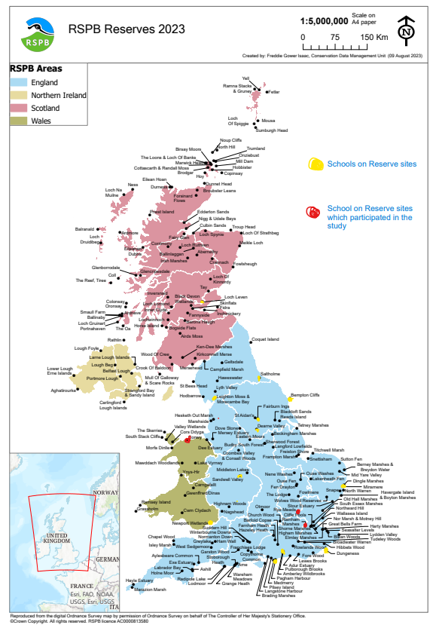

  - Theoretical frameworks: Changing people’s behaviours
As mentioned in chapter 2.2, conservation organisations build people’s CtN to improve their PEB, this requires a change to people’s behaviour. To understand the theory behind creating this change and the planning behind it, this section will explore theory of change and a range of behaviour change theories, seeking to both, understand them but understand their importance to this study.
    - Theory of change
Theory of change is a theory used to explore the steps needed to create a change, in business it can be used in project planning (Beisser, 1970; Connell and Kubisch, 1998; Schein, 1996; Fullan and Ballew, 2004; Fullan, Cuttress and Kilcher, 2005). It is a sequential model with five clear steps shown in figure 5. It starts with awareness, within this study, the awareness of nature or the impact they can have for the environment. This awareness moves to a feeling of frustration or dissatisfaction. Next the movement from a place of negativity to acceptance. Accepting where they currently are and identifying the change needed and how to achieve the change. In this case, it could be identifying their current CtN levels and how they can become more connected. Another example could be identifying the current state of the world linked to climate change and identifying the small steps and changes they can make to have a positive impact on it. In both examples, people would also need to accept the things they cannot change or have control over. Once the changes are identified, there needs to be a period of motivation and prioritisation to lead to the final step, change. The change can appear in many ways, from physical or behavioural change to communication or knowledge changes (Beisser, 1970; Connell and Kubisch, 1998; Schein, 1996; Fullan and Ballew, 2004; Fullan, Cuttress and Kilcher, 2005).

Figure 5: The Theory of Change Model
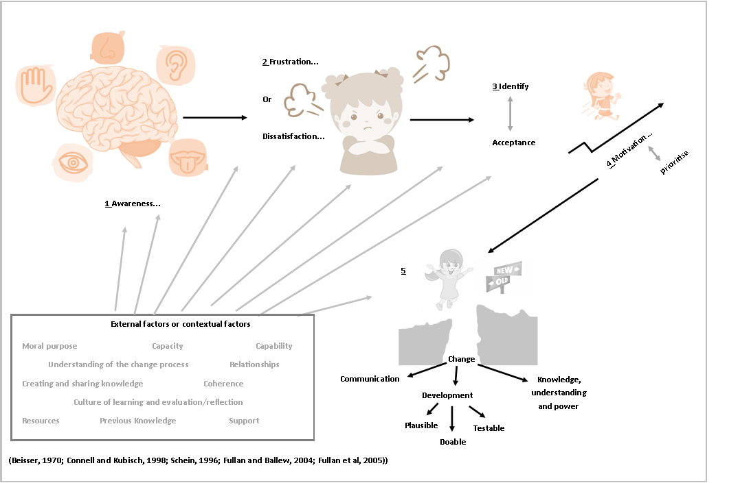
Throughout all stages, external factors and contextual factors will impact the final change outcome. The person’s ability, capacity and capability to achieve the change is crucial for it occurring. Having the correct knowledge, understanding and resources to enable it to occur. If these are all there, the motivation, moral purpose and prioritisation enables it to happen. If some are not quite there, time, planning and support can help to move it forwards (Beisser, 1970; Connell and Rubish, 1998; Schein, 1996; Fullan and Ballew, 2004; Fullan, Cuttress and Kilcher, 2005).

This study will look at how experiential learning impacts a child’s CtN using the RSPBs SoR programme as a convenience sample of participants. Table 2 shows the theory of change for SoR at the RSPB and the theory of change for the impact of experiential learning on CtN.

Table 2: Theory of change for SoR and experiential learning.
Theory of Change: the impact of RSPB’s SoR programme
Awareness | Frustration and dissatisfaction | Acceptance | Motivation and planning | Change
- What is nature?  - Why nature needs saving.  - AfN  - CtN  - Learning objectives, the knowledge or skills. | - Not their normal interests.  - Not their families or peers’ interests.  - Dirty  - Boring  - Not my role to save nature. | - We are in nature today.  - There are things we can do.  - Nature is not too bad.  - It is fun and safe.  - Interest grows | - Fun  - I care  - Connecting – seen they physical exist  - Questions things, want to know more  - How can I help? | - Increase of knowledge linked to curriculum  - PEB  - Wanting to repeat CtN experiences  - Teachers have resources to continue experiences at school.  - Children’s interest sparked.
Theory of change: from experiential learning to connection to nature
Awareness | Frustration and dissatisfaction | Acceptance | Motivation and planning | Change
- Nature  - Physically involved  - Observing others  - pathways | - reflecting on their knowledge and views  - cognitive dissonance | - I am here regardless  - Nature needs my help  - I care for nature (compassion)  - Aware of the beauty  - Part of nature | - Emotionally connected  - Senses connected  - How can I help? (AfN)  - Meaning – what does it mean to me? | - Increase CtN  - More experiential learning  - More outdoor learning

    - Behaviour change theory
Some believe human desires for physical comfort, mobility, power, enjoyment and maintenance of traditions are the main catalysts for the negative environmental changes linked with climate change (Shafiei and Maleksoeidi, 2020; Schultz, 2011; Stern, 2005). From the industrial revolutions’ over exploitation of natural resources and consumerism growth (Shafiei and Maleksoeidi, 2020; Schultz, 2011), to our current drive for technological advances (Myers, 2017; Foley, 2017), we impact our planet.
Due to this a sustainable planet is not possible without patterns of conserving behaviour (De Young, 1993), and with the current perceived urgency to protect the planet (CACE, 2020; Fridays for future, 2020), behaviour change is a major focus (De Young, 1993). Lots of organisations, such as the RSPB, use interventions to implement behaviour change. To maximise the effectiveness of these interventions impacting behaviour, behaviour change needs to be understood, i.e., understand the theory behind behaviour change and make the links between the theory and interventions (Davis et al, 2014).
Behaviour change theory refers to altering habits and behaviours of people (Celestine, 2023), it is not one theory but a range of theories (CommGAP, N.D.; Hardeman et al, 2002; Hargreaves, 2011). Before delving into the different theories there are a series of key elements to consider, see table 3.
Table 3: Different elements part of behaviour change theory (CommGAP, N.D.)
Name of element | Definition | Example linked to this study | Strategy for behaviour change
Threat | Danger, harmful event | Threat to planet, threat to us | Raise awareness, consider severity and susceptibility
Fear | Emotional response to threat | Ecoanxiety | Channel to motivate, prevent denial
Response efficacy | Perception that a response will succeed | AfN, CtN, what they can do | Evidence, examples
Self-efficacy | Perception that they can do it/ succeed | Show they can do it, similar people achieving | Raise confidence
Barriers | Prevent someone/thing from succeeding | Weather, fear, lack of interest | Be aware, attempt to remove
Benefits | Positive consequences | Increase CtN, large numbers of children, increase feedback | Celebration, communicate it with them
Subjective norms | What an individual thinks other think they should do | Same age and interests | Understand peer group, used to advantage
Attitudes | Values and beliefs | Compassion | Measure existing before change
Intentions | Individual plan to do an action | AfN | Genuine vs proxies
Cues to action | External and internal factors which help make decisions | Why they should, the difference they can make | Communicate to trigger decisions
Reactance | Individual reacts against a recommended response | AfN | No manipulation or threat
The elements above are used to build and understand several behaviour change theories, this study will consider three: social cognitive theory (SCT) (Bandura, 2007), theory of planned behaviour (TPB) (Ajzen, 1991) and the transtheoretical model (TTM) (Prochaska and Prochaska, 2019), pulling all three back to the main research question "how does experiential learning impact a child’s CtN?”.
Bandura’s SCT proposes external factors drive people and not inner forces. A triadic model can be used to explain human functioning, see figure 6. The ‘environmental’ factors represent situational influences and the location the behaviour is performed, whereas ‘personal factors’ capture variables like instincts, traits and other individual motivators (CommGAP, N.D.). Other variables not captured in the triad are self-efficacy, outcome expectations, self-control, reinforcements, emotional coping, and observational learning. Shaping the person’s environment to include motivations to change and opportunities for behaviour change and an important part of this model (CommGAP, N.D.). Linking this theory to this study’s focus would suggest that CtN alone will not lead to lasing change unless it embeds motivations to change alongside the knowledge and understanding the experiential learning builds, although the person’s CtN would be part of their personal factors that will impact the behaviour change.

Figure 6: Social cognitive theory model (CommGAP, N.d.)
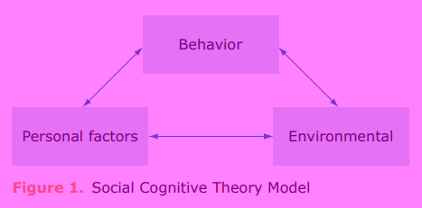
In contrast, TPB focuses on the person’s intention to drive the behaviour being key to it occurring. Intention is determined by attitude (values and beliefs) and subjective norms (social pressure or community views), see figure 7. The person’s perceived control over their ability to do the change or feelings of self-efficacy also impacts on the intent (Shafiei and Maleksiedi, 2020; CommGAP, N.D.; Hargreaves, 2011; Hardeman et al, 2002).
Figure 7: Model of TPB (CommGAP, N.D.)
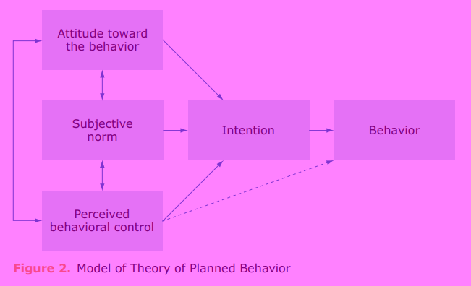
This model focuses on a person’s personal motivation to being the most important variable in predicting behaviour change (Hargreaves, 2011; Hardeman et al, 2002; CommGAP, N.D.). This supports the idea that increasing a person CtN will lead to PEB. As the person perceiving the behaviour as realistic and achievable is key to moving to the behaviour (CommGAP, N.D.; Hardeman et al, 2002; Hargreaves, 2011), any activities design to increase PEB also need to embed the time to prove they can achieve what is being asked. It is too easy to question the impact of the small actions which normally form part of the CtN experiential learning session, so it is important to stress their important impact.
The final change theory or model most closely aligns to the theory of change model shared in section 2.3.1, known as the transtheoretical (stages of change) model, see figure 8. This model proposes change as six steps or stages, beginning with precontemplation. This is where people are not planning on making a change within the next 6 months. When they are planning on making a change, they move into the second stage, contemplation. Whilst here they are aware of the pros and cons of changing, almost weighing them up to decide. Once they know they want to make the change, they start to plan actions for the next month, this is the third stage, preparation. Once planned they move to the fourth stage, action, where they make the behaviour change. To keep this, change the person needs to work at it in the fifth stage, maintenance. Many people stop at this stage and must continuously work at maintain the behaviour change, but some will move to the sixth stage, termination. This is when the behaviour becomes ‘business as usual’ and is completed 100% of the time with little focused thought (CommGAP, N.D.).
Figure 8: Stages of change
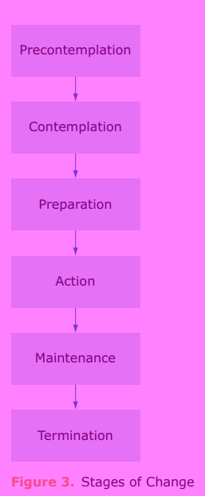
This model differs to the others as it mostly focuses on the steps to behaviour change and not the extraneous variables along the way. Linked to the use of experiential learning to impact a child’s CtN, this model also refers to the stage of moving from CtN to PEB. Things to consider with this model: people get stuck in the early stages without planned intervention, this can be linked to a lack of knowledge or motivation. Using consciousness raising, dramatic relief and self-re-evaluation help people to progress through the stages (CommGAP, N.D.; Prochaska, Johnson and Lee, N.D).
Figure 9 shows the combination of the three behaviour change models and the theory of change theory. This was filled in with the process of moving children/people through experiential learning to move to an increased CtN and increased PEB, figure 9.
Figure 9: Combining several behaviour change models with theory of change model
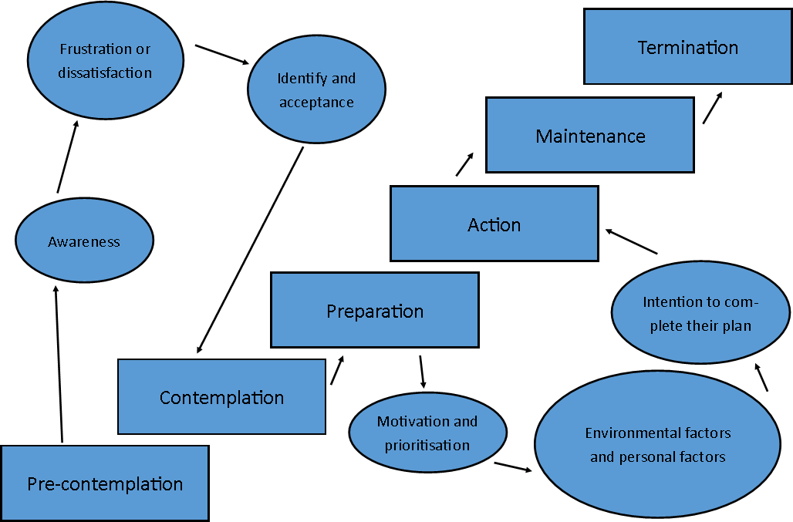

Figure 10: Behaviour change and theory of change model of how experiential learning may impact a child’s CtN and their PEB
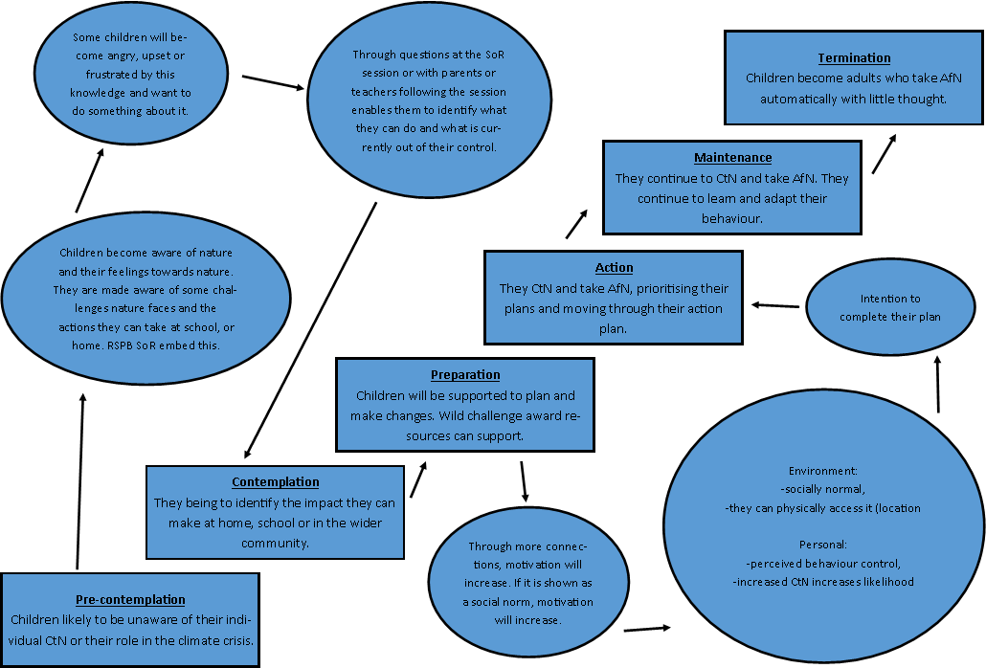
Figure 10 shows the movement through the stages of change, considering how they feel/act at each stage, utilising a combination of the 3 behaviour change models and the theory of change model considered, to ensure all stages and extraneous variables were considered.
  - Experiential learning theory
This study aims to understand the impact experiential learning has on a child’s CtN, so we need to clearly define what this study understands the experiential learning theory (ELT) to be and how that links to the sample chosen in phase 3.
Often the terms experiential learning and experiential education are used interchangeably, despite having clear differences (Humberstone and Prince, 2020; Hedin, 2010). Experiential education tends to refer to the philosophy of education, the programme of learning or context where the learning takes place, whereas experiential learning is the individual learning process and learning context (Humberstone and Prince, 2020; Hedin, 2010). This study focuses on ELT, the learning process used.
Even with the clear focus on ELT, there are many definitions used in literature:
- Learning from experience or doing (Lewis and Williams, 1994; Hedins, 2010; Chan, 2012; Mainemetis, Boyatzis and Kolb, 2002; McCarthy, 2010).
- Learning from everyday life experience (Usher and Soloman, 1999; Hedin, 2010; March, 2010; Kolb and Kolb, 2017).
- Learning through reflection and transformation (Cincera, Johnson and Kroufek, 2020; McCarthy, 2010; Mainemetis, Boyatzis and Kolb, 2002; Hedin, 2010).
- Directly in touch through active participation (Keeton and Tate, 1978; Kolb and Kolb, 2017; Hedin, 2010; Yount, 2001).
This study will focus on ELT in both the simplest sense and the circular process. In the simpler sense, children who attend a SoR session will experience hands-on activities where they will learn from doing. As the simpler definition only captures half of the ELT cycle (Kolb and Kolb, 2017) it will also link to the circular process, with sessions including most of the stages throughout them.
This theory is built on six propositions:
- Learning should be conceived as a process and not the list of outcomes
- All learning is relearning – identify and draw out what they already know and think, then build on this
- Conflict, differences and disagreement drive the learning process
- Learning is a holistic process, the functioning of the whole person: thinking, feeling, perceiving and behaving
- Learning results from a person-environment interaction
- Learning is the process of creating knowledge relative to the intellectual ability and metacognition of the individual (Prins, Veenman and Elshout, 2006)
(Kolb and Kolb, 2006).
The four stage, circular process (Cincera, Johnson and Kroufek, 2020) is most effective when all stages are moved through, although most students prefer one part over the others, figure 11 (McCarthy, 2010; Chan, 2012). It is intended to incorporate experience, perception, cognition and behaviour (McCarthy, 2010; Hedin, 2010), or doing, sensing, observing, reflecting, thinking and planning (Sharlanova, 2004).
Figure 11: The experiential learning cycle (Kolb and Kolb, 2017)
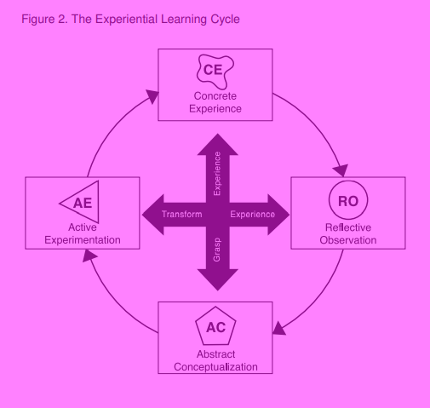
This model depicts two opposing dimensions of Concrete Experience (CE) and Abstract Conceptualisation (AC), the grasping experience stages, and another two Reflective Observation (RO) and Active Experimentation (AE), the transforming experiences. In the grasping experience stages (experience/abstract), the learner can learn through hands on learning or considering the learning through more symbolic representation, like analysis or planning. The transforming experience (action/reflection) enables them to observe others or jump straight in. Learners can enter at any stage (McCarthy, 2010; Kolb and Kolb, 2017).
As well as understanding the two experiences, it is important to consider each step separately:
- CE – student is an active participant, for example connection pathway, hands on
- RO – student consciously reflects on experience, for example: plenaries encouraging reflection
- AC – student tries to conceptualise theory or model of what has been observed, for example using resources or applying knowledge to something else
- AE – student plans how to test the model/theory or plan for forthcoming experience, for example: sharing knowledge with others
(Sharlanova, 2004).
There are some who argue that models can simplify reality and reduce learning (Ord and Leather, 2011), with Kolb’s ELT cycle not grasping the complexities (Kuk and Holst, 2018) and the sensual intimacy needed (Leather, 2018) for learning. Jarvis created a model which captured more of the complexities, see figure 12 (Kuk and Holst, 2018)
Figure 12: Jarvis’ model of experiential learning theory (Kuk and Holst, 2018)
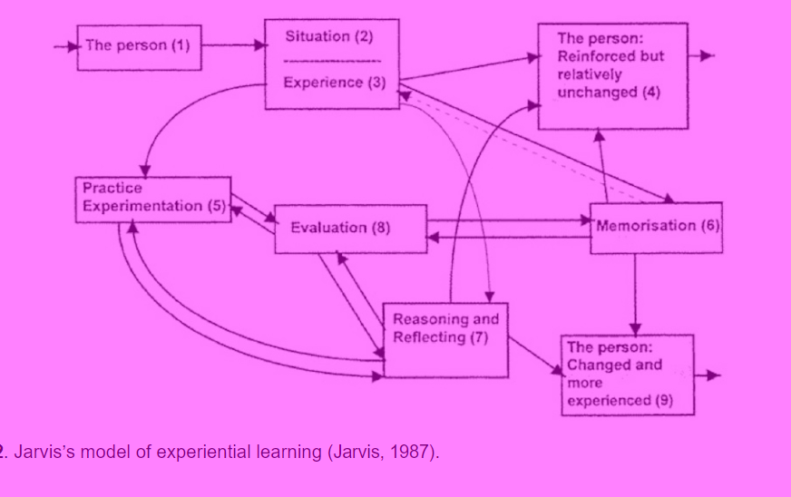
Both models show links between prior learning, new experiences, time, reflection and individual perspectives (Kuk and Holst, 2018). A criticism of Kolb’s cyclic model is that it doesn't incorporate linear movements (Bergstein, Avery and Neumann, 2010), Jarvis’ model is more complex than the cyclic model, so captures more of the linear needs (Kuk and Holst, 2018]. This study will continue to use Kolb’s model when considering how experiential learning is linked to the participants, although many of the steps seen in Jarvis’ model are also utilised.
2.5 The relationship between experiential learning theory and CtN
Now the reader knows what experiential learning theory is and how this study is defining a CtN, we now need to consider the potential relationship between the two.
As explained in section 2.2.3, organisations and nature conservation charities, like the RSPB, aim to influence a child’s CtN by using outdoor learning activities to move the children through the CtN pathways. Using an experiential learning design in the outdoor learning activities, can enable this learning to be more impactful (McCarthy, 2010; Chan, 2012). Research shows strong connections between experiential learning theory and outdoor learning (Moseley et al, 2019; Grimword, Gordan and Stevens, 2018). Most outdoor learning is innately experiential in the simplest sense, promoting personal connections to nature through active engagement with the environment (Moseley et al, 2019), but more thought must go into meeting all stages of the cycle. Figure 13 shows the cycle of experiential learning and how the RSPB activities implement it (Chmolova, 2015).

Figure 13: The cycle of Experiential Learning and how RSPB activities implement it (Chomolova, 2015).
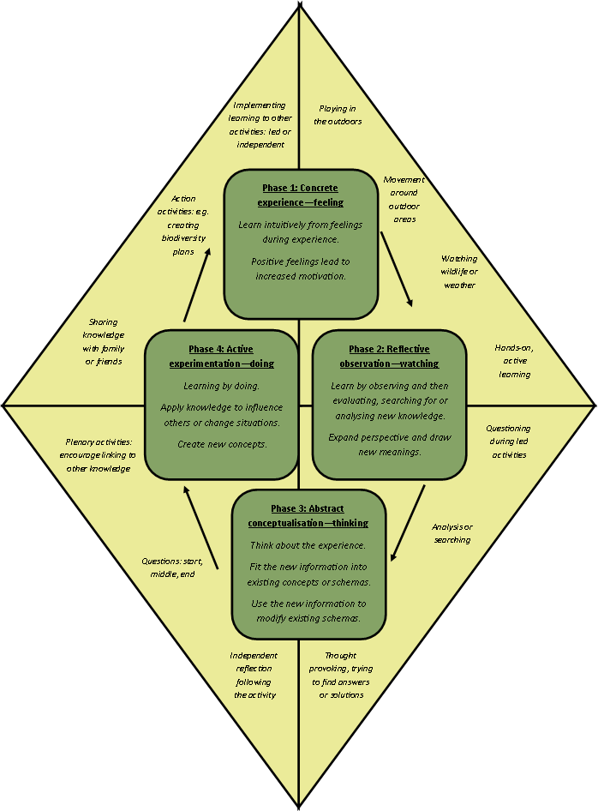
Taking children through the steps of experiential learning should embed any learning achieved and have an increased likelihood of impacting their future schemas. A schema is a unit of functional analysis, where knowledge is linked with an action. They enable assimilation, the ability to make sense of a situation, and accommodation, they change over time through new knowledge and actions (Arbib, 1992). A simpler definition of a schema is an active organisation of past reactions or experiences, which are operated when giving a well-adapted organic response (Bartlett, 1995); Arbib, 1992). A slightly different way of describing it is the rules or scripts all humans use to interpret the world and predict situations occurring. If information doesn’t align with a currently held schema it is much more likely to be misunderstood (Widmayer, N.D.). Ultimately, all humans create schemas in their mind and build on them using new experiences to adapt or create new schemas. A schema can be created developed or connected with other schemas to enhance the person’s understanding of a topic or piece of knowledge (Chomolova, 2015). By using experiential learning to impact schemas around nature and their connection to nature, charities can also almost influence the future, as research has shown that people who are more connected complete more environmentally friendly activities now and in the future (Broom, 2017; Rosa, Profice and Collado, 2018; Wells and Leikies, 2006; Wojciechowski and Ernst, 2018). Extraneous variables which may impact a child’s CtN.
Powerful impacts on children come from both positive and negative experiences (Chan, 2012) and as mentioned in section 2.3.1, there are many variables which may impact a child’s CtN. Therefore, these need considering during the design of the tool but also during the data analysis. Table 4 shows some potential variables, how they may have an impact and how this study will consider them.
Table 4: Potential extraneous variables, their input and how they are considered in this study
Extraneous variable | How it might impact a child CTN | How it will be considered in this study
Country | Depending on the country they're in, will impact the outdoor learning they have in schools. In the English and Irish national curriculum, children need an outdoor education experience as stated in the PE sections, whereas it is more embedded in Scotland and Wales. | SoR sites in England, Wales and Scotland will be invited to take part.  During data analysis the different school groups will be compared to check for a significant difference, if no significant differences found between the groups, then it is likely there is no significant difference between countries.
Urban vs rural | Dependent on the living location, children grow up with different experiences, with urban locations often not designed to nurture a child's connection to nature (Giusti et al, 2018). | SoR sites are based in a range of rural and urban locations, which attract a variety of urban or rural schools.  During data analysis the different school groups will be compared to check for a significant difference. If no significant differences found between the groups, then it is likely there is no significant difference between urban and rural locations.
Covid-19 | The early part of the UK's lockdown enabled some to spend time in nature, with a nice spring and government sanction daily walks. Reduced traffic enabled birds, plants and animals to thrive, making them easier to hear or see (Friedman et al, 2021). | We will test the data for normality, this will allow us to know if the data is normally distributed.  We will not investigate the impact of COVID, but a future study might want to.
Time pressures | Both parents and teachers should go to find time to spend repeated regular experiences outdoors (Friedman et al, 2021). | We will test the data for normality, this will allow us to know if the data is normally distributed.  During data analysis the different school groups and different year groups will be checked to see if there is a significant difference.
learning styles and teaching styles | Achievement increases when teaching styles much the children's learning style (Dunn, Beaudry and Klavas, 1989). | We will aim for eight reserves to take part.  During data analysis the different groups will be compared to check for a significant difference. If no significant difference is found it is likely that the learning styles and teaching styles have not had a significant impact.
prior knowledge | Learning should build on children's previous experiences and knowledge (Chan, 2012). | Data will be tested for normality.
session design | Children can experience different sessions when attending SoR sessions, which may impact differently. | We will aim for eight reserves to take part.  During data analysis the different groups will be compared for a significant difference. If no significant difference is found it is likely that the session design has had no significant impact.
age of children | This study is enabling children aged 7 to 11 to participate. The older they are, the longer they have had to experience nature. | You will aim for eight reserves to take part with a range of year three to year 6 pupils.  During data analysis the different year groups will be tested for a significant difference. If no significant difference is found it is likely that the age of the children has little impact
Maslow's hierarchy of needs | The pyramid of needs needs to be met so that they can focus on their effort on learning, otherwise all effort is focused on the unmet needs (Burleson and Thoron, 2014). | Data will be tested for normality.  Drawing data analysis both school groups and year groups will be tested for a significant difference.
Weather | Weather that is too wet, hot or cold may distract the children from their activities. | Sessions will be clustered in summer and autumn. A further study could have sessions across the whole year and compare them during data analysis to see if there is a significant difference.  In this study, groups will be compared to see if there is a significant difference.

  - How can we measure a CtN in children?
Currently a variety tools can measure CtN, as shown in table 5. Unfortunately, most are designed for a one-off trait measurement and not for a comparative, state measurement over short amounts of time (Carr and Hughes, 2020; Bragg et al, 2013). Due to this, the first two stages of this research focus on creating a tool to measure a child's CtN state, which is crucial to answering this study’s research question. If this research shows that the new tool is valid and effective at measuring changes in children's CtN then organisations could use it to evaluate and compare the different methods of developing CtN to decide which they should and shouldn't offer.
Table 5: The different Connection to Nature Measurement Tools available and their main use
Tool | Reference
Emotional Affinity to Nature (EAN) | Kals, Schumacher and Montada (1999)
Inclusion of nature with self (INS) | Schultz (2002)
Environmental Identity Scale (EIS) | Clayton and Opotow (2003)
Connection to Nature Scale (CNS) | Mayer and Frantz (2004)
Nature Relatedness Scale (NR) | Nisbet, Zelenski and Murphy (2008)
Connection to nature index (CNI) | Cheng and Monroe (2012)
Nature Relatedness Scale, Short Version (NR6) | Nisbet and Zelenski (2013)
Nature Connectedness Inventory (NCI) | Ernst and Theimer (2011)
Evaluating Nature Activities for Connection Tool (ENACT) | Carr and Hughes (2020)
Love and care for nature (LCN) | Perkins (2010)
Environmental Behaviour Scale (EBS) | Stets and Biga (2003)
Ecological worldview and awareness of consequences (EWAC) | Stets and Biga (2003)
Connection with nature (CWN) | Dutcher et al (2007)
Ecological Paradigm Scale (EPS) and New Ecological Paradigm Scale (NEP) | Dunlap et al (2000)
Environmental identity (EID) | Olivos and Aragones (2011)
Emotional Motives Scale (EMS) | Schultz (2000, 2001, 2004)
Implicit Association Test of Self-Nature (IAT) | Fernham et al (1999)
Extended inclusion of nature in self scale (EINS) | Martin and Czellar (2016)

This research aims to investigate how experiential learning experiences may impact a child’s CtN however as there is no tool currently available proven to measure this change one needs to be created. Using analysis of current tools by the research and consultation with RSPB staff/volunteers, statements were chosen to create the new tool (appendix A). This process was chosen to use current statements which are suitable for children rather than creating new statements that have never been tested for validity or reliability. A facilitator questionnaire and open-ended questions on the new tool will enable the consideration of extraneous variables.
  - Summary and emerging issues
This chapter has explained this study’s understanding of CtN, AfN, ELT, and behaviour change theory, clearly setting out the definitions and models used by this study. It has explained the need for this study, through the impact it can have on evaluation interventions which could lead to PEB, helping to prevent the climate crisis from worsening. It has set out an awareness of current CtN evaluation tools and how they are not suited for measuring a child’s CtN state, therefore showing the need for the first two phases of this study. The next chapter will set out the research methods used and align this study with the paradigms it fits in.

Chapter 3
Research Methods
Procedures or techniques utilised to collate and analyse data linked to research questions or hypotheses are described as research methods (Crotty, 1988; Wahyini, 2012; Humberstone and Prince, 2020). This chapter will inform the reader of the chosen research methodology whilst providing a rationale of their use to address the objectives shared in chapter 1.3. It will cover; research paradigm, research strategy, data collection, frameworks for data analysis, potential limitations and hurdles, ethical concerns before concluding with a summary linking to the next chapter.

3.1 Research aims and objectives
This study aims to explore and answer the research question ‘how does experiential learning impact a child’s connection to nature?’ through the following two aims:
- Creation of a measurement tool which can measure the state of a child’s CtN, i.e., the change in a child’s CtN over time.
- Investigation of how experiential learning impacts a child’s CtN
To achieve the two aims, it is crucial the research design is suitable to realise the following four objectives shown below:
- Creation of a measurement tool through analysis of current tools available during a literature review in combination with an online survey with staff members involved in experiential learning.
- Evaluation and improvement of tool through parent-led interviews with children.
- Comparison of child’s CtN scores pre- and post- experiential learning experience to explore the impact.
- Consideration of extraneous variables and their impact on CtN scores.
3.2 Research Paradigm
It is important to recognise how the researchers’ world views and chosen paradigm impact and influence the research. As there are many paradigms this can exasperate the complexity of research (Humberstone and Prince, 2020; Maxwell, 2011; Blaikie and Priest, 2017). A paradigm can be described as a fundamental image of the subject matter within science (Gokturk, n.d.) or a discipline matrix or set of preconceptions (Blaikie and Priest, 2017), or even the basic belief system(s) or world view that guides an investigation (Guba and Lincoln, 1994a; Humberstone and Prince, 2020). In social science it can be split into; ontological assumptions (understanding reality), epistemology (concepts, theories and techniques of investigation), exemplars, and chosen research methods (Blaikie and Priest, 2017). It is recognised that the researchers’ ontological, epistemological and methodological commitments can restrict the methods available for use, therefore having an important impact on research which needs recognising (Humberstone and Prince, 2020).
In this study the dominant paradigm adopted was neo-positivism. Although this is the dominant paradigm, some characteristics linked with critical realism are also adopted in a multi-paradigm approach. A multi-paradigm approach was chosen to combine the two paradigms together, although utilising an imbalance between them, enabling the removal of some limitations found when only choosing one of the paradigms. A sequential-use type was utilised, where each step had to occur first before the next was possible (Blaikie and Priest, 2017).
Neo-positivism is a paradigm that evolved from positivism, whilst trying to remove some of the limitations linked with positivism. It is a scientific method which focuses on using deductive logic through the method of disproving a hypothesis (Blaikie and Priest, 2017). It is aligned with an ontological assumption of a ‘cautious realist’, which believes that reality exists independent of human minds, however direct access to that reality is not possible (Blaikie and Priest, 2017). The epistemological assumption is falsification: the belief that knowledge is gathered through trial-and-error processes where theories are suggested and tested; as the act of observing is an interpretive process, they believe tests should be used to falsify rather than confirm the theories; as knowledge cannot be proven true, it must be considered as tentative and open to revision (Blaikie and Priest, 2017). Due to this study’s researcher previously studying as a biomedical scientist before moving into the environmental education and social science fields, a rigid scientific process is what they are most comfortable with. This partially led to the need for the new quantitative measurement tool to be created and deployed.
The above was combined through a multi-paradigm approach with the paradigm critical realist. A critical realist believes that any scientific principles needed to explain any aspect of social life have already been identified. They also reject inductive and reductive logics, for the use of retroduction: beginning with a loose idea of where they want to head through research, but the majority develops as research continues. An ontological assumption of depth realism is used, where social reality is constructed by cognitive resources or social actors, with social structures not existing independently of the activities they influence or the conceptions of those actors participating in them. A neo-realism epistemological assumption is taken, considering knowledge being derived from structures of mechanisms which produce them, this allows for the possibility that competing or cancelling mechanism may operate independently (Blaikie and Priest, 2017). In this study, this paradigm is more evident during the creation of the measurement tool, where retroductive logics allowed the movement from other tools to the newly created one. It was also able to direct analytic comparisons after data collection, as prior to collection we were unsure of what extraneous variables (I.e., weather, site, year group, activities) would be present.
Therefore, it is important to align the study’s research strategy with the dominant neo-positivism paradigm and to consider where elements of a critical realist paradigm can help to strengthen the study.
3.3 Research Strategy
A research strategy is an overall plan for conducting research studies which consider theory and practice (Johannesson and Perjons, 2014). As theory and practice are inseparable (Pierre, 2016; Humberstone and Prince, 2020) we will consider theory first before focusing on the methods practiced. This study’s question ‘how does experiential learning impact a child’s CtN?’ will be answered through the data collection method of a survey: a sample of children attending an experiential learning school sessions on a nature reserve will complete pre- and post- questionnaires.
Due to the participants being children with limited access to technology on the day, a paper survey was chosen, specifically a fill-in-the-blank (FITB). This was chosen as it has the lowest equipment costs (Porter, 2004) and matched what the researcher and participants had access to. Limitations of this type of survey include human errors, time taken and costs associated with printing and postage (Porter, 2004; Taherdoost, 2016). As this in the main survey technique utilised, this study combatted these limitations by sharing costs between site and researcher, printing at sit to remove the need for postage to site and building in checks for potential errors.
Alongside the paper survey, online surveys were also used: phase 1 used an online workshop style and phase 2 used a parent-led interview which included a survey style prompt. With these being online, they reduced the challenges around cost and security, but kept the challenge around human error and time for analysis and input as they were much more qualitative in design.
In align with the neo-positivism paradigm, the dominant data type is quantitative: data which is normally numerical in nature and subject to statistical testing (Humberstone and Prince, 2020; Bazeley, 2004). The use of quantitative data in phase 3 enables the study to collect responses to questions using Likert scales of 0-5 and collate them to create an overall score or aggregation of scores (Chambers et al, 2001). This aligns with many current CtN tools (Cheng and Monroe, 2012; Nisbet, Zelenski and Murphy, 2008; Schultz, 2002). Although it is important to recognise the potential for errors or important information which may not be captured utilising such a closed question style (Chambers et al, 2001), therefore a mixed methods or mixed model (Bazeley, 2002) approach was utilised. Specifically, the use of qualitative data (textual data) (Bazeley, 2004) to triangulate findings and understand the impact of a range of variables. For phase 1, this was fully integrated together with the same questionnaires asking both styles of questions where phase 3 utilised quantitative and qualitative together side-by-side (Bazeley, 2004).
3.4 Data collection
3.4.1 Timelines, phases and impact of covid-19
This study was completed in a series of phases due to the need for a new tool to be created to measure a child’s state CtN (Stone, 1993; Taherdoost, 2016). Table 6 below details the varying timelines used:

Table 6: A description of the phases and timelines used
Phase number and explanation | Relevant dates | Justify/explain with references
Pre-phase 1: Literature review of current tools and researcher reflections on which statements could be used. | Throughout 2021 and January 2022. | Utilising questions from tools which already exist in literature enabled the creation (or collation) of a new tool aimed at measuring a child’s CtN state. Using already existing questions meant they have already had some reliability and validity testing, rather than creating entirely new questions.  This stage enabled the researcher to reduce the number of questions being shared in phase 1. Questions were considered in the following ways:  - Are they linked to the 5 pathways or action?  - Are they suitable for children aged 7-11 years? (Using the researcher’s knowledge as a previous primary school teacher).  - Are they likely to change following an experiential learning session?
Phase 1: consultation with experiential learning facilitators around questions to go into the tool | February and March 2022 | This phase enabled the reduced number of questions produced from the pre-phase above to be shared with people who work with/in SoR at the RSPB. This meant they were able to consider whether the questions were suitable for the audience in phase 3 of this study. This also helped to remove researcher bias in the creation of the tool, as it was now being created from the thoughts of 6 people and not just the researcher alone.
Phase 2: pilot evaluation and adaptation of the new CtN state measurement tool | Originally this would have happened between March and April before phase 3 began. Unfortunately, the original 5 children/families who were recruited failed to complete the process, therefore the 1 successful participant completed phase 2 in December 2022. | To ensure the tool was understood and able to be used by children, a sample of children completed this phase. 4 children were meant to complete this stage, unfortunately only 1 successfully completed it.  This worked as the pilot stage which is recommended when creating new measurement tools (Stone, 1993; Taherdoost, 2016). Unfortunately, it was completed after phase 3 and with only one child’s view, but it still provides useful insight to any potential anomalies found in the data and for future improvement and use of the tool.
Phase 3: data collection and analysis using the new tool to answer the research question | Between June 2022 and October 2022 | The original aim was for this to occur after the creation, testing, evaluation and improvement of the tool, in alignment with the recommended steps to creating new tools (Stone, 1993; Taherdoost, 2016). Unfortunately, it occurred before the piloting, evaluation and improvement. Following the failed completion of the original 5 families/children for phase 2, the decision was made to continue with phase 3 data collection, due to the completion date of September 2023, as summer term is the best time to get the numbers of children desired for phase 3 and the time it takes to analyse and write up.

3.4.2 Methods of sampling
Sampling enables researchers to systematically select a smaller amount of representative people from a pre-defined population (Sharma, 2017). This study uses a non-probability sampling method due to the participants fitting best in a purposive or convenience sample method (Sharma, 2017; Floyd and Fowler, 2014).
A purposive sample of 5 staff and volunteers linked to the RSPB SoR programme were recruited for phase 1 of the study. They were recruited via an email request and through a learning officer meeting. The original aim was to have 8 members for the phase 1 sample, enough to give a variety of views but to make it manageable (Muthen and Muthen, 2002; Francis et al, 2010; Burmeister and Aitken, 2012). Having 5 was slightly less than the ideal but was still enough to understand their thoughts and shape the new measurement tool.
For phase 2, a convenience sample of 4-6 children aged between 7 and 11 years old was to be used (Muthen and Muthen, 2002; Francis et al, 2010; Burmeister and Aitken, 2012). Despite 5 children/families being recruited to complete phase 2, none of them completed the process due to covid-19 and other commitments. For the actual study, only 1 child was recruited to participate in this phase, a female age 8 years. Although this wasn’t an ideal number for validity and reliability, one participant is better than none and could still help to identify any extreme concerns linked to the child-friendliness of the new measurement tool.
Purposive and convenience sampling were combined to get a sample for phase 3. At least 8 schools with approximately 240 children attending an RSPB SoR session would be recruited via email. Due to covid, time prioritisation of the learning officers (RSPB staff members who lead SoR) and suitable year groups, only 4 schools were recruited (Muthen and Muthen, 2002; Francis et al, 2010; Burmeister and Aitken, 2012). Table 7 shows the breakdown of the 120 phase 3 participants:
Table 7: Participants involved in phase 3 of the study
Reserve Location | Month of SoR session | Number of children  (pre-analysis) | Year group | Other information gathered
Rainham Marshes, England | July 2022 | 20 | 6 | Learning officer led the group, they have worked in the RSPB for several years
Rainham Marshes, England | July 2022 | 15 | 6 | Learning officer led the group, have worked in the RSPB for just under a year
Conwy Nature Reserve | September 2022 | 22 | 6 | Learning officer led the group, working on a maternity cover contract
Rye Meads | July 2022 | 53 | 4 | The group was split between a learning officer and learning assistant, both have worked in the RSPB for several years

  - Research Methods
Aligned with neo-positivism paradigm, a mixed methods research design was used with survey being the main data collection method used throughout all phases of the study (Blaikie and Priest, 2017; Humberstone and Prince, 2020).
An online workshop style questionnaire was used during phase 1, utilising the online software ‘Google JamBoard’ (appendix C). This tool enabled participants to answer questions in an open-ended workshop style by physically dragging statements along a scale and adding their own via virtual post-it-notes. This online survey method enabled a cost-effective, secure way of collecting data (Porter, 2004). The use of a qualitative design enabled a broad understanding of what the participants thought and chose, although this made it more complex to analyse, therefore the scaled statements were analysed using quantitative analysis, which enabled easier comparisons of their views.
Allowing the participants to complete the questionnaire independently and separate from the researcher enabled the answers to be their own without being biased by other’s thoughts (Chenail, 2011). Although having the researcher and the participants separate made it even more important to have clear, unambiguous and unbiased questions (Taherdoost, 2016; Stone, 1993).
Phase 3 also employed the data collection method of a questionnaire, but this time they were completed in person on a paper FITB survey (Porter, 2004). The session leader completed a questionnaire comprised of open-ended, qualitative questions, appendix D. These aligned with the critical realism secondary paradigm, enabling the collection of information which could lead to understanding the extraneous variables that were present without making assumptions or narrowing what might be shared. Once shared, retroductive logic can be used to analyse the data to explore whether the extraneous variables have any significant impact on the child’s CtN.
In collaboration with this, the primary school children completed a mixed methods (quantitative and qualitative) questionnaire, once at the start of the day before any experiential learning sessions (pre-) and again at the end of the day following the experiential learning experiences (post-), appendix A. The quantitative data enabled the aggregation of scores to create CtN score for each child pre- and post-experiential learning experience (Chambers et al, 2001). These were analysed to see whether a significant difference between the pre- and post- results existed, with any difference seen being an approximation of participant change impacted by the experiential learning experience especially in the absence of a control group (Geldhof et al, 2018).
A parent-led interview was used to gather the phase 2 data using a qualitative design, appendix E. This enabled the survey to be piloted for identifying any potential pitfalls and ambiguities (Stone, 1993; Taherdoost, 2016), whilst removing the researcher to reduce researcher bias (Chenail, 2011).
Having data from the piloted parental ‘interview’, the RSPB leader and the children themselves enables the data to be explored considering the impact of extraneous variables or pitfalls in the questionnaire. This allowed what can be called ‘triangulation’ of data (Lauri, 2011; Thurmond, 2001; Kimchi, Polivka and Stevenson, 1991).
  - Framework for data analysis
Without a process of analysis, data is partial and incomplete (Humberstone and Prince, 2020; Jackson and Mazzei, 2013). This means that the method of data analysis is important to pick apart what the data can show us and help to answer the research question. As this study has 3 phases of data collection, it also requires 3 phases of data analysis. Due to surveys collecting both quantitative and qualitative data, the analysis will be completed using both thematic and statistical analysis.
The data collected from the online survey through Google JamBoard, appendix C, was analysed in two ways. First the researcher used thematic analysis (looking for common themes in the participants answers), before analysis of the statement sorting by ‘scoring’ the statements between -8 and +8 as if on a scale. The mean, mode, median and range were explored to give clear positive statements to use, negative statements to ignore and some potential statements to consider in more detail. Phase 2 was designed to help reduce statements if groups had too many. Thematic analysis of the remaining open-ended questions allowed further understanding of potential extraneous variables and things to consider during creation and implementation of the measurement tool.
Phases 2’s data was transcribed from the recording into a word document, with colour coding identifying the child and parent speakers. Times were captured to enable the researcher to return to the relevant part of the recording if required. Once the transcription was complete, the data was chunked into the different parts of the questionnaire and what the participant was sharing/saying interpreted. This was inputted into a table, enabling the data to be easily cross-referenced with other data linked specifically to the individual questions.
The main portion of data was collected during phase 3. As a large portion of this was quantitative, the software tool ‘SPSS’ was used to support the analysis. There were several steps to analyse this quantitative data, using both parametric and non-parametric testing:
- Check for errors using descriptive statistics, i.e., mean, standard deviation, numbers
- Check for normality using Skewness, Kurtosis and Kolmogorov-Smirnov tests, using the histograms and boxplots created to check for errors and outliers
- Outliers compared with their original data to check for errors
- As the data met the assumptions for parametric testing, the prescore and postscore data was compared using a paired-samples T-test and a one-way repeated measures Analysis of Variance (ANOVA)
- An independent T-test and a mixed between-within analysis of variance were used to check whether there was a difference between year groups
- A mixed between-within analysis of variance was used to check for a difference between groups, to infer any differences between the reserves and sessions
Following analysis of the whole data, the data was split into the sub-sections of the questionnaire before being analysed using non-parametric testing:
- Descriptive statistics checked for errors
- Normality was checked using Skewness, Kurtosis and Kolmogorov-Smirnov tests, using the histograms and boxplots created to check for errors and outliers
- As it did not meet the assumptions for parametric testing, a Manns Whitney test was used to check for difference in post-pre data and a Friedman’s two-way analysis of variance by ranks
- A Kruskal-Wallis test checked for any difference in distribution across the years
Having data from the piloted parental ‘interview’, the RSPB leader and the children themselves enables the data to be checked considering the effect of extraneous variables or pitfalls in the questionnaire. This allowed what can be called ‘triangulation’ of data (Lauri, 2011; Thurmond, 2001; Kimchi, Polivka and Stevenson, 1991). Triangulation of data was also used to check for any issues with the tool when considering year group used, group differences and sub-section differences – by analysing these three we can ensure the tool was robust, valid and reliable across these extraneous variables and also have a broader understanding of how experiential learning may impact a child’s CtN.
  - Limitations and potential hurdles
Limitations represent a weakness within the study which may influence outcomes or conclusions (Ross and Bibler Zaidi, 2019). Limitations tend to be challenges which the researcher has limited control over, whereas delimitations are introduced by the researcher (Price and Murnan, 2004). As all research is subject to them, it is important to fully consider possible limitations and hurdles to justify the choice of data collection methods, analysis and frameworks. By considering them, control measures can be embedded to improve the faithful implementation of the research and enhance its reliability and validity (Ross and Bibler Zaidi, 2019; Price and Murnan, 2004). As reliability and validity enable researchers to communicate the rigour of the research process used and the trustworthiness of research findings (Roberts and Priest, 2006), it is important to consider these in reference to this study.
Trustworthiness depends on several things: the initial research question, data collection methods, analysis and how conclusions are drawn (Roberts and Priest, 2006). To ensure this study is trustworthy, it has been transparent when there have been challenges, for example in the recruitment of participants for all phases leading to numbers being less than what was originally hoped for and where data collection methods have been designed to reduce the chance of researcher bias by removing them from asking the questions. Being open about these hurdles has shown that the research is open and honest, therefore increasing the trustworthiness.
Reliability refers to whether a test can be repeated and provide similar results under different circumstances (Roberts and Priest, 2006). As this is the first time this measurement tool has been used, it is not certain whether it will give similar results each time. A range of parametric and non-parametric statistical testing has been utilised to see whether year groups, participant group (i.e., reserve) and whether the results were ‘normal’. As they met these or no significant differences were found, the test is likely to be reliable. The use of already existing questions to collate into the tool also strengthens this.
Validity is about the closeness of what we believe is being measured to what was intended (Roberts and Priest, 2006). As the questions came from tools which are already used in literature and the ‘real world’, they are likely to measure the child’s CtN as intended. As there is a significant difference from the pre- to the post-CtN score, it is likely to be measuring the CtN state as intended rather than the trait value. Future research could be used to compare this new measure with an already existing one, such as the CNI (Cheng and Monroe, 2012), to further prove this validity.
A delimitation of this study is the focus on primary school children aged 7-11 years. This was chosen as the target audience due to them being old enough to understand the style of measurement tool, but also young enough to align with what the research shows about under 11’s being a suitable age to target when using CtN as a measure for future PEBs. Therefore, this needs to be acknowledged as it limits the generalisability of results to this age group but is not necessarily a limitation as it was a chosen age focus. This may lead to other limitations due to the purposive and convenience sample methods utilised, and the self-selection created through participants opting out, although as this study focused on the specific audience of children attending RSPB reserves, it is not a limitation for the results and conclusion of this study, only the application to future studies. Therefore, further research is needed to trial and evaluate the new measurement tool before its reliability and validity can be proven fully.

  - Ethical Concerns
Researchers need to be aware of culturally responsible, relational, reflexive ethics informed by social justice values (for example ethnicity, age, sexual orientation and power) (Humberstone and Prince, 2020; Lahnmen et al, 2011).
McCrone (2002) explains that there are six fundamental principles to consider: respect, honesty, beneficence, justice, non-maleficence, and competence, which can be chunked into four key ethic deliberations: informed consent, confidentiality and anonymity, honesty, gains and justice, and a risk of harm (Humberstone and Prince, 2020). These need to be identified and considered during modern studies, with increased attention when children or vulnerable adults are also involved.
Using the University’s Ethics Form (Appendix B) and RSPB risk assessments, ensured this research was ethically sound. There was limited risk for participant, researcher, data collectors, university or organisation, and any risk that was present was reduced by following the risk assessments.
All questionnaires were designed to ensure data minimisation and returned copies were stored securely aligned with the RSPB GDPR (General Data Protection Regulation) compliance training and policies. Participants consented to participating in the written or verbally recorded data, both of which were only used for the purpose explained during informed consent. They understood their right to data omission, removal and usage. Data was anonymised and regularly cleansed, with any identifiable or unneeded data destroyed.
Safeguarding is an important ethical consideration: RSPB staff are DBS checked and are RSPB safeguarding training compliant, ensuring risk to participants and staff/volunteers is low. As the research forms a small section of the usual day/session, there should not be an increase of disclosures or incidents. Questionnaires will not encourage disclosures: they will contain closed questions, or open-ended questions specific to nature connectedness, and not wider feelings/emotions. Usual site/session procedures will occur for any emergency situations such as fire, first aid or violent members of the public.
There was a Coronavirus transmission risk during sessions. Due to this, the sessions only went ahead when they met the RSPB COVID requirements. As the participants came from schools, the children were in bubble sizes decided by their schools’ guidelines. RSPB staff/volunteers kept a 2m distance from others, reducing chances of transmission. Hands were washed regularly throughout, especially after using shared equipment.
  - Chapter Summary
This chapter set out and provided the rationale for the research paradigm and strategy. Through a detailed breakdown of the data collection, analysis and sampling methods the reader should have a clear understanding of how the methodology aligns with the chosen paradigm and how the objectives will be met, and the research question answered. Finally, this chapter considered the limitations, potential hurdles and ethical concerns linked with this study, with a focus on how to utilise control measures to make the study as valuable and trustworthy as possible. The next chapter will detail the data analysis and the findings of all 3 phases of the study.

Chapter 4
Findings, analysis and discussion
The main aim of this study was to answer the question ‘how does experiential learning impact a child’s CtN?’. The research was conducted using several phases, with phase 3 collecting the data to answer the above question, a full breakdown of the research methods is in chapter 3. This chapter presents the findings of each phase, explores and interprets them in the wider context of answering the research question and their relevance to existing literature. Any conclusions drawn from this analysis will be shared in chapter 5: Conclusion.
4.1 Pre-phase 1: The findings of the literature review of current measurement tools
Fourteen different tools were analysed by the researcher, exploring their link to the CtN pathways and action, the number of items included suitability for children and trait vs state. Table 8 shows the researchers initial findings:
Table 8: The current CtN measurement tools
Current measurement tool | Reference | Number of items |  |  |  |  |  |  | Children vs adult | State vs trait
Current measurement tool | Reference | Total | Beauty | Meaning | Compassion | Emotion | Contact | Action | Children vs adult | State vs trait
LCN | Perkins, 2010 | 15 | 0 | 1 | 5 | 8 | 1 | 2 | Adult | Trait
CNS | Mayer and Frantz, 2004 | 14 | 1 | 0 | 12 | 0 | 0 | 1 | Adult | Both
EBS | Stets and Biga, 2003 | 7 | 0 | 0 | 0 | 0 | 0 | 7 | Adult | Trait
EIS | Stets and Biga, 2003 | 11 | 0 | 0 | 5 | 2 | 0 | 4 | Adult | Trait
EWAC | Stets and Biga, 2003 | 15 (12) | 0 | 3 | 5 | 0 | 0 | 4 | Adult | Trait
CWN | Dutcher et al, 2007 | 16 | 0 | 5 | 5 | 0 | 0 | 6
INS | Schultz, 2001; Bragg et al, 2013 | 1 | 0 | 0 | 1 | 0 | 0 | 0 | Adult | Trait
EPS/NEP | Dunlap et al, 2000; Schultz, 2004 | 15 |  |  |  |  |  |  | Adult | Trait
EMS | Schultz, 2000; Schultz, 2001; Schultz, 2004 | 12 |  |  |  |  |  |  | Adult | Trait
IAT | Farnham et al, 1999; Schultz, 2004 | 0 | 0 | 0 | 0 | 0 | 0 | 0 | Adult | Trait
NR/NR6 | Nisbet, Zelenski and Murphy, 2009 | 21 | 4 | 0 | 12 | 1 | 0 | 4 | Adult | State
EINS | Martin and Czellar, 2016 | 4 | 0 | 0 | 4 | 0 | 0 | 0 | Adult | Trait
EID | Olivos and Araganes, 2011 | 24 | 1 | 1 | 7 | 2 | 7 | 6 | Adult | Trait
CNI | Cheng and Monroe, 2012; Bragg et al, 2013 | 17 | 0 | 1 | 3 | 4 | 4 | 5 | Child | Trait
Table 8 shows there is currently no consistent approach to the number of items or how they break down into the pathways and action, therefore the new measure will aim to have ~18 items with 3 focused in each sub-section.
Next the researcher sorted 140 statements from 11 measures (LCN, CNS, EBS, EIS, EWAC, CWN, INS, NR, EINS, EID and CNI) by hand into the different sub-sections, appendix F. Statements were colour coded (green=suitable for children, pink=not suitable for children and blue=consider wording), with some suggestions given. Table 9 below shows the numbers considered and coded:

Table 9 – The sorted statements from different CtN measurement tools
Subsection | Current measures used for statements | Number of statements
Subsection | Current measures used for statements | total | Green | blue | pink | Taken to phase 1 | Adapted from original
Beauty | CNS, NR, EID | 6 | 4 | 2 | 0 | 6 | 2
Meaning | LCN, EWAC, CWN, EID, CNI | 11 | 3 | 3 | 5 | 6 | 3
Compassion | LCN, CNS, EIS, EWAC, CWN, INS, NR, EINS, EID, CNI | 56 | 12 | 18 | 26 | 11 | 0
Emotion | LCN, EIS, NR, EID, CNI | 18 | 9 | 5 | 4 | 10 | 2
Contact | LCN, EID, CNI | 12 | 7 | 2 | 3 | 8 | 2
Action | LCN, CNS, EBS, EIS, EWAC, CWN, NR, EID, CNI | 37 | 6 | 7 | 24 | 5 | 2
The 11 statements that were adapted from pre-phase to phase 1 were adapted to make them more child friendly based on the researcher’s primary school teacher background. The remaining chosen statements were inputted into Google JamBoard with no alterations, ready for phase 1 data collection, appendix C.

4.2 Phase 1: Does the participants understanding match the literature?
The data collected from the online survey through Google JamBoard was analysed in two ways. First the researcher used thematic analysis (looking for common themes in the participants answers), before analysing the sorted statements by ‘scoring’ the statements between -8 and +8 as if on a scale. The mean, mode, median values and range were explored to give clear positive statements to use, negative statements to ignore and some potential statements to consider in more detail. Phase 2 was designed to help reduce statements if groups had too many, appendix E.
Phase 1 started by asking four open ended questions. As participants answered these questions in a range of ways, the researcher hand-wrote out all answers given by participants, splitting each answer into separate bullet points based on topic/meaning. They then went through and underlined or marked with a shape using thematic analysis. In the margin these were grouped into the different pathways to a connection to nature (including action), as described in the literature review earlier and other themes, appendix G. Table 10 shows this breakdown.
Table 10: Thematic analysis of RSPB staff thoughts
Question (row)  Themes (column) | Q1A) What is a CtN? | Q1B) How does SoR impact a child’s CtN? | Q1C) Why are SoR visits important to RSPB regarding a child’s CtN? | Q1D) How can you measure the impact SoR has on a child’s CtN?
Beauty | 1 | 1 | 0 | 0
Emotion | 4 | 3 | 0 | 0
Compassion | 5 | 0 | 0 | 0
Contact | 8 | 7 | 1 | 0
Meaning | 3 | 3 | 0 | 0
Action | 1 | 1 | 4 | 0
Time | 2 | 0 | 0 | 2
Age | 1 | 0 | 0 | 0
How | 2 | 5 | 4 | 0
Theory of change | 3 | 9 | 0 | 2
Location | 0 | 5 | 2 | 1
RSPB | 0 | 2 | 3 | 2
Who | 0 | 1 | 4 | 11
Positive and negative | 0 | 1 | 0 | 0
Policy or strategy | 0 | 0 | 3 | 0
Data | 0 | 0 | 2 | 0
One off vs multiple | 0 | 0 | 0 | 1
survey | 0 | 0 | 0 | 15

Q1A asked “What is a connection to nature?”. This question was asked to ensure all participants’ understanding of a CtN aligned with that decided in this study, through detailed literature analysis. Participants answered this question in a range of ways. Through thematic analysis contact, compassion and emotion were the top three themes used when explaining a connection to nature with beauty, action and age being used the least. This showed that some pathways are more thought of when explaining a connection to nature. The researcher was confident that all participants understood what a CtN was in the same was as being used in this research so all the participants answers can be included throughout the rest of the study’s data analysis.
Q1B asked “How does a SoR visit impact a child’s CtN?”. This question was asked to begin the understanding of what needs to be included in an experiential learning session for there to be an impact on a child’s CtN and to identify any extraneous variables we needed to be considered during phase 3 of the study. Thematic analysis showed theory of change, contact, how and location were the top themes and beauty, action, who and positive/negative were the least common themes. There were references to experiences being empowering and child-centred, enabling social norming (i.e., children influencing other) and exploring a range of different habitats. These needed to be considered during the analysis of phase 3 data in case differences in these items lead to differences in the data, sections 4.5-4.7 show this analysis.
Q1C asked “why are SoR visits important to RSPB regarding a child’s CtN?”, for the same reasons explained for Q1B above. Thematic analysis showed action, how and who as the most common themes, and contact, location and data as the least common. This question had a higher importance on actions when considering what a connection to nature is or how a SoR session can impact a child’s CtN, this is interesting as it aligns with the literatures linking of CtN to PEB.
Q1D asked “how can you measure the impact SoR has on a child’s CtN?” to explore the participants thoughts about a measurement tool. The thematic analysis found that participants felt a survey and considering who to ask was important (e.g., children on sites, teachers), they did not mention the pathways to CtN when considering how to measure a child’s CtN. This study used a survey for both children and the facilitator of the learning experience. As research showed the importance of the pathways (Richardson, Lumber and Sheffield, 2017; Pocock et al, 2023; Lengieza and Swim, 2021) this study used them as sub-section in the new tool.

4.3 Phase 1: Which statements should be used in the new measurement tool?
Participants were given an arrow along which they placed different post-it-notes, these were then analysed in two ways: the order in which they were placed (as originally planned), and they were given a ‘scored ranking’ based on their location (from -8 to +8, scoring from the middle of the post-it – this was because most had placed their post-it’s in a non-uniformed way as if to give them a score). They repeated this task for 6 categories based on the 5 pathways and action.

Table 11: The number of statements used in the new measurement tool and how they were chosen
Subsection | Current measures used for statements | Number of statements
Subsection | Current measures used for statements | From phase 1 | Ranked lowest = removed | Ranked middle = considered further | Ranked highest = used | Taken to phase 2 | Adapted from original
Beauty | CNS, NR, EID | 6 | 2 | 2 | 2 | 4 | 1
Meaning | LCN, EWAC, CWN, EID, CNI | 6 | 3 | 1 | 2 | 3 | 1
Compassion | LCN, CNS, EIS, EWAC, CWN, INS, NR, EINS, EID, CNI | 11 | 6 | 2 | 3 | 3 | 0
Emotion | LCN, EIS, NR, EID, CNI | 10 | 4 | 1 | 5 | 6 | 0
Contact | LCN, EID, CNI | 8 | 4 | 1 | 3 | 3 | 2
Action | LCN, CNS, EBS, EIS, EWAC, CWN, NR, EID, CNI | 5 | 2 | 1 | 2 | 3 | 1
Through this analysis, the researcher managed to reduce 46 statements to 20 statements. Two sub-sections have 4 statements rather than the desired 3, phase 2 data collection was designed to reduce this down further based on the children’s views. Some statements were adapted slightly to ensure suitability for children, as shown in appendix H.
Alongside the ordering displayed as quantitative data above, they were also asked to consider their top 3 with the questions below:
- Are there any adaptations that could make them better?
- How long would an activity need to occur before a change may be noticed?
- Is there anything else that needs to be considered?”
These were captured from the post-it notes onto paper and hand-written thematic analysis occurred; appendix G. Table 12 shows what themes were found linked to each sub-section.
Table 12 – Thematic analysis of participant views on the sub-section’s questions.
Sub-section (row)  Themes (column) | Beauty | Meaning | Compassion | Emotion | Contact | Action | Total across sub-sections
Beauty | 0 | 0 | 0 | 0 | 0 | 0 | 0
Emotion | 0 | 0 | 0 | 0 | 0 | 0 | 0
Compassion | 0 | 0 | 0 | 0 | 0 | 0 | 0
Contact | 0 | 0 | 0 | 0 | 1 | 0 | 1
Meaning | 0 | 1 | 0 | 0 | 0 | 0 | 1
Action | 0 | 0 | 0 | 0 | 0 | 0 | 1
Facilitation | 1 | 0 | 0 | 0 | 0 | 0 | 1
Time | 3 | 1 | 1 | 2 | 0 | 0 | 7
Time (impact) | 2 | 3 | 0 | 3 | 1 | 2 | 11
Peer relationships | 1 | 0 | 0 | 0 | 0 | 1 | 2
Statement query | 2 | 2 | 3 | 0 | 1 | 5 | 13
Statement suggestion | 6 | 7 | 3 | 6 | 1 | 6 | 29
Culture/ background | 1 | 0 | 0 | 0 | 0 | 0 | 1
Location | 1 | 0 | 0 | 0 | 0 | 0 | 1
How | 1 | 1 | 2 | 0 | 0 | 1 | 5
Reliability | 0 | 0 | 0 | 2 | 0 | 0 | 2
Relationships | 0 | 0 | 1 | 0 | 1 | 0 | 2
Access | 0 | 1 | 1 | 0 | 0 | 1 | 3
Value | 0 | 2 | 0 | 0 | 0 | 0 | 2
Opposing views | 0 | 0 | 1 | 0 | 0 | 0 | 1
The thematic analysis of the participants views showed that there were many suggestions or queries around the statements themselves, these were often referring to wording or simplification of statements to ensure they were suitable for children, and often linked to the lower scored statements which were not used in the final measurement tool. The other common themes were around time and impact, often referring to how repeated exposure can have an increased or more long-term impact on CtN, this is not directly relevant to this study, but should be considered in future studies, perhaps a longitudinal study exploring the change of CtN in a few children over time in a more qualitative, case-study approach.

4.4 Phase 2: How suitable is the new measurement tool for a child?
Unfortunately, following a successful recruitment of 5 children/families, none completed the parent-led interview. This can be linked to covid-19 and time pressures. Following a second recruitment, only one participant completed this phase of data collection. They were only able to participate after phase 3 data collection had occurred. The decision was made that it was still an important part of the data collection and should still be completed and included.
One participant, a girl aged 8 completed it on the 28th of December 2022 with her Mum reading the questions to her. The conversation followed the script, explained in the research methods section, and was recorded on Samsung notes. The recording was emailed to the researcher, who transcribed it onto Microsoft word, colour coding for who was speaking (parent and child). The following table shows the child’s responses to the different questions which had potential to be included in the final measurement tool and the researcher’s interpretation/analysis:
Table 13: The analysis of suitability of the new measurement tool
Part of questionnaire referred to | Question | Child’s response | Researcher’s interpretation/comments
Instructions | N/A – instructions | 01:41 What’s your nickname? Nylon.  01:46 So, what, what, all those instructions what are they asking you to do in your own words. *pause* to rate the questions, say that again. To ‘er’ rate the questions that she asked. Yeah good, ok. *pause* if you, if you agree with what she asks what rating would you give it. Pardon? If you agree, if you strongly agree what number rating would you give it? 5 5, good girl OK. Are there any parts of the instructions that were confusing or didn't make sense? no Do you need any more information or would you feel happy that you understand? I feel happy that I understand Is there anything that could be done to make it easier *pause* or is it fine as it is? fine as it is I think Sure, do you want to have some thinking time? Thinking time, ‘hmm’. *pause* yeah fine as it is. | Child was able to give herself a nickname with little thought and was able to explain what the instructions were asking.
Key | N/A – Key | 02:55 OK, so this is what it said on the last slide “for each numbered sentence please choose how much you agree with it, one means you don't agree, it doesn't link to how your feeling”, do you remember reading all that? ‘em hm’ yeah  or there's this key, which one do you prefer? which one makes, do you prefer the written explanation, the key or having both? Which one's best for you? I think having both. You do? Yeah ok. Because sometimes I can’t decide. What do you mean you can’t decide? I think having both of them is easier. Is easier to understand? Yeah. If you were just given the key, would you understand it? Yeah. And if you were just given that, would you understand it? Yeah. But it’s nice to have both? Yeah. You don’t feel like it’s too much information? It’s not too much. Ok. | Child preferred having both available, although she explained that she couldn’t decide and would be happy with one or the other.
Beauty | - Even in the middle of the city, I notice nature around me. | 04:03 first one is all about beauty “even in the middle of the city, I notice nature around me”. Do you understand that question? yeah Any words you don't understand? no Think it's clear? Yeah, four so you would say four would you? | Child understood it.
Beauty | - I take notice of wildlife wherever I am. | 04:22 “I take notice of wildlife wherever I am”. I understand it. Good. ‘Erm’, four | Child understood it.
Beauty | - I enjoy being outdoors even in unpleasant weather. | 04:32 “I enjoy being outdoors even in unpleasant weather” four you understand the words? Yeah, I understand everything | Child understood it.
Beauty | - Nature can be beautiful, for example: a sunset, the moon, or a mountain range. | 04:40 “Nature can be beautiful, for example the sunset, the moon or a mountain range”. Four and you understand all the vocab? Yeah. Ok cool. It’s not 5, because it’s not really really clear, though I understand perfectly  04:55 what do you mean it's not clear? It is clear and I understand them perfectly. Oh OK it is clear, you understand them, no words that you don't understand? | Child understood it but did mention it wasn’t clear, once probed by her parent, the child couldn’t explain what wasn’t clear. This could be the question to remove if the researcher wanted to reduce it to 3 statements in the beauty section.
Beauty | Reducing the number of questions | Was there a sentence you didn’t like very much? No. Was there a sentence that you really liked? No. There the same. Do you think they mean the same thing or do you think they mean slightly different things? They mean slightly different things OK cool | Child was happy with all the questions and thought they all meant slightly different things.
Meaning | - Learning about the natural world should be an important part of every child’s life. | 05:34 “Learning about the natural world should be an important part of every child's life”, do you understand what it means? Yeah *pause* people five You’d say five? Yeah. I’d agree. | Child understood it.
Meaning | - People cannot live without plants and animals. | 05:46 “People cannot live without plants and animals” yeah, yeah I understand, five. | Child understood it.
Meaning | - I enjoy learning about nature. | 05:54 “I enjoy learning about nature” I understand, five | Child understood it.
Meaning | Reflection on the section | 05:58 Are there any sentences that you didn't like or are great or you could improve? ‘hmmm’ You think they were all good? yeah (child says something about the other slide) speak clearly and say that again just like that other slide | Child had no preference between the statements.
Compassion | - I am not separate from nature, but a part of it. | 06:19 “I am separate from nature but a part of it” sorry” I am not separate from nature but a part of it” so you’re separate, you're part of it yeah you're part of nature I understand you’re included in it you understand OK | Child claimed she understood it, but just repeated it rather than fully explaining it, so this may be a statement that needs further explaining for some children dependent on age and ability.
Compassion | - I feel very connected to all living things and the Earth. | 06:34 “I feel very connected to all living things and the earth” (child says something researcher can’t make out – something like “I don’t really understand, erm *something*) speak clearly darling, “I feel very connected to all living things on the earth” I understand 5 | Child claimed to understand it but did say something quietly which wasn’t fully captured by the voice recorder which sounded like they didn’t understand it. Again, this could be a statement that needs clarifying for some children.
Compassion | - Humans are part of the natural world. | 06:47 “humans are part of the natural world” I understand 5 | Child understood it.
Compassion | Reflection on the section | 06:13 ok, this ones about compassion, do you know that means? ‘hmm’ ‘hmmm’ no. OK so compassion is a word that you're not sure about.  06:51 Any sentences that you don't like? I like them all That you love? I like them all Anything for improvements No OK so compassion, showing compassion means that you, well it’s a bit like empathy, it’s kind of like saying ‘yeah I care as well, I understand and I feel passionate about that. I feel for you’. It’s a bit like you don't, you don't like when people don't respect the earth because you're compassionate towards the Earth. | Child didn’t know what compassion meant, so if we are including the sub-headings in the measurement tool, we may want to consider that that could confuse some children.  They had no preference for any of the statements.
Emotion | - I feel a deep love for nature. | 07:19 OK the next ones about emotion “I feel a deep love for nature” understand five | Child understood it.
Emotion | - I feel joy being in nature. | 07:25 “I feel joy in being in nature” understand five | Child understood it.
Emotion | - When I feel sad, I like to go outside and enjoy nature. | 07:30 “when I feel sad, I like to go outside and enjoy nature” understand five Yeah, does it help you when you go outside if you're feeling sad just being outdoors cheer you up? ‘hmmm’ yeah I like reading ok, yeah, reading would be your go to but I understand it.  But would you agree that out of five means you strongly agree that going outside to enjoy nature it would help you if you're sad? Sometimes if I don't have a bed to read I see I like to go outside yeah | Child claimed to understand it but after scoring the statement a strongly agree/5 she went on to explain that reading in bed is her ’go to’ when she is sad. This would suggest that her answer of a ‘5’ is not a true reflection of her feelings and could be representative of other children’s responses, showing them scoring higher than they actually think due to various unknown reasons.
Emotion | - Being in the natural environment makes me feel peaceful. | 07:58 “Being in the natural environment makes me feel peaceful” uh-huh agree yeah understand? understand | Child understood it.
Emotion | - Being outdoors makes me happy. | 08:06 “being outdoors makes me happy” uh-hmm | Child understood it.
Emotion | - I often feel emotionally close to nature. | 08:09 “I often feel emotionally close to nature” yep | Child understood it.
Emotion | Reducing the number of questions down | 10:08 Oh yeah back on this one, sorry, back on the emotion one. so there's lots of sentences there yeah Now if you could keep only three of them, I’ll zoom in for you, oh I can’t zoom in. You can read them right. If you could only keep three of those, which ones would you keep?  10:25 *pause*  10:42 one, two, three OK why did you choose those? Because *pause* like the joy and the deep love for nature sounds similar OK and feeling sad like and being in the natural environment those two sound similar ‘hmm mm’ and these two also be quite similar so I pick that one  11:12 OK so tell me which numbers again that you would keep use the numbers here to help you 11 13 15 ‘ahh’ I see because 11 and 12 are similar you think 11 is better yeah deep love is better to understand than joy  11:26 OK and 13 or 14 are similar yeah why did you choose 13 rather than 14 ‘cause it's easier to understand  11:39 OK and why did you choose 15 rather than 16? It’s a shorter sentence which mean it’s easier to understand and emotionally is a long word So you think emotional close is a bit more complicated yeah | The child chose statements 11, 13 and 15, so if we want to shrink this section, we may want to choose these three statements to include.  She explained that ‘deep love’ is better to understand than ‘joy’. That 13 is easier to understand and then 15 is easier to understand due to it being shorter and ‘happy’ being easier to understand than ‘emotionally close’.
Contact | - I really enjoy activities outdoors, such as camping, hiking, swimming or looking for bugs. | 08:40 “I really enjoy activities outdoors, such as camping, hiking, swimming or looking for bugs”. They're just examples. OK It doesn't mean that you have to like all of those. Four, yeah. If I didn't explain that, do you think you would have thought that you have to enjoy all of those in order to give it a high rating? Or did you understand that they're just examples? examples OK | Child understood it.  Parent asked about whether the child understood that they didn’t need to like all the examples to score it highly – the child claimed to understand that, but it may be something that needs explaining to some children. Is there a way to re-word this in the questionnaire?
Contact | - I spend a lot of time in natural settings, e.g., woods, mountains, deserts, lakes, oceans, or fields. | 09:04 “I spend a lot of time in natural settings. EG words mountains deserts lakes oceans or fields” *pause* understand that one? Four, yeah I understand but I don’t do them | Child understood it but explained that they don’t do those examples. We may want to change the examples to ones which children are more likely to come across regularly in their day to day lives.
Contact | - I like to hear different sounds in nature. | 09:18 “I like to hear different sounds in nature” yeah understand understand but I don’t do | Child understood it.
Contact | General reflection on section | 09:23 OK any sentences you like the least or most? No No all good. Yeah yeah all good.  08:14 Ok so that’s all good, now ‘uhh’ last one and then there's a different type of slide. So I read, this is about contact. You know that means? No Can you work it out? No What do you think? Don’t know. Have you heard of contacting people? yeah Being in contact? Yeah. What does that mean? Being able to speak to them lots. Yeah, like being in touch with them, ok. | Child had no preference between statements.  Child didn’t understand the word ‘contact’ without prompting from their parent. Consider removing the sub-headings from the questionnaire if they are not explained as they do not necessarily add to the answers the children give but could just confuse.
Action | - Taking care of animals is important to me. | 09:31 oh no, there’s one more. This is action, you understand that? ‘hmm mm’  09:33 “Taking care of animals is important to me” yes five | Child understood it.
Action | - Picking up rubbish/litter form the ground can help the environment. | 09:37 “Picking up rubbish or litter from the ground can help the environment” yes five | Child understood it.
Action | - I like to garden. | 09:39 “I like to garden” *pause* uh, yeah four. You understand that one? I understand OK | Child understood it.
Although the child claimed to understand most of the statements, we should recognise that this is one child of one age and ability, which therefore means this is not likely to be representative of all children in the age range of 7-11 of whom this measurement tool is designed for. As this was completed after the phase 3 data was collected, it did not impact the research tool used, but should be considered alongside the data gathered to understand any challenges children may have faced in understanding the tool and to consider how the tool may be improved for future use.
The study kept in this conversation, to enable the recording to identify any large concerns and enable the researcher to consider things they may not have spotted or considered themselves, for example: the ability to understand the subheadings, and understanding of the use of examples. These are two examples raised through the parents questioning which had not been fully thought of previously.
Another thing to note was the child scoring lots of the statements as 4’s and 5’s, especially the “When I feel sad, I like to go outside and enjoy nature” statement, as during that conversation the child shared that she liked to read in bed when she is sad. This could suggest that other answers during phase 3 data collection may not be true representations of what they child thinks and may be based on what they have understood (or mis-understood) or what they think they should be putting. This needs to be considered carefully during analysis of phase 3 data.
The final thing to consider was the three statements chosen by the child from the emotion sub-section. Due to the challenges with time of phase 2 completion, these did not align with the questions the research took into the phase 3 measurement tool. Therefore, if repeating the use of this tool in the future, the emotion section could be changed to include “I feel a deep love for nature” and remove “Being in the natural environment makes me feel peaceful” and “I often feel emotionally close to nature” to aid with the children’s understanding of the statements and therefore the reliability of their responses.
4.5 Phase 3: How does experiential learning impact a child’s CtN?
Using SPSS, the post-prescore data (initially generated in excel) for all participants was checked for gaps, min, max and means. No concerns were noted. The first Kolmogorov-Smirnov test showed a significance of 0.049 which is less than 0.05, showing the data is not normally distributed. This aligned with the skewness and kurtosis also shown (Skewness=-0.56, Kurtosis=1.579), neither of which were close to 0. See figures 14 and 15 below.
Figure 14: Histogram of postscore minus prescore data
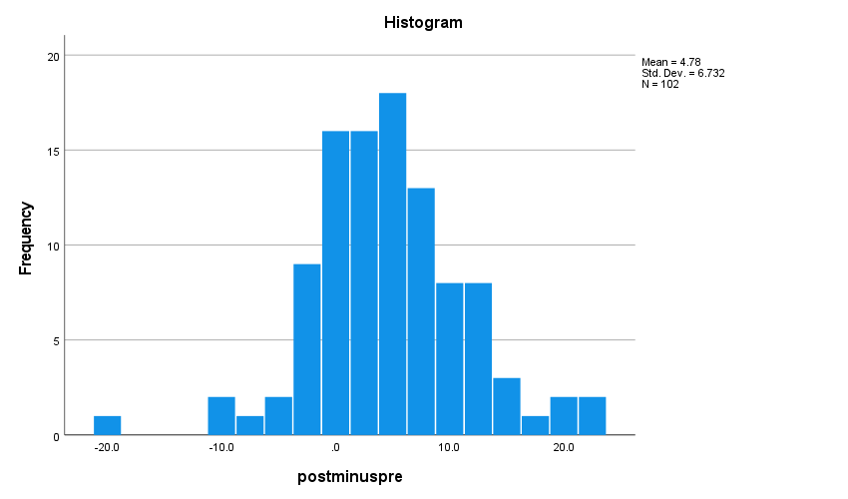
Figure 15: Boxplot of postscore minus prescore data
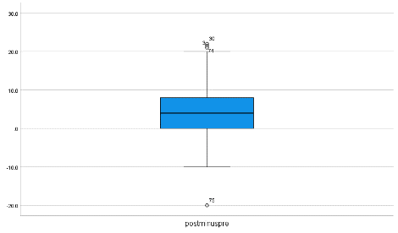
As the data was not normally distributed and the box plot showed four outliers (75, 30, 3 and 74), these participants were checked for errors. Two had missing entries in their prescore data and two had no missing entries. One did have an error in data entry which was corrected. The remaining data was rechecked and correct. Tests were conducted again with the one data point corrected.
Once corrected, the box plot showed the remaining three outliers (30, 3 and 74). Both the skewness and kurtosis were closer to 0 showing the data was now closer to being normally distributed (Skewness=0.239, Kurtosis=0.474). The Kolmogorov-Smirnov test showed the data was normally distributed (s=0.115) when using the 0.05 value. As the data is now normally distributed, the outliers will be kept in the data. See figures 16 and 17 below.
Figure 16: Histogram of postscore minus prescore data
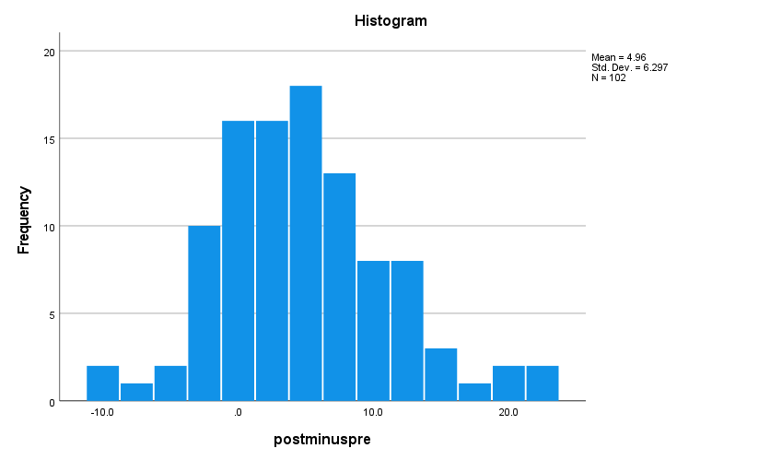
Figure 17: Boxplot of postscore minus prescore data
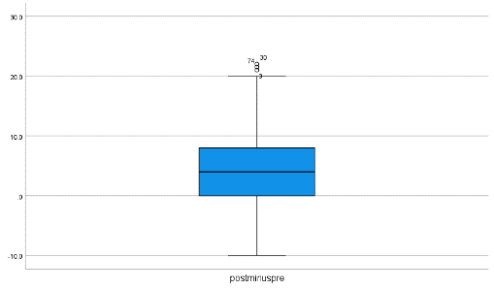
As the data met the assumptions, parametric testing was used. A paired-samples T-test was conducted to evaluate the impact of experiential learning on a child’s CtN. There was a significant difference observed between the prescore (m=79.038, SD=9.7763) and postscore (m=84.054, SD=10.5243). [t(101)=-7.875, p<0.001]. The magnitude of differences in the means was very large (eta squared=-1.59) when using Swalilowsky’s (2009) figure of 1.2 as large and 2.0 as huge.
A one-way repeated measures ANOVA was also conducted to compare a child’s CtN pre-session and post-experiential learning session. The means and standard deviations are presented in table 14. There was a significant effect for time [wilks lambda=<0.001, f(1,101)=62.018, p=<0.001, multivariate partial eta squared=0.380]. Using Cohen’s guidelines which show 0.14 as a large effect, these results show a very large effect.
Table 14- Means and standard deviation of the prescore and postscore data
Paired Samples Statistics
 |  | Mean | N | Std. Deviation | Std. Error Mean
Pair 1 | Prescore | 79.034 | 102 | 9.7763 | .9680
Pair 1 | Postscore | 84.054 | 102 | 10.5243 | 1.0421

Parametric testing showed a significant difference between prescores and postscores with a very large effect size across the whole group of children. This suggests that experiential learning has a large effect on a child’s CtN leading to a significant increase, aligning with the definition presenting CtN as malleable and measurable (Richardson, 2023). Before this can be concluded, we need to explore the impact that any extraneous variables may have had.
4.6 Phase 3: What extraneous variables may have impacted the results?
To explore the potential extraneous variables and their effects, the session leaders completed a qualitative questionnaire, appendix D. Table 15 summarises their responses.
Table 15: The session leaders’ responses
Activities completed | Positive experiences | Negative experiences | Weather | Completion of survey | Anything else
Investigating rivers  Field sketch  Wildlife surveys  OS map work | Tiny crabs – some children were excited and distracted  Sparrow hawk tried but failed to catch a sparrow | Tiny crabs – some children moved away  Dog poo | Warm, bright, sunny | Bright group  Independent completion  Took it seriously  A few questions asked | Behaviour on journey = told off on arrival  Lots of traffic during journey
Pond dipping | Unusual creatures  Learned about what they found | None | Cloudy temperature, 17°c | Some non-English speaking pupils needed help  Questionnaires too long for some pupils | Pupils totally involved  Staff enjoyed pupils being occupied
Discovering birds  Living things and their habitats | Enjoyed bird session, learning about migration  Moisture and light readings in different habitats | One said they could hear the wind and it made them cold | Cloudy, damp from previous night’s rain | Most completed quickly without prompts  3 needed extra support from staff | Lively group  Great basic knowledge of wildlife (more than an average class)  Staff not engaged but didn’t affect the class
Living things in their habitats  Pond dipping | Children engaged and enthusiastic  Sweep netting  Unfamiliar animals  Pond dipping – large backswimmers, fish, big leeches | Some scared of spiders and harvestmen  Worried about pond creatures jumping out of tub  Hot ~27°c especially in the afternoon | Hot ~27°c  Morning was ok with a breeze, after lunch felt pretty hot | Completed at school pre/post – time constraints | One of the best schools  Kids – polite but engaged, respectful of habitats and animals  School -deprived area, activities likely to be new to children, schools first visit  Adults engaged and encouraging with children
Living things in their habitats  Pond dipping | Children enthusiastic about both activities  Loved finding the caprid bugs, leeches and spiders | Very hot and sunny afternoon (28°c)  Little shade | Hot, humid, muggy ~28°c | Arrived late/left early so completed at school  Children were responsive, attentive and very cooperative and knowledgeable | Children – very involved in activities  Adults – fully involved in working with children  Prepared for activities by doing minibeast hunting in school groups and exploring school pond
As the group with a large proportion of non-English speaking pupils struggled to complete the forms (66.67%), more work is needed to further refine the tool and ensure the survey is inclusive and suitable for all children aged 7-11 years in UK schools, with a focus on 2nd language learners. 15.83% of participants had more than 4 data points missing, which suggests that they struggled with answering it too, this study did not collect any data other than the non-English speaking information above.
The table above showed the following extraneous variables to consider:
- Different sessions completed at different sites
- Impact of travel on their pre-score values, e.g., traffic delays
- Impact of teacher ‘telling them off’
- Engagement of school staff
- Background of school and children, e.g., deprived, first vs repeated exposure
- Weather, e.g., too hot, damp, cloudy, cold wind, little shade
- Negative experiences, e.g., dog poo, spiders, harvestmen
Some of the above align with extraneous variables explored in table 4, section 2.5, others were not considered prior to this stage. To explore whether these variables had a significant impact on results, the data was analysed for significant differences between the groups. Box’s test of Equality of covariance matrices showed a significant value of 0.061 which is greater than the 0.001 value, showing a non-significant result, meeting the assumptions needed for parametric testing. A mixed between-within analysis of variance was conducted to compare the prescore and postscore results for each group (the different schools/reserves). The means and standard deviations are displayed in table 16. There was no significant difference between groups, with a Wilks’ Lambda test (S=<0.001, f=0.941). There was a significant difference within groups (s=0.202, f=24.875), with a very large effect size (0.202).
Table 16: Descriptive statistics for the prescore and postscore data across the different sites
Descriptive Statistics
 | Site | Mean | Std. Deviation | N
Prescore | 1 | 76.045 | 11.9810 | 22
Prescore | 2 | 74.333 | 11.2190 | 6
Prescore | 3 | 82.457 | 9.3722 | 23
Prescore | 4 | 79.333 | 8.3353 | 51
Prescore | Total | 79.034 | 9.7763 | 102
Postscore | 1 | 81.909 | 13.7630 | 22
Postscore | 2 | 75.333 | 15.4229 | 6
Postscore | 3 | 87.196 | 10.1542 | 23
Postscore | 4 | 84.588 | 7.6842 | 51
Postscore | Total | 84.054 | 10.5243 | 102

We also investigated whether there was a significant difference between the year groups. Box’s test of Equality of covariance matrices showed a significant value of 0.002 which is greater than the 0.001 value, showing a non-significant result, meeting the assumptions needed for parametric testing. A mixed between-within analysis of variance was conducted to compare the prescore and postscore results for each group (year 4 and 6). The means and standard deviations are displayed in table 17. There was no significant difference between groups, with a Wilks’ Lambda test (S=0.714, f=0.135). There was a significant difference within groups (s=<0.001, f=61.487), with a very large effect size (0.202).
Table 17: Descriptive statistics for the prescore and postscore data across the different years
Descriptive Statistics
 | Year | Mean | Std. Deviation | N
Prescore | 4 | 79.333 | 8.3353 | 51
Prescore | 6 | 78.735 | 11.1087 | 51
Prescore | Total | 79.034 | 9.7763 | 102
Postscore | 4 | 84.588 | 7.6842 | 51
Postscore | 6 | 83.520 | 12.8105 | 51
Postscore | Total | 84.054 | 10.5243 | 102

As there was no significant difference found between the groups and year groups, we found no significant impact caused by these extraneous variables in this study, although further studies focused on these specifically will allow a more accurate conclusion of impact.
4.7 Phase 3: How does experiential learning impact the different sub-sections?
To explore the impact of experiential learning on the different pathways, including action, pre-post data was tested. As the data was shown not to be normally distributed, non-parametric testing was used (all subgroups had a Kolmogorov-Smirnov s=<0.001). The figures below show the distribution of data.
Figure 18: Comparing the pre and post histograms for each sub-section
Beauty | 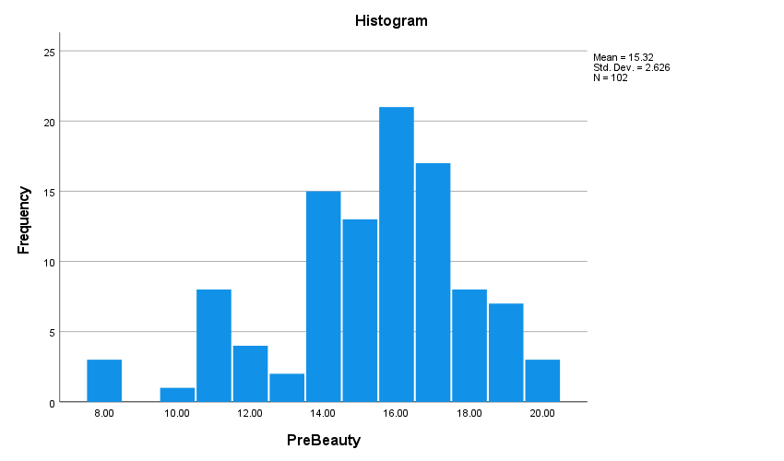 | 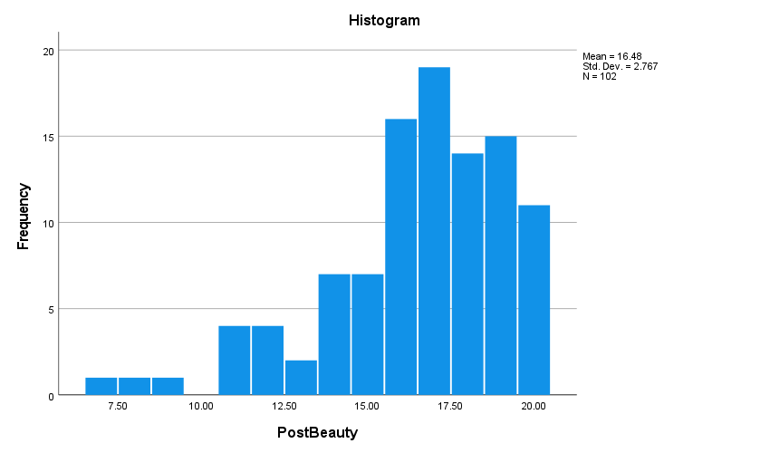
Meaning | 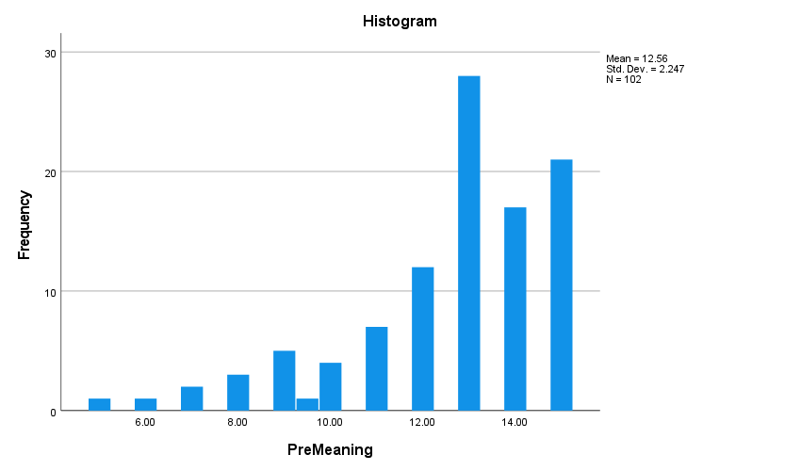 | 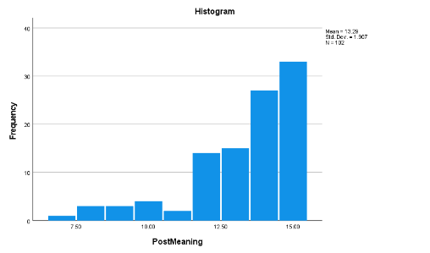
Compassion | 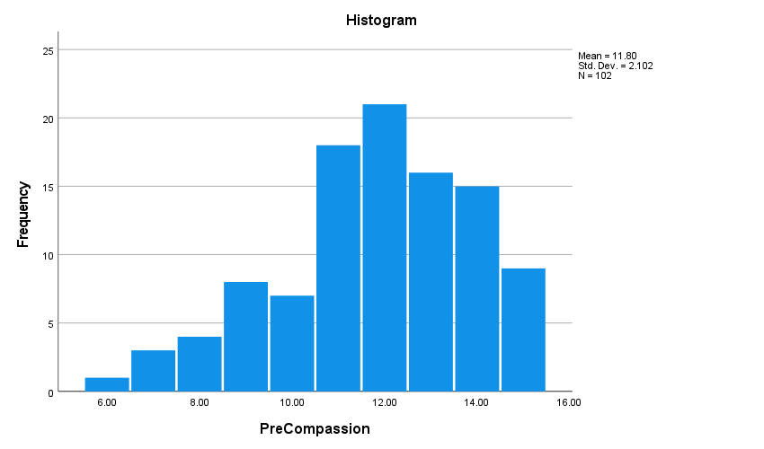 | 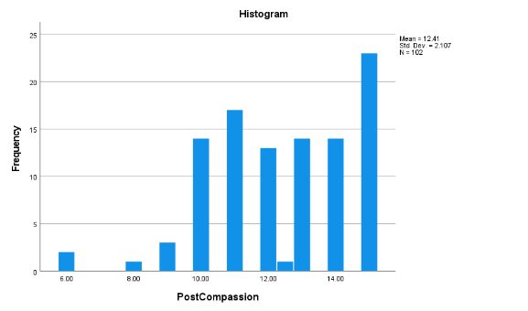
Emotion | 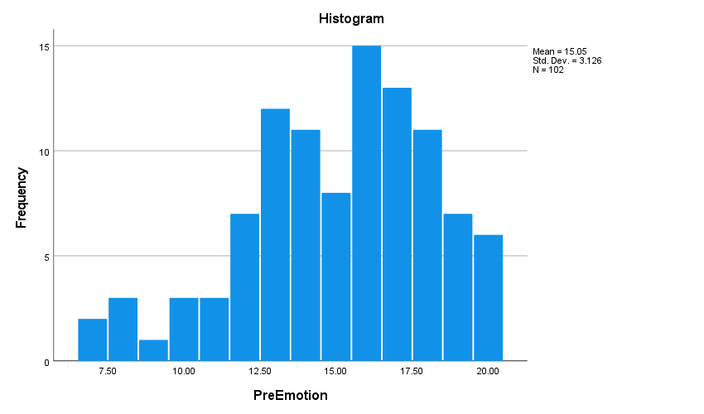 | 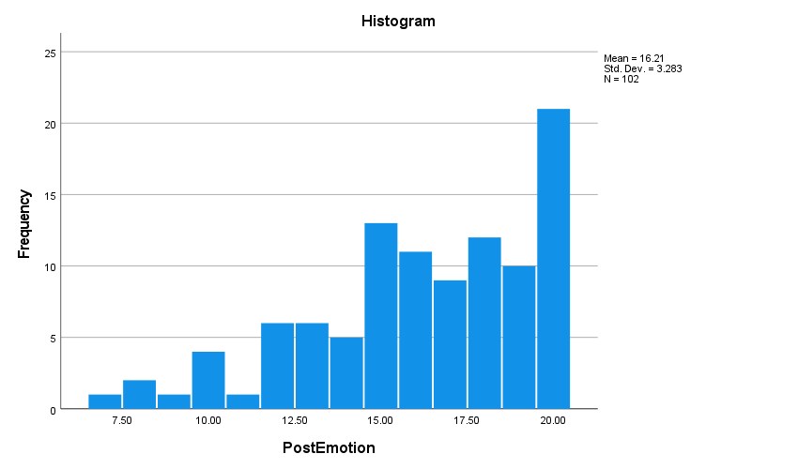
Contact | 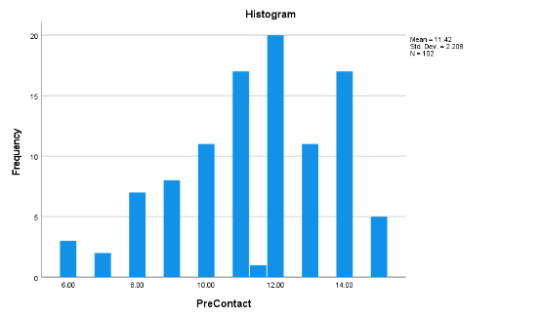 | 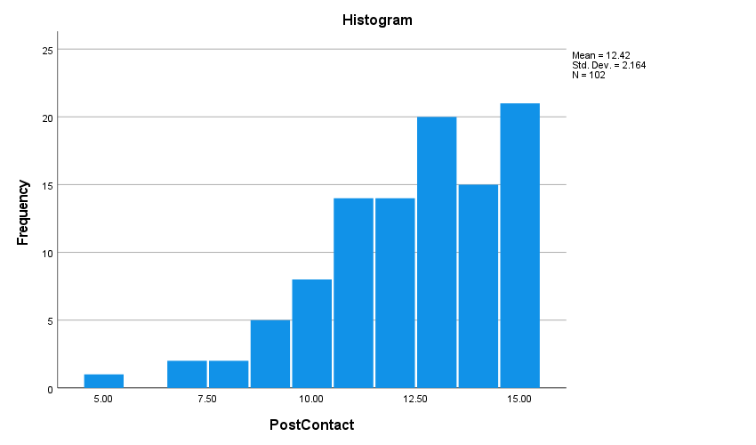
Action | 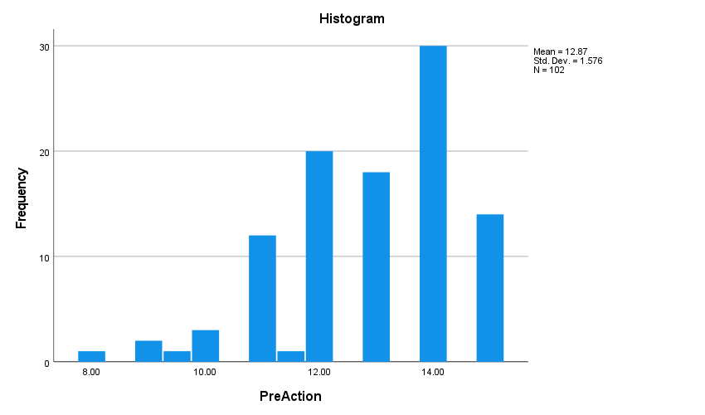 | 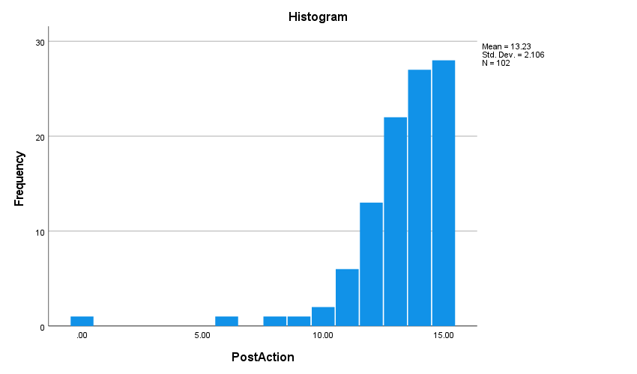

The above figures show all pre-scores began skewed to the right, but also following the experiential learning experience that they all moved more to the right. The sub-section ‘meaning’ was the least normally distributed data of them all, this suggests that these questions may benefit from being checked independently or that this group of children were more positive with their responses than an average population.
A Wilcoxon Signed Rank test was completed to explore whether the median differences between pre-subgroup and post-subgroup equalled 0. Table 18 shows that the null hypothesis was rejected for all the sub-sections, meaning that there was a difference between the pre and post scores.

Table 18: Wilcoxon signed rank test for each sub-sections prescore and postscore.
Subgroup | Null hypothesis | Significance (the significance level is 0.05) | Decision
Beauty | The median of differences between PreBeauty and PostBeauty equals 0. | <0.001 | Reject the null hypothesis.
Meaning | The median of differences between PreMeaning and PostMeaning equals 0. | <.001 | Reject the null hypothesis.
Compassion | The median of differences between PreCompassion and PostCompassion equals 0. | .013 | Reject the null hypothesis.
Emotion | The median of differences between PreEmotion and PostEmotion equals 0. | <.001 | Reject the null hypothesis.
Contact | The median of differences between PreContact and PostContact equals 0. | <.001 | Reject the null hypothesis.
Action | The median of differences between PreAction and PostAction equals 0. | .004 | Reject the null hypothesis.

A Mann Whitney test was used to test whether the distribution of post minus pre scores for each category were the same across both year 4 and year 6. Table 19shows that the subsections were the same across the year groups, suggesting year group or age had no significant impact on the scores in the different sections.

Table 19: Mann Whitney test on the distribution of post minus pre scores for each sub-section for the different year groups
Subgroup | Null hypothesis | Significance (the significance level is 0.05) | Decision
Beauty | The distribution of PminusPBe is the same across categories of Year. | .535 | Retain the null hypothesis. | 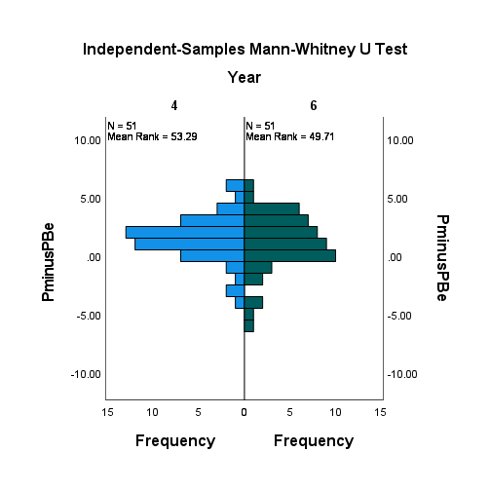
Meaning | The distribution of PminPMean is the same across categories of Year. | .884 | Retain the null hypothesis. | 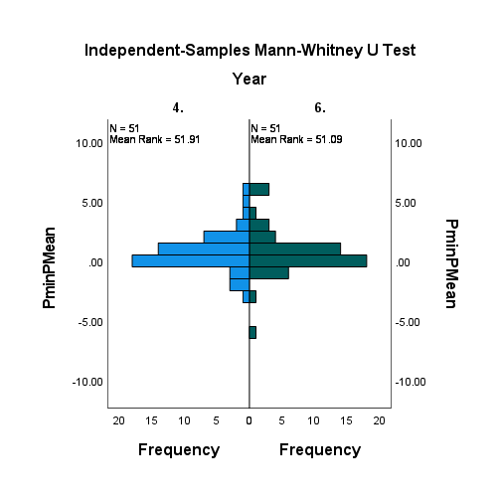
Compassion | The distribution of PminPCompa is the same across categories of Year. | .637 | Retain the null hypothesis. | 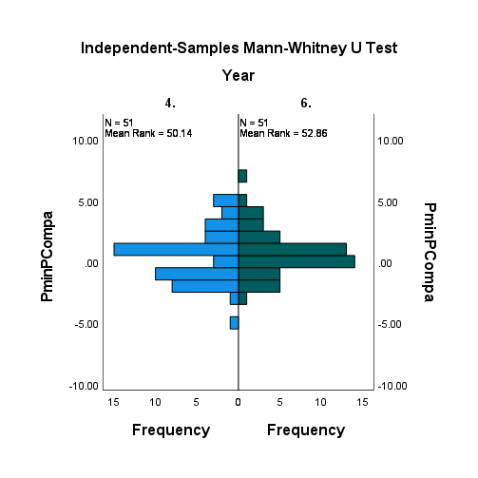
Emotion | The distribution of PminPEm is the same across categories of Year. | .201 | Retain the null hypothesis. | 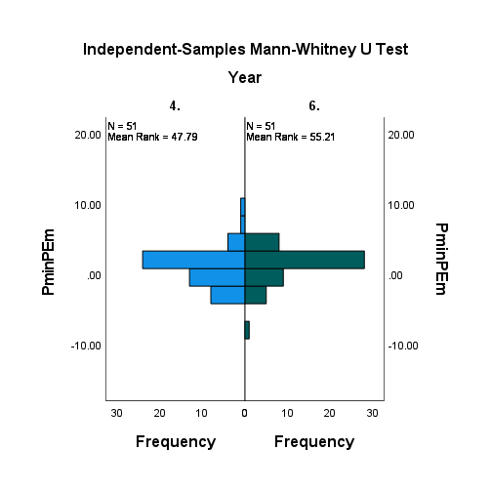
Contact | The distribution of PminPCont is the same across categories of Year. | 1.000 | Retain the null hypothesis. | 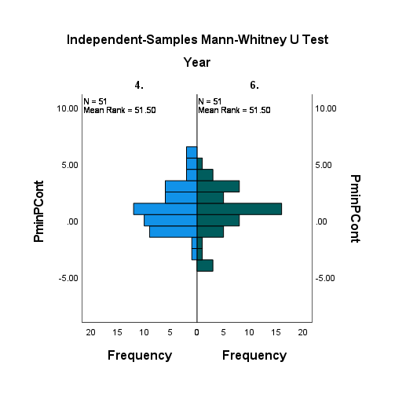
Action | The distribution of PminPAct is the same across categories of Year. | .403 | Retain the null hypothesis. | 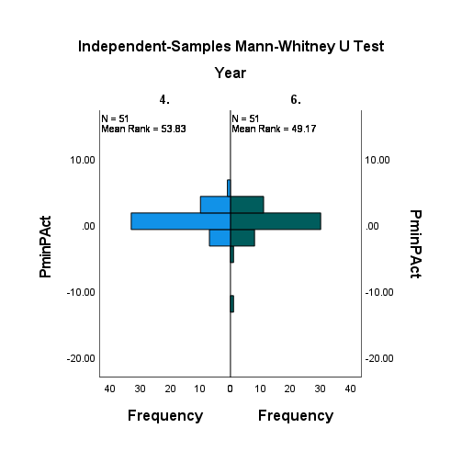

A Mann Whitney test was used to test whether the distribution of post minus pre scores for each category were the same across the different groups (i.e., sites/reserves). Table 20 shows that the subsections were the same across the different groups, suggesting year group or age had no significant impact on the scores in the different sections.

Table 20: Mann Whitney test on the distribution of post minus pre scores for each sub-sections for the different groups
Subgroup | Null hypothesis | Significance (the significance level is 0.05) | Decision
Beauty | The distribution of PminusPBe is the same across categories of Site. | .638 | Retain the null hypothesis. | 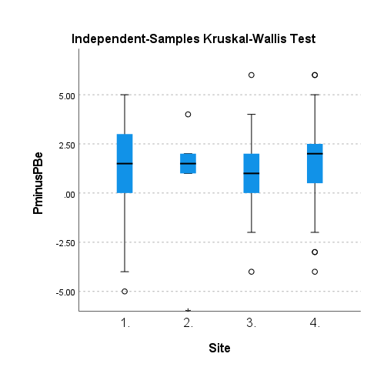
Meaning | The distribution of PminPMean is the same across categories of Site. | .935 | Retain the null hypothesis. | 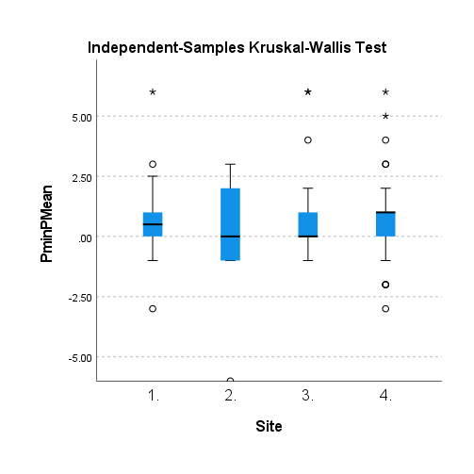
Compassion | The distribution of PminPCompa is the same across categories of Site. | .678 | Retain the null hypothesis. | 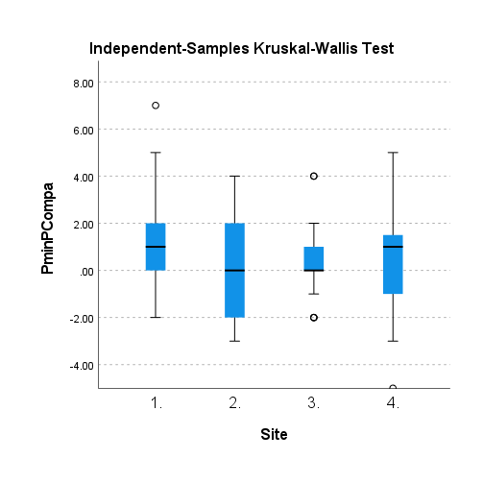
Emotion | The distribution of PminPEm is the same across categories of Site. | .623 | Retain the null hypothesis. | 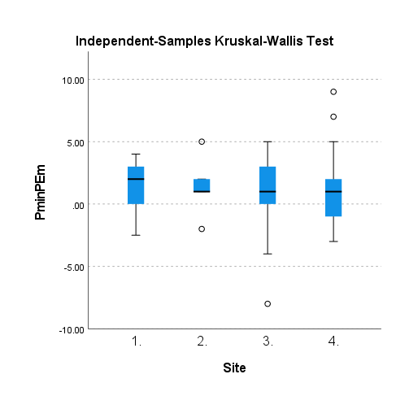
Contact | The distribution of PminPCont is the same across categories of Site. | .965 | Retain the null hypothesis. | 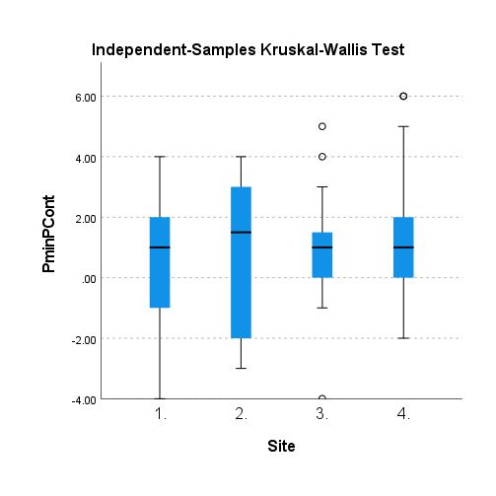
Action | The distribution of PminPAct is the same across categories of Site. | .700 | Retain the null hypothesis. | 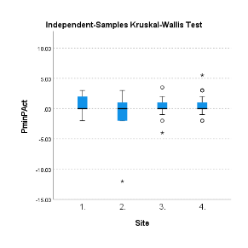

A Friedman two-way analysis of variance by ranks test was conducted to check whether the distributions of pre-minus-post scores for each sub-section were the same. It showed that they were not the same (s=<0.001). Figures below show the differences seen.
Figure 19: Related-samples Friedman’s two-way analysis of variance by ranks 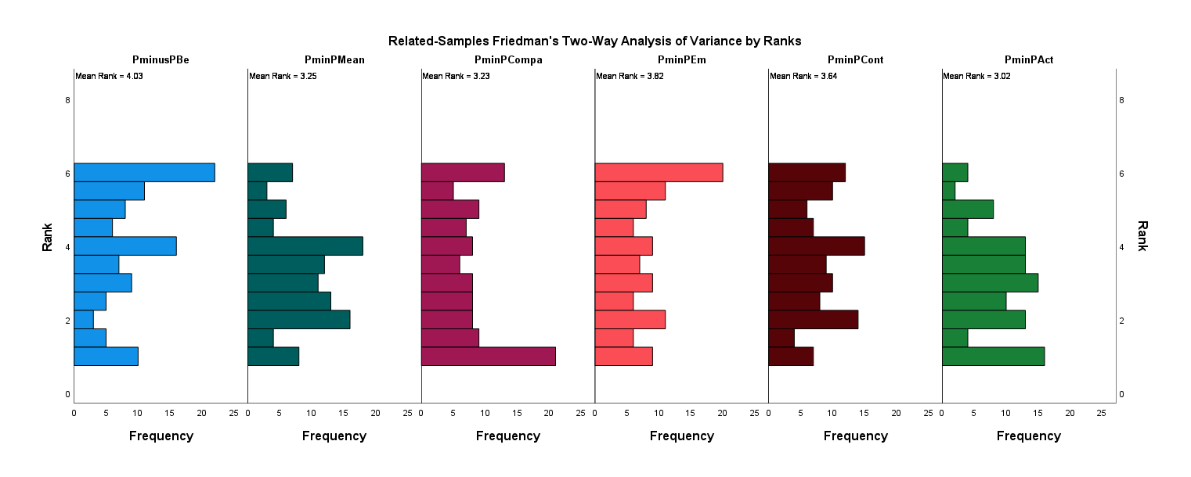
As detailed in section 4.5, parametric testing showed a significant difference between prescores and postscores with a very large effect size across the whole group of children. This suggested that experiential learning has a large effect on a child’s CtN leading to a significant increase. It also suggests that the measurement tool is measuring a change in a child’s CtN state. This shows this tool is effective for measuring a child’s CtN state, which most current tools (Table 8, section 4.1) do not claim to measure. Further research should be done to strengthen this. This tool could be a strong addition to evaluation methods used in a variety of conservation interventions aimed at children aged 7-11 years, including those participating in the National Education Nature Park programme (Natural History Museum, 2023), with the ability to show an increase in CtN and therefore the likelihood of increased future PEBs (Richardson and Chapple, 2021; Otto and Pensini, 2017).
Section 4.7 has shown, through non-parametric testing, that there was a significant difference between the prescores and postscores in each sub-section of the questionnaire, showing that all sub-sections measured a change in state CtN. This aligns with table 2, section 2.3.1, which shows beauty, emotion and CtN increasing as part of the theory of change for SoR and experiential learning theory. It also showed that there was no significant difference caused by the extraneous variables of age, year group, reserve location, weather, sessions completed or session leaders, by comparing the prescore minus postscore data for year 4 and 6 as well as the four different reserves.

Chapter 5
Conclusion
5.1 Introduction
This study aimed to creature a measurement tool which can measure the state of a child’s CtN and to use the tool to investigate how experiential learning impacts a child’s CtN. These aims enabled the research question ‘how does experiential learning impact a child’s CtN?’ to be answered. The following four objectives outline the process used to achieve the above:
- Creation of a measurement tool through analysis of current tools available during a literature review in combination with an online survey with staff members involved in experiential learning.
- Evaluation and improvement of tool through parent-led interviews with children.
- Comparison of child’s CtN scores pre- and post- experiential learning experience to explore the impact.
- Consideration of extraneous variables and their impact on CtN scores.
This chapter will consider each objective, addressing how they were met through literature review (Chapter 2) and data analysis (Chapter 4). It will then consider strengths and limitations of the study, before sharing recommendations around future work. Finally, it will conclude with a self-reflection from the researcher.

5.2 Research Objectives: Summary of Findings and Conclusions
Through a review of literature, 14 measurement tools were considered for their suitability for children and CtN state measure, with 4 utilised in the new tool. Descriptive analysis of 5 RSPB staff/volunteers and the researchers’ thoughts enabled the reduction of statements from 140 to 20, based on child suitability and likelihood of experiential learning experiences impacting them. The remaining number of statements were found to be suitable for children aged 7 to 11 and likely to be impacted by experiential learning such as that offered in school and reserve sessions. In conclusion, objective one found there were several CtN measurement tools available for adults CtN state and trait measurement, a few for children's trait measurement but barely any for child CtN state. This aligns with what table 5 previously stated. Analysis of literature and surveys collated the 20 suitable statements for the new tool (appendix A).
One parent-led interview showed that the measurement tool was understand by an 8-year-old girl. It found that she scored them highly, even when she expressed something opposing this verbally, this led to careful consideration of phase 3 participants who scored high during the pre-questionnaire, to consider impact of scoring higher to please or due to peer expectations. She also chose her favourite statements for sub-section ‘emotion’, with well explained reasoning for her choices. Due to timing issues, this study used different statements, so these could be used in future research instead. In conclusion, objective 2 confirmed the appropriateness of the statements for a child’s understanding but raised the need for awareness of bias in answers.
Pre- post- data was collected from 102 primary school children attending SoR sessions between July and September 2022, via the new measurement tool. Through parametric testing, a one-way repeated measures ANOVA, a significant difference between the pre and post questionnaire scores with a large effect size was found. The comparison of the means showed an increase in CtN following the experiential learning experience. In conclusion, experiential learning had a significant impact on a child's CtN, leading to an increase in CtN following an outdoor learning session.
Analysis of literature showed that location, time, prior knowledge, covid-19 and learning styles could impact CtN (Chan, 2012; Giusti et al, 2018; Friedman et al, 2021; Dunn, Beaudry and Klavas, 1989). Thematic analysis of session leader’s questionnaires complemented this data, sharing that time of session, location and prior knowledge were experienced differently between groups. It also showed differences between weather, negative and positive experiences. Non-parametric testing found no significant differences between the reserve groups or the year groups. Therefore, it is suggested that there were no significant differences caused by any of the extraneous variables mentioned. In conclusion, there was no evidence of extraneous variables impacting the data, with no significant difference found between the year groups (four and six), or the four reserve groups, therefore experiential learning led to a significant difference between pre/post CtN data, with a positive increase in CtN, regardless of age or location.

5.3 Strengths and limitations
Using a multi-paradigm approach and a mixed method design was a strength of this study. Blaikie and Priest (2017) explained that a multi-paradigm approach enables the counteraction of each paradigm’s limitations. As well as this, it enabled this study to use both retroductive and deductive logic as needed for the different stages.
Non-probability sampling and the sample sizes proved challenging and therefore as a limitation of this study. As the RSPB staff/volunteer participants were recruited via an e-mail, we only got an opinion from those who were interested in the content. In phase 1, this had little negative impact, and may actually be a strength: the participants were knowledgeable in the field of experiential outdoor learning and/or children, therefore enabling accurate responses. With phase 3, reserves who opted in may be those who are more confident with delivery, therefore leading to only a partial representation of delivery across the SoR programme. A larger sample for phase 2 and 3 from across more reserves and countries, would have given more generalisable results (Muthen and Muthen, 2002; Francis et al, 2010; Burmeister and Aitken, 2012).
The creation of a new tool could be seen as a limitation, although the thorough steps used to collate it counterbalance this. 75% statements come from recognised CtN measurement tools, with the remaining 25% being adopted from current tools to make them child friendly. It was created using input from six people and evaluated by one child. All these steps help to ensure it is suitable and reliable. However, when utilised in phase 3, a significant proportion of 2nd language English speaking children could not complete the questionnaire in the time frame they were given. This suggests that the tool is suitable for children with an English reading ability of aged 7+, but not for those with a lower reading age, especially if English is not their first language. A future study could be completed to refine the tool for suitability for 2nd language learners and younger learners.

5.4 Recommendations
Further studies could be completed to prove the validity and reliability of this new tool. Increasing the sample size but also recruiting from wider than the RSPB SoR programme and potentially involving a control group to explore the naturally changing CtN.
Another recommendation would be to use the tool in a longitudinal study, to build a true picture of how long the CtN change lasts. This could also build in data collection around PEB to explore whether the CtN increase shown with this tool impacts future PEB.
A final recommendation is to try this across different countries and locations to consider its effectiveness with different racial and cultural influences, with a further focus of refining the tool’s suitable for those with an English reading level below age 7, specifically English as an additional language learners.

5.5 Self Reflection
The content and awareness of the need for this study arose from the researcher working for the RSPB, being able to link work and study together has been valuable to spark interest in the area but also to see it’s potential for use in the ‘real world’. It has been a long process due to recruitment challenges and timeline changes, partially linked to COVID-19. It wouldn't be true to say there has been no dip in motivation, so it is a sense of great achievement and relief as it nears completion. Having the ability to tap into support networks at work and at university was important to the successful completion of this work: being able to understand the slight discrepancies between study and work. Overall moving through this process has enabled the researcher to grow as a researcher, having a much broader understanding of the literature behind the details used at work, and a greater understanding of parametric and non-parametric testing. The study sits within the gap shown in the workplace but also literature, enabling it to be useful for future research and evaluations.

15,462 words
Reference List
ActionAid (2023). Climate change and flooding. Available at: https://www.actionaid.org.uk/our-work/emergencies-disasters-humanitarian-response/climate-change-and-flooding (Accessed: 15th August 2023)
Ajzen, I., (1991) The theory of planned behaviour Organisational behavioural human decision processes 50(2) P.179-211
Aljazeera (2021). Australia’s forest fires fanned by climate crisis: Study. Available at: https://www.aljazeera.com/news/2021/11/29/australias-forest-fires-fanned-by-climate-crisis-study#:~:text=CSIRO%20scientists%20identified%20climate%20change,fuel%20loads%20for%20Australian%20forests (Accessed: 15th August 2023)
Arbib, M. A. (1992). Schema Theory, in S. C. Shapiro (Ed.) The Encyclopaedia of Artificial Intelligence. USA: Wiley-Interscience 1427-43
Archer and Rahmstorf (2012) The Climate Crisis: An Introductory Guide to Climate Change (4th Ed.) USA, New York: Cambridge University Press
Ashworth, J. (2022). Bird flu outbreak devastates UK seabird colonies. Available at: https://www.nhm.ac.uk/discover/news/2022/june/bird-flu-outbreak-devastates-uk-seabird-colonies.html#:~:text=Climate%20change%20has%20been%20suggested,little%20effect%20on%20HPAI%20epidemiology (Accessed: 15th August 2023)
Avis, W. (2016). Methods and approaches to understanding behaviour change in GSDRC Helpdesk Research Report 1. Birmingham, UK: GSDRS, University of Birmingham, P. 389
Avis, W. (2016). Methods and approaches to understanding behaviour change. Available at: https://gsdrc.org/wp-content/uploads/2016/08/HDQ1389.pdf (Accessed: 14th June 2023)
Bandura, A., (2001) Social Cognitive Theory: An agentic perspective. Annual review of psychology 51(1) P.1-26
Barker, S. (2007) Reconnecting with nature, Journal of Biological Education, 41:4, 147-149. Available at: https://www.tandfonline.com/doi/abs/10.1080/00219266.2007.9656089 (Accessed: 12th August 2023)
Barrable, A., and Booth, D., (2020) Increasing Nature Connection in Children: A Mini Review of Interventions. Frontiers Psychology 11(?) pages? Available at: https://www.frontiersin.org/articles/10.3389/fpsyg.2020.00492/full (Accessed:12th August 2023)
Bartlett, F. C. (1995). Remembering: A study in Experimental and Social Psychology. 2nd Edition. England: Cambridge University Press

Bazeley, P. (2004). Issues in Mixing Qualitative and Quantitative Approaches to Research, in R. Buber, J. Gardner, and L. Richards (eds) Applying qualitative methods to marketing management research. UK: Palgrave Macmillan, 141-156

Beard, C., and Wilson, J., (2002) The power of experiential learning: A handbook for trainers and educators. UK: Kogan Page

Beery, T., (2001) Nordic in nature: Friluftsliv and environmental connectedness. Environmental Education Research 19(1) P.94-117

Beisser, A., (1970) The paradoxical theory of change. Gestalt therapy now 1(1) P.77-80

Bergensteiner, H., Avery, G., and Neumann, R., (2010) Kolb’s experiential learning model: critique from a modelling perspective. Studies in continuing education 31(1) P.29-46

Berkes, F., (2004) Rethinking Community-Based Conservation. Conservation Biology 18(3) P.621-630

Berkes, F., Folke, C., and Colding, J., (2000) Linking social and ecological systems: management practices and social mechanisms for building resilience. UK: Cambridge University Press

Biggam, J., (2021) Succeeding with your master’s dissertation. (5th Ed) England: Open University Press

Birch, J., Rishbeth, C. and Payne, S.R., 2020. Nature doesn't judge you–how urban nature supports young people's mental health and wellbeing in a diverse UK city. Health & Place, 62, p.102296.

Blaikie, N., and Priest, J., (2017) Social Research: Paradigms in action. Cambridge: Polity Press

Blankenship, J., (2023) 10 reasons to prove that climate change is a hoax. Available at: https://www.lootpress.com/10-reasons-to-prove-that-climate-change-is-a-hoax/ (Accessed: 23rd September 2023

Boase, T (2023) How did the RSPB start – and who were the women who founded it? Available at: https://www.discoverwildlife.com/people/rspb-history (accessed: 23rd September 2023)

Bradshaw, G., and Bekoff, M., (2001) Ecology and social responsibility: The re-embodiment of science trends. Ecology and Evolution 16(8) P. 460-465

Bragg et al (2013) Measuring Connection to Nature in children aged 8-12: A robust methodology for the RSPB [online] RSPB and The University of Essex [Accessed: 09/11/2020] Available from: http://rackspace-web1.rspb.org.uk/Images/methodology-report_tcm9-354606.pdf
Broom, C. (2017) Exploring the Relations Between Childhood Experiences in Nature and Young Adult’s Environmental Attitudes and Behaviours. Australian Journal of Environmental Education. 33(1) 34-47

Burleson, S., ad Thoron, A., (2014) Maslow’s hierarchy of needs and its relation to learning and achievement. Available at: http://knowen-production.s3.amazonaws.com/uploads/attachment/file/2007/Maslow_E2_80_99s%2BHierarchy%2Bof%2BNeeds%2Band%2BIts%2BRelation%2Bto%2BLearning.pdf (Accessed: 12th August 2023)

Burmeister, E., and Aitken, L., (2012) Sample size: How many is enough? Australian Critical Care 25(4) P.271-274

CACE (2020) History of Climate Emergency Actions by Councils [online] CACE [Viewed: 09/11/2020] Available from: https://www.caceonline.org/history.html#

Cambridge Conservation Initiative (CCI) (2019) RSPB Available at: https://www.cambridgeconservation.org/about/partners/rspb/ (Accessed: 12th September 2023)

Capaldi, C., Dopko, R., and Zelenski, J., (2014) The relationship between nature connectedness and happiness: a meta-analysis. Frontiers Psychology 5(1) P.976

Capaldi, C., Passmore, H., Nisbet, E., Zelenski, J., and Dopko, R., (2015) Flourishing in nature: A review of the benefits of connecting with nature and its application as a wellbeing intervention. International Journal of Wellbeing, 5(4), 1-16 Available at: https://www.internationaljournalofwellbeing.org/index.php/ijow/article/view/449/509 (Accessed: 12th August 2023)

Carbon Disclosure Project (CDP) (2023) Protecting people and the planet. Available at: https://www.cdp.net/en/research/global-reports/protecting-people-and-the-planet (Accessed: date)

Carr V. and Hughes J., (2020) Development of ENACT (Evaluating Nature Activities for Connection Tool). Submitted 2020

Chambers, R., Petsch, P., Upoff, N., Ravillion, M., Bourguigon, F., Sahn, D., Moser, C., Barrett, C., Booth, D., Rao, V., and Christiansen, L., (2001) Qualitative and quantitative poverty appraisal: Complementarities, tensions and the way forward

Chan, C., (2012) Exploring an experiential learning project through Kolb’s learning theory using a qualitative research method. European Journal of Engineering Education 37(4) P.405-415

Chen et al (2013) Understanding Biophilia leisure as facilitating well-being and the environment: an examination of participants’ attitudes toward horticultural activity. Leisure sciences [online] 35(1) 301-319 [Viewed: 28/02/2020] Available from: DOI 10.1080/01490400.2013.797323

Chenail, R., (2011) Interviewing the investigator: strategies for addressing instrumentation and researcher bias. Concerns in qualitative research. The qualitative repent 16(1) P.255-262

Cheng and Monroe, (2012) Connection to nature: Children’s affective attitude toward nature. Environment and behaviour [online] 44(1) 31-49 [Viewed: 28/02/2020] Available at: DOI 10.1177/0013916510385082

Cho Y. and Lee D., (2018) ‘Love honey, hate honeybees’: revising biophilia of elementary school students through environmental education program. Environmental Educational research [online] 24(3) 445-446 [viewed: 28/02/2020] Available from: https://doi.org/10.1080/13504622.2017.1279277

Chomolova, K. (2015) Experiential learning: Breaking down the learning cycle [online] The report by class central [Viewed: 04.10.2020] Available from: https://www.classcentral.com/report/experiential-learning/

Cincera, J., Johnson, B., and Kroufek, R., (2020) Outdoor environmental education programme leader’s theories of experiential learning. Cambridge Journal of Education 50(6) P.729-745

Clayton S. and Opotow S., (2003) Introduction: identity and the natural environment. Identity and the environment the psychological significance of nature 1 -24

Climate Wise, (2022) Climate change timeline Available at: https://climate-wise.com/news-and-articles/climate-change-a-timeline/ (Accessed: 12th May 2023)
Clowney D., (2013) Biophilia as an environmental virtue. J Agricultural Environmental Ethics [online] 26(1) 999-1014 [Viewed: 28/02/2020] Available at: DOI 10.1007/s10806-013-9-437-z
Communication for Governance and Accountability Program (CommGAP) (N.D.) Themes of behavior change Available at: https://assets.publishing.service.gov.uk/media/57a08b4bed915d622c000bfd/BehaviorChangeweb.pdf (Accessed: date)

Community Conservation (N.D) What is community conservation? Available at: https://communityconservation.org/our-work/what-is-community-conservation/#:~:text=THE%20PERFECT%20EXAMPLE,(locally%20known%20as%20baboons). (Accessed: 23rd September 2023)

Connell, J., and Kubisch, A., (1998) Applying a theory of change approach to the evaluation of comprehensive community initiatives: progress, prospects and problems. New approaches to evaluating community initiatives 2(15-44) P.1-16

Cook, C., (2022) The HOAX of “Climate Change”. Available at: https://royalexaminer.com/the-hoax-of-climate-change/ (Accessed: 23rd September 2023)

Council of Europe (2020) Our world, ourselves: using human rights to protect the planet. Available at: https://human-rights-channel.coe.int/protect-planet-en.html (Accessed: 12th July 2023)

Creswell, J., and Poth, C., (2018) Qualitative inquiry and research design: choosing among five approaches, 4th Ed. USA: SAGE publications

Crotty, M.J., 1998. The foundations of social research: Meaning and perspective in the research process. The foundations of social research, pp.1-256.

Darebin (2016) Minutes of the council meetings [pdf] Darebin [Viewed: 09/11/2020]

Dasgupta, P., (2008) Discounting Climate Change. Journal of risk and uncertainty. 37(1) P.141-169

Davis, A., Wombach, K., Nelson, E., Odar, C., Lillis, T., McKinley, A., and Gallagher, M., (2014) Health behaviour change in pregnant women: a two-phase study. Telemedicine and e-health 20(12) P.1165-1169

De Young, R., (1993) Changing behavior and making it stick: The conceptualisation and management of conservation behavior. Environmental and behavior 25(3) P. 485-505

Denchak, M., (2019) Flooding and Climate Change: Everything You Need to Know. NRDC, 10th April Available at: https://www.nrdc.org/stories/flooding-and-climate-change-everything-you-need-know#facts (Accessed: 15th June 2023)

Diaz S., Demissew, S., Joly, C., Lonsdale, W., and Larigauderie, A., (2015) A rosetta stone for nature’s benefits to people. PLoS Biology 13(1) 1002040

DiChristopher, T., (2017) Murray Energy CEO claims global warming is a hoax, says 4,000 scientists tell him so. Available at: https://www.cnbc.com/2017/02/17/murray-energy-ceo-claims-global-warming-is-a-hoax.html (Accessed: 23rd September 2023)

Dunlap, R. Van Liere, K., Mertig, A., and Jones, R., (2002) New trends in measuring environmental attitudes: Measuring endorsement of the new ecological paradigm: A revised NEP scale. Journal of social issues 56(3) P.425-442

Dunn, R., Beaudy, J., and Klavas, A., (1989) Survey of research on learning styles Education leadership 46(6) P.50-58

Dutcher, D., Finley, J., Luloff, A., and Johnson, J., (2007) Connecting with nature as a measure of environmental values. Environment and Behavior 39(4) P. 474-493

Earthwatch Europe (2022) Nature connection: a transformational change Available at: https://earthwatch.org.uk/news/blogs/573-nature-connection-a-transformational-change#:~:text=The%20answer%20is%20simple%3A%20when,strongest%20predictor%20of%20ecological%20behaviour. (Accessed: 13th June 2023)

Ernst, J. and Theimer, S. (2011) Evaluating the effects of environmental education programming on connectedness to nature, Environmental Education Research, 17(5), 577-598,

Fernham, A., (1999) Beat system resistance: Think backwards for successful system implementation. Human Resources London P.83-83
Floyd, J., and Fowler Jr. (2014) Survey Research Methods 5th Ed. USA: SAGE Publications

Foley, J., (2017) Living by the lessons of the planet. Science 356(6335) P. 251-252

Ford, J.D., Zavaleta-Cortijo, C., Ainembabazi, T., Anza-Ramirez, C., Arotoma-Rojas, I., Bezerra, J., Chicmana-Zapata, V., Galappaththi, E.K., Hangula, M., Kazaana, C. and Lwasa, S., (2022). Interactions between climate and COVID-19. The Lancet Planetary Health, 6(10), pp.825-833.

Francis, J., Johnston, M., Robertson, C., Glidewell, L., Entwhistle, V., Eccles, M., and Grimshaw, J., (2010) What is an adequate sample size? Operationalising data saturation for theory-based interview studies. Psychology Health 25(10) P.1129-1245
Frantz, C., and Mayer, F., (2014) The importance of connecting nature in assessing environmental education programs. Stud. Educ. Eval. 41(1) P.85-89
Fridays for Future (2020) Who we are [online] Fridays for Future [Viewed: 09/11/2020} Available from: https://fridaysforfuture.org/what-we-do/who-we-are/

Friedman, S., Imrie, S., Fink, E., Gedikoglu, M., and Hughes, C., (2021) Understanding changes to children’s connections to nature during the covid-19 pandemic and implications for child well-being. People and nature 4(1) P.155-165

Fullan, M and Ballew, A. (2004) Leading in a culture of change, personal action guide and workbook. Jossey Bass. United States of America

Fullan, M., Cuttress, C., & Kilcher, A. (2005). Eight forces for leaders of change. National Staff Development Council, 26(4), 54-64.

Gabriel, Y. and Lang, T., 2006. The unmanageable consumer. Sage.

Gardner, G., (1998) Many climate scientists do not agree that global warming is happening. BMJ 316(7138) P.1164

Geldhof J., Warner D.A., Jennifer K. Finders, Asia A. Thogmartin, Adam Clark, Kelly A. Longway, (2018) Revisiting the utility of retrospective pre-post designs: The need for mixed-method pilot data, Evaluation and Program Planning, [online] 70(1) 83-89 Available from: Revisiting the utility of retrospective pre-post designs: The need for mixed-method pilot data - ScienceDirect

Gilbert, M., Slingenbergh, J., and Xiao, X., (2008) Climate change and avian influenza. Revue Sscientifique et technique (Internaitol office of Epizotics) 27(2) . 459-459

Giusti, M., Svane, U., Raymond, C., and Beery, T., (2018) A framework to assess where and how children connect to nature. Frontiers in psychology 8(1) P.2283-2283

Gokturk, E., (2005) What is “paradigm” Available at: http:/heim.ifi.kio.no/~erek/essays/paradigm (accessed: date)

Grimwood, B., Gordon, M., and Stevens, Z., (2018). Cultivating nature connection: Instructor narratives of urban outdoor education. Journal of experiential education 41(2) P. 204-219

Guba, E., ad Lincoln, Y., (1994a) Competing paradigms in qualitative research. Handbook of qualitative research 2(163-194) P. 105-105

Guba, E., and Lincoln, Y., (1994b) Paradigmatic controversies, contradictions and emerging confluences. In N.K. Denzin and Y.S. Lincoln (Eds.) The SAGE Handbook of Qualitative Research (3rd Ed.) P.191-216 London: SAGE

Gullone, E., (2000) The biophilia hypothesis and life in the 21st Century: Increasing mental health or increasing pathology? Journal of happiness studies 1(1) P. 293-322

Gupta, S., Rouse, B., and Sarangi, P., (2021) Did climate change influence the emergence, transmission and expression of the covid-19 pandemic? Frontiers in medicine 8(1) P. 769208

Hardeman, W., Johnston, M., Johnston, D., Bonetti, D., Wareham, N., and Kinmonth, A., (2002) Application of the theory of planned behaviour in behaviour change interventions: A systematic review. Psychology and health 17(2) P. 123-158

Hargreaves, T., (2011) Practice-ing behaviour change: Applying social practice theory to pro-environmental behaviour change. Journal of consumer culture 11(1) P. 79-99

Harvey, C. (2022) Fires Doubled Australia’s Carbon Emissions – Ecosystems May Never Soak It Back Up. E&E News, 11th January, Available at: https://www.scientificamerican.com/article/fires-doubled-australias-carbon-emissions-ecosystems-may-never-soak-it-back-up/#:~:text=The%20study%20found%20that%20the,tons%20on%20top%20of%20it (Accessed: 12th June 2023)
Hedin, N., (2010) Experiential learning: Theory and challenge Christian education journal 7(1) P. 107-117

Houghton, J., Callander, B., and Varney, S., (1992) Climate change 1992. Great Britain: University Press, Cambridge

Howell, A., Dopka, R., Passmore, H., and Buro, K., (2011) Nature connectedness: associations with well-being and mindfulness Pers Individ. Dif. 51(1) P.166-171

Humberstone, B., and Prince, H., (2020) Research methods in outdoor studies. UK: Routledge

IPPC (2007) The state of climate change science 2007. Available at: https://books.google.co.uk/books?hl=en&lr=&id=YqXmNrZQwfEC&oi=fnd&pg=PA31&dq=climate+change+&ots=qctyuuVg66&sig=IGq0q7sqLltN_PNRA2TzFhHIrVs&redir_esc=y#v=onepage&q=climate%20change&f=false (Accessed: 3rd September 2023)

IPPC (2022) The evidence is clear: The time for action is now. We can halve emissions by 2030 Available at: https://www.ipcc.ch/2022/04/04/ipcc-ar6-wgiii-pressrelease/ (Accessed: 3rd September 2023)

IPPC (2023) History of the IPCC Available at: https://www.ipcc.ch/about/history/ (Accessed: 3rd September 2023

ITV news (2022) Climate change posing ‘existential threat to human civilisation’ and time is running out. Available at: https://www.lse.ac.uk/granthaminstitute/news/climate-change-posing-existential-threat-to-human-civilisation-and-time-is-running-out/ (Accessed: 28th August 2023)

Jackson, A., and Mazzei, L., (2013) Plugging one text into another: Thinking with theory in qualitative research. Qualitative inquiry 19(4) P.261-271

Johannesson, P., and Perjans, E., (2014) Research strategies and methods. An introduction to design science 1(1) P.39-73

Kahn Jr. P., (2011) Technological nature: Adaption and the future of human life. MIT Press

Kals, Schumacher and Montada (1999) Emotional affinity toward nature as a motivational basis to protect nature. Environment and Behaviour 31(2) 178-202

Kamerbeck, C., (2023) Climate change, hoax or imminent catastrophe? Available from: https://www.dnv.com/article/climate-change-hoax-or-imminent-catastrophe--179622 (Accessed: 23rd September 2023)

Kimchi, J., Polivka, B., and Stevenson, J., (1991) Triangulation Operational Definitions Nursing Research 40(6) P. 364-366
Knight, A., Cowling, R., and Campbell, (2006) An operational model for implementing conservation action. Conservation biology20(2) P. 408-419

Kolb, A., and Kolb, D., (2006) Learning styles and learning spaces: A review of the multidisciplinary application of experiential learning theory in higher education.

Kolb, A., and Kolb, D., (2017) Experiential learning theory as a guide for experiential educators in higher education. Experiential learning and teaching in higher education 1(1) P. 7-44

Kolb, A., and Kolb, D., (2017) The Experiential Educator: Principles and practices of experiential learning. USA: EBLS Press

Kuk, H., and Holst, J., (2018) A dissection of experiential learning theory: Alternative approaches to reflection. Adult learning 29(4) P.150-157

Lahman, M., Geist, M., Rodriguez, K., Gaglia, P., and DeRoche, K., (2011) Culturally responsive relational reflexive ethics in research: The three R’s Qualitative and quantitative: International Journal of Methodology 46(6) P. 1397-1414

Lancswt, (N.D.) Action for nature Available at: https://www.lancswt.org.uk/action-for-nature (Accessed: 1st September 2023)

Lanza, K., Alcazar, M., Chen, B. and Kohl III, H.W., 2023. Connection to nature is associated with social-emotional learning of children. Current Research in Ecological and Social Psychology, 4, p.100083.

Lauri, M., (2011) Triangulation of data analysis techniques. Papers on social representations 20(2) P.34-35

Leary, M. R., Tipsord, J. M., and Tate, E. B. (2008). “Allo-inclusive identity: incorporating the social and natural worlds into one’s sense of self,” in Transcending Self-Interest: Psychological Explorations of the Quiet Ego, eds H. A. Wayment and J. J. Bauer (Washington, DC: American Psychological Association), 137–147. Doi: 10.1037/11771-013

Leather, M., (2018) A critique of “forest school” or something lost in translation. Journal of outdoor and environmental education 21(1) P.5-18

Lengieza, M., and Swim, J., (2021) The paths to connectedness: A review of the antecedents of connectedness to nature Frontiers Psychology 12 (https://doi.org/10.3389/fpsyg.2021.763231)

Lenth, R., (2012) Some practical guidelines for effective sample size determination. The American Statistician 55(3) P. 187-193

Lewis, L., and Williams, C., (1994) Experiential learning: past and present new directions for adult and continuing education 62(1) P. 5-16

Li, D., Luman, Z., Shuang, M., Shuai, S., and Lixia, Z., (2019) What influences an individual’s pro-environmental behavior? A literature review. Resources, conservation and recycling 146(1) P. 28-34

Lieflander, A., Frohlich, G., Bogner, F., and Schultz, P., (2013) Promoting connectedness with nature through environmental education. Environmental education research 19(3) P. 370-384

Liu, Y., Cleary, A., Fielding, K., Murray, Z., and Roiko, A., (2022) Nature connection, pro-environmental behaviours and wellbeing: Understanding and mediating role of nature contact. Landscape and Urban Planning 228(1) Available at: https://www.sciencedirect.com/science/article/abs/pii/S0169204622001992#:~:text=Promoting%20higher%20levels%20of%20pro,Restall%20and%20Conrad%2C%202015) (Accessed: 24th July 2023)

Louv, R., (2008) Last child in the woods: Saving our children from nature-deficit disorder. London: Atlantic Books

Louv, R., (2012) The Nature Principle: Reconnecting with life in a virtual age. New York: Algonquin Books of Chapel Hill

Louv, R., (2017) Vitamin N: The essential guide to a nature-rich life. London: Atlantic Books

Ludwig, D., (2009) The era of management is over. Ecosystems 4(1) P.758-764

Lumber R., Richardson M., and Sheffield D., (2017) Beyond knowing nature: contact, emotion, compassion, meaning, and beauty are pathways to nature connection. PLoS ONE [online] 12(5) [Viewed: 25/02/2020] Available from: https://doi.org/10.13/1/journal.pone.0177186

Lumber, R., Richardson, M., and Sheffield, D., (2018) The seven pathways to nature connectedness: A focus group exploration. Available at: Microsoft Word - The Seven Pathways to Nature Connectedness EEP Submission (dmu.ac.uk) (Accessed: 12th September 2023)

Mackay, C. M., & Schmitt, M. T. (2019). Do people who feel connected to nature do more to protect it? A meta-analysis. Journal of Environmental Psychology, 65 101323.

Mainemetis, C., Boyatzis, R., and Kolb, D., (2002) Learning styles and adaptive flexibility: Testing experiential learning theory. SAGE Journals 33(1) P. 5-33

Malba, K., and Banjo, F., (2023) Shocking photos of extreme weather around the world in 2023 so far https://www.globalcitizen.org/en/content/photos-extreme-weather-events-2023-climate-change/

Mallet, R., (2012) Eco-guilt motivates eco-friendly behavior. Ecopsychology 4(3) P. 223-231

March, J., (2010) The ambiguities of experience. USA: Cornell University Press.

Martin, C., and Czellar, S., (2016) The extended inclusion of nature in self scale. Journal of Environmental Psychology 47(1) P. 181-194

Matrin, L., White, M. P., Hunt, A., Richardson, M., Pahl, S., and Burt, J. (2020) Nature contact, nature connectedness and associations with health, wellbeing and pro-environmental behaviours. Journal of Environmental Psychology, 101389.
Maxwell, J., (2011) Paradigms or toolkits? Philosophical and methodological positions as heuristics for mixed methods research. Midwestern Educational Researcher 24(2) P. 27-30

Mayer et al, (2009) Why is nature beneficial? Environmental and behaviour. [online] 41(5) 607-643 [Viewed: 25/02/2020] Available from: DOI10.11.77/00129165089319745
Mayer S. and Frantz C., (2004) The connection to nature scale: A measure of individuals feelings in connections with nature. Journal of environmental psychology 24(4) 503-515

McAbee, S., Landis, R., and Burke, M., (2017) Inductive reasoning: The promise of big data. Human resource management review 27(2) P. 277-290

McCarthy, M., (2010) Experiential learning theory: From theory to practice. Journal of Business and Economics Research (JBER) 8(5) P. 131-140

McClanahan, T., Cinner, J., Maina, J., Graham, N., Daw, T., Stead, S., Wamukota, A., Brown, K., Ateweberhan, M., Venus, V., and Polunin, N., (2008) Conservation action in a changing climate. Conservation letters 1(2) P. 53-59

McCrone, W., (2002) Law and ethics in mental health and deafness. In V. Guttman (Ed.) Ethics in mental health and deafness (38-51) Washington DC: Gallaudet University Press

McEwan, K., Richardson, M., Sheffield, D., Ferguson, F. J., and Brindley, P. (2019). A Smartphone App for Improving Mental Health through Connecting with Urban Nature. International Journal of Environmental Research and Public health, 16(18), 3373.
Miller, J., (2006) Restoration, reconciliation and reconnecting with nature nearby. Biological Conservation 127(3) 356-361 Available at: https://www.sciencedirect.com/science/article/abs/pii/S0006320705003678?via%3Dihub (Accessed: 14th June 2023)

MIT (2021) Why do some people call climate change an “existential threat”? Available at: https://climate.mit.edu/ask-mit/why-do-some-people-call-climate-change-existential-threat (Accessed: 28th June 2023)

Moore, R., and Wong, H., (1997) Natural learning: The life of an environmental schoolyard. Creating environments for rediscovering nature’s way of teaching. MIG Communications. 800 Hearst Ave. Berkley CA 94710

Moseley, C., Summerford, H., Paschke, M., Parks, C., and Utley, J., (2020) Road to collaboration: Experiential learning theory as a framework for environmental education program development. Applied Environmental Education and Communication 19(3) P. 238-258
Muller, R., (2012) The Conservation of climate-change sceptic. Available at: https://courses.physics.illinois.edu/phys150/sp2017/Muller_NYT_28Jul2012.pdf (Accessed: 23rd September 2023)

Muthein, L., and Muthen, B., (2002) How to use a Monte Carlo study to decide on sample size and determine power. Structural equation modelling 9(4) P. 599-620

Myers, S., (2017) Planetary health: Protecting human health on a rapidly changing planet. The Lancet 390(10114) P. 2860-2868

National History museum, (2023) National Education Nature Park and Climate Action Awards Available at: https://www.nhm.ac.uk/about-us/national-impact/national-education-nature-park-and-climate-action-awards-scheme.html (Accessed 23rd September 2023)

National Trust. (2020). Noticing Nature. Available at: www.nationaltrust.org.uk/features/get-connected-to-nature (Accessed: 15th July 2023)
Nisbet and Zelenski (2013) The NR-6: a new brief measure of nature relatedness. Front. Psychol. 4(813)

Nisbet et al change to Nisbet, E., Zelenski, J., and Murphy, S. (2009) The nature relatedness scale: linking individuals’ connection with nature to environmental concern and behavior. Environ Behav 41(1) P. 715-740

Nisbet, Zelenski and murphy (2008) The Nature relatedness scale Environment and Behaviour 41(5) 715-740

NOAA (2021) Protecting our planet starts with you Available at: https://oceanservice.noaa.gov/ocean/earthday.html (Accessed: 27th August 2023)

Olivos, P., and Aragones, J., (2011) Psychometric properties of the environmental identity scale (EID) Psychology 2(1) P. 65-74

Ord, J., and Leather, M., (2011) The substance beneath the labels of experiential learning: The importance of John Dewey for outdoor education. Journal of outdoor and environmental education 15(1) P.13-23
Orr D., (1993) “Love it or lose it: The coming Biophilia revolution” In the Biophilia Hypothesis 415-440

Otto, S., and Pensini, P. (2017). Nature-based environmental education of children: Environmental knowledge and connectedness to nature, together are related to ecological behaviour. Global Environmental Change, 47, 88-94.
Perkins, H., (2010) Measuring love and care for nature. Journal of environmental psychology 30(4) P.455-463
Piccininni, C., Michaelson, V., Janssen, I., and Pickett, W. (2018). Outdoor play and nature connectedness as potential correlates of internalized mental health symptoms among Canadian adolescents. Preventative Medicine, 112m 168-175.
Pierre, E., (2016) Refusing human being in humanist qualitative inquiry. Qualitative inquiry and global crises 6(1) P. 40-55

Pierrehumbert, R. (2019) There is no Plan B for dealing with the climate crisis. Bulletin of the Atomic Scientists, 75:5, 215-221. Available at: https://www.tandfonline.com/doi/abs/10.1080/00963402.2019.1654255 (Accessed: 23rd August 2023)
Plotkin, B., (2008) Nature and the human soul: Cultivating wholeness and community in a fragmented world. California: New World Library

Pocock, M., Hamlin, I., Christelow, J., Passmore, H., and Richardson, M., (2023) The benefits of citizen science and nature-noticing activities for well-being, nature connectedness, and pro-nature conservation behaviours. British Ecological Society, people and nature 5(2) P. 591-606

Poppell, K., and Monroe, M., (2017) Why is exposure to nature important in early childhood. Available at: https://edis.ifas.ufl.edu/publication/FR394 (Accessed: 15th August 2023)

Porter, S.R. (2004) Pros and cons of paper and electronic surveys, New Directions for Institutional Research [online] 2004(121) 91-97. [Viewed 01/09/2023] Available from: https://doi.org/10.1002/ir.103

Price, E., Maguire, S., Firth, C., Lumber, R., Richardson, M., and Young, R., (2022) Factors associated with nature connectedness in school-aged children. Current research in ecological and social psychology 3(1) P100037

Price, J., and Murnan, J., (2004) Research limitations and the necessity of reporting them. American journal of health education 35(2) P. 66-67

Prins, F.J., Veenman, M.V. and Elshout, J.J., (2006) The impact of intellectual ability and metacognition on learning: New support for the threshold of problematicity theory. Learning and instruction, 16(4), p.374-387

Pritchard, A., Richardson, M., Sheffield, D., and McEwan, K. (2019). The relationship between nature connectedness and eudemonic wellbeing: a meta-analysis. Journal of Happiness Studies, 1-23.
Prochaska, J., and Prochaska, J., (2019) Transtheoretical model Lifestyle medicine 3rd Ed. P.219-228

Prochaska, J., Johnson, S., and Lee, P., (N.D.) Model of behaviour change. The handbook of health behaviour changes p. 59

Renowden, C., Beer, T., and Mata, L., (2022) Exploring integrated ArtScience experiences to foster nature connectedness through head, heart and hand. People and nature 4(2) P. 519-533

Repetto, R., (2008) The climate crisis and the adaptation myth. Available at: https://elischolar.library.yale.edu/cgi/viewcontent.cgi?article=1019&context=fes-pubs (Accessed: 12th July 2023)

Restall B., and Conrad, E., (2015) A literature review of connectedness to nature and its potential for environmental management, Journal of Environmental Management, 159(1) 264-278. Available at: https://www.sciencedirect.com/science/article/abs/pii/S0301479715300748 (Accessed: 13th June 2023)

Richardson M, Lumber, R and Sheffield, D. (2017) Beyond knowing nature: Contact, emotion, compassion, meaning, and beauty are pathways to nature connection. PLoS ONE B12B (5)

Richardson, M., (2023) Nature connectedness. Available at: derby.ac.uk/NCyRG (Accessed: 23rd March 2023)

Richardson, M., and Chapple, P., (2021) Nature and me Available at: http://ncxrg.wp.derby.ac.uk/wp-content/uploads/sites/28/2021/04/NatureMe-Booklet-2021.pdf (Accessed: 23rd March 2023)
Richardson, M., Hunt, A., Kinhds, J., Bragg, R., Fido, D., Petronzi, D., Barbett, L., Clitherow, T. J., and White, M. (2019). An Affective Measure of Nature Connectedness for Children and Adults: Waliation, Performance and Insights. Sustainability, 11(12), 3250.
Richardson, M., Sheffield, D., Harvye, C., and Petronzi, D., (2015) The Impact of Children’s Connection to Nature Available at: https://www.rspb.org.uk/globalassets/downloads/documents/positions/education/the-impact-of-childrens-connection-to-nature.pdf (Accessed: 17th June 2023)

Riley (2022) Timeline of climate change Available from: https://www.britannica.com/story/timeline-of-climate-change (Accessed: 12th June 2023)
Roberts, P., and Priest, H., (2006) Reliability and validity in research Nursing Standard 20(44) P. 41-46

Rosa, C., Profice, C. and Collado, S. (2018). Nature Experiences and Adult’s Self-Reported Pro-Environmental Behaviours: The Role of Connectedness to Nature and Childhood Nature Experiences. Frontiers in Psychology 9(1055) 1-10

Ross, P., and Bibler Zaidi, N., (2019) Limited by our limitations Perspectives on medical education 8(1) P261-264

RSPB (2015). The Impact of Children’s Connection to Nature: A Report for the Royal Society for the Protection of Birds (RSPB). Available online at: https://www.rspb.org.uk/globalassets/downloads/documents/positions/education/the-impact-of-childrens-connection-to-nature.pdf (accessed March 11, 2019).

RSPB (2023a) Browse events. Available at: https://events.rspb.org.uk/browse?filter[tags][0]=362 (Accessed: date)

RSPB (2023b) I Learn
RSPB (2023c) School trips to RSPB reserves Available at https://www.rspb.org.uk/our-work/rspb-news/rspb-news-stories/schools-on-reserves/ (Accessed: 23rd September 2023)

RSPB (N.D.a) Take action for nature in your community Available at: https://www.rspb.org.uk/get-involved/activities/nature-on-your-doorstep/take-action-for-nature-in-your-community/ (accessed: 23rd September 2023)
RSPB (N.D.b) Seven steps to save nature by 2030 Available from: https://www.rspb.org.uk/our-work/rspb-news/rspb-news-stories/seven-steps-to-save-nature-by-2030/ (Accessed: 16th August 2023)

RSPB (N.D.c) Our mission Available at: https://www.rspb.org.uk/about-the-rspb/about-us/our-mission/ (Accessed: 1st September 2023)

RSPB (N.D.d) Climate Change [online] RSPB: Our positions: climate change [Viewed: 29/02/2020] Available from: RSPB.org.uk/our-work/our-positions-and-casework/our-positions/climate-change

Schein, E., (1996) Kurt Lewin’s change theory in the field and in the classroom: Notes toward a model of managed learning. Systems practice 9(1) P. 27-47

Schon, D., (1991) The reflective practitioner: How professionals think in action. USA: Ashgate

Schoonenboom J. and Johnson R., (2017) How to construct a mixed methods research design. Kolner z Soz SozPsychol [online] 69(2) 107-131 [viewed: 29/02/2020] Available from: https://www.ncbi.nlm.nih.gov/pmc/articles/PMC5602001/

Schultz, P. (2000) New environmental theories: Empathizing with nature: The effects of perspective taking on concern for environmental issues. Journal of social issues 56(3) P. 391-406

Schultz, P. (2001) The structure of environmental concern: concern for self, other people, and the biosphere Journal of Environmental Psychology 21(4) 327-339

Schultz, P. (2011) Conservation means behaviour Conservation biology 25(6) P.1080-1083

Schultz, P. and Kaiser, F., (2012) Promoting pro-environmental behaviour Available at: https://academic.oup.com/edited-volume/36322/chapter-abstract/318676493?redirectedFrom=fulltext (Accessed: 12th June 2023)

Schultz, P., (2002) Inclusion with nature: The psychology of human-nature relations. In Psychology of sustainable development (pp. 61-78) Boston, MA: Springer US
Schultz, P., Shriver, C., Tabanico, J., and Khazian, A., (2004) Implicit connections with nature Journal of environmental psychology 24(1) P.31-42

Scwartz, J., (2023) A Brief History of China’s Global Warming Hoax from 1863 to Right Now. Available from: erogjrig (accessed: 23rd September 2023)

Shafie, A., and Maleksaeidi, H., (2020) Pro-environmental behavious of university students: Application of protection motivation theory Global Ecology and Conservation 22(1) P.00908

Sharlanova, V., (2004) Experiential learning Trakia journal of sciences 2(4) P. 36-39

Sharma, G., (2017) Pros and cons of different sampling techniques. International journal of applied research 3(7) P. 749-752

Stern, P., (2005) Understanding individuals’ environmentally significant behaviour Envtl L Rep News and analysis 35(1) P.10785

Stets, J., and Biga, C., (2003) Bringing identity theory into environmental sociology Sociological theory 21(4) 398-423

Stone, D., (1993) Design a questionnaire British Medical Journal 307(6914) P. 1264-1266

Taherdoost, H., (2016) How to design and create an effective survey/questionnaire: A step by step guide. International Journey of Academic Research in Management (IJARM) 5(4) P. 37-41

Thurmond, V., (2001) The point of triangulation. Journal of nursing scholarship 33(3) P.253-258

UK Research and innovation (UKRI) (2021) A brief history of climate change discoveries. Available at: https://www.discover.ukri.org/a-brief-history-of-climate-change-discoveries/index.htm (Accessed: 12th June 2023)

UNCC (2021) Climate Change Leads to More Extreme Weather, but Early Warnings Save Lives Available at: https://unfccc.int/news/climate-change-leads-to-more-extreme-weather-but-early-warnings-save-lives (Accessed: July 13th 2023)

United Nations (2015) Paris Agreement Available at: https://unfccc.int/sites/default/files/english_paris_agreement.pdf (Accessed: 10th August 2023)

United Nations (N.D.) Action for nature Available at: https://www.un.org/en/climatechange/action-nature (Accessed: 10th August 2023)

Usher, R., and Soloman, N., (1999) Experiential learning and the shaping of subjectivity in the workplace. Studies in the education of adults 31(2) P. 155-162

Vikstrom, B., (2009) Master of the universe or the humble servant: How the concept of sustainable development is affecting our understanding of humanity and nature, In Nature, space and the sacred. Bergmann S., (Ed.) 2009 Ashgate Publishing Ltd.

Vining, J., Merrick, M., and Price, E., (2008) The distinction between humans and nature: Human perceptions of connectedness to nature and elements of the natural and unnatural human ecology review 1(1) P. 1-11

Wahyuni, D., (2012) The research design maze: Understanding paradigms, cases, methods and methodologies. Journal of applied management accounting research 10(1) P. 69-80

Weart (2023) The discovery of global warming. Available at: https://history.aip.org/climate/timeline.htm (Accessed: 15th August 2023)

Wells, N. and Lekies, K. (2006) Nature and the Life Course Pathways from Childhood Nature Experiences to Adult Environmentalism. Children, Youth and Environments. 16(1) 1-24
Wells, N.M., 2000. At home with nature: Effects of “greenness” on children’s cognitive functioning. Environment and behavior, 32(6), pp.775-795.

White, R., (2004) Young children’s relationship with nature: It’s importance to children’s development and the earth’s future. White Hutchinson Leisure and Learning groups 16(2) P.1-9

Widmayer, (N.D.) Schema theory: An introduction Available at: https://citeseerx.ist.psu.edu/document?repid=rep1&type=pdf&doi=47b15487db915f62aec7a1f57c6f64c0c1c5234f (Accessed: 15th August 2023)

Wilson E., (1984) Biophilia Cambridge: Harvard University Press

Wojciehowski, M. and Ernst, J. (2018) Creative by Nature: Investigating the Impact of Nature Preschools on Young Children’s Creative Thinking. International Journal of Early Childhood Environmental Education. 6(1) 3-20
Workforgood, 2020 RSPB Available at: https://workforgood.co.uk/charities/rspb/ accessed: 23rd September 2023

Worth, J., (2003) Book review of Greening school grounds: Creating habitats for learning, children, youth and environments 13(2) P. 157-161

WWF (N.D.a) 10 things you can do to help save our planet Available at: https://www.wwf.org.uk/thingsyoucando (accessed: 20th August 2023)

WWF (N.D.b) 10 Myths about climate change. Available at: https://www.wwf.org.uk/updates/here-are-10-myths-about-climate-change (accessed: 23rd September 2023)

Yount, W., (2001) Experiential learning In Anthony, M., (Ed.) Evangelical dictionary of Christian education (276-277) Grand Rapids, MI: Baker Publishing

Zelenski, J. and Nisbet, E., (2014) Happiness and feeling connected: The distinct role of nature relatedness. Environ. Behav. 46(1) P. 3-23

Zylstra et al, (2014) Connectedness as a core conservation concern: A interdisciplinary review of theory and a call for practice. Springer Science Reviews [online] 2(1), 119-143 [Viewed 25/02/2020] Available from: http://doi.org/10.1007/s40362-014-0021-3
Appendices
Appendix A – New Measurement Tool used in Phase 3
The pre- post- survey was created using statements (some adapted) from other CtN surveys. Children created it on a printed version either independently or with support from the adults with them.

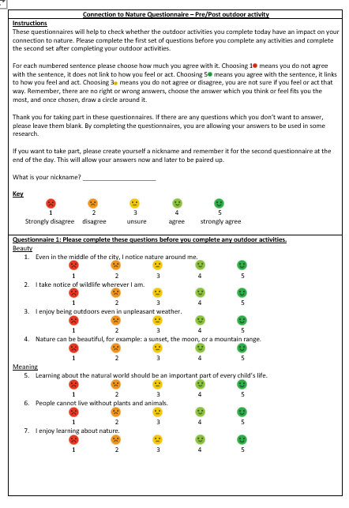
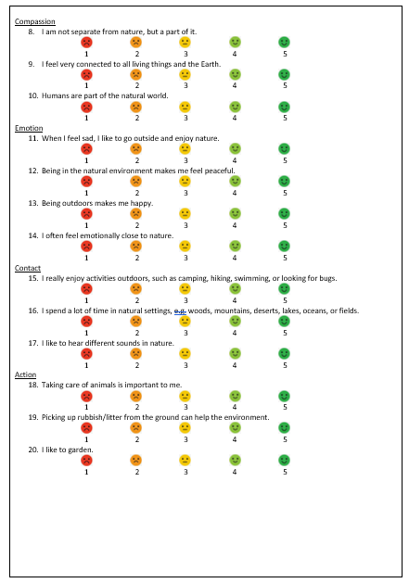
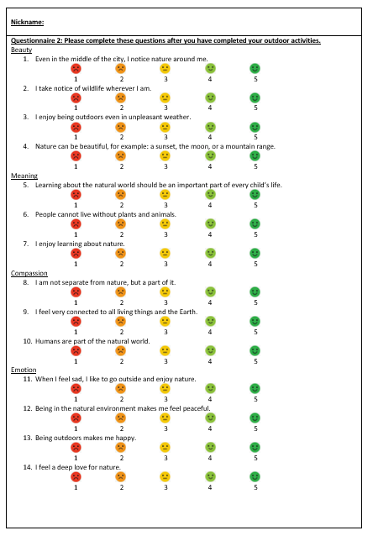
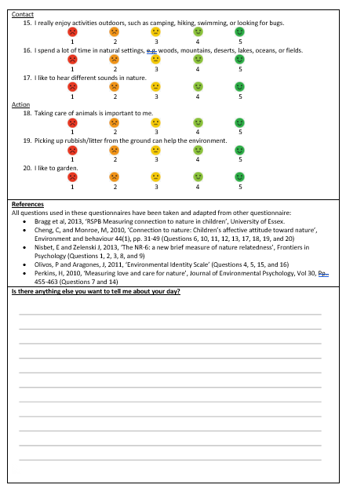

Appendix B – Ethical Approval Form
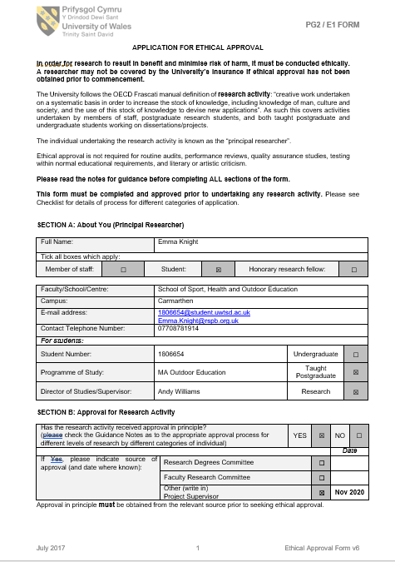
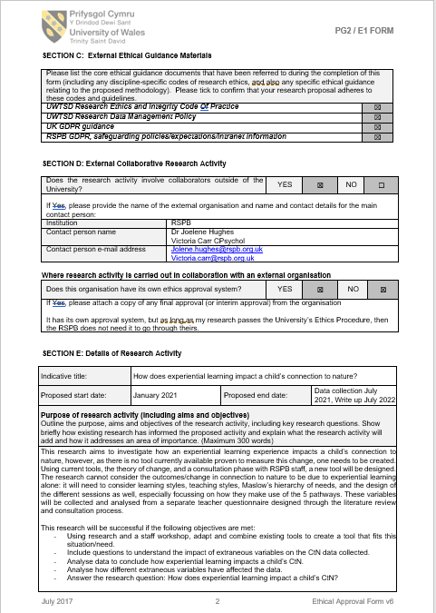

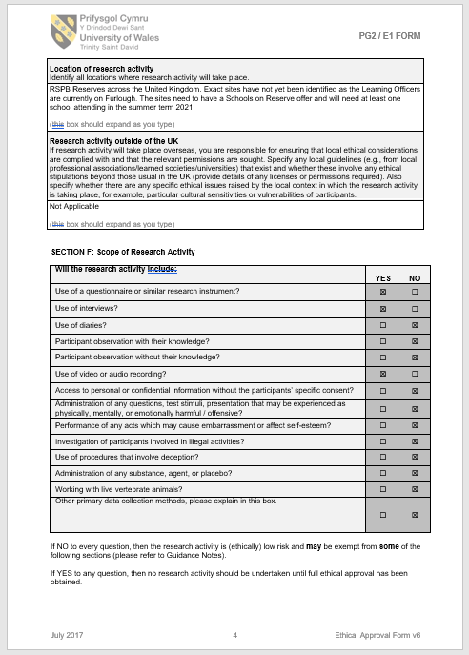
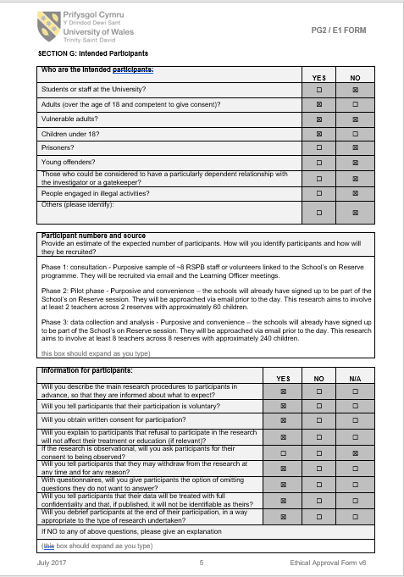

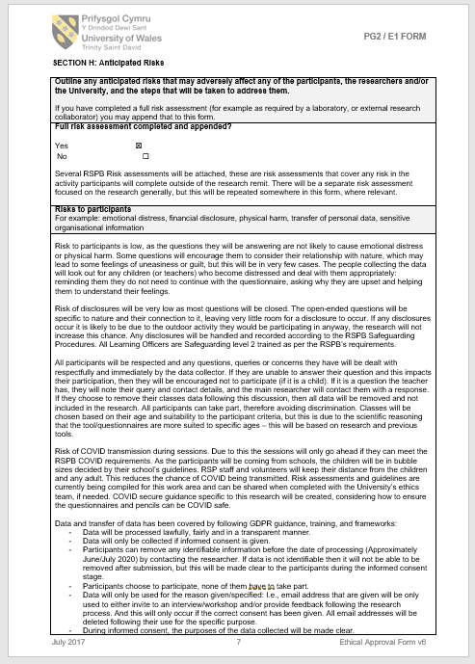
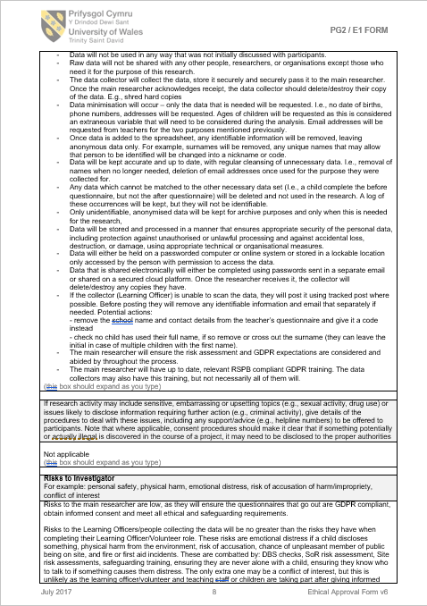

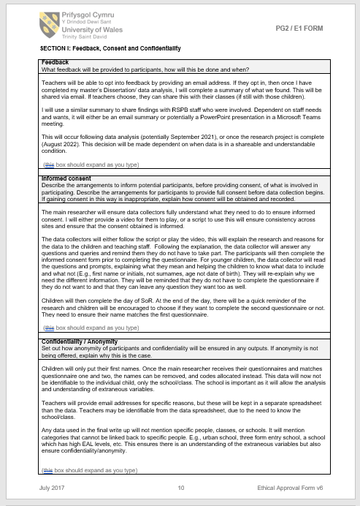

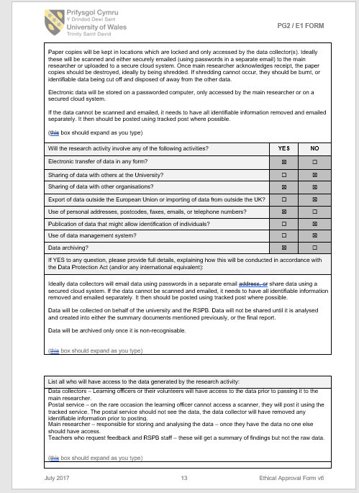

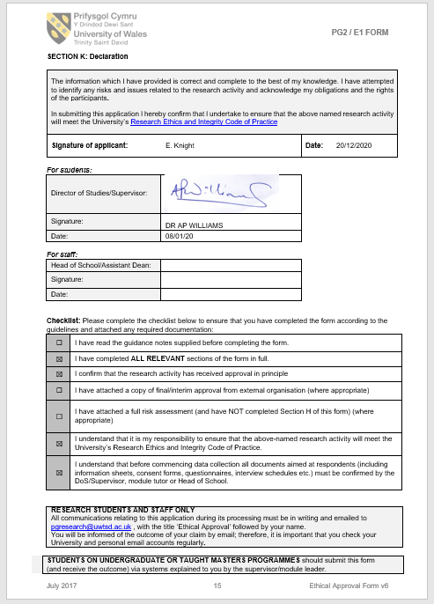

Appendix C – ‘Google JamBoard’ Online Survey for Phase 1
The phase 1 questions and process were provided in a Google JamBoard for the participants to work through independently. It was designed in a workshop fashion to allow for open-ended questions and sorting of statements/post-it notes. The data was collected from any typed answers the participants added to the JamBoard.
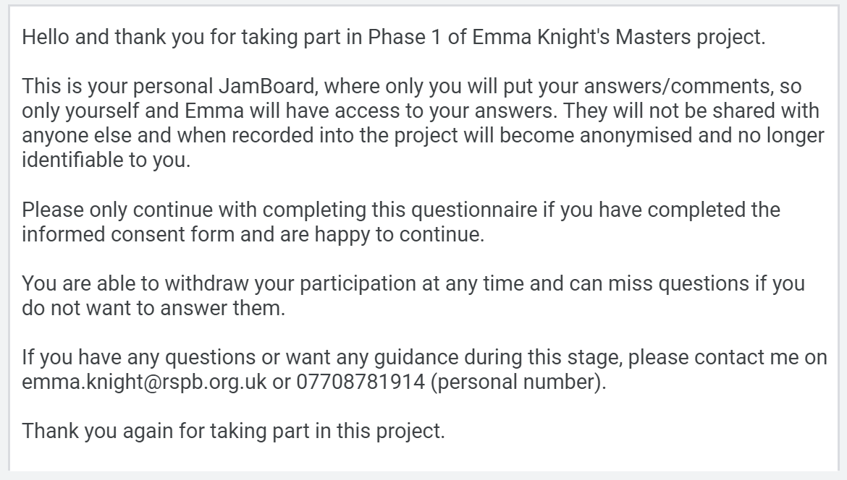
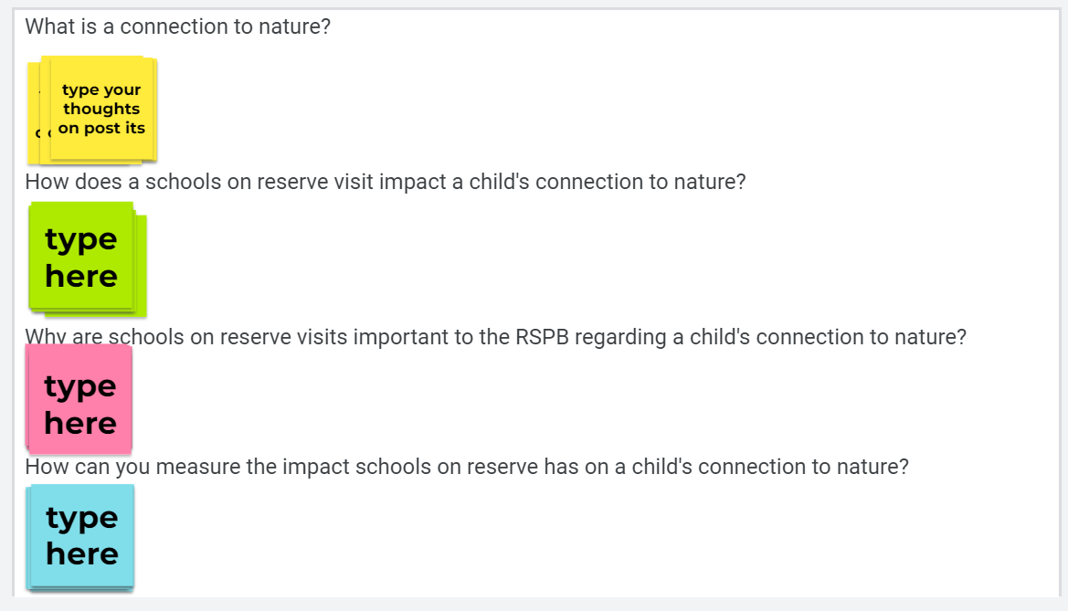
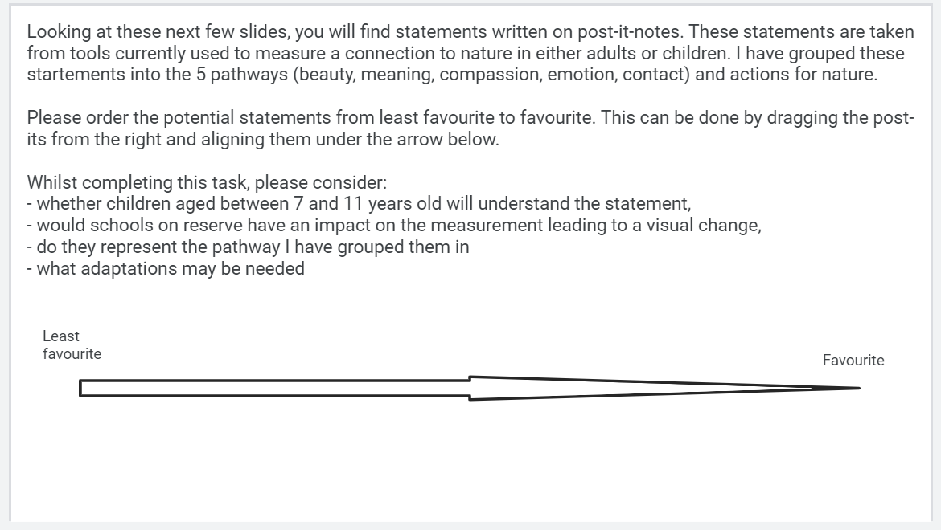
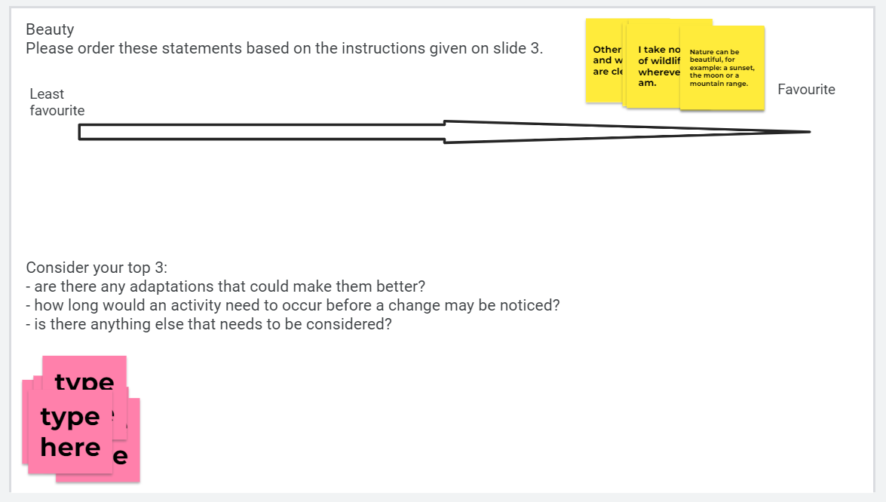
Statements were stored in the corner as above, but for the purpose of this appendix I have spread them out so the statements offered can be read.
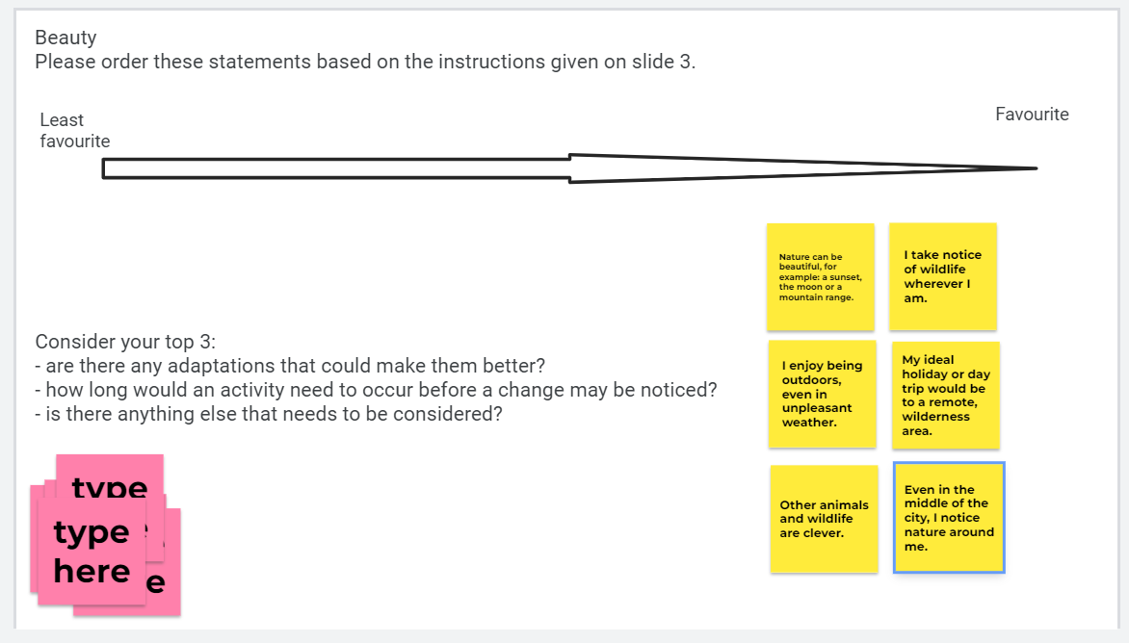
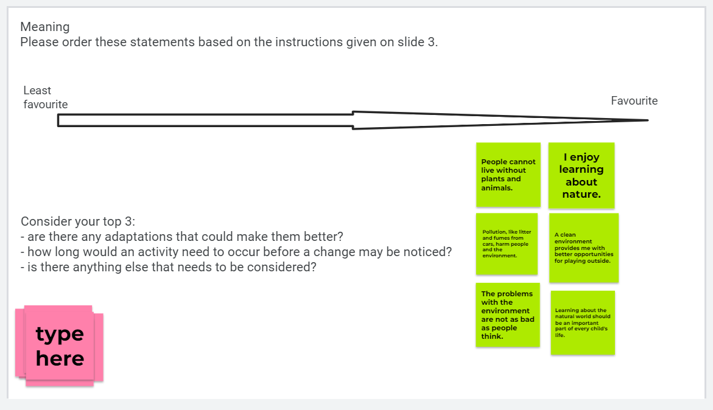
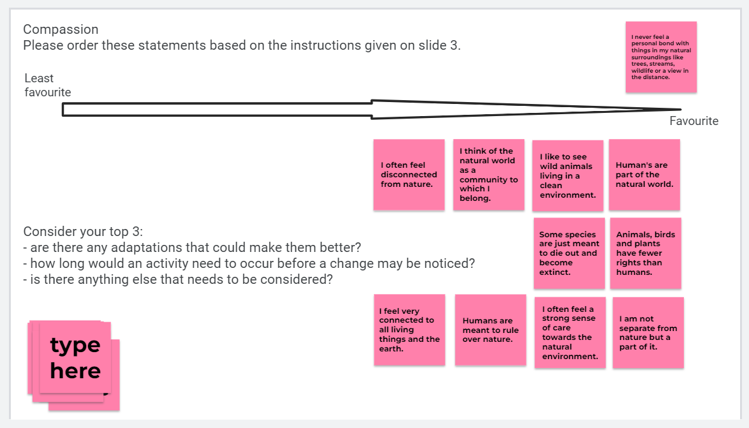
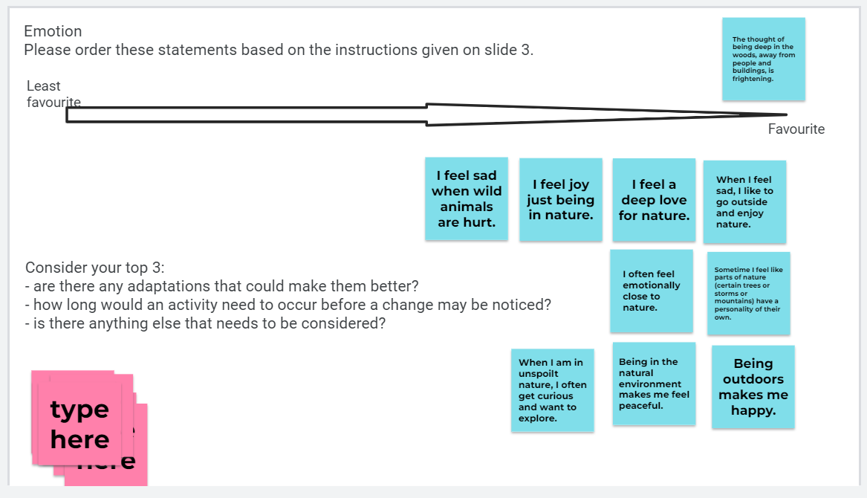
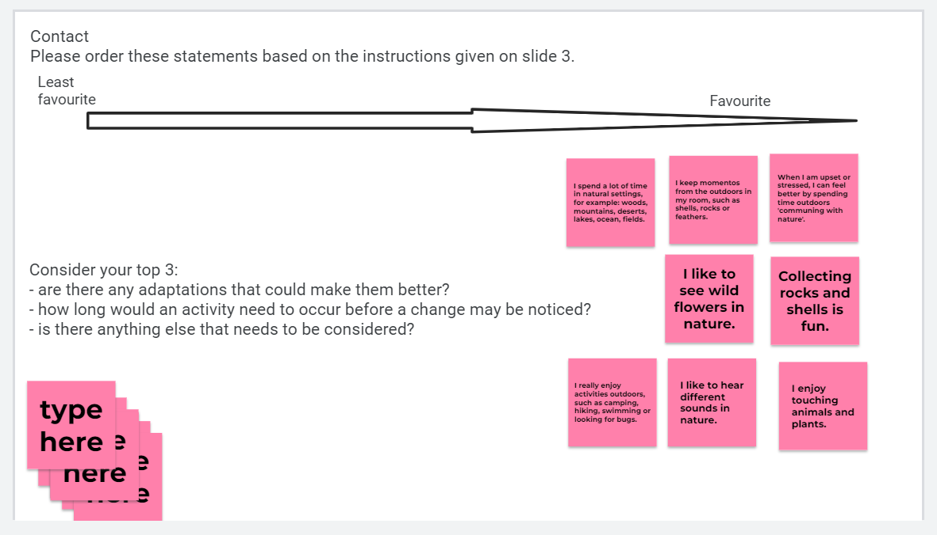
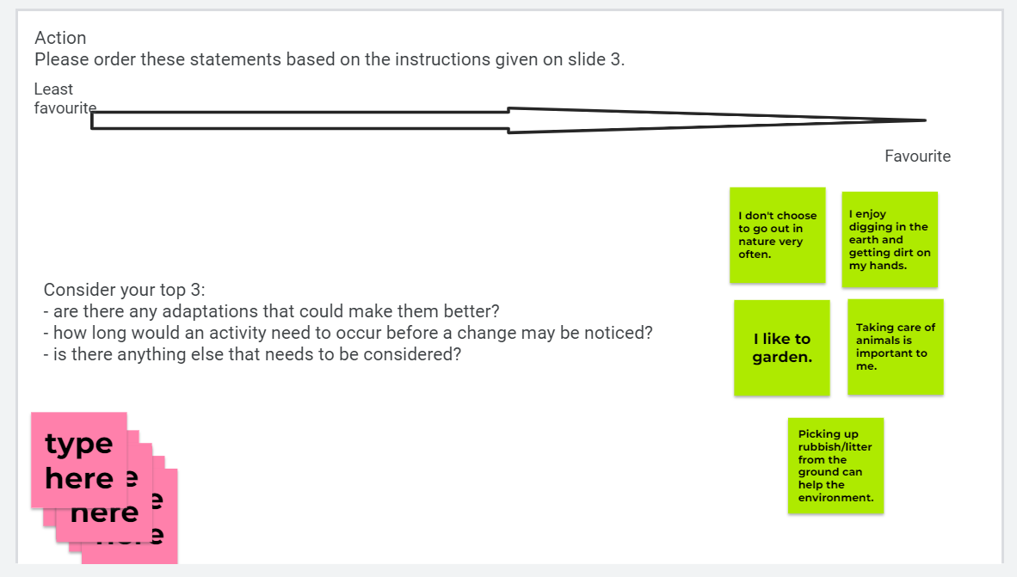
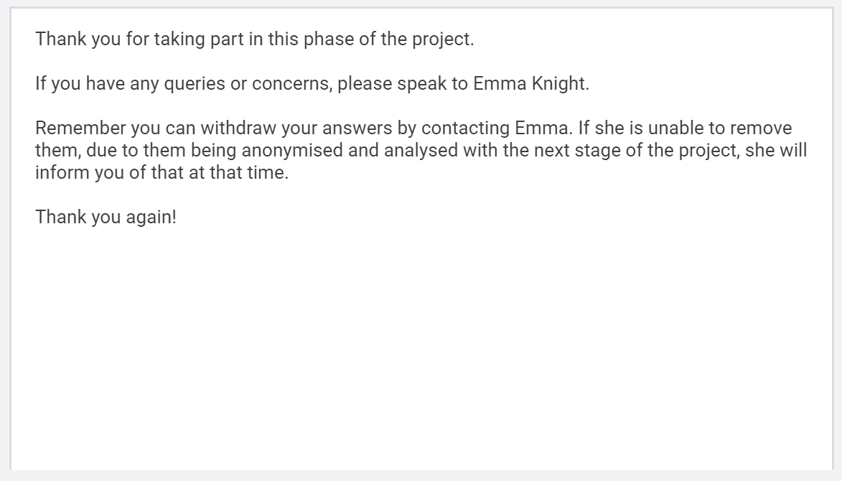

Appendix D – Session Leader Questionnaire for Phase 3
SoR leaders completed this questionnaire following the session. Some completed it electronically and others completed a printed version.
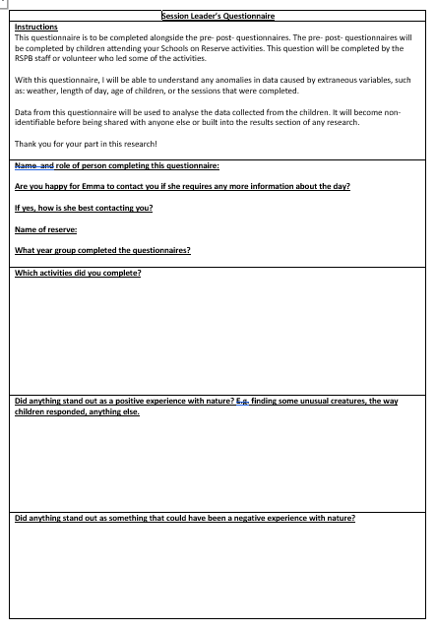
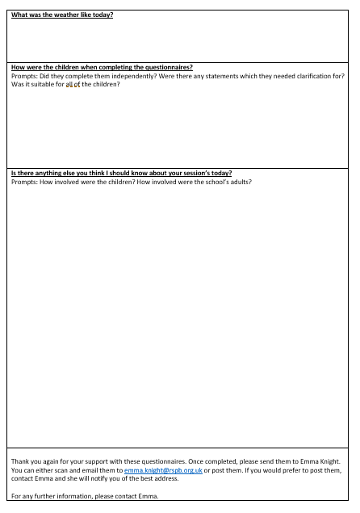

Appendix E – Parent-led interview prompts for Phase 2
The process was provided in a PowerPoint presentation for the parent to move through with their child. They were allowed to be flexible with their conversation and follow the direction the child took as much as they wanted, this was to give guidance on what I needed from the conversation. Conversations were recorded as video or voice.
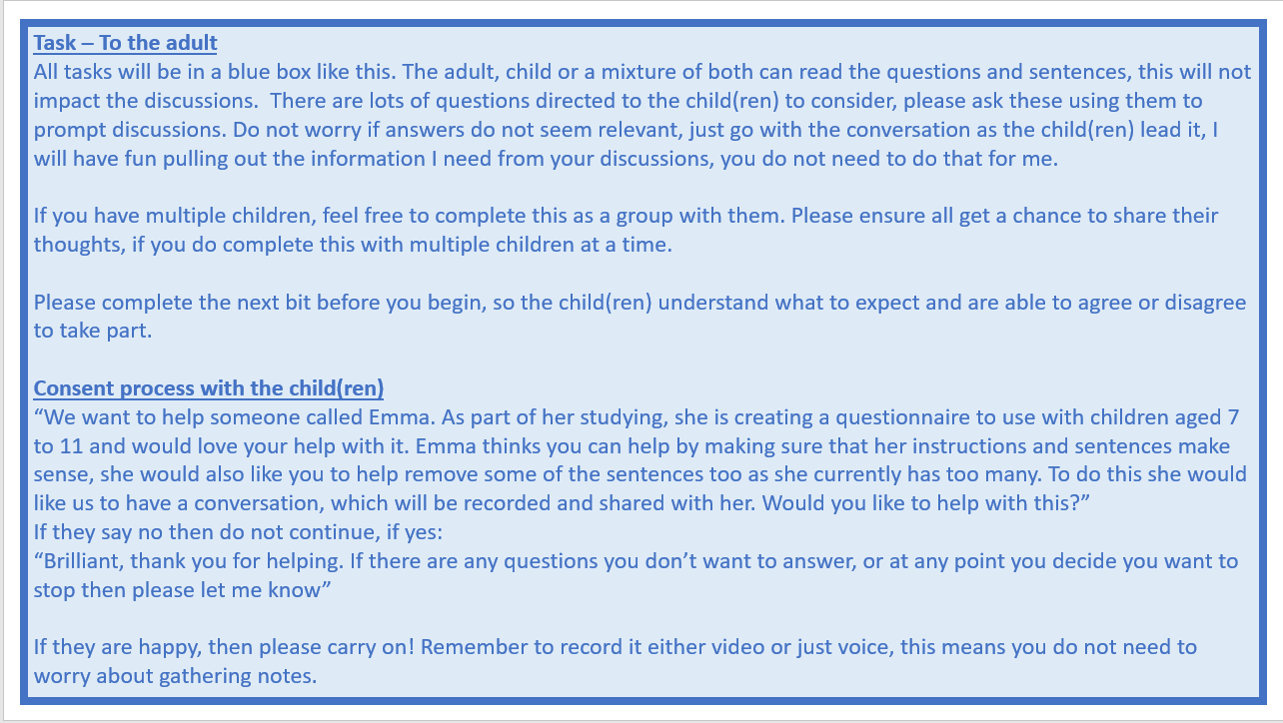
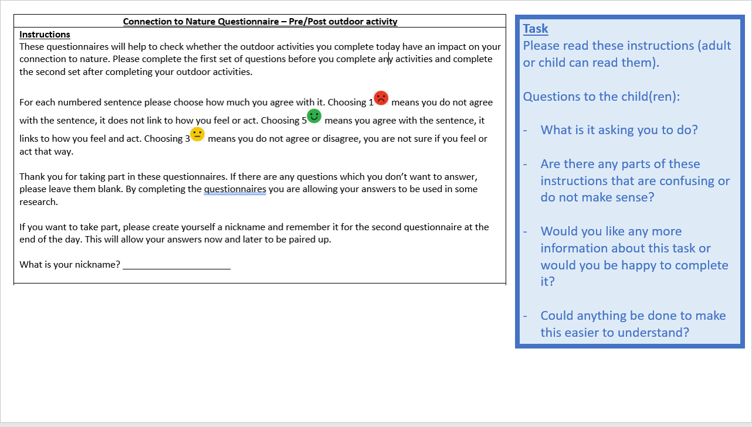
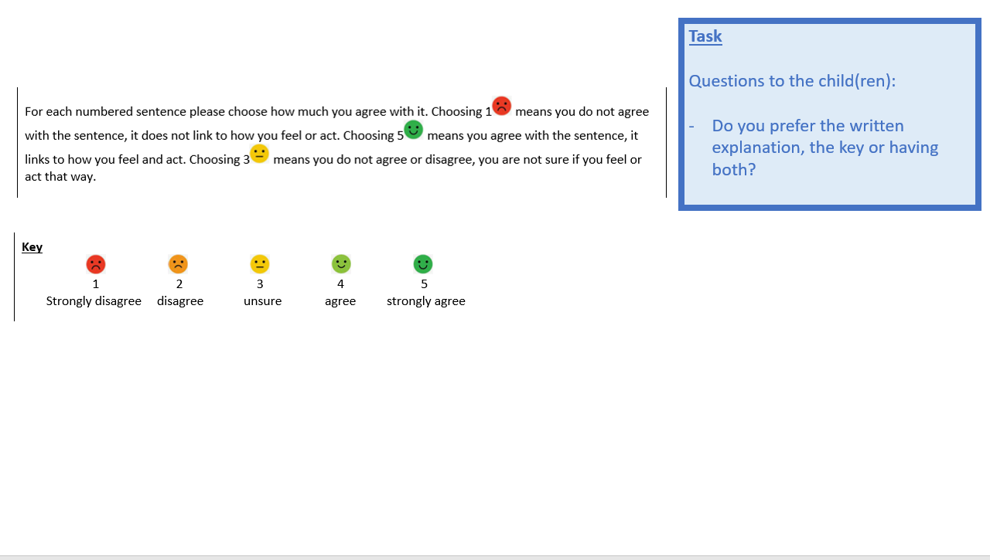
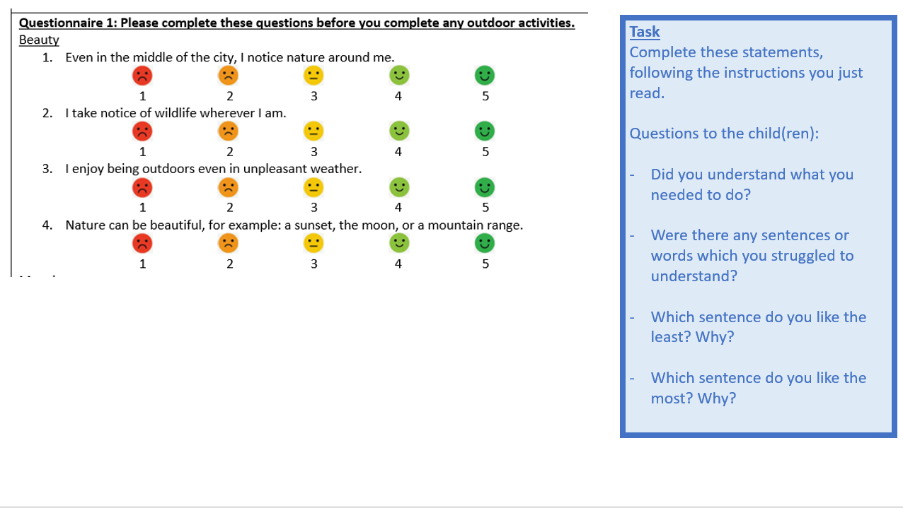
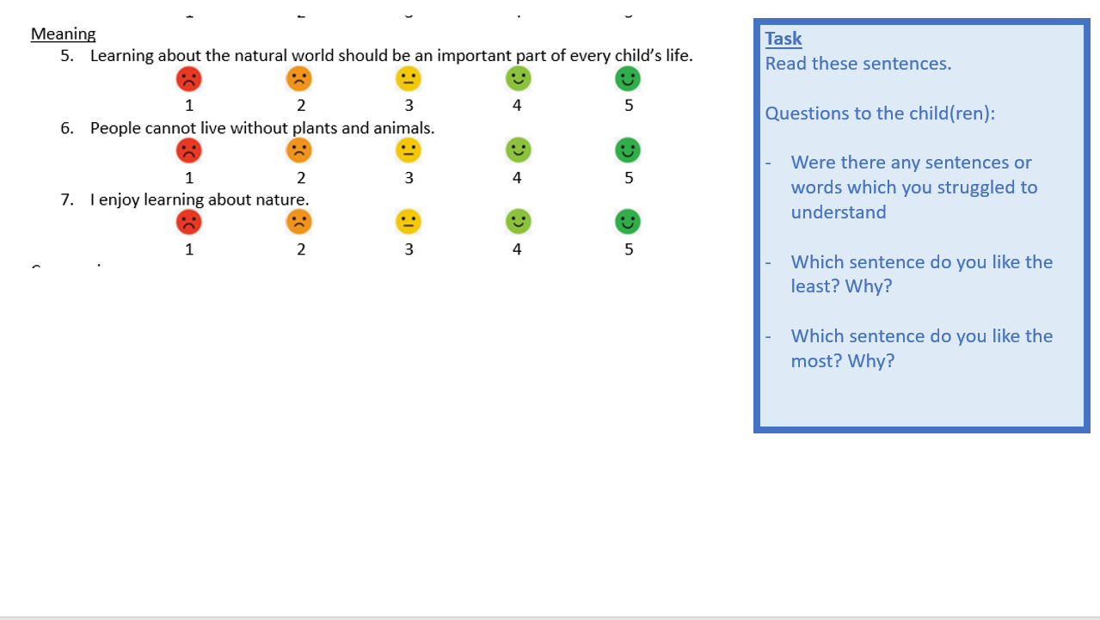
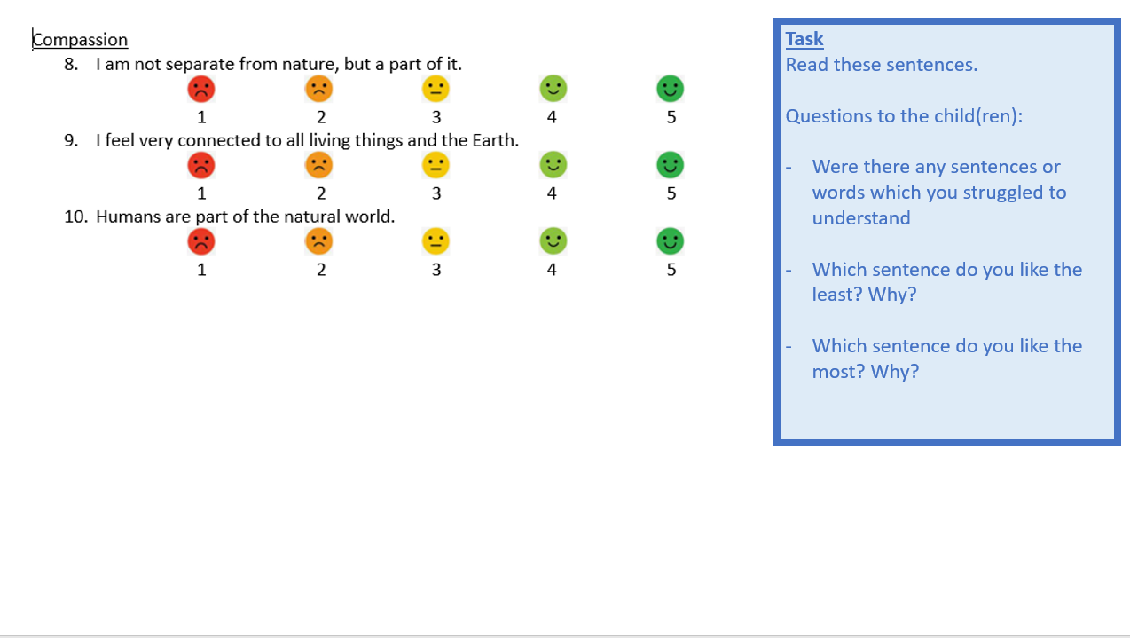
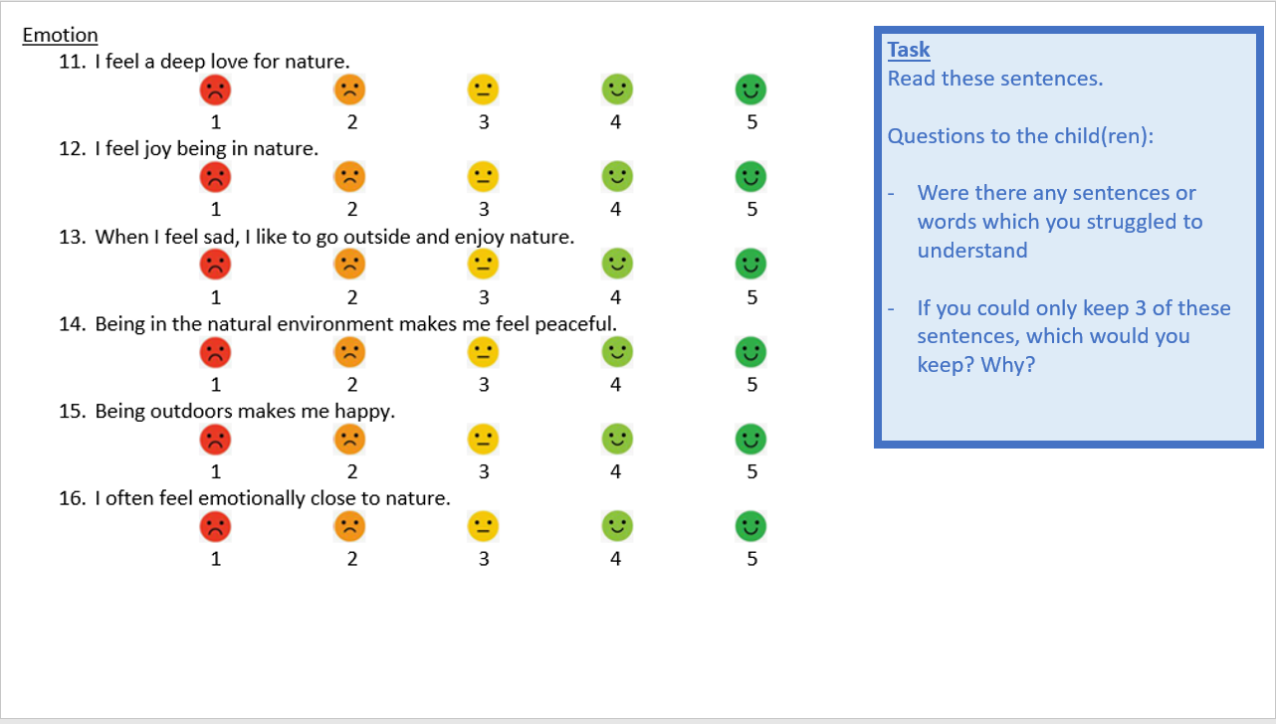
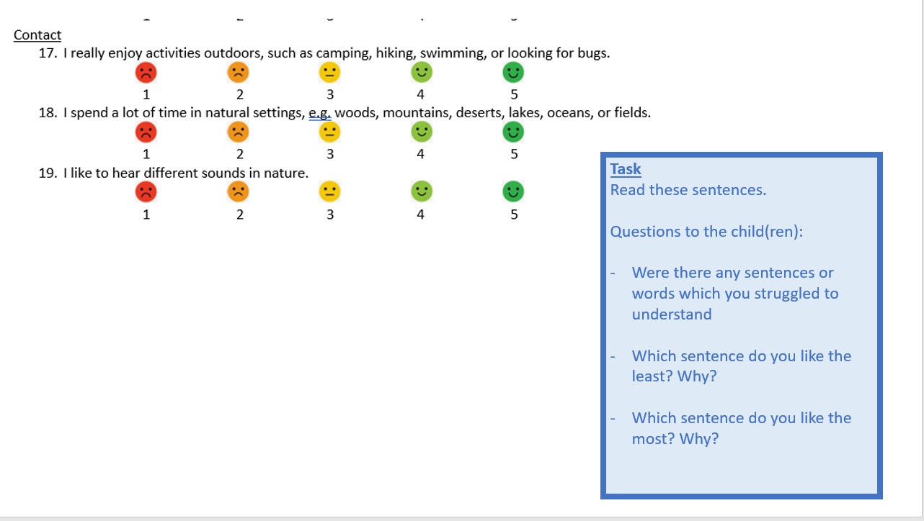
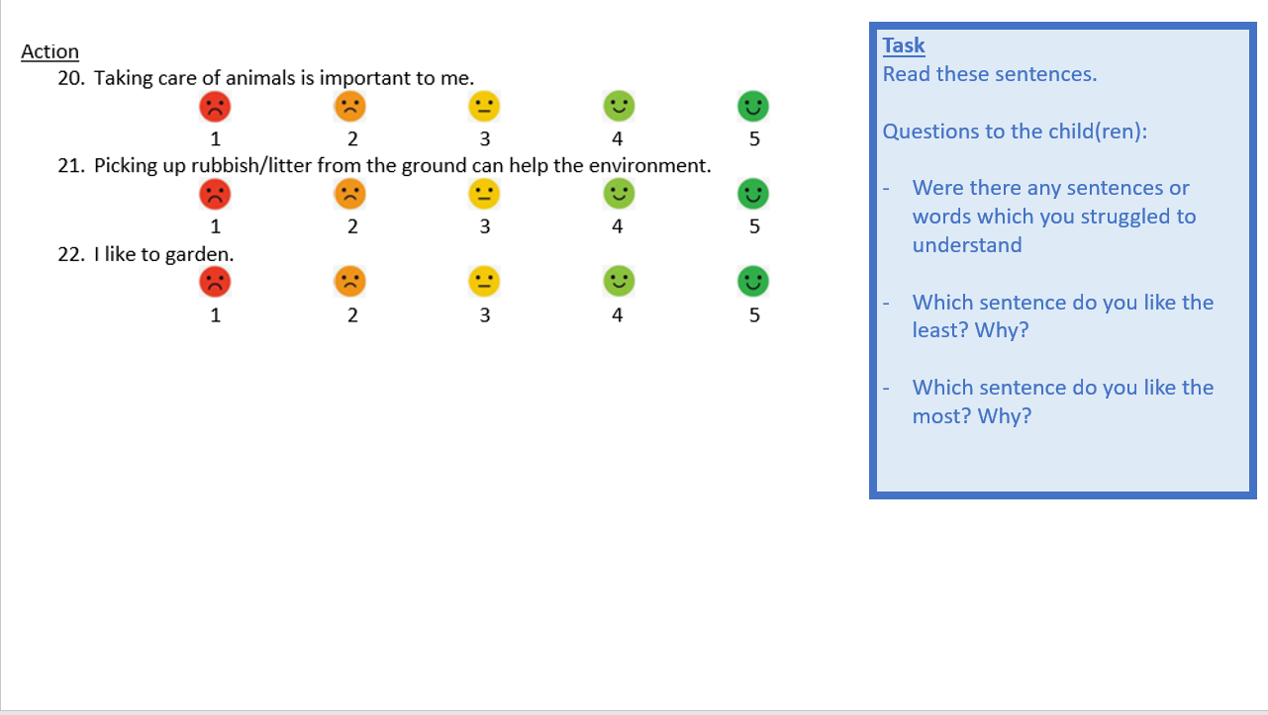
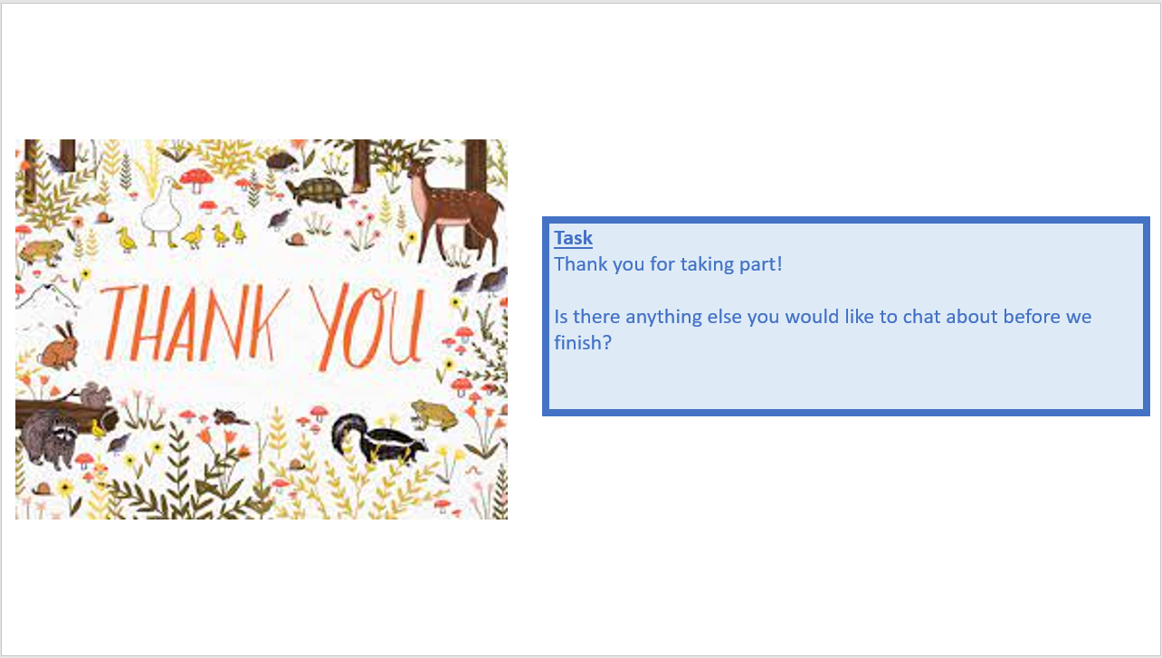

Appendix F – Hand-analysis of statements from CtN measurement tools
Statements from currently available CtN measurement tools were sorted into the different pathway sub-sections and action.
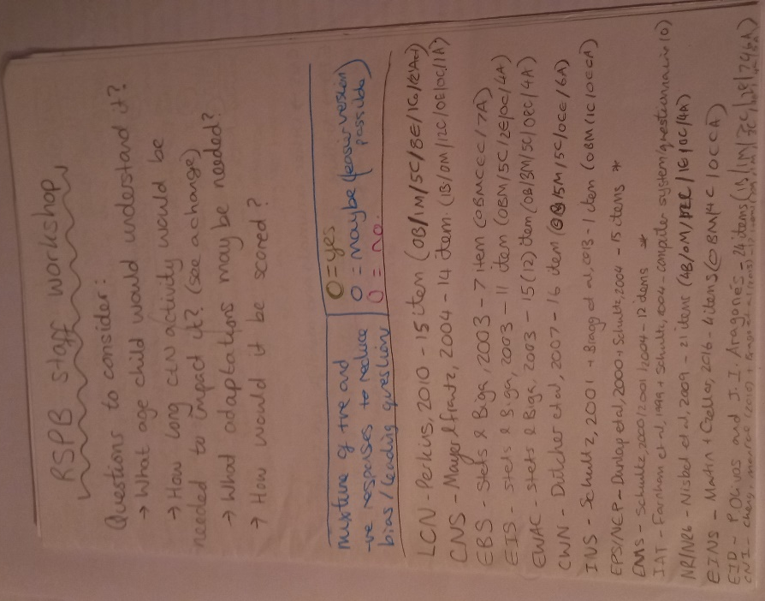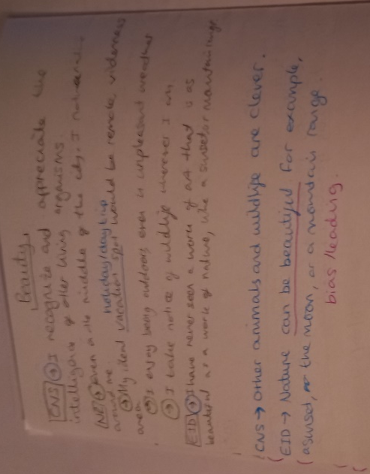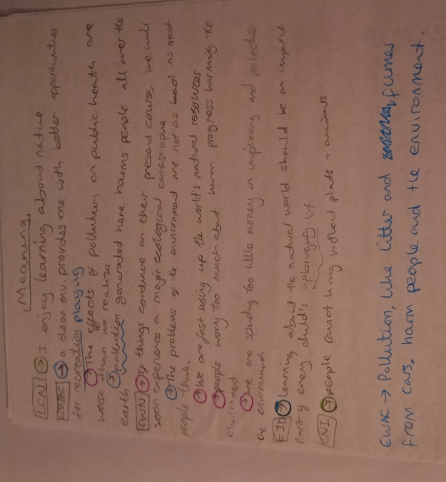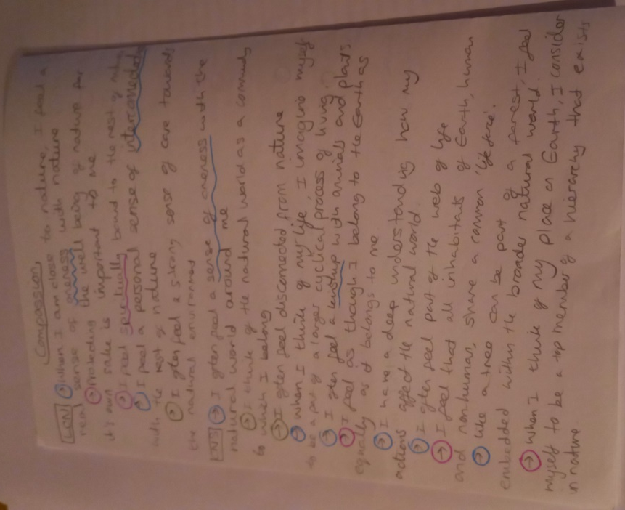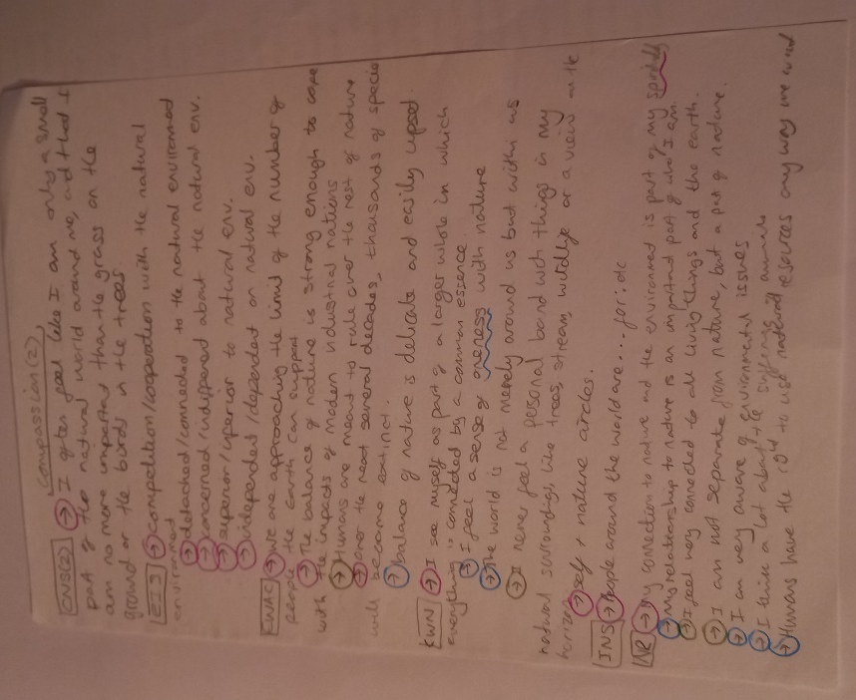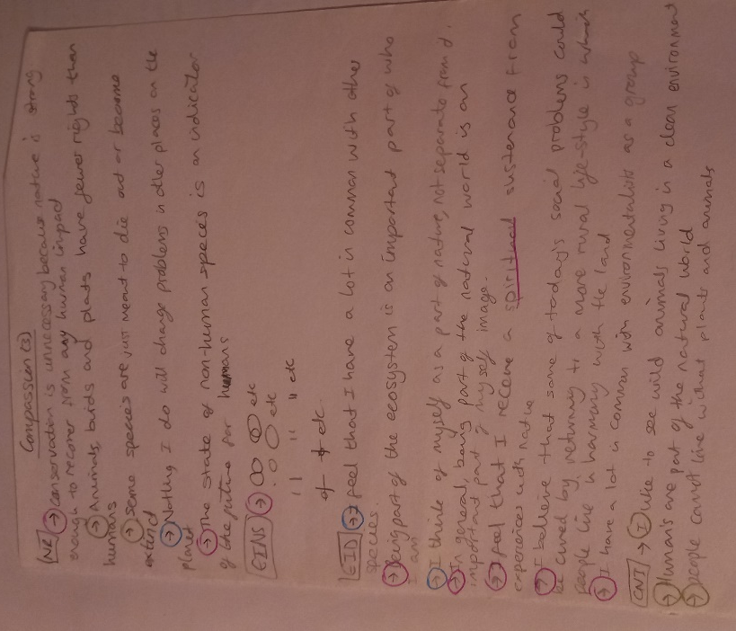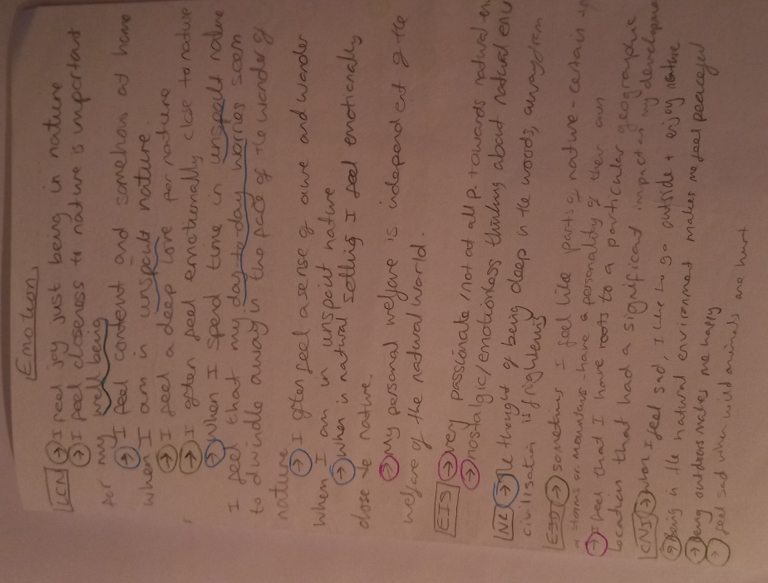
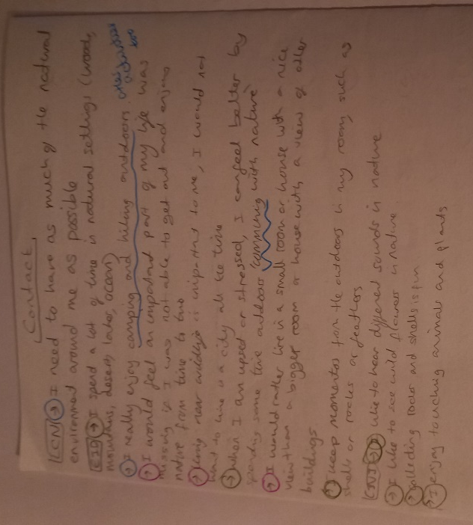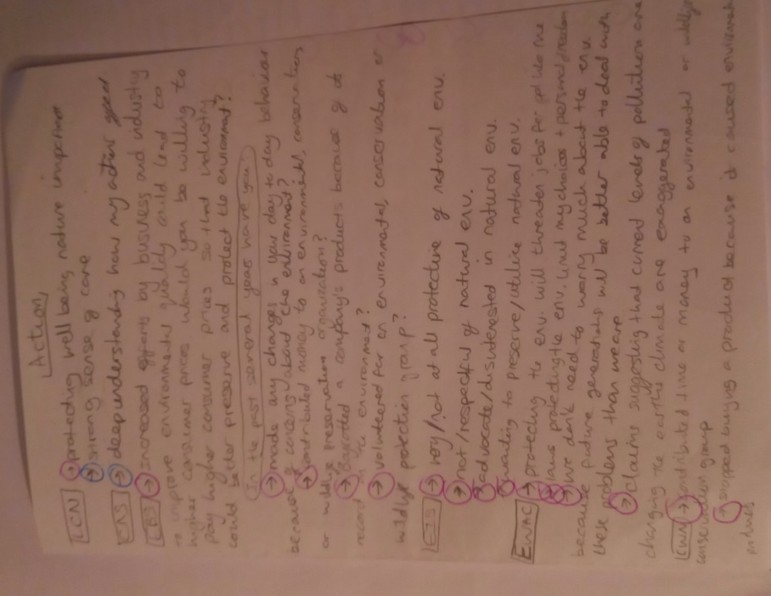
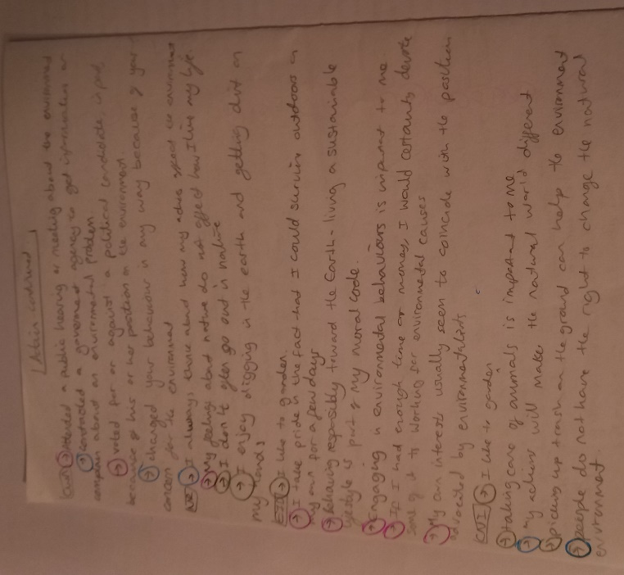

Appendix G – Thematic analysis of phase 1 data
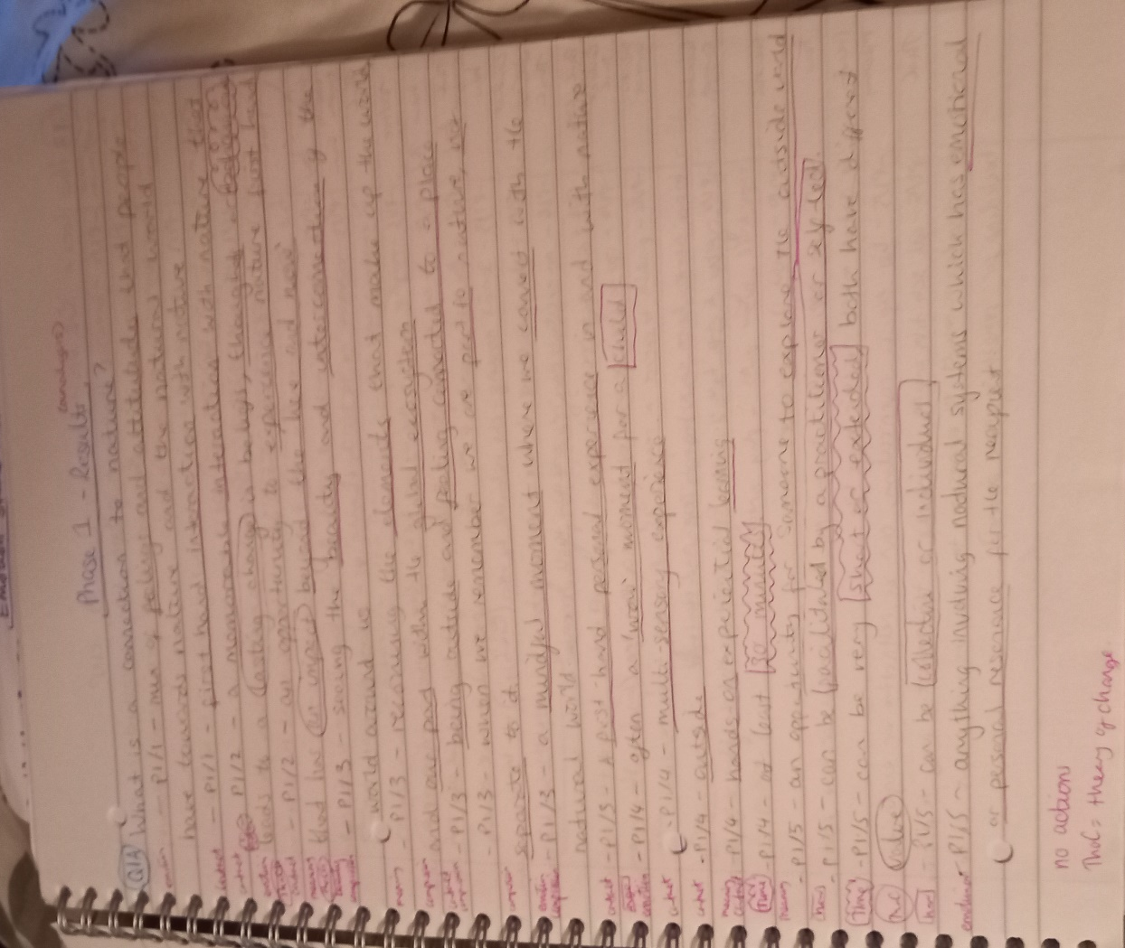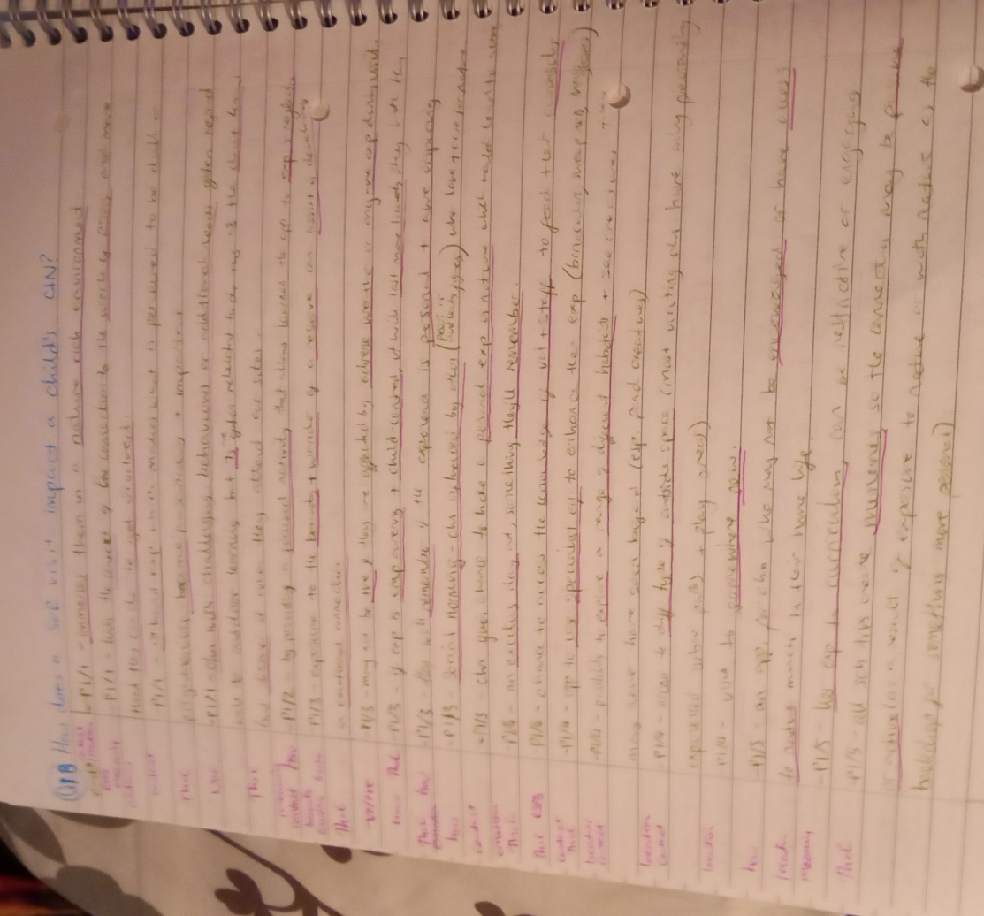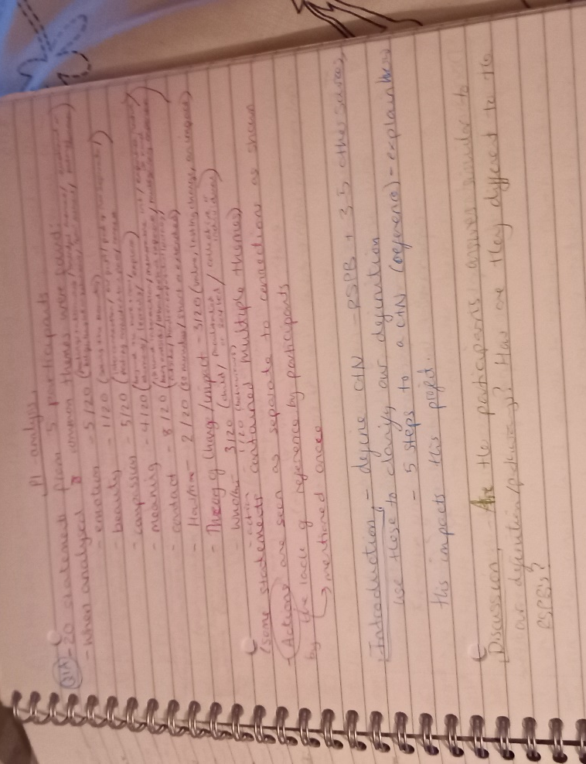
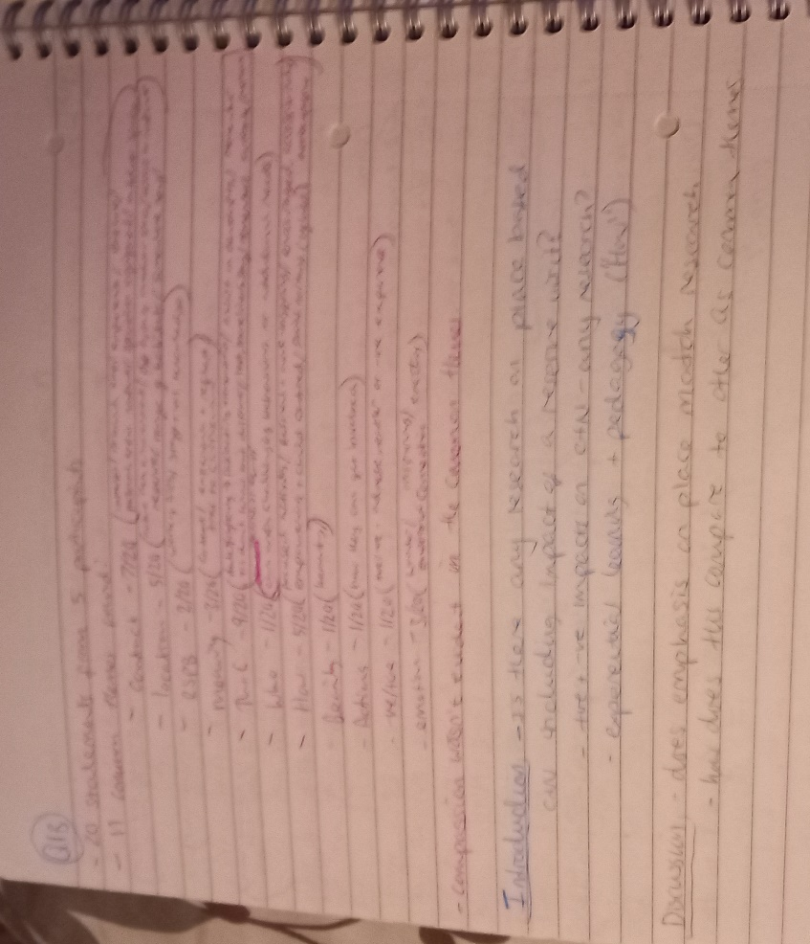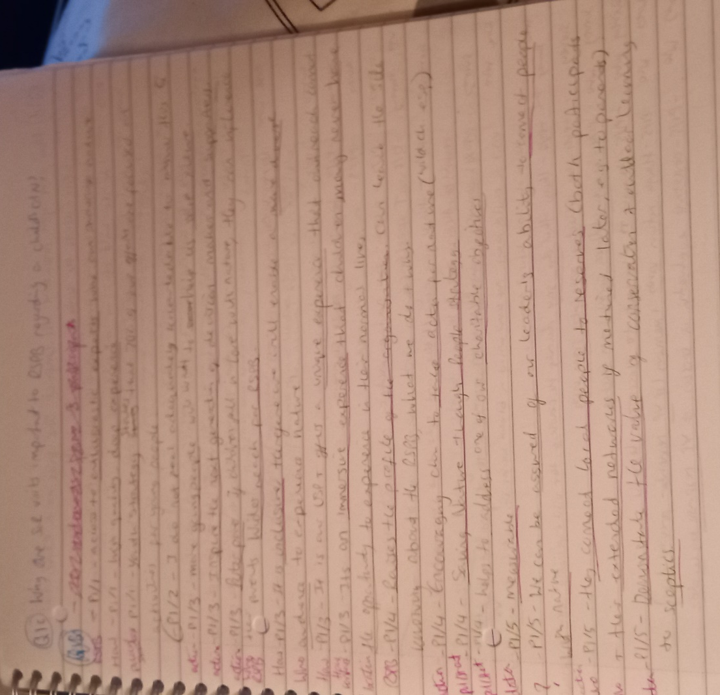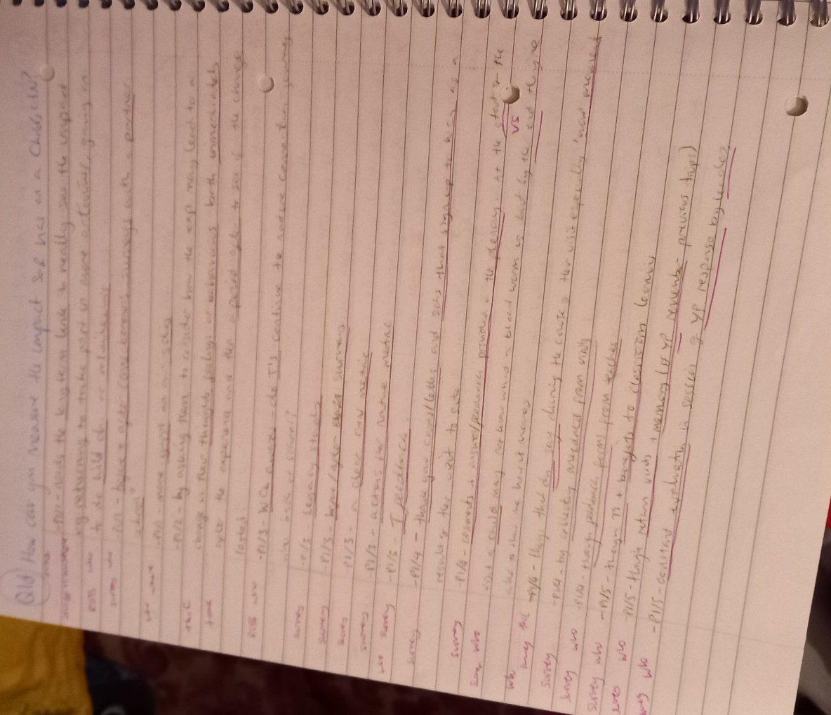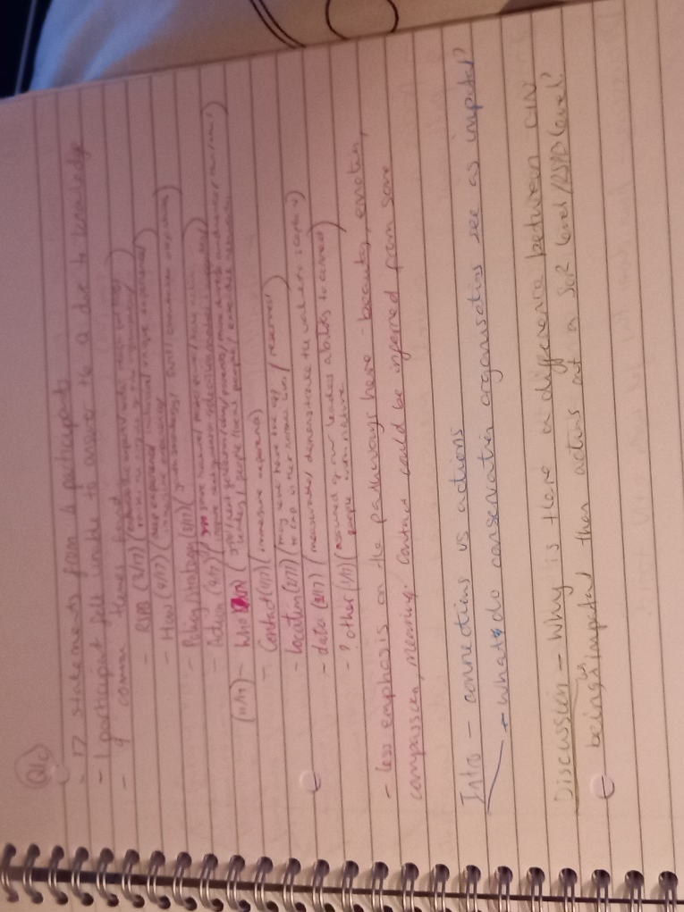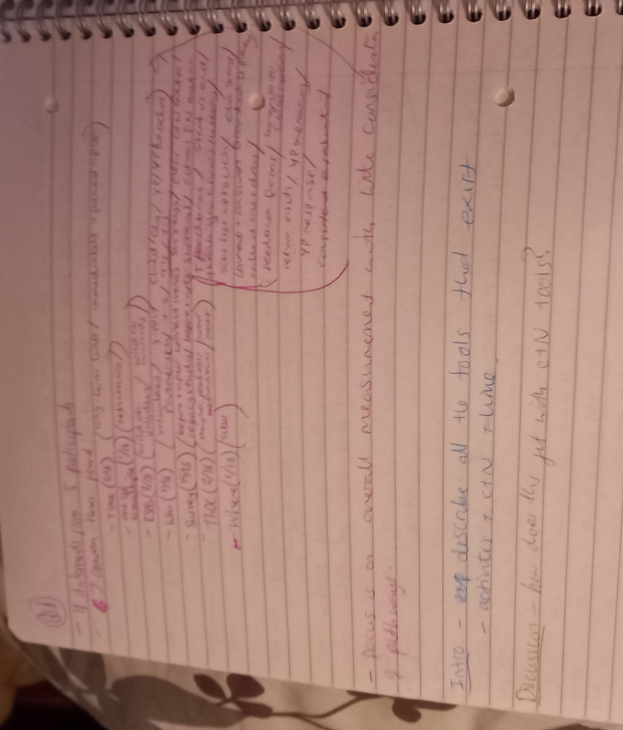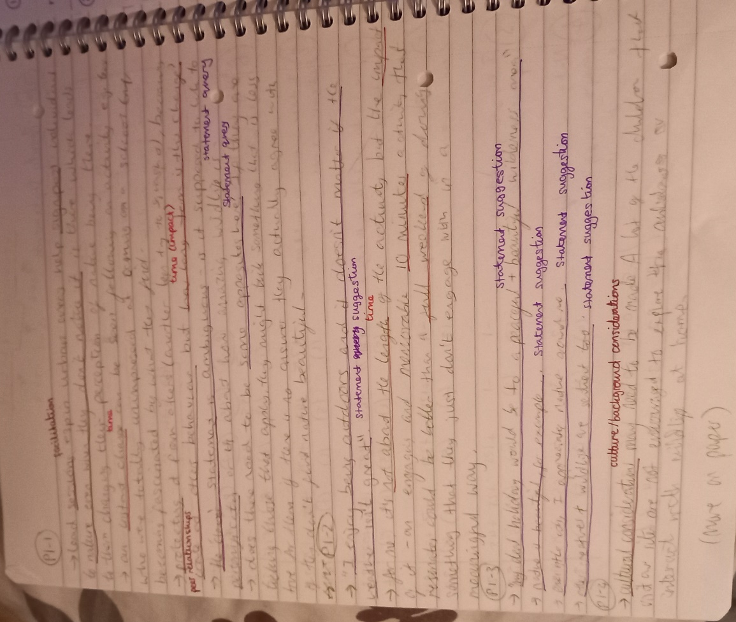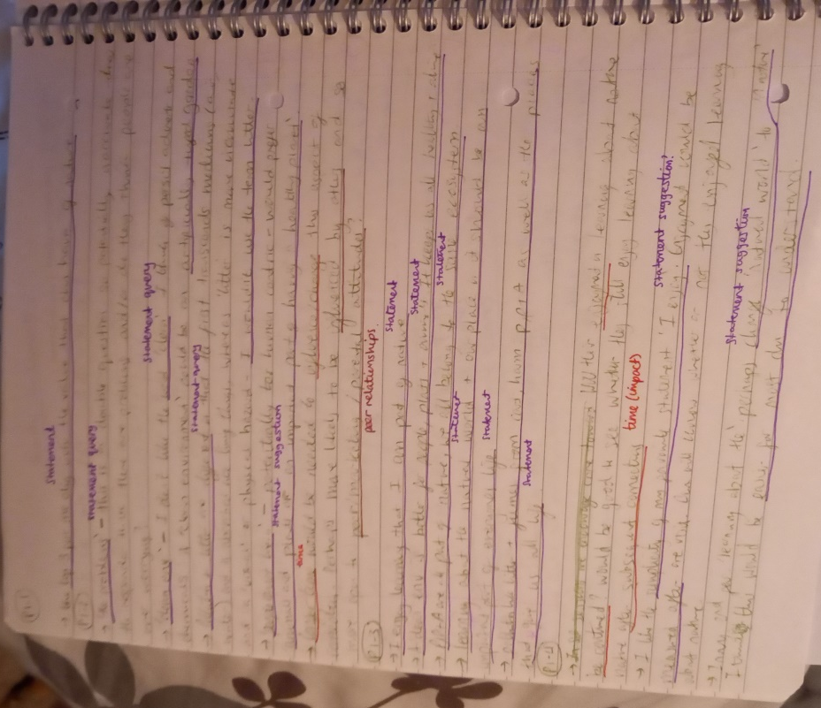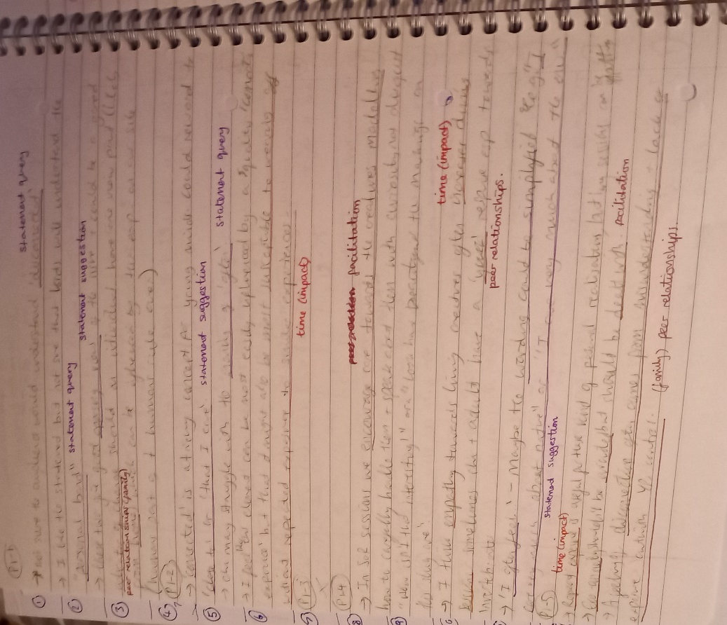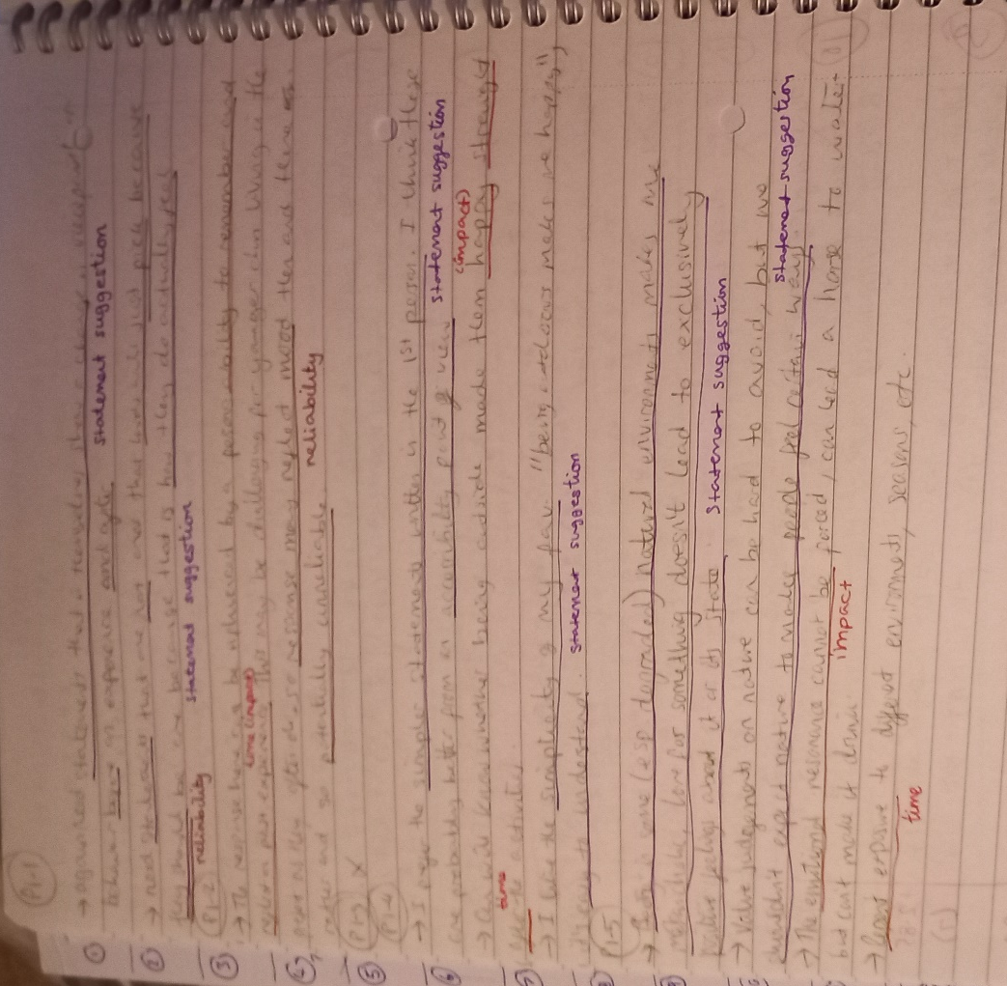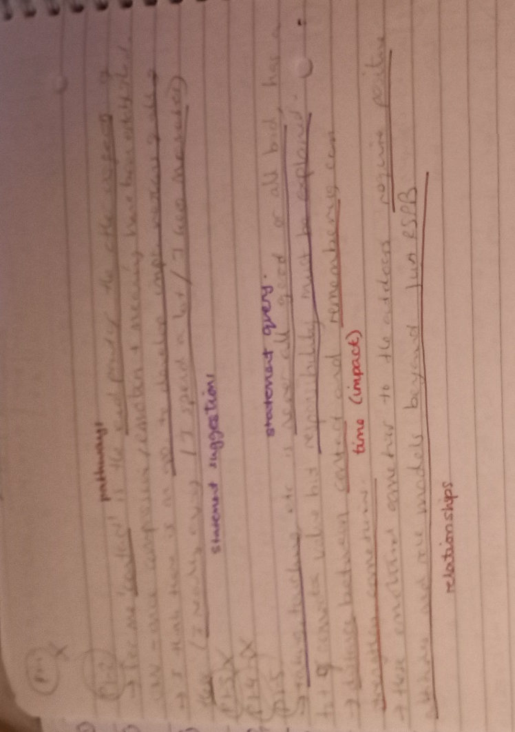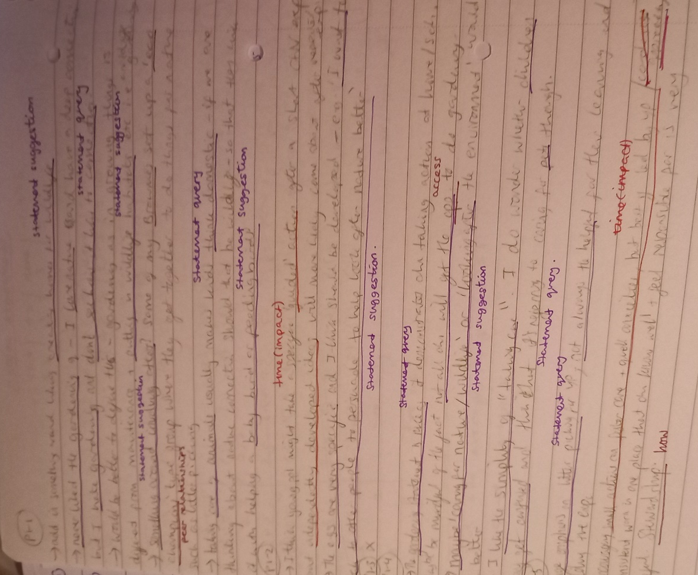

Appendix H – Adaptations to statements used in new tool (Phase 3)
The table below shows the statements used, where they were from and whether they have been changed.
The questions used in the new measurement tool and where they have come from
Sub-section | Question used in new tool | Has it been changed? | If changed, explain why. | Reference
Beauty | Even in the middle of the city, I notice nature around me. | No | N/A | NR
Beauty | I take notice of wildlife wherever I am. | No | N/A | NR
Beauty | I enjoy being outdoors even in unpleasant weather. | No | N/A | NR
Beauty | Nature can be beautiful, for example: a sunset, the moon, or a mountain range. | Yes | It was changed from “I have never seen a work of art that is as beautiful as a work of nature, like a sunset or mountain range”. It was simplified and the moon added as a further example to make it more suitable for children. | EID
Meaning | Learning about the natural world should be an important part of every child’s life. | Yes | “Child’s upbringing” was simplified to “child’s life” | EID
Meaning | People cannot live without plants and animals. | No | N/A | CNI
Meaning | I enjoy learning about nature. | No | N/A | LCN
Compassion | I am not separate from nature, but a part of it. | No | N/A | NR
Compassion | I feel very connected to all living things and the Earth. | No | N/A | NR
Compassion | Humans are part of the natural world. | No | N/A | CNI
Emotion | When I feel sad, I like to go outside and enjoy nature. | No | N/A | CNI
Emotion | Being in the natural environment makes me feel peaceful. | No | N/A | CNI
Emotion | Being outdoors makes me happy. | No | N/A | CNI
Emotion | I often feel emotionally close to nature. | No | N/A | LCN
Contact | I really enjoy activities outdoors, such as camping, hiking, swimming, or looking for bugs. | Yes | It was changed from “I really enjoy camping and hiking outdoors”, to widen the examples used, making them more suitable for children. | EID
Contact | I spend a lot of time in natural settings, e.g., woods, mountains, deserts, lakes, oceans, or fields. | Yes | The examples were given as examples instead of in brackets and fields was added as an example. | EID
Contact | I like to hear different sounds in nature. | No | N/A | CNI
Action | Taking care of animals is important to me. | No | N/A | CNI
Action | Picking up rubbish/litter from the ground can help the environment. | Yes | “Trash” was change to “rubbish/litter” to make it more British. | CNI
Action | I like to garden. | No | N/A | CNI and EID

