PARKINSON’S DISEASE
An Information Booklet on Long-term Condition Management
LCHS7003 – Community Care and Management of Longer-term Conditions
Component 1 | Information Booklet | 3,000-word assessment
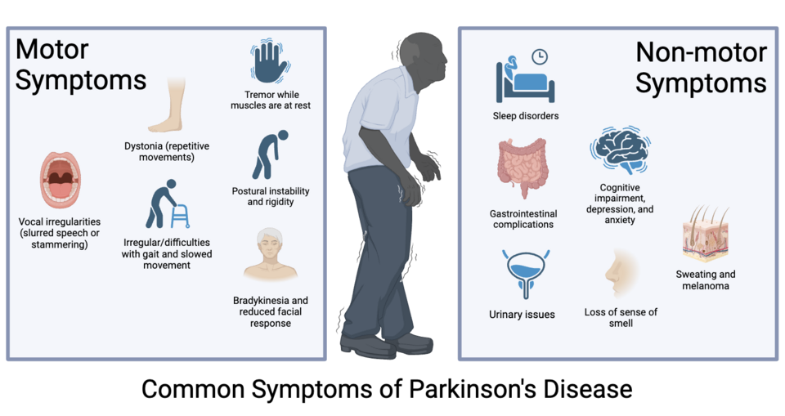
Student name: Khushikumari Manubhai Solanki
Student ID number: 2611364
Lecturer: Dr Aishat Bakre
Programme: MSc Public Health and Social Care in Practice
Submission date: 23 October 2026
Prepared for health and care service users and professionals in the UK

Table of Contents
1. Definition 3
2. Burden / Prevalence 4
3. Risk Factors 5
3.1 Modifiable risk factors 6
3.2 Non-modifiable risk factors 6
4. Aim 7
5. Physical, Psychological and Social Implications 7
5.1 Physical implications 7
5.2 Psychological implications 7
5.3 Social implications 8
6. Evidence-based Treatment and Management in the NHS 9
7. Theoretical Models and Frameworks for Improved Outcomes 10
7.1 UK model: House of Care framework for Parkinson’s 10
7.2 Application of the Chronic Care Model to Parkinson’s Long-term Management 11
8. Health and Social Care Policies and Agendas 12
9. Recommendations for Improvement 12
10. Conclusion 13
Reference List 14

1. Definition
Parkinson's disease is a neurodegenerative disorder in which there is damage to nerve cells that are responsible for motor control, particularly cells producing the neurotransmitter dopamine within the substantia nigra region of the brain. Dopamine is responsible for the coordination of movement. Reduced levels cause slowing of movement, rigidity, and resting tremor. Parkinson’s can also impact sleep, mood, cognitive function, digestion, pain, sense of smell, and blood pressure regulation (World Health Organization, 2023; Ben-Shlomo et al., 2024).
Parkinson's disease is variable from person to person. It is diagnosed primarily through clinical evaluation based on signs, history, and examinations. It is not curable, although treatments, rehabilitation, and social services can help with symptom management and quality of life (World Health Organization, 2022; National Institute for Health and Care Excellence, 2017). Holistic treatment is crucial throughout the course of the disease.
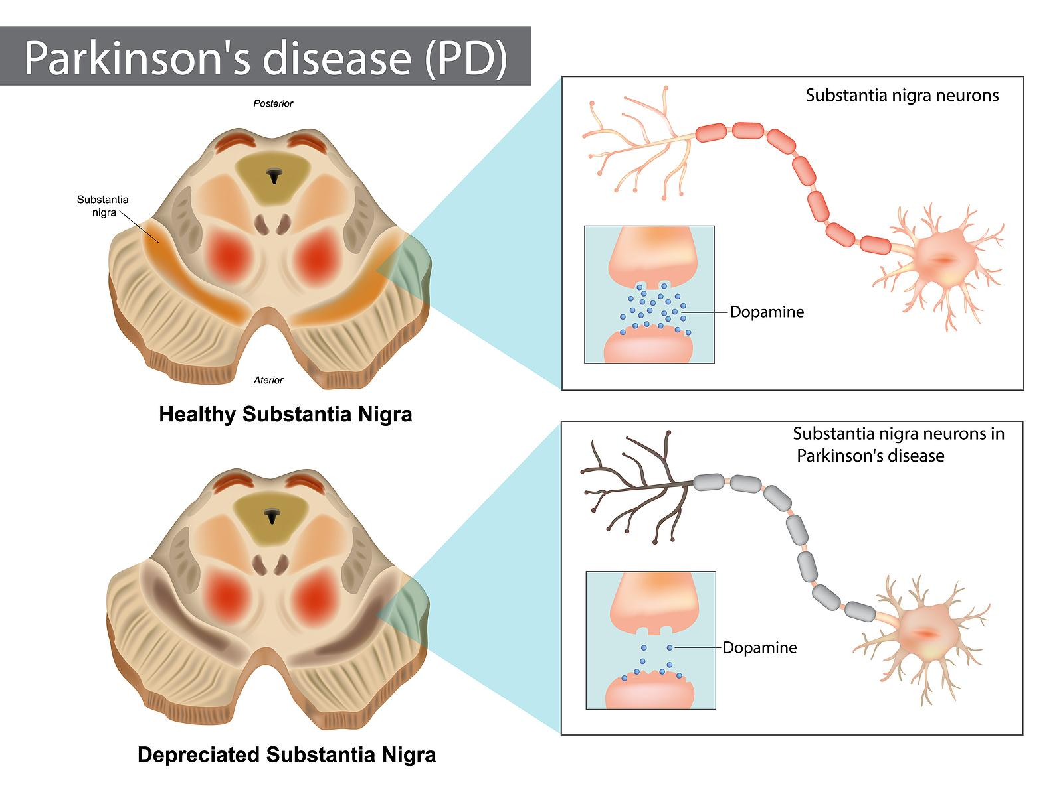
Figure 1: Degeneration of the substantia nigra and reduced dopamine signalling in Parkinson’s disease.
Source: CPR Therapy, Patient Guide for Parkinson’s Disease. View the original image and source webpage.

2. Burden / Prevalence
Parkinson’s disease is now becoming a rising public health problem worldwide. According to WHO, global prevalence had more than doubled within 25 years, and more than 8.5 million people were living with the disease in 2019. Global estimates indicated 5.8 million disability adjusted life years and 329,000 deaths due to Parkinson’s disease in 2019 (WHO, 2022; WHO, 2023).
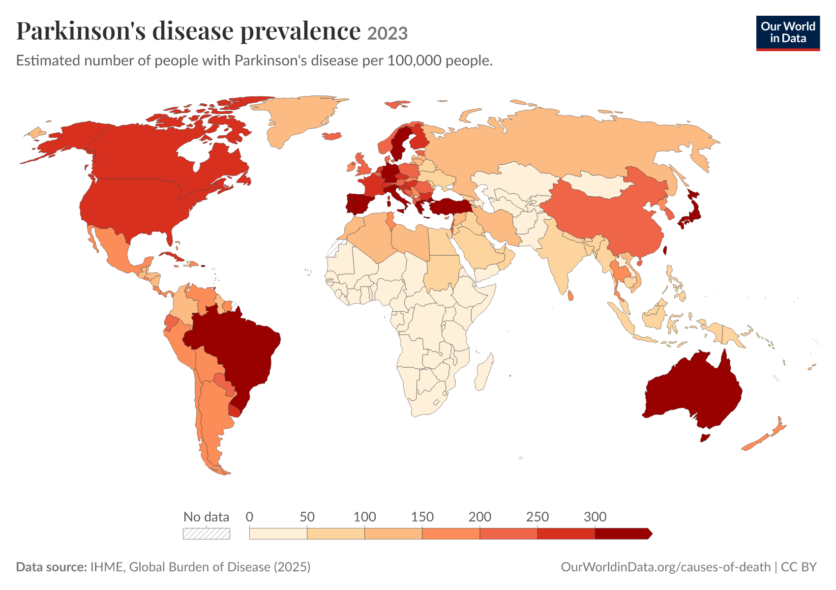
Figure 2: Global prevalence of Parkinson’s disease, 2023
Source link: Our World in Data – Parkinson’s disease prevalence
In the UK, Parknison’s UK estimated that there would be around 166,000 people diagnosed with the disease in 2025, out of whom, approximately 139,000 people in England, 14,000 in Scotland, 8,600 in Wales and 4,400 in Northern Ireland. It is estimated that as many as 21,000 extra people could have the disease in the UK but without any diagnosis, which can cause problems in getting treatments and services (Parkinso’s UK, 2025a; Parkinso’s UK, 2025b). About 28,000 new cases of Parkinson’s disease were expected in the UK in 2025, while the charity mentions that number of cases is lower than what was expected before the pandemic (Parkinso’s UK, 2025a).
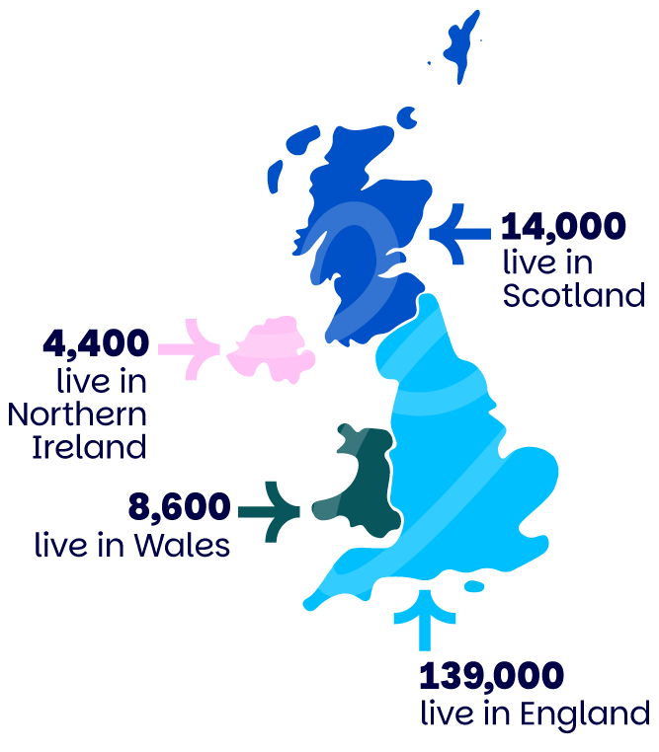
Figure 3: Number of people diagnosed with Parkinson’s disease across the UK, 2025
Source link: Parkinson’s UK – Statistics
Table 1: Selected estimates of Parkinson’s disease burden
Indicator | Estimate | Source / interpretation
Global prevalence (2019) | More than 8.5 million | WHO (2022); global estimate
Global disability burden (2019) | 5.8 million DALYs | WHO (2022); 81% higher than 2000
People diagnosed in the UK (2025) | Around 166,000 | Parkinson’s UK (2025a)
Potentially undiagnosed in the UK | Up to 21,000 | Parkinson’s UK (2025b); charity estimate
These UK prevalence rates have implications for the planning of services, as older people are likely to require medication reviews, specialist nursing, falls prevention, and rehabilitation and help at home. There is variability in the data sources; the reported diagnosis gap highlights potential underestimation of prevalence, informing a need for investment in timely diagnosis and integrated care (Ben-Shlomo et al., 2024; UK Parliament, 2024).

3. Risk Factors
The exact cause for the majority of cases of Parkinson's disease is not clear. Aging, hereditary predisposition, and environmental factors might have some impact. The correlation does not indicate causation, and the results may be biased due to factors such as recall bias and different measures of exposure (Ben-Shlomo et al., 2024; Brolin et al., 2025; Shan et al., 2023).

3.1 Modifiable risk factors
1. Pesticide exposure. There is some evidence that exposure to certain pesticides (such as organochlorine chemicals) at work or in the environment increases the risk of Parkinson’s disease. A meta-analysis of 17 case-control studies shows an association with organochlorine exposure, although there is variation according to the methods and region. Safer management and use of protective equipment and regulations are reasonable but cannot assure protection (Xu et al., 2024).
2. Industrial solvent exposure. Trichloroethylene (TCE) – a solvent used in some industrial processes – has been linked to the risk of developing Parkinson’s disease in epidemiological and biological studies. TCE has been identified by Dorsey et al. (2023) as an environmental risk that may be understudied. Delay between exposure and disease diagnosis makes it hard to establish causation. However, safer substitution and control are still reasonable actions.
3. Traumatic brain injury. A history of traumatic brain injury is a risk factor of a later occurrence of Parkinsonism, but there is difference in the criteria of injury and definition of Parkinson's disease compared to post-traumatic movement disorders. A systematic review highlights the need for more evidence on post-traumatic Parkinsonism (Rojvirat et al., 2024). It is important to prevent head injury as a general measure of health but not as a prevention of Parkinson's.

3.2 Non-modifiable risk factors
1. Increasing age. Age is a strong risk factor at a population level. The risk of having Parkinson's disease is higher in elderly people. This may be explained by biological changes during life cycle. At the same time, younger-onset disease exists and one should not disregard the symptoms because of young age (Ben-Shlomo et al., 2024).
2. Biological sex. There are more men than women with a diagnosis of Parkinson’s in most populations. According to Parkinson’s UK, 59% of people in the UK with the diagnosis are men. The reasons are biological, occupational and diagnostic and may not be explained by genetic polymorphisms. Common genetic differences are autosomal (Parkinson’s UK, 2025a; Blauwendraat et al., 2021).
3. Family history and genetic variation. The majority of cases are not inherited but the family history and genetic variation, such as LRRK2, GBA1 and SNCA genes, can influence the susceptibility. Genetic variation does not necessarily mean that a person will have the disease (Müller, 2022; Ben-Shlomo et al., 2024).

4. Aim
The aim of this booklet is to explain Parkinson’s disease and evaluate its physical, psychological and social effects, evidence-based NHS management, the House of Care and Chronic Care Model, and health and social care policies. It also recommends improvements in person-centred care, self-management and support for families and carers.

5. Physical, Psychological and Social Implications

5.1 Physical implications
Physical difficulties include mobility, balance and falls. Slowing, stiffness, freezing and gait and postural changes could make dressing, cooking, shopping and outdoor movement difficult. A meta-analysis of 54 studies of 7,546 people found that about 48% had at least one fall and 32% had two or more falls during the observation period. These are not exact figures for any individual patient but they highlight the need for assessment and prevention of falls (Van Bladel et al., 2023). The potential for injuries and fear of falling can lead to decreased activities.
There could also be difficulties with speech and swallowing. Voice problems and unclear speech could make talking more demanding, while difficulties in swallowing could lead to choking and aspiration problems. Therapy for speech and language difficulties will provide techniques for voice improvement, communication, and safe swallowing. Reviews suggest that some clinical trials have limitations due to small sample sizes and varying measures of results (Herd et al., 2021a; Herd et al., 2021b). Early assessment and regular review in case of any changes is essential.
Non-motor symptoms could also be as impairing as motor ones. Sleep disturbance, fatigue, constipation, pain, bladder and kidney symptoms and changes in blood pressure could interfere with daily routine and increase risk of falls. Meta-analysis showed sleep disturbances, excessive daytime sleepiness and insomnia as important interrelated symptoms (Maggi et al., 2023). An emphasis on tremors could overshadow other disturbing symptoms.

5.2 Psychological implications
Depression is common and not an understandable consequence of being diagnosed. A systematic review and meta-analysis of 129 studies with 38,304 participants suggested a depression prevalence of 38%, although this estimate varied between settings and measures (Cong et al., 2022). Low mood may lead to inactivity and disengagement from treatment. Ask about patients' mood and provide appropriate psychological or pharmaceutical help.
Anxiety might be linked to uncertainty, the impact on public perception of their condition, the fear of falling, issues around employment, and changes in independence. Anxiety might exacerbate patients' experience of motor symptoms and discourage them from participating in activities. According to Parkinson's UK, mental health problems are widespread among people with Parkinson's, while the surveys conducted during the pandemic have shown an increase in anxiety and physical symptoms associated with reduced access to services and routines (Parkinson's UK, 2022; Cong et al., 2022). The inclusion of mental health screening in addition to neurological one seems necessary.
The cognitive changes may include attention and planning problems and memory impairment; some individuals develop Parkinson's disease dementia. A meta-analysis of 295 observational studies found dementia frequency to be 26% on average, varying depending on age, disease duration and severity, and study methodology (Severiano e Sousa et al., 2022). Cognitive changes might influence decision-making abilities and compliance with medication regimen. Screen cognitive functioning sensitively, engage the person into decision-making, and assess capacity for making each specific decision rather than general incapacity.

5.3 Social implications
Social withdrawal can arise from slow movements, difficult speech, unpredictable fatigue, and fear in public spaces. Social withdrawal could affect the quality of life for both individuals with Parkinson's disease and their caregivers (Ahn et al., 2022). Transportation and inaccessibility could result in social isolation. Group activities, adaptive exercise programs, and social prescribing might help if available.
Stigma is an additional barrier. The visible tremors, lack of facial expressions, and slow response can lead to being perceived as intoxicated, uninterested, or cognitively impaired. Perceived stigmatization is associated with the quality of life in particular combination with other diseases (Islam et al., 2022). Public awareness and good communication could prevent misinterpretation, along with practical assistance.
The consequences reach employment, household income, and family life. Symptoms and consultations can require a change in the working schedule or early retirement, while transport, medical equipment, and nursing might increase costs. Family members can be responsible for managing medications, personal care, transportation, and psychological support. Review of 114 articles showed that caregiving can affect physical, emotional, social, and financial well-being, especially with the increase in disability (Aamodt et al., 2024). Carers UK notes the mental health pressure of unpaid caregivers (Carers UK, 2023). Carers need assessment, respite, and information, with the individual's agreement (Parkinson's UK, 2024).

6. Evidence-based Treatment and Management in the NHS
Currently, there is no cure for Parkinson's disease, and management is aimed at alleviating the symptoms, preserving independence, and maintaining quality of life. Treatment must be individualized based on the symptoms, age of the patient, priorities, comorbid conditions, and potential side effects. Patients are usually treated with levodopa when the motor symptoms are having an impact on their quality of life. In certain cases, dopamine agonists and monoamine oxidase-B inhibitors may be taken into consideration. Benefits should be weighed against dyskinesia, wearing-off, drowsiness, hallucinations, or impulse control issues. It is crucial not to make any changes to medication independently (NICE, 2017; NHS, n.d.).
It is essential that rehabilitation becomes an integral component of management in Parkinson's disease. Specifically, Parkinson's-specific physiotherapy helps with gait, balance, transfers, strength, posture, and freezing of gait. According to a Cochrane network meta-analysis of 156 randomized controlled trials, physical activity improves motor symptoms and quality of life in most types of exercises. However, no single exercise program could be recommended for all patients due to insufficient evidence and estimates (Ernst et al., 2024). Exercises should be individualized according to personal goals, falls risk, and disease stage.
An occupational therapist helps patients to adjust to their daily activities, conserve their energy, minimize environmental dangers at home, and use the equipment. A speech and language therapist will help patients with communication, voice, and swallowing problems. Dietitians are useful in case of weight loss, constipation, and swallowing problems. Nurses specializing in Parkinson's disease, GPs, neurologists, pharmacists, mental health professionals, and social care professionals facilitate continuity of care between appointments and settings. In case of carefully chosen patients suffering from motor fluctuations, deep brain stimulation may be beneficial, although it involves risks associated with surgery and cognitive impairment. Furthermore, the procedure will not stop the progression of the condition. Therefore, it is crucial to discuss its benefits and drawbacks, as well as potential implications for the family routine and caregivers (Petersen et al., 2024). Cavallieri et al. (2024) suggest discussing the issue with the family before the procedure.
A written care plan should include symptoms, medications, contacts, preferences, and future requirements. The NHS recommends making a plan in cooperation with the healthcare team, involving carers in some cases (NHS, n.d.).

7. Theoretical Models and Frameworks for Improved Outcomes

7.1 UK model: House of Care framework for Parkinson’s
The House of Care is a person-centred framework for planning long-term condition care. Its parts are an informed person and carer, a health and care team committed to partnership, community and informal support (“more than medicine”), and organisational systems that enable care planning. These parts meet through a conversation to agree goals and actions (Coulter et al., 2016; Health and Social Care Alliance Scotland, n.d.). For Parkinson’s, this connects medicine reviews, physiotherapy, speech and swallowing support, emotional care, carer needs and goals such as walking outdoors or remaining at work.
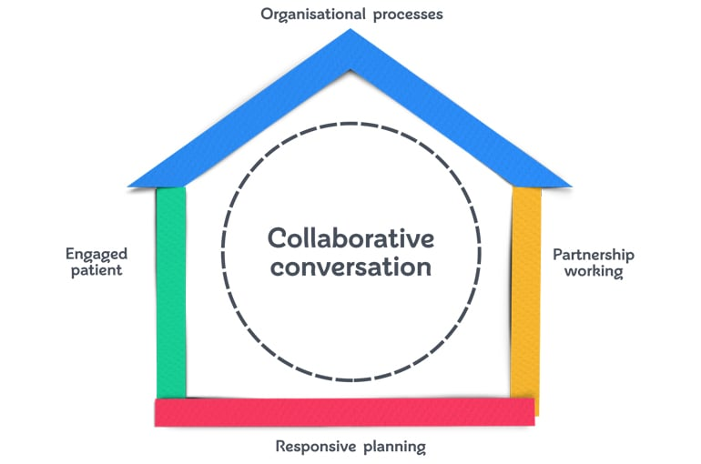
Figure 4: House of Care model for Parkinson’s
(Source: Coulter, A., Roberts, S. and Dixon, A., 2013)
The strength of the House of Care is that it focuses on common goals, relations, and social support rather than symptom management only. However, the House of Care requires the availability of staff time, information, and services available in the area. It means that when transport, peer groups, or rehabilitation services are not available, it will be challenging for patients to achieve their goals and, therefore, require additional resources and access evaluation.

7.2 Application of the Chronic Care Model to Parkinson’s Long-term Management
The Chronic Care Model (CCM) is designed to describe how health-care systems can change their approaches from the reactive visits to the proactive, well-organized care. CCM consists of six interrelated components: the organization of the health system, community resources and policies, self-management support, delivery system design, evidence-based decision support, and clinical information systems. These components allow informing and engaging patients and preparing and organizing health-care providers for productive work (Wagner et al., 2001). In Parkinson’s disease, these components include regular reviews, drug history, rehabilitation, caregivers’ education, and referral to exercise or peer-support groups.
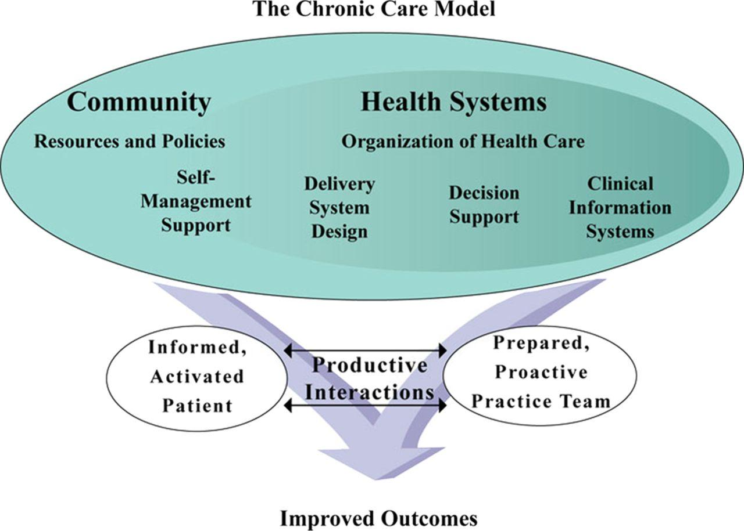
Figure 5: The Chronic Care Model applied to long-term Parkinson’s disease management
(Source: Batalden et al., 2016)
The CCM connects self-management to team organization, evidence and information systems. The model can be used to inform service redesign in primary, community and specialist care, and is not just limited to an individual care plan. However, the broad elements included in the CCM alone do not automatically result in person-centred practice, and requires accountability, workforce and patient-defined outcome measures. The House of Care complements the CCM, as it provides a framework for how each individual’s care planning conversation will be structured using patient priorities.

8. Health and Social Care Policies and Agendas
NICE guidelines provide clinical assessment and management for Parkinson’s, while shared decision-making guidelines provide guidance on decisions that are made in partnership between patients and healthcare professionals, and may include family members or carers in the process where relevant (NICE, 2017; NICE, 2021). WHO’s technical brief emphasizes awareness, risk reduction and treatment opportunities especially in regions with limited neurological services (WHO, 2022).
The House of Care provides a structure for personalized care-planning conversations, while the Chronic Care Model provides organizational and clinical change needed for proactive and coordinated care (Coulter et al., 2016; Wagner et al., 2001).
However, implementation is uneven. The parliamentary reply in December 2024 showed that more than 234,000 patients waited to see a neurologist in September 2024 in England, with 54% seeing specialists within 18 weeks (UK Parliament, 2024). The statistics were general and did not include information on Parkinson’s disease specifically. However, they highlight the problems with capacity that affect diagnosis and follow-up care. Workforce shortages, high travel expenses, digital exclusion, and lack of community rehabilitation services might hinder implementation. National standards require local plans, workforce development, transparency about waiting times and patient experience data. Healthcare services should verify access in rural, disadvantaged, and minority communities.

9. Recommendations for Improvement
First, services must increase the focus on timely diagnosis and review. Referral pathways must be clear for primary care providers, while neurological services must have wait-list review and follow-up processes for those whose condition or medication issue has deteriorated. Contacts and a named coordinator must be provided to the patient whenever possible. These interventions address the gap in diagnoses in the UK and neurology service challenges (Parkinson’s UK, 2025b; UK Parliament, 2024).
Second, everyone with Parkinson's disease must have a joint care and self-management plan that includes personal goals, medicines and their schedule, needs related to mobility and falls, mood and cognition, communication and swallowing, nutritional aspects, and contacts in case of crisis. The plan must be reviewed following important changes and shared among relevant services with permission for individualised care and decision-making (NHS England, 2022; NICE, 2021).
Third, all individuals with Parkinson's disease should have access to Parkinson's-specific rehabilitation. This intervention includes physiotherapy, occupational therapy, and speech and language therapy according to the person's needs. Remote access is only available when it is clinically appropriate and possible. Collaboration between local health services and voluntary organizations and social prescribing link workers must be implemented to reduce loneliness and encourage participation in services. Outcomes of rehabilitation must be assessed in terms of falls prevention, functional activities, communication, quality of life, and reaching personal goals (Ernst et al., 2024; Ahn et al., 2022).
Fourth, carers must be identified with respect and offered an assessment, training, information, peer support, and respite. Person with Parkinson's disease must retain central role in decision-making, while the carer should be able to discuss his/her own needs. Palliative care and advance care planning must be offered based on needs and preferences of the individual, not just during the last weeks of life. Discussion may cover future symptoms, place of care, nutritional and other issues, as well as treatment options. The review will help implement personalized palliative care for both persons and caregivers (Garon et al., 2024). Access to and outcomes of services must be audited for different groups.

10. Conclusion
Parkinson’s disease is a dynamic disorder with aspects that relate to movement, non-movement, psychology and society. Statistics across the globe and in the UK show there is a need for healthcare in terms of this condition. Even though treatment and rehabilitation may improve the problem and quality of life, success will depend on early diagnosis, coordination, family participation and accessibility. House of Care and Chronic Care Model are both tools that can complement each other where one helps with planning while the other with organizing and managing care. Key points include shared decision-making, referral, rehabilitation, family participation and advance care planning for patients with Parkinson’s disease (Dup, 2020).

Reference List
Aamodt, W.W., Kluger, B.M., Mirham, M., Job, A., Lettenberger, S.E., Mosley, P.E. and Seshadri, S. (2024) ‘Caregiver burden in Parkinson disease: a scoping review of the literature from 2017–2022’, Journal of Geriatric Psychiatry and Neurology, 37(2), pp. 96–113. https://doi.org/10.1177/08919887231195219
Ahn, S., Springer, K. and Gibson, J.S. (2022) ‘Social withdrawal in Parkinson’s disease: a scoping review’, Geriatric Nursing, 48, pp. 258–268. https://doi.org/10.1016/j.gerinurse.2022.10.010
Batalden, M., Batalden, P., Margolis, P., Seid, M., Armstrong, G., Opipari-Arrigan, L. and Hartung, H. (2016) ‘Coproduction of healthcare service’, BMJ Quality & Safety, 25(7), pp. 509–517. Available at: https://doi.org/10.1136/bmjqs-2015-004315
Ben-Shlomo, Y., Darweesh, S., Llibre-Guerra, J., Marras, C., San Luciano, M. and Tanner, C. (2024) ‘The epidemiology of Parkinson’s disease’, The Lancet, 403(10423), pp. 283–292. https://doi.org/10.1016/S0140-6736(23)01419-8
Blauwendraat, C., Iwaki, H., Makarious, M.B., Bandres‐Ciga, S., Leonard, H.L., Grenn, F.P., Lake, J., Krohn, L., Tan, M., Kim, J.J. and Gibbs, J.R., 2021. Investigation of autosomal genetic sex differences in Parkinson's disease. Annals of neurology, 90(1), pp.35-42. https://doi.org/10.1002/ana.26090
Brolin, K.A., Schaeffer, E., Kuri, A., Rumrich, I.K., Schuh, A.F.S., Darweesh, S.K.L., Kaasinen, V., Tolppanen, A.-M., Chahine, L.M. and Noyce, A.J. (2025) ‘Environmental risk factors for Parkinson’s disease: a critical review and policy implications’, Movement Disorders, 40(2), pp. 204–221. https://doi.org/10.1002/mds.30067
Carers UK (2023) State of Caring Survey 2023: The impact of caring on health. London: Carers UK. https://www.carersuk.org/reports/state-of-caring-survey-2023-the-impact-of-caring-on-health/
Cavallieri, F., Ghirotto, L., Sireci, F., Parmeggiani, M., Pedroni, C., Mardones, F.A., Bassi, M.C., Fioravanti, V., Fraix, V., Moro, E. and Valzania, F. (2024) ‘Caregivers’ burden and deep brain stimulation for Parkinson disease: a systematic review of qualitative studies’, European Journal of Neurology, 31(3), e16149. https://doi.org/10.1111/ene.16149
Cong, S., Xiang, C., Zhang, S., Zhang, T., Wang, H. and Cong, S. (2022) ‘Prevalence and clinical aspects of depression in Parkinson’s disease: a systematic review and meta-analysis of 129 studies’, Neuroscience & Biobehavioral Reviews, 141, 104749. https://doi.org/10.1016/j.neubiorev.2022.104749
Coulter, A., Kramer, G., Warren, T. and Salisbury, C. (2016) ‘Building the House of Care for people with long-term conditions: the foundation of the House of Care framework’, British Journal of General Practice, 66(645), pp. e288–e290. https://doi.org/10.3399/bjgp16X684745
Dorsey, E.R., Zafar, M., Lettenberger, S.E., Pawlik, M.E., Kinel, D., Frissen, M., Schneider, R.B., Kieburtz, K., Tanner, C.M., De Miranda, B.R., Goldman, S.M. and Bloem, B.R. (2023) ‘Trichloroethylene: an invisible cause of Parkinson’s disease?’, Journal of Parkinson’s Disease, 13(2), pp. 203–218. https://doi.org/10.3233/JPD-225047
Ernst, M., Folkerts, A.-K., Gollan, R., Lieker, E., Caro-Valenzuela, J., Adams, A., Cryns, N., Monsef, I., Dresen, A., Roheger, M., Eggers, C., Skoetz, N. and Kalbe, E. (2024) ‘Physical exercise for people with Parkinson’s disease: a systematic review and network meta-analysis’, Cochrane Database of Systematic Reviews, 2024(4), CD013856. https://doi.org/10.1002/14651858.CD013856.pub3
Garon, M., Weck, C., Rosqvist, K., Odin, P., Schrag, A., Krikmann, Ü., Pedrosa, D.J., Antonini, A., Lorenzl, S., Martins Pereira, S. and Paal, P. (2024) ‘A systematic practice review: providing palliative care for people with Parkinson’s disease and their caregivers’, Palliative Medicine, 38(1), pp. 57–68. https://doi.org/10.1177/02692163231214408
Health and Social Care Alliance Scotland (The ALLIANCE) (n.d.) The House of Care Model. Available at: https://www.alliance-scotland.org.uk/past-work-and-projects/scotlands-house-of-care/the-house-of-care-model/ (Accessed: 22 October 2026).
Herd, C.P., Tomlinson, C.L., Deane, K.H.O., Brady, M.C., Smith, C.H., Sackley, C.M. and Clarke, C.E. (2021a) ‘Speech and language therapy versus placebo or no intervention for speech problems in Parkinson’s disease’, Cochrane Database of Systematic Reviews, 2021(11), CD002812. https://doi.org/10.1002/14651858.CD002812.pub2
Herd, C.P., Tomlinson, C.L., Deane, K.H.O., Brady, M.C., Smith, C.H., Sackley, C.M. and Clarke, C.E. (2021b) ‘Comparison of speech and language therapy techniques for speech problems in Parkinson’s disease’, Cochrane Database of Systematic Reviews, 2021(11), CD002814. https://doi.org/10.1002/14651858.CD002814.pub2
Islam, S.S., Neargarder, S., Kinger, S.B., Fox-Fuller, J.T., Salazar, R.D. and Cronin-Golomb, A. (2022) ‘Perceived stigma and quality of life in Parkinson’s disease with additional health conditions’, General Psychiatry, 35(3), e100653. https://doi.org/10.1136/gpsych-2021-100653
Li, J.A., Loevaas, M.B., Guan, C., Goh, L., Allen, N.E., Mak, M.K.Y., Lv, J. and Paul, S.S. (2023) ‘Does exercise attenuate disease progression in people with Parkinson’s disease? A systematic review with meta-analyses’, Neurorehabilitation and Neural Repair, 37(5), pp. 328–352. https://doi.org/10.1177/15459683231172752
Maggi, G., Vitale, C., Cerciello, F. and Santangelo, G. (2023) ‘Sleep and wakefulness disturbances in Parkinson’s disease: a meta-analysis on prevalence and clinical aspects of REM sleep behavior disorder, excessive daytime sleepiness and insomnia’, Sleep Medicine Reviews, 68, 101759. https://doi.org/10.1016/j.smrv.2023.101759
Müller, T. (2022) ‘The genetic background of Parkinson’s disease and novel therapeutic targets’, Expert Opinion on Therapeutic Targets, 26(10), pp. 827–836. https://doi.org/10.1080/14728222.2022.2153037
National Health Service (NHS) (n.d.) Parkinson’s disease: treatment. https://www.nhs.uk/conditions/parkinsons-disease/treatment/
National Institute for Health and Care Excellence (NICE) (2017) Parkinson’s disease in adults (NG71). London: NICE. Current online recommendations accessed 14 October 2026. https://www.nice.org.uk/guidance/ng71/chapter/Recommendations
National Institute for Health and Care Excellence (NICE) (2021) Shared decision making (NG197). London: NICE. https://www.nice.org.uk/guidance/ng197/chapter/recommendations
NHS England (2022) Personalised care factsheets. London: NHS England. https://www.england.nhs.uk/publication/personalised-care-factsheets/
Npatne (2023) PD Symptoms.png [image]. Wikimedia Commons, licensed under CC BY-SA 4.0. https://commons.wikimedia.org/wiki/File:PD_Symptoms.png
Parkinson’s UK (2022) Research reveals impact of the pandemic on the Parkinson’s community. London: Parkinson’s UK. https://www.parkinsons.org.uk/news/2022/research-reveals-impact-pandemic-parkinsons-community
Parkinson’s UK (2024) Getting support as a carer. London: Parkinson’s UK. https://www.parkinsons.org.uk/support/caring-for-someone/getting-support-as-a-carer
Parkinson’s UK (2025a) Parkinson’s statistics. London: Parkinson’s UK. https://www.parkinsons.org.uk/information/about-parkinsons/statistics
Parkinson’s UK (2025b) Thousands are living with Parkinson’s undiagnosed and unsupported, our new research finds. London: Parkinson’s UK, 22 October. https://www.parkinsons.org.uk/news/2025/thousands-are-living-parkinsons-undiagnosed-and-unsupported-our-new-research-finds
Perepezko, K., Hinkle, J.T., Forbes, E.J., Pontone, G.M., Mills, K.A. and Gallo, J.J. (2023) ‘The impact of caregiving on quality of life in Parkinson’s disease: a systematic review’, International Journal of Geriatric Psychiatry, 38(1), e5870. https://doi.org/10.1002/gps.5870
Petersen, J.J., Kamp, C.B., Faltermeier, P., Juul, S., Løkkegaard, A., Gluud, C. and Jakobsen, J.C. (2024) ‘Deep brain stimulation for Parkinson’s disease: systematic review with meta-analysis and trial sequential analysis’, BMJ Medicine, 3(1), e000705. https://doi.org/10.1136/bmjmed-2023-000705
Rojvirat, C., Arismendi, G.R., Feinstein, E., Guzman, M., Citron, B.A. and Delic, V. (2024) ‘Systematic review of post-traumatic parkinsonism, an emerging parkinsonian disorder among survivors of traumatic brain injury’, Neurotrauma Reports, 5(1), pp. 37–49. https://doi.org/10.1089/neur.2023.0104
Severiano e Sousa, C., Alarcão, J., Pavão Martins, I. and Ferreira, J.J. (2022) ‘Frequency of dementia in Parkinson’s disease: a systematic review and meta-analysis’, Journal of the Neurological Sciences, 432, 120077. https://doi.org/10.1016/j.jns.2021.120077
Shan, L., Heusinkveld, H.J., Paul, K.C., Hughes, S., Darweesh, S.K.L., Bloem, B.R. and Homberg, J.R. (2023) ‘Towards improved screening of toxins for Parkinson’s risk’, npj Parkinson’s Disease, 9, 169. https://doi.org/10.1038/s41531-023-00615-9
UK Parliament (2024) Written question 16559: Waiting lists for Parkinson’s disease treatment. Answered 3 December 2024. https://questions-statements.parliament.uk/written-questions/detail/2024-11-27/16559/
Van Bladel, A., Herssens, N., Bouche, K., Cambier, D., Maes, L. and Lefeber, N. (2023) ‘Proportion of falls reported in persons with Parkinson’s disease: a meta-analysis’, Clinical Rehabilitation, 37(9). https://doi.org/10.1177/02692155231158565
Wagner, E.H., Austin, B.T., Davis, C., Hindmarsh, M., Schaefer, J. and Bonomi, A. (2001) ‘Improving chronic illness care: translating evidence into action’, Health Affairs, 20(6), pp. 64–78. https://doi.org/10.1377/hlthaff.20.6.64
World Health Organization (WHO) (2022) Parkinson disease: a public health approach. Technical brief. Geneva: WHO. https://www.who.int/publications/i/item/9789240050983
World Health Organization (WHO) (2023) Parkinson disease. Fact sheet, 9 August. Geneva: WHO. https://www.who.int/news-room/fact-sheets/detail/parkinson-disease
Xu, Y., Su, Y., Cai, S., Yao, Y. and Chen, X. (2024) ‘Environmental and occupational exposure to organochlorine pesticides associated with Parkinson’s disease risk: a systematic review and meta-analysis based on epidemiological evidence’, Public Health, 237, pp. 374–386. https://doi.org/10.1016/j.puhe.2024.10.035

