developing workplace critical thinking
How Individuals Beliefs, Attitudes and Values impact on workplace behaviour.

Samantha Davis 1812476
Ba Leadership and Management Skills in the Workplace.

Contents
Executive Summary 2
Introduction. 3
Findings 5
Conclusion 11
Recommendations 12
References 13

Executive Summary
The following report is going to identifying various Management theories which are aligned within the Coca- Cola Company. The researcher is going to be using the RED Model to critically assess their impact on the values, attitudes ands beliefs of the individual and organisation. The researcher is also going to identifying recommendations on various theorists that Coca-Cola can align within their organisation to complement the way they are currently operating.

Introduction.
The following report will be identifying various classical management theorists and aligning their theories within the Coca-Cola organisation. Coca-Cola is a global company which is ranked 3rd amongst the best brands worldwide. They were founded in the United States in 1892 and have an estimated value of 73.1 billion dollars.
Coca-Colas mission statement is “to refresh the world in mind, body and spirit. To inspire moments of optimism and happiness through our brands and actions. To create value and make a difference.” (Coca-cola.co.uk, 2020)
To achieve their mission Coca-Cola has developed a set of 6 P’s that can help including People, Portfolio, Partners, Planet, Profit and Productivity. As well as these 6 P’s Coca- Cola also have the following shared values that determine how they behave: Leadership, Collaboration Integrity, Accountability, Passion, Diversity and Quality.Through researching Coca-Cola and understanding the various Classical Management theorists the following report will be able to identify the pros and cons of aligning these theories and which ones will help complement their organisation.
In this report the researcher is going to critically analyse the impact of management theories and their relevance to a chosen organisation. The researcher will be assessing the impact of these theories once aligned with the organisations Values Attitudes and Beliefs.
Values Attitudes and Beliefs are the foundations of how individuals or organisations behave. They are important in the way we act, treat peers, approach situations. 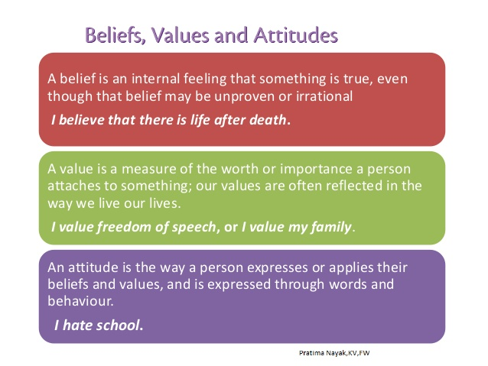 (Beliefs,values and attitudes, 2020)

Employees have their own values when they walk in the door, and they are influenced everyday by the values they experience in your organisation.” (Barrett Values Centre, 2020)
Coca-Cola needs to ensure that their employers know their values and that they are reinforced in everything they do and that all levels of employees and managements live these values.(Fixer: How can we inspire staff to live our values?, 2020)
The researcher will be assessing how various management theories align to Coca-Cola values and how they are impacting on their success. The researcher will also be looking at ways to bring other management theories on board to improve the organization success. Throughout this report the researcher will also be using Critical Thinking Models to complete his findings. To help employers and employees better understand their values Barrett Values Centre offers many assessments to help.

Findings
Management theories can be linked to motivation, leadership and change and by understanding and aligning these theories Coca-Cola can continue to grow and succeed in the knowledge they are doing everything positively to not only improve their organisation but also to complement their employees needs and work environment. There are 4 schools of management theories including Scientific, Behavioural, Classical and Modern and for the importance of this report the researcher is going to be understanding and identifying the classical theorist which is the foundation of Coca-Cola and will be finding the critics and any gaps will be filled with recommendation of aligning others.
Theories can help employers understand an experience more clearly and understand what criteria is required to make the experience positive. These theories can also help with communicating, negotiation, and to keep the organisation UpToDate with changes. There are 3 important Classical theorists including
Max Webber- Beuracracy
Henry Fayol -Scientific/Classical
Frederick Taylor – Scientific
Henry Fayol was a Classical Theorist (1841-1925), he is one of a few theorists who are responsible for laying the foundation for a modern management theory. Fayol’s administrative theory believed that management consist of 5 principle elements
- Forecasting
- Planning
- Organising
- Coordinating
- Controlling
Fayol also believed that there were 14 principles that also went hand in hand with these 5 important roles - specialisation/division of labour, authority with responsibility, discipline, unity of command, unity of direction, subordination of individual interest to the general interest, remuneration of staff, centralisation, scalar chain/line of authority, order, equity, stability of tenure, initiative, and esprit de corps. Fayol believed that these were essential to help managers organise and interact with their staff (Henri Fayol's Principles of Management: Early Management Theory, 2020)

Fayol’s theory aligns well within the Coca- Cola company as the 5 main principles layout a template for Coca- Cola to follow and achieve their goals.
Forecasting principle is an excellent way for Coca Cola to not only communicate with all their employees but is also allowing all internal and external stakeholders to be aware of their vision and plans and to monitor their progress. They are forecasting a plan of action to help them achieve their ambition for a world without waste.
In 2018, the Coca-Cola system announced an industry-first goal to help collect and recycle the equivalent of every bottle or can we sell worldwide by 2030. “Consumers around the world care about our planet. They want and expect companies like ours to be leaders and help make a litter-free world possible,” says James Quincey, president and CEO, The Coca-Cola Company.

“Through our World Without Waste vision, we are investing in our planet and in our packaging to help make the world’s packaging problem a thing of the past.” (World Without Waste | Making the future more sustainable | Coca-Cola GB, 2020)

Planning
Organising By liaising with local bottlers and having external partnerships/collaborations with WWF and River Trust, Keep Britain Tidy and The Ellen MacArthur Foundation, Coca- Cola is not only showing awareness but is being sensitive to local market conditions.This out sourcing and collaborations with others is helping to develop their own resources.

Frderick Taylors theory would not be suitable for Coca- Cola however would work well within a factory environment as there is no flexibility, innovation or creativity.
Another theorist model Coca-Cola could introduce to complement Fayol and fill in any gaps would be Herzberg Two Factor Theory. This theory could go a long way in strengthening staff morale with the positives being benefited by Coca-Cola.
In 1959, Frederick Herzberg, a behavioural scientist proposed a two-factor theory or the motivator-hygiene theory. According to Herzberg, there are some job factors that result in satisfaction while there are other job factors that prevent dissatisfaction. According to Herzberg, the opposite of “Satisfaction” is “No satisfaction” and the opposite of “Dissatisfaction” is “No Dissatisfaction”
Herzberg further broke this down into Motivator Factors and Hygiene Factors. (Herzbergs Two-Factor Theory of Motivation, 2020)
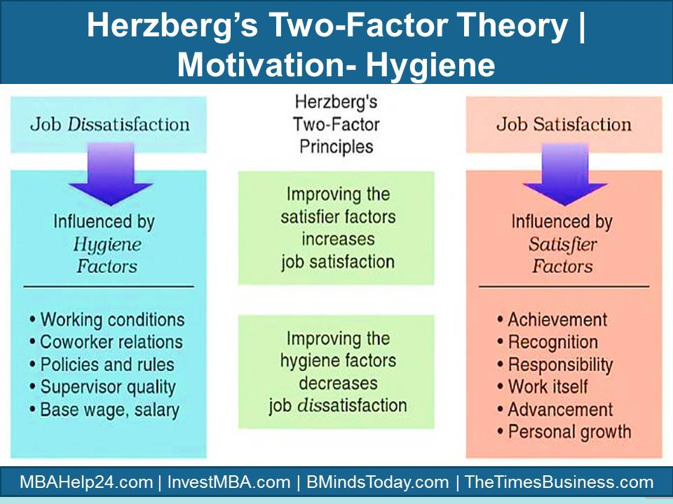 (Herzberg ’s Two- Factor Theory of Motivation, 2020)

By improving on the Motivating and hygiene factors Coca Cola is ensuring that they are responsible employers and that working under the Coca-Cola umbrella is a sought after job as they are positively promoting themselves as word class leader in the employment world. Not only are they making the working environment a pleasant and enjoyable environment, but they are also being considerate to the different culture’s values attitudes and beliefs of all their stakeholders. Some of the motivating factors are as follow
- Achievement: Will boost staff morale whilst everyone will feel a sense of getting the job done. This can also promote teamwork.
- Recognition: Employees should be rewarded for their success even if it is not monetary, they should be praised for their work.
- The work itself: The work should always remain challenging as this will keep staff motivated and interested in the task at hand
- Responsibility: It is important that employees know the positives and negatives of their tasks as this can give them an ownership and encourage them to work harder and learn from mistakes
- Growth: There should be the opportunity for rewards, promotion and formal/informal training this will boost staff morale and see an increase and improvement in work standards.
- The Hygiene factors include
- Company policies, these should promote equality to all and not be unrealistic
- Work conditions: The work environment should be safe and fit for use along with all machinery and equipment used.
- Salary: This should be competitive with the outside world. The pay/promotion structure should also be fair and realistic
- Security: It is important that employees feel that their job is secure, and they are not under the constant threat of being laid-off.

(Coca-Cola, 2020) believe that they live their Values. Their values act as a compass for their actions and behaviour around the world.
“Clarifying individuals and organisations values can help to create a win-win outcome for all concerned. Individuals can find meaning in their work, and companies can develop a committed workforce.” (Sullivan, Sullivan and Buffton, 2001)

- Leadership: The courage to shape a better future
- Collaboration: Leverage collective genius
- Integrity: Be real
- Accountability: If it is to be, it is up to me
- Passion: Committed in heart and mind
- Diversity: As inclusive as our brands
- Quality: What we do, we do well
Coca Cola believe that to remain true to their vision and values they need to
Focus on the Market- be focussing on their consumers, they need to be aware of what is expected of them globally as culture and expectations differ around the globe. They also need to get out into the market and research, listen and evaluate what their consumers, customers and franchise partners need and wants. They need to constantly be curious.
Work Smart- Coca -Cola need to be constantly working efficiently and be prepared to change their plan if it is failing, it is important that they are prepared to act with speed whilst remaining constructively discontent.
Act Like Owners-Coca-Cola need to be prepared to be held accountable by their stakeholders both internally and externally, this will also help them to learn from the decisions they have made and evaluate what was positive/ negative an understand why. They also need to be willing to reward their employees for hard work, determination and the ability to improve and solve problems.
Be the Brand- They need to ensure that they are excellent ambassadors for the brand and that they are recruiting the kid of managers who are not only passionate and fun but that can inspire other to be better.
Coca-Cola believes that they are true to their vision and values and by having these policies and benefits that they are also complementing their employee’s values beliefs and attitudes.
“Coca-Cola has very specific practices in place to ensure that employees are motivated to do their best and feel like they have an important role in the company's future. “(What Type of Employee Motivation Does Coca-Cola Offer? 2020)

Coca-Cola believes in asking their employees for their opinions this is done through the interview process and annually through an Employee Insight Survey. These surveys not only ask how the company is run but also how they can improve things. These results are what Coca-Cola used to develop its mission statement and core values. The responses from these surveys are tracked and help with improvements from year to year. This survey shows the employees that their opinions matter and that management is listening.
Coca-Cola are also keen to train and further develop their employees. There are several training and development programmes available to encourage and motivate their employees. This is again a big morale boost for employees as they are given the opportunity to learn and grow which gives them a sense of security for their future within the company as they are being invested in. There is also the Coca-Cola University which is an online teaching platform. Employees are also given the opportunity to work within a different department, role or even a different country encouraging them to become multi-skilled and learn about other cultures.
Different Coca-Cola work sites offer different perks including cafeteria, free parking, free beverages/fruit, onsite gym, dry cleaning and creches. Coca-Cola believe these perks will boost motivation amongst their employees.
“Coca-Cola also offers financial rewards to motivate employees to reach greater pinnacles. Compensation is competitive. Every year, employees have performance reviews that give them a chance to receive merit raises. A Coca-Cola Red Tag program rewards employees with travel and merchandise as a way to recognize exceptional performance. Employees also get tuition reimbursement, and their children can qualify for scholarship funds. Car discounts, free parking and employee discount programs are also offered.” “(What Type of Employee Motivation Does Coca-Cola Offer? 2020)

It is important when analysing theses statements and values that the researcher use 1 of 2 Critical Thinking Models, he can either use the
Pearson Red Model
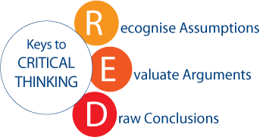(Pearson,2015)

Stephen Touilman
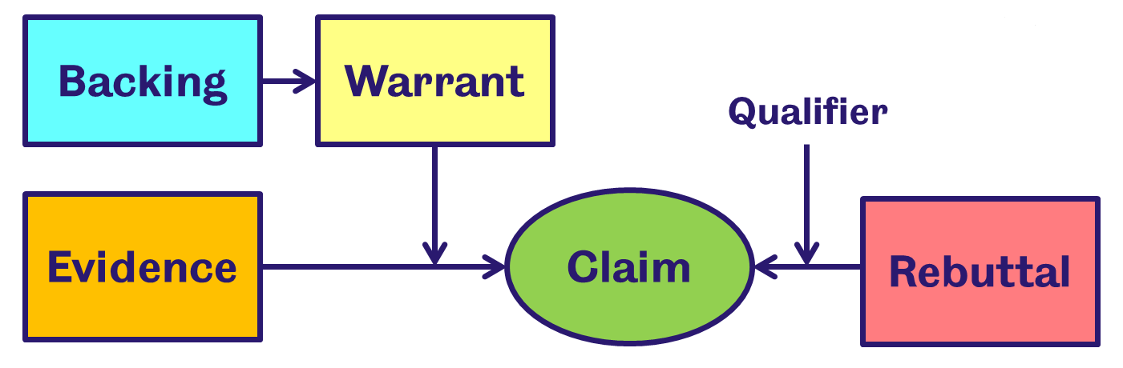 (Critical Thinking Resource: Toulmin Model for Argument Construction, 2020)
Both of these models can help identify if press releases and statements that Coca-Cola claim or release are in fact actual or if they are biased and false.

Conclusion
On reflection of the report the researcher can identify that Coca-Cola has aligned the Fayol management theory well within the organisation. The report shows that Coca-Cola are doing everything possible to remain true to their core values and continue to grow within the global market. Although Coca-Cola has seen its fair share of negative press through its vision and passion the organisation is seen to be doing well and as promised. However, Coca- Cola have also aligned with some elements of the Herzeberg Two- Factor Principles and could only improve and further within their employer’s sectors by ensuring they improve on both Motivator Factors and Hygiene Factors universally. With the needs and demands of consumers worldwide constantly changing along with legal and economic changes it is important that Coca- Cola have a plan to ensure that they are leading the way in these changes instead of following their competitors.
The report also suggest that Coca-Cola are also trying to stay true to their employees values, attitudes and behaviours and with all of their hard work and collaborations it will be interesting to see if they can reach their vision of a World Without Waste by 2030.

Recommendations
- It is recommended that all new recruits take a personal values assessment to ensure they are a good fit for the company.
- That all managers know what is expected of them and that they are aware of the aligned theorist’s theory.

References
Barrett Values Centre. (2020). Barrett Values Centre | Your Organisation, Thriving. [online] Available at: https://www.valuescentre.com/ [Accessed 2 Mar. 2020].
Career Trend. 2020. What Type of Employee Motivation Does Coca-Cola Offer? [online] Available at: <https://careertrend.com/type-employee-motivation-cocacola-offer-37161.html> [Accessed 18 June 2020].
Coca-cola.co.uk. 2020. Coca-Cola and WWF: A Brief History of Water Stewardship in the UK. [online] Available at: <https://www.coca-cola.co.uk/marketing/sponsorships-and-partnerships/coca-cola-and-wwf-a-brief-history-of-water-stewardship-in-the-uk> [Accessed 17 June 2020].
Coca-cola.co.uk. 2020. Great British Spring Clean: Coca-Cola Staff Take to The Streets | Sponsorships and Partnerships | Coca-Cola GB. [online] Available at: <https://www.coca-cola.co.uk/marketing/sponsorships-and-partnerships/great-british-spring-clean> [Accessed 17 June 2020].
Coca-cola.co.uk. 2020. World Without Waste | Making the Future More Sustainable | Coca-Cola GB. [online] Available at: <https://www.coca-cola.co.uk/sustainability/global-sustainability-vision/a-world-without-waste> [Accessed 17 June 2020].
Ellenmacarthurfoundation.org. 2020. Our Network. [online] Available at: <https://www.ellenmacarthurfoundation.org/our-story/our-network> [Accessed 17 June 2020].
Mindtools.com. 2020. Henri Fayol's Principles of Management: Early Management Theory. [online] Available at: <https://www.mindtools.com/pages/article/henri-fayol.htm> [Accessed 17 June 2020].
People Management. 2020. Fixer: How Can We Inspire Staff to Live Our Values? [online] Available at: <https://www.peoplemanagement.co.uk/experts/advice/fixer-inspire-staff-live-values> [Accessed 20 March 2020].
Slideshare.net. 2020. Beliefs, Values and Attitudes. [online] Available at: <https://www.slideshare.net/pratimanayak39/beliefsvalues-and-attitudes> [Accessed 25 March 2020].
Sullivan, W., Sullivan, R. and Buffton, B., 2001. Aligning individual and organisational values to support change. Journal of Change Management, 2(3), pp.247-254.
Us.talentlens.com. (2020). Talent Lens | Pearson. [online] Available at: https://us.talentlens.com/ [Accessed 18 June. 2020].
Learnthewritingprocess.blogspot.com. 2020. Critical Thinking Resource: Toulmin Model for Argument Construction. [online] Available at: <https://learnthewritingprocess.blogspot.com/2018/10/critical-thinking-resource-toulmin.html> [Accessed 18 June 2020].

