
BSc (Hons) Professional Policing Practice

How effective are police interventions in domestic abuse cases at protecting the short- and long-term wellbeing of children.

Cari Trayhern
2246064

Dedication:

I would like to express my sincere gratitude to my family, especially my mam, dad, brother, sister, nan and bamp for their unwavering love, encouragement and support throughout my studies. Your belief in me has given me the motivation and determination to continue, even during the hardest times. I am incredibly grateful for everything you have done to help me get to where I am today.

I would also like to thank my partner James, for his patience, understanding and constant encouragement throughout this time. Thankyou for always supporting me, listening when things became stressful and reminding me to keep going. Your reassurance and belief in me have meant more than you know. Always.

Finally, I would like to express my sincere appreciation to my tutor Tash, for your guidance, knowledge and support throughout the last three years. You have been invaluable in helping me develop as a whole. Thankyou for your time, patience and just being there for me.
Declaration:
This work has not previously been accepted in substance for any degree and is not being concurrently submitted in candidature for any degree.
Signed: C Trayhern
Date: 28/05/2026

STATEMENT 1
This dissertation is being submitted in partial fulfilment of the requirements for the degree of BA.
Signed: C Trayhern
Date: 28/05/2026

STATEMENT 2
This dissertation is the result of my own independent work/investigation, except where otherwise stated.
Other sources are acknowledged by footnotes giving explicit references. A bibliography is appended.
Signed: C Trayhern
Date: 28/05/2026

STATEMENT 3
I hereby give consent for my dissertation, if accepted, to be available for photocopying and for interlibrary loan, and for the title and summary to be made available to outside organisations.
Signed; C Trayhern
Date:28/05/2026

STATEMENT 4
I hereby give consent for my dissertation, if accepted, to be available on the university’s IT system to those who have consent to use the system.
Signed: C Trayhern
Date:28/05/2026
Abstract
Domestic abuse remains a significant issue which not only affects adult victims but also many younger and older children who are exposed to such abusive environments. Children living in house holds where domestic abuse occurs are at an increased risk of experiencing adverse childhood experiences (ACEs), which can have lasting effects on their psychological, behavioural, emotional and social development. Police officers are often the first line of professionals to respond to incidents of domestic abuse and therefore play a crucial role in safeguarding children and reducing as much as possible further risk of harm. This dissertation examines the effectiveness of police interventions in domestic abuse cases at protecting the short and long term wellbeing of children.

A mixed methods approach was used using primary quantitative data collected through two questionnaire distributed to serving police officers and members of the public. The findings were analysed using descriptive statistics and graphs and compared with existing academic literature, legislation and national policing guidance. The results demonstrate that police interventions are generally viewed as essential to safeguard children and responding to domestic abuse incidents. However, the police survey also identifies significant barriers which are affecting effectiveness, which are high workloads, limited resources and communication challenges between partner agencies and victim disengagement. These factors are perceived to reduce the consistency and impact of police safeguarding measures long term.

The study concludes that although the police intervention is a crucial component of protecting children affected by domestic abuse, policing alone cannot achieve long term positive outcomes. It is essential for children’s wellbeing to have effective multi-agency collaboration, early intervention, information sharing and continues support for families. This research as a whole recommends specialist investment is needed in domestic abuse training, improved inter-agency communication and more effective resources for safeguarding teams to strengthen responses to protect children who are experiencing domestic abuse.
Contents
Chapter 1 – Introduction…………………………………………………………………1
1.1 Background…………………………………………………………………..1
1.2 Research Aim………………………………………………………………...2
1.3 Research Objectives…………………………………………………………2
1.4 Research Questions…………………………………………………………..3
1.5 Rationale for Study…………………………………………………………..3
1.6 Structure of Dissertation……………………………………………………..4
Chapter 2 – Literature review …………………………………………………...………5
2.1 Introduction…………………………………………………………………5
2.2 Defining Domestic Abuse……………………………………………...……5
2.3 The Impact of Domestic Abuse on Children……………………………...…7
2.4 Adverse Childhood Experiences (ACEs) …………………………………...8
2.5 Child development and trauma……………………………………………..10
2.6 Police Powers and Safeguarding Responsibilities …………………………13
2.7 Domestic Abuse Risk Assessment and Child Safeguarding………………..14
2.8 Multi-agency Working in Safeguarding Children……………………….…16
2.9 Evaluating the Effectiveness of Police Interventions………………………18
2.10 Gaps in Literature…………………………………………………………19
2.11 Conclusion ………………………………………………………..………20
Chapter 3 – Methodology …………………………………………………………...…21
3.1 Introduction……………………………………………………………...…21
3.2 Research Philosophy ………………………………………………………21
3.3 Research Design ………………………………………………………...…21
3.4 Data Collection……………………………………………………..………22
3.5 Sampling Strategy …………………………………………………………23
3.6 Reliability and Validity ……………………………………………………24
3.7 Ethical Considerations………………………………………………..……24
3.8 Limitations…………………………………………………………………24
Chapter 4 – Findings and Results …………………………………………...…………26
4.1 Introduction……………………………………………………………...…26
4.2 Public Questionnaire Findings…………………………………………...…26
4.3 Police Questionnaire Findings……………………………………………...29
4.4 Comparison of Public and Police Responses………………………………30
4.5 Conclusion …………………………………………………………………31
Chapter 5 – Discussion ………………………………………………………………...32
5.1 Introduction………………………………………………………………...32
5.2 Impact of Domestic Abuse on Children……………………………………32
5.3 Police Intervention and Safeguarding………………………………………32
5.4 Multi-agency Working ……………………………………………………..32
5.5 Implications for Policing…………………………………………………...32
5.6 Conclusion …………………………………………………………………33
Chapter 6 – Conclusion ……………………………………………………………..…34
6.1 Introduction………………………………………………………………...34
6.2 Conclusion…………………………………………………………………34
6.3 Recommendations …………………………………………………………34
6.4 Limitations………………………………………………………………….35
6.5 Suggestions for Future Research …………………………………………..36
6.6 Final Conclusion……………………………………………………………36
Bibliography …………………………………………………………………….……..37
Appendices …………………………………………………………………………….43
Appendix A – Application for Ethical Approval ………………………………43
Appendix B – Research Proposal Form………………………………………..56
Appendix C – Public survey……………………………………………………61
Appendix D – Police survey……………………………………………………64
Appendix E - Graphs…………………………………………………………...68

List of Figures
Figure 4.1 – Public Questionnaire graph for question 4; Police respond appropriately to domestic abuse incidents. …………………………………………………………
Figure 4.2 – Public Questionnaire graph for question 13; More should be done to safeguard children affected by domestic abuse. …………………………………………
Figure 4.3 – Police Questionnaire for question 19; What is the biggest challenge in safeguarding children during domestic abuse investigations. …………………………
Glossary of terms

Adverse Childhood Experiences (ACEs) – Possible traumatic experiences one may experience during childhood, including abuse, neglect and household dysfunction, which can lead to affects to health and wellbeing throughout life.
Child safeguarding – Actions taken to protect children from abuse, exploitation and neglect while promoting their welfare.
Domestic abuse – Behaviour between individuals aged 16 years or over who are personally connected which is abusive, this can include emotionally, physically, sexual, psychological, coercive, controlling, economic or threatening behaviour.
Domestic violence disclosure scheme (Clares Law) – a scheme allowing police to disclose information about an individuals history of abusive behaviour where it is necessary to protect someone who may be at risk.
DASH risk assessment – a assessment in which is completed by frontline professionals to identify risk which is faced by victims of domestic abuse.
Early intervention – identifying and acting on safeguarding concerns at the earliest opportunity to reduce future harm.
MARAC – a meeting where agencies share information to create coordinated safety plans for victims and high risk of serious harm.
Police intervention – any actions which is taken by police officers who have responded to domestic abuse, this includes investigation, safeguarding, arrests, referral to partner agencies and ongoing risk management.
Safeguarding – the collective responsibility of organisations and professionals to protect vulnerable individuals from harm.
Trauma-informed policing – an approach recognising the effects of trauma on victims and children, with responses designed to reduce further harm while improving support and engagement.
Wellbeing – the physical, emotional, psychological and social health of an individual.

List of legislation and key policy documents

Legislation
- Children Act 1989
- Children Act 2004
- Crime and Disorder Act 1998
- Data Protection Act 2018
- Domestic Abuse Act 2021
- Human Rights Act 1998
- Serious Crime Act 2015

Government Guidance and National Policy
- College of policing – Authorised Professional Practice (APP): Domestic Abuse
- HM Government – Working Together To Safeguard Children (2023)
- Home Office – Domestic Abuse Statutory Guidance (2022)
- Home Office – Domestic Abuse Act 2021: Statutory Guidance
- HMICFRS – Report on the Police Response to Violence Against Women and Girls
- National Police Chiefs’ Council (NPCC) – National Policing Strategy on Violence Against Women and Girls
- NICE Guidelines NG76 – Child Abuse and Neglect
- SafeLives – Domestic Abuse Practice Guidance

Chapter 1 – Introduction
  - Background
Domestic abuse remains one of the most significant safeguarding issues encountered by police forces across England and Wales. It affects anyone, regardless of age, gender, ethnicity or economic status and can extend further than just physical violence. This includes coercive and controlling behaviour, emotional abuse, sexual abuse and economic abuse. The Domestic Abuse Act 2021 established a statutory definition of domestic abuse and, importantly, recognised that children who see, hear of experience the effects of domestic abuse are victims themselves (Home Office, 2022).
Historically, police responses to domestic abuse cases always focused on the victims themselves and the investigation of criminal offences. However, increasing evidence and statistics has demonstrated that children who live in houses in which domestic abuse takes place experience significant harm, even when they are not the direct target of violence. Exposure to domestic abuse has been associated with emotional distress, depression, anxiety, behavioural difficulties, poor educational and impaired social development (Holwell, 2011; Holt, Buckley and Whelan 2008). These effects can continue into adulthood, increases the likelihood of mental ill health, substance misuse, involvement in offending behaviour and difficulties in forming healthy relationship.
The recognition of children as victims has resulted in greater emphasis on safeguarding within policing. Police officers are frequently the first professional to attend domestic abuse incident and therefore are at a position to identify risk, protecting children from immediate harm and initiating safeguarding referrals. Officers must make complex decisions regarding arrest, gathering evidence, completion of domestic abuse risk assessments and referrals to partner agencies such as social services for children. These decisions are often made rapidly whilst also balancing the immediate safety of victims with longer term safeguarding issues.
Research into Adverse Childhood Experiences (ACEs) has further improved long term impacts of childhood exposure to domestic abuse. ACEs refer to stressful or traumatic events experienced during childhood, including abuse, neglect and childhood dysfunction.
Despite legislation changes and increased knowledge of safeguarding responsibilities, questions still remain regarding the effectiveness and consistency of police responses. Previous studies have identified variations in officer decision making, differences in safeguarding practices between police forces and challenges associated with information sharing between partner agencies. Whilst a significant amount of research gone into the impact of domestic abuse, less attention has been focused on how police interventions influence children’s wellbeing over both the short and long term.
This dissertation seeks to address that gap by examining how police interventions during domestic abuse incidents affect children’s wellbeing.

  - Research Aim
The overall aim of this research is to examine how police interventions during domestic abuse incidents affect the short- and long-term wellbeing of children in England and Wales. This study seeks to evaluate the effectiveness of current policing practices in safeguarding children exposed to domestic abuse whilst exploring whether existing interventions adequately address immediate and long-term risks. Through the use of primary research alongside an analysis of current academic literature, this will identify strengths within current policing practice, highlight areas requiring improvement and provide recommendations for future safeguarding strategies.

  - Research Objectives
To achieve the research aim, the following objectives have been established:
- To critically examine the impact that exposure to domestic abuse has on children’s short- and long-term wellbeing.
- To evaluate the role of police officers in safeguarding children during domestic abuse investigations.
- To examine current legislation, policy and safeguarding procedures relating to domestic abuse and child protection.
- To explore the views of police officers regarding current safeguarding practices through primary questionnaire research.
- To explore public perceptions of police responses to domestic abuse involving children.
- To identify areas where police interventions could be improved to better safeguard children and reduce future harm.

  - Research Questions
The dissertation will seek to answer the following research questions;
Primary research question;
How effective are police interventions in domestic abuse cases at protecting the short- and long-term wellbeing of children?
Secondary research questions;
- What are the short and long term effects of domestic abuse on children’s wellbeing?
- What safeguarding responsibilities do police officers carry when attending domestic abuse incidents involving children?
- How effective are current police interventions in protecting children from further harm?
- What are the perceptions of police officers and members of the public regarding the current police responses?
- What changes can improve and strengthen safeguarding outcomes for children exposed to domestic abuse?

  - Rationale for Study
Domestic abuse continues to place an extreme demand on policing across England and Wales, accounting for a significant proportion of incidents attended by frontline officers. According to the Home Office (2022), police recorded domestic abuse incidents remain among the highest volume safeguarding calls received by police forces each year. While most attention has been given to protecting adult victims, children have often been viewed as secondary victims despite increasing evidence demonstrating the profound impact domestic abuse has on their development and wellbeing.
The rationale for this research therefore grows from the need to evaluate whether current police interventions effectively protect children beyond the immediate incident.

  - Structure of Dissertation
This dissertation consists of six chapters.
Chapter one introduces the research topic, outlines the background to the study, presents the research aim, objectives and research questions, and explains the rational underpinning the research.
Chapter two presents a critical review of existing academic literature relation to domestic abuse, childhood trauma, adverse childhood experiences (ACEs), safeguarding responsibilities, police interventions and multi-agency work. It also identifies gaps within the current literature which justify the need for this research.
Chapter three outlines the methodology established within the study. It explains the research philosophy, research design, sampling strategy, questionnaire design, ethical considerations, limitations and methods of data analysis.
Chapter four presents the findings obtained through questionnaires completed by police officers and members of the public. Results displayed using descriptive statistics and graphs where appropriate before being analysed in relation to the research questions.
Chapter five discusses the findings by comparing the primary research with existing academic literature. Areas of agreement, contradiction and emerging themes will be critically evaluated to determine effectiveness of current police interventions.
Chapter six concludes the dissertation by answering the research questions, acknowledging the limitations of the study and providing recommendations for policing practice, safeguarding police and future research.
Chapter 2 - Literature review
2.1 Introduction
The purpose of this literature review is to critically evaluate existing research relating to domestic abuse, the impact of exposure to abuse on children and the role of police interventions in safeguarding vulnerable children. The review draws upon peer-reviewed academic literature, legislation, government policy and policing guidance to provide a comprehensive understanding of the current evidence base.
Domestic abuse has increasingly been recognised as social issue requiring a coordinated response from criminal justice agencies, health services, education providers and children social care (Home Office, 2022). Within this framework, police officers often act as the first point of contact for families experiencing abuse, placing them in prime position to identify risk, safeguard children and initiate the multi agency interventions (College of Policing 2022). Understanding how effective these interventions are is essential in evaluating whether current policing practices adequately protect children from immediate harm and potential long term harm.
The literature reviewed in this chapter demonstrates that although significant progress has been made through legislative reform and improved safeguarding procedures, considerable challenges remain. Inconsistencies in police responses, different levels of safeguarding practice and difficulties with inter agency communication continue to affect outcomes for children exposed to domestic abuse.

2.2 Defining Domestic Abuse
The definition of domestic abuse has evolved significantly over the last two decades, leading to a further understanding of abusive behaviour beyond just physical violence. Historically, domestic abuse was commonly associated with physical assault occurring within intimate relationships. However contemporary research recognises that abuse can take place in many forms, including emotional, psychological, sexual, financial and technological abuse, alongside coercive and controlling behaviour (Stark, 2007).
In England and Wales, the Domestic Abuse Act 2021 provides the first statutory definition of domestic abuse. The act states that behaviour is abuse where it consists of physical or sexual abuse, violent of threatening behaviour, economic abuse or psychological, emotional or other forms of abuse between indicates ages 16 years or over who are personally connected (Home Office 2022). Importantly, the legislation also recognises that children who see, hear of experience the effects of domestic abuse are also victims themselves, representing a significant shift in safeguarding policy.
The legislative development reflects growing evidence that children may suffer significant harm despite never being physically assaulted themselves. Holden (2003) argues that describing children as “witnesses” to domestic abuse underestimates their experiences, as many directly observe assaults, attempts to intervene, hear incidents occurring elsewhere within the home or experience the emotional consequences of living within an abusive environment. Consequently, many researchers advocate the term “children exposed to domestic abuse” rather than “child witnesses”, acknowledging the broader ways in which abuse affects children daily lives.
Although the statutory definition provides clarity, some academics argue that domestic abuse remains difficult to define due to complexity and diversity. Johnson (2008), for example, distinguishes between different forms of domestic violence, including coercive controlling violence and situational couple violence, suggesting that not all abusive relationships follow certain patterns. The distinction has important implications for policing because different forms of abuse may require different safeguarding responses and levels of intervention.
When coercive control was introduced as a criminal offence under the Serious Crime Act 2015, it further transformed policing practice by recognising that repeated patterns of psychological domination can be equally as harmful as physical violence. Stark (2007) argues that coercive control systematically deprives victims of autonomy, creating environments of fear, isolation and intimidation. Children who live within such households may therefore experience stress despite relatively limited physical violence, illustrating why safeguarding decisions cannot be made on visible injuries.
For police officers attending domestic abuse incidents, recognising these less visible forms of abuse presents an ongoing challenge. Although physical injuries may be absent, victims can minimise abuse through fear, and children themselves may not disclose their experiences. Consequently, frontline officers are required to identify subtle indicators of risk while making safeguarding decisions under what can be significant time pressures. This highlights the importance of effective training and evidence-based risk assessments within policing.
The recognition that domestic abuse extends beyond isolated criminal incidents towards patterns of coercive behaviour has fundamentally altered expectations of police officers. Rather than just solely investigating offences in which harm or injury has occurred, policing increasingly emphasises early identification, prevention and safeguarding.

2.3 The Impact of Domestic Abuse on Children
Children living in households which are affected by domestic abuse experience a huge range of emotional, psychological, behavioural and developmental issues. Although not every child responds the same, research demonstrates that exposure to abuse significantly increases the likelihood of negative outcomes throughout childhood and adulthood (Holt, Buckley and Whelan, 2008).
One of the most immediate consequences is emotional distress. Children exposed to domestic abuse commonly experience anxiety, fear, guilt and confusion, often believing themselves responsible for the violence occurring within the household (Meltzer et al, 2009). Younger children will demonstrate behavioural regression, including bedwetting, separation anxiety and disrupted attachment, whilst older children frequently show aggression, withdrawal or declining academic performance. These behaviours are often misunderstood as disciplinary issues rather than indicators of trauma.
Research has also demonstrated significant neurological issues associated with prolonged childhood trauma. Perry (2006) argues that repeated exposure to stress activates the body stress response systems to such an extent that normal brain development may be altered. Children living within abusive households often remain in a constant state of hypervigilance, waiting for further violence. Over time, this prolonged activation may impair emotional regulation, memory, concentration and decision making, with implications extending into adolescence and adulthood.
Educational outcomes are also affected similarly. Children exposed to domestic abuse commonly experience anxiety, fear, guilt and confusion (Evans, Davies and DiLillo, 2008). Schools therefore play an important role in identifying safeguarding concerns, however without effective information sharing between education providers and police, opportunities for early intervention may be missed.
Despite the overwhelming evidence describing negative outcomes, it is important to recognise that not all children who experience domestic abuse experience lifelong harm. Howell (2011) highlights the concept of resilience, arguing that protective factors including supportive relationships, effective professional intervention and stable educational environments, may significantly reduce adverse outcomes. This suggests that timely police safeguarding and effective multi-agency support have the potential to interrupt trajectories leading towards poorer health and wellbeing.
Consequently, evaluating police interventions requires consideration not only of immediate victim safety but also children’s longer-term recovery.

2.4 Adverse Childhood Experiences (ACEs)
The concept of adverse childhood experiences (ACEs) has become increasingly influential in helping to understand the long-term effects of domestic abuse on childhood trauma. First introduced by Felitti et al. (1998), ACEs describe potentially traumatic events experienced before the age of 18, including domestic abuse, physical and emotional abuse, neglect, parental substance misuse, parental mental health, family breakdown and the imprisonment of a household member. The original ACE study demonstrated a strong bond between childhood adversity and poor health, social and behavioural outcomes in adulthood, highlighting that individuals exposed to multiple adverse experiences were significantly more likely to develop chronic illness, mental health conditions and engage in high-risk behaviours later on in life.
Exposure to domestic abuse is recognised as one of the core ACEs because of its effect of children’s development, unlike a single traumatic event, domestic abuse often occurs repeatedly over extended periods, creating an environment of chronic stress and uncertainty. This sustained exposure can influence neurological development, emotional regulation and the formation of secure relationships, increasing vulnerability to adverse outcomes throughout the life course (Hughes et al., 2017).
The ACE framework shifts professional focus towards prevention rather than reaction. Rather than viewing childhood trauma as an isolated event, the framework encourages agencies such as the police, health services and social care to recognise cumulative harm and intervene before everything escalates too much. Within policing, this supports a safeguarding centred approach in which officers consider not only the immediate incident but also the wider circumstances surrounding a child’s home life and environment. Completing safeguarding referrals and noting a child’s presence at domestic abuse incidents and sharing information with partner agencies therefore become essential opportunities to reduce future harm.
The biological effects of childhood trauma further reinforce the importance of early intervention. Shonkoff et al. (2012) describe the concept of toxic stress, whereby repeated activation of a child’s stress response system disrupts normal brain development. In environments characterised by persistent domestic abuse, children will stay in a constant state of alertness for a long time. This ongoing physiological stress has been associated with impaired cognitive development, emotional dysregulation and increasing change of having anxiety and depression in later life.
However, despite its use, the ACE framework still has its criticism. One limitation is that the original ACE study focused predominantly on associations between childhood adversity and adult outcomes rather than demonstrating direct causation (Felitti et al., 1998). Whilst strong statistical relationships exists, it cannot be assumed that exposure to domestic abuse alone determines someone’s future health or behaviour. Factors all influence resilience and recovery, such as economic circumstances, community support, educational opportunities and positive adult relationships.
Another criticism concerns the simplicity of ACE scoring. The original framework allocates equal weight to each adverse experience despite evidence suggesting that different forms of trauma vary considerably in severity, duration and impact (Finkelhor, 2018). For example, occasional parental conflict and years of coercive control may each contribute one ACE despite representing different lived experiences. Furthermore, the framework does not account for protective factors that may reduce long term harm, such as supportive family members, effective safeguarding interventions or access to mental health services.
Within policing, there is also a risk that ACEs become viewed as a predictive tool rather than an aid to judgement. Although research shows that individuals with multiple ACEs have increased risks of poor outcomes, many children exposed to adversity do not experience serious long term difficulties. Howell (2011) argues that resilience plays a crucial in determining outcomes, with positive relationships, stable educational environments and early professional intervention significantly improving children’s ability to recover from the trauma. Police officers should therefore avoid assuming negative outcomes and instead focus on their role in strengthening protective factors through effective safeguarding.
The relevance of ACEs to domestic abuse policing is particularly important when considering cumulative exposures. Police officers may attend multiple incidents at the same address over a period of months or years. Whilst each incident may appear at different levels of risk, repeated exposure can create substantial cumulative harm for children within the household. This highlights the importance of thorough information recording, intelligence sharing and effective partnership working to ensure patterns of abuse are recognised rather than assessed in isolation.
Recent developments within policing increasingly reflects trauma informed practice, recognising that behavioural difficulty traits shown by children may represent adaptive responses to traumatic experiences rather than deliberate misconduct. Trauma informed policing encourages officers to consider the wider context surrounding children’s behaviour, communicating effectively with victims and working together with safeguarding professionals to reduce the risk of re traumatisation (College of Policing, 2022). Such approaches align closely with the principles underlining the ACE framework by prioritising long term wellbeing alongside immediate safety.

2.5 Child development and Trauma
Understanding how domestic abuse influences child development is fundamental when evaluating the effectiveness of police interventions. Children experience and process trauma differently depending on their age, developmental stage and the presence of protective factors within their environment. Consequently, safeguarding responses must consider not only the immediate risks presented by domestic abuse but also the potential long term implications for children’s emotional, cognitive and social development.
Developmental psychologists have consistently argued that childhood represents a crucial period during which experiences shape future behaviour and wellbeing. One of the most influential theories is Bowlby’s (1969) Attachment theory, which indicates that secure emotional attachments formed during infancy provide the foundation for healthy emotional regulation, resilience and interpersonal relationships throughout life. When domestic abuse occurs within the family home, these attachments may be disrupted as caregivers become less emotionally available because of fear, trauma or coercive control. As a result, children may develop insecure attachment styles characterised by anxiety, emotional withdrawal or difficulties trusting others.
Ainsworth et al. (1978) expanded upon Bowlby’s work by identifying distinct attachment styles, including secure, avoidant, ambivalent and disorganised attachment. Children exposed to domestic abuse are more likely to develop disorganised attachment patterns often displaying contradictory behaviours towards caregivers whom they perceive us both a source of comfort and fear. This confusion may continue into adolescence and adulthood, affecting future friendships, intimate relationships and emotional wellbeing.
The effects of trauma vary considerable according to developmental stage. Infants and toddlers may struggle to understand the causes of violence but remain highly sensitive to emotional tension within the household. Exposure during these early years may interfere with language development, emotional regulation and the formation of secure attachments (Perry, 2006). Nursery aged children frequently display behavioural changes including nightmares, regression, increased dependency and separation anxiety. Such behaviours may be incorrectly interpreted as developmental immaturity rather than indicators of trauma.
School aged children often begin to recognise abusive behaviour but lack the emotional maturity to process what they have witnessed. Many experience feelings of guilt, believing they are responsible for causing conflict within the home (Holt, Buckley and Whelan, 2008). Educational achievement may decline due to poor concentration, sleep disruption and heightened anxiety, while relationships with peers may become increasingly challenging. Teachers are therefore frequently among the first professionals to identify safeguarding concerns, emphasising the importance of communication between education providers and police services.
Adolescents may respond differently again. Some keep their experiences in, resulting in depression, anxiety, self harm or social withdrawal. Whereas others then show aggression, substance misuse or offending behaviour (Evans, Davies and DiLillo, 2008). These behavioural responses should not necessarily be viewed as deliberate bad behaviour but may instead be coping mechanisms developed as a result to prolonged exposure to fear and instability. Trauma informed practice encourages professionals, including police officers, to understand these behaviours within their wider context rather than responding solely through punishment.
Neuroscientific research has further enhanced understanding of how domestic abuse affects children’s development. Perry (2006) argues that repeated activation of the stress response system alters neurological development by strengthening survival focused brain pathways at the expense of higher cognitive functioning. Children who are repeatedly exposed to violence may therefore become hypervigilant, constantly anticipating danger even in safe environments. The state of heightened alternes can affect attention, memory, emotional wellbeing and decision making, creating challenges that extend well beyond childhood.
While the literature consistently highlights the damaging consequences of domestic abuse, it is equally important to recognise children’s capacity for resilience. Resilience refers to the ability to adapt in the correct way despite experiencing adversity. Rutter (2012) argues that resilience is not an innate personality trait but rather a dynamic process influenced by relationships, social support and access to effective interventions. Protective factors such as stable caregivers, positive school experiences and timely safeguarding support can significantly reduce the long term impact of trauma.
This has direct implications for policing. Police officers attending domestic abuse incidents often represent the first opportunity for intervention. The quality of officers communication with children, the accuracy of safeguarding referrals and the speed with which support services become involved may all influence children’s recovery. Although police cannot eliminate the trauma which children have already been experienced, effective intervention may strengthen protective factors and reduce continued exposure to abuse.
Nevertheless, research specially examining children’s experiences of police attendance remains limited. Existing studies predominantly focus on the psychological consequences of domestic abuse rather than children’s perceptions of professional intervention. This represents an important gap within the literature because understanding whether police actions contribute positively to children’s wellbeing remains central to overall safeguarding effectiveness.
Overall, the literature indicates that although domestic abuse can affect every stage of child development, early intervention and effective safeguarding may reduce long-term harm. These findings reinforce the importance of examining how police interventions contribute to protecting children beyond the immediate incident in which was attended.

2.6 Police Powers and Safeguarding Responsibilities
Police officers play a crucial role in responding to domestic abuse, balancing their responsibility to investigate any criminal offences and duty to safeguard vulnerable victims. In England and Wales, this responsibility has expanded considerably over recent years as domestic abuse has increasingly been recognised as a safeguarding issue rather than just a criminal justice matter.
The Children Act 1989 establishes that the welfare of a child if paramount, placing a legal duty on agencies to protect children who are suffering or are likely to suffer harm. Although the local authorities have primary responsibility for child protection investigations, police officers are often the first professionals to identify safeguarding concerns during emergency responses. Consequently, decisions made during initial attendance can have lasting implications for children’s safety and wellbeing.
The introduction of the Domestic Abuse Act 2021 further strengthened this responsibility by recognising children who see, hear or experience domestic abuse as victims in their own right. The legislative change reinforces the expectation that police officers consider children’s experiences throughout every domestic abuse investigation rather than focusing exclusively on adult victims.
Operationally, police officers are expected to conduct comprehensive risk assessments, gather evidence, protect victims from immediate harm and complete safeguarding referrals where children are present. Officers must also identify coercive and controlling behaviour, consider the wider history of abuse and evaluate whether further protective measures, including Domestic Violence Protection Notices (DVPNs), Domestic Violence Protection Orders (DVPOs) or bail conditions are appropriate.
The college of policing Authorised Professional Practice (APP) emphasises that safeguarding should begin from the first point of contact with victims. Officers are expected to adopt a victim centred approach, which recognises that domestic abuse frequently involves repeated patterns of coercion rather than one isolated incident. Effective communication with victims, appropriate evidence gathering and accurate documentation are therefore essential in supporting both criminal investigations and safeguarding interventions.
However, implementing these responsibilities consistently remains challenging. Frontline officers frequently operate within time pressured environments surrounding operational demands, limited resources and high workloads. Robinson, Pinchevsky and Guthrie (2016) argue that the variations in officer experience, training and organisational culture may influence safeguarding decisions, potentially leading to inconsistencies in the quality of protection provided to children.
Multi agency working further complicates police responsibilities. Effective safeguarding depends on fast information sharing between police, children’s services, education teachers and healthcare professionals. While initiatives such as Multi-Agency Risk Assessment Conferences (MARACs) have improved collaboration in many areas, research shows that communication barriers, differing organisation priorities and resource limitations continue to affect partnership effectiveness (Stanley and Humphreys, 2017).
Effective safeguarding therefore depends on recognising risk, understanding children’s needs and working collaboratively with partner agencies.

2.7 Domestic Abuse Risk Assessment and Child Safeguarding
Effective risk assessment is a fundamental component of the police response to domestic abuse. While the immediate priority for initially attending officers is to ensure the safety of those involved, policing has increasingly adopted a preventative approach that seeks to identify ongoing risks and reduce the likelihood of future harm. This is particularly important where children are present, as repeated exposure to domestic abuse can have a huge developmental and psychological impact (Holt, Buckley and Whelan, 2008).
Within England and Wales, police officers have to use the Domestic Abuse, Stalking and Harassment (DASH) risk assessment to identify the level of risk posed to victims and make safeguarding decisions. Developed by Richards (2009), the DASH model consists of structured questions designed to identify indicators associated with serious harm or murder, including escalation of violence, coercive control, threats to kill, access to weapons and the involvement of any children. Information obtained through the assessment leads to referrals to specialist domestic abuse services, Multi-Agency Risk Assessment Conferences (MARACs) and children’s social care.
DASH provides officers with a structured, evidence-informed approach to assessing domestic abuse rather than completely relying on their intuition. Standardised risk assessments can improve consistency between officers and reduce the likelihood of serious warning signs being missed or overlooked. Robinson (2010) argues that structured assessments also enhance information sharing between agencies by providing a common framework through which risk can be communicated.
However, there is also researchers who question the effectiveness of the DASH. Robinson, Myhill and Wire (2018) argue that although structured risk assessments support decision making, they should not replace officers professional judgement. Domestic abuse is very complex and no checklist can capture the full dynamics of every abusive relationship. Victims may minimise abuse through fear, emotional attachment or coercion from the perpetrator, resulting in risk assessments underestimating the true level of danger.
These concerns are particularly relevant when considering children. Although DASH includes questions relating to children who live in the household, critics argue that the assessment was originally developed with adult victims in mind, nobody else. However, the broader developmental needs of children may receive insufficient attention during initial police attendance. Brandon et al. (2020) suggest that the safeguarding professionals should consider not only immediate physical safety but also children’s emotional wellbeing, educational stability and cumulative exposure to abuse.
Another limitation relates to the dynamic nature of domestic abuse. Risk is rarely static and may fluctuate significantly over time. Factors such as separation, criminal investigations or changes in child contact arrangements may increase the likelihood of further violence (Campbell et al., 2009). One single assessment completed by attending officers my therefore fail to reflect future risks unless there is information which is continuously reviewed and shared between partner agencies.
The role of professional judgement remains critical despite the availability of structured assessments. Experienced officers can often identify subtle indicators of coercive control, victim vulnerability and child distress that many not be fully reflected within formal risk assessment questionnaires. On the other hand, inconsistent training or limited experience may lead to different opinions about the same circumstances. This variability highlights how important it is to have ongoing domestic abuse training and supervision to ensure safeguarding decisions remain consistent across police forces.
Police safeguarding responsibilities stretch furthermore than just completing risk assessments. Officers are expected to complete child at risk referrals whenever children are present and are affected by domestic abuse, regardless if they directly witnessed the violence or not. This reflects growing recognition that exposure to domestic abuse itself constitutes a safeguarding concern under the Domestic Abuse Act 2021. Effective referrals allow children’s social care, health professionals and education professionals to assess ongoing needs to help organise the correct and most suitable support.
Despite these developments, inspections by His Majesty’s Inspectorate of Constabulary and Fire & Rescue Services (HMICFRS) have repeatedly found inconsistencies in the quality of domestic abuse investigations and safeguarding across police forces. Variations in supervision, workload pressures and recording practices continue to affect the consistency of referrals and risk management. These findings suggest that while policy expectations are well established, implementation remains inconsistent.
Overall, the literature indicates that the risk assessment tool such as DASH provides much support for frontline officers but should be viewed as one component of a wider safeguarding process. Effective police intervention depends not only upon identifying immediate danger but also upon recognising the cumulative impact of domestic abuse on children and ensuring fast and effective referrals to appropriate partner agencies.

2.8 Multi-agency Working in Safeguarding Children
Domestic abuse rarely exists in isolation and frequently requires intervention from multiple organisations. Multi-agency working has become a crucial point of safeguarding policy throughout England and Wales.
The Children Act 2004 places a duty upon public agencies to cooperate in promoting the welfare of children. This legislative framework recognises that effective safeguarding requires information sharing between police, children’s social care, education, healthcare providers and specialist domestic abuse services. No single agency is likely to possess a complete understanding of the risks facing a child; therefore, collaboration is essential in developing effective safeguarding plans.
One of the most significant examples of partnership is the Multi-Agency Risk Assessment Conference (MARAC). MARAC meetings bring together representatives from policing, social services, probation, healthcare, housing and specialist domestic abuse organisations to discuss high risk cases and agree on safety plans (SafeLives, 2024). By combining information from multiple agencies, MARAC aims to reduce repeat victimisation, improve child safeguarding and manage risks posed by perpetrators.
Research generally supports the value of partner agency work. Stanley and Humphreys (2017) argue that coordinated interventions improve communication between professionals and reduces the likelihood that vulnerable children are overlooked. Information held by schools, healthcare professionals or social workers may provide context unavailable to attending police officers, allowing safeguarded decisions to be based upon a more complete understanding of family circumstances.
Nevertheless, implementing partnership work remains challenging. Munro (2011), identified information sharing failures as a recurring feature of serious case reviews involving child deaths and significant harm. Agencies may operate different recording systems, apply levels of threshold for intervention or experience delays in enhancing information. These barriers may result in disconnected safeguarding responses despite concerns being identified by professionals.
Police officers themselves are unsure of outcomes after submitting referrals to children’s social care. Whilst officers complete safeguarding referrals after domestic abuse incidents, limited feedback make it hard to know whether concerns resulted in meaningful intervention. This can reduce opportunities for organisational learning and hinder officers understanding of effective safeguarding practice.
Resources pressures present an additional challenge. Rising demand across policing, children’s social care and healthcare has places significant pressure on safeguarding services. Caseload pressures can delay assessments, reduces opportunities for home visits and limit the availability of specialist support programmes. Consequently, even where effective referrals are made, agencies can struggle to provide quick intervention.
Despite these challenges, this literature demonstrates that children experience better outcomes when agencies collaborate effectively. Information sharing, joint decision making and safeguarding plans increase the likelihood that risks are identified early and appropriate support is provided. For police officers, this reinforces the importance of accurate recording, comprehensive risk assessment and quick referrals as essential contributions to wider safeguarding processes.
Rather than viewing domestic abuse only through criminal justice eye, contemporary policing increasingly recognises safeguarding as a shared responsibility requiring collaboration between multiple agencies.

2.9 Evaluating the Effectiveness of Police Interventions
Evaluating the effectiveness of police interventions in domestic abuse incidents involving children is complex. Traditional measures of police performance, such as arrest rates, prosecution outcomes and crime reduction, provide only a partial indication of effectiveness. In the context of domestic abuse, particularly where children are involved, successful policing extends beyond criminal justice outcomes to include safeguarding, prevention of further harm and improved long term wellbeing for victims.
Police officers initial actions, including separating all parties involved, gathering evidence, speaking with children where appropriate, completing risk assessments and making safeguarding referrals can significantly influence the support. As such, frontline officers occupy a unique position in identifying vulnerability and initiating interventions that may reduce both immediate and future harm (College of Policing, 2022).
Research suggest that a proactive police response can improve victim safety and increase engagement with supporting services. Evidence led investigations, the use of body worn video, photographs of injuries and all witness statements have reduced reliance upon victims’ testimony alone, particularly where victims are reluctant to support criminal proceedings (Home office, 2022). This acknowledges the reality that fear, coercion and emotional dependency frequently affect victims’ willingness to participate in trials and prosecutions.
However, measuring the effectiveness of these interventions from the perspective of children remains a lot more difficult. While criminal justice outcomes indicate successful investigations, they provide very little insight into children’s emotional recovery or longer term wellbeing. Humphreys and Stanley (2006) argue that safeguarding outcomes should not just be assessed by if immediate harm was prevented but also by whether children receive sustained support following police involvement.
The quality of communication between police and children has also attracted increasing attention within the literature. Historically, children were rarely spoken to directly during investigations, resulting in officers focusing on the adult victims and offenders. Safeguarding guidance encourages officers to recognise children as individuals with their own experiences and support needs (College of Policing, 2022). Research suggests that when children feel listened to and treated respectfully by professionals, they are more likely to develop trust in services and engage positively with support (Callaghan et al., 2018).
The literature also highlights the importance of adopting trauma informed policing approaches. Trauma informed practice sees that victims and children may answer questions in ways which appear inconsistent or confusing due to psychological effects of trauma rather than deliberate dishonesty. Officers who understand this are better at communicating properly, gathering evidence sensitively and reduce likelihood of re-traumatisation (College of Policing, 2022). These approaches are recognised to improve victim engagement.

2.10 Gaps in Literature
Firstly, much of the existing research concentrates on the impact of domestic abuse itself rather than evaluating effectiveness of police interventions. While numerous studies explore childhood trauma, relatively few examine where policing practices improve children’s wellbeing following police attendance. As a result, evidence concerning the long term effectiveness of police safeguarding remains limited. Furthermore, few studies compare the perspectives of frontline police officers with those of the public, despite both groups influencing perceptions of safeguarding effectiveness.
Secondly, children’s own experience of police intervention remain underrepresented, ethical and practical considerations make research involving children particularly challenging, resulting in studies relying on perspectives of professionals or adult survivors. Although studies provide insight, it does not fully capture children’s experiences of police attendance of safeguarding.
Additionally, relatively little research directly compares professional and public perceptions of police responses to domestic abuse involving children. Police officers possess operational experience of safeguarding procedures, whereas members of the public may evaluate police effectiveness based upon trust, confidence and person expectations. Comparing these may identify differences in understanding and reveal opportunities to strengthen public confidence in policing.

2.11 Conclusion
This chapter has critically reviewed the literature surrounding domestic abuse, childhood trauma and police safeguarding responsibilities. The evidence demonstrates that domestic abuse has significant consequences for children’s emotional, psychological and social development while highlighting the increasing emphasis placed upon safeguarding, trauma informed practice and multi agency working. Despite legislative reform and improvements in policing practice, evidence evaluating the effectiveness of police interventions remain limited, particularly regarding children’s long term wellbeing. These gaps provide the justification for the present study.
Chapter 3 – Methodology
3.1 Introduction
This chapter outlines the research philosophy, design, data collection methods and sampling strategy used within the study. It also discusses reliability, validity, ethical considerations and the study’s limitations.
Given the sensitive nature of domestic abuse, careful consideration was given to selecting research methods that enabled participants to respond anonymously while minimising potential distress. This study adopts a quantitative approach through the use of questionnaires to both police and members of public. This enabled comparisons between police officers and members of the public.

3.2 Research Philosophy
The research adopts a deductive approach, whereby existing theories and literature surrounding domestic abuse, ACEs, trauma informed policing and safeguarding are used to develop the research before collecting primary data.
Deductive research begins with knowledge before testing whether the findings support or challenge existing theory (Saunders, Lewis and Thornhill, 2023).
This approach was chosen as the research seeks to determine if perceptions of police officers and members of the public reflect the evidence presented in the literature. Rather than developing new theories, the study examines whether existing evidence is reflected in contemporary participant perceptions.

3.3 Research Design
A cross-sectional design enabled current options regarding police interventions to be collected at a single point in time. This approach is commonly used within social science research to investigate attitudes, beliefs and perceptions across different groups (Bryman, 2021).
A quantitative design was selected because it allows numerical data to be collected from a relatively large number of participants, enabling patterns and comparisons to be identified objectively. The study specifically compares the views of two distinct populations: police officers and members of the public. Comparing these groups provide valuable insight into whether professional experiences align with public perceptions of police responses to domestic abuse and the safeguarding of children.
Structured questionnaires were chosen as the primary research instrument because they provide consistency in the questions presented to participants. Standardised questions reduced bias by ensuring all participants answered identical questions in the same format, improving reliability of the data collected (Bell, Bryman and Harley, 2022). Furthermore, questionnaires are cost effective, straightforward to distribute electronically and allow participants to respond anonymously, which is particularly important when researching sensitive such as a domestic abuse.
Although interviews may have generated richer qualitative data, they were not considered suitable due to the sensitive nature of the topic, time constraints associated with the dissertation, and the increased ethical considerations involved in discussing potentially traumatic experiences. A questionnaire therefore represented the most practical and appropriate method for answering the research question.

3.4 Data Collection
Primary data were collected through two structured online questionnaires. One questionnaire designed for serving police officers, while the second for members of the public. Separate questionnaires ensured questions were relevant to each participant group while allowing comparisons to be made.
The public questionnaire examined participant perceptions of police responses to domestic abuse, confidence in policing, awareness of safeguarding responsibility and options regarding whether police interventions effectively protect children affected by domestic abuse.
Both questionnaires consisted primarily of closed ended questions using Likert scales ranging from ‘strongly agree’ to ‘strongly disagree’, alongside multiple-choice questions and limited demographic questions. This enabled responses to be quantified and analysed statistically while maintaining consistency between participants.
The questionnaires were distributed electronically using an online survey platform. Online distribution was selected because it enabled participants to complete the survey at a convenient time while maintaining anonymity. Electronic survey also reduce administrative costs and improve accessibility for participants across England and Wales.
The questionnaires were reviewed before distribution to ensure questions were clear, concise and free from ambiguity, reducing the likelihood of misinterpretation.

3.5 Sampling Strategy
This research utilised non-probability convenience sampling. Convenience sampling involved selecting participants who are readily available and willing to participate (Saunders, Lewis and Thornhill, 2023). Convenience sampling was appropriate due to the practical constraints associated with undergraduate research.
Police officers participants were recruited through professional contacts where participation was entirely voluntary. Members of the public were recruited through online distribution methods and social media platforms, allowing a wider range of participants to contribute their views.
Although convenience sampling limits the extent to which findings can be generalised to the wider population, it remains one of the most frequently used sampling methods within undergraduate social research due to its practicality and accessibility (Bryman, 2021).
It is anticipated that 30 police officers and 50 members of the public will participate in this study. While relatively modest, this sample size is considered sufficient to identify trends and compare the perceptions of the two participant groups. All participants will be aged 18 years or over and participation will be entirely voluntary.
The inclusion criteria required participants to either be serving police officers within England and Wales or members of the public aged 18 years or above. Individuals under the age of 18 were excluded due to the ethical implications associated with obtaining consent from minors and the sensitive subject matter being investigated.

3.6 Reliability and Validity
Reliability refers to the consistency of the research methods and the extent to which the study could be repeated with similar results (Saunders, Lewis and Thornhill, 2023). To improve reliability, both questionnaires consisted primarily of closed-ended questions presented in the same order to all participants. The questionnaires were reviewed before distribution to ensure the wording was clear and consistent, reducing the likelihood of participants interpreting questions differently.
Validity refers to whether to research accurately measures what it intends to measure (Bryman, 2021). The questionnaire design was informed by the literature review and aligned with the research aims and objectives. Separate questionnaires were developed for police officers and members of the public to ensure questions were appropriate to each group, allowing comparisons to be made. Although participant responses reflected personal perceptions rather than objective measures of police effectiveness, these perceptions were central to answering the research question.

3.7 Ethical Considerations
Ethical considerations were fundamental throughout this research due to the sensitive nature. Participation was entirely voluntary, and all participants were provided with information explaining the purpose of the research before completing the questionnaire. Participants were informed that they could withdraw at any stage before submitting their responses.
No personal identifying information was collected, ensuring anonymity and confidentiality throughout. All data were stored securely in accordance with the Data Protection Act 2018 and General Data Protection Regulation (GDPR). As the questionnaire focused on perceptions of police interventions rather than own experiences, the risk of causing emotional distress was reduced.

3.8 Limitations
Several limitations should be acknowledged. Firstly, the use of convenience sampling limits the generalisability of the findings, as participants were selected based on accessibility rather than random sampling. Consequently, the views obtained may not be fully represent all police officers or members of the public across England and Wales.
Secondly, the study relied on self-reported questionnaire responses, meaning findings were dependent upon participants providing honest and accurate answers. As domestic abuse is a sensitive topic, some participants may have responses in ways they considered socially acceptable rather than expressing true opinions.
Finally, the research adopted a quantitative design, allowing comparisons to be made between participant groups but limiting opportunities to explore participants views in greater depth. Future research could incorporate qualitative interviews to provide a richer understanding of perceptions surrounding police safeguarding interventions.

Chapter 4 – Findings and Results
4.1 Introduction
This chapter presents the findings obtained from the primary research conducted for this dissertation. Two online questionnaires were distributed. One aimed at police officers and the other at members of the public.
A total of 80 participants completed the questionnaires, 30 police officers and 50 members of the public. The findings are presented thematically and supported by descriptive statics and graphs.

4.2 Public Questionnaire Findings
Participants demographics
Age:
The largest proportion of respondents were aged 18-24 years (38%) followed by 45-54 years (24%), 55 years and above (20%), 25-34 (16%), and 35-44 years (2%). The responses therefore represent a broad range of adult age groups, although younger adults were most strongly represented.

Gender:
Female: 28 (56%)
Male: 22 (44%)
Non binary: 0
Prefer not to say: 0
The relatively balanced gender distribution provides perspectives from both male and female respondents.

Public confidence in police responses:
Several questions explored respondents confidence in police intervention during domestic abuse incidents.

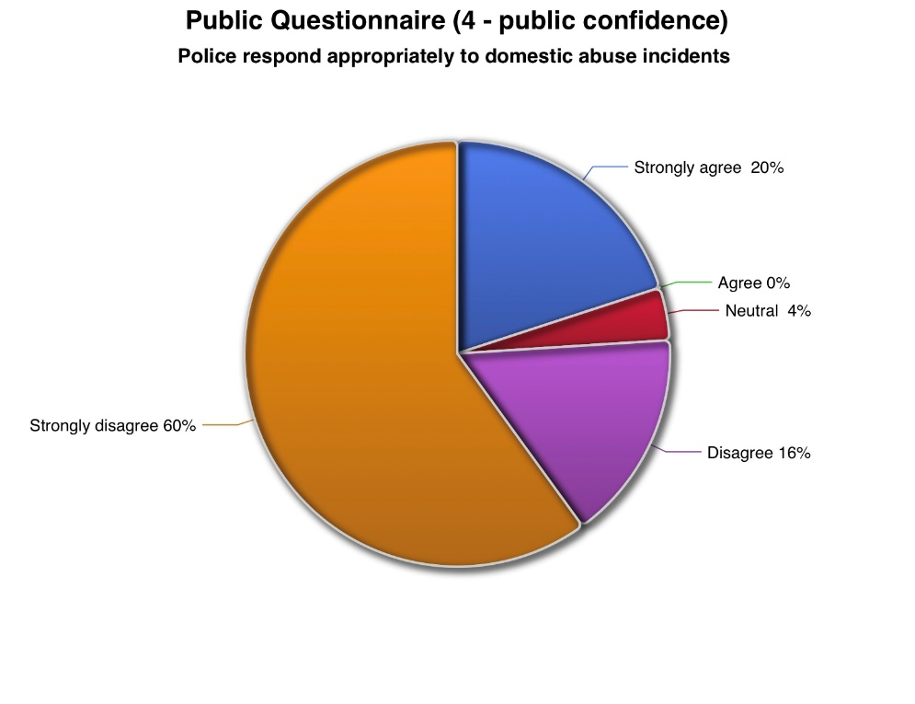
Figure 4.1 – Public Questionnaire graph for question 4; Police respond appropriately to domestic abuse incidents
The above graph shows 60% strongly disagreed, while only 20% strongly agreed, demonstrating a considerable divide in public opinion. A second question produced an even stronger trend, with 70% strongly disagreeing, suggesting many respondents don’t believe police intervention achieve positive results. Overall, the findings indicate limited public confidence in the effectiveness of police responses.

Importance of police intervention:
Despite criticism of police responses, participants agreed that police intervention remains necessary during domestic abuse incidents.
For one question
Strongly agree: 7
Agree: 23

Another question received particularly strong support, with;
Strongly agree: 46 (92%)
Neutral:1 (2%)
Disagree: 3 (6%)
This indicates widespread agreement that police intervention is necessary during domestic abuse incidents.

Impact on children:
Participants overwhelmingly recognise that domestic abuse has significant consequences for children
Responses shown;
Strongly agree: 38 (76%)
Agree: 2 (4%)
Neutral: 5 (10%)
Disagree: 5 (10%)
This demonstrates a high level of public awareness regarding the impact domestic abuse has upon children’s wellbeing.

Support following police attendance:
Several questions examined perceptions of support available after police intervention
One question showed:
Disagree: 37(74%)
Strongly disagree: 3 (6%)
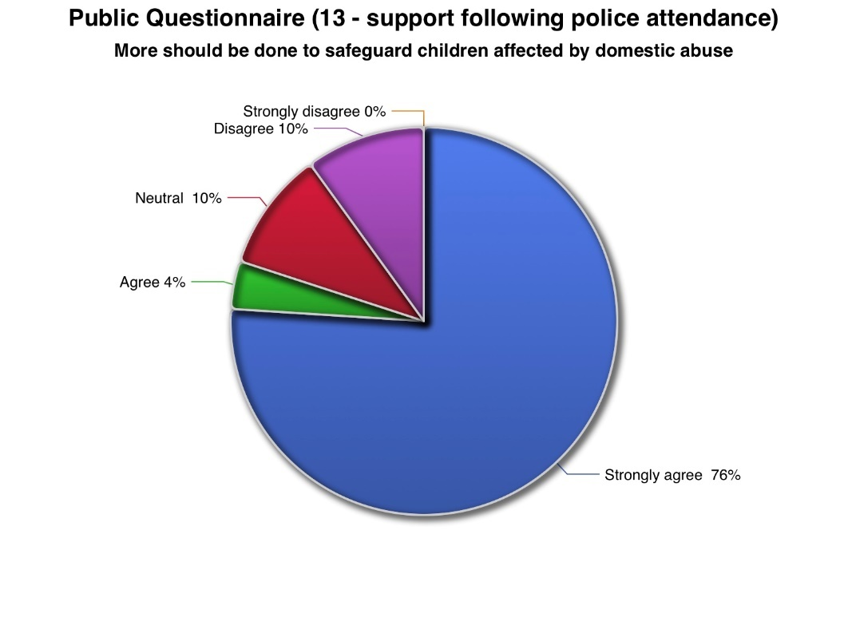
Figure 4.2 – Public Questionnaire graph for question 13; More should be done to safeguard children affected by domestic abuse.
Responses consistently suggested that participants perceived deficiencies in long term safeguarding and follow up support.
Awareness of support services:
Participants were asked whether they knew where families affected by domestic abuse could access support services.
Yes: 7 (14%)
No: 43 (86%)
The findings suggest limited public awareness of available domestic abuse support services highlighting a potential need for improved signposting and public education.

4.3 Police Questionnaire Findings
Police officers demonstrated strong awareness of the impact of domestic abuse on children and recognised safeguarding as a core policing responsibility.

However officers also acknowledged several barriers affecting their ability to provide the most effective response.
The most common barriers included:
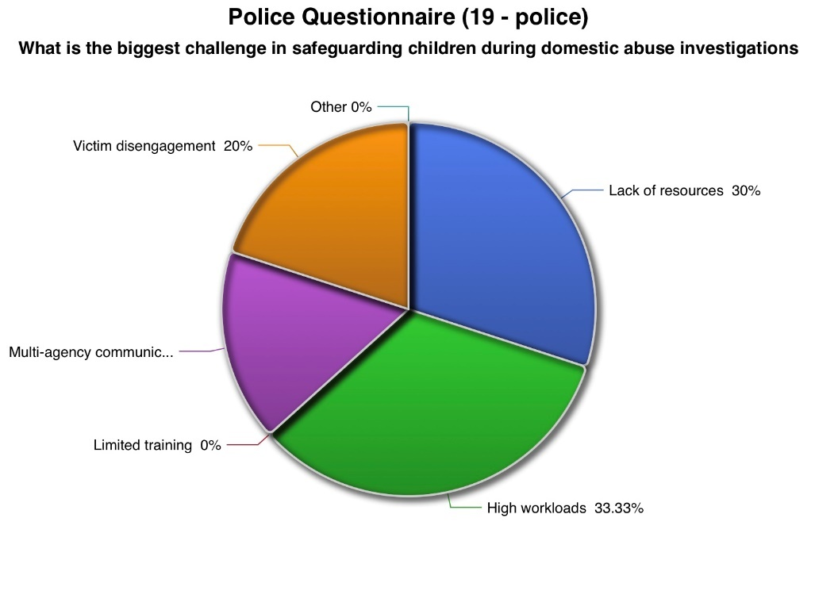
Figure 4.3 – Police Questionnaire for question 19; What is the biggest challenge in safeguarding children during domestic abuse investigations.
The most frequently identified barriers were high workloads, victim disengagement, limited organisational resources and difficulties in multi-agency communication.
Notably, no respondents identified a lack of training as a primary barrier, suggesting officers generally feel trained but not constrained by operational pressures rather than knowledge or competence.

4.4 Comparison of Public and Police Responses
Comparison of both questionnaires demonstrates several important similarities and differences.
However, differences emerged regarding perceptions of effectiveness.
Police officers generally expressed confidence in their understanding of safeguarding responsibilities whilst simultaneously identifying organisational barriers that reduce effectiveness. Conversely, members of the public reported lower confidence in police responses, particularly regarding long term, safeguarding and ongoing support for affected children.
Overall, the findings suggest a gap between public expectations of police intervention and officers’ perceptions of the operational challenges affecting safeguarding practice.

4.5 Conclusion
The findings demonstrate widespread agreement that domestic abuse has serious consequences for children’s wellbeing and that police intervention remains essential. However, differences emerged regarding perceptions of police effectiveness. Police officers identified operational pressures, including workload, resources and multi-agency communication, as barriers to effective safeguarding, whereas members of the public expressed lower confidence in police responses and limited awareness of available support services, these findings provide the basis for the discussion.

Chapter 5 – Discussion
5.1 Introduction
This chapter discusses the findings in chapter 4, by comparing with the literature in chapter 2 by addressing the research question.

5.2 Impact of Domestic Abuse on Children
The findings demonstrated strong agreement among both groups, which is that domestic abuse has a significant impact on children’s wellbeing. This supports previous research which identifies exposure to domestic abuse as a major ACE associated with poor emotional, psychological and developmental outcomes (Felitti et al., 1998; Hughes et al., 2017).

5.3 Police Intervention and Safeguarding
Members of the public expressed lower confidence in the effectiveness of police responses than police officers, suggesting uncertainty about current police interventions providing long term protection for children.
Police officers identified workload pressures, limited resources and communication between agencies as main barriers to safeguarding. This is consistent with Robinson, Pinchevsky and Guthrie (2016), who argue that operational pressures can affect safeguarding.

5.4 Multi-agency Working
The findings show the importance of partnership working in safeguarding children affected by domestic abuse. Police officers recognise that effective safeguarding relies on communication with healthcare, education and domestic abuse services, supporting Stanley and Humphreys (2017).
Public responses also showed limited awareness of support services, suggesting it is not always visible to families in need. Improving signposting and communication therefore may increase confidence in police responses while improving access to support.

5.5 Implications for Policing
This indicates that police intervention is the beginning rather than the end of safeguarding. Long term outcomes depend on support from partner agencies. This reflects the emphasis on trauma-informed policing and early intervention.
It also highlights importance of investment in domestic abuse resources, safeguarding training and partnership working.

5.6 Conclusion
Overall, this supports the existing literature by demonstrating that domestic abuse has a impact on children’s wellbeing and that police play a huge role in safeguarding. However, public confidence suggest improvements are needed universally.

Chapter 6 – Conclusion
6.1 Introduction
This chapter summarises the key findings of the research, answers the research question and presents recommendations, limitations and suggestions for future research.

6.2 Conclusion
The aim of this dissertation was to investigate how police investigations in domestic abuse situations affect short- and long-term wellbeing of children. Through a review of primary research collected from police officers and members of the public, the study has demonstrated that police intervention plays a critical role in safeguarding children exposed to domestic abuse. However, this is influenced by organisational pressures, multi agency collaboration and the availability of ongoing support.
These findings were reinforced by the primary research, with police officers and members of the public recognising the impact domestic abuse has on children.
The findings indicate that police intervention is essential but is most effective when supported by multi-agency safeguarding. Sustainable improvements in children depend on partnership between police, social care, healthcare, education services and specialist domestic abuse organisations.
The findings demonstrate that police interventions can positively influence childrens immediate safety and long-term wellbeing. However, their effectiveness depends on adequate resources, information sharing and collaborative safeguarding between partner agencies.

6.3 Recommendations
Increase organisational resources
Police forces should invest in staffing and specialist domestic abuse resources to reduce workloads and improve safeguarding capacity.

Strengthen multi-agency communication
Improved information sharing between police, children’s services, healthcare professionals, schools and specialist domestic abuse organisations would enable identification of risk and more coordinated safeguarding interventions.

Public awareness
The findings indicated limited public awareness of domestic abuse support services. Police and partner agencies should improve signposting and public awareness campaigns.

Trauma-informed policing
Continued investment in trauma-informed policing should remain a priority to improve communication and reduce re-traumatisation.

Follow-up safeguarding
Police attendance should be viewed as the beginning rather than the end of safeguarding. Greater emphasis should be places on follow-up contact, referrals and partnership working to support children beyond the immediate incident.

6.4 Limitations
This study has several limitations. The use of convenience sampling and a sample of 80 participants limits the generalisability of the findings. In addition, the questionnaire design relied on self-reported perceptions rather than direct observation of police practice and did not allow participants to explain their responses in detail. Despite these limitations, the research provides valuable insight into both professional and public perceptions of police safeguarding interventions.

6.5 Suggestions for Future Research
Future research should explore children’s experiences of police intervention using age-appropriate and ethically approved methods. Additional studies could compare safeguarding practices across different police forces or examine the long term outcomes of specific intervention methods.
Research involving larger and more geographically diverse samples would also strengthen the understanding of how policing practices influence children’s wellbeing and whether public confidence varies across different communities.

6.6 Final Conclusion
Children exposed to domestic abuse remain among the most vulnerable individuals encountered by police. This research demonstrates that police interventions play a vital role in protecting children from immediate harm and initiating safeguarding measures. However, long term outcomes depend on effective partnership working, sufficient organisational resources and continued support beyond the initial police responses. By strengthening these areas, police services can further improve the protection and wellbeing of children affected by domestic abuse.

Word count - 8784
Bibliography

Ainsworth, Frank, and Patricia Hansen. “The Munro Review of Child Protection: Final Report — a Child-Centred System: A Review and Commentary.” Children Australia, vol. 36, no. 03, Sept. 2011, pp. 164–168, 10.1375/jcas.36.3.164.

Ainsworth, Mary, et al. Patterns of Attachment: A Psychological Study of the Strange Situation. 1978. New York, Routlage, 1978.

Bowlby, John. Attachment and Loss. Vol. 1, London, Pimlico, 1969.

---. “Attachment and Loss. Vol. I. Attachment..” Man, vol. 5, no. 3, Sept. 1982, 10.2307/2798963.

Brandon, Marian, et al. “Complexity and Challenge: A Triennial Analysis of SCRs.” Complexity and Challenge, 2020, https://assets.publishing.service.gov.uk/government/uploads/system/uploads/attachment_data/file/869586/TRIENNIAL_SCR_REPORT_2014_to_2017.pdf. Accessed 27 June 2026.

Brayne, Hugh, et al. Law for Social Workers. 13th ed., Oxford, United Kingdom, Oxford University Press, 2015.
“British Society of Criminology.”

Bryant, Robin, and Sarah Bryant. Blackstone’S Handbook for Policing Students. Oxford, Oxford University Press, 2020.
Campbell, Jacquelyn C., et al. “The Danger Assessment: Validation of a Lethality Risk Assessment Instrument for Intimate Partner Femicide.” Journal of Interpersonal Violence, vol. 24, no. 4, 29 Apr. 2008, pp. 653–674, 10.1177/0886260508317180.

Children Act. “Children Act 1989.” HM Government, 1989.

Clark, Tom, et al. Bryman’S Social Research Methods. 2016. Alan Bryman, 2 Apr. 2026.

Cohen, Louis, et al. Research Methods in Education. Routledge, 12 Oct. 2017, https://www.perlego.com/paid/book/1331848/research-methods-in-education-pdf?campaignid=436530068&adgroupid=1353500616599525&msclkid=b640f734cc9b1d3f150e9d52f406a60a&utm_source=bing&utm_medium=cpc&utm_campaign=2.2.1.1%20dsag. Accessed 25 June 2026.

Creswell, John W, and J. David Creswell. Research Design: Qualitative, Quantitative & Mixed Methods Approaches. 6th ed., Los Angeles, Sage, 2018.

Department for Education. “Working Together to Safeguard Children.” 2025.

“Domestic Abuse | College of Policing.” Domestic abuse | College of Policing, 16 Sept. 2015.

Evans, Sarah E., et al. “Exposure to Domestic Violence: A Meta-Analysis of Child and Adolescent Outcomes.” Aggression and Violent Behavior, vol. 13, no. 2, 2008, pp. 131–140. Science Direct, http://digitalcommons.unl.edu/cgi/viewcontent.cgi?article=1320&context=psychfacpub, 10.1016/j.avb.2008.02.005. Accessed 18 June 2026.
Felitti, Vincent J, et al. “Relationship of Childhood Abuse and Household Dysfunction to Many of the Leading Causes of Death in Adults.” American Journal of Preventive Medicine, vol. 14, no. 4, May 1998, pp. 245–258, https://pubmed.ncbi.nlm.nih.gov/9635069/, https://doi.org/10.1016/S0749-3797(98)00017-8. Accessed 16 June 2026.

Finkelhor, David. “Screening for Adverse Childhood Experiences (ACEs): Cautions and Suggestions.” Child Abuse & Neglect, vol. 85, no. 1, Nov. 2018, pp. 174–179, 10.1016/j.chiabu.2017.07.016.

for, Centre. “Domestic Abuse in England and Wales Overview.” Office for National Statistics, 26 Nov. 2025.

GOV.UK. “Data Protection Act 2018.” 2018.

Gov.uk. “Domestic Abuse Act 2021.” 2021.

Great Britain. Domestic Abuse ACT 2021 : Chapter 17. S.L., Stationery Office Books, 2021.

Hmicfrs Violence Against Women and Girls Progress Report. 2021, https://cdn.prgloo.com/media/e5d54f6baa4e45698e2ef4c2bf830f14.pdf. Accessed 24 June 2026.

Holden, G W . “Children Exposed to Domestic Violence and Child Abuse: Terminology and Taxonomy - Bing.” Bing, 2026, https://www.bing.com/search?q=children%20exposed%20to%20domestic%20violence%20and%20child%20abuse%3a%20terminology%20and%20taxonomy&qs=n&form=qbre&sp=-1&lq=0&pq=children%20exposed%20to%20domestic%20violence%20and%20child%20abuse%3a%20terminology%20and%20taxonomy&sc=0-79&sk=&cvid=bc2e2a04247945b4b9cc815211f918a4. Accessed 25 June 2026.

Holt, Stephanie, et al. “The Impact of Exposure to Domestic Violence on Children and Young People: A Review of the Literature.” Child Abuse & Neglect, vol. 32, no. 8, Aug. 2008, pp. 797–810, https://www.sciencedirect.com/science/article/pii/S0145213408001348, https://doi.org/10.1016/j.chiabu.2008.02.004. Accessed 16 June 2026.

Home Office. “Domestic Abuse: Statutory Guidance .” 5 Sept. 2022.

Home office. “New Guidance Will Ensure All Forms of Domestic Abuse Are Recognised.” 8 July 2022.

Howell, Kathryn H. “Resilience and Psychopathology in Children Exposed to Family Violence.” Aggression and Violent Behavior, vol. 16, no. 6, Nov. 2011, pp. 562–569, 10.1016/j.avb.2011.09.001.

Hughes, Karen, et al. “The Effect of Multiple Adverse Childhood Experiences on Health: A Systematic Review and Meta-Analysis.” The Lancet Public Health, vol. 2, no. 8, Aug. 2017, pp. 356–366, https://www.thelancet.com/journals/lanpub/article/PIIS2468-2667(17)30118-4/fulltext. Accessed 16 June 2026.

Human Rights Act. “Human Rights Act 1998.” 1998.

Johnson, Michael P. A Typology of Domestic Violence: Intimate Terrorism, Violent Resistance, and Situational Couple Violence. Boston, Northeastern University Press, 2008.

legislation.gov.uk. “Crime and Disorder Act 1998.” 1998.

LOUGHRAN, GILLIAN. “Learning to Act: The Children Act 1989.” Children & Society, vol. 5, no. 1, 28 June 2018, pp. 11–20, 10.1111/j.1099-0860.1991.tb00515.x.
Meltzer, Howard, et al. “The Mental Health of Children Who Witness Domestic Violence.” Child & Family Social Work, vol. 14, no. 4, Nov. 2009, pp. 491–501.

NICE. “Nice | the National Institute for Health and Care Excellence.” NICE, 2025.
Perry. “APA PsycNet.” 2006.

Robinson, Amanda L., et al. “A Small Constellation: Risk Factors Informing Police Perceptions of Domestic Abuse.” Policing and Society, vol. 28, no. 2, 29 Feb. 2016, pp. 189–204, 10.1080/10439463.2016.1151881.

Robinson, Amanda L, et al. “Practitioner (Mis)Understandings of Coercive Control in England and Wales.” Criminology & Criminal Justice, vol. 18, no. 1, 6 Sept. 2017, pp. 29–49, 10.1177/1748895817728381. Accessed 25 June 2026.

Robinson, Amanda L. “Risk and Intimate Partner Violence -ORCA.” Cardiff.Ac.Uk, 2022, https://orca.cardiff.ac.uk/id/eprint/30025/, Robinson, Amanda L. &lt;https://orca.cardiff.ac.uk/view/cardiffauthors/A0089621.html&gt; ORCID: https://orcid.org/0000-0002-5071-850X &lt;https://orcid.org/0000-0002-5071-850X&gt; 2011. Risk and intimate partner violence. Kemshall, Hazel and Wilkinson, Bernadette, eds. Good practice in assessing risk current knowledge, issues and approaches, London: Jessica Kingsley Publishers, pp. 119-138. . Accessed 26 June 2026.

Rutter, Michael. “Resilience as a Dynamic Concept.” Development and Psychopathology, vol. 24, no. 02, 2012, pp. 335–344, https://pubmed.ncbi.nlm.nih.gov/22559117/, 10.1017/S0954579412000028. Accessed 22 June 2026.

SafeLives. “Dash Risk Assessment Resources for Professionals.” 2025.

Shonkoff, Jack, and Andrew Garner. “The Lifelong Effects of Early Childhood Adversity and Toxic Stress.” Pediatrics, vol. 129, no. 1, 26 Dec. 2012, pp. 232–246, https://publications.aap.org/pediatrics/article/129/1/e232/31628/The-Lifelong-Effects-of-Early-Childhood-Adversity?autologincheck=redirected,
https://doi.org/10.1542/peds.2011-2663. Accessed 20 June 2026.

Stanley, Nicky, and Cathy Humphreys. “Identifying the Key Components of a ‘Whole Family’ Intervention for Families Experiencing Domestic Violence and Abuse.” Journal of Gender-Based Violence, vol. 1, no. 1, May 2017, pp. 99–115, 10.1332/239868017x14913081639164. Accessed 22 June 2026.

Stark, Evan. “Coercive Control: How Men Entrap Women in Personal Life.” Choice Reviews Online, vol. 46, no. 04, 1 Dec. 2007, pp. 46–2380–46–2380, 10.5860/choice.46-2380.

UK Government. “Data Protection Act.” www.gov.uk, 2025.
---. “Serious Crime Act 2015.” 2015.
Appendix A – Application For Ethical Approval
APPLICATION FOR ETHICAL APPROVAL

In order for research to result in benefit and minimise risk of harm, it must be conducted ethically. A researcher may not be covered by the University’s insurance if ethical approval has not been obtained prior to commencement.

The University follows the OECD Frascati manual definition of research activity: “creative work undertaken on a systematic basis in order to increase the stock of knowledge, including knowledge of man, culture and society, and the use of this stock of knowledge to devise new applications”. As such this covers activities undertaken by members of staff, postgraduate research students, and both taught postgraduate and undergraduate students working on dissertations/projects.

The individual undertaking the research activity is known as the “principal researcher”.

Ethical approval is not required for routine audits, performance reviews, quality assurance studies, testing within normal educational requirements, and literary or artistic criticism.

Please read the notes for guidance before completing ALL sections of the form.

This form must be completed and approved prior to undertaking any research activity. Please see Checklist for details of process for different categories of application.

Delete the Guidance Notes at the end of the form BEFORE submitting your application

SECTION A: About You (Principal Researcher)
Full Name: |  | Cari Trayhern
Tick all boxes which apply: |  | Member of staff: | ☐ | Honorary research fellow: | ☐
Undergraduate Student | ☒ | Taught Postgraduate Student | ☐ | Postgraduate Research Student | ☐

Institute/Academic Discipline/Centre: | IMH
Campus: | Swansea
E-mail address: | 2246064@student.uwtsd.ac.uk
Contact Telephone Number: | N/A
For students:
Student Number: | 2246064
Programme of Study: | Bachelor of Science: Professional Policing Practice
Director of Studies/Supervisor: | Jane Davies

SECTION B: Approval for Research Activity
Has the research activity received approval in principle?  (please check the Guidance Notes as to the appropriate approval process for different levels of research by different categories of individual) |  | YES | ☐ | NO | ☒
 |  |  |  | Date
If Yes, please indicate source of approval (and date where known): Approval in principle must be obtained from the relevant source prior to seeking ethical approval | Research Degrees Committee |  | ☐
 | Institute Research Committee |  | ☐
 | Other (write in) |  | ☐

SECTION C: Internal and External Ethical Guidance Materials
Please list the core ethical guidance documents that have been referred to during the completion of this form (including any discipline-specific codes of research ethics, and also any specific ethical guidance relating to the proposed methodology). Please tick to confirm that your research proposal adheres to these codes and guidelines.
UWTSD Research Ethics & Integrity Code of Practice | ☒
UWTSD Research Data Management Policy | ☒
 | ☐

SECTION D: External Collaborative Research Activity
Does the research activity involve collaborators outside of the University? | YES | ☐ | NO | ☒
If Yes, please provide the name of the external organisation and name and contact details for the main contact person and confirmation this person has consented to their personal data being shared.as part of this collaboration.

SECTION E: Details of Research Activity
Indicative title: | How effective are police interventions in domestic abuse cases at protecting the short- and long-term wellbeing of children
Proposed start date: | February 2026 | Proposed end date: | July 2026
Introduction to the Research (maximum 300 words)
Ensure that you write for a Non-Specialist Audience when outlining your response to the three points below:
- Purpose of Research Activity
- Proposed Research Question
- Aims of Research Activity
- Objectives of Research Activity
Demonstrate, briefly, how Existing Research has informed the proposed activity and explain
- What the research activity will add to the body of knowledge
- How it addresses an area of importance.
Purpose of Research Activity
Domestic abuse is recognised as one of the most significant safeguarding issues affecting children within the United Kingdom. Although children may not always actually be the direct victims of domestic abuse, exposure to domestic abuse can have emotional, psychological and developmental consequences that extend into adulthood. Police officers are often the first professionals to respond to domestic abuse incidents and therefore play a crucial role in identifying risk, safeguarding children and referring families to appropriate support services.

This research is important because there is increasing recognition of children as victims in their own right following legislative changes such as the Domestic Abuse Act 2021. Despite improvements in policy, concerns remain surrounding how effective police responses and multi agency work in helping the long term wellbeing of children.
Research Question
How effective are police interventions in domestic abuse cases at protecting the short- and long-term wellbeing of children.
Aims of Research Activity
The overall aim of this research is to examine how police interventions during domestic abuse incidents affect the short- and long-term wellbeing of children in England and Wales. This study seeks to evaluate the effectiveness of current policing practices in safeguarding children exposed to domestic abuse whilst exploring whether existing interventions adequately address immediate and long-term risks. Through the use of primary research alongside an analysis of current academic literature, this will identify strengths within current policing practice, highlight areas requiring improvement and provide recommendations for future safeguarding strategies
Objectives of Research Activity
- To Critically examine the impact that exposure to domestic abuse has on children’s short- and long-term wellbeing.
- To evaluate the role of police officers in safeguarding children during domestic abuse investigations.
- To examine current legislation, policy and safeguarding procedures relating to domestic abuse and child protection.
- To explore the views of police officers regarding current safeguarding practices through primary questionnaire research.
- To explore public perceptions of police responses to domestic abuse involving children.

Proposed methods (maximum 600 words)
Provide a brief summary of all the methods that may be used in the research activity, making it clear what specific techniques may be used. If methods other than those listed in this section are deemed appropriate later, additional ethical approval for those methods will be needed.
This study aims to evaluate the effectiveness of current police interventions through primary research involving police officers and members of the public. Existing literature, including government reports, academic journals and policing guidance has informed the research and highlighted the re occurring gaps between policy and operational practice. Primary research that will be used is questionnaires which will be completed by police officers and members of the public.

Location of research activity
Identify all locations where research activity will take place.
Research will be carried out throughout Gwent Police/ South Wales Police area.
Research activity outside of the UK
If research activity will take place overseas, you are responsible for ensuring that local ethical considerations are complied with and that the relevant permissions are sought. Specify any local guidelines (e.g. from local professional associations/learned societies/universities) that exist and whether these involve any ethical stipulations beyond those usual in the UK (provide details of any licenses or permissions required). Also specify whether there are any specific ethical issues raised by the local context in which the research activity is taking place, for example, particular cultural and/or legal sensitivities or vulnerabilities of participants.
N/A

SECTION F: Scope of Research Activity
Will the research activity include: | YES | NO
Use of a questionnaire or similar research instrument? | ☒ | ☐
Use of interviews? | ☐ | ☒
Use of diaries? | ☐ | ☒
Participant observation with their knowledge? | ☐ | ☒
Participant observation without their knowledge? | ☐ | ☒
Use of video or audio recording? | ☐ | ☒
Access to personal or confidential information without the participants’ specific consent? | ☐ | ☒
Administration of any questions, test stimuli, presentation that may be experienced as physically, mentally or emotionally harmful / offensive? | ☐ | ☒
Performance of any acts which may cause embarrassment or affect self-esteem? | ☐ | ☒
Investigation of participants involved in illegal activities? | ☐ | ☒
Use of procedures that involve deception? | ☐ | ☒
Administration of any substance, agent or placebo? | ☐ | ☒
Working with live vertebrate animals? | ☐ | ☒
Other primary data collection methods, please explain in this box  For example, ‘focus groups’. Please indicate the type of data collection method(s) in this box and tick the accompany box. | ☐ | ☒
Details of any other primary data collection method:  (this box should expand as you type) | ☐ | ☒
If NO to every question, then the research activity is (ethically) low risk and may be exempt from some of the following sections (please refer to Guidance Notes).

If YES to any question, then no research activity should be undertaken until full ethical approval has been obtained.
SECTION G: Intended Participants
Who are the intended participants: | YES | NO
Students or staff at the University? | ☒ | ☐
Adults (over the age of 18 and competent to give consent)? | ☒ | ☐
Vulnerable adults? | ☐ | ☒
Children and Young People under the age of 18? (Consent from Parent, Carer or Guardian will be required) | ☐ | ☒
Prisoners? | ☐ | ☒
Young offenders? | ☐ | ☒
Those who could be considered to have a particularly dependent relationship with the investigator or a gatekeeper? | ☐ | ☒
People engaged in illegal activities? | ☐ | ☒
Others (please identify specifically any group who may be unable to give consent) please indicate here and tick the appropriate box. | ☐ | ☒
Other – please indicate here:  (this box should expand as you type) | ☐ | ☒

Participant numbers and source
Provide an estimate of the expected number of participants. How will you identify participants and how will they be recruited?
How many participants are expected? | The response aim is approximately 80 – 100 persons.
Who will the participants be? | The target sample for this research will be police officers and members of the public.
How will you identify the participants? | Via work and family members of work colleagues.

Information for participants: | YES | NO | N/A
Will you describe the main research procedures to participants in advance, so that they are informed about what to expect? | ☐ | ☐ | ☒
Will you tell participants that their participation is voluntary? | ☒ | ☐ | ☐
Will you obtain written consent for participation? | ☐ | ☒ | ☐
Will you explain to participants that refusal to participate in the research will not affect their treatment or education (if relevant)? | ☐ | ☐ | ☒
If the research is observational, will you ask participants for their consent to being observed? | ☐ | ☐ | ☒
Will you tell participants that they may withdraw from the research at any time and for any reason? | ☒ | ☐ | ☐
With questionnaires, will you give participants the option of omitting questions they do not want to answer? | ☒ | ☐ | ☐
Will you tell participants that their data will be treated with full confidentiality and that, if published, it will not be identifiable as theirs? | ☒ | ☐ | ☐
Will you debrief participants at the end of their participation, in a way appropriate to the type of research undertaken? | ☒ | ☐ | ☐
If NO to any of above questions, please give an explanation
Q15 – the questionnaire will show implied consent and is only completed on a voluntary basis. Should participants not be willing to consent, they will not be asked to complete the questionnaire. Additionally, all survey participants will be over the age of 18 at the time of completing.

(this box should expand as you type)

Information for participants: | YES | NO | N/A
Will participants be paid? | ☐ | ☒ | ☐
Is specialist electrical or other equipment to be used with participants? | ☐ | ☒ | ☐
Are there any financial or other interests to the investigator or University arising from this study? | ☐ | ☒ | ☐
Will the research activity involve deliberately misleading participants in any way, or the partial or full concealment of the specific study aims? | ☐ | ☒ | ☐
If YES to any question, please provide full details
(this box should expand as you type)

SECTION H: Anticipated Risks
Outline any anticipated risks that may adversely affect any of the participants, the researchers and/or the University, and the steps that will be taken to address them.

If you have completed a full risk assessment (for example as required by a laboratory, or external research collaborator) you may append that to this form.
Full risk assessment completed and appended? |  | Yes | ☐
 |  | No | ☒
Risks to participants
For example: emotional distress, financial disclosure, physical harm, transfer of personal data, sensitive organisational information
Risk to Participant:  No risk identified | How will you mitigate the Risk to Participant
If research activity may include sensitive, embarrassing or upsetting topics (e.g. sexual activity, drug use) or issues likely to disclose information requiring further action (e.g. criminal activity), give details of the procedures to deal with these issues, including any support/advice (e.g. helpline numbers) to be offered to participants. Note that where applicable, consent procedures should make it clear that if something potentially or actually illegal is discovered in the course of a project, it may need to be disclosed to the proper authorities
No risk identified

(this box should expand as you type)
Risks to investigator
For example: personal safety, physical harm, emotional distress, risk of accusation of harm/impropriety, conflict of interest
Risk to Investigator:  No risk identified | How will you mitigate the Risk to Investigator:
University/institutional risks
For example: adverse publicity, financial loss, data protection
Risk to University:  No risk identified  (this box should expand as you type) | How will you mitigate the Risk to University:  .  (this box should expand as you type)

Disclosure and Barring Service
If the research activity involves children or vulnerable adults, a Disclosure and Barring Service (DBS) certificate must be obtained before any contact with such participants. | YES | NO | N/A
Does your research require you to hold a current DBS Certificate? | ☐ | ☐ | ☒

SECTION I: Feedback, Consent and Confidentiality
Feedback
What de-briefing and feedback will be provided to participants, how will this be done and when?
The survey will be completely anonymous, there will be no ability to provide feedback to the survey participants.

Informed consent
Describe the arrangements to inform potential participants, before providing consent, of what is involved in participating. Describe the arrangements for participants to provide full consent before data collection begins. If gaining consent in this way is inappropriate, explain how consent will be obtained and recorded in accordance with prevailing data protection legislation.
Before starting the survey, there will be information at the top which explains what taking part in the survey means. No personal data will be collected throughout the survey and participation is voluntary, this will be explained in the information sheet prior to completing the survey. It will be made clear that participants can stop filling it out whenever. Participants will be asked to tick a box to consent.

Confidentiality / Anonymity
Set out how anonymity of participants and confidentiality will be ensured in any outputs. If anonymity is not being offered, explain why this is the case.
Confidentiality and anonymity will be guaranteed by the researcher. No names, dates of birth or contact information will be used.
.

SECTION J: Data Protection and Storage
In completing this section refer to the University’s Research Data Management Policy and the extensive resources on the University’s Research Data Management web pages (http://uwtsd.ac.uk/library/research-data-management/).
Does the research activity involve personal data (as defined by the General Data Protection Regulation 2016 “GDPR” and the Data Protection Act 2018 “DPA”)? | YES | NO
“Personal data” means any information relating to an identified or identifiable natural person (‘data subject’). An identifiable natural person is one who can be identified, directly or indirectly, in particular by reference to an identifier such as a name, an identification number, location data, an online identifier or to one or more factors specific to the physical, physiological, genetic, mental, economic, cultural or social identity of that natural person. |  | x
If YES, provide a description of the data and explain why this data needs to be collected:
Does it involve special category data (as defined by the GDPR)? | YES | NO
“Special category data” means sensitive personal data consisting of information as to the data subjects’ –  (a) racial or ethnic origin,  (b) political opinions,  (c ) religious beliefs or other beliefs of a similar nature,  (d) membership of a trade union (within the meaning of the Trade Union and Labour Relations (Consolidation) Act 1992),  (e) physical or mental health or condition,  (f) sexual life,  (g) genetics,  (h) biometric data (as used for ID purposes), | ☐ | ☒
If YES, provide a description of the special category data and explain why this data needs to be collected:
(this box should expand as you type)
Will the research activity involve storing personal data and/or special category data on one of the following: | YES | NO
Manual files (i.e. in paper form)? | ☐ | ☒
University computers? | ☐ | ☒
Private company computers? | ☐ | ☒
Home or other personal computers? | ☒ | ☐
Laptop computers/ CDs/ Portable disk-drives/ memory sticks? | ☐ | ☒
“Cloud” storage or websites? | ☐ | ☒
Other – specify: | ☐ | ☒
For all stored data, explain the measures in place to ensure the security of the data collected, data confidentiality, including details of password protection, encryption, anonymisation and pseudonymisation:
The data will remain anonymous. Computers will be fully encrypted with passwords also. Any memory sticks will be safely stored in a locked drawer.

All Data Storage
Will the research activity involve any of the following activities: | YES | NO
Electronic transfer of data in any form? | ☐ | ☒
Sharing of data with others at the University? | ☐ | ☒
Sharing of data with other organisations? | ☐ | ☒
Export of data outside the European Union or importing of data from outside the UK? | ☐ | ☒
Use of personal addresses, postcodes, faxes, emails or telephone numbers? | ☐ | ☒
Publication of data that might allow identification of individuals? | ☐ | ☒
Use of data management system? | ☐ | ☒
Data archiving? | ☐ | ☒
If YES to any question, please provide full details, explaining how this will be conducted in accordance with the GDPR and DPA (and/or any international equivalent):
N/A

List all who will have access to the data generated by the research activity:
N/A

List who will have control of, and act as custodian(s) for, data generated by the research activity:
Only myself

Give details of data storage arrangements, including security measures in place to protect the data, where data will be stored, how long for, and in what form. Will data be archived – if so how and if not why not.
All data will be secured on my laptop.
No identifiable information will be collected in the survey, ensuring the anonymity of the respondents and files will be stored throughout the research process.
As the information collected will be anonymous and only used this for this dissertation, it will not be kept long term. This will then be discarded once the university has marked and assessed by the university.

Please indicate if your data will be stored in the UWTSD Research Data Repository (see https://researchdata.uwtsd.ac.uk/ ). If so please explain. (Most relevant to academic staff)
N/A

(this box should expand as you type)
Confirm that you have read the UWTSD guidance on data management (see https://www.uwtsd.ac.uk/library/research-data-management/) | YES | ☒
 | NO | ☐
Confirm that you are aware that you need to keep all data until after your research has completed or the end of your funding | YES | ☒
 | NO | ☐
SECTION K: Declaration
The information which I have provided is correct and complete to the best of my knowledge. I have attempted to identify any risks and issues related to the research activity and acknowledge my obligations and the rights of the participants.

In submitting this application I hereby confirm that I undertake to ensure that the above named research activity will meet the University’s Research Ethics and Integrity Code of Practice which is published on the website: https://www.uwtsd.ac.uk/research/research-ethics/
Signature of applicant: | C. Trayhern | Date:

For students:
Director of Studies/Supervisor:
Signature:
Date:

For staff:
Head of School/Assistant Dean:
Signature:
Date:

I have read the guidance notes supplied before completing the form

I have completed ALL RELEVANT sections of the form in full

I confirm that the research activity has received approval in principle

Appendix B – Research Proposal Form



UNDERGRADUATE DISSERTATION
RESEARCH PROPOSAL FORM

Please complete the following research proposal and submit it to Turnitin.

Which project option are you taking? Please tick:

8,000 word project: X
OR
4,000 word project and presentation:

NAME: Cari Trayhern | STUDENT ID No.: 2246064
DRAFT RESEARCH TITLE QUESTION:
How effective are police interventions in domestic abuse cases at protecting the short- and long-term wellbeing of children.

INTRODUCTION:
Domestic abuse is recognised as one of the most significant safeguarding issues affecting children within the United Kingdom. Although children may not always actually be the direct victims of domestic abuse, exposure to domestic abuse can have emotional, psychological and developmental consequences that extend into adulthood. Police officers are often the first professionals to respond to domestic abuse incidents and therefore play a crucial role in identifying risk, safeguarding children and referring families to appropriate support services.

This research is important because there is increasing recognition of children as victims in their own right following legislative changes such as the Domestic Abuse Act 2021. Despite improvements in policy, concerns remain surrounding how effective police responses and multi agency work in helping the long term wellbeing of children.

This study aims to evaluate the effectiveness of current police interventions through primary research involving police officers and members of the public. Existing literature, including government reports, academic journals and policing guidance has informed the research and highlighted the re occurring gaps between policy and operational practice.

SUMMARY OF RESEARCH OBJECTIVES:
The objectives of this research are to;
- To Critically examine the impact that exposure to domestic abuse has on children’s short- and long-term wellbeing.
- To evaluate the role of police officers in safeguarding children during domestic abuse investigations.
- To examine current legislation, policy and safeguarding procedures relating to domestic abuse and child protection.
- To explore the views of police officers regarding current safeguarding practices through primary questionnaire research.
- To explore public perceptions of police responses to domestic abuse involving children.

LITERATURE REVIEW:
The literature review examines existing research surrounding domestic abuse, childhood trauma and police safeguarding responsibilities.

Key literature includes:
- Domestic abuse act (2021)
- Children act (1989)
- Working together to safeguard children (2023)
- HMICFRS reports into police responses to domestic abuse
- NICE guidance
- NSPCC publications
- Home office domestic abuse statistics
- Felitti et al. (1998) Adverse Childhood Experiences (ACE) study
- Bowlbys attachment theory
- Brofenbrenners ecological systems theory
- Academic research examining childhood trauma, policing and safeguarding

This literature demonstrates that children who are exposed to domestic abuse are at increased risk of anxiety, depression, behavioural difficulties and poor long term outcomes. Whilst legislation has strengthened safeguarding responsibilities, research shows ongoing issues including inconsistent police responses, high workloads, communication between agencies and limited resources.

A gap remains in understanding how frontline police officers and members of the public perceive current safeguarding practices, which this research seeks to address through primary data collection.

SUMMARY OF RESEARCH –SURVEY METHOD:
This study adopts a mixed method approach using quantitative primary research.

Two anonymous online questionnaires were distributed;
- Police officers (30 responses)
- Members of the public (50 responses)

The questionnaires consisted primarily of closed questions, multiple choice questions and demographic questions, with limited opportunities for additional comments.

The quantitative data were analysed using descriptive statistics and presented using charts and tables to identify patterns and compare responses between both participant groups.

Ethical considerations included informed consent, anonymity, voluntary participation, confidentiality and secure storage of data.

Questionnaires were selected as the most appropriate research method because they allow for data to be collected from a larger number of participants within the time available. Using separate questionnaires for police officers and members of the public allow comparisons to be made between professional experience and public perceptions of how police respond to incidents involving children. Anonymous questionnaires encouraged honest responses and reduced the likelihood of participants feeling pressured to answer in a certain way.

SUMMARY OF SAMPLING FRAMEWORK:
The target sample consisted of serving police officers and members of the public aged 18 and over. Police officers were selected because of their direct experience of responding to domestic abuse incidents and implementing safeguarding procedures. Members of the public were included to gain insight into public confidence and perceptions of police responses to domestic abuse.

A convenience sampling method was used due to accessibility and the limited timescale of the research. A total of 30 police officers and 50 members of the public completed the questionnaires. This sample was considered appropriate as it enabled comparisons between both groups while providing sufficient data to identify trends relevant to the research objectives.

ETHICAL ISSUES:
Several ethical considerations were addressed throughout the research. Participation was entirely voluntary, and informed consent was obtained before participants completed the questionnaire. All responses were anonymous, and no identifiable personal information was collected. Participants were informed that they could withdraw from the study at any time before submitting their responses.

As the research explored domestic abuse, there was potential for participants to experience emotional discomfort. Information regarding support services was made available where appropriate. Data was stored securely in accordance with the UK general data protection regulation (UK GDPR) and university ethical guidelines.

TIME SCALE:
Introduction: February 2026
Literature review: March - April 2026
Methodology: May 2026
Results and analysis: June 2026
Conclusion: July 2026
REFERENCE LIST:
Bowlby, John. Attachment and Loss. Vol. 1, London, Pimlico, 1969.

“Domestic Abuse | College of Policing.” Domestic abuse | College of Policing, 16 Sept. 2015.

Felitti, Vincent J, et al. “Relationship of Childhood Abuse and Household Dysfunction to Many of the Leading Causes of Death in Adults.” American Journal of Preventive Medicine, vol. 14, no. 4, May 1998, pp. 245–258, https://pubmed.ncbi.nlm.nih.gov/9635069/, https://doi.org/10.1016/S0749-3797(98)00017-8.

Home office. “New Guidance Will Ensure All Forms of Domestic Abuse Are Recognised.” 8 July 2022.

Shonkoff, Jack, and Andrew Garner. “The Lifelong Effects of Early Childhood Adversity and Toxic Stress.” Pediatrics, vol. 129, no. 1, 26 Dec. 2012, pp. 232–246, https://publications.aap.org/pediatrics/article/129/1/e232/31628/The-Lifelong-Effects-of-Early-Childhood-Adversity?autologincheck=redirected, https://doi.org/10.1542/peds.2011-2663.

Appendix C – Public survey

Thank you for taking part in this research. This questionnaire forms part of an undergraduate dissertation exploring how police interventions in domestic abuse incidents influence the short- and long-term wellbeing of children in England and Wales.
Participation is voluntary and anonymous. You may withdraw at any time before submitting your responses. No identifying information will be collected.
Consent agreement -
I confirm that:
- I am aged 18 years or over.
- I have read the participant information.
- I understand participation is voluntary.
- I understand my responses are anonymous.
- I consent to my anonymous responses being used for this dissertation.

Section 1 – About You
- Age
18-24
25-34
35-44
45-54
55+

- Gender
Male
Female
Non-binary
Prefer not to say
Prefer to self-describe:

- Have you ever had contact with the police regarding a domestic abuse incident?
Yes
No
Prefer not to say

Section 2 – Perceptions of Police Responses
For questions 4-13, please indicate your level of agreement.
Strongly Agree/ Agree/ Neutral/ Disagree/ Strongly Disagree
- Police respond appropriately to domestic abuse incidents.
- Police take children’s welfare seriously during domestic abuse investigations.
- Police interventions improve children’s immediate safety.
- Police intervention improve children’s long term wellbeing.
- Children exposed to domestic abuse should automatically receive safeguarding support.
- Police work effectively with social services.
- Police have enough resources to deal with domestic abuse.
- Early police intervention reduces harm to children.
- I have confidence in the police to protect children exposed to domestic abuse.
- More should be done to safeguard children affected by domestic abuse

Section 3 – Final questions
- Before today, were you aware that children are recognised as victims under the Domestic Abuse Act 2021?
Yes
No

- In your opinion, what should police do differently to protect children affected by domestic abuse?
(Optional free-text response)
Appendix D – Police survey

Thankyou for taking part in this research. This questionnaire forms a part of an undergraduate dissertation exploring how police interventions in domestic abuse incidents influence the short and long term wellbeing of children in England and Wales.
Participation is voluntary and anonymous. You may stop completing the questionnaire at any time before submission. No personally identifiable information will be collected.
Consent agreement -
I confirm that:
- I am aged 18 years or over.
- I have read the participant information.
- I understand participation is voluntary.
- I understand my responses are anonymous.
- I consent to my anonymous responses being used for this dissertation.
Section 1 – Background information
- What is your age?
18-24
25-34
35-44
45-54
55+

- Gender
Male
Female
Non-binary
Prefer not to say
Prefer to self-describe……

- Which police force do you work for?
Free text (optional)

- How many years have you served as a police officer?
Less than 2 years
2-5 years
6-10 years
11-15 years
More than 15 years

- Which department do you currently work in?
Response
Neighbourhood Policing
CID
Safeguarding
Roads Policing
Other

Section 2 – Police interventions
For questions 6-15, please indicate your level of agreement
Strongly Agree/ Agree/ Neutral/ Disagree/ Strongly Disagree
- Police attendance at domestic abuse incidents improves the safety of children.
- Police officers receive sufficient training to identify the impact of domestic abuse on children.
- Children should always be viewed as victims when exposed to domestic abuse.
- Current safeguarding procedures adequately protect children.
- Multi-agency working improves outcomes for children.
- DASH risk assessment effectively identify children at risk.
- Time pressures negatively affect safeguarding decisions.
- Repeat domestic abuse incidents increase the risk of long term harm to children.
- Trauma-informed policing improves outcomes for children.
- Police intervention can reduce long-term psychological harm experienced by children.

Section 3 – Professional Experience
- How often do you attend domestic abuse incidents?
Daily
Weekly
Monthly
Rarely
Never

- Have you received specialist domestic abuse training?
Yes
No

- Do you believe additional training is needed?
Yes
No
Unsure

- In your opinion, what is the biggest challenge in safeguarding children during domestic abuse investigations?
Lack of resources
High workloads
Limited training
Multi-agency communication
Victim disengagement
Other (specify)

- Please provide any additional comments regarding police responses to domestic abuse involving children.
(Optional free-text response)

Appendix E – Graphs
Figure 4.1 – Public Questionnaire graph for question 4; Police respond appropriately to domestic abuse incidents.
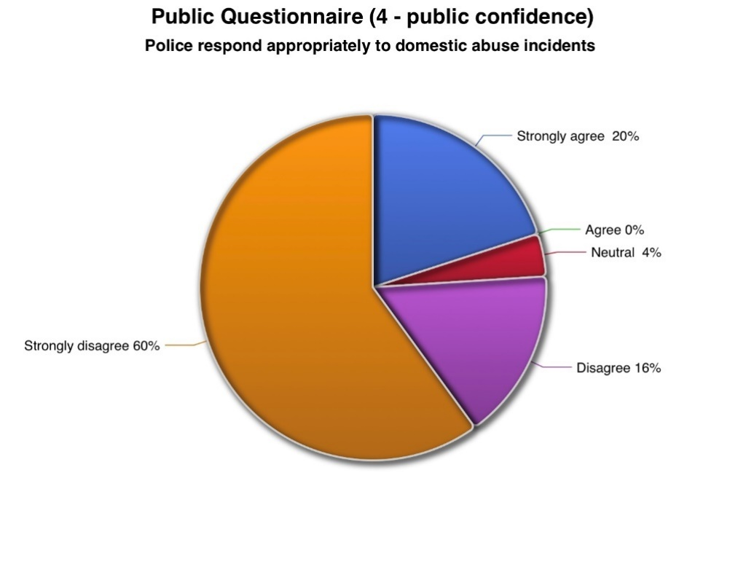

Figure 4.2 – Public Questionnaire graph for question 13; More should be done to safeguard children affected by domestic abuse.
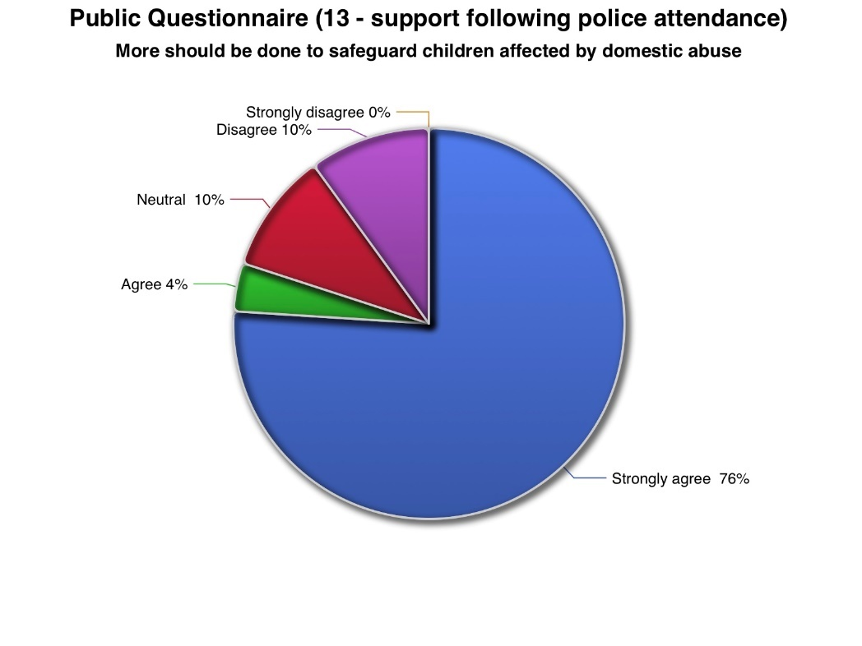
Figure 4.3 – Police Questionnaire for question 19; What is the biggest challenge in safeguarding children during domestic abuse investigations.


