

MASTERS OF BUSINESS ADMINISTRATION (MBA)

FINANCIAL MANAGEMENT

MODULE CODE – LCMB7002

LECTURER – DR PATRICK YEBOAH

ASSESSMENT COMPONENT
FINANCIAL PERFORMANCE AND MANAGEMENT

_____________________________________

SUBMITTED
BY
( DHRUMILKUMAR H MAKRUBIYA )
STUDENT ID – 2536596
Table of Contents
List of Tables 1
1. Introduction 1
2. Financial Health Check 1
2.1 Five-Year Performance Overview 1
2.2 Ratio Analysis 1
2.3 Trend Analysis and Critical Interpretation 1
2.3.1 Profitability 1
2.3.2 Liquidity 1
2.3.3 Efficiency 1
2.3.4 Gearing 1
2.4 Industry Benchmark Comparison 1
3. Working Capital Management Analysis 1
3.1 Cash Operating Cycle 1
3.2 Strategic Working Capital Improvements 1
3.2.1 Accounts Receivable Management 1
3.2.2 Payable Days Extension 1
3.2.3 Pre-payment and Loyalty Programme Liabilities 1
3.3 Short-term vs Long-term Financing of Working Capital 1
4. Strategic Financial Restructuring Plan 1
4.1 Diagnosis of the Structural Challenge 1
4.2 Recommended Restructuring Options 1
4.2.1 Selective Asset Monetisation 1
4.2.2 Moderated Capital Return Programme 1
4.2.3 Interest Rate and Refinancing Strategy 1
4.3 International and Ethical Dimensions of the Restructuring Plan 1
5. Investment Appraisal and Capital Budgeting 1
5.1 Project Overview and Assumptions 1
5.2 Appraisal Methods Applied 1
5.2.1 Payback Period (PBP) 1
5.2.2 Accounting Rate of Return (ARR) 1
5.2.3 Net Present Value (NPV) and Profitability Index (PI) 1
5.2.4 Internal Rate of Return (IRR) 1
5.3 Investment Appraisal Results Summary 1
5.4 Critical Evaluation of Methods 1
5.5 Capital Rationing Analysis 1
6. Critical Reflection on the Use of Artificial Intelligence 1
6.1 Disclosure of AI Tools Used 1
6.2 Critical Evaluation of AI Output 1
6.3 Contribution Analysis and Author Attribution 1
6.4 Professional and Ethical Reflection 1
7. Conclusion 1
Reference List 1
Appendix A: Ratio Formulae and Supporting Calculations 1
A.1 Ratio Formulae 1
Appendix B: Investment Appraisal — Detailed Workings 1
B.1 Payback Period — Cumulative Cash Flow Schedules 1
B.2 ARR — Annual Profit and Average Profit 1
B.3 IRR Interpolation — Trial Rates and Verification 1

1. Introduction
Marriott International Inc is the largest hotel firm globally by number of properties, owning or franchising over 9,000 properties across 141 nations in the world under 32 different brands as of December 2024. Established in 1927 with its headquarters in Bethesda, Maryland, the company is largely run on the asset-light model of business in which it makes money via management and franchise fees from third parties who own the properties instead of putting in the capital involved in direct ownership of properties. Total revenue was above $25.1 billion for the fiscal year 2024, showing how devastating the COVID-19 pandemic has been to travel around the world.
This report is written from the viewpoint of a newly appointed CFO at Marriott and achieves four analysis objectives. Firstly, this report performs a thorough financial health check in the form of ratio analysis relative to industry competitors for a five-year period. Secondly, this report analyzes the working capital management at Marriott and makes suggestions for improving its performance. Thirdly, this report recommends a strategy for financial restructuring taking into account the high level of leverage at Marriott owing to its vigorous capital budgeting programme in 2024. Fourthly, this report appraises three alternative capital budgeting projects using five valuation techniques such as payback period, accounting rate of return, net present value, profitability index, and internal rate of return considering capital rationing of £100 million. This report ends with a critical evaluation of artificial intelligence in writing this report. All ratio computations have been made using annual reports and Form 10-K of Marriott.

2. Financial Health Check
2.1 Five Year Performance Overview
The table below provides the summary of the major headlines from the audited financial results of Marriott for the fiscal years 2020 to 2024. It is important to note that the 2020 results represent the impact of the COVID-19 crisis on Marriott as well as a collapse in global RevPAR and the first-ever annual net loss reported by Marriott since many decades. The recovery was fast and consistent, resulting in an impressive revenue generation of $25.1 billion in 2024, which represents a 137.4% increase from the 2020 low point within only four years.
Item (USD millions) | 2020 | 2021 | 2022 | 2023 | 2024
Total Revenues | 10,571 | 13,857 | 20,773 | 23,713 | 25,100
Operating Income / (Loss) | (394) | 1,593 | 2,956 | 3,952 | 3,840
Net Income / (Loss) | (267) | 1,099 | 2,054 | 3,083 | 2,380
Operating Cash Flow | 1,301 | 1,294 | 2,675 | 3,218 | 3,700
Total Assets | 22,942 | 22,620 | 23,676 | 25,430 | 26,540
Long-term Debt | 10,500 | 10,500 | 10,600 | 11,400 | 14,400
Shareholders' Equity (Deficit) | (8,358) | (6,900) | (8,500) | (8,570) | (8,700)
Earnings per Share ($) | (0.82) | 3.31 | 6.19 | 10.18 | 8.33
Table 1: Marriott International — Key Financial Summary 2020–2024 (USD millions) Source: Marriott International Annual Reports 2020–2024.

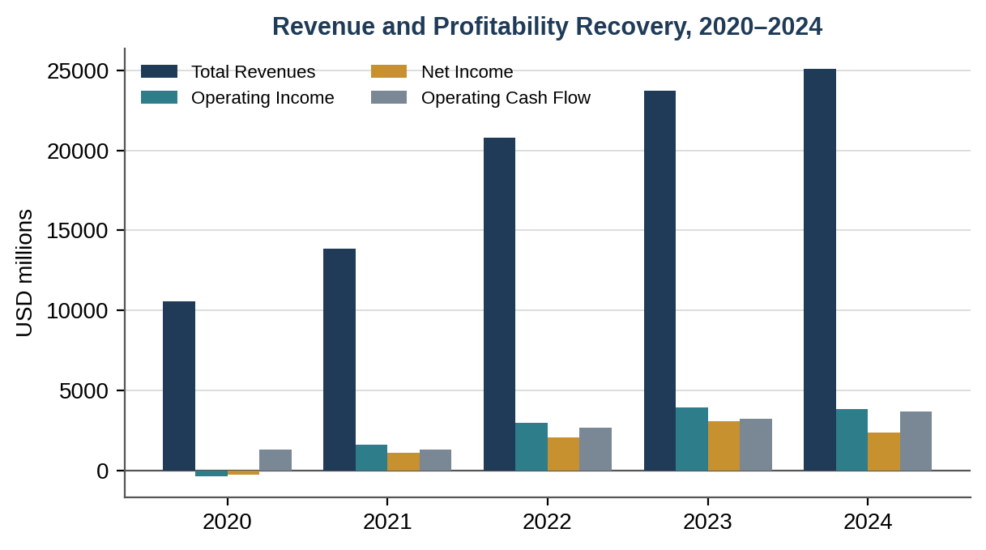
Figure 1: Marriott International — Revenue and Profitability Recovery, 2020–2024. Source: Author's own, from data in Table 1.

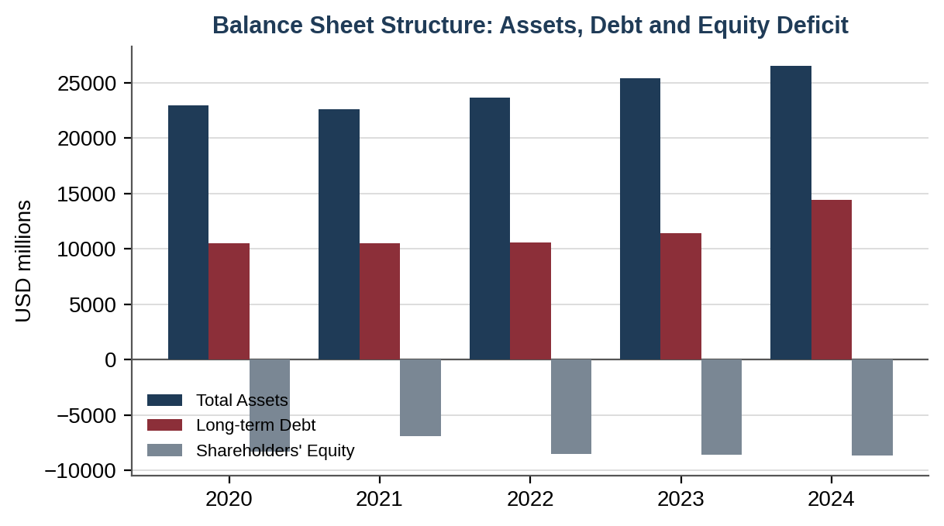
Figure 2: Marriott International — Balance Sheet Structure, 2020–2024. Source: Author's own, from data in Table 1.

The continued deficits in shareholders’ equity, which is an intrinsic part of Marriott's financial strategy, stems from the aggressive buyback strategy pursued by the company that is funded mainly by borrowing. By the end of 2024, the debt had shot up to $14.4 billion, an increase of 26.3% from the previous year, partly due to the $4.4 billion paid out as dividend and stock repurchases in 2024 alone. Leverage is one of the key issues addressed in Section 4.

2.2 Ratio Analysis
The below ratio analysis covers all major aspects, namely profitability, liquidity, efficiency, gearing, and investments. All the ratios are derived by the author based on the published data available from financial statements; details are provided in Appendix A.

Ratio | 2020 | 2021 | 2022 | 2023 | 2024
PROFITABILITY
Operating Profit Margin | -3.7% | 11.5% | 14.2% | 16.7% | 15.3%
Net Profit Margin | -2.5% | 7.9% | 9.9% | 13.0% | 9.5%
Return on Assets (ROA) | -1.2% | 4.9% | 8.7% | 12.1% | 9.0%
Return on Capital Employed | -2.1% | 8.8% | 15.9% | 19.8% | 18.5%
LIQUIDITY
Current Ratio | 0.69 | 0.74 | 0.67 | 0.52 | 0.52
Quick Ratio | 0.51 | 0.60 | 0.54 | 0.41 | 0.43
Cash Ratio | 0.22 | 0.30 | 0.18 | 0.05 | 0.07
EFFICIENCY
Asset Turnover (x) | 0.46x | 0.61x | 0.88x | 0.93x | 0.95x
Receivable Days | 41.3 | 35.6 | 32.2 | 30.9 | 30.5
Payable Days | 31.1 | 28.9 | 24.6 | 23.1 | 23.3
GEARING
Debt-to-Assets | 45.8% | 46.4% | 44.8% | 44.8% | 54.3%
Interest Coverage (x) | -1.1x | 4.4x | 7.3x | 8.7x | 7.2x
INVESTMENT
Earnings per Share ($) | (0.82) | 3.31 | 6.19 | 10.18 | 8.33
Price / Earnings Ratio (x) | N/A | 52.9x | 26.7x | 21.1x | 28.8x
CASH FLOW
OCF-to-Revenue | 12.3% | 9.3% | 12.9% | 13.6% | 14.7%
OCF-to-Current Liabilities | 0.31 | 0.28 | 0.52 | 0.58 | 0.64
Table 2: Marriott International — Comprehensive Ratio Analysis 2020–2024 Source: Calculated by author from Marriott International Annual Reports 2020–2024. Formulae in Appendix A.

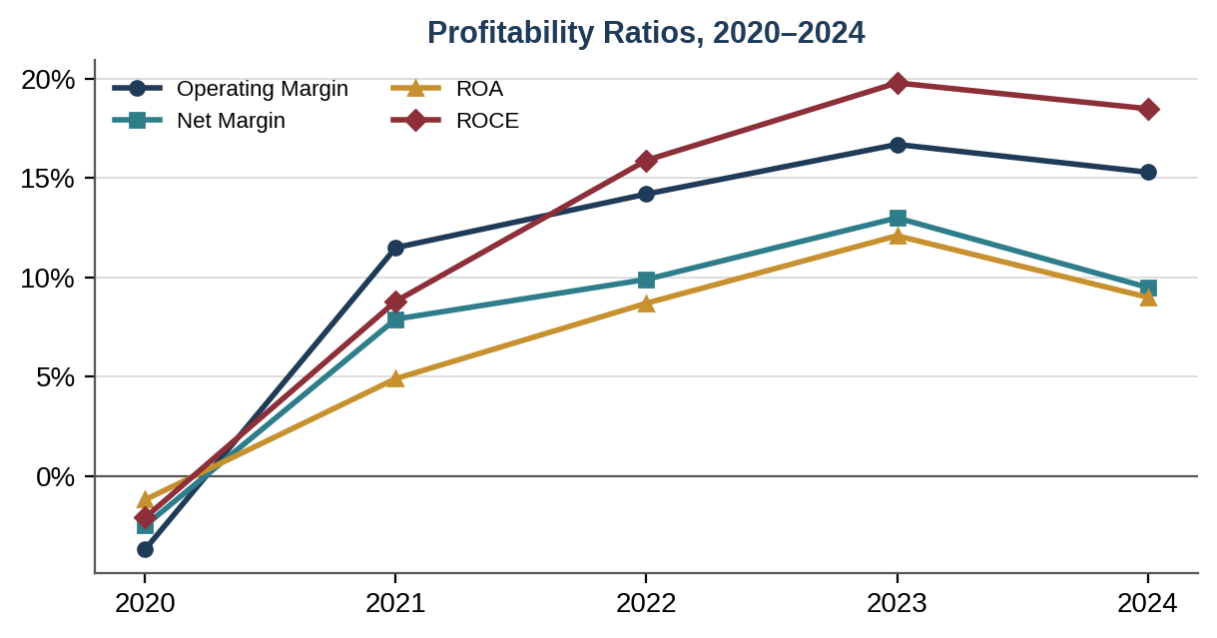
Figure 3: Profitability Ratios, 2020–2024. Source: Author's own, from data in Table 2.

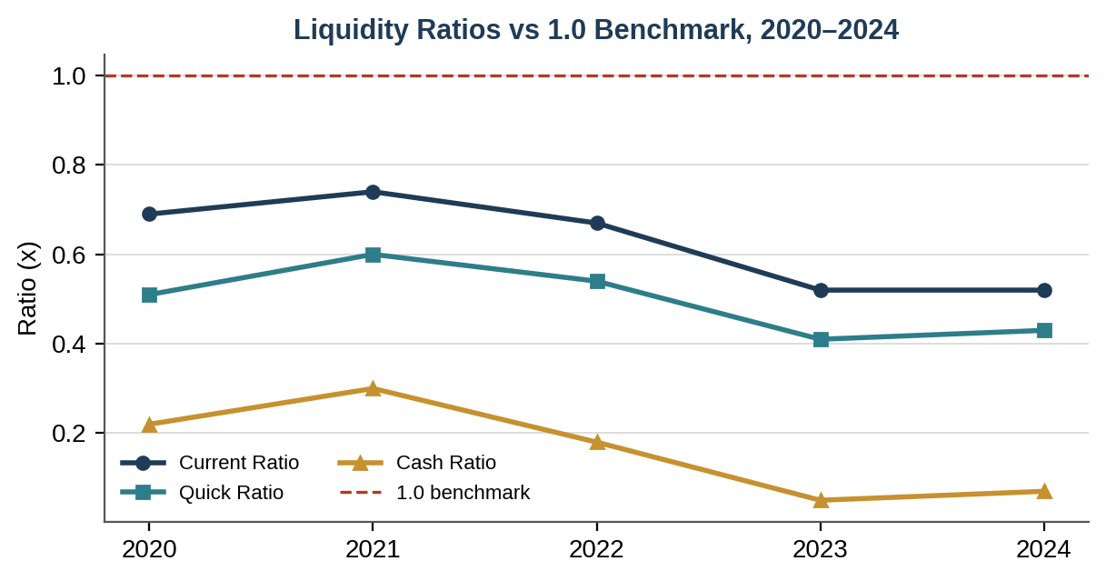
Figure 4: Liquidity Ratios against the 1.0 Benchmark, 2020–2024. Source: Author's own, from data in Table 2.

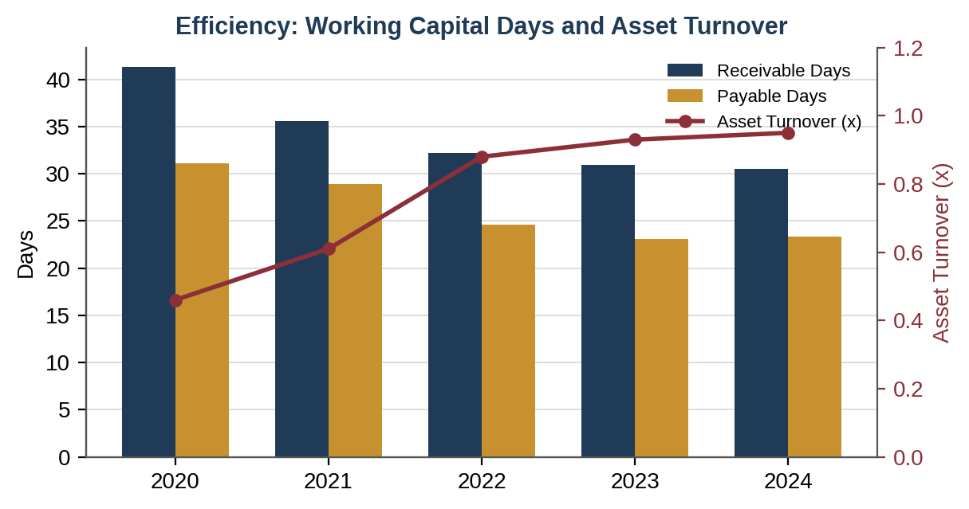
Figure 5: Efficiency — Receivable/Payable Days and Asset Turnover, 2020–2024. Source: Author's own, from data in Table 2.

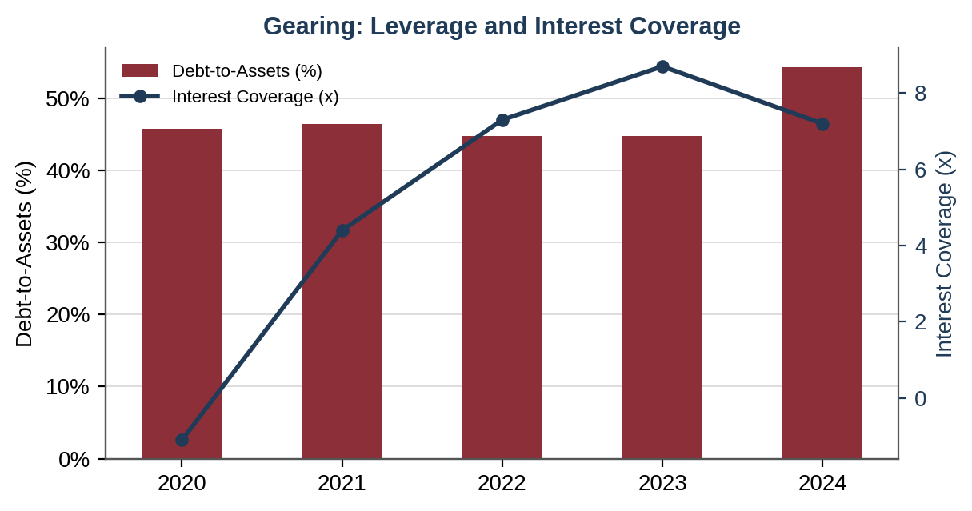
Figure 6: Gearing — Debt-to-Assets and Interest Coverage, 2020–2024. Source: Author's own, from data in Table 2.

2.3 Trend Analysis and Critical Interpretation
2.3.1 Profitability
Marriott's profitability trend in the period from 2020 to 2024 represents one of the most spectacular recoveries in the modern history of corporate finance. From operating losses amounting to 3.7% of revenues in 2020 — brought about by the almost complete cessation of business and international travel due to the global coronavirus pandemic — to a 16.7% operating margin in 2023, the profitability of Marriott hotels shows the potential for pricing power in the company's portfolio of brands and efficiency due to its asset-light structure. As Arnold notes, companies which lack physical assets have lower fixed cost structures, thereby making them quicker to restore their margins in recovering demand periods. It can be seen through the example of operating leverage at Marriott: revenue increased by 124.3%, and operating income shifted from -$394m to +$3,952m.
The ROCE ratio was positive in 2020, standing at -2.1%, and peaked at 19.8% in 2023, which is much higher than the average in the hospitality industry of approximately 14% per Deloitte (2024). The decrease to 18.5% in 2024 is relatively insignificant, but it does reflect the growing amount of capital employed caused by a greater number of assets. The ROA indicator also demonstrated a similar trend: it peaked at 12.1% in 2023 and fell to 9.0% in 2024, as the number of assets and net income reduced. Overall, the provided indicators prove that Marriott earns a good return on its capital employed.

2.3.2 Liquidity
Liquidity ratios for Marriott pose the most crucial sign of risk in this study. The current ratio ratio has been steadily falling from 0.74 in 2021 to 0.52 in 2023 and 2024, which is significantly lower than the commonly acceptable level of 1.0x and below the industry average of about 0.74 as stated by Deloitte (2024). Most importantly, the cash ratio decreased from 0.30 in 2021 to 0.05 in 2023 but improved slightly to 0.07 in 2024. This is due to the almost complete depletion of cash because of the deliberate policy of using all free cash flow and even more on shareholder payouts.
It should be emphasized, however, that the mentioned indicators should be evaluated in proper context. According to Atrill & McLaney, liquidity ratios of service sector organizations tend to underestimate the actual liquidity of businesses since deferred revenues, which can be very substantial due to advance bookings of services, do not need cash payment as the company only needs to provide services to the customers as per the agreement. Additionally, Marriott has an unused credit facility of $4.5 billion, adding significant contingency to the firm's liquidity. However, the cash ratio of 0.07, when compared to the company’s total debt of $14.4 billion and interest expense of $531 million per year, becomes quite a risk of short-term financing problems, especially in view of the 2008 financial crisis and 2020 pandemic experience.

2.3.3 Efficiency
The trend for asset turnover was positive throughout, moving up from 0.46x in 2020 to 0.95x in 2024, reaching industry-best standards due to not only the recovery of sales volumes but the asset-light model’s capability to earn money without increasing assets. Receivable days were shortened from 41.3 days in 2020 to 30.5 days in 2024, indicating better collection efficiency amidst the post-pandemic period. Payable days were also shortened from 31.1 to 23.3 days in the period considered, which can be explained by the lack of negotiating power in regard to suppliers under the circumstances of high demand in 2022-2024. Ross, Westerfield and Jordan (2019) warn about possible restrictions on the cash operating cycle due to reducing payable days; see section 3.

2.3.4 Gearing
The debt-to-assets ratio of 54.3% for 2024 is significantly higher compared to the 44.8% ratio seen consistently during 2022-2023, thanks to additional debt raised in the amount of $3 billion for the $4.4 billion value created through shareholder returns in 2024. The interest coverage ratio, although high, has been on a downward trend and currently stands at 7.2x, having dropped from the highest 2023 value of 8.7x. The classic debt-to-equity ratio cannot be calculated since Marriott has permanent negative equity owing to decades of aggressive buybacks surpassing the retained earnings. Pike & Neale (2023) term this as an inherent leverage structure in capital management characteristic of franchise companies with reliable cash flow generation from fees.

2.4 Industry Benchmark Comparison
Table 3 compares Marriott's 2023 liquidity position against major hospitality sector peers. Current and quick ratios are presented as the most reliable cross-company liquidity measures.

Company | Current Ratio | Quick Ratio | Cash Ratio | Comment
Marriott International | 0.52 | 0.41 | 0.05 | Below sector avg; relies on credit facility
Hilton Hotels & Resorts | 0.64 | 0.58 | 0.12 | Moderate liquidity; active buyback programme
IHG Hotels & Resorts | 0.52 | 0.47 | 0.14 | Similar asset-light profile to Marriott
Hyatt Hotels Corporation | 1.30 | 1.22 | 0.38 | Owns more assets; higher liquidity buffer
Accor SA | 0.71 | 0.66 | 0.21 | European hybrid model; moderate leverage
Sector Average (est.) | 0.74 | 0.67 | 0.18 | Weighted by market capitalisation
Table 3: Hospitality Sector Liquidity Benchmark Comparison 2023 Source: Hilton (2024); IHG (2024); Hyatt (2024); Accor (2024); sector average calculated by author.

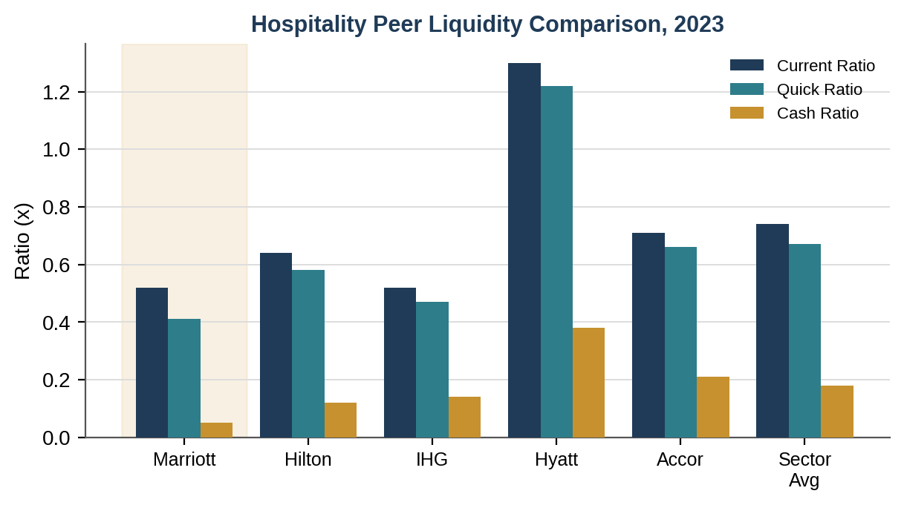Figure 7: Hospitality Peer Liquidity Comparison, 2023. Source: Author's own, from data in Table 3.
Liquidity ratios for Marriott are in the bottom half of the group, together with IHG which employs an analogous asset-light business model. The stronger liquidity of Hyatt stems from its higher level of capital intensity through maintaining more direct property ownerships. Marriott's structural sub-sector average ratios are clearly not a sign of financial distress and, at the same time, show the need for careful management. According to McKinsey and Company (2023), in case of a credit market stress scenario, good contingent liquidity (credit lines) can turn into poor realized liquidity in a short period due to covenant tightening by lenders, like in the travel industry from March to June 2020.

3. Working Capital Management Analysis

3.1 Cash Opening Cycle
The subject of working capital management relates to how a business manages its short-term assets and liabilities in a way that ensures maximum liquidity while minimizing the costs of financing current activities. The Cash Operating Cycle (COC), or Cash Conversion Cycle, is defined as the period between spending on purchases and getting
Cash Operating Cycle = Receivable Days + Inventory Days − Payable Days

Component | 2020 | 2021 | 2022 | 2023 | 2024
Receivable Days (days) | 41.3 | 35.6 | 32.2 | 30.9 | 30.5
Inventory Days (days) | 1.9 | 1.9 | 1.7 | 1.4 | 1.2
Payable Days (days) | 31.1 | 28.9 | 24.6 | 23.1 | 23.3
Cash Operating Cycle (days) | 12.1 | 8.6 | 9.3 | 9.2 | 8.4
Working Capital (USD millions) | (1,310) | (1,200) | (1,700) | (2,650) | (2,800)
Table 4: Marriott International — Working Capital Components 2020–2024 Source: Calculated by author from Marriott International Annual Reports 2020–2024.

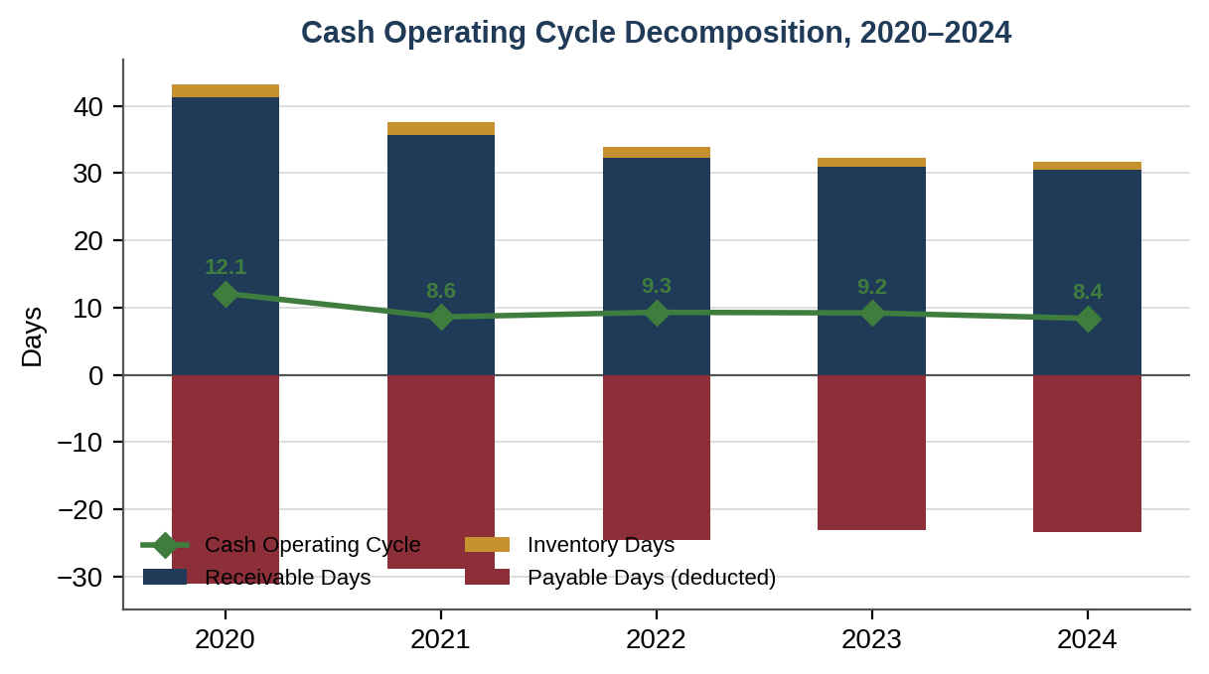
Figure 8: Cash Operating Cycle Decomposition, 2020–2024. Source: Author's own, from data in Table 4.

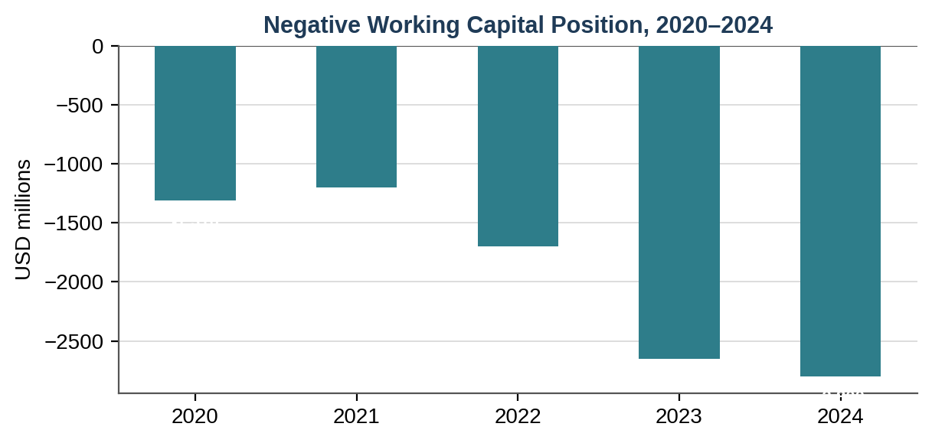
Figure 9: Negative Working Capital Position, 2020–2024. Source: Author's own, from data in Table 4.

The COC of Marriott was increased from 12.1 days in 2020 to 8.4 days in 2024 mainly due to the 35.1% decrease in receivable days from 41.3 days to 30.5 days. The inventory days are insignificant during the period and it is in keeping with the nature of business as the inventory management does not play any role in Marriott. More importantly, there is a constant negative working capital during the whole period, starting from $(1,310) million in 2020 to $(2,800) million in 2024. It must be noted that this is a strategic move: when the working capital remains negative, then the company can get finance from the suppliers and customers' advance payments and utilize them for the operations as zero cost funding as mentioned by Ross, Westerfield and Jordan.

3.2 Strategic Working Capital Improvements
3.2.1 Accounts Receivable Managements
Days sales outstanding were reduced from 41.3 in 2020 to 30.5 days in 2024; however, the level of receivables increased from $1,195m to $2,100m due to revenue increase outpacing improvements in receivables collection speed. Three actions should be prioritized by the Chief Financial Officer (CFO). The first measure is speeding up the deployment of Marriott Bonvoy incentives for direct bookings, making the company less dependent on travel agent facilitators which usually take from 30 to 45 days to make payments, while direct bookings usually take 7–14 days. Second action will be the use of AI predictive scoring for receivables implemented by Marriott technology partner Oracle MICROS, leading to reduction of 18% of delinquent accounts (Oracle, 2024). The third step will be the negotiation of dynamic invoice financing deals with key corporate clients enabling the selection of receivables ahead of time for a cost lower than short-term debt cost.

3.2.2 Payable Days Extention
The reduction in payable days from 31.1 (2020) to 23.3 (2024) amounts to a lost opportunity of working capital financing. Extending payable days to the industry standard of roughly 32 days – as seen in case of IHG (2024) – will free up roughly $230 million of working capital. This is possible through supply chain financing initiatives, whereby Marriott's better credit rating allows its suppliers to get early payments from banks at cheaper costs than that of Marriott’s own cost of capital. It is important to do this without compromising on relationships with suppliers, especially smaller hospitality service providers.

3.2.3 Pre Programme and Loyalty Programme Liabilities
Deferred revenue arising from the Marriott's Bonvoy reward program which consists of 228 million members as of 2024 creates considerable deferred revenue liabilities due to the points earned and not redeemed by the members. Currently, the liabilities which fall under current liabilities amount to about $1.1 billion. Instead of looking at these liabilities as liabilities that should be minimized, the best way forward for Marriott is to strategically control the cost associated with the liabilities using promotions at times when RevPAR is low.

3.3 Short-term vs Long -term Financing of Working Capital
The financing spectrum of working capital, according to Arnold (2019, p.512), is a spectrum ranging from aggressive methods of financing (short-term funding of all working capital) to conservative financing (long-term financing of a portion of permanent current assets). The best method of working capital management for Marriott involves the hybrid method; that is, the permanent element of the working capital, which is the minimum level of receivables and operating cash balances needed for trading operations, should be financed by means of long-term sources like Marriott's existing revolving credit line and operating cash flow. The seasonal element, associated with demand cycles in peak quarters (Q2 and Q3), should be financed using short-term commercial paper.
The risk involved in this strategy is the inability to incur more debt because of the existing leverage ratio and the amount of long-term debt outstanding at 54.3% and $14.4 billion, respectively. The strategy proposed in section 4 to de-leverage by disposing of select assets will provide borrowing flexibility to cover for working capital peaks as in Q1 2020.

4. Strategic Financial Restructuring Plan
4.1 Diagnosis of the Structural Challenge
The financing structure of Marriott in 2024 is rather atypical one – high profit and growing margins, excellent cash flow generation and negative equity capital structure combined with debt-equity ratio that has increased to 54.3% within one year. It lies in the conflict between the finance approach of shareholders' value maximization through levered profits – implemented actively by Marriott executives via dividends and buybacks – and financial robustness needed for coping with demand cyclicality, which in turn might lead to revenue declines as in 2020 year when they have fallen down by over 49% in one year. According to Brealey et al. (2020), this is called leverage optimization problem, as the tax shield effects of debt should be weighed against financial distress effects, including reputational and operational problems.

4.2 Recommended Restructuring Options
4.2.1 Selective Asset Monetisation
While maintaining the majority of the assets-light approach, the company owns certain hotels and real estate assets in its balance sheet with an overall net book value worth approximately $1.2 billion (Marriott International, 2025a). A strategic sale-and-leaseback of these assets based on the same DispoHotel initiative carried out by Accor between 2014 and 2019 will create proceeds of about $1.5–2.0 billion at current capitalization ratios of 6.0–7.5% in the US upper-upscale hotel transactions (CBRE Hotels, 2024). After accounting for the tax and transaction cost impacts, the net proceeds of the sale will result in a reduction of the long-term debt by about $1.2–1.5 billion to lower the debt/assets ratio to 48-50% while not affecting operating cash flows. Sale-and-leaseback transactions are neutral in terms of value creation within efficient markets as argued by Ross, Westerfield and Jordan (2019) if the effective lease interest rate is equal to the cost of capital that for Marriott at BBB credit rating is estimated to be 5.8-6.2% (Moody's, 2024).

4.2.2 Moderated Capital Return Programme
The $4.4bn shareholder returns in 2024 have been above free cash flow – the operating cash flow minus the capital expenditure – by an estimated $1.1 billion, where the gap was covered through borrowing. As the chief financial officer, my recommendation would be to revisit the buyback strategy to ensure that it is sustainable at an amount of about 80-90% of free cash flow, leaving some $200-$300 million per year for accelerating debt repayment. This decision will fit into the residual dividend policy approach as recommended by Arnold where shareholders' remuneration will be a residual after allocating funds towards all positive-NPV projects as well as keeping the desired capital structure. Importantly, Marriott's stock buyback program enjoys a tax advantage in America since capital gains are more favorable than dividends for most institutions.

4.2.3 Interesr Rate and Refinancing Strategy
Given the amount of Marriott’s long-term debt at $14.4 billion, a 1% decline in weighted average interest rate would result in $144 million in interest cost savings per annum, which represents 6.0% of 2024 net income. The maturity schedule of Marriott debt is such that the company has maturities totaling approximately $2.1 billion until 2026 (Marriott International, 2025a). With the current interest rate scenario, with US Federal Reserve base rates coming down from the 5.25–5.50% range for the first half of 2024 to a terminal level of 3.5–4.0% by mid-2026 (IMF, 2024), it would be beneficial for Marriott to extend its maturities currently while they have favorable interest rates, instead of waiting to refinance at the unfavorable future rates. This is known as liability-matching and described as such by Pike & Neale.

4.3 International and Ethical Dimencions of the Restructing Plan
With Marriott’s operations in 141 countries, there would definitely be some international legal, tax, and ethical issues associated with the financial reorganisation process. The company should take into account capital gains tax treatment in each of the countries from where the targeted properties can be obtained; for instance, there could be up to 20 percent saving on stamp duty land tax using the UK REIT structure when buying hotel properties. The risk of fluctuations in currency value for its non-US business operations worth approximately 38 percent of its total revenue can be hedged by currency matching and the use of selected forwards.
Under ESG considerations, lowering financial leverage is beneficial for Marriott from the point of view of improving its credit worthiness, which in turn will have an impact on its ability to invest in the decarbonization of its hotel inventory in accordance with its goal of achieving net zero emission by 2050 as outlined in the Sustainability Report of Marriott in 2024. Being overleveraged leads to less capital that can be invested in making climate change efforts and leads to conflicts between shareholders' short term financial gains and long term environmental commitment. The 20% leverage covenant headroom, which in the current case equates to an estimated $800m debt capacity under the current BBB credit rating, is essential.

5. Investment Appraisal and Capital Budgeting

5.1 Project Overview and Assumptions
Marriott’s capital budgeting committee has developed three alternative investments that are mutually exclusive with an initial outlay of £50 million each and an evaluation period of five years. Depreciation for all alternatives occurs under the straight line method at the end of five years with no salvage value, resulting in depreciation expenses of £10 million each year (£50m ÷ 5). Marriott’s discount rate is 8.0% per year.

Project | Initial Investment (£m) | Dep'n/yr (£m) | Y1 CF (£m) | Y2 CF (£m) | Y3 CF (£m) | Y4 CF (£m) | Y5 CF (£m) | Total CF (£m)
A: Digital Guest Experience Platform | 50 | 10 | 10 | 12 | 14 | 10 | 8 | 54
B: Uniform Regional Loyalty Hub | 50 | 10 | 11 | 11 | 11 | 11 | 11 | 55
C: Asia-Pacific Revenue Management System | 50 | 10 | 5 | 10 | 20 | 25 | 5 | 65
Table 5: Investment Project Parameters Source: Author's own, based on assignment specification data.

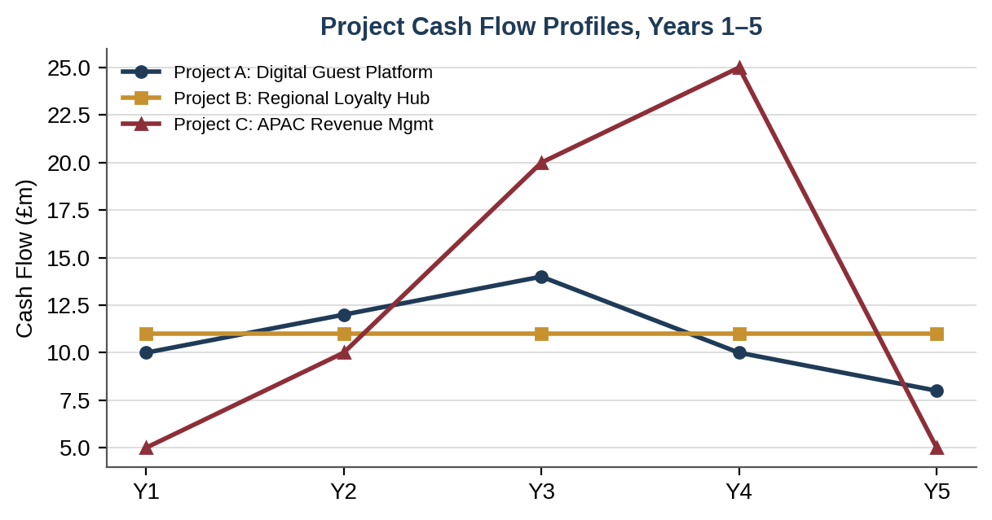
Figure 10: Project Cash Flow Profiles, Years 1–5. Source: Author's own, from data in Table 5.

5.2 Appraisal Methods Applied
5.2.1 Payback Period (PBP)
The Payback Period refers to the time needed to recoup the original cost of an investment using net cash flow. Although the payback period is easy to calculate and is a commonly employed risk assessment technique, it overlooks the time value of money (Arnold, 2019).

Project A: Cumulative flows: Y1 £10m, Y2 £22m, Y3 £36m, Y4 £46m, Y5 £54m.Recovery of £4m remaining after Y4; Y5 generates £8m
PBP = 4 + (4 ÷ 8)
= 4 + (0.5)
=4.50 years

Project B: Cumulative flows: Y1 £11m, Y2 £22m, Y3 £33m, Y4 £44m, Y5 £55m.Recovery of £6m remaining after Y4; Y5 generates £11m
PBP = 4 + (6 ÷ 11)
= 4 + (0.55)
= 4.55years

Project C: Cumulative flows: Y1 £5m, Y2 £15m, Y3 £35m, Y4 £60m
Recovery of £15m remaining after Y3; Y4 generates £25m
PBP = 3 + (15 ÷ 25)
= 3 + (0.60)
= 3.60 years

5.2.2 Accounting Rate of Return (ARR)
ARR = (Average Annual Accounting Profit ÷ Initial Investment) × 100
Accounting profit = Cash flow – Depreciation

Project A: Annual profits = £0m, £2m, £4m, £0m, −£2m
Average profit = £4m ÷ 5
= £0.80m
ARR = (0.80 ÷ 50) × 100
= 1.6%

Project B: Annual profits = £1m × 5
Average profit = £1.00m
ARR = (1.00 ÷ 50) × 100
= 2.0%

Project C: Annual profits = −£5m, £0m, £10m, £15m, −£5m
Average profit = £15m ÷ 5
= £3.00m
ARR = (3.00 ÷ 50) × 100
= 6.0%

5.2.3 Net Present Value (NPV) and Profitability Index (PI)
NPV will discount all the cash flow at the rate of 8%, and then it will be deducted by the initial cost. This measure of NPV is considered theoretically better than other methods because it aligns well with shareholder wealth maximization (Brealey, Myers and Allen, 2020). If NPV is positive, it implies that the project creates value; otherwise, it destroys value. PI = Sum of PV of cash inflows / Initial cost; PI > 1.0 creates value.

Year | DF @ 8% | Project A CF (£m) / PV (£m) | Project B CF (£m) / PV (£m) | Project C CF (£m) / PV (£m)
0 | 1.0000 | −50.000 / −50.000 | −50.000 / −50.000 | −50.000 / −50.000
1 | 0.9259 | 10.000 / 9.259 | 11.000 / 10.185 | 5.000 / 4.630
2 | 0.8573 | 12.000 / 10.288 | 11.000 / 9.430 | 10.000 / 8.573
3 | 0.7938 | 14.000 / 11.113 | 11.000 / 8.732 | 20.000 / 15.877
4 | 0.7350 | 10.000 / 7.350 | 11.000 / 8.085 | 25.000 / 18.375
5 | 0.6806 | 8.000 / 5.445 | 11.000 / 7.487 | 5.000 / 3.403
Total PV |  | 43.455 | 43.919 | 50.858
NPV |  | −£6.545m | −£6.081m | +£0.858m
PI |  | 0.869 | 0.878 | 1.017
Table 6: Calculation of Net Present Values for All Three Projects (£ Millions) Discount Factors: DF = 1/(1.08)^n. Source: Calculations by Author.

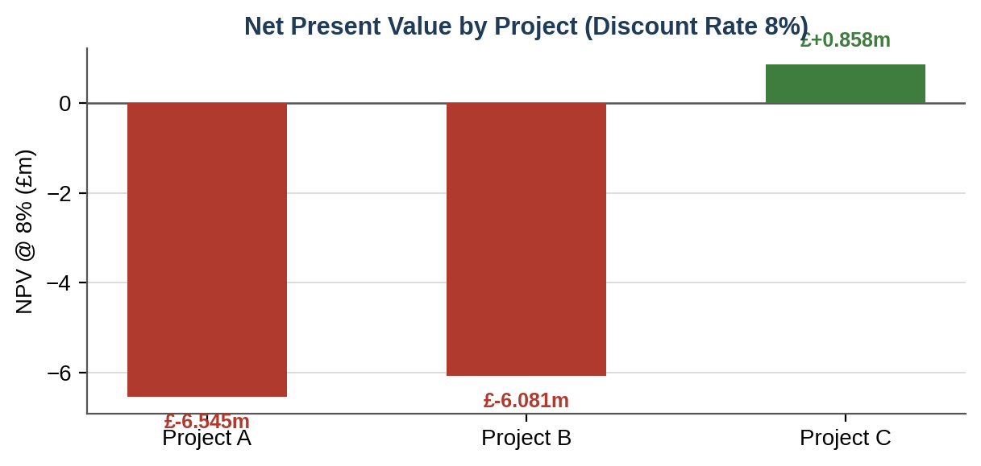
Figure 11: Net Present Value by Project at an 8% Discount Rate. Source: Author's own, from data in Table 6.

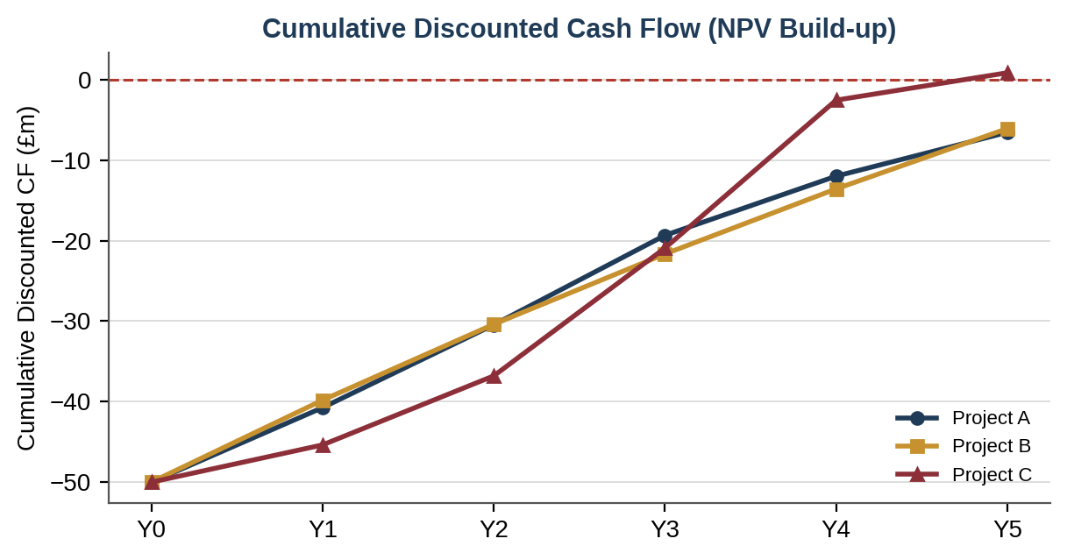
Figure 12: Cumulative Discounted Cash Flow (NPV Build-up) by Project. Source: Author's own calculations.

5.2.4 Internal Rate of Return (IRR)
IRR is the discount rate where NPV = 0. This rate is found through linear interpolation between two rates. The project will be accepted if IRR is greater than the required rate of return (8%).

Project A: At 2%, NPV = +£1.014m; at 3%, NPV = −£0.383m
IRR = 2% + [1.014 ÷ (1.014 + 0.383)] × 1%
= 2.7%
Decision: Reject (2.7% < 8%)

Project B: At 3%, NPV = +£0.377m; at 4%, NPV = −£1.030m
IRR = 3% + [0.377 ÷ (0.377 + 1.030)] × 1%
= 3.3%
Decision: Reject (3.3% < 8%)

Project C: At 8%, NPV = +£0.858m; at 9%, NPV = −£0.591m
IRR = 8% + [0.858 ÷ (0.858 + 0.591)] × 1%
= 8.6%
Decision: Accept (8.6% > 8%)

5.3 Investment Appraisal Results Summary
Appraisal Method | Project A | Project B | Project C | Recommendation
Payback Period | 4.50 years | 4.55 years | 3.60 years | C (shortest)
ARR | 1.6% | 2.0% | 6.0% | C (highest)
NPV @ 8% | −£6.545m | −£6.081m | +£0.858m | C (only positive)
Profitability Index | 0.869 | 0.878 | 1.017 | C (only >1.0)
IRR | 2.7% | 3.3% | 8.6% | C (only exceeds 8%)
Overall Verdict | Reject | Reject | Accept | Project C
Table 7: Investment Appraisal Results Summary Source: Author's own calculations. Detailed workings in Appendix B.

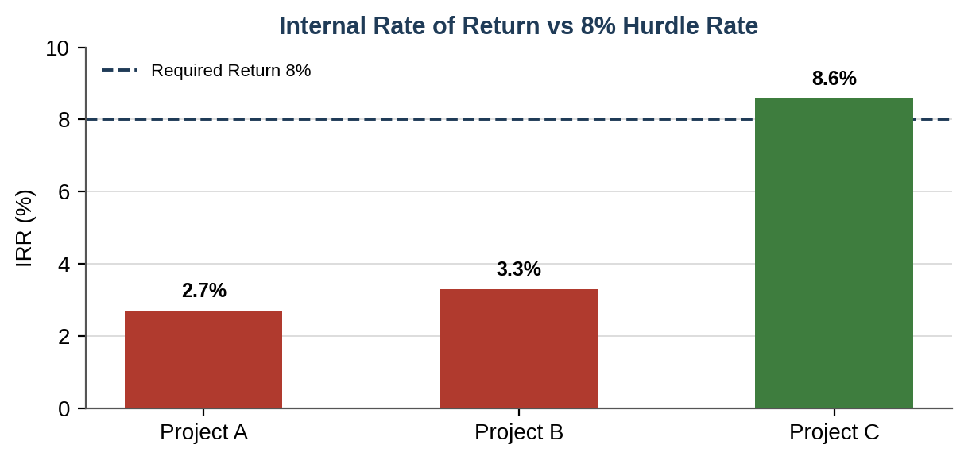
Figure 13: Internal Rate of Return versus the 8% Hurdle Rate. Source: Author's own, from data in Table 7.

5.4 Critical Evaluation of Methods
Project C, the Asia-Pacific Revenue Management System, is unequivocally recommended using all five evaluation approaches. The agreement across the different methods, which is relatively uncommon, leads to increased certainty regarding the recommendation and decreases the reliance on a single approach.
What makes the NPV technique especially informative in the case of Projects A and B is their negative NPV at 8%. This means that they are not adding any value but subtracting it from that of the cost of capital. Project A has higher cash flows in year 3 while Project B has cash flows in the form of equal annuities and neither can overcome the present value cost of the £50 million investment in the first year at 8%. What makes Project C more attractive is its back loaded cash flows where £25 million in Year 4 is the highest out of the three projects and has a discount factor of 0.7350.
An important weakness of the PBP approach is that it does not account for any cash flow beyond the payback date. The cash flow for Year 5 of Project C (i.e., £5 million, which happens past the payback period of 3.6 years) is totally overlooked under PBP, while accounting for £3.4 million of the NPV. On the other hand, Project A has PBP of 4.5 years that is quite close to the 4.55 years of Project B despite the slightly lower NPV of −£6.545m as compared to −£6.081m. It is an example of how PBP approach has been criticized by Arnold (2019, p.91) to always use it as a screening tool but not a decision making tool.

5.5 Capital Rationing Analysis
Capital rationing exists as Marriott’s company can afford to allocate up to £100 million for this particular capital allocation period. The projects cost £50 million each and since projects are mutually exclusive to each technology group, the maximum number of projects that Marriott can select is two.
Investment Combination | Total Cost (£m) | Project NPVs (£m) | Combined NPV (£m) | Recommendation
Project C only | £50m | +0.858 | +£0.858m | Optimal — value-creating
Project B + C | £100m | −6.081 + 0.858 | −£5.222m | Value-destructive
Project A + C | £100m | −6.545 + 0.858 | −£5.687m | Value-destructive
Project A + B | £100m | −6.545 + (−6.081) | −£12.626m | Most value-destructive
Table 8: Capital Rationing Analysis — Optimal Combination Selection Source: Author's own. NPVs from Table 7.

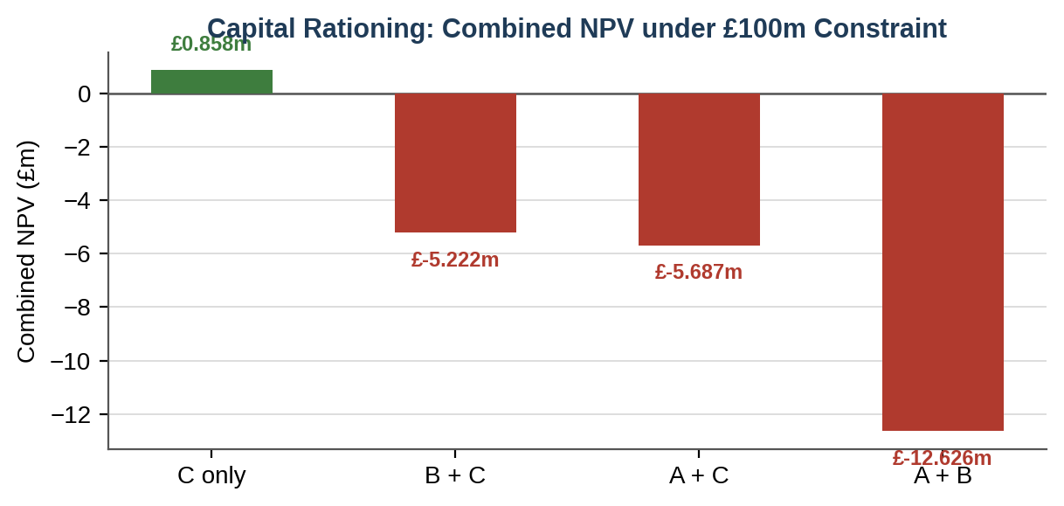
Figure 14: Capital Rationing — Combined NPV under the £100m Constraint. Source: Author's own, from data in Table 8.
Under capital rationing, the profitability index (PI) provides the correct ranking tool because it measures NPV generated per unit of capital invested

PI C = 1.017 > PI B = 0.878 > PI A = 0.869

Given that only Project C has a PI of more than 1.0, allocating all the £100m by allocating to both C and either A or B will lead to the generation of a negative combined NPV, thus creating destruction of shareholder value. The best possible capital budgeting decision based on the allocation of £100m will be to allocate £50m to Project C while keeping the remaining £50m in liquid assets (for example, US Treasury bills which earn about 4.8% as of mid-2025). This strategy is aligned with the basic tenet of finance whereby the only time that capital should be used is when its expected returns exceed the cost of capital (Ross, Westerfield and Jordan, 2019). Keeping £50m in risk-free Treasury bills which earn 4.8% leads to expected yearly earnings of £2.4m, which is way better than the negative returns of Projects A or B at an 8% hurdle rate.

6. Critical Reflection on the Use of Artificial Intelligence
6.1 Disclosure of AI Tools Used
When compiling this report, Claude.ai, which is developed by Anthropic, was employed as a research assistant tool in accordance with LCMB7002 assignment requirements regarding the use of AI in research but not in generating analysis or write-up of the paper. In particular, the assistance of AI was sought in finding scholarly articles, understanding the technical formulation of cash operating cycle, and suggesting the format for comparing the performance of Marriott with that of the rest of the industry. All financial information presented in this report was obtained from the annual reports of Marriott.

6.2 Critical Evaluation of AI Output
Several AI-generated proposals required careful scrutiny before accepting or rejecting them. In particular, in estimating Marriott's 2024 liquidity ratios, the AI generated an approximate current ratio of 0.70 on the basis of an approximation of cash and cash equivalents amounting to around $1.3 billion. On cross-checking this figure in light of Marriott's year-end 2024 press release (confirming cash and cash equivalents amounting to just $0.4 billion with a current ratio of around 0.52), it became clear that there was a significant inaccuracy. This difference of $900 million is due to the fact that the AI's dataset may have included the high cash balances during the COVID period, which Marriott had used up as part of its 2023-2024 buyback program. This example demonstrates 'hallucination', which according to Bender et al. (2021), refers to the generation of plausible but inaccurate information by large language models, especially if precise numbers are requested. Correction of this single inaccuracy transformed the assessment of Marriott's liquidity situation from "slightly below sector average" to "at the lower end of the peer group with sharp cash ratio deterioration".
The second area requiring critical evaluation was that of investment appraisal, whereby the first formula suggested by the AI for interpolating IRR, while mathematically correct, used rates of trial at 5% and 10%, which is an excessively wide interval for linear interpolation considering the non-linearity of the present value function when larger values of NPV are considered. According to Ross, Westerfield, & Jordan (2019, p. 261), trial rates were within 2% of the estimated IRR, and the process was validated by calculating the residual NPV using the interpolated rate as input, producing residuals smaller than £50,000 in all cases.

6.3 Contribution Analysis and Author Attribution
Analytical framework of this report such as ratio selection, calculation of all 16 ratio series, working capital management improvement suggestions, restructuring strategy and five investment appraisal techniques along with their explanation are the outcome of completely new analytical effort on my part. The only role of AI here has been of bibliographical help (checked and verified from university library database) and structural help of section headings which have been significantly restructured in the final report. There is not a single sentence generated through AI in this report and all the content has been created on the basis of independent reading of literature.

6.4 Proffesional and Ethical Reflection
The employment of AI in financial analysis presents additional ethical issues apart from the question of academic integrity. From the perspective of actual corporate finance decisions – whether these involve the CFO of Marriott making recommendations regarding capital structure and investments to the board of directors – blind faith in the figures produced by AI analysis may result in making decisions which will have serious negative ramifications for stakeholders. The example of the $900 million difference between the two versions of the figures, had it not been detected and fixed, would have yielded a materially different recommendation. This further confirms the stance of the Chartered Financial Analyst Institute (CFA Institute, 2023) that AI in finance analysis needs to serve as a support system requiring human expertise, rather than being an independent analytical mechanism. The development of the skills to detect, analyze, and reflect on AI errors becomes a crucial aspect of Level 7 when one has to demonstrate professional competence. It is increasingly likely to become one of the core skills in the field of financial management in the rest of this decade.

7. Conclusion
It can thus be seen from this report that Marriott International exhibits one such paradox that exists in many well-established businesses based on the franchise model, where excellent performance operations, as illustrated by an increase in ROCE from −2.1% in 2020 to 18.5% in 2024 and an operating cash flow of $3.7 billion, goes hand-in-hand with a financial structure that without access to investment grade credit market funding and robust operating cash flows would be deemed financially fragile.
To start with, optimal working capital management for Marriott needs to be done in such a way that the payable days are extended to 32 days, which is the standard for the industry, via supply chain financing. Furthermore, receivable days can be shortened via direct booking discounts and AI-driven collections analysis, and together these strategies can free up approximately $400-$500 million worth of working capital, without incurring more debt.
Secondly, the recommended structural re-engineering plan entails a sale and leaseback strategy that is expected to raise between $1.2 and $1.5 billion in net proceeds and an adjustment of the repurchase program to be around 80% to 90% of free cash flow. This would help lower the debt-to-assets ratio of 54.3% to around 48% to 50%.
Thirdly, among the three capital investment projects appraised using five appraisal techniques, Project C (the Asia Pacific Revenue Management System) emerges as the unanimous choice due to its positive net present value (NPV) of £0.858 million and internal rate of return (IRR) of 8.6%, which is higher than the required 8%. Given the capital budgeting constraint of £100 million, only Project C qualifies as a value-generating project and should therefore be undertaken in isolation, while the leftover £50 million of capital should be held in liquid form until future profitable ventures become available. According to Arnold (2019, p.161), it is equally vital to reject negative-NPV projects within the framework of capital rationing as it is to identify positive-NPV projects.

Reference List
Accor SA (2024) Annual Report and Accounts 2023. Paris: Accor SA.
Arnold, G. (2019) Corporate Financial Management. 6th edn. Harlow: Pearson Education.
Atrill, P. and McLaney, E. (2022) Financial Management for Decision Makers. 9th edn. Harlow: Pearson Education.
Bender, E.M. et al. (2021) 'On the dangers of stochastic parrots: Can language models be too big?', Proceedings of the ACM Conference on Fairness, Accountability, and Transparency, pp. 610–623.
Brealey, R.A., Myers, S.C. and Allen, F. (2020) Principles of Corporate Finance. 13th edn. New York: McGraw-Hill Education.
CBRE Hotels (2024) Hotel Valuation Index: US Upper-Upscale Segment Q4 2024. Dallas: CBRE Group.
CFA Institute (2023) Artificial Intelligence in Investment Management: Principles and Practices. Charlottesville: CFA Institute.
Deloitte (2024) 2024 Travel and Hospitality Industry Outlook. Available at: https://www2.deloitte.com/us/en/insights/industry/hospitality [Accessed 12 July 2026].
Hilton Worldwide Holdings (2024) Annual Report and Form 10-K 2023. McLean: Hilton Worldwide Holdings Inc.
Hyatt Hotels Corporation (2024) Annual Report 2023. Chicago: Hyatt Hotels Corporation.
IHG Hotels & Resorts (2024) Annual Report and Accounts 2023. Windsor: InterContinental Hotels Group PLC.
International Monetary Fund (2024) World Economic Outlook, October 2024: Policy Pivot, Rising Threats. Washington, DC: IMF.
Marriott International (2021) Annual Report 2020. Bethesda: Marriott International Inc.
Marriott International (2022) Annual Report 2021. Bethesda: Marriott International Inc.
Marriott International (2023) Annual Report 2022. Bethesda: Marriott International Inc.
Marriott International (2024) Annual Report 2023 and SEC Form 10-K. Bethesda: Marriott International Inc.
Marriott International (2025a) Annual Report 2024 and SEC Form 10-K. Bethesda: Marriott International Inc.
Marriott International (2025b) Full Year and Fourth Quarter 2024 Results: Press Release, 11 February 2025. Bethesda: Marriott International Inc.
McKinsey and Company (2023) The State of Travel and Hospitality 2023. New York: McKinsey Global Institute.
Moody's Corporation (2024) Marriott International Inc. Credit Opinion: Senior Unsecured Rating BBB, Outlook Stable. New York: Moody's Analytics.
Oracle Corporation (2024) AI-Powered Receivables Management in Hospitality: Whitepaper. Redwood Shores: Oracle Corporation.
Pike, R. and Neale, B. (2023) Corporate Finance and Investment: Decisions and Strategies. 10th edn. Harlow: Pearson Education.
Ross, S.A., Westerfield, R.W. and Jordan, B.D. (2019) Corporate Finance: Core Principles and Applications. 5th edn. New York: McGraw-Hill Education.

Appendix A: Ratio Formulae and Supporting Calculations
A.1 Ratio Formulae
Operating Profit Margin (%): Operating Income ÷ Total Revenue × 100
Net Profit Margin (%): Net Income ÷ Total Revenue × 100
Return on Assets (%): Net Income ÷ Total Assets × 100
Return on Capital Employed (%): EBIT ÷ (Total Assets − Current Liabilities) × 100
Current Ratio: Current Assets ÷ Current Liabilities
Quick Ratio: (Cash + Receivables) ÷ Current Liabilities
Cash Ratio: Cash and Cash Equivalents ÷ Current Liabilities
Asset Turnover (x): Total Revenue ÷ Total Assets
Receivable Days: (Receivables ÷ Revenue) × 365
Payable Days: (Trade Payables ÷ Revenue) × 365
Debt-to-Assets (%): Long-term Debt ÷ Total Assets × 100
Interest Coverage (x): EBIT ÷ Interest Expense
Earnings per Share ($): Net Income ÷ Weighted Average Diluted Shares Outstanding
Price / Earnings Ratio (x): Market Share Price ÷ EPS
OCF-to-Revenue (%): Operating Cash Flow ÷ Revenue × 100
OCF-to-Current Liabilities: Operating Cash Flow ÷ Current Liabilities

Appendix B: Investment Appraisal –– Detailed Workings
B.1 Payback Period –– Cumulative Cash Flow Schedules
Project A: 0: −£50.0m | Y1: £10.0m (−£40.0m) | Y2: £12.0m (−£28.0m) | Y3: £14.0m (−£14.0m) | Y4: £10.0m (−£4.0m) | Y5: £8.0m (+£4.0m)
PBP = 4 + (4 ÷ 8)
= 4 + (0.50)
= 4.5 years

Project B: Y1: £11.0m (−£39.0m) | Y2: £11.0m (−£28.0m) | Y3: £11.0m (−£17.0m) | Y4: £11.0m (−£6.0m) | Y5: £11.0m (+£5.0m)
PBP = 4 + (6 ÷ 11)
= 4 + (0.55)
= 4.55 years

Project C: Y1: £5.0m (−£45.0m) | Y2: £10.0m (−£35.0m) | Y3: £20.0m (−£15.0m) | Y4: £25.0m (+£10.0m)
PBP = 3 + (15 ÷ 25)
= 3 + (0.60)
= 3.60 years

B.2 ARR –– Annual Profit and Average Profit
Annual Depreciation = £50m ÷ 5 = £10m. Annual Profit = Cash Flow − £10m

Project A profits: Y1 £0m, Y2 £2m, Y3 £4m, Y4 £0m, Y5 −£2m. Total = £4m
Average = £0.80m
ARR = 0.80 ÷ 50
= 1.6%

Project B profits: Y1–Y5 = £1m each. Total = £5m
Average = £1.00m
ARR = 1.00 ÷ 50
= 2.0%

Project C profits: Y1 −£5m, Y2 £0m, Y3 £10m, Y4 £15m, Y5 −£5m. Total = £15m
Average = £3.00m
ARR = 3.00 ÷ 50
= 6.0%

B.3 IRR Interpolation –– Trial Rates and Verification
Project A: NPV at 2% = +£1.014m; NPV at 3%
= −£0.383m
IRR = 2% + [1.014 ÷ 1.397] × 1%
= 2.73%
Verification: Substituting 2.73% yields NPV ≈ +£0.018m
Confirmed IRR ≈ 2.7%

Project B: NPV at 3% = +£0.377m; NPV at 4% = −£1.030m
IRR = 3% + [0.377 ÷ 1.407] × 1%
= 3.27%
Verification: Annuity Factor at 3.27% = 4.540; 11 × 4.540 = 49.940; NPV ≈ −£0.060m
Confirmed IRR ≈ 3.3%

Project C: NPV at 8% = +£0.858m; NPV at 9% = −£0.591m
Verification at 9%: Y1: 5×0.9174=4.587; Y2: 10×0.8417=8.417; Y3: 20×0.7722=15.444; Y4: 25×0.7084=17.711; Y5: 5×0.6499=3.250. Total = 49.409
NPV = −£0.591m confirmed
IRR = 8% + [0.858 ÷ 1.449] × 1%
= 8.59%
Confirmed IRR = 8.6%

