5/14/2026
Aliu Djalo (2117368)

university of wales trinity saint david

Data Warehousing & Data Mining (ACCA6026)

Data Warehousing
Table of Contents
1. Introduction. 3
1.1. Background 3
1.2. Purpose and Scope 3
1.3. Report Structure 3
2. Task 1: Strategic Case. 4
2.1. OLTP vs Data Warehouses 4
2.2. Data Warehouse Architecture and ETL 5
2.3. Data Marts 7
2.4. Normalised vs Dimensional 8
3. Task 2: Design. 9
3.1. Source Systems 9
3.2. Star Schema 10
3.3. Data Marts 12
3.4. ETL Plan 13
3.5. Data Quality & Governance 15
4. Conclusion. 15

List of Figures:
Figure 1: Proposed Data Warehouse Architecture for Rags'n'Riches 6
Figure 2: Example Star Schema (Rentals) 9
Figure 3: Proposed Data Warehouse Schema for Rags'n'Riches 11

List of Tables:
Table 1: Comparison of OLTP Systems and Data Warehouses 4
Table 2: Internal and External Source Systems for the Rags'n'Riches Data Warehouse 10
Table 3: Proposed Data Marts and Extracted Warehouse Tables 13
Table 4: Source-to-Warehouse Table Mapping 14
Table 5: Example Attribute Mapping for Rentals_Fact 15

Introduction.

Background
Rags’n’Riches Ltd is a UK-based prop and costume hire company that supplies items to theatre groups, film production units and other creative organisations. The company operates from its main administrative office in Raglan, South Wales and has six warehouses across the UK, each specialising in different types of costumes or props. As the business prepares for possible growth linked to increased film production in the UK, the board wants to rationalise operations, improve profitability and ensure that its IT systems can support a larger and more complex rental operation.
The company currently uses an online transaction processing (OLTP) system to manage day-to-day operations such as order entry, stock movements, deliveries and returns. However, this system is not optimised for the analytical and reporting needs that support strategic planning.

Purpose and Scope
This report addresses how a data warehouse solution can improve the way Rags’n’Riches captures, stores, analyses and presents business data. In particular, it considers how better data use can support monthly reporting on profitability, popular items, acquisitions and write-offs, as well as wider decisions about stock, warehouse performance, delivery costs and future growth.

Report Structure
Task 1 explains the strategic case for introducing a data warehouse in a way that is suitable for the CEO and board. Task 2 then develops a more technical proposed data warehouse design, including source systems, star schema design data marts, ETL planning and data quality considerations.

Task 1: Strategic Case.

OLTP vs Data Warehouses
Rags'n'Riches already uses operational systems to support daily business activities such as recording orders, tracking stock movements, confirming deliveries, processing returns and creating invoices. These systems are essential for running the company day to day. However, as the company aims to rationalise operations, improve profitability and prepare for possible growth in the UK film industry, the board also needs better access to historical and integrated business information.
An online transaction processing (OLTP) system is designed to handle current business transactions quickly and accurately. Table 1 summarises the key differences between OLTP systems and data warehouses.

Aspect | OLTP System | Data Warehouse
Purpose | Support day-to-day operations | Support analysis and decision making
Users | Operational staff | Managers and analysts
Data scope | Current operational data | Historical and integrated data
Workload | Many small, fast transactions | Fewer, complex analytical queries
Example | Recording an order | Comparing 5 year warehouse profitability

Table 1: Comparison of OLTP Systems and Data Warehouses

A data warehouse is a subject-oriented, integrated, time-variant and non-volatile store of data that supports analysis and management decision-making [1], [2]. Unlike OLTP systems, which are optimised for many small, fast transactions on current data, a data warehouse is optimised for complex queries across large volumes of historical data [3]. For Rags'n'Riches, this would mean bringing together data from orders, transport, warehouse stock, finance, fuel cards and item records to create a clearer view of business performance over time.
Investing in a data warehouse would help the CEO and board compare warehouse performance, identify popular and profitable items, monitor delivery and fuel costs, analyse write-offs and acquisitions, and make stronger decisions about future growth. Running these kinds of analytical queries directly against the operational systems would risk slowing down day-to-day order processing. A data warehouse would support the existing OLTP systems rather than replace them.

Data Warehouse Architecture and ETL
A data warehouse is a structured reporting environment that brings together data from different operational systems, stores it historically and prepares it for analysis and management decision-making [1], [2]. Figure 1 shows the proposed architecture for Rags'n'Riches, laid out as a left-to-right flow from the company's operational systems through to the reports used by managers.
On the left of the architecture sit the source systems. The main internal sources include the orders database, the stock and item records held at each warehouse, the transport database that tracks stock movements between sites, the delivery and returns records, the tablet uploads used to record inventory and damage checks, the finance system that handles invoices and payments, the fuel card system used by company drivers, and the records relating to new acquisitions and write-offs. A small number of external sources are also useful, including postcode and geocoding data to calculate delivery distances to the nearest warehouse, supplier data to keep replacement costs up to date, fuel price data to monitor transport costs and industry trend data to support strategic planning [1], [2].
Data from these sources is first copied into a staging area, which acts as a temporary holding zone where data can be checked and prepared before it enters the main warehouse. The staging layer is an important part of modern data warehouse architecture because it supports cleansing, preparation and quality checks before the data is loaded for reporting [2], [4].
The ETL process stands for Extract, Transform and Load. The extract step copies data from the source systems using read-only access, so it does not affect daily operations. The transform step cleans and standardises the data, for example by matching client names across systems, applying rental discounts and emergency surcharges, integrating fuel card transactions with vehicle records and converting postcodes into delivery distances. The load step then inserts the cleaned data into the central data warehouse [4], [5].
Once loaded, the data warehouse holds integrated historical data that feeds smaller data marts for specific departments and finally the dashboards and reports used by senior managers [2].
A key benefit of this architecture is that ETL can be scheduled to run overnight or outside peak hours, meaning order entry, deliveries and tablet uploads continue as normal during the day. In the future, change data capture could be added to extract only changed records, reducing system load further [5]. Overall, this design allows Rags'n'Riches to produce stronger reports on warehouse performance, delivery costs, item profitability, stock movement, acquisitions and write-offs, without disrupting day-to-day operations.

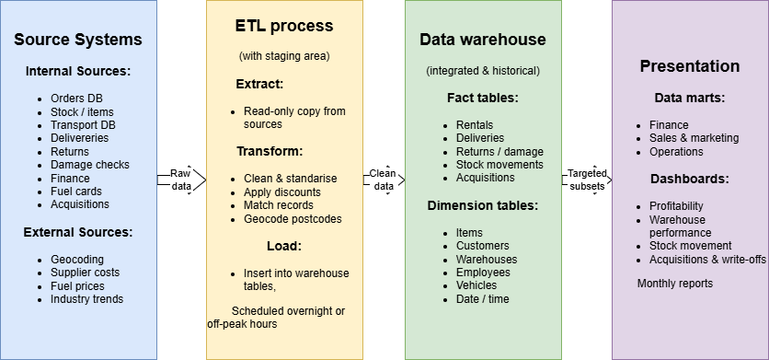
Figure 1: Proposed Data Warehouse Architecture for Rags'n'Riches

Data Marts
Data marts are smaller, focused sections of a data warehouse designed to support the needs of particular departments or managers [1], [2]. Instead of accessing the full warehouse, managers can use a data mart that contains only the information relevant to their role. This makes reporting faster, easier to understand, and more suitable for non-technical users. For Rags'n'Riches, the data marts would be created from the central data warehouse to ensure that all departments work from the same consistent business data [1].
The managing director would require a strategic overview of the company's overall performance across all six warehouses. Their data mart could contain aggregated information on revenue, profit margins, warehouse performance, customer growth and long-term business trends. This would allow the managing director to compare the profitability of specialist warehouses, such as the Abergavenny pantomime warehouse or the Evesham militaria warehouse and support decisions about rationalisation and future expansion, particularly in light of the predicted growth in the UK film industry.
The finance director would require more detailed financial reporting and cost analysis. Their data mart could include invoice data, customer payments, outstanding balances, delivery and fuel costs, emergency surcharges, acquisition costs and stock write-offs. This would help the finance department monitor monthly incomings and outgoings, control transport expenses, analyse profitability and identify financial risks more effectively.
The sales and marketing director would focus mainly on customer demand and rental trends. Their data mart could contain information about popular items, customer types, seasonal demand patterns, repeat customers and high-value clients such as film studios or theatre companies. The mart would also support analysis of emergency orders, discount usage and the popularity of different costume or prop categories. This would help the company identify growth opportunities and target marketing activities more effectively.
Overall, data marts would provide each director with focused and relevant information without requiring them to search through the entire data warehouse or rely on IT staff to produce ad-hoc reports. Because all marts are drawn from the same central warehouse, the information would remain consistent across the organisation [6].

Normalised vs Dimensional
OLTP databases are typically designed using a normalised structure, usually to third normal form, which reduces redundancy and supports the integrity of frequent transactional updates [7]. At Rags'n'Riches, this is well suited to systems that record orders, deliveries and stock movements, where data is written and updated constantly. However, normalised schemas require many joins to produce reports, which makes them inefficient for analytical workloads.
A data warehouse instead uses a dimensional structure, which is deliberately denormalised to support fast, intuitive querying [8]. Dimensional models organise data around two main types of table. Fact tables record measurable business events using numerical measures such as rental cost, discount applied, rental duration and delivery distance. Dimension tables describe the context of those events and answer the questions of who, what, where and when for example item, customer, warehouse and date.
These tables are arranged into a star schema, where a central fact table is surrounded by its dimensions, as illustrated in Figure 2. For Rags'n'Riches, a Rentals_Fact table could link to Item_Dim, Customer_Dim, Warehouse_Dim and Date_Dim, allowing the company to easily answer questions such as which warehouse generates the most revenue from film studio rentals each quarter. Where dimensions such as Date_Dim or Customer_Dim are used by more than one fact table, they are described as conformed dimensions, which ensures consistency across the warehouse [9], [10].
The normalised and dimensional approaches are therefore complementary: normalised structures support operational accuracy, while dimensional structures support reporting and decision-making.

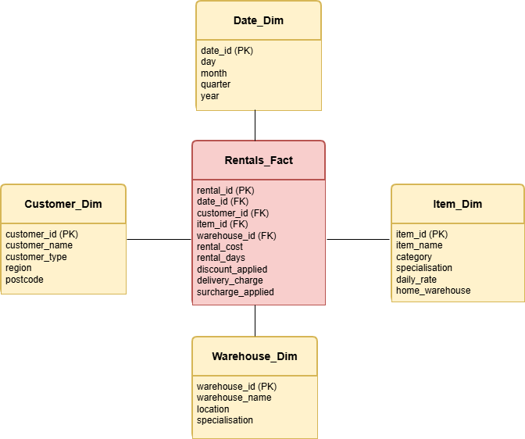

Figure 2: Example Star Schema (Rentals)

Task 2: Design.

Source Systems
The proposed Rags'n'Riches data warehouse would combine data from several internal and external source systems to create a single integrated environment for reporting and analysis. Internal systems would provide operational data relating to rentals, deliveries, stock movements between warehouses, invoices, employee records and inventory and damage checks. External sources would support business analysis by providing information such as delivery distance calculations, replacement costs and fuel price trends. Integrating multiple sources into a central warehouse improves consistency and supports stronger organisational decision-making [2]. Further details of how each source will be extracted, transformed, and loaded into the warehouse are provided in Section 3.4.

Source System | Type | Purpose
Orders Database | Internal | Rental transaction records
Transport Database | Internal | Stock movements between warehouses
Delivery Database | Internal | Delivery and return confirmations
Tablet Uploads | Internal | Inventory and damage check records
Fuel Card System | Internal | Vehicle fuel use and mileage
Finance System | Internal | Invoices, payments and balances
HR System | Internal | Employee records
Geocoding / Postcode Data | External | Delivery distance calculations
Supplier Data | External | Item replacement and acquisition costs
Fuel Price Data | External | Transport cost monitoring

Table 2: Internal and External Source Systems for the Rags'n'Riches Data Warehouse

Star Schema
The proposed data warehouse for Rags'n'Riches is designed as a multi-star (galaxy) schema, which is appropriate when a business needs to analyse several related but distinct operational processes [1], [2]. Figure 3 illustrates the proposed schema, which includes three fact tables, four conformed dimensions, five independent dimensions, three metadata tables, three aggregate tables and three master data tables. This structure follows dimensional modelling principles by separating measurable business events from their descriptive business context.

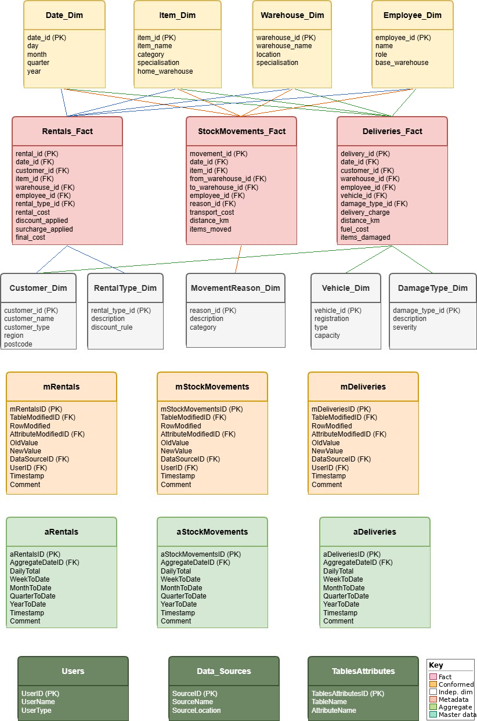
Figure 3: Proposed Data Warehouse Schema for Rags'n'Riches

The three fact tables represent the company's main business processes. Rentals_Fact records rental transactions for individual rented items, including measures such as rental cost, discounts, surcharges and final cost. StockMovements_Fact records the movement of items between warehouses, including transport cost, distance travelled and quantity moved. Deliveries_Fact records delivery and return events, including delivery charges, fuel costs, travelled distance and damaged items. Multiple fact tables are suitable because rentals, stock movements and deliveries each involve different measures and analytical requirements.
Four dimensions are conformed because they are shared across all fact tables: Date_Dim, Item_Dim, Warehouse_Dim and Employee_Dim. Conformed dimensions improve consistency by allowing data to be analysed across different business processes using the same business definitions [2], [9]. The remaining dimensions are independent because they support only one fact table. For example, Vehicle_Dim and DamageType_Dim relate only to deliveries, while MovementReason_Dim applies only to stock movements.
The metadata tables store audit and modification information relating to each fact table, including modified attributes, source systems, old and new values, users and timestamps. The aggregate tables store pre-calculated daily, weekly, monthly, quarterly and yearly summaries, improving reporting performance by reducing the need to repeatedly query large fact tables [4], [5]. The master data tables hold reference information relating to users, source systems and table attributes to support governance and traceability.
Overall, the schema supports the company's reporting requirements, including warehouse performance analysis, delivery cost monitoring, stock movement analysis, item profitability reporting and strategic planning for the predicted growth in the UK film industry.

Data Marts
Three data marts would be extracted from the central data warehouse, as shown in Table 3, with each containing the subset of fact tables, dimensions and aggregate data relevant to a specific department's analytical requirements [2]. The marts reuse conformed dimensions such as Date_Dim, Item_Dim and Warehouse_Dim to ensure reporting consistency across different areas of the business.

Data Mart | Fact tables | Key dimensions | Aggregates
MD Strategic Mart | Rentals_Fact, Deliveries_Fact | Date, Warehouse, Item, Customer | aRentals, aDeliveries
Finance Mart | Rentals_Fact, StockMovements_Fact, Deliveries_Fact | Date, Warehouse, Customer, Item | aRentals, aStockMovements, aDeliveries
Sales & Marketing Mart | Rentals_Fact | Date, Customer, Item, RentalType | aRentals

Table 3: Proposed Data Marts and Extracted Warehouse Tables

The Managing Director's strategic data mart would use summarised data from Rentals_Fact and Deliveries_Fact, supported by aRentals and aDeliveries, to provide a high-level view of company performance across all six warehouses. Relevant dimensions would include Date_Dim, Warehouse_Dim, Item_Dim and Customer_Dim.
The Finance data mart would use Rentals_Fact, StockMovements_Fact, Deliveries_Fact, aRentals, aStockMovements and aDeliveries to support profitability analysis, invoice monitoring, delivery cost reporting and financial trend analysis. Relevant dimensions would include Date_Dim, Customer_Dim, Warehouse_Dim and Item_Dim.
The Sales and Marketing data mart would focus on rental trends, customer demand and popular item categories using Rentals_Fact, aRentals, and dimensions including Date_Dim, Customer_Dim, Item_Dim and RentalType_Dim. This would support analysis of high-demand costumes, seasonal trends, and customer activity across rental schemes such as complete sets, individual costumes and emergency orders.

ETL Plan
The ETL process described in Section 2.2 would run as a scheduled overnight batch process to minimise disruption to operational systems [5]. Table 4 shows how the main operational database tables would populate the corresponding warehouse tables, while Table 5 provides a worked example of attribute-level transformations for Rentals_Fact.
Source Database Tables | Data Warehouse Table
Orders, OrderLines, Customers, Items | Rentals_Fact
Transport, StockTransfers | StockMovements_Fact
Deliveries, Returns, DamageReports, FuelCards | Deliveries_Fact
Calendar (system-generated) | Date_Dim
Items, ItemCategories | Item_Dim
Warehouses | Warehouse_Dim
HR / Employees | Employee_Dim
Customers | Customer_Dim
RentalSchemes | RentalType_Dim
MovementReasons | MovementReason_Dim
Vehicles | Vehicle_Dim
DamageCategories | DamageType_Dim
All warehouse tables (audit logs) | mRentals, mStockMovements, mDeliveries
Computed from fact tables | aRentals, aStockMovements, aDeliveries
ETL configuration / Admin | Users, Data_Sources, TablesAttributes

Table 4: Source-to-Warehouse Table Mapping

Target Attribute | Source(s) | Processing Required | Missing Value? | Incorrect Value?
rental_id (PK) | Orders.OrderID | Generate surrogate key | Reject row | Reject row
date_id (FK) | Orders.OrderDate | Look up date_id in Date_Dim | Use current date | Reject row
customer_id (FK) | Orders.CustomerID | Look up customer_id in Customer_Dim | Use "Unknown" record | Log and use "Unknown"
item_id (FK) | OrderLines.ItemID | Look up item_id in Item_Dim | Reject row | Log and reject row
rental_cost | OrderLines.DailyRate multiplied by RentalDays | Calculate | Use 0 and log | Log and recalculate
surcharge_applied | OrderDate vs DeliveryDate | Apply 15% if less than 14 days notice | Use 0 | Log and recalculate

Table 5: Example Attribute Mapping for Rentals_Fact

Table 5 demonstrates how source data would be extracted, transformed and loaded into the warehouse schema. Transformations include generating surrogate keys, looking up dimension keys, calculating rental charges and applying emergency surcharges where orders are placed with less than the required notice period. The ETL process would also apply validation checks to handle missing or incorrect values before loading the data into the warehouse.
Similar transformation rules would be created for all remaining warehouse tables during implementation. The validation rules shown in Table 5 form part of the wider data quality process discussed in Section 3.5.

Data Quality & Governance
Data quality is a critical concern during the ETL process, where missing values, inconsistent customer records and incorrect cost calculations must be identified and corrected through the validation rules outlined in Table 5. During normal warehouse operation, governance issues include compliance with GDPR and the UK Data Protection Act 2018, user access control, and auditability of data changes [11]. The metadata and master data tables within the proposed schema directly support traceability, governance and controlled access to warehouse data.

Conclusion.
The proposed data warehouse and supporting data marts would provide Rags'n'Riches with an integrated, reliable and well-governed reporting environment to help rationalise operations, improve profitability and support future growth in the UK film industry.

References
[1] W. H. Inmon, Building the Data Warehouse, 4th ed, 4th ed Ed. WILEY, 2005. [Online]. Available: https://www.google.co.uk/books/edition/Building_the_Data_Warehouse/QFKTmh5IFS4C?hl=en&gbpv=1
[2] R. Kimball and M. Ross,The Data Warehouse Toolkit: The Definitive Guide to Dimensional Modeling, 3rd ed Ed. John Wiley & Sons, 2013. [Online]. Available: https://books.google.co.uk/books?hl=fr&lr=&id=4rFXzk8wAB8C&oi=fnd&pg=PR27&dq=R.+Kimball+and+M.+Ross,+The+Data+Warehouse+Toolkit:+The+Definitive+Guide+to+Dimensional+Modeling,+3rd+ed.+Indianapolis,+IN:+Wiley,+2013.&ots=3q9TOiTcRH&sig=38LV14-bE-y3guaPZSnYZg69K90&redir_esc=y#v=onepage&q&f=false
[3] S. Chaudhuri and U. Dayal, "An overview of data warehousing and OLAP technology," Mar 1997, Accessed: 14/05/2026. Available at: https://dl-acm-org.uwtsd.idm.oclc.org/doi/pdf/10.1145/248603.248616.
[4] V. Rainardi, Building a Data Warehouse: With Examples in SQL Server, Apress, 2007. [Online]. Available: https://books.google.co.uk/books?id=KEW_AUD6GegC&printsec=frontcover&source=gbs_ge_summary_r&cad=0#v=onepage&q&f=false
[5] P. Vassiliadis, "(PDF) A Survey of Extract-Transform-Load Technology." Jul 2009, Accessed: May 14, 2026. Available at: https://www.researchgate.net/publication/220613761_A_Survey_of_Extract-Transform-Load_Technology.
[6] T. Ariyachandra and H. Watson, "Key organizational factors in data warehouse architecture selection," Decision Support Systems. vol. 49, no. 2, pp.200–212, -05-01 2010, doi: 10.1016/j.dss.2010.02.006. Accessed: May 14, 2026. Available at: https://www.sciencedirect.com/science/article/pii/S0167923610000436.
[7] E. F. Codd, "A relational model of data for large shared data banks," Jun 1970, Accessed: May 14, 2026. Available at: https://dl.acm.org/doi/pdf/10.1145/362384.362685.
[8] A. Vaisman and E. Zimányi, Data Warehouse Systems: Design and Implementation, 2nd ed Ed. Springer, 2022. [Online]. Available: https://www.google.co.uk/books/edition/Data_Warehouse_Systems/U5x7EAAAQBAJ?hl=en&gbpv=1&dq=A.+Vaisman+and+E.+Zim%C3%A1nyi,+Data+Warehouse+Systems:+Design+and+Implementation,+2nd+ed.+Berlin,+Germany:+Springer,+2022.&printsec=frontcover
[9] R. Kimball."A Dimensional Modeling Manifesto" Kimball Group. (-08-02-1997). Accessed: May 14, 20262026, [Blog]. Available at: https://www.kimballgroup.com/1997/08/a-dimensional-modeling-manifesto/
[10] A. Dhaouadi, K. Bousselmi, M. M. Gammoudi, S. Monnet and S. Hammoudi, "Data Warehousing Process Modeling from Classical Approaches to New Trends: Main Features and Comparisons," vol. 7, no. 8, pp.113, /8 2022, doi: 10.3390/data7080113. Accessed: May 14, 2026. Available at: https://www.mdpi.com/2306-5729/7/8/113.
[11] T. Ekundayo and J. Chinoperekweyi, "Identifying The Core Data Governance Framework Principle: A Framework Comparative Analysis," vol. 5, pp.30–53, -01-01 2023, Accessed: May 14, 2026. Available at: https://www.researchgate.net/profile/Justine-Chinoperekweyi-2/publication/366759618_Identifying_The_Core_Data_Governance_Framework_Principle_A_Framework_Comparative_Analysis/links/63b1a79f097c7832ca81589f/Identifying-The-Core-Data-Governance-Framework-Principle-A-Framework-Comparative-Analysis.pdf.

