

School of International Hotel Management
BA International Hotel Management

Planning and Delivering an International Meeting/Event

PRIDE IN HOSPITALITY

LEADERSHIP SUMMIT

Student Name: Oleg Goncear
Student ID: 2231041

Module: International Meeting Management for the Hotel Industry

Module code: BMIH 6007
Lecturer: Kathryn Flynn

I acknowledge using the Grammarly App on 21.02.2025 to check my document for grammatical and syntactical mistakes.

Introduction
The Pride in Hospitality Leadership Summit allows industry leaders, HR professionals, and advocacy organisations to network professionally and debate best practices to foster LGBTQ+ inclusivity within the hospitality industry. The event, which is held at Andaz Amsterdam Prinsengracht, a renowned venue for its dedication to diversity and inclusion, addresses workplace challenges and LGBTQ+ representation (Vongvisitsin and Wong, 2021).
This report employs the Event Planning Cycle and the Event Management Body of Knowledge (EMBOK) model to organise event administration, design, marketing, operations, and risk management (Bowdin et al., 2011). It also analyses industry trends, including sustainability, digital engagement, and hybrid participation (Ray, 2019).
This report ensures that all attendees have a professional, inclusive, and impactful experience by adhering to structured methodologies and addressing industry challenges, consequently presenting an extensive event strategy that aligns with global DEI objectives and hospitality trends.

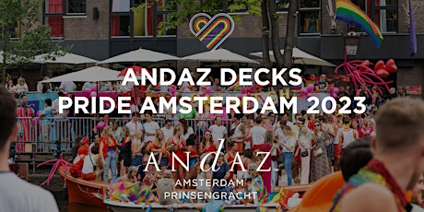

- The Event Cycle
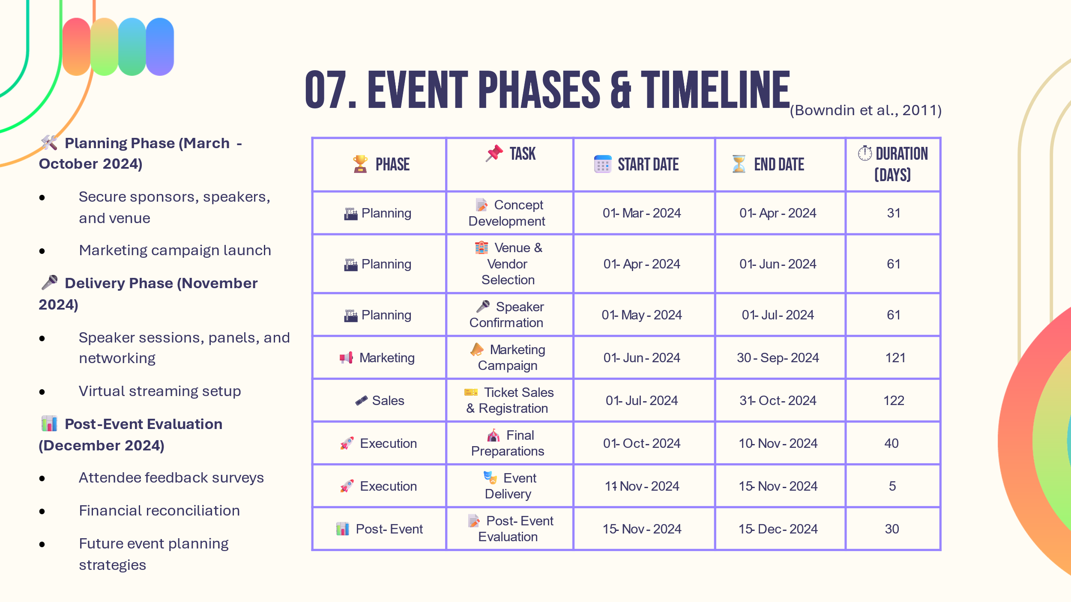
The Event Cycle is a fundamental framework that directs an event's planning, delivery, and post-event evaluation. To ensure structured and efficient event management for the Pride in Hospitality Leadership Summit, adherence to Bowdin et al.'s (2011) Event Cycle is essential.
📌 Planning Phase (March - October 2024)
In this phase, the event concept is defined, the feasibility is evaluated, and initial sponsorship interest is secured. During this period, critical logistical components are implemented, including the confirmation of speakers, the selection of venues, and the commencement of marketing campaigns. Research shows the significance of pre-event marketing and strategic sponsorship acquisition, reinforcing the dependence of hospitality events on effective sponsorship engagement (Bowdin et al., 2011).
📌 Delivery Phase (November 2024)
This phase covers the event, including keynote speeches, networking sessions, and panel discussions. November was selected to coincide with International LGBTQ+ Awareness Days, maximising media and industry attention. Furthermore, industry leaders were able to attend without any scheduling complications by ensuring that there were no conflicts with key hospitality conferences. If successful, future events may expand beyond Amsterdam to other global hospitality centres or adopt a year-round engagement model (Friedman, 2019).
📌 Post-Event Evaluation (November 15 - December 15, 2024)
This phase is dedicated to the collection of feedback, the evaluation of financial results, and the setting of standards for future events. More likely, events that effectively evaluate and adapt based on post-event data will maintain long-term relevance (Friedman, 2019).
The Pride in Hospitality Leadership Summit strives to achieve lasting impact, ensure financial sustainability, and increase engagement by adhering to these structured phases.


- Event Concept: The Delegate Experience
The Pride in Hospitality Leadership Summit is intended to offer attendees an interactive, informative, and engaging experience. Delegates will engage in educational sessions, contribute to discussions on LGBTQ+ inclusivity within the hospitality sector, and build connections with industry executives. The event promotes a collaborative environment for dialogue and actionable change by combining professional development and networking (Bowdin et al., 2011).
Itinerary for the Day
⏰ Time | 📌 Activity | 📝 Description
08:30 - 09:30 | ☕ Registration and Welcome Breakfast | Attendees check in, network over coffee, and receive event materials.
09:30 - 10:00 | 🎤 Opening Address | Keynote speech on inclusivity trends in hospitality.
10:15 - 11:45 | 🏳️‍🌈 Panel Discussion: "LGBTQ+ Leadership in Hospitality" | Industry leaders share insights on career advancement for LGBTQ+ professionals.
12:00 - 13:00 | 🍽️ Networking Lunch | Delegates connect with peers, sponsors, and advocacy groups.
13:15 - 14:15 | 🏢 Workshop: "Creating an Inclusive Workplace" | Hands-on session on implementing LGBTQ+-friendly HR policies.
14:30 - 15:30 | 📊 Case Study Session: Best Practices in DEI | Hotels and companies present successful LGBTQ+ inclusion strategies.
15:45 - 16:45 | 🤖 Future Outlook: Technology and Diversity | Experts discuss hybrid event technology and AI for DEI.
17:00 - 18:00 | 🎉 Closing Keynote and Networking Reception | The final address will have a vision for future inclusivity in hospitality.

The event's design will be a reflection of the LGBTQ+ inclusivity theme. A colour-coordinated stage design that reflects the Pride flag, panel arrangements that promote open dialogue, and LGBTQ+-themed visual displays will be displayed at the Andaz Amsterdam Prinsengracht. Entertainment will prioritise LGBTQ+ speakers and performers, therefore perpetuating representation. Furthermore, catering vendors will be LGBTQ+-owned businesses that provide a menu influenced by various global cultures, celebrating LGBTQ+ culture in a manner that goes beyond Western perspectives (Bowdin et al., 2011).
The summit is designed to encourage interactive engagement rather than inert participation. Participants will engage in collaborative workshops, live polls, and Q&A sessions to facilitate meaningful discussions. Prom hospitality brands, including Marriott and Hilton, will conduct mentorship sessions to offer attendees a glimpse into inclusive workplaces (Ray, 2019).
The Andaz Amsterdam Prinsengracht was selected due to its central location, modern infrastructure, accessibility features, and LGBTQ+-friendly policies. It provides a professional environment and interactive sessions, with a capacity of 500 attendees. A backup venue, the Hotel Pulitzer Amsterdam, has been secured as a contingency measure to guarantee the uninterrupted running of the event in the case of an emergency (Nolan, 2020).
The Pride in Hospitality Leadership Summit guarantees attendants will depart with practical strategies to promote LGBTQ+ inclusion in their workplaces by integrating education, networking, and cultural representation (Ray, 2019).
- Aim and Objectives of the Event
Overarching Aim
The Pride in Hospitality Leadership Summit is intended to facilitate networking, education, and policy discussions to promote LGBTQ+ inclusivity within the hospitality sector. Bowdin et al. (2011) state that building an industry-wide dialogue regarding diversity, equity, and inclusion (DEI) contributes to developing a more inclusive environment for LGBTQ+ professionals.

To ensure meaningful impact, the event's objectives follow the SMART Goals Framework (Doran, 1981):
📌Specific: The objectives concentrate on the diversity of the audience, corporate sponsorships, and LGBTQ+ representation. For example, visibility is guaranteed by promising that 60% of speakers and panellists are members of the LGBTQ+ community (Bangura and Choi, 2024).
📌Measurable: The event's objective is to create a standard for corporate engagement by collaborating with at least ten key hospitality brands, including Marriott and Hilton.
📌Achievable: Given the rising demand for DEI-focused events, securing 500+ attendees is realistic (Ray, 2019).
📌Relevant: The objectives are consistent with industry trends, guaranteeing that 40% of attendees are HR managers and DEI officers, who are critical decision-makers (Madera et al., 2023).
📌Time-bound: These goals are set to be achieved within the planning and execution phases of the event to ensure accountability (Bowdin et al., 2011).
The event can drive real, measurable progress in the hospitality industry by structuring objectives with clear benchmarks and deadlines.



- Event Management: Skills and Resources Required
Strategic planning, operational expertise, and a well-coordinated staff are essential for successfully organising a large-scale hospitality event. Multiple teams are involved in the Pride in Hospitality Leadership Summit, each accountable for a distinct aspect of event execution (Friedman, 2019).
📌Operational Planning
Smooth logistics are a critical component of event management. Accessibility considerations, seating configurations, and compliance with safety regulations are all part of venue coordination (Bowdin et al., 2011). Logistics management comprises transportation arrangements, signage, crowd control measures, and on-site equipment setup. Catering is another critical component that necessitates collaborations with LGBTQ+-owned food vendors to align with the event's principles.
📌Human Resources and Staffing
A team of event coordinators is responsible for the event's scheduling, venue setup, and efficient administration (Bowdin et al., 2011). Tech support teams are essential for managing live streaming, audiovisual installations, and virtual engagement tools, as the event is hybrid (Doran et al., 2024). Furthermore, security staff will guarantee attendees' safety by conducting emergency preparedness training and implementing population control measures (Nadda et al., 2020).
To provide a professional and seamless experience, a well-organised event necessitates the meticulous planning and effective coordination of these teams.

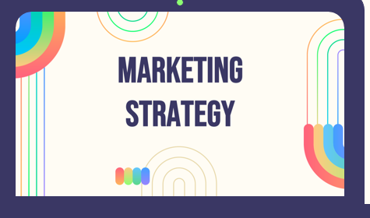
- Marketing Strategy for the Event
It is essential to have a clearly defined marketing strategy to attract attendees, secure sponsorships, and optimise the visibility of the Pride in Hospitality Leadership Summit. The event guarantees a targeted approach that reaches key industry professionals and stakeholders through traditional and digital outreach methods.

Promotional Strategies
📌Social Media Campaigns: The event will use targeted sponsored advertisements on LinkedIn, PinkNews, and Instagram, focusing on hospitality professionals, DEI advocates, and LGBTQ+ workplace allies (Yavuz and Enes, 2021). Before and during the event, engagement will be fostered through interactive Instagram stories, LinkedIn posts, and a personalised event hashtag.
📌Email Outreach: HR managers, DEI officers, and hospitality administrators will receive direct invitations to the event, guaranteeing that industry decision-makers are fully informed. Early bird registration discounts and exclusive speaker previews will form a segmented email campaign.
📌Website and Ticketing: A centralised hub for hybrid attendees will be a dedicated event portal that provides access to live-streaming, event information, and registration systems.
Sponsorship and Public Relations
📌Corporate Partnerships: Marriott, Hilton, and AccorHotels will be significant sponsors. Their participation improves the event's credibility, funding, and industry recognition.
📌LGBTQ+ Media Collaborations: The event will be covered in hospitality-focused LGBTQ+ publications, such as Out and Equal Workplace Summit, broadening its community reach.

Merchandising and Engagement
📌Branded Merchandise: The sale of event-branded notebooks, paper bags, and T-shirts will increase post-event visibility and generate additional revenue.
📌Interactive Engagement: Attendees will be encouraged to participate in LinkedIn discussion forums and share their event experiences on social media using a custom event hashtag.
Expected Impact and Sustainability Efforts
Live-streaming technology, real-time Q&As, and digital networking features will be employed to promote global participation by implementing a hybrid model. QR-based programs, paperless ticketing, and a completely digital registration process are among the sustainability initiatives implemented to reduce the environmental impact and promote eco-friendly event management (Doran et al., 2024).

- Contingency Plan and Risk Management
Risk management is indispensable for the Pride in Hospitality Leadership Summit to be conducted efficiently. A comprehensive contingency plan has been implemented to mitigate security risks, venue disruptions, shortages of staff, technical failures, and health concerns (Salama, 2021).
Key Risk Factors and Mitigation Strategies
📌Staffing Shortages
Unexpected staff absences may disrupt operations. Last-minute replacements will be guaranteed through agreements with on-call staffing agencies and a pool of trained volunteers (Lockstone-Binney et al., 2020).
📌Technical Failures
Stable audiovisual performance and live broadcasting are essential for a hybrid event. Backup internet providers, alternative power sources, and pre-event equipment testing will mitigate disruptions (Doran et al., 2024).

📌Venue Disruptions
Hotel Pulitzer Amsterdam has been designated as a secondary venue in the event of venue unavailability, in order to prevent cancellations and guarantee continuity.
📌Security Threats
Large-scale events may result in security violations or protests. Crowd control, emergency response, and risk assessment will be overseen by security personnel who have been trained and will work in conjunction with local law enforcement (Moyle et al., 2014).
📌Health and Safety Risks
According to Filippo et al. (2021), protocols for COVID-19 will encompass a medical response team, contactless check-ins, and sanitisation stations.
In addition to conforming to the Equal Treatment Act 1994, the event adheres to GDPR regulations, fire safety standards, and disability access laws. A crisis communication plan will offer real-time updates through on-site staff, digital notifications, and SMS alerts.
The summit guarantees a secure, inclusive, and well-organised experience for all participants by proactively mitigating risks.


- Event Budget
It is imperative that the Pride in Hospitality Leadership Summit is conducted efficiently and its objectives are met through thorough financial planning. A budget that is well-organised ensures that the event is financially viable by maintaining a balance between revenue and expenses (Janjusevic and Mathur, 2021).
Income and Expenditure Breakdown
The event's total cost is £150,000, which includes the expense of the venue, catering, speaker fees, marketing, and technology.

Expense Category | £💰
Venue Rental | 50,000
Catering | 20,000
Speaker Fees | 30,000
Marketing | 15,000
Tech and Streaming | 25,000
Miscellaneous | 10,000
Total Costs | 150,000

The venue rental is the most significant expense, comprising one-third of the total budget. In order to attract attendees and preserve a professional environment, it is imperative to have a venue of high standard (I Amsterdam, 2024).
The inclusivity motif is further reinforced by the £20,000 catering costs, which guarantee high-quality food services from LGBTQ+-owned vendors.
The fees for high-profile speakers, which include travel, accommodations, and compensation, total £30,000. The credibility of the event and the attraction of industry professionals are contingent upon the presence of well-respected speakers (Getz and Page, 2024).
£15,000 is allocated to marketing initiatives to guarantee effective communication through LGBTQ+ media partnerships and social media campaigns (Yavuz and Enes, 2021).
The increasing demand for hybrid event participation is reflected in the allocation of £25,000 for technology and streaming services (Hottle et al., 2015).
Miscellaneous expenses, which encompass logistics, unexpected costs, and supplementary services, total £10,000.

Revenue Streams
Income Source | £💰
Sponsorships (Marriott, AccorHotels, Hilton) | 80,000
Ticket Sales (500 attendees @ €100) | 50,000
Merchandise Sales | 20,000
Total Revenue | 150,000

The event's revenue is predominantly derived from corporate sponsorships, which account for £80,000 or 53% of the total. Hospitality brands are enthusiastic about supporting events that are consistent with their corporate social responsibility objectives, as they acknowledge the importance of LGBTQ+ inclusivity (Toal and Brown, 2022).
Assuming that 500 attendees purchase tickets at £100 each, ticket sales generate £50,000. To promote participation, ticket prices are maintained at a reasonable level, with particular focus on independent hospitality professionals and small businesses (Mehmood, 2020).
Merchandise sales contribute an additional £20,000, which is used to cover the cost of branded event materials, including journals, T-shirts, and tote bags. According to research, event merchandise not only increases brand recall but also generates revenue (Getz and Page, 2024).
Financial Feasibility
The event reaches its break-even point, guaranteeing that all expenses are recouped. Structured budgeting and financial planning facilitate stability and mitigate unexpected losses (Janjusevic and Mathur, 2021).
By procuring sponsorships and diversifying revenue sources, the Pride in Hospitality Leadership Summit provides a sustainable financial model for future editions.

- Situational and Cultural Considerations
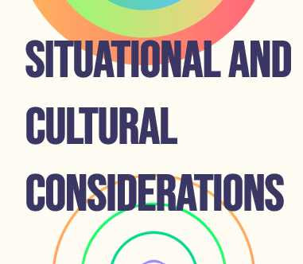
It is imperative to understand the event's broader context in order to ensure its success. A PESTEL analysis is employed to identify the primary external factors that affect the Pride in Hospitality Leadership Summit (Ramely et al., 2023).
📌Political/Legal Considerations
According to the Government of the Netherlands (2024), the Equal Treatment Act 1994 guarantees the protection of LGBTQ+ individuals under Dutch law. The event's mission of workplace inclusivity is strengthened by this robust legal framework, allowing organisations to engage with it with confidence.
📌Economic Factors
Corporate sponsorships and investments in diversity initiatives are on the rise as the hospitality sector recovers from the pandemic (Getz and Page, 2024). The financial climate is favourable for this event, as global brands prioritise inclusive leadership.
📌Social Considerations
Public demand for inclusive corporate environments is on the rise (Ray, 2019). LGBTQ+ professionals are searching for secure work environments, and companies are responding by participating in industry-specific DEI (Diversity, Equity, and Inclusion) events.
📌Technological Influences
The hybrid event model facilitates increased accessibility and participation (Doran et al., 2024). Attendees from around the globe can participate in the summit through digital networking tools and live streaming.
📌Environmental Considerations
Sustainability is a top priority. The event collaborates with catering businesses that are LGBTQ+-owned and specialise in eco-friendly culinary services (Hottle et al., 2015).
📌Competitive Landscape
This summit has the potential to lead the conversation, as there are few LGBTQ+-focused hospitality events (Nadda et al., 2020).
By conducting an analysis of these factors, the event is in accordance with global inclusion initiatives, stakeholder expectations, and industry trends (Ramely et al., 2023).

- Conclusion and Recommendations

The Pride in Hospitality Leadership Summit is a response to the increasing demand for diversity, equity, and inclusion (DEI) in the hospitality industry. The event guarantees a structured, impactful approach that extends beyond networking by promoting corporate mentorship, industry policy discussions, and year-round engagement through the use of the EMBOK model and Event Planning Cycle (Bowdin et al., 2011).
The event's design is influenced by significant industry trends. Corporations are increasingly investing in DEI initiatives, acknowledging the correlation between employee satisfaction and inclusive workplaces (Madera et al., 2023). The emergence of hybrid event models enables global participation while simultaneously mitigating environmental impact (Doran et al., 2024). Industry expectations are met by sustainability initiatives, including the procurement of sustainable vendors owned by LGBTQ+ individuals (Hottle et al., 2015). Furthermore, attendee interaction is improved by technology-driven engagement, which is achieved through virtual Q&A sessions, digital networking, and social media (In Event, 2023).
Through the integration of these trends, the summit promotes industry-wide inclusivity and long-term impact in the hospitality sector.
📊Recommendations for Future Growth
📌Boosting Hybrid Participation
Expanding virtual access with interactive features, making it easier for global attendees to connect and participate.

📌Long-Term Partnership Building
Strengthening corporate sponsorships by creating year-round engagement opportunities with major hospitality brands.
📌Sustainability Focus
Further integrating sustainable practices, such as carbon offset initiatives and partnerships with environmentally conscious vendors.
The Pride in Hospitality Leadership Summit can establish itself as a premier LGBTQ+ inclusion event in the hospitality industry by implementing these recommendations, which will guarantee ongoing industry support and long-term impact.

References
- Bangura, E. and Choi, M., 2024. Creative Event Design and Management: An Exploratory Study of Event Professionals Perspective. International Journal of Hospitality and Tourism Systems, 17(4), pp. 29-37. https://www.proquest.com/scholarly-journals/creative-event-design-management-exploratory/docview/3149525076/se-2?accountid=130472.
- Bowdin, G., Allen, J., and Harris, R., 2011. Events Management. https://research-ebsco-com.ezproxy.uwtsd.ac.uk/linkprocessor/plink?id=0713b2d6-c559-3133-a063-9c460741a170.
- Bowdin, G., Allen, J., Harris, R., McDonnell, I. and O’Toole, W., 2011. Events Management. 3rd edn. London: Routledge. https://research-ebsco-com.ezproxy.uwtsd.ac.uk/linkprocessor/plink?id=0713b2d6-c559-3133-a063-9c460741a170
- Cheruon, M. and Korir, J., 2023. Dynamic capability and competitive advantage of event management in hospitality industry. https://doi.org/10.1080/22243534.2024.2318100
- Doran, G.T. (1981) ‘There’s a S.M.A.R.T. way to write management’s goals and objectives’, Management Review.
- Doran, A.L., Dutch, V., Warren, B., Watson, R.A., Murphy, K., Aldis, A., Cooper, I., Cockram, C., Harp, D., Desmau, M. and Keppler, L., 2024. Planning virtual and hybrid events: steps to improve inclusion and accessibility. Geoscience Communication, 7(4), pp. 227-244. https://www.proquest.com/scholarly-journals/planning-virtual-hybrid-events-steps-improve/docview/3111750941/se-2?accountid=130472
- Friedman, B., 2019. Hospitality, Tourism, and Events Industry Competency Model: Human Resource Management Implications. , 43, pp. 101-116. https://doi.org/10.25944/ZNMWSE.2019.03.101116.
- Getz, D. and Page, S., 2024. Event Studies: Theory, Research and Policy for Planned Events. https://doi.org/10.32890/jeth2023.3.4
- Government of the Netherlands, 2024. Prohibition of Discrimination Under the Equal Treatment Act 1994. https://www.government.nl/topics/discrimination/prohibition-of-discrimination.
- Homer, D., 2023. Sustainable Event Planning: Beyond the Basics. The Event Planner EXPO 2024. https://www.theeventplannerexpo.com/sustainable-event-planning-beyond-the-basics/
- Hottle, T.A., Bilec, M.M., Brown, N.R. and Landis, A.E., 2015. Toward zero waste: Composting and recycling for sustainable venue based events. Waste Management, 38, pp.86-94. https://doi.org/10.1016/j.wasman.2015.01.019
- Hutson, B., 2022. Strategic event planning in hospitality: The need to adapt to digital transformation. https://digitalcommons.usf.edu/cgi/viewcontent.cgi?article=1006&context=jght
- I Amsterdam, 2024. LGBTQ+ history and milestones in Amsterdam. https://www.iamsterdam.com/en/whats-on/lgbtqi-history-and-milestones-in-amsterdam
- In Event, 2023. Enhancing Event Attendee Engagement In the Digital Era. https://inevent.com/blog/others/enhancing-event-attendee-engagement-in-the-digital-era.html
- Janjusevic, J. and Mathur, S., 2021. Financial Planning and Budgeting of Events. https://goodfellowpublishers.com/free_files/Chapter%206-2f618ec8191eced8552eaffeb274a351.pdf
- Lockstone-Binney, L., Hanlon, C. and Jago, L.K., 2020. Staffing for successful events: having the right skills in the right place at the right time. https://vuir.vu.edu.au/42047/2/Lockstone-Binney_Hanlon_JagoJune2019.pdf
- Madera, J.M., Yang, W., Wu, L., Ma, E. and Xu, S., 2023. Diversity and Inclusion in Hospitality and Tourism: Bridging the Gap Between Employee and Customer Perspectives. International Journal of Contemporary Hospitality Management. https://www.proquest.com/scholarly-journals/diversity-inclusion-hospitality-tourism-bridging/docview/2885477196/se-2?accountid=130472
- Mehmood, M., 2020. Finance in the Hospitality Industry. https://doi.org/10.4018/978-1-7998-2204-2.ch011
- Moyle, B., Kennelly, M. and Lamont, M., 2014. Risk management and contingency planning in events: Participants’ reactions to the cancellation of Ironman New Zealand 2012. International Journal of Event Management Research, 8(1), pp.94-106. https://citeseerx.ist.psu.edu/document?repid=rep1&type=pdf&doi=2817eb1b745aaebc3e07b563cc2e7a72e90029b0
- Nadda, V., Arnott, I. and Sealy, W., 2020. Legal, Safety, and Environmental Challenges for Event Management: Emerging Research and Opportunities. https://doi.org/10.4018/978-1-7998-3230-0
- Nolan, J., 2020. The supply and design of different types of venues for hospitality events. https://www.proquest.com/scholarly-journals/supply-design-different-types-venues-business/docview/2499019479/se-2?accountid=130472
- O’Toole, W., 2022. Events Feasibility and Development: From Strategy to Operations. https://doi.org/10.4324/9781003172703
- Owusu-Mintah, S.B. and Dacosta, F.D., 2017. A study of events organised by hospitality industries in Accra, Ghana. https://www.ajhtl.com/uploads/7/1/6/3/7163688/article_45_vol_6__2__2017.pdf
- Ramely, A., Talib, M.F.A., Ahmad, R. and Yusof, N., 2023. Examining PESTEL Analysis of Event Businesses in Malaysia. Journal of Event, Tourism and Hospitality Studies. https://doi.org/10.32890/jeth2023.3.4.
- Ray, P., 2019. Diversity and Inclusion: Corporate Communications Advances the Practice. https://www.proquest.com/scholarly-journals/diversity-inclusion-corporate-communications/docview/2310249640/se-2?accountid=130472
- Revilla, R.G., Olga, M.M. and Einsle, C.S., 2023. Advances in event management using new technologies and mobile applications. International Journal of Event and Festival Management, 14(1), pp. 56-72. https://www.proquest.com/scholarly-journals/advances-event-management-using-new-technologies/docview/2772230099/se-2?accountid=130472
- Salama, M., 2021. Event Project Management: Principles, Technology, and Innovation. https://www-vlebooks-com.ezproxy.uwtsd.ac.uk/Product/Index/2829158?page=0&startBookmarkId=-1
- Stewart, M., 2023. The Role of Event Technology In Enhancing Attendee Engagement and Experience. The Event Plannerexpo website 2024. https://hub.theeventplannerexpo.com/attendee-engagement/the-role-of-event-technology-in-enhancing-attendee-engagement-and-experience
- Toal, B. and Brown, T., 2022. LGBTQ+ Inclusion In Sustainability. Diverse Sustainability Initiative. Crowberry Consulting. https://www.diversesustainability.net/resources/blog/lgbtq-inclusion-in-sustainability/
- Vongvisitsin, T.B. and Wong, A.K.F., 2021. Organisational change towards LGBTQ+ inclusion in hospitality and tourism: Managerial perspectives. Tourism Management, 86, p.104331. https://doi.org/10.1016/j.tourman.2021.104331
- Wmah, B., and Amnm, G., 2021. An Empirical Study on the Venue Attributes on Customer Satisfaction of Wedding Banquets in Sri Lanka. International Journal of Engineering and Management Research. https://doi.org/10.31033/IJEMR.11.1.21.
- Yavuz, G. and Enes, K., 2021. Social Media and Events: Before, During, and After. https://doi.org/10.4018/978-1-7998-4954-4.ch009

Appendixes
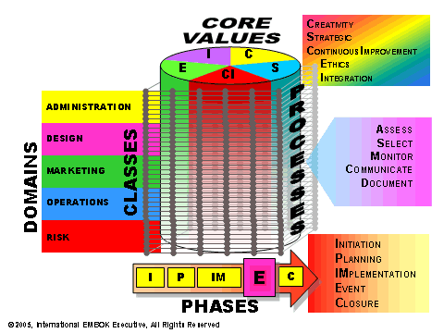
Appendix A

Key Event Design Considerations (EMBOK Model)
Strategic organisation, financial planning, logistics, and creative design comprise event planning. The Pride in Hospitality Leadership Summit is organised around five critical domains: administration, design, marketing, operations, and risk management, all of which are based on the EMBOK (Event Management Body of Knowledge) Framework (Bowdin et al., 2011).
📌Administration
Financial management is essential for the success of any event. The summit's budget is evenly distributed among venue rental, catering, marketing, technology, and speaker fees (O'Toole, in 2022). Additionally, ticket sales generate additional revenue, while sponsors such as Marriott, Hilton, and AccorHotels significantly contribute to funding. The research indicates that hospitality events that effectively manage finances are more likely to maintain long-term viability (Bowdin et al., 2011).
Effective teams necessitate proper training. Marketing professionals, security staff, event coordinators, and technical support staff guarantee efficient operations (Lockstone-Binney et al., 2020). The hospitality industry's events are significantly reliant on competent staff to ensure guest satisfaction (Owusu-Mintah and Dacosta, 2017).
Data security is also essential, particularly for hybrid events. Post-event surveys facilitate performance evaluation, while encrypted ticketing and registration systems safeguard attendee data (Bowdin et al., 2011).
In order to gain credibility, it is essential to engage stakeholders. According to Getz and Page (2024), the event's relevance is maintained through partnerships with corporate sponsors, LGBTQ+ advocacy organisations, and local businesses.
In order to execute, it is essential to create a structured timeline. The scheduling of tasks, including venue registration, marketing campaigns, and logistics, is meticulously organised (Bowdin et al., 2011).
📌Design
Every aspect of this event is infused with the theme of LGBTQ+ inclusivity in hospitality. The objective is to offer LGBTQ+ professionals secure environments, networking opportunities, and discussions that are specifically designed for them (Vongvisitsin and Wong, 2021).
In order to maintain the attention of attendants, it is imperative to implement a structured program layout. The event will include interactive workshops, panel discussions, and keynote speeches, which are recognised for their ability to improve professional development at hospitality conferences (Friedman, 2019).
Due to its accessibility and LGBTQ+-friendly policies, the Andaz Amsterdam Prinsengracht was selected as the venue (I Amsterdam, 2024). The secondary venue, Hotel Pulitzer Amsterdam, guarantees continuity in the event that it is necessary.
A format that has gained popularity in hospitality-based events is live-streaming, that allows participation beyond the venue (Cheruon and Korir, 2023).
The event's primary message will be reinforced by LGBTQ+-owned caterers who will provide food and beverage services. Research indicates that catering selections should be in accordance with event themes to ensure a enjoyable experience (Wmah and Amnm, 2021).

📌Marketing
Maximum event visibility is guaranteed by an effective marketing strategy. A combination of email marketing, social media, and LGBTQ+-specific platforms, such as PinkNews, will be implemented (Bowdin et al., 2011).
Sponsorships not only provide financial support for events but also expand their audience. Hilton, Marriott, and AccorHotels, among other hospitality brands, will experience increased exposure while simultaneously advocating for inclusivity. Sponsorship-driven hospitality events are more likely to achieve financial success (Getz and Page, 2024).
📌Operations
The selection of the appropriate venue is contingent upon the policies regarding inclusivity, accessibility, and capacity (Nolan, 2020).
Trained security personnel, emergency exits, and first aid stations comprise an effective health and safety plan (Salama, 2021).
Digital networking features, live Q&As, and hybrid attendance are all supported by audiovisual technology (Revilla et al., 2023).
Eco-friendly catering and recycling facilities are among the waste management strategies that are consistent with sustainability objectives (Salama, 2021).
📌Risk Management
All policies are guaranteed that they conform to inclusivity standards through adherence to the Equal Treatment Act 1994 (Government of the Netherlands, 2024).
In order to mitigate disruptions, security planning necessitates cooperation with local law enforcement (Salama, 2021).
Financial protection is guaranteed by insurance coverage for venue liability, cancellations, and participant safety (Moyle et al., 2014).
The Pride in Hospitality Leadership Summit will be inclusive, financially sustainable, and well-organised by addressing these five domains.

Appendix B

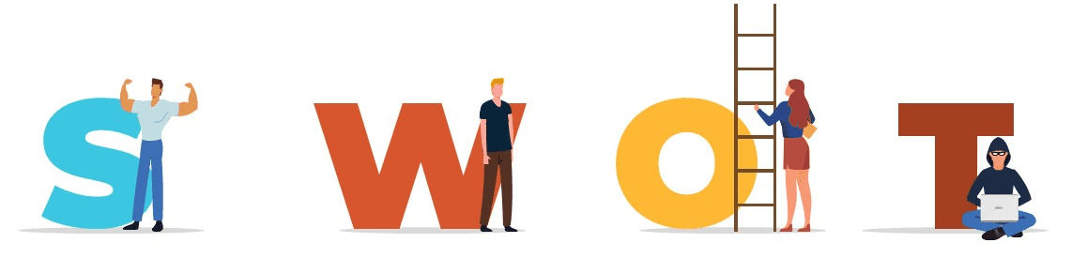

SWOT Analysis
The summit's strong alignment with industry trends, corporate sponsorship, and hybrid accessibility is underscored by the SWOT analysis. Nevertheless, meticulous planning is necessary due to the financial dependence on sponsorships and the competition from other events. The event's foundation can be fortified by opportunities for technology integration and long-term partnerships. The event's success and long-term sustainability will be contingent upon the effective management of risks, particularly those related to funding and security.
📌Strengths
The event's undeniable alignment with industry trends is one of its most significant advantages. The event's relevance is clearly demonstrated by the growing demand for diversity, equity, and inclusion (DEI) initiatives in the hospitality sector (Madera et al., 2023). The summit distinguishes itself from general hospitality conferences by promoting itself as a premier LGBTQ+ hospitality event.
The robust corporate sponsorship base is another significant advantage. In addition to their financial contributions, Hilton, Marriott, and AccorHotels offer networking opportunities and keynote speakers. Their participation assures broader industry participation and increases credibility (Bangura and Choi, 2024).
Another benefit is the hybrid event model. By integrating in-person and virtual participation, the summit accommodates international attendants who may be unable to travel, increasing accessibility and the potential for attendance (Doran et al., 2024).
📌Weaknesses
The event is confronted with internal challenges, despite its assets. Its dependence on sponsorship funding is a significant vulnerability. Although securing corporate support is advantageous, it also implies that the event's financial stability is contingent upon external contributions. The budget may experience deficits in the event that significant sponsors withdraw (Janjusevic and Mathur, 2021).
The first-year nature of the event is another potential vulnerability. Given that the summit is a new initiative, it may be more difficult to recruit high-profile speakers or attendees due to its lack of historical credibility. Events that have a proven track record typically have an easier time procuring registrations and partnerships (Bowdin et al., 2011).
Furthermore, the venue's capacity is restricted to 500 attendants, which may limit engagement in comparison to larger hospitality conferences. While this sets a more intimate atmosphere, it may also restrict networking opportunities for attendees who are interested in building more extensive industry connections (Doran et al., 2024).
📌Opportunities
A valuable opportunity is presented by the hospitality industry's increasing investment in LGBTQ+ inclusion. This event has the potential to serve as a recurring platform for corporate engagement, as numerous hospitality companies are expanding their DEI programs (Ray, 2019).
The expansion of hybrid event features presents a substantial opportunity. Leveraging interactive technologies, including LinkedIn networking groups, live Q&As, and real-time polling, may improve engagement and participation. Adopting these tools can improve the experiences of attendees as hybrid events become more common (In Event, 2023).
Long-term partnerships represent an additional opportunity. The event has the potential for creating annual sponsorship agreements with prominent hospitality brands, which would guarantee consistent financial support. Furthermore, the event's reputation could be improved and its audience could be expanded by creating partnerships with LGBTQ+ advocacy organisations (Vongvisitsin and Wong, 2021).
Finally, there is a potential for prospective international expansion. Hutson (2022) suggests that the summit could expand into a multi-location event if it proves effective, expanding its global reach and impact to a broader audience of professionals worldwide.
📌Threats
There are numerous outside factors that could potentially undermine the summit's success. Sponsorship commitments may be influenced by economic downturns, which may reduce the willingness of corporate partners to allocate funds for event sponsorships (Bowdin et al., 2011).
Competition from other industry events is another cause of concern. Although there are few LGBTQ+-specific hospitality summits, major hospitality conferences could overshadow the event, attracting potential attendees who may prioritise broader industry networking opportunities (Nadda et al., 2020).
Additionally, safety risks must be evaluated. Occasionally, LGBTQ+-focused events encounter external opposition, necessitating the implementation of rigorous security protocols. It is imperative to guarantee the safety of attendees by collaborating with local authorities and employing qualified staff (Moyle et al., 2014).
Finally, the hybrid model may encounter technical difficulties. Remote attendees' engagement and contentment may be reduced by an inadequate virtual experience, including server crashes or substandard streaming quality (Doran et al., 2024).

Appendix C

SOAR Analysis of the Pride in Hospitality Leadership Summit
A structured evaluation of the event's performance, aspirations, and anticipated outcomes is provided by a SOAR (Strengths, Opportunities, Aspirations, and Results) analysis. In addition to identifying strengths and challenges, this methodology promotes long-term objectives and measurable results.
📌Strengths
The Pride in Hospitality Leadership Summit stands out by its powerful industry alignment. Diversity, equity, and inclusion (DEI) are becoming increasingly important in the hospitality sector, rendering this event highly pertinent (Madera et al., 2023). In contrast to general hospitality conferences, the summit is a crucial platform for professionals who advocate for workplace diversity, as it has a distinct focus on LGBT+ inclusivity in hospitality.
The event's corporate sponsorship support is another noteworthy asset. Financial stability and credibility are guaranteed by the support of prominent hospitality brands, including Hilton, Marriott, and AccorHotels (Bangura and Choi, 2024). Industry leaders and professionals who are invested in DEI initiatives are also attracted to their participation.
Another significant advantage is the hybrid event model. Particularly for international professionals who may be unable to travel, the capacity to accommodate both in-person and virtual attendees significantly increases participation and broadens accessibility (Doran et al., 2024).
📌Opportunities
Corporate investment in LGBTQ+ inclusion is increasing, which presents an opportunity for the long-term expansion of existing events. This summit has the potential to establish itself as an annual industry touchpoint for inclusivity initiatives, as numerous hospitality brands are currently in the process of creating DEI programs (Ray, 2019).
Another opportunity is presented by the expansion of the hybrid features of the event. The event can be made more dynamic and accessible by incorporating interactive technologies such as live Q&As, networking forums, and attendee polling, which may improve engagement (In Event, 2023).
Establishing long-term partnerships with LGBTQ+ advocacy organisations and industry executives presents an additional opportunity. The event's credibility will be boosted and consistent financial support will be guaranteed by building alliances with global DEI groups and securing multi-year sponsorship agreements (Vongvisitsin and Wong, 2021).
Finally, the event may be expanded to an international scale. In order to attract a more diverse, global audience, future editions of the summit could be held in various locations, given the increasing global interest in LGBTQ+ inclusivity (Hutson, 2022).
📌Aspirations
The Pride in Hospitality Leadership Summit's overall objective is to position itself as the premier global hospitality event that promotes DEI. The objective is to create a standard for LGBTQ+ inclusivity in the industry, which will guarantee that organisations implement quantifiable measures to promote workplace equity and diversity.
An additional objective is to increase corporate involvement by encouraging more active engagement among prominent hospitality brands in policy-making discussions, sponsorships, and panel discussions. Directly engaging CEOs and HR executives in discussions will facilitate genuine industry transformation (Madera et al., 2023).
Additionally, the summit seeks to increase attendee engagement by incorporating personalised digital experiences, including AI-powered matchmaking for business opportunities and tailored networking recommendations. These features have the potential to convert the event into an interactive knowledge hub, as opposed to a conventional conference (Stewart, 2023).
Another significant objective is sustainability. The event's objective is to promote a zero-waste policy, guaranteeing that all printed materials, catering, and merchandise are environmentally favourable. The establishment of partnerships with sustainable vendors and local LGBTQ+-owned businesses is consistent with the overarching objectives of corporate social responsibility (CSR) (Homer, 2023).
📌Results (Measurable Outcomes)
To guarantee success, the event will track key performance indicators (KPIs), including:
✅ Attendance Metrics (500+ attendees in the first year, with an increase of 20% annually)
✅ Corporate Sponsorships (securing at least 10 major brands as financial or strategic partners)
✅ Speaker Diversity (at least 60% LGBTQ+ representation among speakers and panellists) (Bangura and Choi, 2024)
✅ Engagement Levels (achieving a 75% satisfaction rating from attendees based on post-event surveys)
✅ Sustainability Impact (reducing event waste by 50% compared to traditional conferences through recycling and eco-friendly alternatives) (Hottle et al., 2015)
The Pride in Hospitality Leadership Summit can establish itself as a sustainable, high-impact event that drives real change in the hospitality industry by accomplishing these results.

