Programme: BA (Hons) Leadership and Management Skills for the Workplace

LCLM5006: Developing Emotional Intelligence Skills

Component 2 - Individual Written Report

Student Name: Vasile Vatamaniuc
Student ID: 2413828
Lecturer: Nishi Ramsurrun

Table of Contents
Introduction 3
Task 1: Emotional Intelligence in Workplace 5
Critical understanding of emotional intelligence (using emotional intelligence models) 5
Critical evaluation of applying the core components of emotional intelligence in the workplace 6
Contribution of emotional intelligence 8
Task 2: Managing a Multigenerational Workforce 10
Distinct characteristics and expectations of different generational groups within the workplace 10
Use of emotional intelligence and mindfulness increasing inclusive and productive work environment 12
Conclusion 14
Reference List 15

Introduction
Emotional intelligence (EI) refers to the ability of understanding and managing one’s own emotions, along with others. The trait includes emotional awareness, harnessing emotions to thinking and problem-solving and regulating emotions in an effective manner. Cultivation of emotional intelligence contributes to greater comprehension of social cues and feelings that can be further utilised in effective responsiveness. The implications of EI harbour critical functionalities that support the development of an inclusive and supportive workplace environment for all employees.
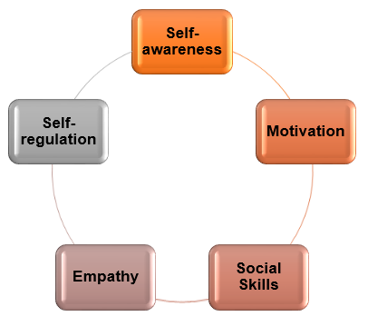
Figure 1: Key components of emotional intelligence
Practice of nurturing mindfulness and EI in professional environments allows a person to understand his/her own feelings, while comprehending other perceptions as well. Shah and Sah (2024) have opined that the interrelationship between emotional intelligence and workplace productivity indicates sustainable organisational success. It is one of the primary reasons for organisations to become increasingly attentive to EI to boost team morale, conflict resolution, team performance, and communication. Incorporation of EI in operational practices such as employee development, leadership capabilities, and recruitment strategies play a significant role to understand the potential for team performance and inclusiveness within the work culture.

A study has revealed that 90% of top performers often score high in emotional intelligence while employees who have undergone stress management and EQ (emotional quotient) training demonstrate 93% more productivity growth (Price, 2023). Therefore, EI has become a critical part of the current workplace culture within the organisation to improve employee performance for long-term success. This report explores the significance and contribution of EI in the workplace, along with its relevance in managing a multigenerational (Gen X, Millennial, Gen Z) team.

Task 1: Emotional Intelligence in Workplace

Critical understanding of emotional intelligence (using emotional intelligence models)
Knowledge of EI is considered as part of the core professional skills due to its ability to direct emotional regulations. Observations disclosed that major projects might stall due to lack of emotional intelligence among employees and emotional misunderstandings despite having high competence in technical and analytical skills (Mineo, 2025). Critical understanding and knowledge of EI in this context is valuable, allowing both leaders and employees to navigate complexity of relationships within a workplace situation.
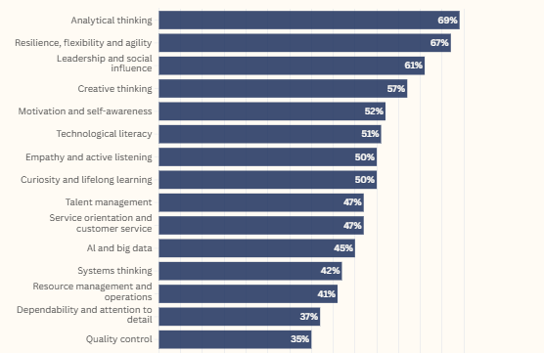
Figure 2: Core skills in 2025
(Source: Mineo, 2025)
Different emotional intelligence models are considerable to develop critical knowledge of EI, including Goleman’s emotional intelligence model, Bar-On’s Emotional-Social Intelligence Model, and Mayer and Salovey’s Ability Model.
Goleman’s emotional intelligence model
Emotional intelligence model proposed by Daniel Goleman targets four domains, namely self-awareness, self management, social awareness, and relationship management. It comprises twelve competencies, such as adaptability, emotional self-control, and organisational awareness. These competencies are critical to manage cognitive complexity of a given task, which is pivotal in the organisational situation to boost overall performance. According to this model, EI can be learned, practiced, and eventually enhanced to accomplish workplace success. Varvatsoulias (2023) explained that emotional intelligence is notably impulsive. Comprehension of one's own and others’ emotions is, therefore, necessary for supporting effective leadership decisions and team performance.
Bar-On’s Emotional-Social Intelligence Model
Similar to Goleman’s emotional intelligence model, Bar-On’s emotional-social intelligence model pointed out five main domains, along with 15 subscales, which are officially evaluated using emotional quotient inventory or EQ-i. These five areas of emotional intelligence are self-perception, self-expression, interpersonal, decision-making, and stress management (Craig, 2019). According to the model, these factors are the primary drivers of human behaviour and relationships. Development of these emotional-social domains allows individuals to establish a conscious collection between social and emotional perceptions, enhancing overall tolerance, knowledge of social cues, and others. Nevertheless, the main drawback of this model is the chances of subjective bias and trait overlaps that can deliver a misinterpretation of emotional intelligence for individuals.
Salovey’s Ability Model
The notion of Salovey’s ability model focuses on the emotions themselves and their interaction with the thoughts. It purely focuses on emotions unlike the other models of emotional intelligence where ranges of different competencies are considered emotion. According to the opinion of Shah et al. (2026), the ability model considers EI as a cognitive skill that entails the correct perception of emotions, facilitation of thought through it, regulation of emotions, and understanding emotional language. Each factor is crucial for navigating complexity of human emotions, minimising potential misinterpretation that can leave a negative impact on decisions, making, and team performance. Nevertheless, this model visibly isolates cognitive skills from traits like motivation and optimism, creating a strict distinction between personality and intelligence. It might limit the overall concept of emotional intelligence, restricting practical applicability.

Critical evaluation of applying the core components of emotional intelligence in the workplace
Performance improvement
Proper application of the core emotional intelligence components in the workplace benefits workplace performance by ensuring the betterment of communication and conflict resolution amongst professionals. For example, having strong self-awareness among employees and leaders allows them to determine the factors that are causing negative reactions or stress. Goleman’s emotional intelligence model presents self-awareness as one of the key domains of EI, which not only addresses employee development opportunities, but also the leadership capabilities of meeting employee needs at an emotional level. A Harvard study disclosed that only about 15% people are sufficiently self-aware while there is only less than 30% correlation between people’s actual and self-perceived competence (Dickerson, 2025). For this reason, developing in-depth knowledge regarding these components supports overall teamwork improvement and employee engagement.
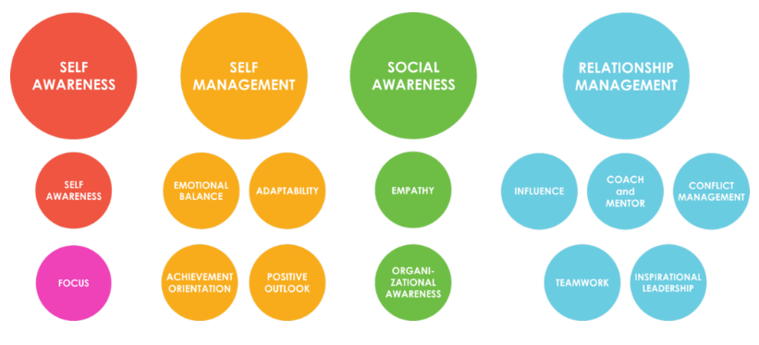
Figure 3: Domains and competencies in Goleman’s emotional intelligence model
(Source: Daniel Goleman, 2026)
In light of Goleman’s emotional intelligence model, focus on surroundings and emotional triggers, active listening to others, practicing empathy, and learning to balance emotions can effectively help employees and leaders to deliver agile and long-term performance. As opined by Lima et al. (2022), managerial ability to EI helps in understanding employee behaviour towards job satisfaction and dissatisfaction, which leads to performance improvement. The ability to identify triggers and reframe negative thoughts supports a process that can benefit organisations in presenting an emotionally intelligent team.
Collaboration
Deep association with EI improves teamwork, creating the environment for cooperative problem-solving, open communication, and understanding each other’s’ feelings. It also helps them in assessing strengths and weaknesses to adjust responsibility according to the organisational needs. According to Bar-On’s Emotional-social intelligence model, core factors, such as self-expression and interpersonal relationship management, contribute to convey honest perception with the team members. García et al. (2022) explained that this model facilitates both personal and behavioural changes, including adaptive coping and mindfulness. These approaches can be considered while developing the EI competences within an individual for better team collaboration, which leaders may consider while interacting with the team members. Moreover, awareness of how team members feel and problem-resolution with equal effort from team members not only supports a supportive organisational culture, but also develops trust among team members.

Well-being
Core components of emotional intelligence directly support employee well-being within a workplace, which can be highlighted through the notion of Salovey’s ability model. For example, perceiving emotions can benefit leaders to understand both verbal and non-verbal cues, indicating any signs of frustration among employees. According to the reports, 40% of employees across the world reported to feel stressed within the workplace (Gallup, 2026). On the other hand, understanding shifts in emotions is effective in determining the workplace triggers that contribute to declining employee well-being. Leaders within workplaces can utilise these understandings to determine their course of actions that focuses on both performance improvement and collaborative outcomes, without compromising emotional and mental well-being of employees.
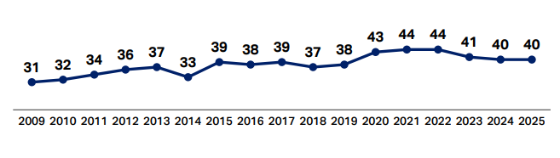
Figure 4: Daily stress increase over the years among employees
(Source: Gallup, 2026)

Contribution of emotional intelligence
Effective communication
Emotional intelligence contributes significantly in developing effective communication skills in modern workplace or organisations. Kakarla (2025) states that emotional intelligence plays a crucial part in transforming the effectiveness of an individual in interpersonal communication. It is considered as the ability of the individual to recognise, understand and regulate their own emotions and feelings and be considerate of other’s emotions. Mukhidinovich (2024) further commented that emotional intelligence during communication helps the person to convey their thoughts, ideas and feelings effectively, while responding to others in an empathetic way. Modern organisations resemble an interconnected and diverse world, which comes with their own unique set of communication challenges, which differ from cultural diversity to digitally enabled interactions (Jinyoung, 2024). Hence, emotional intelligence helps the individuals to gain the ability to read emotional cues, adapt communication style and empathise with others. This in turn contributes significantly in building effective communication in both professional and personal level to adjust the modern organisation's settings.

Conflict management
Apart from playing a crucial role in team communication, emotional intelligence also influences conflict management in modern organisations. Winardi et al. (2022) highlighted that strong emotional intelligence competencies help the team members operating in modern organisation settings to be efficient at controlling their emotions and showing empathy. Because of this, there is a higher probability of enhanced conflict resolution procedures, which in turn foster a space for positive communication. Further, it has been reported by Jinyoung (2024) that organisations that encourage their employees to practise emotional intelligence principles have teams that are highly capable of addressing team related challenges and work through their interpersonal conflicts. In addition, they show determination to take advantage of the diverse perspectives, ideas, and opinions shown by different members within the team.
Leadership
Emotional intelligence is one of the important competencies that are attributed to effective leadership in modern organizations. Coronado-Maldonado and Benítez-Márquez (2023) illustrates the importance of emotional intelligence in effective leadership, where the senior management at organisations need to demonstrate high emotional intelligence competencies as the foremost leadership.
The leaders need to be self-aware of their own strengths and emotional triggers, should demonstrate calmness, empathy, and support to the employees even in sudden crises, and expected circumstances. Kakarla (2025) opined that emotional intelligence contributes to an effective leadership skill. This enables the leaders in modern organisations to communicate with emotional awareness and sensitivity and support leaders to promote positive and inclusive work environments to make employees feel supported, valued and heard.
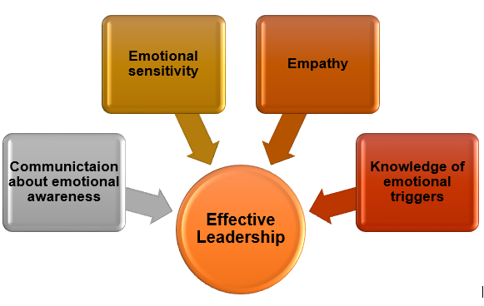
Figure 5: Relationship between leadership and EI

Decision-making
Teams and employees with high levels of emotional intelligence show resilient skills that offer them emotional stability. Because of which, they can calmly deal with stressful work situations and can make effective decisions. Alzoubi and Aziz (2021) highlighted that employees and leaders with high emotional intelligence have resilience, emotional clarity, and ability to prioritise the work requirements and organisational goals effectively. In addition, Khalisah (2023) navigated the effectiveness of emotion intelligence in the context of self-regulation on decision-making. It reported that strong emotional intelligence enables individuals to fail less likely to stress induced cognitive biases and follow a cool-headed approach for decision-making in high-pressure negotiations.

Task 2: Managing a Multigenerational Workforce

Distinct characteristics and expectations of different generational groups within the workplace
Different characteristics and expectations between generations shape their behavioural attributes and actions within the workplace. The following table presents an overview of distinctiveness within a multigenerational workplace.
Generations | Characteristics | Expectations
Generation X | - Pragmatism (mostly focused on practicality)  - Direct communication approach  - Potential rigidity towards shifts | This generation respects competence and expects autonomous performance opportunities within the workplace. They expect a strict work-life balance compared to other generations.
Generation Y (Millennials) | - Mostly consumer-driven mind-set  - Digitally competent but not native to digital technologies  - Harbours high ambition  - Purpose-focused | Expectations of work-life balance are high among this generation’s employees. Their value to continuous learning and purpose-driven actions leads to an inclusive culture within the organisations.
Generation Z | - Digitally-native and highly competitive  - Independence and autonomy-driven  - Security-focused | The economic uncertainty within the current professional environment nurtured an expectation of job security and professional well-being. These employees prioritise mental well-being and transparent leadership that support continuous growth. Moreover, a preference for work-life balance with robust flexibility of job hours can be noted among Gen Z employees.

A notable difference between Gen X, Gen Y, and Gen Z present in their communication style, values, motivation, and technological adaptability that effectively addresses their organisational effectiveness. For example, Gen X prefers autonomy and pragmatism while Gen X focuses on career progression and Gen Z emphasises inclusivity and mental health. A distinguishable difference in core value among these generations helps organisations to establish management and motivational strategies that can maximise the performance.
Technological adaptability also varies among generations that eventually affect performance competence of employees in a multigenerational workplace. A study has revealed that 86% of Gen Z considers technology as an integral part of their lives and has a higher likelihood of sharing these technologies with other Gen Z’s compared to millennial (CTA, 2024). It allows Gen Z employees to relate to technological advancements and application far better compared to other generations, which reflects on their organisational effectiveness. Current dynamics of the professional environment signifies a higher inclusion of technology to enhance operational agility and responsiveness. However, the motivational level of this generation is volatile, which reduces the overall effectiveness of their performance within an organisation. For example, 44% of Gen Z employees want a steady career path, compared to 46% of millennials (Deloitte, 2026). On the other hand, 42% of millennial mentioned cost of living as one of their primary financial concerns, compared to 38% of Gen Z. These differences in priorities also affect their work performance significantly as motivational needs at physiological and safety level are required to be addressed first. Unlike Gen X and Gen Y, Gen Z employees show a higher chances of work shift if their values and needs are not addressed accordingly within the workplace.
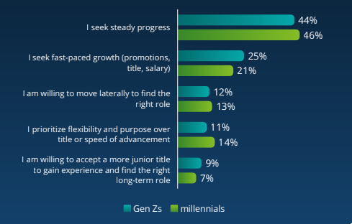
Figure 6: Gen Z and millennial’ focus on career paths
(Source: Deloitte, 2026)
Compared to these generations, Gen X demonstrates a strong emphasis on autonomy, ambition, and financial security, which determines their behavioural attributes within the workplace. According to the opinion of Krajac and Samardzija (2024), this generation is often perceived as pessimistic and self-reliant. These attributes not only disrupt the potential for collaborative actions within the workplace, but also create a conflict of interest with other employees from different generations. For instance, Gen X puts complete faith in their managers and supervisors without doubting ethical aspects, unlike Gen Z and Gen Y who values mental well-being and alignment of personal values with the organisational goals. Nevertheless, the primary impact of these differences reflects in work style, communication, performance strategies, and organisational culture.

Use of emotional intelligence and mindfulness increasing inclusive and productive work environment
Managers can use emotional intelligence and mindfulness in developing an inclusive and productive workplace environment by nurturing self-awareness, empathetic communication, and a sense of emotional safety among employees. According to the opinion of Cahyono (2024), social skills as a part of the emotional intelligence component enables individuals to effectively manage relationships, communicate transparently, and influence others. It is a significant consideration in a multigenerational workplace environment to ensure team cooperation.

EI and mindfulness in recruitment
Integration of emotional intelligence and mindfulness in the recruitment of a multigenerational team helps in active assessment of core competencies among employees from each generation. It allows leaders to use emotional regulations for generations like millennial and Z, while foundational stability is prioritised for Gen X. Moreover, conscious awareness of the differences helps in mitigation of generational stereotypes in the recruitment process. EI and mindfulness in the recruitment process guides the interview process and incorporates reflective viewpoints to determine potential triggers. Sudarmi and Sunaryo (2024) has pointed out that candidates with higher emotional intelligence engage with communication that is more mindful. Therefore, both EI and mindfulness helps in bridging the generational gap during the recruitment process.
EI and mindfulness in management
Application of EI and mindfulness within the workplace environment contributes to development of tailored communication and flexible execution that can meet the requirements and needs of a multigenerational team. It is a primary criterion to create an inclusive and productive workplace environment. According to the reports, 79% of employees agreed that their communication with leaders affects their understanding of organisation goals and by extension their productivity, motivation, and job satisfaction (Kojic and Milicevic, 2026). Thus, emotional intelligence and mindfulness effectively improve the cross-generational mentoring within the workplace that improves the employee productivity.
EI and mindfulness in employee retention
Cross-generational mentorship developed through emotional intelligence and mindfulness often helps in pairing older employees with the younger ones, to distribute knowledge and skills. For example, Gen Z employees can train Gen X and Gen Y employees in developing digital skills and in return can gain wisdom regarding patience and work-life balance. On the other hand, it promotes a better conflict resolution approach by incorporating emotional regulations and lower reactivity. Such actions contribute to improved and supportive organisational culture, retaining employees effectively despite being a multigenerational team.

Conclusion
Emotional Intelligence and its influence on employee management play an important role in the current business environment that can be concluded from this report. Leadership decisions regarding employee development need to focus on individual requirements and preferences of employees based on their generational characteristics. It revealed that Gen Z’s preference of direct and transparent communication, technological competence, and need for inclusivity could promote a better organisational effectiveness. The knowledge of EI in such scenarios helps in establishing a tailored management and recruitment strategy that often maximises collaborative workplace outcome and productivity.
The report concludes that high EI ensures strong employee performance due to their ability to understand their own and peers’ emotions, which further reflect on their communication and interaction approaches. Leaders’ ability to understand the emotional status of employees determines their competence in creating an inclusive work culture, supporting both individual and collective needs of employees. Moreover, it promotes a psychological safe work environment for them, allowing employees to open up in front of the leaders, which further supports an open communication. Both mindfulness and emotional intelligence in this context is crucial for successful team management that have a diverse generational background.
It can be concluded from the report that EI and mindfulness contributes to the growth of organisations by fostering a culture of empathy, emotional regulations, and self-awareness within the workplace. The approach not only allows leaders to ensure physical and psychological well-being of employees, but also ensures a healthy work environment that nurtures stress management, communication, and improved employee engagement.

Reference List
Alzoubi, H.M. and Aziz, R. (2021) ‘Does emotional intelligence contribute to quality of strategic decisions? The mediating role of open innovation’, Journal of Open Innovation: Technology, Market, and Complexity, 7(2), p.130. Available at: https://doi.org/10.3390/joitmc7020130
Cahyono, N.D., (2024) ‘The role of emotional intelligence in HR leadership: Building strong teams in a multigenerational’, The Journal of Academic Science, 1(6), pp.706-714. Available at: https://thejoas.com/index.php/thejoas/article/download/114/152.
Coronado-Maldonado, I. and Benítez-Márquez, M.D. (2023) ‘Emotional intelligence, leadership, and work teams: A hybrid literature review’, Heliyon, 9(10), pp.1-19. Available at: https://doi.org/10.1016/j.heliyon.2023.e20356
Craig, H. (2019) Emotional Intelligence Theories & Components Explained. Available at: https://positivepsychology.com/emotional-intelligence-theories/. (Accessed 4 August 2026)
CTA (2024) CTA Research: Exploring Gen Z Views and Preferences in Technology. Available at: https://www.cta.tech/press-releases/cta-research-exploring-gen-z-views-and-preferences-in-technology. (Accessed 1 August 2026)
Daniel Goleman (2026) Available at: https://danielgolemanemotionalintelligence.com/ei-overview-the-four-domains-and-twelve-competencies/. (Accessed 2 August 2026)
Deloitte (2026) 2026 Gen Z and Millennial Survey. Available at: https://www.deloitte.com/content/dam/assets-shared/docs/campaigns/2026/2026-genz-millennial-survey.pdf. (Accessed 29 July 2026)
Dickerson, C. (2025) The Ladder of Inference: Building Self-Awareness to Be A Better Human-Centered Leader. Available at: https://www.harvardbusiness.org/insight/the-ladder-of-inference-building-self-awareness-to-be-a-better-human-centered-leader/?utm_source=chatgpt.com. (Accessed 5 August 2026)
Gallup (2026) State of the Global Workplace. Available at: https://www.gallup.com/workplace/349484/state-of-the-global-workplace.aspx. (Accessed 31 July 2026)
García, A., Rodríguez, M. and Fernández, D., (2022) ‘Transformative Effects of Stress Management Training Based on Bar-On’s Emotional Intelligence Model in Nursing Students: A Qualitative Study’, Journal of Integrative Nursing and Palliative Care, 3(1-2022), pp.133-147. Available at: https://journalinpc.com/storage/files/article/afad5999-0941-4386-a3e7-cd38830b9a21-qB3H4FMq4hLGBABk/abL2k11qLFjdJSa.pdf.
Jinyoung, H. (2024) ‘The role of emotional intelligence in team dynamics’, International Journal of Science and Research Archive, 13(02), pp.1396-1406. Available at: https://doi.org/10.30574/ijsra.2024.13.2.1875
Kakarla, U. (2025) ‘Emotional intelligence in interpersonal communication, International Journal of Innovative Scientific Research, 3(1), pp.111-121. Available at: https://ijisr.net/ijisr/article/download/49/47
Khalisah, N. (2023) ‘The role of emotional intelligence in effective decision-making’, Journal of Management and Administration Provision, 3(1), pp.17-21. Available at: https://doi.org/10.55885/jmap.v3i1.220
Kojic, M. and Milicevic, O. (2026) Workplace Communication Statistics in 2026. Available at: https://pumble.com/learn/communication/communication-statistics/. (Accessed 4 August 2026)
Krajac, L. and Samardzija, J., (2024) ‘Workplace motivation across X, Y, and Z generations: An organizational behavior perspective’, In Economic and Social Development, International Scientific Conference on Economic and Social Development (Vol. 112, p. 550). Available at: https://www.researchgate.net/profile/Venelin-Terziev/publication/381321368_Social_transformations_and_social_programming/links/666954a685a4ee7261bb806c/Social-transformations-and-social-programming.pdf#page=570.
Lima, D., Spahi, J. and Shala, V., (2022) ‘The Management of emotional intelligence in the workplace impact on improving employee performance’, Calitatea, 23(188), pp.297-301. Available at: https://www.researchgate.net/profile/Jyxhel-Spahi/publication/361152081_The_management_of_emotional_intelligence_in_the_workplace_impact_on_improving_employee_performance/links/629fc1e8a3fe3e3df86529b3/The-management-of-emotional-intelligence-in-the-workplace-impact-on-improving-employee-performance.pdf.
Mineo, L. (2025) Why employers want workers with high EQs. Available at: https://news.harvard.edu/gazette/story/2025/08/what-is-emotional-intelligence-and-why-is-it-crucial-in-the-workplace/. (Accessed 1 August 2026)
Mukhidinovich, J.O. (2024) ‘Understanding emotional intelligence’, Universal Science Perspectives International Scientific Practical Journal, 1(1), pp.111-121. Available at: https://interspp.com/index.php/usp/article/download/13/13
Price, A. (2023) The Importance Of Emotional Intelligence At Work. Available at: https://www.forbes.com/councils/forbeshumanresourcescouncil/2023/07/18/the-importance-of-emotional-intelligence-at-work/. (Accessed 31 July 2026)
Shah, B. and Sah, K., (2024) ‘The impact of emotional intelligence in the workplace on productivity’, International Journal of Business and Management Invention, 13(10), pp.69-76. Available at: https://www.drbinodshah.com.np/wp-content/uploads/2025/04/the-impact-of-emotional-intelligence-in-the-workplace-on-productivity.pdf.
Shah, S.A.A., Shah, S.I., Mangi, Q.A., Shah, S.M.M. and Khaskheli, G.A., (2026) ‘Emotional Intelligence and Its Impact on Workplace Performance: A Comprehensive Analysis’, ASSAJ, 5(01), pp.3221-3227. Available at: https://www.assajournal.com/index.php/36/article/download/1686/2528.
Sudarmi, E. and Sunaryo, W., (2024) ‘Understanding Self-Awareness and Its Impact on Job Interview Performance: A Qualitative Study on Candidate Reflection, Stress Management, and Employability Outcomes’, Sinergi International Journal of Psychology, 2(1), pp.41-52. Available at: https://journal.sinergi.or.id/index.php/Psychology/article/download/518/374.
Varvatsoulias, G., (2023) ‘Investing cognitions in emotions? Is that what really matters? A methodological review on Daniel Goleman’s emotional intelligence book (1996) in line with cognitive-behavioural psychotherapeutic postulates’, Education Sciences & Psychology, 68(3), pp.3-58. Available at: https://www.researchgate.net/profile/George-Varvatsoulias-2/publication/378857683_Investing_cognitions_in_emotions_Is_that_what_really_matters_A_methodological_review_on_Daniel_Goleman's_emotional_intelligence_book_1996_in_line_with_cognitive-behavioural_psychotherapeutic_postulate/links/65ede2859ab2af0ef8ac8775/Investing-cognitions-in-emotions-Is-that-what-really-matters-A-methodological-review-on-Daniel-Golemans-emotional-intelligence-book-1996-in-line-with-cognitive-behavioural-psychotherapeutic-postulates.pdf.
Winardi, M.A., Prentice, C. and Weaven, S. (2022) ‘Systematic literature review on emotional intelligence and conflict management’, Journal of global scholars of marketing science, 32(3), pp.372-397. Available at: https://doi.org/10.1080/21639159.2020.1808847

