Micros Peripherals and Interfaces
ACDA4004
Student number: 2308626

Contents
Section 1 3
Section 2 4
Section 3 5
Task 1 5
Task 2 5
Task 3 6
Task 4 6
Task 5 6
Task 6 6

Intro
In this assignment, I will be creating assembly code tailored to a specific set of predefined tasks. I will illustrate each code segment with clear examples, accompanied by thorough explanations of my coding approach. This will include a detailed breakdown of the logic that underpins each segment, as well as an exploration of how these segments work together within the overall structure of the program. Moreover, I will highlight any particular challenges I face during the coding process, examining the obstacles and outlining the strategies I employed to overcome them. This will ensure a rich and comprehensive understanding of assembly language and its various functionalities, enabling readers to appreciate the intricacies involved in low-level programming.

Section 1
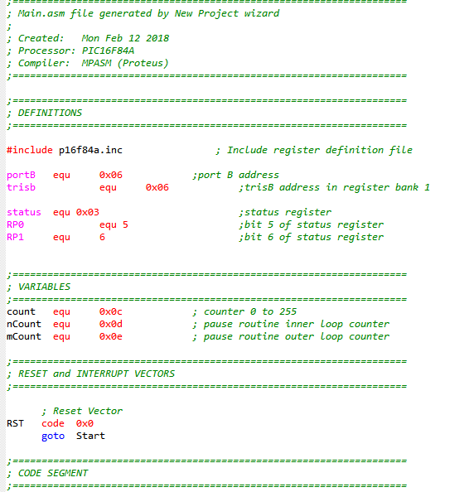
Figure 1
Before we begin the coding process, it is essential to meticulously set up the initial environment. This setup starts with configuring the registers, which are critical components that manage the flow of data and instructions within the system. Registers serve as temporary storage locations that allow the processor to quickly and efficiently access and manipulate information. These small storage spaces operate at high speeds, enabling the CPU to perform calculations and execute commands without delay.
In addition to configuring the registers, it is important to clearly define the program's inputs and outputs. This involves identifying the different data sources, sensors, or external devices that the application will interact with. By clearly outlining the expected inputs—such as user data, environmental measurements, or signals from sensors—we ensure that the program can appropriately handle various data types. Similarly, defining the outputs, whether they involve displaying data, triggering actions in connected devices, or relaying information back to the user, is equally important.
Establishing these inputs and outputs with clarity fosters seamless communication and data exchange between the program and the external environment. This thorough preparation of foundational elements allows us to lay a strong groundwork for our coding efforts. With a well-configured environment and clearly defined interactions, we enhance our ability to build a robust and efficient application that meets user needs and responds dynamically to different conditions.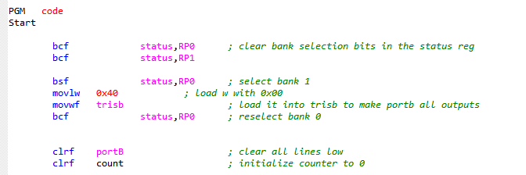Figure 2
Figure two provides an in-depth overview of the program's setup process, clearly outlining each critical step involved in initializing the system. To ensure optimal operation and prevent any issues, I am currently focusing on resetting the counter and meticulously clearing all registers and ports within the system.
During this careful procedure, I observed that a key value, which is essential for proper function, was mistakenly set to 0x40. This particular misconfiguration has the potential to create significant complications during code execution, which could jeopardize the overall reliability and performance of the entire system.
To proactively mitigate this risk and safeguard the system’s stability, I have taken the necessary step of recalibrating this incorrect value to 0x00. This adjustment is designed to enhance consistent and dependable performance, effectively minimizing the likelihood of unintended errors that may arise during the execution of the program. By addressing this issue, I aim to ensure that the system operates seamlessly and meets all operational requirements.
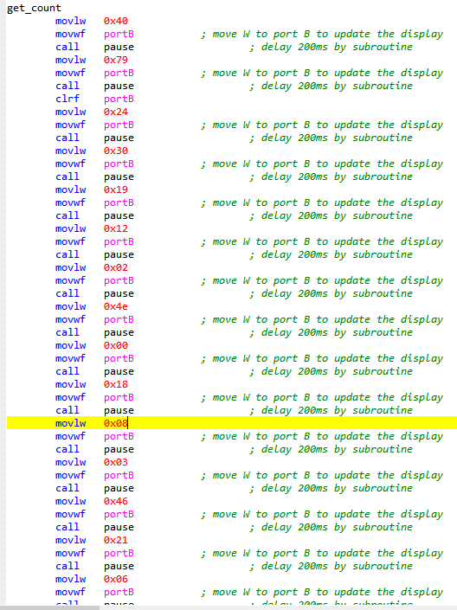
Figure 3
Figure 3 provides a comprehensive illustration of a somewhat cumbersome method for executing this program. The process involves iterating through each line of code one at a time, modifying the variable 'w' accordingly, and continuously reassigning it as the output. I opted for this approach because it simplifies the structure of the code, making it more straightforward to debug and identify any potential errors during the development process. After each time the code updates the output for port B, it invokes a delay subroutine. This subroutine introduces a 0.2-second pause, allowing time for the output to stabilize before transitioning to the next value in the sequence. Although there are certainly more efficient and elegant methods available for programming this functionality, my main goal at the time was to ensure that the program was operational. I prioritized getting a working solution over refining the program to be simpler or more efficient. This focus on functionality over simplicity was a key consideration during the development phase.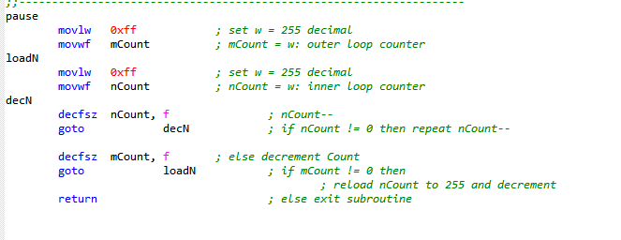
Figure 4
The diagram provides a detailed overview of the delay process, indicating that it introduces a specific delay of 0.2 seconds. This 0.2-second interval serves as a brief pause or lag in the system's response time, which is critical in various operational contexts.
This delay, though seemingly small, plays a significant role in improving overall system performance. By allowing for a smoother transition between tasks, it helps mitigate the impact of abrupt changes, which can lead to inefficiencies or errors. In situations where processes need to flow seamlessly from one to another, this brief lag can act as a buffer, giving the system an opportunity to align its operations more effectively.
Moreover, the 0.2-second delay can enhance synchronization with other systems or processes that may be running concurrently. By ensuring that all components of a system work together in a coordinated manner, this delay helps reduce the likelihood of discrepancies and inconsistencies that can arise from desynchronized operations.
In summary, while the delay might seem negligible at first glance, it is a vital element in optimizing system functionality. It not only promotes smoother transitions and better performance but also facilitates a cohesive integration with other processes, ultimately contributing to a more reliable and efficient overall system.

Section 2
To effectively display the hexadecimal values from 0 to F on a seven-segment display, I began by calculating the hexadecimal codes that correspond to each of these values. This foundational step laid the groundwork for developing a program that would sequentially cycle through each value, presenting each one on the display in real time.

Focusing on values A through F, I conducted a detailed analysis to determine which specific segments of the seven-segment display needed to be illuminated to accurately depict each character. Each segment can be visualized as a bit in a binary number, where it can either be activated (represented as 1) or deactivated (represented as 0).

I meticulously mapped out the segments associated with the letters A to F, translating the necessary segments into binary numbers. This involved identifying which segments needed to glow to form the distinct shapes of these hexadecimal characters. After establishing the correct binary configurations for each value, I then converted these binary representations into their corresponding hexadecimal codes.

This systematic approach ensures that the appropriate segments light up for each character on the display, resulting in a clear and precise representation of the hexadecimal values ranging from 0 to F. By illuminating the correct segments, the display vividly presents each character, facilitating easy reading and interpretation.
This has given me the following values:
Value binary hex
A 0001000 0x08
B 0000011 0x03
C 1000110 0x46
D 1011110 0x21
E 0000110 0x06
F 0001110 0x0e

Section 3

Task 1

Start

Task 2
This code is designed to provide a simple interaction where pressing one button will display the letter "l" on the screen. Conversely, when you press the other button, the letter "r" will appear instead. This functionality allows for a clear and intuitive way to distinguish between the two actions through visual feedback.
Clear all ports
Set port b to an output
Start
if button 1 is high, set output b to 0x47 so the seven-segment display prints out an L
if button 2 is high, set output b to 0x4e so the seven-segment display prints out an r
else set output b to 0x00
return to start

Task 3
This pseudocode outlines the functionality of two distinct buttons—Button 1 and Button 2—and their interaction with a series of LED lights.
When Button 1 is pressed, the code triggers a command that activates all connected LEDs, resulting in them illuminating brightly and simultaneously. This feature is useful for applications that require a visual signal, such as alert systems or decorative lighting setups.
Conversely, when Button 2 is pressed, the code sends a command to deactivate all the LEDs, leading to their immediate shutdown and darkness. This functionality is crucial for conserving energy and providing a clear visual indication that the lighting system is off.
This simple yet effective interface allows users to control the LED lights with ease, ensuring that they can easily switch between full illumination and complete darkness as needed, making it ideal for both practical applications and user-friendly designs.
Clear all ports
Set port b to an output
Start
When button 1 is high, set output b to 0x7f to set all the segments to high
If button 2 is high, set output b to 0x00 to clear the seven-segment display
Return to start

Task 4
Clear all ports
Set port b to an output
Create a segment including the values 0-9 in hex
Set digit to 5
Start
Display digit on output b
Subroutine button 1
When button 1 is high, increase the digit value by 1.
Subroutine button 2
When button 2 is high, decrease the digit value by 1 =.
if digit is 10
Set digit to 9
If digit is -1
Set digit to 0
Go to start

This pseudocode offers a clear and concise representation of my code, meticulously crafted to align with the specified project requirements. It highlights the core functionalities and the foundational logic, ensuring that the concepts are easily comprehensible. By streamlining the presentation, this approach provides an insightful overview of how the code effectively meets the project's objectives, showcasing key algorithms and their intended outcomes in a structured manner. Furthermore, the clarity of this document promotes engaging discussions about potential enhancements and future developments, paving the way for continuous improvement and innovation.

Task 5
Clear all ports
Set port b tou output
If button 1 is pressed
Send output through pin b 8 creating a sound throught the buzzer

Conclusion
In conclusion, assembly language is an essential tool for programmers who require low-level access to computer hardware and seek precise control over the execution of their code. This low-level programming language enables direct interaction with the machine's architecture, allowing developers to manipulate memory and processor instructions effectively. However, the process of writing code in assembly can be quite time-consuming and technically demanding. This is primarily due to its inherent complexity, where even simple operations can require a significant amount of detailed coding, coupled with the necessity for meticulous attention to every detail to avoid errors.
Despite its potential for delivering outstanding performance and enabling developers to optimize their programs for specific tasks, assembly language is often outshined by modern programming languages. These contemporary languages, such as Python, Java, and C++, offer a more user-friendly experience by incorporating higher-level abstractions and extensive standard libraries. This makes it considerably easier for developers to write, maintain, and debug their code, significantly reducing the time and effort involved in software development.
Moreover, modern languages typically come with robust development environments and tools, enhancing productivity and collaboration among programmers. Consequently, while assembly language may hold its merits in terms of performance and control, it is crucial to weigh these benefits against the more efficient and streamlined options that today's programming landscape offers. By choosing higher-level languages, developers can focus on solving complex problems without getting bogged down by the intricacies of low-level programming.

Refrences
Pic16f84a data sheet used throughut the assignment
PIC16F84A Data Sheet

