Josh Ford
1701602
Lecturer: Kemi Ademoye

Phones Web app
Report
Application development

Contents
Table of Figures 1
1. Abstract 2
2. Application Development concepts 2
3. Requirements 3
3.1 software requirements specification 3
3.2 software design 3
3.3 Implementation 3
3.4 Software verification and validation 4
3.5 Evaluation 4
4. Design 4
5. Implementation section 4
5.1 screenshots 5
6. Evaluation 7
7. References 9

Table of Figures
Figure 1. Screenshot of page showing phones on the web app.

Figure 2. Screenshot of the page showing the filters working.

Figure 3. Screenshot of the details page of each phone.

Figure 4. Screenshot of the log in page.

Figure 5. Screenshot of the edit ability.

Figure 6. Screenshot of user trying edit ability while not being a admin.

Abstract
The report looks at the design and development process of the web application implemented. It looks at how the user designs the web app and how it will look. It also explains what the web app is and how it was made. it looks at a software requirements specification technique and how the web app was implemented. It covers screenshots on how the web app was created and what it looks like. It then evaluates how good and what was successful in the web app, then how it would be changed or what would be added if done next time.

Application Development concepts
There are many security vulnerabilities in web applications and there are many that can affect the state of the web application.
Injections: The first example is injections, the most known type of injections are SQL injections. A SQL injection is when a hacker can use malicious SQL statements and uses them on websites/applications to get around security measures. This could be a log in screen, they can use this method to bypass this and even access the details of the log in. These rely on a server to add, edit and even delete data on a website [1]. The risks of this is losing valuable data, having the web application change or have data added to it which could affect users that use it. The impact of this could be the web application showing sensitive data which has been accessed by the SQL injection. The counter measures of this would be to include prepared statements so that the SQL statements do not work when attempted.
Cross site scripting is another type of injection, this one is when the attacker finds a way around the same origin policy with tells apart different web sites from each other, this then allows the user to let the user enter sensitive data into the website not knowing that they are allowing the hacker into their data. They then have hold of the user’s data [2]. The cite made talks about how cross site scripting works and explains how the attacker to ‘Masquerade as a victim user, to carry out any actions that the user is able preform’ [2]. This backs up the point made that says that the attacker can hide something for example text or part of something that tells the user what they are about to do like about it not being safe. The risks of this could be having data that is being stored in the website being leaked and stolen this would then mean that these details which could be bank details or other sensitive data could be looked at. The impact of this would be that the sensitive data would be leaked, also the attacker has a way into the website and could keep the user out of the website and the user can do nothing. To prevent these http attacks would be to only allow the http responses to be only in HTML or JavaScript using content type headers [2].
Another security vulnerabilities would be cross site request forgery (CSRF). This is when an attacker tricks the user into pressing something on the website and thinking it is the correct one, while the user also being logged in, this would also mean that with the user pressing this and the user thinking nothing of it, the attacker then has access to sensitive details and has access to the user’s account. The risks of this would be passwords being changed and data being stolen [3]. The impact would be losing control of the website and struggling to get it back as passwords have been changed and the attacker will just keep the user out from gaining access again. Ways to prevent this would be to stop websites to stop remembering usernames and passwords.
Software design patterns are methods that can be used when designing software, they are patterns that are used when thinking about the ways in which the software could be created. They are guidelines that can be followed when creating software. The software design pattern that is suitable to the project that was created is the factory method design pattern, this is because the web app has lots of classes along with subclasses. The pros of this would be when creating a web application using this method, if an upgrade or feature was added to the web app, it could be created inside of a sub class, this means that if it was to be changed or upgraded, you only then have to change that class rather than multiple classes. The drawbacks of this method will be if the type of project being created does not include a number of subclasses like if it was for a number of different objects that were being added, they might not be able to be added into sub classes because of them being different.

Requirements
The web application is about phones and the details about them, it will display all the current phones and let the user search for different phones using the filters provided. It will display all the phones and let the user view the phones that are on the page and choose one and look at the page of the phone which will display the full details of the phone including its features and the price. It will also let the user buy the phone. The target audience is for anyone who is interested in phones and is looking for a phone. The information and content of the web application is relevant and will be useful for when looking at phones.

Software requirements specification
The purpose of the web application is to be able to look at the different phones that will be on the website. To also look at all the individual details about each phone and how much they cost.
The website will have a page which will display all the phones that are on the site. The user will be able to look at each phone individually. The user would also be able to filter the phones when searching for one, this could be looking at only the phones of a certain make or model. Once chosen the user will be able to purchase a phone.
The requirements for the web app will be the phones that will be put on the website, this would be the names, price, makes and description of the phones. The other requirements will be for the user to search for a specific type of phone as well and make or model of phone. To also view each phone and look at its specs and price. Also, to be able to purchase the phone. [4]

Software design
Software design is the creation of something created by software to fix something or to help with something. To maintain good software design, the creator must make sure the software accomplishes its tasks and does it well. Also, it must be maintainable, fixable and it must last. These can be accomplished by creating and designing it well and looking at every possibility and issue.

Implementation
Implementation is looking at all the designs and putting it into effect. This will be looking at everything that has been created to design the web application and putting it into action. This will mean when the web application is being created, every issue that would have been brought up will be put into action so that when the creating stage is underway, not as many issues will be brought up.

Software verification and validation
Software verification and validation is after the web app has been created and it is the final stage of the process. Verification is looking at the web app and deciding if it meets the requirements.
‘…a process of evaluating the intermediary work products of a software development lifecycle to check if they are in the right track...’ [5]. This could include the requirements document that was created.
Validation is when testing comes in, each aspect of the web app is tested and is made sure it is working. This is an important stage of the process because without it, it might not be working and might encounter more problems. The testing stage will be thorough and will make sure everything is working. ‘Validation is determining if the system compiles with the requirements’ [6]

Evaluation
The evaluation stage is when the user looks back and looks at whether the requirements and goals of the application were made and succeeded. The requirements and design requirements are looked at and decided at whether they have been met. Also, it is looked at what could be done differently.

Design
The design principle that was used when creating the web application was the open closed principle. This principle is when you are creating the web app, you can upgrade or extend something in the web app rather than change it. An example of this is having a bike class and then making a class propeller, then further on upgrading the class and calling it engine. This was used when creating the class because when creating the web application, some classes were created to get it working and then when other features so then they can be changed so suit the new feature.

Implementation section
The main models, views and controllers that have been made while creating the web application were the phonedetails and purchase viewmodels, these were for purchasing the phone on the website and the phonedetails for getting the details of the phone from the phonedetails class. There were also two controllers also called phonedetails and phonepurchases, these were the displaying of certain aspects of the webpage. The phonePurchase controller was for the purchasing of the phone, some classes inside of this was the conformation of the phone, and the purchasing of the phone. There was also the main views of the webpage this would be the way the page looks, it contains the parts of the page which would be what would be displayed on the page what would be the Phones themselves and the filters.

screenshots
This is the main page which all the phones are displayed on.
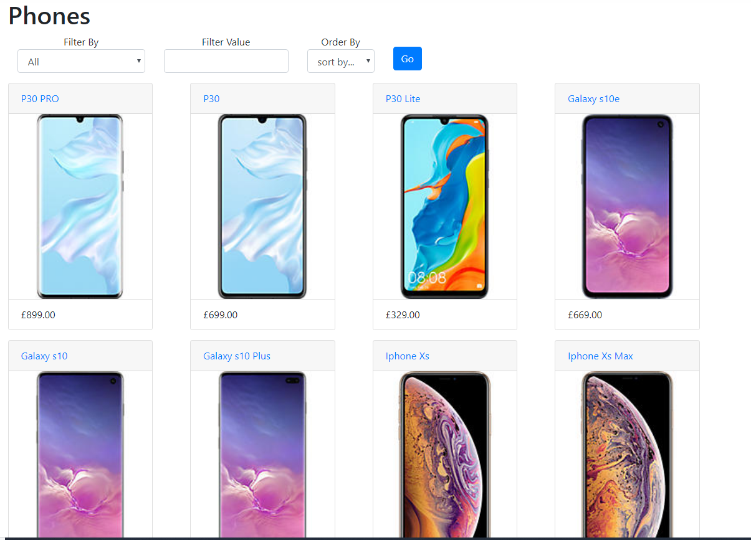
Figure 1

This is the filters which the user can search for specific phones
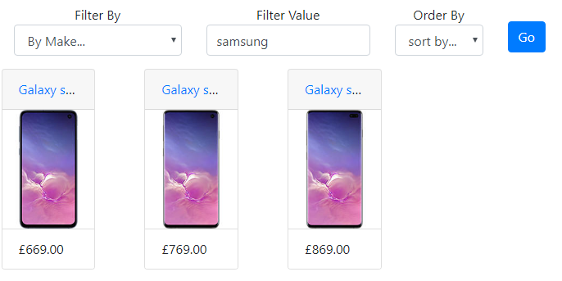
Figure 2

This is the page of each individual phone and its specs, price and description.
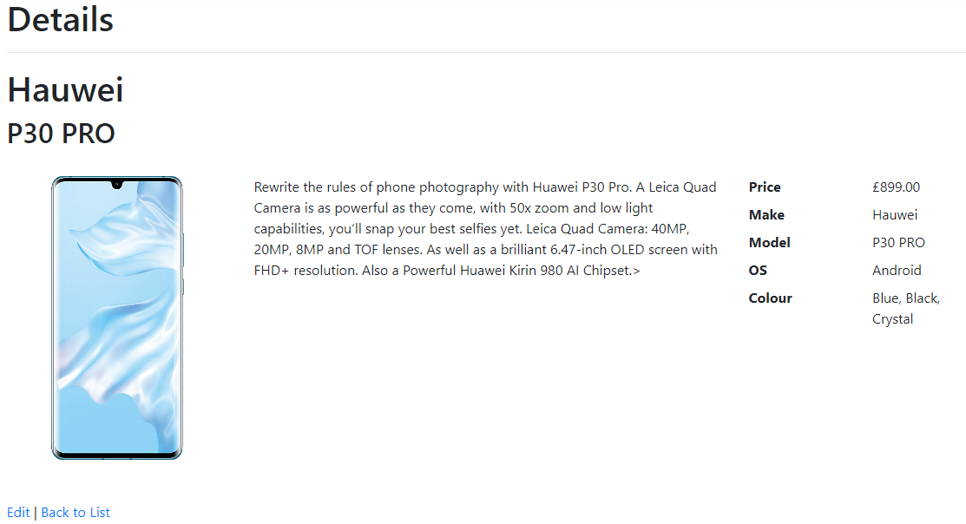
Figure 3

This is the log page which can be logged in using a created username and password or logged in using a Microsoft or google account.
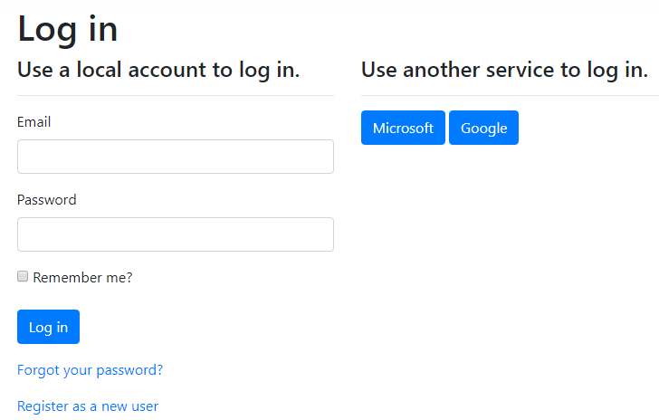
Figure 4

Evaluation
Verification and validation are important parts in a web application because without it, it might not work. Verification is looking at if the web application meets the requirements that the user made in the design process. The requirements were for the application to display the different phones, for the user to be able to search for the phone they are looking for, this was tested and shown below.
Figure 2

Another requirement was to be able to view a phone individually and look at the details of the phone, to view the price, description and pictures. The app was tested to see if the page for each phone would load and it was tested and shown below.
Figure 3
Another feature was to be able to log into the web app and be able to edit the web app using the features that are only available to the admin. As shown in figure 5, it shows the edit ability when logged into the admin account, then in figure 6 It shows pressing the edit button after being logged into a normal account.
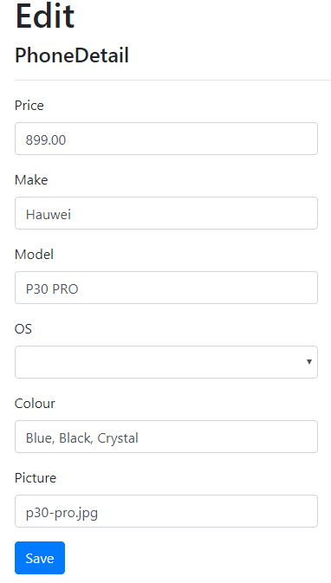

Figure 6
Figure 5

Overall the web application that was created is similar and meets the requirements that the author made at the start of the document, the website functions exactly how the user wanted it to function. The layout of the website is simple and lets the user clearly look at each phone and see which one is which and clearly displays the price of each phone at the bottom of each phone. The usability of the website is good, it is easy for the user to navigate around the web application and the content is appropriate and has accurate information about each phone.
Reflecting on the website, it is a success and functions how the user designed it to work. If it was to be done again, more phones would have been added and maybe phone accessories would have been added to the web app. These additional accessories could be linked to each phone for future improvements.

References

[1] | “What is SQL Injection (SQLi) and How to Prevent It,” acunetix, [Online]. Available: https://www.acunetix.com/websitesecurity/sql-injection/.
[2] | “Cross-site scripting,” portswigger, [Online]. Available: https://portswigger.net/web-security/cross-site-scripting.
[3] | “Cross site request forgery (CSRF) attack,” imperva, [Online]. Available: https://www.imperva.com/learn/application-security/csrf-cross-site-request-forgery/.
[4] | N. Krüger, “How to Write a Software Requirements Specification,” perforce, [Online]. Available: https://www.perforce.com/blog/alm/how-write-software-requirements-specification-srs-document.
[5] | 23rd April 2019. [Online]. Available: https://www.softwaretestinghelp.com/what-is-verification-and-validation/.
[6] | Try QA, [Online]. Available: http://tryqa.com/what-is-validation-in-software-testing-or-what-is-software-validation/.

marking criteria and Student FEEDBACK

This section details the extent to which the assessment criteria are demonstrated by you, which in turn determines your mark. The marks available for each category of skill are shown. Lecturers will use the space provided to comment on the achievement of the task(s), including those areas in which you have performed well and areas that would benefit from development/improvement.

Common Assessment Criteria Applied (Assignment 2) | Marks available | Marks  awarded
1. Engagement with Literature Skills

Good evidence of engagement with literature skills. For additional improvements, expand the range of reference sources consulted to include more academic reference sources. (Grade mark: 60.00%) | 5 | 3
2. Knowledge and Understanding Skills

Good examples of some common web security issues have been presented, but your explanations need to be clearer. The section on design patterns is weak and requires a clearer explanation of how the chosen design pattern works and is relevant to web applications. (Grade mark: 48.00%) | 25 | 12
3. Cognitive and Intellectual Skills

A basic evaluation of the implemented application has been provided. Documentary evidence of testing is limited and needs to be improved beyond screenshots to further demonstrate different test cases of the application's functionality. Some of your test cases are for default functionality provided with the VS application template which works straight out of the box. I am more interested in functionality that you have created. (Grade mark: 45.00%) | 20 | 9
4. Practical Application Skills

A good attempt featuring a simple application based on the class tutorial but there is room for improvement. Requirements and the intended design have been well thought out. Good attempt at changing the default views, but there is still some room for improvement. Generally, the application is incomplete and requires more functionality as the functionality is currently limited to displaying data. The edit and create views are the defaults, which require some added functionality to make them work. Filtering is partially working and you did get the authorisation working but hide links from unauthorised users. (Grade mark: 57.78%) | 45 | 26
5. Transferable Skills for Life and Professional Practice

The report is of average standard. See your report for suggested improvements. (Grade mark: 50.00%) | 5 | 2.5

Assignment Mark (Assessment marks are subject to ratification at the Exam Board. These comments and marks are to give feedback on module work and are for guidance only until they are confirmed. ) | Late Submission Penalties (tick if appropriate) |  | 52.5%
 | Up to 1 week late (40% Max) |  | 52.5%
 | Over 1 week late (0%) |  | 52.5%

