BMDS7009-CW2

Design standards for clinical digital systems

Introduction
Digital Health and Care Wales (DHCW) is an NHS Wales Special Health Authority responsible for providing “digital and data services which support the delivery of health and social care” (DHCW, 2024). This includes front-line clinical digital systems for clinical staff to view and manage patient care, such as Welsh Clinical Portal (WCP), the Welsh Nursing Care Record (WNCR) and WCP Mobile (DHCW, no date c).
In 2022, an assessment of WCP user interface was completed. It found (Lucena Araujo, 2023):
- Variation in the use of icons (Fig. 1).
- Variation in colours.
- Inconsistency in the presentation of tables.
- Inconsistent terminology.
- Inconsistent use of acronyms.
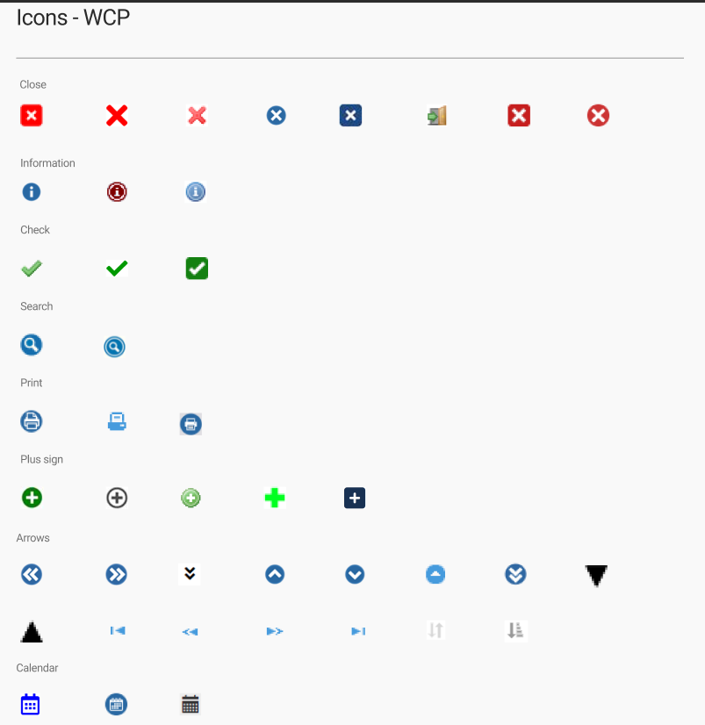
Figure 1: WCP icons (Lucena Araujo, 2023).

Based upon that discovery work, this essay proposes the delivery of organisation-wide design standards in DHCW for clinical digital systems, focused on enhancing user experience (UX) through consistent user interface (UI). These standards should be based on broad evidence-based research and practical knowledge from key stakeholders.
A design standard is a “set of guides, design patterns, conventions and resources to build a website or digital service” (Rohan, 2022). For DHCW’s clinical digital systems, design standards should consider:
- Icons.
- Colours.
- Typography.
- Terminology.
- Presentation of information, e.g., tables, checkboxes.
- Chronology and presentation of date/time.
- Drop down menus/lists.
- Display of information in PDFs.
- Functionality, e.g., misfile, autofill, saving, sensitive information.
- Navigation, e.g., header, footer, contents lists, pagination.
- Accessibility.

Poor usability of healthcare systems can result in poor patient care, through errors in data entry, failure to capture relevant data, and inability to share information (Madandola et al., 2023). If systems do not support workflows, vital information can be missed, leading to negative patient outcomes (Pew Charitable Trust, 2019).
Conversely, design standards result in increased satisfaction for users because systems are easier to use. This saves the user time, enhances accessibility, and reduces error and cognitive load (Wright et al., 2018). In healthcare, user friendly systems improve clinicians’ ability to “achieve their goals” (Suzianti and Arrafah, 2019) and “take action on the information provided” (Sittig et al., 2008). Studies have highlighted the importance of usability over functionality (Wynn et al., 2023), and note digital systems should put the user at the centre of design (Park et al., 2021; Hardiker et al., 2024). Digital healthcare is a complex environment, and different users may have different abilities, settings, needs and experiences, so multiple experience paths must be explored to identify the most appropriate UI for the widest range of users (Kumar et al., 2014).
For digital product teams, design systems bring further benefits, including:
- Enhancing productivity and speed of design and build.
- Supporting the maintenance of systems through consistency in functionality.
- Reducing cost and resources including training new staff.

Welsh Government recognises the value of user centred, inclusive and accessible design for the delivery of digital solutions, and standardising and optimising how work is done (Welsh Government, 2023). Similarly, design and user experience are key to DHCW’s aim “to deliver high quality digital products and services” (DHCW, 2023).
Digital design standards are not novel. Both UK and Welsh Government have online guidance for digital content (Welsh Government, no date; UK Government, 2012), though these are not specific to healthcare. NHS England have a multi-faceted service manual covering principles, accessibility and an extensive design system, which aims to “build consistent, usable services that put people first” (NHS England, no date).
Within DHCW, there are branding and communications standards (Kings, 2024) and data standards (DHCW, no date a). DHCW complies with national regulations and audits, including ISO27001 for information security (DHCW, no date b). However, there are currently no standards for the “look and feel” of DHCW digital systems.
As the leading provider of clinical digital systems for NHS Wales, it is important DHCW keeps pace with technology sector trends in digital design. The aim of this paper is to explore change and improvement methodology and outline an approach to creating and implementing a digital design standard for DHCW. The initial scope is defined and documented design standards, an online library for icons and reusable components, and a delivery and communications strategy.

Methods
Quality improvement is a coordinated and evidence-based approach to solving problems, improving service provision, and, in healthcare, enhancing outcomes for staff and patients (Backhouse, 2020). It requires organisations or teams to identify an issue, understand it from a range of perspectives, develop a change plan, test potential solutions, and evaluate outcomes (Jones, Kwong and Warburton, 2021).
This paper aims to improve the quality of the user interface of clinical digital systems developed or supplied by DHCW. This will be achieved through the creation of evidence-based design standards made available on a website or SharePoint intranet page, designed with and accessible to all staff involved in systems delivery. It will provide rules and structure to the design and development of systems used by clinical staff, meaning all clinical systems would have a similar look and feel, thereby enhancing user experience.
This essay adopts a range of frameworks and theories to guide the introduction of design standards for clinical digital systems in DHCW.

Double Diamond
The Double Diamond (Fig. 2) is a simple visualisation of how design and innovation is undertaken. It defines four distinct phases broken down into two diamonds, the first representing how the problem is identified, and the second addressing the solution (Design Council, no date). The shape represents “points of iteration for research, learning, prototyping and testing” (Design Council, no date).
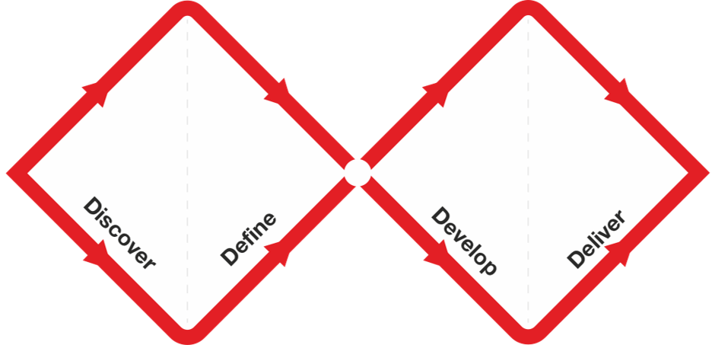
Figure 2: The Double Diamond is licensed under a CC BY 4.0 license (Design Council, no date).
At the start of this study, the discovery phase has been completed by DHCW colleagues, and a high level definition of the problem was reached, so the next step is for this author to further understand the problem and propose a suitable solution.

Cynefin Framework
The Cynefin Framework (Fig. 3) helps contextualise a problem and identify the actions required for a solution (Cynefin Co., no date). The framework will map the level of complexity and risk associated with the introduction of design standards and changes to user interface.
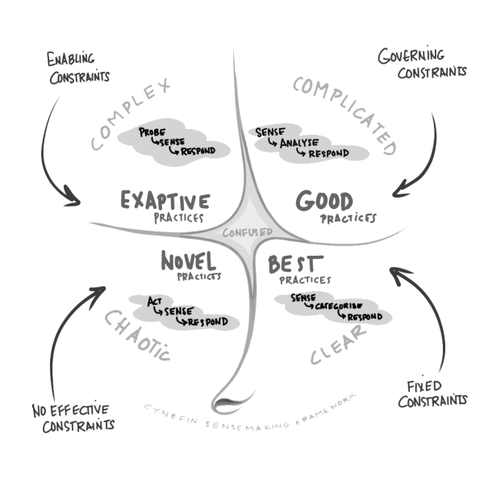
Figure 3: Cynefin framework (Cynefin Co., no date).

Theory of Change
Theory of Change posits that change is dependent on analysis of context, individuals and rationale (Scott, 2016). In healthcare, this change relies on early identification of gaps in current knowledge, stakeholder engagement and embedding interventions within organisational a specific context (De Silva et al., 2014). This approach works best by establishing long-term goals and “mapping backwards” to identify dependencies, assumptions, outcomes and risks (Scott, 2016). This paper will use the Theory of Change to build a project plan, based on a long-term goal agreed with stakeholders.

Behavioural change
Pilat and Krastev (2021) suggest the success of change is dependent on user behaviour. The COM-B system assesses users’ capabilities, motivation and opportunities for change – these factors interact to impact behaviour, and vice versa (Michie, van Stralen and West, 2011). To improve user interface across DHCW systems, a COM-B assessment helps identify interventions required to create an environment conducive to change.
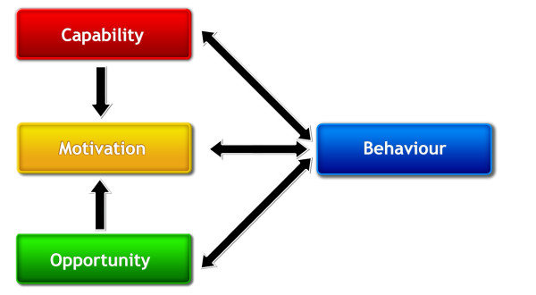
Figure 4: The COM-B system - a framework for understanding behaviour (Michie et al, 2011).

Plan Do Study Act
Plan, Do, Study, Act (PDSA) is an iterative cycle of change on a foundation of testing, learning and refinement (Moen, 2009). It can be supported by the Model for Improvement (Fig. 5), which poses three questions to focus attention on the outcome the project aims to achieve (Moen, 2009).
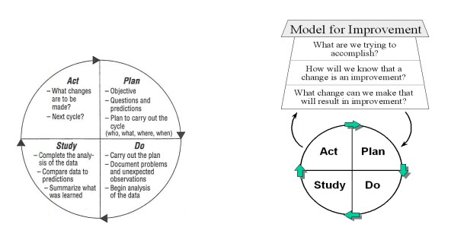
Figure 5: PDSA and Model for Improvement (Moen, 2009).
These frameworks provide a flexible approach “to ensure fit-for-purpose solutions are developed” (Taylor et al., 2014). Regarding design standards for DHCW, they provide a structure around which a quality improvement project can be designed and delivered.

Agile Project Management
Shirley (2020) defines a project as a task with a defined goal that is new, scheduled, and uses limited organisational resources. The UK Government project delivery standard (2021) expands on this for public sector projects, highlighting the importance of governance.
The agile approach breaks down projects into smaller components delivered in incremental cycles (Sowden, 2011). Agile sits on eight principles including collaborating, communicating, focusing on business need and quality (Agile Business Consortium, 2014).
Iterative improvement is key to the agile process. It starts with defining and contextualising a problem, then designing, testing and implementing a solution, all within a controlled plan (Shirley, 2020). The aim is to “deliver real business benefits to users as early as practical” (Agile Business Consortium, 2014), so once a piece of work is complete, it is released to users and evaluated, and then another cycle commences, whilst learning and adapting in every iteration.
This paper will use agile project management techniques to plan, structure and deliver design standards for DHCW systems. Agile is complimented by PDSA – the structure of PDSA provides clear steps for each iteration of the agile project cycle. Agile methodology is particularly appropriate for this project, in which stakeholder engagement and flexibility are essential to ensuring changes are based on realistic ideas and lessons learned from practical knowledge and experience.

Discussion

What?
This paper proposes DHCW produces design standards for clinical digital systems, aiming to enhance user experience (UX) through consistent user interface (UI).
In line with the Theory of Change, this long-term goal is ratified by stakeholders including DHCW Directors and teams involved in the delivery of clinical and digital systems. No current standards of this nature exist within the organisation, and there are no effective governance constraints. Therefore, this project aligns with the Cynefin framework definition of “chaotic,” meaning it is a novel venture for DHCW. Therefore, the framework proposes the project should act, sense, then respond (Cynefin Co., no date), meaning propose an approach, evaluate its effectiveness, and then adapt as required and repeat the cycle.

How?
The project combines theoretical approaches from Cynefin, PDSA and Agile through an iterative process of doing and learning.
First, the project proposes establishing a working group with a standing agenda to guide the process for establishing design standards, based on evidence-based research and practical knowledge from experienced stakeholders. Figure 6 summarises the Terms of Reference including meeting structure, outputs and assumptions.
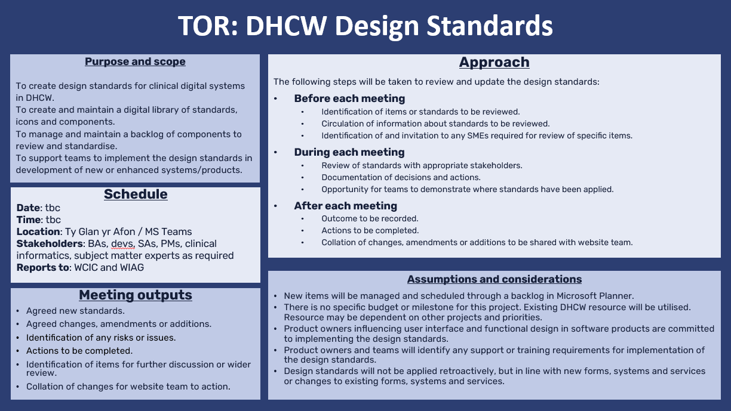
Figure 6: Terms of Reference.

The Terms specify the role of product owners and teams in implementing the design standards and identifying any training needs. It is noted that changes to clinical digital systems should be introduced into new development or change cycles, rather than retroactively – DHCW does not have capacity to redevelop all existing software upfront to align with the design standards, but natural cycles of development and change will facilitate opportunities to introduce the standards organically.
The suitability of these Terms should be reviewed after each iteration, and, if necessary, adapted based on lessons learned.
Progress will be managed using Microsoft Planner – each item is represented as a ticket on the planner, and research, ideas, considerations and concerns can be documented within each ticket (see Fig. 7).
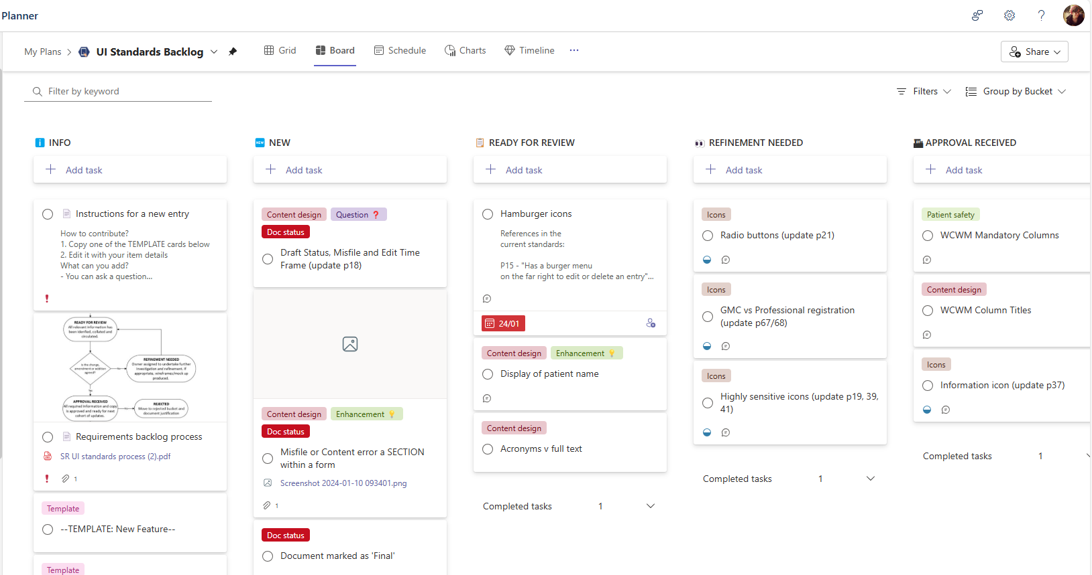
Figure 7: example of Microsoft Planner for design standards backlog.

The outputs of this working group would be passed to a team responsible for building the design standards platform, whether a website or SharePoint, with the standards clearly described and searchable, and a complementary components library.

When?
With a long-term goal as the focus, it is challenging to define how long this project may take, but it is possible to attempt to define a few initial iterations. Based on the outcomes of the discovery work, early phases may include:

Iteration | Item
1 | Icons
2 | Colours
3 | Tables
4 | Drop down menus
Table 1: iterations and items.
Utilising the PDSA methodology will enable the project team to:
- Plan: research an item to understand current use and best practice.
- Do: propose the standard for that item and implement the standard in digital systems.
- Study: evaluate whether the standard is having the desired effect on UX.
- Act: review whether refinement is required to the standard.
The evaluation of whether standardisation is having a positive impact should involve a reassessment of consistency across digital systems, compared to the original discovery work, and should include user feedback surveys. Rather than assessing one item at a time, it is advised to assess once several changes have been implemented – an iteration may be short and users may get frustrated if they are asked for feedback after every minor update.
Once an iteration is complete, a new iteration should begin. This alignment of PDSA and Agile will deliver standards as quickly as possible, therefore providing the benefits of new standards as fast as possible.

Who?
In Agile, all stakeholders participate in governance, focused on meeting goals, managing risk and optimising performance (Agile Business Consortium, 2014). The agile project team should include individuals with the skills and knowledge to inform choices about the design standards, such as business analysts, developers, solutions architects and clinical informaticists. It may be appropriate to invite specialists as required, such as patient safety, data standards, or Welsh language.
However, it’s also key to maintain engagement with wider stakeholders. This project would report into two DHCW boards:
- Welsh Clinical Informatics Council (WCIC) – an all Wales board with clinical informatics representatives to advise and govern DHCW workstreams.
- Welsh Informatics Assurance Group (WIAG) – an assurance board with leads from each area of DHCW including digital delivery.
By engaging stakeholders at all levels, this project can explore NHS Wales’ preparedness for change, using COM-B to identify possible interventions needed to prepare colleagues for the implementation of design standards. Table 2 highlights additional stakeholder groups and the strategy for communication.

Stakeholder | Impact | Influence | Strategy for engaging
DHCW Directors and Executives | Low | High | Email briefings; highlight reports; management meetings.
Teams delivering clinical digital systems | High | High | Teams channel; regular briefing updates via Teams; email briefings; demonstrations; DHCW staff briefings.
All Digital Health and Care Wales employees | Medium | Medium | Teams channel; email briefings; demonstrations; DHCW staff briefings; WIAG.
Users of clinical digital systems and services | Medium | Medium | Email briefings; WCIC meetings; site visits.
Health board and trusts digital depts | Low | Low | Email briefings; demonstrations; site visits.
Third party suppliers | Medium | Low | If appropriate, email briefings; supplier meetings.
Patients and carers | Low | Low | Patient forums; NHS Wales App team.
Table 2: stakeholder communication plan.

Risks and dependencies
This project does not come without risk. The main risk is engagement and ownership of the design standards. If stakeholders do not engage and agree with the design standards, they may not be adopted or implemented, resulting in continued poor UI. Therefore, senior leadership must prioritise and support organisational change activities required to create and implement design standards where necessary.
Resource capacity is another risk. Teams across DHCW have high workloads. This project relies on skilled staff to participate in meetings and agree design standards. If staff do not have the capacity to participate, the design standards may not reflect best practice, so DHCW leadership must recognise the importance of this work and facilitate time for staff to engage with the project.
In the discovery phase, DHCW captured lessons learned from the NHS Digital Service Manual team. They noted the team worked full time on the project, establishing the processes required for the long-term sustainability of the standards. For DHCW to succeed, dedicated funding and resource must be allocated.
This project must also be compliant with national and sector-specific legislation and guidelines. The examples below, though not an exhaustive list, are essential to developing digital clinical systems, so design standards cannot sit in isolation of these wider factors.
- Equality Act 2010 legislates that public bodies must ensure services are accessible to all (Gov.UK, 2013).
- Welsh Language Act states public bodies should give equal treatment to Welsh and English languages (Welsh Government, 2020).
- General Data Protection Regulation (GPDR) sets out rules for privacy and security of personal data (Wolford, no date).
Table 3 summarises the dependencies for the success of DHCW design standards.
ID | Dependency
D1 | Leadership and sponsorship by DHCW Directors and product owners.
D2 | Project team’s ability to agree on design standards.
D3 | Commitment to implementation of design standards by product owners and teams.
D4 | Resource capacity to build and maintain design standards website / SharePoint.
D5 | Consideration of wider standards and legislation such as Welsh Language, Information Governance, accessibility, etc.
Table 3: dependencies.

Limitations and future studies
This paper lacks a detailed assessment of DHCW’s readiness for change. It proposed the use of COM-B and outlines stakeholder groups and methods of engagement but does not fully assess the organisation against the COM-B framework. A future study into DHCW’s environment through COM-B may help identify which interventions are required to facilitate the introduction of design standards.
This project depends on support and ownership from product teams and experienced staff. Delivery teams must be able to attend meetings and workshops, and product owners will be responsible for implementing new standards. However, consideration has not been given to quality assurance. Who will be responsible for ensuring teams comply with design standards? What are the incentives for compliance? According to Taylor et al. (2014), there are no formal criteria for evaluating PDSA cycles, so this paper describes potential ways the impact of standards could be assessed, but a more formal evaluation framework should be considered. A future phase of this project should identify where responsibility sits for compliance and introduce quality assurance assessments to evaluate whether teams are implementing changes to align systems with design standards.
The stakeholder plan references third-party suppliers. Many DHCW services are integrated with or procured through external organisations, so it could be stipulated in procurement contracts that third-parties align with DHCW standards. It would enhance the long-term goal of this initiative, but DHCW leadership must drive this if appropriate.
(Park et al., 2021) state that enhanced UI provides value, but only if quality data is collected via clinical systems. DHCW data standards support product teams to ensure systems capture and store data that complies with quality standards (DHCW, no date a), but product teams must not confuse design standards with data standards. This paper focuses on the benefits of design standards in improving the usability clinical digital systems. A future improvement may be to reassess UI with a broader view intertwining design and data.

Conclusion
This paper proposes DHCW produce design standards for clinical digital systems. The approach outlined here sits on the Agile principles of collaboration and communication, with the long-term goal of enhancing user experience, and Theory of Change values of assessing context to understand assumptions and risks. Items will be assessed, discussed and standardised through a PDSA cycle with evidence-based knowledge from skilled professionals. This improvement initiative depends on broad stakeholder engagement and senior leadership prioritisation and sponsorship.

References
Agile Business Consortium (2014) Agile PM v2 Project Management Handbook. 2nd edn. Agile Business Consortium.
Backhouse, A. (2020) ‘Quality improvement into practice’. Available at: https://doi.org/10.1136/bmj.m865.
Cynefin Co. (no date) About - Cynefin Framework - The Cynefin Co. Available at: https://thecynefin.co/about-us/about-cynefin-framework/?srsltid=AfmBOoqWabb7k-1fCIotmyhd8XCWDXJBi7vgRp29OnBQBMETVOmFFjS_ (Accessed: 19 January 2025).
Design Council (no date) History of the Double Diamond. Available at: https://www.designcouncil.org.uk/our-resources/the-double-diamond/history-of-the-double-diamond/ (Accessed: 26 January 2025).
DHCW (2023) Integrated Medium Term Plan 2023-26. Available at: https://dhcw.nhs.wales/about-us/board-committee-and-advisory-boards/dhcw-sha-board/board-papers/pln-dhcw-imtp-2326-final-2/ (Accessed: 26 January 2025).
DHCW (2024) Organisational Strategy 2024-2030. Available at: https://dhcw.nhs.wales/about-us/key-documents/strategies/organisational-strategy-2024-2030/ (Accessed: 23 January 2025).
DHCW (no date a) Information Design and Standards Development. Available at: https://dhcw.nhs.wales/data/information-standards/ (Accessed: 26 January 2025).
DHCW (no date b) Quality standards. Available at: https://dhcw.nhs.wales/about-us/keeping-patient-information-safe/quality-standards/ (Accessed: 26 January 2025).
DHCW (no date c) Welsh Clinical Portal. Available at: https://dhcw.nhs.wales/product-directory/our-digital-services/welsh-clinical-portal/ (Accessed: 23 January 2025).
Gov.UK (2013) Equality Act 2010: guidance. Available at: https://www.gov.uk/guidance/equality-act-2010-guidance#public-sector-equality-duty (Accessed: 6 February 2025).
Hardiker, N.R. et al. (2024) ‘Reinterpreting the Nursing Record for an Electronic Context: Development Principles’, Studies in Health Technology and Informatics, 315, pp. 14–18. Available at: https://doi.org/10.3233/SHTI240098.
Jones, B., Kwong, E. and Warburton, W. (2021) ‘Quality improvement made simple’. The Health Foundation. Available at: https://doi.org/10.37829/HF-2021-I05.
Kings, H. (2024) ‘All Wales Brand Guidelines’. Available at: file:///C:/Users/ka252639/Downloads/All%20Wales%20Brand%20Guidelines.pdf (Accessed: 26 January 2025).
Kumar, A. et al. (2014) ‘Conceptualization and application of an approach for designing healthcare software interfaces’, Journal of Biomedical Informatics, 49, pp. 171–186. Available at: https://doi.org/10.1016/J.JBI.2014.02.007.
Lucena Araujo, S. (2023) ‘Design standards for the clinical digital systems’. unpublished.
Madandola, O.O. et al. (2023) ‘The relationship between electronic health records user interface features and data quality of patient clinical information: an integrative review’, Journal of the American Medical Informatics Association, 31(1), pp. 240–255. Available at: https://doi.org/10.1093/JAMIA/OCAD188.
Michie, S., van Stralen, M.M. and West, R. (2011) ‘The behaviour change wheel: A new method for characterising and designing behaviour change interventions’, Implementation Science, 6(1), pp. 1–12. Available at: https://doi.org/10.1186/1748-5908-6-42/TABLES/3.
Moen, R. (2009) ‘Foundation and History of the PDSA Cycle’. Available at: https://www.praxisframework.org/files/pdsa-history-ron-moen.pdf (Accessed: 19 January 2025).
NHS England (no date) Digital Service Manual. Available at: https://service-manual.nhs.uk/ (Accessed: 26 January 2025).
Park, J.Y. et al. (2021) ‘Disentangling the clinical data chaos: Usercentered interface system design for trauma centers’, PLoS ONE, 16(5 May). Available at: https://doi.org/10.1371/JOURNAL.PONE.0251140.
Pew Charitable Trust (2019) Poor Usability of Electronic Health Records Can Lead to Drug Errors, Jeopardizing Pediatric Patients. Available at: https://www.pewtrusts.org/en/research-and-analysis/issue-briefs/2019/04/poor-usability-of-electronic-health-records-can-lead-to-drug-errors-jeopardizing-pediatric-patients (Accessed: 6 February 2025).
Pilat, D. and Krastev, S. (2021) The COM-B Model for Behavior Change. Available at: https://thedecisionlab.com/reference-guide/organizational-behavior/the-com-b-model-for-behavior-change (Accessed: 19 January 2025).
Rohan, C. (2022) Why should we build services using a design system? Available at: https://digitalhealth.blog.gov.uk/2022/06/08/why-should-we-build-services-using-a-design-system/ (Accessed: 23 January 2025).
Scott, P.J. (2016) ‘Mixed Methods: A Paradigm for Holistic Evaluation of Health IT’, Evidence-Based Health Informatics: Promoting Safety and Efficiency through Scientific Methods and Ethical Policy, 222, pp. 102–113. Available at: https://doi.org/10.3233/978-1-61499-635-4-102.
Shirley, D.L.. (2020) Project management for healthcare. 2nd ed. CRC Press.
De Silva, M.J. et al. (2014) ‘Theory of Change: A theory-driven approach to enhance the Medical Research Council’s framework for complex interventions’, Trials, 15(1), pp. 1–13. Available at: https://doi.org/10.1186/1745-6215-15-267/FIGURES/2.
Sittig, D.F. et al. (2008) ‘Grand challenges in clinical decision support’, Journal of Biomedical Informatics, 41(2), pp. 387–392. Available at: https://doi.org/10.1016/j.jbi.2007.09.003.
Sowden, R. (2011) Managing Successful Programmes. 4th edition. Stationary Office.
Suzianti, A. and Arrafah, G. (2019) ‘User Interface Redesign of Dental Clinic ERP System using Design Thinking: A Case Study CCS Concepts’. Available at: https://doi.org/10.1145/3364335.3364369.
Taylor, M.J. et al. (2014) ‘Systematic review of the application of the plan-do-study-act method to improve quality in healthcare’, BMJ Quality and Safety, 23(4), pp. 290–298. Available at: https://doi.org/10.1136/BMJQS-2013-001862.
UK Government (2012) Government Design Principles. Available at: https://www.gov.uk/guidance/government-design-principles#do-the-hard-work-to-make-it-simple (Accessed: 26 January 2025).
UK Government (2021) ‘Government Functional Standard: project delivery’. Available at: http://www.nationalarchives.gov.uk/doc/open-government-licence/ (Accessed: 19 January 2025).
Welsh Government (2020) Welsh Language Act 1993. Available at: https://law.gov.wales/culture/welsh-language/welsh-language-act-1993 (Accessed: 6 February 2025).
Welsh Government (2023) Digital and data strategy for health and social care in Wales [HTML] | GOV.WALES, Welsh Government. Available at: https://www.gov.wales/digital-and-data-strategy-health-and-social-care-wales-html (Accessed: 29 October 2024).
Welsh Government (no date) GOV.WALES standards and guidance. Available at: https://www.gov.wales/gov-wales-standards-guidance (Accessed: 26 January 2025).
Wolford, B. (no date) What is GDPR, the EU’s new data protection law? Available at: https://gdpr.eu/what-is-gdpr/ (Accessed: 6 February 2025).
Wright, A. et al. (2018) ‘Development and evaluation of a novel user interface for reviewing clinical microbiology results’, Journal of the American Medical Informatics Association, 25(8), pp. 1064–1068. Available at: https://doi.org/10.1093/jamia/ocy014.
Wynn, M. et al. (2023) ‘Digitizing nursing: A theoretical and holistic exploration to understand the adoption and use of digital technologies by nurses’, Journal of Advanced Nursing, 79, pp. 3737–3747. Available at: https://doi.org/10.1111/jan.15810.

Glossary
Acronym | Meaning | Category
COM-B | Capability, Opportunity, Motivation, Behaviour | Framework
DHCW | Digital Health and Care Wales | Organisation
GPDR | General Data Protection Regulation | Legislation
PDSA | Plan Do Study Act | Framework
UI | User interface | Design terminology
UX | User experience | Design terminology
WCP | Welsh Clinical Portal | System
WIAG | Welsh Informatics Assurance Group | Board
WCIC | Welsh Clinical Informatics Council | Board
WNCR | Welsh Nursing Care Record | System

Other information
I confirm this essay is my own original work and does not include text created by a generative artificial intelligence tool.

