



This Photo by Unknown Author is licensed under CC BY-ND

Usability Engineering – Prototyping & Testing

- Twitter versus Mastodon
2. UWTSD Cluedo

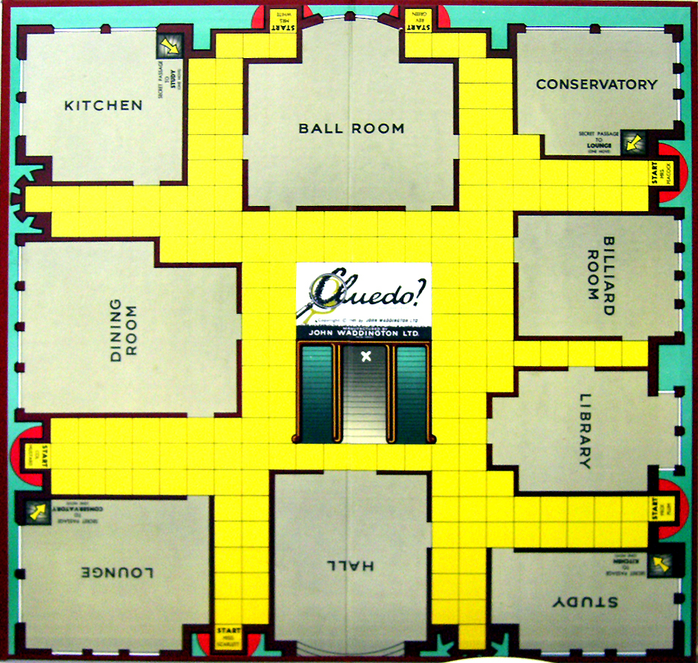
[1] [2] [3]
School of Applied Computing | Assignment Title:  Prototyping and Testing | Code: ACCB6017
Module:
Usability Engineering

Student:  Theresa Darzins  No 1909721 | Programme: Computing Portfolio  BSc/HND Computing | Lecturer:  Dr. Nik Whitehead  Date: 24th March 2023

Contents
1.0 INTRODUCTION 1
1.1 Aim 1
1.2 Objectives 1
1.3 Structure of Report 1
2.0 TASK 1 – Twitter vs Mastodon Short Report 2
2.1 Similarities 2
2.2 Differences 3
2.3 Target Group Overlap 4
2.4 Significant Elements of Psychology, Usability, Design 5
2.5 What Does Not Work Well in Each? 6
2.6 What Works Well in Each? 7
2.7 Copyright Issues 8
3.0 TASK 2 – UWTSD Cluedo 9
3.1 What is UX/UI User Experience? 9
3.2 UX Design Process Flow Chart 10
3.3 Gather Requirements 11
3.3.1 People and Materials Needed to Play 11
3.3.2 Rules of the Game 11
3.3.3 User and Experience Requirements 11
3.3.4 Not all Users Able-bodied 12
3.4 Analyse Requirements 13
3.4.1 Overall Usability Requirements 13
3.4.2 UWTSD Cluedo MoSCoW Chart 13
3.5 Questions 14
3.5.1 Usability vs Playability Goals 14
3.5.2 How to Aid Deaf/Hard of Hearing Users 15
3.5.3 How to Aid Visually Impaired Users 15
3.6 Information Architecture 15
3.6.1 Card Sorting 16
3.6.2 Cards Arranged into Preliminary Site Plan 17
3.7 Site Map with Links 18
3.7.1 Flow Chart – Navigation of App 19
3.7.2 Game – Flow Chart Cognitive Walkthrough 21
3.8 Wireframes 23
3.9 Prototype 23
3.10 Usability Testing 23
3.10.1 Usability Analysis For Game 23
3.10.2 How Information Gathered to Support Design of Personas 24
3.10.3 Form for Screening Four Usability Candidates 25
3.10.4 Summary of Four Personas Chosen and Why 26
3.10.5 How Feedback Collected 26
3.10.6 Results of Focus Group Held 27
3.10.7 User Requirements/Experience Discovered 27
3.10.8 How Ensured Users Covered Personas Defined 28
3.10.9 Usability/Emotional Responses 28
3.10.10 Expected 30
3.10.11 Unexpected 30
3.10.12 Post-Test Questionnaire 30
3.10.13 Summary of Problems/Remedial Actions Taken or Considered 32
3.10.14 Action List 34
4.0 CONCLUSION 35
4.1 Twitter Vs Mastodon 35
4.2 UWTSD Cluedo 35
4.2.1 Disability Aids Help All 35
4.2.2 Social 36
4.2.3 Future Development 36
4.2.4 Balance Game between too easy and too hard 37
5.0 REFERENCES 38
6.0 APPENDIX 42
6.1 Gather Requirements 42
6.1.1 People and Materials Needed to Play 42
6.1.2 Rules of the Game 42
6.1.3 UWTSD Cluedo Board 48
6.1.4 UWTSD Cluedo Clue Sheet 50
6.2 Analyse Requirements 51
6.2.1 MoSCoW User Requirements for UWTSD Cluedo Mobile App 51
6.3 Design of UX Drawings for UWTSD Cluedo 54
6.3.1 Overview 54
6.3.2 Detailed Game Play Instructions ‘Chunked’ 55
6.3.3 Wireframes 60
6.4 Usability Testing 77
6.4.1 User Selection Forms 77
6.4.2 User Consent Form 81
6.4.3 User Questionnaire Post-Test 82

Table 1 Structure of Report 1
Table 2 Similarities between Twitter and Mastodon 2
Table 3 Differences between Twitter and Mastodon 3
Table 4 Reasons to Migrate from Twitter to Mastodon and vice versa 4
Table 5 Significant elements of Psychology, Usability, Design 5
Table 6 What does not work well in each 6
Table 7 Features in each that work well 7
Table 8 Copyright Issues 8
Table 9 Overall Usability Requirements 13
Table 10 UX vs PX 14
Table 11 Cognitive Walkthrough of Site Navigation 20
Table 12 Cognitive Walkthrough of Game 22
Table 13 Form for Screening Usability Candidates 25
Table 14 Summary of Four Personas Chosen 26
Table 15 How Feedback Collected 26
Table 16 Post-Test Questionnaire Results 31
Table 17 Standard Score Ratings 31
Table 18 Summary of Problems/Remedial Actions 32
Table 19 Example Cluedo Clue Sheet 45
Table 20 How the UWTSD Board differs from Classic 49
Table 21 MoSCoW User Requirements for Cluedo Mobile App 51
Table 22 Register/Logon 60
Table 23 Home Page/Site Map 61
Table 24 Overview 62
Table 25 Discover People 63
Table 26 Settings; Discovery, Notifications, Payments 64
Table 27 Message 65
Table 28 Profile and Password Reset 66
Table 29 Invite and Book 67
Table 30 Events Calendar 68
Table 31 Play Game 69
Table 32 UWTSD Location 73
Table 33 E Mail Us 74
Table 34 Products 75
Table 35 User Support 76

Figure 1 UX/UI User Experience 9
Figure 2 UX Design Process Flow Chart 10
Figure 3 Initial Card Sorted 16
Figure 4 Cards sorted into rough site plan 17
Figure 5 Final Site Map 18
Figure 6 Flow Chart – Navigation of App 19
Figure 7 Game - Flow Chart Cognitive Walkthrough 21
Figure 8 Action List 34
Figure 9 Board Game Mock-up 48
Figure 10 Register/Logon 60
Figure 11 Home Page/Site Map 61
Figure 12 Overview 62
Figure 13 Discover People 63
Figure 14 Settings; Discovery, Notifications, Payments 64
Figure 15 Message 65
Figure 16 Profile and Password Reset 66
Figure 17 Invite and Book 67
Figure 18 Events Calendar 68
Figure 19 Play Game (1) Intro – 1 of 8 69
Figure 20 Play Game (2) Board and (3) Clue Sheet 70
Figure 21 Play Game(4) Card Reveal (5) Question Card (6) Accuse 71
Figure 22 Play Game (7& Alternate 7) Winner/Out (8) Won! 72
Figure 23 UWTSD Location 73
Figure 24 E Mail Us 74
Figure 25 Products 75
Figure 26 User Support 76

INTRODUCTION

Aim

Research and evaluate cognitive and social information processing.

Objectives

    - Select, apply and analyse critically, interface evaluation techniques.
    - Synthesise complex design solutions, based on usability engineering and software development.
    - Critically assess input/output hardware for specialised applications, e.g., for disabled people and 3D modelling applications.

Structure of Report

Table 1 Structure of Report
No. | Chapter Name
1 | Introduction
2 | Task 1 | Twitter Vs Mastodon – Short Report
3 | Task 2 | UWTSD Cluedo UX – User Experience
4 | Conclusion
5 | References
6 | Appendix | - Gather Requirements  Requirements & Rules  - Analyse Requirements  MoSCoW Chart  - Design of UX Drawings  Chunked Rules  Wireframes  - Usability Testing  Test Subject Forms  Questionnaire Post-Test

TASK 1 – Twitter vs Mastodon Short Report

Similarities

Table 2 Similarities between Twitter and Mastodon
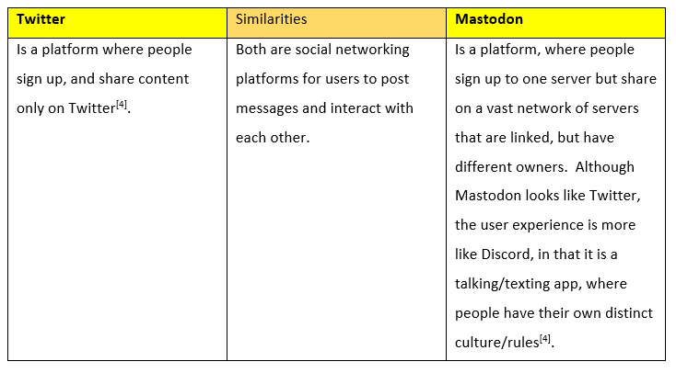

2.2 Differences

The differences in their design impacts their useability:
Table 3 Differences between Twitter and Mastodon
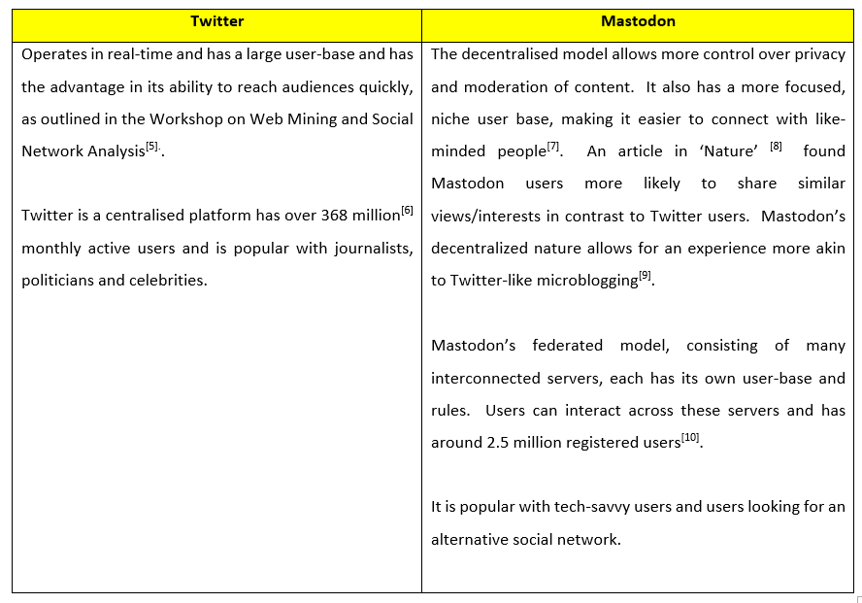

Target Group Overlap

Table 4 Reasons to Migrate from Twitter to Mastodon and vice versa
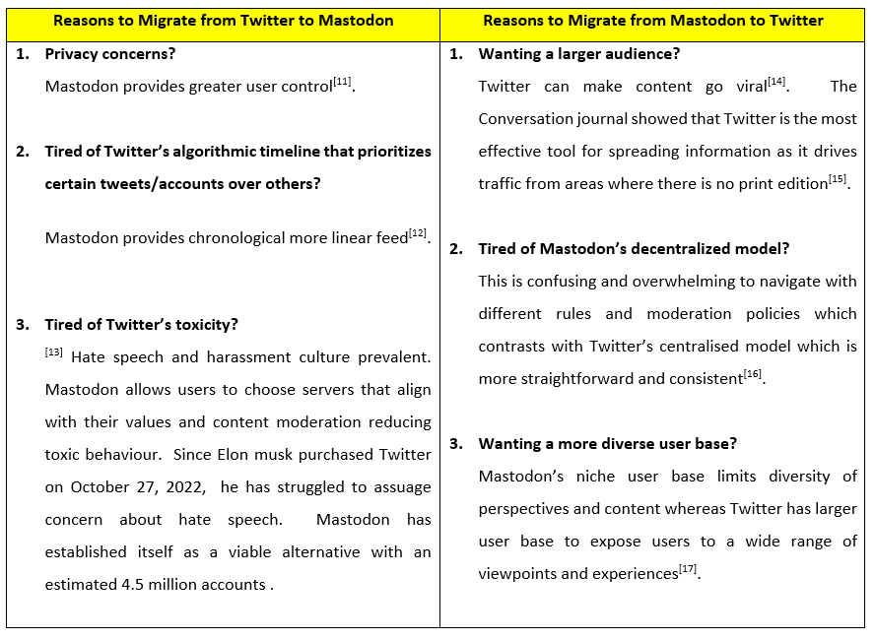

Significant Elements of Psychology, Usability, Design

Table 5 Significant elements of Psychology, Usability, Design
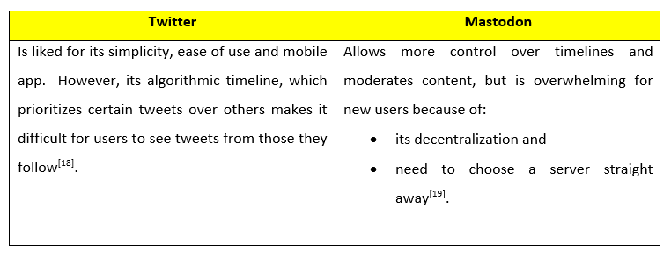

2.5 What Does Not Work Well in Each?

Table 6 What does not work well in each
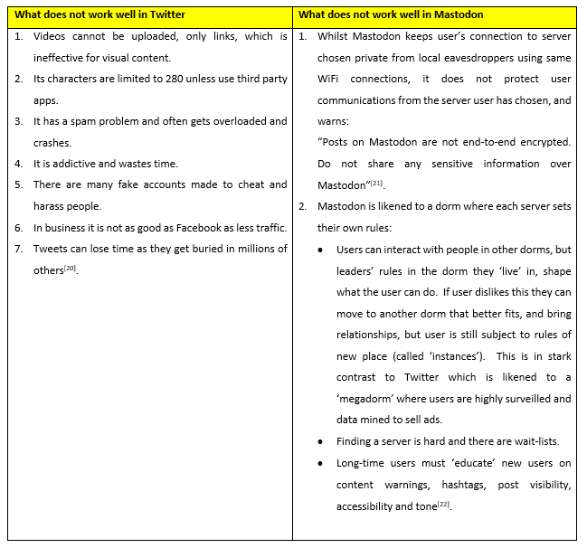

2.6 What Works Well in Each?

Table 7 Features in each that work well
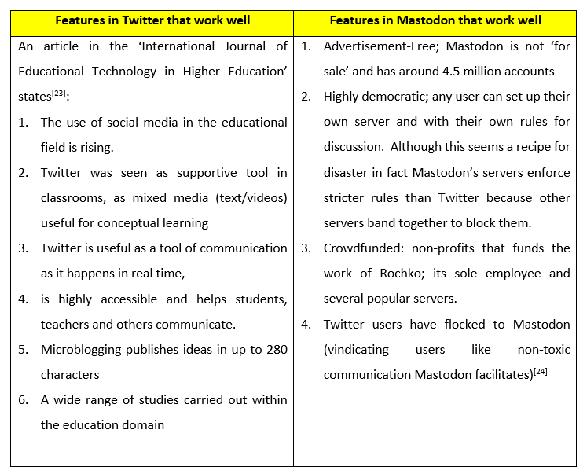

2.7 Copyright Issues

Table 8 Copyright Issues
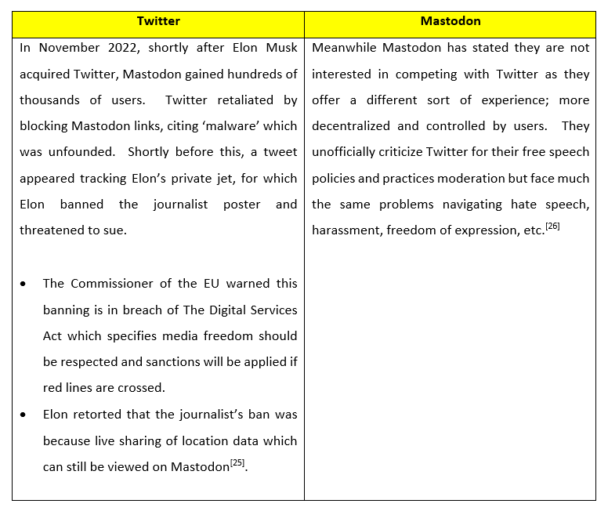

3.0 TASK 2 – UWTSD Cluedo

The task is to develop a UWTSD Cluedo Game suitable for Mobile use, showing the UX/UI Experience.

3.1 What is UX/UI User Experience?

UX (user experience) and UI (user Interface)^{[27]}:
- have specific requirements each,
- but also have some things in common.

For the purposes of this preliminary report UX covered as UI will be covered in a further report.
Figure 1 UX/UI User Experience
^{[27]}
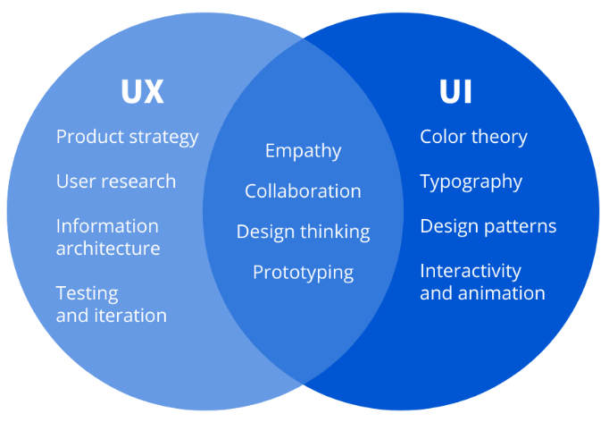

3.2 UX Design Process Flow Chart

To map out the process the author has used the following UX Design Process:
^{[28]}
Figure 2 UX Design Process Flow Chart
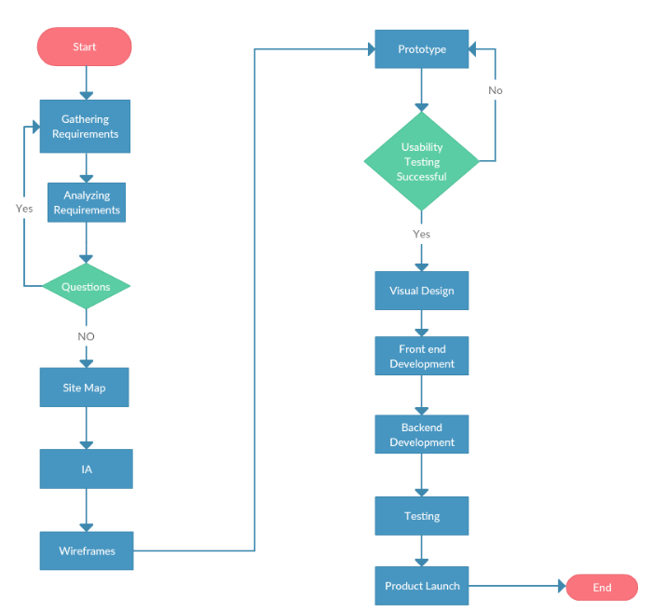

This report will focus only up to ‘usability testing successful Y/N?’ as the remainder will be covered under a future report.

3.3 Gather Requirements

3.3.1 People and Materials Needed to Play
See Appendix.

3.3.2 Rules of the Game
See Appendix.

3.3.3 User and Experience Requirements
      - How Game needs to be structured for ease of use:
- Ensure there are always back buttons on every screen to undo actions.
- Ensure the user always in no doubt how to progress.
- Ensure voice-over dialogue visible, when allowed by rules of game (when cards revealed, reveal only to suggester).
- Ensure voice over can be lowered/muted if required.
- Ensure the written dialogue can be minimised if not needed.
- Ensure zoom function can be enabled if required.
- Ensure once a button pressed it makes a noise like a click to validate it has been clicked, as well as go to the screen clicked on.

      - Information that is location-sensitive:
- Ensure that game actions that cannot be processed have a warning:
i.e.,
“You are not in --- location; this command is invalid”,
or
“it is not your turn, it is ---‘s turn”, etc.

      - How Does this fit into the App?
- This fits into the app to help all users, not only disabled.
- If it were irritating to user, have option to turn off voice over and just see written dialogue

3.3.4 Not all Users Able-bodied
Pre-empting those users who have issues with:
- Sight
- Hearing
- Other – i.e., dexterity, learning impairment, autism, ageing, recovering from operations, etc.
will also make the app more user-friendly for all ^{[29]}.

Disability affects around 14.1 million people in the U.K.: ^{[30]}.
- 19% are of working age
- 44% are retired.

New public sector web sites must meet WCAG 2.1 level AA standards using the GDS guidelines. Things that help compliance are as simple as:

- Giving ‘Alt Text’ descriptive titles to images to help blind people using screen readers decipher.
- Putting periods in abbreviations (i.e., C.I.A.) helps transcription.
- For those with colour-blindness (8% men and 0.3% of females) try to never put yellow/blue/green next to each other.
- Describe link buttons (not ‘click here’).
- Make links clickable - space as widely apart as possible.
- Contrast (pale colours need black words and dark ones need white).
- Keep copy as simply worded as possible.

3.4 Analyse Requirements

3.4.1 Overall Usability Requirements
Table 9 Overall Usability Requirements
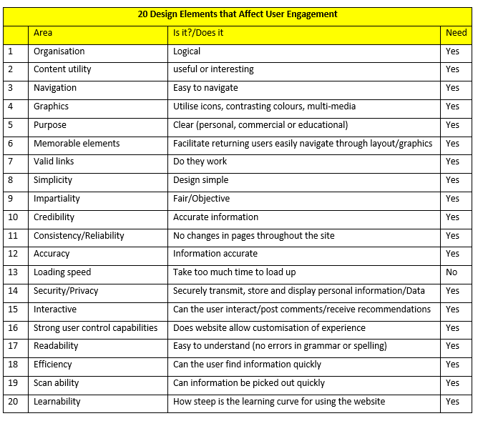
^{[31}

3.4.2 UWTSD Cluedo MoSCoW Chart
See Appendix.

3.5 Questions

3.5.1 Usability vs Playability Goals
Considering the differences in Objectives of ^{[32]}:
- Player Experience vs
- User Experience
is ‘Playability’ usability?
Table 10 UX vs PX
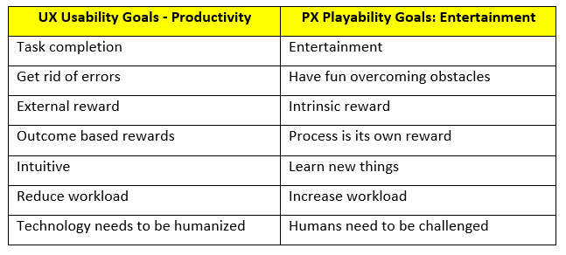

Even though there are different goals in each category, it was found that yes, playability can be linked heavily to usability^{[33]}.

3.5.2 How to Aid Deaf/Hard of Hearing Users
By having most* of the voice over dialogue on top of the ‘tick a tape screen’ to read.
*Some voice overs only to specific players must be omitted to others, as per rules of the game on revealing correctly suggested cards solely to the suggester. However, the voice over to the deaf/hard of hearing must say name(s) of person(s) revealing a card(s), which also helps the visually impaired users too.

3.5.3 How to Aid Visually Impaired Users
By making a window within the window able to zoom in and out, for all users, for their own screens, with overview of the whole board still visible, so can always still see the ‘big picture’.

3.6 Information Architecture

To support user research, end-to-end, the following needed to be carried out^{[34]}:

3.6.1 Card Sorting
Conceptualise, group, and label to gain insights to users’ mental models enabling understanding of necessary structure.
Figure 3 Initial Card Sorted
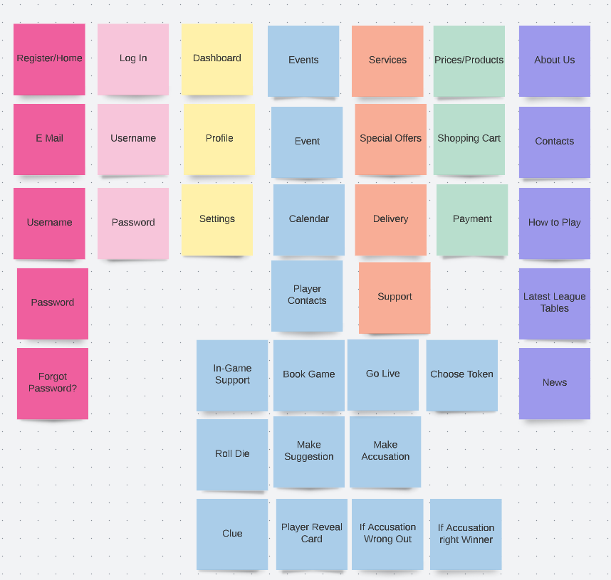
^{[35]}

3.6.2 Cards Arranged into Preliminary Site Plan

Figure 4 Cards sorted into rough site plan
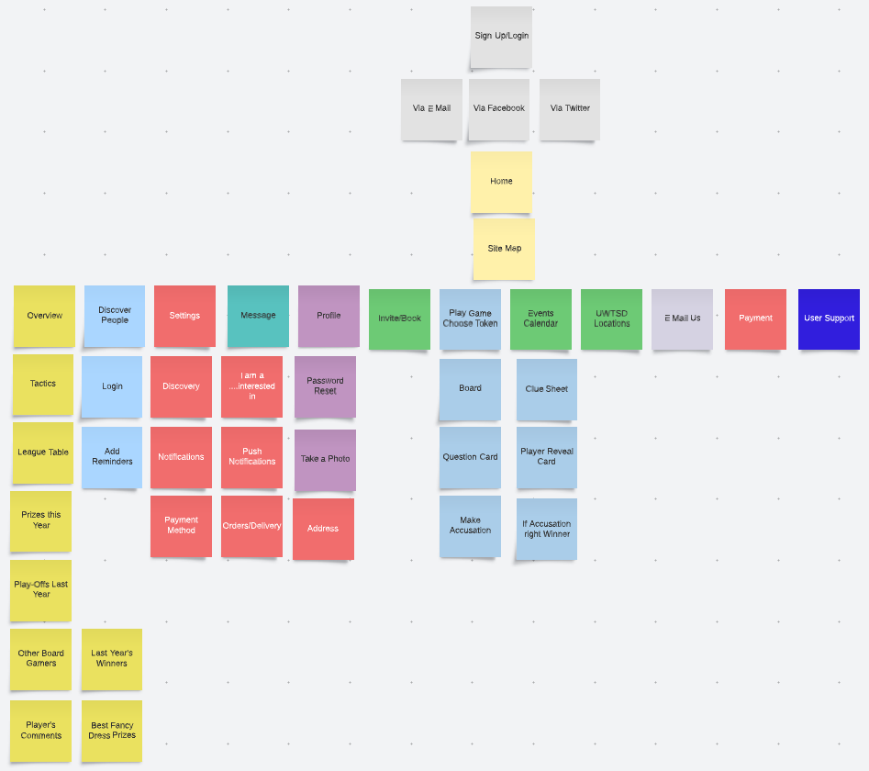
^{[35]}
]

3.7 Site Map with Links

Figure 5 Final Site Map
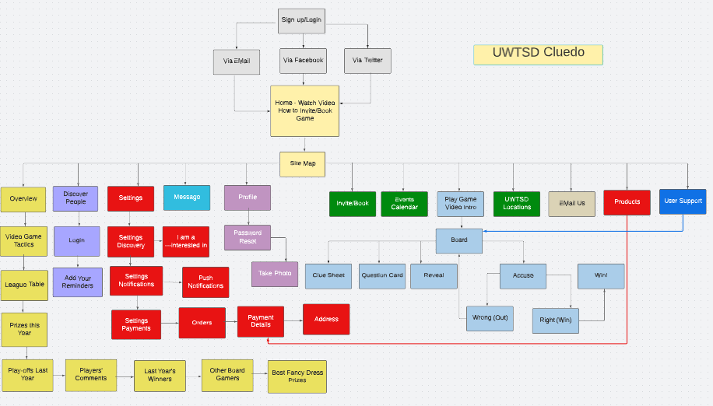
^{[35]}

3.7.1 Flow Chart – Navigation of App
^{[36]}
Figure 6 Flow Chart – Navigation of App
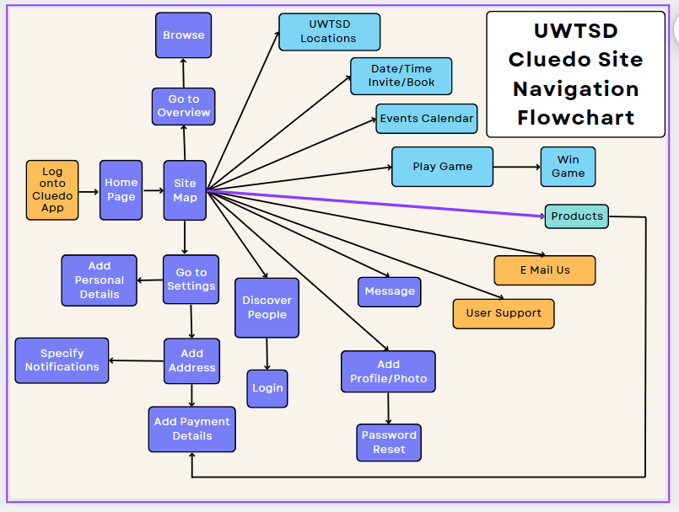
Table 11 Cognitive Walkthrough of Site Navigation
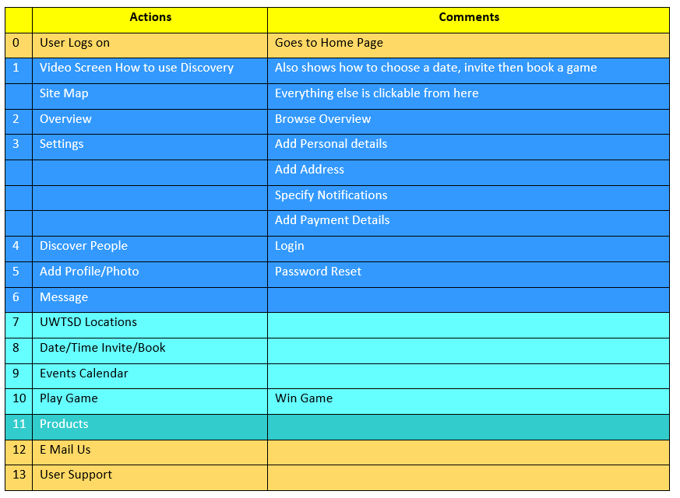

3.7.2 Game – Flow Chart Cognitive Walkthrough
^{[36]}
Figure 7 Game - Flow Chart Cognitive Walkthrough
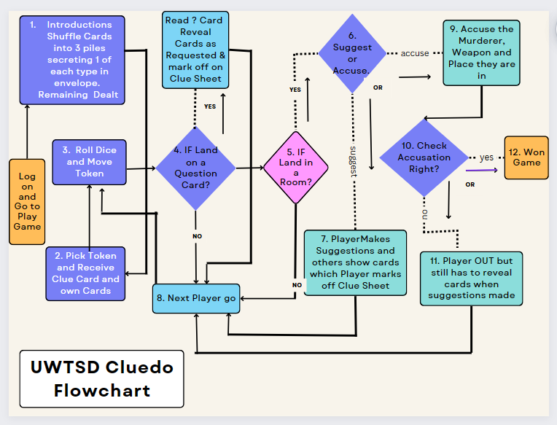

Table 12 Cognitive Walkthrough of Game
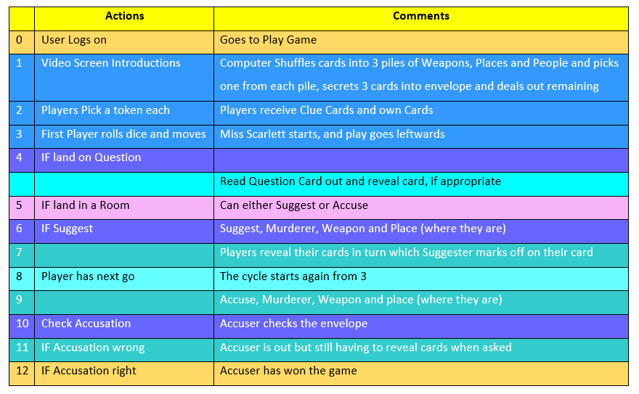

3.8 Wireframes

See Appendix.

3.9 Prototype

Final prototype will be made available after testing completed and all changes agreed.

3.10 Usability Testing

Users cannot be designers and designers cannot be users. Although they fulfil complementary roles, they are fundamentally different^{[37]}:
- Users define the problems
- Designers create solutions to those problems
The user must be put at the centre, with the designer able to empathise to create an effective product.

3.10.1 Usability Analysis For Game
The following categories must be put to good use, to facilitate usability^{[38]}:
- Simple dialogue
- Speak in user’s language
- Minimise memory load
- Be consistent
- Provide feedback
- Provide exits clearly marked
- Provide shortcuts
- Give good error messages
- Prevent errors

3.10.2 How Information Gathered to Support Design of Personas
The form overleaf posted online on University Intranet, and author selected users according to the last column requirements^{[39]}.

For the forms of the four users chosen, please see Appendix.

3.10.3 Form for Screening Four Usability Candidates
Table 13 Form for Screening Usability Candidates
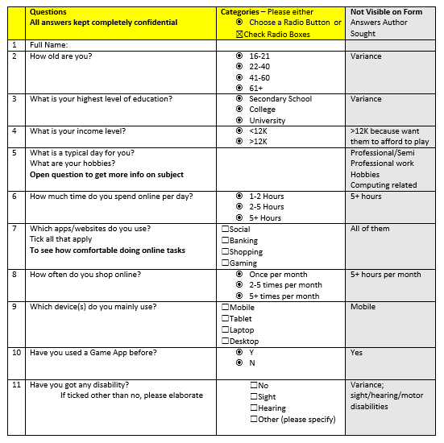
^{[39]}

3.10.4 Summary of Four Personas Chosen and Why
Table 14 Summary of Four Personas Chosen
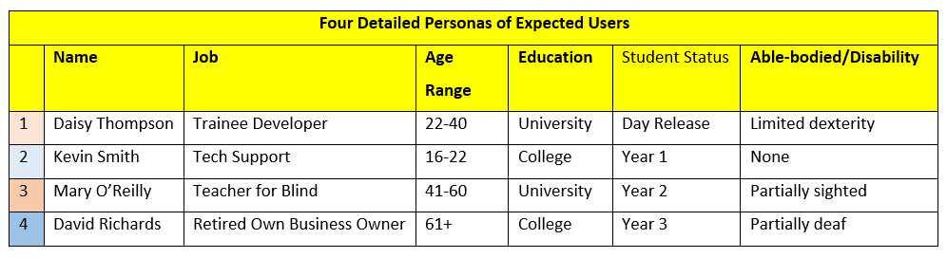

3.10.5 How Feedback Collected
The ‘think aloud’ protocol was used. Because participants videoed, a consent form was signed, and the experiment was structured thus:
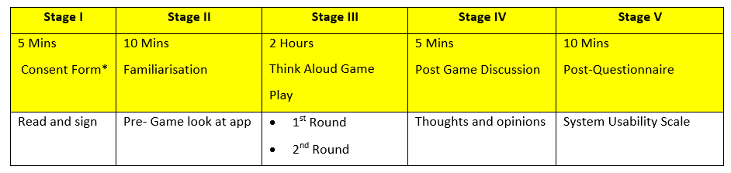
Table 15 How Feedback Collected

* Consent form in Appendix.
Any questions they asked during the game were side-stepped, until participants, either figured them out themselves, or author made note of something needed that wasn’t there.

3.10.6 Results of Focus Group Held
Booking; there was a small amount of confusion when the date had to be decided first, and invite after so the wording changed. Also, a video of how to choose date and time, invite people, then book, was put on the home page.
In the ‘Overview’ Section; the video on How to Play a Better Game helped, as it:
- was a refresher, outlining rules,
- indicated which controls to use for which situations,
- had warnings of what not to do (i.e., share your screen with wrong player(s),
- David found the written commentary across the top was useful as hard of hearing.
- Kevin, Daisy and Mary found the written commentary sometimes distracting, so the option to turn it off was added.
- Mary said the option to play on an iPad rather than phone would have been much more user-friendly although on the iPhone it was just about workable, but not that enjoyable, due to her sight limitation. She liked the zoom option as it was difficult to see the weapons and asked could these be made bigger? This was put into a ‘to do’ list as she made a good point. Although zoom worked, she said it slowed down her game.
- Daisy used a stylus pointer to press the symbols, as had dexterity issue. She said the written commentary would be useful for when she was in noisy environment, but liked the option to switch off, when screen size too small.

3.10.7 User Requirements/Experience Discovered
Regarding the voice-over Kevin asked if there could be an option for the inviter to oversee the game instead. This was put in the ‘to do’ list as a good suggestion for more confident players.
Mary, Daisy and David preferred to have the computer voice- over, as it left them free to concentrate .
The option to change the voice style was discussed but a consensus could not be reached. The younger two wanted Darth Vader’s voice and the older two warned players would tire of that even sooner. It was decided to add this voice change as an option to be added to Sprint 2 as it was creating a lot of laughter so would attract more users.

3.10.8 How Ensured Users Covered Personas Defined
Those chosen because they were:
- Hobby Gamers
- Mainly use Mobiles
- Confident Tech users
And diverse in:
- Age ranges
- Education levels
- Physical abilities

3.10.9 Usability/Emotional Responses
User involvement is key to design-thinking success. An empathetic approach significantly affects the impact of a product’s development. Frequently the bestsellers are not first releases, but those appealing to users emotionally and functionally. Designers’ empathetic approach leads to superior products, as they observe things that others might miss. These insights spark innovation and good design creates customer loyalty^{[40]}.

Test Results:
Once users had played 1 round, in the next round they made suggestions every time able to, and more accusations were forthcoming as they gained confidence (sometimes misplaced!).

Although the question cards were initially perceived as ‘treats’ they were very soon revealed to be the opposite, which resulted in much mirth from the player’s opponents – Schadenfreude!

After Game Discussion
The consensus overall, was that it was simple to use, but would be better suited to a larger screen such as an iPad because of:
- the closeness of controls at the bottom of the Play Game screen.
- the squeezing up of the Board when needed to see written commentary.

Participants requested lists of users to be grouped according to their study area to meet up with others on same course . This was noted as an extra field needed when form filling in Discovery to enable sorting.

Beginner in-Person Classes in the Café or Library were also suggested to combat loneliness, and aid mental health and wellbeing. It was also seen as a good way to promote the Computing Course at UWTSD.

Daisy, Kevin and Mary were enthusiastic to be able to connect with course compatriots in this way to have a ‘non-work’ excuse to socialise that didn’t involve going down the pub, but David asked, ‘couldn’t we all go down the pub and play it anyway!’.
When the overall purpose of the game discussed, it was seen as:
- A useful tool to connect with others to help with mental health.
- A way to promote UWTSD’s computing capabilities.
- An exercise in to how to build a gaming app at beginner level.

3.10.10 Expected
- The game was perceived as somewhat tedious when no one was able to suggest as not yet in a room.
- Extra care had to be taken when choosing player to reveal card to (drop down menu) in order not to reveal to wrong player.
- Players unsure if their microphone automatically muted when this was happening and play experience confirmed it was.
- However, the share screen wasn’t automatically chosen; players had to pick who to share with and then stop sharing once .

3.10.11 Unexpected
- Kevin became slightly bored, and remarked UWTSD Cluedo not as exciting as other games he had played online previously. To remedy this, it was decided to up the Prize money to make it more attractive.
- Daisy suggested we do monthly small prize to fastest winner of a Fancy Dress of their choice. This was seen as good incentive to keep players interested and noted for the next agile sprint.

3.10.12 Post-Test Questionnaire
- Individual System Usability Scale Questionnaires shown in Appendix.
- The average score indicated the software was in the mid-region of Good at 76. A score of 80.3 would have to be achieved to rank it as excellent.

Table 16 Post-Test Questionnaire Results
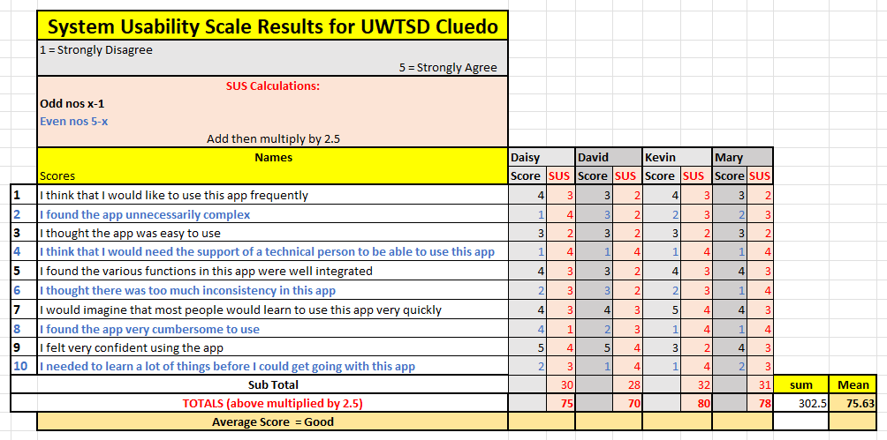
^{[41]}

Table 17 Standard Score Ratings
^{[41]}
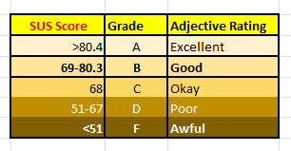

3.10.13 Summary of Problems/Remedial Actions Taken or Considered

Table 18 Summary of Problems/Remedial Actions

Regarding | Problem | Remedied/To be Remedied/Remedy Considered
Usability Test
Invite/Book | Players did not realise had to choose date/time first | - Reworded page to Choose Date/Time, Invite, then book  - Highlighted Video ‘How to Invite/Book’ on Home Page
Rules | Players disagreed on Rules | - Highlighted Video ‘How to Play’ on Overview Page  - Computer interjects if rules broken
Written Commentary | Some players found it distracting | - Toggle button for Commentary on/off  - Hard of Hearing/Deaf users liked and users in noisy environment
Weapons | Too small to see | - Optional button added for Zoom  - Make weapons bigger in next sprint
Voice Over | A bit annoying | - Add options for different voices - funny to increase users  i.e., Darth Vader, Donald Duck, Chandler Bing/Ross from Friends, Big Bang Theory characters, etc.  - Voice over Toggle on/off
Reveal Card | Sometimes Players made mistake in drop down | - Make suggesting Player automatically the only one to see  - Take it out of Player’s hands and computer shows Suggester
Discover People | Players wanted to first contact those on their course | - Add a ‘Course’ field in Discovery to enable Player to sort  - Make Beginner In-Person Sessions available monthly
Incentives | Players wanted incentives | - Make Tournament Winner Prize Sizeable (£1,000)  - Make Monthly Prize a Fancy Dress of their choice (£20-30)

Cont’d/…

Regarding | Problem | Remedied/To be Remedied/Remedy Considered
Post-Test
Confidence | Half were not confident | - Fully computerise Reveal Card so computer does instead of user choice from drop down menu*.  - Make the app easier to use:  i.e., voice activated when moving tokens; i.e., 2 forward 3 left*.
Consistency | Some inconsistencies | - Minimise the Logo so it could be put in same place on every screen.  - Give Site a more consistent scheme

* Bearing in mind, balance is essential, as by reducing cognitive load, game may no longer be seen as sufficiently challenging^{[42]}.

3.10.14 Action List
Figure 8 Action List
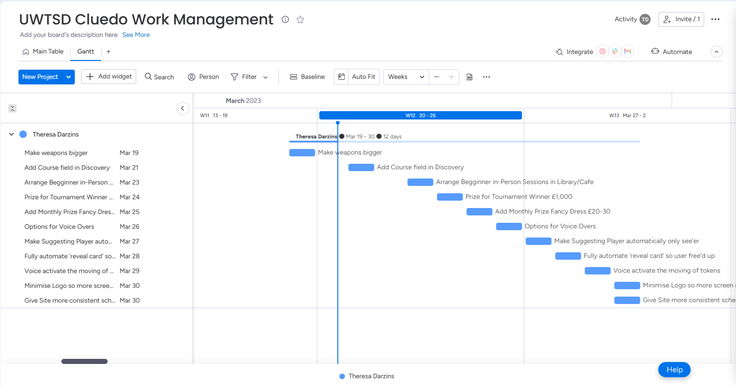
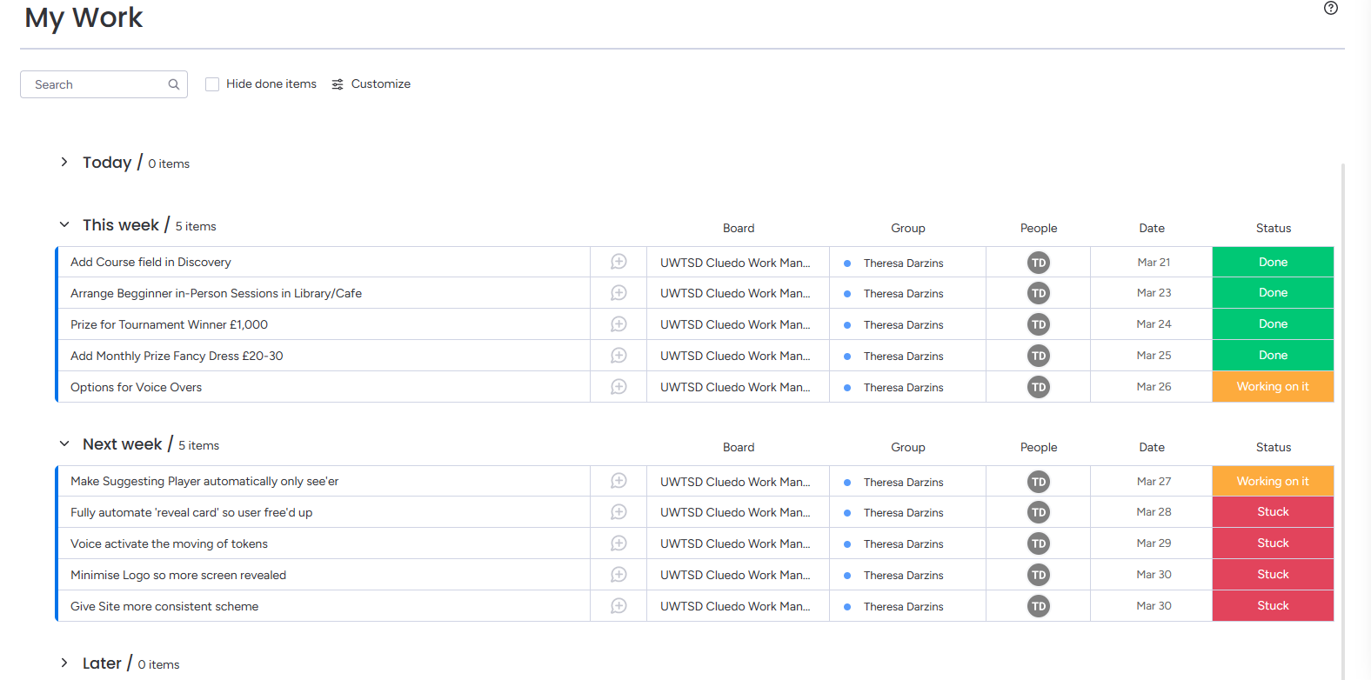
^{[43]}

4.0 CONCLUSION

4.1 Twitter Vs Mastodon

Whilst Twitter and Mastodon are both social media platforms, Twitter appeals more to those wishing to connect with the world in general, whereas Mastodon appeals to those wanting a more specialised connection to specific groups.

Twitter is still dominant, but Mastodon is catching up, despite its unwieldy way of onboarding, having to choose a server before being able to browse.

With Elon Musk using Twitter as his own personal platform, it will be interesting to see whether EU regulators will bite, as they threatened to do, when he tried to stifle free speech last year. It is hoped that copyright issues will resolve themselves considering the aforementioned.

4.2 UWTSD Cluedo

4.2.1 Disability Aids Help All

The aids to help disabled were useful for able-bodied users as well, as:
- Written commentary could be read across screen so not disturbing others when playing
- Written commentary could be read across screen when user in a noisy environment and cannot hear.
- Zoom function helps people see things on the small screen when playing on iPhones.

4.2.2 Social

The game was seen as healthy way to connect with other students without it being all about studying.
Students wished to contact first, those on their course, to see if connection possible, before venturing further.
It was felt having a game like this specifically connected to the university, would:
- Aid in mental health and wellbeing.
- Be a useful way to promote computing at UWTSD.
- Show a how a game is built at beginner level.
Incentives Suggested for next Agile Sprint for Players to play the game:
- Make the Discovery lists able to be grouped/sorted by Course
- Make the Annual prize sufficiently tempting (£1,000)
- Give a monthly Fancy Dress prize for fastest Player of the Month (£20-30)
- Hold Beginner Games in groups, in person, at regular intervals in Café/Library
- Written commentary on was also useful to non-disabled players, so can play in crowded area without disturbing others.

4.2.3 Future Development

Software SUS Score
The average ranking achieved was 75.6 which, being at the middle of Good could still be improved upon.

Compliance with WCAG 2.1
Ensure App follows disability legislation.

4.2.4 Balance Game between too easy and too hard
Although usability equates to playability, the game must straddle either side of a knife-edge whereby:
- one side involves retaining sufficient challenges for player enjoyment

and the other involves

- taking away some of the tasks to make the game user-friendly
This is a dilemma for the Designer to solve, as:
- Designers cannot take on the role of Players and Players cannot take on the role of Designers.

5.0 REFERENCES

[1] | “Small Twitter Logo - LogoDix,” logodix.com. https://logodix.com/small-twitter (accessed Feb. 27, 2023).‌
[2] | “Yahoo Search - Web Search,” uk.search.yahoo.com. https://uk.search.yahoo.com/yhs/search
[3] | “Clue Game Board 1965 Cluedo by JDWinkerman on DeviantArt,” www.deviantart.com. https://www.deviantart.com/jdwinkerman/art/Clue-Game-Board-1965-Cluedo-585962962 (accessed Feb. 27, 2023).‌
[4] | “What Is Mastodon and Why Are People Leaving Twitter for It?,” The New York Times, 2022. Available: https://www.nytimes.com/2022/11/07/technology/mastodon-twitter-elon-musk.html‌
[5] | A. Java, T. Finin, X. Song, and B. Tseng, in 9th KDD & 1st SNA KDD 2007 Workshop on Web Mining & Social Network Analysis, pp. 56–65. Available: https://www.researchgate.net/publication/234786863_Why_we_Twitter_Understanding_microblogging_usage_and_communities
[6] | “Twitter: number of users worldwide 2024,” Statista. Twitter: number of users worldwide 2024 | Statista (accessed Feb 27, 2023)
[7] | R. W. Gehl and D. Zulli, “The digital covenant: non-centralized platform governance on the mastodon social network,” Information, Communication & Society, pp. 1–17, Dec. 2022, doi: https://doi.org/10.1080/1369118x.2022.2147400.‌
[8] | C. Stokel-Walker, “Should I join Mastodon? A scientists’ guide to Twitter’s rival,” Nature, Nov. 2022, doi: https://doi.org/10.1038/d41586-022-03668-7.‌
[9] | A. Z. Rozenshtein, “Moderating the Fediverse: Content Moderation on Distributed Social Media,” papers.ssrn.com, Nov. 23, 2022. https://ssrn.com/abstract=4213674  (accessed Mar. 01, 2023).
[10] | S. Silverman, “Mastodon Social Reaches 2.5 Million Users Amid Twitter Shakeup,” Entrepreneur, Dec. 21, 2022. https://www.entrepreneur.com/business-news/mastodon-social-reaches-25-million-users-amid-twitter/441586 (accessed Feb. 27, 2023)
[11] | C. C. and R. Mir, “The Fediverse Could Be Awesome (If We Don’t Screw It Up),” Electronic Frontier Foundation, Nov. 16, 2022. https://www.eff.org/deeplinks/2022/11/fediverse-could-be-awesome-if-we-dont-screw-it (accessed Feb. 27, 2023).
[12] | A. Barry, “Could Mastodon take over from Twitter - and how do you join?,” TheJournal.ie. https://www.thejournal.ie/what-is-mastodon-and-how-do-i-join-it-ireland-5912976-Nov2022/ (accessed Mar. 01, 2023).‌

[13] | Sheth, V. L. Shalin, and U. Kursuncu, “Defining and detecting toxicity on social media: context and knowledge are key,” Neurocomputing, vol. 490, Dec. 2021, doi: https://doi.org/10.1016/j.neucom.2021.11.095
[14] | G. Pressgrove, B. W. McKeever, and S. M. Jang, “What is Contagious? Exploring why content goes viral on Twitter: A case study of the ALS Ice Bucket Challenge,” International Journal of Non-profit and Voluntary Sector Marketing, vol. 23, no. 1, p. e1586, Aug. 2017, doi: https://doi.org/10.1002/nvsm.1586.‌
[15] | J. Jewell, “How Twitter has helped the emergence of a new journalism,” The Conversation. https://theconversation.com/how-twitter-has-helped-the-emergence-of-a-new-journalism-19841‌
[16] | “People are leaving Twitter for Mastodon. But not everyone is convinced it’s the best alternative — yet.,” NBC News. https://www.nbcnews.com/tech/mastodon-social-media-twitter-rcna56288 (accessed Mar. 1, 2022).‌
[17] | “They traded Twitter for Mastodon Social. Now what?,” Washington Post. Accessed: Mar. 01, 2023. [Online]. Available: https://www.washingtonpost.com/technology/2022/11/05/twitter-replacement-mastodon-social-reviews/‌
[18] | J. Bagrow and L. Mitchell, “Do social media algorithms erode our ability to make decisions freely? The jury is out,” The Conversation, Oct. 12, 2020. https://theconversation.com/do-social-media-algorithms-erode-our-ability-to-make-decisions-freely-the-jury-is-out-140729
[19] | A. Silberling, “A beginner’s guide to Mastodon, the open-source Twitter alternative,” TechCrunch, Nov. 08, 2022. https://techcrunch.com/2022/11/08/what-is-mastodon (accessed Mar. 01, 2023).
[20] | https://www.facebook.com/Science.online.1/?ref=bookmarks, “The advantages and disadvantages of Twitter | Science online,” Science online, May 30, 2015. https://www.online-sciences.com/technology/the-advantages-and-disadvantages-of-twitter/ (accessed Mar. 1, 2023).‌
[21] | B. Budlington, “Is Mastodon Private and Secure? Let’s Take a Look”, Electronic Frontier Foundation. Is Mastodon Private and Secure? Let’s Take a Look | Electronic Frontier Foundation (eff.org)
[22] | B. C. Keegan, “What is Mastodon? A social media expert explains how the ‘federated’ network works and why it won’t be a new Twitter,” The Conversation. https://theconversation.com/what-is-mastodon-a-social-media-expert-explains-how-the-federated-network-works-and-why-it-wont-be-a-new-twitter-194329 (accessed Mar. 02, 2023).
[23] | A. Malik, C. Heyman-Schrum, and A. Johri, “Use of Twitter across educational settings: a review of the literature,” International Journal of Educational Technology in Higher Education, vol. 16, no. 1, Sep. 2019, doi: https://doi.org/10.1186/s41239-019-0166-x.‌

[24] | “Twitter Rival Mastodon’s Founder Has a Vision for Democratizing Social Media,” Time. https://time.com/6229230/mastodon-eugen-rochko-interview/ (accessed Mar. 06, 2023).
[25] | “Twitter blocks users from sharing Mastodon links,” BBC News, Dec. 16, 2022. Accessed: Mar. 22, 2023. [Online]. Available: https://www.bbc.co.uk/news/technology-63999452 (accessed Mar. 22, 2023)‌
[26] | “Mastodon,” joinmastodon.org. https://joinmastodon.org/ [Online] (accessed Mar. 22, 2023)‌‌
[27] | Coursera, “UI vs. UX Design: What’s the Difference?,” Coursera, 2022. https://www.coursera.org/articles/ui-vs-ux-design (accessed Mar. 06, 2023)
[28] | “Behance,” www.behance.net. https://www.behance.net/gallery/38712069/UIUX-Process (accessed Mar. 05, 2023).
[29] | S. Krug, Don’t Make Me Think. Pearson Education, 2009.
[30] | “Accessibility Testing,” Ten10. https://ten10.com/accessibility-testing (accessed Mar. 18, 2023).
[31] | R. Garett, J. Chiu, L. Zhang, and S. D. Young, “A Literature Review: Website Design and User Engagement,” Online journal of communication and media technologies, vol. 6, no. 3, pp. 1–14, 2016, Available: https://www.ncbi.nlm.nih.gov/pmc/articles/PMC4974011/‌
[32] | G. Sanchez, P. Zea, and N. Guiterrez, “From usability to playability Introduction to Player-centered video game development process,” Springer. Available: https://link.springer.com/ chapter/10.1007/978-3-642-02806-9_9
[33] | D. Pinelle, N. Wong, and T. Stach, “Heuristic evaluation for games: usability principles for video game design,” in Proceedings of the SIGCHI Conference on Human Factors in Computing Systems, pp. 1453–1462 ACM 2008. Available: https://Heuristic evaluation for games | Proceedings of the SIGCHI Conference on Human Factors in Computing Systems (acm.org)‌
[34] | “What Is Optimal Workshop?,” Optimal Workshop. https://www.optimalworkshop.com/features/(accessed Mar. 06, 2023)
[35] | “Lucid visual collaboration suite: Log in,” lucid.app. https://lucid.app/lucidspark/16ea4e5e-5ebe-4f3c-b133-3fada0797a1f/edit?beaconFlowId=1F135E5B67DD1F3D&invitationId=inv _c601f5f2-36e9-47c6-902c-76a1f3e3f749 (accessed Mar. 05, 2023).‌
[36] | Canva, “Canva,” Canva.com, 2022. https://www.canva.com‌ (accessed Mar.20, 2023)
[37] | A. Cooper, The inmates are running the asylum. Indianapolis, Ind.: Sams Publ, 1999. Available: https://dl.acm.org/citation.cfm?id=553473  ‌
[38] | J. Nielsen, “Heuristic evaluation of user interfaces,” in CHI ’90: Proceedings of the SIGCHI Conference on Human Factors in Computing Systems, p. 249. Available: https://dl.acm.org/doi/10.1145/97243.97281‌
[39] | “User & Usability Testing Questions: Ultimate Guide | Adobe XD Ideas,” Ideas. https://xd.adobe.com/ideas/process/user-testing/usability-testing-questions-tips-examples/‌  (accessed Mar. 06, 2023)
[40] | S. Carthy, K. Cormican, and S. Campaio, “Knowing me knowing you: Understanding user involvement in the design process,” in Procedia Computer Science, p. Procedia Computer Science 181 (2021) 135–14. Available: file:///C:/Users/There/AppData/Local/Packages/microsoft.windowscommunicationsapps_8wekyb3d8bbwe/LocalState/Files/S0/4/Attachments/1-s2.0-S1877050921001514-main[4101].pdf‌
[41] | Brooke, John. (1995). SUS: A quick and dirty usability scale. Usability Eval. Ind.. 189.
[42] | D. Novik, J. Vicario, B. Santaella, and I. Gris, “Empirical Analysis of Playability vs Usability in a Computer Game,” Paper, The University of Texas at El Paso. Accessed: Mar. 19, 2023. [Online]. Available: https://link.springer.com/content/pdf/10.1007/978-3-319-07626-3_68.pdf?pdf=inline%20link‌
[43] | “Welcome to monday.com | a new way of working,” uwtsd7.monday.com. https://uwtsd7.monday.com/boards/1167693517 (accessed Mar. 20, 2023).‌
[44] | “How to Play Clue (Cluedo): 11 Steps (with Pictures),” wikiHow. https://www.wikihow.com/Play-Clue-(Cluedo) (accessed Mar. 17, 2023).
[45] | B. Marr, “The Five Biggest Gaming Technology Trends In 2022,” Forbes. https://www.forbes.com/sites/bernardmarr/2022/02/28/the-five-biggest-gaming-technology-trends-in-2022/?sh=6d5c5de05fc7 (accessed Mar. 06, 2023).‌
[46] | “A. Ibrahim, Balsamiq Cloud,” balsamiq.cloud. https://balsamiq.cloud/‌ (accessed Mar. 06, 2023)
[47] | Efstratios Theodorou, “Let the Gamers Do The Talking: A Comparative Study of Two Usability Testing Methods for Video Games,” Thesis, London University. Accessed: Mar. 19, 2023. [Online]. Available: https://uclic.ucl.ac.uk/content/2-study/4-current-taught-course/1-distinction-projects/8-10/theodoroue.pdf‌

Word Count |  |  |  | 10% | Total
 | Allowance |  | 2500 | 250 | 2750
Minus | Tables | to Table 16 | 136
Minus | Figures | to Fig 8 | 57
 |  |  | 193
Gross | 2,903
Net | 2,710 |  | 40

6.0 APPENDIX

6.1 Gather Requirements
The requirements needed are as follows:

6.1.1 People and Materials Needed to Play

To play: you need 2-6 Players, but for 2 players different rules apply. For the purposes of this report, it is assumed more than 2 players will play as with only 2 persons the game would be over too quickly and guesses too easy. More than 6 would need more characters.
Must Haves:
- A Board with 9 locations and places and question marks marked out.
- there are openings and secret doors marked on the board
- there are either ? on the board or on the die
- A Deck of cards with 6 People, 6 Weapons, 9 Places
- A Deck of cards with questions
- 2 Die
With/without clue logo,
if without ‘?’ marked randomly on the board
- 6 Character Tokens and 6 Weapon Tokens

6.1.2 Rules of the Game
The object of the game is to work out by the process of elimination, which 3 cards depicting^{[44]}:
    - A murderer
    - A weapon
    - A place (where the murder took place)
have been placed in the ‘murder envelope’, kept secret in the middle of the board.
- Appoint Card Dealer to separate the deck of cards into 3 piles containing:
- People
- Places
- Weapons

- Place these cards face down in 3 piles.

- Shuffle 1 pile, turning pile over so no one can see face, spread them out and ask for 1 player to pick one card and lay chosen card face down on table.

- Repeat with next 2 piles.

- Once have 3 cards, face down, place in ‘Murder envelope’ and put the envelope in the middle of the Board.

- The weapon tokens are placed either in the middle of the board or one in each room (preference).

- Each player picks a Person token (I.e., Colonel Mustard etc.) and puts them on the board in a separate corresponding coloured room) - if more tokens than players place all extra tokens, still place them on the board in their allotted colour coded spaces.

- Dealer shuffles the remainder of the deck and deals out to all the players; it does not matter if number of cards uneven.

- Each person keeps their own cards a secret.

- A Clue Card and a pen is given to each player for players to write in their character names and others too. Each person keeps their Clue Card secret too.

- Each player looks at own cards and ticks them off on their own Clue Card to eliminate the:

      - Who
      - What
      - Where
On their own sheet

Table 19 Example Cluedo Clue Sheet
^{[44]}
Clue Card | Player 1 | Player 2 | Player 3 | Player 4 | Player 5 | Player 6
Player Name (User) | ----- | ---- | ---- | ---- | ---- | ----
Token Name | Char 1 | Char 2 | Char 3 | Char 4 | Char 5 | Char 6
Who?
- Character 1
- Character 2
- Character 3
- Character 4
- Character 5
- Character 6
What?
- Weapon 1
- Weapon 2
- Weapon 3
- Weapon 4
- Weapon 5
- Weapon 6
Where?
- Place 1
- Place 2
- Place 3
- Place 4
- Place 5
- Place 6
- Place 7
- Place 8
- Place 9

- Always Start the game with ‘Miss Scarlet’ who rolls the die and play continues clockwise around the board. If any player eliminated from the game skip them and continue.

- On a player’s turn, they move the die the number of spaces they scored moving in straight lines vertically and horizontally but not diagonally.

- When they enter a room, they can guess:

- who the murderer is,
- what the weapon was and
- where the murder was

Players can only guess when they are themselves in the room where they suspect the murder happened. For example, they could say:
“I think it was
- Mr. Green
- In the study
- With the candlestick”
The ‘suggesting’ player then moves the character token and the murder weapon into the room they are in.

- Then, if this is a match for the cards any players holding, players immediately to their left, in turn, must show the accusing player only, secretly one card of their own choosing, that matches suggester’s guess.

- Once the accusing Player is shown that/those card(s), they cross it off on their sheet card that matches the guess, to narrow down the possibilities until they solve the murder.

- Once a player solves the case, they can enter the room where they think the murder took place and accuse by saying the name of the murderer, the murder weapon, and the place aloud

- That player then opens the envelope without others seeing and, if correct they show the cards to prove they win, if incorrect they put the cards back in the envelope without showing and are out. However, they do have to still participate in showing cards secretly to suggesters when suggestions correct^{[44]}.

6.1.3 UWTSD Cluedo Board
Figure 9 Board Game Mock-up
^{[44]}
 | Secret Passage to Gardens |  |  |  |  |  |  |  |  |  |  |  |  |  |  |  |  |  |  |  |  | Secret Passage to Study
 | Common |  |  |  |  |  |  |  |  | Cafe |  |  |  |  |  |  |  |  |  |  |  | Kitchen
 | Room
 |  |  |  |  |  |  |  |  | Secret Cards
 | Recept Hall |  |  |  |  |  |  |  |  | Cluedo |  |  |  |  |  |  |  |  |  |  | Auditorium
 |  |  |  |  |  |  |  |  | Question Cards
 | Study |  |  |  |  |  | Library |  |  |  |  |  |  | Computer Room |  |  |  |  |  |  |  | Gardens
 | Secret Passage to Kitchen |  |  |  |  |  |  |  |  |  |  |  |  |  |  |  |  |  |  |  |  | Secret Passage to Common Rm

Table 20 How the UWTSD Board differs from Classic
^{[44]}
 | UWTSD Board |  | Classic Board | Token (Alias) | Real Name
1 | Common Room |  | Lounge | Miss Scarlett
2 | Cafe |  | Dining Room | Colonel Mustard
3 | Kitchen |  | Kitchen
4 | Reception Hall |  | Hall
5 | Auditorium |  | Ballroom | Dr. Orchid
6 | Study Area |  | Study
7 | Library |  | Library | Prof Plum
8 | Computer Room |  | Billiard Room | Mrs Peacock
9 | Gardens |  | Conservatory | Reverend Green

6.1.4 UWTSD Cluedo Clue Sheet
Notice Names of test subjects pre-filled, ready for Game.
^{[44]}
Clue Card – Find Out Who Murdered Dr. Black, UWTSD Vice Chancellor?
 | * starts Game | 1 | 2 | 3 | 4 | 5 | 6
 | Token Name | Scarlett* | Orchid | Plum | Mustard | Green | Peacock
 | Tick who is playing | DT |  | KS | DR |  | MR
 | Who?
1 | Daisy Thompson
2
3 | Kevin Smith
4 | David Richards
5
6 | Mary O’Reilly
 | What?
 | Bomb
 | Gun
 | Dagger
 | Car
 | Axe
 | Syringe
 | Where?
 | Common Room
 | Cafe
 | Kitchen
 | Reception Hall
 | Auditorium
 | Study Area
 | Library
 | Computer Room
 | Gardens

6.2 Analyse Requirements

6.2.1 MoSCoW User Requirements for UWTSD Cluedo Mobile App
Table 21 MoSCoW User Requirements for Cluedo Mobile App
 | MoSCoW User Requirements for Cluedo Mobile App | Must  Have | Should  Have | Could  Have | Won’t  Have  (yet)
1 | Players – minimum of 3, maximum of 6  because <2 too obvious, >6 insufficient tokens | X
2 | Board with 9 locations with entrances and secret passages marked (see over) | X
3 | Card Deck containing: 6 Characters, 6 Weapons, 9 Locations | X
4 | Question Cards with questions | X
5 | 2 Die, 6 Weapons, 6 Character Tokens and Set of Rules | X
6 | Clue Sheet with Characters marked across top for Players to check (see over) | X
7 | Voice Overs/Pop Up Dialogue:  Always also written on screen except those that are to be kept secret*
8 | User Has Option to turn down voice over, and/or minimise written commentary | X
9 | Same board to be always visible to all:  - Shown at start with all Tokens in Correct Starting Place  - Question Cards Secret in middle of Board  - Envelope for Secret cards in middle of Board  - Tokens’ latest moves kept updated  - If rule broken, voice over warning, to specify which rule has been broken  - Zoom facility for individual users, affecting their views only | X
10 | Begin Game:  - Card deck sorted into 3 piles of: Characters, Weapons, Locations  - Computer hand picks 1 card off top of each pile and discretely places into envelope which places in middle of the board  - Voice over asks Players in turn to Choose their Tokens:  - Computer issues Clue Sheet with Characters and Players Specified in top columns | X

 | MoSCoW User Requirements for Cluedo Mobile App  -2- | Must  Have | Should  Have | Could  Have | Won’t  Have  (yet)
11 | Turns: A voice over specifies:  - Which Player’s turn it is  - Miss Scarlett always starts play which then proceeds to the left.  - Asks them to roll the die, which game facilitates  - Specifies score.  - If question card applicable both displays it and reads it out  - If question card calls for reveal cards – voice and display said cards on side widow kept open so users can click on to hear)  - Allow Player to move token specified jumps from their current positions  - Ask if Player if want to suggest? or go on to next player? | X
12 | Suggestions:  Whenever Suggestions made (for Suggester):  - Voice over asks each of the other players in turn if they have any of those cards suggested and they must press Y/N then,  - Picture Pop ups of other players’ cards, that that Player chose to reveal, are shown only to the Suggester  - A voice over also speaks which cards revealed by each Player only to Suggester* | X
13 | Suggestions: for other Players:  - Other Players (not suggesting) hear a voice over specifying only the name of Player who revealed a card (but not which card)  - The voice over is also pop up written on screen | X
14 | When Accusation made (for Accuser):  - A Voice over to say Player Name has made an accusation and then  - Pop up only to the Accuser to show secretly the content of pack of 3 cards written on just that Accuser player’s screen*  - Voice over to say whether the accusation was right or wrong. | X
15 | Voice over when getting Question Card to read it out to all and see it written on screen |  | X

 | MoSCoW User Requirements for Cluedo Mobile App  -3- | Must  Have | Should  Have | Could  Have | Won’t  Have  (yet)
16 | Voice over for anyone breaking the Rules to say rule they broke and see it written on screen |  | X
17 | Annual Tournament for Top Players with Cash Prize |  | X
18 | Fancy Dress for Players to purchase from online Store |  | X
19 | Fancy Dress Prize for fastest Player of the Month |  | X
19 | Package Tour to purchase from online store for Annual Play Offs |  |  | X
20 | Special Joy Stick to Purchase from Store (for mouse intolerant Players) |  |  | X
21 | Win/Earn NFT’s (Non-Fungible Tokens) trade ins for in-Game items in blockchain^{[45]} |  |  |  | X
22 | Play to earn using cryptocurrency^{[45]} |  |  |  | X
23 | Interactive Game on Virtual Reality Goggles where players jump all over board |  |  |  | X
24 | Game that they can personalise their own characters and interact in VR |  |  |  | X

6.3 Design of UX Drawings for UWTSD Cluedo

6.3.1 Overview
- Registration/Log In
- User Name
- Password
Log In
- Forgot Password?

- Player Diary Select
- Lead Player invites others from list giving date/start time
- Others have 1 hour to confirm – if any N responses LP can invite other Players instead and once sufficient players reached LP can press book
- E Mail sent to all Players with link to join on specific date/time

- Set Up Game
- Players Choose Token each (radio buttons to choose 1 only)
- Score Card sent to each Player with their token clearly marked
- 3 Cards Selected from People, Places, Weapons and placed in Secret envelope
- Remaining cards dealt out to all players
- Clue Sheets can then be marked by each Player, as to which ones they possess to eliminate these from 3 in secret envelope

- Game Play
- Miss Scarlet always starts, then play proceeds to the left each player taking turns to roll the die
- Clue Cards may or may not be applicable
- Once Player reaches a room they may suggest a murderer and a weapon that took place in the room they are situated.
- Each player going leftwards must secretly reveal any card they have of their choice which suggester has guessed correctly and the suggester marks off on their own clue list.
- Player may also accuse, once in a room they suspect murder took place, but on inspection, if wrong they are out. However, they still participate, secretly revealing cards they have to suggesters when asked.
  - When player accuses correctly, they show the cards to all, proving they won (game end).

6.3.2 Detailed Game Play Instructions ‘Chunked’

- Registration
Player registers online to play.
  - Either:
- Register as new user:
“Enter Username: (E Mail address)” or,
- Log In

  - Enter Password:
“Enter Password using at least 6 characters one must be a numeric or symbol”
1.2.1 “Please re-enter as Password insufficient characters/no numeric/symbol”
1.2.2 “Password Accepted – an E Mail will be sent to you to confirm registration”

1.3 “Forgot Password? An E Mail will be sent with code to reset”

- Player Diary Select
Lead Player Chooses others to play with and confirms date and start time;
“PROVISO: You Must have more than 2; if <2 and/or > 6 no game”
2.1 Lead Player Enters Username and selects:
2.1.1 Users from a menu of players they wish to play with and,
2.1.2 Dates /Time Start from a drop-down menu
2.2 “Other Players have 1 hour to Respond Y/N”
2.2.1 For all response Messages all players get pop ups “Username has responded Y/N for game on __ at __”
2.2.2 For ‘N’ responses Lead Player can press back button to choose other players 2.2.3 Once sufficient players agreed, Lead Player Presses a BOOK button.
2.2.3 Diary confirmations E Mailed to all selected players with booking code and list of all players
- Set Up Game
All Players log on at selected time and the Board is set up with character in each room and weapons randomly placed in rooms.
3.1 Players choose a token character by pressing a radio button next to screen character
3.1.1 Token character appears next to username on screen
and remaining left for others to choose from – it does not matter if more characters than players
3.2 Once all players chosen a character, a score card sent to each player with appropriate usernames in the columns with pseudonym underneath it
3.3 Dealer separates cards into:
    - People,
    - Places and
    - Weapons
3.3.1 Dealer Shuffles each of the 3 separate piles
3.3.2 Dealer places each pile face down takes one card from the top of each pile and places in envelope, leaving it in the centre of the board
3.4. Dealer shuffles remaining cards and deals them out to all players.
It does not matter if some players have more or less than others if all the cards are dealt
3.5 Players keep their cards a secret and mark which ones they have on their own scorecard.

- Game Play
Overview: Players throw the die, in turn, to move around the board to get to a particular room to suggest:
  - that the murder took place in that room that they arrived in;
  - plus, the name of murderer, and the weapon used
which they hope, are the same in the packet kept secret in the envelope; by the process of elimination, they begin to make assumptions crossing off items on score cards.
They can either:
    - Suggest, or
    - Accuse – if accuse and wrong they are OUT
    - When suggest, players reveal secretly ONE card if guessed right
    - Can only suggest or accuse once in the murder room

4.1 Start Game
Miss Scarlet starts the game by rolling the die (X2 dice) and moves forward the amount on the die.
4.1.1 Moving Rules:
      - No diagonal moves allowed
      - Sideways OK
      - If a character in the doorway not possible to jump over; must stop
      - If enter a room remaining jumps lost
      - If character in the way cannot jump over

  - Clue Cards/Dice Icon:
If land on a spy glass or throw die on spy glass icon, pick a card, and read it out to group
4.2.1 E.g., Clue card could say: reveal your card if you have it or others reveal theirs.
4.3 Make Suggestion:
Once a Player reaches a room, they can suggest, to the player on their left as to:
      - who the murderer is (move icon to the room) and
      - what the weapon was (move the weapon to the room)
      - Only in that room that they reached
      - Icon and weapon stay in that room until play recommences
4.3.1 If any player has, any of those cards suggested:
      - they should reveal that card secretly only to the accuser.
      - All players take turns to reveal a single card - if any of those cards suggested is theirs
      - If a player has 2 or 3 of the cards, they can choose which one to reveal.
4.4 The Game Proceeds Leftwards in a circle:
Player to the left of last player then repeats, rolling the die, moving token, and making suggestions when they reach a room. They cross off on their own check list, as they are secretly shown the cards owned by other players if their suggestions true.
4.5 The Accuser:
until one of the players decides to make a prediction;
4.5.1 “I accuse?? In the (room where accuser is) with the?? Murder weapon”
4.5.2` They must be sure as if incorrect they are OUT;

4.6 When a Prediction is Made:
The Accuser looks secretly in the envelope and if correct they have won. If incorrect they are out.
4.6.1 Prediction Correct? Y/N
4.6.2 If prediction Correct Game over Winner is U/N ---
4.6.3 If prediction incorrect U/N eliminated and game proceeds
4.7 The Game Proceeds
Until someone guesses right, then they reveal the cards to show they are the winner.

6.3.3 Wireframes
Table 22 Register/Logon
1 | - Register or  - Log on | Successful? | If not why not?
1 | Does the user know what they want to do? | Y
2 | Can they see a control that will do the job? | Y
3 | Is it clear how to operate control? | Y
4 | Is the immediate effect understandable? | Y
Figure 10 Register/Logon
^{[46]}
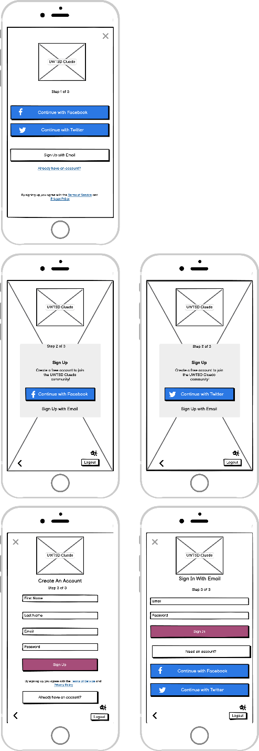
Table 23 Home Page/Site Map
2 | Home Page | Successful? | If not why not?
1 | Does the user know what they want to do? | Y
2 | Can they see a control that will do the job? | Y
3 | Is it clear how to operate control? | Y
4 | Is the immediate effect understandable? | Y
Figure 11 Home Page/Site Map
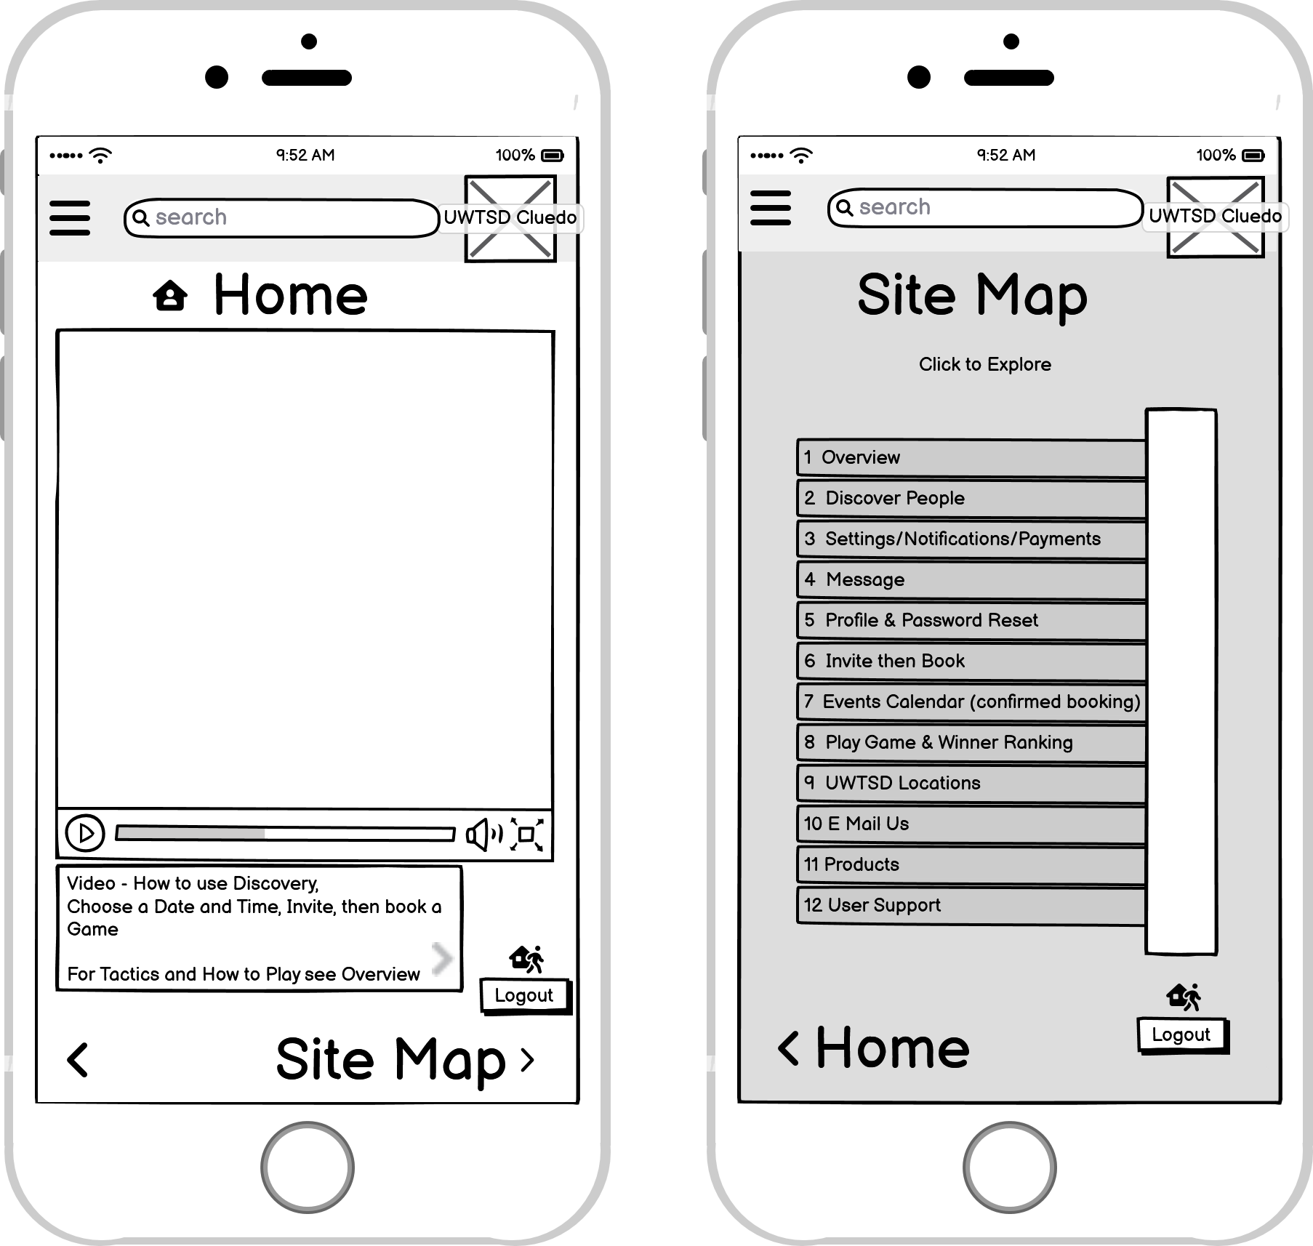
^{[46]}
Table 24 Overview
3 | Overview | Successful? | If not why not?
1 | Does the user know what they want to do? | Y
2 | Can they see a control that will do the job? | Y
3 | Is it clear how to operate control? | Y
4 | Is the immediate effect understandable? | Y
Figure 12 Overview
^{[46]}

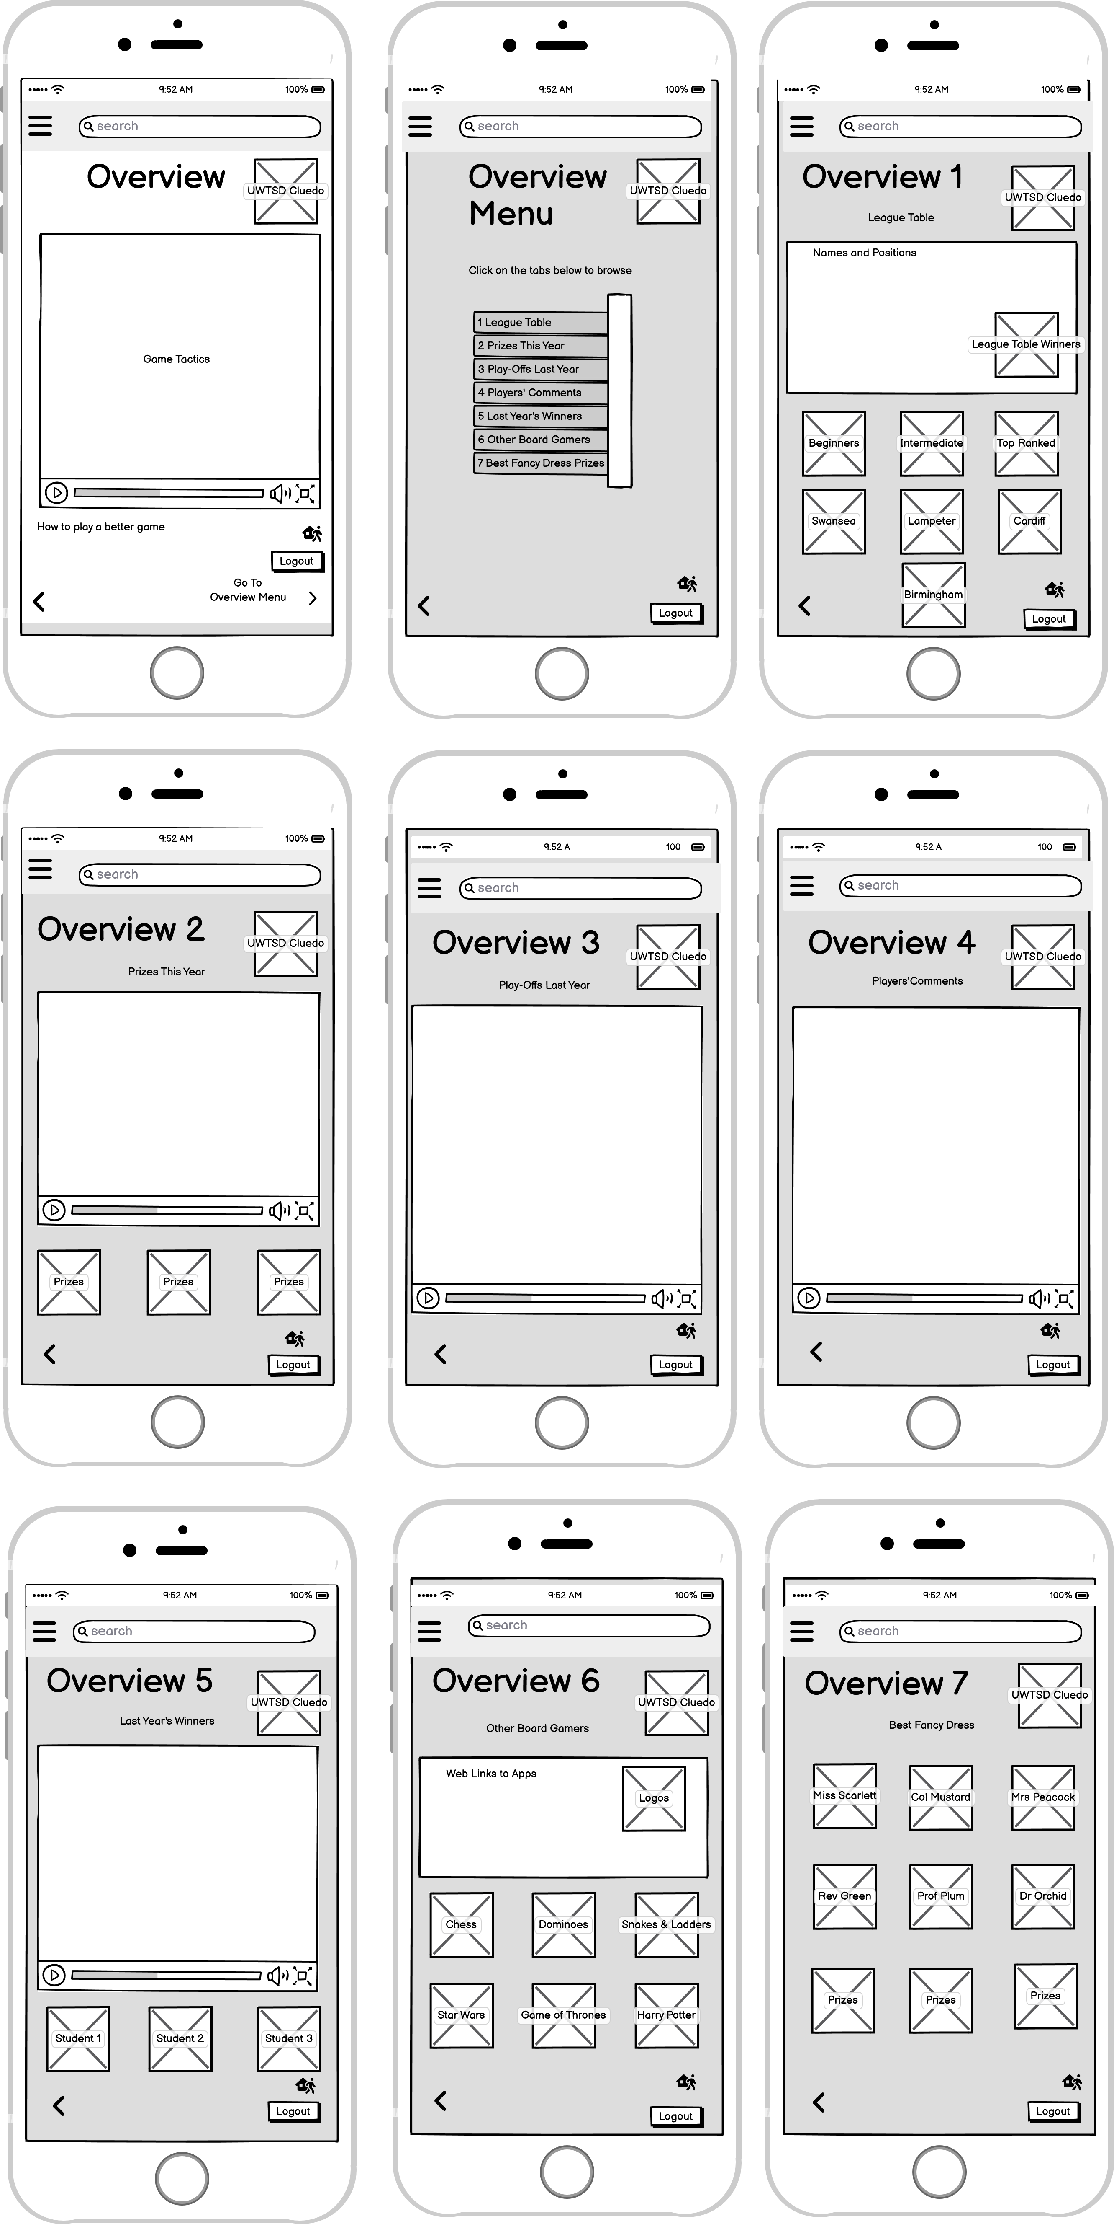
Table 25 Discover People
4 | Discover People | Successful? | If not why not?
1 | Does the user know what they want to do? | Y
2 | Can they see a control that will do the job? | Y
3 | Is it clear how to operate control? | Y
4 | Is the immediate effect understandable? | Y
Figure 13 Discover People
^{[46]}
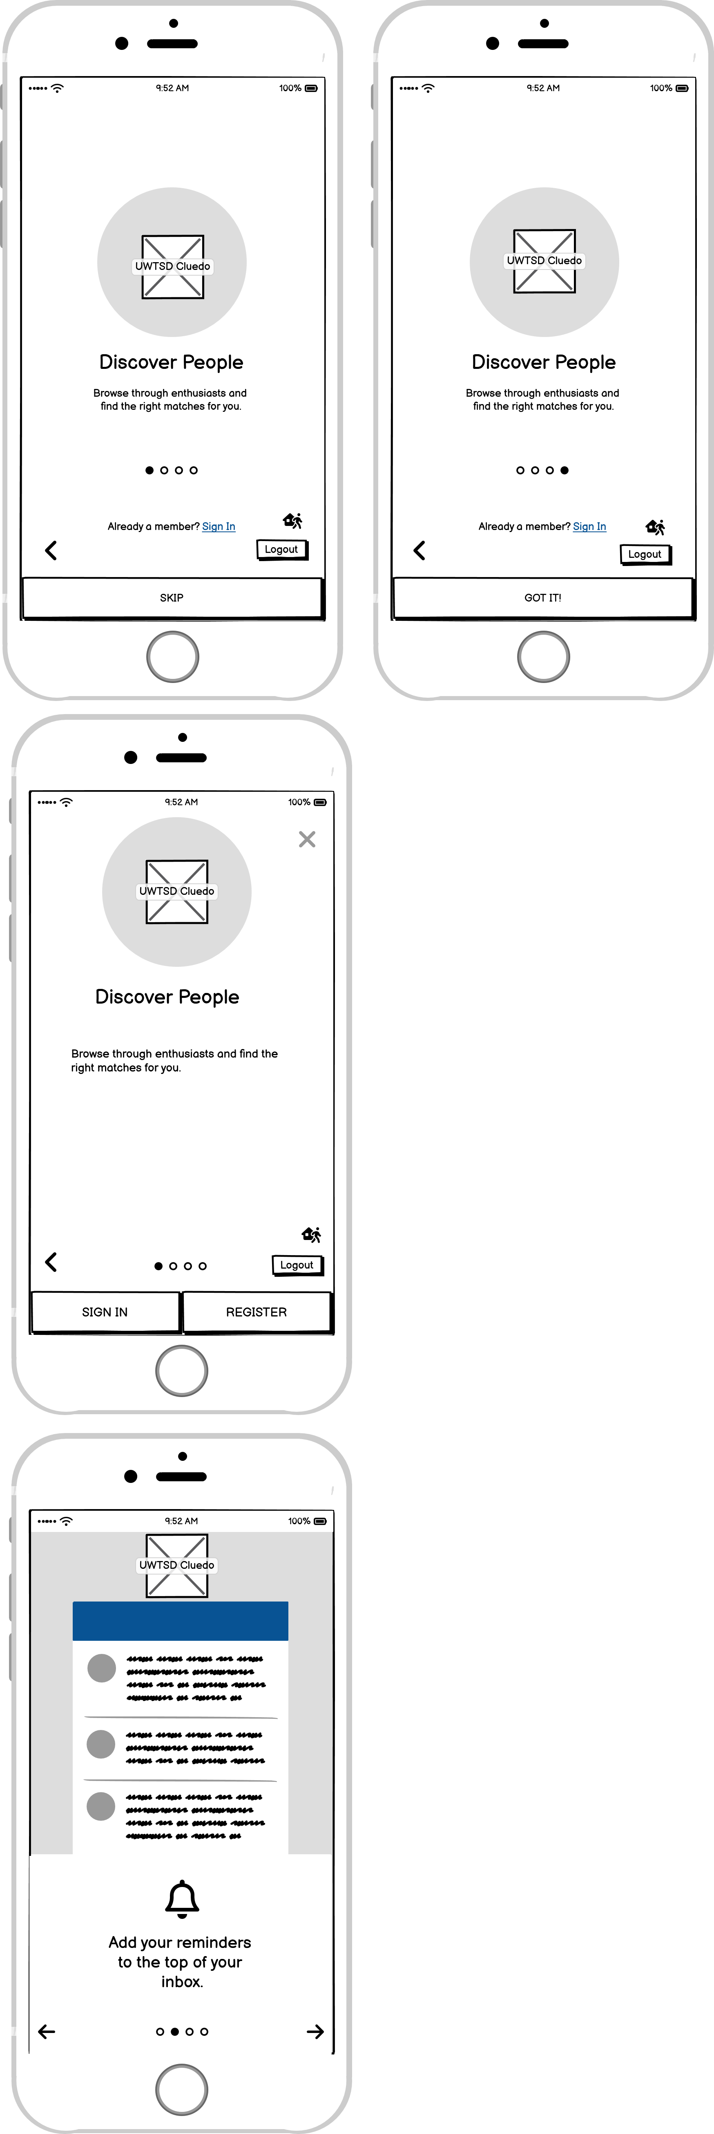
Table 26 Settings; Discovery, Notifications, Payments
5 | Settings  - Discovery,  - Notifications,  - Payments | Successful? | If not why not?
1 | Does the user know what they want to do? | Y
2 | Can they see a control that will do the job? | Y
3 | Is it clear how to operate control? | Y
4 | Is the immediate effect understandable? | Y
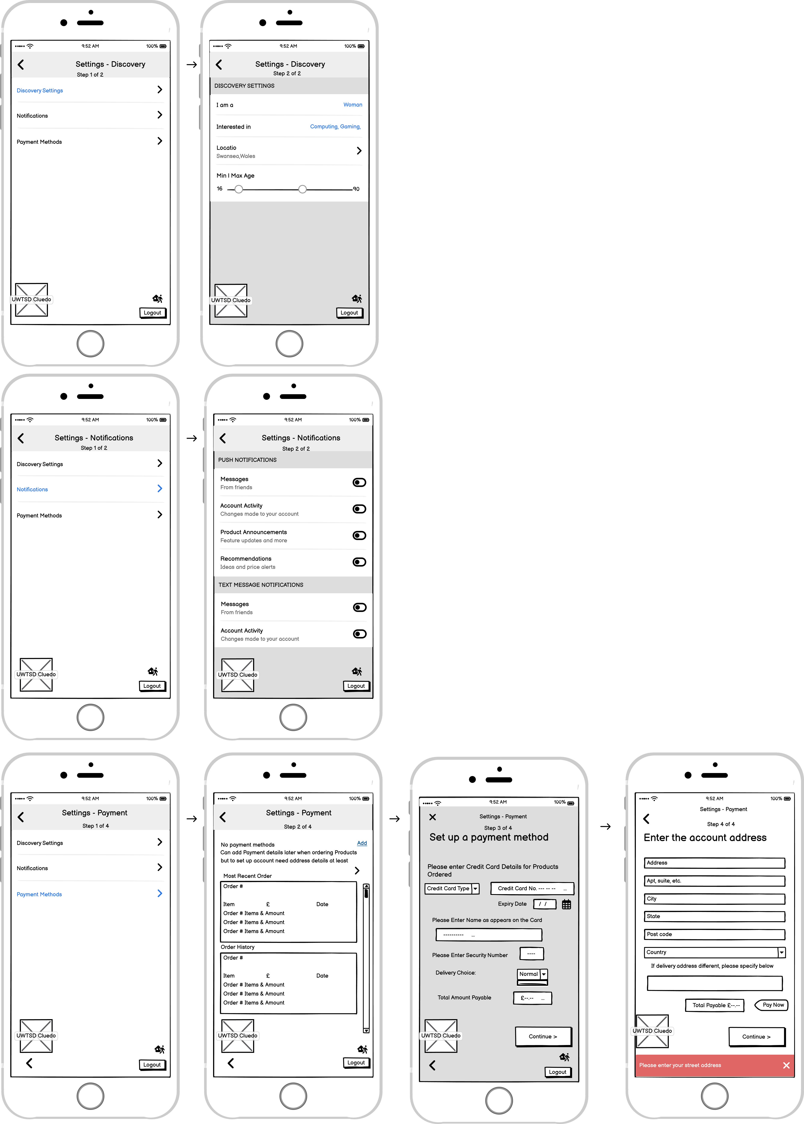
Figure 14 Settings; Discovery, Notifications, Payments
^{[46]}

Table 27 Message
6 | Message | Successful? | If not why not?
1 | Does the user know what they want to do? | Y
2 | Can they see a control that will do the job? | Y
3 | Is it clear how to operate control? | Y
4 | Is the immediate effect understandable? | Y
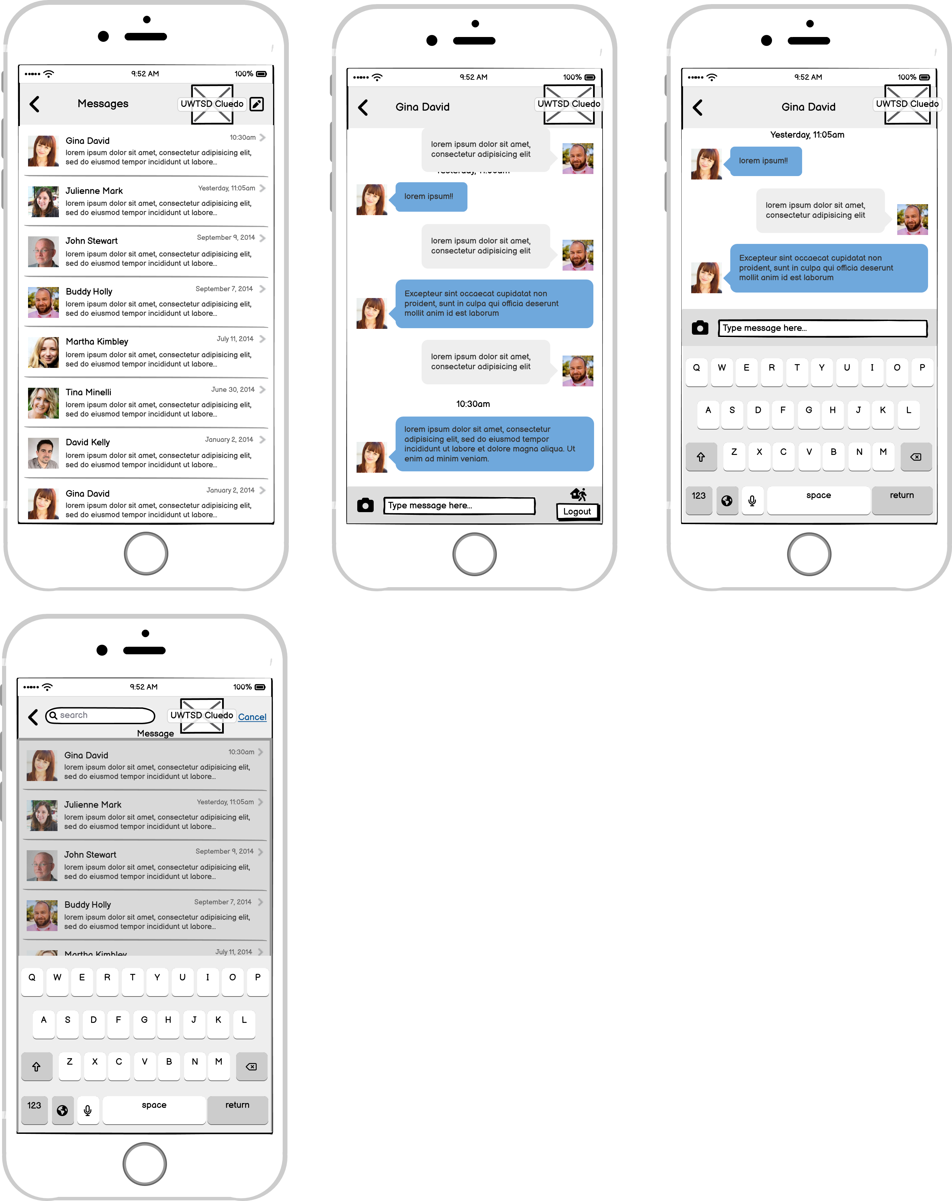
Figure 15 Message
^{[46]}
Table 28 Profile and Password Reset
7 | Profile and Password Reset | Successful? | If not why not?
1 | Does the user know what they want to do? | Y
2 | Can they see a control that will do the job? | Y
3 | Is it clear how to operate control? | Y
4 | Is the immediate effect understandable? | Y
Figure 16 Profile and Password Reset
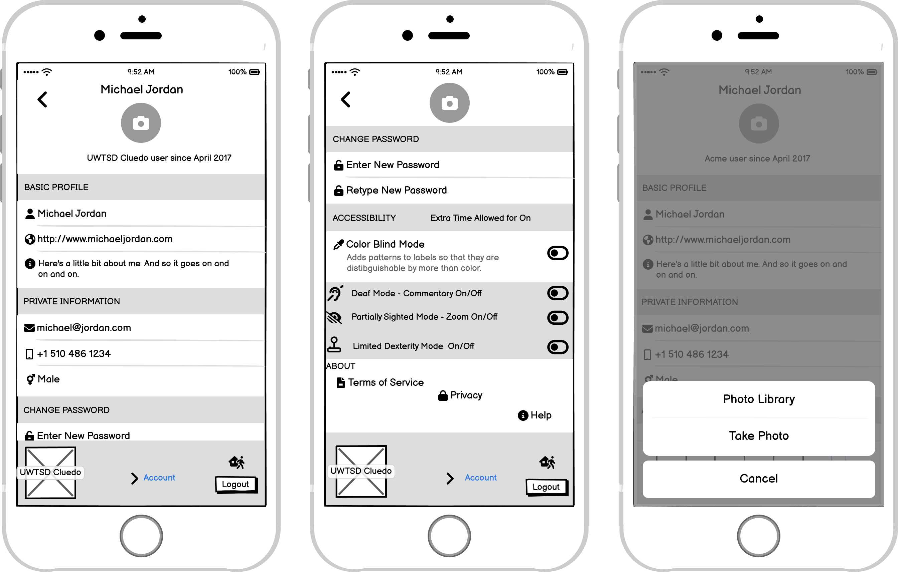
^{[46]}
Table 29 Invite and Book
8 | Invite and Book | Successful? | If not why not?
1 | Does the user know what they want to do? | Y
2 | Can they see a control that will do the job? | Y
3 | Is it clear how to operate control? | Y
4 | Is the immediate effect understandable? | Y
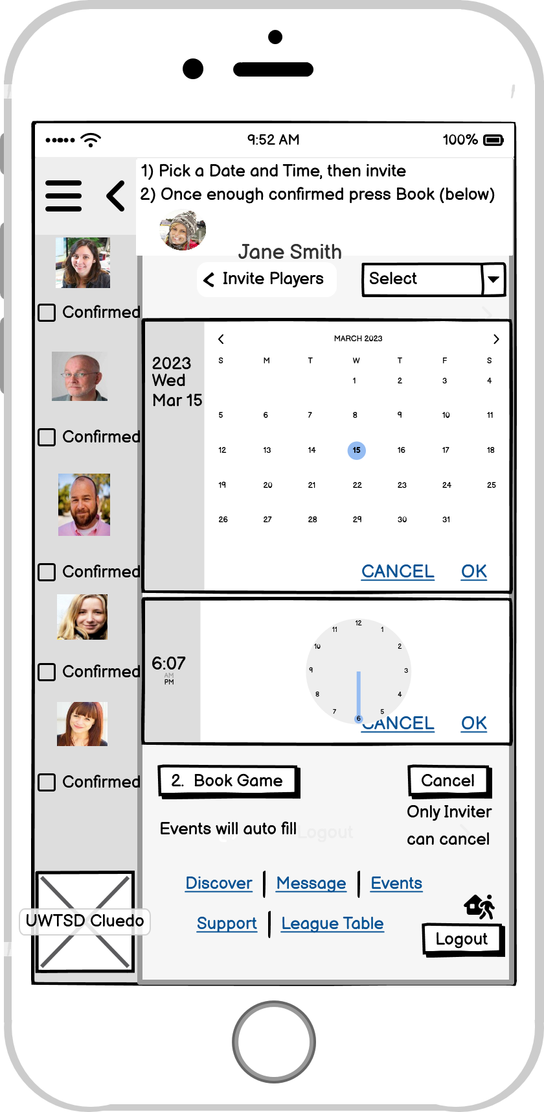
Figure 17 Invite and Book
^{[46]}

Table 30 Events Calendar
9 | Events Calendar | Successful? | If not why not?
1 | Does the user know what they want to do? | Y
2 | Can they see a control that will do the job? | Y
3 | Is it clear how to operate control? | Y
4 | Is the immediate effect understandable? | Y
Figure 18 Events Calendar
^{[46]}
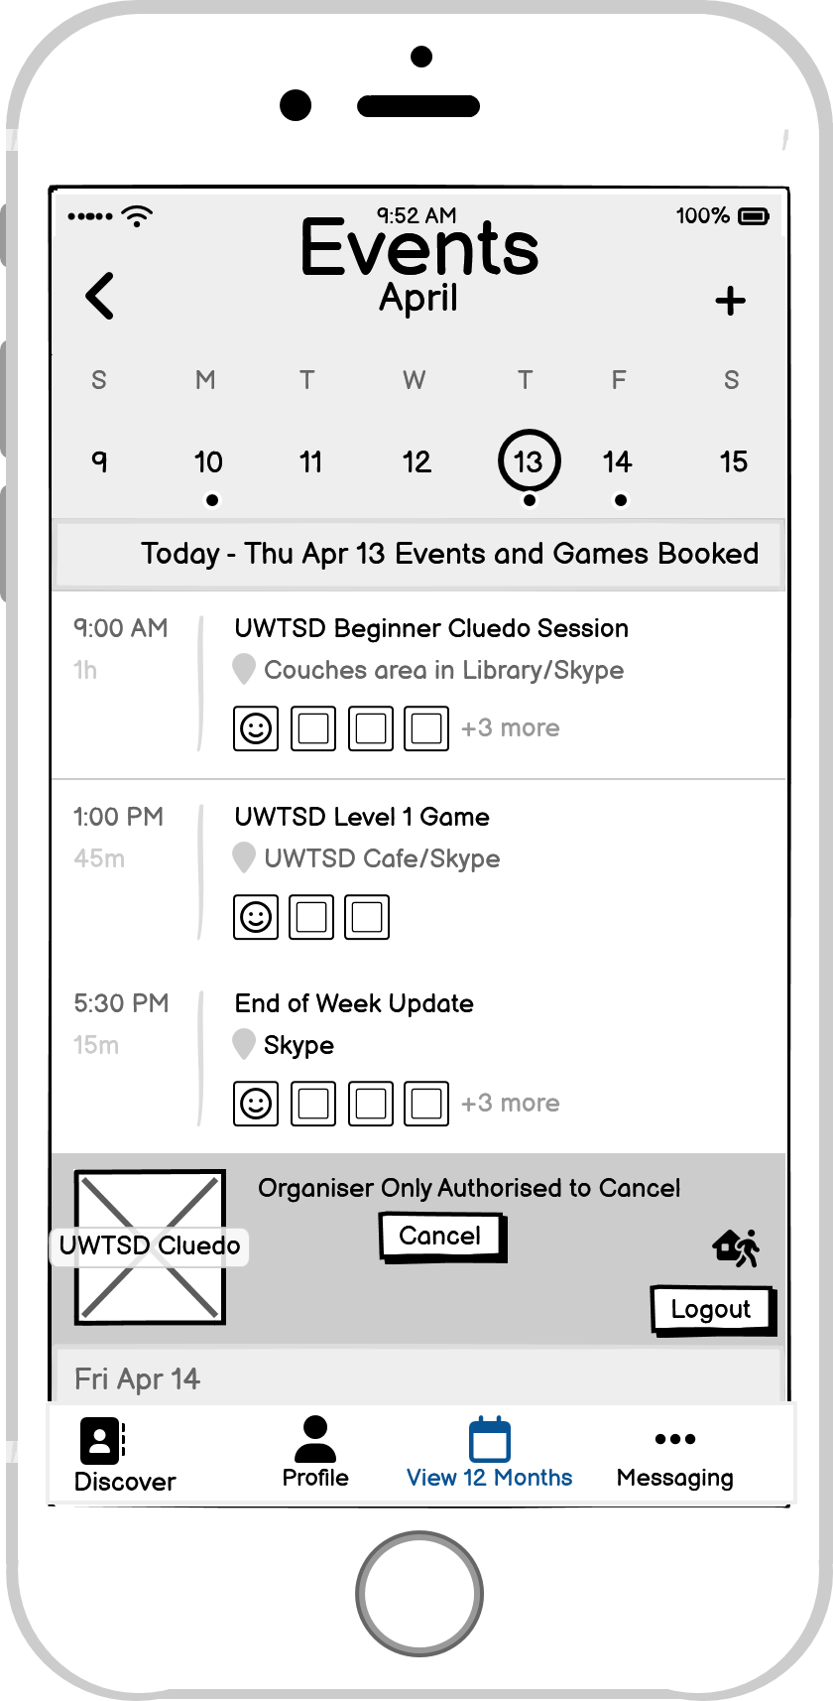
Table 31 Play Game
10 | Play Game | Successful? | If not why not?
1 | Does the user know what they want to do? | Y
2 | Can they see a control that will do the job? | Y
3 | Is it clear how to operate control? | Y
4 | Is the immediate effect understandable? | Y
Figure 19 Play Game (1) Intro – 1 of 8
^{[46]}
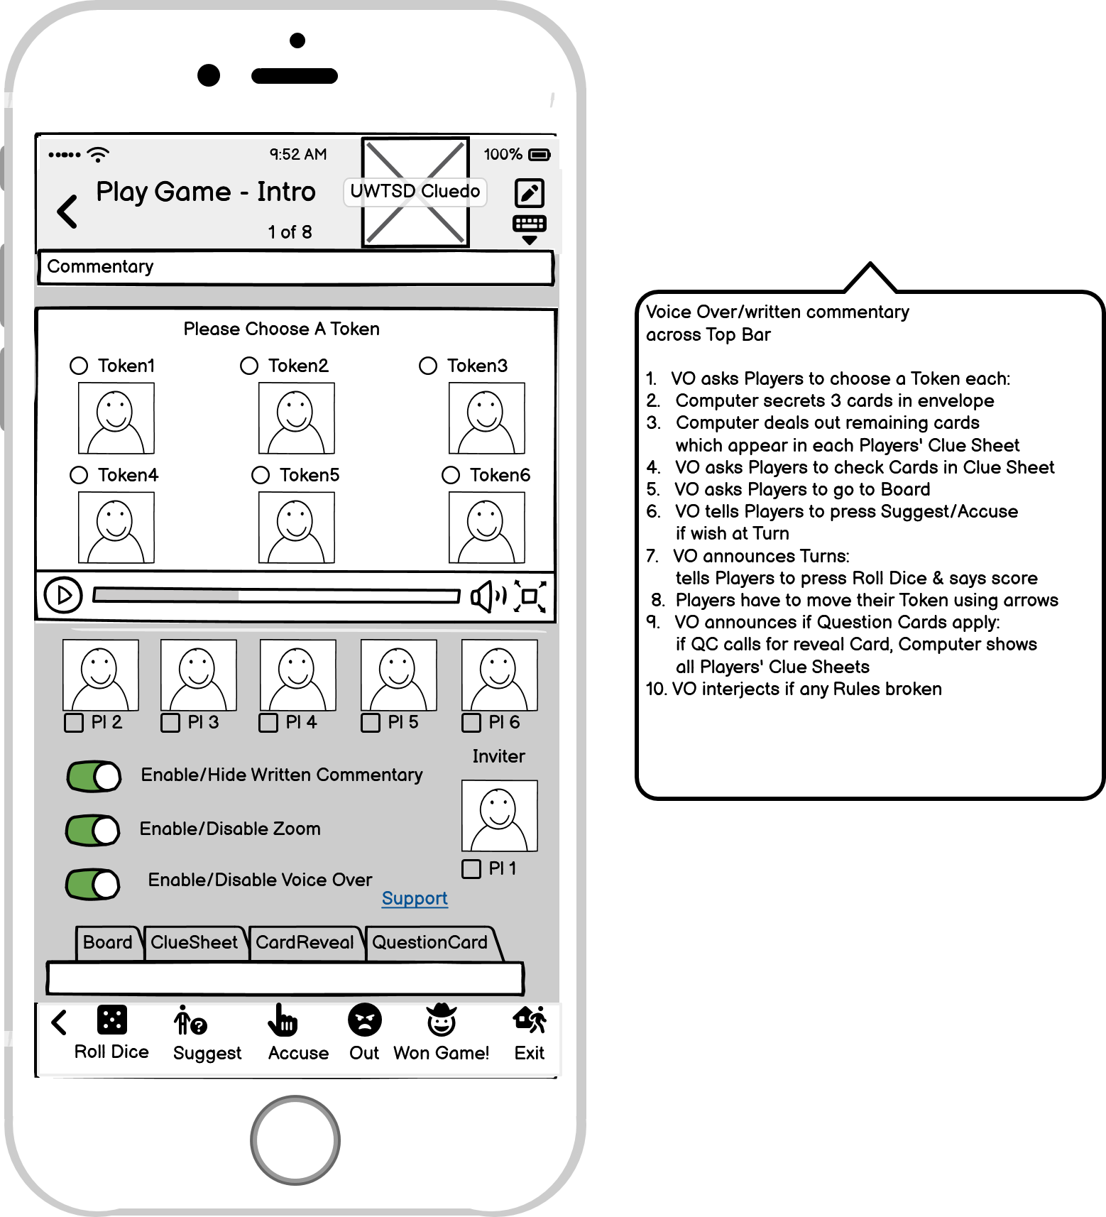
Figure 20 Play Game (2) Board and (3) Clue Sheet
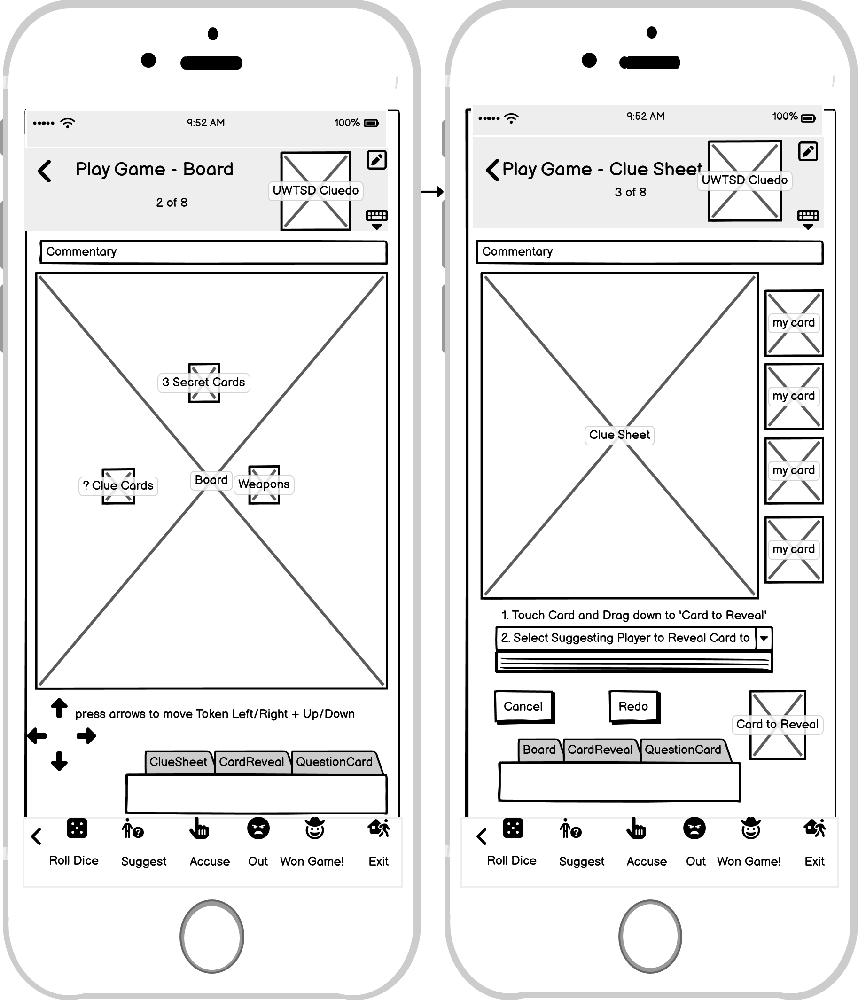
^{[46]}
Figure 21 Play Game(4) Card Reveal (5) Question Card (6) Accuse
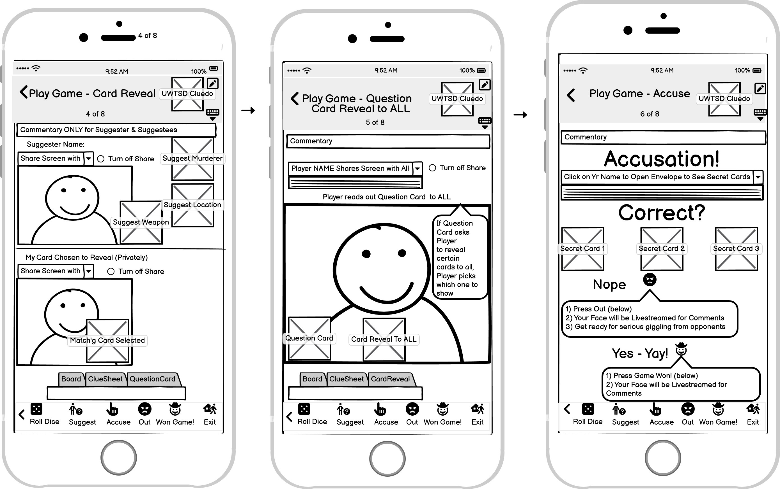
^{[46]}
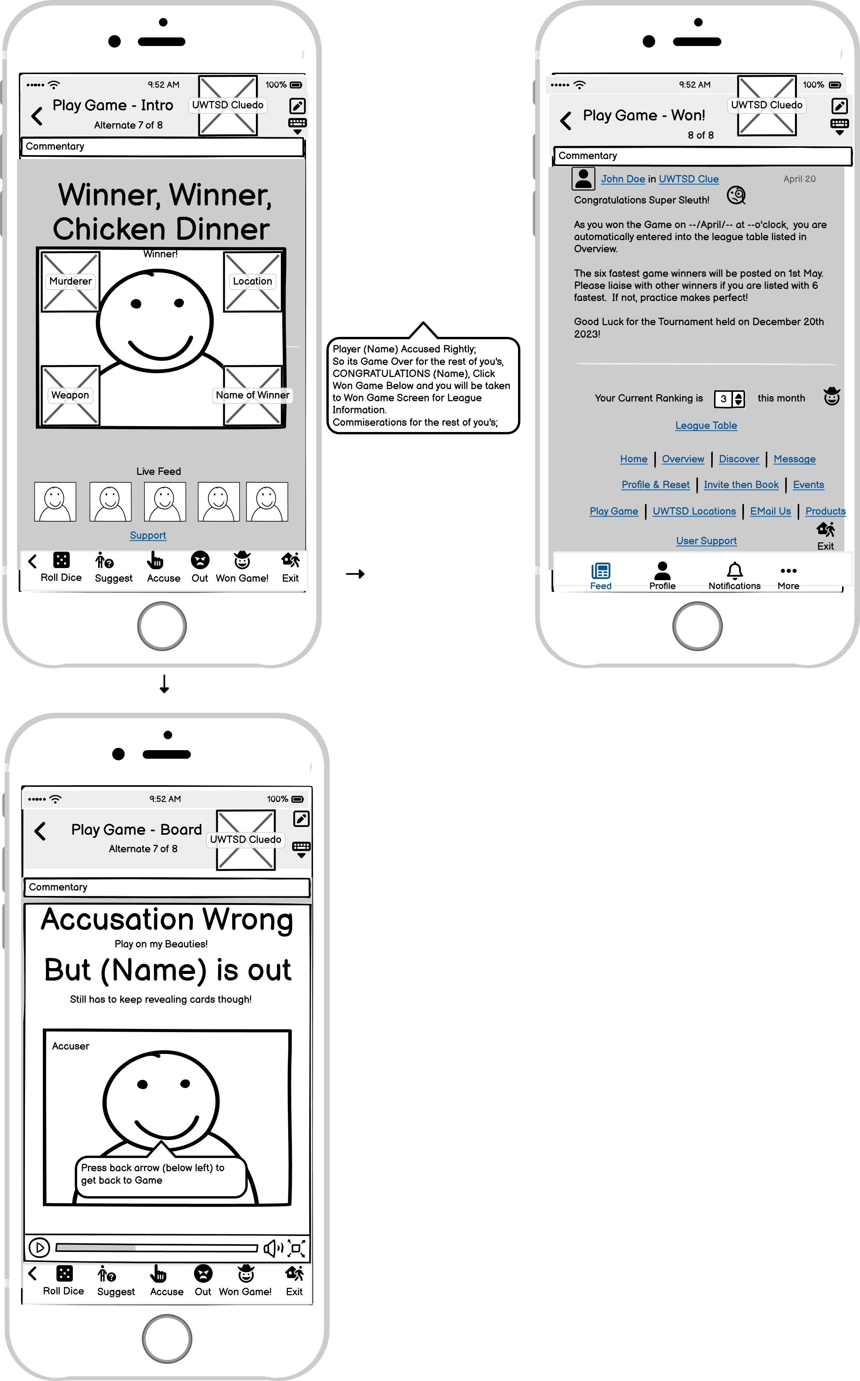
Figure 22 Play Game (7& Alternate 7) Winner/Out (8) Won!
^{[46]}

Table 32 UWTSD Location
11 | UWTSD Location | Successful? | If not why not?
1 | Does the user know what they want to do? | Y
2 | Can they see a control that will do the job? | Y
3 | Is it clear how to operate control? | Y
4 | Is the immediate effect understandable? | Y
Figure 23 UWTSD Location
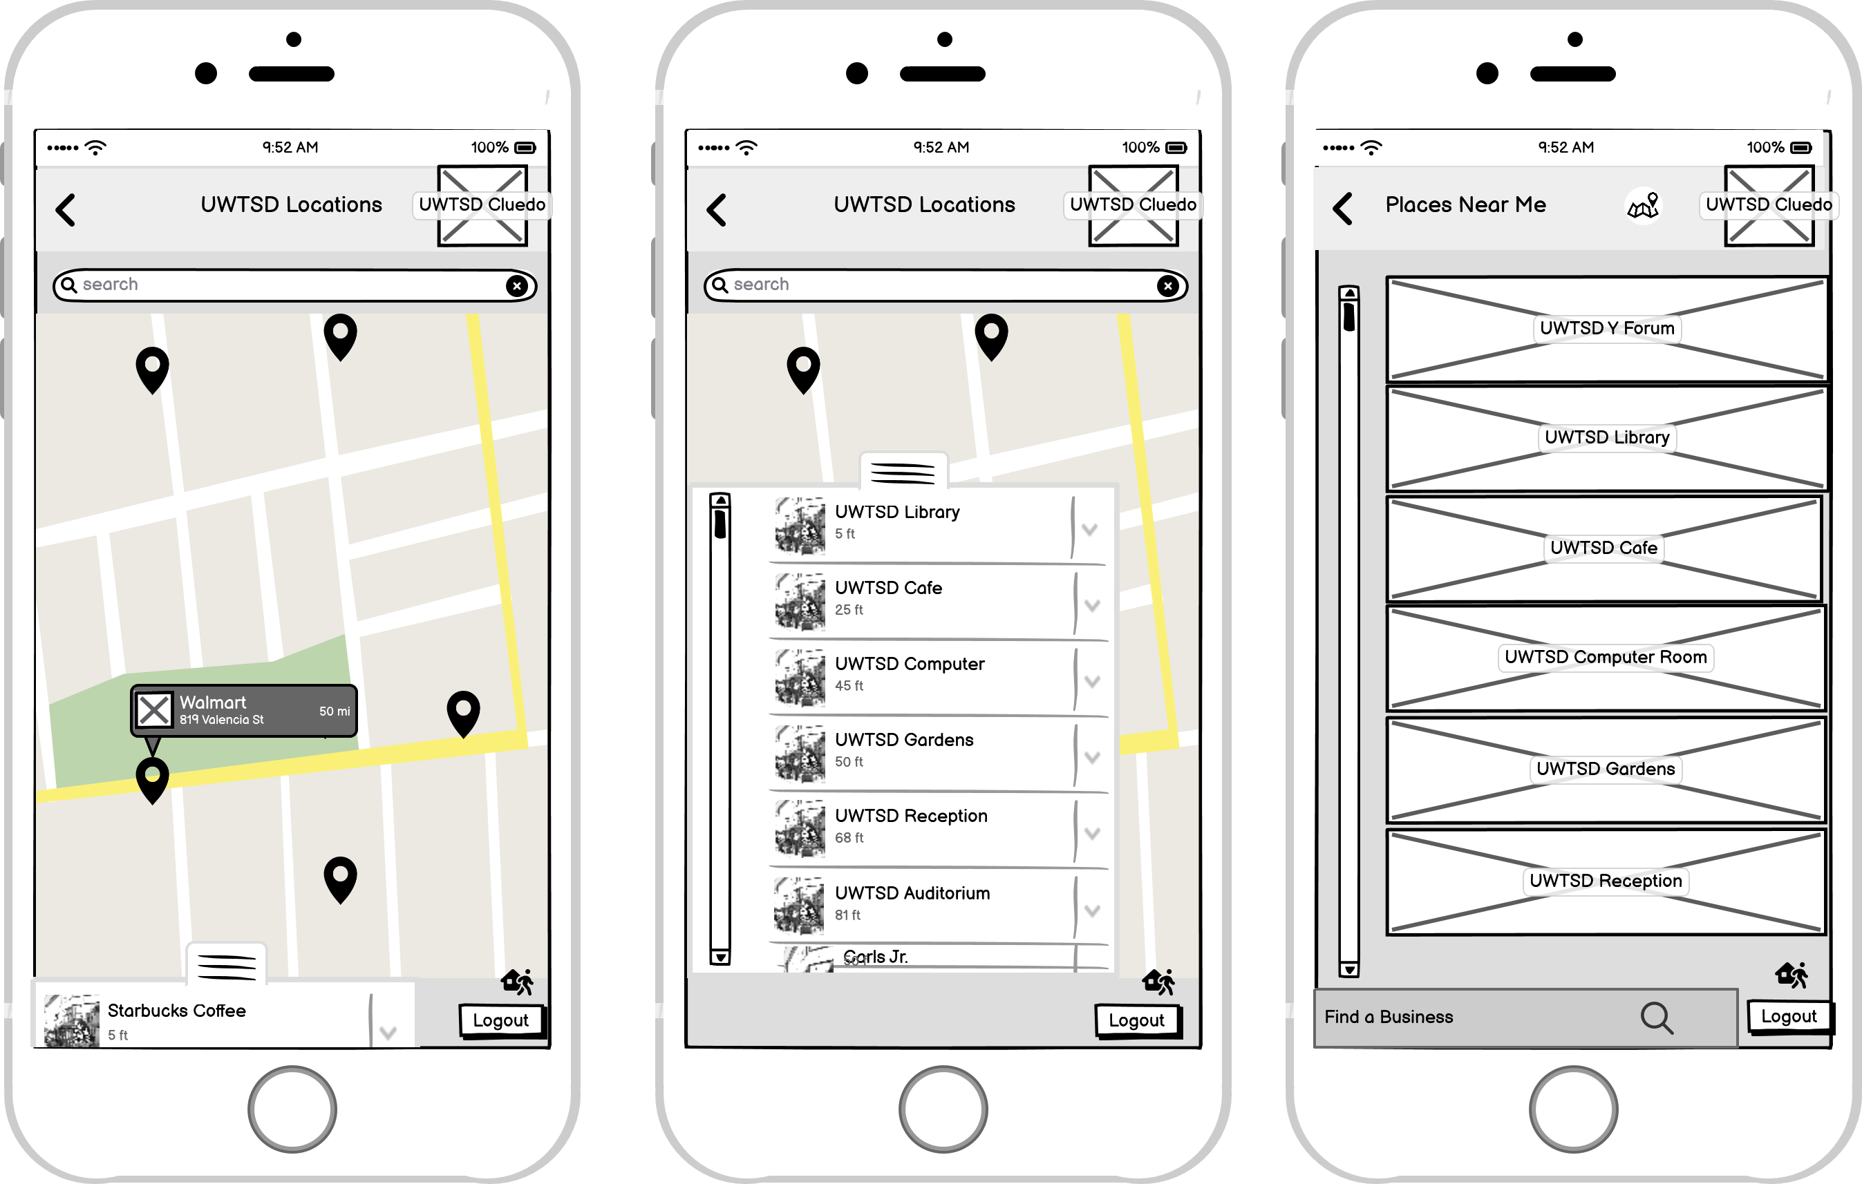
^{[46]}

Table 33 E Mail Us
12 | E Mail Us | Successful? | If not why not?
1 | Does the user know what they want to do? | Y
2 | Can they see a control that will do the job? | Y
3 | Is it clear how to operate control? | Y
4 | Is the immediate effect understandable? | Y
Figure 24 E Mail Us
^{[46]}

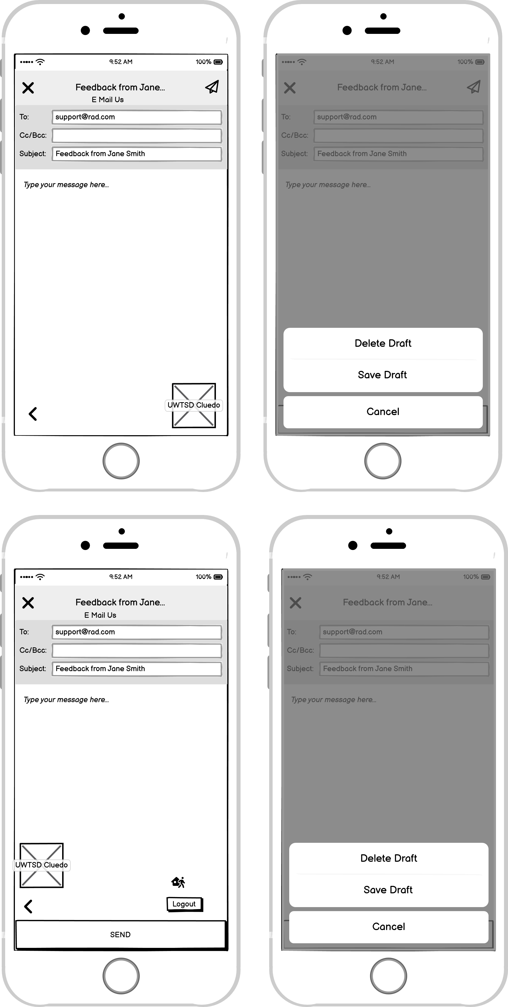
Table 34 Products
13 | Products | Successful? | If not why not?
1 | Does the user know what they want to do? | Y
2 | Can they see a control that will do the job? | Y
3 | Is it clear how to operate control? | Y
4 | Is the immediate effect understandable? | Y
Figure 25 Products
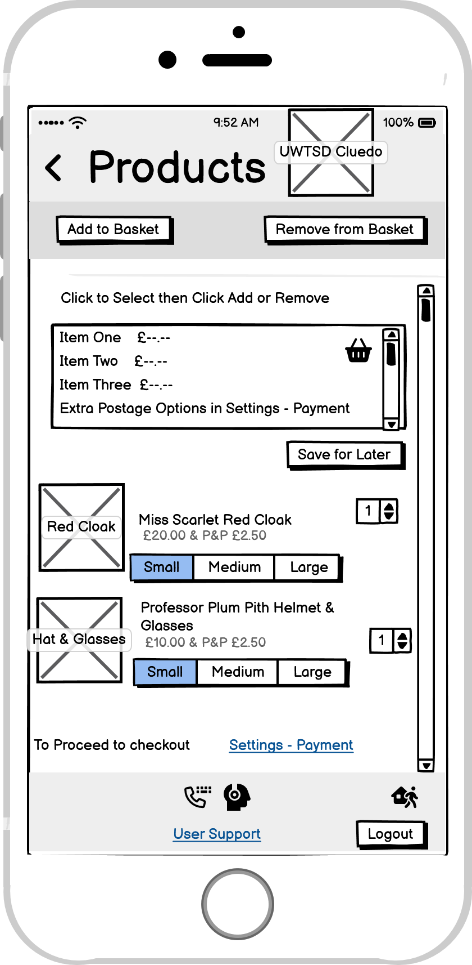
^{[46]}
Table 35 User Support
14 | User Support | Successful? | If not why not?
1 | Does the user know what they want to do? | Y
2 | Can they see a control that will do the job? | Y
3 | Is it clear how to operate control? | Y
4 | Is the immediate effect understandable? | Y
Figure 26 User Support
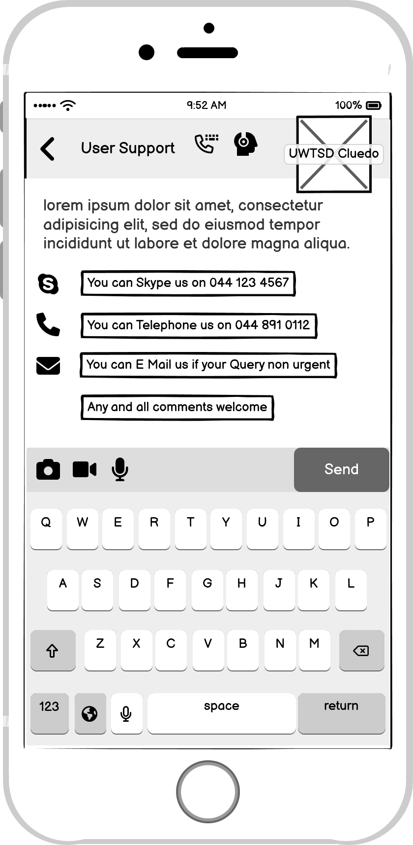
^{[46]}

6.4 Usability Testing

6.4.1 User Selection Forms
^{[39]}Test Subject 1
 | Questions | Answers | Tester Comments
1 | Full Name: | Daisy Thompson | Young Professional Female with limited dexterity
2 | How old are you? | - 22-40
3 | What is your highest level of education? | - University
4 | What is your income level? | - >12K
5 | What is a typical day for you?  What are your hobbies? | Trainee Developer 9-5  5-10 Computing, Gaming, Social
6 | How much time do you spend online per day? | - 5+ Hours
7 | Which apps/websites do you use?  Tick all that apply | ☐Social  ☒Banking  ☒Shopping  ☒Gaming
8 | How often do you shop online? | - 5+ times per month
9 | Which device(s) do you mainly use? | ☒Mobile  ☐Tablet  ☒Laptop  ☐Desktop
10 | Have you used a Game App before? | - Y
11 | Have you got any disability?  If crossed box other than no, please elaborate | ☒Other (please specify) | Limited hand dexterity (use joystick instead of mouse/pointer stick)

^{[39]}Test Subject 2
 | Questions | Answers | Tester Comments
1 | Full Name: | Kevin Smith | Young, Semi-Professional male
2 | How old are you? | - 16-21
3 | What is your highest level of education? | - College
4 | What is your income level? | - >12K
5 | What is a typical day for you?  What are your hobbies? | Tech Support in call centre 9-5  6-11 Gaming
6 | How much time do you spend online per day? | - 5+ Hours
7 | Which apps/websites do you mostly use? | ☒Social  ☒Banking  ☒Shopping  ☒Gaming
8 | How often do you shop online? | - 5+ times per month
9 | Which device(s) do you mainly use? | ☒Mobile  ☐Tablet  ☐Laptop  ☐Desktop
10 | Have you used a Game App before? | - Y
11 | Have you got any disability?  If crossed other than no, please elaborate | ☒No

^{[39]}Test Subject 3
 | Questions | Answers | Test Comments
1 | Full Name: | Mary O’Reilly | Older professional female with sight deficiency
2 | How old are you? | - 41-60
3 | What is your highest level of education? | - University
4 | What is your income level? | - >12K
5 | What is a typical day for you?  What are your hobbies? | Computing Teacher in Secondary school for the blind  Gaming
6 | How much time do you spend online per day? | - 5+ Hours
7 | Which apps/websites do you use? | ☒Social  ☒Banking  ☒Shopping  ☒Gaming
8 | How often do you shop online? | - 5+ times per month
9 | Which device(s) do you mainly use? | ☒Mobile  ☒Tablet  ☒Laptop  ☐Desktop
10 | Have you used a Game App before? | - Y | Yes
11 | Have you got any disability?  If crossed other than no, please elaborate | ☒Sight  Partially sighted but registered blind | Partially sighted but registered blind

^{[39]}Test Subject 4
 | Questions | Answers | Test Comments
1 | Full Name: | David Richards | Older professional male with hearing deficiency
2 | How old are you? | - 61+
3 | What is your highest level of education? | - College
4 | What is your income level? | - >12K
5 | What is a typical day for you?  What are your hobbies? | Retired (own business)  Gaming
6 | How much time do you spend online per day? | - 5+ Hours
7 | Which apps/websites do you use? | ☒Social  ☒Banking  ☒Shopping  ☒Gaming
8 | How often do you shop online? | - 5+ times per month
9 | Which device(s) do you mainly use? | ☒Mobile  ☒Tablet  ☐Laptop  ☐Desktop
10 | Have you used a Game App before? | - Y | Yes
11 | Have you got any disability?  If crossed other than no, please elaborate | ☒Hearing  Partially deaf | Partially deaf

6.4.2 User Consent Form
^{[47]}


This form is to be completed independently by the participant after reading the Information Sheet and/or having listened to an explanation about the research.

Title of Project: UWTSD Cluedo | UWTSD Cluedo
This study has been approved by the UWTSD Research Ethics Committee  Project ID No. ACCA6017: | BSc/2023/1909721/ACCA6017
Participant’s Statement:

I ……………………………………………………………………………………….
Agree that I have:

- read the information sheet and/or the project has been explained to me orally;
- had the opportunity to ask questions and discuss the study;
- understood that my participation will be audio/video recorded;
- I am aware of and consent to the use of these recordings only for purposes directly connected to this study (e.g., video data analysis), and that I will not be identified by name in these recordings, and that after the research is finished these recordings will be deleted or stored securely, in line with data protection requirements;
- understood that my participation will be audio/video recorded and I am aware of and consent to, any use you intend to make of the recordings after the end of the project;
- understood that I must not take part if I have had any signs of epilepsy or motion sickness when playing games in the past.

I understand that I am free to withdraw from the study without penalty if I so wish and I consent to the processing of my personal information for the purposes of this study only and that it will not be used for any other purpose. I understand that such information will be treated as strictly confidential and handled in accordance with the provisions of the Data Protection Act 1998.

Signed:………………………………………………………………….……… Date: ………………………………………………………

Investigator’s Statement I, Theresa Darzins, confirm that I have carefully explained the purpose of the study to the participant and outlined any reasonably foreseeable risks or benefits (where applicable).

Signed: …………………………………………………………………………. Date:………………………………………………………

6.4.3 User Questionnaire Post-Test

System Usability Score Form^{[37]}

^{[37]} | Daisy | Strongly Disagree |  |  |  | Strongly Agree
 |  | 1 | 2 | 3 | 4 | 5
1. | I think that I would like to use this system frequently. |  |  |  | 4
2 | I found the system unnecessarily complex. | 1
3 | I thought the system was easy to use. |  |  | 3
4 | I think that I would need the support of a technical person to be able to use this system. | 1
5 | I found the various functions in this system were well integrated. |  |  |  | 4
6 | I thought there was too much inconsistency in this system. |  | 2
7 | I would imagine that most people would learn to use this system very quickly. |  |  |  | 4
8 | I found the system very cumbersome to use. |  |  |  | 4
9 | I felt very confident using the system. |  |  |  |  | 5
10 | I needed to learn a lot of things before I could get going with this system. |  | 2

System Usability Score Form

 | ^{[37]}  Kevin | Strongly Disagree |  |  |  | Strongly Agree
 |  | 1 | 2 | 3 | 4 | 5
1. | I think that I would like to use this system frequently. |  |  |  | 4
2 | I found the system unnecessarily complex. |  | 2
3 | I thought the system was easy to use. |  |  | 3
4 | I think that I would need the support of a technical person to be able to use this system. | 1
5 | I found the various functions in this system were well integrated. |  |  |  | 4
6 | I thought there was too much inconsistency in this system. |  | 2
7 | I would imagine that most people would learn to use this system very quickly. |  |  |  |  | 5
8 | I found the system very cumbersome to use. | 1
9 | I felt very confident using the system. |  |  | 3
10 | I needed to learn a lot of things before I could get going with this system. | 1

System Usability Score Form

 | ^{[37]}  David | Strongly Disagree |  |  |  | Strongly Agree
 |  | 1 | 2 | 3 | 4 | 5
1. | I think that I would like to use this system frequently. |  |  | 3
2 | I found the system unnecessarily complex. |  |  | 3
3 | I thought the system was easy to use. |  |  | 3
4 | I think that I would need the support of a technical person to be able to use this system. | 1
5 | I found the various functions in this system were well integrated. |  |  | 3
6 | I thought there was too much inconsistency in this system. |  |  | 3
7 | I would imagine that most people would learn to use this system very quickly. |  |  |  | 4
8 | I found the system very cumbersome to use. |  | 2
9 | I felt very confident using the system. |  |  |  |  | 5
10 | I needed to learn a lot of things before I could get going with this system. | 1

System Usability Score Form

 | ^{[37]}  Mary | Strongly Disagree |  |  |  | Strongly Agree
 |  | 1 | 2 | 3 | 4 | 5
1. | I think that I would like to use this system frequently. |  |  | 3
2 | I found the system unnecessarily complex. |  | 2
3 | I thought the system was easy to use. |  |  | 3
4 | I think that I would need the support of a technical person to be able to use this system. | 1
5 | I found the various functions in this system were well integrated. |  |  |  | 4
6 | I thought there was too much inconsistency in this system. | 1
7 | I would imagine that most people would learn to use this system very quickly. |  |  |  | 4
8 | I found the system very cumbersome to use. | 1
9 | I felt very confident using the system. |  |  |  | 4
10 | I needed to learn a lot of things before I could get going with this system. |  | 2

