Rhys Whatty
1900045
Application of Graphics Principles using OpenGL and C++
ACCA6021 – Games and Graphics Programming

Contents
Introduction 2
Task 1 3
Task 2 6
Task 3 7
Appendix A: Written Code 8
References 10

Introduction

The OpenGL Graphics Pipeline is very useful library to assist in the creation of games, allowing programmers to generate windows with which vectors can be drawn and transformed. As a good portion of graphics relies on established mathematical methods, meshes can be sent through the pipeline to be converted into local, object and view space, and finally a graphics viewport in order to allow for the rendering of objects within a 3D space. This is used in order to generate programming environments for 3D games. [1]

When converted vertices within a view space, there are several operations that can be performed on said vertices, such as transformations, projections, culling and clipping. These can affect how the vertex is viewed in a view space, as well as how much of it is viewed as a result of falling out of the rendered view space. [1]

Task 1 – Transforming a Vertex

The first task involved translating and converting a vertex. The vertex and the values needed are all provided below.
Vertex – (1, 3, 2)
Rotation Angle – 70.0°
Translation distance – (1.5, 0, -1)

Viewpoint – (0, 6, -1)
Up Vector – (0, 1, 0)
LookAt Viewpoint – (1.5, 0, 0)
FOV – 34.0°
Near Plane Distance – 1.5
Far Plane Distance – 100

First, the vertex of (1, 3, 2) is translated along the X-Axis. This step requires the use of the vertex, translation distance and rotation angle provided above. In order for this process to occur, the value of the x co-ordinate is adjusted by the x value of the translation distance to produce the new vertex of (2.5, 3, 2). Once this process is complete, the vertex is rotated around the Y-Axis by 70°. Transforming a graph through rotation requires the use of one of three matrices in order to solve, depending on what co-ordinate value the vertex is being rotated around. Rotating around the Y-Axis will require use of the following matrix multiplication formula:

X’ cosθ 0 sinθ 0 X
Y = 0 1 0 0 * Y
Z’ -sinθ 0 cosθ 0 Z
1 0 0 0 1 1

Using the vertex co-ordinates and replacing θ with 70, the final Vertex Co-ordinate that is produced is (1.41, 3, -0.14).
Next, using the viewpoint, lookAt viewpoint and up vector, the vertex is converted into view space, giving us the following view matrix:

X 0 -6 -1
Y = 1.5 0 0
Z’ 0 1 0
Finally, it is converted into a perspective transformation. In order to calculate this, the aspect ratio is required, through calculating the ratio of the near and far clipping planes, which calculates out to be an aspect ratio of 66.67.
Next, the perspective matrix is calculated. The formula for the matrix is:

X A 0 0 0
Y = 0 q 0 0
Z 0 0 B C
1 0 0 -1 0

Next the values of q, A, B and C are calculated. The value of q is first calculated with the following equation:
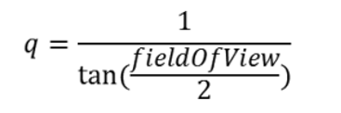
Using the value of q along with near and far plane distances, the values of A, B, and C can now be calculated using the following equations.
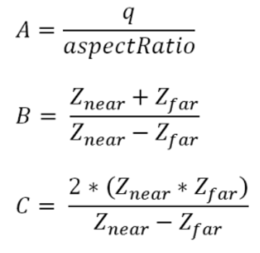

With the values a radian value, the following matrix table is then produced.

X 0.004 0 0 0
Y = 0 0.29 0 0
Z 0 0 -1.03 -3.05
1 0 0 -1 0

[2]

Task 2 – Planes and Distance

For task 2, the same vertex of (1, 3, 2) that was used in the previous task will be used. Using the vertex and the plane equation x·n + p₀·n = 0, the distance of the vertex from the plane’s surface will be calculated, where n = (-1, 2, 0) and p₀ = (2.5, 2, 4).

The values of n will be referred to as (A, B, C) and the values of p₀ will be referred to as (px, py, pz) when discussing equations.
The plane equation provided above can be rewritten as Apx +Bpy + Cpz + D = 0, where D = - A(px) – B(py) – C(pz), making use of the stated values of n and p₀. Using this information, this allows for the plane equation to be written as -x + 2y + 0z – 6.5 = 0.
The formula for working out the distance between the vertex and the plane (d) can be shown as d = |Apx + Bpy + Cpz + D| / (root) A² + B² + C². Plugging in values and converting from the re-arrangement of equations as stated in the above equation, this brings out the length of d to be 2.24, which is the distance of the vertex from the plane. [2]

Task 3 – C++ Application

Task 3 had the calculations made during tasks 1 and 2 placed into a piece of code. A copy of the full piece of source code can be located in Appendix A.
First, the transformation matrix is placed outputted, followed by the vertex itself. Then the code transforms the vertex, and outputs the resulting vector.
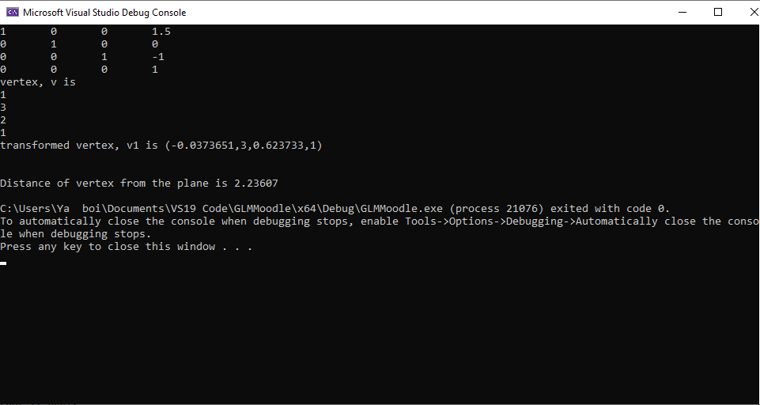

The code then creates the view space through use of the lookAt command, as seen in this segment of code:
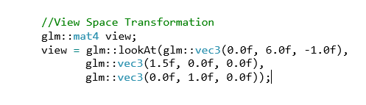
Finally, the code calculates the distance of the vertex from the plane using the formula stated in the task above, and outputs the resulting distance into the command window as seen in the command window screenshot above. The results of this line up with the results calculated in task 2.

[3] [4] [5]

Appendix A: Written Code
//// Include all GLM core / GLSL features
#include "./glm/glm.hpp" // vec2, vec3, mat4, radians
//// Include all GLM extensions
#include "./glm/ext.hpp" // perspective, translate, rotate
#include <iostream>
using namespace std;
void coutM4x4(glm::mat4 const&);
void coutVec4(glm::vec4 const& v);
int main(void)
{
//create a translation matrix
float tx = 1.5, ty = 0.0, tz = -1.0;
glm::mat4 T1 =
glm::mat4(1.0, 0.0, 0.0, 0.0, // note this is the leftmost column, not the top row
0.0, 1.0, 0.0, 0.0,
0.0, 0.0, 1.0, 0.0,
tx, ty, tz, 1.0);
coutM4x4(T1);
//set up a rotation angle and find sin and cos of it.
float thetaRadians = glm::radians(70.0);
float sinTheta = glm::sin(thetaRadians);
float cosTheta = glm::cos(thetaRadians);
//create a rotation matrix
glm::mat4 R1 =
glm::mat4(cosTheta, 0.0, sinTheta, 0.0, // note this is the leftmost column, not the top row
0.0, 1.0, 0.0, 0.0,
-sinTheta, 0.0, cosTheta, 0.0,
0.0, 0.0, 0.0, 1.0);

// create a model matrix for concatination of transforms
glm::mat4 M(1.0); //initialize to the identity matrix, I
M = T1 * R1 * M; //we can multiply matrices M=R*T
//set up a vertex for translation
glm::vec4 v = glm::vec4(1.0f, 3.0f, 2.0f, 1.0f);

cout << "vertex, v is " << endl;
coutVec4(v);
glm::vec4 v1 = M * v; //local space to world space

cout << "transformed vertex, v1 is ";
cout << "(" << v1.x << "," << v1.y << "," << v1.z << "," << v1.w << ")" << endl;

//View Space Transformation
glm::mat4 view;
view = glm::lookAt(glm::vec3(0.0f, 6.0f, -1.0f),
glm::vec3(1.5f, 0.0f, 0.0f),
glm::vec3(0.0f, 1.0f, 0.0f));

//Calculating distance of vertex from plane
cout << endl << endl << "Distance of vertex from the plane is " << (-1 + 6 + 0) / sqrt((1 * 1) + (2 * 2) + (0 * 0)) << endl;

return 0;
}
void coutVec4(glm::vec4 const& v)
{
for (int j = 0; j < 4; j++)
{
cout << v[j] << "\t";
cout << endl;
}

}
void coutM4x4(glm::mat4 const& T)
{
for (int i = 0; i < 4; i++)
{
for (int j = 0; j < 4; j++)
{
cout << T[j][i] << "\t";
}
cout << endl;
}
}

References

[1] | P. &. e. a. Baker, Computer graphics with Open GL, Pearson, 2014.
[2] | V. S. Gordon, Computer Graphics Programming in OpenGL using C++, Dulles, Virginia: Mercury Learning and Information, 2021.
[3] | J. Foley, Computer graphics : principles and practice, Addison-Wesley, 1996.
[4] | L. &. V. V. J. Bishop, Essential mathematics for games and interactive applications, CRC Press, Taylor & Francis Group, 2016.
[5] | F. a. K. S. M. Hill, Computer Graphics Using OpenGL, Prentice Hall International Inc, 2015.

