Assignment 1A – Business Plan Proposal
Module – Managing Enterprise in the 21st Century
Module Code – BMSK4006

Name - Mohammed Nazmul Ahmed – 1805954

Introduction

Good afternoon, we have been tasked with creating a business plan of our own. There are 4 key areas that we will be discussing during our presentation. These are finance, human resources, marketing and physical. My role within the team will look at all the physical aspects required to set up our business.

Location

When opening a new business, it is essential that the right location is chosen for our business. The location will affect total sales, cost of running, and how the business operates. We have chosen a location that is located within a busy community, with lots of residents which make it very tempting for residents close by to use.

Satellite image of our location

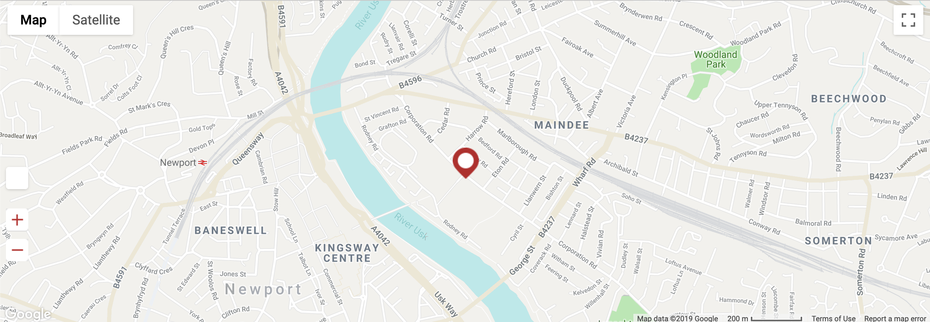

This location is of a big size where there is a lot of room for expansion (47,868.00 ft² (4,447.08 m²). As Hamel (2019) states there are other aspects that need to be considered when deciding on location such as rules and regulations, competition and accessibility. However, it is argued by Sherman (2019) that before you decide on a location, it is essential that you can legally trade from that location. This location has been chosen as there are not many competitors around, within a 2-mile radius. This is a huge advantage for our business as we will benefit from local residents who are unable to travel to Wonderland via cars. Even though this location is ideal for our business it is also suggested by Fox (2017) that situating your business near competition is also beneficial as this gives consumers a choice and it must be a prime location for business. Currently this building is being used as offices however, previously it has been a gym, therefore, as for building regulations I believe there would be no issue regarding our venture however we still would make enquiries about the rules and regulations. Leonard (2018) iterates that rules and regulations benefit consumers by dealing with employees as they are a lot happier. Biggest issue we will face with the rules and regulations would be the cost a of money and time and worst of all getting refused for planning. Another major aspect we would need to consider would be the accessibility. For example, has the location have disability access, consider disabled toilets and whether we would need a lift for access to upper levels. “The law requires reasonable adjustments by businesses – such as adapting premises, removing physical barriers or providing the service another way”. (Out-Law.com, 2004). Also, if accessibility is poor, it will be difficult to market the business and will affect sales. Even though location is key, it is imperative that the size of the building meets your desired needs. The reason behind this statement is that the business will have room for expansion also the bigger location you have the more employees will be required to operate the business. Our location allows us to expand upwards as there are 4 floors that we could occupy therefore we could consider doing different sessions such as mummy and toddler days, have separate area for sensory play welcoming disabled children and children with autism.

Equipment

When considering the physical aspects required within our business, we determined that we would need all the equipment for the soft play area such as ball pits, climbing frame etc. this would require a lot of finance and we would need a specialist who can fit this in all for us. We also, decided on having a cafeteria area where we would sell soft drinks, hot drinks, sandwiches and hot food, therefore, we would need to acquire the right kitchen appliances and utensils to have the cafeteria running. Also, we would need to adhere to the food hygiene rules in place meaning we would have to train our staff. We looked at having a complex IT system to be put in place however we decided that a standard IT system would work great for our business to keep costs down. On the other hand, we’ve decided to install a high-quality security system as there are many children visiting our business, so we want to make sure that the location is as safe as possible also this gives guardians an added security that their children are in safe hands.

Car park

The decision was made to open our business at this location as there are up to 100 car parking spaces available to our customers. This is a huge bonus for us as it is easily accessible by families with cars and also enough space for large vehicles bringing in large number of people. The parking is not chargeable so therefore is another incentive for people to use Wonderland. “Newport is the third largest city in Wales (resident population approximately 146,000) and occupied a strategic location on the M4 between Cardiff and Bristol. The city benefits from excellent transport links, being less than two hours from London by rail, 15 minutes from Cardiff and 20 minutes from Bristol Parkway. Drive time to Cardiff is just 20 minutes and both Bristol and Cardiff Airports are reached in under an hour.” This information was provided by JLL property.

References

- Hamel, G. (2019). Why Is Business Location Important?. [online] Yourbusiness.azcentral.com. Available at: https://yourbusiness.azcentral.com/business-location-important-3566.html [Accessed 28 May 2019].
- Robertson, S. (2019). Disabled access to buildings: law in force today. [online] Out-law.com. Available at: https://www.out-law.com/page-4941 [Accessed 28 May 2019].
- Tarling, P. (2019). Victoria House. [online] Property.jll.co.uk. Available at: https://property.jll.co.uk/sale-office/office-sale-newport-np19-0bh-7869 [Accessed 28 May 2019].
- Sherman, F. (2019). Why Is the Location of a Business Important?. [online] Smallbusiness.chron.com. Available at: https://smallbusiness.chron.com/location-business-important-43239.html [Accessed 10 Jun. 2019].
- Fox, J. (2017). Six factors to consider when choosing a location for your business. [online] Virgin. Available at: https://www.virgin.com/entrepreneur/six-factors-consider-when-choosing-location-your-business [Accessed 10 Jun. 2019].
- Leonard, K. (2018). The Importance of Obeying the Rules and Regulations in the Workplace. [online] Smallbusiness.chron.com. Available at: https://smallbusiness.chron.com/importance-obeying-rules-regulations-workplace-18690.html [Accessed 10 Jun. 2019].

